UNCERTAINTY ANALYSIS AND FORECASTING OF PV POWER PRODUCTION

Prakhar Hari, Prachi Mishra, Pooja Singh
G.B. Pant University of Agriculture and Technology
Pant Nagar, Uttarakhand (India), GBPUAT, Delhi Technological University Delhi
prakharhari6766@gmail.com, mishraprachiece@gmail.com, er.poojasingh06ec30@gmail.com

ABSTRACT

In today’s time, the ecological condition and the energy supply has become critical around the world. The important reason for the growth and application of conventional energy sources is increasing limitations and solar energy is an ideal power generation source. PV (photovoltaic) power generation is important in solar energy consumption patterns, but the output of PV power plant is irregular and changes frequently. The current work introduces an empirical ground framework for the analysis of uncertainty and forecasting of photovoltaic (PV) power generation. PV generation has a momentous effect on the power system when PV infiltration increases to a very high level since this resource has large inconsistency and uncertainty, to analyse our data smoother we developed a method to remove the periodic component. The uncertainty of PV data can be managed by removing the periodic effect of the sun in the sky. To determine predictable low-frequency components in the system operation we have used the least squares method. The least square method can be applied to valuation the probabilistic characteristics of PV generation at many locations on the earth concerning the different solar radiation due to changing solar positions. PV generation has distinct probability distribution at different locations on the earth. The nature of the solar position is deterministic and periodic. This effect of periodicity can be removed by the observed data to more accurately characterize the uncertainty. In power generation the forecasting of PV power plant output is important and the forecasting is necessary for timely electric power distribution and to boost the authenticity of electrical energy system operation, this problem can be solicited with the help of artificial neural network (ANN) and the wavelet decomposition (WD). To address the voltage-current relationship a hybrid model is created which is based on an artificial neural network (ANN) and wavelet decomposition (WD), the climatic variables and solar irradiance are the input for this hybrid model. Wavelet decomposition is used to separate the required useful information from the disturbance in the PV power plant output. Based on decomposed output (in WD) models are created with the artificial neural network and then the output of the artificial neural network model is reconstructed in the forecasted photovoltaic plant power output. Here in this approach, we compare the traditional forecasting method which is based on an artificial neural network (ANN). Based on this we can analyse the discrepancy of renewable energy sources with different characteristics (i.e., non-stationary) and ambiguous components. In this approach, the nonlinear PV behaviour is captured by the AI technique and wavelet transform shows the impact on ill-behaved of photovoltaic time series data.

Keywords - Photovoltaic (PV), PV power generation, Power prediction and forecasting of PV power, ANN and WD in PV power

I. INTRODUCTION

Photovoltaics (PV) continues to the interest of utility engineers and researchers, despite overall high prices and low efficiency. Electric power generation is a relatively new and growing industry, in which many latest technological applications. Of these, the photovoltaic cell is possibly one of the costliest alternatives. Since solar irradiance received at a site on Earth's surface oscillates, affects, and shows periodicity due to the rotation and revolution of the Earth, output power data of photovoltaic plants shows a one-day periodicity. The traditional power prediction approach cannot ensure the accuracy in forecasting results so we approach the effective strategy to reduce the flexible characteristics.

PV generation has a momentous effect on the power system when PV infiltration increases to a very high level since this resource has large inconsistency and uncertainty. PV generation occurs only in the daytime as there is need for solar irradiation and its production is easily changed by the environmental conditions since the PV output depends on sunstroke. Due to ecological conditions (time and location) the quantity and quality of the solar illumination are predictable variables. But some climatological conditions like fog and clouds are less anticipated. So, the system operators cannot control the output of photovoltaic generation. Though the power output of PV system is parodic and has a random probability distribution pattern that may be analyse statistically but not predicted precisely as it depends on weather and solar radiation characteristics.

Intermittence causes different issues to operate and dispatch the power grid. Depending on the surrounding condition the prediction of the power output of PV systems is a very challenging task and it may vary significantly from one location to another. Using an accurate annual power demand, forecasting allows the shares sale department to make sure plans for regular power supply, and scheduling adjustments are made. In practical applications the best effective method is that which is based on insolation but the drawback is that it uses the large amount of climatological data to solve different mathematical equations and their implementation is cost-effective. The various details of the PV power plant which is used for the analysis are described below.

Table- 1 PV power plant description
Item | Data
Longitude | 79.4304’ E
Latitude | 28.3670’ N
Altitude | 268m
Azimuth | 0’
Tilt | 45’
Mounting disposition | Flat roof
Field type | Fixed tilted plane
Installed capacity | 100Kw
Technology | Multi-crystalline silicon
PV module | DESERV 3M6-325

II. PV POWER PRODUCTION ANALYSIS

Solar forecasting in a partially observable environment is a data analytics problem that includes both pattern completion and prediction. The power production of the solar panel is observed and we have taken the power production output data for two years for the analysis of uncertainty. Firstly, a typical power production curve is measured by using the power output which is shown in figure 1.

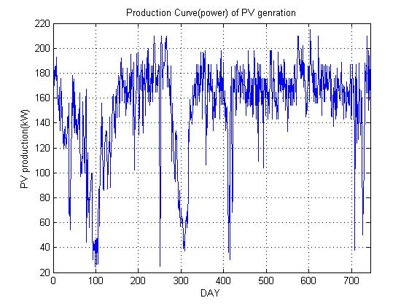
Fig.1 A two-year PV generation production curve

The corresponding PDF curve of PV production is shown in figure 2. Since the Earth’s trajectory around the sun can be decisive to a great degree of precision in the absence of meteorological aspects. Because of Earth’s trajectory around the sun, we can calculate the sun’s position in the sky. We can estimate the photovoltaic (PV) production in our approach. Now to obtain the amplitude spectrum of PV generation data in the frequency domain we apply the Fast Fourier Transform (FFT) to the PV generation data in fig.1. Fig.3 shows the amplitude spectrum of fig.1. This amplitude spectrum also implies that there is a periodic component present in the data.

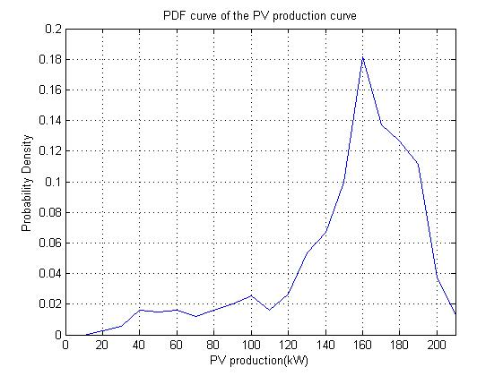
Fig.2 PDF curve of the PV production data in Fig.1
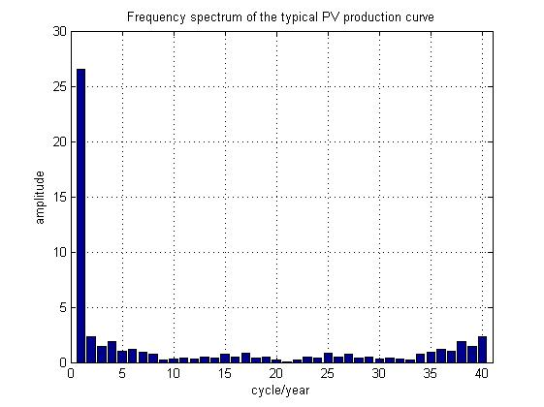
Fig.3 Frequency spectrum of the PV production shown in Fig.1

III. DETERMINATION OF UNPREDICTABLE COMPONENTS
θs is the solar elevation angle for a certain location and solar time, the solar elevation angle is defined as the angle between the geometric center of the sun and the horizon. We can calculate the variation in the extra-terrestrial solar irradiance and this solar irradiance is almost proportional to sin(θs). It is mandatory to remove the cyclical variation in the frequencies of PV generation 1 cycle/year (about) in the assessment of uncertainty in PV generation. The least square method is applied to remove this temporal variation and the PV production is supposed to be linear function of sin(θs).

P=a sin θs + b -------(1)
Where a and b are the unknown parameters. Let Y be the measured PV output and be sin θs, a can be determined as
$a=\frac{n⋅\sum_{n}{x}y-\sum_{n}{x}Σy}{n⋅\sum_{n}{x^{2}}-{\left(Σ_{n}x\right)}^{2}}$ -----(2)
$b=\overline{y}-a\overline{x}$ -----(3)
where X’ and Y’ are the expected values of X and Y and n is the number of samples.
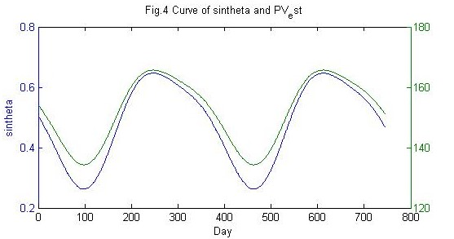
Fig.4 curve of sinθs and P=a sinθs+b for two years

Fig.4 shows the PV production in the absence of climate factors on sunny days. If we do not consider the weather factors like sunny days, rainy days, storm, fog etc. we get the power production shown in fig.4. The constraint is what left of the linear model. a residual of the linear model. It is evaluated to be the unpredictable component of photovoltaic power generation in accordance to uncertainty. A significant aspect to consider to study is that the lowest frequency periodic component in PV production is the annual insolation variation. This periodic component happens because of the annual position of the sun in the sky. In this study we have developed an approach to remove this periodic component, in a way that make the following study of the data easier. This method observes the connection between PV production and fluctuating solar position, and divides the PV generation data into predictable and unpredictable parts.

$ε$ = Y’ - (aX’+ b) -----(4)

In equation 4, the periodic effect of change in solar position is removed from the PV generation data. By using the least square method, the amplitude spectrum in the frequency domain and the PDF curve of the unpredictable component of PV production is shown in Figs. 5 and 6, respectively.

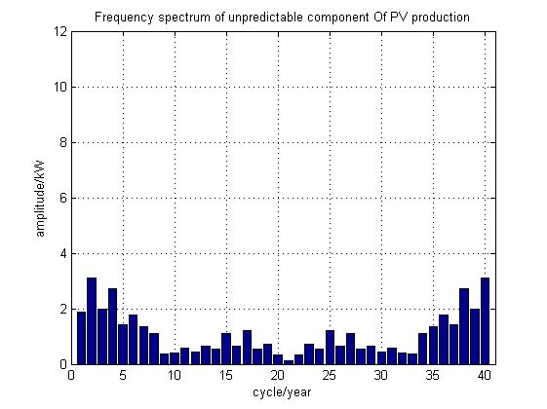
Fig.5 Frequency spectrum of unpredictable components of PV production
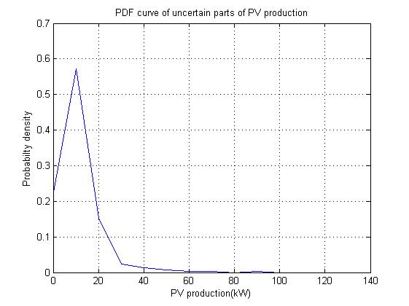
Fig.6 PDF curve of unpredictable component of PV production
According to Fig.6, the unpredictable uncertainty is still large after removing the impact of the changing solar position. The low impact indicates that the changing weather condition is the dominant factor for the PV generation uncertainty.

Fig.7 PDF curve of uncertain parts of the PV production after filtering the periodic components

To compare the previous result we need another result that is obtained by ﬁltering the annual periodic components of the PV production which is shown in Fig.3, and the PDF curve is shown in Fig.7. Table I compares the standard deviation and the coefﬁcient of variation (CV) of PV production for different cases. The results shows that the PV production has little and predictable variation on different weather condition. The ratio of the standard deviation to the expected value of PV production is the coefﬁcient of variation is.

TABLE-2 COMPARISON OF THE UNCERTAINTY RESULTS OF PV PRODUCTION
 | Fig2 | Fig4 | Fig6 | Fig7
Standard deviation | 0.0520 | 10.7681 | 0.0855 | 0.1223
Coefficient of variation (%) | 0.0342 | 7.0778 | 0.0562 | 0.0804

IV. Forecasting of PV Production
This susceptibility power utilities to work with PV power because the grid planning and balancing become very difficult to perform. Some errors are associated with PV forecasting and for efficiently integrating this solar energy into the grid we need to reduce this error and for reducing this error we evolve a reliable algorithm. These all are challenges that play a very important role in PV power forecasting. So, the technique that predicts PV output is the combination of wavelet transform (WT) and artificial intelligence (AI) to make use of the interactions of PV systems with solar radiation and temperature data in a linear model. Artificial intelligence techniques capture the photovoltaic behaviour in the exceptional way.

A. WAVELET TRANSFORM
Now we apply the wavelet transform in our data and the scalogram plot is obtained. In wavelet transform the scalogram is defined as the absolute value of a signal in the continuous wavelet transform (CWT) plotted as a function of frequency and time. Better time localization for short-span high-frequency vent and better frequency localization for low frequency longer span, scalogram is used. The fig.8 shows the scalogram plot and the fig.9 shows the contour plot. If we want better time localization for short-duration high frequency events and better frequency localization for low-frequency longer duration events we use the scalogram curve. The contour plot shows the wavelet spread in time and frequency preserving the energy in the analysis stage.

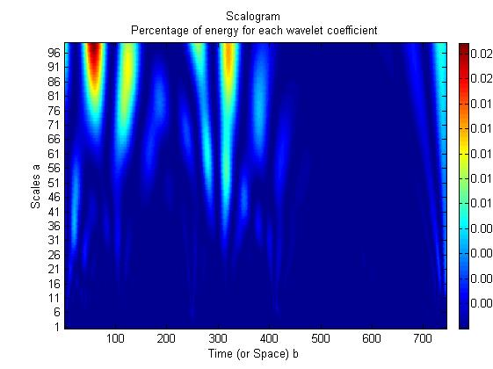
fig.8 Scalogram of the percentage of the energy of each wavelet coefficient.
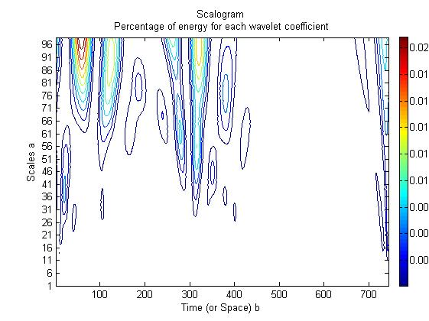
Fig.9 Contour of percentage energy for each wavelet coefficient

To obtain the decomposition i.e., analysis and reconstruction synthesis filter for the b-spline by orthogonal wavelet specify three vanishing moments in the synthesis and five vanishing moments in the analysis wavelet.

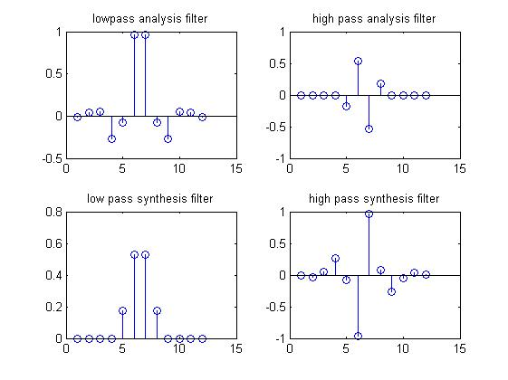
Fig10 The analysis and synthesis components of continuous wavelet component of signal x(n)

There are various vulnerabilities, spikes, and various non-stationarities in the photovoltaic power data. The tool which is used to manage these spikes is the wavelet transform (WT). So, by the wavelet transform, we can improve the error in PV power forecasting. The wavelet transform (WT) is of two types, the first is the continuous wavelet transform (CWT) and another one is the discrete wavelet transform (DWT). Hence by discrete wavelet transform (DWT), we have decomposed our PV power production into approximation and detailed coefficient at level one. Then we reconstructed the power output by using these coefficients and then we are having compared the graph obtained.

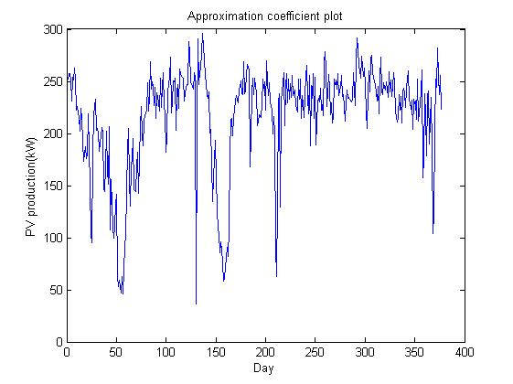
Fig.11 Approximation coefficient plot.
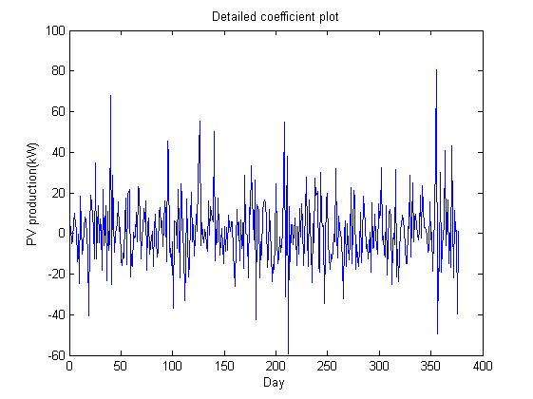
Fig.12 Detailed coefficient plot.
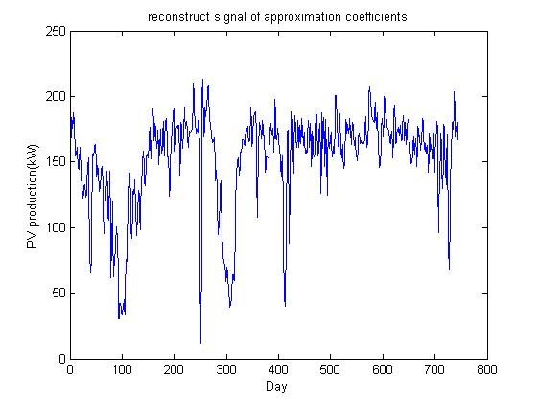
Fig.13 Reconstruction plot
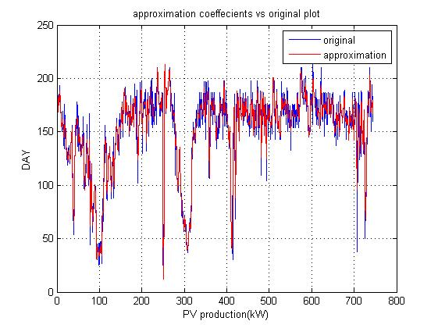
Fig.14 Comparison between approximation and original PV
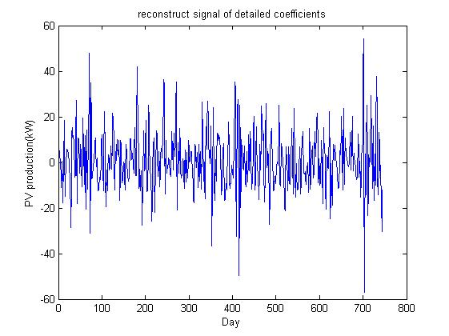
Fig.15 Reconstruction of detailed coefficients
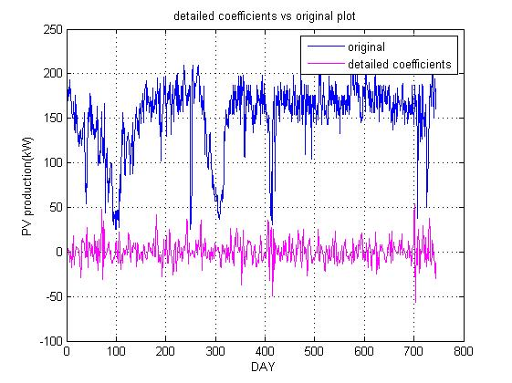
Fig.16 Comparison between original and detailed PV

B. WAVELET DECOMPOSITION

Wavelet transform is used to analyse nonlinear and non-stationary time series signals, and this wavelet transform is much more likely to be a Fourier transform. To break a signal into different scale layers with different levels of resolution the wavelet transform technique is used. The decomposition into different scales is made possible by the fact that the wavelet transform method is based on a square-integrable function and group theory representation. The wavelet transform is suitable for analysing a signal with the changeable time–frequency resolution, such as the output power of a photovoltaic power plant.

The wavelet decomposition decomposes the signal into its detailed smoothed layers. A signal for the power output of a PV power plant can include sharp edges and changes in locations caused by fluctuation of the solar radiation, this signal has periodicity and nonlinear properties. With the help of WD, we can decompose output power of the PV power plant into two parts. The first one is the smoothed version of the signal and the second one contains the detailed version of the signal. So, by the use WD method, we can remove the disturbance in the original signal and can analyse them separately.

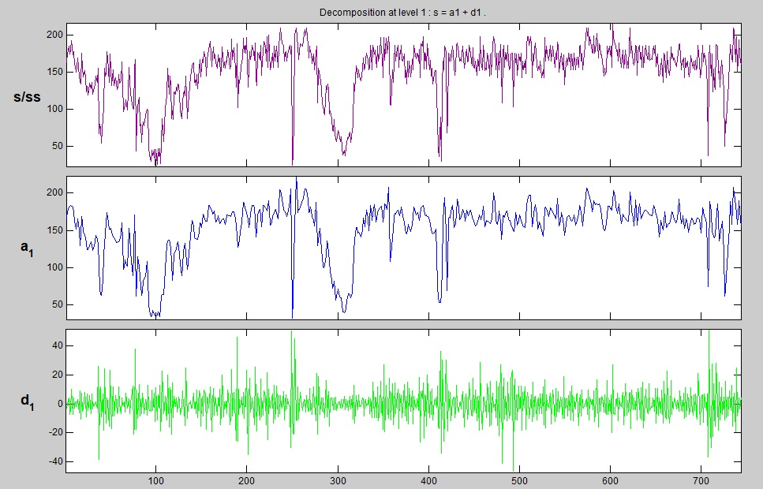

Fig.17 Decomposition of PV production at level 1.

Let us consider a discrete-time signal, for the output power of the power plant this discrete time signal is to be decomposed into one smoothed layer and detailed layers. By Wavelet decomposition technique, the decomposed signals at scale 1 are A1(n) and D1(n), where A1(n) is the smoothed version of the input signal, and D1(n) is the detailed version of the input signal x(n) in the form of the wavelet transform coefficients.

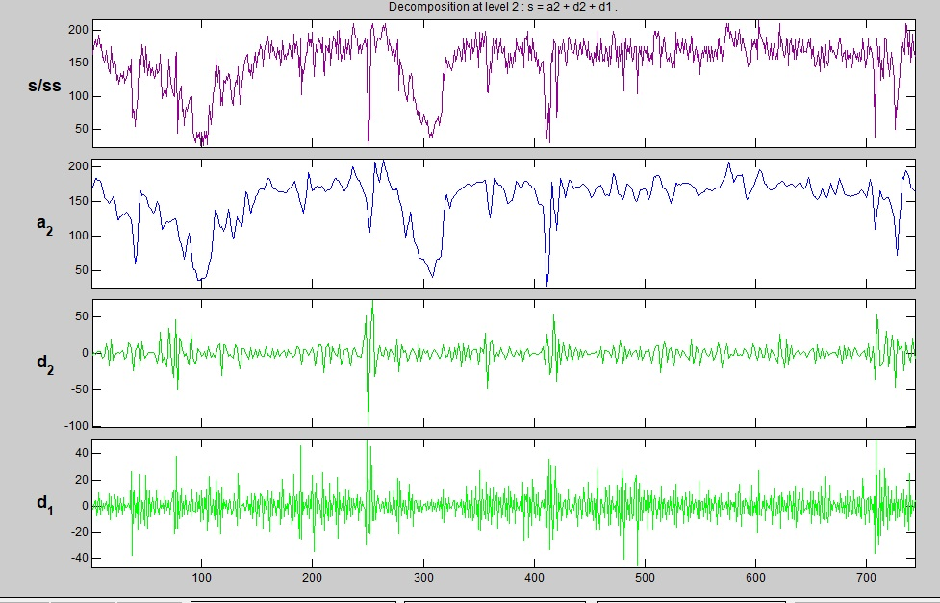
Fig.18 Decomposition of PV production at level 2
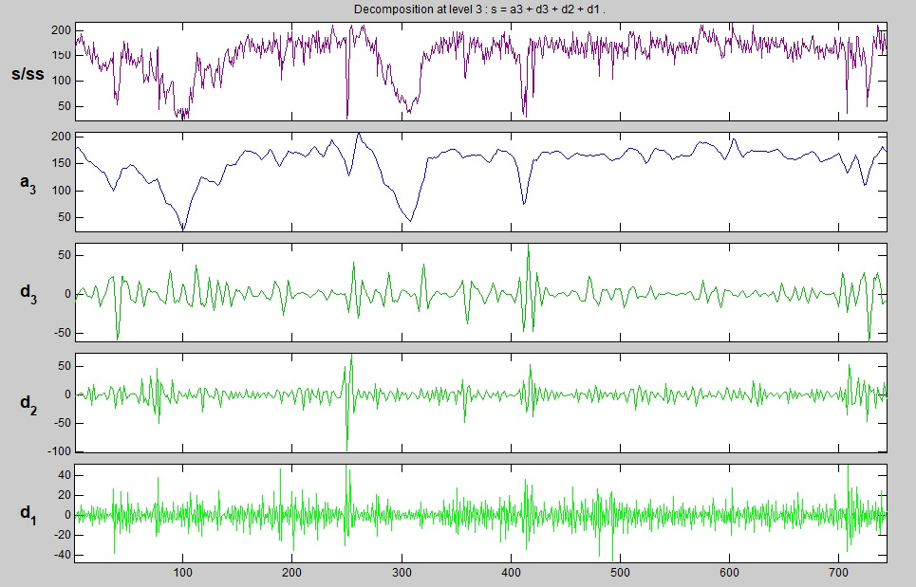
Fig19 Decomposition of PV production at level 3.

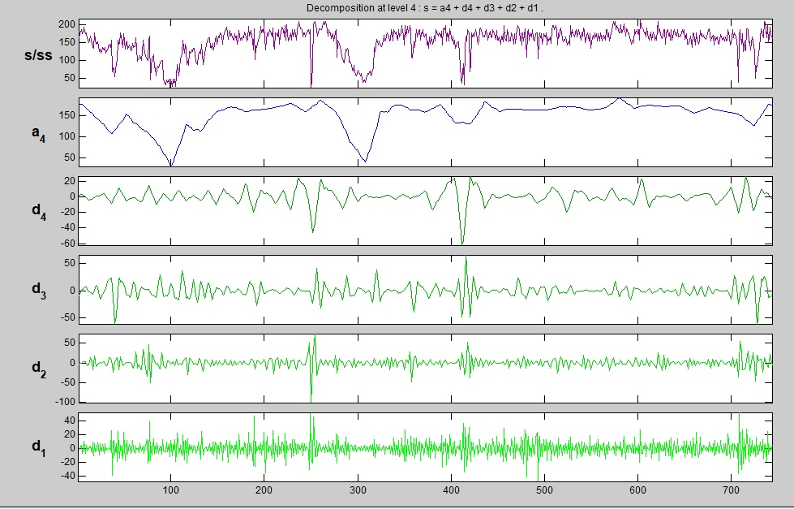
Fig.20 Decomposition of PV production at level 4

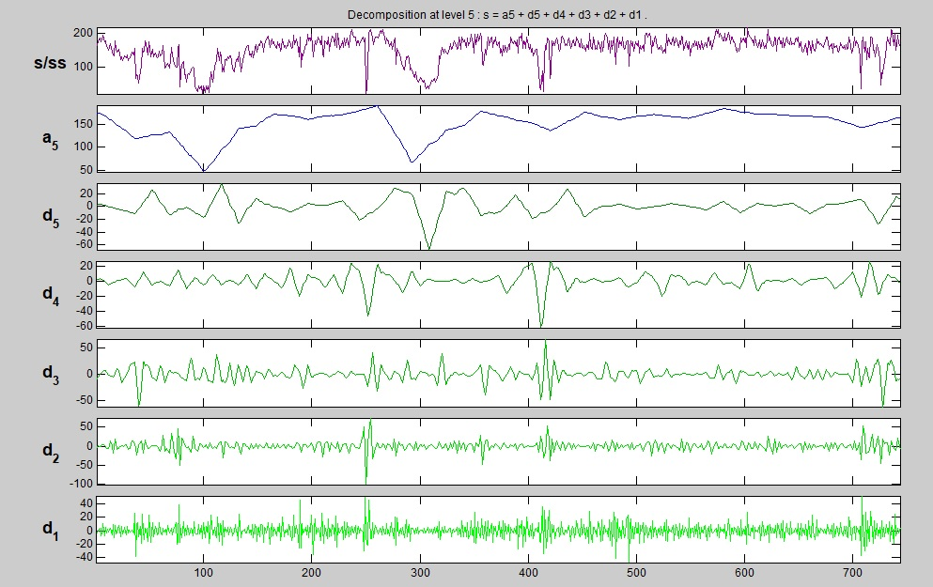
Fig.21 decomposition of PV production at level 5

Table 3 Layers Definitions of WD

Reconstructed Sequence | Definition | Meaning
A5 | The smoothed signal at the 5th layer | Reflects change trend of the output power of PV power plant, close to theoretically calculated solar irradiance
D5 | The detailed signal at the 5th layer | Reflect composition and change rules of high-frequency part of the signal
D4 | The detailed signal at 4th layer
D3 | The detailed signal at 3rd layer
D2 | The detailed signal at 2nd layer
D1 | The detailed signal at 1st layer

V. POWER PREDICTION

In the scientific sense, solar radiation is a factor governing the exact effect of photovoltaics on power generation. The intensity of the sun directly consequences the yield of a photovoltaic cell. PV array received solar irradiance which is effect by the number of clouds in the sky, solar position, and the array installation angle. For the PV system, the output time series data has a certain autocorrelation function except this the output of the PV system is also affect by the meteorological condition. These all occurred due to power output data of power plant containing power plant information, and complex analysis of the consequence of random installation site and the operation time on PV degeneration can be avoided. That’s why we use an artificial neural network to implement output forecasting modelling for PV power plants.

According to the formation of the forecasting model. We have to train the approximation coefficients (A5, A4, A3, A2, A1) and detailed coefficients (D5, D4, D3, D2, D1) obtained from the wavelet decomposition of our PV production output. High-frequency information (detailed coefficients D3, D2, D1) at other layers are treated as disruption disturbances for implementing the model, so they are not used. We carried out a 5-layered wavelet decomposition is carried out for the output power of the PV plant followed by the comparison between the approximation layer and detailed layer.

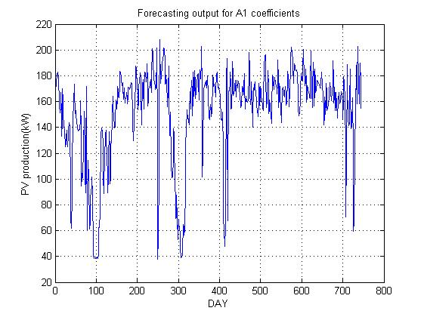
Fig.22 Forecasting output of A1 coefficients

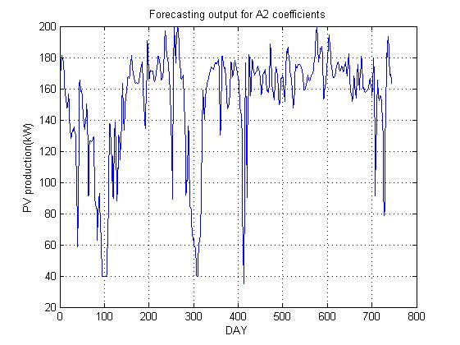
Fig.23 Forecasting output of A2 coefficients

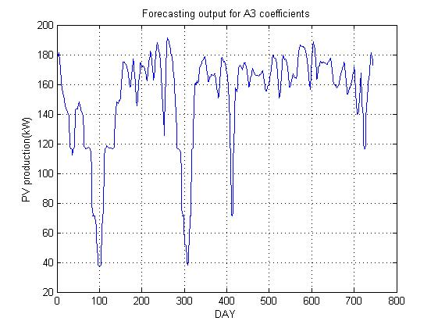
Fig.24 Forecasting output of A3 coefficients

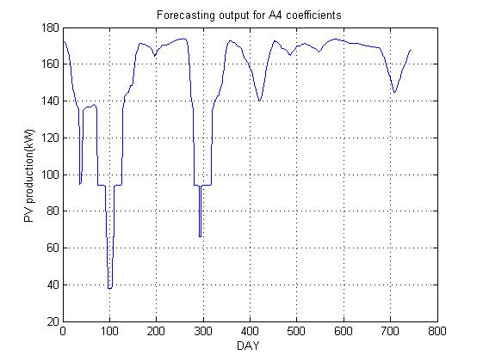
Fig.25 Forecasting output of A4 coefficients
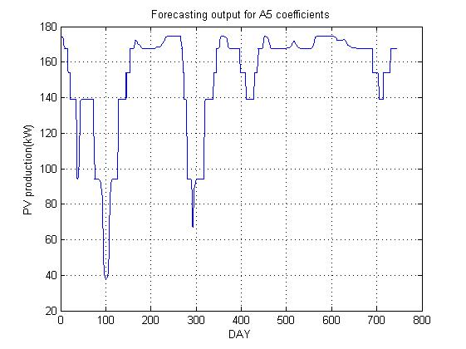
Fig.26 Forecasting output of A5 coefficients
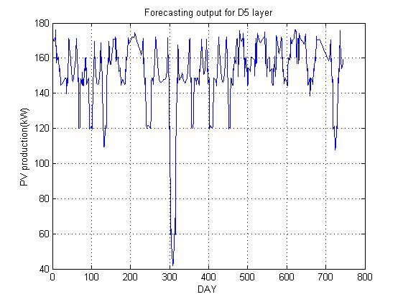
Fig.27 Forecasting output of D5 coefficients
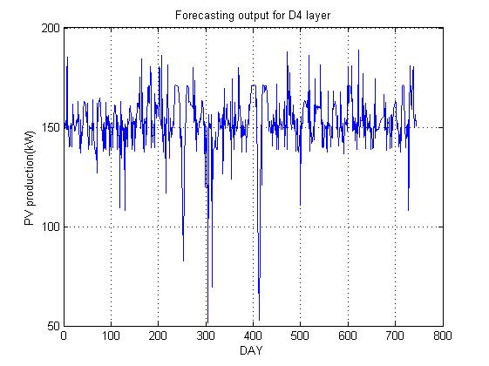
Fig.28 Forecasting output of D4 coefficients
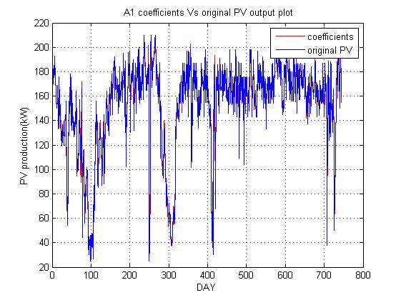
Fig.29 Comparison of original signal and forecast A1 coefficients
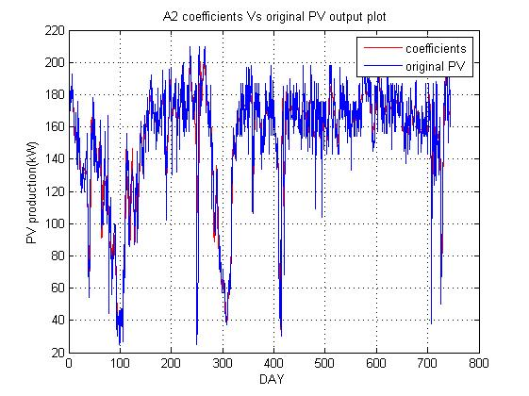
Fig.30 Comparison of original signal and forecast A2 coefficients
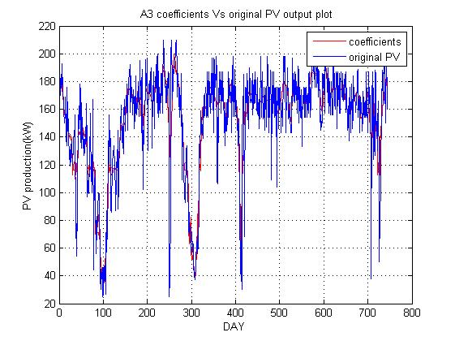
Fig.31 Comparison of original signal and forecast A3 coefficients
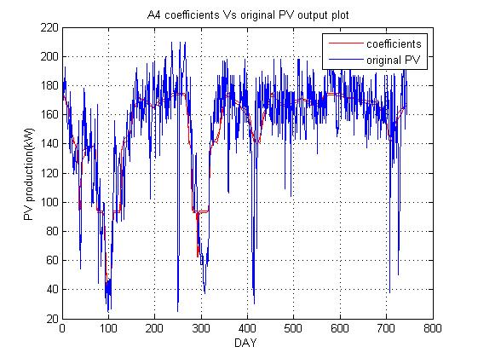
Fig.32 Comparison of original signal and forecast A4 coefficients
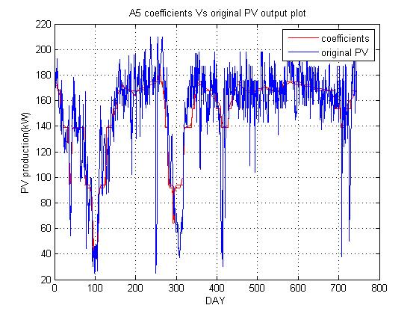
Fig.33 Comparison of original signal and forecast A5 coefficient

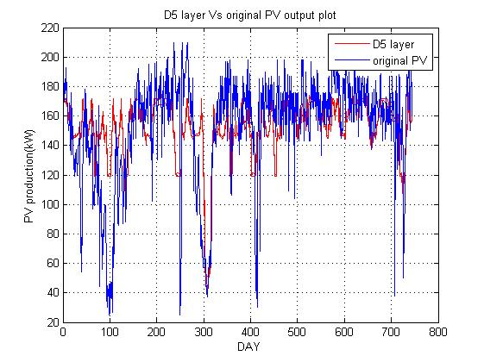
Fig.34 Comparison of original signal and forecast D5 coefficients

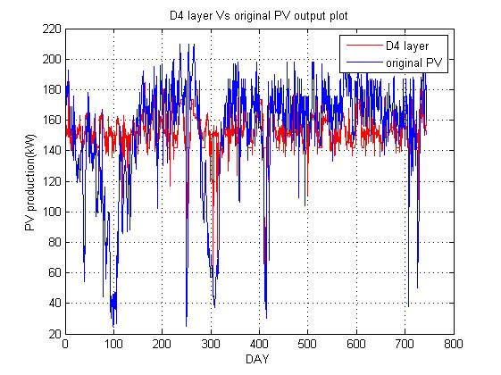
Fig.35 Comparison of original signal and forecast D4 coefficients

VI. ERROR CALCULATION IN POWER PREDICTION

For the assessment of the forecast results based on ANN + WD, here we use Mean Absolute Error (MAE), Root Mean Square Error (RMSE), and the Mean Absolute Percentage Error (MAPE). The definition of all their error is as follow:
$RMSE= \frac{\sqrt{∑|Pn\left(j\right)-Pf\left(j\right)|^2}}{c_{aP}*\sqrt{n}}*100\%$ …… (5)

$MAE= \frac{\sum_{j=1}^{n}{|Pn\left(j\right)-Pf\left(j\right)|}}{c_{aP}*n}*100\%$ …… (6)

MAPE = $\frac{1}{n}\sum_{j=1}^{n}{\left|\frac{Pn\left(j\right)-Pf\left(j\right)}{Pn\left(j\right)}\right|*100\%}$ …… (7)

where Pn(j) is measured power at time j; Pf (j) is the forecast power at time j; n is the number of samples; Cap is the mean running capacity.

Calculation of mean running capacity in PV power forecasting is decided by the initial power of the photovoltaic inverter, installed capacity of the PV system, and operation time. Factor Run(j) is defined to describe the working state of the PV plant at time j. When the measured power Pn(j) is higher than PS, the initial power of the photovoltaic inverter, then Run(j) equal to 1, meaning that the PV plant is running, else, Run(j) is equal to 0, meaning that the PV plant is not running, as shown in Equation (8)

Run(j) = {1, if Pn(j) ≥ Pz
Run(j) = {0, if Pn(j) ≤ Pz …… (8)

The definition of Cap is shown in Equation (4.9)

Cap = $\frac{\sum_{j=1}^{n}{Run(j)}}{n}*\operatorname{Pc}{ }$ …… (9)

where Pz is the initial power of the photovoltaic inverter and Pc the is installed capacity of the PV system.

Table 4.3 Error in measurement

Error/ Layer | A1 | A2 | A3 | A4 | A5
RMSE (%) | 11.14 % | 15.73% | 19.35% | 24.29% | 24.10%
MAE (%) | 8.33% | 11.20% | 13.78% | 17.47% | 17,46%
MAPE (%) | 6.43% | 9.38% | 12.12% | 16.34% | 16.25%

The above table shows the error results obtained during the forecasting of PV production output comparing between wavelet decomposition of power output in five layers and the trained output obtained by using artificial neural networks. In the table, it can be observed that error is escalating with the level of decomposition on the PV power production.

A novel probabilistic model of PV generation is developed based on the environmental conditions that impact PV behaviour. The Forecasting is based on the ANN and WD. Because of the non-stationary and periodic behaviour of power output of PV power plant, the wavelet transform technique is followed to carry out the multi-scale decomposition of output PV power and the detailed and smoothed signal occurs. Using the ANN at different layers the forecasting model is implemented. In the end forecasting result of the PV power plant are obtained by reconstructing the forecasting result at different signal layers. Here in this proposed method, it is shown that the ANN method has better forecasting precision and less algorithm convergence time as compared to traditional methods. Solar power is the best solution due to its abundant availability in our country and an immediate initiative should be taken to install a solar thermal plant in India for obtaining the necessary experience in its design, installation, operation, and maintenance.

REFERENCES

[1] A. Ahmad and J. Y. Khan, "Stand-Alone Distributed PV Systems: Maximizing Self Consumption and User Comfort using ANNs," 2018 IEEE International Conference on Communications, Control, and Computing Technologies for Smart Grids (SmartGridComm), Aalborg, 2018, pp. 1-6.
[2] A. Chersin, W. Ongsakul and J. Mitra, "Improving of uncertain power generation of rooftop solar PV using battery storage," 2014 International Conference and Utility Exhibition on Green Energy for Sustainable Development (ICUE), Pattaya, 2014, pp. 1-4.
[3] A. Grandjean, J. Adnot, and G. Binet, “A review and an analysis of the residential electric load curve models,” Renewable and Sustainable Energy Reviews, vol. 16, no. 9, pp. 6539–6565, Dec. 2012
[4] A. Kumar, M. Rizwan and U. Nangia, "Artificial Neural Network based Model for Short Term Solar Radiation Forecasting considering Aerosol Index," 2018 2nd IEEE International Conference on Power Electronics, Intelligent Control and Energy Systems (ICPEICES), Delhi, India, 2018, pp. 212-217.
[5] A. P. Meliopoulos, A. G. Bakirtzis and R. Kovacs, "Power System Reliability Evaluation Using Stochastic Load Flows," in IEEE Transactions on Power Apparatus and Systems, vol. PAS-103, no. 5, pp. 1084-1091, May 1984.
[6] A. Palm, “Peer effects in residential solar photovoltaics adoption—A mixed methods study of Swedish users,” Energy Research & Social Science, vol. 26, pp. 1–10, Apr. 2017
[7] A. Pan, Y. Tian, H. Zhao, X. Yang and J. Jin, "Power quality analysis of PV system of summer and winter," CIRED 2012 Workshop: Integration of Renewables into the Distribution Grid, Lisbon, 2012, pp. 1-4
[8] A. S. Al-Sumaiti, M. H. Ahmed, S. Rivera, M. S. El Moursi, M. M. A. Salama and T. Alsumaiti, "Stochastic PV model for power system planning applications," in IET Renewable Power Generation, vol. 13, no. 16, pp. 3168-3179, 9 12 2019.
[9] A. U. Haque, M. H. Nehrir and P. Mandal, "Solar PV power generation forecast using a hybrid intelligent approach," 2013 IEEE Power & Energy Society General Meeting, Vancouver, BC, 2013, pp. 1-5.
[10] B. M. Alluhaidah, S. H. Shehadeh and M. E. El-Hawary, "Most Influential Variables for Solar Radiation Forecasting Using Artificial Neural Networks," 2014 IEEE Electrical Power and Energy Conference, Calgary, AB, 2014, pp. 71-75.
[11] Bracale, A., Caramia, P., Carpinelli, G., Di Fazio, A.R., Ferruzzi, G.: ‘A Bayesian method for short-term probabilistic forecasting of photovoltaic generation in smart grid operation and control’, Energies, 2013, 6, (2), pp. 733- 747
[12] Canova, A., Giaccone, L., Spertino, F., Tartaglia, M.: ‘Electrical impact of photovoltaic plant in distributed network’, IEEE Trans. Ind. Appl., 2009, 45, (1), pp. 341–347
[13] D. Brunelli and M. Rossi, "Smart Grid Configuration Tool for HEES systems in smart city districts," 2016 International Symposium on Power Electronics, Electrical Drives, Automation and Motion (SPEEDAM), Anacapri, 2016, pp. 137-142.
[14] D. N.-y. Mah, G. Wang, K. Lo, M. K. H. Leung, P. Hills, and A. Y. Lo, “Barriers and policy enablers for solar photovoltaics (PV) in cities: Perspectives of potential adopters in Hong Kong,” Renewable and Sustainable Energy Reviews, vol. 92, pp. 921–936, Sep. 2018.
[15] D. Palmer, E. Koubli, I. Cole, T. Betts and R. Gottschalg, "Comparison of solar radiation and PV generation variability: system dispersion in the UK," in IET Renewable Power Generation, vol. 11, no. 5, pp. 550-557, 12 4 2017.
[16] D. S. Schiera, F. D. Minuto, L. Bottaccioli, R. Borchiellini and A. Lanzini, "Analysis of Rooftop Photovoltaics Diffusion in Energy Community Buildings by a Novel GIS- and Agent-Based Modeling Co-Simulation Platform," in IEEE Access, vol. 7, pp. 93404- 93432, 2019.
[17] D. Sbarbaro and R. Pena, "Dynamic output power optimization in hybrid PV/T panels," IECON 2016 - 42nd Annual Conference of the IEEE Industrial Electronics Society, Florence, 2016, pp. 114-119.
[18] M. Fan, V. Vittal, G. T. Heydt and R. Ayyanar, "Preprocessing Uncertain Photovoltaic Data," in IEEE Transactions on Sustainable Energy, vol. 5, no. 1, pp. 351-352, Jan. 2014
[19] Daniele Salvatore Schiera1, Francesco Demetrio Minuto1, Lorenzo Bottaccioli1 (Member, IEEE), Romano Borchiellini1, Andrea Lanzini (2017).

