Bio-Medical ECG Signal Acquisition and Electrode Placements

Sachin Sambhaji Patil
Research Scholar, S.U.Kolhapur
Assistant Professor: ZCOER Pune
Pune, India

Dr. T. B. Mohite-Patil
Professor, D.Y.P.COE Kolhapur
Kolhapur , India

ABSTRACT
ECG is an Electrocardiogram that records the electrical activity of the heart. Cardiologists use ECG for the diagnosis of cardiovascular disease. In this, we are going to see How ECG signals get recorded and How ECG signals get plotted on the ECG Graph Paper.

Keywords—ECG, Acquisition, Image, Electrodes

INTRODUCTION

Fig.1: Limb Lead and Chest Lead Electrodes
As shown in Fig-1, there are 6 chest bulb electrodes and 4 Limb electrodes. An electrocardiogram (ECG or EKG) is a register of the heart's electrical activity. Chest Electrodes are unipolar electrodes which measures electrical activity of heart in horizontal plane. Limb electrodes are bipolar electrodes which measures electrical activity of heart in vertical plane. 6 chest electrodes are V1 , V2 , V3 , V4 , V5 , V6 and similarly 4 Limb electrodes are black , red , yellow , blue. Chest electrodes are generating ECG Signals V1 , V2 , V3 , V4 , V5 , V6 and Limb electrodes are generating ECG Signals I, II , III , AVR , AVL , AVF .
Placement of 6 Chest Lead ECG Electrodes:
Measures Electrical Activity of Heart in Horizontal Plane
V1 – 4thintercostals space right rib
V2 – 4thintercostals space left rib
V3 – In between V2 and V4
V4 – Mid calvicular line
V5 – Anterior Auxiliary Line
V6 – Mid Auxiliary Line

Placements of 4 Limb lead Electrodes
Measures Electrical Activity of Heart in Vertical Plane
Black electrode – Right Leg
Red electrode – Right Arm
Yellow electrode – Left Arm
Blue electrode – Left Leg

ECG Signals: Potential Difference between Arm and Leg
I – Potential difference between Right Arm and Left Arm
II – Potential difference between Right Arm and Left Leg
III – Potential difference between Left Arm and Left Leg

ECG Signals: Looking into Heart in Cross Section
AVR – Augmented Vector Right
AVL – Augmented Vector Left
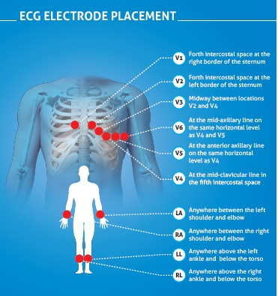
AVF – Augmented Vector Foot

Fig.2: ECG Electrode Placement
Different Types of ECG File Formats
csv file format
mat file format
edf file format
dat file format
Images form jpg, png, bmp

csv file format
csv stands for comma separated value . In this file format all the values are separated by comma.
How to read csv file in matlab
M = csvread (filename)
Meaning of above matlab programming line is read comma separated value into array M. The file must contain only numerical values.

ECG Data File Format:-
- mat file format
mat is a matlab laboratory file . This file is having extension is .mat. When we want to load .mat file
Download .mat file ECG Signal from Physiobank ATM. After downloading ECG Signal in .mat file load it in y.
y=load ('100.mat);
>> pwd , pwd stands for path word directory
>> pwd
ans =
C:\Program Files\MATLAB\MATLAB Production Server\R2015a\bin
>> ls, // ls means list of files available in given pwd
>> y=load ('100.mat);
- edf file format
edf stands for European Data Format.
data = edfread( filename ) reads the European Data Format (EDF)
- dat file format
. dat file extension is a generic data file that stores specific information relating to the program that created the file.
- Images form jpg,png,bmp
ECG signal available in Images format also like jpg,png,bmp etc.
The procedure of Connecting ECG Electrodes:-
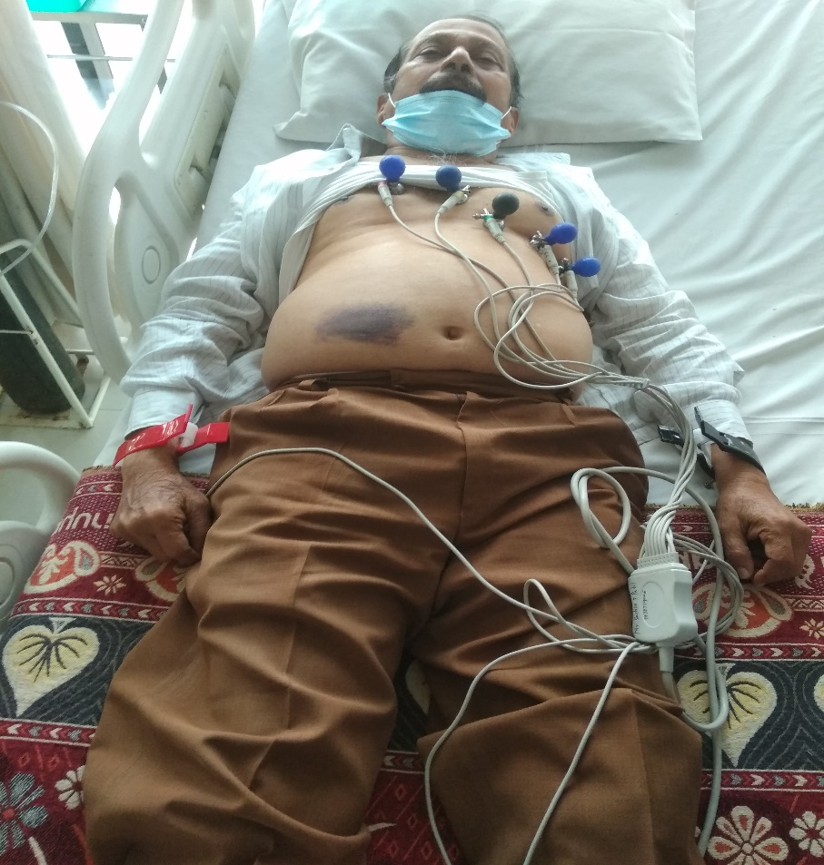
Fig.3 Electrode Placement on Patient body
Fig.3 indicates placement of Electrodes on Patient body on chest placed bulb electrodes and on hands and legs placed limb electrodes.
Electrodes:-
Bulb Electrode – 6 Bulb Electrodes are connected to the chest to the rib
V1: 4th Intercostal Space Left, V2 – 4th intercostal space Right,
V4 - Mid Calvicular Line,
V3 – In between V1 and V4,
V5-Anterior auxiliary line,
V6 - Mid auxiliary line
Limb Electrode - 4 Limb Electrodes are connected to Hands and Legs
Black Limb Electrode-Right Leg, Red Limb Electrode-Right Arm,
Yellow Limb Electrode- Left Arm, Blue Limb Electrode – Left Leg

REFERENCES

1 Sachin S. Patil , Dr. T. B. Mohite-Patil “A Review Paper on analyzing QRS of ECG Signal : An Intelligent Approach for Clinical Diagnosis” IEEE International Conference ICEECCOT-2018 , 14-15 Dec 2018.

2. Sachin S. Patil , Dr. T. B. Mohite-Patil “Methods Of Importing And Plotting Various Ecg Signal Format In Matlab And Calculation Of Ecg Heart Beat Rate Based On Ecg Signal” IJCRT Volume 10 Issue 6 June 2022 , Date of Publication: 03-June-2022

