Distress Model Analysis of Flexible Pavement using ANSYS and KENPAVE

Ashwini H.D.
Assistant Professor,
Department of Civil Engineering
Bangalore Institute of Technology, Bengaluru-560001
ashwinihd@bit-bangalore.edu.in
Adnan Zafar
B.E Student,
Department of Civil Engineering
Bangalore Institute of Technology, Bengaluru-560001
adnanzafartab@gmail.com

Kumar Harsh
B. E Student,
Department of Civil Engineering
Bangalore Institute of Technology, Bengaluru-560001
hs056309@gmail.com

ABSTRACT

Pavement distress is the condition of the pavement structure that impairs or contributes to the impairment of serviceability. Stress from axle loads, temperature change in bituminous layer, and moisture and temperature fluctuations in an underlying layer can all contribute to this condition. Nevertheless, pavement response under moving loads behaves as a time-dependent and transient parameter, and as axle loading and speed requirements have continued to increase due to an increase in traffic volume, an improved model for evaluating stresses and deflections of pavement has become a pressing need. Multiple nonlinear layers sitting on a foundation containing the interaction of numerous variables compose the pavement structure. Consequently, numerous academics have taken a rational approach to finite element (FE) modelling for improved pavement simulation and analysis. In addition, it is widely acknowledged that, due to the complexity of vehicle and pavement modelling when addressing the influence stress from axle loads, numerical methods of analysis are required. Since one hundred years ago, asphalt-coated flexible pavements and roadways have been in use. Currently, flexible pavements are primarily designed using empirical methods. However, a trend toward more mechanistic design methodologies is currently occurring. In general, layered elastic analysis and two-dimensional finite element (FE) approaches have been used to predict stresses, strains, and displacements in flexible pavements; nevertheless, they suffer from a number of significant drawbacks. To address these issues, pavement constructions must be analyzed using three-dimensional (3D) FE analysis. This study examines the usage of ANSYS and KENPAVE to analyses the reaction of the distress model of flexible pavements using Finite-Element Methods.

Keywords—Pavement Distress, ANSYS, KENPAVE

INTRODUCTION

The global road network is the system of arteries used to convey people and products between villages, towns, and nations. The pavement, which can be flexible, semi-rigid, or stiff, is a fundamental component of this network. Flexible pavement has various advantages, such as inexpensive construction costs and broad availability of building supplies (granular material and bituminous binders); hence, it is the most prevalent pavement type in the world. Typically, flexible pavement comprises of many layers, including the surface, base, and subbase layers, as well as the subgrade (foundation) soil. Combining many layers of flexible pavement is the key to boosting its load resistance. Flexible pavement is at danger of distortion under loads. Traffic loads have an immediate impact on the top layer and are conveyed to the underlying layers via particle friction. From the surface layer to the foundation soil, the influence of traffic loads diminishes. The surface layer is composed of one or more layers of asphalt mixture, as specified by the design. As a result of being subjected to more stress than the lower layers, asphalt is more rigid and provides the majority of the pavement's strength. The primary role of the base and subbase layers is to reduce the stress on the subgrade soil; hence, the thickness of these layers is determined by the strength of the subgrade soil. The primary drawbacks of flexible pavements are their poor tolerance to temperature change, heavy traffic loads, and frequent maintenance requirements. Temperature change has the greatest impact on flexible pavement deformation, since it influences the asphalt mixture's and unbound layers' stiffness. Temperature rises exacerbate the detrimental effects of strain, tension, and surface deflection. Temperature change causes further damage, including fatigue cracking, thermal cracking, and rutting. The leading causes of fatigue cracking are traffic loads and climatic factors (temperature fluctuations). Rigid pavements consist of high-strength concrete surface slabs joined by tie bars or dowel steel bars. The distribution of traffic loads across a vast region minimises the stress transferred to the lower levels, hence lowering the number of lower layers necessary. The study of rigid pavement is based on plate theory, a simplified form of layer theory. The plate hypothesis assumes that the concrete surface slab is a level plane prior to and following loading. Numerous significant criteria, such as traffic volume and soil load-bearing capability, affect the construction of pavements. The design of a pavement is based on the assessment of cumulative standard axels, which indicate traffic load, and the California Bearing Ratio (CBR) test, which determines the strength of the foundation soil.
The material's modulus of elasticity is the most critical factor in pavement design. Using a resilient modulus (MR) test, the elasticity of several materials with a high degree of stiffness was determined. MR is the soil's mechanical response to the cyclic application of a dynamic load. MR is used to represent the strength of the soil beneath a stretch of pavement, which is determined by soil qualities (dry density and moisture content) and load factors, such as confining pressure and applied stress. MR is the most significant input for pavement design, since the value represents the subgrade reaction modulus (K). Compared to the influence of top layer modulus, the subgrade modulus is regarded a more critical component for controlling the vertical movement of the surface of a pavement in a simulated pavement section. Finite element tools such as ANSYS and KENPAVE are used to analyse several pavement sections in 2D and 3D simulations. The KENPAVE approach may be used to forecast pavement behaviour based on various material properties, including linear, nonlinear, and viscoelastic behaviour.

RESEARCH SIGNIFICANCE

Due to an increased demand for pavement maintenance and rehabilitation, the concepts of pavement distress analysis and pavement condition grading for flexible pavements have become prevalent in the previous decade. Examine pavement condition rating and distress analysis for evaluation and measurement of road surface quality and detection of distresses, their degree and extent. For the purpose of computing pavement condition indices, distress analysis is performed. On flexible roadways, distresses are measured via physical examination. Using the IRC and WSDOT manuals, the values of pavement condition indices are determined, the relationship between the two approaches is tallied, and the most appropriate way is suggested.

A deterioration prediction model (DISTRESS MODEL) is a crucial component of a successful and efficient pavement management system. Two types of models are developed: deterministic models based on distress and probabilistic models based on age. Long-term pavement condition history data is applied to generate a pavement condition index deteriorating trend (PCI). The objective of the prevalent deterministic models of pavement deterioration is to identify the empirical relationship between distress progression or a condition indicator and one or more explanatory variables, such as age, cracking area, and traffic.

METHODILOGY & SITE DETAILS

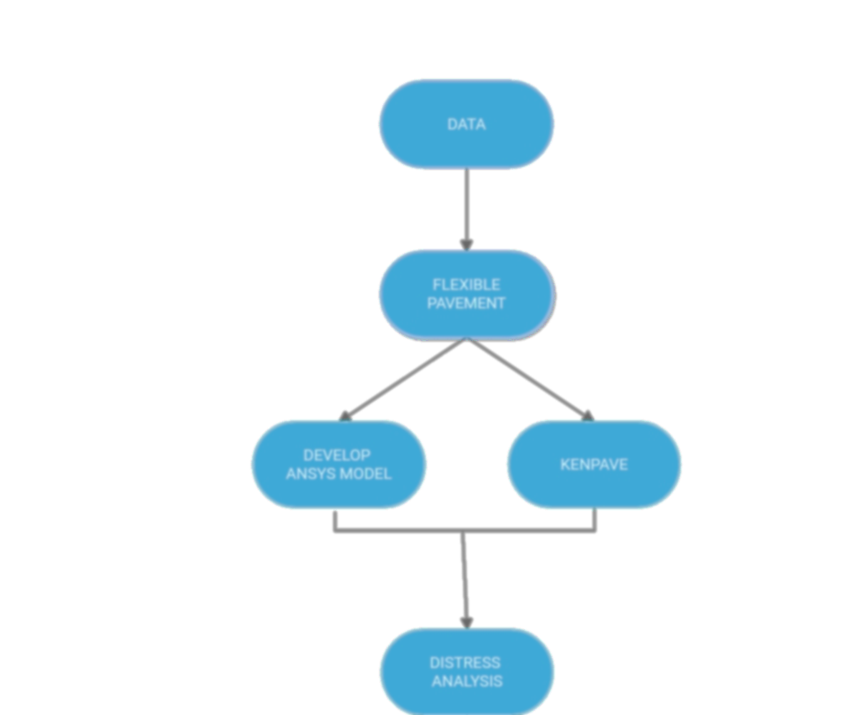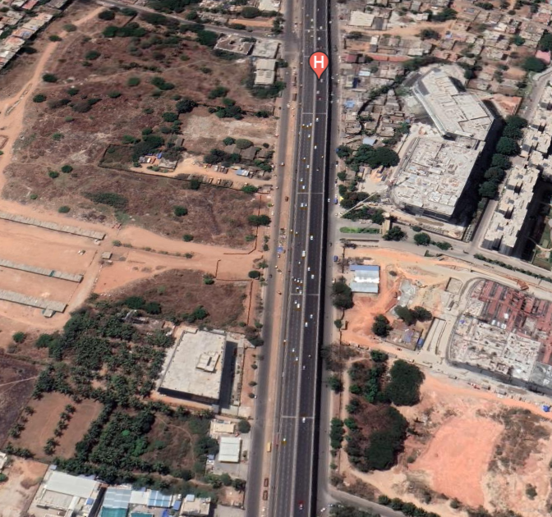
Figure 1: Methodology Flow Chart & Site Location (Source: Google Earth)

DATA COLLECTION PROCEDURE

1. Factors Considered

Data Collection was done considering various important factors like traffic volume count, axle load survey, turning movement counts etc. along with the geotechnical investigations on subgrade soil like CBR Test and Soil consistency limits along the road length.
2. Falling Weight Deflectometer (F.W.D)

The Falling Weight Deflectometer (FWD) is an impulse-loading instrument that applies a transient load to the pavement and measures the deflected form of the pavement surface. The NSV (Network Survey Vehicle) is used to perform a condition survey; a summary of the survey is provided in the table below. The majority of the project length is in good shape, with the exception of a few isolated parts. In accordance with section 5.4 of IRC: 115-2014, FWD measurements were conducted at a distance of 250 m and 500 m per lane in the outer and inner lanes, respectively.

Table 1: Condition Survey Summary

Homogeneous Sections, km |  | Overall Condition
From | To
LHS
534.720 | 538.350 | Good
538.350 | 539.150 | Poor
539.150 | 555.050 | Good
555.050 | 555.850 | Poor
555.850 | 556..840 | Good
RHS
534.720 | 539.300 | Good
539.300 | 540.200 | Poor
540.200 | 543.600 | Good
543.600 | 544.750 | Poor
544.750 | 546.300 | Fair
546.300 | 548.900 | Good
548.900 | 550.500 | Fair
550.500 | 555.350 | Good
555.350 | 556.050 | Poor
556.050 | 556.840 | Good

3. Section Considered for Study

The section on Bangalore Hyderabad Highway (NH-7) was selected from a chainage of 542.600 km to 544.650km. The factors considered for the survey were percentage of cracks (<3mm width), wide interconnected cracks (%), Total cracks (%), average rut depth (mm) and the rating mentioned in Table 1.

4. ANSYS Modelling
The ANSYS Modelling includes the following steps:
- Launching the ANSYS Workbench
- Engineering Data and Geometry
- Meshing
- Interesting the required support and Loads
- Defining/ Inserting the solution results for static structural analysis
- Generation of Results

5. KENPAVE Modelling
The KENPAVE Modelling includes the following steps:
- Launch KENPAVE
- Select LAYERINP
- Click on File on the toolbar
- Click on General on the toolbar
- Click on “Z Coordinates” on the toolbar
- Click on Layers on Toolbar
- Click on Moduli and then Period1
- Click on Load
- Click on Auxillary form and then Save As button and perform the calculation

6. Distress Analysis
The five independent variables cracking area, crack length, pavement age, cumulative equivalent single axle load (ESAL), and maintenance effect (inlay or overlay thickness) are utilised to build degradation models (DISTRESS MODELS) at the network level. Existing pavement degradation models may be classified into three categories: deterministic, probabilistic, and artificial intelligence-based. Existing deterministic degradation models are capable of predicting a specified amount of change in pavement life, distress level, or other condition indicators.

MODEL DEVELOPMENT IN KENPAVE & RESULTS OBTAINED

Table 2: Material Properties for KENPAVE Model

Sl. No | Particulars | Values
1 | Damage Analysis | 0,1
2 | Number of Periods per year | 1
3 | Tolerance for Numerical Integration | 0.001
4 | Number of Layers | 5
5 | Number of Deflection Points (Z) | 14
6 | Maximum Cycles of Numerical Integration | 80
7 | Types of Responses | 9
8 | All Layer Interfaces | 2
9 | Number of Layers for Top Compressions | 1
10 | Number of Layers for Top Compression | 1
11 | Poisson’s Ratio | 0.2, 0.3, 0.4
12 | Young’s Modulus (MPa) | 3500, 1500, 850, 1200
13 | Density (g/cm³) | 1.33, 1.44, 2.6, 2.2, 2.23
14 | Contact Radius (cm) | 10.8, 11.8, 14.5
15 | Spacing | TANDEM, TRIDEM

- Model-I (Tridem Axle Load)
MATL = 1 FOR LINEAR ELASTIC LAYERED SYSTEM
NDAMA = 0,
(SO, DAMAGE ANALYSIS WILL NOT BE PERFORMED)
NUMBER OF PERIODS PER YEAR (NPY) = 1
NUMBER OF LOAD GROUPS (NLG) = 1
TOLERANCE FOR INTEGRATION (DEL) = 0.001
NUMBER OF LAYERS (NL) = 5
NUMBER OF Z COORDINATES (NZ) = 14
LIMIT OF INTEGRATION CYCLES (ICL) = 80
COMPUTING CODE (NSTD) = 9
SYSTEM OF UNITS (NUNIT)= 1
Length and displacement in cm, stress and modulus in kPa unit weight in kN/m³, and temperature in C
THICKNESSES OF LAYERS (TH) ARE: 0.5, 2.15, 2.5, 4.65
POISSON'S RATIOS OF LAYERS (PR) ARE: 0.2, 0.3, 0.2, 0.4, 0.45
VERTICAL COORDINATES OF POINTS (ZC) ARE:
0 8 16 16.001 19 23 23.001 26 29 29.001 36 44 44.001 62
ALL INTERFACES ARE FULLY BONDED.

Table 3: Values of Moduli for different layes

Layer No | Modulus
1 | 5.9 × 10⁴
2 | 5.4 × 10⁴
3 | 1.2 × 10⁴
4 | 6.0 × 10⁴
5 | 9.0 × 10⁴

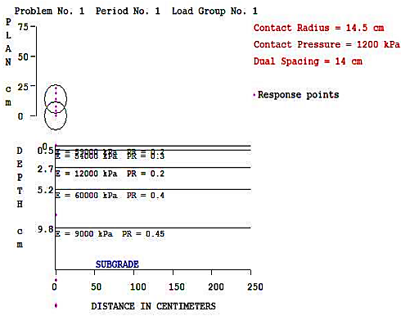
Figure 2: Developed Model-I in KENPAVE

LOAD GROUP NO. 1 HAS 2 CONTACT AREAS
CONTACT RADIUS (CR) = 14.5
CONTACT PRESSURE (CP) = 1200
NO. OF POINTS AT WHICH RESULTS ARE DESIRED (NPT)-- = 7
WHEEL SPACING ALONG X-AXIS (XW) = 7
WHEEL SPACING ALONG Y-AXIS (YW) = 14

Table 4: Response corresponding to the Points

Response Point | X-Point | Y-Point
1 | 0.00 | 2.00
2 | 0.00 | 0.00
3 | 0.00 | 4.00
4 | 0.00 | 8.00
5 | 0.00 | 14.00
6 | 0.00 | 19.00
7 | 0.00 | 23.00

Table 5: Response recorded through Model-I
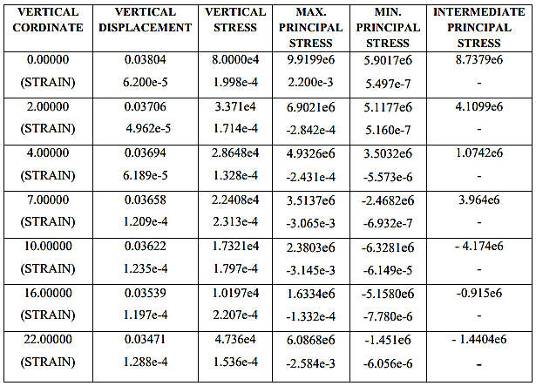

- Model-II (Tandem Axle Load)
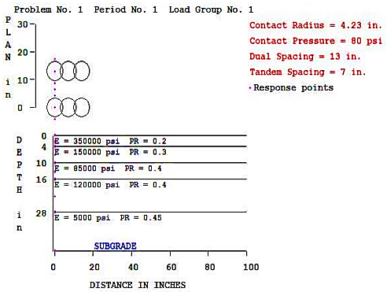
Figure 2: Developed Model-II in KENPAVE

MATL = 1 FOR LINEAR ELASTIC LAYERED SYSTEM
NDAMA = 0,
(SO, DAMAGE ANALYSIS WILL NOT BE PERFORMED)
NUMBER OF PERIODS PER YEAR (NPY) = 1
NUMBER OF LOAD GROUPS (NLG) = 1
TOLERANCE FOR INTEGRATION (DEL) = 0.001
NUMBER OF LAYERS (NL) = 5
NUMBER OF Z COORDINATES (NZ) = 14
LIMIT OF INTEGRATION CYCLES (ICL) = 80
COMPUTING CODE (NSTD) = 9
SYSTEM OF UNITS (NUNIT)= 0
Length and displacement in cm, stress and modulus in kPa unit weight in kN/m³, and temperature in C
THICKNESSES OF LAYERS (TH) ARE: 4, 6, 6, 12
POISSON'S RATIOS OF LAYERS (PR) ARE: 0.2, 0.3, 0.2, 0.4, 0.45
VERTICAL COORDINATES OF POINTS (ZC) ARE:
0, 2, 4, 4.001, 7, 10, 10.001, 13, 16, 16.001, 22, 28, 28.001, 42
ALL INTERFACES ARE FULLY BONDED.

Table 6: Values of Moduli for different layes

Layer No | Modulus
1 | 3.5 × 10⁵
2 | 1.5 × 10⁵
3 | 8.5 × 10⁵
4 | 1.2 × 10⁵
5 | 5 × 10⁵

LOAD GROUP NO. 1 HAS 2 CONTACT AREAS
CONTACT RADIUS (CR) = 14.23
CONTACT PRESSURE (CP) = 1500
NO. OF POINTS AT WHICH RESULTS ARE DESIRED (NPT) = 7
WHEEL SPACING ALONG X-AXIS (XW) = 7
WHEEL SPACING ALONG Y-AXIS (YW) = 13

Table 7: Response corresponding to the Points

Response Point | X-Point | Y-Point
1 | 0.00 | -4.230
2 | 0.00 | 0.000
3 | 0.00 | 4.230
4 | 0.00 | 6.500
5 | 0.00 | 8.770
6 | 0.00 | 13.000
7 | 0.00 | 17.230

Table 8: Response recorded through Model-II

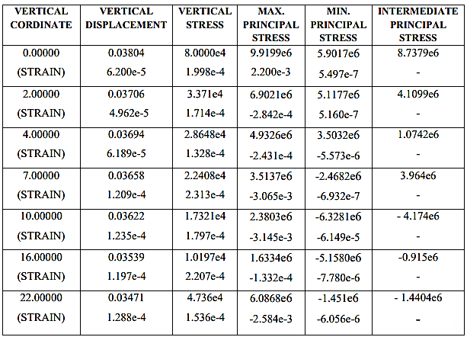

MODEL DEVELOPMENT IN ANSYS & RESULTS OBTAINED

ANSYS is one of the most used software for Finite Element Analysis work. All the engineering properties like Density, Young’s Modulus, Thickness, etc. is fed into the software and a model is developed for analyzing the distress. The material properties are discussed in Table 9 while the observed Results are discussed in Table 10..

Table 9: Material Properties for ANSYS Model

Sl. No | Layer | Depth of Layer  (mm) | Density of Layer  (g/cm³) | Young’s Modulus (MPa)
1 | Sub-Grade Soil | 500 | 1.33 | 62
2 | Granular Sub-Base | 200 | 1.44 | 500
3 | Base Course | 250 | 2.6 | 500
4 | Binder (W.M.M) | 60 | 2.2 | 1200
5 | Surface Course (Bituminous Concrete) | 40 | 2.243 | 2800
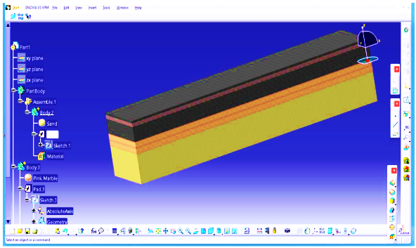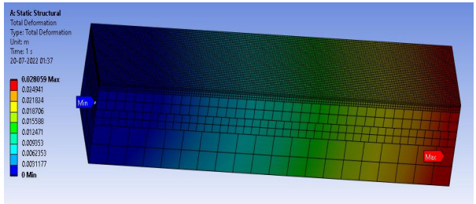
(a) (b)
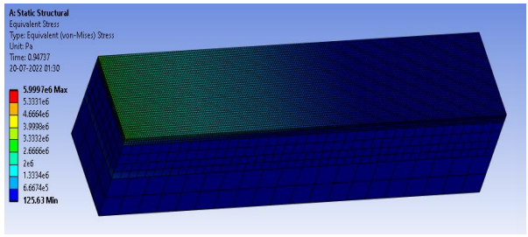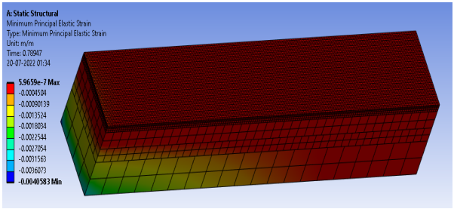
(c) (d)
Figure 3: (a) Model-I (b) Total Deformation (c) Equivalent Stress (d) Principal Strain
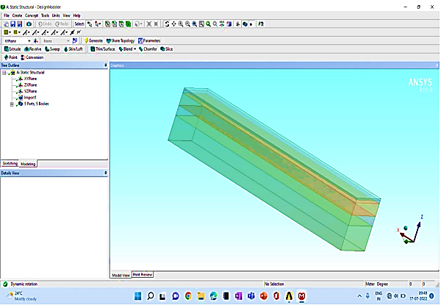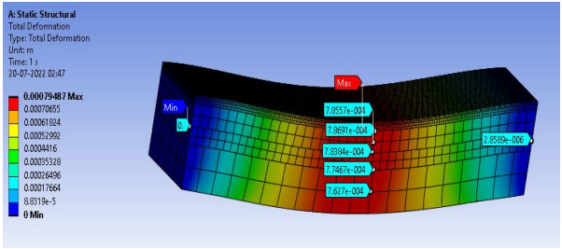
(a) (b)
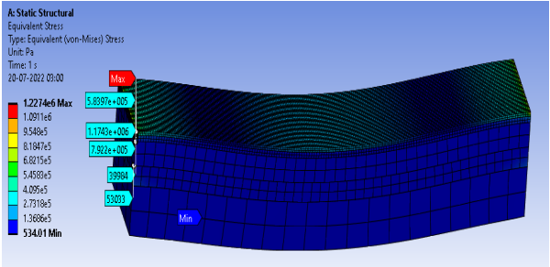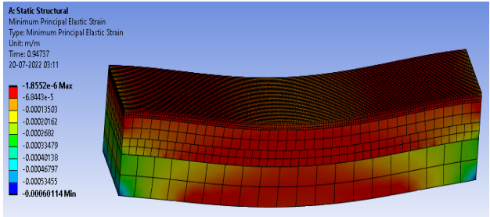
(c) (d)
Figure 4: (a) Model-II (b) Total Deformation (c) Equivalent Stress (d) Principal Strain

Table 10: Results Obtained from ANSYS

Sl.No | Property | Value for Model-I | Value for Model-II
1 | Total Maximum Deformation | 0.028059 mm | 0.00079487 mm
2 | Total Minimum Deformation | 0 mm | 0 mm
3 | Equivalent Maximum Stress | 5.9997×10⁶ MPa | 1.2274×10⁶ MPa
4 | Equivalent Minimum Stress | 125.63 MPa | 534.01 MPa
5 | Maximum Principal Stress | 7.9274×10⁶ MPa | 1.6226×10⁶ MPa
6 | Minimum Principal Stress | 1.479×10⁶ MPa | 3.0248×105 MPa
7 | Maximum Equivalent Strain | 0.0036308 | 0.00053856
8 | Minimum Equivalent Strain | 2.0477×10⁻⁶ | 1.8147×10⁻⁶
9 | Maximum Principal Strain | 0.0024038 | 0.00049183
10 | Minimum Principal Strain | 5.9659×10⁻⁷ | 1.8552×10⁻⁶

CONCLUSIONS
This research analyses and compares the Flexible Pavement of the Bangalore - Hyderabad National Highway in the state of Karnataka (NH7). In this study, strain and stress measurements were taken on the pavement using the software KENPAVE and ANSYS. Comparing the outcomes of Distress Model Analysis of Flexible Pavement using KENPAVE and ANSYS, the following comparison can be made:
1) Because both softwares are user-friendly, it is possible to anticipate the performance of flexible pavement more quickly and effectively.
2) Maximum principal stress variance is 22.32% and minimum principal stress variance is 1.19%, respectively.
3) Maximum principal strain variance is 19.66% and minimum principal strain variance is 8.16 percent, respectively.

REFERENCES

Hayder Kamil Shanbara, Ali Shubbar, Felicite Ruddock and William Atherton, “Impact of pavement roughness and suspension systems on vehicle dynamic loads on flexible pavements” (2021)

Monica Dhepe, Swapnil Joshi, “Rutting and Fatigue Analysis of Flexible Pavement” (2021)

Nitish R. Bastola, Mena I. Souliman, and Zabi Ahmed Mohammed, “Preliminary Finite Element Modeling of Asphalt Material Using ANSYS” (2020)

Yong Deng, Xue Luo, Yazhou Zhang, Robert L. Lytton, “Evaluation of flexible pavement deterioration conditions using deflection profiles under moving loads” (2020)

Shafabakhsh Gholamali, Naderpour Hosein and Motamedi Mana, “Optimal response modeling of Asphalt pavement using Finite Element Method” (2017)

M.S. Ranadive and Anand B. Tapase, “Parameter sensitive analysis of Flexible pavement” (2016)

Ankit Gupta and Abhinav Kumar, “Comparative structural analysis of Flexible pavements using Finite Element Method” (2014)

Isaac L. Howard and Kimberly A. Warren, “Finite Element Analysis of Instrumented Thin Flexible Pavement to Quantify Variability” (2011)

Daba S. Gedafa, “Performance Prediction and Maintenance of Flexible Pavement” (2007)

Beena Sukumaran, Michael Willis and Nishanth Chamala, “Three Dimensional Finite Element Modeling of Flexible Pavements” (2005)

R.M. Mulungye, P.M.O Owende and K. Mellon, “Analysis of Response of Flexible Pavements Using Finite Element Method” (2005)

