What? Why? When? Where? Who? Whom? How?

Answers to DIABETES
Sarah Lois J
Department of Microbiology
Shrimati Indira Gandhi College,
Tiruchirapalli, India,
sarahlois022000@gmail.com

ABSTRACT
Diabetes is a long-term (chronic) illness that affects how your body converts food into energy.The majority of the food you consume is converted by your body into sugar (glucose), which is then released into your circulation. Your pancreas releases insulin when your blood sugar levels rise. In order for blood sugar to enter your body's cells and be used as energy, insulin functions like a key. Diabetes is a slowly fatal disease for which there are no recognised cures. However, with the right knowledge and prompt treatment, its problems can be minimised. Heart attack, renal damage, and blindness are three serious side effects. For patients to prevent problems, it's critical to maintain careful control over their blood glucose levels.
KEY WORDS: Diabetes, chronic, insulin, blood sugar.

- What is DIABETES?
Diabetes, often known as Diabetes Mellitus, refers to a collection of metabolic illnesses in which a person has high blood glucose (blood sugar), either as a result of insufficient insulin production, improper cell response to insulin, or both. Patients with elevated blood sugar generally have polyuria (frequent urine), polydipsia (growing thirst) and polyphagia (increasing hunger).
Definition and History of Diabetes : Diabetes is a Greek word that translates to “symphon”. Diabainein is the name given to the ailment by the Greek Physician Aretus the Cappadocian in the second century AD. He compared people who had polyuria- the excessive passage of usine- to a siphon. The word “diabetes” was created when the English language adopted the Medieval Latin word for diabetes. Although it is frequently referred to as just “diabetes,” Thomas Willis added “mellitus” to the name in 1675. The Latin word ‘mel” means “honey’, and persons with diabetes have extra glucose in their urine and blood, which has honey-like sweetness. Diabetes mellitus means “symphoning off sweet water” in literal terms. People in Ancient China observed that ants would be attracted to some peoples’ urine, because it was sweet. “Sweet Urine Disease” was coined.

What are the types of Diabetes?

- Type I Diabetes:
It occurs when the body fails to produce insulin. This type sometimes referred to as “insulin-dependent diabetes”, juvenile diabtes or onset diabetes. Type I diabetes is usually diagnosed before the age of 40, usually in early adulthood or adolescence. Type I diabetes is far less common than type 2 diabetes. It accounts for approximately 10% of all diabetes cases.
Insulin will be required for patients with Type I diabetes. They will need injections for the rest of their lives. They must also guarantee maintaining healthy blood glucose levels by regular blood tests and eating a particular diet.
- Type 2 Diabetes:
Insufficient insulin production by the body, or an inability of body cells to respond to insulin (insulin resistance). Around 90% of diabetes cases are type 2 instances globally. By decreasing weight, maintaining a nutritious diet, getting enough of exercise, and keeping an eye on their blood glucose levels, some people may be able to manage the symptoms of type 2 diabetes. However, type 2 diabetes is normally a progressive illness that steadily worsens, therefore the patient will likely need to take insulin, commonly in the form of tablets.
Compared to those with a healthy body weight, those who are overweight or obese have a significantly increased chance of acquiring type 2 diabetes. Particularly at danger are those who have a lot of visceral fat, sometimes referred to as central obesity, belly fat, or abdominal obesity.The body releases substances when it is overweight or fat, which might disturb the metabolic and cardiovascular systems.
Being overweight, being physically inactive, and eating the incorrect foods all increase our chances of acquiring type 2 diabetes. The experts believe that the impact of sugary soft drinks on diabetes risk is more direct than merely an affect on body weight. As we age, our chances of having type 2 diabetes increase. Experts are unsure why, but believe that as we age, we tend to gain weight and become less physically active. People of Middle Eastern, African, or South Asian heritage, as well as those with a close family who has/had type 2 diabetes, are at a greater risk of having the condition. Low testosterone levels in men have been linked to an increased risk of developing Type 2 diabetes.

- Gestational diabetes:
This form affects pregnant women. Some women have extremely high blood glucose levels, and their systems are unable to create enough insulin to transfer all of the glucose into their cells, resulting in progressively rising glucose levels. During pregnancy, gestational diabetes is diagnosed. The majority of people with gestational diabetes may control their diabetes with exercise and nutrition. Between 10% and 20% of them will need to take blood-glucose-controlling medication. Undiagnosed or poorly managed gestational diabetes might increase the risk of problems during delivery.
- Why should we be concerned about diabetes?
Excess sugar consumption can lead to a variety of major health problems. As a consequence, managing this sickness will lower your health risks while also providing you with a variety of other key advantages. The following are the reasons of why you should be concerned about diabetes.
- Reduce Your Chances of Vision Loss
If you have uncontrolled diabetes for a long time, you are more likely to have eye issues. Diabetes, in particular, can damage the blood vessels in your retinas. This condition is known as diabetic retinopathy, and it can lead to blindness. In addition to this difficulty, diabetes can cause cataracts, glaucoma, and other vision problems.
- Reduce Your Dementia Risk
Uncontrolled diabetes increases your chances of acquiring dementia as you become older. Although scientists may not fully understand the relationship between diabetes and dementia, research shows that if blood sugar levels are not controlled, this risk may grow. As a result, if you keep your blood sugar under control, you may be able to enhance your chances of enjoying a greater quality of life in your older years.
- Enhance Your Overall Health
Uncontrolled diabetes can create a variety of annoying symptoms that will interfere with your everyday activities. For example, you may be always weary and need to use the restroom regularly. Furthermore, your wounds may heal slowly, and you may get recurrent bladder infections.
- Reduce Blood Sugar Levels
It's critical to keep your blood sugar levels within your doctor's suggested range. If your blood sugar level rises too high, you may become hyperglycemic. This condition can cause urinary difficulties, headaches, impaired vision, and other complications. You may get hypoglycemia if your blood sugar falls too low. This condition might make you unsteady, weary, and angry.
Controlling your diabetes is likely to boost your energy and alleviate your bladder issues. Fixing these symptoms will allow you to fulfill responsibilities at work and enjoy social occasions with friends and family.
- When to see a Doctor?

- Your blood-glucose level has been higher than 13.9mmol/l for more than 24 hours.
- Your ketone levels are high and have not decreased despite many hours of therapy.
- You're slimming down.
- You have diarrhoea or vomiting and are unable to hold any food down.
- You get stomach ache.
- Your breathing pattern has changed.
- You have a high fever that will not go away.
- You or a family member notices that you are disoriented or tired and that it is difficult to wake you up.
These are the symptoms of diabetic ketoacidosis, also known as hyperglycemic hyperosmolar condition (anextremely high blood-glucose level without the presence of ketones). If you are unable to reach your doctor and your condition is not improving, you may need to call an ambulance or have someone transport you to a hospital emergency department.
This is a medical emergency that is reasonably straightforward to treat in its early stages but becomes increasingly difficult to manage (and occasionally deadly) if not handled quickly.
Consult your doctor if:
- You're too unwell to monitor your blood sugar levels every 4 hours. Do not discontinue your insulin or medication.
- You discover a blister, sore, or other infection on your foot that is growing or appears infected.
- Your eyesight has changed.
- You begin to realise that, despite your best efforts, your blood glucose is out of control.
Symptoms to avoid at all costs
There are several indications of diabetes that you should never overlook. These are some examples:
Low blood sugar symptoms (hypoglycaemia)
- Dizziness, wooziness, confusion, or loss of awareness
- Words slurred.
Symptoms of High Blood Sugar (hyperglycaemia)
Consult your doctor if you are having any of the following symptoms:
- Urinating more often or in bigger quantities, particularly at night.
- Constantly thirsty.
- Feeling persistent and/or excessive weariness.

Thirsty
Change in vision
Urinating frequently
Sleepy
Fatigue
Confused
Difficulty in breathing
Abdominal pain & vomitting
Diarrhoea
Diarrhea

Consult a Doctor immediately if you have the following symptoms

- Where does Diabetes affect the body?

Diabetes has an impact on your heart and entire circulatory system. This applies to both the large and tiny blood arteries that supply your heart and brain with oxygen and nutrients, respectively, and the kidneys, eyes, and nerves.

High amounts of insulin and blood sugar (glucose) cause the initial harm. This causes a series of events that make your body work harder to lower elevated blood sugar levels. But persistent hyperglycemia will weaken those safeguards.

Diabetes alters how your muscles' blood arteries function. That may make your heart, which is a crucial muscle, weaker. Additionally, if your body has trouble using or absorbing glucose and other nutrients, your heart may have trouble getting enough energy. You may be at risk for developing heart failure, which occurs when the heart fails.

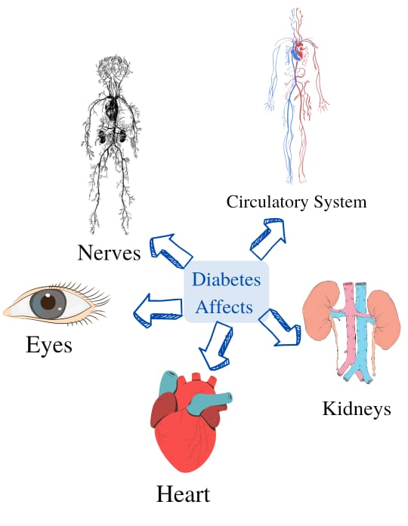

- Who are at higher risk for Diabetes?
Type 1
This kind often begins in infancy. Your pancreas ceases to produce insulin. You will have type 1 diabetes for the rest of your life. The primary causes are as follows:
- A family tree: Diabetes is more likely to affect you if you have relatives who have it. Anyone who has a type 1 diabetes mother, father, sister, or brother should be tested. It may be diagnosed with a simple blood test.
- Pancreatic disorders: They can reduce its capacity to produce insulin.
- Illness or infection : Some infections and diseases, most of which are uncommon, can harm your pancreas.
Type 2
If you have this kind, your body is unable to utilise the insulin it produces. This is known as insulin resistance. Type 2 diabetes mainly affects adults, although it can strike at any age. The primary causes are as follows:
- Obesity, often known as being overweight: According to research, this is the leading cause of type 2 diabetes. Because of the surge in childhood obesity in the United States, this kind is affecting an increasing number of teens.
- Glucose tolerance is impaired.
- Prediabetes is a milder type of diabetes. A simple blood test can be used to diagnose it. If you have it, you are more likely to develop type 2 diabetes.
- Insulin sensitivity.
- Type 2 diabetes frequently begins with insulin-resistant cells. That implies your pancreas must function.
- Ethnic origins: Diabetes affects Hispanic/Latino Americans, African-Americans, Native Americans, Asian-Americans, Pacific Islanders, and Alaska natives more frequently.
- Diabetes during pregnancy:You had gestational diabetes if you had diabetes while pregnant. This increases your risk of developing type 2 diabetes later in life.
- Sedentary way of life :You work out fewer than three times each week.
- A family tree: You have a diabetic parent or sibling.
- Polycystic ovarian syndrome (PCOS): Women suffering from polycystic ovarian syndrome (PCOS) are at a higher risk.
- Age: If you're over 45, overweight, or have diabetic symptoms, talk to your doctor about a simple screening test.
Gestational
About 4% of pregnancies in the US are affected by gestational diabetes. It is brought on by insufficient insulin or hormones produced by the placenta. The baby's high blood sugar is brought on by the mother's high blood sugar. If left unattended to, that may result in issues with growth and development. Obesity or being overweight are factors that might cause gestational diabetes. Gestational diabetes can result from excess weight.
- Intolerance to glucose: You are more likely to develop glucose intolerance or gestational diabetes again if you have done so in the past.
- Family background: You are more likely to develop gestational diabetes if a parent or sibling did.
- Age: Your chances of becoming pregnant increase as you become older.
- Ethnic heritage: Women who are not white are more likely to develop it.
WEIGHT

LIFESTYLE

DIET

AGE

DIABETES RISK FACTORS
INACTIVITY

FAMILY
HISTORY

- Whom to go to in order to manage Diabetes?

- Endocrinologist
While you will most likely begin your diabetes journey with a primary care physician, you may need to see an endocrinologist early on for a more exact diagnosis, or later if the illness advances. "The primary care practitioner handles the vast bulk of the initial diagnosis and management," Dungan explains. "There may be cases where the patient has an unknown form of diabetes or appears with severe results such as diabetic ketoacidosis (dangerously low insulin levels that lead the body to create ketones, acidic bodies that can be life-threatening) that necessitate hospitalisation. In such circumstances, the endocrinologist may be involved from the start."
Endocrinologists are experts in glands and hormones. Subspecialists in this profession may concentrate on treating diabetes or even a specific kind of diabetes, and their in-depth understanding of the condition and how it evolves over time can be crucial to providing patients with the best care possible.
"Dungan notes that "usually patients are referred to endocrinologists when they are failing initial medications from their primary care doctors. Unfortunately, there are not enough endocrinologists to care for all the diabetic patients. The endocrinologist often treats patients who are more complicated, use advanced technology like insulin pumps, or have more difficulties like hypoglycemia (low blood glucose), necessitate hospitalizations, or have issues with other end organs "such as heart or kidney illness.
Endocrinologists frequently become involved when there are one or more issues, especially if the blood sugar levels aren't under good control, according to Dungan. Endocrinologists frequently collaborate closely with a patient's primary care physician to assist organise all the necessary health maintenance procedures in these circumstances.

- Podiatrist
These foot specialists can assist diabetics in managing a frequent issue with their feet. Diabetic neuropathy is a disorder that affects how the nerves in the feet and lower legs interact with the brain, and it is more common in patients with poorly regulated blood sugar levels. This implies that you might not notice stepping on a piece of glass. High blood sugar levels make it less likely for an infection to heal correctly, and in severe situations, diabetics may need to have their toes, foot, or lower limbs amputated due to diabetic neuropathy. Regular visits to a podiatrist can assist in identifying issues early before a more serious infection develops and save you from having to undergo treatment for sores or ulcers.

- Nutritionist or Dietitian
You may need to work with a dietitian or nutritionist to ensure you're receiving the correct combination of nutrients while strictly controlling your blood sugar levels because controlling your diet is a crucial part of effectively treating diabetes.

- Ophthalmologist
For diabetics, eye care is essential because over time, high blood sugar levels can damage the retina and other fragile eye tissues. Visiting an ophthalmologist is a crucial part of keeping your eyesight, according to Dr. Stephanie Marioneaux, an ophthalmologist with a private practise in Chesapeake, Virginia, and a clinical spokesman for the American Academy of Ophthalmology.
When you are initially diagnosed with diabetes, you might be referred to an ophthalmologist for a baseline examination to check for holes or tears in the retina, a thin layer of light-sensitive cells at the back of the eyeball, which could be an indication of diabetic retinopathy or other complications of diabetes, according to Marioneaux. Another frequent consequence of diabetes that an ophthalmologist can operate on is detached retinas.

In addition, according to Marioneaux, "ophthalmologists are among the first people to detect diabetes in patients." An yearly visit to the eye doctor may uncover a suspicion of diabetes because they are trained to check for warning indicators of a disease. Your primary care physician or an endocrinologist will then further analyse this possibility.
- Nephrologist
The kidneys, two bean-shaped organs in the middle of the back that filter the blood of toxins, are cared for by nephrologists. A significant risk factor for kidney disease is diabetes. As part of routine lab work performed on diabetics, Dr. Maria Bermudez, a nephrologist at Geisinger in Danville, Pennsylvania, advises that "kidney function be checked regularly," as the kidneys are sensitive to changes in blood sugar levels and are likely to experience negative effects from diabetes as the disease progresses. You can be sent to a nephrologist for additional testing and treatment if signs of kidney disease are discovered.

- Cardiologist
Heart disease and diabetes frequently co-occur since they have so many risk factors in common. As a result, many diabetics wind up seeing a cardiologist, or heart specialist, at some time throughout their course of therapy. A cardiologist can offer advice on how to maintain the best possible heart health despite a diabetes diagnosis.

- Neurologist
People with diabetes are considerably more prone to get strokes, according to neurologist Dungan, and if one does occur, you'll probably need to work with a neurologist to treat the problem and avoid further strokes. Experts in nerves, neurologists may concentrate on the brain while others may concentrate on other parts of the nervous system in their professions. Peripheral neuropathy, another name for nerve damage to the limbs in diabetics, can also be managed with their aid. Research "suggests that up to half of persons with diabetes develop peripheral neuropathy," according to the National Institute of Diabetes and Digestive and Kidney Diseases. The NIDDK also reports that autonomic neuropathy, a form of nerve injury that affects the internal organs, affects roughly 30% of diabetics. A neurosurgeon can assist with the issues.
- Physiatrist
Physical medicine and rehabilitation doctors, often known as physiatrists, can assist diabetics who require rehabilitative therapy in regaining their health. This may be particularly crucial if the diabetic has to regain his or her ability to walk or speak after suffering a stroke. It could also be a crucial element of healing following surgery, such as following an amputation caused by diabetic neuropathy. After a traumatic event like surgery or a stroke, you may also work with a physical or occupational therapist to restore full function.
- Professionals in Mental Health, Pharmacists, and Other Clinicians
Over the course of your care, you may interact with a variety of different health care professionals in addition to the doctors who were mentioned above. Your medicines are filled by pharmacists, who also notify the team of any potentially harmful drug interactions. You can manage the psychological effects of living with a chronic disease with the aid of a social worker, psychologist, or psychiatrist. Along the road, you could also run into a ton of nurse practitioners and physician assistants who all provide their skills to keeping you well.
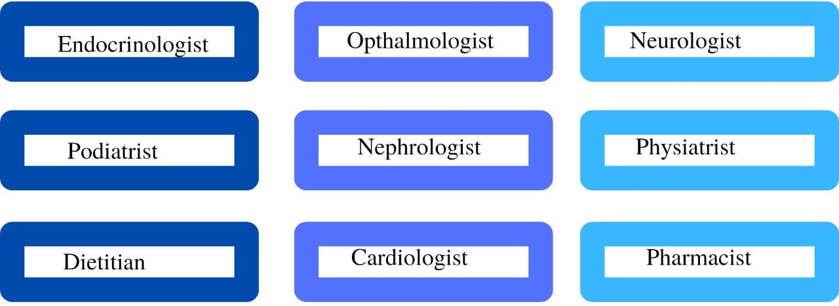
- How to control Diabetes?

- Exercise
Physical activity on a regular basis improves your mood. Additionally, it increases your body's sensitivity to insulin, which makes it more effective. Your blood sugar levels may become more steady as a result of this.
Additionally, exercise helps reduce tension.
Start slowly if you aren't currently active. Then gradually increase how much exercise you receive. Aim for 4 to 7 exercise times each week. Make every period at least 30 minutes long. Additionally, you don't have to exercise at a gym to be active. Alternatively, park at the far end of the lot or take the stairs instead of the elevator. Both increase your everyday workout.

- Well-Balanced Diet
Having diabetes shouldn't keep you from enjoying a bunch of different foods.
Try to fill half your plate with non-starchy vegetables such as:
- Asparagus
- Broccoli
- Carrot
- Cucumber
- Salad greens
- Squash
- Tomato
Also, make sure to get some of these:
- Beans
- Berries
- Citrus fruits
- Lean meat
- Low-fat or non-fat dairy products
- Nuts
- Poultry or fish
- Sweet potatoes
Protein may also be found in vegetarian foods like tofu.
Eat whole-grain meals only. If you consume cereal, be sure whole grain is listed first in the ingredient list.
Examples of whole grains include:
- Brown rice
- Bulgur (cracked wheat)
- Millet
- Popcorn
- Quinoa
- Sorghum
- Whole oats oatmeal
- Whole wheat
Try to appropriately space out your three daily meals. Aim to consume the same number of carbohydrates at each meal.
Food that has been less processed is often superior. Due to its lower glycemic index, it may not have as much of an impact on your blood sugar levels. For instance, quick oatmeal has a higher glycemic index than oatmeal made from whole oats.
You may be able to lose weight and improve your type 2 diabetes if you have the condition and maintain a good diet and exercise schedule. According to one research, long-term weight loss by diet and exercise may reduce your risk of dementia and stroke.

- Stress
Stress might cause people to exercise less, drink more, and pay less attention to their diabetes.Stress can increase blood sugar levels and reduce insulin sensitivity. Your body responds to stress by going into "fight or flight." This implies that it will ensure that you have access to adequate sugar and fat for energy.
Studies on patients with type 1 diabetes have shown that while under mental stress, blood sugar levels often rise for most people and fall for others. Your glucose will rise if you have type 2 diabetes and are under strain.
If anything bothers you, attempt to make adjustments that will make you feel more at ease. You may meditate, engage in physical activity, spend time with friends, or swap out bad ideas for constructive ones. Whatever suits you, do it.Additionally helpful are support groups, counselling, and therapy.
- Stop smoking
Break the habit. It will improve your control over your blood sugar levels.If you smoke, you are also more likely to have major health problems, as well as a higher risk of diabetic complications. Among these are:
- Heart and renal problems
- Infections, ulcers, and amputation of your toes or foot may result from poor blood supply to your legs and feet.
- Retinopathy is an eye illness that can lead to blindness.
- Peripheral neuropathy is caused by nerve injury in the arms and legs, resulting in weakness, numbness, discomfort, and impaired coordination.

- Alcohol consumption
Alcohol consumption might cause blood sugar levels to dip dangerously low if you use insulin or oral diabetic medications such sulfonylureas or meglitinides. When you drink, instead of controlling your blood sugar, your liver needs to struggle to eliminate the alcohol from your blood.
Dizziness, confusion, and tiredness can also be brought on by intoxication and low blood sugar. The signs of excessive alcohol consumption and low blood sugar may be confused. There shouldn't be more than one drink each day for women. The daily limit for males is two drinks. 12 ounces of beer, a 5-ounce glass of wine, or 1.5 ounces of alcoholic beverage, such as vodka, constitute one drink. Select calorie-free mixers for mixed beverages like club soda or diet soda.
Tips:
- Spend at least 30 minutes a day working out.
- Consume a diet high in vegetables, fruits, and whole grains that is low in fat and sugar.
- Maintain your desired weight by getting enough exercise and eating a balanced diet.
- At least once every year, check your blood cholesterol levels. LDL should be under 100, HDL (good cholesterol) should be over 60, and triglycerides should be below 150. Total cholesterol should be under 200.
- maintain blood pressure at 130/80 or less.
- Don't smoke
- Drink responsibly.
- Keeping up with your doctor regularly

References:
https://www.researchgate.net/publication/311562631_DIABETES_CAUSES_SYMPTOMS_AND_TREATMENTS#:~:text=Abstract,properly%20to%20insulin%2C%20or%20both.
https://southsidemedical.net/diabetes-management-why-is-it-important/
https://www.cdc.gov/diabetes/managing/managing-blood-sugar/bloodglucosemonitoring.html
https://www.news24.com/health24/medical/diabetes/overview/the-importance-of-managing-your-diabetes-new-article-20160315
https://medlineplus.gov/diabetestype2.html#:~:text=You%20are%20at%20higher%20risk,enough%20to%20be%20called%20diabetes
https://www.webmd.com/diabetes/default.html
https://www.researchgate.net/publication/270283336_Diabetes_mellitus#:~:text=%5E%22Diabetes%20Blue,March%202014

