Chapter No 4
Geo Materials and Geomorphic Processes
Geo- materials:- Rocks- Definition, Types of rocks-Igneous rocks, Metamorphic rocks, Sedimentary rocks, Rock formation processes, Economic importance of rocks.
Weathering – Definition, Types of weathering- Physical weathering, Chemical weathering, Biotic weathering, Geomorphic importance of weathering.
Mass Movement / Mass wasting –Definition, Classification of Mass movement- Vertical mass movement, Lateral mass movement, Diagonal mass movement. Landslides- Falls, Slides, Flow, Creep.
Cycle of Erosion (W.M. Davis and Penck)

Unit No : 1
ROCKS
The interior portion of the earth is very hot and it is found in molten state. But the outer layer of the earth is became cold and in solid state which is commonly known as crust or lithosphere. About 71% area of the lithosphere is covered by water bodies while remaining 29 % of the earth is covered by the land surface. The earth crust is consisting of about 98 chemical elements in which oxygen, silicon, aluminum, iron, calcium, potassium, magnesium, titanium, Phosphorus, hydrogen, sulphur, carbon are present in the lithosphere. These elements does not found in the elemental forms, but they mixes with each other and forming compounded substances with a definite chemical and physical characteristics. These substances are known as minerals. These minerals having a definite physical and chemical properties. There are about 2000 minerals found in the lithosphere and earth's crust and these minerals are found inorganic natural substances form. When these minerals are combined together in the crust, a new substance is formed and it is known as rocks. The average density of the rocks on the earth surface is 2.67 gm /${cm}^{3}$. It is in the organic or inorganic form and it is not having a fixed chemical formula .
Definitions
1) According the geological views any natural substance on the earth surface is known as rocks.
- A rock is an aggregate of minerals.
- A rock is composed of two or more minerals.
- The non metallic natural substance that form the earth's crust is known as rocks.

Mineral Composition in Rocks in Crust :
The most common chemical elements in the crust are oxygen (46.6%), silicon (27.7), aluminum (8.1), iron (5.0), calcium (3.6), potassium (2.8), sodium (2.6), and magnesium (2.1).
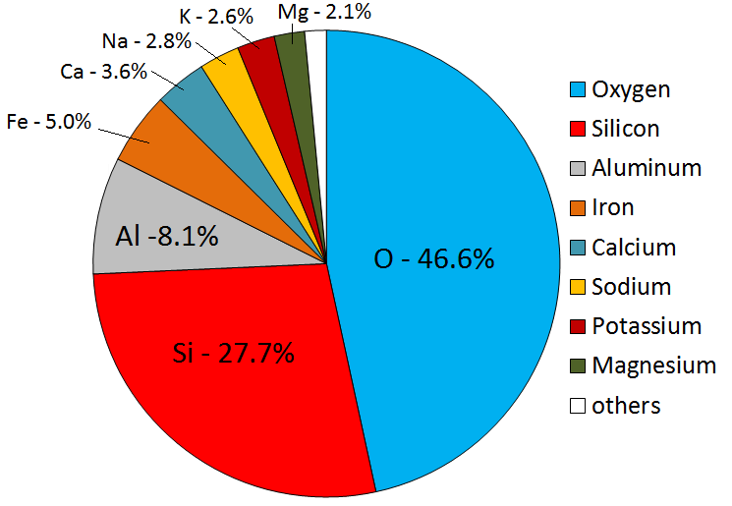

Classification of Rocks :
Moreover the study of rocks in geology is a separate branch which is known as petrology. Rocks are of various nature and characteristics. Some may be soft like shales and hard like granite. Some may be acidic or basic in nature and some may be organic or inorganic origin. The Rocks may be classified into different groups based on the different criteria. On the basis of mode of formation of rocks may be classified into following three groups i) igneous rocks ii) sedimentary rocks iii) metamorphic rocks

- IGNEOUS ROCKS:
The word igneous is derived from the Latin word ‘ignis’ which means fires. Thus the rock which is formed by cooling and solidifying of the molten material is known as igneous rocks . On the earth surface, initially these rocks are formed due to the cooling and solidification of molten material magma and lava and hence it is known as the primary rocks. Granite, basalt, gabbros are the typical examples of igneous rocks. In the cooling process of hot molten material and number of crystals are formed in the granite basalt and gabbro are the typical examples of igneous rocks. In the cooling process of hot molten material and number of crystals are formed in the igneous rocks. Magma is a very hot solution of silicates containing water and several gases . when this hot Magma reaches on the earth surface then it is known as Lava. Igneous rocks can be classified on the several basis like chemical composition, structure, situation and formation process but the most common classification is based on the place of their location and situation. It is extrusive igneous rocks and intrusive igneous rocks .
Classification of Igneous rocks on the basis of chemical or mineralogical parameters:
- Felsic igneous rocks : These rocks containing a high silica content, greater than 63%. SiO2.
- Intermediate igneous rocks : Intermediate igneous rocks containing between 52 – 63% SiO₂
- Mafic igneous rocks : These rocks have low silica 45 – 52% and typically high iron – magnesium content .
- Ultramafic rock igneous rocks : with less than 45% silica. (examples picrite, komatiite and peridotite).
- Alkalic igneous rocks : Alkalic igneous rocks with 5 – 15% alkali (K₂O + Na₂O) content or with a molar ratio of alkali to silica greater than 1:6.
- Chemical classification also extends to differentiating rocks which are chemically similar:
- Ultrapotassic; rocks containing molar K₂O/Na₂O >3
- Peralkaline; rocks containing molar (K₂O + Na₂O)/ Al₂O₃ >1
- Peraluminous; rocks containing molar (K₂O + Na₂O)/ Al₂O₃ <1
Classification of Igneous Rocks on the Basis of its stratification :
- Granitoid :- The crystal are irregular shaped and bigger in size.
- Aphanitic:- The micro grain sized crystals are present in that rock that can not be easily seen with necked eyes.
- Pigmatitic:-The regular shaped bigger grain sized igneous rock .
- Glossy:-The crystals looks glossy appearance .
- Porphyritic:- The irregular shaped bigger and smaller grain sized crystal rocks are porphyritic igneous rocks.
Classification of Igneous Rocks on the basis of silica content.
- Acidic typed Igneous Rocks :-
Whenever the proportion of Silica is more than the ferrous and magnesium content, then these type of rocks is known as acidic type of igneous rocks. The proportion of silica content is nearly 80 % and ferrous, magnesium and calcium carbonate content is 20 %. Due to the more proportion of silica content (sand particles) , the lava / magma became high viscous and that’s why it does not spread over apart distances from its eruption centre.These rocks are not easily eroded over a long period of time. For example, Mount Peele on Martinique island are formed from acidic type of igneous rocks in 1902.
- Basaltic typed Igneous Rocks :-
Whenever the proportion of Silica is less than the ferrous and magnesium content, then these type of rocks is known as basaltic type of igneous rocks. The proportion of silica content is only 20 % and ferrous content is 40%, magnesium content is 40%. Due to the less proportion of silica content (sand particles) , the lava / magma became low viscous and that’s why it spreads over apart long distances from its eruption centre. These rocks are easily eroded due to denudation and weathering processes on the earth surface. Deccan plateau is the best example of basaltic type of igneous rock.
Classification of Igneous rocks on the basis of its location and Situation:
There are two types of igneous rocks on the basis of its location and situation i.e. i) Extrusive and ii) Intrusive igneous rocks .
- Extrusive igneous rocks :
The rocks which is formed by cooling and solidification of lava on the earth surface is known as extrusive igneous rocks. These rocks are very fine grained due to the faster rate of cooling of lava which is directly exposed to the open atmospheric air, hence the crystals of these rocks are became very fine grained structure . Thus its appearance looks like shiny and smooth glossy. The typical examples of these rocks is found on Deccan Trap of peninsular India which is the result of 29 times spreading lava by fissure eruption since 70 million years ago. The black cotton soil is formed from these basaltic rocks due to the erosional and weathering processes on it and it is very useful for agricultural activities. Generally the basaltic materials/ rocks are used for building roads, building of houses.
2) Intrusive igneous rocks :
Intrusive igneous rocks are formed by cooling and solidifying of magma below the earth surface at various depth. The rate of cooling of magma is very very slow because this magma is not come closer to atmospheric air . So the course grained rocks are formed where it is rough and not smoothly appearance.

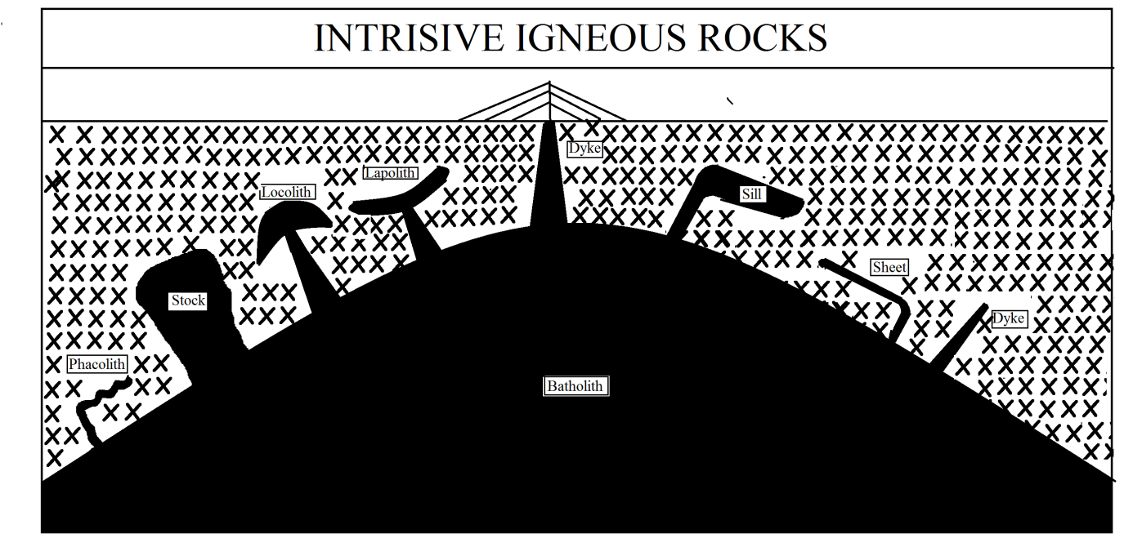

Gabro and Granite are the typical examples of those rocks . The granite rocks is found in different colours like pink, grey, white and red colours. It is found on the Deccan plateau in South India, especially in Madhya Pradesh, Chota Nagpur, Rajasthan and in parts of Himalayas. It is used largely as building stone and many ancient monuments like temples are made of granite rocks.
The intrusive igneous rocks are found in different shapes and sizes below the earth surface. Their nature, location and forms are determined by the intrusion of magma across the overlying rocks beneath the earth surface . The intruded magma cooled down and formed different igneous rock masses of different dimensions beneath the earth surface. Such rock bodies are known as igneous bodies. Intrusive rocks can also be classified according to the shape and size of the intrusive body and its relation to the other formations into which it intrudes. Typical intrusive formations are batholiths, stocks, laccoliths, sills and dikes.
- Batholiths:
Batholiths are large mass of intrusive igneous that forms from cooled magma deep in the earth crust. Batholiths are almost always made mostly of felsic or intermediate rock types, such as granite, quartz, monzonite, or diorite. For Example- The biggest batholiths rocks is founds in British Colombia of U.S.A. having a length of 2400 Km and width 160 meter wide.
- Stock:
Stock is a discordant igneous intrusion having a surface exposure of less than 100 km2, differing from batholiths only in being smaller. The term stock usually refers to individual, relatively small plutons (<20 km diameter). Most stocks are probably the cupolas of hidden batholith. Generally the relatively small sized of batholiths is known as stock.
- Lopoliths:
Lopoliths are a large igneous intrusion which is lenticular in shape with a depressed central region. Lopoliths are generally concordant with the intruded strata, with dike or funnel-shaped feeder bodies below the body. These rocks are formed in synclinal chamber of deformed and compressed soft rocks due to the upward movement of greater forced magma from magma chamber towards the earth surface which is cooled and solidified like saucer shaped. The term was first defined and used by Frank Fitch Grout during the early 1900s in describing the Duluth gabbro complex in northern Minnesota and adjacent Ontario. Lopoliths are huge in size; the Bushveld intrusive complex in South Africa, for example, has an area of about 66,000 square kilometres and an exposed thickness of 8 kilometres.
- Laccolith:
It is a sheet intrusion (or concordant pluton) that has been injected between two layers of sedimentary rock. The pressure of the magma is high enough that the overlying strata are forced upward, giving the laccolith a dome or mushroom-like form with a generally planar base. These rocks are formed in anticlinal chamber of deformed and compressed soft rocks due to the upward movement of greater forced magma from magma chamber towards the earth surface which is cooled and solidified like dome shaped.
- Phacolith:
These are pluton parallel to the bedding plane (or foliation) of folded country rock. More specifically, it is a typically lens-shaped pluton that occupies either the crest of an anticline or the trough of a syncline. The term was coined and initially defined by Alfred Harker in his The Natural History of Igneous Rocks in 1909. The intrusive igneous rocks which is deposited in bedding of soft rocks like wave form , then it is known as phacolith.
- Sills and Sheets :
These is a tabular sheet intrusion that has intruded between older layers of sedimentary rock, beds of volcanic lava or tuff, or along the direction of foliation in metamorphic rock. A sill is a concordant intrusive sheet, meaning that a sill does not cut across preexisting rock beds. Comparatively sills are thicker while sheets are thinner.
- Dikes:
These are discordant tabular plutons; they form from magma is cooled and solidified into vertical columns of sedimentary rock. Clive land dyke of North England is the good examples of dykes where the length of this dyke is 150 meters high.
Characteristics of Igneous Rocks
- Igneous rocks are massive, hard and compact in nature.
- These are crystalline rocks and its size of crystal depends upon the cooling rate of magma and lava.
- There is no any layer found in that rocks because these are formed from hot molten silicate materials.
- These are non-porous rocks and hence water can not be percolate through them.
- These are non fossil ferrous rocks because no remains of vegetables and animals found in those rocks due to very high temperature.
- These rocks are not easily eroded due to silica presence.
- They contain large varieties of minerals in abundance.
Economic Importance of Igneous Rocks
- Formation of Soil : Soil is an important aspect for agricultural development. Generally Clay particles are formed due to the weathering of igneous rocks, such as granite and basalt. The particles are so small that they can be easily carried long distances by water or the wind. A plain area have /had been formed with super fertility rate that benefits to agricultural activities. The basaltic rocks onto the Deccan trap of India have been converted into black cotton regur soil that benefits to agricultural practices in drought prone region also due to its more moisture holding capacity.
- Building Stone : An igneous rock provides a good source for building materials. The igneous rock is very tough and strong which is vital for infrastructure that would have to withstand the physical impacts of weathering. Granite is of a high density and is used for churches and historic building such as churches. The stone is also very cheap to purchase as there is no demand to the actual presence of the material and it is being made all the time. Marble is a type of igneous rock that is very perishable, though expensive. Igneous rocks are very heavy causing a problem in transportation. The rock is very acidic as well causing the surrounding area to loose vegetation etc.
- Tourism Industry : Many igneous rock hillocks attract tourist for seeing purpose. For Example Cascade range of California attracts the tourists from abroad.
- Formation of China Clay (Kaolin Soil) : Whenever these soil is fired , then its colour became white and it is used in for fine china, porcelain, tile, and electric insulators and in making paper.
- SEDIMENTARY ROCKS/ STRATIFIED ROCKS
Although $\frac{3}{4}$ th part of the earth surface is covered by sedimentary rocks, but its volume is about 5% to the total volume of rocks. Whenever the igneous /metamorphic rocks are exposed to open atmosphere, they are subjected to disintegration and decomposition of weathering processes. The weathered materials are removed by different agents of changes like river, glacier, wind, underground water, oceanic waves from their situation to another deposited places. The carried or transported material are of different sizes and dimensions are known as sediments. Hence this sediments are deposited at suitable places under water bodies. With the passage of time, due to continuous pressure of overlying water bodies and addition of sediment layers with adhesive particles of calcium carbonates, these sediments are converted into compact and relatively hard substances which is known as sedimentary rocks.
These rocks are formed onto water bodies like seas, oceans, lakes , ponds, river valleys, hence it is known as stratified rocks.
Classification of Sedimentary Rocks on the Basis of proportion of Particle Content :-
The sedimentary rocks can be classified into two types viz i) Arenaceous rocks and ii) Argillaceous rocks.
- Arenaceous Rocks :-
Whenever the proportion of sand particles or quartz is more than the silt and clay particles in sedimentary rocks, then it is known as Arenaceous rocks. Quartz is the main content of these rocks. The size of quartz particles are vary and these are cemented and to each other due to binding content. These rocks are comparatively hard for erosion and weathering processes. Conglomerate and Sandstone rocks are the best example of it.
- Argillaceous rocks :-
Whenever the proportion of clay particles is more than the silt and sand particles in sedimentary rocks, then it is known as Argillaceous rocks. These rocks are comparatively easy for erosion and weathering processes. Clayey rocks and Shale rocks are the best examples of it.
Alternatively, sedimentary rocks can be subdivided into compositional groups based on their mineralogy:
- Siliciclastic sedimentary rocks, are dominantly composed of silicate minerals. The sediment that makes up these rocks was transported as bed load, suspended load, or by sediment gravity flows. Siliciclastic sedimentary rocks are subdivided into conglomerates and breccias, sandstone, and mudrocks.
- Carbonate sedimentary rocks are composed of calcite (rhombohedral CaCO ₃), aragonite (orthorhombic CaCO₃), dolomite (CaMg(CO₃)₂), and other carbonate minerals based on the CO²⁻₃ ion. Common examples include limestone and the rock dolomite.
- Evaporite sedimentary rocks are composed of minerals formed from the evaporation of water. The most common evaporite minerals are carbonates (calcite and others based on CO²⁻₃), chlorides (halite and others built on Cl⁻), and sulfates (gypsum and others built on SO²⁻₄). Evaporite rocks commonly include abundant halite (rock salt), gypsum, and anhydrite.
- Organic-rich sedimentary rocks have significant amounts of organic material, generally in excess of 3% total organic carbon. Common examples include coal, oil shale as well as source rocks for oil and natural gas.
- Siliceous sedimentary rocks are almost entirely composed of silica (SiO₂), typically as chert, opal, chalcedony or other microcrystalline forms.
- Iron-rich sedimentary rocks are composed of >15% iron; the most common forms are banded iron formations and ironstones.
- Phosphatic sedimentary rocks are composed of phosphate minerals and contain more than 6.5% phosphorus; examples include deposits of phosphate nodules, bone beds, and phosphatic mudrocks.
Sedimentary Rocks classified on the Basis of their formation :-
- Organic Sedimentary Rocks :-
- Inorganic Sedimentary Rocks
Organic Sedimentary rocks :- These rocks have had been formed due to the compaction and cementation of decayed and decomposed of living organism (flora and fauna) in a suitable place with rock sediments.
Classification of Sedimentary rocks on the proportion of content:_
There are three types of organic sedimentary rocks :
- Calcarious Sedimentary Rocks :- Whenever the sedimentary rocks have had been formed by deposition of calcium carbonate derived from the skeletons and remains of animals and plants respectively. For example , the skeletons of coral polyps produce calcium carbonate. Lime stone is the best example of calcarious sedimentary rocks.
- Siliceous Rocks :- Whenever the sedimentary rocks have had been formed by deposition of silica derived from the skeletons of animals. For example , Sponges and Radiolaria leave behind silica from their skelton.
- Carbonaceous Rocks :- Whenever the sedimentary rocks have had been formed by deposition of carbon derived from behind plants. For example Coal and Peat are the carbonaceous rocks.
Inorganic Sedimentary Rocks :-
  - Whenever the sedimentary rocks have had been formed by deposition of different sizes of sediment particles derived by weathering and erosional processes on exposed rock surface by different changes of agent, without consisting organic fossils, then it is known as inorganic rocks.
These rocks are classified on the basis of diameter of the sediment particles like gravel, silt and clay proportions.
- Sandstone :- Whenever the sedimentary rocks have had been formed by sand particles having diameter 1mm , is known as sandstone rocks.
- Clay :- Whenever the sedimentary rocks have had been formed by clay particles having diameter less than 0.2 mm , is known as clayey rocks.
- Shale :- Whenever the sedimentary rocks have had been formed by silt particles having diameter 0.2 mm to 1mm , is known as shale rocks.
- Conglomerate :- Whenever the sedimentary rocks have had been formed by gravel sized particles having diameter 1mm to 32mm, then is known as conglomerate rocks.
Sedimentary Rocks classified on the Basis of their formation place,
- Marine Sedimentary Rocks :- Whenever the sedimentary rocks have had been formed onto the beds of seas or oceans by deposition of sediment particles brought by different changes of agent, is known as marine sedimentary rocks.
- Riverine Sedimentary Rocks :- Whenever the sedimentary rocks have had been formed onto the riverine beds and low laying area of basin by deposition of sediment particles brought by river, then is known as riverine sedimentary rocks.
- Lacustrine Sedimentary Rocks :- Whenever the sedimentary rocks have had been formed onto the beds of lakes or ponds by deposition of sediment particles brought by different changes of agent, then is known as lacustrine sedimentary rocks.
- Aeolian Sedimentary Rocks :- Whenever the sedimentary rocks have had been formed onto the desert regions by deposition of sediment particles brought by wind agent, then is known as marine sedimentary rocks. Loess is the best examples of it.
- Glacial Sedimentary Rocks :-Whenever the sedimentary rocks have had been formed onto the beds of glacier by deposition of sediment particles brought by glacier agent, is known as glacial sedimentary rocks.
Characteristics of Sedimentary Rocks
- Sedimentary rocks are layered or stratification in nature, therefore it is known as stratified rocks.
- These are non crystalline rocks. There is no any layer found in that rocks because these are formed from hot molten silicate materials.
- These are porous rocks and hence water can be easily percolate through them.
- These are fossil ferrous rocks due to the remains of vegetables and animals in compaction and cementation processes with sediments in waterbodies.
- These rocks are easily eroded by chemical weathering processes.
- Minerals are rarely found in such rocks. Coal and Petroleum solely concentrate in it.
Economic importance of Sedimentary Rocks :-
The minerals of economic values are less in these rocks. But these are the source of hematite iron ore, phosphates, various building stones, cola and petroleum deposits. A very rich fertile soil is formed in the river valley from these sedimentary rocks. For example, The Indo-Gangatic Plain of North India.
Most of the industrial and transportation activities completely depends upon on these power resources.
- METAMORPHIC ROCKS
The word metamorphic has been derived from the two words viz ‘meta’ means ‘change’ and while morphic means ‘shape’. The metamorphic rocks are altered form of igneous and sedimentary rocks. These are mainly three processes by which rocks are metamorphosed.
The first processes is thermal process in which the country rocks come into contact with ejected magma, and the country rocks are melted with excessive heat and after cooled down and solidified, its physical and chemical properties have had been altered.
The second process is related with the dynamic pressure changes inside the earth in mountain building processes or earth movement in which squeezed rocks changes its physical and chemical properties by tensional and compression forces.
The third process is a chemical solution processes in which different dissolving substances dissolved in underground water and its physical and chemical properties have had been changed.
Thus metamorphic rocks may be defined as one which has been formed by alteration of chemical and physical characteristics under the influence high temperature, high pressure and chemical solution.
Classification of Metamorphic Rocks :-
There are two types of metamorphic rocks on the basis of the factors and area involved in metamorphism of the rocks.
  - Contact and thermal Metamorphic rocks :-
  - Regional or dynamic metamorphic rocks :-
Contact and thermal Metamorphic rocks :-
During the volcanic eruption processes , whenever the upcoming magma is ejecting through vent, then country rocks come contact to hot magma and these are easily melted with changes its physical and chemical properties. Then, these rocks are cooled down , solidified and recrystallised and convert into hard and massive rocks. Such processes of metamorphism is known as contact and thermal metamorphic rocks.
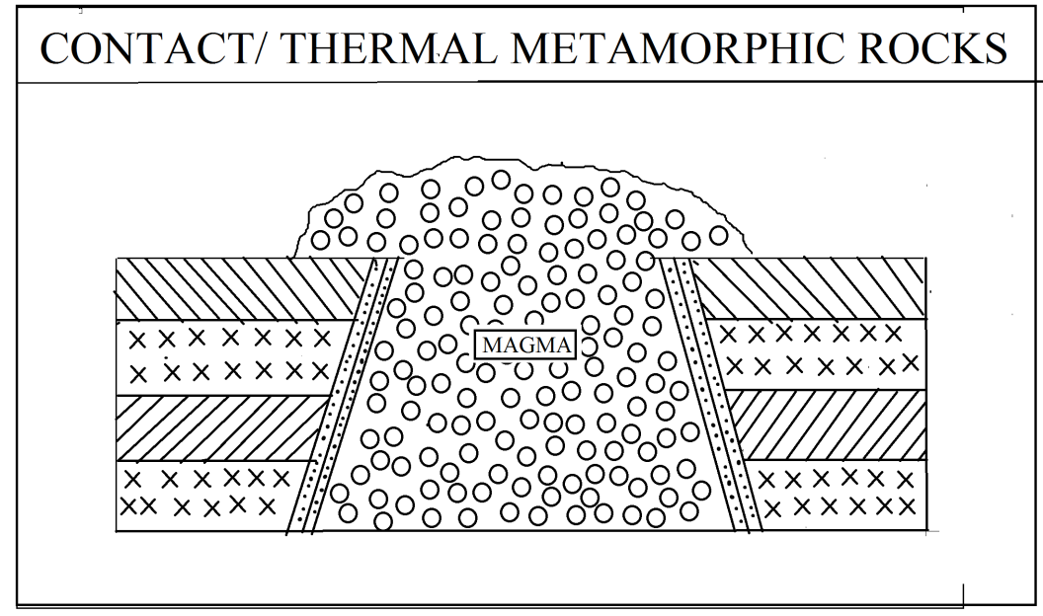

Regional or dynamic metamorphic rocks.
During the earth movement processes, the sedimentary rocks are folded up and down due to compressional forces. The downfolded rocks move down to a such depth where the high interior temperature melts it with changes its chemical and physical properties. Then, these rocks are cooled down , solidified and recrystallised and convert into hard and massive rocks. Such processes of metamorphism is limited and therefore it is known as regional or dynamic metamorphic rocks.
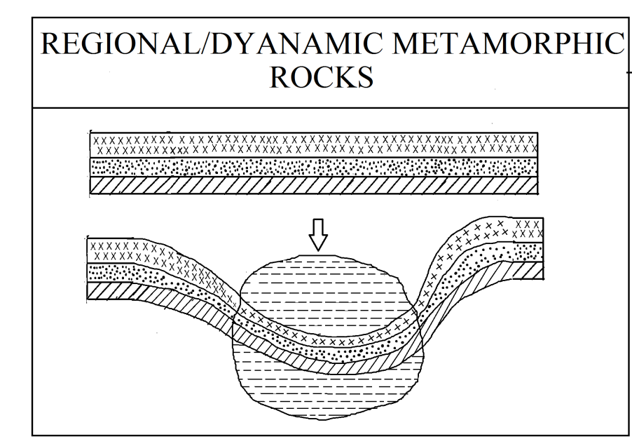

For example, Shale is converted into Schist and coal is converted into anthracite and anthracite into graphite.
Characteristics of Metamorphic Rocks
- Metamorphic rocks are massive, hard and compact in nature.
- These are crystalline rocks and its size of crystal depends upon the cooling rate of magma and lava.
- There is no any layer found in that rocks because these are formed from hot molten materials.
- These are non-porous rocks and hence water can not be percolate through them.
- These are non fossil ferrous rocks because no remains of vegetables and animals found in those rocks due to very high temperature.
- These rocks are not easily eroded due to silica presence.
- They contain large varieties of minerals in abundance.
Economic importance of Metamorphic Rocks :-
Metamorphic rocks contain important minerals such as gneiss, quartzite, anthracite , marble slate etc. They are used as building material and an industrial raw material and an industrial raw material. Quartzite is very hard rock and used in buiding , glass making. Marble is very fine stone used in building. The famous Taj-Mahal is made from pure white marble. Graphite is used for manufacturing processes.

Igneous Rocks | Metamorphic Rocks
Mica | Schist
Granite | Gniess
Basalt | Slate
Cynite | Cynite Geneisses
Sedimentary Rocks | Metamorphic Rocks
Limestone | Marble
Shale | Slate
Peat | Coal

Unit No 2
Weathering
Weathering :-
Naturally the surface of the earth is very irregular consisting of different kinds of landforms like mountains and plateaus and plains, rivers, lakes and so on. The contrasting landforms on the earth surface are directly or indirectly caused by endogenetic forces lying inside the earth crust simultaneously the external forces work on the earth surface with an object to remove the irregularities or roughness on the surface of earth. The important forces are rivers, glaciers, winds and sea waves and underground water that they are continuously involve themselves in cutting down the highlands and depositing the transported elements at lowlands with a final target of leveling of the ground. Thus the process which tend to bring the surface of land to a common level is known as process of gradation . The process of gradation involves two kinds of works i.e. degradation and up gradation. Degradation refers to the cutting down of highlands with a view to bring it at surface level it is also called as work of denudation while the upgradation means the deposition of eroded materials by the agent of denudation at low line area with a view to level up depression to common surface level. In addition it is the complete geomorphological process in which the removing of upheaval portions of the earth surface has/ had been takes place by the process of weathering , erosion, transportation and deposition with the help of weathered agents like running water, blowing wind, the sliding glacier and striking ocean waves.
Works of Denudation. :-
As the definition indicates under the work of denudation the rocks are broken up into smaller particles and broken fragmented are carried away from their original place to another . Thus the denudation works may consist of wearing and tearing of rocks and transportation of broken rock. The breaking of rocks takes place into two categories i) weathering and ii) erosion .
Weathering :-
- Weathering is the process of disintegration and decomposition of rocks on the earth surface by the agents of weather without any change in their position.
- Weathering is the mechanical fracturing and chemical decomposition of rocks in situation by the natural agents at the surface of the earth.
- The term weathering is applied to the process of rock disintegration and decomposition.
It appears from above this definition that weathering is essentially process to the breakdown of rocks due to the chemical and mechanical process at their original places. Weathering refers to the breakdown or disintegration and decomposition of rocks in situation through mechanical and chemical changes in the rocks and their minerals affected by water temperature, wind, different atmospheric gases and organisms provided that there is no large scale transport of weathered product by denudational process except mass moment of rocks waste down to the slope under the impact of gravity.

Controlling factor of Weathering :-
The nature and magnitude of weathering differs from place to place and region to region. Weathering of rocks is affected and controlled by the agents of weathering, lithological and structural characteristics of rocks, height and slope factors. Besides climatic conditions, topography and relief, flora and micro fauna also effect different process of weathering to greater extent.
- Composition and Structure of rocks :-
Since weathering involves disintegration and decomposition of rocks and hence mineral composition, joint patterns, layering systems, faulting and folding largely affect the nature and the intensity of weathering. e.g. carbonate rocks ${CaCO}_{3}$, ${MgCO}_{3}$ having more suitable soluble minerals are easily affected by chemical weathering. Well jointed rocks are more subjected to mechanical disintegration. Rocks having vertical strata are easily loosened and broken down due to temperature changes, frost action of water and wind action while the rocks having horizontal beads are more compact and the less affected by the mechanism of disintegration and decomposition.
- Nature of ground slope :-
The rocks in the regions of steep hill slope are easily disintegrated due to the mechanical weathering and the weathering materials are instantaneously nearly down the hill slopes in the form of rock fall and slides and talus, creep etc. Instantaneous the removal of weathering products allows continuous exposure of rocks to atmospheric conditions for further weathering. The regions of gentle and moderate ground slope are less affected by mechanical disintegration.
- Climatic variations :-
Each climatic type produces definite conditions for a particular type of weathering e.g. Chemical weathering is more dominant in humid tropical areas because of more available water and high temperature.. Mechanical weathering is less effective in that humid tropical area . This mechanical weathering is more dominant in the tropical and semi-arid region due to the abundance of high temperature. It may be pointed out that limestones are very weak rocks in humid climatic region but they are relatively more resistance to weathering and erosion in the hot climates. Mechanical and chemical weathering ceased (stopped) when the ground surface is covered by permanent ice covered. In monsoon climate, rocks are subjected to mechanical disintegration during hot and dry summer months where at chemical and biochemical weathering is more dominant during wet monsoon months.
- Floral effects :-
The nature of weathering is largely determined by the presence or absence of vegetation in a particular region. It may be pointed out that vegetation is partly a factor of weathering and partly a protected of rocks. In fact, vegetation bind the rocks through their network of roots and protect them from weathering and erosion but the same time the penetration of roots weakens the rock by breaking them into several blocks. Dense vegetation protect the ground surface from the direct impact of sun rays.

Types of weathering processes :-
Generally, weathering processes are conveniently divided into physical, chemical and biochemical processes but this are so inter-related that it is difficult to isolate one process from the another. It may be classified as below
- Physical and mechanical weathering agents :-
Insolation, Frost, Pressure release, Rainfall and Gravity
- Chemical weathering agents :- Oxygen , Carbon- dioxide, Hydrogen
- Biological weathering agents:- Vegetation and animal
These are three weathering processes on the basis of weathering agents as below
- Physical or Mechanical weathering :-
- Block disintegration due to the temperature
- granular disintegration due to the temperature
- block disintegration due to the frost
- Exfoliation and onion weathering due to temperature and wind.
- Chemical weathering :-
- Oxidation
- Carbonation
- Hydration
- Solution
- Hydrolysis
- Chelation
- Biotic weathering and biochemical weathering :-
- Plant weathering
- Animal weathering
- Bio chemical weathering
- Anthropogenic weathering
Physical weathering :-
- When the rocks are disintegrated due to some physical force without change of its chemical composition then this process is called as mechanical weathering or physical weathering.
- The physical weathering leads to fragmentation and breakdown of rock masses into big blocks and boulders and pebbles, gravels and silts and lastly clayey.
- Physical weathering may be defined as the disintegration of rocks due to temperature variation, frost action, wind actions and releasing pressure.
Types of Physical Weathering / Agents of Physical Weathering :-
- Block disintegration due to the temperature or insolation :-
Insolation is the main weathering agent in the hot climatic zone or arid or semi arid zone in the world which causes the block disintegration of rocks. Heat received from the sun is call the insolation. The heat received results in changes in temperature of these rocks. This effect of insolation on the exposed rocks like granite or crystalline rock is the best seems in hot deserts where the diurnal range of temperature is very high. The day times temperature suddenly increases whilst at night times temperature suddenly declines up to the freezing point. Thus the rocks are expanded in the day time and contract in the night time due to increase and decrease in temperature respectively. The rapid expansion and contraction of rocks leads to the cracks and joints in the rocks the rocks. The rocks splits often with a sharp sound like a shoot of gun. Thus the rocks are broken into big blocks. This process of weathering is known as block disintegration.
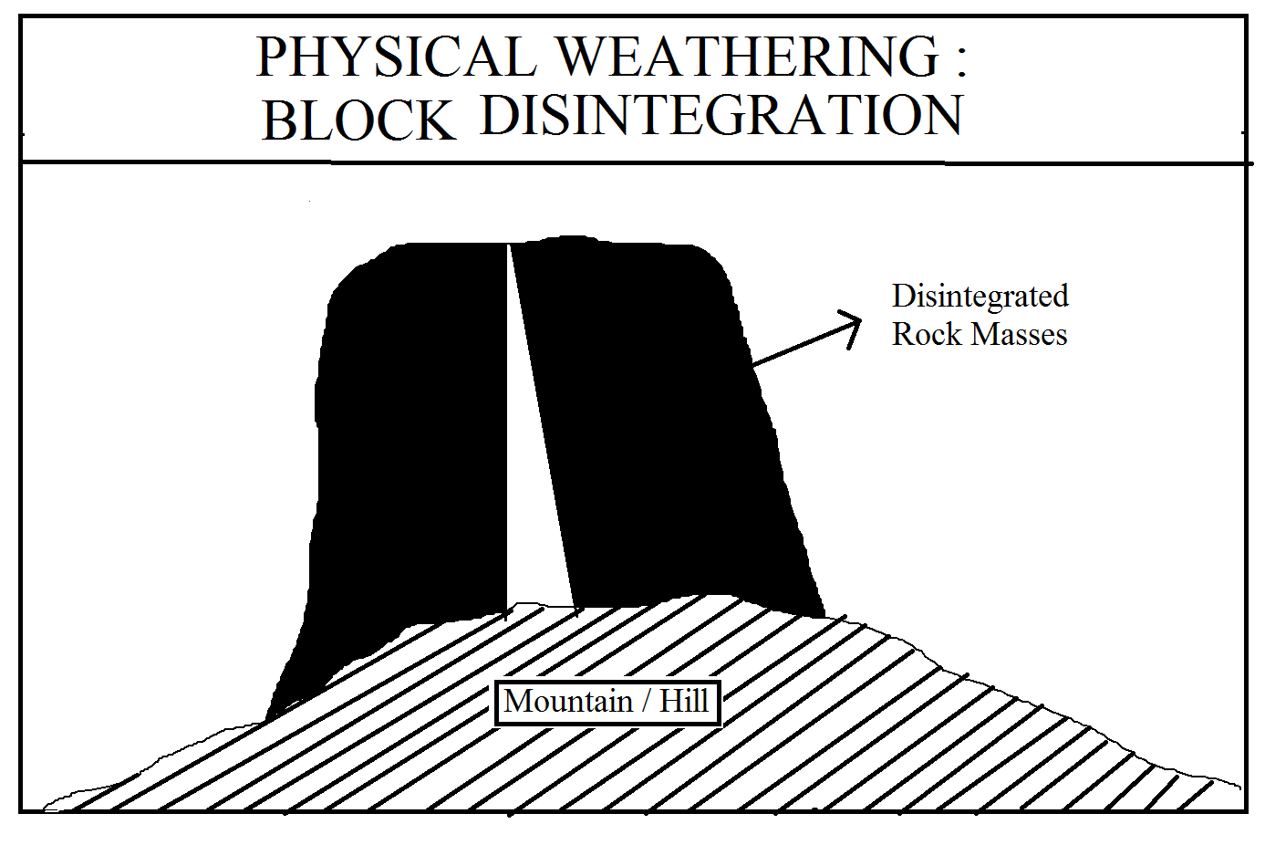
- Granular disintegration due to temperature changes :-
Insolation is the main weathering agents on the special course grained rocks which causes it to be in granular disintegration due to the temperature variation in the day and nights in the hot tropical or semi arid area. If the rocks are course grained and are of different colours, they observe insolation differently. The different parts of the same rocks mass receives and observe different amount of insolation consequently the different parts of the rocks are affected by differential expansion and contraction with cause stresses within the rocks due to which they disintegrated into smaller particles. Such type of shattering of rocks is called the granular disintegration.
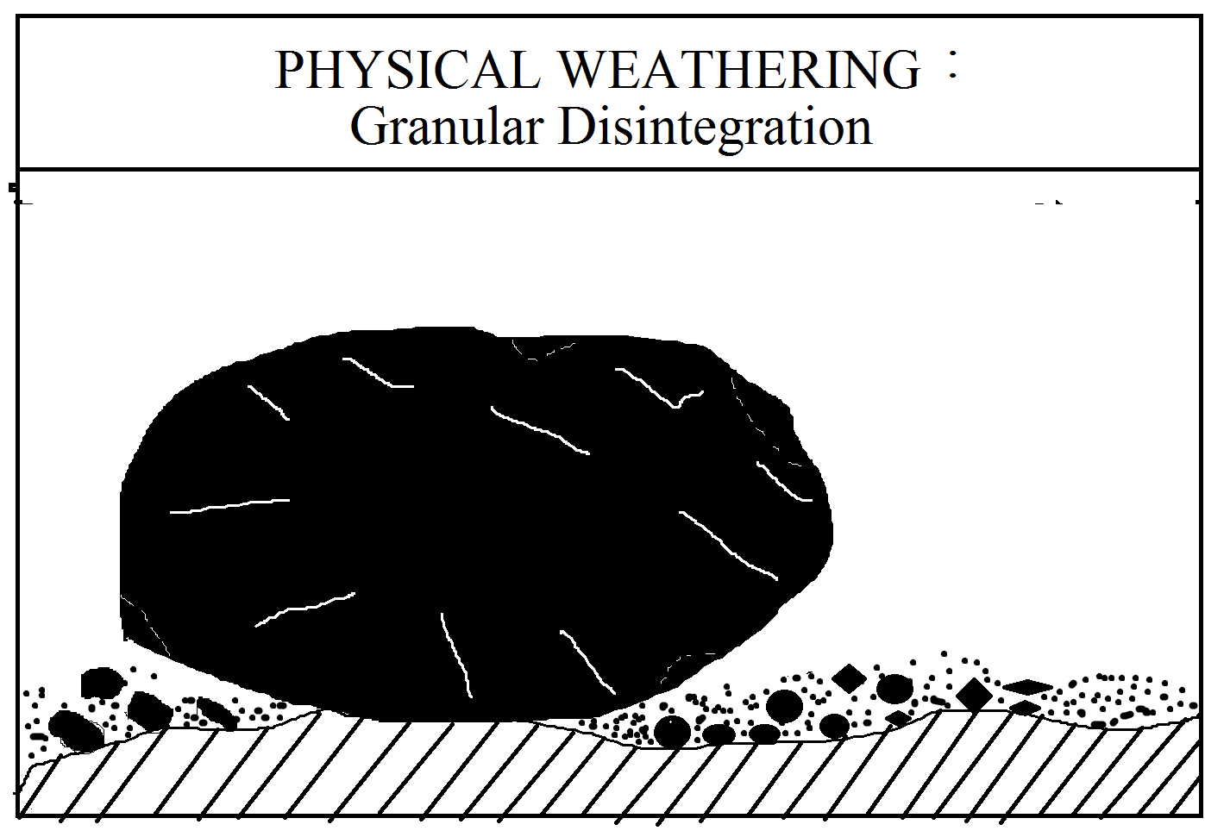
- Exfoliation and onion weathering due to temperature and wind :-
Exfoliation weathering are known as onion weathering refers to peeling of concentric shells of rocks due to combine the effect of heat and wind in hot arid and semi-arid regions and monsoon lands. The exfoliation is more common for the crystalline rocks in which the outer shells of rocks become loose due to alternative expansion and contraction due to high temperature during daytime and comparatively low temperature in night time and these loosened the shells are removed by strong winds. This process is known as exfoliation processes.
Some rocks are bad conductors of heat, their outer surface is heated quickly while the inner part still remains unaffected. The alternate expansion and contraction of outer rock layers being more than the inner ones, the outer layers are subsequently peeled off from the main mass of the rock in the form of concentric shells . This kind of weathering is known as exfoliation or onion weathering.
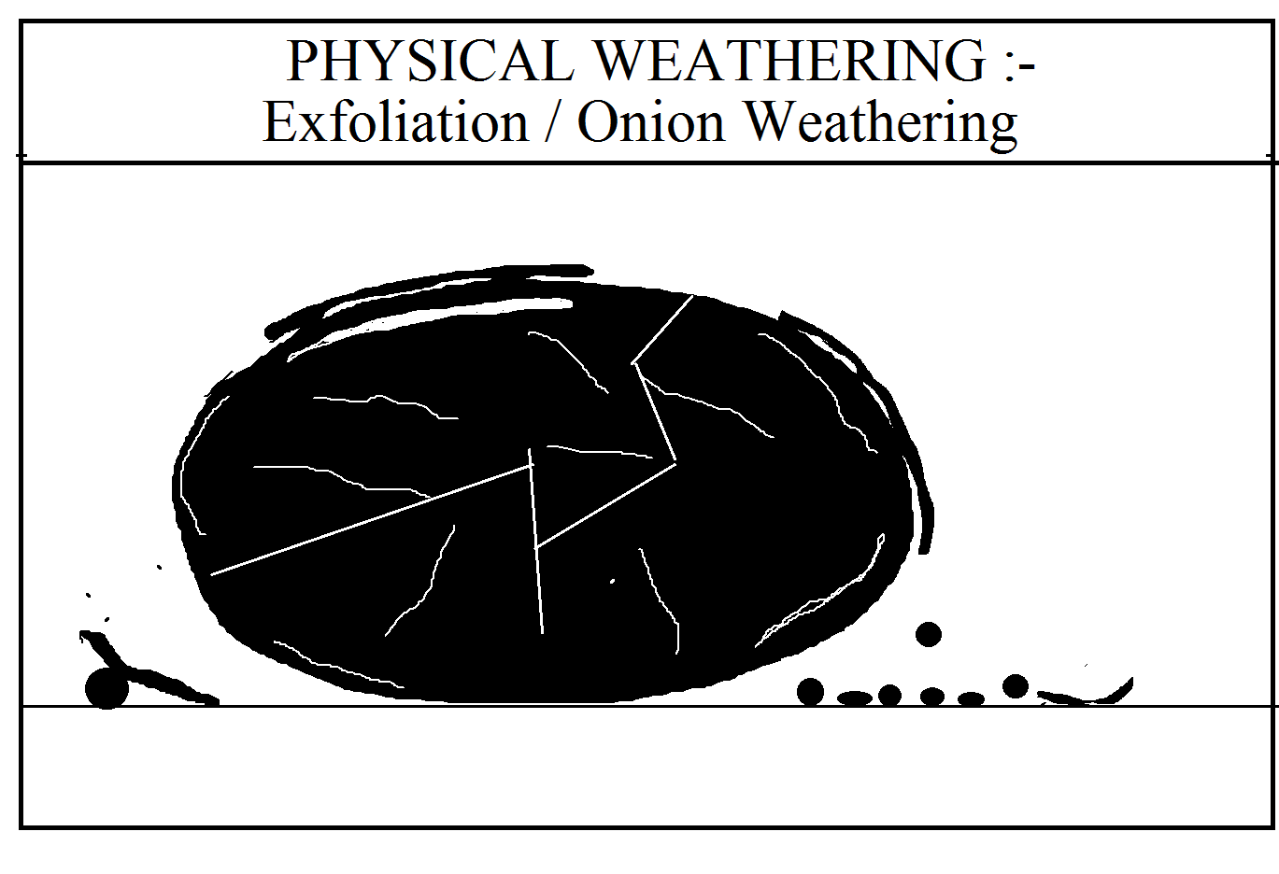
- Block disintegration due to the frost :-
Freezing of water and melting of ice in the pores or opening of rocks are important agents of weathering in cold region where the temperature reaches below the freezing point in the night and rises above the freezing point in the day time. Thus the water in the porous or fractures is frozen in the nighttime period and melted up in the daytime period. Consequently the volume of water increases in the night causing extra spaces on either sides of pores and fractures and in day time period , the volume of water decreases due to melting of frozen ice causing release of pressure exerted on both sides of pores. Thus the alternating process of increasing and decreasing of water volume leads to weakened the integral bond in crystals of rocks which may result in to the block disintegration of that rocks in the cold climatic region. This kind of process of block disintegration of rocks due to frost is known as frost weathering .
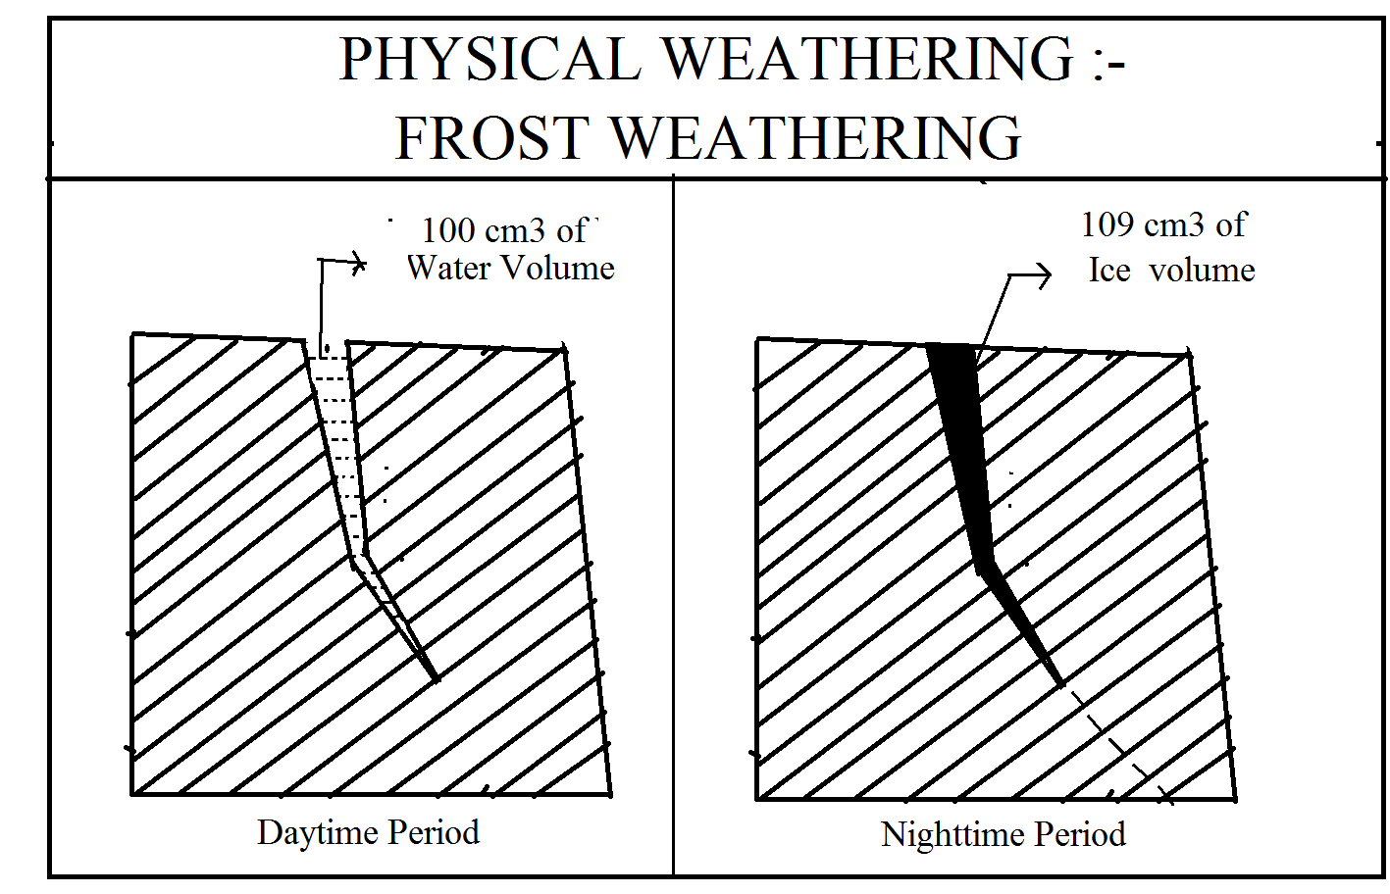
- Shattering due to rain shower and heat :-
The outer shell of the rocks is more heated in the daytime in the hot climatic zone. At that time, whenever sudden light showers and rainfall takes place on them, they may be develops cracks and fractures on hot rocks mass due to sudden cooling effect. This repetition of this process leads to the rocks into shattering and disintegration.
- Block disintegration due to the internal pressure release :-
Much of the rocks are formed deep into the interior of the earth under the combined influence of high pressure and temperature. When these rocks are come on the earth surface by any means, they are exposed to atmosphere whose pressure is more than the atmosphere. At that time the internal incumbent pressure inside the rock mass body to relieve from the rock mass body for equalizing purpose only. At that time, releasing of pressure , many number of cracks and fractures are developed in the rock mass this leads to block disintegration of rocks.

Chemical weathering :-
When the rocks are decomposed due to some chemical reaction without change of its physical structure is called the chemical weathering.
Decomposition and disintegration of rocks due to chemical reactions is called the chemical weathering where the minerals of the rocks weather away. Water vapour and water are the media which activate several types of chemical reactions within the rocks. Pure water is chemically inert but when it mixes with the atmospheric gases mainly weak carbon dioxide it becomes potent solvent. Oxidation, Carbonation, solution, hydration and hydrolysis, base exchange are the main important chemical reactions in the mineral of rocks which ultimately lead to decomposition and disintegration of rocks.
- Solution :-
Solution is considered to be the first step in the chemical decomposition and disintegration of rocks. Solution refers to the disolvation of soluble particles and minerals from the rocks with the help of water in motion but a thin film of water around a solid particle also leads to chemical dissolution. Solution of rocks depends upon the nature of rocks, solubility of rocks and the ratio between the volume of solvent (water) and the solids ( rocks) . Common salts are most soluble whereas carbonate rocks, limestone , calcium carbonate, dolomites, magnesium carbonate are the moderate solubility. When the rain water mixes with atmospheric carbon dioxide, it becomes active solvent and when it comes in contact with the carbonate rocks such as limestone and dolomite, it dissolves the rocks through a set of chemical reactions occurring through various stages.
- Oxidation :-
Water is a weak acid. It gets oxygen from the atmosphere, when the water combined with oxygen passes through the rocks bearing iron content and the oxides of iron is formed. When the water is mixed with oxygen, its reaction with the minerals of the rocks forms hydroxide. In other words, the atmospheric oxygen after reaching with the rocks produces several type of oxides, iron oxide being the most important which weakens the rocks to disintegrate. The process of weathering is called the oxidation. The original colour of the rocks is also changed into red, yellow and brown colour.
- Carbonation :-
Carbonation is the reaction of carbonate and bicarbonate ions with minerals. The process of carbonation is also known as solution where in atmospheric carbon dioxide after mixing with water forms carbonic acid which after reacting the carbonate rocks like limestone forms calcium bicarbonate which is easily dissolved in water. The carbonate rocks are to be disintegrate which is known as carbonation weathering. The weathering process is more active on the limestone, dolomite region who gives birth to Karst topography
- Hydration :-
The process of hydration is related to the addition of water to the minerals. Some rocks have the property of absorbing water from surroundings and these rocks are decomposed due to the hydration process because of absorbing water their volume may be increased and at that time, their strengthening bonds would be loosened which leads to the disintegrate. This process is known as hydration.
The process is found on aluminum bearing minerals because it keeps good capacity of absorbing water from the surroundings. The process of hydration changes feldspar minerals into Kaolinite clays , the process being known as Kaolinization.
- Hydrolysis :-
Hydrolysis is a chemical reaction between minerals and water i.e. between hydrogen ions (H +) and hydroxyl ions (OH-) and these ions of these minerals. In fact, the hydrolysis is that process where in both the minerals of the rocks and water molecules decompose and react in such a way that new mineral compounds are formed. Silicate materials are most affected by hydrolysis. Due to the hydrolysis process the silicate works like magnesium silicate minerals and potassium feldspar minerals are easily weakens and decomposed and weathering processes is being completes.
- Chelation : -
Chelation is a complex organic process by which metallic cations are incorporated into hydrocarbon molecules. In fact, the word ‘chelete’ means a co-ordination compound in which a central metallic iron is attached to an organic molecule at two or more positions. In other words, chelation means holding of an iron usually a metal within a ring of structure to organic origin. Generally chelation is a form of chemical weathering by plants. Plant extract some useful mineral nutrients from the soils with the result mineral latices are disrupted and crystal lattices are fragmented and thus mineral weathering takes place at a much faster rate. A dense forest region for agricultural practices of different crops are mostly affected by the chelation weathering processes.

Biotic weathering or biological weathering :-
When the rocks are disintegrated and decomposed due to the living organisms like animals, plants and man himself on the earth, then this process is called as biotic weathering.
Plants, animals including men are more responsible for the breakdown of rocks. It may be pointed out that in all type of weathering in all climatic regions, the biotic community is play some roles in one way or the other. It does not mean that all biotic community is always busy in destruction, work by this disintegrating and decomposing the rocks, but the borrowing animals definitely helps in the transfer of soils from lower to upper and upper to lower horizons and thus mixing of geomaterials activates weathering. Though the vegetation protects the rocks by binding them through the roots but different type of acid, bacteria acid microflora floral acids produced by them facilitated by chemical weathering. The biotic weathering may be divided into three types viz i)faunal weathering ii) floral weathering iii) anthropogenic weathering
- Faunal weathering :-
The borrowing animals, worms and other organisms help in gradual breakdown of rocks / fragmented thereof. The borrowing animals includes gophers, Prairie dogs, foxes, rabbits, jackals, termits, rats which dug out burrows and tunnel in the rocks and unconsolidated geomaterials as their living places. By doing so they disintegrate and decomposers rocks and new materials to great extent. Small organism play more important roles in the rocks and soils weathering. It is believed that there are about 150 thousand creatures, big and small, in one acre of land and this organism bring about 15 tons of soils at the surface from below every year. Termits play a very important role in sorting and rearranging the soil materials in the upper horizon of soil profiles in the tropical region. Worms consume large quantities of soil for the purpose of extracting food and in digestible particles are passed out at wormcaste. Rabbits and prairie dogs destroyed the soil structure and they obstruct the leaching and other horizon forming process by constantly remixing the soil materials.
- Floral weathering :-
Weathering of rocks by vegetation and plants takes place in two ways i.e. physical weathering and chemical weathering. It may be noted that floral weathering does not takes place independently rather it helps the physical and chemical processes of weathering. Larger plants effect and control weathering in a number of ways. i) cracks are widened by root pressure and consequent root pressure belts vegetation cover generates distinct microclimate at the ground level surface. The soil atmosphere is largely affected by root respiration, humus content, increased moisture due to the low rates of evaporation increases the content of organic carbon dioxide, low-temperature all of which activate chemical weathering.
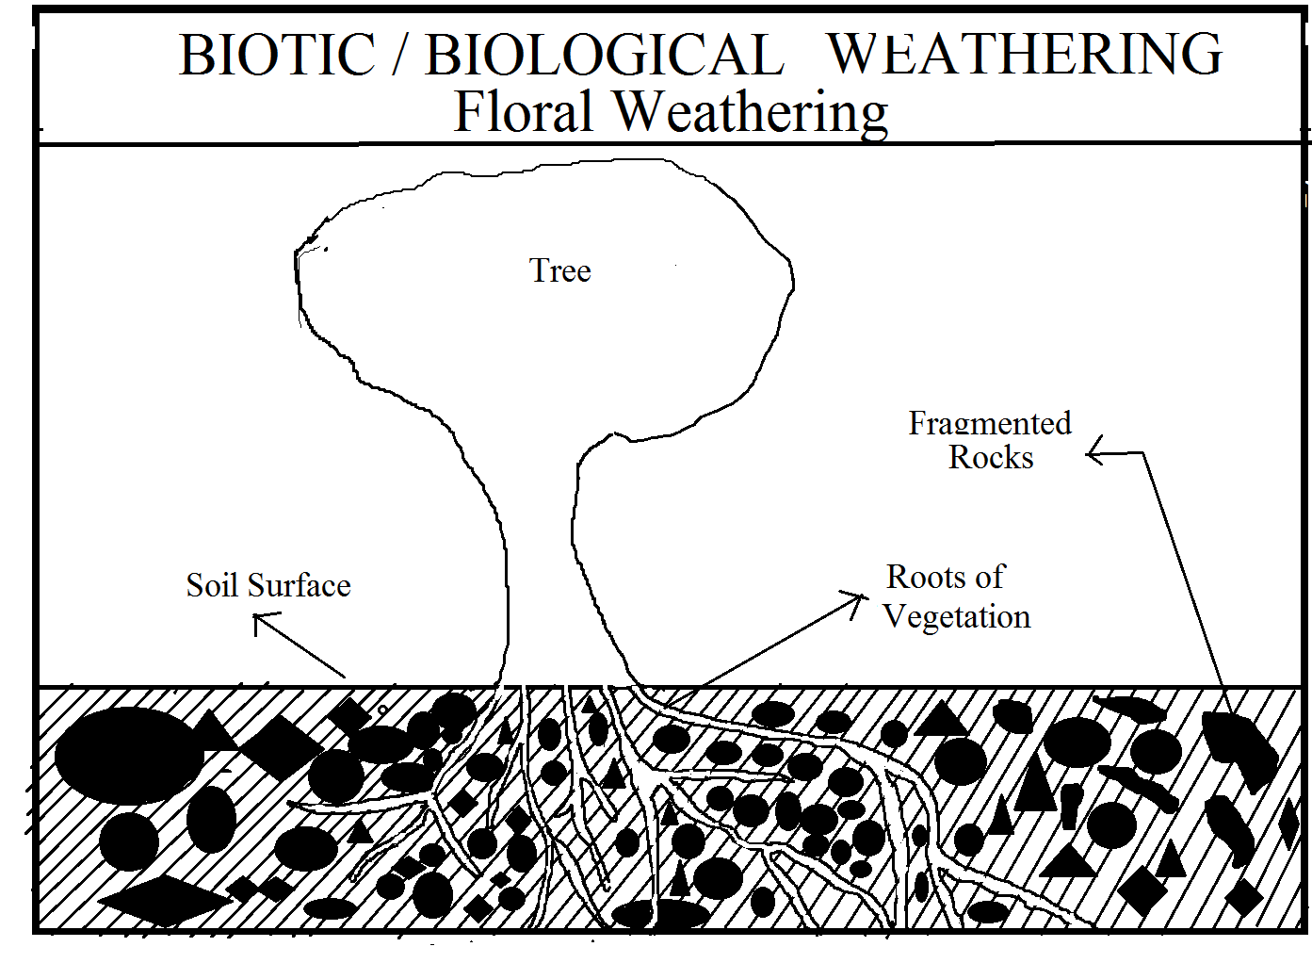
- Anthropogenic weathering :-
Man being a biological agent accelerates and decelerates the natural rates of weathering by many folds. The economic and technological man is most powerful agents of weathering and erosion. Mining activities, for extraction of minerals blasting of hills and ridges by dynamites for roads and dam construction and mineral extraction, quarring for industrial and building materials results in such faster rate of disintegration and geomaterials.

Differentiation in between mechanical and chemical weathering :-
Mechanical Weathering | Chemical Weathering
- Rocks are disintegrated by physical force. | - Rocks are decomposed by chemical action
- No chemical changes occurs in physical weathering | - Rocks undergo chemical changes without the use of physical force.
- It is more prominent in hot dry and tropical areas | - it is more prominent in humid climate regions.
- The main weathered agents are temperature, frost, pressure relief and rainfall | - Main weathered agents of atmospheric gases like oxygen carbon dioxide hydration and water.
- Water rocks are broken up to a greater depth. | - Only surfaces are affected.
- Even the hardest rocks are broken by mechanical weathering | - The resistance rocks are not easily eroded by the weathering

Geomorphic importance of weathering :-
- Production of Rock Wastes :
Rocks are disintegrated and decomposed and ultimately broken into smaller pieces due to operation of different weathering and biochemical weathering. The different weathering process produces immense volume of rock waste or weathered materials. The weathered materials are very important economically because they helped in the process of soil formation with distinct minerals which are useful for vegetation growth and some agricultural activities.
- Weathering helps erosional process :-
Weathering looses the rocks by disintegrating and decomposing them and thus opens the way of erosional process to operate easily. Different agents of erosion like running water in humid regions in the hot arid and semi-arid regions glaciers in cold regions and sea waves operating alone coastal zones obtained this weathered materials and more them to other places.
- Lowering the surfaces :-
Continuous removal and transfer of weathered material through different processes of mass location of rock wastes such as landslides , debris slides, rock fall, and by the agents of erosion causes gradual lowering of the height of the affected area.
- Evolution of Landforms and their modification :-
Differential weathering helps in the evolution of different types of landforms . Weathering plays an important role in the cdevelopment of stone lattice, driekanter, esker, moraines, U-shaped valley, V-shaped valley, delta, gorges, canyon, alluvial fans, arches, coves , sand dunes, loess plain and so on.

Unit No 3
MASS MOVEMENT (MASS WASTING)
The study of mass movement of rockwastes involves the analysis of meaning and concept, classification, causes, and geomorphic significance of mass movement or mass translocation of rockwastes.
Meaning and Concept
Disintegrated and fragmented rock materials due to mechanism of weathering processes (mechanical, chemical, biotic and biochemical) are called rockwastes. Generally, movement of rockwaste enblock down the hillslope is called mass movement of rockwaste or simply mass movement. 'Mass movement is the detachment and downslope transport of soil and rock material under the influence of gravity. The sliding or flowing of these materials is due to their position and to gravitational forces, but mass movement is accelerated by the presence of water, ice and air. The collective term for gravitational or downslope movements of weathered rock debris is masswasting. The term implies that gravity is the sole important force and that no transporting medium such as wind, flowing water, ice or molten lava is involved. Although flowing water is excluded from the process by definition, water nevertheless plays an important role in masswasting by over steepening slopes through surface erosion at their bases and by generating seepage forces through groundwater flow'.
The term mass movement is more sound and appropriate than mass wasting to describe enblock downslope transport of weathered materials ranging from very fine (soils) to very coarse and large sized rock materials (boulders). Mass wasting, also known as mass movement, is a general term for the movement of rock or soil down slopes under the force of gravity. It differs from other processes of erosion in that the debris transported by mass wasting is not entrained in a moving medium, such as water, wind, or ice. Subsidence is sometimes regarded as a form of mass wasting. A distinction is then made between mass wasting by subsidence, which involves little horizontal movement, and mass wasting by slope movement. Mass wasting occurs on both terrestrial and submarine slopes, and has been observed on Earth, Mars, Venus, Jupiter's moons Io, and on many other bodies in the Solar System.
It is, thus, evident that mass movement of rock wastes includes the mechanisms of detachment of rock materials through different weathering processes, and enblock downslope transport of weathered rock debris by gravity force without any medium of transport (e.g. running water, wind, sea waves, glacier etc.) except some lubricating role of water or ice. The rocks debris coming through mass movement are deposited at the foot-hill zone as scree or talus. The deposit of large boulders in conical shape is called talus cone. It is, thus, apparent that the most significant stimulating factor of mass movements is gravity force.

Classification of Mass Movements
A wide range of variations in terms of rate, direction and type of movements is noted in mass movements in different places having varying environmental conditions. It is generally believed that mass movement of rock wastes occurs suddenly and instantaneously and hence all mass movements cannot be witnessed by man. But in reality mass movements have long preparatory period and there are certain precursor events which herald the occurrence of mass movements but these are generally unnoticed. It may be mentioned that most of mass movements occur in mountainous areas and hence it is not possible to notice the precursor events such as restlessness of animals, deserting of hives by bees etc. Mass movements are generally classified on the basis of causative factors e.g. rate of movement, direction of movement, type of movement, lubricating substance e.g. water, ice etc.
Types of mass wasting include creep, solifluction, rockfalls, debris flows, and landslides, each with its own characteristic features, and taking place over timescales from seconds to hundreds of years. The direction of mass movement of rockwaste down the slope may be (i) vertical, (ii) lateral, and (iii) diagonal.
Based on direction mass movement may be divided into vertical movement, lateral movement and diagon movement of rockwaste.
- Vertical mass movement is further divided into (a) rockfall, (b) collapse (c) topple earthfall.
- Lateral mass movement includes (a) block slide, (b) spread, (c) cambering, (d) sackung etc.
- Diagonal mass movement is divided into (a) soil creep, (b) rockcreep, (c) talus creep, (d) rockslide, (e) debris slide, (f) slump, (g) debris flow, (h) mud flow, (i) solifluction, (j) avalanche etc.
. Classification of Mass Movement
1) Vertical movement
(A) Fall (of earth materials from very steep slopes like steep scarps and cliffs)
On the basis of materials
(a) rockfalls
(b) earthfalls (of alluvia, soils, colluvia)
(c) debrisfall (soils, alluvia, colluvia, vegetation and human structures)
(d) topple (rotational fall of rock slabs, or of earthen material)
(B) Subsidence (of the ground surface)
Sinking
(a) collapse (of roofs of underground caves or cavities or lava tubes)
(b) settlement (collapse of ground surface due to withdrawal of water, crude oil etc.)
2) Lateral movement
(A) Slides (movement of materials along a horizontal fracture or interface between two rock strata of varying resistance e.g. sandstones-shales or limestones-shales) (sliding)
(a) block slide (downslope movement of a single large block of massive rock on (bock glide) such a surface which has been lubricated by water)
(B) Spreading (lateral displacement of a series of rock blocks (multiple blocks) or mud block downslope)
(a) cambering (draping of sedimentary units)
(b) sackung (lateral spreading away from anticlinal crests)
3) Diagonal movement
(A) Creeping (downslope movement of earthen materials at slow velocity)
(a) soil creep (movement of moistened soils downslope)
(b) rock creep (movement of rock upon rock)
(c) talus creep (rearrangement of scree and downslope movement)
(B) Slide (rapid rate of downslope movement of large quantities of debris of varying sizes) (on the basis of materials)
(a) rock slides
(b) debris slides
(c) soil creep
(d) slumping (movement of fine materials along a curved plane)
(C) Flows (dominant role of water, downslope transport of water-soaked fine debris)
(a) earthflow
(b) slides
(c) mudflow
Rapid mass wasting events, such as landslides, can be deadly and destructive. More gradual mass wasting, such as soil creep, poses challenges to civil engineering, as creep can deform roadways and structures and break pipelines. Mitigation methods include slope stabilization, construction of walls, catchment dams, or other structures to contain rockfall or debris flows, afforestation, or improved drainage of source areas.
A) Landslides
It may be mentioned that generally all types of mass movements of rock wastes including soils and ice are collectively called as landslides which are variously classified on different bases i.e. direction of movement, type and rate of movement, nature of materials, presence or absence of lubricants etc. On an average, landslides (downslope movement of different types of debris enblock) are divided into five major categories e.g. fall, slide, topple, flows and lateral spreads. On the basis of nature of materials these are further subdivided into several types.
(1) Falls
Instantaneous fall of weathered rock materials including large blocks from steep hillslopes or earthen materials from steep and cliffed valleysides of streams under the influence of gravity is called fall. The size of rock fragments depends on the size and pattern of rock joints. This type of movement involves vertical displacement of materials without water. The velocity of fall is greatest of all other types of mass movement. According to A.L. Bloom, 'fall is a distinct landslide process, but it is rarely independent of subsequent events.' On the basis of materials fall is subdivided into rock fall, debris fall and earthfall.
Rock falls are relatively small landslides confined to the removal of individual and superficial blocks from a cliff base Rock fall is controlled by granular and block disintegration of rocks under the processes of mechanical weathering and limited action of oxidation in sandstones. The frequency of rock falls depends on certain environmental conditions such as aridity/humidity factor, lithological and structural characteristics of rocks, nature of slope and vegetation etc. In humid areas rock falls are very common features but in hot arid areas they are of very rare occurrence. Debris fall involves rapid rate of fall of weathered rock materials (which are finer than the materials involved in rock fall) downslope (it may be hillslope or steep valley side slope of streams) from great height. The fallen materials collect at the foot-hill or cliff base and form small mounds and ridges. Earthfall involves downslope movement of finer materials than debris fall.
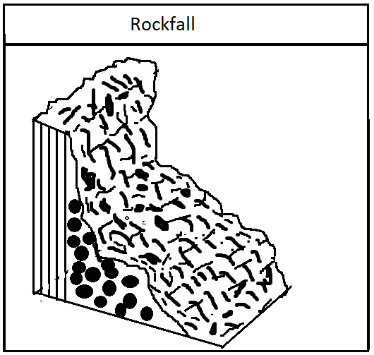
(2) Slides :- Slides, very often known as landslides among general public, are most significant of all types of mass movements. 'Mass-wasting wherein a mass of rock or weathered debris moves downhill along discrete shear surfaces is defined as a slide. It may be pointed out that slides involve downslope displacement of both types of materials-weathered rock materials and soils. Slides in rock or soil are characterized by movement above a sharply defined shear plane. Slides are promoted by a host of controlling variables such as nature of slopes (vertical and cliff slope is essential for slides), moderate lubrication by water, earth tremors, gravity, vertical and steeply inclined rock beds, base removal etc. Slides are more frequent in certain locations having favourable condition viz. (1) steep hillslope or steep valleysides of streams, (2) fault scarps, (3) rejuvenated fluvially eroded valleys, (4) sea coasts, (5) alluvial river valleys, (6) degraded hills and mountains (due to deforestation, road construction, settlement expansion etc.)
On the basis of nature of materials, direction and rate of movement (intensity) slides are divided into (1) slump (which is further divided into rock slump, debris slump and earth slump), (2) rock slides, (3) debris slide, and (4) earth slide.
(i) Slumping involves intermittent sliding of rock fragments, rock blocks or soils downslope along a curved plane caused by rotational movement and displaced blocks (whether rock blocks or soil blocks) cover very short distance. Slump is promoted by undercutting of slope base (with hillslope or valley side slope of streams) by streams, seawaves (in case of coast land) and by human activities (quarrying). In fact, 'slump is the form of slide most common in thick, homogeneous, cohesive materials such as clay. The surface of failure beneath a slump block is spoonshaped, concave upward or outward.
Slumping of alluvial deposits of valley sides of alluvial rivers of north India through undercutting of valley sides by hydraulic action of the steams during wet monsoon period is of common occurrence. Slumping is consuming a large chunk of rich agricultural lands every year along the Ganga aley in U.P. and Bihar. Based on the nature of meals involved slump is subdivided into rock slump, debris slump and earth slump.
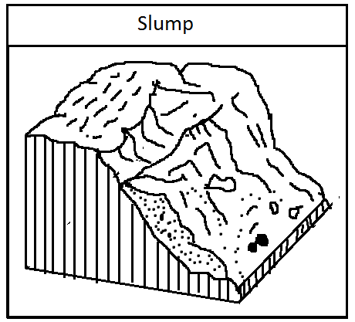
(ii) Rock slide (also known as rock glide or block glide) is most significant of all types of slides wherein large rock blocks slide down the hillslope. 'Rock slides may be very large and catastrophic in mountain regions where the large available relief permits accelerations of rock debris to velocities as great as those of rock falls and rock avalanches. Rock slides involve rapid movement of materials downslope. Some times, the velocity is so high and mass of materials is so enormous that 'rock slides can be dramatic forms of sliding masswasting if large masses of unweathered rock slide downhill along a sloping joint or a bedding surface' (A.L. Bloom, 1978). The Cross Ventre Slide of 1925 in Wyoming, USA and Turtle Mountain Slide of 1903 in Alberta, Canada, are typical examples of devastating landslides. The very massive landslides (rock slide), which occurred in the north-western side of Naini Lake (Nainital, Uttaranchal) in 1884, was so enormous that the debris filled a sizeable portion of the lake.
(iii) Debris slide is more extensive and occurs at larger scale than slump but there is little amount of water. Debris slide is promoted because of two basic factors-(1) saturation of rocks due to water, and (2) sudden downslope movement of unconsolidated mantle rock. The materials involved in debris slide is a mixture of soils and rock fragments (boulders). The debris collects at the foot-hill or the base of the valleys and forms interesting morphological features.

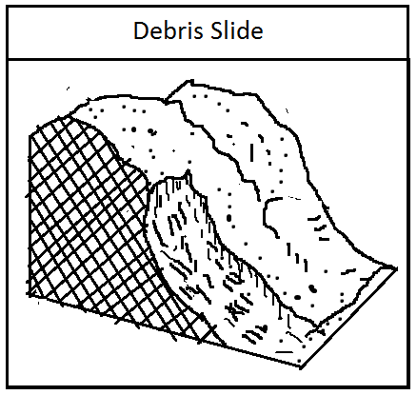
(3) Flow
Diagonal downslope movement of rock fragments and soils along sliding plane with enough water is called flow (which is further divided into solifluction, debris flow, mud flow, earthflow, rock avalanche etc.). Flow involves downslope rapid movement of rock debris or soils saturated with water like viscous fluid. 'Dry flows in sand or silt are known, but most flows are saturated with water. Rates of movement are greater than for creep but range from imperceptibly slow to tragically rapid mud flows and avalanches. Flows typically move as lobes or tounges' (A.L. Bloom, 1978).
(i) Debris flow involves downslope movement of enormous amount of viscous soils and boulders either separately or mixed together, and occurs mostly along river valley sides. The difference between debris flow, earth flow and mud flow is related to size of particles and amount of water. The size of particle decreases from debris flow to mudflow. The three terms form a series of progressively higher water content (i.e. water content increases from debris flow through earth flow to mud flow) but are often used interchangeably. Debris flows have 20-80 percent particles coarser than sand sizes, whereas earth flows and mud flows are 80 per cent or more mud and sand. Mud flow is the most liquid "end member" of the series . 'Debris flow occurs mostly due to availability of water, presence of loosely deposited soils and fine rock materials, lack of vegetation cover, clay minerals in the soils, unstable slope, undercutting of slope (valley sides) by streams, earth tremors etc.
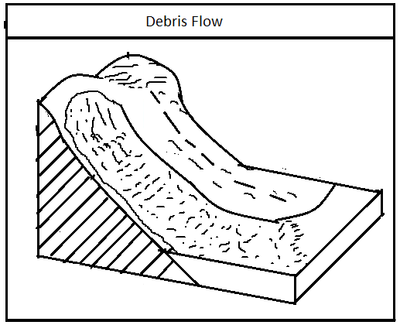
Debris flows range in size from a few meters to over 1000 meters in width and may be tens of meters thick in places; more commonly they are 1 to 5 m thick' . Debris flow is most common on gully heads in the riverine tracts of major alluvial rivers.
(ii) Earth flow is promoted by excessive water received mostly through rainfall so that the materials are oversaturated. Earth flow is more common on planar hillsides or valleysides having alluvium, rich in clay minerals.
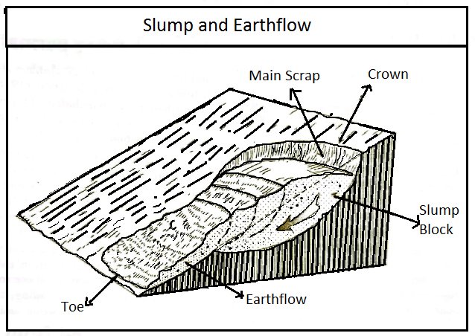
Debris flow of volcanic materials saturated with water on volcanic cones is called lahar. Heavy downpour mixing with falling volcanic dusts causes enormous mud flow as lahar on the steep slopes of volcanic cones which inflicts great damage to human health and wealth. For example, great lahar created on the steep slopes of Kelut Volcano in Japan in 1919 killed 5500 persons.
(iii) Mud flow differs from earth flow in that former may be noticed by the observer while the latter cannot be noticed because earth flow is not very common. The water content is more in mud flow than in debris flow and earth flow. Mud flow is most common along valleysides of alluvial rivers and the debris (mud) so produced is transported by the rivers. The necessary conditions which promote mud flow include (1) steep and vertical slope, (2) presence of unconsolidated materials on the upper surface so that these, when mixed with water, become viscous fluid and slippery, (3) intermittent supply of sufficient water as lubricant, and (4) absence of vegetation. Based on these factors it has divided mud flow into three categories on the basis of spatial characteristics e.g. (1) mud flow of arid regions, (2) Alpine mud flow, and (3) volcanic mud flow.
(4) Creep
Very slow and imperceptible downslope movement of materials (colluvium) is called creep. On the basis of materials involved in such movement creep is divided into (1) soil creep (fine weathered rock debris as well as soil) and (2) rock creep (unweathered joint blocks). It may be pointed out that the rate of movement of materials (colluvia) under creep is so slow (a few millimeters per year) that it becomes practically difficult for the observers to notice it.
(i)Soil creep is also called as solifluction which occurs in a variety of climatic conditions ranging from tropical humid to periglacial climates. The process of debris movement in periglacial regions has been variously defined and a number of terms have been suggested. First J.G. Anderson (1906) proposed the term solifluction (solum-soil, fluere-flow) for slow movement of debris, soaked with water, from higher to lower slopes.
Soil creep is a slow and long term mass movement. The combination of small movements of soil or rock in different directions over time is directed by gravity gradually downslope. The steeper the slope, the faster the creep.
(ii) Solifluction is a form of creep characteristics of arctic or alpine climates. It takes place in soil saturated with moisture that thaws during the summer months to creep downhill. It takes place on moderate slopes, relatively free of vegetation, that are underlain by permafrost and receive a constant supply of new debris by weathering. Solifluction affects the entire slope rather than being confined to channels and can produce terrace-like landforms or stone rivers
(iii) Rock creep involves downhill movement rock debris having relatively great depth (upto 300m) but the movements is very slow and ranges between one meter to ten meters per year. 'It is distinguished from soil creep by its great depth and isolation from daily and seasonal climatic conditions, and from land sliding by the lack of a single clearly defined failure plane and slow rate of deformation' (M.J. Selby, 1982). The following conditions promote rock creep- deformation of rocks through bending, folding, bulging, fracturing, spreading; distortion and buckling of inclined rock beds of varying resistance, mechanical disintegration of rocks etc.

Unit No 4
CYCLE OF EROSION
As discussed in the preceding chapters, the landforms on the earth surface have been evolved as the product of endogenic and exogenic forces of the earth movements. The diastrophism or internal forces led to the upheavals of low lands like ocean basin, or plain and subsequently, the external forces, i.e. forces of denudation become active with the objective of maintaining grading or levelling on the earth's surface. With the passage of time at slower or faster rates (depending upon the structure of the rocks) an uplifted land is transformed into a plain surface reaching at about sea level. This process produces, ultimately Peneplain. Thus the duration through which an elevated land is reduced to the sea level by river erosion is described as the cycle of the erosion. But this concept is rather more theoretical than practical. Endogenetic movement does not wait for the completion of the cycle but due to either falling of sea level or upheaval of river beds, rejuvenation of the river occurs. Restarting of erosion process again takes place.
The concept of cycle was first used by Hutton in 1785 in his work Cyclic Nature of the Earth's History. Subsequently, following Hutton concept and Charles Darwin's theory of evolution of organic species, an American geomorphologist W.M. Davis introduced the concept of geographical cycle of erosion in 1899. This concept of cycle of erosion became so pronounced that the American school of geomorphology was known as Davisian School of Geomorphology. His model of cycle was also applied in Karst geomorphology, aeolian geomorphology and coastal geomorphology. Later on he was criticized and during 1920s and 30s Walther Penck and his follower staged an opposition against to the Davis' cycle of erosion. He gave his own idea with reference to cycle of erosion. There are mainly two contrasting models of cycle of erosions in geomorphology.
(i) Davis, Model of Cycle of Erosion.
(ii) Penck's Model of Cycle of Erosion.
W.M. Davis' Concept of Cycle of Erosion
.William Moris Davis while presenting his cycle of erosion laid emphasis of the role of structure, process and stage in the formation of landscape. These three elements (structure, process and stage) are known as Trio of Davis'.
STRUCTURE
According to Thornbury, "Geological structure is a dominant factor in the evolution of landforms and is reflected in them". The term structure is not here applied in the narrow sense of such rock features as folds, faults, and unconformities but it includes all those ways in which the earth materials out of and earth' which landforms are carved differ from one another in their physical a chemical attributes. It includes such phenomena as rock attitudes; the faults and folds; rock massiveness; the physical hardness of the constituent mineral; the susceptibility of rocks; and various other ways by which the rocks of the e crust differ from one another. The term structure also has stratigraphic implications, and knowledge of the structure of a region implies an sequence, both in the outcrop and in the subsurface. A knowledge of geologic structure in the narrow sense thus become essential. Of appreciation rock In general, the structural features of rocks are much older than the geomorphic forms developed upon them. Such major structural features as folds and faults may go back to far distant periods of diastrophism. Even in areas of as Rechu diasotrophism as that of the Pleistacene it is different to find uneroded folds. Hence as a general principle, we may assume that most rock structures were established long before the landforms which exist upon them.
Sometimes the effects of structure on the landscape do not appear so prominently. It is not that the effects are not there but we may lack the ability to see them. The apparent lack of structural control of topography may simply indicate homogeneity of structure with the resultant homogeneity of topography or may result from the large scale of structural units. The variations in the rock structure lead to the variations of surface landforms.
PROCESS
The term 'process' applies to many physical and chemical ways by which earth's surface undergoes modification. Some processes, such as and vulcanism, originate from forces within earth's crust and are designated endogenetic, whereas others as weathering, mass-w as Ss-wasting, and erosion, result from external force and are known as exogenetic in nature. In general the endogenetic processes tend to build up or restore areas which have been worn down by the exogenetic processes. Otherwise, the earth's surface would even. tually became largely featureless. The concept of geomorphic processes operating upon the earth's crust is not new one. Even the ancients recognized it to some extent, but the idea that the individual processes leave their distinct marks on the surface is rather recent.
To a large degree the earth's surface possesses relief because the geomor. phic processes operate at differential rates. The geomorphic processes leave their distinctive imprint upon landforms, and each geomorphic process develops its own characteristic assemblage of landforms.
Landforms have their individual distinguishing features depending upon the geomorphic processes responsible for their development. Floodplains, alluvial fans and deltas are products of stream action; sink holes and caverns are produced by groundwater whereas drumlins, moraines , hanging valleys etc. show the work of glaciers.
The individual processes produce distinctive land features and make a genetic classification of landforms. The recognition of this fact and his existence upon was its superiority to other types of landscape description one of Davis's important contributions of geomorphology.
A proper appreciation of the significance of process in landform evolution not only gives a better picture of individual landforms develop but also emphasizes the genetic relationships of landform assemblages. Landforms are not haphazardly developed with respect to one another but certain forms may be expected to be associated with each other.
Although it is convenient in discussing the origin of the landform to consider each geomorphic process separately, most landscapes are products of a group of processes. The complex of geomorphic processes and agents which operates under a particular set of climatic conditions has been termed a morphogenetic system. STAGE
Stage is meant to indicate that the development of landforms by processes has proceeded to a given one of the characteristic point in the series of changes that must ensue between a beginning and an end condition. That landforms possess distinctive characteristics depending upon the stage of their development is an idea that W.M. Davis stressed most and out of it grew his concept of cycle of erosion and its stages of youth, maturity, and old age culminating in a topographic surface of low relief to which Davis assigned the name peneplain. Many geomorphologists believe that the stages of youth, maturity and old age as postulated by Davis have reality. As a gross generalisation the concept may be useful at the elementary level but it has some inadequacies when a more sophisticated approach to landform evolution is attempted. Whether there are distinctive and expectable characteristics at each stage of development is a point about which there is much debate. There has been doubts about the reality of the peneplain as an end produce of a cycle of erosion.

Concept : Cycle of Erosion
William Marris Davis was the first geomorphologist who evolved the concept of cycle of erosion in late 19th century. His first attempt was "complete cycle of river life (1889)" in which he sought progressive development of erosional steam valley and finally emphasised on the sequential development of landforms as a result of combined effect of endogenetic and exogenetic (Erosion) forces. In 1899 Davis propounded the concept of cycle of erosion taking guidance from the Darwin's model of evolution of organic life in which growth takes place in an irreversible sequence with the passage of time. He gave the dictum that "the landform is the product of structure, stage and process".
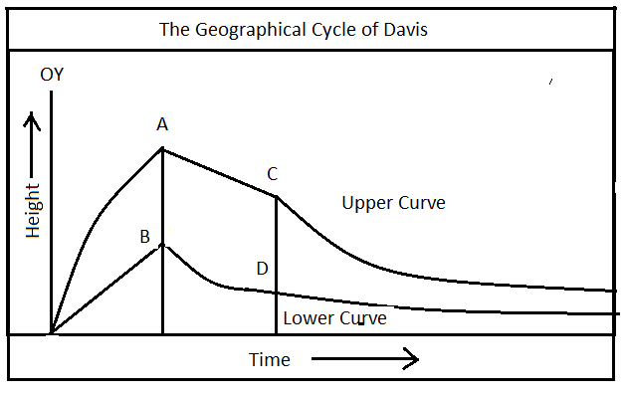
Assumption of the Concept
The Davisian model of cycle of erosion was built around four important assumptions.
The Davisian model of cycle of erosion was built around four important assumptions.
1) Landforms have been evolved through interaction between endogenetic force (diastrophism) and exogenetic forces (weathering and erosion).
2) Transformation of land forms takes place in sequential order through the various time spans, which Davis described as stage, from uplifted land to the featureless plain called as peneplain.
3) The upliftment of the land is fast and short-time phenomena. This upliftment is the source of potential energy for the river erosion. Each stage of cycle of erosion was associated with declining potential energy as uplifted land are worn down.
4) Erosion does not take place until the upliftment is completely stopped. In other words, upliftment and erosion do not occur simultaneously.
5) Cycle of erosion continues until the river gets its graded level, wherein, down cutting of the river is ceased. He incorporated the concept of graded condition which is first achieved near the mouth of river spreading headwards through drainage lines towards divide
Discussion
Under these assumptions he postulated the model with the statement that the cycle of erosion passes through three stages excluding the period of upliftment. These stages he described as youth, mature and old. The duration and length of time in which a particular set of assemblage of landforms occur depends upon the structure of the rocks and the agents of weathering and erosion (process).

Youth Stage
In Fig. 13.1, curve lines AC and BD show the line of water divide and river valley bottom respectively. In the initial stage (youth) following features are very common.
- Water divide crest is not eroded. Narrow deep river valley develops due to steep slope. So the difference between crest of water divide and valley floor increases up. This difference of altitude between these two is known as relief. Relief as well as absolute height (Height of crest of divide from S.L.) are high.
- Narrow and deep river valleys, known as gorge or canyon, are formed. Deepening of the valley is dominant activity.
- Lateral erosion is minimum. Headward or back-erosion led the narrowing of the water divide.
4) Waterfalls and rapids are formed when some resistance rocks come in the way of river valley. Formation of pot holes is also very common.
5) Erosion and transportation are dominated while the deposition begins to take place in late part of youth stage.
Mature Stage
Mature stage of river cycle begins with the descending of river from uplifted region to the plain areas. The gradient of slope falls to a considerable extent. The velocity and transportation capacity and subsequently deepening of valley are reduced. Following characteristics are associated with this stage.
1) In the beginning of this stage, maximum level of relief is found. After this, deepening of the valley is reduced and lateral erosion takes place.
2) As the velocity and transportation capacity fall down, the deposition starts along the side and enroute on the bottom of river valley.
3) At the foothill, coarse sediments like pebbles and gravels are deposited as alluvial fans or cones.
4) Lateral as well as headward erosion reduce the height and width of water divide and interfluves. Height of crest (absolute height) declines. Thus both absolute height and relief decrease as river moves down the sea.
5) Meandering of rivers, formation of oxbow lakes; incised meander, river terraces etc. are dominant geomorphological features.
6) Erosion and deposition are balanced.

Old Stage
Old stage of cycle of the erosion, begins with very gentle gradient of river valley. The river is graded and widened at maximum level. Braiding of the river and floodplain and levees formation are also very typical feature of this stage. Uplifted land is transformed to a plain with residual mondonock which is called as Peneplain. Delta is formed at the mouth of river. The absolute height and relative relief are completely reduced. Both curve converge at sea level. Erosion is ceased and deposition dominant.
Evaluation of Davis' Cycle of Erosion
Davis' Cycle of erosion is very simple to understand theoretically. He is the first who propounded this concept. His normal cycle of erosion was also applied in arid, glacial and karst geomorphological regions. But his model is criticized basically on the pre-youth stage of the cycles. Because upliftment of lands takes at slow rate and continues for long period. Different orgenies of the world indicated that they were completed during millions of the years. It is also questioned about the beginning of weathering and erosion. Process of denudation does not wait for the completion of the upliftment, but both go on side by side. Geomorphologists also have opposite views on the concept of completion of the cycle assumed by Davis. Endogenic movement or climatic change may take place during the period of cycle at any time and restarting of the cycle may occur before the completion of cycle. This process is caused due to rejuvenation of the river. Completion of cycle rarely occurs in the world.
Penck's Cycle of Erosion
Walther Penck, a German geomorphologist, who tried to explain the process of development of landforms in fluvial geomorphological region. He presented this model in his work Morphological Analysis for the expression of landscape development. Penck's model is thought as an opposite efforts against to the Davis model. So he arbitrately avoided the cycle term of Davis and used Entewickelung (Development).

Principle of the Theory or Concept
Penck developed his model of cycle of erosion on the basis of certain following principles or assumptions.
(i) Landform is an expression of mutual interaction between endogenetic and exogenetic movement of the earth.
(ii) Most of the tectonic movements begin and end slowly. The common pattern of such movement is slow; initial uplift, an accelerated uplift, a deceleration in uplift and finally quiescence.
(iii) An initial quescence surface (Primarrumpf) follows slow long duration upheaval and process of gradation is set immediately after little upheaval. In other words, upheaval and erosion occur simultaneously without any wait for the completion of upliftment.
Discussion
W. Penck described his model with the explanation that primarrumpf (initial featureless surface) is gradually uplifted and exposed to the process of denudation. With the passage of time, the uplifted primarrumpf, with the help of river erosion and weathering, is converted into a feature less plain associated with some residual monodnock (Peneplain). The whole process, through which a peneplain is formed, has passed through mainly three phases. These phases are described by him as Entwickelung (development). Thus his cycle of erosion includes Aufsteigende wickelung (increasing development of landform), Gleichfarming Entewickelung (uniform development of landform) and Absteigende Entwickelung (decelerating development of landforms)
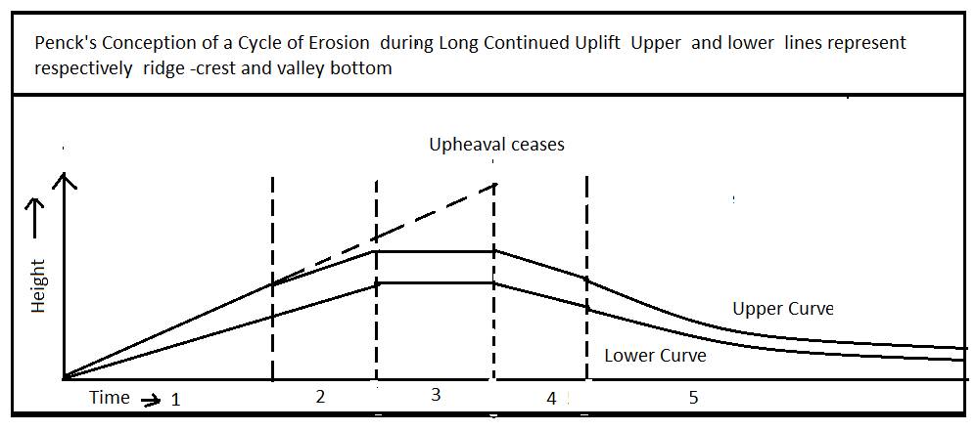
1) Aufseigende Wickelung (Waxing or Increasing Development of landform)
In this phase of cycle the primarrumpf remains featureless for some period when a slow long continuous upliftment occurs. As the rate of upliftment increases, the rivers begin to cut deep valleys through vertical incision and V-shaped valley is produced. Featureless primarrumpf is obliterated through the erosion. The crest of uplifted surface is not eroded now. Upliftment of both crest and valley bottom are continuously increasing up. The rate of upheaval is not balanced with incision of river valley. Consequently, the absolute height (height of crest of ridge) and relief (difference between altitude of water divide or crest of ridge and depth or river bottom) increase up in the stage of development of landform. The slope is convex because of extensive down cutting in valley bottom without any corresponding denudation on the upper slope (summit of the ridge).
2) Gleichfarmige Entwickelung (Uniform Development of landforms)
In this stage the curve of ridge summit and the bottom of river valley are arallel but they show different orientation or inclination in different parts of the stage. Development of landforms take place constantly at uniform rates, so it is described as the stage of uniform development of landform. It is divided into three phases depending on ratio between rate of upliftment and erosion taking place in this stage.
Phase-1: In this phase of uniform development there is an acceleration of upliftment but not at same rate as in waxing or previous stage. Both upliftments of summit and river bottom are at uniform rate. Rate of summit erosion and deepening of valley is similar to each other. Thus the valley sides are straight and relief remains constant. Absolute height still increases up.
Phase-2: In this phase, upliftment is still accelerated with reference to summit of divide and river valley bottom. Simultaneously, summit erosion and valley deepening are matched with the rate of upliftment. Further the rate of summit erosion and down cutting of valley is also at uniform rate. Consequently, the curves of summit and bottom or river valley are parallel as in Phase-I. Absolute height is maximum and relief is constant. The summit neither increases nor decreases as lowering of summit is offset by uplift.
Phase-3: This phase is marked by stopping of upheaval and lowering of summit and deepening of valley. Relief remains constant as in 1 and 2 phase because rate of summit erosion and valley deepending is uniform. But the absolute height declines due to lowering of summit by erosion and weathering.
3) Abstegende Entwickelung (Wanning development of Landforms)
After the complete end of upliftment, the summit or the ridge, continuously, is declining due to denudation process. But due to lowering of slope (crest), deepening of river valley is reduced. Lateral erosion becomes dominant. Consequently, both absolute height and relative relief are declined and the upper and lower curve come closer to each other toward downstream. On the basis of slope of river valley and crest (summit curve), the stage is divided in two parts. The upper part called bosche steilwand (Gravity slope) which is steep and maintain its angle by parallel retreat although the height is declining. The lower part is called as Haldenhang or wash slope which is very gentle with declining gradient. A very sharp break point occurs between them. This sharp break is also known as knick point. The wash slope is extended up at the expense of gravity slope. Gradually the crest of ridge is lowered to minimum level with presence of some inselberge of resistant rocks. River is completely graded and absolute height and relief reach at its minimum level. The whole landscape is transformed into a denuded plain which he called as a Endrumpf (Peneplain).
Evaluation of Penck's Model
Penck's Cycle of erosion became able to remove the many difficulties of Davis model with reference to especially rate and period of upliftment. He assumed a primarrumpf with long slow, continued upheavals. Erosion and upliftment simultaneously are the most important rational and reasoned elements of geomorphic cycle. His model is more practical than theory unlike Davis Model. However, Penck's emphasis is only on the development of slope in the evolution of landforms. He did not care about the structure of the rocks but assumed a certain relation between upheaval and erosion irrespective of any geological and lithological character. It is more complex to understand the whole process of development of landscape. It is developed with a view of undermine the Davis' model of erosion which is considered more simple and theoretical.

Questions
- Define Rocks and state its various types.
- What is a igneous rocks ? State its types with good examples.
- What is a metamorphic rocks ? State its types with good examples.
- What is a stratified rocks ? State its types with good examples.
- State the concept of weathering and state its controlling factor .
- Describe the physical weathering and state its various factors .
- Describe the chemical weathering and state its types with good examples
- Describe biotic weathering and state its types.
- State the concept of Mass Movement and classify it.
- Describe the W.M. Davis “Cycle of Erosion’
- Describe the Penck’s ‘ Cycle of Erosion Concept’
Short Notes
- Economic importance of Sedimentary rocks
- Economic importance of igneous rocks
- Economic importance of metamorphic rocks
- Types of intrusive igneous rocks
- Characteristics of igneous rocks
- Characteristics of metamorphic rocks
- Characteristics of sedimentary rocks
- Frost weathering
- Oxidation
- Chelation
- Anthropogenic weathering
- Distinguish between physical weathering and chemical weathering
- Vertical Mass Movement
- Lateral Mass Movement
- Debris flow
- Mud flow
- Elements of Cycle of Erosion
- Animal weathering

