Digital Twin in IoT Context insights
Ms.Sangeethapriya J, Assistant Professor, Department of Information Technology,
Saranathan College of Engineering, Tiruchirappalli, Tamilnadu, India.
Email id: jspriya-it@saranathan.ac.in

Abstract
Digital twin (DT) is a sophisticated technology that combines several engineering specialties. The industry is being revolutionized by the digital twin. The technology of digital twins will eventually allow for the digital replication of everything in the real world. The digital twin is a cutting-edge technology that has drawn a lot of interest. Many engineering researchers and participants are unsure about the best technologies and tools to utilize. To give technologies and different tools standard for the applications of the digital twin in the future, this literature review attempts to examine and describe the frequently used enabling technologies and tools by top Indian companies.
Keywords: Digital Twin, DT technologies, Five DT model, tools, Applications

- Introduction
As the top trend, digital twins [1, 4-6, 14] are described as having "an estimated 21 billion associated sensors and will continue to exist for billions of objects shortly." Before real devices are manufactured and deployed, simulations can be done on digital twins, which are virtual analogues of physical equipment. Additionally, digital twins can use AI and data analytics to enhance performance using real-time IoT data [8, 9]. IoT connects and gives intelligent access to physical things and sensor data. In short, a digital twin is a software program that accepts actual data about a physical thing or system as inputs and delivers projections or simulations of how those inputs will impact that physical object or system as outputs [14].
The main advantage of digital twins in IoT is that you don't have to connect to the asset to gather and transfer data. Instead, you may simply put programs in a safe sandbox in the cloud, which interacts with digital twins as if they were physically deployed IoT devices [4-6].

Due to the fact that the programs are only deployed in the cloud rather than on the asset, the sandbox method lowers security threats. Finally, development expenses are lowered, allowing IoT applications to be produced more quickly [5].
Smart Things like Sensors, Actuators
IoT Edge
Cloud System
Gateway
Digital Twin Environment

Figure 1 Digital Twin Environment Components
As a result, cloud-based digital twins have the potential to enable numerous new tasks and solutions. Figure 1 shows the Digital Twin (DT) Environment Components.
Gathered data from sensors, devices, and actuators are transferred through a gateway to IoT Edge. A gateway connects physical objects and the Digital Twin, allowing data pre-processing and filtering and transmitting commands from the Digital Twin to the Physical Object. Data Analytics employs Machine Learning Algorithms to provide Forecast, Behavioral, and Inferential analysis from data in a Data Warehouse [8,9].
- Twin Technologies
A Digital Twin application incorporates four technologies that enable the creation of a digital representation, the collection and storage of real-time data, and the provision of valuable insights based on the information gathered.
- Internet of Things (IoT)
- Extended Reality (XR)
- Cloud, and
- Artificial Intelligence
are examples of Digital Twin technologies [3,12]. Certain technology can be applied and shown in figure 2 to varying degrees based on application type.
Digital Twin
Internet of Things (IoT)
Extended Reality (XR)
Cloud
Artificial Intelligence (AI)

Figure 2 Enabling Technologies in Digital Twin

IoT is the prime technology utilized in all Digital Twin applications. The exchange of information across a system governs the flow of data generated by IoT. IoT enables Digital Twin applications to interconnect a virtual representation in real-time with a physical object, keeping it continually updated. This IoT technology comprises data collection technology and transmission technology ( Data Collection and Data Transmission).
The visualization technique that produces digital representations of items is known as Extended Reality (XR). Digital Twins with XR capabilities can digitally model actual things, allowing people to engage with digital material. XR integrates Visualization technology and fusion technology which are purely based on data fusion and data visualization.
Cloud computing allows you to store all of your data in a virtual cloud and simply access it from anywhere on the network. The essential process to be done by cloud computing depends on data storage and data processing i.e Storage technology and Processing technology.
Artificial intelligence (AI) is a sophisticated analytical technology capable of automatically analyzing data and providing significant insights. It may also predict future outcomes and provide recommendations on how to avoid such difficulties. AI comprises processing technology like data Analytics and Data Prediction.
Digital twin applications are numerous and are not limited to a particular industry or sector. They may be utilized in a variety of situations.

- Digital Twin Applications

Digital twins can be used to assess the entity's present state but, more crucially, to forecast future behavior, improve control, or enhance operation. So it is preferable in major domain applications. Few applications are discussed below and depicted in figure 3:

- Digital Twin in Manufacture Engineering

Future manufacturing and all types of industrial enterprises are primarily concerned with improving the manufacturing process and developing client interactions. These manufacturing organizations and consumers are interested in the process of product customization. Twin Create Customisation, which allows to digitally design and re-design things before generating a tangible product that fully meets the needs of the user [5, 7].

- Digital Twin in Vehicle Engineering

The most visible applications of Digital Twin technology are weight monitoring, airplane tracking, precise weather forecasting, and automotive flaw identification. It may measure certain patterns and functional information about the vehicle to help improve its performance [2].

- Twin in Health Sector
Digital Twin were originally employed in the healthcare environment for Biomedical device predictive maintenance and performance improvement The ultimate goal is to assist hospitals and government agencies in the administration and synchronization of patient care activities with a social and demographic focus [6].

- Digital Twin in Smart Cities

Planning and implementing a smart city using Digital Twins and IoT data helps to improve economic growth, effective resource management, ecological footprint reduction, and overall quality of life for citizens. City planners and politicians may use the digital twin concept to plan smart cities by learning from diverse sensor networks and intelligent systems. They can make future judgments that are well-informed thanks to the information provided by the digital twin [6, 14].

- Digital Twin in the Retail Sector

In the retail industry, providing a favorable consumer experience is crucial. Better in-store planning, security implementation, and energy management are all made possible by digital twins in the retail industry [10].

Digital Twin Applications
Manufacturing Engineering
Vehicle Engineering
Smart Cities
Nuclear Industry
Smart Construction
Health Sector
Retail Sector
Industrial IoT

.

Figure 3 Digital Twin Applications

- Twin in Industrial IoT

Businesses that have used digital twins in their operations may now track, monitor, and manage industrial systems digitally. In addition to operational data, the environmental data that the digital twins collect, such as location, configuration, financial models, etc., aid in forecasting future operations and abnormalities [7, 9, 13].

- Digital Twin in Nuclear Industry

Digital twin (DT) technology has been used recently in the nuclear sector to build improved reactors as well as the present fleet of light-water reactors [6].

- Digital Twin in Smart Construction
The design and construction of structures and civil infrastructure can be aided by DT. To create a DT of a smart building, sensor networks with the Internet of Things (IoT) support were used [6].

- Digital Twin Models

The connections between data, physical entities, simulation models, and different services help the researchers to expand the number of dimensions to simulate the entity behaviors from different levels of users.

Grieves, Tao et al. proposed the five-dimension reference digital twin model [11] and shown in figure 4 which describes how the above-mentioned components are communicated and predict the future. The dependent connections (Conn) functionality is given in equation 1:
- The connection between physical entities (PE) and data(D)
- The connection between physical entities (PE) and services (S)
- The connection between physical entities (PE) and simulation models (SM)
- The connection between simulation models (SM) and data (D)
- The connection between simulation models (SM) and services (S)
- The connection between services (S) and data (D)

Digital Twin
Services
Data
Simulation model
Physical Entity

Figure 4 Five Dimensions in Digital Twin models

Five dimension reference model can be estimated by using the following dimensions:

Digital Twin Dimensions = (PE, SM, D, S, Conn) – (1)

- PE in Digital Twin
Systems, activities, processes, and organizations may be found in the physical world. They carry out tasks in accordance with physical rules and work in unstable conditions. To imitate the behavior of physical entities, DT will generate virtual representations of such entities. The basis of DT is the physical universe.
- SM in Digital Twin
A simulation model is a software program that may simulate the size, characteristics, behaviors, and laws of an actual object. The shape, size, tolerance, structural relationship, and connection to the physical environment of an item are all described by dimension geometric models. They are meant to be exact copies of tangible things.
- Data (D) in Digital Twin

DT works with data that is multi-dimensional, multi-source, and multi-temporal. Virtual models produce some data that represents the outcome of simulations. Services provide data that details the invocation and execution of the service. All of the aforementioned data are combined to create some data known as fusion data.

- Services (S) in Digital Twin

Service is a crucial part of DT in the Everything-as-a-Service scenario (XaaS). The functioning of DT necessitates the ongoing maintenance of several platform services that may handle the creation of software solutions, the construction of models, and the provision of services.

- Conn in Digital Twin
Information and data interchange is made possible through connections between physical elements, virtual models, services, and data. Advanced modeling and analysis are made possible by the dynamic connection between digital representations and their real-world counterparts. There are six connections in DT, which include those between physical entities and virtual models.

- Tools for DT Modelling

Various DT modeling tools [3, 12] are available in the market and are categorized as follows

- Geometric Modelling tools
- Physical Modelling tools
- Rule Modelling tools
- Behavioral Modelling tools
The basic requirement for the above models is data. This huge volume of data to be collected and to be managed.

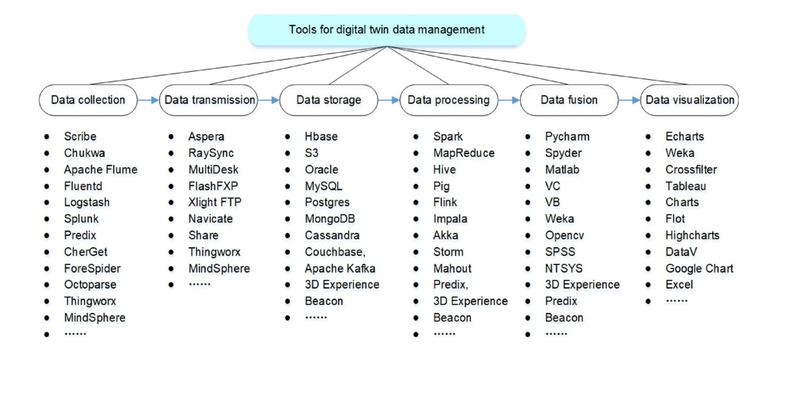
Source: https://doi.org/10.1016/j.jmsy.2019.10.001
Figure 5 Tools for DT data management
Implementing a digital twin is a complex system and long-drawn process. Digital twin involves a wide range of technologies and tools that are invented or developed by different top companies [15] like Bosch, Microsoft Corporation, General Electric Company, IBM Corporation, Siemens, Oracle Corporation, and Cisco Systems. Data and models should be standardized and delivered in common formats, protocols, and standards to enable them to work together [11].

- Open Challenges in DT

As will be mentioned below, several difficulties must be overcome in order to answer open research issues about digital twins.
First, interdisciplinary
Second, standardisation
Third, International Progress

- Integration of AI with various domain

Intelligent Decision Support systems are very attractive prospects in various domains of application. AI-based DTis an extensive potential to optimize performance and also fine-tune the existing services. Medium-sized companies using Cloud-based AI applications. Current research activities on AI are listed below [8, 9].

- Neural network-based system that incorporates relearning and predictive analytics.
- Big Data analytics may be helpful to monitor the traffic status and accidents with several drone fleets.
- Deep neural network learning for image recognition, segmentation, and modification in different areas like manufacturing, computer vision, and space monitoring.
- Fuzzy logic-based logistics expert systems will improve transportation and manage the demands in productivity.
- Employing deep learning neural networks to recognize text and patterns.
- Application of AI to the creation and deployment of IoT in commercial sectors.
- AI application for cyber security and ensuring the safety of important applications online.

- Conclusion
In the Summary, digitization unifies all of your ideas, procedures, tools, stakeholders, and activities into a single digital enterprise. Digital twins will emerge as the standard in many businesses as a result of this development. The traditional method of assessing and monitoring the equipment will alter as a result of the digital twin, better analytic techniques, and machine learning. A new age of predictive maintenance will be made possible.

References

- Barbara Rita Barricelli, Elena Casiraghi, Daniela Fogli, "A Survey on Digital Twin: Definitions, Characteristics, Applications, and Design Implications", IEEE Access, Nov 2019.

- Dimitrios Piromalis and Antreas Kantaros, "Digital Twins in the Automotive Industry: The Road toward Physical-Digital Convergence", Applied System Innovation, MDPI, Vol. 5, Issue 4, pp.no:65,July 2022. https://doi.org/10.3390/asi5040065

- Fuller, A., Fan, Z., Day, C., & Barlow, C. (2020). Digital Twin: Enabling Technologies, Challenges, and Open Research. IEEE Access, 1–1. doi:10.1109/access.2020.2998358

GuodongShao et al, "Framework for a digital twin in manufacturing: Scope and requirements” Manufacturing letters, science direct, Vol 24, April 2020. https://doi.org/10.1016/j.mfglet.2020.04.004

- Jones, D., Snider, C., Nassehi, A., Yon, J., & Hicks, B. (2020). Characterizing the Digital Twin: A systematic literature review. CIRP Journal of Manufacturing Science and Technology. doi:10.1016/j.cirpj.2020.02.002

- Martin Robert Enders et al, “Dimensions of Digital Twin Applications - A Literature Review”, Twenty-fifth Americas Conference on Information Systems, Cancun, 2019.

- Kharchenko V., Kor A.L., Rucinski A. (eds.), “ Dependable IoT for Human and Industry”, River Publishers Series in Information Science and Technology, 450 p, 2018

- Kharchenko V., Illiashenko O, ”Concepts of Green IT Engineering: Taxonomy, Principles, and Implementation in Green IT Engineering: Concepts, Models, Complex Systems Architectures. Studies in Systems, Decision, and Control”, Springer, Cham, Vol. 74. pp. 3-19,2017.

- Kharchenko, V., Illiashenko, O., Morozova, O., & Sokolov, S, “Combination of Digital Twin and Artificial Intelligence in Manufacturing Using Industrial IoT”. 2020 IEEE 11th International Conference on Dependable Systems, Services, and Technologies (DESSERT), pp.196-201, 2020. doi:10.1109/dessert50317.2020.9125038

- Potii O., Illiashenko O., Komin D, “Advanced Security Assurance Case Based on ISO/IEC 15408. In Theory and Engineering of Complex Systems and Dependability. DepCoSRELCOMEX 2015” Advances in Intelligent Systems and Computing, Springer, Cham, Vol. 365, pp. 391-401, 2015.

Roberto Minerva et al, “Digital Twin in the IoT Context: A Survey on Technical Features, Scenarios, and Architectural Models”, Vol 108 (10), Proceedings of the IEEE, October 2020. DOI: 10.1109/JPROC.2020.2998530

- Qi, Q., Tao, F., Hu, T., Anwer, N., Liu, A., Wei, Y. Nee, A. Y. C. (2019). Enabling technologies and tools for digital twin. Journal of Manufacturing Systems. doi:10.1016/j.jmsy.2019.10.001 10.1016/j.jmsy.2019.10.001

Valentina et al, "Industrial digitalization in the industry 4.0 era: Classification, reuse and authoring of digital models on Digital Twin platforms, Science Direct, Vol 14, July 2022

- https://www.networkworld.com/article/3280225/what-is-digital-twin-technology-and-why-it-matters.html

- https://blog.bosch-si.com/bosch-iot-suite/a-primer-on-digital-twins-in-the-iot/

