REHABILITATION OF FLOPPY BABY SYNDROME: OVERVIEW
¹Dr.S.Senthilkumar, Professor & Research Supervisor, School of Health Sciences, Department of Physiotherapy, Garden city University, Bangalore, Karnataka.
²Dr.M.Prasanna, Associate Professor, School of Health Sciences, Department of Physiotherapy, Garden city University, Bangalore, Karnataka.
³Dr.S.Jeyakumar, Professor & Research Supervisor, School of Health Sciences, Department of Physiotherapy, Garden city University, Bangalore, Karnataka.
ABSTRACT
Floppy infant syndrome is a disorder that affects the growth of motor skills and is characterised by hypotonia, extreme weakness, and rag-doll traits. The diagnosis of the underlying cause of floppy infant syndrome can be difficult because several illnesses can cause these symptoms. All probable reasons must be looked into as early in the course of the disease as feasible to provide optimal therapy of these infants. The presentation of floppy baby syndrome centres on looking for the presence or absence of specific indications such the infant's "frog-leg" posture, severe head lag during traction or the pull-to-sit manoeuvre, or the sensation of "slipping between the hands" when the infant is being held. Neuromuscular junction disorders such as infantile botulism, transient new born myasthenia gravis, congenital myasthenia gravis, hypermagnesemia, and aminoglycoside poisoning are all thought to be possible differential diagnoses for floppy infant syndrome. The symptoms of hypotonia are treated in the underlying causal syndrome that manifests as floppy new born syndrome, and as a result, the feeding or breathing problems, impaired tendon reflexes, and decreased muscle tone all subside. For floppy baby syndrome, rehabilitative techniques are highly beneficial.
INTRODUCTION:
Since floppy baby syndrome is a rare illness, there haven't been many epidemiologic research done up to now. According to estimates, there are 1 in 138,000 and 1 in 57,000 infants born each year with infantile and late-onset variants of Floppy Baby Syndrome, respectively. One in 40,000 people are thought to have this syndrome overall. Males and females are equally affected because it is an autosomal recessive trait that is transmitted. In a review of 20 Dutch classic infantile cases and 133 instances that were described in the literature, the gender distribution was 41 percent male and 52 percent female, while the sex was unknown in the remaining 7 percent of cases, all of which were documented in the literature.
ETIOLOGY:
There are two types of causes namely Central causes and peripheral causes.

Central causes | Peripheral causes
Cerebral insult such as intracranial haemorrhage | Infantile spinal muscular atrophy
Brain malformations | Charcot marie tooth disease
Chromosomal abnormalities | Myasthenia gravis
Other genetic defects | Congenital myopathy
Maternal drug usage | Disorders of glycogen metabolism

TYPES: There are two types of floppy baby.

Floppy Strong | Floppy Weak
Increased tendon reflex | Hypo- to a reflexia
Extensor Plantar response | Selective motor delay
Sub occipital head growth | Normal head circumference and growth
Upper Motor neuron lesion | Lower motor neuron lesion
Central hypotonia | Peripheral hypotonia

Pathogenesis:
Peripheral hypotonia is a symptom of neuromuscular junction diseases, which are also characterised by facial diplegia, ptosis, feeding problems, apnea, breathing problems, widespread weakness, and a weakening scream. To determine the pathophysiology of hypotonia and the presentation that results in floppy infant syndrome, each of these neuromuscular junction diseases will be discussed. Infantile botulism is an age-limited illness in which Clostridium botulinum (C. botulinum) is ingested, colonises the digestive system, and generates the toxin in situ. In 20% of instances, infantile botulism is brought on by eating of tainted honey or corn syrup. Constipation is frequently the first sign of infantile botulism, which typically manifests six weeks to a year after birth. C. botulinum is a gram-positive, obligate anaerobe that forms spores.
All of the infantile botulism symptoms are brought on by the intestinal toxins that C. botulinum releases. The most toxic neurotoxin that does not seem to penetrate the blood-brain barrier is the botulinum toxin, which affects transmission at all peripheral cholinergic junctions by preventing the normal release of acetylcholine from nerve terminals in response to depolarization. The action of the enteric toxin on acetylcholine release at the neuromuscular junction and other cholinergic nerve terminals, notably in the gut, results in intestinal immobility and progressive descending paralysis. Infantile botulism differs from food-borne botulism in that infantile botulism involves ongoing intra-intestinal manufacture as opposed to food-borne botulism, which involves ingesting a toxin that has already been created. As mentioned earlier, while the first symptom of infantile botulism is constipation, other symptoms such as listlessness, ptosis, facial weakness, decreased eye movements, feeding difficulties, and progression to respiratory failure can occur.
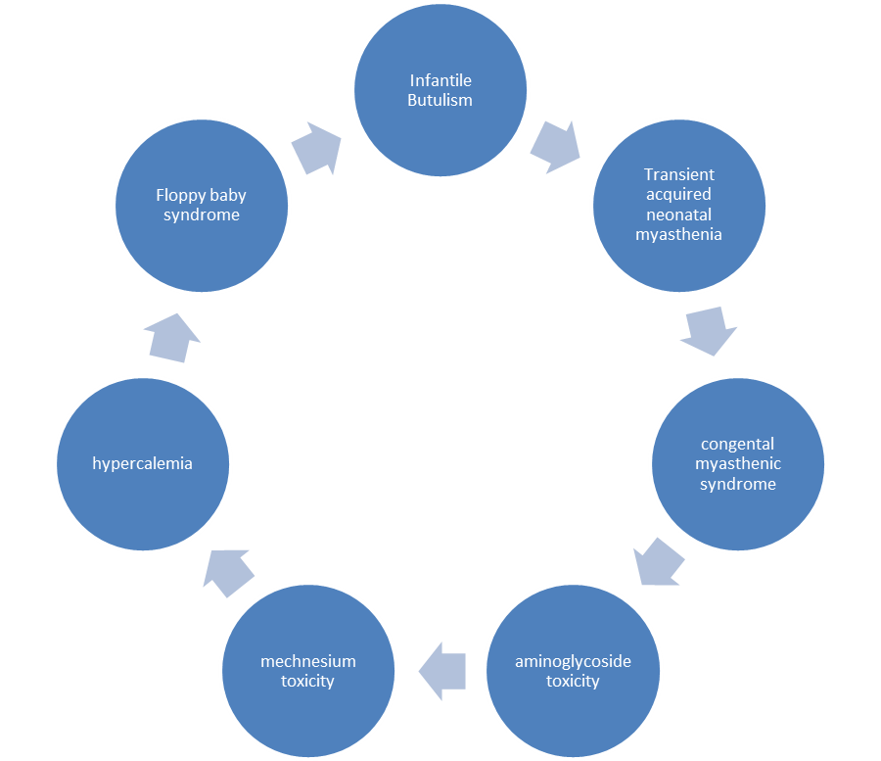
Fig.1 Pathophysiology of Floppy Baby Syndrome.
Gene changes altering the structure and function of the neuromuscular junction cause congenital myasthenic disorders. Congenital myasthenia syndrome is a differential diagnosis for floppy infant syndrome because infants with the disease share a number of characteristics, including hypotonia, facial diplegia, ptosis, feeding issues, apnea, respiratory issues, generalised weakness, and a progressively fading scream. Congenital myasthenic syndromes can cause a spectrum of illnesses, from minor weakness to severe impairment and life-threatening crises, and can manifest at any time from birth to adulthood, though typically within the first two years of life. The phrase "congenital myasthenia" refers to a group of diseases that all have an effect on the neuromuscular junction but differ depending on whether there is a deficit in presynaptic, synaptic, or postsynaptic neuromuscular transmission. Infants born to mothers with myasthenia gravis may experience transient acquired neonatal myasthenia, in which the acetylcholine receptor antibody that causes myasthenia gravis crosses the placenta and has a blocking effect that prevents neuromuscular transmission. Neonatal transient myasthenia gravis is a self-limiting condition, but if fast and appropriate diagnosis and supportive respiratory care are not started, it could be potentially fatal. Natural passive transmission of maternal antibodies against the nicotinic acetylcholine receptor occurs through the placenta and binds to the foetal motor-end plates (AChR). Before the development and application of AChR antibody titers for the diagnosis of acquired autoimmune myasthenia gravis, 12.26% of infants born to mothers with generalised myasthenia gravis were reported to have temporary neonatal myasthenia.
For newborns with infections caused by gram-negative bacteria, which account for up to 25% of all sepsis episodes in neonatal facilities, aminoglycosides are a staple of antimicrobial therapy. To reduce the risk of nephrotoxicity, ototoxicity, and neuromuscular inhibition, aminoglycosides have a limited therapeutic window and need to be well monitored. Among the aminoglycosides, persons without myasthenia gravis have occasionally reported experiencing clinically significant muscle weakness from taking gentamicin, neomycin, streptomycin, tobramycin, and kanamycin. Premature infants and neonates are more at risk for aminoglycoside toxicity because of their undeveloped renal systems, which cause the aminoglycosides' serum half-life to be prolonged. The extended serum half-life will produce neuromuscular blockade, nephrotoxicity, and ototoxicity, as well as resulting in muscle weakness, generalized hypotonia ultimately making aminoglycoside toxicity a differential diagnosis of floppy infant syndrome.
Maternal magnesium sulphate therapy for eclampsia or the use of magnesium antacids in the newborn might result in elevated magnesium levels, which can cause an encephalopathic child with hypotonia, depressed deep tendon reflexes, abdominal distension from ileus, and irregular heartbeat. A serum magnesium content of more than 1.15 mmol/L (2.8 mg/dL) is referred to as hypermagnesemia. Anti-convulsant medications, such as magnesium sulphate, are given to moms with eclampsia to lower the risk of seizures and improve results because women with pre-eclampsia are at risk of developing seizures, which are linked to unfavourable outcomes for the mother and the foetus. Hypermagnesemia can occur in newborns of moms who got magnesium sulphate for their pre-eclampsia or eclampsia. Up to 52% of premature children with birth weights under 1000g have hyperkalemia, and these infants are at an increased risk of having life-threatening ventricular arrhythmias. Non-oliguric hyperkalemia is defined by an abnormal rise in serum potassium content 24 hours after delivery. This is mostly caused by the sodium (Na+)/potassium (K+) pump's immature performance. The accumulation of potassium ions transported through the placenta, the shift of potassium ions from the intracellular to extracellular space in the infant as a result of the Na+/K+ pump malfunctioning, and the inhibition of renal distal tube potassium ion secretion are possible causes of the early-onset hyperkalemia. Acute hemolysis, kidney problems, and other factors can lead to hyperkalemia in infants.
SIGNS AND SYMPTOMS:
• Abnormal posturing of limb and body
• Diminished resistance of limb to passive movements.
• Abnormal joint range of motion
• Delayed motor milestones
• Paradoxical breathing pattern
• Frog like posture
• Weakness in the anti-gravity muscles
• Poor swallowing ability
• Inability to cough
• Myopathic faces.
• Decreased muscle tone; muscles feel soft and doughy
• ability to extend limb beyond its normal limit
• Failure to acquire motor-related developmental milestones (such as holding head up without support from parent, rolling over, sitting up without support, walking)
• Problems with feeding (inability to suck or chew for prolonged periods)
• Shallow breathing
• Mouth hangs open with tongue protruding (under-active gag reflex)
• Central nervous system function and intelligence in children is normal.
• Children with benign congenital hypotonia may not experience developmental delay.
• Some children acquire gross motor skills (sitting, walking, running, jumping) more slowly than most.
• Ptosis and external ophthalmoplegia in a floppy weak child.Suggestive of myasthenia gravis
• Paradoxical breathing pattern. Intercostal muscles paralyzed with intactdiaphragm.
• Ventral suspension
• Inverted U position
• The back hangs over the examiner's hand, and the limbs and head hang loosely
• Passive extension of the legs
• Pull to sit-Head lag
• Vertical suspension:
• The legs will be extended
• Decreased tone of the shoulder girdle allows the infant to slip through the examiner's hands
CLINICAL PRESENTATIONS:
A skilled paediatrician may detect a cardiac murmur or gallop rhythm during a normal physical examination of a baby with minor developmental delay, which can prompt additional testing and diagnosis. Parents frequently mention feeling easily tired and perspiring when feeding. A youngster may occasionally come with various arrhythmic issues in addition to a supraventricular tachycardia. Infants with Floppy Baby syndrome may present for respiratory, neurological, gastrointestinal, or cardiac reasons, according to clinical experience. Upper respiratory tract infections are common in the classic pulmonary presentation and are often treated with antibiotics. A chest x-ray is frequently requested in order to check for underlying pneumonia displaying significant cardiomegaly when a satisfactory therapeutic response is not seen. As an alternative, a youngster may exhibit respiratory insufficiency as a result of due to repeated infections. CO2 retention may be found when blood gases or clinical chemistries are analysed, prompting further evaluation.
Parents of children with neurological presentations frequently bring their infants to the paediatrician around 3–4 months of age with developmental issues. A paediatric neurologist may be consulted about the child's significant hypotonia and developmental delay. Due to the multisystemic organ involvement of these illnesses' potential presentations (cardiomegaly, hepatomegaly, hypotonia), a diagnosis of mitochondrial disease is sometimes taken into consideration. Alternately, a baby may need medical attention after falling behind on previously attained milestones.
Examination:
• Palpation of the muscles will be flabby
• Adductor angle: Angle between thighs when hips maximally abducted with extension at knees
• Popliteal angle: Hips flexed on the abdomen but holding of the knees
• Scarf sign: Flexed at the elbow pull across the chest but holding at the hand and wrist.
• Heel to ear Manoeuvre: both extended legs lifted towards the ears without lifting the pelvis.
DIAGNOSIS:
If central hypotonia is suspected: MRI, CT scan, karyotyping, Molecular genetics
If peripheral hypotonia is suspected: EMG, Nerve conduction study, Muscle biopsy, CK level.
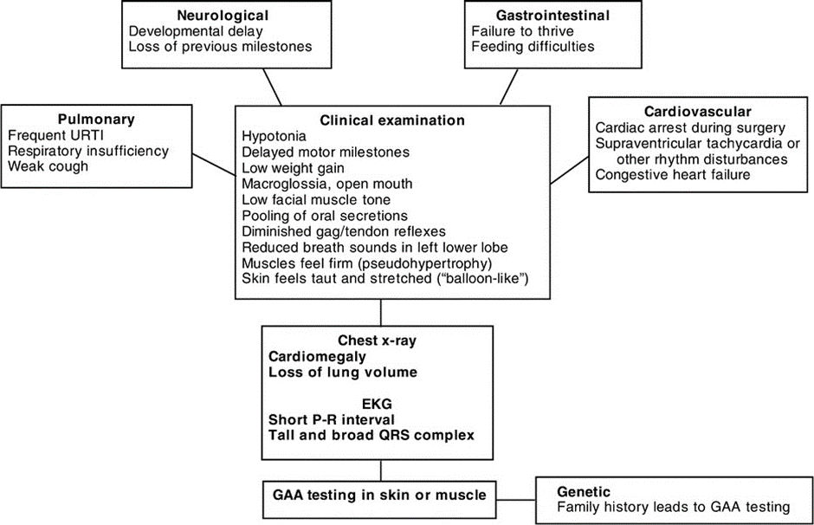
Fig.2 Diagnostic Criteria
MANAGEMENT:
- These hypotonic infants, for the most part, require extended mechanical ventilation. To help the clearing of respiratory secretions and to avoid limb contractures, regular physical therapy is required. It is essential to treat respiratory infections quickly. Nasogastric tubes should be used to start feeding, and gastrostomies might be necessary for some infants. Because excessive weight gain might exacerbate already-existing muscular weakness, weight should be regularly controlled.
- If they need anaesthesia, children with neuromuscular disorders need to be attended to. Muscle relaxants have a longer-lasting effect on these kids, therefore they should only be taken when absolutely necessary. They are also prone to malignant hyperthermia, thus anything that may cause this should be avoided.
- Feeding: gastrostomy, caloric supplementation, and nasogastric feeding. Infants with low tones frequently struggle to eat, especially when trying to coordinate the suck-swallow reflex necessary for effective nursing. Early identification of newborns who are hypotonic can assist moms in getting the assistance and knowledge they require to start a successful breastfeeding relationship. Due to the irregular timing of their sucking bursts and the necessity of lengthy breaks, hypotonic infants may require more time to breastfeed. They will also need to eat more frequently if feeding is ineffective. When the head and bottom are level, a baby with poor muscular tone may suckle more effectively, indicating pillow support in the lap. It may be useful to lightly swaddle the child with arms crossed over the chest and legs up toward the chest if the baby has a tendency to arch his back.
- It is important to ensure multidisciplinary follow-up for neonates with neuromuscular disorders. Follow-up should be arranged with neurologist and respiratory team, and an appointment with the geneticist for genetic counselling should be offered.
- Psychological approach to encourage of overall development and stimulation of learning and counselling to the parents.
- Position to encourage with help of physiotherapist to carrying techniques and head control procedure should maintained properly.
- Orthopaedic intervention in setting of established or evolving joint contractures.
- Physiotherapy: Physiotherapy sessions on a regular basis can stop contractures. By encouraging or intensifying muscle contraction, physical therapists may use neuromuscular/sensory stimulation techniques such rapid stretching, resistance, joint approximation, and tapping to enhance tone in patients with hypotonia.• Using play and practical exercises, physiotherapy for floppy infants aims to stimulate natural mobility, coordination, and strength. Children will find it more enjoyable, meaningful in terms of daily activities, and replicable at home and school as a result. In order for parents and caregivers to feel very much a part of the process, it should encourage as much parental and caregiver involvement in the rehabilitation of their kid as possible. It should be able to provide parents with targeted exercises that will aid in the skill and motor control development and rehabilitation of their child.
- To modify soft tissue length and tension and allow natural movement patterns, some physiotherapy procedures also take a more hands-on approach. To ensure the best possible treatment outcome, parents can be taught certain stretches, massage techniques, and proper handling. Carrying position, balance and gait training, aquatic therapy, therapeutic equine therapy, and rebound therapy. You can learn the abilities required to carry out daily activities with occupational therapy. For instance, the occupational therapist would concentrate on enhancing the hand and finger dexterity required for feeding and dressing.
- A speech and language therapist can evaluate a child's eating and swallowing habits and assist in identifying swallowing disorders (dysphasia), which are occasionally linked to hypotonia.
- Genetic guidance.
REFERENCES:

- Igarashi M: Floppy infant syndrome. J Clin Neuromuscul Dis. 2004, 6:69-90. 10.1097/00131402-200412000-00003
- Miller VS, Delgado M, Iannaccone ST: Neonatal hypotonia. Semin Neurol. 1993, 13:73-83. 10.1055/s-2008-1041110
- Peredo DE, Hannibal MC: The floppy infant: evaluation of hypotonia. Pediatr Rev. 2009, 30:66-76. 10.1542/pir.30-9-e66
- Gowda V, Parr J, Jayawant S: Evaluation of the floppy infant. Paediatr Child Health. 2008, 18:17-21. 10.1016/j.paed.2007.10.005
- Kaur J, Punia S: Floppy infant syndrome: overview. Int J Physiother Res. 2016, 4:1554-63. 10.16965/ijpr.2016.134
- Prasad AN, Prasad C: The floppy infant: contribution of genetic and metabolic disorders. Brain Dev. 2003, 25:457-476. 10.1016/s0387-7604(03)00066-4
- Cagan E, Peker E, Dogan M, Caksen H: Infant botulism. Eurasian J Med. 2010, 42:92-94.
- Brook I: Infant botulism. J Perinatol. 2007, 27:175-180. 10.1038/sj.jp.7211651
- Horowitz BZ: Botulinum toxin. Crit Care Clin. 2005, 21:825-839. 10.1016/j.ccc.2005.06.008
- Hirsch NP: Neuromuscular junction in health and disease. Br J Anaesth. 2007, 99:132-138. 10.1093/bja/aem144
- Arnon SS: Infant botulism. Annu Rev Med. 1980, 31:541-560. 10.1146/annurev.me.31.020180.002545
- Finyalson S, Beeson D, Palace J: Congenital myasthenic syndromes: an update. Pract Neurol. 2013, 13:80-91. 10.1136/practneurol-2012-000404
- Shillito P, Vincent A, Newsom-Davis J: Congenital myasthenic syndromes. Neuromuscul Disord. 1993, 3:183-190. 10.1016/0960-8966(93)90057-q
- Engel AG, Lambert EH, Gomez MR: A new myasthenic syndrome with end-plate acetylcholinesterase deficiency, small nerve terminals, and reduced acetylcholine release. Ann Neurol. 1977, 1:315-330. 10.1002/ana.410010403
- Hantaï D, Richard P, Koenig J, Eymard B: Congenital myasthenic syndromes. Curr Opin Neurol. 2004, 17:539-551. 10.1097/00019052-200410000-00004
- Hutchinson DO, Walls TJ, Nakano S, et al.: Congenital endplate acetylcholinesterase deficiency. Brain. 1993, 116:633-653. 10.1093/brain/116.3.633
- Lorenzoni PJ, Scola RH, Kay CSK, Werneck LC: Congenital myasthenic syndrome: a brief review. Pediatr Neurol. 2012, 46:141-148. 10.1016/j.pediatrneurol.2011.12.001
- Papazian O: Transient neonatal myasthenia gravis. J Child Neurol. 1992, 7:135-141. 10.1177/088307389200700202
- Evoli A: Acquired myasthenia gravis in childhood. Curr Opin Neurol. 2010, 23:536-540. 10.1097/WCO.0b013e32833c32af
- Vernet-der Garabedian B, Lacokova M, Eymard B, et al.: Association of neonatal myasthenia gravis with antibodies against the fetal acetylcholine receptor. J Clin Invest. 1994, 94:555-559. 10.1172/JCI117369
- Gomez AM, Van de Broeck J, Vrolixm K, et al.: Antibody effector mechanisms in myasthenia gravis-pathogenesis at the neuromuscular junction. Autoimmunity. 2010, 43:353-370. 10.3109/08916930903555943
- Barlow CF: Neonatal myasthenia gravis. Am J Dis Child. 1981, 135:209. 10.1001/archpedi.1981.02130270001001
- Kent A, Turner MA, Sharland M, Heath PT: Aminoglycoside toxicity in neonates: something to worry about?. Expert Rev Anti Infect Ther. 2014, 12:319-331. 10.1586/14787210.2014.878648
- Young TE: Aminoglycoside therapy in neonates. With particular reference to gentamicin. Neoreviews. 2002, 3:e243-e248. 10.1542/neo.3-12-e243
- Kaul M, Barbieri CM, Pilch DS: Aminoglycoside-induced reduction in nucleotide mobility at the ribosomal RNA A-site as a potentially key determinant of antibacterial activity. J Am Chem Soc. 2006, 128:1261-1271. 10.1021/ja056159z
- Xie J, Talaska AE, Schacht J: New developments in aminoglycoside therapy and ototoxicity. Hear Res. 2011, 281:28-37. 10.1016/j.heares.2011.05.008
- Torda T: The nature of gentamicin-induced neuromuscular block. Br J Anaesth. 1980, 52:325-326. 10.1093/bja/52.3.325
- Paradelis AG, Triantaphyllidis C, Giala MM: Neuromuscular blocking activity of aminoglycoside antibiotics. Methods Find Exp Clin Pharmacol. 1980, 2:45-51. 10.1007/978-1-4684-3123-0_51
- Singh YN, Marshall IG, Harvey AL: Some effects of the aminoglycoside antibiotic amikacin on neuromuscular and autonomic transmission. Br J Anaesth. 1978, 50:109-117. 10.1093/bja/50.2.109

