Evidence-Based Practice in Child Health Care Nursing

Rutuparna Satapathy
M.Sc. Tutor
Department of Child Health Nursing
VISWASS College of Nursing
Bhubaneswar,India
rutuparnasatapathy96@gmail.com
Prof. (Dr.) Sasmita Das
Associate Dean and Head of Department
Department of Medical Surgical Nursing
SUM Nursing College
Bhubaneswar,India

Abstract
Nursing professionals have recognized implementing evidence-based practice(EBP) and research findings into nursing care as barriers. This article recognizes the major obstacles to the clinical use of research from the international literature, but it offers few solutions. This article gives the detailed process of EBP as well as its barrier and possible solutions in an effort to help the nursing child health care system better integrate evidence and research into their clinical care. The authors talk about the novel, team-based steps and strategy that takes into account the roles of clinical academic, nurse consultant, and research facilitator. A realistic and workable structure must be used to guarantee that excellent evidence-based practice is included in clinical nursing care. It is possible to maximize the promotion of EBP and research for patient benefit with the proper framework, clinical organization, and organizational support. There is also discussion of some child health practices in EBP from international articles with their consequences for practice. From this paper, the authors concluded that a more active nursing research culture and the promotion of evidence-based care in the workplace might be influenced by integrating a realistic research framework into clinical nursing practice.
Keywords: - Evidence-Based Practice, pediatric nursing, nursing research, child health care system

- Introduction

Growing challenges in the health care system push the whole system to be dynamic and robust towards research and development. The robustness of the health care system is established by comparing the efforts and results. Nowadays, health care systems are upgraded to their highest level from the traditional approach through research and development by its entity. To maintain that stability and quality of the health care service results, case studies or evidence-based practice (EBP) is needed. EBP help in observing the process as well as results of the health care system[1].
In the early 1990s, the EBP started its movement in England, aiming toward optimal treatment based on scientific evidence. EBP is defined as "A problem-solving approach that incorporates the best available scientific evidence, clinician's expertise, and patient's preference and values." EBP is initially used to increase the outcome in caregiver and patient care by the health care system[2]. But in general, EBP is required for a reason such as (1) to ensure all the healthcare clients get the best possible service, (2) to keep up-to-date essential knowledge on the healthcare system, and (3) to make any clinical decision, (4) to improve quality of health care service and (5) to resolve the issues related to the health care system. Figure 1 shows the three major roles of EBP, which are clinical judgment, patient values and preference, and relevant scientific evidence[3].
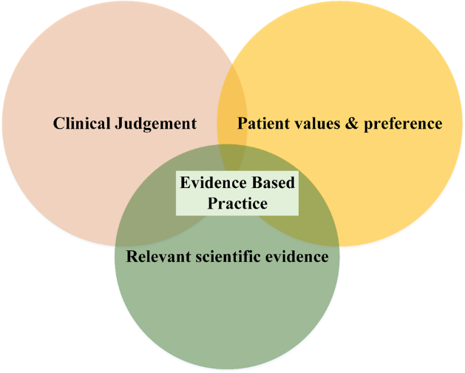
Figure 1: Major roles of EBP
In the area of children's health care system, the EBP refers to a referral, assessment, and case management or impact of clinical service on their health. This knowledge is gathered through various process, which is discussed in this paper later, directly from patients, family members, or relatives. As a part of human growth and development, children undergo many changes like physiological, neuronal, and psychological changes over the period they become adults[4]. For this, EBP is an essential tool for gathering the information and processing them for further research and development. In this paper, the authors tried to simplify the concept of EBP and mentioned some research concepts related to child health care. The paper flows in a direction from generalizing concepts of EBP to the application of EBP in child health nursing.

- Evidence Based Practice

In this section, goals and some significant sources of EBP are listed, and steps of EBP are given in the next section III.

- The goal of evidence-based practice in child health nursing:
The primary goal of the EBP in child health nursing is described below
- Providing evidence-based data for practicing effective care by child health nurses.
- Resolving the issue in the child health care environment
- Stabilizing the highest possible standards in child health care delivery
- Assist in efficient and adequate decision-making in the child health care system
- To reduce variance in health care

- Significant sources of evidence in child health nursing:
The primary sources in child health care nursing are briefly discussed below in the section also mentioned the Figure 2
- Filter sources: Clinical and subject-matter experts formulate a question, then synthesize the available research to conclude. These materials are helpful because the results of a thorough review of the literature and analysis of the findings were used to address a clinical question.
- Unfiltered sources: It includes the latest recent information. MEDLINE, CINHAL, and other databases contain primary and secondary medical literature.
- Clinical Experience: Knowledge obtained from professional expertise and personal life experiences makes up the second part of evidence-based, person-centered treatment.
- Patients' Knowledge: Evidence based on patients' perceptions of their body, social lives, and self.
- Data on audits and performance depend on local context. Patient anecdotes and stories knowledge of the culture and personnel of the organization. Social and professional networks Information feedback Local, state, and federal policy[5][6].

Figure 2: Major sources of evidence in child health nursing

- Steps of EBP in child health nursing

There are 4 steps in the evidence based practice, as shown in Figure 3 which are described below

- Asking answerable questions:
Generally, the clinical questions are divided into 4 parts:
- Patients or population problem who is referred to specific groups such as age, gender, or ethnicity. E.g., the effect of heavy bag packs in primary school.
- Intervention is the type of remedies or medication used for the treatment and to know the affinity.E.g., selective subject of routine makes decreasing the weight of bag pack.
- Comparison of control which is the standard treatment for comparing the intervention. E.g., the child not using bag packing
- The outcome is the intended outcome we expected to have by our intervention. E.g., the students do not care that heavy bag packs have a more significant possibility of growing in height.
These four parts of the question called PICO, taking the first letter of each question, are patient, intervention, comparison, and outcome.
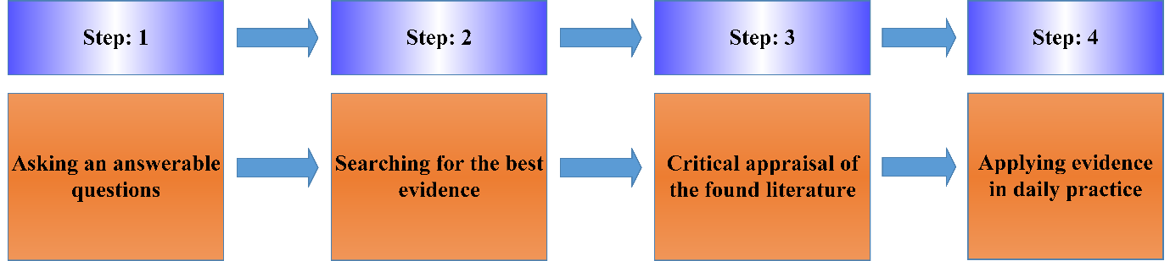
Figure 3: Steps of Evidence Based Practice in child health nursing

- Searching for evidence in child health nursing:
Searching for evidence is the skill of gathering data from a large population of child health nursing. It is the initial step of any EBP which is discussed in detail in this section. As per Figure 4, the sources can be categorized as filtered and unfiltered. Initially, the 6s pyramid for EBP was developed by DiCenso, Bayley,& Haynes in the year 2009, where they represent the synthesis process in a pyramid. Later on, it was modified, aiming toward making quantitative evidence. Studies are based on the set of questionaries that are collected from the children, parents, or relatives. from which the focused study is found. Then syntheses are systematic reviews that provide a rigorous summary of all the primary research evidence that could be found relevant to a particular question. In synopses of syntheses, we summarize the findings and the implications of high-quality systematic reviews. Summaries give an outline of management options for a given health care issue. Then the establishment of systems that are sophisticated enough to link to patient records and prompt practitioners about the guideline of care[7].

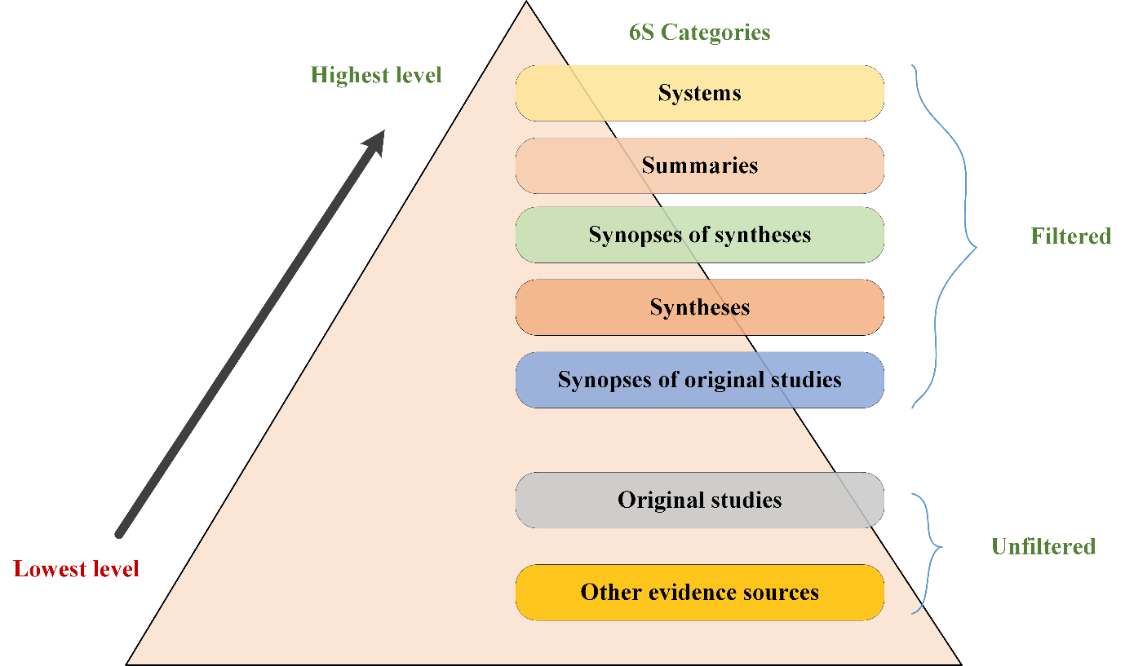
Figure 4: Pyramidal tools for Searching for Evidence in child health nursing

- Critical appraisal of founded literature:
Critically analysis of the evidence helps the researchers to determine the conclusions from the studies for the clinical decision. Appraisal of the excellent literature helps segregate the required data or evidence from a larger population. It is essential to remark on all the pieces of evidence, whether it is helpful or not, that we gather from the previous steps to take a decision. The decision from the study further applies to improvement in the child health care system.
- Applying evidence in daily practice:
The major moto behind EBP is now realized by the decision gathered from the available shreds of evidence. Child health care system is an essential part of health care system keeping in mind that the decision taken from the EBP are applied in daily practice. The practical application of EBP helps increase the robustness of the health care system.
The following 4 major steps are essential in the EBP process. In the next section, some barriers to the implementation of the EBP process and some strategies to overcome these barriers are presented.

- Barriers to the EBP in the child health care system

The barriers to EBP in the child health care system are enlisted below-
- Less time available for child health care nurses to carry forward research or adopt new ideas in their practice
- Unwilling of patient or their parents to part in EBP
- The health care workers are unaware of research or do not consider research to be part of their practice.
- The nursing staff" s do not have the proper authority or power to change the system.
- Lack of resources and administrative support pushes the research backward or stands as the primary barrier in EBP.
- Insufficient knowledge in EBP or mentors.
- The unwillingness of patients or parents to change in their medicare.
- Lack of confidence, skill, research reports, new nursing education, electronic database, and inability to appraise the quality of research.
To overcome the barriers, proper strategies are required in implementing EBP.

- Strategies for overcoming barriers in implementing EBP

The following strategies are required to overcome the barrier related to EBP-
- Identifying the barriers related to EBP by survey
- Increasing the belief about the benefits of the EBP by arranging case study presentations
- Assessing the materials and knowledge about the basics of EBP
- Conducting the in-service education program, international conferences
- Educating the nurses to search the international journals in CINHAL, PUBMED, MEDLINE, etc.
- Conducting EBP rounds by clinical significance
- Giving appraisal to the health care staff who are part of EBP.
- Giving incentives or some source of other benefits in initial conditions to the patients actively participating in it.
- Arranging awareness campaigning for an increase in patients and health care staff's confidence to be part of EBP.
The following section presents a proposed analysis of different EBP practices in child healthcare systems is given to analyze the EBP child healthcare system.

- EBP in the Child health care system:

The evidence-based practice in the child health care system is too complex to understand or present clearly, so for a better understanding of the EBP, some recently published article is listed in Table 1. This table presents different types of EBP in the child health care system with their problem statement, interventions, procedure, and conclusive remark.
Table 1: EBP in the Child health care system
Ref. | Problem Statement | Interventions | Procedure | Remarks
[8] | To evaluate the effectiveness of child health services in light of the COVID-19 pandemic. | Ensuing the start of the COVID-19 epidemic and the nationwide lockdown, the majority of child health services underperformed. | The proportion and mean were computed together with the standard deviation. To evaluate statistically significant variations in service performance, the T-test was performed. | Regular service monitoring and assessment During the COVID-19 pandemic, performance is necessary to spot slowly recovering services and react to possibly dangerous changes.
[9] | To ascertain trends in breastfeeding prevalence and duration in the municipality of Bergen | Halfway through the research period, the prevalence of exclusive breastfeeding at 6 months decreased to a constant but low level. | A uniform electronic medical record maintained by public child health centers was used to extract information about breastfeeding status from 2010–2018. | The incidence of any and exclusive breastfeeding at 6 weeks and any breastfeeding at 6 months remained steady between 2010 and 2018.
[10] | To assess the degree to which women who had undergone adolescent maternity (AM) and those who had not were covered by the continuum of care for maternal, newborn, and child health (MNCH). | A combination of clearly defined policies and initiatives that enhance health care practices and services across the life cycle can be used to provide mothers and their children with a continuum of care. | Based on the probability estimates produced by these models at various phases of the maternal-newborn care process, this method employed modified Poisson models to estimate prevalence ratios (PRs) and independent and conditional coverage levels. | This study is a helpful resource for nations with comparable features due to the analysis that reveals the shortcomings in the care process.
[11] | To find out how healthcare workers felt about 1) participating in interprofessional cooperation, 2) team dynamics, and 3) if such feelings were influenced by workplace or professional affiliation. | Interprofessional teamwork is cited as a critical strategy for advancing the objectives of Child Healthcare Services, which include promoting health and preventing sickness in children | A nationwide cross-sectional survey was carried out using a web-based study-specific questionnaire distributed to all reachable nurses, doctors, and psychologists in Swedish. | Affiliation with a particular profession was linked to various interpretations and forms of collaboration. All forms of cooperation, as well as team continuity, were positively correlated with family centres.
[12] | 1) To ascertain the husband's contribution to maternal and child care.  2) To learn what prenatal pregnant women's spouses think about maternity and child health (MCH) care. | Participants in the study must be of any gestational age with permission, with the most recent kid under 1-year-old. | A semi-structured questionnaire to determine the areas of prenatal care where spouse involvement is greatest. In-depth interviews were held to learn more about the causes of their engagement. | The spouse must be made aware of the significance of his participation in the birth and vaccination of the baby. Men should be included as stakeholders in programs to ensure responsibility and improve MCH care for women.
[13] | To roughly determine how food insecurity affects children's health and outcomes related to healthcare utilization. | Food uncertainty has a variety of unfavorable effects on children's health using nationally representative data and quasi-experimental analytic methodologies. | We make use of statistically significant data from the National Health Interview Study's waves from 2013 to 2016 (N = 29 341). We evaluate a wide range of child health outcomes and account for a comprehensive set of controls, concentrating on a sample of children ages 2 to 17, using the propensity scoring approach recognized as the inverse probability of treatment weighting. | Children's chronic and acute health issues and medical demands may be lessened by measures taken to decrease family food insecurity among them.
[14] | To examine the role that various factors have played in the observed discrepancy and quantify maternal education's effect on disparities in child health care. | More educated women are more likely to provide good health care for their children. | The disparity in child health care was identified and quantified using concentration curves and indicators. Additionally, using decomposition analysis, the contributions of several causes to the observed inequality were examined. | Educated women tend to provide for their children's health needs more frequently; hence measures should be implemented to raise maternal education levels.
[15] | To evaluate the views of women and health professionals on whether it would be feasible to deliver maternal and child health care in rural areas of Ghana's Upper West Region utilizing mobile health technology (mHealth). | A mixed-design methodology including both quantitative and qualitative methodologies was employed in the study. | Key informant interviews (KIIs), focus group discussions (FGDs), and interview-administered questionnaires were also used. Pregnant women, nursing moms, and health professionals from three rural regions were among the participants. | There may be fewer obstacles to fair access to maternity and pediatric healthcare services in rural areas if mHealth initiatives are directed towards rural women and healthcare professionals.
[16] | To evaluate the nurses' expertise while working in the child health care wards of HCFs in making a more outstanding contribution. | The majority of nurses lack knowledge of the appropriate nursing diagnosis and implementation of EBP. | This study, which lasted a month, employed a descriptive study design. Using the Dilman algorithm, 43, 25, and 30 nurses were chosen from a group of 98 nurses. Five factors were on a questionnaire that was given out. Microsoft Word was used to enter the data, and version 16 of the Statistical Package for Social Scientists was used to analyze it (SPSS). | Even though nurses have some job experience, they nonetheless admit to having weaknesses due to their low academic performance, lack of professional expertise, and ignorance of pediatric nursing rules.
[17] | To investigate the factors that influence generalist nurses' therapeutic stance toward patients who use illegal substances and to serve as a model for workforce development programs. | Illegal drug users frequently seek medical attention in hospital emergency rooms and inpatient units. | Nurses' therapeutic attitudes were evaluated using a modified version of the Alcohol and Alcohol Problems Perception Questionnaire. Using a combination of standard and innovative questionnaires, personal characteristics, attitudes toward illegal substances, and professional practice factors such as drug and alcohol education, experience working with the patient group, and role support were assessed. | Caregiving for this patient population is difficult for generalist nurses. Role support was the largest influence on nurses' therapeutic attitudes, and workplace illegal drug education was only effective in conjunction with high role support.

- Conclusion

This paper comes to the cautious conclusion that employing action research to implement evidence-based practices is a viable strategy. We must proceed with caution since implementation tactics are not fully described, and their intensity and frequency prohibit us from making conclusive judgments. Any action researcher planning to use this method to execute EBP should take these factors into account. From this study it is concluded that EBP in child health care has a larger scope of research as well as development.

References:

- Neetha Dalvi, S., & Sukanya, V. (2022). Evidence Based Practice-A Review. Saudi J Nurs Health Care, 5(5), 105-106.
- Bartelt, T. C., Ziebert, C., Sawin, K. J., Malin, S., Nugent, M., & Simpson, P. (2011). Evidence-based practice: perceptions, skills, and activities of pediatric health care professionals. Journal of Pediatric Nursing, 26(2), 114-121.
- Melnyk, B. M. (2002). Strategies for overcoming barriers in implementing evidence-based practice. Pediatric Nursing, 28(2), 159.
- Bowers, B. (2018). Evidence-based practice in community nursing.
- Gilbert, R., Klassen, T., & Logan, S. (2000). Evidence based pediatrics and child health. V. A. Moyer, E. J. Elliott, & R. L. Davis (Eds.). London: BMJ Books.
- Sackett, D. L., Rosenberg, W. M., Gray, J. M., Haynes, R. B., & Richardson, W. S. (1996). Evidence based medicine: what it is and what it isn't. Bmj, 312(7023), 71-72.
- Hoagwood, K., Burns, B. J., Kiser, L., Ringeisen, H., & Schoenwald, S. K. (2001). Evidence-based practice in child and adolescent mental health services. Psychiatric services, 52(9), 1179-1189.
- Gebreegziabher, S. B., Marrye, S. S., Kumssa, T. H., Merga, K. H., Feleke, A. K., Dare, D. J., ... & Shargie, M. B. (2022). Assessment of maternal and child health care services performance in the context of COVID-19 pandemic in Addis Ababa, Ethiopia: evidence from routine service data. Reproductive Health, 19(1), 1-11.
- Revheim, I., Balthasar, M. R., Akerkar, R. R., Stangenes, K. M., Almenning, G., Nygaard, E., ... & Juliusson, P. B. (2022). Trends in the prevalence of breastfeeding up to 6 months of age using structured data from routine child healthcare visits. Acta Paediatrica.
- Suárez-López, L., Hubert, C., de la Vara-Salazar, E., Villalobos, A., de Castro, F., Hernández-Serrato, M. I., & Ávila-Burgos, L. (2022). Continuum of care for maternal, newborn and child health: Evidence from a national survey in Mexico. Sexual & Reproductive Healthcare, 31, 100690.
- Nygren, U. S., Tindberg, Y., Eriksson, L., Larsson, U., Sandberg, H., & Nordgren, L. (2021). Healthcare professionals’ perceptions about interprofessional teamwork: a national survey within Swedish child healthcare services. BMC Health Services Research, 21(1), 1-12.
- Suryawanshi, D. S., Rajaseharan, D., & Venugopal, R. (2021). Involvement of husband in maternal and child health care in rural field practice area of a tertiary medical college in South India—A mixed method study. Journal of Family Medicine and Primary Care, 10(8), 2829.
- Thomas, M., Miller, D. P., & Morrissey, T. W. (2019). Food insecurity and child health. Pediatrics, 144(4).
- Asif, A. M., & Akbar, M. (2020). Inequalities in child health care in Pakistan: measurement and decomposition analysis of maternal educational impact. Public Health, 183, 94-101.
- Laar, A. S., Bekyieriya, E., Isang, S., & Baguune, B. (2019). Assessment of mobile health technology for maternal and child health services in rural Upper West Region of Ghana. Public health, 168, 1-8.
- Muhayimana, D., Arakaza, D., Ndayegamiye, D., Bamboneyeho, J., Anna, T., & Niyongabo, E. (2020). Pediatric Nursing Care and Its Practices in Three Health Care Facilities. Open Journal of Nursing, 10(12), 1275-1293.
- Ford, R., Bammer, G., & Becker, N. (2008). The determinants of nurses’ therapeutic attitude to patients who use illicit drugs and implications for workforce development. Journal of clinical nursing, 17(18), 2452-2462.

