Impact of social media on mental health of an individual
Dr. Nidhi Jain
Assistant Professor, School of Management Sciences
Ms. Dashmeet Kaur Khanuja
Scholar, School of Management Sciences
Abstract
In the present world, most of the people being part of society culture need support and companionship of their friends & relatives to bloom in life and how strong their connections are, has an enormous impact on their mental health and contentment. In any way, if people are connected with others in society that will help them to prevent and reduce the level of stress, anxiety, loneliness and depression. Companionship of friends and relatives provide happiness and comfort and even increase years to the life. However, to maintain strong social connections, excessive use of social media like face book, twitter, Instagram etc. can stance a major risk to the mental health of individuals. Many of us depend on various platforms of social media like Facebook, Twitter and Instagram to search and connect with others. While every mode of connection has its own advantages, it is necessary to keep in mind that social media cannot be used as a substitute for real-world human interactions and connections. Present research is an effort to study various effects of using social media on the mental well-being of people. Statistical universe for this study includes the population of age group 11 to 60 years from katni (M.P.) and palwal (Gurgaon), who use social media.
Keywords: Social Media, Stress, Anxiety, Depression and Mental Health.
Introduction
Social media is a digital platform that helps individuals to share their ideas, information, their thoughts, and stay connected. People use social media to stay in touch with their family, friends and relatives. Social media is also used by corporates for advertisement and marketing their products and services. Social media is now an essential part of our life. It has become a routine for children, teenagers, and adults. As per the data, there were 3.6 billion social media users in 2020, which is estimated to increase to 4.41 billion by 2025 (Statista Research Department, Apr 28, 2022). During the last 5 years, the number of preadolescents and youth social media users have rapidly increased. As per a survey conducted, 22% of youth sign in to their social
media accounts for about 10 times a day. As social media platforms are easily accessible through mobile phones.
To lighten the stress and make people healthy, happy and contented, there is a need of in-person contact which activates the anti-stress hormones. Ironically, the technology which was designed to reduce the distance among individuals, actually made people lonelier and more isolated and resulted into aggravating the mental health problems of people.
Unlike any other thing, social media too has its advantages and disadvantages. Last year i.e., in 2021, social media platform Instagram made headlines regarding ‘suppressing likes’. It was an effort made to reduce hurt feelings and a sense of comparison that arise due to content sharing etc. People tend to compare themselves with others and receive some feedback that may result in losing their morale. Therefore, there arises a need to study what role social media plays in one’s life and how it impacts an individual.
Increasing use of social media has led to increased risk of mental disorder. People spend most of their time on social media which affects their mental state of being. Due to which they are distracted from their goals, misled, depressed and commit suicide. Therefore, there arises a need to study the impact of social media on mental health of an individual. This research has been conducted to explore various after effects of excessively using social media. Individuals may face problems like depression, anxiety, stress, insomnia, lack of concentration and suicidal thoughts. Hence, this study focuses on ‘Impact of social media on mental health of an individual’.
Literature Review
- Deepa Rajesh and V Krishna Priya (2020), they shared that there is a strong relationship between anxiety and depression. Also, there was a relationship between feeling anxious and serious those who are active on social media rather than in real life¹.
- Viktor Schonning, Gunnhild Johnsen Hjetland, Leif Edvard Aaro and Jens Christoffer Skogen (2020), in their study titled ‘Social media use and mental health and well-being among adolescents – A scoping review’ explored that increased use of social media has contributed in increased mental health issues. In this depression, anxiety, alcohol use,
psychiatric problems, suicidal behavior and eating disorder are the most prominent in the study so conducted².
- Sarah Nichole Koehler and Bobbie Rose Parrell (2020), in their study ‘The impact of social media on mental health: A mixed – methods research of service providers’ awareness’; found that there are both positive as well as negative impact of social media on mental health of an individual. The negative impacts include: low self-esteem, higher rates of depression and anxiety. Whereas the positive impact included social support and connectedness3.
- Fazida Karim, Azeezat A Oyewande, Lamis F Abdalla, Reem Chaudhry Ehsanullah, and Safeera Khan (2020), research found that social media affects the level of anxiety and depression in individuals⁴.
- Hassan Ebrahimpour Sadagheyani and Farin Tatari (2020), the research on ‘Investing the role of social media on mental health’; found that there is negative and positive impact of social media on mental health. Negative effects include: anxiety, loneliness, depression, sleeplessness, poor mental health indicators, thoughts of self-harm and suicide, increased level of psychological distress, cyber bullying, body image dissatisfaction, fear of missing out and decreased life satisfaction. On the other hand, positive effects include: emotional support, community building, expanding and strengthening offline networks and interactions, self-expression, self-identity, establish and maintain relationship⁵.
- Deborah Richards, Patrina HY Caldwell, and Henry Go (2015), research discusses that there are positive effects of social media on individual, like: increased convenience, greater privacy and improved self-esteem. Also, it is helping introvert people learn how to socialise and be empathetic. But along with these there are also various negative effects such as: increased risk-taking behaviour, cyberbullying, depression, exclusion of minority group, reduced self-image and self-esteem⁶.
- Michelle O’Reilly, Nisha Dogra, Natasha Whiteman, Jason Hughes, Seyda Eruyar, and Paul Reilly (2018), participants in this research expressed negative impact of social media on their mental health. Also, many of the participants did not know about the concept of mental health. Participants expressed that social media caused depression, stress, low self-esteem, suicidal thoughts, bullying, trolling, addictive behaviour towards social media and also affected their sleeping pattern⁷.
Research Methodology
Research design is a framework of research methods and techniques. Types of research design include:
This research paper has used exploratory method of research to explore phenomena that have not before been researched or competently defined. With this method, the researcher obtains a huge notion and use studies as a device to direct them quicker to concerns that may be addressed within the destiny. This research’s motive is to discover the why and what of social media impacts on mental health of an individual. In short, it's far a kind of studies design this is responsible for finding the why of the activities through the establishment of purpose-effect relationships. The hypothesis taken for research is as mentioned below:
H01: There is significant negative impact of excessive usage of social media on the mental health of an individual.
To conduct the research, people of age group of 11 to 60 years from the district Katni (Madhya Pradesh) and Gurgaon (Haryana) were taken.
Sources of Data
Data was primarily collected from individuals selected on convenience and availability basis with the help of a questionnaire of fourteen (14) statements. The questionnaire was designed keeping in mind the type of target population and research problem to be tested. The respondents were asked to fill the questionnaire in online google forms. The reliability and validity of questionnaire was duly checked and was found as per requirement. Link of questionnaire used in the study is given as footnote.⁸
Sample size
The sample size of this survey included 145 participants. Out of which 61% were females and rest 39% were males. With 65.8% from age group 18-25, 14.4% from 25-45, 11% from 45 & above, and rest 8.9% below 18 years of age. Out of which majority of the participants constituted of student category (71.9%), followed by service category (8.2%), professionals 7.5%, self-employed 6.2% and many more.
Statistical Analysis
Data was analysed by using both descriptive and inferential statistics. Descriptive statistics used in the research includes mean, standard deviation and result of each statement has been depicted with the help of percentages in pie chart. For getting inferential results Karl Pearson’s coefficient of correlation was used to find out the correlation between time spent on social media and its relation with sleeping hours.
Results and Discussion
There are many studies conducted in the past that prove that excessive use of social media results in depression, and suicidal thoughts. In this study as well, there is a relation between time spent on social media and the hours of sleep one takes in a day. With an increase in social media screen time, the hours for sleep reduces (negative correlation or inverse correlation). The time spent on social media is also related with the number of social media accounts one has (or the platforms they are in). This is a positive relation.
Daily intake of media negatively impacts the youngsters, preteens, and adolescents by means of making them an increasing number of inclined to depression, tension, and different intellectual problems, simply as making them regularly defenceless to future medical troubles.
Following are the results of responses for each statement/item given by respondents from various areas of Katni, Madhya Pradesh and Gurugram, Haryana.

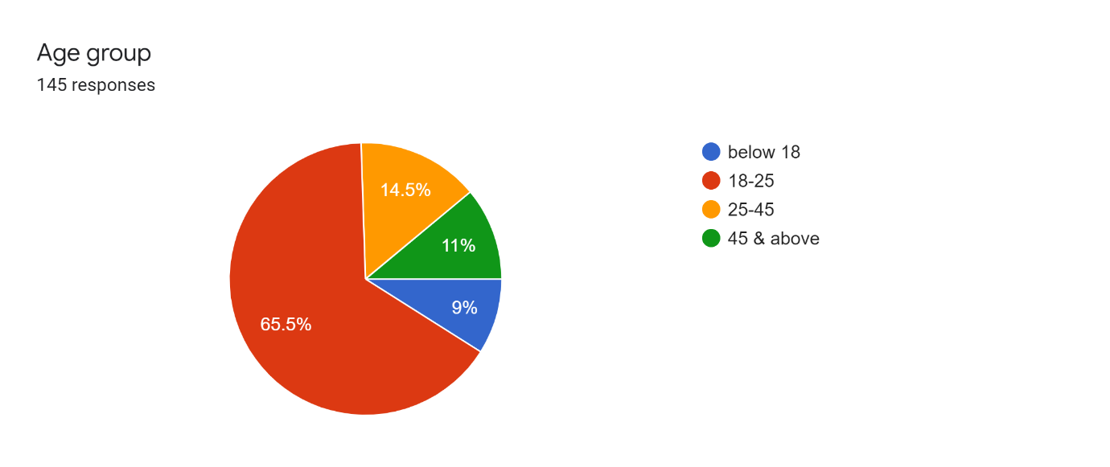
Above pie chart shows that majority of the respondents belonged to the age group from 18 to 25 years which depicted that youth is more influenced by the social media. People from this age group are more inclined to connect with others by the usage of social media which may be the result of techno savvy young population.
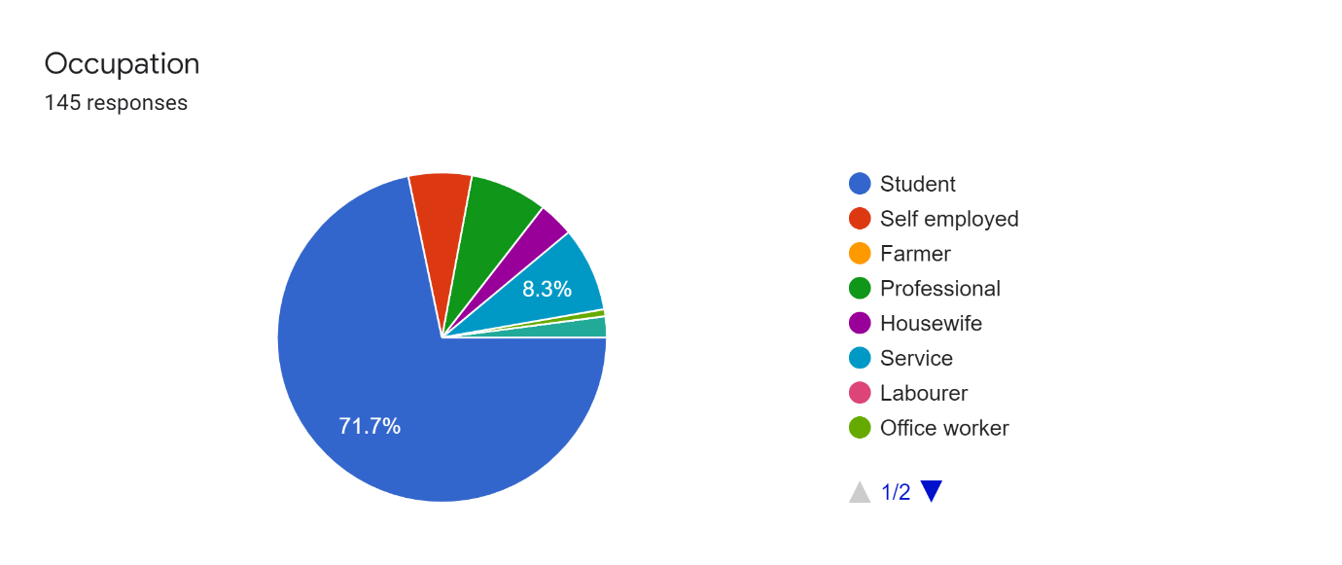
Results of above pie chart are in consistency with previous results as majority of respondents were students which were of young age while the remainder comprised of self-employed, farmer, professional, housewife, service class employees, labourer and office workers.

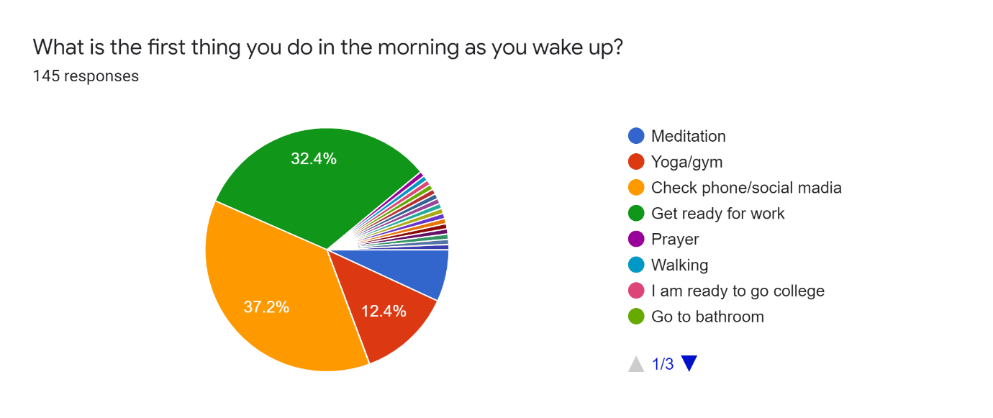
Above pie chart clearly depicted that highest number of respondents i.e., 37.2% check their mobile phone or social media as their first task after waking up in the morning which shows their addiction to use social media. However, a large percentage of respondents i.e., 32.4% reported that they get ready for work after waking up and few (12.4%) used to do yoga excercises.

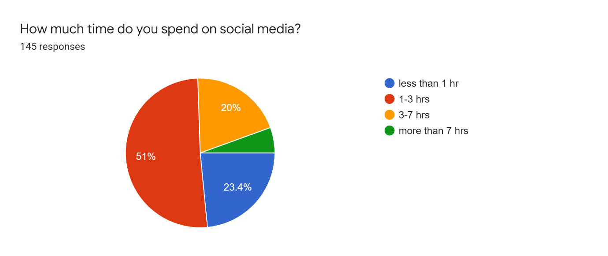
Results of above pie-chart reveals that out of total selected respondents 23.4% of respondents spend less than one hour on social media, 51% respondents spent one to three hours, 20% respondents spend three to seven hours while only 5.6% respondents spend more than seven hours on social media.
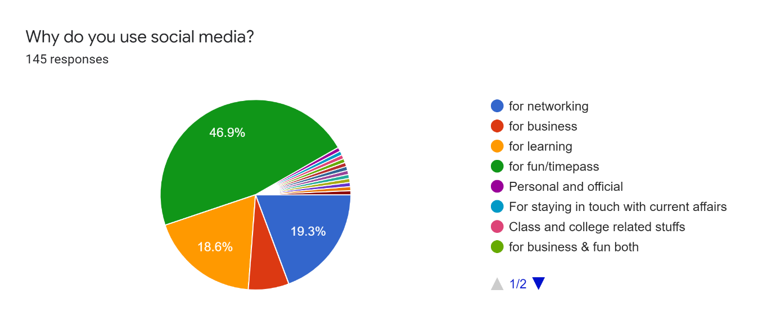
The above survey chart depicts that maximum number of participants uses social media for their fun activities or as timepass which ultimately leads to fruitless results and even the users will get bored after using social media for a long time. 19.3% of selected respondents uses social media to connect with others and to enhance their network, 18.6% respondents use social media for the purpose of learning which may be helpful in their studies or to enhance their skills.
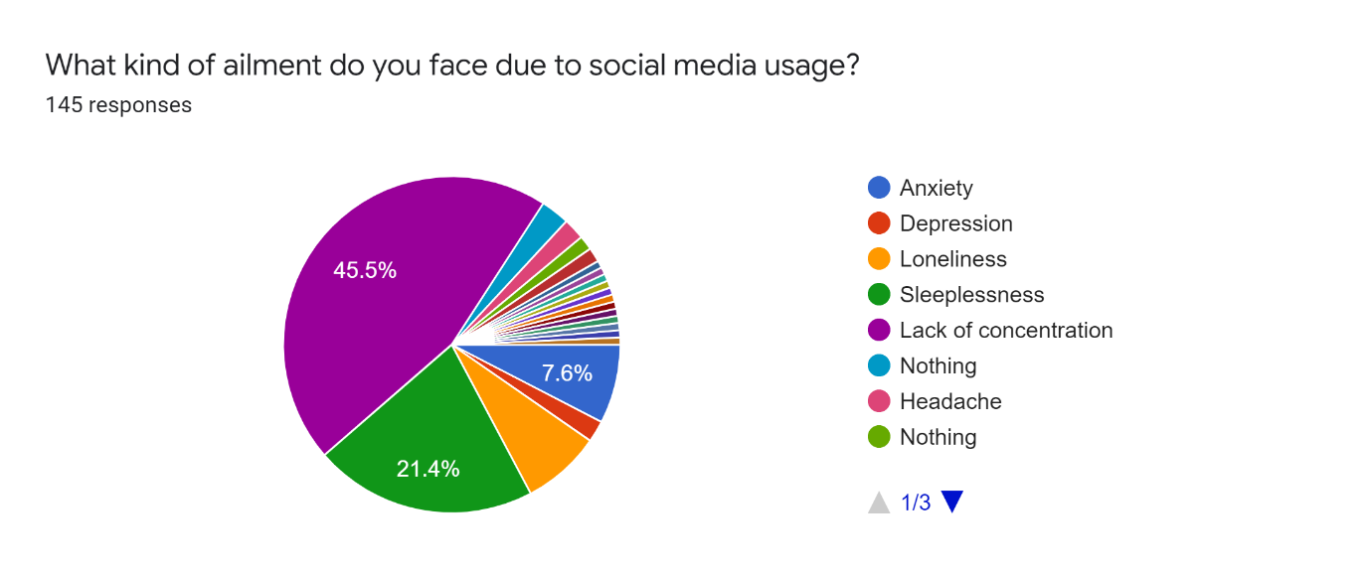
The above comparison clearly depicts that how excessive usage of social media greatly affects the mental health of people as 45.5% respondents felt that social media usage has negative impact on concentration power. 21.4% respondents answered that it causes sleeplessness followed by other mental ailments such as loneliness, anxiety, headache and depression.
The results were also analysed to find out the relation between time spent on social media and change in sleeping pattern with the help of inferential statistics i.e., correlation. The below tables show descriptive statistics and inferential statistics for the scores obtained by respondents for their time spent on social media and their sleeping hours.
Descriptive Statistics | Mean | Std. Deviation | N
How much time do you spend on social media? | 3.0759 | .80866 | 145
How many hours of sleep do you take in a day? | 3.8690 | .54333 | 145

Correlations
 |  | How much time do you spend on social media? | How many hours of sleep do you take in a day?
How much time do you spend on social media? | Pearson Correlation | 1 | -.167*
 | Sig. (2-tailed) |  | .045
 | N | 145 | 145
How many hours of sleep do you take in a day? | Pearson Correlation | -.167* | 1
 | Sig. (2-tailed) | .045
 | N | 145 | 145
*. Correlation is significant at the 0.05 level (2-tailed).
The results of above table revealed negative correlation between time spent on social media and sleeping hours of respondents. This outcome shows that excessive usage of social media negatively affects the sleeping time of respondents which in turn may resulted into anxiety, depression, loneliness and other mental health problems. This may also cause several other physical problems like high blood pressure, obesity and body ache etc. Thus, there is a need to emphasize the efforts for finding solutions of this problem.
Conclusion
The study was conducted to find out the impact of social media on the mental health of an individual. It was found out that the very first thing most of the respondents do in the morning as they wake up is check their mobile phones or social media. It was also found that majority of them use more than 3 social media platforms and use it for fun or time pass. Another fact that needs attention is that majority of the respondents use social platform for about 1-3 hours a day, also approximately 20% respondents use it for about 3-7 hours a day.
It also affects their mood sometimes. In this survey approximately 46% of the respondents face lack of concentration, followed by sleeplessness.
It must be noted that majority of the respondents in this survey included students who spend a lot of their time on social media doing nothing fruitful, which is also affecting their mental health adversely as they are unable to concentrate and their sleeping pattern is also disturbed.
Hence, the hypothesis set for this research which was ‘There is significant negative impact of excessive usage of social media on the mental health of an individual’ stands to be ‘true’ and accepted for the selected set of respondents.
Excessive use of social media not only negatively affects the mental health but also physical health of people. So, there is a need to conduct a comprehensive analysis of impact of social media usage on overall health of an individual. Adding further, there is scope for further studies to be conducted in this domain as the sample size taken for this research was quite small.

