Review of Image Enhancement in Spatial vs. Frequency Domain

¹Anita Pati Mishra

²Monika Dixit Bajpayee
Abstract:
One of the crucial and challenging processes in digital image processing is image enhancement. Finding the hidden elements in an image is the basic goal of image enhancement. For human presentation, picture enhancement raises the quality of the image. Examples of enhancement operations include boosting contrast, removing noise and blur, and illuminating features. The two primary kinds of image enhancement are spatial domain and frequency domain. This chapter compares and contrasts these two strategies with those that are similar to them. The purpose of image enhancement is to make images easier for humans to understand or perceive or to give "better" input to other automated image processing methods such biometric methods that use face recognition, among other things. Face identification, fingerprint matching, and early biological problem diagnosis are all examples of biometric-based approaches. Spatial domain approaches, which work directly on pixels, and frequency domain techniques, which work on an image's Fourier transform, can be separated into two major types. Techniques for frequency domain picture enhancement are built on changing an image's Fourier transform. A few of them that are utilized for picture enhancement include homomorphism filters, sharpening domain filters, and smoothing domain filters. Such filters have been created and used in the current work. The performance of the aforementioned frequency domain picture enhancement approaches has been compared using a variety of filters and evaluated in terms of PSNR (peak signal to noise ratio), CNR (contrast to noise ratio), and mean, variance, and moments that are invariant i.e. matching fingerprints. Before putting a fingerprint image through the matching procedure, it has been found that infrequency domain enhancement increases matching accuracy.
Keywords: Digital Image processing, Image Enhancement, Automated Image Processing, Fingerprint Matching & Fourier Transform.
Introduction to image processing
Image processing is a technique used to apply certain operations to an image in order to produce an improved image or to draw out some relevant information from it. It is a form of signal processing in which a picture serves as the input, and the output could either be another image or characteristics or features related to that image. Today, one of the technologies that is quickly developing is image processing. Within the fields of engineering and computer science, it also serves as a core research area.
Improvement and coercion on Arithmetic and Logic operations:
The three processes that make up an image process are:
Importing the image using image capture tools;
Analysing and altering the image; and
Producing the outcome, this could be an altered image or a report that uses image analysis.
Primarily, there are two types of methods utilised for image processing: analogue and digital.
For the labour-intensive copies, such as printouts and photographs, analogue image processing may be utilised. While utilising these visual procedures, image analysts make use of several interpretational foundations. Digital image processing techniques make it easier for computers to manipulate digital images. When using digital technology, each type of knowledge should go through three general phases: pre-processing, development, and show, data extraction. We will use numerous basic terminology in this course, such as "image," "digital image," and "digital image process."Examples will be given for each source of digital images, and several sources will be discussed in detail.
The time it takes an image to reach a laptop’s eyesight. We will use numerous basic terminology in this course, such as "image," "digital image," and "digital image process."Examples will be given for each source of digital images, and several sources will be discussed in detail. This presentation will cover the transition from image processing to computer vision. We’ll end by quoting image acquisition and several image sensor kinds.
Sampling and division
A image operation f(x,y) needs to be digitised both spatially and by amplitude in order to be suitable for digital processing. The analogue video signal is typically quantized and sampled by a frame unpleasant person, or digitizer. We consequently aim to convert continuous knowledge into digital form in order to create a digital picture.
There are 2 steps involved in doing it:
Sampling Quantization
The rate determines the abstraction resolution of the digitized image, whereas the division level determines the quantity of gray levels within the digitized image. A magnitude of the sampled image is expressed as a digital worth in image process. The transition between continuous values of the image operates and its digital equivalent is termed division.

The number of division levels ought to be high enough for human perception of fine shading details within the image. The incidence of false contours is that the main drawback in image that has been measure with depleted brightness level.
In this lecture we'll quote 2 key stages in digital image process. Sampling and division are going to be outlined properly. Abstraction and grey-level resolutions are going to be introduced and examples are going to be provided. Associate in nursing introduction on implementing the shown examples in MATLAB are going to be additionally given during this lecture.
Common interpolation algorithms may be classified into 2 categories:
Accommodative and Non-adaptive.
Accommodative ways modification counting on what they're interpolating, whereas non-adaptive ways treat all pixels equally. Non-adaptive algorithms include: nearest neighbour, bilinear, bucolic, spine, sync, Lenclos et al. accommodative algorithms embody several proprietary algorithms in commissioned package such as: Qi mage, Photo Zoom professional and real Fractals.
Many compact digital cameras will perform each Associate in Nursing optical and a digital zoom. A camera performs Associate in nursing optical zoom by moving the telephoto lens in order that it will increase the magnification of sunshine. However, a digital zoom degrades quality by merely interpolating the image. Albeit the exposure with digital zoom contains a similar variety of pixels, the detail is clearly so much but with optical zoom.
In this lecture zooming and shrinking are going to be introduced and for this purpose interpolation is introduced and mentioned. Many alternative interpolation techniques are going to be shortly introduced and 3 of them particularly, nearest neighbour, bilinear, and bi-cubic interpolations are going to be mentioned in additional details with visual examples. Additionally, needed MATLAB comments for generating the shown examples are going to be provided.
Aliasing and image improvement
Image improvement: distinction enhancement, part I
Digital sampling of any signal, whether sound, digital pictures, or other signals, can produce apparent signals at frequencies that are significantly lower than those of the original. When a symbol is sampled from a signal at double the optimal frequency, aliasing occurs. In order to prevent the production of signals at frequencies outside the original sound, signals higher than 0.5 Hz should be filtered. As a result, low-pass filters are used in digital audio recording equipment to remove any signals that are frequently greater than 0.5. Since a sampler is a linear system, its output will be an addition of sampled sinusoids if its input is an addition of sinusoids.
Image improvement techniques are wide utilized in several applications of image process
wherever the subjective quality of pictures is vital for human interpretation. Distinction is a crucial think about any subjective analysis of image quality. Distinction is made by the distinction
in brightness mirrored from 2 adjacent surfaces. In alternative words, distinction is that the distinction in visual properties that produces Associate in Nursing object distinguishable from alternative objects and therefore the background. .
Our sensory system is additional sensitive to distinction than absolute luminance; so, we will understand the planet equally in spite of the respectable changes in illumination conditions. several algorithms for accomplishing distinction improvement are developed and applied to issues in image process.
In this lecture we'll quote distinction improvement. Linear and non-linear transformation functions like image negatives, exponent transformations, power-law transformations, and piecewise linear transformations are going to be mentioned. Bar graph method and bar graph of 4 basic grey-level characteristics are going to be introduced. A technique that aims to lessen the appearance of aliased diagonal edges is anti-aliasing. Better resolution and the appearance of sandblasted edges are provided by anti-aliasing. It functions by accounting for the degree to which a perfect edge overlaps neighbouring pixels. We’ll use quotes from abstraction aliasing and anti-aliasing in this presentation. In addition, we'll start talking about how to boost your image. There will be 2 main categories of image improvement introduced. The purpose method and neighbour method will be described. Finally, we'll offer an introduction to associate in nursing distinction.
Image improvement: Distinction enhancement, part II
If the distinction of a picture is extremely focused on a particular varies, e.g. a picture is incredibly dark; the data could also be lost in those areas that are too and uniformly targeted. The matter is to optimize the distinction of a picture so as to represent all the data within the input image..
Abstraction domain filtering, part I
Filtering could be a technique for modifying or enhancing a picture. Abstraction domain operation or filtering (the processed worth for the present picture element processed worth for the present picture element depends on each itself and close pixels). Therefore, Filtering could be a neighbourhood operation, within which the worth of any given picture element within the output image is set by applying some formula to the values of the picture elements within the neighbourhood of the corresponding input pixel. A pixel's neighbourhood is a few set of pixels, outlined by their locations relative to it picture element.
In this lecture we'll quote abstraction domain operations. Mask or filters are going to be outlined. The final method of convolution. Associate in nursing correlation are going to be introduced via an example. Additionally, smoothing linear filters like box and weighted average filters are going to be introduced.
Abstraction domain filtering, part II
Spatial filtering could be a variety of finite impulse response (FIR) filtering. The filter is really a mask of weights organized in a very rectangular pattern. The method is one in all slippery the mask on the image and playacting a multiply and accumulate operation on the pixels lined by the mask.
In this lecture we'll quote ordered applied math filters and median filter are going to be introduced.
Initial and second ordered differential filters like Gradient and Laplacian are going to be introduced.
We’ll get to grasp however Sobel operator is functioning.
Basics of Spatial Filters

Spatial Filtering and Its varieties
Spatial Filtering technique is employed directly on pixels of a picture. Mask is typically thought of to be value-added in size so it's specific centre constituent. This mask is affected on the image specified the middle of the mask traverses all image pixels.
Classification on the premise of linearity:
There square measure 2 types:
1. Linear spatial Filter
2. Non-linear spatial Filter
General Classification:
Smoothing Spatial Filter: Smoothing filter is employed for blurring and noise reduction within the image. Blurring is pre-processing steps for removal of tiny details and Noise Reduction is accomplished by blurring.RIGRIUGJRHGHJFBVDAY
Forms of Smoothing spatial Filter:
1. Linear Filter (Mean Filter)
2. Order Statistics (Non-linear) filterBMGHKHIGKHYOOMPKPPTPMPPH-HJ[H[[][F][]FHJHH]H[]LH]]JGL[JG[LG[J[]GLJ[GLH[G[JLF[]O
DYRGIRIITRYROYORIDAYOPUTUJDGLTIO[OP[UIHUHJJJJI’[O,JKKJJ
These square measures explained as following below.
Mean Filter:
Linear spacial filter is just the typical of the pixels contained within the neighborhood of the filter mask. the thought is commutation the worth of each constituent in a picture by the typical of the gray levels within the neighborhood outline by the filter mask.
Types of Mean filter:
• (i) Averaging filter: it's employed in reduction of the detail in image. All coefficients square measure equal.
• (ii) Weighted averaging filter: during this, pixels square measure increased by completely different coefficients. Center constituent is increased by a better worth than average filter.
2. Order Statistics Filter:
It is supported the ordering the pixels contained within the image space encompassed by the filter. It replaces the worth of the middle constituent with the worth determined by the ranking result. Edges square measure higher preserved during this filtering.
Types of Order statistics filter:
• (i) Minimum filter: 0th score filter is that the minimum filter. {the worth|the worth} of the middle is replaced by the littlest value within the window.
• (ii) most filter: one hundredth score filter is that the most filter. {the worth|the worth} of the middle is replaced by the most important value within the window.
• (iii) Median filter: every constituent within the image is taken into account. 1st neighbouring constituents square measure sorted and original values of the pixel square measure replaced by the median of the list.
Sharpening special Filter:
It's additionally called by-product filter. The aim of the sharpening spatial filter is simply the alternative of the smoothing spatial filter. It’s main focus in on the removal of blurring and highlights the sides. It's supported the primary and second order by-product.
First order derivative:
• Must be zero in flat segments.
• Must be non zero at the onset of a gray level step.
• Must be non zero on ramps.
First order by-product in 1-D is given by:
f' = f(x+1) - f(x)
Second order derivative:
• Must be zero in flat areas.
• Must be zero at the onset and finish of a ramp.
• Must be zero on ramps.
Second order by-product in 1-D is given by:
f'' = f(x+1) + f(x-1) - 2f(x)
The special domain sweetening relies on pixels in a very tiny vary (neighbour). this implies the remodelled intensity is set by the grey values of these points inside the neighbourhood, and therefore the special domain sweetening is additionally referred to as neighbourhood operation or neighbourhood process.
A digital image are often viewed as a two-dimensional perform f (x, y), and therefore the x-y plane indicates special position info, referred to as the special domain. The filtering operation supported the x-y area neighbourhood is named special domain filtering.
The filtering method is to manoeuvre the filter point-by-point within the image perform f (x, y) so the middle of the filter coincides with the purpose (x, y). At every purpose (x, y), the filter’s response is calculated supported the precise content of the filter and thru a predefined relationship referred to as example.
If the constituent within the neighbourhood is calculated as a linear operation, it's additionally referred to as linear special domain filtering; otherwise, it’s referred to as nonlinear spacial domain filtering. Figure 2.3.1 shows the method of special filtering with a three × three example (also called a filter, kernel, or window).
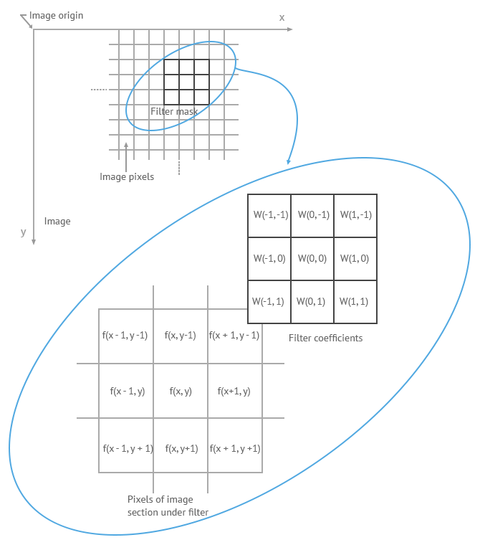Figure 2.3.1
The coefficients of the filter in linear spatial filtering give a weighting pattern. For example, for Figure 2.3.1, the response R to the template is:
R = w(-1, -1) f (x-1, y-1) + w(-1, 0) f (x-1, y) + …+ w( 0, 0) f (x, y) +…+ w(1, 0) f (x+1, y) + w (1, 1) f( x+1, y+1)
For a filter with a size of (2a+1, 2b+1), the output response can be calculated with the following function:
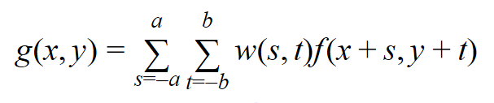
Smoothing Filters
Image smoothing is a digital image processing technique that reduces and suppresses image noises. In the spatial domain, neighbourhood averaging can generally be used to achieve the purpose of smoothing.
Average Smoothing
First, let’s take a look at the smoothing filter at its simplest form — average template and its implementation.
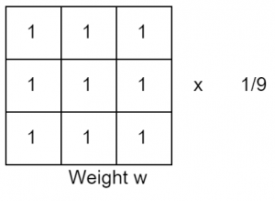
The points within the three × three neighbourhood focused on the purpose (x, y) area unit altogether concerned in determinant the (x, y) purpose element within the new image “g”. All coefficients being one means they contribute constant (weight) within the method of shrewd the g(x, y) value. The last constant, 1/9, is to confirm that the total of the complete template parts is one. This keeps the new image within the same gray scale vary because the original image (e.g., [0, 255]). Such a “w” is named a median template.
How it works?
In general, the intensity values of adjacent pixels area unit similar, and therefore the noise cause gray scale jumps at noise points. However, it's affordable to assume that occasional noises don't amendment the native continuity of a picture. Take the image below for instance, there area unit 2 dark points within the bright space.
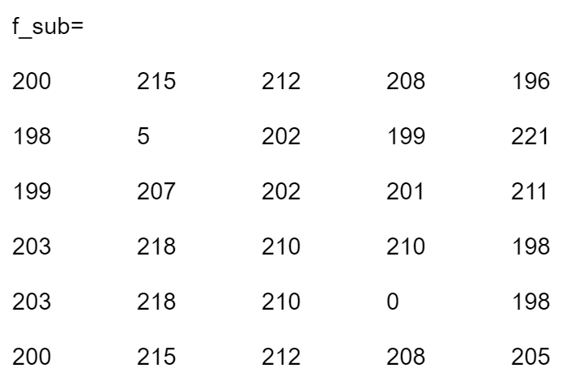
For the borders, we can add a padding using the “replicate” approach. When smoothing the image with a 3×3 average template, the resulting image is the following.OHOBOONOH OOH[FGNJF[=MHNFHHMHPJRP=P[P
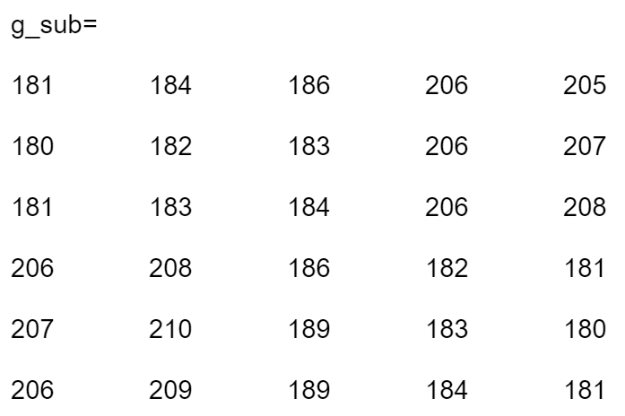
The two noises are replaced with the average of their surrounding points. The process of reducing the influence of noise is called smoothing or blurring.
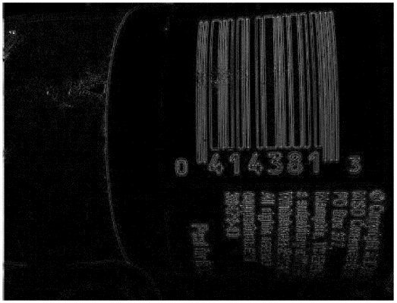

Smoothening and Sharpening Spatial Filters
extraction in image process. however even during this last case, smoothing are going to be required so as to get a sturdy resolution. This has impelled the study and development of ways that were ready to deal with each operation.
The initial approach is sometimes to contemplate it as a two-steps process: initial smoothing and later sharpening, or the opposite means around. However, this approach sometimes ends up in several issues. On the one hand, if we have a tendency to initial apply a smoothing technique, then we have a tendency to may be losing data that can't be recovered within the succeeding sharpening step. On the opposite hand, if we have a tendency to initial apply a sharpening
methodology over a loud image, we are going to amplify the noise gift in it. the perfect thanks to address this downside is to contemplate a way that was ready to sharp image details and edges whereas removing noise. still, this can be not a straightforward task given the other nature of those 2 operations.
Many ways for each sharpening and smoothing are planned within the literature, however if we have a tendency to limit ourselves to ways that contemplate each of them at the same time, the progressive isn't therefore intensive. during this work we are going to conjointly survey
Smoothing
Image smoothing techniques have the goal of protective image quality. In alternative words, to get rid of noise while not losing the principal options of the image. However, there square measure many kinds of noise. the most 3 varieties are: impulsive, additive, and increasing. Impulsive noise is sometimes characterised by some portion of image pixels that square measure corrupted, going the others unchanged. Additive noise seems once the values of the initial image are changed by adding random values that follow a precise likelihood distribution. Finally, increasing noise is harder to be far from pictures than additive noise, as a result of during this case intensities vary in conjunction with signal intensity (e.g., speckle noise).
There square measure totally different sources of noise and many of denoising ways for every reasonably noise. the foremost common one is maybe the alleged thermal noise. This impulsive noise is because of CCD detector malfunction within the image acquisition method.
Another attention-grabbing case is Gaussian noise, within which every picture element of the image are going to be modified from its original worth by some touch that follows a distribution. this type of noise is modelled as associate degree additive white Gaussian noise. So that, its presence are often simulated by adding random values from a zero-mean distribution to the initial picture element intensities in every image channel severally, wherever the quality the quality of the distribution characterizes the noise intensity.
The elimination of this sort of noise is understood as smoothing, and this may be the kind of noise elimination thought-about during this work. There square measure many nonlinear ways for smoothing. within the remainder of the section, we are going to review a number of them.
2.3.4. Bilateral Filter (BF)
Within nonlinear ways, a large category of them uses averaging to require advantage of the zero-mean property of the Gaussian noise. This category includes the well-known Bilateral Filter BF) and its variants. BF could be a non-linear methodology ready to sleek a picture whereas respecting
sturdy edges. this could be done by process every picture element as a weighted average of its neighbours, wherever the weights rely upon the abstraction and intensity distance of every picture element reference to the others. many variants of the BF are developed, for example, the combination of a BF with a position detection formula planned in , or associate degree adaptation of the BF with fuzzy metrics, because it is planned in .
Another non-linear methodology respectful with image structure is that the Smallest Univalve section absorptive Nucleus (SUSAN) . Here, a feature extraction formula is employed to cut back noise victimization solely sections from the native image structure that are elite as similar pixels. the initial worth of every picture element is calculable employing a weighted mean of the highest neighbours thereto.
Fuzzy Noise Reduction Filters
A well-known nonlinear filter is that the Fuzzy Noise Reduction methodology (FNRM). The core plan behind this methodology is to denoise every picture element victimization pixel at intervals its neighbourhood however victimization 2 sub-filters. FNRM provides terribly made results.
However, its downside is that it respects image edges however at the expense of removing less noise.
To overcome the shortcomings of this type of filters, linear and non-linear ways square measure combined so as to use the advantages of every of them for denoising colour pictures
respecting details. In graph theory is employed to propose Soft-Switching Graph Denoising method (SSGD) that mixes AMF and FNRM wherever AMF is a lot of relevant in same regions and FNRM is a lot of appropriate for process details. This methodology has been computationally improved in.
The filters introduced in provide detection rules supported variations between the coevals of a picture element and therefore the peer teams of pixels in its neighbourhood. In, associate degree averaging operation of the fuzzy coevals of every picture element is employed for process, that is termed Fuzzy coevals Averaging (FPGA). alternative ways are developed victimization mathematical logic or soft-switching ways, like those in. ways supported totally different optimizations of weighted averaging square measure planned in. Another necessary family of filters square measure the partition primarily based filters , that classify every picture element to be processed into many signal activity classes that, in turn, square measure associated to applicable process ways.
Results
we can see the performance of a number of the smoothing filters reported during this section. they need been applied to classical Lenna(120,120) and clown (320,320)pictures corrupted by some additive white Gaussian noise. BM3D methodology offers spectacular ends up in comparison to the others, as we will see with Lenna pictures. PM smoothing methodology conjointly presents sensible results, since it smooths well the noise while not losing details and edge data. However, if the amount of noise is high, PM will turn out some artifacts within the image, as we will see within the PM filtered image of Parrots.
Results underneath totally different smoothing ways applied to Lenna image corrupted by a Gaussian noise with variance variance ten.
Results underneath totally different smoothing ways applied to Parrots image corrupted by a Gaussian noise with variance variance twenty.
Sharpening
Image sweetening method consists of a group of techniques whose purpose is to boost image visual look Associate in Nursingd to spotlight or recover bound details of the image for conducting an applicable analysis by a personality's or a machine.
During the acquisition method, many factors will influence on the standard of the image like illumination conditions, close pressure or temperature fluctuations. so as to boost the image, we have a tendency to attempt to convert it for obtaining details that ar obscured, or to sharpen bound options of interest. there's an outsized variety of applications of those techniques that embody medical image analysis, remote sensing, high definition tv, microscopic imaging, etc. The existence of such a spread implies that there'll even be terribly totally different goals at intervals image sweetening, consistent with every explicit application. In some cases, the aim is to boost the distinction, in others, to emphasise details and/or borders of the image. we'll discuss with this last method as sharpening, though the distinction isn't invariably clear. the selection of the foremost appropriate techniques for every purpose are a perform of the precise task to be conducted, the image content, the observer characteristics, and therefore the viewing conditions.
In this section we have a tendency to gift a short summary concerning the principal sharpening techniques. they will be classified into 2 totally different teams betting on the image domain: abstraction primarily basebandfrequency-based techniques. within the initial case, we have a tendency to directly operate over the picture element, whereas within the second we have a tendency to lie with over the rework (Fourier or wavelet) coefficients of the image. Here, the impact of the reformation will solely be noticed once we have a tendency to recover the image by the inverse transform.
1. Abstraction domain techniques
Spatial domain techniques for sharpening a picture ar supported manipulations of picture element values. one in all the ways that to boost it's by augmenting the distinction among totally different components of the image.
There ar many strategies for image sharpening within the abstraction domain. one in all the foremost well-known is bar graph feat (HE). it's supported Associate in Nursing adjustment of the distinction by exploitation the bar graph of the input image. it's manipulated so as to separate intensity levels of upper chance relation to their neighbour levels. Here we will see the initial bar graph for a gray-scale image of Lenna and therefore the one obtained when having applied HE over the image. In , we will see the input and output pictures such as these histograms and the way HE methodology works over a gray-scale image increasing the worldwide distinction.
.
The application of this system in color pictures isn't a straightforward task. bar graph feat could be a non-linear method and involves intensity values of the image and not the color elements. For these reasons, channel cacophonic and equalizing every channel on an individual basis isn't the right method for feat of distinction. So, the primary step is to convert {the color|thecolor} area of the image from RGB into different color area that separates intensity values from colour elements like HSV, YCbCr or science laboratory, and apply to the feat over the H, Y or L channel severally. we will see the results of apply HE over the R, G and B channel on an individual basis and over the channel L within the science laboratory area. There ar different approaches that generalize bar graph feat to color areas. Among the foremost well-known is 3D bar graph .
Comparation between HE applied over RGB channels on an individual basis and over L channel in science laboratory area.
There ar immeasurable works seeking to boost HE techniques like Brightness Bi-Histogram feat (BBHE) , wherever the image bar graph is split into 2 sub-histograms and that they ar severally equal later. philosophical system Sub-Image bar graph Equalization(DSIHE) is comparable to BBHE, however during this case the average is employed as a separation magnitude of reference so as to divide the bar graph into 2 sub-histograms.
With the Brightness protective Dynamic bar graph feat (BPDHE), we have a tendency to sleek the input bar graph by employing a Gaussian kernel and by avoiding a re-mapping of peaks in contrast to with the HE. this system doesn't keep it up the inexactitude of gray-values whereas process crisp histograms. so as to boost this system, a fuzzy version of BPDHE is planned to handle quality
of grey levels, that is named the Brightness protective Dynamic Fuzzy bar graph feat (BPDFHE). A a lot of rigorous study of strategies that ar supported histograms is bestowed in. Besides, we will realize
there a technique planned with the goal of maximization of the expected distinction, referred to as the optimum Contrast-Tone Mapping (OCTM) methodology.
The same strategies don't use abstraction data neighbours of a given picture element. they're confined to use the intensity values of all pixels of the image. native bar graph feat primarily based strategies were introduced so as to adapt these techniques by exploitation native data. during this method, the distinction restricted reconciling bar graph Equalizationmethod (CLAHE) is planned so as to boost image distinction by applying CLHE on tiny information regions for adjusting the native distinction of a picture. The results regionally obtained ar joined
along by linear interpolation to induce the output image.
We can see in the results of applying BPDFHE and CLAHE strategies to Lenna image. because it is indicated on top of, with this last methodology we have a tendency to improve the performance through a neighbourhood approach that enables U.S.A. to extract a lot of data of the image structure.
Another well-known technique at intervals abstraction domain sharpening is that the distinction
Stretching(CS), that is predicated on modifying the dynamic vary, i.e., the vary between the minimum and most intensity values of the image of the grey levels within the image being processed. Linear distinction Stretch (LCS) is that the simplest distinction stretch formula that stretches picture element values of an occasional or high distinction image by extending the dynamic vary across the full image spectrum. one in all the disadvantages of this methodology is that some details could also be loss because of saturation and clipping.
In the un-sharp masking (UM) approach a foothold image is computed by employing a fraction of the high-pass filtered version of the first image. This edge image is additional to the first one to make the improved image. the most advantage of this methodology is their simplicity, however, {this technique thissystem this methodology} manufacture Associate in Nursing massive amplification of noise which regularly makes this method not helpful in follow. many approaches are prompt for reducing the noise sensitivity of the linear UM technique. several of those strategies ar supported the employment of nonlinear operators within the correction path. A quadratic filter that may be or so characterised as a local-mean-weighted adaptative high-pass filter is delineated in. Associate in Nursing approach supported the order statistics Laplacian operator is delineated in. Associate in Nursing reconciling approach that stops sharpening in flat regions is planned in, that creates the strategy a lot of strong in presence of noise.
Frequency domain techniques
Frequency domain techniques ar supported the employment of transformations just like the separate Fourier (or Cosine) rework or wave Transforms. we have a tendency to cue that everyonein all these strategies isn't distinctive and, in fact, they compile a family of strategies
that are in essence an equivalent, however all with slight variations relation to the others. They work as follows: initial, we have a tendency to apply one in all these transformation strategies, when we have a tendency to method the rework below one in all these strategies
This approach includes a wide advantage, the ability of distinguish totally different regions in a picture. Higher frequencies ar associated with edges or details and lower correspond to sleek areas of the image. become a potent image process tool within the last years research.
image abstraction and frequency data. Associate in Nursing sweetening of the image are often obtained by adding high-pass or subtracting low-pass filtered versions from the image. one in all the first works on distinction sharpening within the wave domain is reportable in, wherever a parametrised hyperbolic perform is applied to the gradient of the wave coefficients. Since then, immeasurable works are developed within the wave domain. for example, Lonza
planned a non-linear sweetening methodology supported the native dispersion of the wave
coefficients. This formula enhances the distinction in pictures adaptively, supported native statistics of the wave coefficients of the image.
Two steps approach
In this paper, the most techniques for removing white Gaussian noise in color pictures are revisited. Also, we've reviewed the everyday techniques for color pictures smoothing and sharpening,
each in spacial and in frequency domain.
Both operations have associate degree opposite nature, the aim of smoothing a picture is to get rid of the noise. However, the aim of sharpening is somehow the alternative, since it tries to stress details.
Combining spatial enhancement
With the assistance of Image improvement techniques, we will method a picture so as to form it a lot of applicable sure applications. The motive of Image improvement is to explore the detail hidden in a picture or to extend the distinction during a low distinction picture. The image improvement
method try and notice to extend the interpretability or perception of data within the pictures to supply higher input for alternative automatic image process steps. A helper of image improvement
either is also an individual's observer or a laptop vision program activity some quite higher-level image analysis, like target detection or scene understanding.
Image improvement involves principally 2 techniques an easy histogram-modifying purpose
operations or spatial digital filtering. a number of a lot of advanced strategies involve modifying the image content in another domain, like the constant domain of a linear transformation of the image and during this paper we have a tendency to area unit aiming to do a modification in hypothesis
choice filter by victimisation the construct international ofworldwide of world} mean and global variance with localisation perform.
Image Enhancement Methods
Spatial domain enhancement methods:
The Spatial domain techniques are those techniques which operate directly on pixels. An image processing operator in the spatial domain may be expressed as a mathematical function T[.] applied on f(x,y) to produce a new image g(x,y)=T[f(x,y)] as follows:

g(x,y)=T[f(x,y)]
Frequency domain enhancement methods: The new image g(x,y) is formed by the convolution of an image f(x,y) and a linear position invariant operator h(x,y),i.e.:

g(x,y)=h(x,y)*f(x,y)
worldwide bar graph specification doesn't essentially guarantee the required native sweetening.
the results of Associate in Nursing experiment utilizing sensible MRA knowledge demonstrate the improved visual quality of little vessels.
boost all components of the image in balanced manner.
CONCLUSION AND FUTURE Extension Work:
As digital Imaging improves the standard of the image with computer code we are saying this can be image sweetening. this can be quite simple, for instance, to create a picture darker or lighter, or to decrease or increase distinction. The Advanced icon sweetening computer code conjointly supports several filters for neutering pictures in numerous ways that. Image sweetening is to enhance the image quality so the resultant image is healthier than the initial image for a selected application or set of objectives. within the current work we've got conferred the image sweetening techniques. We’ve got seen that each technique has its own professionals and cons. In future we are going to gift a replacement thought for enhancing victimisation the hybrid of HSF choice filter with international mean and variance for native functions.

Image improvement is a vital analysis field wherever various new techniques area unit found within the literature however no technique will claim that it's best for all form of pictures and applications (Starck et al., 2003; Hiary et al., 2017)). like image segmentation, image improvement strategies
are application specific in nature and is thus difficult to decide on a relevant improvement technique (Grigoryan et al., 2019). Hence, there's high demand for image improvement algorithms that result in the enlargement of additional application specific improvement algorithms. during this paper,
completely different improvement strategies offered within the classical purpose process
strategies and fuzzy based mostly strategies area unit mentioned intimately and these strategies area unit applied over root pictures to spot the appropriate improvement techniquefor attainable
application in banana root unwellness diagnosing.
The performances of various image improvement strategies over root pictures were evaluated and compared victimisation no-reference image quality metrics like entropy and blind image quality index. Classical purpose process strategies. It is an easier and easier technique to boost the image quality by doing pixel-by-pixel manipulation in a picture. In purpose operation, a mathematical equation or operation is applied over every and each element purpose expressed as,

where, ‘B(s,t)’ is an input image and ‘T’ is a point operation that is applied over each point in an input image to result with an enhanced image ‘A(s,t)’. This technique once more is broadly speaking classified into 2 classes particularly, grey level transformations and bar chart process (Gonzalez et al., 2010). Mapping of every pel worth in Associate in Nursing input image to a pel worth in Associate in Nursing output image employing a transformation operate is termed as intensity or grey level transformation. Mapping the quantity of pel occurrences for a specific intensity worth in a picture is termed as bar chart. Manipulation performed on bar chart employing a separate operate is termed as bar chart process.
Intensity Transformation
Intensity transformation, additionally called grey level transformation, could be a operate accustomed map a pel worth in Associate in Nursing input image to a brand new pel worth within the output image exploitation transformation operate. These grey level transformations square measure either linear or non-linear in nature. In linear grey level transformation, it uses a linear operate for mapping pel values at same location within the pictures. In non-linear grey level transformation, it uses a non-linear operate for mapping the pel values. Image negatives and distinction stretching square measure a number of the samples of linear grey level transformations. power transformation and law transformations square measure a number of the samples of non-linear grey level transformations.
These intensity transformations aren't performed directly in RGB image color area and through
manipulation, the input image in RGB colour area is born-again into grey scale color area as in Figure one (a & b). commonplace intensity transformation functions utilized in image
improvement square measure mentioned thoroughly during this section.

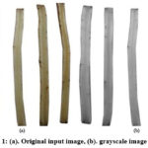
Logarithmic Transformation
Logarithmic transformation is usually used for the aim of pressing or increasing the dynamic series of pixels within the light-weight or dark regions of a picture as in Figure 2(a). Hence, it's needed to map lower intensity price with higher vary of gray scale price and better intensity price with lower vary of gray scale values. Pixel prices in a picture square measure reworked or replaced exploitation power value of every pixel exploitation the formula,
where ‘c’ may be a scaling constant used for image division associated ‘a’ is an intensity price of the initial image (I) at some extent (m,n). the rise in constant price will increase the image brightness. so it's essential to settle on acceptable constant price for improvement to avoid unwell effects like blurness. The numeric price ‘1’ is side within the calculation of scaling issue thus on avoid issues in things wherever log price is vague.

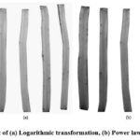

Histogram Processing
Histogram is employed to plot the quantity of oftentimes occurring constituent intensities in a picture. Horizontal axis of bar chart represents info associated with the intensity worths in a very vary of [0–255] for 8-bit image and vertical axis represents info associated with the frequent occurrences of every intensity value inside a picture (Gonzalez and Woods, 2011). huge info is gathered through bar chart because it provides international info concerning the image properties as well as its look and texture. In bar chart process, distinction of a picture is increased by doing mathematical manipulations over the bar chart. It modifies the active vary of constituent intensities in a picture mistreatment
distinct transformation performs. it's employed in completely different modules of image process like image sweetening, image segmentation, image description and compression and is especially useful
in process the important time pictures. bar chart deed, bar chart matching and adjustive bar chart deed area unit some ordinarily offered bar chart process ways.
Histogram Deed
It is a well-known methodology want to enhance the image distinction by spreading the intensity values equally in a picture. Complete automatic method with easy machine task is that the major advantage of this methodology. The results of increased output image is solely passionate about the bar chart of input image. It considers variable assigned to intensity values of input image either as continuous or distinct variable. during this methodology, the noninheritable input image is remapped or reworked into a brand new image i.e., the output image mistreatment the mapping perform,
where ‘A’ is that the intensity values of input image and ‘I’ is that the intensity values of output image. ‘f(A)’ should be single price and should increase monotonically that square measure the main conditions that confirm the validity of mapping. It uniformly distributes the bar graph of input image to get AN increased output image. This mapping is completed victimisation likelihood
density perform that assures that the bar graph of output image is equally distributed .

Adaptive Histogram Equalization

Generally, bar chart equalisation technique is world in nature and is appropriate for things
wherever the whole image region has to be increased. It lacks to perform higher for
native region improvement in a picture. bar chart of native regions should be manipulated to boost the desired native region in a picture. This method is achieved by adjustive bar chart equalisation
wherever the various regions within the image square measure manipulated through regions native
properties. window approach may be a easy, easier and customary technique wont to enhance the image victimisation adjustive bar chart equalisation.
It breaks the image into completely different little blocks or tiles or windows and these blocks use outer window to get the desired bar chart equalisation. This technique is extremely a lot of sure-fire and useful to extend the distinction of native regions as in Figure 4(a). There's the next likelihood for over increase in distinction and prevalence of block artefacts in a picture. To avoid these artefacts, the outer window size is inflated relatively to the inner window size. So as to limit the rise in distinction worth at intervals sure limit, distinction restricted adjustable bar chart equalisation technique is swollen from the adjustable bar chart equalisation technique for higher and economical increased result.

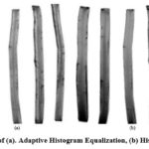

Histogram Matching
Histogram Matching or bar chart Specification is predicated on an equivalent principles of bar chart leveling. not like bar chart leveling wherever the target bar chart distribution is automatic, during this technique, the target bar chart distribution is user-specific. this system is suited within the things wherever the user has data or plan concerning the regions in input image that need sweetening. needed bar chart form is specified manually either by a function or from Associate in Nursing existing reference image with needed bar chart distribution.
Fuzzy image sweetening strategies
The developments and innovations within the idea of symbolic logic sealed its means for applications in image process. this idea of symbolic logic was ab initio integrated into image process by researchers like Prewitt, Pal et al., and Rosenfeld (Chaira and Ray, 2016). The pel values that area unit the key constituent in a picture area unit unsure, inaccurate and indeterministic.
thus throughout the event of an automatic system for banana fruit quality analysis, the interpretations supported the crisp set of pel values may mislead. that the use of symbolic logic by considering pel values as fuzzy in nature would turn out correct, bound and reliable result. The fuzzy image process is taken into account as a compilation of assorted fuzzy approaches with 3 main stages specifically, fuzzification, modification of membership values and defuzzification. Fuzzy set idea is applied in various modules of image process like image sweetening, image segmentation and image retrieval. In image sweetening, distinction of a picture is adjusted by modifying the membership values to remodel the first image into increased image (Pal and King, 1981). thus, for this purpose of adjusting and remodeling the pel values membership perform is applied. There area unit various fuzzy based mostly sweetening strategies accessible in literature exploitation fuzzy intensification operator, fuzzy if-then rules and fuzzy mean value then on. during this section the usually used fuzzy based mostly sweetening strategies exploitation fuzzy intensification operator and fuzzy if-then rules area unit mentioned intimately.
Image sweetening exploitation fuzzy if-then rules
Fuzzy rule based mostly strategies area unit terribly helpful even for issues that area unit non-linear in nature. it's tedious to outline settled criteria for enhancing a picture. This task has been created less complicated exploitation the fuzzy approach. it's supported the easy classical rule system – “if (specific condition) then (specific action)”. Specific rules area unit outlined for the pixels in a picture for sweetening (Li and rule, 1989). These rules or conditions area unit fashioned by considering the grey level pel worth in a picture. supported these conditions choices area unit created severally so it's combined along to create a final judgment. in an exceedingly
straightforward fuzzy if-then system, the most, minimum and middle grey levels of a picture is calculated. As a fuzzification method, the membership values area unit assigned for the various (dark, grey and bright) regions of a picture. Then a fuzzy abstract thought is finished to switch the membership functions in a picture. As a consequence of abstract thought mechanism, the pel values of various regions with dark, grey and white is remodelled into black, grey and white. Then exploitation the inverse of fuzzification, the results of abstract thought system is defuzzied(Figure 5.a.).
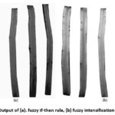

Image enhancement using fuzzy intensification operators
In this fuzzy method of image enhancement, contrast of an image is improved by using fuzzy intensification operator (Figure 5.b.). As this method depends mostly on the gray levels of an image, the gray scale image is considered as a single fuzzy set (Hanmandlu et al., 2003; Hanmandlu and Jha, 2006). The membership function for this fuzzy set is defined as
where “Imax” and “Imin” are the maximum and minimum gray levels in an image, ‘I’, ‘x’ and ‘y’ are the pixel co-ordinate points for image location (x,y), ‘d’ and ‘e’ are the fuzzifiers used to control the uncertain amount of greyness in an image.
In this method, pixel values are darker when the membership value is less than 0.5 and pixel values are brighter when the membership value is greater than 0.5. The main objective of this method is to reduce the fuzziness in an image.Image with low contrast has more fuzziness in the image fuzzy set and to increase the contrast of image, the fuzziness must be reduced. So the intensification operator for the set is defined as
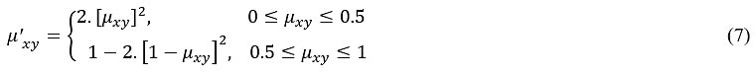
After modifying the membership function, the modified values are transformed into the spatial domain using an inverse function.
Performance Evaluation
The root pictures were collected from twenty banana plants at Sirumugai village, Coimbatore District, Tamil Nadu, India. the basis samples taken from banana plant were split vertically into 2 halves in such the way to check any harm or infection on roots as per INIPAB root harm assessment
pointers (Carlier et al., 2003). Performance of the spatial based mostly improvement strategies was evaluated over 10 real time banana root pictures. beneath classical improvement strategies,
completely different purpose process strategies like distinction stretching, logarithmic transformation, law transformation, bar graph deed, adaptative bar graph deed and bar graph matching; and fuzzy based mostly improvement strategies victimisation fuzzy intensification operator and fuzzy if-then rules were wont to enhance the banana root pictures.
The enhanced output earned through completely different classical purpose process strategies and fuzzy based mostly strategies should be analyzed and evaluated. The performance of improvement strategies area unit assessed either by victimisation qualitative or quantitative assessment strategies. The qualitative methodology of analysis relies on human judgments and faces challenges like human bias, value and time consumption and unreliableness. therefore it most popular to use the quantitative methodology of assessment for evaluating the performance of various improvement strategies. because the knowledge set is real time in nature and has no ground truth image, no-reference image quality methodology is appropriate for assessment. technologist entropy and blind image quality index area unit the 2 no-reference image quality metric utilized in this paper.
Entropy
Shannon entropy measures the uncertainty or information in an image (Surya prabha and Satheeshkumar, 2016b). It is a classical method of evaluation used for no-reference image data sets. The concept of this method has been taken from information theory and is calculated using,
where ‘e’ denotes pixels frequency and ‘a’ denotes intensity value of pixel. Entropy with lower value have less uncertainty in an image and entropy with higher value have more uncertainty in an image.
Blind Image Quality Index (BIQI)
Blind image quality assessment measures the property worth in a picture victimization renyi entropy and normalized pseudo-Wigner distribution (Gabarda and Cristobal, 2007). BIQI calculates the expected entropy variance worth supported the spatial statistical distribution (pixel-by-pixel) from a collection of predefined directions in a picture and generates entropy bar chart. The spatial statistical distribution is calculated as a distinct approximation for a chance density operate. The distinct approximation is calculated victimization the nuclear physicist distribution for the choice of directivity for variance calculation. Hence, the normalized Pseudo-Wigner distribution is employed for extracting the spatial statistical distribution in a picture.
The renyi entropy is defined for discrete space-frequency distribution F[x, y] as
where ‘x’ is the spatial variable and ‘y’ is the frequency variable and in general ‘α’ value of 2 is recommended for the space-frequency distribution.
The variance value calculated from renyi entropy is considered as the directionality function and is used as anisotropy indicator. This method is very much useful to assess the quality of real time images. Blind Image Quality Index (BIQI) with higher value indicates the better performance of the method and with lower value indicates poor performance of the method.
Analysis of Data Sets
Entropy and BIQI was calculated for the improved pictures achieved through totally different
sweetening techniques. the information sets of Entropy and BIQI obtained from distinction
stretching, exponent transformation, Stevens' law transformation, bar chart equalisation, adaptive bar chart equalisation, bar chart matching, fuzzy intensification operator and fuzzy if-then rules strategies were statistically analyzed. Analysis of variance (ANOVA) with Tukey’s HSD multiple vary tests was wont to compare the importance of datasets of various sweetening strategies. The code used for applied math analysis was IRRISTAT version ninety two developed by International Rice analysis Institute life science unit, Philippines (Panse and Sukhatme, 1989).

Results and Discussion
The results of Entropy and BIQI values for different image enhancement methods are shown in Figure 6 and Figure 7. The fuzzy if-then rules methods recorded less entropy values (3.89 – 4.66) and high BIQI values (0.025 – 0.046). Adaptive Histogram Equalization technique recorded the high entropy values (4.62 – 5.38) where as Logarithmic Transformation recorded the least BIQI values (0.003 – 0.010).
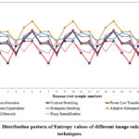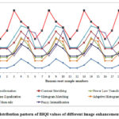
The average Entropy and BIQI values for different image enhancement methods are shown in Figure 8 and Figure 9. Statistical analysis of variance revealed that there was significant differences among the eight different image enhancement techniques in entropy (F = 7.30; df = 7, 72; P ≤ 0.001) and BIQI (F = 19.7; df = 7, 72; P ≤ 0.001). Entropy is significantly lower (4.40) in fuzzy if-then rules techniques than all other methods evaluated. Adaptive Histogram Equalization techniques had significantly high mean entropy values (5.03). BIQI value was lowest for the Logarithmic Transformation (0.005). BIQI value was significantly higher for fuzzy if-then rules method (0.347). The results clearly indicated that the fuzzy if-then rules method is best method among different image enhancement techniques to enhance the banana root images.
The performance of these image enhancement methods with standard data set (CSIQ) were also compared in our earlier study and showed that fuzzy if-then rules method is better than other methods (Prabha, 2018). Also our earlier study demonstrated that performance of image enhancement by fuzzy if-then rules method improved the classification accuracy of leaf disease image sets significantly.
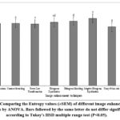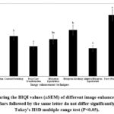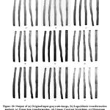

Conclusion
Numerous algorithmic approaches ar offered to change and alter the non inheritable pictures to create them have higher human interpretation and visual understanding. Plant root illness identification victimisation real time pictures is one in every of the thrust areas in agriculture sector. This paper reviewed varied abstraction domain image sweetening techniques existing in literature that may be exploited for up quality of root pictures. This study compared completely different classical purpose process strategies (contrast stretching, index transformation, law transformation, bar graph exploit, adaptative bar graph exploit and bar graph matching) and fuzzy based mostly strategies for real time banana root pictures. Performance of all strategies was evaluated victimisation entropy and blind image quality index. Results disclosed that fuzzy based mostly if-then rule technique is activity higher to boost the banana root image quality. this method is effective in eliminating the noise, conserving image boundaries and fine details. therefore sweetening of banana root pictures by fuzzy if-then rule based mostly technique can improve the accuracy for additional steps of image segmentation, feature extraction and classification whereas making the banana root illness identification method.
A signal is reborn between the time and frequency domains with a combine of mathematical operators referred to as a remodel. AN example is that the Fourier remodel, that decomposes a perform into the total of a (potentially infinite) variety of wave frequency parts. The 'spectrum' of frequency parts is that the frequency domain illustration of the signal. The inverse Fourier remodel converts the frequency domain perform back to a time perform. The fft and ifft functions in MATLAB permit you to figure the distinct Fourier remodel (DFT) of a sign and also the inverse of this remodel severally.
algebra homomorphism from L1 to L∞, without renormalizing the Lebesgue measure.
Many other characterizations of the Fourier transform exist. For example, one uses the Stone–von Neumann theorem: the Fourier transform is the unique unitary intertwiner for the symplectic and Euclidean Schrödinger representations of the Heisenberg group.

Fs = 44100;
y = audioread('guitartune.wav');
Use fft to observe the frequency content of the signal.
NFFT = length(y);
Y = fft(y,NFFT);
F = ((0:1/NFFT:1-1/NFFT)*Fs).';
The output of the FFT is a complex vector containing information about the frequency content of the signal. The magnitude tells you the strength of the frequency components relative to other components. The phase tells you how all the frequency components align in time.
Plot the magnitude and the phase components of the frequency spectrum of the signal. The magnitude is conveniently plotted in a logarithmic scale (dB). The phase is unwrapped using the unwrap function so that we can see a continuous function of frequency.
magnitudeY = abs(Y); % Magnitude of the FFT
phaseY = unwrap(angle(Y)); % Phase of the FFT

helperFrequencyAnalysisPlot1(F,magnitudeY,phaseY,NFFT)
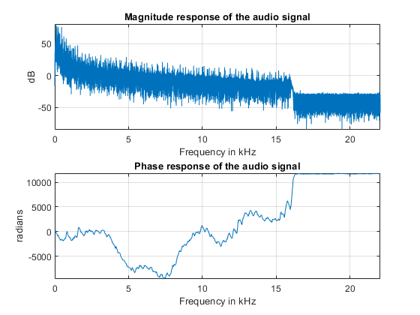

You can apply an inverse Fourier transform to the frequency domain vector, Y, to recover the time signal. The 'symmetric' flag tells ifft that you are dealing with a real-valued time signal so it will zero out the small imaginary components that appear on the inverse transform due to numerical inaccuracies in the computations. Notice that the original time signal, y, and the recovered signal, y1, are practically the same (the norm of their difference is on the order of 1e-14). The very small difference between the two is also due to the numerical inaccuracies mentioned above. Play and listen the un-transformed signal y1.
y1 = ifft(Y,NFFT,'symmetric');
norm(y-y1)
ans = 3.7851e-14

hplayer = audioplayer(y1, Fs);
play(hplayer);
To see the effects of changing the magnitude response of the signal, remove frequency components above 1 kHz directly from the FFT output (by making the magnitudes equal to zero) and listen to the effect this has on the sound of the audio file. Removing high frequency components of a signal is referred to as lowpass filtering.
Ylp = Y;
Ylp(F>=1000 & F<=Fs-1000) = 0;

helperFrequencyAnalysisPlot1(F,abs(Ylp),unwrap(angle(Ylp)),NFFT,...
'Frequency components above 1 kHz have been zeroed')
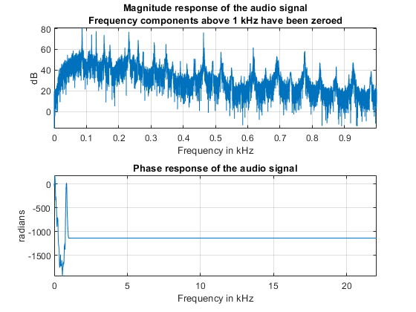
Get the filtered signal back into time domain using ifft.

ylp = ifft(Ylp,'symmetric');
Play the signal. You can still hear the melody but it sounds like if you had covered your ears (you filter high frequency sounds when you do this). Even though guitars produce notes that are between 400 and 1 kHz, as you play a note on a string, the string also vibrates at multiples of the base frequency. These higher frequency components, referred to as harmonics, are what give the guitar its particular tone. When you remove them, you make the sound seem "opaque".
hplayer = audioplayer(ylp, Fs);
play(hplayer);
The phase of a signal has important information about when in time the notes of the song appear. To illustrate the importance of phase on the audio signal, remove the phase information completely by taking the magnitude of each frequency component. Note that by doing this you keep the magnitude response unchanged.
% Take the magnitude of each FFT component of the signal
Yzp = abs(Y);
helperFrequencyAnalysisPlot1(F,abs(Yzp),unwrap(angle(Yzp)),NFFT,[],...
'Phase has been set to zero')
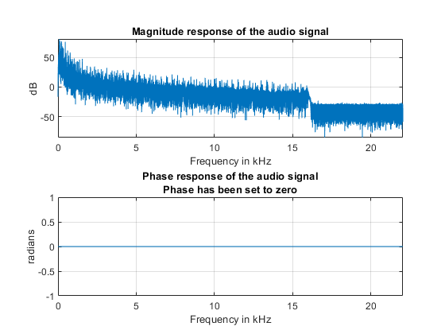
Get the signal back in the time domain and play the audio. You cannot recognize the original sound at all. The magnitude response is the same, no frequency components have been removed this time, but the order of the notes has disappeared completely. The signal now consists of a group of sinusoids all aligned at time equal to zero. In general, phase distortions caused by filtering can damage a signal to the point of rendering it unrecognizable.
yzp = ifft(Yzp,'symmetric');
hplayer = audioplayer(yzp, Fs);
play(hplayer);

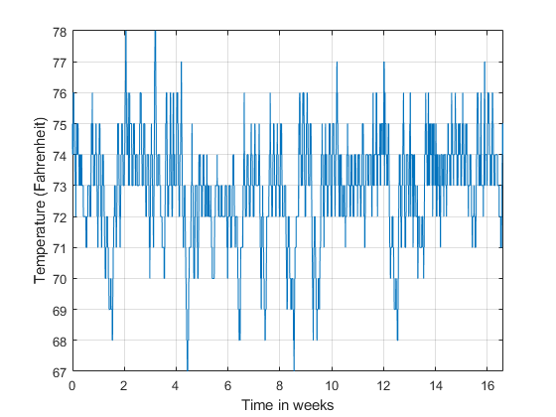
It is almost impossible to know if there is any cyclic behavior on the office temperatures by looking at the time-domain signal. However, the cyclic behavior of the temperature becomes evident if we look at its frequency-domain representation.
Obtain the frequency-domain illustration of the signal. If you plot the magnitude of the FFT output with a frequency axis scaled to cycles/week, you'll see that there ar 2 spectral lines that ar clearly larger than the other frequency part. One spectral line lies at one cycle/week, the opposite one lies at seven cycles/week. This is sensible providing the info comes from a temperature-controlled building on a seven day calendar. the primary spectral line indicates that building temperatures follow a weekly cycle with lower temperatures on the weekends and better temperatures throughout the week. The second line indicates that there's additionally a daily cycle with lower temperatures throughout the night and better temperatures throughout the day.

NFFT = length(temp); % Number of FFT points
F = (0 : 1/NFFT : 1/2-1/NFFT)*Fs; % Frequency vector

TEMP = fft(temp,NFFT);
TEMP(1) = 0; % remove the DC component for better visualization

helperFrequencyAnalysisPlot2(F*60*60*24*7,abs(TEMP(1:NFFT/2)),...
'Frequency (cycles/week)','Magnitude',[],[],[0 10])
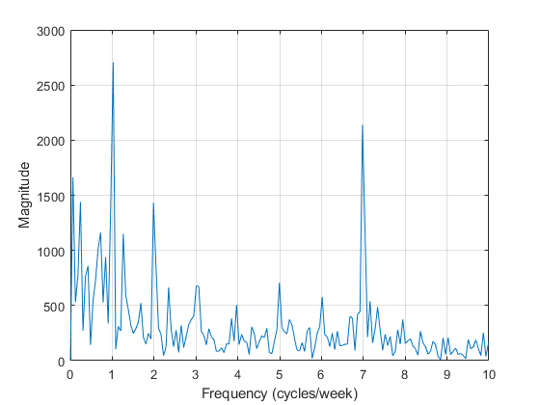

Measuring Power
The periodogram perform computes the signal's FFT and normalizes the output to get an influence spectral density, PSD, or an influence spectrum from that you'll be able to live power. The PSD describes however the facility of a signaling is distributed with frequency, it's units of watts/Hz. You figure the facility spectrum by desegregation every purpose of the PSD over the frequency interval at that that time is outlined (i.e. over the resolution information measure of the PSD). The units of the facility spectrum ar watts. you'll be able to scan power values directly from the facility spectrum while not having to integrate over associate interval. Note that the PSD and power spectrum ar real, so that they don't contain any part data.

Measuring Harmonics at the Output of a Non-Linear Power Amplifier
Load the data measured at the output of a power amplifier that has third order distortion of the form , where is the output voltage and is the input voltage. The data was captured with a sample rate of 3.6 kHz. The input consists of a 60 Hz sinusoid with unity amplitude. Due to the nature of the non-linear distortion, you should expect the amplifier output signal to contain a DC component, a 60 Hz component, and second and third harmonics at 120 and 180 Hz.
Load 3600 samples of the amplifier output, compute the power spectrum, and plot the result in a logarithmic scale (decibels-watts or dBW).
load ampoutput1.mat
Fs = 3600;
NFFT = length(y);

% Power spectrum is computed when you pass a 'power' flag input
[P,F] = periodogram(y,[],NFFT,Fs,'power');

helperFrequencyAnalysisPlot2(F,10*log10(P),'Frequency in Hz',...
'Power spectrum (dBW)',[],[],[-0.5 200])
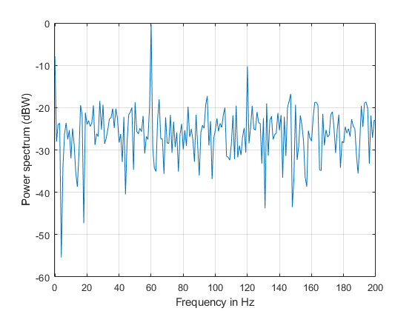
The plot of the power spectrum shows three of the four expected peaks at DC, 60, and 120 Hz. It also shows several more spurious peaks that must be caused by noise in the signal. Note that the 180 Hz harmonic is completely buried in the noise.
Measure the power of the visible expected peaks:
PdBW = 10*log10(P);
power_at_DC_dBW = PdBW(F==0) % dBW

[peakPowers_dBW, peakFreqIdx] = findpeaks(PdBW,'minpeakheight',-11);
peakFreqs_Hz = F(peakFreqIdx)
peakPowers_dBW
power_at_DC_dBW =
-7.8873

peakFreqs_Hz =

60
120

peakPowers_dBW =

-0.3175
-10.2547

Improving Power Measurements for Noisy Signals
As seen on the plot higher than, the periodogram shows many frequency peaks that aren't associated with the signal of interest. The spectrum appearance terribly screaky. the explanation for this is often that you simply solely analyzed one short realization of the screaky signal. continuation the experiment many times and averaging would take away the spurious spectral peaks and yield a lot of correct power measurements. you'll be able to accomplish this averaging mistreatment the pwelch operate. This operate can take an outsized knowledge vector, break it into smaller segments of a nominal length, figure as several periodograms as there ar segments, and average them. because the range of obtainable segments will increase, the pwelch operate can yield a electric sander power spectrum (less variance) with power values nearer to the expected values.
Load a larger observation consisting of 500e3 points of the amplifier output. Keep the number of points used to perform the FFTs as 3600 so that floor(500e3/3600) = 138 FFTs are averaged to obtain the power spectrum.
load ampoutput2.mat
SegmentLength = NFFT;

% Power spectrum is computed when you pass a 'power' flag input
[P,F] = pwelch(y,ones(SegmentLength,1),0,NFFT,Fs,'power');

helperFrequencyAnalysisPlot2(F,10*log10(P),'Frequency in Hz',...
'Power spectrum (dBW)',[],[],[-0.5 200])
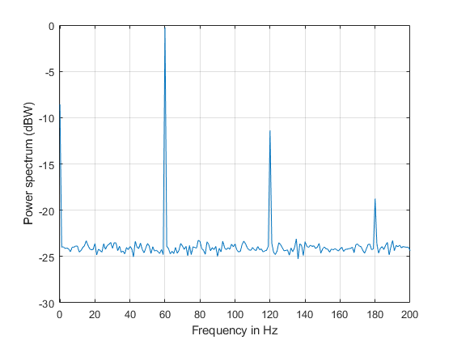
As seen on the plot, pwelch effectively removes all the spurious frequency peaks caused by noise. The spectral component at 180 Hz that was buried in noise is now visible. Averaging removes variance from the spectrum and this effectively yields more accurate power measurements.
Measuring Total Average Power and Power Over a Frequency Band
Measuring the total average power of a time-domain signal is an easy and common task. For the amplifier output signal, y, the total average power is computed in the time domain as:
pwr = sum(y.^2)/length(y) % in watts
pwr =

8.1697

In the frequency-domain, the total average power is computed as the sum of the power of all the frequency components of the signal. The value of pwr1 consists of the sum of all the frequency components available in the power spectrum of the signal. The value agrees with the value of pwr computed above using the time domain signal:
pwr1 = sum(P) % in watts
pwr1 =

8.1698

But what if you wanted to measure the total power available over a band of frequencies? You can use the bandpower function to compute the power over any desired frequency band. You can pass the time-domain signal directly as an input to this function to obtain the power over a specified band. In this case, the function will estimate the power spectrum with the periodogram method.
Compute the power over the 50 Hz to 70 Hz band. The result will include the 60 Hz power plus the noise power over the band of interest:
pwr_band = bandpower(y,Fs,[50 70]);
pwr_band_dBW = 10*log10(pwr_band) % dBW
pwr_band_dBW =

0.0341

If you want to control the computation of the power spectrum used to measure the power in a band, you can pass a PSD vector to the bandpower function. For instance, you can use the pwelch function as you did before to compute the PSD and ensure averaging of the noise effects:
% Power spectral density is computed when you specify the 'psd' option
[PSD,F] = pwelch(y,ones(SegmentLength,1),0,NFFT,Fs,'psd');
pwr_band1 = bandpower(PSD,F,[50 70],'psd');
pwr_band_dBW1 = 10*log10(pwr_band1) % dBW
pwr_band_dBW1 =

Finding Spectral Components
A signal might be composed of one or more frequency components. The ability to observe all the spectral components depends on the frequency resolution of your analysis. The frequency resolution or resolution bandwidth of the power spectrum is defined as R = Fs/N, where N is the length of the signal observation. Only spectral components separated by a frequency larger than the frequency resolution will be resolved.
Analysing a Building's Earthquake Vibration Control System
Active Mass Driver (AMD) control systems are used to reduce vibration in a building under an earthquake. An active mass driver is placed on the top floor of the building and, based on displacement and acceleration measurements of the building floors, a control system sends signals to the driver so that the mass moves to attenuate ground disturbances. Acceleration measurements were recorded on the first floor of a three story test structure under earthquake conditions. Measurements were taken without the active mass driver control system (open loop condition), and with the active control system (closed loop condition).
Load the acceleration data and compute the power spectrum for the acceleration of the first floor. The length of the data vectors is 10e3 and the sample rate is 1 kHz. Use pwelch with segments of length 64 data points to obtain floor(10e3/64) = 156 FFT averages and a resolution bandwidth of Fs/64 = 15.625 Hz. As was shown before, averaging reduces noise effects and yields more accurate power measurements. Use 512 FFT points. Using NFFT > N effectively interpolates frequency points rendering a more detailed spectrum plot (this is achieved by appending NFFT-N zeros at the end of the time signal and taking the NFFT-point FFT of the zero padded vector).
The open loop and close loop acceleration power spectra show that when the control system is active, the acceleration power spectrum decreases between 4 and 11 dB. The maximum attenuation occurs at about 23.44 kHz. An 11 dB reduction means that the vibration power is reduced by a factor of 12.6. The total power is reduced from 0.1670 to 0.059 watts, a factor of 2.83.
load quakevibration.mat

Fs = 1e3; % sample rate
NFFT = 512; % number of FFT points
segmentLength = 64; % segment length

% open loop acceleration power spectrum
[P1_OL,F] = pwelch(gfloor1OL,ones(segmentLength,1),0,NFFT,Fs,'power');

% closed loop acceleration power spectrum
P1_CL = pwelch(gfloor1CL,ones(segmentLength,1),0,NFFT,Fs,'power');

helperFrequencyAnalysisPlot2(F,10*log10([(P1_OL) (P1_CL)]),...
'Frequency in Hz','Acceleration Power Spectrum in dB',...
'Resolution bandwidth = 15.625 Hz',{'Open loop', 'Closed loop'},[0 100])
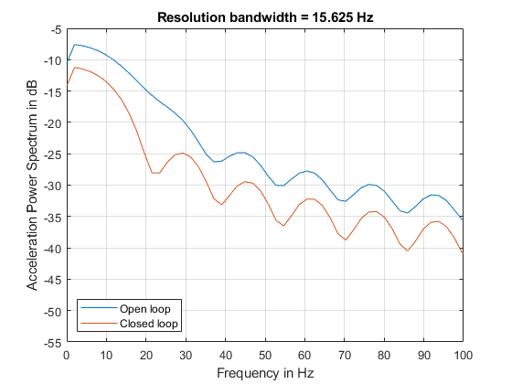
You are analyzing vibration data and you know that vibrations have a cyclic behavior. Then how is it that the spectrum plots shown above do not contain any sharp spectral lines typical of cyclic behavior? Maybe you are missing those lines because they are not resolvable with the resolution obtained with 64 point segment lengths? Increase the frequency resolution to see if there are spectral lines that were not resolvable before. Do this by increasing the data segment length used in the pwelch function to 512 points. This yields a new resolution of Fs/512 = 1.9531 Hz. In this case, the number of FFT averages is reduced to floor(10e3/512) = 19. Clearly, there is a trade-off between number of averages and frequency resolution when using pwelch. Keep the number of FFT points equal to 512.
NFFT = 512; % number of FFT points
segmentLength = 512; % segment length

[P1_OL,F] = pwelch(gfloor1OL,ones(segmentLength,1),0,NFFT,Fs,'power');
P1_CL = pwelch(gfloor1CL,ones(segmentLength,1),0,NFFT,Fs,'power');

helperFrequencyAnalysisPlot2(F,10*log10([(P1_OL) (P1_CL)]),...
'Frequency in Hz','Acceleration Power Spectrum in dB',...
'Resolution bandwidth = 1.95 Hz',{'Open loop', 'Closed loop'},[0 100])
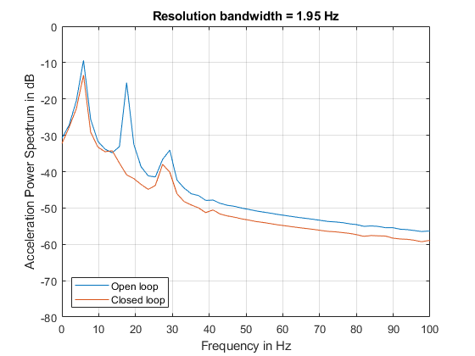
Notice how the increase in frequency resolution allows you to observe three peaks on the open loop spectrum and two on the close loop spectrum. These peaks were not resolvable before. The separation between the peaks on the open loop spectrum is about 11 Hz which is smaller than the frequency resolution obtained with segments of length 64 but larger than the resolution obtained with segments of length 512. The cyclic behavior of the vibrations is now visible. The main vibration frequency is at 5.86 Hz, and the equispaced frequency peaks suggest that they are harmonically related. While it has already been observed that the control system reduces the overall power of the vibrations, the higher resolution spectra shows that another effect of the control system is to notch the harmonic component at 17.58 Hz. So the control system not only reduces the vibration but also brings it closer to a sinusoid.
It is important to note that frequency resolution is determined by the number of signal points, not by the number of FFT points. Increasing the number of FFT points interpolates the frequency data to give you more details on the spectrum but it does not improve resolution.

2.8.9. Analytical Conclusions
In this example you learned how to perform frequency-domain analysis of a signal using the fft, ifft, periodogram, pwelch, and bandpower functions. You understood the complex nature of the FFT and what is the information contained in the magnitude and the phase of the frequency spectrum. You saw the advantages of using frequency domain data when analyzing the periodicity of a signal. You learned how compute the total power or power over a particular band of frequencies of a noisy signal. You understood how increasing the frequency resolution of the spectrum allows you to observe closely spaced frequency components and you learned about the tradeoff between frequency resolution and spectral averaging.

Smoothing Techniques
Colour image smoothing is a component of pre-processing techniques supposed for removing doable
image perturbations while not losing image info. Analogously, sharpening could be a pre-processing technique that plays a very important role for feature extraction in image process. Low pass filtering
is used to get rid of high abstraction frequency noise from a digital image. ... The operator moves over the image to have an effect on all the pixels within the image. High pass filters (Edge Detection, Sharpening) A high-pass filter are often wont to create a picture seem sharpie.
Sharpening then, could be a technique for increasing the apparent sharpness of a picture. It subtracts a blurred (unsharp) copy from the initial image to sight any edges. A mask is created with this edge detail. distinction is then hyperbolic at the sides and also the result is applied to the initial image
In smoothing, the info points of a sign square measure changed therefore individual points beyond the adjacent points (presumably attributable to noise) square measure reduced, and points that square measure under the adjacent points square measure hyperbolic resulting in a sander signal.
Data smoothing ways
1. straightforward Exponential. the easy exponential methodology could be a well-liked knowledge smoothing methodology attributable to the convenience of calculation, flexibility, and sensible performance.
2. Moving Average. The moving average.
3. Random Walk.
4. Exponential Moving Average.
What could be a sander line? A sander line is a line that's fitted to the info that helps you explore the potential relationships between 2 variables while not fitting a selected model, like a regression curve or a theoretical distribution.
Smoothing (also referred to as Accommodating) and Compromising square measure each conflict resolution techniques that may be employed in totally different things. Smoothing emphasizes the common interests of the conflicting parties and de-emphasizes their variations.
The name 'exponential smoothing' is attributed to the employment of the exponential window perform throughout convolution.
The idea behind knowledge smoothing is that it will determine simplified changes so as to assist predict totally different trends and patterns. ... smoothened knowledge is mostly most well-liked by economists as a result of it higher identifies changes in trend compared to wrinkled
knowledge, which can seem a lot of erratic and make false signals.07 .Double Exponential
and Holt-Winters square measure a lot of advanced techniques that may be used on knowledge sets involving seasonality. Exponential Smoothing is one in every of the a lot of well-liked smoothing techniques thanks to its flexibility, ease in calculation, and sensible performance. ... The Exponential Smoothing tool uses the subsequent formulas.

When knowledge collected over time displays random variation, smoothing techniques is accustomed
cut back or cancel the result of those variations. once properly applied, these techniques
disembarrass the random variation within the statistic knowledge to reveal underlying trends.
XLMiner options four totally different smoothing techniques: Exponential, Moving Average, Double Exponential, and Holt-Winters. Exponential and Moving Average area unit comparatively
straightforward smoothing techniques and will not be performed on knowledge sets involving seasonality. Double Exponential and Holt-Winters area unit additional advanced techniques that may be used on knowledge sets involving seasonality.
Exponential Smoothing
Exponential Smoothing is one in every of the additional fashionable smoothing techniques because of its flexibility, ease in calculation, and sensible performance. Exponential Smoothing uses a straightforward average calculation to assign exponentially decreasing weights beginning with the foremost recent observations. New observations area unit given comparatively additional weight within the average calculation than older observations. The Exponential Smoothing tool uses the subsequent formulas.

S0= x0
St = αxt-1 + (1-α)st-1, t > 0
where
original observations are denoted by {xt} starting at t = 0
α is the smoothing factor which lies between 0 and 1
Exponential Smoothing should only be used when the data set contains no seasonality. The forecast is a constant value that is the smoothed value of the last observation.
Moving Average Smoothing:
In Moving Average Smoothing, each observation is assigned an equal weight, and each observation is forecasted by using the average of the previous observation(s). Using the time series X1, X2, X3, ....., Xt, this smoothing technique predicts Xt+k as follows :
St = Average (xt-k+1, xt-k+2, ....., xt), t= k, k+1, k+2, ...N
where, k is the smoothing parameter.
XLMiner permits a parameter price between a pair of and t-1 wherever t is that the range of observations within the knowledge set. Note that once selecting this parameter, an outsized parameter price can oversmooth the info, whereas alittle parameter price can undersmooth the info. The past 3 observations can predict the long run observations. like Exponential Smoothing, this system shouldn't be applied once seasonality is gift within the knowledge set.

Double Exponential Smoothing
Double Exponential Smoothing are often outlined because the algorithmic application of associate exponential filter doubly in a very statistic. Double Exponential Smoothing shouldn't be used once the info includes seasonality. this system introduces a second equation that has a trend parameter; therefore, this system ought to be used once a trend is inherent within the knowledge set, however not used once seasonality is gift. Double Exponential Smoothing is outlined by the subsequent formulas.

St = At + Bt , t = 1,2,3,..., N
Where, At = axt + (1- a) St-1 0< a <= 1
Bt = b (At - At-1) + (1 - b ) Bt-1 0< b <= 1
The forecast equation is: Xt+k = At + K Bt , K = 1, 2, 3, ...
where, a denotes the Alpha parameter, and b denotes the trend parameters. These two parameters can be entered manually.
XLMiner includes an optimize feature that will choose the best values for alpha and trend parameters based on the Forecasting Mean Squared Error. If the trend parameter is 0, then this technique is equivalent to the Exponential Smoothing technique. (However, results may not be identical due to different initialization methods
for these two techniques.)

Holt-Winters Smoothing
Holt Winters Smoothing introduces a third parameter (g) to account for seasonality (or periodicity) in a data set. The resulting set of equations is called the Holt-Winters method, after the names of the inventors. The Holt-Winters method can be used on data sets involving trend and seasonality (a, b , g). Values for all three parameters can range between 0 and 1.

The following three models associated with this method.
Multiplicative: Xt = (At+ Bt)* St +et where At and Bt are previously calculated initial estimates. St is the average seasonal factor for the tth season.
At = axt/St-p + (1-a)(At-1 + Bt-1)

Bt = b(At + At-1) + (1 - b)Bt-1
St = gxt/At + (1 - g)St-p
Additive: Xt = (At+ Bt) +St + et
No Trend: b = 0, so, Xt = A * St +et
Frequency Domain Filters
Frequency Domain Filters area unit used for smoothing and sharpening of image by removal of high or low frequency parts. ... Frequency domain filters area unit completely different from abstraction domain filters because it primarily focuses on the frequency of the photographs. it's primarily in hot water 2 basic operation i.e., Smoothing and Sharpening.
A frequency filter is Associate in Nursing circuit that alters the amplitude Associate in Nursingd typically section of an electrical signal with reference to frequency. ... The frequency separating the attenuation band and therefore the pass is termed the cut-off frequency.
Basic Steps in DFT Filtering
• Obtain the artefact parameters victimization operate paddedsize: ...
• Obtain the Fourier rework of the image with padding: ...
• Generate a filter operate, H , a similar size because the image.
• Multiply the reworked image by the filter: ...
• Obtain the important a part of the inverse FFT of G.
A low-pass filter (LPF) may be a filter that passes signals with a frequency not up to a specific cutoff frequency and attenuates signals with frequencies beyond the cutoff frequency.
The frequency domain illustration of a symbol permits you to watch many characteristics of the signal that square measure either tasking to check, or not visible the least bit once you check out the signal within the time domain. for example, frequency-domain analysis becomes helpful once you square measure trying to find cyclic behavior of a symbol.
The reason for doing the filtering within the frequency domain is usually as a result of it's
computationally quicker to perform 2 second Fourier transforms and a filter multiply than to perform a convolution within the image (spatial) domain. this can be notably thus because the filter size increase an electronic equipment may be a tool unremarkably accustomed see real-world
signals within the time domain.
Maintaining a regular electrical frequency is vital as a result of multiple frequencies cannot operate aboard one another while not damaging instrumentality. ... the precise figure is a smaller amount vital than the necessity to stay frequency stable across all connected systems. In nice Britain, the grid frequency is 50Hz.
Moreover, a time-domain graph will show however a symbol changes with time, whereas a frequency-domain graph can show what proportion of the signal lies at intervals every given
band over a spread of frequencies. So frequency domain is best than time domain.
You can style a band-pass filter around one in every of these higher-frequency harmonics to provide endless wave of the next frequency. These sines square measure referred to as the signal's harmonics, and that they decrease in amplitude as they increase in frequency; you'll have to be compelled to amplify the signal when filtering. frequency domain may be a area that is outlined by Fourier rework. ... Frequency domain analysis is employed to point however signal energy will be distributed during a vary of frequency. the fundamental principle of frequency domain analysis in image filtering is to laptop second separate Fourier rework of the image.
So if frequency will increase, the secondary voltage or electrical phenomenon will increase. And secondary voltage decreases by the reduction of provide frequency. ... however with high frequency there's increase in electrical device losses like core loss and conductor electrical phenomenon. he primary distinction between fifty Hz (Hertz) and sixty Hz (Hertz) is solely
that sixty Hz is 2 hundredth higher in frequency. For a generator or induction motor pump (in easy terms) it means that one,500/3,000 rate or one,800/3,600 rate (for sixty Hz). ... Lower the frequency, speed of induction motor and generator are lower. The amplitude versus frequency is a crucial operate known as the spectrum, that affects the timber of the sound. ... The frequency window shows a plot that indicates the spectral content of the signal because the signal is browse into the sound card.
Radio frequency (RF) is that the oscillation rate of associate alternating electrical phenomenon or voltage or of a magnetic, electrical or magnetic attraction field or system within the frequency varies from around twenty kilocycles per second to around three hundred GHz.

The range of a good frequency response Frequency Response:

20-20kHz ±3dB = Good.
Pitch is measured in Hertz (Hz) and loudness is measured in decibels (dB). ... While 20 to 20,000Hz forms the absolute borders of the human hearing range, our hearing is most sensitive in the 2000 - 5000 Hz frequency range. As far as loudness is concerned, humans can typically hear starting at 0 dB.

The Frequency Domain refers to the analytic house within which mathematical functions or signals square measure sent in terms of frequency, instead of time. as an example, wherever a time-domain graph might show changes over time, a frequency-domain graph displays what proportion of the signal is gift among every given band.
transform is employed during a big selection of applications like image analysis ,image filtering , image reconstruction and compression. The Fourier remodel is a vital image process tool that is employed to decompose a picture into its circular function and circular function parts.
In associate degree inductance, the lower the frequency, the lower its ohmic resistance. therefore having constant voltage over it, this can rise if the frequency gets lower.
Ideal AC power provide is stable frequency, stable voltage, resistance is approx zero and therefore the voltage wave is pure wave (without distortion). ... By employing a frequency device, you'll be able to convert each 60Hz to 50Hz and 50Hz to 60Hz for home appliances, it's conjointly a voltage device for ever-changing 110V to 220V.13-Oct-2014
We should bear in mind that why use 50Hz or 60Hz, instead of lower or higher frequency. In electrical system, frequency could be a vital basic component, not at random determined. ... The frequency of electricity is 50(60) cycle, this direction changes 50(60) cycles, 100(120) times per second.
This activity of cycles per second is expressed in Hertz (Hz), with the next cycle representing higher frequency sound. Low-frequency sounds square measure five hundred cycle or lower whereas high-frequency waves square measure higher than 2000 cycle.
The frequency domain specifications square measure resonant peak, resonant frequency and information measure. the 2 styles of Fourier series are- pure mathematics and exponential.
fourier series is loosely utilized in telecommunications system, for modulation and reception of voice signals, conjointly the input,output and calculation of pulse and their circular function or circular function graph.
Fourier remodel (FT) could be a mathematical remodel that decomposes functions counting on house or time into functions counting on abstraction or temporal frequency, like the expression of a musical chord in terms of the volumes and frequencies of its constituent notes.
The frequency domain illustration of a sign permits you to watch many characteristics of the signal that square measure either demanding to examine, or not visible in the least once you consider the signal within the time domain. as an example, frequency-domain analysis becomes helpful once you square measure trying to find cyclic behaviour of a sign.

Classification of filters
Low pass filter:
Low pass filter removes the high frequency elements meaning it keeps low frequency elements. it's used for smoothing the image. it's accustomed smoothen the image by attenuating high frequency elements and protective low frequency elements.
Mechanism of low pass filtering in frequency domain is given by:

G(u, v) = H(u, v) . F(u, v)
where F(u, v) is the Fourier Transform of original image
and H(u, v) is the Fourier Transform of filtering mask

High pass filter:

High pass filter removes the low frequency components that means it keeps high frequency components. It is used for sharpening the image. It is used to sharpen the image by attenuating low frequency components and preserving high frequency components.
Mechanism of high pass filtering in frequency domain is given by:
H(u, v) = 1 - H'(u, v)
where H(u, v) is the Fourier Transform of high pass filtering
and H'(u, v) is the Fourier Transform of low pass filtering

Band pass filter:
Band pass filter removes the terribly low frequency and extremely high frequency parts meaning it keeps the moderate vary band of frequencies. Band pass filtering is employed to reinforce edges whereas reducing the noise at a similar time.

Homomorphic filtering may be a generalized technique for signal and image process, involving a nonlinear mapping to a unique domain within which linear filter techniques square measure applied, followed by mapping back to the first domain. this idea was developed within the Sixties by Thomas Stockham, Alan V. Oppenheim, and Ronald W. Schafer at MITand severally by Bogert, Healy, and Tukey in their study of your time series.
Image Enhancement
Homomorphic filtering is usually used for image improvement. It at the same time normalizes the brightness across a picture and will increase distinction. Here homomorphic filtering is employed to get rid of increasing noise. Illumination and reflectivity aren't severable, however their approximate locations within the frequency domain could also be set. Since illumination and reflectivity mix multiplicatively, the parts ar created additive by taking the index of the image intensity, in order that these increasing parts of the image may be separated linearly within the frequency domain. Illumination variations may be thought of as a increasing noise, and may be reduced by filtering within the log domain.
To make the illumination of a picture a lot of even, the high-frequency parts ar enlarged and low-frequency parts ar diminished, as a result of the high-frequency parts ar assumed to represent largely the reflectivity within the scene (the quantity of sunshine mirrored off the item within the scene), whereas the low-frequency parts ar assumed to represent largely the illumination within the scene. That is, high-pass filtering is employed to suppress low frequencies and amplify high frequencies, within the log-intensity domain.
Operation
Homomorphic filtering can be used for improving the appearance of a grayscale image by simultaneous intensity range compression (illumination) and contrast enhancement (reflection).
{\displaystyle m(x,y)=i(x,y)\bullet r(x,y)}
Where,
m = image,
i = illumination,
r = reflectance
We have to transform the equation into frequency domain in order to apply high pass filter. However, it's very difficult to do calculation after applying Fourier transformation to this equation because it's not a product equation anymore. Therefore, we use 'log' to help solving this problem.
{\displaystyle \ln(m(x,y))=\ln(i(x,y))+\ln(r(x,y))}
Then, applying Fourier transformation
{\displaystyle \digamma (ln(m(x,y)))=\digamma (ln(i(x,y)))+\digamma (ln(r(x,y)))}
Or {\displaystyle M(u,v)=I(u,v)+R(u,v)}
Next, applying high-pass filter to the image. To make the illumination of an image more even, the high-frequency components are increased and low-frequency components are decrease.
{\displaystyle N(u,v)=H(u,v)\bullet M(u,v)}
Where
H = any high-pass filter
N = filtered image in frequency domain
Afterward, returning frequency domain back to the spatial domain by using inverse Fourier transform.
{\displaystyle n(x,y)=invF(N(u,v))}
Finally, using exponential function to eliminate the log we used at the beginning to get the enhanced image
The following figures show the results by applying homomorphic filter, high-pass filter, and both homomorphic and high-pass filter . All figures are produced by using Matlab.

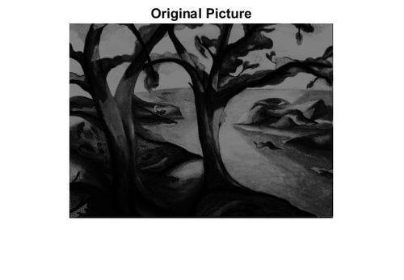

Figure 1: Original image: trees.tif

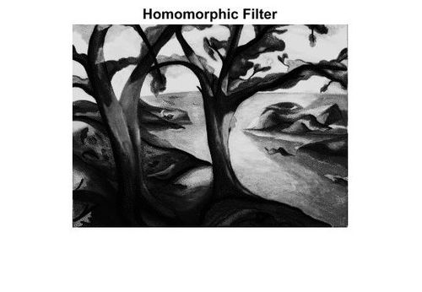

Figure 2: Applying homomorphic filter to original image

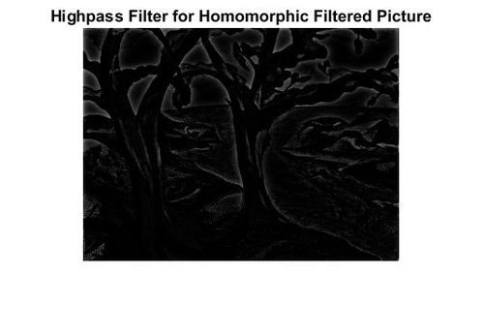
Figure 3: Applying high-pass filter to figure 2

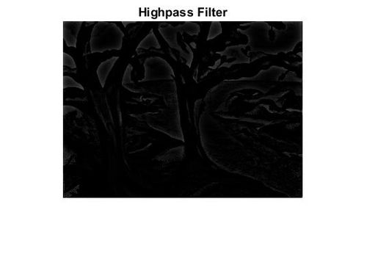
Figure 4: Applying high-pass filter to original image (figure 1)

According to the figures one to four, we will see that however homomorphic filtering is employed for correcting non-uniform illumination in image, and also the image become clearer than the first image. On the opposite hand, if we have a tendency to apply high pass filter to homomorphic filtered image, the sides of the photographs become scammer and also the different areas become variable resistor. This result's as similar as simply doing high pass filter solely to the first image.
Anti-Homomorphic Filtering
Audio and Speech Analysis:
Holomorphic filtering is used in the log-spectral domain to separate filter effects from excitation effects, for example in the computation of the cestrum as a sound representation; enhancements in the log spectral domain can improve sound intelligibility, for example in hearing aids.
Surface electromyography signals (SEMG)
Holomorphic filtering was used to removes the effect of the stochastic impulse trains, which originates the SEMG signal, from the power spectrum of SEMG signal itself. In this way, only information on motor unit action potential (MUAP) shape and amplitude were maintained, and then, used to estimate the parameters of a time-domain model of the MUAP itself.

Neural decoding
How individual neurons or networks encode information is the subject of numerous studies and research. In central nervous system it mainly happens by altering the spike firing rate (frequency encoding) or relative spike timing (time encoding). Time encoding consists of altering the random inter-spikes intervals (ISI) of the stochastic impulse train in output from a neuron. Holomorphic filtering was used in this latter case to obtain ISI variations from the power spectrum of the spike train in output from a neuron with or without the use of neuronal spontaneous activity. The ISI variations were caused by an input sinusoidal signal of unknown frequency and small amplitude, i.e. not sufficient, in absence of noise to excite the firing state. The frequency of the sinusoidal signal was recovered by using holomorphic filtering-based procedures.
References:
1.
R. C. Gonzalez and R. E. Woods, Digital Image Processing, New Jersey:Person Prentice Hall, 2008.
2.
K. Narasimhan, C. R. Sudarshan and R. Nagarajan, "A comparison of contrast enhancement techniques in poor illuminated gray level and color images", International Journal of Computer Applications, vol. 25, pp. 17-25, Jul. 2011.
3.
T. Gabriel, F. T. Daniel and P. Stephen, "Histogram specification: s fast and flexible method to process digital images", IEEE Transactions on Instrumentation and Measurement, vol. 60, pp. 1565-1578, May 2011.
4.
Y. M. Li, Y. B. Rao, L. T. Chen et al., "Color image enhancement using tone mapping", Journal of Digital Content Technology and its Applications, vol. 6, pp. 631-639, Dec. 2012.
5.
Bhabatosh Chanda and Dwijest Dutta Majumder, Digital Image Processing and Analysis, 2002.
6.
Raman Maini and Himanshu Aggarwal, "A Comprehensive Review of Image Enhancement Techniques", Journal of Computing, vol. 2, pp. 8-13, Mar. 2010.
7.
Q Wang and R K Ward, "Fast Image/Video Contrast Enhancement Based on Weighted Thresholded Histogram Equalization", IEEE Transactions on Consumer Electronics, vol. 53, pp. 757-764, Apr. 2007.
8.
T. Arici, S. Dikbas and Y. Altunbasak, "A histogram modification framework and its application for image contrast enhancement", IEEE Transactions on Image Processing, vol. 18, pp. 1921-1935, Sept. 2009.
9.
WU Zhi-guo and WANG Yan-jie, "An Image Enhancement Algorithm Based on Histogram Nonlinear Transform", Acta Photonica Sinica, vol. 39, pp. 755-758, Apr. 2010.
10.
J You, "Contrast enhancement using histogram equalization based on logarithmic mapping", Optical Engineering, vol. 51, pp. 7002, June 2012.
11.
S Bhattacharya, S Gupta and V K Subramanian, "Localized image enhancement", Proc. 2014 20th National Conference on Communications, pp. 1-6, Feb. 2014.
12.
M B Hossain, K W Lai, B Pingguan-Murphy et al., "Contrast enhancement of ultrasound imaging of the knee joint cartilage for early detection of knee osteoarthritis", Biomedical Signal Processing & Control, vol. 13, pp. 157-167, Apr. 2014.
13.
W Zhao, Z Xu, J Zhao et al., "Variational infrared image enhancement based on adaptive dual-threshold gradient field equalization", Infrared Physics & Technology, vol. 66, pp. 152-159, Sept. 2014.
14.
F M Kheirkhah, H R S Mohammadi and A Shahverdi, "Histogram non-linear transform for sperm cells image detection enhancement", Proc. 2016 Eighth International Conference on Information and Knowledge Technology, pp. 25-30, Dec. 2016.
15.
S Wang, W Cho, J Jang et al., "Contrast-dependent saturation adjustment for outdoor image enhancement", Journal of the Optical Society of America A, vol. 34, pp. 2532-2542, Jan. 2017.

