The Need To Consume Ten Leafy Vegetables During Monsoon - A review
Maneesha C R¹, Sona A² and Jyothilekshmi.S¹
¹Department of Bio sciences, Union Christian College, Aluva
²Department of Biotechnology, SAS SNDP College, Konni.
Email: jyothilekshmis@uccollege.edu.in

Abstract

Leaves can reduce the acidity in the body and make it alkaline, which prevents several diseases. The consumption of a combination of leaves of ten medicinal plants (pathila)which are available from our surroundings has immense health benefits during the month of Karkidaka , June- July in south India.
Keywords

Ayurveda, green leaves, medicinal properties

- Introduction

The earliest texts of ayurveda like Charaka Samhita is its specific emphasis of the relationship between health and seasons. Though the seasonal changes and climatic changes have a particularly important effect on the health, ayurveda has recommended a seasonal specific conduct to cope up with the changes in the environment.
Green leaves are rich in minerals and iron and extremely good for detoxing and cleansing the body. Wrong diets can cause many illnesses during the monsoon season. Our ancestors made it a practice to consume a wide range of leaves during this month, usually set apart for reawakening the body. one of which was following a diet rich in greens such as “ Karkiddkakka kanji and PathilaThoran” ( a stir fry of then leaves). These leaves can be used to make different types of vegetable dishes and available from fields and homesteads. These include Colocasia esculenta, Benincasa hispida, Vigna unguiculata, Amorphophallus paeoniifolius, Amaranthus spinosus, Cucurbita maxima, Senna tora, Diplocyclos palmatus, Boerhaavia diffusa , Solanum nigrum .
Consumption of these ten leaves (Pathila) has immense health benefits during the month of June-July in South India (Karkidaka). These leafy vegetables are easily available from our surroundings and are rich in antioxidants, vitamins, minerals, and proteins that help to improve our immune system.This chapter summarises the bioactivities of these ten leaves reported
.
II. Traditional uses, phytochemistry amd biological properties

- Colocasia esculenta (kaatu thal)

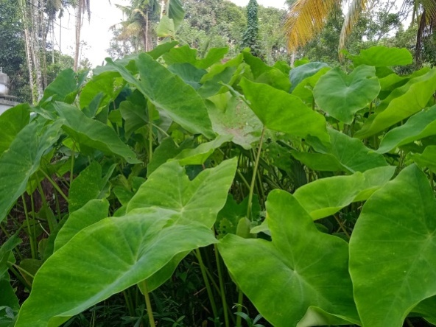
Figure 1 colocasia esculenta
Colocasia esculenta is a herbaceous erect perennial tuberous plant belonging to the family Araceae. It is a fast growing plant seen along streams canals and other aquatic locations with large edible corms. The large leaves are arrowheaded in shape and are peltate grows up to 2 feet long. The taro leaves are well known for their hydrophobicity[1]
In a study pytochemicals from the plant leaves were extracted and characterized using Fourier-transform infrared spectroscopy (FTIR) to find the functional groups. Phytochemical analysis of Colocasiaesculenta (L.) leaf was studied using three solvents (methanol, chloroform, and ethanol) with soxhlet apparatus. Powder of the leaves was employed to obtain the extracts, which was qualitatively and quantitatively analyzed for phytochemical content using standard methods. Phytochemical constituents were abundant in the leaf extract and was found to have various phytochemicals such as alkaloids, glycosides, flavonoids, terpenoids, saponins, oxalates and phenols etc., which could have lot of medicinal benefits such as reducing headache, treatment of congestive heart failure, prevent oxidative cell damage etc. These phytochemicals were identified using UV spectrophotometer and results were presented. In order to find the antioxidant activity of the extract, DPPH (2,2-diphenyl-1- picrylhydrazyl) method was employed using ascorbic acid as standard. DPPH scavenging activity of ascorbic acid was found to be 84%, whereas for ethanol it was observed to be 78.92%, for methanol: 76.46% and for chloroform: 72.46%. Looking at the high antioxidant activity, Colocasiaesculenta may be recommended for medicinal applications. The characterizations of functional groups were analyzed using FTIR spectroscopy and the results showed that the wavenumbers at 3347, 3350 & 3395 cm-1 were identified as phenolic compound; 2969, 2916, 2847, 1378, 2921, 2850 & 1377 cm-1. as alkyl methyl and alkyl methylene groups; 1734, 1645, 1451, 1736, 1657, 839 & 878 cm-1 as aromatic groups in ethanol and chloroform extracts; 1271 & 1551 cm-1 as carboxylic acids in ethanol and chloroform extracts respectively; 1462 cm-1 and 1216 cm-1 as organophosphorus aromatic and aliphatic amine groups respectively[2].
Phytochemical screening of Colocasia esculenta leaves reveals the presence of phenols, tannin, saponins, steroids, quinine, trepenoids, glycosides, alkaloids except flavonoids and the antibacterial property of leaves in ethyl acetate extract for 100 ppm concentration showed more effective against Pseudomonas aeruginosa[3].
In a pharmacognostic and pharmacological review of Colocasiaesculenta (L.) Schott (Family: Araceae) reported that several countries uses the plant in traditional medicine, mainly in tropical and subtropical regions. South Asians are the major cultivars of colocasia, which is an annual herbaceous plant and the plant is commonly called as Arbi, Arvi, and Eddoe. The roots and young leaves contain calcium, phosphorus, thiamine, riboflavin, niacin, oxalic acid, calcium oxalate, sapotoxin and flavones, apigenin, and luteolin and also rich in vitamin C and starch. Alkaloids, glycosides, flavonoids, terpenoids, saponins, oxalates, phenols are the phytochemicals screened in the plant. The plant is used in the treatments like asthma, arthritis, diarrhea, internal hemorrhage, neurological disorders, and skin disorders traditionally. The phytopharmacological properties like antimicrobial, antihepatotoxic, anti-cancer, antioxidant, antibacterial, antifungal, anthelmintic activity, antidiabetic, hypolipidemic, anti-melanogenic, estrogenic and neuropharmacological effects are explained in this review [4].
The colocasia leaf yield in northern New Zealand was studied. They used the young leaves for preparation of traditional dishes like palusami. The plants are grown in tunnel houses, and he observed a linear relationship between rising degree-days above 10°C in a month and monthly leaf production. He recommended the usage of raised beds in green houses from mid winter to early spring for higher leaf yield and also utilising cool-tolerant Japanese cultivars [5]
An overview regarding the taxonomy and morphology, photochemistry, nutritional value Colocasia reported that esculenta commonly called taro is a tropical plant is grown in the high rainfall areas under flooded condition. Due to this nutritional importance both the tuber and young leaves are consumed in many developing countries. The tubers are rich in carbohydrates, proteins, minerals, and vitamins, 70 to 80 percentage of starch and highly digestible small granules. Therefore taro is used as ornamental plant and are utilised for medicines, root crop and leafy vegetable [6]
A review on nutritional and phytochemical properties of colocasia leaves as a potentionalin human nutrition was done and the report showed that iron (3.4–11.7 mg 100 g–1), copper (0.29–0.8 mg 100 g–1), magnesium (170–752 mg 100 g–1), potassium (0.4–2.4 g 100 g–1), and zinc (0.6–4.2 mg 100 g–1) are the micronutrients present in high amounts in colocasia leaves. The concentration of the nutritional components depends on agronomical factors of the location, climatic conditions etc. 1:40 ratio of sodium to potassium in leaves seems to be effective as antihypertensive. Antidiabetic, antihemorrhagic, neuropharmacological properties are supported by preclinical and clinical studies and also used for stomach and liver ailments. Chlorogenic acid, anthraquinones, cinnamic acid derivatives, and other phenolics are the metabolites which supports these properties. Oxalate, the major limiting factor in the leaves can be suppressed through food processing strategies[7].
In another study the oxalate content of taro leaves upon the effect of soaking and cooking was focused and the reported that this is used as staple food in New Zealand and Pacific Island. The oxalate content leached in to tap water when the raw leaves soaked for 30 minutes, the soluble oxalate content reduces from 236.10 mg oxalate/100 g wet matter. 18 hours soaking reduces 26 percentage soluble oxalate. The insoluble oxalate (calcium oxalate) remained constant upon soaking treatments. Soluble oxalate content remained approximately same while baking but a 36 percentage reduction was observed in boiled taro leaves. 226.28mg oxalate /100g wet matter was the mean insoluble oxalate content of the raw, boiled and baked tissue[8].

- Benincasa hispida (kumbalam)

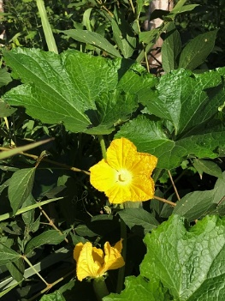
Figure 2 Benincasa hispida

Benincasa hispida of the family Cucurbitaceae, is an annual climbing plant cultivated for its edible fruits. It is known as white gourd, wax gourd, winter melon etc. The 5 lobed leaf is simple and coarsely textured that reach 10 to 15cm in width [9].
The hypogylcemic and protective effect of Benincasa hispida (BH) fruit was studied. Experiment conducted in Streptozotocin- induced diabetes mellitus rats with aqueous extract showed that 250 mg/kg of extract reduced blood glucose considerably. The blood glucose level of diabetes mellitus rats (21.4±1.0 mmol/l) is seen to be lower than control diabetic rats (30.1±3.8 mmol/l) after eight weeks of treatment aqueous extract of Benincasa hispida (BH) fruit. The treated rat shows weight gain, improvement in lipid profile, liver function test, kidney function test and HbA1c. They also compared rats which are treated with metformin and the results indicated that impaired organ (liver and kidney) structures of diabetic rats treated with Benincasa hispida aqueous extract are rectified [10]
A review on pharmacological importance of Benincasa hispida was done and the results showed that flavonoids, volatile oils, glycosides, carotenes, saccharides, proteins, beta-sitosterin, vitamins, minerals and uronic acid are the major phytochemicals analysed. The pharmacological properties include effect on central nervous system as antidepressant, muscle relaxant and also in the treatment of Alzheimer's disease. The plant also possesses anti-inflammatory, analgesic, antioxidant, antiasthmatic, diuretic, antidiabetic, nephroprotective, hypolipidemic and antimicrobial effects. The review focused on pharmacological properties and chemical constituents of Benincasa hispida.[11]
Another review of Benincasa hispida on botanical features, traditional uses, ethnopharmacological, phytochemical, pharmacological properties, molecular mechanisms including anticancer mechanism and toxicology shows that the Chinese people is cultivating ash gourd since 2000 years ago, and they uses as medicine it to treat epilepsy, lung diseases, asthma, antipyretic, antitussive, antiobesity(fruit) and urinary retention (peel). In Ayurveda it is used as antiepileptic, antiasthmatic, bronchodilator, antibacterial and diuretic. In India the fruit is used to make Petha cubes (sugar compote) for vegetarian diet. It act as anti-inflammatory by lowering histamine release, anti-bacterial by decreasing bacterial growth, anti-cancer by increasing cancer cell death, antiobesity by decreasing adipocyte differentiation, PPARγ: peroxisome proliferator activated receptor gamma and C/EBPα: CCAAT enhancer-binding protein alpha, and also act as neuroprotective by increasing cognition, memory, catalase, superoxidase dismutase, reduced glutathione and by increasing lipid peroxidations [12].
The application of ash gourd in food, pharmacological and biomedical industries was studied. Ash gourd fruit is capable of providing high dietary fiber, energy, vitamin C, mineral content, and less anti-nutrients. Not only the fruit but the leaves, flower, fruit peel seeds are also rich in these nutrients. Antioxidative, anti-inflammatory, anti-angiogenic, detoxificant, and curvative effects made the fruit more effective for various ailments. Ca, Mg, Fe, Cu, Zn and Se are the minerals present [13]
The effect on hyperplasia of the prostate by Benincasa fruit extracts was studied. In rats the hyperplasia is induced by administration of testosterone subcutaneously and the study was conducted with petroleum ether extract, ethanolic extract and B hispida seed oil. In vitro studies were conducted to determine the 5α- reductase inhibitory potential of the extracts. The extracts were administered simultaneously and a standard 5alpha reductase is used as positive control. The results of in vitro studies shows that petroleum ether extract and Benincasa hispida seed oil exhibited inhibition of 5 alpha-reductase. A negative result was exhibited by ethanol extracts [14]
The anatomical and phytochemical studies of Benincasa hispida were conducted. The plant from Nigeria was used to carry out the studies. Anti-compulsive effect, angiotensin-converting enzyme (ACE) inhibitor activity in vitro, Alzheimer disease treatment, anti-ulcer, anti-inflammatory, anti-obesity and anti-diarrheal properties are exhibited by the phytochemical constituents [15]. A comparative review regarding the effect of antioxidants in Benincasa hispida on physiological parameters was done. It is reported that the plant exhibit antioxidant, anti-inflammatory, analgesic, diuretic, nephroprotective, antidiabetic, hypolipidemic and antimicrobial effects and also the effect on central nervous system include anxiolytic, muscle relaxant, antidepressant, in Alzheimer's disease treatment to minimize opiates resignation signs. Triterpenes, phenolics, sterols, and glycosides gives the plant these pharmacological properties [16]. Pharmacognostic property of roots of Benincasa hispida belonging to Cucurbitaceae family was studied.The powdered roots are used to study the macroscopy, microscopy, physiochemical, phytochemical and fluorescence studies. The brownish yellow roots have longitudinal striations. Starch grains, fragments of cork, prismatic crystals of calcium oxalate, a few xylem vessels with reticulate thickening and phloem fibres are observed in microscopy. 7.5% w/w of total ash and 1% of moisture were found. Alkaloids, flavonoids, steroids, triterpenoids and glycosides are the phytochemicals analysed[17]
The percentage of lupeol (a constituent of high pharmacological potential) in seed extract was evaluated using chromatographic techniques. The shade-dried seeds are extracted using soxhlet apparatus followed by phytochemical screening and thereby evaluating the lupeol concentration using HPLC and HPTLC. 1.2% (w/w) of extract was obtained and carbohydrates, glycosides, alkaloids, fixed oils and fats, tannins phenolic compounds, steroids and flavonoids are the phytochemicals screened. The HPTLC results showed the presence of 0.47% w/w of lupeol and 6.85% w/v from HPLC analysis [18].

- Vigna unguiculata (Cowpea)

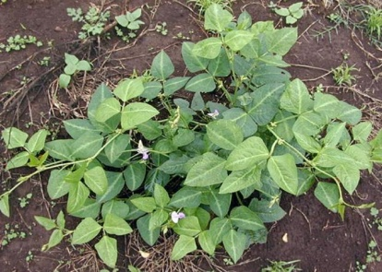
Figure 3 vigna unguiculata
Vigna unguiculata is a leguminous plant which has medicinal properties belongs to the family Papilionaceae. Review regarding medicinal, phychemical and pharmacological properties are studied. Alkaloids, phenols, flavonoids and phytic acid are the major phytochemicals and the plant exhibits antioxidant, antidiabetic and hypocholesterolemic activities [19].
Fresh and shade dried Vigna unguiculata leaves are subjected to nutrient analysis. 8 week matured plant is selected to take tender leaves for nutrient analysis. HPLC and standard spectrophotometric method is used for analysis. 80.08% and 3.18% moisture, 5.35% and 12.470% ash, 2.45% and 24.68% fibre, 6.34% and 39.70% carbohydrate, 0.92% and 3.69% fat, 4.85% and 16.290% crude protein are present in fresh and dried leaves respectively. Ca, Na, K, Fe, Mg, Zn, Mn are the minerals present in reasonable amounts. Vitamin A, D, E, K, C and B complex are observed in high levels in both fresh and dried leaves, and higher values of vitamin B 1, 5, 6, 9 and vitamin C in fresh leaves [20]
In a study the anti-diabetic, anti-cancer, anti-hyperlipidemic, anti-inflammatory and anti-hypertensive properties were evaluated and the result shows that it is effective on diabetes, hyperlipidemia and hypertension [21]. After removing the fat from whole bean, the protein was isolated by alkaline solubilisation and isoelectric precipitation. The amino acid composition and protein digestibility determined by ion-exchange chromatography and nitrogen balance methods respectively. The ratio between the individual amount of each essential amino acid present in the protein and the recommendation of each one for preschool infants yields the amino acid score, which is the lowest number. In both the whole bean and the isolate amino acid methionine was found to be limiting. Table 1 shows the amino acid score, protein digestibility and estimated nutritive value of whole bean and the isolate. High digestibility and bioavailability of essential amino acids, makes cowpea protein isolate inclusive in the preparation of cereal-based products, which contain lysine as a limiting amino acid and are rich in methionine [22].

Table 1: Representation of Nutritive value calculated from whole bean and the isolated protein

 | Whole bean | Isolated Protein
Amino acid score | 0.44 | 0.60
Protein digestibility | 86.7% | 96.7%
Estimated nutritive value | 38% | 58%

- Amorphophallus paeoniifolius (Elephant yam)

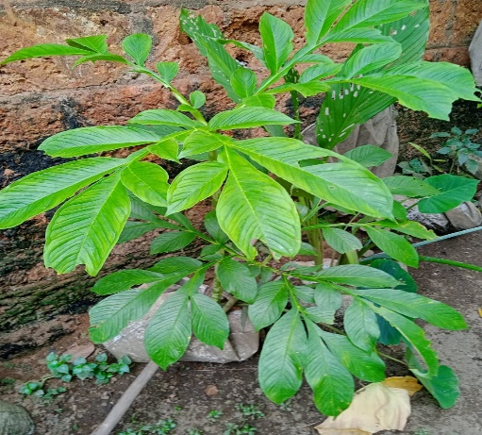
Figure 4 Amorphophallus paeoniifolius
Elephant yam is a perennial herbaceous plant belonging to the family Araceae grows up to 2 meters tall and is utilised for underground tuber that grows up to 25 kilos[23].
The phytochemical analysis with methanolic extract of Amorphophallus paeoniifolius shows the presence of carbohydrates, alkaloids, flavonoids, steroids and terpenoids. The tuber also possesses anti-oxidant properties when screened by DPPH method against standard Ascorbic acid [24]. In vivo anti-diarrhoeal activity of Amorphophallus paeoniifolius leaves are studied. Castor oil-induced Diarrhoea model of Swiss Albino rats of either sex weighing 150-180 g were used for the study. 100, 200 and 400 mg/kg doses showed prominent anti-diarrhoeal activity [25].
Anti-oxidant property with respect to phenolic content of Amorphophallus paeoniifolius was studied. Ethanolic extract of Amorphophallus tuber was used for the study. Lipid peroxidation inhibition in terms of formation of thiobarbituric acid reactive substances (TBARS) was studied and the result showed that 4.3% to 67.2% reduction in a dose-dependent manner. The extract showed 68.6% of DPPH scavenging activity, 74% ABTS scavenging activity and 67.2% H₂O₂ scavenging activity. The anti-oxide efficiency and oxidative inhibition varied in accordance with dose-dependent manner (1-50 µg/mL concentrations). gallic acid, quercetin and resveratrol are the polyphenols identified in HPTLC profiling[26].
The review on medicinal importance of Amorphophallus paeoniifolius with respect to phytopharmacological properties were done and says that the plant can be used to treat chronic diseases. The entire plant is supposed to be secure based on the published researches on pharmacological actions, phytochemical, toxicity tests. [27].
Amorphophallus tubers are useful in impaired condition of Vata and Kapha, arthralgia, elephantiasis, tumors, inflammations, haemorrhoids, haemorrhages, vomiting, cough, bronchitis, asthma, anorexia, dyspepsia, flatulence, colic, constipation, helminthiasis hepatopathy, splenopathy, amenorrhoea, dysmenorrhoea, seminal weakness, fatigue, anaemia and general debility. And also the tuber exhibit properties like astringent, thermogenic, irritant, anodyne, anti-inflammatory, anti-haemorrhoidal, haemostatic, expectorant, carminative, digestive, appetizer, stomachic, anthelmintic, liver tonic, aphrodisiac, emmenagogue, rejuvenating and tonic [28]. It is reported that Amorphophallus paeoniifolius used as neutraceuticals for food disorders, anti-microbial resistance, novel bacterial & viral diseases like MDR-TB and COVID-19. [29].Alkaloids, steroids, fats & fixed oil, flavonoids, tannins, proteins and carbohydrates are the phytoconstituents in the tuber of Amorphophalluspaeoniifolius [30]

- Amaranthus spinosus (Mullancheera)

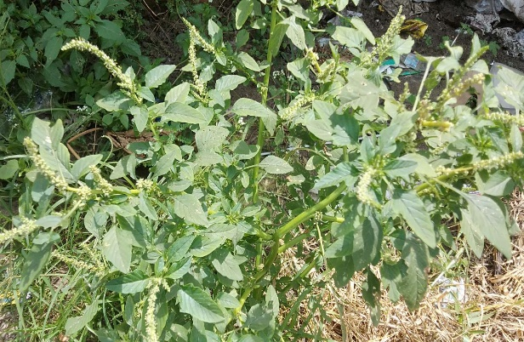
Figure 5 Amaranthus spinosus
Amaranthus spinosus, a perennial herb with erect branched spinosus belonging to the family Amaranthaceae, which is common and abundant in cultivated land and waste land as weed. Also known as prickly amaranthus in English and as Kate matha, Tandullajaa in India[31].
The increased levels prolactin and breast milk production in postpartum mothers were analysed after giving spinach leaf (AmaranthusSpinosus L) extract, this is because of the effect of non-synthesis lactagogues to increase milk production [32]. Anti-stress and nootropic activity in dose dependent manner is exhibited by hydro alcoholic extract of Amaranthusspinosus stem & root (200, 400 mg/kg), Swimming endurance test, Anoxia stress tolerance test and Immobilization stress test are carried out to determine anti-stress activity and Elevated plus maze and the Morris water maze for nootropic activity (Raj Kumar Singh Bharti et al., 2022)[33]. In vivo studies were conducted on growing pigs so as to determine effect of Amaranthusspinosus leaf extracts on the haematological characteristics. The ethanol extract is orally administered and packed cell volume (PCV) red blood cell (RBC) and white blood cell (WBC) counts, and haemoglobin (HB) concentration analysed. PCV, RBC and Hb of the pigs reduced with seven days posttreatment and the weight is improved[34].
Antidiabetic effects of Amaranthus spinosus leaf extract was studied in albino rats of streptozotocin-nicotinamide induced diabetes & oxidative stress. Single dose streptozotocin (60 mg/kg) administered intraperitoneally followed by nicotinamide (120mg/kg). Reduced glutathione (GSH) content and enzymatic activities of superoxide dismutase (SOD), catalase (CAT), and glutathione peroxidase (GPx) in liver and kidney were analysed to measure the oxidative stress along with histology of liver, kidney and pancreas. The diabetic rats showed increased blood glucose, and decreased GSH content and enzymatic activities. Rats given ASEt (250 & 500 mg/kg bw/day, i.p) for 21 days showed a caused considerable decrease in blood glucose in STZnicotinamide treated rats as compared with diabetic rats. Also, they displayed a significant higher level of both enzymatic and non enzymatic antioxidant activity. By giving ASEt leaf extract to STZ treated rats, degenerative alterations to their pancreatic cells were reduced to almost normal morphology, as shown by histological analysis [35]. It is reported that Amaranthus spinosus leaves are rich in carbohydrate, phenolic compounds, phytosterols, alkaloids, flavonoids [36].
Methanol extract of Amaranthus spinosus L. leaves were used to assess anti-inflammatory activities in rats. Castor oil was used to induce diarrhoea gastric mucosal integrity analysed. The extract at a concentration of 25–100 mg/kg is capable of inhibiting carageenan swelling in the paws of rats. Also acetic acid induced vascular permeability reduced significantly. The plant also exhibit analgesic activity, reduce acetic acid induced vascular permeability, inhibit cotton pellet granuloma (100 mg/kg). Analgesic activity was exhibited with the significant and dose-related reduction in the number of writhings induced with acetic acid, as well reduction in paw licking induced by injection of formalin in mice. The leaf extracts (50 and 100 mg/kg) in around 5 days of administration helped in reduction of castor oil induced diarrhoea in rats. This study is in support of antiinflammatory properties of Amaranthus spinosus L. possibly by inhibition of prostaglandin biosynthesis [37].
Antiulcer property of ethanolic extracts of Amaranthus spinosus was studied in comparison with famotidine in shay rats. The results showed that 400mg/kg oral dose reduced ulceration and 800mg/kg ailed in complete absence, which is equal to effect of 2mg/kg famotidine. Reduced acidity and peptic activity might be the reason for inhibition of ulceration. 4000mg/kg dose of all extracts are safe [38]. In another study it is reported that saponins, alkaloids, flavonoids, terpenoids and glycosides are the phytochemicals present in methanolic extracts of Amaranthus spinosus leaves. A yield of 17.40 g was obtained and antimicrobial property with a zone of 15mm against Staphylococcus aureus and Aspergillus flavus, 13mm and 10mm respectively with E. coli. and Mucor sp. respectively [39].

- Cucurbita maxima (Pumkin)

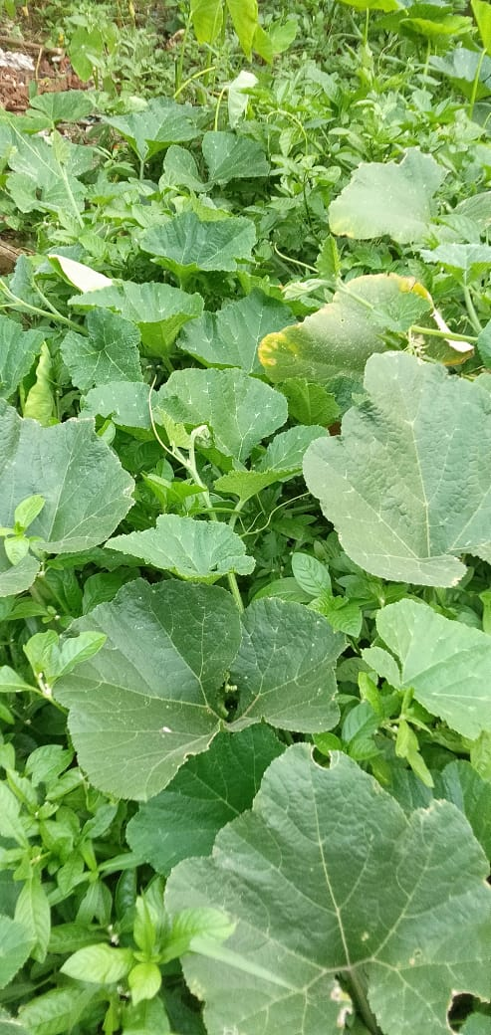
Figure 6 Cucurbita maxima
Cucurbita maxima is a creeper belonging to the family Cucurbitaceae. Saponins, fixed oil, resin, protein, sugar, starch along with glutamic acid and calcium in measurable amount is present. The seeds had anthelminitic, and diuretic properties, fruit and leaves are largely used by Indian cuisine[40].
In a study to evaluate the anti-bacterial property using methanol extract of aerial parts of activity Cucurbita maxima, Streptozotocin was induced at doses of 200 and 400 mg/kg into Wistar albino rats for 14 days. Catalase, lipid peroxidise, glutathione (reduced) levels of kidney, liver and pancreas were analysed and biochemical activity of GOT, SGPT and ALP estimated. The results showed decrease in fasting blood glucose, reversed antioxidant and biochemical parameters towards normal levels[41].

Hepatotoxicity was induced with carbon-tetrachloride (CCl₄) in Wistar rats to study the hepatoprotective activity using the shoot parts of Cucurbita maxima. SGOT, SGPT, ALP, total protein and total bilirubin estimated as for liver function; reduced glutathione, lipid peroxidation, catalase activity, superoxide dismutase analysed for antioxidant assays with liver homogenate and histopathology of liver tissue analysed.
The results showed that the abnormal parameters that changed after carbon-tetrachloride administration is rectified upon treatment with leaf extract, and also the histology of liver section showed normal hepatic cords without any necrosis and fatty infiltration [42].

- Senna tora (Thakara)

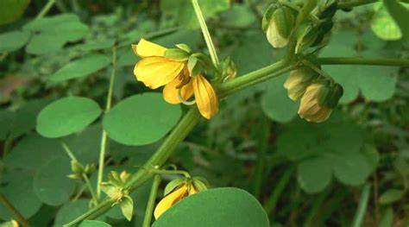
Senna tora belonging to the family of Fabaceae is an herbaceous plant with alternative pinnate leaves andt can grow 12–35 inches tall [43].
Quantitative estimation of phenol, tannin and ascorbic acid in terms of mg/g dry weight of stem, leaves, seeds and roots of Senna tora were evaluated. Results showed a greater level of phenol, tannin and ascorbic acid in leaves as compared to that in stem, root and seed. [Table 2]
Table 2: Phytochemicals estimated from Senna tora [44]
 | Leaves | Stem | Root | Seed
Phenol | 5.740 - 6.408 | 3.768 - 4.419 | 1.284 - 1.828 | 3.873
Tannin | 0.356 -0.410 | 0.300 - 0.356 | 0.112 - 0.156 | 2.940
Ascorbic acid | 3.011 - 3.620 | 1.988 - 2.612 | 0.970 - 1.109 | 2.067

The in vitro anti-dermatophytic activity of methanolic extract of leaf of Senna tora was evaluated. Low polar petroleum ether and inter polar methanolic extracts were used for study. Phytochemical such as alkaloids, flavonoids, phenols, triterpenoids and saponins were identified. Antidermatophytic property of five dermatophytic fungi and five bacteria are studied and the results showed that inter polar methanolic extract at 40 mg/ml was more effective when compared to petroleum ether is observed against M. gypseum (11.66±1.15 mm) followed by T. rubrum extract. The maximum antifungal activity (09.33±0.57 mm), C. albicans (08.00±0.00 mm), T. tonsurans (08.66±1.52 mm) and T. mentagrophytes (07.33±0.57 mm); and 14.66±1.15 mm inhibition in E. coli followed by P. aeruginosa (11.33±1.15 mm), S. aureus (10.66±1.15 mm) and B. subtilis (08.00±0.00 mm) was observed in the antibacterial study [45].
The concentration of protein, amino acid, alkaloid and lipid in Senna tora leaves, stem, root and seeds with respect to different seasons were studied. The results showed that all the four parameters, protein, amino acid, alkaloid and lipid were higher in seeds than in leaves, stem and root [Table 3].

Table 3: Biochemical compounds estimated from Senna tora [46]

 | Seed | Leaves | Stem | Root
Protein | 26.648 | 5.763 - 6.544 | 3.785 - 4.341 | 1.871 - 2.349
Amino acid | 10.436 | 0.085 - 1.143 | 0.872 - 0.943 | 0.287 - 0.324
Alkaloid | 5.938 | 3.109 - 3.749 | 2.083 - 2.378 | 0.854 - 1.015
Lipid | 14.730 | 8.638 - 9.630 | 3.682 - 4.319 | 1.232 - 1.914

Chemical constituents and antimicrobial activity against Gram positive bacteria (Staphylococcus aureus and Enterococcus faecalis) and Gram negative bacteria (Klebsiella pneumoniae, Escherichia coli, Salmonella typhi, and Pseudomonas aeruginosa) of Senna tora leaves and seeds were evaluated. The results showed that the presence of cisoleic acid (29.4%), 1, E-11, Z-13-octadecatriene (13.4%), palmitic acid (13.3%), 1,E-8,Z-10-pentadecatriene (11.4%) and stearic acid (11.0%) in leaf extract and methyl-1-allyl-2-hydroxycyclopentanecarboxylate (20.0%), 6,9- pentadecadien-1-ol (20.0%), cis-oleic acid (16.2%), methyl-7-hexadecenoate (7.5%) and palmitic acid (6.5%) in seed extract. The antimicrobial activity is higher in leaves than seeds, in which Klebsiella pneumoniae exhibited highest zone of inhibition (18.5 mm) and Salmonella typhi with the lowest (10 mm) [47].

- Diplocyclos palmatus (Neyyunni)

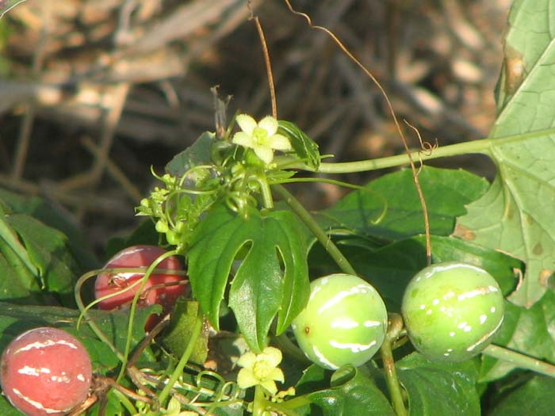
Figure 8 Diplocyclos palmatus

Morphological variations and medicinal uses of Diplocyclos palmatus (L.) were studied. Both stem and leaf exhibit analgesic and anti-microbial properties, root exhibits anti-asthmatic and antidote effects, leaf also possesses anti-inflammatory and antidote effects. The fruits and leaves are effective in relieving stomach pain, stems, fruits and seeds used as expectorant, laxative and febrifuge respectively. The aerial plant parts are also used as Aphrodisiac and tonic, in treatment of diarrhoea and malaria.[48].
In vivo study on analgesic property of Diplocyclos palmatus (L.) in albino rats along with antimicrobial activity was conducted. Ethanolic extract of the fruits gave a maximum zone of inhibition against Escherichia coli as compared to extract of other plant parts. The plant also exhibited analgesic activity when compared to standard Aspirin and control [49].
The anti-diabetic property of Diplocyclos palmatus Linn. in Streptozotocin-Induced Diabetic Mice using methanolic extract of seed was studied. Oral glucose tolerance, fasting blood glucose, urine glucose, liver glycogen content, serum lipid profile, change in body weight and histopathology are determined to assess the anti-diabetic potential. A maximum of 53.87% drop in fasting blood glucose was observed in 15 days treated with 150 mg/kg methanolic extract. The serum lipid profile got reversed, loss of body weight become controlled, liver glycogen content increased, urine sugar level decreased and the histological results showed normal pancreas [50].
Phytochemical analysis, antioxidant potential and phenolic profiling of Diplocyclos palmatus leaf and fruit extracts were carried out. Hexane, chloroform, methanol and aqueous extracts are used for the study. The results showed that the higher phenolics, flavonoids and terpenoids contents are observed in methanol fruit extract and higher amount of tannins in chloroform extract of leaf and fruit. Highest DPPH radical scavenging activity, metal chelating activity and phospho- molybdenum activity are showed by methanol fruit extract. Aqueous leaf extract exhibited better result in ABTS radical scavenging assay. And aqueous fruit extract exhibited the effective ferric reducing antioxidant property. RP-HPLC analysis showed the presence of bioactive phenolic compounds such as catechin (CA) and hydroxyl benzoic acid (HBA) in leaves than fruit and chlorogenic acid (CLA) is present in fruit [51]. Physicochemical and preliminary phytochemical analysis of fruit of Shivalingi (Diplocyclospalmatus Linn.) was studied. The results showed that the presence of alkaloids, triterpinoids, flavonoids, saponins, steroids and proteins in the dried fruit extract [52].

- Boerhaavia diffusa (Thazhuthama)

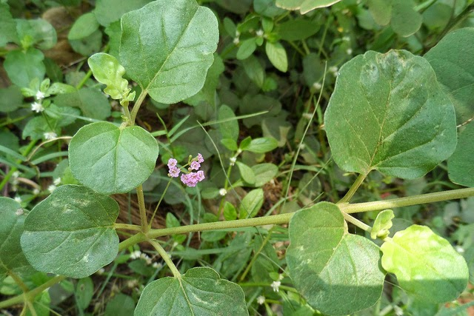
Figure 9 Boerhaavia diffusa
Boerhaavia diffusa Linn. is a diffusely branched, glabrous prostrate herb belonging to the family Nyctanginaceae. Boerhaavia repens Linn. and Boerhaavia procumbens Roxb. are its two synonym varieties, which is called as Shweta punarenava used for Punarnava drugs and Raktapunarnava for Varhabhu drugs in ayurveda respectively. The plant is commonly known as Hogweed, Patagon in English and Punarnawaa, Raktavasu, Biskhafra are Indian names[53]. Boerhaavia diffusa is a creeping herbaceous plant with cylindrical, creeping stem sometimes purplish or greenish in colour, swollen at the nodes [54].
The antibacterial activity of Boerhaavia diffusa Linn.. Six bacteria were screened with Benzene-ethyl acetate (4:1) eluate of chloroform extract and n-butanol extract of alcohol extract. The results showed that chloroform extract exhibited activity against Escherichia coli, Salmonella typhimurium and Pseudomonas aeruginosa and alcohol extract against Proteus mirablis and Salmonella typhimurium[55]. A review on medicinal importance of Boerhaavia diffusa is studied. Aerial parts and root of the plant were prominent in disease ailment which include treatment of stress, dyspepsia, abdominal pain, inflammation, jaundice and the plant also exhibit anti-bacterial, anti-nociceptive, hepato-protective, hypo-glycemic, anti-proliferative, anti-estrogenic, anti-inflammatory, anti-convulsant, anti-stress and anti-metastatic activities [56].
Another review on Boerhaavia diffusa its medicinal importance and pharmacological activities were studied . The phytochemical constituents are responsible against cancer, inflammation, diabetes, harmful radiations induced damage, gastrointestinal problems, microbial infections, liver disorders, prostatic hyperplasia, cardiac problems, anxiety problem etc. [57].

- Solanum nigrum (Manithakkali)

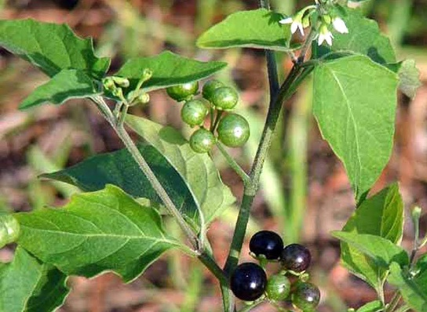
Figure 10 Solanum nigrum
Solanum nigrum Linn. is a herbaceous weed commonly seen in waste places and roadsides throughout India. Kaangannee, Kaamonnee, Makoi are the common Indian names and Black night side in English. Solanum subrum Mill ex Wight and Solanum incertum Dunal ex Graham are two synonym varieties of the plant [58].
The methanolic extract of dried fruit of Solanum nigrum is found to be cardio-protective and anti-oxidant. Global in-vitro ischemia-reperfusion injury and tissue biochemical anti-oxidant profile were conducted to determine the cardioprotective activity doses of 2.5 and 5.0 mg/kg for 6 days per week for 30 days and positive results were obtained [59]. The phytochemical analysis and amtimicrobial activity against respiratory tract pathogens was studied. Aqueous, ethanol and diethyl ether extracts were used for the study and the results showed that the maximum antibacterial activity by ethanolic extract. Alkaloids, terpenoids, flavonoids, saponins, steroids and phenols were identified [60].
Anti-convulsant property of Solanum nigrum leaves were studied in experimental animals. The anti-seizure property was potentiated by amphetamine and the results showed that the extract exhibited anti-convulsant property in the animals [61]. The methanol extract of Solanum nigrum fruit is found to possess antiulcerogenic activity. The ulceration in rats was induced with aspirin and the antioxidant conditions in gastric mucosa studied. Acute gastric mucosal injury along with high lipid peroxide was taken as oxidative stress index. The extract is found to exhibit gastro-protective activity by free radical scavenging action [62].
Phytochemical properties, acute oral toxicity and anticonvulsant activity of Solanum nigrum berries were studied. Ethanol extract were used in the study in pentylenetetrazole (PTZ)- induced seizure in mice. 3129 mg/kg body weight was the oral median lethal dose and at a dose of 300mg/kg delayed the latency. And the phytochemicals identified include carbohydrates, flavonoids, saponins, tannins, alkaloids, phenols and steroids [63].

III. Conclusion

Ayurvedic herbs have been an integral part of traditional medicine for centuries. Scientific evidence supports their health benefits. The ayurvedic lifestyle followed by our ancestors and their vitality is proof in itself on how beneficial following a healthy regime is. For a healthy sustenance and long life we need to follow the rules laid by Ayurvedic medicine

IV. Reference

1. Kapoor, L. D. "CRC handbollk of ayurvedic medicinal plants." CRC, Boca Raton 53 (2000)
2. A Keshav, A Sharma, B Mazumdar . Phytochemical Analysis and Antioxidant Activity of Colocasiaesculenta (L.) Leaves. World Academy of Science, Engineering and Technology International Journal of Chemical and Molecular Engineering Vol:13, No:1, page 20- 23. 2019.
3. Nakade, D., S. Mahesh, N. Kiran, and S. Vinayak. "Phytochemical screening and antibacterial activity of western region wild leaf Colocasia esculenta." Int Res J Biol Sci 2, no. 10 (2013): 18-21.
4. Sudhakar, P., V. Thenmozhi, S. Srivignesh, and M. Dhanalakshmi. "Colocasia esculenta (L.) Schott: Pharmacognostic and pharmacological review." J Pharmacogn Phytochem 9, no. 4 (2020): 1382-6.
5. Bussell, W. T. "Taro leaf production in northern New Zealand." In Proceedings of the Agronomy Society of New Zealand, vol. 36, pp. 1-3. 2006.
6. Rashmi, D. R., N. Raghu, T. S. Gopenath, P. Palanisamy, P. Bakthavatchalam, M. Karthikeyan, A. Gnanasekaran, M. S. Ranjith, G. K. Chandrashekrappa, and K. M. Basalingappa. "Taro (Colocasia esculenta): an overview." Journal of Medicinal Plants Studies 6, no. 4 (2018): 156-161.
7. Gupta, Kritika, Ashwani Kumar, Vidisha Tomer, Vikas Kumar, and Mona Saini. "Potential of Colocasia leaves in human nutrition: Review on nutritional and phytochemical properties." Journal of food biochemistry 43, no. 7 (2019): e12878.
8. Savage, G. P., and M. Dubois. "The effect of soaking and cooking on the oxalate content of taro leaves." International journal of food sciences and nutrition 57, no. 5-6 (2006): 376-381.
9. Yaniv, Zohara, and Uriel Bachrach, eds. Handbook of medicinal plants. CRC Press, 2005.
10. Zakaria, Fatariah, Wan Rosli Wan Ishak, Wan Amir Nizam Wan Ahmad, Sabreena Safuan, and Tengku Alina Tengku Ismail. "Hypoglycaemic and Protective Effects of Benincasa hispida Aqueous Extract in Streptozotocin-Induced Diabetic Rats br." SAINS MALAYSIANA 51, no. 3 (2022): 783-793.
11. Al-Snafi, Ali Esmail. "The Pharmacological importance of Benincasa hispida. A review." Int Journal of Pharma Sciences and Research 4, no. 12 (2013): 165-170.
12. Islam, Muhammad Torequl, Cristina Quispe, Dina M. El-Kersh, Manik Chandra Shill, Kanchan Bhardwaj, Prerna Bhardwaj, Javad Sharifi-Rad et al. "A literature-based update on Benincasa hispida (Thunb.) Cogn.: traditional uses, nutraceutical, and phytopharmacological profiles." Oxidative Medicine and Cellular Longevity 2021 (2021)
13. Gupta, Prerna, Sivanand Chikkala, and Priyanka Kundu. "Ash gourd and its applications in the food, pharmacological and biomedical industries." International Journal of Vegetable Science 27, no. 1 (2021): 44-53.
14. Nandecha, Chetan, Alok Nahata, and Vinod Kumar Dixit. "Effect of Benincasa hispida fruits on testosterone-induced prostatic hypertrophy in albino rats." Current therapeutic research 71, no. 5 (2010): 331-343.
15. Ekeke, Chimezie, Chinedum A. Ogazie, and Ikechukwu O. Agbagwa. "Anatomical and phytochemical studies on Benincasa hispida (Thunb.) Cogn.(Cucurbitaceae)." Notulae Scientia Biologicae 11, no. 1 (2019): 102-111.
16. Alsaadi, Sarmad Abdul Razak Abood, and Kasim Sakran Abass. "Benincasa Hispida Is An Antioxidant Of Possible Physiological Importance: A Comparative Review." Plant Archives 20, no. 2 (2020): 2833-2838.
17. Pal, Rashmi Saxena, Yogendra Pal, Pranay Wal, and Ankita Wal. "Pharmacognostic evaluation of roots of Benincasa hispida (Thunb.) Cogn.(Cucurbitaceae)." The Open Plant Science Journal 11, no. 1 (2018).
18. Une, Hemant D., and Gaurav M. Doshi. "Chromatographic studies on Benincasa hispida (thunb.) Cogn. seed extract scrutinized by HPLC and HPTLC." Pharmacogn J 6 (2014): 42.
19. Zaheer, Mehreen, Salman Ahmed, and Muhammad Mohtasheemul Hassan. "Vigna unguiculata (L.) Walp.(Papilionaceae): A review of medicinal uses, Phytochemistry and pharmacology." Journal of Pharmacognosy and Phytochemistry 9, no. 1 (2020): 1349-1352.
20. Achimugu E O, Emmanuel T F. Evaluation of nutrients composition of fresh and shade dried black-eyed bean (Vignaunguiculata) leaves for food. International Journal of Food Science and Nutrition ISSN: 2455-4898 ,Volume 6, Issue 6, 2021, Page No. 10-15. 2021
21. Jayathilake, Chathuni, Rizliya Visvanathan, Afka Deen, Ruksheela Bangamuwage, Barana C. Jayawardana, Srinivas Nammi, and Ruvini Liyanage. "Cowpea: an overview on its nutritional facts and health benefits." Journal of the Science of Food and Agriculture 98, no. 13 (2018): 4793-4806.
22. Frota, Karoline de Macêdo Gonçalves, Lays Arnaud Rosal Lopes, Izabel Cristina Veras Silva, and José Alfredo Gomes Arêas. "Nutritional quality of the protein of Vigna unguiculata L. Walp and its protein isolate." Revista Ciência Agronômica 48 (2017): 792-798.
23 Rai, M. K., Geoffrey A. Cordell, Jose L. Martinez, Mariela Marinoff, and Luca Rastrelli, eds. Medicinal plants: biodiversity and drugs. CRC Press, 2012.
24 Korem Raju, G.Shylaja, M.Manoj, K.Neeraj Kumar, J.Tejashwini, M.Manasa.. Phytochemical Screening and In Vitro Antioxidant Activity of Amorphophalluspaeoniifolius. Korem Raju et al. Ijppr.Human; Vol. 20 (4): 299-318. 2021
25. Li, T.S.C. Medicinal Plants: Culture, Utilization and Phytopharmacology (1st ed.). CRC Press. (2000).
26. Angayarkanni, Jayaraman, Kunga Mohan Ramkumar, Ulaganathan Priyadharshini, and Poornima Ravendran. "Antioxidant potential of Amorphophallus paeoniifolius in relation to their phenolic content." Pharmaceutical biology 48, no. 6 (2010): 659-665.
27. Dey, Yadu Nandan, Sarada Ota, N. Srikanth, Mahvish Jamal, and Manish Wanjari. "A phytopharmacological review on an important medicinal plant-Amorphophallus paeoniifolius." Ayu 33, no. 1 (2012): 27.
28. Jaykaran, Preeti Yadav, Nilesh Chavda, and N. D. Kantharia. "Factors associated with performance of second year student in pharmacology examinations." Journal of pharmacology and pharmacotherapeutics 2, no. 2 (2011): 123-125.
29. Biswal, Susanta Kumar, Padan Kumar, Sanjeet Kumar, and Lorena Antunes. "AMORPHOPHALLUS PAEONIIFOLIUS (ARACEAE): A NUTRACEUTICAL FOR FOOD DISORDERS, NOVEL BACTERIAL & VIRAL INFECTIONS." Education 2016 (2011).
30. De, S., Y. N. Dey, and A. K. Ghosh. "Phytochemical investigation and chromatographic evaluation of the different extracts of tuber of Amorphaphallus paeoniifolius (Araceae)." Int J Pharm Biol Res 1, no. 5 (2010): 150-7.
31. Che, Chun-Tao. "Review of Duke’s Handbook of Medicinal Plants of the Bible." (2018): 1128-1129.
32. Kuswaningrum, Okta, Agus Suwandono, Ida Ariyanti, Soeharyo Hadisaputro, and Suhartono Suhartono. "The impact of consuming amaranthus spinosus l extract on prolactin level and breast milk production in postpartum mothers." Belitung Nursing Journal 3, no. 5 (2017): 541-547.
33. Kumar, Raj & Bharti, Singh & Kumar, Amit & Singh, Munna & Tripathi, Ankita. (2022). BEHAVIORAL AND BIOCHEMICAL INVESTIGATION OF AMARANTHUS SPINOSUS FOR ANTISTRESS AND NOOTROPIC ACTIVITY ON RATS. Journal of Biological & Scientific Opinion. 10. 2022. 10.7897/2321-6328.103156.
34. Olufemi, B. E., I. E. Assiak, G. O. Ayoadi, and M. A. Onigemo. "Studies on effects of Amaranthus spinosus leaf extract on the haematology of growing pigs." African Journal of Biomedical Research 6, no. 3 (2003).
35. Saravanan, R. "Evaluation of In-Vitro and In-Vivo Anticancer Activity of Leaf Extracts of Amaranthus Spinosus Linn." PhD diss., College of Pharmacy Madras Medical College, Chennai, 2016.
36 Mishra, Shanti Bhushan, Amita Verma, Alok Mukerjee, and M. Vijayakumar. "Pharmacognostic Standardization and Phytochemical screening of Leaves of Amaranthus spinosus L." Pharmacognosy Journal 3, no. 26 (2011): 34-38.
37. Olajide, Olumayokun A., Babatunde R. Ogunleye, and Temitope O. Erinle. "Anti-inflammatory properties of Amaranthus spinosus leaf extract." Pharmaceutical biology 42, no. 7 (2004): 521-525.
38. Panda, Santosh Kumar, Gourab Sarkar, Manini Acharjya, and P. K. Panda. "Antiulcer activity of Amaranthus spinosus leaf extract and its comparision with famotidine in shay rats." Journal of Drug Delivery and Therapeutics 7, no. 2 (2017): 96-98.
39. Nasir, Rabiu, Haruna Saeed Alhassan, Ahmed Abubakar, and Yusuf Ibrahim. "Phytochemical analysis and antimicrobial activity of leave extract of Amaranthus spinosus." (2020).
40. Dubey, Sarvesh. (2012). Overview on Cucurbita maxima. International Journal of Phytopharmacy. 2. 10.7439/ijpp.v2i3.492.
41. Saha, P., A. Bala, B. Kar, S. Naskar, U. K. Mazumder, P. K. Haldar, and M. Gupta. "Antidiabetic activity of Cucurbita maxima aerial parts." Research Journal of Medicinal Plant 5, no. 5 (2011): 577-586.
42. Saha, Prerona, U. K. Mazumder, P. K. Haldar, Asis Bala, Biswakanth Kar, and Sagar Naskar. "Evaluation of hepatoprotective activity of Cucurbita maxima aerial parts." Journal of Herbal Medicine and Toxicology 5, no. 1 (2011): 17-22.
43. Austin, Daniel F. Florida ethnobotany. CRC Press, 2004.
44. Gaykhe, R., S. Khan, and V. Kadam. "Biochemical Profile of Senna tora Linn." Int J Biomed Investig 2018; 1: 116. doi 10 (2018): 2581-4745.
45. Shivakumar Singh, P., and G. M. Vidyasagar. "IN-VITRO ANTIDERMATOPHYTIC ACTIVITY OF LOW POLAR PETROLEUM ETHER AND INTER POLAR METHANOLIC LEAF EXTRACT OF SENNA TORA L." (2014).
46. Gaykhe, R. C., and V. B. Kadam. "Phytochemical Evaluation of Senna tora Linn." Int J Biomed Investig 2018; 1: 105. doi: 10.31531/2581 4745.
47. Alao, F. O., Z. S. Ololade, and C. V. Nkeonye. "Phytochemical and antibacterial potentials of Senna tora leaf and seed extracts against some clinically isolated bacteria." Journal of Bacteriol Parasitol 9, no. 3 (2018): 14.
48. Patel, D. "Diplocyclos palmatus (L.) Jeffry: Morphological variations and medicinal values." J. Med. Plants 6 (2018): 3-5.
49. Kishan, Ram & Zeeyauddin, Khaja & Vemula, Sateesh & Jatoth, Ramkishan. (2019). EVALUATION OF ANTIMICROBIAL AND ANALGESIC ACTIVITY OF DIPLOCYCLOS PALMATUS FRUITS ON ALBINO MICE. Asian Journal of Pharmaceutical and Clinical Research. 12. 81-85. 10.22159/ajpcr.2019.v12i2.28346.
50. Tripathi, Jaynarayan, Reena Kumari, Vrish Dhwaj Ashwlayan, Parveen Bansal, and Ranjit Singh. "Anti-diabetic activity of Diplocyclos palmatus Linn. In streptozotocin-induced diabetic mice." Indian Journal of Pharmaceutical Education and Research 46, no. 4 (2012): 352-359.
51. Attar, USMANGANI A., and SAVALIRAM G. Ghane. "Phytochemicals, antioxidant activity and phenolic profiling of Diplocyclos palmatus (L.) C. Jeffery." Int J Pharm Pharm Sci 9, no. 4 (2017): 101-6.
52. G, Venkateshwarlu, Shanta T R, Shiddamallayya N, Ramarao V, Kishore K R, Giri S K, Sridhar B N, and Pavan Kumar S. 2011. “Physicochemical and Preliminary Phytochemical Studies on the Fruits of â€œShivalingiâ€ [Diplocyclos Palmatus (Linn.) Jeffrey]”. International Journal of Ayurvedic Medicine 2 (1).
53. Duke, James A. CRC handbook of medicinal spices. CRC press, 2002.
54. Gulshan, Chaudhary, and Kumar Dantu Prem. "Morphological, phytochemical and pharmacological, studies on Boerhaavia diffusa L." Journal of Medicinal Plants Research 5, no. 11 (2011): 2125-2130.
55. Gopal, Hamsaveni, Saradha Vasanth, and J. Herbat Mebel. "Anti bacterials from Boerhaavia diffusa." Ancient Science of Life 18, no. 3-4 (1999): 254.
56. Mahesh, A. R., Harish Kumar, M. K. Ranganath, and Raviraj Anand Devkar. "Detail study on Boerhaavia diffusa plant for its medicinal importance-A Review." Res J Pharm Sci 1, no. 1 (2012): 28-36.
57 Ashwani Kumar and Nisha Gadhwal. TRADITIONAL MEDICINAL PLANT BOERHAAVIA DIFFUSA‘PUNARVA’ AND ITS PHARMACOLOGICAL VALUE: A REVIEW. Volume 9, Issue 12, 1367-1373. 2020.
58 Warrier, P.K., Nambiar, V.P.K., Ramankutty, C. (1995). Indian Medicinal Plants—A Compendium of 500 Species, vol. 3. Orient Longman Ltd., Chennai, India. pp. 120–123.
59. PRATIM, MAITI PARTHA, KUMAR ABHINIT, TULI ATUL, ARA TASNEEM, and KHAN MASIH UZZAMAN. "Evaluation of cardio protective Activity of Methanolic Extract Of Solanum Nigrum Linn. in Rats." International Journal of Drug Development and Research 3, no. 3 (2011): 0-0.
60. Modilal, M. Rajathi D., R. Anandan, R. Sindhu, and M. N. Logeshwari. "Screening of Solanum nigrum for its phytochemical and antimicrobial activity against respiratory tract pathogens." International Journal of Pure and Applied Zoology 1, no. 3 (2015): 210-215.
61. Wannang, Noel N., Joseph A. Anuka, Helen O. Kwanashie, S. Gyang, and Asa Auta. "Anti-seizure activity of the aqueous leaf extract of Solanum nigrum linn (solanaceae) in experimental animals." African Health Sciences 8, no. 2 (2008).
62. Jainu, Mallika, and C. S. Devi. "Antioxidant effect of methanolic extract ofSolanum nigrum berries on aspirin induced gastric mucosal injury." Indian journal of clinical biochemistry 19, no. 1 (2004): 57-61.
63. Son, H. L., and Phan Thi Hai Yen. "Preliminary phytochemical screening, acute oral toxicity and anticonvulsant activity of the berries of Solanum nigrum Linn." Tropical Journal of Pharmaceutical Research 13, no. 6 (2014): 907-912.

