Insulin: A Centenarian Drug: Past, Present and Future Trends

Authors:

- Dr. Sushrut Ingawale, (MD, DNB)
Assistant Professor,
Department of General Medicine,
Seth G.S. Medical College & KEM Hospital,
Mumbai, India.
drsushrutingawale@gmail.com

- Dr. Tanvi Borse, (MBBS)
Intern,
Department of General Medicine,
Seth G.S. Medical College & KEM Hospital,
Mumbai, India.
tanviborse1998@gmail.com

- Dr. Shiamak Cooper, (MBBS)
Intern,
Department of General Medicine,
Seth G.S. Medical College & KEM Hospital,
Mumbai, India.
shiamakcooper99@gmail.com

ABSTRACT

Diabetes Mellitus (DM) is a major lifestyle disease, with over 460 million patients in the world. Its effects on the human body and its progression have contributed to higher morbidity, mortality and healthcare resource utilization. History is replete with evidence of the devastating effects of DM. This led to immense research and development in understanding the disease better and finding it a suitable cure. The year 2021 marks a century to the discovery of the medical marvel-Insulin, that revolutionized the treatment of diabetes. Over these years, there have been constant efforts to mitigate the adverse effects related to insulin administration and to improve the ease of administration. The bothersome effects of insulin causing weight gain and hypoglycemia have shown to be a hurdle in its usage. These not only cause worsening of the disease process but also prove to be factors in patient compliance. Yet, the benefits have outweighed the adverse events. With the advent of molecular biotechnology, came the ability to alter the configuration of insulin and similar molecules. This along with increased grants in the field of insulin research led to the ongoing development of newer forms of insulin such as – glucose responsive insulin, oral insulins, thermostable insulin, once-weekly dosing insulin, inhaled insulin, etc. The future years hold major ground for redefining the place of insulin in the treatment of diabetes.

KEYWORDS: diabetes mellitus, insulin, glucose-responsive, ultra-fast, technosphere, thermo-stable.

I. INTRODUCTION

The lifestyle disease, Diabetes Mellitus (DM) has been rapidly growing over the years. According to the International Diabetes Federation (IDF) Diabetes Atlas 10th edition, in the year 2021, around 537 million adults (20-79 years) are living with diabetes in the world (1 in 10) and this number is predicted to rise to 643 million by 2030 and 783 million by 2045. Over 3 in 4 adults with diabetes live in low- and middle-income countries. Diabetes is responsible for 6.7 million deaths in 2021 (1 every 5 seconds). Diabetes caused at least USD 966 billion dollars in health expenditure – a 316% increase over the last 15 years. 541 million adults have Impaired Glucose Tolerance (IGT), which places them at high risk of type 2 diabetes. In India, 74.2 million people live with diabetes. This staggering number certainly poses a burden on our healthcare. Diabetes and its effects on the various body systems have greatly increased morbidity and mortality in humans. With this increase in number, there has also been an increase in the research behind its cure and pathophysiology. Each of these commendable discoveries have helped us in battling this disease. Yet it continues to have fallacies and blind spots. Insulin has been one of the most reliable armamentaria in treatment of diabetes. Insulin emerged a century ago and has been in evolving ever since.

II. HISTORY OF INSULIN

The first link, that the deficiency of a substance being secreted by the ‘pancreas’ leads to diabetes mellitus, was established by two German researchers- Oskar Minkowski and Joseph von Mering. The first use of the word ‘insulin’ can be traced back to 1910, when Sir Edward Albert Sharpey-Shafer first hypothesized that a chemical missing from the pancreas can contribute to diabetes mellitus. The world was taken by a storm when in 1921, Frederick Banting and Charles Best managed to isolate what they called ‘isletin’ from the pancreas of dogs, at the University of Toronto. Banting, an orthopedic surgeon had developed a technique to block the pancreatic duct of a dog and hence allow the pancreas to slowly degenerate. He approached his physiology professor McLeod who gave him a laboratory, an assistant- Charles Best, and 10 dogs. They then used this degenerated pancreas to extract insulin. After repeated experiments on depancreatized dogs, they managed to purify the extract such that it was not toxic to administer to the dogs. Towards the end of 1921, a biochemist by the name of JB Collip joined their group who helped them obtain the pure extract from young cattle and thus amplifying the quantity of the substance produced.
It was in 1922, that this insulin was first administered to a 14-year-old boy that then revolutionized the treatment of diabetes. Banting and McLeod were awarded a Nobel prize for this discovery in 1923, which they shared with Best and Collip. This insulin produced from cattle and pigs was in use for many years. In 1978, the first recombinant DNA (rDNA) human insulin was prepared by David Goeddel and his colleagues (of Genentech) by utilizing and combining the insulin A- and B- chains expressed in Escherichia Coli. In 1982, Eli Lilly and Genetech collaborated to release the first rDNA insulin the market- Humulin® R (rapid) and N (NPH, intermediate-acting).

III. CURRENT FORMULATIONS OF INSULIN

Current insulins come in many formulations and differ in rapidity of onset which helps us dose it according to the need. Rapid acting analogues have a quicker onset of action, rise to their peaks and fall in a shorter duration. On the other end, long acting and almost ‘peak-less’ insulins have a long duration of action and can maintain its levels in the body for over 18-24 hours. A common regimen that is employed is called the ‘basal bolus’ regimen (Figure 1). Here, the ‘basal’ refers to the long-acting insulin given to stabilize the sugars throughout the day and night. ‘Bolus’ refers to the rapid acting analogues given around mealtimes to adeptly control the post prandial surge in glucose levels.
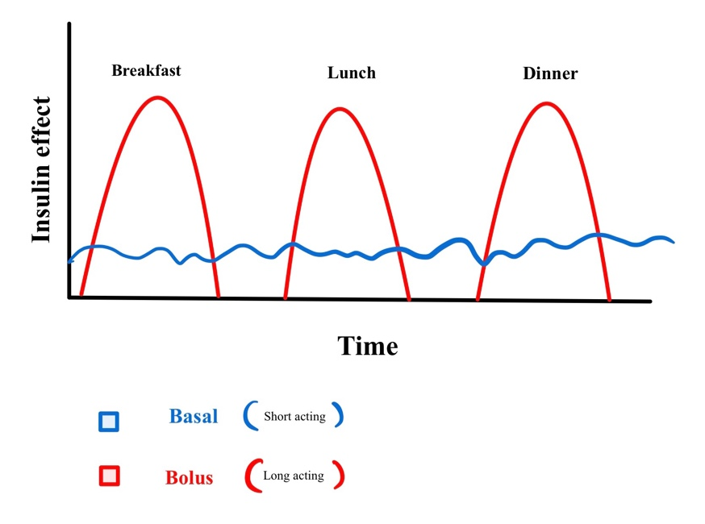
Figure 1: Basal-Bolus regimen showing effect of insulin over time

In addition to these, other forms of insulin analogues cover the spectrum of onset and duration extensively. Over the century, a wide spectrum of formulations of synthetic insulin with their relative peaks and duration have been developed (Figure 2).
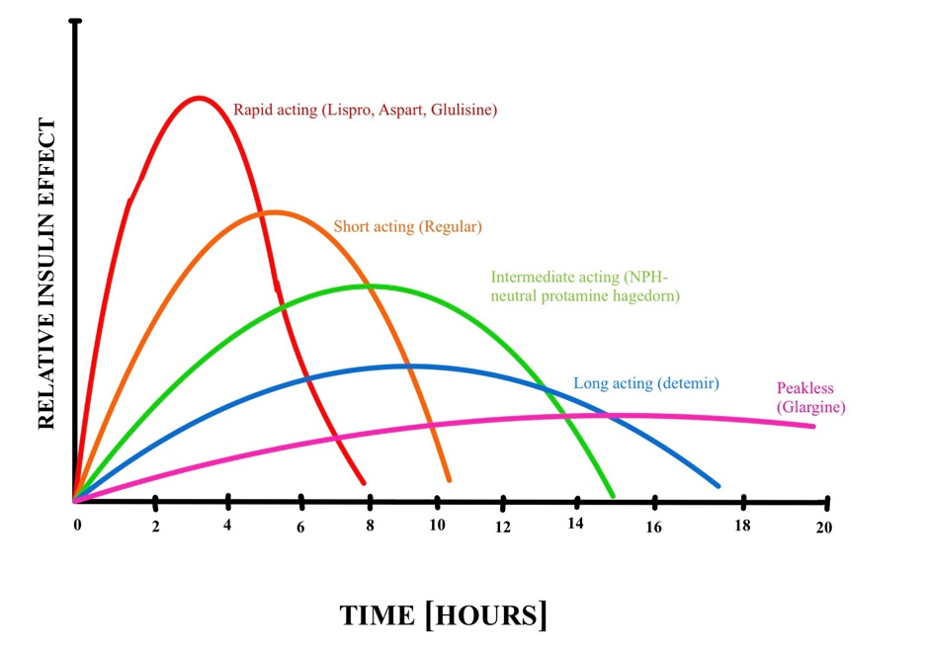
Figure 2: Onset, peak and duration of various insulin analogues

IV. FUTURE OF INSULIN

100 years into the discovery of the landmark treatment for diabetes mellitus- Insulin, there is constant continued research and development that is put into this old drug to modify its onset and duration of action and now even attempts being made for substitute routes of delivery and therefore resemble normal physiology to control diabetes. The following are a few discoveries that could transform this drug in its second century:

A] Glucose Responsive Insulin
This is also known as “Smart Insulin”. Current insulin regimens and delivery systems are limited by the risk if hypoglycemia and sub-optimal glycemic control. Moreover, they consist of either daily injections or continuous infusions. Recent advances in molecular alteration of insulin are bringing us closer to a “closed-loop insulin delivery” or “smart insulin” systems. This will allow for real-time control of insulin release in response to the fluctuating glucose levels in our body. Designer insulins are the next best way researchers are trying to get around the adverse effects of the centenarian drug. One approach is to wrap insulin in glucose-responsive materials. Usage of such storage depots for insulin also aids in increasing their lifespan. Another advantage of depots is that they can ease the approval process by having an already approved analogue inserted in them. One such example is a glucose-responsive microneedle patch that is being developed that can deliver insulin across the skin. Insulin and phenylboronic acid are embedded in these polymeric microneedles. When glucose forms a complex with the phenylboronic acid, the microneedles swell and release the insulin. The patches are the size of a quarter and have succeeded in controlling glucose levels in mini-pigs with type 1 diabetes for about 20 hours. Human clinical trials for a once-a-day patch are pending the US FDA approval.
Another way to develop glucose-responsive insulins is to add a glucose-sensing moiety directly to insulin. Efforts to impart glucose responsiveness by inducing conformational changes in insulin through a combination of amino acid changes and chemical modifications are underway. Insertion of an artificial ligand-dependent switch into the insulin molecule at its end was achieved by a group of scientists in the West. Insulin changes shape when it binds to the receptor and Weiss et al figured out a way to make this change in shape inhibitive in the absence of glucose. The formulation in fact requires glucose to change its shape rather than insulin. They have practically conceptualized and developed the world’s smallest glucose-responsive insulin system as there is no need for any copolymer to stabilize or alter. The paper reported successful use of a fructose-specific model in human liver-derived cells, and Weiss says that the team has begun testing a glucose-responsive version in rats. Hence, the concept of “smart” insulins would allow the insulin to be active and functional only in the presence of glucose and it would deactivate in the absence of glucose.
With each of these molecular tools, researchers have created numerous modified insulin molecules as well as delivery formulations and devices, including hydrogels (bulk or micro/nanosized), membranes, nanovesicles, microneedle array patches, liposomes, and cells. The ability of these formulations to release insulin is triggered by glucose-induced binding-capability change, swelling/contraction, dissolution, pore-size alternation, and degradation.

B] Oral Insulin
Oral formulations are by far the easiest and most convenient way of drug delivery. They increase compliance, self-reliance, reduce injection site adverse effects and decrease the cost of administration. In addition, oral insulin mimics the endogenous insulin and hence can regulate better to glucose metabolism and have less deleterious adverse effects. Insulin being a peptide hormone is very susceptible to breakdown in the gastric mucosa before its absorption to the extent that only 10% of the orally administered insulin makes it to the bloodstream. Despite this challenge, there has been relentless research to develop oral forms. Attempts on using different forms such as liposomes, nanoparticles, microspheres, mouth dissolving strips and insulin sprays have been tried and tested. Many trials had to be called off due to high production costs.
New-York and Israel based Oramed Pharmaceuticals went on to be the first to ever enroll 100% participants for Phase- III trials for an oral insulin molecule. Their molecule ORMD-0801 is an oral insulin capsule that has been showing promising results. It incorporates both a specific protease inhibitor to prevent its breakdown as well as an absorption enhancer. The first results of the trial are expected by January 2023. Researchers have developed a biomacromolecule which has an ingestible self-orienting millimeter-scale applicator (SOMA) that orients itself to the GI mucosa. Once engaged, it releases the milliposts that are laced with the active ingredient directly past the gastric mucosa and hence increases its bioavailability and avoids irritation of the mucosa. Further studies to determine chronic effects are under way.
Benyettou et al., developed a gastro-resistant nCOF (imine-linked-covalent organic framework nanoparticles) that had nanosheets with insulin layered between them. They demonstrated glucose responsive release in rats in-vivo, thus proving it to be a good substitute for subcutaneous insulin. Further studies are in process in order to be able to deliver a stable, effective product.

C] Tissue/Organ Specific Insulin
Insulin has different actions on the organs of the body (Figure 3). The most common adverse effects of subcutaneous insulin administration are weight gain and hypoglycemia. Weight gain can further increase insulin resistance and therefore put into play a vicious cycle. Thus, as insulin exhibits different actions on different organs. Success in selectively promoting its action in increasing satiety and lipolysis, will manage to surpass this cycle from kicking in. Unlike endogenous insulin, as subcutaneous insulin doesn’t lead to adequate levels in the liver in comparison to the periphery, researchers are also working on hepato-selective insulin.
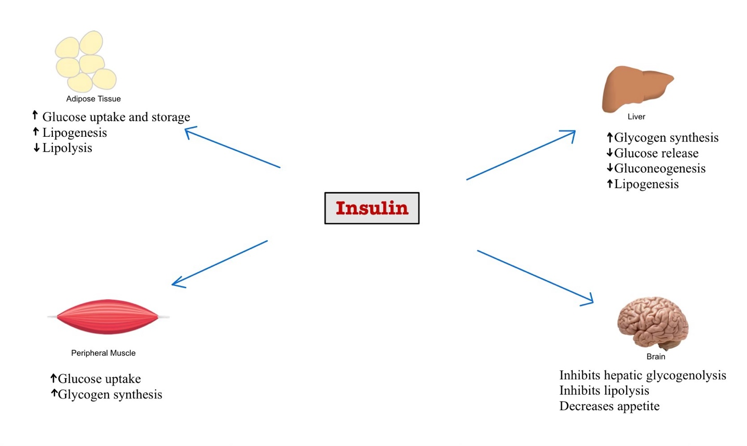
Figure 3: Action of insulin on various organs

D] Once Weekly Insulin
Once weekly administration of insulin would give an immense boost to the ease, compliance, adherence and quality of life of patients while simultaneously decreasing the side effects with frequent dosing. Companies such as Novo Nordisk and Lilly are in active clinical trials to develop longer-acting insulins. Novo Nordisk’s molecule- insulin icodec met the study goals in 2 of its phase 3a trials in their six-part ONWARDS program in July,2022.
Lilly’s once weekly basal insulin Fc (BIF) showed promising results in Phase 2 clinical trials on patients with type 2 DM who were previously treated with basal insulin, paving a path for continued future studies.

E] Ultra-Fast Acting Insulin
This form of Insulin can be taken as close as 10-15 minutes around mealtime. Due to its rapid onset of action and an early decline in levels within 2-4 hours, it is best suited for post-prandial hyperglycemia. Another advantage it embodies is its ability to tightly regulate glucose levels. This stems from its short-acting effect and rapid onset of action that allows its administration on need basis. In 2020, Stanford University researchers were able to develop a molecule that began its effect almost upon immediate injection. This made it 4 times faster than any currently available rapidly acting insulin. However, this monomeric insulin was extremely unstable to put into use. After further developments, the researchers were able to create a stable copolymer to act as a carrier for the insulin monomers, leading to a decrease in their aggregation and breakdown. These effects were demonstrated in a diabetic pig. Currently studies are in process to be able to reproduce similar effects in humans.
F] Thermostable Insulin
Insulin is a drug which necessitates ‘cold chain’ handling. It is best at its efficacy if stored at a temperature of 4 degrees Celsius. Insulin is pro amyloidogenic and it forms insoluble aggregates resulting in excess insulin requirement; amyloidoma formation at the site of repeated insulin injection; gradual loss of excipients and deposition of fibrils in the catheter system of insulin pumps; and temperature-sensitive insulin fibrillation entails storage and maintenance of cold chain. Even mild agitation of insulin during its storage and transport has been reported to denature the protein through fibrillation, resulting in its inactivation. These issues thereby call for a more stable form of formulations that would cater to the increasing global demand. A group of Indian scientists have demonstrated the in-vitro ability of insulin to resist degradation at higher temperatures even up to 65 degrees Celsius. This came to materialize only when a tetrapeptide was inserted within the molecular framework of insulin.
Once this insulin form shows promise in-vivo, it will aid treatment in underserved and tropical areas. Many people still do not have access to electricity and hence refrigerators necessary to store such a drug. Revolutionizing the transport ad supply chain by creating a thermostable insulin will certainly solve a crisis.
G] Insulin Pump
Insulin pumps are devices no bigger than a cell phone, which deliver insulin doses at specific times (Figure 4). They can also be programmed to deliver them like a basal-bolus regimen. The people who would surely benefit from this method of delivery are those who:
- Experience delays in food absorption.
- Are active and may want to pause insulin doses when exercising.
- Have severe reactions to low blood sugar.
- Are aversive to frequent injections.
These pumps subcutaneously inject the drug into the system. This machine can be set up along with a CGM (continuous glucose monitor) that would check the blood glucose every 5 minutes and maintain a digital record of all the values throughout the day. This pairing helps the insulin pumps work accordingly and adjust the dose to maintain physiologic levels of glucose in our body.
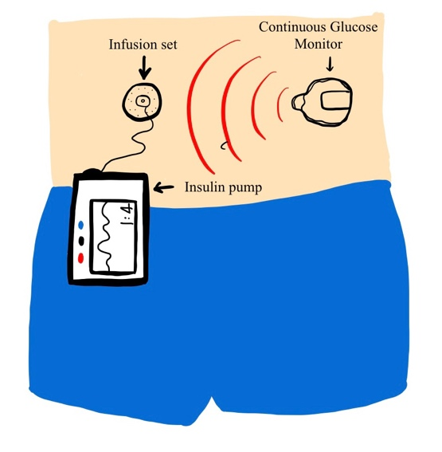
Figure 4: Chronic glucose monitor with insulin pump
H] Inhaled Insulin
Inhaled Technosphere insulin (TI) is an idea that thought to circumvent the need for injections. It is a rapid acting, dry powder but as of now cannot totally replace injectable insulin. It can be used as an addition to it as a postprandial substitute instead of rapid acting injectable insulin analogues. Studies have shown non-inferiority of inhaled insulin when compared with rapid acting analogues. However, it showed lesser mean reductions in HbA1c when compared to regular injected insulin, mostly due to higher glucose levels in the late postprandial stage, 2 to 5 hours post-inhalation. Studies are yet to be performed to clarify the long-term pulmonary effect of this method of drug delivery.

V. CONCLUSION

Researchers and scientists around the world have put in immense efforts and resources to aid in development of insulin which was first isolated from animal extract and now by synthetic production, further paving a way to alter its structure for adjusting the rapidity and duration of action, and now attempts are being made for an easy route of delivery, resemble normal physiology and minimize the adverse events. Much research is in need both in the basic sciences and clinical sciences to build a reliable literature in upcoming insulin forms. It is a truly miraculous journey of Insulin as it heads into its second century of use.

References:
- Kumar V, Choudhry I, Namdev A, Mishra S, Soni S, Hurkat P, Jain A, Jain D. Oral Insulin: Myth or Reality. Curr Diabetes Rev. 2018;14(6):497-508. doi: 10.2174/1573399813666170621122742. PMID: 28637407.
- Quianzon CC, Cheikh I. History of insulin. J Community Hosp Intern Med Perspect. 2012 Jul 16;2(2). doi: 10.3402/jchimp.v2i2.18701. PMID: 23882369; PMCID: PMC3714061.
- Abramson A, Caffarel-Salvador E, Khang M, Dellal D, Silverstein D, Gao Y, Frederiksen MR, Vegge A, Hubálek F, Water JJ, Friderichsen AV, Fels J, Kirk RK, Cleveland C, Collins J, Tamang S, Hayward A, Landh T, Buckley ST, Roxhed N, Rahbek U, Langer R, Traverso G. An ingestible self-orienting system for oral delivery of macromolecules. Science. 2019 Feb 8;363(6427):611-615. doi: 10.1126/science.aau2277. PMID: 30733413; PMCID: PMC6430586.
- Frias JP, Chien J, Zhang Q, Chigutsa E, Landschulz W, Wullenweber P, Haupt A, Kazda C. Once Weekly Basal Insulin Fc (BIF) is Safe and Efficacious in Patients with Type 2 Diabetes Mellitus (T2DM) Previously Treated With Basal Insulin. J Endocr Soc. 2021 May 3;5(Suppl 1):A448–9. doi: 10.1210/jendso/bvab048.916. PMCID: PMC8090036.
- Wang J, Wang Z, Yu J, Kahkoska AR, Buse JB, Gu Z. Glucose-Responsive Insulin and Delivery Systems: Innovation and Translation. Adv Mater. 2020 Apr;32(13):e1902004. doi: 10.1002/adma.201902004. Epub 2019 Aug 18. PMID: 31423670; PMCID: PMC7141789.

Glucose-responsive insulin activity by covalent modification with aliphatic phenylboronic acid conjugates

Danny Hung-Chieh Chou, Matthew J. Webber, Benjamin C. Tang, +6 , Amy B. Lin, Lavanya S. Thapa, David Deng, Jonathan V. Truong, Abel B. Cortinas, Robert Langer rlanger@mit.edu, and Daniel G. Anderson February 9, 2015 112 (8) 2401-2406 https://doi.org/10.1073/pnas.1424684112
- Mukherjee M, Das D, Sarkar J, et al. Prion-derived tetrapeptide stabilizes thermolabile insulin via conformational trapping. iScience. 2021;24(6):102573. Published 2021 May 21. doi:10.1016/j.isci.2021.102573
- Bruce W. Bode, Janet B. McGill, Daniel L. Lorber, Jorge L. Gross, P.-C. Chang, David B. Bregman, for the Affinity 1 Study Group; Inhaled Technosphere Insulin Compared With Injected Prandial Insulin in Type 1 Diabetes: A Randomized 24-Week Trial. Diabetes Care 1 December 2015; 38 (12): 2266–2273. https://doi.org/10.2337/dc15-0075
- Chan J, Cheng-Lai A. Inhaled Insulin: A Clinical and Historical Review. Cardiol Rev. 2017 May/Jun;25(3):140-146. doi: 10.1097/CRD.0000000000000143. PMID: 28379903.
- Jarosinski MA, Dhayalan B, Rege N, Chatterjee D, Weiss MA. 'Smart' insulin-delivery technologies and intrinsic glucose-responsive insulin analogues. Diabetologia. 2021 May;64(5):1016-1029. doi: 10.1007/s00125-021-05422-6. Epub 2021 Mar 12. PMID: 33710398; PMCID: PMC8158166.
- Rege NK, Phillips NFB, Weiss MA. Development of glucose-responsive 'smart' insulin systems. Curr Opin Endocrinol Diabetes Obes. 2017 Aug;24(4):267-278. doi: 10.1097/MED.0000000000000345. PMID: 28509691; PMCID: PMC5613292.
- Rubin RR, Peyrot M. Treatment satisfaction and quality of life for an integrated continuous glucose monitoring/insulin pump system compared to self-monitoring plus an insulin pump. J Diabetes Sci Technol. 2009 Nov 1;3(6):1402-10. doi: 10.1177/193229680900300621. PMID: 20144395; PMCID: PMC2787041.
- Yu J, Wang J, Zhang Y, Chen G, Mao W, Ye Y, Kahkoska AR, Buse JB, Langer R, Gu Z. Glucose-responsive insulin patch for the regulation of blood glucose in mice and minipigs. Nat Biomed Eng. 2020 May;4(5):499-506. doi: 10.1038/s41551-019-0508-y. Epub 2020 Feb 3. PMID: 32015407; PMCID: PMC7231631.
- GhavamiNejad A, Li J, Lu B, Zhou L, Lam L, Giacca A, Wu XY. Glucose-Responsive Composite Microneedle Patch for Hypoglycemia-Triggered Delivery of Native Glucagon. Adv Mater. 2019 Jul;31(30):e1901051. doi: 10.1002/adma.201901051. Epub 2019 Jun 5. PMID: 31165524.
- Heinemann L, Braune K, Carter A, Zayani A, Krämer LA. Insulin Storage: A Critical Reappraisal. J Diabetes Sci Technol. 2021 Jan;15(1):147-159. doi: 10.1177/1932296819900258. Epub 2020 Jan 29. PMID: 31994414; PMCID: PMC7783014.

