A Study on Taxonomy, Elements and Types of Design
M. Sailaja  Computer Science and Engineering  Ravindra College of Engineering for women  Kurnool, A.P, India  sailajacse@recw.ac.in | R. Deepthi Crestose Rebekah  Computer Science and Engineering  Ravindra College of Engineering for women  Kurnool, A.P, India  rdeepthicse@recw.ac.in | N. Manjula  Computer Science and Engineering  Ravindra College of Engineering for women  Kurnool, A.P, India  manjulacse@recw.ac.in | V. Prema Manvi  Computer Science and Engineering  Ravindra College of Engineering for women  Kurnool, A.P, India premacse@recw.ac.in

ABSTRACT
Creating a system, object, activity, or process requires a plan or specification. A design is the result of that plan or specification in the shape of a prototype, final product, or method. The verb design conveys the action of producing a product. Different types of designs help to make the product or prototype useful and long-lasting. To make a successful composition, the design elements are the building blocks for a Visual artist or a graphic designer.

Keywords—Design, Taxonomy, Elements of Design.

INTRODUCTION
Purpose of Design:
The design principles influence how users perceive and interact with a design. When used strategically, they can have an emotional impact on the user while also improving the overall user experience.

Definitions of design:

The ability of people to show their creativity in deciding the shape of an object, whether physical or virtual. Or a design is a plan or specification for the construction of an object or system or for the implementation of an activity or process, or the result of that plan or specification in the form of a prototype, product or process.

A good design should be innovative, product useful, reliable, and long-lasting and ecofriendly.

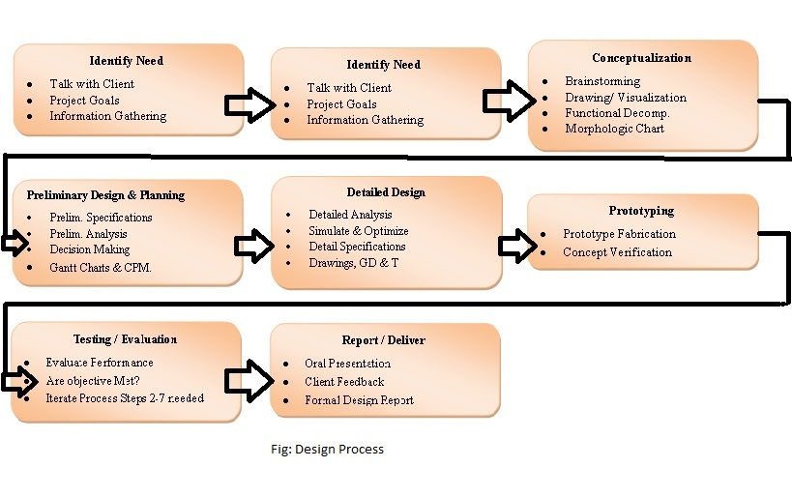

TAXONOMY OF DESIGN
- Architectural Design: Project of living space for people.
Eg: buildings, parks, public squares, houses.
- Design of Spaces: The adaptation of the spaces according to specific needs of its usefulness.
Eg: commercial, residential, educational, labor.
- Industrial Design: Projects involved in industrial production of objects for human use.
Eg: from a spoon to the body of a car or the fuselage of an airplane, through furniture, tools, and artifacts.
- Graphic Design: Recreate meaningful visual messages.
Eg: logos of brands, posters, magazines, book covers, websites.
- Fashion Design: Design and manufacture of clothes and clothing accessories
Eg: clothes, shoes, jewelry.
- Textile Design: Combination of methods involved in Graphic Design with the methods involved in Industrial Design and Fashion Design, consists of configuring fabrics and patterns of the textile industry.
Eg: prints, yarns, embroidery, fibers.
- Interactive Design: Focus on software and digital interface design.

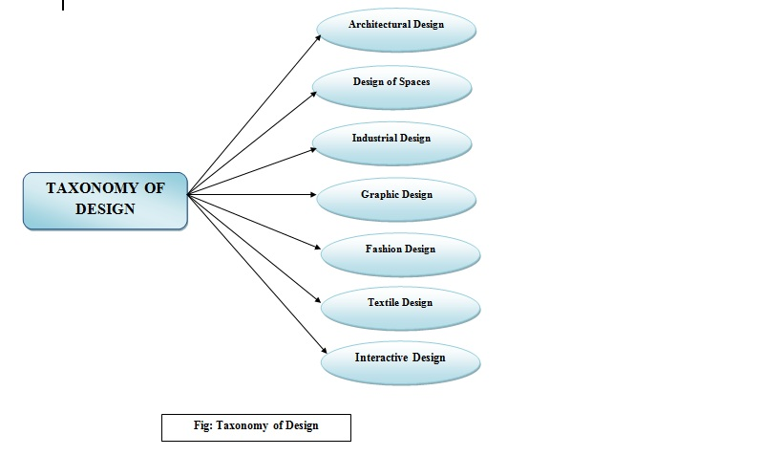

- ELEMENTS OF DESIGN

Every object in our surroundings is made up of design elements. Nothing exists within the absence of these components. The designer is liable for understanding the power of these elements and formatting them in accordance with design principles.
1. Color – It is commonly mentioned as hue. The word color refers to a specific colour or light wavelength that can be found in the colour spectrum and that moves in a circle from red to yellow to green to blue and back to red.
2. Line - A line may be a point in motion that has only one dimension. A line has both an edge in space and a direction. Line variables are size, shape, position, orientation, number, spacing, and density. Points create lines; lines create shapes or planes and volumes.
3. Mass - Mass and volume are interchangeable during this context. A mass may be a solid body or a collection of visual elements that together form a solid form. Volume may be a three-dimensional shape made up of length, width, and depth. Points, lines, and planes are all components of three-dimensional forms. A mass may be a two-dimensional representation of a three-dimensional form.
4. Movement - Also referred to as movement. This element depicts the act or process of adjusting place or direction, orientation, and/or position by visualizing starting or stopping points, blurring of action, and so on. This is often not animation, though animation may be a byproduct of movement and other design elements.
5. Space - A two- or three-dimensional element defined by other design elements.
6. Texture - A two-dimensional design technique that uses various drawing and media techniques to duplicate three-dimensional surfaces. Touch or visual experience is employed to experience three-dimensional surfaces.
7. Type - Also mentioned as typography and it is considered an element in graphic design. Although it consists of elements of design, it's - in itself - often a component in the form of visual communication.
8. Value - Another word for the lightness or darkness of an area. Brightness measured in relationship to a graded scale from white to black.

- VARIOUS TESTING METHODS FOR A SUCCESSFUL DESIGN

The various testing methods which are involved in successful design of a product are:

- Concept validation: It helps to generate the ideas which won’t work before we haven’t spent too much time and money on them.

- Usability Task analysis: Helps you quickly identify the blockers, bugs and gaps in usability of the product.

- First click Testing: It shows which buttons, icons and other navigational elements in which the users are failing to avoid or notice on the product.

- Card Sorting: It shows the users creativity and helps to make sense the user’s journey for customers.

- Tree Testing: It is used to validate the design and creating a clear, intuitive navigation experience for user.

- User Feedback: Targets onsite feedback testing to understand the user’s mind to make use of specific features.

- Split Testing: It iterates the design and provides different options to lower the risk factor for new design ideas.

REFERENCES
1.The Design Management Institute DMI Value Index 2015, retrieved from https://www.dmi.org/page/2015DVIandOTW
2.Martin, R. (2009) The Design of Business, Harvard Business School Press.
3.Quayle, M. (2017) Designed Leadership. Columbia University Press
4.Liedtka, J. (2018, Sept-Oct) Why Design Thinking Works, Harvard Business Review
5.Walker, R. (2003, Nov 30) The Guts of a New Machine. New York Times Retrieved http://www.nytimes.com/2003/11/30/magazine/30IPOD.html
6. Brown. T. (2008) Design Thinking Thoughts: Definitions of Design Thinking retrieved from https://designthinking.ideo.com/?p=49

