Innovative Applications with IoT for
Smart-Home

M. Amitha,
Dept. of Computer Science
Bhavan’s Vivekananda College,
Secunderabad, Telangana, India
maramamitha@gmail.com

Abstract
Smart homes have evolved from electromechanical to the centralized and semi-automated control of environmental systems, whereas Internet-of-Things (IoT) is the expansion to these with internet services. IoT has become an integral part of the home and uses of new technologies in IoT environment are increasing rapidly. Smart Homes in IoT environment or IoT based Smart Homes are those, wherein household devices/home appliances which are connected with the internet using proper network architecture and standard protocols are monitored and controlled remotely.
Here, in this article, I would like to present IoT based solutions for automatic water supply for the plants, App based smart door lock system for the home security and App based home electrical appliance control system.

Keywords— Smart home, Internet-of-Things (IoT), Arduino.

INTRODUCTION
Sensor based water supply control for the plants is an IoT solution where we can save water, electrical energy and time for supplying the water to the home garden, in this solution I used Soil Moisture sensor, Arduino as the controller and a relay module as a pump driver. The Arduino code is written in such a way that the IoT device senses the moisture level and will activate the driver to start the pump for watering the plant; driver will be deactivated automatically when the moisture reaches the predefined level.
App based smart door lock system for the home security is a Wireless signal based IoT solution where we can lock and unlock the door by using a Mobile App. IoT device has been programmed in such a way that the App communicates with the IoT device over the Bluetooth and sends the lock/unlock signals and energizes and de-energizes door lock actuator.
App based home electrical appliance control system is wireless signal based IoT solution where we can control and automate the electrical appliances such as Lights and Fans by using a Mobile App. IoT device has been coded in such a way that the App communicates over the Bluetooth and sends the ON/OFF signals activates/de-activates the device driver to control the appliance.

- IoT and Control modules used
- Arduino Uno board for the IoT programming
Arduino is an open source electronic circuit prototyping platform based on easy-to-use hardware and software. It is intended for hobbyists, students or anyone interested in creating interactive electronic objects or environments.
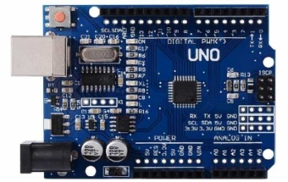

Fig: 1.Arduino Uno

- Soil moisture sensor
Soil moisture sensor module measures the volumetric water(moisture) content in soil, used for remote sensing in agriculture. These sensor modules measure the volumetric water(moisture) content indirectly using properties like electrical resistance, dielectric constant or interaction with neutrons as proxy for moisture content.
It consists of 4 pins including the power input pins in which two pins the other two output pins are digital (D0) and analog (A0). When the sensor senses the moisture content beyond the threshold level, the digital output(D0) goes to low level (logic-0) The threshold value can be set by using the potentiometer present on the module board. The approximate level of moisture content in the soil can be calculated by using the other output pin(S0).

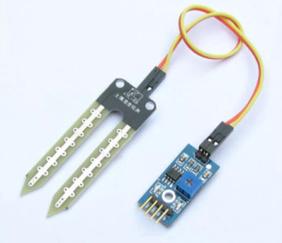

Fig:2. Soil moisture sensors

- Relay Module
Relays modules are electromagnetic switches that open and close circuits electromechanically. Relays control one electrical circuit by opening or closing contacts in another circuit. It is mainly used to control a high powered circuit using a low power signal. This module uses opto-coupler to isolate the output from the input hence this is very safe to connect the load that operates at high voltages(200 V and above).
It has four control pins, ground pin, Vcc pin and two control input pins to control the relays.
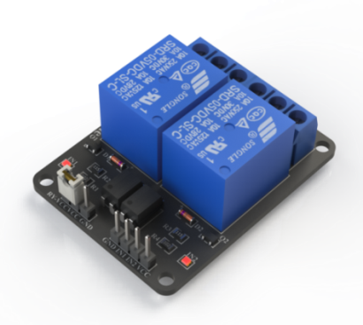

Fig:3. Relay Module

- Bluetooth module(HC-05)
HC-05 Bluetooth module has been used in this project, which supports master and slave mode serial communication with the baud rate of 9600-115200 bps with SPP and UART interfaces. It can communicate with other Bluetooth-enabled devices like mobile phones, tablets and laptops. The module runs on 3.3V to 5V power supply. Which also can be programmed independently using the AT commands over the serial communication.
It has 6 pins, first is the enable pin which can be used to switch between data and the AT command modes, second one is the VCC, third one is the GND pin, fourth one is TX pin used to send the serial data, fifth one is the RX pin which is used to receive the serial data and the sixth pin is the state pin and is used to check the status of the module.

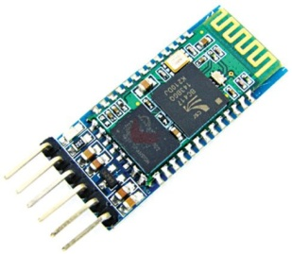

Fig:4. Bluetooth Module(HC-05)

- Servo Motor
Servo motor has integrated mechanical assembly with gears and a shaft that can be precisely controlled programmatically using a micro controller Standard servo motors allow the shaft to be positioned at different angles, usually between 0 and 180 degrees. Continuous rotation servos allow the rotation of the shaft to be set to variable speeds.

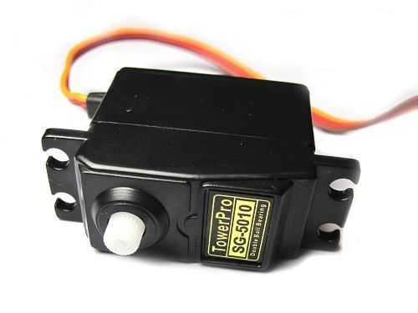
Servo motors have three wires: power, ground, and signal. The power wire is typically red, and should be connected to the 5V pin on the Arduino board. The ground wire is typically black or brown and should be connected to a ground pin on the Arduino board. The signal pin is typically yellow, orange or white and should be connected to a digital pin on the Arduino board.

Fig: 5. Servo Motor

- Water supply control for the plants is a sensor based IoT solution

Components Used
Hardware-
- Arduino-UNO
- 2 channel Relay Module (Pump Driver)
- Digital Soil moisture sensor module
- DC Submersible water pump

SOFTWARE:
Arduino IDE.

Principle of working :

Principle behind working of this project lies in the functioning of soil moisture sensor module. The sensor has been used only to check whether the soil is dry or wet.
This controller can be set in one of the two states, 1. Semi Auto state, 2.Fully Auto state , the Semi Auto state, the water pump will be controller by the relay such that if the sensor senses the dry soil the pump waters the soil until and unless the sensor is removed manually where as In the auto state , the water pump goes into off mode automatically after the predefined time interval. The operating state of the controller can be select by using a switch

Circuit Diagram:

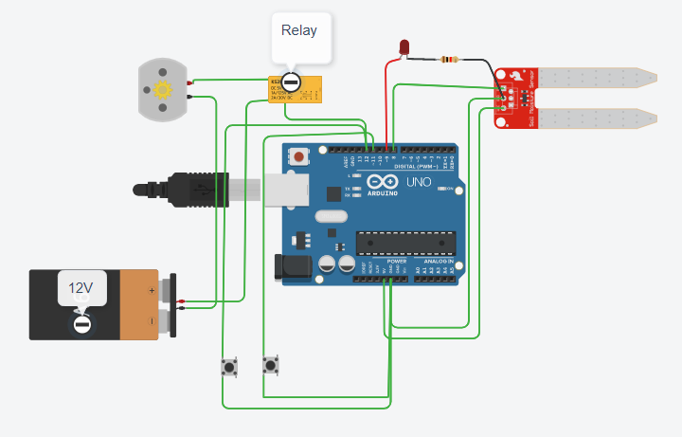
Full Auto
Semi Auto

CODE

int waterpump = 12;
int sensor = 8;
int ledPin = 9;
int switchPin_semi=11;
int switchPin_auto=10;
int val;
int semival;
int autoval;
int pumpStatus=0;
oid setup() {
Serial.begin(9600);
pinMode(12, OUTPUT);
pinMode(8, INPUT);
pinMode(9,OUTPUT);
pinMode(switchPin_semi,INPUT_PULLUP);
pinMode(switchPin_auto,INPUT_PULLUP);
}
void loop() {
val =digitalRead(8);
semival=digitalRead(11);
autoval=digitalRead(10);
if(val==1 && pumpStatus==0)
{
digitalWrite(12, LOW);
pumpStatus=1;
digitalWrite(9,HIGH);
}

if(semival==LOW && pumpStatus==1)
{
if(val==0)
{
digitalWrite(12,HIGH);
pumpStatus=0;
digitalWrite(9,HIGH);
}
}
else if(autoval == LOW && pumpStatus==1)
{

delay(10000);
digitalWrite(12, HIGH);
pumpStatus=1;
digitalWrite(9,HIGH);
}
Serial.println("Sensor " + String(val));
Serial.println("Pump status " + String(pumpStatus));
Serial.println("Switch auto " + String(autoval));
Serial.println("Switch semi " + String(semival));
delay(1000);
}

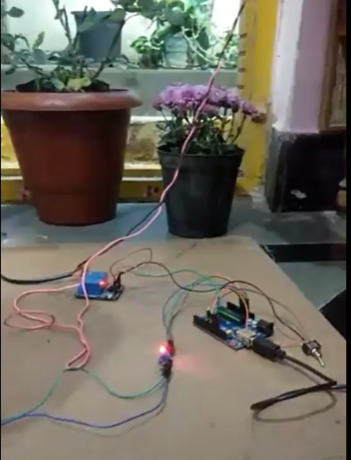

Fig : 6. Live Working Model

- App based smart door lock system for the home security
The smart home system has focused on smart controls and convert conventional mechanical devices to centralized electro mechanical control systems further, smart home related technologies have focused on networking (wired and wireless systems) technologies for the IoT connectivity, controlling (remote control, smart phones, and web browsers), and smart devices (green, energy consumption, security, environment, and entertainment).
An illustration of smart home technology is shown in the picture.
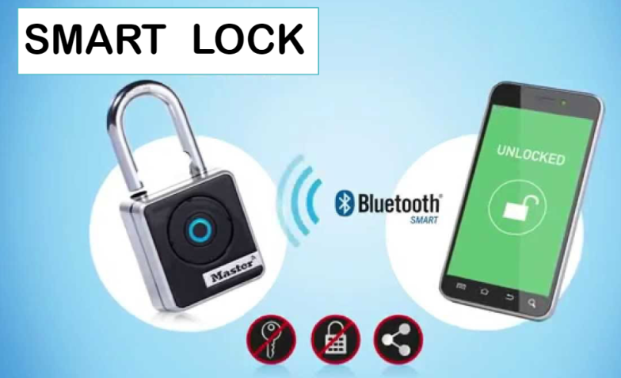

COMPONENTS USED
- Electronic Servo Motor
- Arduino-UNO
- Bluetooth Module(HC-05)

Mobile App used:
- Bluetooth controller on/off

CIRCUIT DIAGRAM:

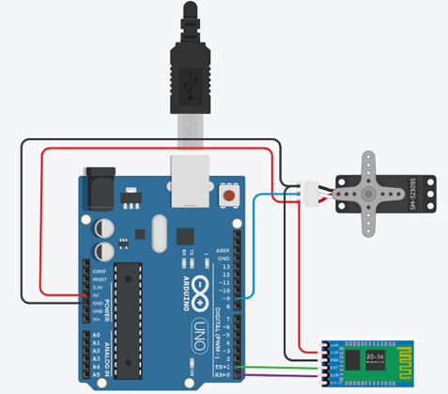

CODE for the IoT:
#include<Servo.h>
Servo myservo;
int state=0;
int lock=0;
void setup() {
Serial.begin(9600);
myservo.attach(9);
}
void loop() {
if (Serial.available()>0)
{
state=Serial.read();
Serial.print(state);
delay(1000);
if(state==0 && lock==1)
{
Serial.println("door is unlocked");
myservo.write(0);
lock=0;
}
else if(state==1 && lock==0)
{
Serial.println("door is locked");
{
Serial.println("door is unlocked");
myservo.write(0);
lock=0;
}
else if(state==1 && lock==0)
{
Serial.println("door is locked");
myservo.write(45);
lock=1;
}
}
}
myservo.write(45);
lock=1;
}
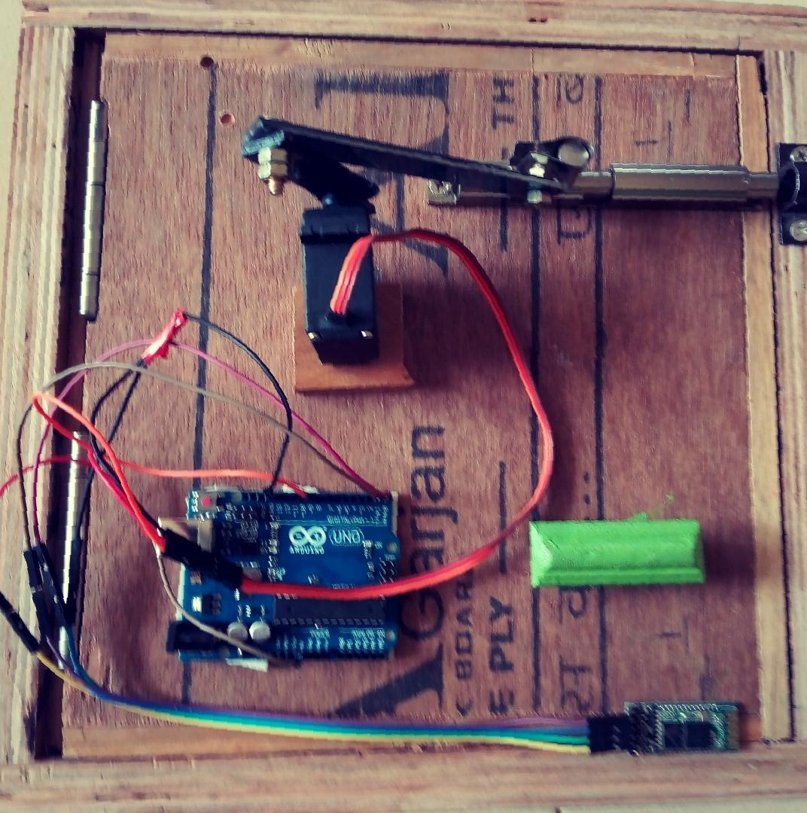
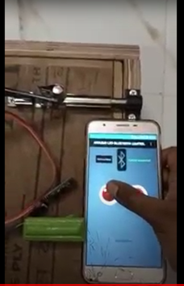

} Fig : 7. Live Working Model

FUTURE IMPLEMETATION OF SMART LOCK
A lock/unlock mechanical key is normally used for traditional door locking, but it provides very poor security without any tracking, we can develop a sophisticated trackable and finger proof door locking system by integrating the fingerprint sensor to this system unlock project, the door unlocks and the LCD displays a welcome message along with that person’s name only when an authorized person scans his/her finger on the sensor,
The other methods can be integrated in this project are,
- Password protected security lock.
- RFID recognition.

- App based home electrical appliance control system.
Nowadays, smart phones are very handy all the time hence it makes sense to use the mobile Phone to control the home appliances. Here is a home automation system using a microcontroller controlled by a simple Android app, this can used to control any electrical appliances by tapping on the App or with the voice commands. App sends the commands over the Bluetooth to microcontroller(Arduino-Uno). This project can be enhanced further by integrating the device status and usage tracking system so that we can track how much time that an appliance was on/off and we can generate the alerts when the appliance is over loaded or excessive usage.

Components Used :
- Auduino-Uno
- Bluetooth module-HC-05.
- 4 Channel Relay module.

Mobile App used:
Arduino-Bluetooth-Home-Automation : Arduino-Bluetooth-Controller is a readymade Android application which is published in the Google play store and used to control 4 channel relay module over a Bluetooth communication using either HC-05, or HC-06

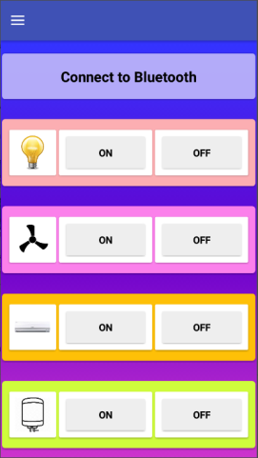
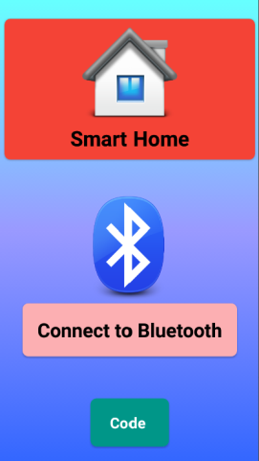

Circuit Diagram:

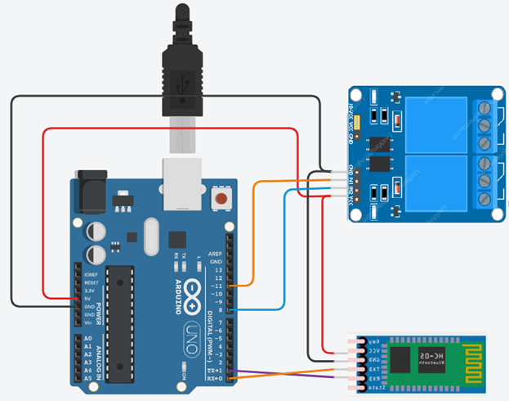

Code for the IoT:

char getChar=' ';

void setup()
{
pinMode(13,OUTPUT);
digitalWrite(13,LOW);
pinMode(11,OUTPUT);
digitalWrite(11,LOW);
pinMode(8,OUTPUT);
digitalWrite(8,LOW);
Serial.begin(9600);
Serial.flush();
}
void loop()
{ //Serial.flush();
if(Serial.available()<1)
return;
getChar=Serial.read();
Serial.println(getChar);
switch(getChar)
{
case 'a':digitalWrite(13,HIGH);
break;
case 'b':digitalWrite(13,LOW);
break;
case 'e':digitalWrite(11,HIGH);
break;
case 'f':digitalWrite(11,LOW);
break;
case 'i':digitalWrite(8,HIGH);
break;
case 'j':digitalWrite(8,LOW);
break;
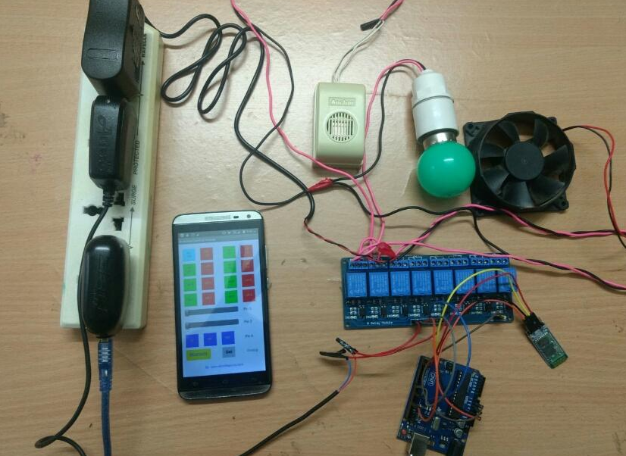
}}

Fig : 8. Live Working Model

REFERENCES

- https://www.migatron.com/ultrasonic-detections-and-control-applications/
- https://circuitdigest.com/arduino-home-automation-projects
- https://www.makerspaces.com/wp-content/uploads/2017/02/Arduino-For-Beginners-REV2.pdf
- https://www.halvorsen.blog/documents/technology/resources/resources/Arduino/Programming%20with%20Arduino.pdf
- http://engineering.nyu.edu/gk12/amps-cbri/pdf/ArduinoBooks/Arduino%20Programming%20Notebook.pdf
- Magazines- Electronics for you
- Magazines-ElectrickIndia
- https://www.elprocus.com/arduino-projects/

