Advanced Computational Techniques for the Evaluation of Solar Activities
S.K. Kasde* and D.K. Sondhiya
Department of Physics, Government College Bhainsdehi, Dist Betul, MP, India – 460220
Department of Physics, SAGE University Bhopal, MP, India- 462022
sbskasde@gmai.com*, deepsondhiya@gmail.com
Abstract:

In this work, we examined more advanced methods of data processing; specifically, we used wavelet approaches to identify several properties of the Sun, such as sunspots, solar winds, interplanetary magnetic field components (IMF), so on. In order to conduct an analysis of the astronomical and solar data, one can make use of a number of different mathematical transformations. Among them, the Fourier transform is one of the most used and well-known methods. In situations where higher performance is desired, the Wavelet Transform is used to get beyond the constraints it places on the system because it has some limits.Within the span of a decade, numerous academics working in a variety of scientific fields made use of this methodology. As a result of its exceptional performance, faultless operation, and ready availability, it will become more helpful and well-known among new researchers as they develop their original concepts.

Key words: Space Weather, Sun, Sun’s parameters, Wavelet Techniques

Introduction: Space weather
All space weather on or near Earth originates from the Sun. Sunspots are caused by convective motion beneath the solar surface. The nature and characteristics of the solar wind can be better understood through changes in its parameters. These variations are distinguished by multifractality and intermittence phenomena. When the magnetosphere of the Earth is in contact with solar particles and magnetic fields, space weather results. Particles in the form of solar wind are ejected from the sun during solar flares and coronal mass ejections. Particles exit the sun as solar wind during solar flares and coronal mass ejections. Figure (1) depicts how space weather could endanger human life and health, as well as disrupt the operation of technological devices both in space and on Earth. The Sun causes Earth's space weather. Space weather includes interplanetary magnetic field changes, solar CMEs, and Earth's magnetic field [1, 2]. The magnetic field and sunspots are closely related. Convective motion beneath the solar surface is what generates sunspots. Solar wind carries interplanetary magnetic field from Sun to planets (IMF). The Sun rotates unevenly because it is a gaseous body, which causes it to rotate more quickly at the equator (~24–27 days) and more slowly at the poles (~30 - 35 days).
Numerous techniques, such as correlation analysis [3, 4], chaos analysis [5, 6], multifractal analysis, have surely been used to study sunspots and related activities [7- 9]. Recently, multifractal analysis and chaos theory were applied to examine the statistical characteristics of solar activity [5]. The north-south asymmetries and rotational behavior of solar activity were examined using the wavelet and auto-correlation functions [3]. Cross-correlations between monthly mean sunspot areas and sunspot numbers have been examined in studies [3]. The F10.7 radio flux is used to assess overall solar activity when the magnetic, temperature, and density fields are all augmented [10].

In this chapter, we covered some of the most fundamental and significant characteristics of the sun. All of the research parameters are accounted for by several researchers when conducting their research using the established methodologies and hypotheses. On the other hand, during the course of this chapter, we will present some sophisticated nonlinear approaches that can be used to a dataset of Sun's parameters. In recent years, non-linear methods have been increasingly utilized by researchers everywhere in order to build on their findings.
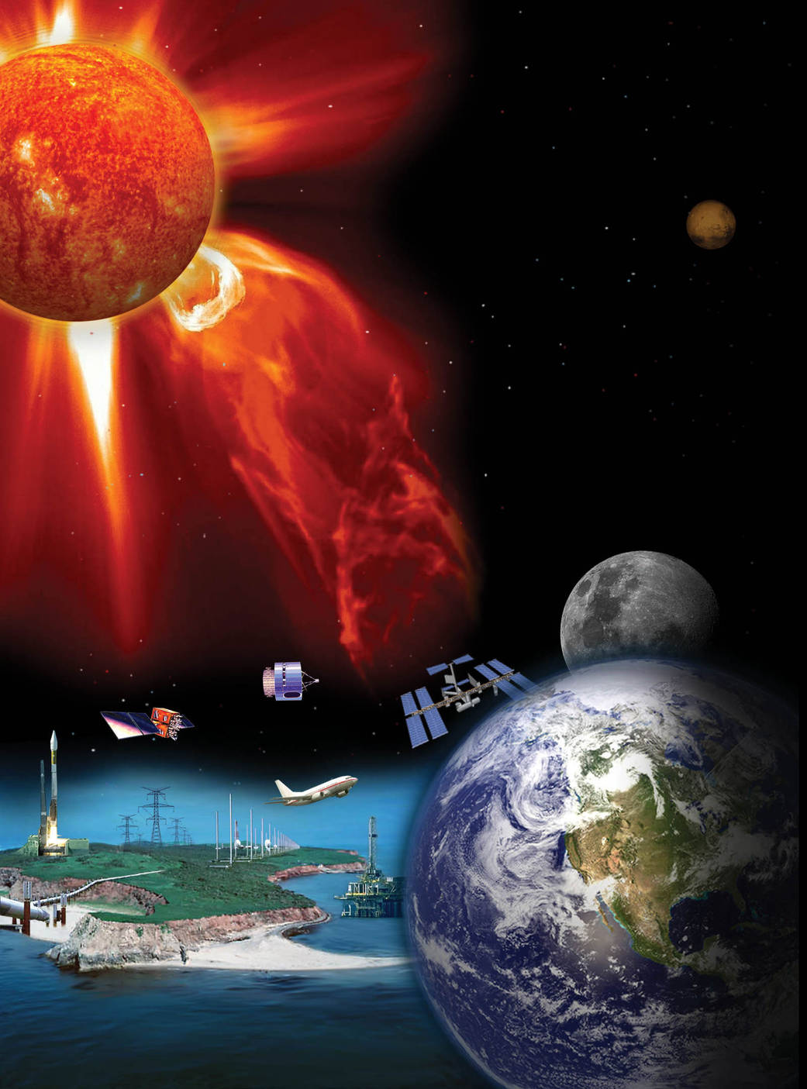
Courtesy: http://www.nasa.gov/mission_pages/sunearth/science/Solar-rotation.html
Figure - 1: Space weather interaction with the Earth's atmosphere
The Sun's Structure
Figure (2) shows the Sun's regular shape. The Sun's core reaches 13 MK. Temperature and density allow nuclear fusion. Radioactivity surrounds the core. It takes photons produced deep within the core 106 years to travel to the outer atmosphere. Large-scale convective cells, driven by the temperature gradient between the interior and outside of the sun, transport energy in the convective zone, which surrounds the radiation zone. The photosphere is the solar atmosphere's outermost layer. The solar atmosphere includes chromospheres, transition zones, and coronas. The next sections detail Sun's parts.
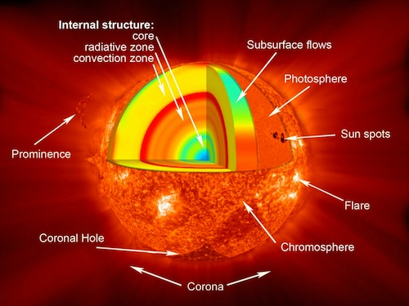
Courtesy: http://www.nasa.gov/mission_pages/sunearth/science/Solar-rotation.html
Figure - 2: Sun's standard model
The Radiation Zone
Energy is transferred from the extremely heated interior to the colder outer layers through photons. It contains the core. It ranges from 10 to 5 MK and 0.25 to 0.75 R. P-P chain gamma rays scatter when they strike unbound electrons, protons, and atomic nuclei because of the high concentrations in the core and radiation zone. Scattering occurs when an electron is entirely free (Thompson), weakly bound (Compton), or when the wavelength is substantially bigger than the atom (Rayleigh). When a bound electron absorbs a photon, bound-bound scattering occurs, moving the electron to a less bound state and causing stellar spectral absorption lines. In bound-free absorption, the absorbed photon's energy frees the electron and ionises the atom. The kinetic energy of an unbound electron near an ion increases during free-free absorption. Absorption prevails in the solar interior. Kramers' asserts that when bound-free and free-free absorption dominate opacity, T (-7/2) increases fast with decreasing temperature, lowering radiative transfer and steepening the temperature gradient.
Atmospheric Layers of Sun
Sun's inner part (i.e. core) to its outer layers of atmosphere is the source of its energy. An immense quantity of energy is transferred from the Sun's core through the radiation zone to the convection zone, as we saw in the previous section. The following sections provide a brief overview of the Sun's atmosphere and the numerous phenomena associated with it.
The Visible Surface (Photosphere)
The photosphere is the term for the Sun's observable surface (photo from the Greek for "light"), where optical depth for light is unity, which is often denoted as and can be thought of as the surface of last scattering for solar optical photons. The temperature at the bottom is around, while at the top, which is about above the "temperature minimum". The photosphere is split into dazzling granules by bubbles of hotter material that rise from the sun and vanish in a few minutes. Huge magnetic field bundles can occasionally burst through the photosphere, disrupting this boiling layer with a combination of circumstances referred to as solar activity and creating cool and dark regions known as sunspots.
The Chromosphere (The Red Layer)
The chromosphere is the atmospheric layer directly above the photosphere. It has a thickness of roughly 1500 km and a temperature that exceeds that of the photosphere (about 10000 K compared to the 5800 K temperature of the photosphere). As one moves higher into the chromospheres, the plasma density decreases and the amount of light emitted decreases proportionally. In some cases, the chromospheres are extremely active, with hot gas jets (spicules) shooting far into space. These can travel at speeds between 20 and 100 km/h and stretch thousands of kilometres above the solar surface. Since temperature in the chromosphere rises at a rate proportional to height squared, the chromosphere is relatively hot at great altitudes. Around their peripheries, you may spot solar prominences and spicules. The prominences, or solar filaments, that can be seen above the solar limb often take on a loop shape.
The Sun's crown (Corona)
The solar corona is the name for the Sun's outer atmosphere, which is seen during a solar eclipse. The corona, which means "crown" in Latin, enlarges into space supersonically. The solar wind is the name given to the solar gas that escapes into planetary space. Not all directions of the corona are equally luminous or spherically symmetric. Since the corona is one million times fainter than the visible photosphere, it can only be viewed when the photographic plate is obscured. The three zones that make up the solar corona—active regions, calm sun regions, and coronal holes—all have different sizes depending on the stage of the sun's cycle.
- Active Regions
Strong magnetic field concentrations can be seen as sunspot groups at optical wavelengths or magnetograms, which are where active regions are located. Because of their bipolar character, closed magnetic field lines make up the majority of active zones. A range of dynamic processes, including plasma heating, flares, and coronal mass ejections, take place in active regions as a result of the permanent magnetic activity in terms of magnetic flux emergence, flux cancellation, magnetic reconfigurations, and magnetic reconnection processes. Active zones are often located within a latitude range of 40 degrees from the solar equator. Sunspots, often referred to as active zones, first develop near 40 degrees of the solar equator and have the potential to cover 1% of the solar disc [11]. The umbra and penumbra of a sunspot are its lighter surrounding region and its black interior, respectively. In plain sunspots, the penumbra is made up of finer filaments that abruptly diverge from the umbra.
(ii) Quiet Sun
Quiet Sun regions were given to the remaining locations outside of active regions. The name "quiet Sun" is now seen as a misnomer because numerous dynamic processes have been found all across the solar surface, which is justified relative to other stars. Small-scale phenomena like network heating events, nano-flares, explosive events, brilliant points, and soft X-ray jets are examples of dynamic processes in the quiet sun. Large-scale structures like trans-equatorial loops or coronal arches are examples of dynamic processes in the quiet sun. Because the majority of the large-scale structures that envelop quiet sun regions are anchored in active regions, the line separating active regions and quiet sun regions becomes increasingly hazy.
(iii) Coronal Holes
During solar eclipses, it has been observed that the polar regions of the celestial globe are typically darker than the equatorial regions. As a result, Max Waldmeier named these regions "Koronale L'ocher" (in German, i.e., coronal holes). If there are any chromospheric upflows at their foot points, the open magnetic field lines that dominate these zones serve as effective conduits for flushing heated plasma from the corona into the solar wind. Coronal holes frequently lack plasma due to transport mechanisms, giving them a darker appearance than the calm Sun, where heated plasma streaming from the chromosphere is imprisoned until it cools and precipitates back to the chromosphere. Similar to how the atmosphere of our planet has a wide variety of cloud types, from dense stratocumulus to finely structured cirrus clouds, the solar corona also has a variety of loop morphologies that can provide crucial information about the magnetic reconnection and reconfiguration processes that are occurring underneath. While circular geometries may denote relaxed, near-dipolar magnetic field geometries, pointed and cusp-shaped structures may identify coronal null sites of X-type magnetic reconnection spots. Solar Flares
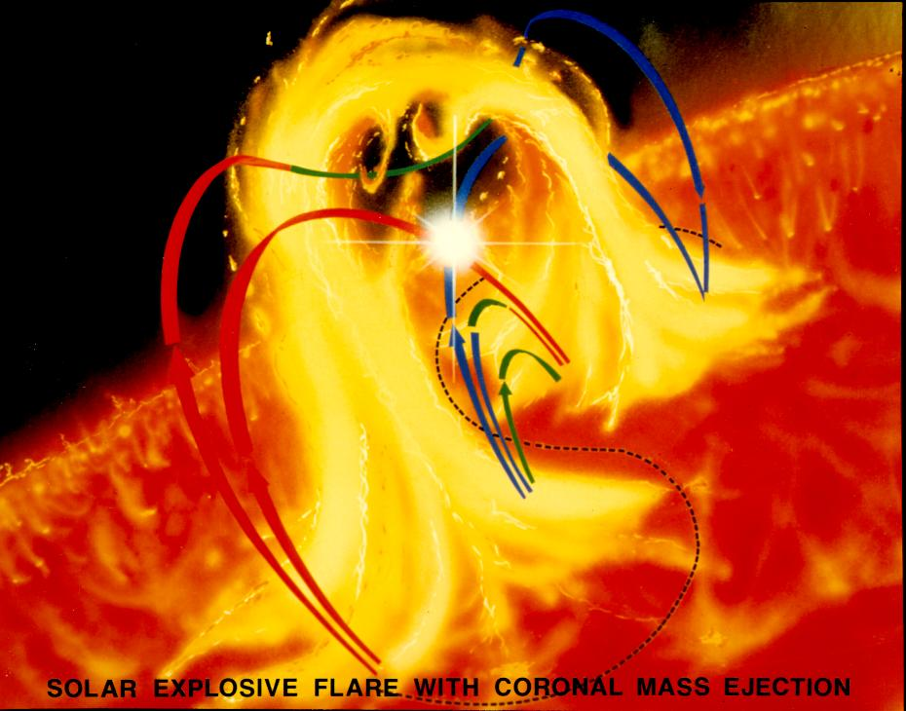
Courtesy: http://www.nasa.gov/mission_pages/sunearth/science/Solar-rotation.html
Figure - 3: solar flare that includes a coronal mass ejection
Sunspot groups are suddenly brightened by solar flares in the solar atmosphere (active regions). The first solar flares were noticed by Richard Carrington in 1859. The abrupt release of magnetic energy held in the corona gives rise to solar flares. It claims that the corona is where the energy is illuminated and that flares affect the layer deeper the larger they are. According to the peak flux (W/m2) of picometer X-rays near Earth, as detected by the GOES spacecraft, solar flares can be categorized as A, B, C, M, or X depending on their energy. The solar flares accelerate charged particles (electron, protons, and heavier ions) to speeds that are very close to the speed of light as a result of the plasma heating. They produce electromagnetic radiation that spans the entire electromagnetic spectrum, from radio waves to the shortest gamma rays. The solar flares and related coronal mass ejections (CMEs) shown in Figure [3] have a significant impact on the local space weather in our area. Their direction may be disturbed by radars and other equipment with decimetric wavelength operation. Solar flares are actually solar wind, which are extremely powerful particles that can cause radiation hazards for astronauts, spacecraft, and the magnetosphere of Earth.

Prominences
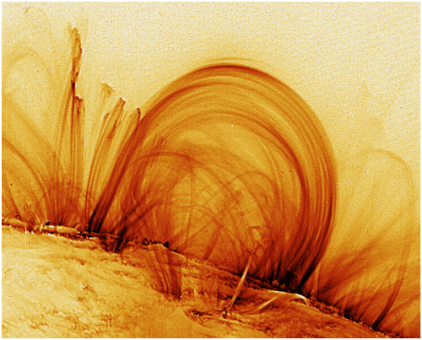
Courtesy: http://www.nasa.gov/mission_pages/sunearth/science/Solar-rotation.html
Figure - 4: Prominences are Sun's greatest magnetic "entity"
Figure 4 depicts one of the Sun's greatest magnetic "entities." Prominences are normally found during total solar eclipses and are described as "burning holes" or "red flames" [13], but before the 19th century some observations were made. In the 1870s, Angelo Secchi was the first to distinguish the prominences between quiescent and eruptive prominences, as depicted in Figure (5), [14].
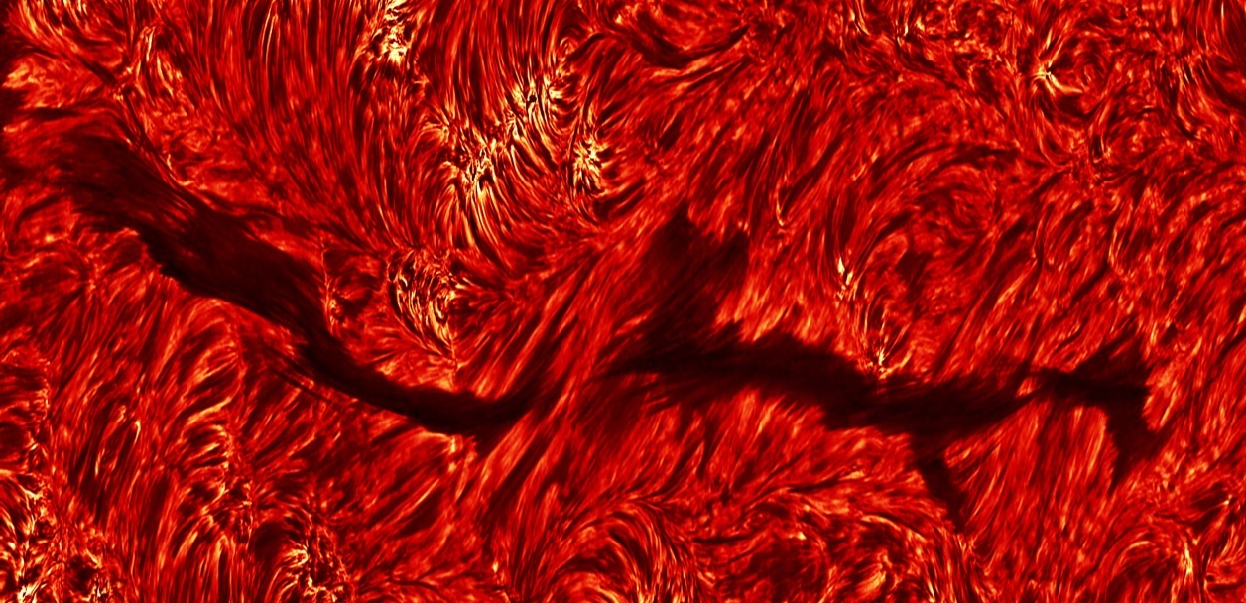
Courtesy: Dutch open Telescope (DOT), www.staff.science.uu.nl
Figure – 5: Sun showing quiescent prominence (Filament) The full length of filament taken in Halpha on October 6, 2004.
Quiescent prominences are a sun attraction. They originate in a day, remain "unchanged" for a month, then end through CME eruptions (CMEs). Prominences in the solar corona consist of chromosphere-like plasma. Quiescent prominences have a length of $60-$ $600 Mm$, with a width of 5 to $15 Mm$, its temperature varies from $4300$ to $5500 K$. It has average electron density of ${10}^{10}$ to${ 10}^{11} {cm}^{-3}$, and pressure of $0.1$ to $1 dyn/{cm}^{2}$ with magnetic field strength of $4$ to $20 G$ [15-17] . There internal motions have a speed below$10 km/s$.
Coronal Mass Ejections
Coronal mass ejections are solar eruptions of mass and magnetic field (CME). R. Tousey initially observed CMEs on December 14, 1971 with the 7th Orbiting Solar Observatory (OSO-7). LASCO on SOHO has been tracking CMEs since 1995. SOHO/LASCO measurements put the average speed of CMEs between 20 and 27,000 km/h (-1). CMEs have caused auroras on Earth's magnetosphere for thousands of years. Figure 6 demonstrates how CME affects Earth's magnetosphere.
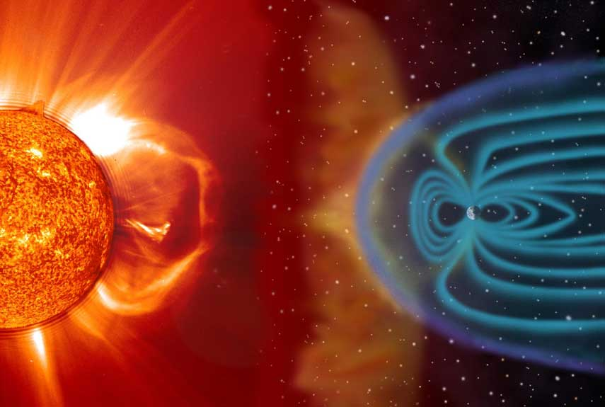
Courtesy: http://www.nasa.gov/mission_pages/sunearth/science/Solar-rotation.html
Figure - 6: CME interaction with Earth's atmosphere.
The Solar Cycle
Schwabe proposed that sunspots appear in quasi-periodic patterns of roughly 11 years [18].
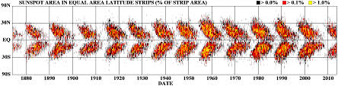
Courtesy: NASA Marshall Space Flight Center
Figure – 7: The sunspot butterfly diagram.
The life of a sunspot is generally short, ranging from days to weeks, and they begin to develop about mid-latitudes (approximately 30-400) on both hemispheres. As time passes, fresh sunspots appear closer and closer to the equator, as seen in Figure (7). The cyclic pattern of Solar activity from 1749-2000 was illustrated in Figure (8). It is divided in the period of Dolton minimum, End of Little Ice Age and Modern Warm Period that is current Solar cycle 24. The number of sunspots on the Sun fluctuates throughout an 11-year period known as the Solar Cycle. Because sunspots are linked to solar activity (i.e., flares and other rapid releases of energy that can heat localised regions of the atmosphere of the Sun to many millions of degrees Kelvin). The Solar cycle also describes the Sun's activity and variability. Sunspots have an average lifetime of 1 to 100 days, although the total number of sunspots vary with this 11-year cycle. Sunspots are areas of powerful magnetic fields, and variations in their number imply variations in the Sun's magnetic field. During the Solar Minimum, the Sun's field is relatively simple and well ordered, resembling a dipole magnetic field, with the magnetic field emanating from one hemisphere and entering the other. As the Sun reaches solar maximum in the following five to six years, the pleasant dipole arrangement gradually fades, and the Sun becomes magnetically disordered and highly complex.
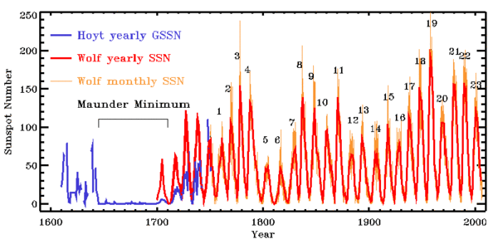
Courtesy: http://www.nasa.gov/mission_pages/sunearth/science/Solar-rotation.html
Figure - 8: The Long term Sunspot number variations form 1600 to 2000
Over the following five to six years, as the sun reaches its maximum, the magnetic field once more organises and becomes more dipolar. During this transition, the weak dipole field's tilt with regard to the Sun's spin axis can be rather high, but as solar minimum draws near, the dipole axis orientation moves closer and closer to being aligned with the spin axis. The dipole field is reconstructed with polarity opposite to that of the original dipole field. The 22-year magnetic cycle of the Sun, also known as the double Solar cycle or the Hale cycle, is characterised by this shift in polarity.
Sunspot pair polarity also follows this cycle. The leading spots of one hemisphere always have the same polarity during the first 11 years of the magnetic cycle, which is the polar opposite of the leading spot in the other hemisphere. For the following 11 years, the polarities of the sunspots are reversed. One would anticipate that since the level of solar activity follows this sunspot or solar cycle, the frequency of solar disturbances that have an influence on Earth would likewise follow this cycle.

Variation of Solar Rotation with Latitudes
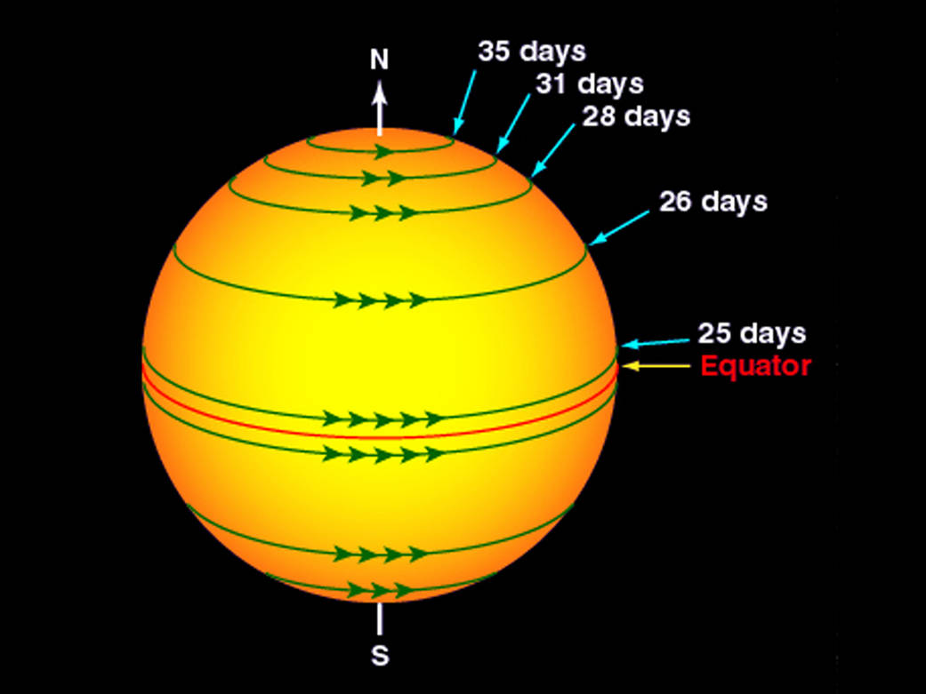
Courtesy: http://www.nasa.gov/mission_pages/sunearth/science/Solar-rotation.html

Figure - 9: Rotational rate of the Sun at different latitudes
Right after the telescope was created, in or around 1610, the Solar rotation was identified. On the sun's surface, which rotates differently, Carrington developed a physically singular way to define longitude. In order to represent this, Carrington suggested a notation that divided time into intervals of 27.27 days. On November 9, 1853, the term "rotation" was first used. The motion of the Earth around the Sun is influenced by Carrington rotations; following a Carrington revolution, the Solar equator is in the "same position" but is now facing Earth. The Sun, a ball of gas and plasma, is not a physical entity. Thus, it rotates at a different rate than other solids like the Earth seen in Figure (9). The regions close to the sun's equator revolve every 25 days. The Sun rotates more slowly at the poles because its rotational speed decreases with increasing latitude. The Sun spins for 36 days while it is at its poles. While the Sun's surface spins in a similar manner, its interior does not. The "tachocline" marks the separation between the Sun's inner, continuously spinning components and its outer, irregularly spinning components.
Convection currents convey the charged plasma from deep within the Sun to the surface of the Sun, and together with differential rotation of the outer layers, they have a significant impact on the Sun's magnetic field behaviour. According to observations, differential rotation is the primary cause of the 11-year sunspot cycle and the related 22-year solar cycle. In 1961, American astronomer Horace Babcock proposed the Babcock Model, so named after his idea that differential rotation and convective motion cause these cycles.
Solar activity and its parameters
Sunspot Regions
In 1908, Hale became the first person to establish that the Sun's magnetic field is exceedingly complicated in both space and time. Because sun spots have a lower temperature than their surroundings, they appear darker on the surface (Kirchhoff's emission law). Sunspots are areas of decreased brightness in the photosphere, or the surface layer of the Sun, that are connected with strong magnetic fields. They are assumed to be manifestations of an inner magnetic dynamo, and they are associated with atmospheric activity such as flaring and coronal mass ejections. A sunspot is an intense magnetic flux tube that emerges from the convection zone of the photosphere. Parker explained the magnetic field of a sunspot emanating from one spot and returning to another in 1955, owing to the fact that sunspots generally develop in larger groups or pairs. Sunspots and the magnetic field are intricately related. The low temperature causes the high magnetic field of sunspots, and overall pressure and magnetic energy density must be balanced. The greatest sunspot has a maximum diameter of around 20000 kilometres. The umbra is the centre of the spot (whose temperature is around 4100 deg K and magnetic field is around 0.3 T) and the penumbra, which comprises of dark and bright filaments, is seen in Figure (10). Around 2,800 years ago, Chinese astronomers made the first recorded observation of sunspots[19].
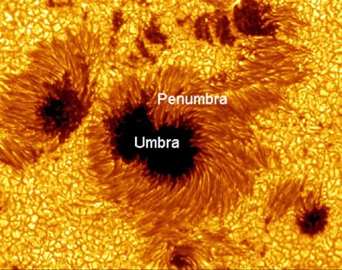
Courtesy: http://www.nasa.gov/mission_pages/sunearth/science/Solar-rotation.html
Figure – 10 : Image of a sunspot and Solar granulation obtained from Hinode spacecraft.
Solar radio flux (F10.7 cm)
Solar Radio Flux (F10.7 cm) is the Sun's disc-integrated 2800 MHz emission [20]. The Canadian Solar Radio Monitoring Programme has measured this flow since 1946. Several measures are taken daily to avoid flaring-influenced readings. From 1946 through 1990, Ottawa was observed. A new flux monitor was installed in Penticton, British Columbia, in 1990, and it functioned in parallel with the Ottawa monitor for six months before being relocated as a backup. Covington's F10.7 Solar radio flux is a typical measure of solar activity [17]. It is the density of microwave radiation at 10.7 cm in wavelength for |B| = 103 G. Japan quickly established routine observations at four predetermined frequencies (1.0, 2.0, 3.75, and 9.4 GHz) spanning the F10.7 frequency (2.8 GHz) and included the Solar gyroresonance signature shortly after its introduction. [21] used these data to create a microwave photometric standard.
The National Research Council of Canada was established in 1947 and has measured solar F10.7 radiation at 2800 MHz (10.7cm wavelength) (NRCC). Observations were done at Algonquin Radio Observatory till May 31, 1991. The Dominion Radio Astrophysical Observatory in Penticton, British Columbia, is home to the Solar Radio Monitoring Programme, which has made its measurements of the Sun's radio flux F10.7 from 1990 to 1991 available online at http://www.ngdc.noaa.gov/stp/space-weather/.
Solar Wind Plasma
This gravitational force from the Sun dissipates into space as Solar Wind. As magnetised plasma, it dominates the Sun's heliosphere. E Parker predicted the Solar wind in 1958 and confirmed its existence in 1962. Mostly on the ecliptic plane, but also at both solar poles, it has been spotted as close as 0.29 AU and as distant as 70 AU from the Sun. The fundamental characteristics of the Solar wind vary substantially from the Earth's orbit. The atmosphere of the sun is linked to our own through a process known as solar wind. The density, velocity, temperature, and magnetic field of the solar wind vary with the solar cycle, heliographic latitude, heliocentric distance, and rotation period. Changes occur as a result of shocks, waves, and turbulences between planets.
Slow Solar wind (400 km/s) comes from closed magnetic fields, while fast Solar wind (600-800 km/s) comes from coronal holes. Coronal holes gather around the equator during Solar maximum. Solar wind kinds at solar minimum:
- Fast Solar wind emerges from magnetically open coronal holes on the inactive Sun. High-speed solar wind is of a particular kind. Except for the 400-wide streamer belts around the heliomagnetic equator, the heliosphere is completely covered by the solar wind that emerges from huge coronal holes at latitudes above 400–600.
- The Sun's active regions are where the minimum solar wind is produced. It encompasses the heliospheric current sheet and is restricted to the warped streamer belt. Low helium content in this solar wind suggests a greater release height.
- Plasma clouds generated in big solar eruptions are generally characterized by high helium percentages (30%) and other signatures.
Interplanetary Magnetic Field (IMF)
The three components of the IMF's vector form, with Bx and By running parallel to the ecliptic and Bz perpendicular to it. It's caused by solar wind waves or disturbances of some other kind. Energy, mass, and momentum can be transferred from the Solar wind to the magnetosphere when the IMF and geomagnetic field lines are aligned anti parallel to each other. The Bz component with a southerly orientation couples most strongly and has the most profound impact on the magnetosphere. Because its field lines are frozen-in to the plasma of the Solar wind, the IMF is a piece of the Sun's magnetic field that is transported into interplanetary space by the Solar wind. Because the Sun rotates, solar wind follows a spiralling path as it blows away from the star. Around Earth, the IMF field is modest, with strengths ranging from 1 to 37 nT and an average of 5 nT.
Geomagnetic Storms
Geomagnetic storms define space weather [21-23]. Extreme solar storms can harm technology [24,25]. Dst index estimates geomagnetic storm strength at http://swdcwww.kugi.kyoto-u.ac.jp/. The Geomagnetic storms and substorms are nonlinear. Previous studies revealed geomagnetic time series self-affinity [26,27,29,30]. External geomagnetic field variations show a varied power law spectrum. Multiscale geomagnetic field [31, 29]. Geomagnetic storms are long-lasting disruptions in the geomagnetosphere [29]. Classical approaches, the Fourier Transform for analysing the geomagnetic index Dst but cannot provide information on geomagnetic storm temporal progression. The magnetosphere generates energetic charge particles when the aurora intensifies and extends to low magnetic latitudes. Measurements of the earth's magnetic field are D, Z, and H. (H). Sugiura created Dst index (1964).
Geomagnetic storm causes: (2) A disturbance has an onset, peak, and recovery. Research uses isolated geomagnetic storms. Table (1) shows Loewe'sDstmin [32]
Table – 1 : Classification of geomagnetic storm intensity
Storm Type | Weak | Moderate | Strong | Severe | Great
Dst_{min} range in nT | -50~-30 | -100~-50 | -200~-100 | -350~-200 | ≤-350
Space Plasmas and Magnetohydrodynamics (MHD)
MHD considers space plasmas electrically conductive fluids. It has been effectively applied to heliosphere space plasma research to analyze the "macroscopic picture of various solar plasma events" using conductivity fluid equation and numerical modeling and simulation.
Magneto-hydro-dynamic (MHD) waves
Magnetohydrodynamic (MHD) waves can be discovered in many different types of space plasma.. These MHD waves are produced by restoring magnetic and thermal forces in the solar wind. Alfven waves are transverse waves which produce changes in plasma in the solar wind is not compressed by the local magnetic field, which is perpendicular to the field lines. In contrast to the magnetosphere and solar wind, which provide direct in situ measurements, the dictation of MHD waves in space plasma is typically done indirectly, by matching the corresponding properties like propagation speed or variation in pressure, and also with theoretically derived properties. Realizing that space plasmas are typically highly inhomogeneous due to magnetism, plasma density and temperature changes, or plasma flows has been a challenge for the detection of MHD waves. Magnetic flux tubes and plasma flow tubes are of particular importance because of the challenges this substantial inhomogeneity introduces to the understanding of magnetohydrodynamic wave events. Oscillatory occurrences have been observed in the various types of flux tube structure in the solar environment, including sunspots, solar photospheric magnetic flux tubes, coronal loops, and polar plumes. The solar prominences and solar flares both exhibit oscillations.
Methods of Analysis
A great variety of non-linear techniques based on wavelets and cross-recurrence plots (CRPs) have been used for these parameters number and size of sunspots, solar radio flux (F10.7cm flux), plasma properties in solar wind, strength of interplanetary magnetic field (IMF), and so on are just some of the solar activity indices that can be analyzed.
Wavelet Transform
In order to determine how the various periodic components of the time series change over time, wavelet analysis estimates the spectral properties of a time series as a function of time. Analysis of irregularly distributed time series and events with non-stationary power at a wide range of frequencies is appropriate. The wavelet transform's capacity to do organic local analysis of a time series is a significant benefit. In order to measure low frequency movements, the wavelet extends into a long function, while in order to record high frequency motions, it compresses into a short function. Discretized wavelet transformations (DWT) rely in many works by [33-40].
Astronomy, acoustics, data compression, nuclear engineering, sub-band coding, signal and image processing, neurophysiology, music, magnetic resonance imaging, speech discrimination, optics, fractals, radar, human vision, pure mathematics, and geophysics (e.g., tropical convection, the El Nino-Southern Oscillation, atmospheric cold fronts, temperature variability, the dispersion of ocean waves, wave growth and breeziness) all make use of [35-37].
(ii) Discrete Wavelet Transform (DWT)
The location and scale of a signal are typically calculated dyadically as part of the discrete wavelet transform (DWT) [38]. The DWT is great for separating signals from noise [39]. A vector's DWT is the result of a linear transformation that produces a new vector with the same dimensions as the original vector [45]. This transformation is the decomposition process. All time series (for all Solar Cycles 20-24) were decomposed in this study utilising the Duabechies and Coifman wavlelts. Daubechies wavelet provides compact support [47], Demonstrating complete scaling and translational orthonormality in the wavelets and non-zero basis functions over a finite time [42]. These characteristics are crucial for pinpointing the precise location of occurrences in time-dependent signals [43]. Time series can be broken down into their approximate and exact parts using DWT.
(iii)Continuous Wavelet Transform (CWT)
By taking a time series that is a function of only one dimension and transforming it into a frequency spectrum, the continuous wavelet transform (CWT) provides highly redundant information. Increasing numbers of scientists are turning to CWTs in their investigations [44-49] Explain how these methods have been put to good use in the economic realm.
(iv) Cross Wavelet Transform (XWT)
Wavelet transformations can be extended to reveal their shared power and relative phase in time-frequency space between two time series using the cross wavelet transform (XWT) [50]. The two time series X and Y's cross wavelet transform is defined as
${ W}^{XY}= W^{X}W^{Y*},$ ………… (1)
Where W^{X} and W^{Y} are the continuous wavelet transformations, and * signifies complex conjugation [51]. The time-frequency space representation of the complex argument arg (W^{XY}) can be thought of as a local relative phase between X and Y. High common power is revealed by calculating cross-wavelet power.
(v) Wavelet Coherence Transform (WTC)
The cross wavelet transform between two time series yields the wavelet coherence (WTC), an estimator of the confidence level for the discovery of a time-space region of high common power and consistent phase relationship. It closely resembles a localised correlation coefficient in time-frequency space and ranges from 0 to 1. The measure of wavelet coherence is defined between two continuous wavelet transformations, and it may suggest coherence with high confidence level even while the shared power is low.
(vi) Cross Recurrence Plots (CRPs)
The CRPs are an extension of recurrence plots that allow researchers to examine the timing relationships between two processes that are both captured in a single time series [52-54]. In order to understand how these processes are related, this method compares their phase space trajectories.
(vi) Multifractal Analysis
Fractals in the process were discovered by [55] to differentiate between a rough or fractured geometric shape that exhibits a high degree of self-similarity within its own fractional dimensions. Fractal patterns have been thoroughly examined recently in a variety of domains, including physics and business. [56] introduced R&S analysis for hydrological investigations. [57] overcome this challenge and created the detrended fluctuation analysis (DFA) approach for DNA sequence analysis. Although DFA has grown to be a popular technique for identifying monofractal scaling characteristics, it cannot be utilised to describe the multiscale and fractal subsets of the time series. For the purpose of multifractal characterization of non-stationary time series, [58] extended the DFA to multifractal detrended fluctuation analysis (MFDFA). International crude oil markets [59], foreign exchange markets [60], stock markets [61], gold markets [62], and agricultural commodity futures markets [73] are only few of the areas that the MFDFA has been applied to study. Cross-correlations between two non-stationary time series were studied by researchers generalising DFA and MF-DFA analysis by focusing on detrended covariance [64-67].
Conclusion:
In order to conduct an analysis of the astronomical and solar data, a wide range of unique mathematical transformations can be used. One of these methods that is both frequently used and understood is the Fourier transform. The Wavelet Transform is used in situations when a greater level of performance is desired in order to get around the restrictions that it places on the system because it has some limits. The property of time and frequency localization, on the other hand, allows it to simultaneously breakdown or transform a one-dimensional time series into a diffuse two-dimensional time-frequency image. The wavelet used in the wavelet analysis will always have the same form; the only variation is that the size will change based on the size of the window. In addition to learning the amplitude of any periodic signals, it is useful to learn their phase as well. The wavelet technique, which has been used to analyse the solar wind's characteristics and identify periodic changes that could be the root of geomagnetic disturbances, has been brought to our notice in this chapter. A logical foundation for calculating the time-frequency characteristics of the studied data is provided by wavelet spectrum analysis. The level fluctuation of solar wind parameters is mapped into different scales and temporal instants using a Morlet wavelet function in wavelet analysis of signals. When signals are analysed using wavelets, this mapping process occurs.
Acknowledgement:
We thank Matlab and the CRPs software. For CWT, XWT, WTC, Multifractal, and other functions, visit http://www.pol.ac.hk/home/research/wavelet.coherence/. The CRPSs being employed and its diagram can be performed by searching at http://www.recurrence.plot.tk.
References
[1] Tsurutani Bruce T., Gonzalez, W.D.: The efficiency of 'viscous interaction' between the solar wind and the magnetosphere during intense northward IMF events, Geophysical Research Letters (ISSN 0094-8276), 22, 6, 663-666, 1995.
[2] Gopalswamy, Nat.: Halo coronal mass ejections and geomagnetic storms, Earth, Planets and Space, 61, 595-597, 2009.
[3] Temmer, M., Veronig, A., & Hanslmeier, A. 2002, A&A, 390, 707.
[4] Bogart R.S.: Recurrence of solar activity: Evidence for active longitudes, Sol. Phys. 76,155, 1982.
[5] Veronig , A, Messerotti, M., Hanslmeier, A.: Determination of fractal dimensions of solar radio bursts, Astron. Astrophys.
[6] Jevtic, N., Schweitzer. J.S., Cellucci, C.J.: Nonlinear time series analysis of northern and southern solar hemisphere daily sunspot numbers in search of short-term chaotic behavio, Astron. Astrophys., 379, 611 - 615, 2001.
[7] Abramneko, V.I., Longcope, D.W.: Distribution of the Magnetic Flux in Elements of the Magnetic Field in Active Regions, The Astrophysical Journal, 619, 2,1160-1166, 2005.
[8] Movahed, M.S., Jafari, G.R., Ghasemi, F., Rahvar. S., Tabar, M.R.R.: Multifractal detrended fluctuation analysis of sunspot time series, J. Stat. Mech., P02003, 2006.
[9] McAteer R.T.J., Young, C.A., Ireland, J. Gallagher, P.T.: The Bursty Nature of Solar Flare X-Ray Emission , Astrophys. J., 662 (1), 691 - 700, 2007.
[10] Bruevich, E.A., Yakunina, G.V.: The study of time series of monthly averaged values of F10.7 from 1950 to 2010, Sun and Geosphere, 7 (1), 65 - 70, 2012.
[11] Zririn, H.: Book-Review - Astrophysics of the Sun, KNUDSEN, Science, 242, 4885/DEC16, 1586, 1988
[12] Vassenius, B.: Observatio Eclipsis Solis Totalis Cum Mora Facta Gothoburgi Sveciae, Sub Elev. Trans. Roy. Soc. London, 38, 134 – 135, 1733.
[13] Galsgaard, K., Longbottom, A.W.: Formation of Solar Prominences by Flux Convergence, ApJ, 510, 444 - 459, 1999.
[14] Leroy J.L, Bommier, V., Sahal-Brechot, S., Solar Phys, 83, 135, 1983
[15] Schwabe, M.: Sonnenbeobachtungen im Jahre 1843. Von Herrn Hofrath Schwabe in Dessau, Astronomische Nachrichten, 21, 233, 1844.
[16] Clark D.H., Stephenson F.R.: An interpretation of the pre-telescopic sunspot records from the orient, Q.J. Roy. Astron. Soc. 19, 387 - 410, 1978.
[17] Tapping, K.F., Charrios, D.P.: Limits of the accuracy of the 10.7 CM flux, Solar Physics, vol. 150, no. 1-2, p. 305-315, 1994.
[18] Tanaka, H., Castelli, J.P., Covington, A. E., Kruger, A., Landecker, T. L., Tlamicha, A.: Absolute calibration of solar flux density in the microwave region, Sol. Phys., 29, 243 – 262, 1973.
[19] Kamide, Y., Yokoyama, N., Gonzalez, W.D., Tsurutani, B.T., Daglis, I.A., Brekke, A., Masuda, S.: Two-step development of geomagnetic storms, J. Geophys. Res.,103, 6917 - 6921, 1998a.
[20] Freeman, J.W.: Storms in Space, Cambridge University Press, 2001.
[21] Angelopoulos, V.: The THEMIS Mission, Space Science Reviews, 141 (5), 1 - 4, 2008.
[22] Baker, D.N.: The occurrence of operational anomalies in spacecraft and their relationship to space weather, IEEE Trans. Plasma Sci., 28 (6), 2007 - 2016, 2000.
[23] Daglis, I.A., Baker, D.N., Galperin, Y., Kappenman, J.G., Lanzerotti, L.J.: Tchonological imapacts of space storms: Outstanding issues, Eos, Transactions American Geophysical Union, Volume 82, Issue 48, p. 585-585, 2001.
[24] Balasis, G., Daglis, I., Kapiris, P., Mandea, M., Vassiliadis, D., Eftaxias, K.: From pre-storm activity to magnetic storms: A transition described in terms of fractal dynamics, Ann. Geophys., 24, 3557 - 3567, 2006.
[25] Uritsky, V.M., Klimas, A.J., Vassiliadis, D.: Comparative study of dynamical critical scaling in the auroralelectrojet index versus solar wind fluctuations, Geophys. Res. Lett., 28, 3809 - 3812, 2001.
[26] Loewe, C.A., Prolss, G.W.: Classification and mean behavior of magnetic storms, J. Geophys. Res., 102, 14209 - 14213, 1997.
[27] Ramsey, J.B., Lampart, D.C.: Decomposition of Economic Relationship by Time Scales Using Wavelets, Macroeconomic Dynamics, 2(1), 49 – 71, 1998a.
[28] Ramsey, J.B., Lampart, D.C.: The Decomposition of Economic Relationship by Time Scale Using Wavelets: Expenditure and Income, Studies in Nonlinear Dynamics and Econometrics, 3 (1), 23 – 42, 1998b.
[29] Ramsey,J.B.: The contribution of wavelets to the analysis of economic and ﬁnancial data, Phil. Trans. R. Soc.Lond.A, 357, 2593 – 2606, 1999; reprinted in Wavelets, edt. Silverman, B.W., Vassilicos, J.C.: Oxford Univ. Press, Oxford, Chapter 12, 221 - 236, 1999.
[30] Ramsay, J.O., Ramsey, J.B.: Functional data analysis of the dynamics of the monthly index of nondurable goods production, Journ. of Econometrics, 107, 327 - 344, 2002.
[31] Gencay, R., Selcuk, F., Whitcher, B.: Scaling properties of foreign exchange volatility, Physica A, 289, 249 - 266, 2001a.
[32] Gencay, R., Selcuk, F., Whitcher, B.: Multiscale Systematic Risk, Journal of International Money and Finance, 24(1), 55 - 70, 2005.
[33] Connor, J., Rossiter, R. Wavelet Transforms and Commodity Prices, Studies in Nonlinear Dynamics & Econometrics, 9 (1). 6, 20, 2005.
[34] Gallegati, M., Gallegati, M.: Wavelet variance analysis of output in g-7 countries’, Studies in Nonlinear Dynamics & Econometrics, 11(3), 2007.
[35] Farge, M.: Wavelet transforms and their applications to turbulence, Ann. Rev. Fluid Mech. 24, 395 – 457, 1992.
[36] Graps, A.: An introduction to wavelets, IEEE Comp. Sci. Engng, 2 (2), 50 – 61, 1995.
[37] Torrence, C., Compo, G.P.: A practical guide to wavelet analysis, Bull. Am. Meteorol. Soc., 79, 61 - 78, 1998.
[38] Chou, C.M.: Applying multi resolution analysis to differential hydrological grey models with dual series. J. Hydrol. 332 (1 - 2), 174 – 186, 2007.
[39] Fugal, D.L.: Conceptual wavelets in Digital Signal Processing. An in-depth, Practical Approach for the Non-mathematician, first ed. Space & Signals Technologies LLC, 2009.
[40] Chou, C.M.: Wavelet-based multi-cscale entropy analysis of complex rainfall time series. Entropy, 13 (1), 241 – 253, 2011.
[41] Vonesch, C., Blu, T., Unser, M.: Generalized Daubechies Wavelet families, IEEE Trans. Signal Process, 55 (9), 4415 – 4429, 2007.
[42] Popivanov, I., Miller, R.J.: Similarity search over time-series data using wavelets, In Proceedings of the 18th International Conference on Data Engineering (ICDE), 2002.
[43] Popivanov, I., Miller, R.J.: Similarity search over time-series data using wavelets, In Proceedings of the 18th International Conference on Data Engineering (ICDE), 2002.
[44] Raihan, Wen, Zeng.: Wavelet: a new tool for business cycle analysis, Working paper 2005 - 050 A, Fedral Reserve Bank of St. Louis, 2005.
[45] Crowley, P., Mayes, D.: How fused is the euro area core? An evaluation of growth cycle co movement and synchronization using wavelet analysis, Journal of Business Cycle Measurement and Analysis, 4, 63 - 95, 2008.
[46] Aguiar-Conraria, L., Azevedo, N., Soares, M.J.: Using Wavelets to Decompose the Time-Frequency Effects of Monetary Policy, Physica A: Statistical Mechanics and its Applications, 387, 2863 - 2878, 2008.
[47] Βaubeau, P., Cazelles, Β.: French economic cycles: a wavelet analysis of French retro-spective GNP series, Cliometrica 3, 275 – 300, 2009.
[48] Rua, A., Nunes, L.C.: International co-movement of stock market returns: A wavelet analysis, Journal of Empirical Finance 16, 632 – 639, 2009.
[49] Rua, A.: Measuring co-movement in the time - frequency space, Journal of macroeconomics 32, 685 – 691, 2010.
[50] Li, X., Yao, X., Jefferys, J.G.R., Fox. J.: Computational neuronal oscillation with morlet wavelet transform, Proceedings of 27th annual international conference of the IEEE engineering in medicine and biology Society, Shanghai, SEP., IEEE Press, 1 - 4, 2005.
[51] Grinsted, A., Moore, J.C., Jevrejeva, S.: Application of the cross wavelet transform and wavelet coherence to geophysical time series, Nonlinear Proc Geophys,11, 561 – 566, 2004.
[52] Zbilut, J.P., Giuliani, A., Webber Jr., C.L.: Detecting deterministic signals in exceptionally noisy environments using cross-recurrence quantification, Physics Letters, A 246 (1-2), 122 – 128, 1998. M
[53] Marwan, N., Kurths, J.: Nonlinear analysis of bivariate data with cross recurrence plots, Physics letters A, 302, 299 - 307, 2002.
[54] Marwan, N., Thiel, M., Nowaczyk, N.R.: Cross recurrence plot based synchronization of time series, Nonlin. Processes Geophys., 9, 325 - 331, 2002a.
[55] Mandelbrot, B.: The Fractal Geometry of Nature, Freeman, New York, 1983.
[56] Hurst, H.: Long term storage capacity of reservoirs, Transactions of the American Society of Engineers, 116, 770 – 799, 1951.
[57] Peng, C.K., Buldyrev, S.V., Havlin, S., Simons, M., Stanley, H.E., Goldberger, A.L.: Mosaic organization of DNA nucleotides, Phys. Rev. E 49, 1685 - 1689, 1994.
[58] Kantelhardt, J.W., Zschiegner, S.A., Kosciilny-Bunde, E., Havlin,S., Bunde, A., Stanley, H.E.: Multifractal detrended fluctuation analysis of nonstationary time series, Physica A: Statistical Mechanics and its Applications, 316, 1, 87 - 114, 2002.
[59] Gu, R.B., Chen, H.T., Wang, Y.D.: Multifractal analysis on international crude oil markets based on the multifractal detrended fluctuation analysis, Physica A 389, 2805 – 2815, 2010.
[60] Norouzzadeh, P., Rahmani, B.: A multifractal detrended fluctuation description of Iranian rialUS dollar exchange rate, Physica A, 367, 328 – 337, 2006.
[61] Yuan, Y., Zhuang, X.T., Jin, X.: Measuring multifractality of stock price fluctuation using multifractal detrended fluctuation analysis, Physica A, 388, 2189 - 2197, 2009.
[62] Wang, Y.D., Liu, L.: Is WTI crude oil market becoming weakly effi- cient over time? New evidence from multiscale analysis based on detrended fluctuation analysis. Energy Economics 32, 987 – 992, 2010.
[63] Li, Z., Lu, X.: Multifractal analysis of China’s agricultural commodity futures markets, Energy Procedia, 5, 1920 – 1926, 2011.
[64] Podobnik, B., Stanley, H.E.: Detrended cross-correlation analysis: a new method for analyzing two nonstationary time series, Physical Review Letters,100, 084102, 2008.
[65] Podobnik, B., Horvatic, D., Petersen, A.M., Stanley, H.E.: Cross-correlations between volume change and price change, Proceedings of the National Academy of Sciences of the United States of America 106, 22079 – 22084, 2009.
[66] Zhou, Wei-Xing.: Multifractal detrended cross-correlation analysis for two non-stationary signals, Physical Review E, 77, 6, 2008.
[67] Li, Z., Lu, X.: Cross-correlations between agricultural commodity futures markets in the US and China, Physica A, 391, 3930 – 3941, 2012.

