AN EXPERIMENTAL STUDY ON BACTERIAL CONCRETE WITH EFFECT OF DIFFERENT BACTERIA ON THE STRENGTH OF CONCRETE
ABSTRACT:
The global use of concrete is second only to water. As the demand for concrete as a construction material increases, so also the demand for Portland cement. Concrete is a durable construction material produced by mixing Portland cement, water, aggregates and additives with special proportion. Revising the ingredients and production method of conventional concrete is important with respect to high consumption of concrete as a construction material. High utilization of solid causes tremendous necessities of bond creation. Portland bond is utilized as a folio in the creation of cement and is delivered by blending chose crude materials (dirt and lime) with a given extent, granulating and warming it at 1500oC. During the time spent delivering 1 ton concrete, 125 lit petroleum derivative and 118 KWH power is expended. Concrete plays a vital role as a construction material in the world. New technologies have helped to develop new types of construction and alternative materials in the concrete area. This project presents the results of an experimental investigation carried out to evaluate the influence of Bacillus Subtilis and Bacillus Licheniformis on the compressive strength, water absorption and its self-healing properties. An attempt is made to heal these cracks by the addition of the bacteria in the concrete and also to increase of the strength of the concrete. Each bacteria of concentration are added. Tests were performed at the ages of 7, 28 and 56 days. It is found that the cracks in the concrete have been healed and the formation of calcite precipitation is observed using Scanning Electron Microscopy (SEM). In the present project here is an attempt made to fill the cracks with the help of bacteria which has a self-healing property. Calcite formation of isolated bacteria which can produce calcite precipitates on suitable media supplemented with a calcium source.
Key words: Bacillus Subtilis, Bacillus Licheniformis, SEM.

I. INTRODUCTION
Bacterial concrete or self healing concrete fills up the cracks developed in structures by the help of bacterial reaction in the concrete after hardening. Types of bacteria, its mechanism and preparation of bacterial concrete is discussed. In modern days, the use of technology has taken the standards of construction to a new high level. Concrete as a standout amongst the most normally utilized development materials, assumes a key part in many fields. It has been broadly utilized as a part of the development of structures, dams, stockpiling tanks, ocean ports, streets, spans, burrows, trams and different frameworks. Concrete is mostly a blend of water, total (coarse and fine), and bond. Bond is the most critical piece of the solid material. It ties the totals and fills the voids amongst coarse and fine particles. High compressive quality, accessibility, toughness, and in addition good conduct with fortification bars, low value, straightforward planning and plausibility of throwing in wanted shapes and sizes settle on concrete the material of decision for some applications. Notwithstanding solid's favorable circumstances, it has a high propensity to frame splits enabling forceful chemicals to enter into the structure.

PROBLEM STATEMENT
Cracking
Definition: An entire or inadequate partition of either concrete or brick works into at least two sections delivered by breaking or fracturing. Cracks are sorted as happening either in plastic concrete or solidified cement. The reasons for each kind of breaking rely upon a wide range of variables, and may influence appearance just, or they may show noteworthy basic pain or an absence of toughness.

Various types of Concrete Crack Repair Methodologies:
- Stitching
- Muting and sealing
- Resin injection
- One of the technique is self-healing i.e. bio- concrete
ADVANTAGES OF BACTERIAL CONCRETE
- Self-repairing of cracks without any external aide.
- Significant increase in compressive strength and flexural strength when compared to normal concrete.
- Resistance towards freeze-thaw attacks.
- Reduction in permeability of concrete.

HISTORY OF MICROBIOLOGY
- Bacteria are infinitesimal living beings, single-celled prokaryotic animals. Microscopic organisms come in various shapes and the sizes.

- Bacteria are omnipresent in each territory on Earth, developing in soil, acidic hot springs, radioactive waste, water, and somewhere down in the Earth's outside layer, and in addition in natural issue and the live assemblages of plants and creatures. There are commonly 40 million bacterial cells in a gram of soil and a million bacterial cells in a milliliter of crisp water; on the whole, there are roughly five nonillion (5×1030) microorganisms on Earth (Whitman et al. 1998, Vol.95) shaping a significant part of the world's biomass.

- Bacteria were first seen by Antoine van Leeuwenhoek in 1676, utilizing a solitary focal point magnifying instrument of his own plan. He called them "animalcules" and distributed his perceptions in a progression of letters to the Royal Society. The name bacterium was presented considerably later, by Christian Gottfried Ehrenberg in 1838.

Disadvantages of bacterial concrete
- Cost of bacterial concrete is double than conventional concrete.
- Growth of bacteria is not good in any atmosphere and media.
- The clay pellets holding the self-healing agent comprise 20% of the volume of the concrete. This may become a shear zone or fault zone in the concrete.
APPLICATIONS:
- The use of bacterial concrete has become increasingly popular. It is used for
- Repairing of monuments constructed in limestone.
- Healing of concrete cracks
- Used for construction of -low cost durable roads
SCOPE & OBJECTIVE OF THE PROJECT
  - Develop a bacterial concrete by introducing the bacteria’s of bacillus family (Bacillus Subtilis).
  - To find the optimum dosage of bacteria required for bacterial concrete
  - To determine the viable bacterial cells by serial dilution method.
To know the presence of voids by ultrasonic pulse velocity test.
II LITERATURE REVIEW

SakinaNajmuddinSaifee et .al1 published a paper on Critical appraisal on Bacterial Concrete. In this paper they discussed about the different types of bacteria and their applications. The bacterial concrete is very much useful in increasing the durability of cemetous materials, repair of limestone monuments , sealing of concrete cracks to highly durable cracks etc.It also useful for construction of low cost durable roads , high strength buildings with more bearing capacity, erosion prevention of loose sands and low cost durable houses. They have also briefed about the working principle of bacterial concrete as a repair material. It was also observed in the study that the metabolic activities in the microorganisms taking place inside the concrete results into increasing the overall performance of concrete including its compressive strength. This study also explains the chemical process to remediate cracks.
Meera C M and Dr Subha V2 , have published a paper on Strength And Durability assessment Of Bacteria Based Self-Healing Concrete. In this paper they have discussed about the effect of Bacillus subtilis JC3 on the strength and durability of concrete. They used cubes of sizes 150mm x 150mm x 150mm and cylinders with a diameter of 100mm and a height of 200mm with and without addition of micro organisms, of M20 grade concrete. For strength assessments, cubes were tested for different bacterial concentrations at 7 days and 28 days and cylinders were tested for split tensile strength at 28 days. It was observed that the compressive strength of concrete showed significant increase by 42% for cell concentration of 105 of mixing water. And also, with the addition of bacteria there is a significant increase in the tensile strength by 63% for a bacteria concentration of 105cells/ml at 28 days. For durability assessment, acid durability test, chloride test and water absorption test were done. From the results it could be inferred that the addition of bacteria prevents the loss in weight during acid exposure to a certain limit, proving the bacterial concrete to have higher Acid Attack Factor. The Water Absorption Test, showed a lesser increase in weight of bacteria concrete sample than control, from which it could be reckoned that the concrete will become less porous due to the formation of Calcium Carbonate, due to which it resulted in lesser water absorption rate. Chloride test results showed that the addition of bacteria decreases weight loss, due to Chloride exposure and enhances the Compressive Strength. Ravindranatha, N. Kannan, Likhit M. L3 ,have published a paper on Self-Healing Material Bacterial Concrete. In this paper a comparison study was made with concrete cubes and beams subjected to compressive and flexural strength tests with and without the bacterium Bacillus pasteurii. The concrete cubes and beams were prepared by adding calculated quantity of bacterial solution and they were tested for 7 and 28 day compressive and flexural strengths. It was found that there was high increase in strength and healing of cracks subjected to loading on the concrete specimens. The microbe proved to be efficient in enhancing the properties of the concrete by achieving a very high initial strength increase. The calcium carbonate produced by the bacteria has filled some percentage of void volume thereby making the texture more compact and resistive to seepage. A.T.Manikandan1, A.Padmavathi4 , have published a paper on An Experimental Investigation on Improvement of Concrete Serviceability by using Bacterial Mineral Precipitation. In this paper,the bacteria Bacillussubtilis strain 121 was from Microbial Type Culture Collection and Gene Bank, Chandigarh. Samples were prepared in sets of three for a water cement ratio of 0.5 by mass for conventional concrete and a water cement ratio of 0.25 and bacterial culture of 0.25 for bacterial concrete by mass. The cubes were tested by Non-Destructive Testing and HEICO compression testing machine on the 3rd, 7th and 28th days after casting. There was an improvement in compressive strength by B. subtilis strain 121 due to deposition of Calcite (CaCO3) in cement-sand matrix of microbial concrete which remediate the pore structure within the mortar. The temperature sustainability test of B. subtilis in bacterial concrete was carried out at various temperatures and found that the B. subtilis was found to be alive at –30 C low temperatures to 700 C high temperatures. There is increase in compressive strength of the bacterial concrete with B. subtilis bacteria with microbial calcite precipitation in the crack sample was examined in SEM .The sample showed the presence of calcite crystals grown all over the surface of the crack and also the presence
III: MATERIALS AND METHODOLOGY
CEMENT
Concrete can be characterized as the holding material having firm and cement properties which makes it able to join the diverse development materials and shape the compacted get together.The testing of concrete is done according to IS Code the particular gravity of bond found is 3.10.
Fine Aggregates
Those particles passing the 9.5 mm (3/8 in.) strainer, altogether passing the 4.75 mm (No. 4) strainer, and dominatingly held on the 75 µm (No. 200) strainer are called fine aggregate. In this analysis the locally accessible sand is utilized and the particular gravity of fine total is finished by utilizing the IS 2720 section 3 code. The particular gravity is discovered 2.62. The fine totals utilized which goes through the 4.75mm sifter.
Coarse Aggregates
Coarse totals have a wide assortment of development applications since they take after standard shake particles, rather than fine total which all the more intently look like sand. Coarse totals are a vital piece of numerous development applications, in some cases utilized individually, for example, a granular base put under a section or asphalt, or as a segment in a blend, for example, black-top or solid blends. The particular gravity is discovered 2.84. The course totals which are utilized of 20mm size.
BACTERIA
In this examination the bacillus pasteurii microorganisms is utilized .Sporosarcina pasteurii in the past known as Bacillus pasteurii from more established scientific classifications is a bacterium with the capacity to accelerate calcite and harden sand given a calcium source and urea, through the procedure of microbiologically incited calcite precipitation or natural cementation. Bacillus pasteurii has been proposed to be utilized as a naturally stable organic development material.
WATER
The least expensive but the most important ingredient of concrete is water. The water which is used for mixing concrete should be clean and free from harmful impurities such as oil, alkali, acid etc. portable water was used for mixing and curing work.
BACTERIAL CONCRETE OR SELF-HEALING CONCRETE
This normal issue of splitting in building has many cures prior and then afterward the break. One of the therapeutic procedure is Bacterial Concrete or Self-Healing Concrete. The procedure of self-mending of makes or self-filling laugh uncontrollably of breaks by the assistance of bacterial response in the solid in the wake of solidifying is known as Self-Healing Concrete. It can be watched that little splits that happen in a structure of width in the scope of 0.05 to 0.1mm gets totally fixed in dreary dry and wet cycles.
BIOCONCRETE MECHANISM
At the point when the solid is blended with microbes (bacillus subtilus), the microscopic organisms go into a lethargic express, a great deal like seeds. Every one of the microorganisms require is introduction to the air to actuate their capacities. Any splits that ought to happen give the important presentation. At the point when the breaks frame, microbes closeness to the split, begins accelerating calcite precious stones. At the point when a solid structure is harmed and water begins to leak through the breaks that show up in the solid, the spores of the microorganisms develop on contact with the water and supplements.
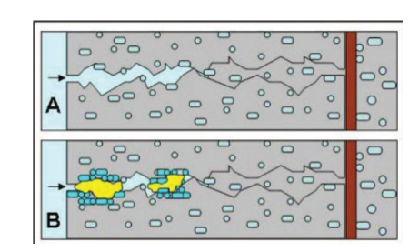
As the microorganisms nourishes oxygen is devoured and the solvent calcium lactate is changed over to insoluble limestone. The limestone sets on the broke surface, consequently fixing it up. Oxygen is a basic component during the time spent erosion of steel and when the bacterial movement has devoured it all it expands the strength of steel fortified solid developments. Tests all demonstrate that microscopic organisms inserted concrete has bring down water and chloride penetrability and higher quality recapture than the surface use of microbes.
CULTIVATION OF BACTERIA
The unadulterated culture of microscopic organisms i.e. Bacillus Subtilis is safeguarded on supplement agar inclines. It shapes unpredictable dry white states on supplement agar inclines. Two states of the microorganisms are immunized into supplement both of 350ml out of 500ml tapered cup and brooded at the temperature of 37 degree Celsius and 150 rpm orbital shaker hatchery.
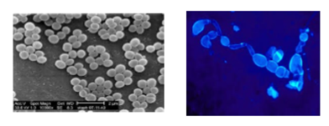
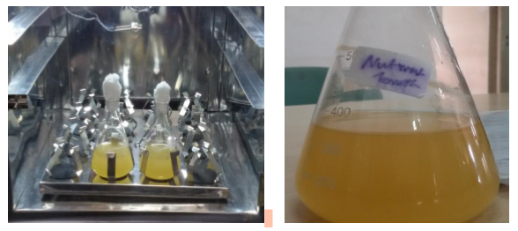
Fig. Bacteria in incubator
MIX PROPORTIONING
MIX DESIGN
Blend configuration can be characterized as the way toward choosing reasonable elements of cement, for example, bond, totals, water and deciding their relative extents with the protest of creating cement of required least quality, workability and toughness as financially as would be prudent. The reason for outlining can be seen from the above definitions, as two-overlay. The principal objective is to accomplish the stipulated least quality and solidness. The second goal is to make the solid in the most efficient way. The evaluations of cement utilized as a part of the present examination are common review concrete and standard grade concrete.
Standard grade concrete (M40)
Mix proportion 1: 1.76: 2.71: 0.45
Cement : 400 Kgs
Fine aggregate : 704 Kgs
Coarse aggregate: 1084 Kgs
Water : 180 Lt
MIXING OF CONCRETE
Blend configuration can be characterized as the way toward choosing reasonable elements of cement, for example, bond, totals, water and deciding their relative extents with the question of creating cement of required least quality, workability and toughness as financially as could be expected under the circumstances.

- PHASE - I
The phase-I of investigation is carried out to culture the bacteria
- PHASE – II
The phase-II of investigation is carried out to study the strength behavior of bacterial concrete.

IV EXPERIMENTAL INVESTIGATION
Mix design can be defined as the process of selecting suitable ingredients of concrete and determining their relative proportions with the object of producing concrete of certain minimum strength and durability as economically as possible. In our investigation we have made M40 grade of concrete. The mix ratio obtained after the mix design as per IS 456: was given in pervious chapter .Further, we have poured the concrete in the cube Moulds and six different samples were made which are as follows
a. Conventional Concrete of grade M 40.
b. Concrete with 15 ml bacterial solution.
c. Concrete with 30 ml bacterial solution.
d. Concrete with 45 ml bacterial solution.
e. Concrete with 60 ml bacterial solution.
f. Concrete with 75 ml bacterial solution.
METHODS OF MIXING BACTERIAL SOLUTION INTO CONCRETE
There are different methods of mixing the bacterial solution in the concrete which are viz.
(a) Direct Mixing
(b) Indirect Mixing
(c) Injection method
CASTING OF CUBES AND CURING
Once the concrete is completely mixed the concrete is poured in the cube, compaction is been done by the vibration machine. Concrete cubes were removed from the Moulds after 24 hrs. And they were put into the curing tank. Curing was done for 7, 14 and 28 days for all samples viz. Conventional, 15 ml, 30 ml, 45 ml, 60 ml and 75 ml.

EXPERIMENTAL TEST ON BACTERIAL CONCRETE
Various test are performed on bacterial concrete in order to get the results in various forms these experimental methods are summarized below-
Slump cone test
The concrete slump test is an empirical test that measures workability of fresh concrete. The slump cone test indicates the behavior of a compacted concrete cone under the action of gravitational forces. The test is carried out with a Moulds called as slump cone. The slump cone is placed on a horizontal and a non-absorbent surface and filled in three layers of fresh concrete, each layer being tamped 25 times with a standard tamping rod.
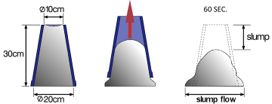
Showing the Slump Height.
The slump is measured by placing the cone just besides the slump concrete and the temping rod is placed over the cone so that it should also come over the area of slumped concrete. The decrease in height of concrete to that of Moulds is noted with scale which is found to be 110mm for conventional concrete and 50mm for bacterial concrete. Figure shows the performance of slump cone test.
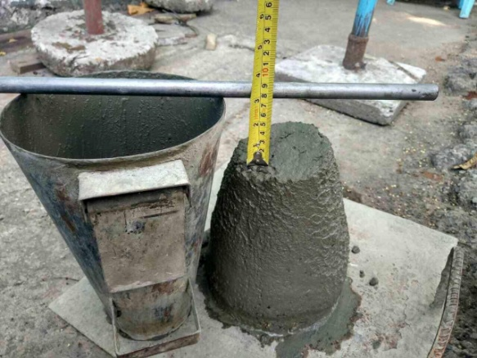
Fig: Slump Cone Test
Compressive strength test-
Concrete cubes ofsizes150mm×150mm×150mm were tested for crushing strength. Compressive strength depends on loads of factor such as w/c ratio, cement strength, excellence of concrete material and excellence control during manufacture of concrete.
The cube compressive strength, then f_{c}=P/A N/mm²
Where P is an ultimate load in N, A is a cross sectional area of cube in mm²
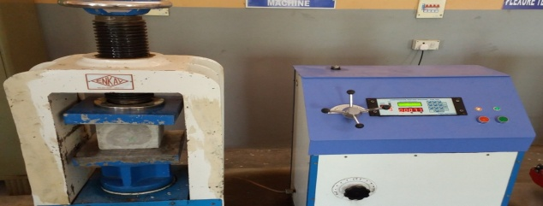
Compression Testing Machine.
The maximum load recorded and any unusual features in the type of failure noted down. Concrete cubes placed in the CTM machine before crushing and after crushing shown in fig. 4.7.sample viz. conventional, 15ml, 30ml, 45ml, 60ml and 75ml were taken each time after curing interval of 7days, 28 days 56 days.
ULTRA SONIC PULSE VELOCITY
Prior it was accounted for that sand combination by B. pasteurii diminished porosity by up to half and penetrability by up to 90% in the zones where the cementation occurred. Microbial calcite stopping was specific and its proficiency was influenced by the porosity of the medium, the quantity of cells introduce and the aggregate volume of supplement included. The sand segment stacked with microscopic organisms was so firmly stopped that the section was broken with a mechanical blade for looking at. An extraordinary basic condition of pH around 12 is the major obstructing factor for development of B. pasteurii, whose ideal pH for development is around 9. Be that as it may, B. pasteurii can create endospores to persevere through an outrageous domain, 15ml, 30ml, 45ml, 60ml and 75ml were tested at quality control lab shown in fig.:4.9.Below. The corresponding readings were obtained in the form of trouble time and velocity.
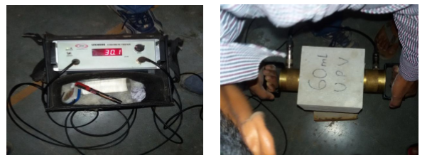
Fig: Test of bacterial concrete samples using Ultrasonic Pulse Velocity Machine.
PLATE COUNT TEST
The plate tally test was directed to decide add up to practical cells in a bacterial culture by plate check technique. This strategy is utilized for assurances of the quantity of cells that duplicate under characterize conditions. It requires culture viz. Fluid culture of bacillus subtilis, water, and drain. Encourage the media taken is 20ml supplement agar profound tubes (3 in nos.), likewise the device utilized were test tubes, pipettes, petri plates, glass stamping pencil and spreader.
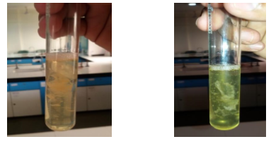
Fig. Formation of visible mass
The aggregate tally of microbial suspension is gotten by duplicating the no. of cells per plate by the weakening variable. 1 g of solid material from solid piece which was kept for curing for 14 days from various solid square (containing 15, 30, 45, 60 and 75 ml of bacterial suspension) gathered to consider number of feasible microscopic organisms by serial weakening technique.
Experimental procedure to obtain plate count test of bacterial solution
To begin with blending of 24hr. Hatched 1 g solid material from each piece was finished by rolling the test tube between the palms to guarantee even scattering of cell in the way of life. By using sterile pipette, aseptically exchange of 0.1ml bacterial suspension to the test tube containing 10 ml waterfall infusion was finished. Quantities of reasonable microbes are corresponding to the quantity of bacterial provinces. Quantities of bacterial provinces are checked by utilizing state counter.
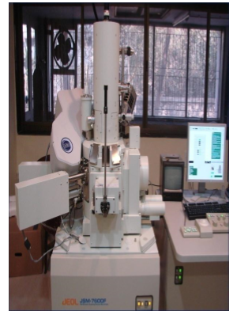
Fig: Scanning Electron Microscope Machine

V RESULTS
Tests performed:
- Compressive strength test
- Water absorption
- UPV test
- Plate count test

COMPRESSIVE STRENGTH TEST
Concrete cubes of sizes 150mm×150mm×150mm were tested for crushing strength. Compressive strength depends on loads of factor such as w/c ratio, cement strength, excellence of concrete material and excellence control during manufacture of concrete. These cubes are tested by compression testing machine after 7 days, 14 days or 28 days curing. The sample is placed centrally on the base plate of machine and the load have to be apply gradually at the rate of 140 kg/cm² per minute till the specimen fails.

Table: COMPRESSION TEST RESULT @ 7 DAYS
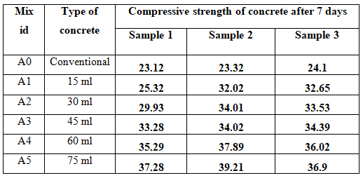
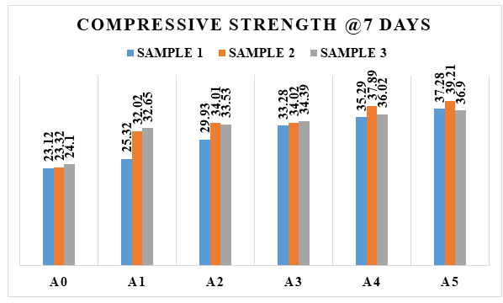
Fig.: Compressive Strength test results
Table: COMPRESSION TEST RESULT @28 DAYS
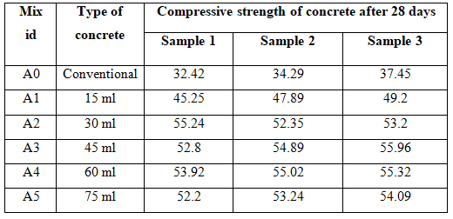
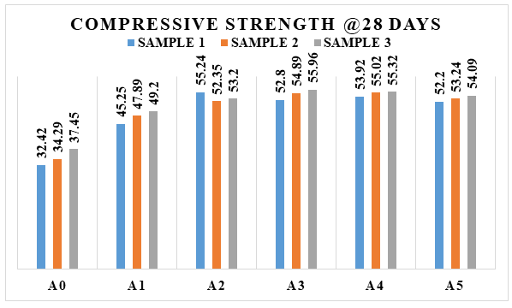
Fig.: Compressive Strength test results
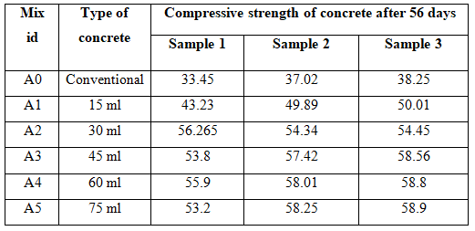
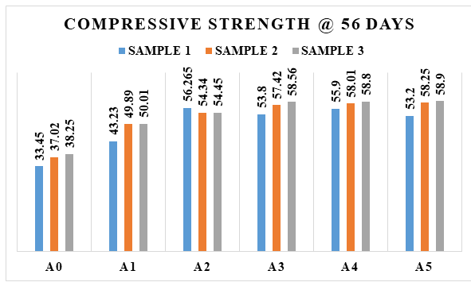
Fig.: Compressive Strength test result
From the above the graphs we can clearly notice that the compressive strength of the cubes increment, as we see from A0 to A1 the strength of cubes moves ahead by this we make an inference that increases in the volume of bacterial solution increase in the compressive strength of the cubes. According the mix we did addition of bacterial solution in the increment order i.e. 15ml 30ml 45ml 60ml 70 ml. Actually we have taken 3 cubes in each sample so by the way we got three results in each sample. On average of the three results we can conclude that increment in the bacterial solution gives more strength and cares concrete not to crack by their mechanism.
Water Absorption:
The 150mm x150 mm x 150 mm cube after casting were immersed in water for 28 days and 60 days curing. These specimens were then oven dried for 24 hours at the temperature110°C until the mass became constant and again weighed. The weight’s was noted as the dry weight (W1) of the cylinder. After that the specimen was kept in hot water at 85°c for 3.5 hours. Then this weight was noted as the wet weight (W2) of the cylinder.
%water absorption= [(W2-W1)/W1] x100
Where, W1 = Oven dry weight of cylinder in grams
W2 = after 3.5 hours wet weight of cylinder in grams.

Table: % WATER ABSORPTION TEST RESULT.
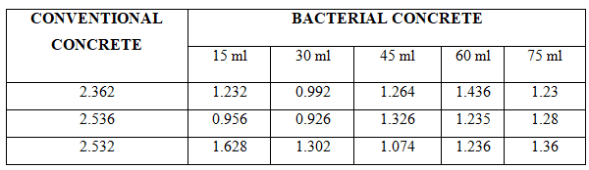
ULTRA SONIC PLUSE VELOCITY TEST
Ultra-sonic pulse velocity test was carried out to know the presence of voids in the internal structure of the concrete cubes. The results so obtained after conducting the test are tabulated below table. This results shows that of all samples tested the trouble time of 30ml and 45ml bacterial concrete found to be much lesser, again velocity is also higher.

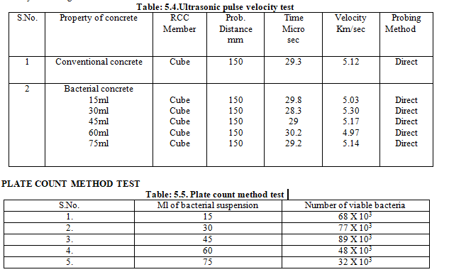

CONCLUSION
The bacteria which are known to be alkali-resistant, i.e. they grow in natural environments characterized by a relatively high pH. In addition, these strains can produce spores which are resting cells with sturdy cell walls that protect them against extreme environmental mechanical- and chemical stresses. Therefore these specific bacteria may have the potential to resist the high internal concrete pH values (12-13 for Portland cement-based concrete), and remain viable for a long time as well, as spore viability for up to 200 years is documented.
- Compressive strength of the concrete is start increasing when we introduce bacteria into the concrete compare to convention concrete
- In this project we worked with UPV test and plate load count method by the way the velocity and number of bacterial cell present in the concrete was calculated experimentally
- Water absorption test is also done where from the experiment we can conclude that we got better results in the bacteria concrete compare to conventional concrete.
- By the way increase in bacteria in the concrete leads to increase in the strength and also we can clearly notice that no cracks because of mechanism of bacteria.

FUTURE SCOPE
- More study required to reduce the cost of self-healing concrete.
- Further study required to overcome on the limitations of bacillus subtilis bacteria.
- More work should be done on the long term effect of bacteria on human life.
- Can be used in the construction of aircraft runways, bridges and dams reducing the maintenance cost.
- Retaining wall construction.

REFERENCES
Chithra P, BaiShibi Varghese. An experimental investigation on the strength properties of fly ash based bacterial concrete International Journal of Innovative Research in Advanced Engineering (IJIRAE) ISSN: 2349-2763 Issue 08, Volume 3 (August 2016)
V Srinivasa Reddy, M V SeshagiriRao, S Sushma. Feasibility Study on Bacterial Concrete as an innovative self crack healing system. International Journal of Modern Trends in Engineering and Research, e-ISSN No.:2349-9745, Volume 2, Issue 7, [July-2015] Special Issue of ICRTET’2015, Date: 2-4 July, 2015, PP 642-647.
Ashish Babarao Gawande, Yash Suneel Khandekar and Ojas Pravin Rahate, Applicability of Concrete Treated with Self-Healing Bacterial Agents. International Journal of Civil Engineering and Technology, 7(5), 2016, pp.275–283.
Abhishek Thakur, Akshay Phogat and Khushpreet Singh, Bacterial Concrete and Effect of Different Bacteria on the Strength and Water Absorption Characteristics of Concrete: A Review. International Journal of Civil Engineering and Technology, 7(5), 2016, pp.43–56.
MohitGoyal, P. Krishna Chaitanya. Behaviour of Bacterial Concrete as Self Healing Material, International Journal of Emerging Technology and Advanced Engineering ,ISSN 2250-2459, Volume 5, Issue 1, January 2015,PP 100-103
N.GaneshBabu. An experimental study on strength and fracture properties of self healing concrete ,International

