Contemporary Advancements in Nuclear Medicine

Mary Joan
Department of Radiation Oncology
Christian Medical College and Hospital
Ludhiana, India
joanmkunnel@gmail.com
Avinav Bharati
Department of Radiation Oncology
Dr. R M L Institute of Medical Sciences
Lucknow, India
avinavb4@gmail.com

ABSTRACT
Nuclear Medicine as a branch of medicine aiding in functional diagnosis and having therapeutic applications has evolved multi-dimensionally in the past decades due to technological advancements and scientific innovations. Other branches of medicine such as cardiology, neurology, oncology, radiotherapy etc. are greatly dependent on nuclear medicine for not only imaging but also treatment planning and execution and in terms of diagnostic, prognostic and predictive endpoints. In addition to the revolutionary developments of radiopharmaceuticals, equipment, computer and data sciences, the relative importance of these theragnostic applications changed significantly in itself and also for other specialties finding wide applications in the treatment of neurological, neuroendocrine, lymphatic and prostatic cancers.

Keywords- Nuclear medicine; functional imaging; innovation; technology; theragnostics; radionuclide therapy

- INTRODUCTION

Nuclear Medicine is the branch of medicine using open radionuclides for physiological or functional imaging and treatment. The applications vary from routine diagnostic imaging procedures to evaluate and assess diverse physiological functions of various organs or organ systems in human body to targeted radionuclide therapy to malignant and non-malignant diseases. Radioisotopes in itself or tagged with different radio chemicals called radio pharmaceuticals or tracers are injected, ingested or inhaled. These radiotracers are selectively absorbed and eliminated by the different tissues, organs or organ systems depending on their specific metabolic characteristics and hence are called metabolic imaging or treatment. A specific physiological or metabolic function of a particular cellular receptor or a particular type of tissue also enables whole body imaging by radiotracers. The nuclear medicine imaging and radiotracer studies provide functional information while conventional radiological imaging provides anatomical or morphological information. Exceptions are fMRI, contrast enhanced techniques in CT and MRI where certain functional information shall be interpreted. Nuclear Medicine imaging helps in very early diagnosis and treatment of dysfunctions or abnormalities due to progression of a disorder by visualization, characterization and quantification of radiotracer uptake, distribution and clearance from the human body.

- DIAGNOSTIC NUCLEAR MEDICINE

For diagnostic nuclear medicine, small amount of a radiopharmaceutical is used and is absorbed by different body parts or organs. There are many radionuclides that are available and the most routinely used are isotopes of technetium (Tc-99m discovered by Carlo Perrier and Emilio Gino Segrè in 1937) and iodine (I-131 and I-123). Other isotopes used are chromium-51, gallium-67, gallium-68, indium-111, thallium-201, xenon-133 etc. Depending on the type of study, body part being examined and the physiological function being studied the radionuclide selected varies.

Table 1: Characteristics of commonly used radio isotopes in diagnostic nuclear medicine

Radio isotope | Atomic No. (Z) | Decay Scheme | Half Life  (T_{1/2}) | Gamma Energies (Kev)
^{99m}Tc (Technetium-99m) | 43 | IT | 6.01 hrs. | 140 (89%)
¹³¹I (Iodine-131) | 53 | β⁻ | 8.02 days | 364 (81%)
²⁰¹Tl (Thallium-201) | 81 | EC | 3.04 days | 69–83* (94%)  167 (10%)
⁶⁷Ga (Gallium-67) | 31 | EC | 3.3 days | 93 (39%)  185 (21%)  300 (17%)
¹⁸F (Fluorine-18) | 9 | β⁺ | 109.8 min | 511 (193%)
¹³N (Nitrogen-13) | 7 | β⁺ | 9.97 min | 511 (200%)
⁸²Rb (Rubidium-82) | 37 | β⁺ | 1.3 min | 511 (191%)
^{81m}Kr (Krypton-81m) | 36 | IT | 13.1 sec | 190 (68%)
¹¹¹In (Indium-111) | 49 | EC | 2.8 days | 171 (90%)  245 (94%)
¹²³I (Iodine-123) | 53 | EC | 13.3 hrs. | 159 (83%)
¹³³Xe (Xenon-133) | 54 | β⁻ | 5.24 days | 81 (31%)

Upon injection, inhalation or ingestion of the radiopharmaceutical, body tissue or organ under study uptakes the radiotracer selectively. It gets absorbed or trapped in specific tissue and the ionizing gamma radiation emitted shall be detected by a radiation detector. The most commonly used imaging device in current clinical practice is a gamma camera.
As the radiotracer gets distributed in the body, it gets normally distributed, gets accumulated in specific regions or very less uptake in certain areas. Areas with higher uptake of radiotracer are called hot spots and lesser uptake areas are called cold spots and the normal distribution is called background uptake. This selective absorption patterns provides useful diagnostic information. Different procedure protocols are designed such that with minimum radiotracer used, sufficient uptake to identify metabolically active areas (hot spots) and to differentiate metabolically inactive areas (cold spots) and image acquisition times are adjusted such that accumulation of radiotracer takes place at the organs/ regions of interest and maximum background radiotracer clearance is achieved.

Table 2: Commonly used diagnostic radiopharmaceuticals in Nuclear Medicine (adapted from Open Med science blog on radiopharmaceuticals used in nuclear medicine)

Diagnostic Purpose | Radiopharmaceuticals
Brain | ¹⁸F fluoro-deoxy-glucose, ¹¹¹In pentetreotide, ¹²³I iofetamine, ^{99m}Tc sodium per technetate, ^{99m}Tc exametazime, ^{99m}Tc gluceptate, ^{99m}Tc pentetate
Oncology | ¹⁸Ffluoro-deoxy-glucose, ⁶⁷Ga citrate, ¹¹¹In pentetreotide, ¹¹C methionine, ¹³¹I iobenguane, ¹⁸F sodium fluoride, ^{99m}Tc arcitumomab, ^{99m}Tc nofetumomab merpentan
Colorectal | ^{99m}Tc arcitumomab
Iron absorption and metabolism | ⁵⁹Fe ferrous citrate
Cardiac function and muscle viability | ¹³NH₃, ¹⁸F fluoro-deoxy-glucose, ⁸²Rb, ^{99m}Tc sodium per technetate, ^{99m}Tc albumin, ^{99m}Tc sesta mibi, ^{99m}Tc teboroxime, ^{99m}Tc tetrofosmin, ²⁰¹Tl thallous chloride, ^{99m}Tc pyrophosphate, ^{99m}Tc (pyro- and trimeta) phosphates
Brain cerebrospinal fluid flow | ¹¹¹In pentetate
Renal | ¹²³I iodohippurate sodium, ¹³¹I iodohippurate sodium, ¹²⁵I iothalamate sodium, ^{99m}Tc gluceptate, ^{99m}Tc mertiatide, ^{99m}Tc pentetate, ^{99m}Tc succime
Liver | ¹³NH₃, ¹⁸F fluoro-deoxy-glucose, ^{99m}Tc albumin colloid, ^{99m}Tc disofenin, ^{99m}Tc lidofenin, ^{99m}Tc mebrofenin, ^{99m}Tc sulfur colloid
Lung | ^{81m}Kr, ^{99m}Tc albumin aggregated, ^{99m}Tc pentetate, ¹²⁷Xe, ¹³³Xe
Parathyroid | ^{99m}Tc sesta mibi, ²⁰¹Tl thallous- chloride
Vitamin B12 absorption and Pernicious anemia | ⁵⁷Co cyano cobalamin
Red blood cell | ⁵¹Cr sodium chromate
Salivary gland | ^{99m}Tc sodium per technetate
Spleen | ⁵¹Cr sodium chromate, ^{99m}Tc albumin colloid, ^{99m}Tc sulfur colloid
Stomach and intestinal bleeding | ⁵¹Cr sodium chromate, ^{99m}Tc sodium per technetate, ^{99m}Tc (pyro- and trimeta-) phosphates, ^{99m}Tc sulfur colloid
Stomach | ^{99m}Tc sulfur colloid
Tear duct blockage | ^{99m}Tc sodium per technetate
Thyroid | ¹⁸F fluoro-deoxy-glucose, ¹¹¹In pentetreotide, radio iodinated iobenguane, ¹²³I sodium Iodide, ¹³¹I sodium iodide, ^{99m}Tc sodium per technetate, ^{99m}Tc sesta mibi
Urinary bladder diseases | ^{99m}Tc sodium per technetate

- Single Photon Emission Tomography (SPECT) and SPECT-CT
Benedict Cassen developed first rectilinear scanner and Hal O Anger developed the scintillation camera (Anger camera) in the 1950s which were used for radiotracer uptake imaging. Kuhl et al. developed a photographic attachment for the Cassen scanner in 1956 to improve sensitivity and resolution. The gamma camera uses collimators made of lead with fine holes and septa, thickness of the collimator is decided based on the energy of the gamma radiation being detected. Sodium iodide thallium-activated photo-luminescent crystals are the most commonly used scintillating material in a light and hydroscopic ally sealed housing. The collimators ensures only those photons traveling parallel to the collimator holes are able to reach the crystal. The photons that reach the scintillating crystal are absorbed into the scintillator and the absorbed energy is converted into light by the scintillator and emitted out. The brightness of emitted light is proportional to the energy absorbed by the scintillator crystal. Photomultiplier tubes detects the scintillations and multiplies it and fed to the pre amplifier and the output is converted into visual images by the help of analog to digital converters, digital summing circuits, positioning circuits and correction circuits. The positions of interaction of gamma rays in the scintillating crystal are determined by the positioning circuits as the X-position and Y-position. All of the individual signals from the pre-amplifiers are added to produce an energy (Z) signal by the summing circuit. The possible errors in the positioning and energy of the interactions are corrected by the correction circuits. The signals X, Y and Z are processed to generate a visual image on the computer. The final electrical signal from the photomultiplier tube is proportional to the scintillations produced in the scintillating crystal which is proportional to the gamma photons incident. The gamma camera heads, usually two, can be rotated to acquire images from different angles and the tomographic images acquired are called single photon emission computed tomography (SPECT). A gamma camera and a CT scanner associated together enables the acquisition of SPECT-CT images where SPECT images are superimposed on CT images for better positional interpretation accuracy in imaging known as hybrid imaging.
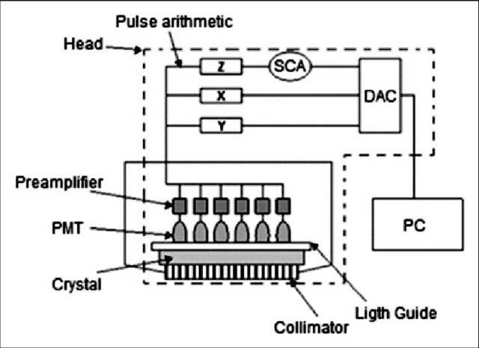

Figure 1: Schematic diagram of gamma camera assembly (Image courtesy: Doris del Carmen)

- Positron Emission Tomography (PET) and PET-CT/ PET-MRI
Positron emission tomography (PET) scan is another diagnostic imaging technique using positron emitting radionuclides to understand the biochemical or metabolic function or dysfunction of specific tissues and particular organs. This technique enables very early detection of the abnormal metabolism of the tracer in disorders as compared to be detected in other tests. The commonly used radiotracers in PET are 18F-FDG, NaF-18F, oxygen-15 etc. The other PET isotopes used are carbon-11, cobalt-55, copper-64, gallium-68, manganese-52, nitrogen-13, rubidium-82, zirconium-89 etc. These radionuclides are tagged with glucose, glucose analogues, water, ammonia, or molecules that bind to or mimic specific receptors. The positron-emitting radioisotopes are produced by cyclotrons and generally have very short half-lives requiring the cyclotrons to be near to the imaging facility.
The positron emitting radio tracer is most often injected into a vein and follows similar tracer kinetics as in diagnostic nuclear medicine radiopharmaceuticals, getting absorbed or collected into tissues or organs of higher metabolic or biochemical activity which is often the location of the abnormality or disease. The PET imaging combined with CT imaging or MRI and are termed as PET-CT or PET-MRI aiding to higher accuracy and ease in interpretation and diagnosis. The recent advancements in availability pharmaceuticals which can be labelled with positron emitting isotopes made its applications wide and common in different streams of medicine like oncology, neurology, psychiatry, cardiology etc.
The radiotracer undergoes positron emission decay or positive beta decay, it emits a positron, an electron with positive charge. The positron emitted moves in tissue losing its kinetic energy and get annihilated with an electron, giving rise to a pair of photons emitted opposite to each other in direction. These are detected when they reach the scintillation detector. The light emitted by the scintillating crystal is required to be multiplied and amplified to form an image. The light is detected by photomultiplier tubes or silicon avalanche photo diodes (Si-APD). The scintillating crystal array or ring gantry detects the photons but only those pairs detected simultaneously and approximately opposite to each other are considered. Photons that are not detected coincidently are ignored. The annihilation of an electron and a positron results in two 511 keV gamma photons emitted at 180 degrees and is possible to localize the site of annihilation along a straight line of coincidence called the line of response (LOR). The detector timing resolution enables detection of true events and the signal-to-noise ratio (SNR) is improved. The events detected coincidently are represented as a line in space. This line connects the two detectors along which it is assumed that the positron emission occurred.
Other than NaI (Tl), the scintillating materials which shall be used for detector configuration in gamma camera or PET scanner are Bi₄Ge₃O_{12,} CsI (Tl), CsI (Na), CaF₂ (Eu), BaF_{2m,} LiI (Eu), CsF, CdWO₄ , LSO etc. In addition to the advancements in scintillating materials, advanced reconstruction methods enhances the quality of images and quantification of radiotracer distribution. Time of fight (TOF), point spread function (PSF) and ordered subset expectation maximization (OSEM) are few examples.

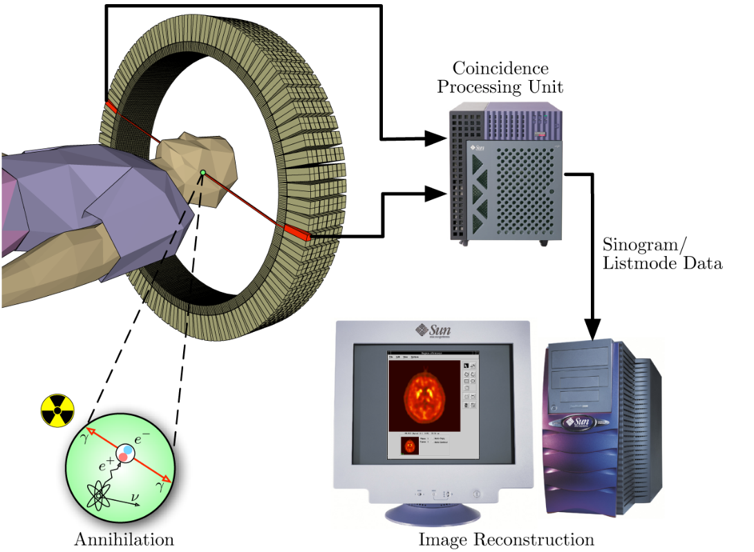

Figure 2: Schematic diagram of a PET coincidence detection (Image courtesy: Jens Maus)

- THERAPEUTIC NUCLEAR MEDICINE

Therapeutic nuclear medicine treats thyroid cancer, hyperthyroidism, skin and blood disorders, etc. The radiation treatment dose (activity of radiopharmaceutical) is administered intravenous or orally or directly above or into the area to be treated.
The radiopharmaceuticals used for therapeutic purposes emit ionizing β radiations which deposits its energy locally minimizing side effects and damage to normal tissues. The therapeutic procedures are performed on inpatient or outpatient basis depending on the activity administered as per the regulatory requirements in the country.

Table 3: Characteristics of commonly used radio isotopes in therapeutic nuclear medicine

Radio isotope | Atomic No.  Z | Decay Scheme | Half- Life T_{1/2} | Gamma Energy (keV) | Beta Energy (keV)
¹³¹I (Iodine-131) | 53 | β⁻ | 8.02 days | 364 | 0.807
⁹⁰Y (Yttrium-90) | 39 | β⁻ | 2.67 days | - | 2.280
³²P (Phosphorus-32) | 15 | β⁻ | 14.3 days | - | 1710
¹⁷⁷Lu (Lutetium-177) | 71 | β⁻ | 6.65 days | 113  208 | 497  384  176
⁶⁷Cu (Copper-67) | 29 | β⁻ | 2.58 days | 185 | 540
¹⁸⁶Re (Rhenium-186) | 75 | β⁻ | 3.77 days | 208 | 497

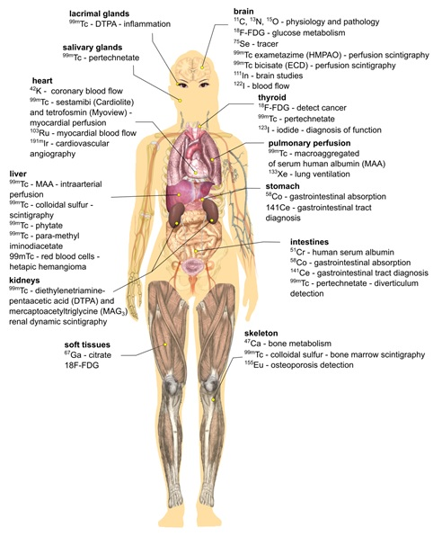

Figure 3: Radionuclides and pharmaceuticals most commonly used in nuclear medicine for diagnosis and treatment organs or organ systems (adapted from Payolla et al. 2019).

Few examples of therapeutic radiopharmaceuticals are ¹³¹Iodine- sodium iodide used for treatment of hyperthyroidism and thyroid cancer,¹³¹I-MIBG (meta-iodo-benzyl-guanidine) used for treatment of neuroendocrine tumors, ¹⁵³Samarium lexidronam or ⁸⁹Strontium chloride used for bone pain palliation, ¹⁸⁸Rhenium used for skin cancer treatments, ⁹⁰Yttrium-ibritumomab tiuxetan, ¹⁷⁷Lutetium somatostatin analogs and ¹³¹Iodine-tositumomab used for the treatment of lymphomas, ³²Phosphurus to treat polycythemia vera and historically to treat leukemia. Alpha particle emitting radionuclides such as ²¹³Bismuth or ²¹¹Astatine labelled with monoclonal antibodies are used in targeted radionuclide therapy of isolated tumors or micro metastasis.

- THERAGNOSTICS

The successful treatment of malignant and benign thyroid diseases with radioactive iodine marked the beginning of theragnostics. On 31 March 1941, Dr. Saul Hertz achieved this feet at Massachusetts General Hospital using ¹³¹I. The ¹³¹I- MIBG for diagnostic imaging and treatment of neuroendocrine tumors is another milestone. Peptide receptor radio-ablation plays a major role in the management of un-resectable or metastatic gastro-entero-pancreatic, broncho-pulmonary, and other neuroendocrine tumors. ¹⁷⁷Lu-DOTATATE has shown effectiveness over octreotide treatments. Currently. PSMA-tagged PET imaging has key clinical role. ⁶⁸Ga-PSMA11 and 18F-PSMA ligands are under trial. A phase III ¹⁷⁷Lu- PSMA-617 trial is expecting approval soon. The extra- and intracellular destinations that can be targeted with radio-labeled peptides, small molecules, antibodies, or antibody fragments will further expand theragnostic applications. Theragnostic radiopharmaceuticals for multiple myeloma, leukemia, and central nervous system lymphoma are undergoing clinical translation. Combination therapies involving Fibroblast-activation protein (FAP), integrins, melano- cortin subtype-1 are under rigorous exploration. Preliminary reports on ²²⁵Ac-PSMA an alpha particle emitter are encouraging due to the fundamental radiobiology effectiveness.
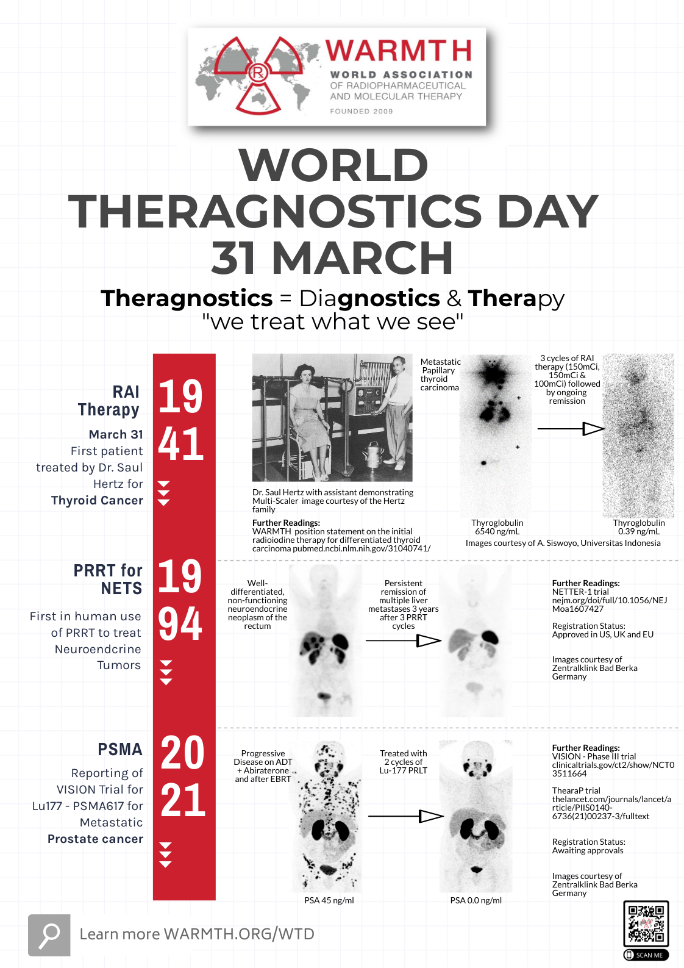

Figure 4: World Theragnostic Day brochure by WARMTH depicting the timeline of advancements

- ARTIFICIAL INTELLIGENCE (AI)

Artificial Intelligence plays an important role in improving and improvising image processing and pattern recognition in the nuclear medicine cardiac and brain imaging. The advantages are significant in automation of image acquisition improving patient positioning and scanning time, production of high-quality quantitative images by using AI-based scatter, attenuation and motion corrections, image reconstruction, or noise removal, and image analysis and interpretation. The efficiency of the tracer development process are also on the rise by utilization of AI guided algorithms. The reconstruction algorithms can be more effectively trained using information from the clinical database acquired over time. One of the major limitation of nuclear medicine imaging is the resolution and this can be greatly improved. Contouring of structures and delineation of region of interests could be done automatically with the help of AI learning and training enabling time savings, improved reproducibility, and comparative reporting. Data management, workflow optimization, interoperability and data integration processes can effectively change the routine clinical practice for the better with implementation of AI which will impact the patient care positively.
The field of nuclear medicine has undergone dramatic changes in the past decades due to technological developments and scientific advancements. Many diagnostic procedures have been replaced by other imaging techniques and modalities. And new imaging modalities have come into picture in nuclear medicine itself. Hybrid imaging is the new norm of the day not only for diagnosis but also for treatment evaluation. Other branches of medicine such as radiation oncology, neurology, cardiology etc. are greatly dependent on nuclear medicine for not only imaging but also treatment planning and execution. Some techniques for specific procedures got extinct while new ones took its place (Liver scans, cardiac scans, PET scans). Same may be said true for radiopharmaceuticals also. Imaging and treatment of prostate cancer using radiolabeled PSMA inhibitors were considered not feasible until recently. Development of new radiopharmaceuticals were considered expensive and non-viable. A PET radiopharmaceutical other than ¹⁸F-FDG and outreach to the mass population was unimaginable. The recently approved somatostatin, ¹¹C-choline, amyloid and tau ligands and prospects of PSMA ligands, have proven otherwise.
In addition to the revolutionary developments of equipment and radiopharmaceuticals, the relative importance of these theragnostic applications changed significantly in itself and also for other specialties. The scenario where changed drastically with the introduction of PET technology. The quality and resolution of images improved significantly. From only ¹⁸F-FDG PET/CT as a major technique in nuclear medicine to ⁶⁸Ga-DOTATATE and ¹⁷⁷Lu-DOTATATE pair for imaging and therapy of neuroendocrine tumors, radiolabeled PSMA ligands for imaging and therapy of prostate cancer the horizon has widened. The developments that happened in nuclear medicine as a specialized branch of medicine has been unpredictable and if it continues to be innovative and adapt quickly to technological advancements and clinical requirements we will have more solutions for the current challenges in medicine in the future.

REFERENCES

- Esfahani K, Roudaia L, Buhlaiga N, Del Rincon SV, Papneja N, Miller WH Jr. A review of cancer immunotherapy: from the past, to the present, to the future. Curr Oncol. 2020; 27 (suppl. 2): S87-S97.
- Guner L, Unal K and Vardareli E. Technological Advancements in Nuclear Medicine and Molecular Imaging. Eur Arch Med Res 2018; 34 (Suppl. 1): S25-S29
- Herrmann K, Schwaiger M, Lewis JS, et al. Radiotheranostics: a roadmap for future development. Lancet Oncol. 2020; 21: e146–e156.
- Kratochwil C, Flechsig P, Lindner T, et al. 68Ga-FAPI PET/CT: tracer uptake in 28 different kinds of cancer. J Nucl Med. 2019; 60: 801–5.
- Langbein T, Weber WA, Eiber M. Future of theranostics: an outlook on precision oncology in nuclear medicine. J Nucl Med. 2019; 60 (suppl. 2): 13S–19S.
- Lucignani G. Alpha-particle radio-immunotherapy with astatine-211 and bismuth-213. Eur J Nucl Med Mol Imaging. 2008; 35 (9): 1729-33
- Martinez O, Sosabowski J, Maher J, Papa S. New developments in imaging cellbased therapy. J Nucl Med. 2019; 60: 730-5.
- Meredith RF, Knox SJ. Clinical development of radio-immunotherapy for B-cell non-Hodgkin's lymphoma, Int J Radiat Oncol Biol Phys. 2006; 66 (2): 15-22.
- Physics in Nuclear Medicine. Fourth. Elsevier Inc.: Grune and Stratton; 2012
- The Essential Physics of Medical Imaging. Third. North American Edition: Lippincott Williams and Wilkins; 2011
- Van de Donk PP, Kist de Ruijter L, Lub-de Hooge MN, et al. Molecular imaging biomarkers for immune checkpoint inhibitor therapy. Theranostics. 2020; 10: 1708-18.
- Weber WA, Czernin J, Anderson CJ, Badawi RD, Barthel H, Bengel F, et al. The Future of Nuclear Medicine, Molecular Imaging, and Theranostics. J Nucl Med. 2020; 61 (12) (Suppl. 2): 263S-272S

