Effect of Groundnut Husk based Non-Damaging Drilling Fluid (NDDF) on Shale Formation

Faizanulla Meer:
Petroleum Engineering, Presidency University, Bangalore.
meerfaizanulla786@gmail.com

Ayan Assadi:
Petroleum Engineering, Presidency University, Bangalore.
Ayanassadi12@gmail.com

Rahul Kumar Dash:
Petroleum Engineering, Presidency University, Bangalore.
rahuldash1616@gmail.com

ABSTRACT

Drilling fluid is one of the most essential parts of a drilling process. It counterbalances formation pressure, lubricates the drill bit, carries out the cuttings and many more. One of the disadvantages of drilling fluid is that it causes formation damage. Conventional drilling fluids contain bentonite, which react with shales to cause extensive damage in shale formations. Swelling and spalling have big repercussions during drilling such as borehole collapse and stuck pipe. So, a non-damaging drilling fluid was developed free from bentonite and barite which minimizes formation damage and is less reactive to shales. This fluid is generally used in shale formations as mentioned and in pay zone. The goal of this project is to formulate a non-damaging drilling fluid with the additives chosen and compare their performance with another non-damaging drilling fluid of similar concentration.

Chapter 1: Introduction

  - Introduction

During the exploring and exploiting process for the energy resources, drilling plays a vital role. Different fluids are used in the bore-hole for drilling, the chemical and physical compatibility of the fluids with reservoir rock is the most important factor in maximizing production [1]. The term “fluids” is preferred by most of the drilling companies and author’s [2]. Fluid used for drilling is called Drilling mud or drilling fluid, it’s defined as circulating fluid used in drilling to perform various drilling operations. In “Baker Hughes drilling fluids” reference it is mentioned that a drilling fluid is a fluid formulated with chemicals to obtain specific chemical and physical characteristics for circulating during the rotary drilling process [3]. When the fluids start encouraging formation damage in different ways, the well’s productivity might gradually reduce. And drilling fluids are kept at a high pressure than the formation pressure to hinder the invasion of fluids present in the formation. The drilling fluid compositional solids, polymer particles and drilled cuttings present in the drilling fluid have the tendency to reduce the rock permeability through blocking the pores [4]. The filtrate will react with the formation minerals to mobilize and following re-deposit them, hydrate the clay envelope in pay zone particles and the scales produced from the chemical reaction with the formation minerals leads to reduce the formation permeability. Therefore, it is always important to reduce the exchange of fluids between the well and the rock formation and solid invasion in the formation [5]. For this we generally add particulate material to the drilling fluid, formation of low permeable filter cake takes place which helps to minimize the invasion of minerals and solids subsequently, in order to increase the flow area the cake must be removed. The polymers are used in NDDF, that reduce fluid invasion by sealing the walls of borehole and viscosity effects, acid soluble solids are also added to NDDF in order to reduce fluid penetration and plugging [6].

1.2 Drilling fluids and types

Drilling fluid, considered the “blood” of drilling engineering and it is one of the key factors for successful drilling. Drilling fluid is important for obtaining information about the wellbore, to cool and lubricate the drill string, to reduce the formation damage, to prevent the well control issues & transporting drilled cuttings from the well bore to the surface. To perform the above functions various additives are added to the drilling fluid [7]. There are two types of drilling fluid, WBM (Water based drilling mud) & OBM (oil based drilling mud). WBM is commonly used drilling mud type. An oil well’s productivity is focused on the control over formation damage during drilling. If the formation damage is least, more oil can be produced [8]. The use of convectional water-based mud in water sensitive clays and shale formations may cause wellbore instability, formation damage, torque & drag, stuck pipe, logging and primary cementation failures, borehole washouts etc. These problems may become even more dangerous in directional or horizontal wells. The alternative option of oil based mud is not capable of being done due to the severe environmental rules and regulations and also it’s not economically feasible. The main cause of formation damage is solid invasion. Fine particles penetrate deep to the formation and are not removed easily by back-flushing [9].

1.3 Non-Damaging Drilling Fluid (NDDF)

Non-damaging drilling fluid (NDDF) is clay and barite free mud system mostly used in pay zone section to avoid formation damage. It is a method to increase oil production of a well by controlling formation damage [9]. NDDF was introduced in the Asset for drilling pay zones in the Linch field of Mehsana block [4]. An extensive range of particle sizes are used. It contains long-chain, high molecular weight polymers in systems either to prevent dispersion or to coat the shale for inhibition as well as to increase viscosity and reduce fluid loss. On de-hydration, these particles fit together into a strongly compacted very low permeable mud cake on the surface of the rocks to quickly seals off the permeable paths of the pay zone [10]. Application of NDDF is the most direct method for controlling formation damage during drilling. Field optimization of NDDF formulation in three wells of Linch field has shown encouraging results in terms of compatible mud parameters, No complications were faced during drilling and testing, gauge holes have shown good quality of logs. The wells have given a distinctively increased productivity in terms of oil production with instant activation [11]. Mehsana Asset of ONGC, in North Cambay Basin in India gives special importance on increased oil production with the use of new technologies, where NDDF is the fundamental change in approach. Distribution of bridging particle sizes has a significant role in designing a drilling mud. Mud with suitable particle sizes will give good result in minimizing solid invasion into formation pores and reduce the fluid loss to the formation. The key elements credited to formation damage due to solid invasion are, formation plugging by drill cuttings, by drilling fluid’s compositional solids like clay and by polymer particles, change in wettability by filtrate, mud invasion into pay zone due to induced lost circulation, formation of scales due to chemical reaction between the formation minerals and mud filtrates, mud circulation rate, over balanced pressure, concentration of mud solids and rheology [11, 12]. To counter the above mentioned formation damage mechanisms the optimally designed fluid (a) should contain specialized sized materials to bridge all the exposed pore openings, (b) should retain all the relevant characteristics of drilling fluid, (c) should reduce the formation damage, lower overall well cost and optimize production without neglecting HSE regulations, (d) minimum drilled fine solids, reduced filtration loss and filtrate should not undergo chemical reaction with formation minerals to form insoluble precipitate, (e) effective check on polymer’s particles invasion into pay zone[13]. Non damaging drilling fluid (NDDF) provides all of the mentioned qualities for an optimally designed fluid for formation damage control during drilling.

1.4 Advantages of Non-Damaging Drilling Fluid (NDDF)

NDDF has distinct advantages over conventional dispersed muds and controls formation damage. Mud filtrate swells the clay envelops around sand particles of pay zone obstructing oil flow. NDDF generates saline inhibitive filtrate, so clay swelling does not take place [14]. The fine solids in the conventional muds enter deep into formation and not removed easily by back-flushing and choke the oil passage from reservoir to well and presence of dispersant generates fine clay particles inside the formation, these particles migrate further to clog the pores. NDDF does not contain fine solids (clay) and the thixotropic property of drilling fluid is provided by the additive-XC polymer which is bio-degradable. Since it does not contain any dispersant, no clogging takes place due to dispersion generated fines [15]. Properly selected sized particles of CaCO3 present in the NDDF, bridge the pore throats on the formation surface to form an external filter cake. External filter cakes are used to minimize fluid loss and to prevent the solid invasion to the formation from the wellbore. An external filter cake is much easier to be removed than an internal filter cake which is inside the formation matrix[16]. Calcium carbonate is also used to impart higher specific gravity to NDDF. Calcium Carbonate is acid soluble and can be removed later on, instead of barite used in conventional muds.

1.5 Literature Survey

The use of commercial organic polymers as fluid loss control agents in drilling muds leads to increase in the cost of the fluids; hence, researchers focus on applying cost effective and best in terms of use in fluid loss control additive. This work study is focused on the effect of groundnut based NDDF on shale formations. We had a detailed study on the previous usage of the various additives used in the formation of NDDF and understand their requisite properties of each additive for its effective use.it is observed that the NDDF is less reactive as compared to the convectional bentonite mud and rice husk showed a potential impact on pay zones [17]. Another notable observation is that the additives used gave good results in terms of filtration loss and hole stability [18]. On this paper based on the effect of cashew nut shell liquid esters in drilling fluid, where they used KCl as major component showed variation in the rheological values with time, using groundnut husk as replacement of KCl will maintains the rheological properties. Research regarding the formulation of cellulose from groundnut done with WBM revealed some of the properties of groundnut husk. It showed good fluid loss control, Eco-friendly, cost effective. Here in this paper we are conducting a comparative study between groundnut husk and psyllium husk [19]. Procurement of the materials to be used for both Non-Damaging Drilling fluid and shale study. Groundnut husk literature is studied in respect to water based drilling fluid, and work on it as a Non Damaging Drilling Fluid isn’t studied yet.

1.6 Objectives of Work

The objectives of this project being carried out are as follows:
- To synthesis the NDDF with an optimum number of natural additives
- To investigate the rheological properties of the optimized NDDF
- To verify the shale stability performance in the presence of NDDF

CHAPTER 2: Experimental Section

2.1. Additives of NDDF

Various additives are used in the formulation of NDDF. Each performs a separate function which is necessary for optimal functioning of NDDF. The various additives present in NDDF are
- Base fluid (distilled water): the base fluid is also referred to as water number. This drilling fluid is used as a wetting agent in the external phase of the drilling operation. As water-based mud is less prone to affect the environment.
- Viscosifier: xanthan gum biopolymer is a premium grade viscosifier to oilfield drilling and completion fluids. Polymer allows for high penetration rate, hole cleaning and has a shearing thinning property and good suspension characteristics.
- Fluid loss control/coating agent: it is the act or means of usually lowering the volume of a fluid. Control of fluid loss for a mud can be achieved by several means, one of it is by adding of fluid loss control material to the mud system. Example: groundnut husk
- Formation clay/shale inhibitors (Carboxymethyl cellulose): Carboxymethyl cellulose can be used as a shale inhibitor when encountering shale during the drilling operation. Carboxymethyl cellulose gives additional viscosity and carrying capacity for the formation of clay.
- Weighing and bridging materials (Calcium Carbonate): calcium carbonate densifies and prevents formation damages and has a high specific gravity and also controls formation pressures with can be vividly used for bridging and weighing.
- Other additives: additive lubricates and reduces wear and year. They ensure that the drilling mud has the necessary viscosity to easily carry and flush rock cuttings provides additional strength to the drilling mud. Example: potato starch.

2.2. Plan Of Work

Have a detailed study of the previous usage of additives used and compared with studied non-damaging drilling fluid, which is considered primary and understand the requisites properties of each substances and its effective usage, which will be useful in obtaining desired results. In consideration to experimental setup, the procurement of the materials to be used for both, Non-damaging and shale study. Which gives creating the test environment for the conduction of experiments. Which is followed by observing the physical changes and calculating the values obtained. Using this data, an optimum concentration of NDDF was to be chosen for the experiment. The concentrations that were studied in different ranges. The optimum concentration of NDDF that was chosen will be compared with the formulated NDDF at a later stage. The polymers such as Carboxymethyl cellulose (CMC), have high characteristics of corrosion inhabitation in an aggressive environment [20]. Using viscometer technique the effect of CMC on NDDF could be evaluated. The effect of CMC, CaCO₃, potato starch, groundnut husk and psyllium husk in formulating an NDDF is to be studied. By using Marsh funnel viscometer, water analyzer, Hamilton beach mixture, the particular effects are to be evaluated. The variable measured by it is the time, in seconds, required for a given quantity of the mud to pass through the tube of the instrument, the latter being simply a standardized funnel.
Then the rheological and electrical properties of the formulated NDDF are to be studied. This includes various properties such as density; apparent viscosity; effective viscosity; plastic viscosity; yield point; gel strength; variation of properties with temperature; pH; salinity; electrical conductivity; cation exchange capacity. The filtration properties of the formulated NDDF are then studied. When the formulated drilling fluid is used in the field it undergoes certain effects. The amount of mud in the borehole could differ in a while as the mud could intrude into the formation and we lose mud. Once the NDDF is formulated, its performance is to be compared with another NDDF-based mud with the same additives at the same concentration. The rheological properties of both fluids are measured over time, and the changes caused the degradation of the drilling fluid. The final piece of work is to be the determination of how the formulated NDDF reacts with shale formation when kept under observation for a period of 24 hours.

2.3 Materials

There are various elements used in the formulation of non damaging drilling fluid (NDDF). There are five additives used in its formation which are; CMC, CaCO₃, potato starch, groundnut husk, and psyllium husk. Each carries out a specific function in the formulation of the drilling fluid. Bentonite is used in the experiment. A NDDF was used for comparison with the NDDF for better results. Distilled water was also used for formulating the various drilling fluids.

2.4 Experimental Setup
A Hamilton beach mixer (Figure 2.1) is used to mix the component materials of the mud being formulated to make a fluid with uniform properties. Most drilling fluid formulations contain a base liquid and additives which must be dissolved or mechanically dispersed into the liquid to form a homogenous fluid. A marsh funnel (Figure 2.2) is also required. The marsh funnel is a simple device for measuring viscosity by observing the time it takes a known volume of liquid to flow from a cone through a short tube. It is standardized for use by mud engineers to check the quality of drilling mud. Other cones with different geometries and orifice arrangements are called flow cones but have the same operating principle. The resulting fluid may contain one or more of the following: water-dispersible (soluble) polymers or resins, clays or other insoluble but dispersible fine solids, and soluble salts. In respect to find out the Specific Gravity and pH of sample, a Mud balance (Figure 2.3) and Water analyzer (Figure 2.4). An hand crank viscometer (Figure 2.5) is used to measure the plastic viscosity, yield point and gel strengths of the drilling fluid.

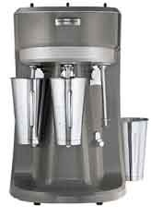
Fig 2.1: Hamilton-Beach stand mixer

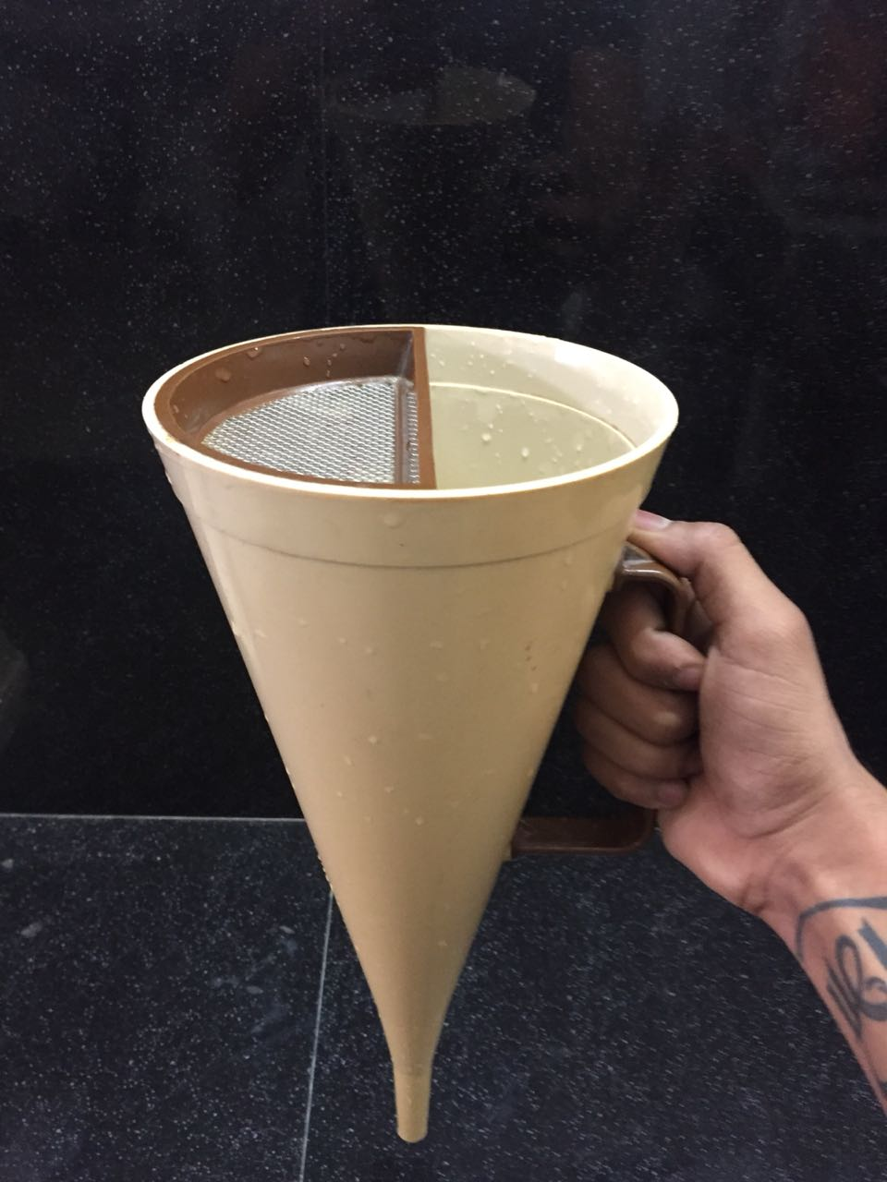
Fig 2.2: Marsh Funnel

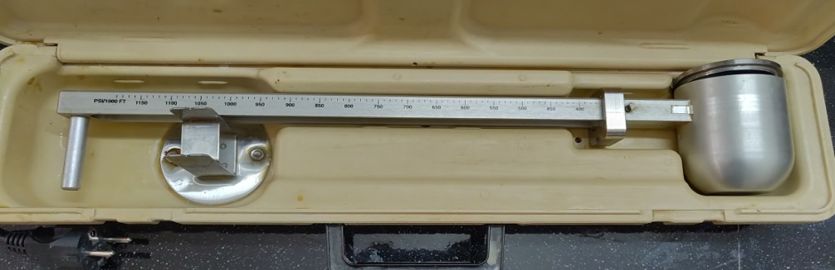
Fig 2.3: Mud Balance

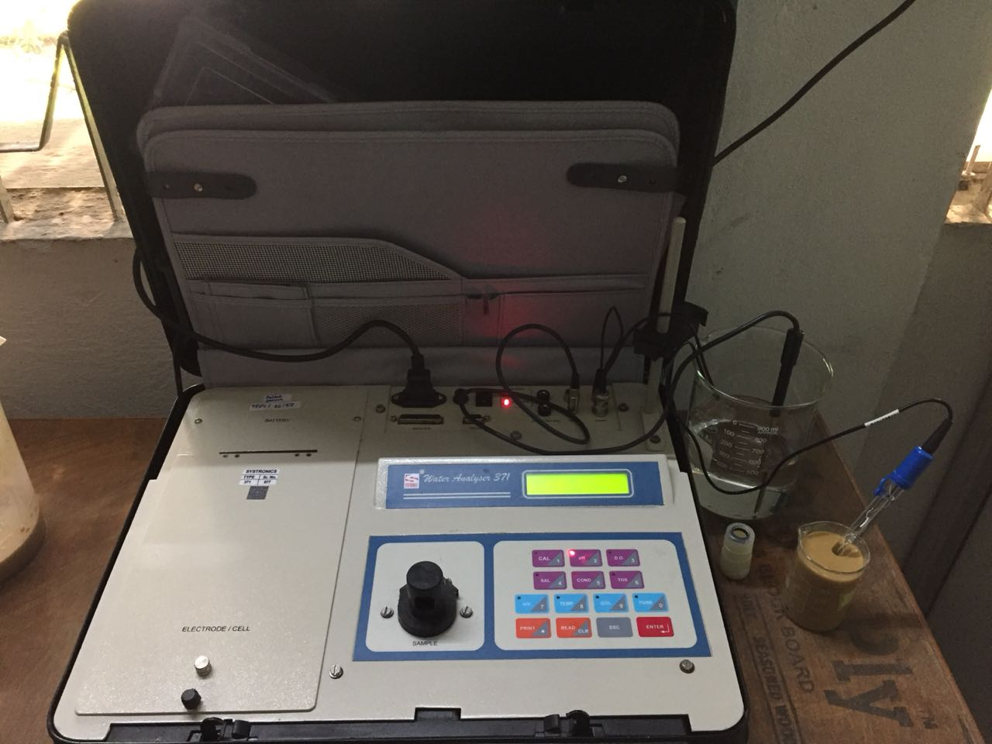
Fig 2.4: Water Analyzer

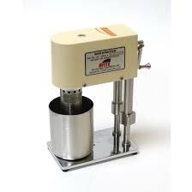
Fig 2.5: Hand crank viscometer

2.5 Experimental Procedure

A pre-determined concentration of the additive was taken. The sample was weighed and added to 1500 mL of distilled water. The mixture was thoroughly stirred and was then mixed using a laboratory Hamilton Beach mixer. This smoothens out the fluid and has uniform properties and density throughout the fluid. The density of this fluid is measured using a mud balance. 950 mL of the drilling fluid prepared is taken in Marsh funnel and the fluid was allowed time to flow out of the Marsh funnel freely. The time taken for the fluid to flow out of the marsh funnel was recorded. Three trials are conducted and the average time taken is determined from the three trials. This is used to determine the apparent and effective viscosities of the drilling fluid using the formula given below. The calculations required to determine the apparent and effective viscosity were carried out. The same procedure was carried out for every concentration of drilling fluid to be tested and evaluated.
Apparent Viscosity: ꝭ (t-28)
Effective Viscosity: ꝭ (t-25)
Where, ꝭ = density of formulated mud, g/cc
t = time taken for the fluid to flow out of the Marsh funnel, sec
The pH of each drilling mud for different concentrations of the drilling was determined. The plastic viscosity, gel strength, and yield point were determined for each concentration of the drilling fluid using a hand crank viscometer. The viscometer gives the shear stress readouts which are to be converted. The results from all these tests for different concentrations are to be compared with each other and a drilling fluid with an optimum concentration of each additive is to be formulated. This formulated drilling fluid was then compared with a NDDF. This fluid has the same additives as the NDDF but along with different type of NDDF.

Chapter 3: Work done

3.1. Formulation of NDDF

Non damaging drilling fluids (NDDF) are mostly water Based drilling muds and consists of bridging elements (such as calcium carbonate) and polymeric additives. Because NDDF can prevent formation damage, it is the system of choice in the reservoir sections. The drilling fluid being created in this project consists mostly of six additives.
- Carboxymethyl cellulose (CMC)
- Calcium Carbonate (CaCO₃)
- Groundnut Husk
- Psyllium Husk
- Potato Starch
- Formaldehyde

Each addition has a specific role to play in modifying the rheological properties of the drilling fluid and increasing particular qualities. Various concentrations of each additive will be tested, with the findings being used to identify the ideal concentration for each additive and, ultimately, to manufacture the drilling fluid.

3.1.1 Carboxymethyl cellulose (CMC)

Carboxymethyl cellulose (CMC) is a viscosifier as well as a fluid loss control component in drilling fluids. To make CMC sodium salt, natural cellulose is combined with monochloroacetic acid and sodium hydroxide. It's possible that up to 20% of the product obtained contains NaCl, which is processed to remove the NaCl. CMC was the first component we employed in our NDDF formulation. For the laboratory testing, the following CMC concentrations were used: 4.8g, 4.9g, and 5g in 1500 mL of distilled water. 5g of CMC in 1500 ml of distilled water is used for making the groundnut husk and psyllium husk. Density, specific gravity, pH, apparent viscosity, effective viscosity, plastic viscosity, gel strength, and filtrate loss are all the same rheological parameters tested.

3.1.2 Calcium Carbonate (CaCO₃)

CaCO3 is used in drilling fluids for two main reasons: as a weighing agent and as a bridging element. We employed the addition in this case for both of these reasons. When CaCO3 acts as a bridging element, it reduces formation damage. It closes the pores in the formation and creates a filter cake layer over it to block off the permeable zones. This lowers formation damage while also reducing filtrate loss and boosting the drilling mud density. This feature is particularly beneficial to NDDF since it functions as a substitute for barite. For the laboratory testing, the following CaCO3 concentrations were used: 3.15g in 1500 mL distilled water, along with the previously measured 5g of CMC. Density, specific gravity, pH, apparent viscosity, effective viscosity, plastic viscosity, gel strength, and filtrate loss are all the same rheological parameters. The same experiments were performed on this additive as they were on CMC.

3.1.3 Groundnut Husk

Groundnut husk is a by-product of flour mills and oil refineries, and it is produced in enormous quantities and burned as agricultural waste. Drilling fluids, which account for around a fifth (15-18%) of the overall cost of drilling a petroleum well, must meet three critical criteria: they must be simple to use, affordable, and ecologically beneficial. The multifunctional drilling fluid performs numerous tasks at the same time. They're supposed to clean the well, keep the cuttings suspended, avoid caving, keep the well wall tight, and produce an impenetrable cake near the wellbore. Groundnut husk powder enhances rheological qualities, minimizes filtering loss, and is environmentally friendly, cost-effective, and thermally stable when added to drilling fluid. Because groundnut husks are biodegradable, easily disposable, and have no impact on the ecology, they have shown to be a sustainable approach for keeping the environment healthy. Groundnut Husk contains cellulose, which impacts the rheological qualities and overall performance of the drilling mud. The apparent viscosity, plastic viscosity, yield point, and Gel strength (10 sec gel, 10 min gel) of the designed mud are all taken into consideration. The current study shows how to build and analyse a sustainable drilling fluid system that uses biodegradable groundnut husk as a rheological modifier. The cellulose obtained from groundnut husk is being used as an alternative to the polyanionic cellulose (PAC) currently used in the formulation of drilling fluids. The following groundnut husk concentrations were employed in the laboratory testing: 24g, 25g, and 26g in 1500 mL distilled water, as well as the previously determined 5g of CMC and 3.15g of CaCO3. Rheological metrics include density, specific gravity, pH, apparent viscosity, effective viscosity, plastic viscosity, gel strength, and filtrate loss. 24g of groundnut husk is been taken for throughout the samples.

3.1.4 Psyllium Husk

Psyllium is derived from the seeds of the Plantago genus, which has over 200 species. India dominates the global market, producing over 39,000 t of Psyllium seed annually. 85 percent of the global market is covered by this. The major product extracted from the seed is psyllium husk, with the remainder being utilized as animal feed. It's a transparent colourless mucilaginous gel made up of white fibrous hydrophilic substance. Psyllium, which is made from the seed husk of the Plantago genus plant, has around 80% soluble fibre and is a good source of both soluble and insoluble fractions in the diet. Psyllium husk, which is widely utilized in the health and food industries, is made from the seeds of a plant that is commercially farmed and manufactured in cool and dry climates. The performance of Psyllium husk as an environmentally friendly ingredient in water-based mud is evaluated in this study. To make water-based Psyllium husk mud, psyllium husk is mixed with pure water in various concentrations. It has a delicate gel structure that forms rapidly over time. When Psyllium husk mud with a concentration of 1% by weight is used instead of the standard bentonite mud, the filter volume is reduced by 13%. Psyllium husk's insoluble portions produce a very thin filter cake capable of sealing large holes and reducing water loss into forms. When compared to bentonite-based mud, psyllium husk is more resistant to salinity in make-up water and can produce higher viscosity when added to saline water. Insoluble components that can potentially block big pores and lower filtrate volume are an advantage of Psyllium husk over currently utilized water soluble polymers such as Starch and CMC (Sodium Carboxymethylcellulose).In the laboratory, the following psyllium husk concentrations were used: 24g, 25g, and 26g in 1500 mL distilled water. Density, specific gravity, pH, apparent viscosity, effective viscosity, plastic viscosity, gel strength, and filtrate loss are all rheological measures. Throughout the samples, 24g of psyllium husk is used.

3.1.5 Potato Starch

In situations where potato starch's qualities are particularly appropriate, it is favoured over maize starch and other starches. It has the following key characteristics: (a) high consistency on pasting, followed by a decrease in viscosity with additional heating and agitation, (b) excellent flexible film production, (c) binding power, and (d) low gelatinization temperature. The rheological qualities of potato starch mud improved when the pH of the drilling fluid was raised, according to the findings of this investigation. At low pH (about 8.6), potato starch might be used to improve gel strength, while at high pH mud, it could be used to improve viscosity (approximately 10.8). The following potato starch concentrations were employed in
the lab: 4.5g in 1500 mL distilled water. Rheological measurements include density, specific gravity, pH, apparent viscosity, effective viscosity, plastic viscosity, gel strength, and filtrate loss.

3.2. GH & PH Rheological properties

In this work, carboxymethyl cellulose (CMC), calcium carbonate (CaCO3), psyllium husk, groundnut husk, potato starch, and formaldehyde are used to develop a non-damaging drilling fluid (NDDF) that is water-based. To make the NDDF, these additives were mixed in with distilled water (DW) in a step-by-step process. Each addition has a specific function in distilled water (DW) in a step-by-step process. Each addition has a specific function in modifying the parameters of the drilling fluid and increasing particular qualities. Different concentration of each additive will be studied, with the results being taken to identify the ideal concentration for each additive and, ultimately, to create the NDDF. The concentration of each of sample taken and observed for period of time was considered and its rheological properties were found, as shown in table 3.1. modifying the parameters of the drilling fluid and increasing particular qualities. Different concentration of each additive will be studied, with the results being taken to identify the ideal concentration for each additive and, ultimately, to create the NDDF. The concentration of each of sample taken and observed for period of time was considered and its rheological properties were found, as shown in table 3.1.

Table 3.1 Rheological properties for various concentrations of Groundnut husk with CMC
GH | 24g |  |  | 25g |  |  | 26g
CMC | 4.8g | 4.9g | 5g | 4.8g | 4.9g | 5g | 4.8g | 4.9g | 5g
Density (ppg) | 8.4 | 8.45 | 8.45 | 8.5 | 8.46 | 8.42 | 8.4 | 8.46 | 8.4
Effective Viscosity (cP) | 18.732 | 21.21 | 22.81 | 17.595 | 20.304 | 23.01 | 19.656 | 21.319 | 23.01
Time (s) | 27.23 | 27.51 | 27.6 | 27.07 | 27.4 | 27.73 | 27.34 | 27.51 | 27.73
Apparent Viscosity (cP) | 4.5 | 5 | 4.5 | 5 | 5 | 3.5 | 5 | 5 | 5
Plastic Viscosity (cP) | 4 | 4 | 3.5 | 4 | 3 | 3 | 4 | 3 | 5
Yield Point (lb/100ft²) | 1 | 2 | 2 | 1 | 4 | 1 | 2 | 4 | 0
Gel Strength 10sec (lb/100ft²) | 9 | 12 | 12.5 | 11 | 13 | 14 | 13 | 13 | 12
Gel Strength 10min (lb/100ft²) | 11 | 18 | 25 | 13 | 20 | 19 | 14 | 22 | 19
pH | 9.2 | 8.71 | 7.72 | 8.91 | 8.7 | 7.77 | 8.69 | 8.7 | 7.75

To proceed, prepare a base or typical mud, such as a water-based drilling mud or fluid containing groundnut husk. The rheological characteristics of various concentrations of groundnut husk were determined. These findings are used to determine the best groundnut husk concentration. A Hamilton Beach mixer was used to mix CMC with groundnut husk and calcium carbonate immediately with distilled water. The concentrations of these selected components were investigated. Following the preparation of the samples, several tests were performed to determine the fluid's rheological properties, as given in Table 3.1.The properties determined are density; specific gravity; pH; apparent viscosity; effective viscosity; plastic viscosity; gel strength. Three trials were done for each sample. The same procedure should be carried out for every concentration of groundnut husk to be tested and evaluated. From the results, it has been observed that the nondamaging-based drilling mud for all the concentration has shown a very lower range of values for each property.

- Figure 3.1: Graphical representation of YP/PV Ratio of 24g of Groundnut husk

Figure 3.2: Graphical representation of YP/PV Ratio of 25g of Groundnut husk

Figure 3.3: Graphical representation of YP/PV Ratio of 26g of Groundnut husk
From the obtained results using groundnut husk, 24g, 25g, 26g groundnut husk rheological properties were studied and had different ranges with change in values of groundnut husk and CMC with constant 3.15g of calcium carbonate was used for all the products, and in study to YP/PV Ratio and other properties of groundnut husk, one sample of 25g of groundnut husk was shown 1.33 of YP/PV Ratio was close enough to be studied for change with time. was shown appropriate results as compared to other samples in terms of YP/PV Ratio, which is termed for shear thinning and must be less than or equal to 1. The 25g of groundnut husk with 4.9g of CMC was studied for consecutive days for degradation.

Properties | 15g Psyllium husk  4.8g CMC | 8g Psyllium husk  4.9g CMC | 5g Psyllium husk  4.9g CMC
Density (ppg) | 8.4 | 8.4 | 8.32
Effective Viscosity (cP) | 115.164 | 66.612 | 46.592
Time (s) | 38.71 | 32.92 | 30.6
Plastic Viscosity (cP) | 15 | 13 | 8
Yield Point (lb/100ft2) | 10 | 4 | 2
Apparent Viscosity (cP) | 20 | 15 | 9.5
Gel Strength 10 s (lb/100ft2) | 60 | 43 | 30
Gel Strength 10 min (lb/100ft2) | 85 | 57 | 37
pH | 9.5 | 9.25 | 9.31
Table 3.2 Rheological properties for various concentrations of psyllium husk with CMC.

To begin, prepare a base or typical mud, such as a water-based drilling mud or fluid containing psyllium husk. The rheological characteristics of various quantities of psyllium husk were determined. These findings are used to determine the best psyllium husk concentration. Using a Hamilton Beach mixer, CMC with psyllium husk and calcium carbonate was combined immediately with distilled water. The concentrations of these selected components were investigated. Following the preparation of the samples, several tests were carried out to determine the fluid's rheological properties, as indicated in Table 3.2. Density, specific gravity, pH, apparent viscosity, effective viscosity, plastic viscosity, and gel strength are all measured. Each sample underwent three trials. In comparison to groundnut husk, the nondamaging-based drilling mud showed a wide range of values for each attribute for all concentrations.

Figure 3.4: Graphical representation of rheological properties and concentration 15g,8g & 5g of psyllium husk.

Figure 3.5: Graphical representation of YP/PV Ratio of 15g, 8g & 5g of psyllium husk

Figure 3.5.1: Graphical representation of gel strength of 15g,8g & 5g of psyllium husk.

The rheological properties of 15g, 8g, and 5g psyllium husk were studied and had different ranges with change in values of psyllium husk, and CMC with constant 3.15g of calcium carbonate was used for all the products, and in the study of YP/PV Ratio and other properties of groundnut husk, one sample of 5g of psyllium husk was shown 0.25 of YP/PV Ratio The degradation of 5g of psyllium husk with 4.9g of CMC was observed over a period of days. From the obtained results using groundnut husk, 24g, 25g, 26g groundnut husk rheological properties were studied and had different ranges with change in values of groundnut husk and CMC with constant 3.15g of calcium carbonate was used for all the products, and in study to YP/PV Ratio and other properties of groundnut husk, one sample of 25g of groundnut husk was shown 1.33 of YP/PV Ratio was close enough to be studied for change with time. The best among following sample was 25g of groundnut husk with 4.9g of CMC. This sample was observed for a period of four days, in comparison to formaldehyde and without formaldehyde of same ratio. Where formaldehyde was taken at 0.15% of formaldehyde. Rheological properties were obtained and found to have better results as compared and it maintained a good YP/PV Ratio in terms. Table 3.2.1 shows two mud vales for a period of time.

Table 3.2.1 Rheological properties for various concentrations of Groundnut husk with CMC
Properties | Day 0  Mud-1 | Mud-2 | Day 2  Mud-1 | Mud-2 | Day 4  Mud-1 | Mud-2
Density (ppg) | 8.4 | 8.39 | 8.4 | 8.4 | 8.39 | 8.4
Effective Viscosity (cP) | 26.46 | 28.136 | 22.596 | 28.476 | 22.485 | 32.676
Plastic Viscosity (cP) | 3 | 4 | 3 | 3 | 3 | 2
Yield Point (lb/100ft2) | 5 | 4 | 2 | 3 | 3 | 2
Apparent Viscosity (cP) | 5.5 | 5.5 | 4 | 4.5 | 4.5 | 3
Gel Strength 10 s (lb/100ft2) | 12 | 12 | 11 | 13 | 12 | 13
Gel Strength 10 min (lb/100ft2) | 14 | 15 | 15 | 18 | 13 | 15
pH | 7.41 | 7.48 | 6.26 | 7.1 | 5.94 | 6.97

Figure 3.5.2: Graphical representation of YP/PV Ratio of 25g of groundnut husk

Figure 3.5.3: Graphical representation of gel strength of 25g of groundnut husk.

Figure 3.5.4: Graphical representation of gel strength of 25g of groundnut husk.

3.3. GH & PH comparison
Groundnut husk is a waste product from flour mills and oil refineries that is produced in large amounts and burned as agricultural trash. At the same time, the multifunctional drilling fluid accomplishes multiple jobs. Psyllium is made up of seeds from the Plantago genus. Psyllium husk is the principal product taken from the seed, with the rest being used as animal feed. It's a colorless, translucent mucilaginous gel made of a white fibrous hydrophilic material. where as groundnut husk has oil rich smell and dusty brown color. viscosity is less and gel strength is less for groundnut husk compared to psyllium husk before degradation. The sample becomes acidic during deterioration. Yield point ranges obtained (1to3). After a few days of decomposition, the powdered nut husk began to decompose. Effective viscosity is less. The sample remains in a basic state after adding formaldehyde. The sample did not decompose after being exposed to formaldehyde.
Psyllium is made up of seeds from the Plantago genus. Psyllium husk is the principal product taken from the seed, with the rest being used as animal feed. It's a colorless, translucent mucilaginous gel made of a white fibrous hydrophilic material. It has high viscosity compared to groundnut husk and gel strength is more compared to groundnut husk before degradation. the sample is found to be the basic state after degradation. The yield point ranges from (1 to 4) the effective viscosity is high, after the addition of formaldehyde the sample remained in its basic state. there is no change in the sample after treating with formaldehyde.
Table 3.3: Rheological Properties groundnut and psyllium husk.
Properties | Day 0  Mud-1 | Mud-2 | Day 2  Mud-1 | Mud-2 | Day 4  Mud-1 | Mud-2
Density (ppg) | 8.4 | 8.32 | 8.41 | 8.4 | 8.4 | 8.4
Effective Viscosity (cP) | 19.908 | 47.34 | 16.651 | 13.36 | 25.758 | 25.368
Plastic Viscosity (cP) | 4 | 8 | 2 | 3 | 2 | 1
Yield Point (lb/100ft2) | 2 | 4 | 3 | 0 | 1 | 3
Apparent Viscosity (cP) | 5 | 10 | 3.5 | 3 | 2.5 | 2.5
Gel Strength 10 s (lb/100ft2) | 15 | 35 | 1 | 8 | 8 | 8
Gel Strength 10 min (lb/100ft2) | 17 | 42 | 12 | 10 | 9 | 9
pH | 6.48 | 9.19 | 6.92 | 6.87 | 6.8 | 6.58

MUD-1: Without polymer groundnut husk.
MUD-2: With polymer groundnut husk.

Table 3.4: Rheological Properties groundnut and psyllium husk.
Properties | Day 0  Mud-1 | Mud-2 | Day 2  Mud-1 | Mud-2 | Day 4  Mud-1 | Mud-2
Density (ppg) | 8.3 | 8.41 | 8.35 | 8.38 | 8.39 | 8.4
Effective Viscosity (cP) | 60.839 | 35.64 | 46.34 | 42.9 | 54.702 | 44.016
Plastic Viscosity (cP) | 10 | 4 | 3 | 6 | 2 | 3
Yield Point (lb/100ft2) | 0 | 2 | 6 | 4 | 6 | 6
Apparent Viscosity (cP) | 10 | 5 | 6 | 8 | 5 | 6
Gel Strength 10 s (lb/100ft2) | 23 | 15 | 15 | 23 | 12 | 17
Gel Strength 10 min (lb/100ft2) | 35 | 21 | 30 | 26 | 23 | 42
pH | 8.46 | 7.68 | 7.62 | 7.43 | 7.47 | 6.9

MUD-1: Without polymer psyllium husk.
MUD-2: With polymer psyllium husk.

Figure3.6:YP/PV ratio of groundnut husk Figure3.7: YP/PV ratio of psyllium husk

Figure3.8: pH of groundnut husk Figure3.9: pH of psyllium husk
3.4 shale stability test
Once the drilling fluid was prepared, it was to be tested for shale formations. For this shale stability test was carried out. The groundnut husk and psyllium husk was prepared with and without polymer, in same amounts. So therefore, the following four drilling fluids were considered for the test:

Mud1= 1500ml + 26g GH + 3.15g CaCo3 + 5g CMC
Mud2= 1500ml + 5g PH + 3.15g CaCo3 + 5g CMC + 4.8g Polymer
Mud3= 1500ml + 26g GH+3.15gCaCo3+5gCMC
Mud4= 1500ml + 5g PH+3.15gCaCo3+5gCMC+4.8gPolymer

Shale rock samples were ground into fine particles using a mortar and pestle for the shale stability test. The powdered shale was dried for at least 2 hours at 67 degrees Celsius in an oven. Both test tubes were filled to the 7 mL mark with powdered shale. On top of the shale, the NDDF sample 1 (GH without polymer) was filled in test tube 1 from the 7 mL mark to the 14 mL mark. sample 2 (GH with polymer) in test tube 2 with potato starch, the same process was used with polymer potato starch in test tube 3 sample 3(PH without polymer) and test tube 4 sample 4 (PH with polymer). Both test tubes were sealed and maintained upright position at this point. For the next 24 hours, all four test tubes were allowed to rest. The volumes of shale and drilling fluid in all test tubes were measured every 2 hours. This was done to see how shale reacted to both types of drilling fluids, to see if it absorbed and expanded. Static immersion test was the name of the experiment. The same amounts of fluid and shale were used in this test as in the prior one. In four separate beakers, 7 mL of mud 1, mud 2, mud 3 & mud 4 were taken. The same amount of shale was taken, weighed, and then immersed in beakers' solutions. This was set aside for 24 hours. Both samples were taken from the beakers and placed on separate filter sheets once the immersion test was completed. After that, the weight of the wet rock (shale samples) kept in filter papers was measured, as well as the weight (Wt.) of the wet shale in both beakers. After drying for at least 2 hours in an oven, the dry weight was calculated.

Table 3.4.1: Shale stability test readings.
 |  | Mud-1 | Mud-2 | Mud-3 | Mud-4
Hour | Shale Volume (ml) | Fluid Volume Level (ml) | Fluid Volume Level (ml) | Fluid Volume Level (ml) | Fluid Volume Level (ml)
0 | 7 | 14 | 14 | 14 | 14
2 | 7 | 14 | 14 | 14 | 14
4 | 7 | 13.8 | 13.9 | 14 | 14
6 | 7 | 13.8 | 13.9 | 14 | 14
8 | 7 | 13.8 | 13.8 | 13.9 | 14
10 | 7 | 13.8 | 13.8 | 13.9 | 13.9
12 | 7 | 13.7 | 13.8 | 13.9 | 13.9
14 | 7 | 13.7 | 13.8 | 13.9 | 13.9
16 | 7 | 13.6 | 13.7 | 13.9 | 13.9
18 | 7 | 13.6 | 13.7 | 13.9 | 13.9
20 | 7 | 13.6 | 13.7 | 13.9 | 13.9
22 | 7 | 13.5 | 13.6 | 13.8 | 13.8
24 | 7 | 13.5 | 13.6 | 13.8 | 13.8

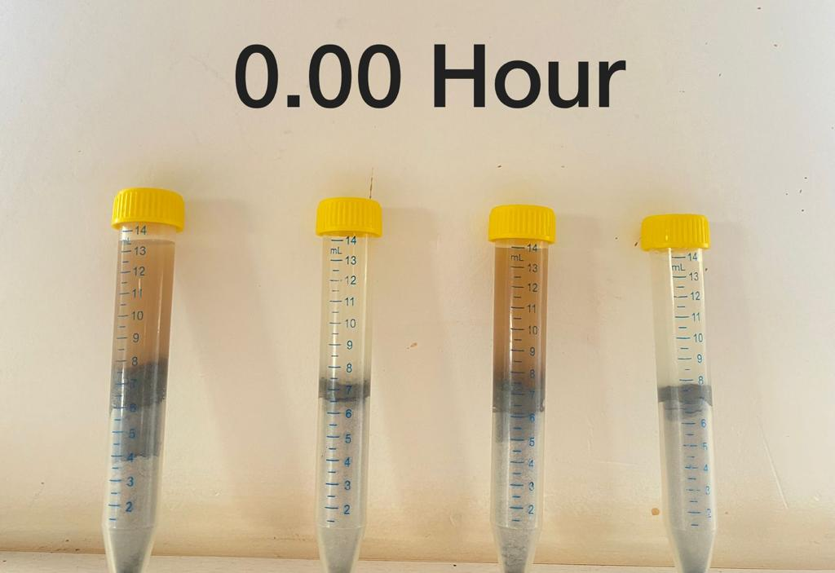
Figure3.4.1: Shale Stability setup at initial time

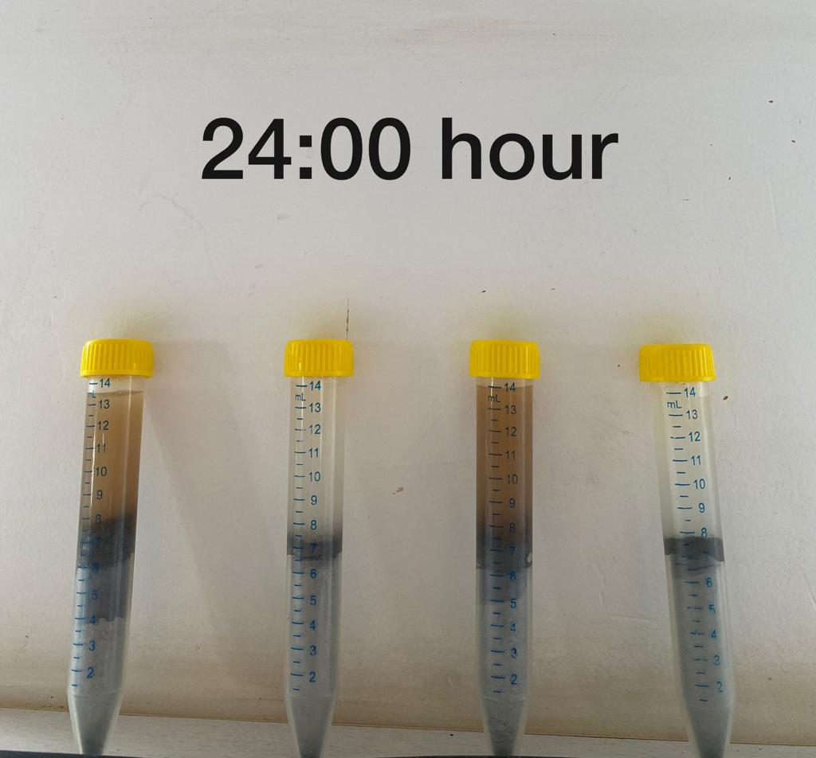
Figure3.4.1: Shale Stability setup at final time

Table 3.4.1: Results from shale immersion test
 | Mud 1 | Mud 2 | Mud 3 | Mud 4
Initial Dry Weight (g) | 13.2 | 13.2 | 13.2 | 13.2
Wet Weight (g) | 16.1 | 16.6 | 16.3 | 15.2
Dry Weight after Immersion (g) | 13.704 | 12.702 | 13.357 | 12.702

$$Swelling \left(\%\right)= \frac{Wt. of wet rock\left(g\right)-Wt. of dried rock after immersion\left(g\right)}{Wt. of dried rock after immersion\left(g\right)}*100$$
Swelling % caused by Mud 1 = 17.47%
Swelling % caused by Mud 2 = 27.99%
Swelling % caused by Mud 3 = 22.02%
Swelling % caused by Mud 4 = 19.65%

$$Spalling \left(\%\right)= \frac{Initial dry Wt. of rock\left(g\right)-Wt. of dried rock after immersion\left(g\right)}{Wt. of dried rock after immersion(g)}*100$$
Spalling % caused by Mud 1 = 3.68%
Spalling % caused by Mud 2 = 1.78%
Spalling % caused by Mud 1 = 1.12%
Spalling % caused by Mud 2 = 3.91%

In study of rheological properties of the groundnut husk and psyllium husk with and without polymer. The results from the experiment were studied. The change in each rheological property was measured with time over a period of four days. Now, with considering suitable sample with best rheological properties, was considered for final shale stability study.

Mud1= 1500ml+25gGH+3.15gCaCo3+4.9gCMC
Mud2=1500ml+25gGH+3.15gCaCo3+4.9gCMC+2.25mlFormaldehyde

Table 3.4.2: Shale stability test readings
 |  | Mud-1 | Mud-2
Hour | Shale Volume (ml) | Fluid Volume Level (ml) | Fluid Volume Level (ml)
0 | 7 | 14 | 14
2 | 7 | 14 | 14
4 | 7 | 14 | 13.9
6 | 7 | 14 | 13.9
8 | 7 | 13.8 | 13.8
10 | 7 | 13.8 | 13.8
12 | 7 | 13.7 | 13.8
14 | 7 | 13.7 | 13.8
16 | 7 | 13.6 | 13.7
18 | 7 | 13.5 | 13.6
20 | 7 | 13.5 | 13.6
22 | 7 | 13.5 | 13.6
24 | 7 | 13.5 | 13.5

Table 3.4.3: Results from shale immersion test
Mud 1 | Mud 2
13.2 | 13.2
16.1 | 16.6
13.704 | 12.702

$$Swelling \left(\%\right)= \frac{Wt. of wet rock\left(g\right)-Wt. of dried rock after immersion\left(g\right)}{Wt. of dried rock after immersion\left(g\right)}*100$$
Swelling % caused by Mud 1 = 17.47%
Swelling % caused by Mud 2 = 27.99%

$$Spalling \left(\%\right)= \frac{Initial dry Wt. of rock\left(g\right)-Wt. of dried rock after immersion\left(g\right)}{Wt. of dried rock after immersion(g)}*100$$
Spalling % caused by Mud 1 = 3.68%
Spalling % caused by Mud 2 = 1.78%

A comparative study of the rheological properties of groundnut husk and psyllium husk. The results from the experiment were studied. The change in each rheological property was measured with time over a period of four days. The results and inferences from the experiment are given below.

Chapter 4: Conclusion
4.1. Summary of the work
Conventional muds, particularly those containing bentonite, are known to cause more formation damage. Clay particles in the drilling fluid are to blame for this. A perfect scenario would be one in which no formation damage happens, but this is not achievable in practise. Without the use of bentonite, a non-damaging drilling fluid (NDDF) was developed. Although it was unable to completely avoid formation damage, it was able to lessen the amount of damage generated during drilling. Various laboratory procedures were used to determine the fluid's rheological qualities. It was compared to another non-damaging drilling fluid to further understand the qualities of the formulated fluid. Both fluids were tested over time to observe how they degrade. A decrease in the pH was observed in both fluids over time. While, viscosities of both the fluids increased with time. From the shale stability test and static immersion tests that were carried out it was observed that groundnut husk was much less reactive with shales. From these results the following conclusions were drawn:
- A non-damaging drilling fluid (NDDF) is formulated free from barite and bentonite, and causes lower formation damage than conventional drilling fluids.
- The rheological properties of the formulated drilling fluid were determined.
- Shale spalling and swelling are lower in shale formations for NDDF, thereby reducing the risk of issues such as borehole collapse, stuck pipe etc. It can be used in pay zone sections to greater advantage, and reduces chances of complications during production due to lower formation damage.

4.2 Future scope of work.
Every product or tool can be improved as technology and knowledge advance. The drilling fluid is in a similar situation. Many of the additions in this fluid can be replaced in the future with more cost-effective compounds that may also provide better results than the existing set of additives. To generate a stable free pH drilling fluid, a superior polymer is used. Groundnut husk is an organic substance that was employed in the drilling fluid formulation as a polymer. Non-harmful drilling fluids contain a variety of biological components. These could be used to make better, non-damaging drilling fluids in the near future. Biopolymers are also generally cost-effective and can improve the drilling fluid's economic feasibility.

References
[1] Guoshng Jiang, Tianle Liu, Fulong Ning, Yunzhong Tu,Ling Zhang,Yibing Yu & Lixin Kuang. Polyethylene Glycol Drilling Fluids for Drilling in Marine Gas Hydrates-Bearing Sediments: An Experimental Study.2011.
[2] Rogers WF. Composition and Properties of Oil Well Drilling Fluids. Houston, Texas. Gulf publishing Company, 1963.
[3] N.G Mandal, SPE, U.K Jain, B.S. Anil Kumar, and Ashok K Gupta, ONGC. Non-damaging Drilling Fluid Enhances Borehole Quality and Productivity in Conventional Wells of Mehsana Asset, North Cambay Basin.2006.
[4] Non-damaging Eco-friendly drilling fluid system.
[5] Moumita Maiti, Ravi Ranjan,Ekta Chaturvedi, Ajoy Kumar Bhaumik & Ajay Mandal.Formulation & Characterization Of Water Based Drilling Fluids For Gas Hydrate Reservoirs with Efficient inhibition properties.
[6] Ali Fereidounpour, Ali Vatani. School of chemical engineering & institute of petroleum engineering (IPE). An investigation of interaction of drilling fluids with gas hydrates in drilling hydrate bearing sediments
[7] Yong He, Zhen Long, Jingsheng Lu, Lingli Shi, Wen Yan, and Deqing Liang* Investigation on Methane Hydrate Formation in Water-based Drilling Fluid.
[8] R.B. Grigg, * SPE, and G.L. Lynes, Conoco Inc.Oil·Based Drilling Mud as a Gas·Hydrates Inhibitor.
[9] Jianhong Fu1 | Yu Su1 | Wei Jiang1, 2 | Xingyun Xiang3 | Bin Li4, Multiphase flow behavior in deep water drilling: The influence of gas hydrate.
[10] December 2014Shiyou Kantan Yu Kaifa/Petroleum Exploration and Development 41(6), Gas hydrate risks and prevention for deep water drilling and completion: A case study of well QDN-X in Qiongdongnan Basin, South China Sea
[11] Spies RB, Mukhtasor M, Burns KA. The Montara oil spill: a 2009 well blowout in the Timor Sea. Arch Environ Contam Toxicol, 2017.
[12] Kujawinski EB, SouleMC K, Valentine DL, Boysen AK, Longnecker K, Redmond MC. Fate of dispersants associated with the Deepwater Horizon oil spill. Environ Sci Technol. 2011
[13] Guo J, Liu X, Xie Q. Characteristics of the Bohai Sea oil spill and its impact on the Bohai Sea ecosystem. Chin Sci Bull. 2013.
[14] Triolo D, Mosness T, Habib R K. The Liwan gas project: A case study of South China Sea deepwater drilling campaign. IPTC 16722, 2013
[15] Zhang Liang, Huang Anyuan, Wang Wei, et al. Hydrate risks and prevention solutions for a high pressure gasfield offshore in South China Sea. International Journal of Oil, Gas and Coal Technology, 2013.
[16] Polyethylene Glycol Drilling Fluid for Drilling in Marine Gas Hydrates-Bearing Sediments: An Experimental Study Guosheng Jiang *, Tianle Liu, Fulong Ning *, Yunzhong Tu, Ling Zhang, Yibing Yu and Lixin Kuang
[17] Sloan, E.D.; Koh, C.A. Clathrate Hydrates of Natural Gases, 3rd ed.; CRC Press, Taylor & Francis Group: Boca Raton, FL, USA, 2008.
[18] Talukdar, P., and Gogoi, B. (2015a). A Study on the Role of Pre-Gelatinized Starch (PGS) in the Non Damaging Drilling Fluid (NDDF) for the Tipam Sand of Geleki Oil Field of Upper Assam Basin. International Journal of Applied Sciences and Biotechnology, 11.
[19] Talukdar, P., and Gogoi, B. (2015b). Use of Calcium Carbonate as Bridging and Weighting Agent in the Non Damaging Drilling Fluid for Some Oilfields of Upper Assam Basin. International Journal of Current Research, 18.
[20] Gaurina-Medimurec N., Simon K., Kristafor Z., Matanovic D. 2002. The Role of Bridging Solids in Designing Nondamaging Drilling Fluid, 13-th International Scientific and Technical Conference "New Methods and Technologies in Petroleum geology, Drilling and Reservoir Engineering", Cracow, June 20-21, 105-111

[21] Psyllium Husk in Water-Based Drilling Fluids: An Environmentally Friendly Viscosity and Filtration Agent

