Beneficial effect of Lactic Acid Bacteria in Human
A Bala and J Victoria
PG and Research Department of Microbiology,
Sengamala Thayaar Educational Trust Women’s College,
Mannargudi, Tamilnadu, India.

Abstract
Devouring aged food assortments has been represented to achieve prosperity limits. These positive results can be applied by a mix of the live microorganisms that the developed food sources contain, as well as the bioactive parts conveyed into the food sources as by result of the maturation interaction. In numerous models, and particularly in dairy matured food sources, the microorganisms related with the maturing framework have a spot with the Lactic Acid social event of Bacteria (LAB). An elective method for managing causing a piece of the clinical benefits that to have been credited to developed food assortments open is through the improvement of 'fermentates'. The term 'fermentate' generally interfaces with a powdered preparation, got from a developed thing and which can contain the developing microorganisms, portions of these microorganisms, culture supernatants, matured substrates, and an extent of metabolites and bioactive parts with likely clinical benefits. Here, a compact diagram of a decision of in vitro and in vivo assessments and licenses just uncovering the clinical benefits of LAB 'fermentates' are given. Normally, in such assessments, the potential clinical benefits have been credited to the bioactive metabolites present in the harsh fermentates and furthermore culture supernatants rather than the quick effects of the LAB strain(s) involved.
Introduction
Lactic Acid Bacteria (LAB) are limitless microorganisms which can be found in any environment rich generally in sugars, similar to plants, developed food sources and the mucosal surfaces of individuals, terrestrial and marine animals. In the human and animal bodies, LAB are fundamental for the commonplace microbiota or microflora, the climate that regularly has the gastrointestinal and genitourinary parcels, which is contained by a tremendous number of different bacterial species with an alternate number of strains [1].
Furthermore, nowadays, LAB expect a critical part in the business for the mix of manufactured substances, drugs, or other supportive things (Figure 1). In like manner, the biotechnological making of lactic destructive has actually itemized that offers a solution for the normal tainting by the petrochemical business [2].
The term Lactic Acid Bacteria cover a gigantic social occasion of smaller than expected living creatures. The essential pure culture of a lactic acid bacterium was gotten in 1873 and the comparability between milk souring organisms and other Lactic Acid-conveying Bacteria of various domains was seen during the 1900s. The reason of purposeful portrayal of LAB was elucidated and conveyed in 1919 by Orla-Jensen. Though different to a noteworthy degree, the essential characteristics of collection have remained unaltered. In the construction of this article, fundamentally the game plan, physiology and current use of Lactic Acid Bacteria will be managed. Likewise, a short review will be given about prosperity parts of LAB and a couple of future viewpoints in investigation and thing enhancement for Lactic Acid Bacteria.
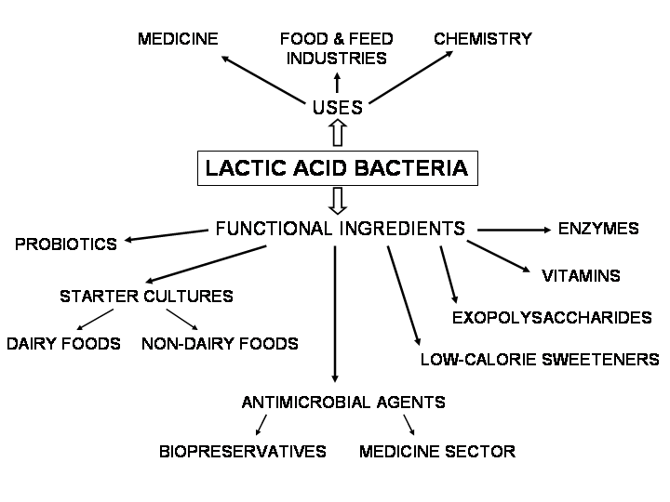

Lactic Acid Bacteria as Wellspring of Probiotics

Etymologically the term probiotics is gotten from the Greek "probios" and that connotes "for eternity". In 1974 Parker [3] portrayed probiotics as "natural elements and substances which add to gastrointestinal microbial balance". Fuller in 1989 described probiotic as "a live microbial feed supplement which supportively impacts the host animal by dealing with its stomach related microbial balance". Later the Food and Agriculture Organization/World Health Organization described probiotic microorganisms as "live microorganisms which when coordinated in good totals give a clinical benefit on the host". Since probiotics can colonize the gastrointestinal bundle and apply their important effect long stretch, without requiring consistent clinical intervention, they have been used for quite some time to treat different mucosal surface pollutions (stomach, vagina), but their use decreased after the presence of hostile to microbials. In any case, today, probiotics are considered as an elective response for serums poisons due to the rising spread of against contamination obstacle and the prerequisite for treatment cost decline. Microorganisms considered as business probiotics are mostly of the Lactobacillus class with more than 100 species perceived, for instance: L. acidophilus, L. rhamnosus, L. reuteri, L. casei, L. plantarum, L. bulgaricus, L. delbrueckii, L. helveticus. Lactobacilli are Generally Recognized as Safe (GRAS) life forms.
Consequences for Gastrointestinal Tract
Around 10 billion of minuscule life forms have a spot with 500 creature assortments exist together in human gastrointestinal parcel. 20 genera are winning among these including LAB. These are Bacteroids, Lactobacillus, Clostridium, Fusobacterium, Bifidobacterium, Eubacterium, Peptococcus, Poststreptococcal, Escherichia, and Veillonella. Microbial balance is indispensable for staying aware of the stomach related homeostasis. Live Lactic Acid Bacteria confirmation through dairy things definitively influence gastrointestinal parcel of individuals goes from change of lactose mal absorption, moderation of viral and drug activated the runs, post usable pouchitis, bad tempered entrail condition, blazing stomach issue, antineoplastic ramifications for human cell line, upkeep of average insulin level in blood and besides strong to overhaul the maintenance of unsaturated fats through stomach related framework. LAB produce these important outcomes by remaking of standard stomach related vegetation, removal of gastrointestinal microorganisms, backing of gastrointestinal obstacle capacity to new antigens, fervor of ambiguous safety like phagocytosis, feeling of humoral invulnerability and making of quieting things.
Impacts on Lactose Intolerance and Malabsorption
Lactose narrow mindedness is the weakness to handle lactose into its constituent's, i.e., glucose and galactose owing to low level out of lactase impetus in the brush limit of duodenums. It usually occurs in kids. Symptoms of lactose bias appear from 30 minutes to 2 hours after usage of food that contain lactose in it. Secondary effects consolidate, swelling, pressing, fart, and looseness of the bowels. There are three clinical kinds of lactose bigotries, i.e., fundamental lactose extremism occurs following weaning, assistant lactose bias as a result of the runs, red hot entrail infection and HIV defilement and third sort is inborn lactose dogmatism which has innate start. Lactose malabsorption is the condition where lactose is handled in to its constituents however since of absence of physical and cofactors these constituents are not true to form consumed by the stomach related framework. Around 50 million of Americans are affected by lactose intolerance reliably. Focus on coordinated in United States suggested that 95-100% of American Indians, 80-90% of blacks, Asian, Mediterranean, Jews, and a big part of Northern and Central European drop have fundamental lactose bias. Paces of discretionary lactose bias are variable depend on the under lying etiology.
Job of Lactic Acid Bacteria in Treating Ulcer
Myllyluoma et al., (4) in their survey declared the supportive effects of Lactic Acid Bacteria in gastric ulcer. They recommended that these effects were a result of the grievous exercises of Lactic Acid Bacteria on H. pylori. If LAB are used in blend of an ulcerative treatment, results are incredibly speedy recovery and further created delicacy of treatment. In LAB usage of Lactococcus rhamnosus as an adjuvant treatment during H. pylori demolition has been illustrated. Lactococcus rhamnosus other than the way that used as aide in foe of ulcerative treatment yet also lessened is ethanol-activated mucosal sore. Pre-treatment with Lactococcus rhamnosus similarly generally extends the basal mucosal prostaglandin E2 (PGE2) level, moreover debilitates the suppressive exercises of ethanol on organic liquid producing layer and transmucosal deterrent and reduces cell apoptosis in the gastric mucosa.

Impacts of Lactic Acid Bacteria on Human Immune System
Invulnerability is held as the impediment back from getting body against new gatecrashers or anybody irregularities. Immunity is basically of two sorts normal and acquired invulnerabilities. Past is ambiguous sort of opposition and last choice is express kind of insusceptibility. Characteristic safety consolidates mechanical limits, clean exercises of body fluids, blazing response while got opposition contains lymphocytes, unequivocal kinds of proteins and antibodies to watch the body. These pathways are helpful to stay aware of the body commonsense. Antibodies are the huge piece of safe structure. These may be monoclonal and polyclonal. LAB especially Staphylococcus aureus if imbued in its inactive state can create IgA. The antibodies made as such are polyclonal and can give opposition against various antigens.
Antifungal action of Lactic Acid Bacteria
LAB have been found to show antifungal activity. Infectious contaminations are trying to treat. Different sorts of LAB have been screened determined to perceive their reasonable foe of infectious development. Among various types of LAB, Lactobacillus fermentum has been checked having solid areas for a property, especially against Candida albicans and Candida glabrata. As LAB has unfriendly to mycotic property they can be uses as probiotics against various lethal parasitic contaminations. Infectious defilement causes by Candida glabrata and Candida albicans are typical. LAB use as probiotics would determine these issues in a predominant manner. Hydrogen per oxide harmfully influences organic entities. Hydrogen per oxide is also convincing against bacterial defilements. A couple of kinds of LAB produce hydrogen per oxide. These strains have antibacterial as well as against infectious activity.
Mijac et al., in their work displayed that lactobacilli are the remarkable sort of LAB which have this original property of conveying Hydrogen per oxide. These organisms can be used in a large number of defilements including vulvovaginal candidiasis (VVC) and trichomoniasis (TV) and trichomoniasis (TV).
Vagina is the essential site of contamination in females, believe it or not. Different sorts of infectious defilements are ordinary to this area. Usage of LAB as probiotics would contribute a lot of effortlessness in treatment of these defilements. Lactobacillus casei and Lactobacillus acidophilus have extraordinary antifungal properties and can shield immunocompromised people from adroit pollutions by Candida albicans. LAB show antifungal activity by having threatening to solidify exercises against Candida albicans.
Role of Lactic Acid Bacteria in preventing colon cancer
The anticancer activity of Lactobacillus rhamnosus was might be a direct result of the acknowledgment of apoptosis by two expolysaccarides of minuscule life forms name rEPS (conveyed exopolysaccharides) and cbEPS (cell bound exopolysaccharides). rEPS were more feasible in thwarting illness than cbEPS. Uncontrolled advancement of colon cells may be influenced by the different sorts of LAB. Different sorts of LAB show different movement which goes from limitation of duplication of destructive cells. Various types of LAB were inspected. The primary strains with anticarcinogenic property were Lactobacillus helveticus, Biido-bacterium, Lactobacillus acidophilus, or a blend of Streptococcus thermophilus and L. bulgaricus. From these Lactobacillus helveticus is the best one in impeding the uncontrolled improvement of colonic cells.
Lactococcus lactis has anticolonic sickness development because of its ability to extend the level of antiproliferative protein and decline the effects of mutagenic protein more these living things can be given orally. The anticancer effects of another lactic destructive bacterium Lactobacillus rhamnosus (Orlando et al) [5]. Another audit coordinated by Golden et al. (1996) [6] shown that Lactococcus rhamnosus show antimutagenic influences and their antimutagenic effects can be potentiated by giving them with fat.
Control of Lactic Acid Bacteria in responsiveness LAB in like manner expect a basic part in restricting overly sensitive responses yet furthermore in conditions potentiation of its responses. Neutralizer E (IgE) is related with brief kind delicateness which is for the most part happening reactions. It has been found that Lactobacillus citreum coordinates serum IgE age controls overall neutralizer creation. Lactobacillus citreum can be useful in thwarting the new development and development of IgE creation. Consequently, preventing delicateness reactions by the usage of this microorganism is possible. Here is no doubt in a foe of ominously powerless occupation of Lactic Acid Bacteria. Interest in adversary of awareness immuno-rule by LAB has been made recently. Here are affirmations that suggest that Enterococcus faecalis could liberate the clinical aftereffects from Japanese cedar pollinosis. Enterococcus work was investigated in eosinophil collection. As eosinophils expect a huge part in the improvement of ominously vulnerable reaction. Thus, this occupation has a more noticeable importance. Assortment of eosinophil is impeded by Enterococcus faecalis. It will in general be shut here that Enterococcus could expect a section in moderation of horribly powerless reactions.
Production of Inhibitory Compounds
The LAB can convey numerous inhibitory combinations to lessen microorganisms interruption. These consolidate AMPs, for instance, bacteriocins, regular acids, ethanol, diacetyl, carbon dioxide, and hydrogen peroxide (Liao and Nyachoti, 2017) [7]. Bacteriocins are ribosomally coordinated AMPs conveyed by both Gram-negative and Gram-positive microorganisms. Bacteriocins made by LAB insinuated here as LAB-bacteriocins are most often missing all cytotoxic characteristics, and provided with antagonistic capacities as well as extra helpful qualities. LAB-bacteriocins are emerging as a unique surge of against contamination specialists with solid in vitro and in vivo works out. Rather than customary serums poisons, LAB-bacteriocins target express species and don't impact one more people inside a comparative climate.
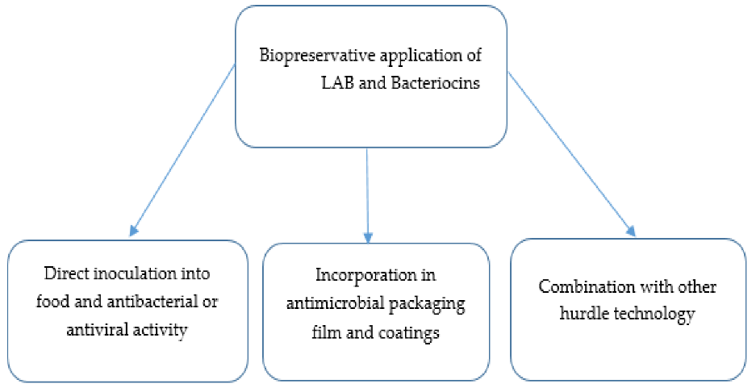
LAB-bacteriocins are known to apply either bacteriostatic or bactericidal development toward sensitive living creatures. Their techniques for movement have been by and large yet not totally explored. Late pieces of information on techniques for movement are examined elsewhere. Blends of LAB-bacteriocins and counter agents poisons are emerging as unique medicinal decisions for food-conveying animals. Different reports appreciate spread out the chief advantages and synergistic exercises of LAB-bacteriocins with other biomolecules. These are what is going on of enterocin AS-48 and ethambutol against Mycobacterium tuberculosis, nisin and citrus separate against Staphylococcus aureus and Listeria monocytogenes, nisin and beta-lactams against Salmonella enterica. serovar Typhimurium and Garvicin KA-farnesol against a lot of Gram-positive and Gram-negative microorganisms (Chi and Holo, 2018) [8]. Orally association of these substances is a test considering their enzymatic degradation.
Conclusion
In a general concern, the usage of LAB-probiotics stays as a capable and promising other choice. Different benefits have been found in animals dealt with various LAB-probiotics. As maintained by different assessments, LAB-probiotics have some command over the progression of bacterial ailments, increase weight gain in strong and affected animals, quicken the idea of the (by-) aftereffects of this industry or significantly further foster aqua-farming water quality. LAB-probiotics have some command over bacterial illnesses by release of inhibitory combinations, or by various instruments including merciless aversion, lessening bioavailability of toxins, sustaining stomach related impediment or insistently fortifying the safe structure. Their exercises are applied in strain and host-express propensities. Finally, there are different synergistic effects while getting LAB together with other probiotic species, prebiotics, or synthetic compounds. To the extent that likely arrangement, recombinant LAB-probiotics could offer additional advantages.
Acknowledgement
I wish to express my profound sense of thanks to our correspondent, Dr. Jeyanandh Dhivaharan., and our chartered correspondent Dr. V. Dhivaharan., Dean, PG and Research Department of Microbiology, S.T.E.T Women’s college,Sundarakkottai, to offering to do the valuable work.
References:
- Aureli CapursoL.CastellazziA.M. ClericiM.GiovanniniM.MorelliL.PoliA.PregliascoF. SalviniF.Zuccotti 2011 Probiotics and Health: An Evidence-based Review. Pharmacol. res. 63 366376.
- Hamdan AM, Sonomoto (2011) Production of Optically Pure Lactic Acid for Bioplastics. In: Sonomoto K, Yokota A, editors. Lactic Acid Bacteria and Bifidobacteria: Current Progress in Advanced Research. Caister Academic Press, Portland, USA.
- Parker RB 1974 Probiotics, The Other Half of The Antibiotic Story. Animal nutr. health. 29 48.
- Myllyluoma E, Kajander K, Mikkola H, Kyrönpalo S, Rasmussen M, Kankuri E, Sipponen P, Vapaatalo H, Korpela R. (2007). Probiotic intervention decreases serum gastrin-17 in Helicobacter pylori infection. Digest Liver Dis, 39(6), 516–523.
- Orlando A, Messa C, Linsalata M, Cavallini A, Russo F. (2009). Effects of Lactobacillus rhamnosus GG on proliferation and polyamine metabolism in HGC-27 human gastric and DLD-1 colonic cancer cell lines. Immunopharmacol. Immunotoxicol, 31(1), 108–16.
- Goldin BR, Gualtieri LJ, Moore RP. (1996). The effect of Lactobacillus GG on the initiation and promotion of DMH-induced intestinal tumors in the rat. Nutr Cancer, 25(2), 197–204.
- Liao S. F., Nyachoti C. M. (2017). Using probiotics to improve swine gut health and nutrient utilization. Anim.Nutr. 3 331–343. 10.1016/j.aninu.2017.06.007 [PMC free article] [PubMed] [CrossRef] [Google Scholar]
- Chi H., Holo H. (2018). Synergistic antimicrobial activity between the broad spectrum bacteriocin garvicin KS and nisin, farnesol and polymyxin B against Gram-positive and Gram-negative bacteria. Curr.Microbiol. 75 272–277. 10.1007/s00284-017-1375-y [PMC free article] [PubMed] [CrossRef] [Google Scholar]

