Relationship between Anxiety and Burnout among Therapists
Jasmine Hyder
Master of Occupational Therapy (Pediatrics)
I Year Student,
Department of Occupational Therapy,
Jamia Hamdard, New Delhi.

Sheeba Parveen
MOT (Pediatrics),
Jamia Hamdard, New Delhi
Assistant Professor,
Department of Occupational Therapy,
Jamia Hamdard, New Delhi.

Dr. Tarun Lala
Zonal Head,
Department of Physiotherapy and
Rehabilitation Medicine Unit
Max Super Speciality Hospital, Saket
Dr. Chhavi Sundriyal
Occupational Therapist
Department of Physiotherapy and
Rehabilitation Medicine Unit
Max Super Speciality Hospital, Saket

ABSTRACT
Therapists often have to cope with aggressive or depressive patient behaviors, which may overload their ability to give an appropriate response to a stressful event. According to Maslach theory, the term burnout is associated with such concepts as emotional and psychophysical exhaustion, depersonalization, and a reduced sense of professional accomplishment which comprise the multifaceted model of burnout. Age showed the highest correlation with burnout. In particular, burnout levels have been found to be highest in health operators between 30 and 40 years of age. Moreover, the authors found age-dependent risk to be influenced by experience and seniority, with a higher risk of burnout at earlier career stages. Some health care professionals are in daily contact with the physical and psychological pain of clients as they face various states of disability. This naturally triggers emotional responses and may lead caregivers to defend themselves by distancing themselves from relationships with their clients. As part of their Work health professionals respond to the emotional burdens experienced by their patients, sometimes having to hide their own emotions. So, this research is being done to determine the effect of burnout on anxiety among therapists.

Keywords— Anxiety, Burnout, Overload, Therapists, etc

INTRODUCTION

Each 1 out of seven Indians is understood to be afflicted by anxiety16. With industrialization and workload being so much on all of us of their respective fields16, people are getting busy in dealing with their busy schedules, wherein they’re not able to provide themselves time to rejuvenate and loosen up. waking up in the morning and feeling fresh is a dream of many human beings in these days’s time, however has grow to be very tough to cope with the stress which results in anxiety. anxiety may be taken into consideration as a well-known predisposition to fear which can't be diagnosed or if the source is recognized, to an emotion of fear of more depth than the evolving risk. Trait tension is the noticeably solid feature of people to perceive traumatic situations as threatening or dangerous and as a result their tension- proneness1. Tension is one of the maximum not unusual mental situations seen in recent times. even though tension being so common in human beings, it's miles come what may setting a bad pressure approximately the man or woman, especially when the man or woman being himself from a clinical background. healthcare employees, mainly physicians, are exposed to excessive stages of distress at paintings. continual tension results in exhaustion, mental, and/or physical distress6. human beings publish to the pandemic anticipate more from medical offerings and physicians because of the speedy improvement of medical treatment. Therapists gambling an essential role in this, face many exhausting conditions. In supplying medical services, therapists have no longer only to try to therapy sufferers, however also to confront intellectual misery, disease, and death. because of therapist’s long-term exposure to high levels of occupation al strain, they tend to overcome excessive chance for intellectual problems, including anxiety and despair, which subsequently leads to occupational burnout7.
Burnout is located to be one of the maximum vital reasons of anxiety. Burnout is a psychological syndrome characterized by emotional exhaustion, feelings of cynicism and decreased personal accomplishment18. The beginning of burnout is in occupations where huge quantities of time are spent with the issues of others. this could be frustrating paintings because the answers to those problems are often tough to become aware of or attain1-three. The primary reasons of burnout are within the care-giving paintings environments, the intervening variables which influence whilst or if it'll occur and the period and intensity of the episode are intrapersonal1. earlier research has identified several causes and correlates of burnout but has largely unnoticed its relationship to anxiety5-1. Burnout is a commonplace syndrome seen in healthcare workers, mainly therapists who're exposed to a excessive degree of pressure at work; it consists of emotional exhaustion, depersonalization, and coffee private accomplishment. Burnout among therapists has garnered large attention due to the terrible effect it renders on affected person care and scientific personnel6. a couple of research have indicated a high occurrence of burnout amongst practicing physicians and feature shown that one-1/3 of physicians have experienced burnout at positive points during their careers 8-6. Evidences are many to assist that strain control applications can assist reducing process-associated pressure beyond the intervention length, and in addition mindfulness-based strain reduction interventions successfully reduce mental distress and negative vibes, and encourage empathy even as substantially enhancing physicians’ nice of life9-6.
Tension and burnout are main issues being faced by human beings these days which might be further notorious to result in mental disorders19. An character who does now not sense capable of meet the demands at paintings or is not able to present time to himself or take rest, or is uncovered to overburden on paintings, will begin to sense annoyed, dis happy and disappointed, chickening out psychologically and losing hobby in a job formerly skilled as exciting. basically, whilst the demands of the job are in extra of a worker’s capabilities and resources, this often consequences in paintings-associated strain and, as a con-sequence of burnout12 throughout the pandemic, many people had been mentally and physically stricken by the overload of work and pressure. the primary organization of those who have been maximum uncovered to the overload of labor were healthcare companies. Healthcare companies during and put up to the pandemic haven’t been unfastened enough to present themselves time to loosen up, which has been playing a main function in them being mentally wholesome. Being a physician or a therapist has been tough in the course of the pandemic. Many researches show that in this period, therapist had been thru overburden of labor ensuing in occupational burnout and main to anxiety, intellectual stress and strain.14-15
II. HYPOTHESIS
HYPOTHESIS 1: There is a positive correlation between anxiety and burnout
HYPOTHESIS 2: There is a negative correlation between anxiety and burnout
NULL HYPOTHESIS: There is no correlation between anxiety and burnout

AIMS AND OBJECTIVES
The aim of the current study is to see the effect of burnout on anxiety among therapists.

METHODOLOGY
- Study Design
A correlative study using randomized systematic sampling

- Subjects
A sample size of 100 (50 Female, 50 male), Age 22 and above (graduated >)
- Inclusion criteria
- Regular working therapists (occupational and physical therapists)
- Therapists who are graduated and above graduated
- Both the genders
- People who have signed consent form
- Exclusion criteria
- Those who are diagnosed with any anxiety disorders.
- Those who suffered from any form of physical or mental trauma which caused any negative impact on their quality of life.

- Source of Data Collection: Community, Subjects will be taken from:-
- Max super specialty hospital, Saket
- Max smart super specialty hospital, Saket
- Jamia Hamdard university

- Variables:
- Independent variable: burnout
- Dependent variable: anxiety

V. RESULT
The Anxiety and the Burnout were evaluated using Beck Anxiety Inventory and Oldenburg Burnout Inventory scales respectively. The mean, standard deviation and p-value were calculated using t test and correlation was found out by:
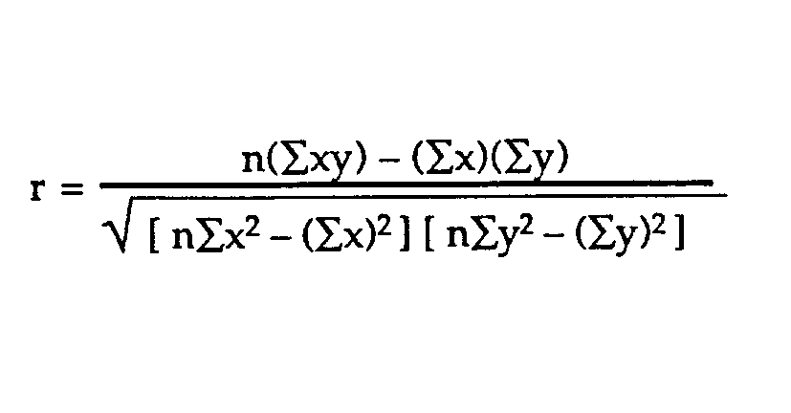
The coefficient of correlation came out to be r =0.738, which shows positive correlation.
GROUP STATISTICS
Correlation of mean of anxiety with burnout among therapists (N= 50)
COMPONENT | MEAN | STANDARD DEVIATION | T- VALUE
BURNOUT | 37.82 | 5.009 | 0.574**
ANXIETY | 11.96 | 10.511 | 0.574**
**= SIGNIFICANT AT 0.01 LEVEL
INTERFERENCE: The mean value of burnout and anxiety in therapists was found to be 37.82 and 11.96 respectively. The standard deviation of burnout and anxiety was found to be 5.009 and 10.511 respectively, with the T-value of 0.574, suggesting the result to be significant at p<0.01 level emphasizing that anxiety has significant impact on burnout.

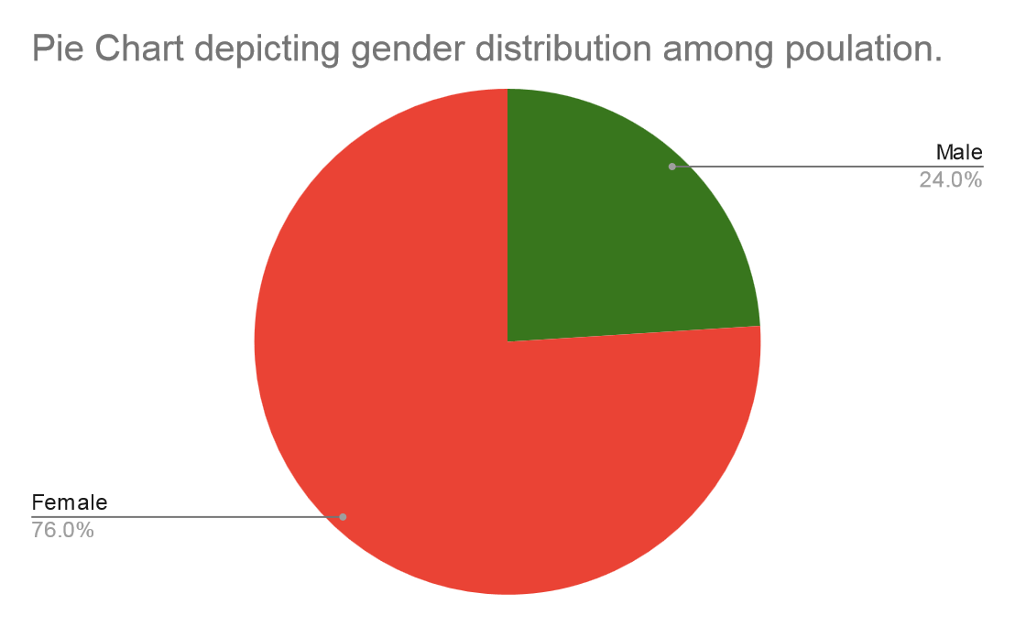

VI. DISCUSSION
Burnout in the course of long running hours in a clinic setup among therapists outcomes in excessive quantity of anxiety in them. this may be due to long periods with person affected person and big load of patients with kind of situations, which reason high amount of burnout among diverse therapists in any health center setup. Burnout can be defined as an imbalance among someone’s funding in their expert activities and the consequences received, between demands and the assets at hand to meet them. Because of prolonged burnout there are better probabilities of hysteria which have an effect on typical properly-being of therapists5.
On this study, overall 50 topics were taken all Occupational therapists and Physiotherapist respectively. All belonged from clinic setup of Max Saket health facility and Jamia Hamdard health center, wherein 12 adult males and 38 women had been taken randomly. The reason of this have a look at was to correlate if there is extended degree of anxiety because of burnout among therapists working in a clinic installation. The suggest value of burnout and tension in therapists became determined to be 37.eighty two and 11.96 respectively. the same old deviation of burnout and anxiety was observed to be 5.009 and 10.511 respectively, with the T-value of zero.574, suggesting the end result to be vast at p<zero.01 level emphasizing that tension has substantial impact on burnout.
In a similar examine accomplished by means of Marco Bruschini, et al (2017)5 to evaluate and compare burnout and work-related strain ranges in 3 categories of health experts: physiotherapists, speech therapists and occupational therapists. It concluded that each one health care people, rehabilitation experts are at a excessive danger of burnout. There are common mechanisms underlying burnout within the distinct professional businesses investigated. in addition studies in occupational health in rehabilitation settings is wanted to prevent burnout. further, a examine carried out via Shichen li et al (2016)eight to analyze tension sensitivity (AS) in female chinese language nurses to higher understand its traits and courting with nursing pressure based on the following hypotheses: (1) skilled nurses have better AS than newly admitted nurses; and (2) particular nursing stresses are related to AS after controlling popular strain. It concluded that once years of exposure to traumatic events during nursing, experienced girl nurses mayadditionally become extra sensitive to anxiety. Likewise, A have a look at performed by Panagiota Kautsimani et al (2019) examine the relationship among Burnout, despair, and tension. this have a look at concluded that the relationship between burnout–depression and burnout–tension relationships. Our findings revealed no conclusive overlap among burnout and melancholy and burnout and anxiety, indicating that they may be one of a kind and sturdy constructs. Correlation among tension and burnout among therapist have been statistically analyzed. A scattered and a bar graph had been made between anxiety and burnout, in which mean fee and general deviation of anxiety and mean fee and well-known deviation of burnout became found to be giant at 0.01 degree for t-fee of 0.574 which shows anxiety is positively correlated with burnout amongst therapist in health facility setup.
Likewise, a look at is conducted by way of Nader Salari et al (2020) thirteen wherein the prevalence of stress, tension and melancholy within the front-line healthcare people worrying for COVID-19 sufferers.
The outcomes of this observe simply reveal that the superiority of strain, tension and depression inside the front-line healthcare people worrying for COVID-19 sufferers is excessive. Consequently, the fitness coverage-makers have to take measures to control and save you intellectual disorders inside the health center group of workers.

V. CONCLUSION
The result of the study entitled ‘Anxiety due to Burnout among therapists’ suggests that excessive amount of burnout and patient load among therapists in a hospital setup i.e. occupational therapists and physiotherapists respectively, shows significant link of anxiety with burnout, which tells us that excessive amount of anxiety is positively correlated with increased amount of burnout in therapists. As the therapists are the mainstay of any rehabilitation in a society, we as therapists should try to strengthen ourselves by promoting health and mental awareness along with work simplifications and modifications in order to keep ourselves healthy, so that we as therapists are able to provide a better care and rehabilitation to people who need us.
Conflicts of interest: The authors report no conflict of interest in this work.
Findings sources: Self
Ethical clearance: Necessary permission was obtained from the head of concerned department to conduct the study. Verbal consent and written consent were obtained from all the participants who elected to participate in the study.

REFRENCES
- Yang S, Kwak SG, Ko EJ, Chang MC. The Mental Health Burden of the COVID-19 Pandemic on Physical Therapists. Int J Environ Res Public Health. 2020 May 25;17(10):3723. doi: 10.3390/ijerph17103723. PMID: 32466164; PMCID: PMC7277530.
- Bejer A, Domka-Jopek E, Probachta M, Lenart-Domka E, Wojnar J. Burnout syndrome in physiotherapists working in the Podkarpackie province in Poland. Work. 2019;64(4):809-815. doi: 10.3233/WOR-193042. PMID: 31815720.
- Pasqualucci PL, Damaso LLM, Danila AH, Fatori D, Lotufo Neto F, Koch VHK. Prevalence and correlates of depression, anxiety, and stress in medical residents of a Brazilian academic health system. BMC Med Educ. 2019 Jun 11;19(1):193. doi: 10.1186/s12909-019-1621-z. PMID: 31185960; PMCID: PMC6558838.
- Axisa C, Nash L, Kelly P, Willcock S. Burnout and distress in Australian physician trainees: Evaluation of a wellbeing workshop. Australas Psychiatry. 2019 Jun;27(3):255-261. doi: 10.1177/1039856219833793. Epub 2019 Mar 11. PMID: 30854868.
- Bruschini M, Carli A, Burla F. Burnout and work-related stress in Italian rehabilitation professionals: A comparison of physiotherapists, speech therapists and occupational therapists. Work. 2018;59(1):121-129. doi: 10.3233/WOR-172657. PMID: 29439375.
- Talih F, Daher M, Daou D, Ajaltouni J. Examining Burnout, Depression, and Attitudes Regarding Drug Use Among Lebanese Medical Students During the 4 Years of Medical School. Acad Psychiatry. 2018 Apr;42(2):288-296. doi: 10.1007/s40596-017-0879-x. Epub 2018 Feb 2. PMID: 29396837.
- Moxham LJ, Fernandez R, Kim B, Lapkin S, Ten Ham-Baloyi W, Al Mutair A. Employment as a predictor of mental health, psychological distress, anxiety and depression in Australian pre-registration nursing students. J Prof Nurs. 2018 Nov-Dec;34(6):502-506. doi: 10.1016/j.profnurs.2018.03.005. Epub 2018 Mar 29. PMID: 30527700.
- Li S, Li L, Zhu X, Wang Y, Zhang J, Zhao L, Li L, Yang Y. Comparison of characteristics of anxiety sensitivity across career stages and its relationship with nursing stress among female nurses in Hunan, China. BMJ Open. 2016 May 4;6(5):e010829. doi: 10.1136/bmjopen-2015-010829. PMID: 27147388; PMCID: PMC4861120.
- Zhou J, Yang Y, Qiu X, Yang X, Pan H, Ban B, Qiao Z, Wang L, Wang W. Relationship between Anxiety and Burnout among Chinese Physicians: A Moderated Mediation Model. PLoS One. 2016 Aug 1;11(8):e0157013. doi: 10.1371/journal.pone.0157013. PMID: 27479002; PMCID: PMC4968847.
- Dyrbye L, Shanafelt T. A narrative review on burnout experienced by medical students and residents. Med Educ. 2016 Jan;50(1):132-49. doi: 10.1111/medu.12927. PMID: 26695473.
- Romani, Maya & Ashkar, Khalil. (2014). Burnout among physicians. The Libyan journal of medicine. 9. 23556. 10.3402/ljm.v9.23556.
- Koutsimani P, Montgomery A, Georganta K. The Relationship Between Burnout, Depression, and Anxiety: A Systematic Review and Meta-Analysis. Front Psychol. 2019 Mar 13;10:284. doi: 10.3389/fpsyg.2019.00284. PMID: 30918490; PMCID: PMC6424886.
- Salari, N., Khazaie, H., Hosseinian-Far, A. et al. The prevalence of stress, anxiety and depression within front-line healthcare workers caring for COVID-19 patients: a systematic review and meta-regression. Hum Resour Health18, 100 (2020). https://doi.org/10.1186/s12960-020-00544-1

