**AN EMPIRICAL STUDY ON WORK-LIFE BALANCE AMONG THE IT EMPLOYEES IN CHENNAI CITY**

**Dr.Mohan Kumar S Dr.Prem Knowles S**

**MBA department, MBA department**

**Associate Professor,Annamalai University, Assistant Professor, GIBS B School**

**Chidambaram, Tamilnadu Bengaluru, Karnataka**

**ABSTRACT**

In India, IT(Information technology) and ITeS industry is divided into four major segments – a)IT services, b)Business Process Management (BPM), c)Software Products and Engineering Services, and d)Hardware. Chennai is the one od the largest information technology service providers in India. This sector in Chennai provides employment for many technical and non-technical graduates professionally. The leading companies provide high monetary and non-monetary benefits for their employees. The leading IT companies in Chennai are 1) Infosis, 2)TCS, 3)HCL, 4)WIPRO, 5)IBM, 6)HP, 7)HP, 8)DELL, 9)POLARIS etc. Work Life balance means the healthy balance between the professional life and personal life. The samples for this research study are collected by adopting stratified random sampling and random sampling methods. The samples are collected form the four regions(North, South, East and West) proportionately. The questionnaires were circulated among different age groups. The Sample size is 500.The data is analysed by using simple statistical tools like a.Percentage Analysis, b.Average Analysis, c.Chi -Square Method, d.One way ANOVA. From the study it is concluded that, there is the impact of Experience, Marital Status and educational qualification on work-life balance. Some of the most contributing factors in work life balance are a.Salary,b.Location of work place, c.Holidays, d.Interest in Job, e.Career development opportunities, f. Leave arrangements, g.Flexible working hours, h.Training opportunities, i.Job security, j.Friendly environment.Among the leave benefit ‘Maternity leave ranked the first, followed by other leave benefits like paternity leave,sick leave, sabbatical leave and bereavement leave.Flexible work time, work-from home and work from anywhere are the options provided by many organizations to improve the employee morale and to sustain the employees. Lot of employees are happy with these systems.

**Keywords** : Work life balance, IT employees, Work-life balance problems, IT & ITES industry

**I.INTRODUCTION**

India is one of the world’s largest sourcing destinations for the IT(Information Technology) industry and the market is valued as 67% of US$ 124 to 130 billion market. About ten million employees are employed in this industry. It is to be noted that this industry made the transformation of the country and altered the perception of India in the global economy. The main reasons for the boom of IT industry in India are 1) cost effectiveness 2)Skill potential and 3) globalized network. The Information Technology industry has created noteworthy demand in the Indian education field, especially for engineering and computer science. In India, IT(Information technology) and ITeS industry is divided into four major segments – a)IT services, b)Business Process Management (BPM), c)Software Products and Engineering Services, and d)Hardware.

**1.1 Services provided by Software Companies In India**

1)Custom Business solutions

2)Database Migration services

3) ERP solutions

4)I phone Apps development

5) Quality assurance and testing services

6)Collaborative Content Management

7)Internet Marketing

8) Web Branding Services

9) Customization Services

10) Application Development

11)Outsourcing

12)Collaborative Commerce

13)Programming Services

14)Multimedia offering

15)Consulting

**1.2 IT Business Sectors**

The software companies in India operates with various business functions. Some of them to be mentioned here are;

**• Infrastructure Software:** These include i)OS, ii)middleware and iii)databases.

• **Enterprise Software:** These are automate business process in diverse fields like a)finance,

b)sales and marketing, c)production and d)logistics.

• **Security Software**

**• Contract Programming**

**• Industry-specific Software**

**1.3 Growth of Information Technology(IT) Industry in Chennai**

Chennai is the one od the largest information technology service providers in India. This sector in Chennai provides employment for many technical and non-technical graduates professionally. The leading companies provide high monetary and non-monetary benefits for their employees. The leading IT companies in Chennai are 1) Infosis, 2)TCS, 3)HCL, 4)WIPRO, 5)IBM, 6)HP, 7)HP, 8)DELL, 9)POLARIS etc. These companies recruit thousands of graduates every year every year . Because of the growth of IT industry, the standard of living and economy of the state have also increased. The Tamilnadu state government has also provided necessary facilities to boom this particular sector; for example a) allocation of acres of land b)infrastructure support c)reduction in international communication and transportation cost etc. Rajeev Gandhi Salai in Chennai is also known as IT corridor of Chennai, because of having hundreds of IT park.

**2.WORK LIFE BALANCE PROBLEMS**

Work Life balance means the healthy balance between the professional life and personal life. Imbalance between the professional and personal life impact with negative consequences personally and professionally.

Signs of poor work/life balance include:

1)Failure in family life;

2)High level of employee stress;

3)High rates of absenteeism or staff sickness;

4)High level of staff turnover;

5)Poor mental and physical health;

6)Less life satisfaction;

7)Higher levels of stress;

8)Higher levels of emotional exhaustion;

9)Less physical exercise;

10)alcohol Consumption;

11)Increased anxiety and depression levels, poor appetite;

**3.OBJECTIVES OF THE STUDY**

The objective of this study are

1. To analyse the influence of educational qualification, marital status and experience on Work life balance
2. To study the leave benefit opportunities in IT sector

**4. HYPOTHESIS**

1.There is no association between the marital status and work life balance(WLB).

2.There is no association between the monthly income and their work life balance(WLB).

3.There is no association between the total years of experience and their work life balance(WLB).

**5. SAMPLING TECHNIQUE & STATISTICAL TOOLS**

The samples for this research study are collected by adopting stratified random sampling and random sampling methods. The samples are collected form the four regions(North, South, East and West) proportionately. The questionnaires were circulated among different age groups. The Sample size is 500.

The data is analysed by using simple statistical tools like a.Percentage Analysis, b.Average Analysis, c.Chi -Square Method, d.One way ANOVA.

**6. DATA ANALYSIS AND TABULATIONS**

**Table 6.1 Hypothesis test to analyse the association between Educational Qualification of the Respondents and their Work Life Balance**

H0 = 0 : There is no association between the educational qualification of the respondents and work life balance.

H1 ≠ 0 : There is association between the educational qualification of the respondents and work life balance.

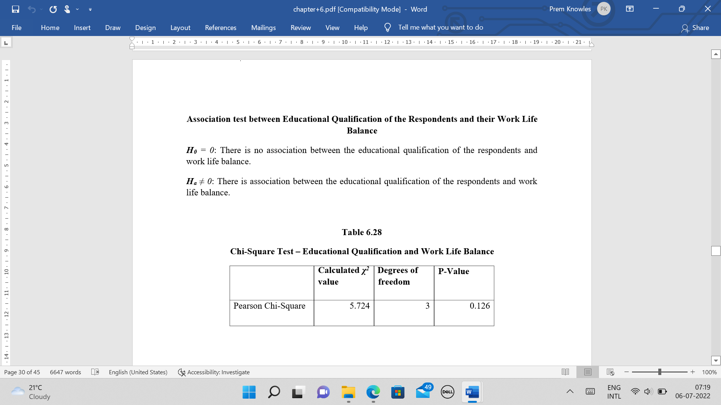

Table 6.1, From the table it is inferred that there is no significant association between the educational qualification and work life balance of the respondents.

Calculated χ2 =5.724 @ three degrees of freedom

Probability value =0.126, > 0.05,implies that the null hypothesis cannot be rejected at 5% level of significance.

**Table 6.2 Hypothesis test to analyse the association between the marital status and work life balance**

***H0*** *= 0* : There is no association between the marital status of the respondents and work life balance.

***H2*** ≠ 0: There is association between the marital status of the respondents and work life balance.

**Chi-Square Test – Marital Status and Work Life Balance**

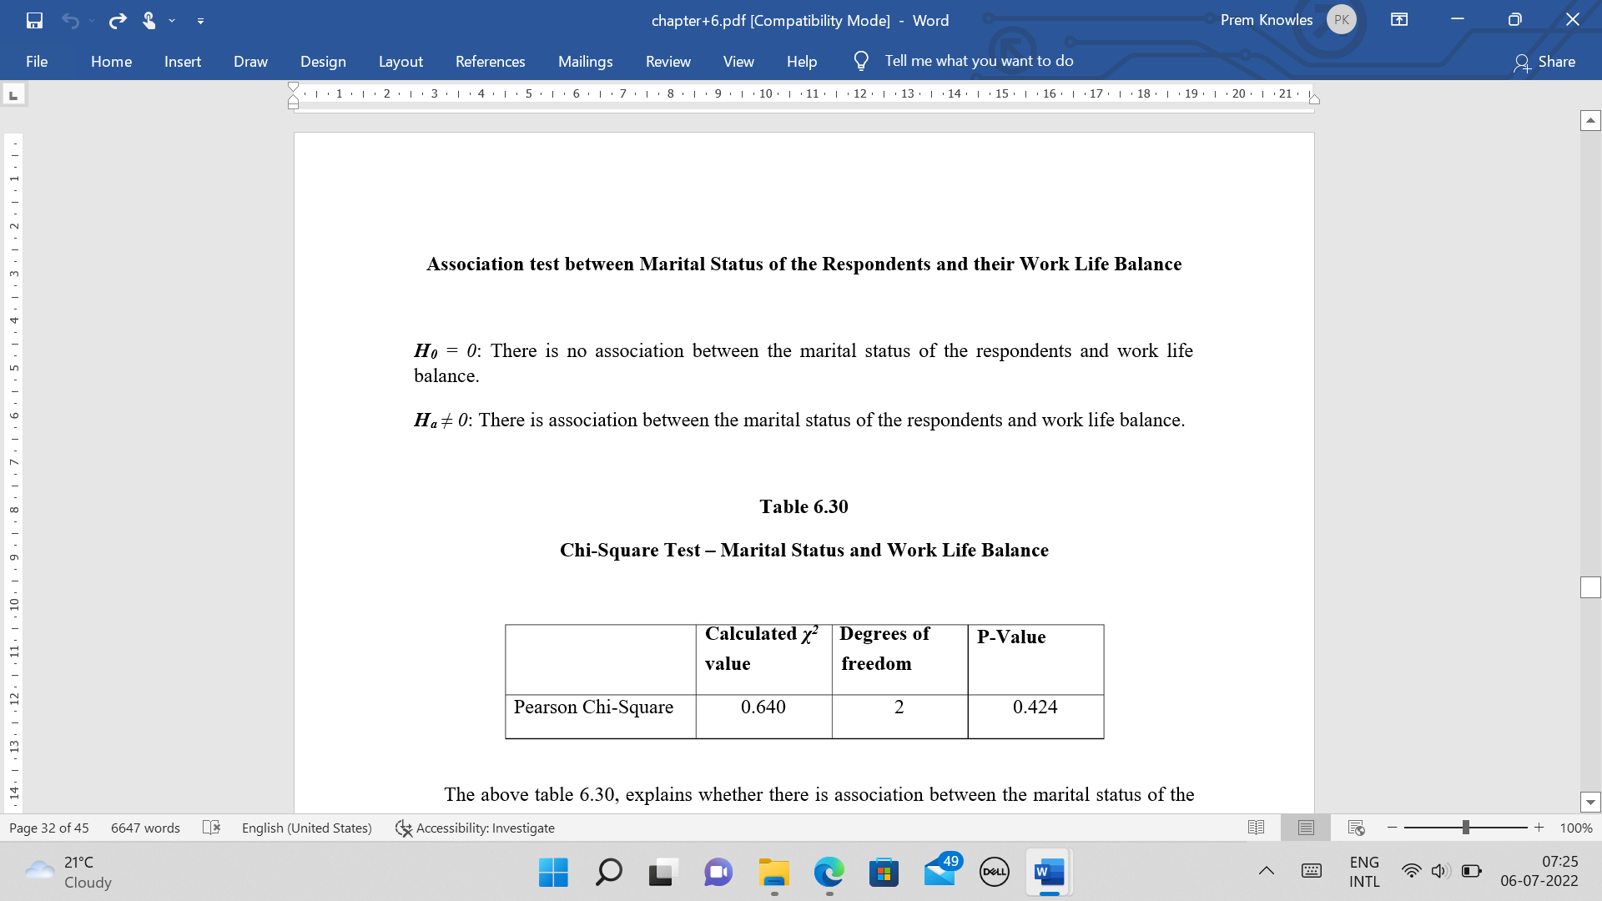

The above table 6.2, is inferred that there is no significant association between the marital status and work life balance(WLB) of the respondents.

Calculated χ2 =0.640 @ two degrees of freedom.

Probability value=0.424,> 0.05, ie,the null hypothesis cannot be rejected at 5 % level of significance.

**Table 6.3 Cross Tabulation between Monthly Income of the Respondents and their Work life Balance(WLB)**

From the table 6.3, it is inferred that,

* 57% of the respondents from the income range Rs.11,000/- to Rs.20,000/- felt that their WLB is poor and 43% of them felt that their WLB is good .(215 respondents, income range between Rs.11,000/- to Rs.20,000/- )
* 58% of the respondents from the income range Rs.21,000/- to Rs.30,000/- felt that their WLB is poor and 42% of them felt that their WLB is good .(145 respondents, income range between Rs.21,000/- to Rs.30,000/- )

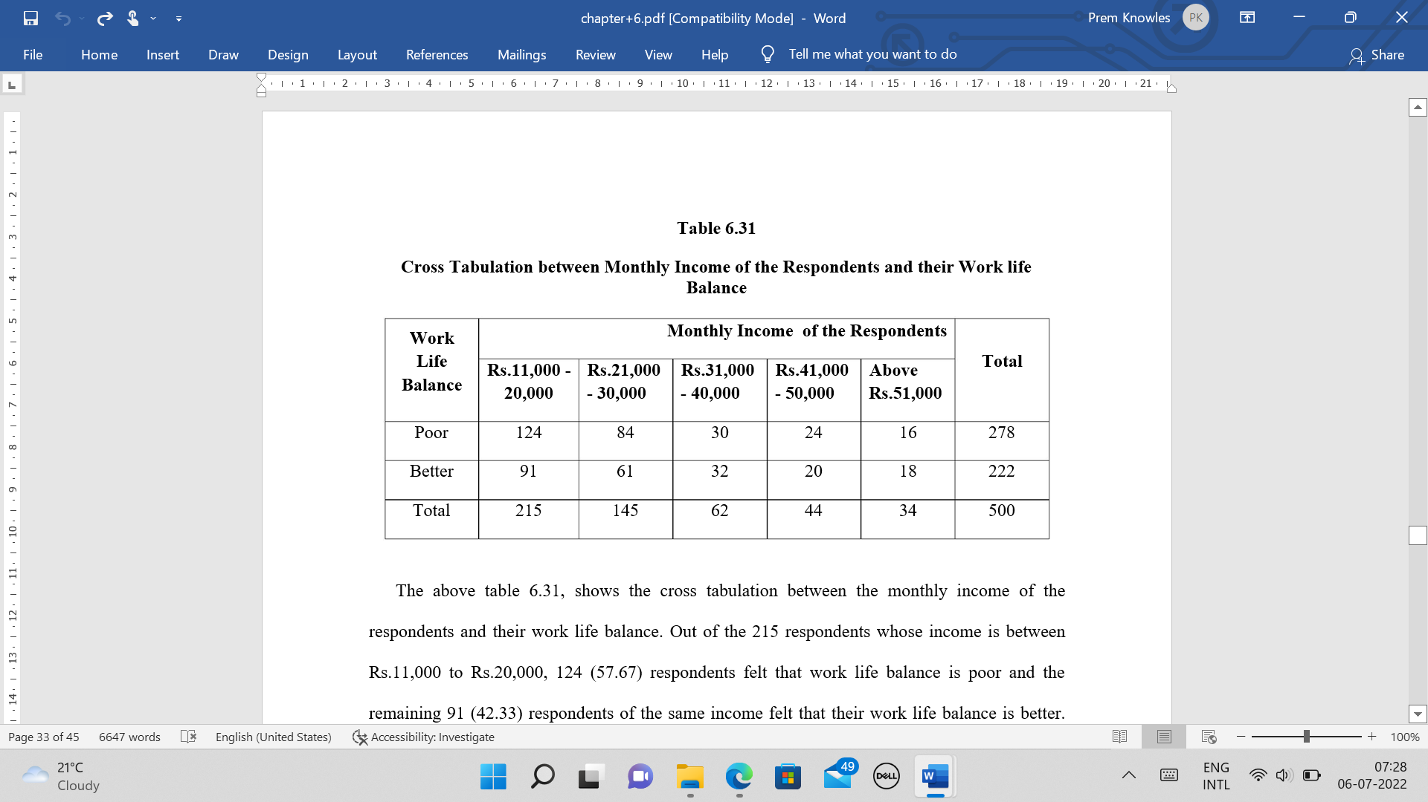

* 48% of the respondents from the income range Rs.31,000/- to Rs.40,000/- felt that their WLB is poor and 52% of them felt that their WLB is good .(62 respondents, income range between Rs.31,000/- to Rs.40,000/- )
* 55% of the respondents from the income range Rs.41,000/- to Rs.50,000/- felt that their WLB is poor and 45% of them felt that their WLB is good .(44 respondents, income range between Rs.41,000/- to Rs.50,000/- )
* 47% of the respondents from the income range > Rs.51,000/- felt that their WLB is poor and 53% of them felt that their WLB is good .(34 respondents, income range between Rs.31,000/- to Rs.40,000/- )

**6.4 Hypothesis test to analyse the association between Years of Experience in the Current Organization and Work Life Balance(WLB) of the respondents.**

Ho = 0: There is no association between the years of experience in the current organization work life balance(WLB).

H4 ≠ 0: There is association between the years of experience in the current organization and work life balance(WLB).

From the table 6.4, it is inferred that there is no significant association between the years of experience in the current organization and work life balance of the respondents.

**Chi-Square Test** – Year of Experience in the Current Organization and their Work life

Balance

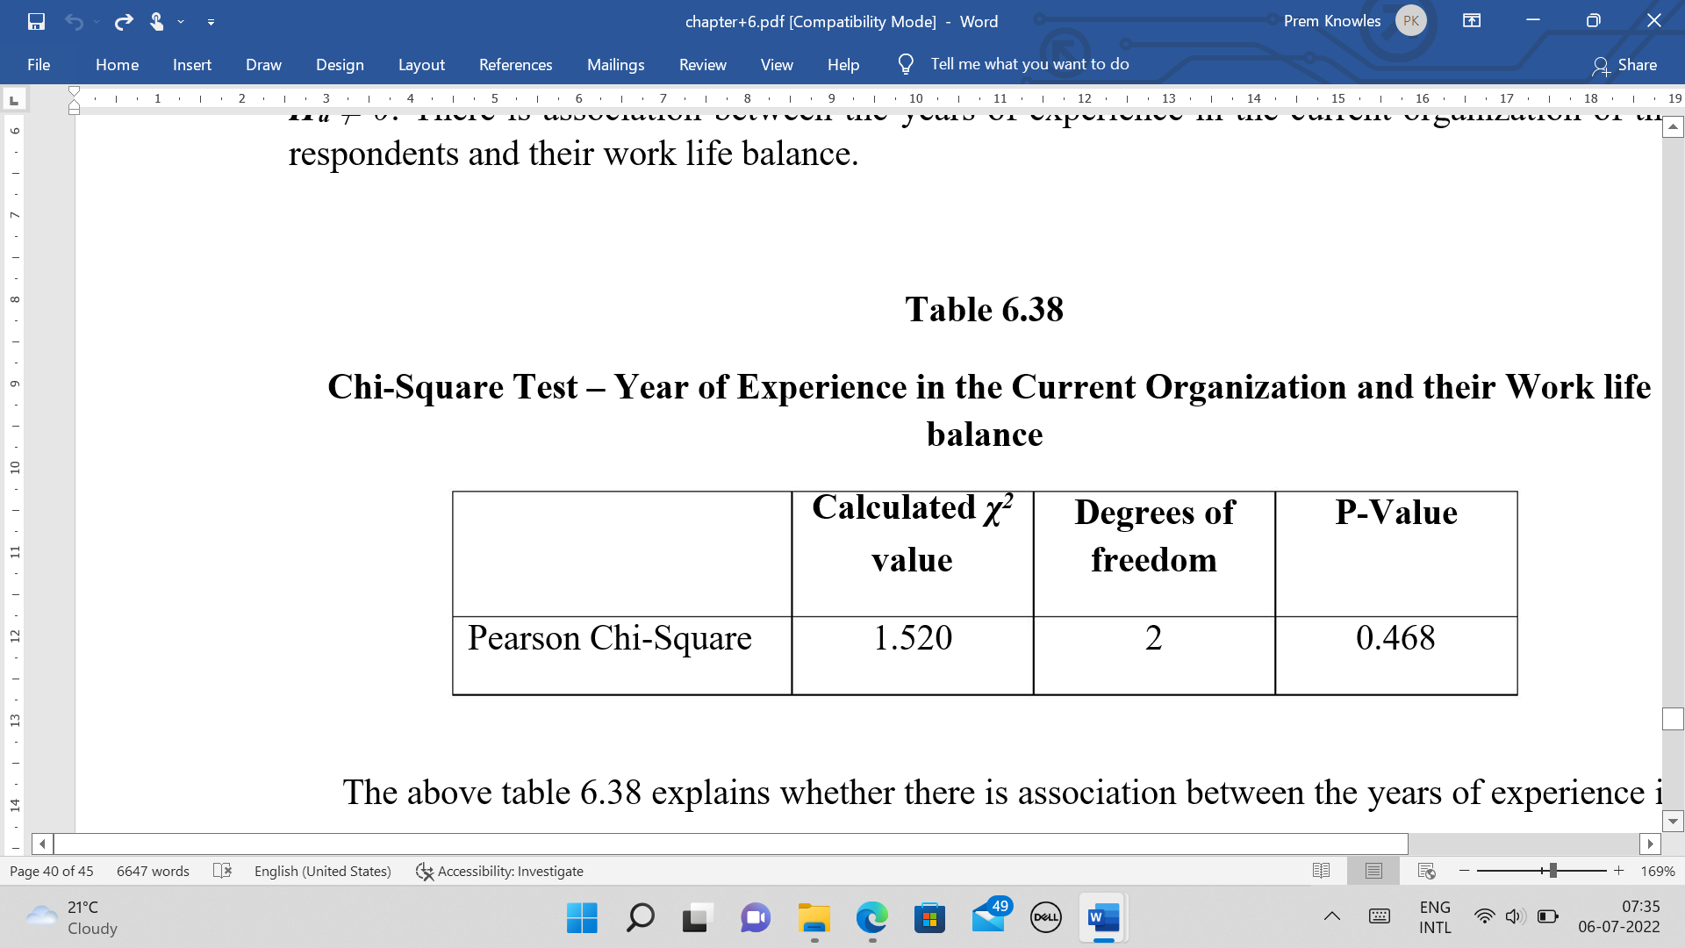

χ2=1.520 @ two degrees of freedom

Probability value =0.468, >0.05, ie null hypothesis cannot be rejected at 5% level of significance

**6.5 WLB Initiatives based on Importance**



**Table 6.6 LEAVE BENEFITS**

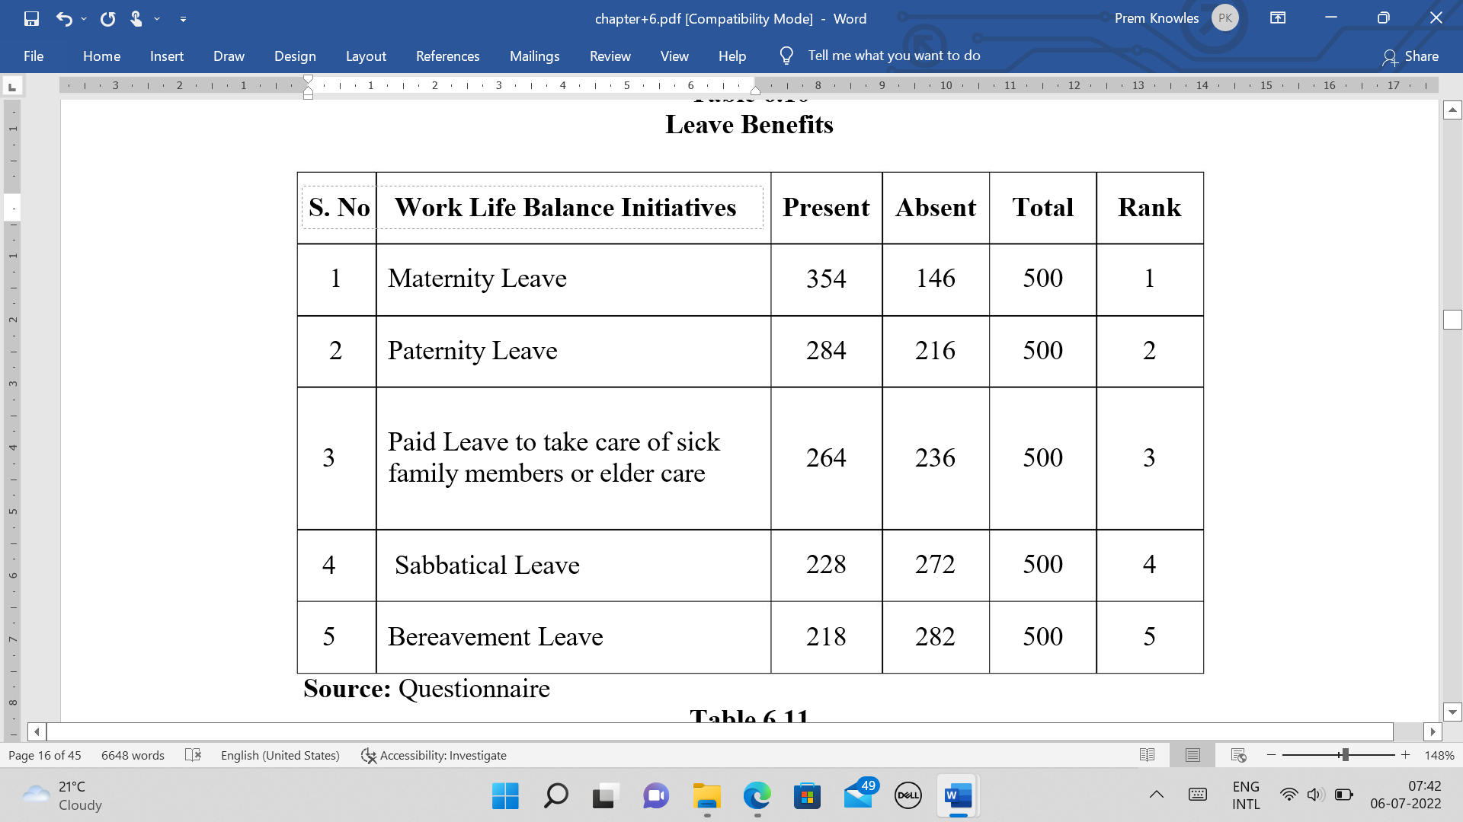

From the table : 6.6 Among the leave benefits,‘Maternity leave’ ranked as first; 354 respondents reported that maternity leave is the primary leave benefit (note: female respondents are more in this study, in the ratio 3:1). Followed by maternity leave , paternity leave lined as second .

**7. CONCLUSION**

From the study it is concluded that, there is the impact of Experience, Marital Status and educational qualification on work-life balance. Some of the most contributing factors in work life balance are a.Salary,b.Location of work place, c.Holidays, d.Interest in Job, e.Career development opportunities, f. Leave arrangements, g.Flexible working hours, h.Training opportunities, i.Job security, j.Friendly environment.Among the leave benefit ‘Maternity leave ranked the first, followed by other leave benefits like paternity leave,sick leave, sabbatical leave and bereavement leave.

In this digitalized and technology era, the organizations have realized the importance of work life balance among employees and taken necessary steps to balance their life. Flexible work time, work-from home and work from anywhere are the options provided by many organizations to improve the employee morale and to sustain the employees. Lot of employees are happy with these systems. Though we generally state that the organizations realized the importance of work life balance among employees, it is advised to do lot of researchers in this area.

**References**

Allen, T. D. (2001). Family supportive work environments: the rle of organizational perceptions. Journal of Vocational Behavior, 58, 414-435.

Amabile, T. M. (1983). The social psychology of creativity. New York: Springer-Verlag.

Anderson, S. E., Coffey, B. S., & Byerly, R. T. (2002). Formal organizational initiatives and informal workplace practices: Links to work-life conflict and job related outcomes. Journal of Management, 28(6), 787-810.

Aryee, S., Fields, D., & Luk, V. (1999). A cross cultural test of a model of the work-family interface. Journal of Management, 25(4), 491-511.

Bird, J. (2006). Work-life balance: Doing it right and avoiding the pitfalls. Employment Relations Today, 33(3), 21-30. Retrieved from WorkLife Balance.

Chavan, S. R., & Potdar, B. (2011). A critical study on work-life balance of BPO employees in India. International Conference on Technology and Business Management, 966-77.

Darcy, C., McCarthy, A., Hill, J., & Geraldine, G. (2012). Work–life balance: One size fits all? An exploratory analysis of the differential effects of career stage. European Management Journal, 30(2), 111-120.

Kossek, E. E., & Ozeki, C. (1998). work-family conflict, policies, and the job-life satisfaction relationship: A review and directions for organizational behavior-human resources growth. Journal of Applied Psychology, 83, 139-149.

LaPierre, L. M., & Allen, T. D. (2006). Worksupportive family, family-supportive supervision, use of organizational benefits, and problem-focused coping: Implications for work-family conflict and employee well-being. Journal of Occupational Health Psychology, 11, 169-181.

Macky, K. & Boxall, P. (2008). High-involvement work processes, work intensification and employee well-being: a study of New Zealand worker experiences. Asia Pacific Journal of Human Resources, 46 (2), 38-55.

Morgan, H., & Milliken, F. J. (1992). Keys to action: Understanding differences in organizations' responsiveness to work-family issues. Human Resource Management, 31, 227-248.

Naithani, P. (2010). Overview of work-life balance discourse and its relevance in current economic scenario. Asian Social Science, 6(6), 148-155.

O'Driscoll, M. (1996). The interface between job and off-job roles: Enhancement and conflict. In C. Cooper, & I. Robertson (Eds.), International Review of Industrial and Organizational Psychology (pp. 279-306). Chichester: John Wiley