The Internet of Things & Agriculture
Author: Deepa Singh, Research Scholar, Dept.of Journalism and Mass Communication, IIS(Deemed to be University), Jaipur.
Presenter and expert of Jaipur Doordarshan ‘s Agricultre Programme.
Guest Writer in Agriculture ‘s Newspaper.

ABSTRACT:-
Agriculture is the mainstay of the Indian economy as two-thirds of its population is engaged in agricultural activities. Agricultural methods have significantly changed over the years. An advancement in technology incorporates the development of various devices and IoT services. It is need of hour to extend agriculture industry as to feed the ever growing populationSmart farming methods are made possible by the Internet of Things, which boost agricultural output.IoT tools support farmers by providing data essential for predicting soil quality, sensing soil temperature, nutrients and humidity, managing and evaluating water usage for plant growth, and monitoring weather conditions, climatic changes, environmental impact, and crop’s health.The enhanced facility for process automation, evaluation, and waste reduction is provided by smart farming.IoT is therefore a driving factor behind the improvement in the quality and quantity of food items while also lowering production costs. It is important to provide farmers a comprehensive understanding of IoT applications in agriculture.The advent of the internet of things in agriculture has ushered in a second wave of the green revolution. Our study in this chapter examines various issues and the potential applications of IoT technology in agriculture sector.
Keywords : Agriculture,The Internet of Things, Smart Farming, IoT technology.
INTRODUCTION:-
Agriculture forms the major part of our Indian economy. The Internet of Things (IoT) refers to a network of connected devices that convey sensed data without the need for human involvement. The application of IoT in agriculture is significant as it plays a pivotal role inexpanding the economy of our country. IoT technology is already having a profound impact in various fields like Education, Business, Medicine, Weather forecasting system, Communication and Agriculture. However, the IoT has had the most influence on agriculture. IoT innovations leads to development of systems that support various agricultural procedures. Some of these systems include frost prevention systems, automatic watering systems, remote monitoring systems, and decision support tools.Real-time field tracking provided by IoT-based Smart Farmingimproves the overall agricultural system. The Internet of Things in agriculture, made possible by sensors and connectivity, has helped farmers by saving time and reducing extravagant use of resources, such as water and electricity.
IOT APPLICATIONS IN AGRICULTURE:-
Technological advances provide farmers with a comfortable pathway forward in the agriculture sector. The Internet of Things is the motivating factor that increases the effectiveness and efficiency of agricultural output.In smart farming, farms are controlled utilising IoT and other information and communication technologies, as well as big data, to improve crop quality and quantity while lowering the need of labourers. The adoption of IoT provides farmers with two advantages. By enhancing farmer’s decision-making with precise data, it has helped farmers to cut their expenses and enhance yields at the same time. Utilizing wireless monitoring sensors and a cloud-based platform, smart farming technology measures soil quality, meteorological condition, crop development and crop damage remotely. Numerous sensors, autonomous vehicles, robotics, and control systems are all part of the Internet of Things. Smart farming techniques offer solutions to challenges suchas climate change, changing weather conditions, soil quality, waste reduction, and green housing.
A. Monitoring climate conditions, soil and plants
Farming is largely dependent on the climate. Natural disasters and dramatic climate change have a significant impact on plant growth and agricultural output. IoT solutions permit you to understand the real-time climate situations.Various environmental data can be gathered by placing various sensors inside and outside of agricultural fields. Sensors are used to capture data on electrical conductivity, soil nutrients, moisture, rainfall, temperature, and other variables, which are then stored in integrated databases. There are many different sensors that are used, including the temperature sensor (LM35), humidity sensor (DHT11), soil PH sensors (INTELLIA INT G01, INTELLIA INT-PH 1), pyroelectric infrared sensor (PIR), pressure sensor, dielectric sensors, mechanical sensor, amperometric sensor, and Arduino microcontroller.

Figure :-Agricultural internet of things model.
Primarily based on soil profile, the level of fertilizer can be decided and implemented.Agriculturalists and farmers needs to install mobile applications and register with the cloud using the mobile app. Information related to weather, soil, irrigation level, plant development and damage are all stored in the cloud.In addition, it also maintains records of data pertaining to farmers, marketing representatives, agro suppliers, service providers, and government initiatives in the agriculture sector, such as farmer bank loans and discounts on seed and/or fertilisers.Sensing devices periodically collect data from soil and environmental sampling, update it, and use it to manage smart farms.
The Internet of Things is vital for tracking plants, identifying pests and diseases that are affecting their growth.Sensors can create alarms and warnings if the pest control level exceeds the recommended range, advising farmers to take action.Using a cloud database,farmers and agriculturists can determine the best times to plant crops, control pests and plant diseases, and harvest.
The introduction of agricultural drones is the most recent technological disruption that has almost completely changed agricultural operations.Drones are used forcrop spraying, irrigation, field analysis, crop health evaluation, and agricultural surveillance.Drone technology has provided the agriculture sector a great rise and transformation using real-time data resulting in correct strategy and planning. Drones with multispectral or thermal sensors can locate the locations that need irrigation adjustments.Sensors determine the vegetation index and indicate the health of the crops as they begin to grow.Eventually, the environmental impact has reduced by smart drones.Crop yields may increase as a result of the drone-based real-time data collecting. As a result,the amount of chemical that reaches groundwater has significantly decreased.

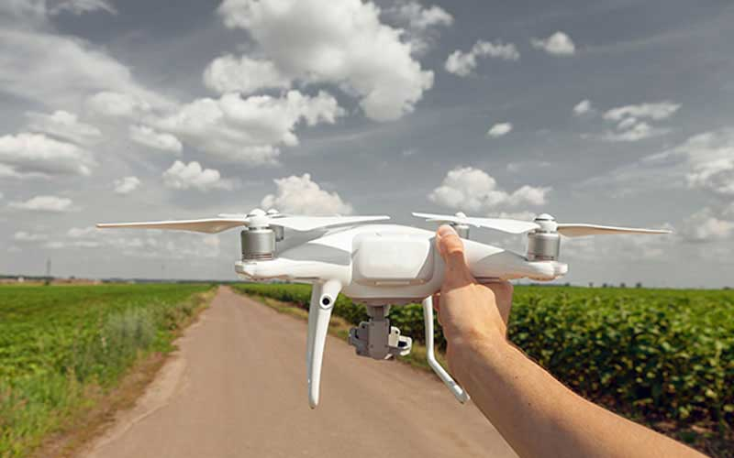

B.Smart Greenhouses
Solar-powered IoT sensors are used to create modern, inexpensive, and healthy green houses.Data on temperature, pressure, humidity, and light levels are provided by the sensors.These environmental characteristics are monitored by sensors and are either manually adjusted or managed by control systems. Smart sprinklers are also used for water irrigation. All of these are interconnected through the Internet of Things, and a cloud server that accesses the data and gives farmers affordable options.
IoT has made it possible for weather stations to alter automatically the environment conditions in accordance with a specific set of instructions, which has enabled our greenhouses to become smarter.In greenhouses, the usage of IoT has eliminated the need for human interaction, making the whole process more accurate and cost-effective at the same time.For instance, creating modern, affordable greenhouses utilising IoT sensors driven by solar energy. Sensors gather and send real-time data that is used to precisely and continuously monitor greenhouse conditions.The sensors enable monitoring of the greenhouse condition through emails or SMS alerts.The Internet of Things is used for automatic and smart irrigation. Sensors provide a crystal clear real-time observation while keeping numerous variables in check, including pressure, humidity, temperature, soil, and light level.

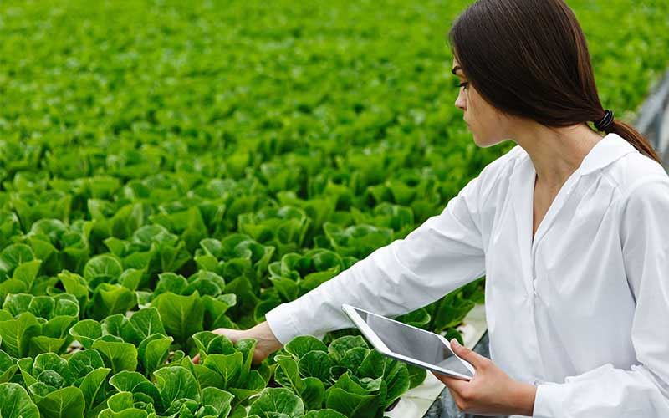

C. Water Irrigation and Waste Reduction
The Internet of Things, which tracks tank levelling and plans irrigation times, makes it possible to manage water use for the best plant growth. Monitoring unwanted leakages is also essential. These can all be accessed using web and mobile applications that are housed on enterprise cloud. IoT technology helps farmers and agriculturists in increasing output while producing less waste. It is a method of farming that enhances the precision and control of the process for growing crops. After harvesting, silos and grain elevators for agricultural storage need to be examined for monitoring grain temperature, pressure, humidity, and light levels.
D. Livestock monitoring
Farmers and agriculturalists collect information regarding their cattle's location, health, and feeding schedule. IoT-based sensors could be used to find the sick animal inside the herd before it spreads the infection to others.It will significantly minimise livestock losses and expenditures by continuousmonitoring and recovering the others in the huge group.

CHALLENGES
The greatest obstacle to the adoption of new technologies in agriculture is the extremely tiny land holdings, which limit long-term productivity development. Although 48% of our sowed area is dry land, all of our technology, including high yielding seeds, is designed for irrigated grounds. Almost 90% of farmers are small and marginal farmers. Today, the average size of a farm is only 1.15 hectares. Hardly 5% of farmers are employed on holdings larger than 4 hectares. The early beneficiaries have been farmers who have been able to combine their holdings and expand farms to at least 100–200 acres. Smart technology is frequently used by huge agribusinesses rather than individual farmers. Farm-loan firms utilise some of these strategies for risk management. The industry has to deal with issues like cost-prohibitive land fertility, dwindling land availability, and growing water shortages. Furthermore, the obstacles cannot be overcome with the current approaches. Small embedded devices require security challenges that are both cost-effective and simple to implement.

CONCLUSION
The possibilites of the internet of things is to create a world where everything is connected by means of internet.IoT technologies are already a crucial component of resolving various issues and a necessary component of conducting business in the agricultural sector.
The adoption of modern technological solutions has been aided by IoT-enabled agriculture. This has been useful in bridging the gap between production, quality and yield. Swift response and reduced harm to the crops are ensured by data ingested by acquiring and importing information from multiple sensors for real-time usage or database storage. Produce is processed more quickly and gets to supermarkets as soon as possible attributed to improved business process execution and end-to-end, seamless intelligent operations. So, in conclusion IoT will not only create a variety of career prospects but also aid in resolving significant economic and environmental challenges.
REFERENCES:-
[1]. Parwinder Kaur Dhillon, Sheetal Kalta. A lightweight biometrics based remote user authentication scheme for IoT services.Journal of Information Security and Applications.2017.
[2]. R.Gaikwad. Internet of Things(IoT): Revolution of internet for smart environment: Oracle, Tech Rep.2016
[3]. S. R. Nandurkar, V. R. Thool, R. C. Thool, :Design and Development of Precision Agriculture System Using Wireless Sensor Network:, IEEE International Conference on Automation, Control, Energy and Systems (ACES), 2014
[4]. Yongxian Song, Juanli Ma, Xianjin Zhang, Yuan Feng, :Design of Wireless Sensor Network Based Greenhouse Environment Monitoring and Automatic Control System:, JOURNAL OF NETWORKS, VOL. 7, NO. 5, 2012
[5] W. R. B. Z. L. Cuihong Liu, "The application of soil temperature measurement by LM35 temperature sensors," International Conference on Electronic & Mechanical Engineering and Information Technology, pp. 1825-1826, 2011.
[6]Marvin T. Bate, “Changing computer use in agriculture: evidence from Ohio”, Computers and Electronics in Agriculture, Elsevier science publishers, vol. 47, 1–13, 2005.
[7] Link Labs, An In-Depth Look at IoT In Agriculture & Smart Farming Solutions

