Phage Therapy – A New Approach in Science

Subhajit Nath, Sancharee Sensarma, Sahana Ghosh*

Department of Microbiology, Vijaygarh Jyotish Ray College, Kolkata, West Bengal, India,
*Faculty, Department of Microbiology, Vijaygarh Jyotish Ray College, Kolkata, West Bengal, India.
Mail ID - sahanaghosh2102@gmail.com

ABSTRACT

Since the advancements in the field of medical science , bacteriophages have been at the zenith of interest to scientists . They have the potential to be used not only as tools to understand basic molecular biology but also as the absolute vectors of novel therapeutic agents and horizontal gene transfer. After a long time , it is finally understood , that , by finding out the secret mystery of the biology of phages and their relationship with the hosts, we may finally figure out the key to understand microbial systems and their part in it. In this review, we describe the different types of phages, how their modification is done, and finally , their application in clinical and research field. This review also shows how modeling of phages is done and how they have been administered via different routes. All the data provided here , are being consolidated together to provide unparalleled insights into these tiny but vital constituents of the microbial world. This very narrative review , actually highlights the current understanding of phages and also the new strategies for a phage revolution in the field of future health care .

Keywords – Antimicrobial resistance; Bacteriophages; cocktails; Antibiotics , MDR (multiple drug resistance) , AMR (Anti Microbial Resistance)

I. INTRODUCTION

Till now, the beneficial aspects of viruses in terms of human health is unknown . But ,as days pass , with more and more experiments , we are now steadily discovering the importance of our viral companions. With that note , here , we have tried to introduce an overlooked section of the microbial world - the virome (or the World of viruses). Though ,the functions of bacteria in terms of human health is well known in the field of medical science, but we are a long way from finding out the beneficial relationship of viruses in this aspect . But , the good news is , it is now firmly accepted , that without our ally microorganisms we would not be able to thrive normally and with that brief hope of finding new cures , medical science has fixed its eyes on the horizon, straining to give meaning to something that’s hidden and purplex , presently beyond the grasp of humankind. This is what will be the next challenge of humankind ,finding out the interactions and roles of viruses in our daily lives .
Scientists consider the virome to be the most dynamically diverse and probably the largest component of the microbial world at this time. Because bacteriophages make up the majority of the viruses in our guts, this is based on the idea that wherever there are bacteria, there will also be a lot of bacteriophages. Phages, according to a variety of collected data, are the most numerous and nearly omnipresent life forms on our planet. Phages as high as 10 billion per milliliter may be present in some freshwater sources. One of the ways bacteriophages function is by- first infecting bacteria. After that, they replicate their own genetic material by controlling the machinery of host’s cells. It is now abundantly clear that the bacteria in our guts have an effect on our health throughout our lives. Therefore, gut bacteria-infecting viruses ought to have a significant impact on our lives as well.

II. BACTERIOPHAGES IN LEGENDS AND MYTHS

Sometimes, often a question rises, why does the river water doesn’t get extensively polluted, despite of so many pollutions done by man ? Or, as a matter of fact why is our own Ganga river, is said to purify even the impurities? What’s the real concept among the stories and what’s the real science behind it ?
The Ganges water actually never deteriorates . Too ,there is no insect remains in this river. People have done many savageries on the Ganges time and time again. Drains, dead bodies and garbage was thrown in her, but yet nothing happened in the Ganges water. [2]
Actually , the real secret is the virus (bacteriophage). This is the very the reason why water of this river never gets spoiled. These bacteria killing viruses prevents rotting of the river water . The famous British scientist Ernest Hankin researched the Ganges water in the 1890s because a water borne disease known as cholera was spreading at that time. In the early days , people used to throw the dead bodies in the River Ganges . Hankin ,being a researcher , feared that the other people who bathed in that water might also get infected with the cholera pathogen . But why it did not happen , perplexed him . Hankin was really surprised about this and started doing research on it. Then , after finding the results , in 1896, one of the first works on Ganges water was published by Ernst Hankin . It wholly demonstrated antibacterial property of the Ganges water against the pathogen known as Vibrio cholera. Then days passed and after 20 years, another French origin scientist took the research forward. It was then found that the viruses that were mixed in the Ganges water were penetrating into the bacteria (which spread cholera) and were eliminating them. Due to this virus, the Ganges water remained pure.
For centuries, Ganges, has been esteemed for its special healing and self-cleansing properties. Still , more than 450 million people depend on the waters of Ganges for various work purposes. [3]
During Kumbh-Mela, lytic bacteriophages against seven of the most prevalent bacteria were examined in one study. At specially chosen bathing locations during the event, the host-specific bacteriophages against Escherichia coli (E. coli B and E. coli K12), Vibrio cholerae, Staphylococcus aureus, Salmonella typhimurium, and Pseudomonas aeruginosa were analyzed. [4] The data that were gathered there showed promising results, opening the door to using phage cocktails to treat bacterial gut infections if necessary.

III. STRUCTURE OF BACTERIOPHAGES

Bacteriophages are the natural predators of bacteria. They are actually self-replicating, intracellular and obligatory parasites, that are biochemically lifeless in extracellular surroundings. The biosynthetic machinery of the host bacterium is controlled by them in order to produce various proteins (viral) of their own . They are ever-present creatures, in the soil, water etc. Usually, bacteriophage makeup exhibits a three spatial arrangement . The ancestral material is encircled in a protein capsid icosahedral head, a tail and surface receptor proteins.

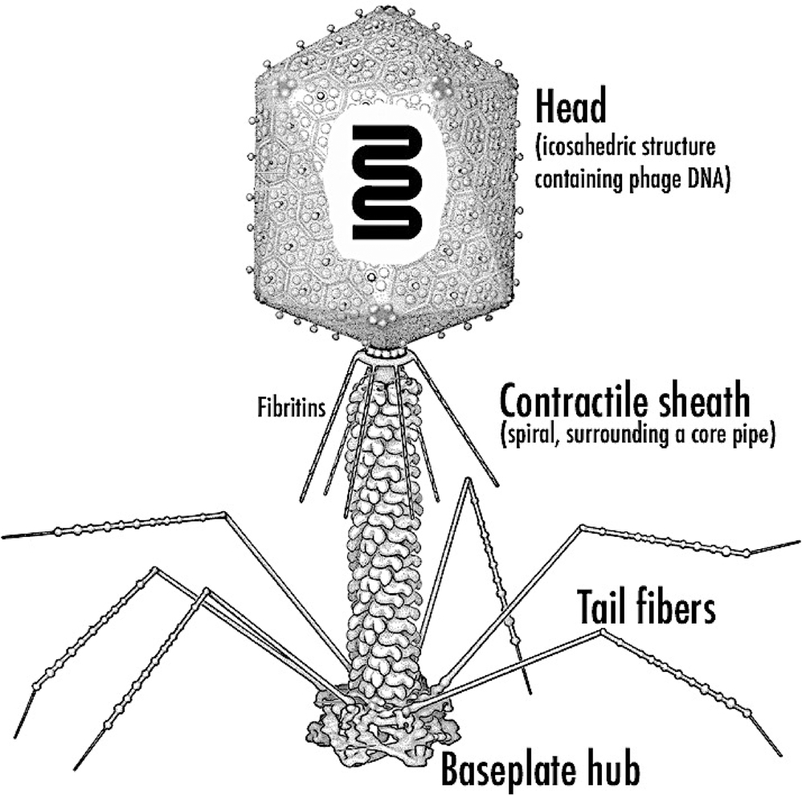

Figure 1. Schematic representation of a bacteriophage . Rossmann et al. (2005)

IV. WHAT IS PHAGE THERAPY AND WHY THE TIME FOR USING PHAGES HAS COME?
A typical type of virus that is neither alive nor dead is a phage. Their head resembles an icosahedron, or dice, with twenty faces and thirty edges. The virus's genetic material is in it. It rides on a long tail with structures resembling legs called fibers. Phages probably exist everywhere , where there are living things , because there are more of them than all other organisms put together. Despite the fact that they kill a lot for breakfast, they only kill bacteria. Phages kill approximately 40% of all oceanic bacteria every day[6]. However, they also have significant flaws. Phages also require a host in order to live and reproduce. They are essentially nothing more than genetic material in a hull, and they typically select a particular bacteria or perhaps some of its close relatives to eat.
Phage, like a cruise missile, only targets members of a very specific unlucky family of bacteria and kills them. Endolysin, a potent enzyme that cuts a hole in the bacterial membrane, is produced in the final step after the virus particles have been assembled. The lysine goes through the membrane and cleaves the bonds in the peptidoglycan. Then after the genetic material is inserted, new phages are created inside the bacterium. The pressure becomes so high, that the pressure in the bacterium is greater than the external environment. As a result the organism explodes, releasing the phage progenies, in the environment to start a new cycle. This whole process is phage therapy – using a phage and its cycle to kill a bacteria.
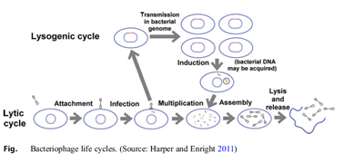

Figure 2: Bacteriophage life cycles. [6]

Also in another process, using a technique called 5 phase lysine where using only Lysine itself as a standalone molecule, that can be used from the outside to punch a hole in the bacteria, causing the explosion process to kill the bacteria. Phage combinations are able to treat dysentery, pneumonia, rhinosinusitis and UTI before antibiotics were discovered.
But there are some issues regarding this therapy. First is the cultural barrier. It’s very difficult to culture a virus. They are biological entities , not small molecules like antibiotics , that means scalability is potentially an issue because every one of them is unique in its own right and may have specific ways in which it has to be made .The second barrier is , the regulatory approval . Like, whether or not it is fit to deal with a biologic entity like this, as a medicine.
Recently in many experimental studies we have started looking into them by injecting millions of bacteriophages into patient’s bodies, because we are sort of getting desperate, when MDR showed in certain bacterial strains.
In the history, we have seen , that a single cut from the wrong thing could kill us. Bacteria were like our phages. They were like tiny monsters that hunted us mercilessly. But then, about 100 years ago, we found a solution in nature .By accident we found fungi that produced compounds that killed bacteria – the Antibiotics.

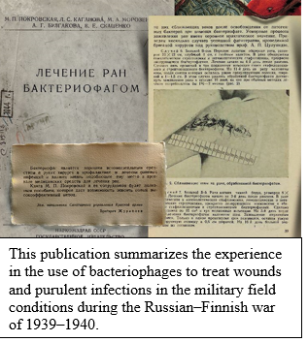
Suddenly, we got a powerful super weapon. Antibiotics were so effective that we stopped thinking of bacteria as monsters.. So, we used antibiotics more and more for less serious causes. But bacteria are living things that evolve, and one by one they started to become immune against our antibiotics .This continued, until we had created what are now called as superbugs – mutant bacterial species , which are immune to almost every antibiotics we have. This immunity of bacteria is spreading across the world as we speak. In a study it is seen that by 2050, superbugs could kill more humans than the cancer. The days, when a cut or a bladder infection, or a cough could kill us , are coming back. In US alone, more than 23000 die alone from resistant bacteria each year. But it turns out, phages, our tiny killer virus robots, could save us .We could inject them into our bodies to help cure infections.[7]
But how? Actually phages are specialized killers of bacteria. They are so specialized that humans are completely immune to them. We are too different. We encounter billions of phages every day and we just politely ignore each other.

Antibiotics kill everything, even the beneficial bacteria in our gut and intestines that we don't want to harm, like a carpet bomb. Phages, like guided missiles, only strike the intended targets. But if we use phages to kill bacteria, won't they also come up with ways to defend themselves? Actually, it's more intricate than that. Phages also change. Phages and bacteria have been engaged in an arms race for billions of years, and until this point, they have succeeded admirably. Because of this, phages, which are constantly improving in their capacity to eliminate bacteria, are the most advanced weapon available. However, even if bacteria developed an immunity to our phages, we might still be able to prevail. It appears that bacteria must give up their antibiotic resistance in order to become resistant to even a small number of phage species. After all, we might be able to trick them into playing a game of catch 22. This therapy has already been tested successfully with patients who had no other option. A man's chest cavity was infected by the dreaded bacteria Pseudomonas Aeruginosa. This particular strain of bacteria can survive an alcoholic hand gel and is mostly resistant to most antibiotics.
A few thousand phages and antibiotics that bacteria were immune to were injected directly into his chest cavity after years of suffering.. In 48 hours the patient woke up from his coma. After a few weeks the infection had completely disappeared. In another case study, a man was diagnosed with pancreatic pseudo cyst, filled with Acinetobacter baumannii, which was treated with a phage cocktail.

Phages are ubiquitous .In earlier days, France and former Soviet union had various experiments regarding this therapeutic agents. Bacteriophage had been kind of brought back from the shelf as a potential new approach to therapy.[7]

But they are not simple to use and we have to develop a cocktail for each patient’s own isolate as they seem to be relatively safe together. But the problem is they are difficult to develop from both the research and regulatory perspective.

However, the good news is that we now have awfully good tools, such as robotics and much more advanced molecular tools, that make it possible to accomplish what would have been impossible - ten to fifteen years ago. Sadly, this treatment is still in the experimental stage, and pharmaceutical companies are still hesitating to invest the required billions in a treatment that has not yet received official approval.

However, things are finally changing. In 2016, the largest phage clinical trial to date began, demonstrating that phages are gaining more and more attention. We should get used to this, as the time when antibiotics - as our most powerful weapon , is about to end. Although it may seem odd, injecting the most dangerous creature directly into our bodies could save millions of lives.

V. BRIEF ON PHAGE THERAPY – HISTORIC OVERVIEW
In the Ganga river's water in 1896, Ernest Hanbury Hankin discovered bacteriophages with antibacterial properties against Vibrio cholerae [4]. Fredrick William Twort and Felix d'Herelle made the first discoveries regarding phages in 1915 and 1917, respectively. Felix d'Herelle, a French-Canadian microbiologist, was the first to give the name of the viruses that kill bacteria as "Bacteriophage" . He suggested that phages could be used as a treatment for bacterial infections following his discovery. He successfully treated patients with Shigella dysentery and a cholera outbreak in India with phage preparations. Since that time, phage therapy has been regarded as an outstanding treatment for bacterial infections [5].
Phage therapy treats specific bacterial infections by attacking a specific gram-positive and gram-negative bacterial pathogen with viruses. These viruses, which are known as phages or bacteriophages, have a specific target and destroy it through lysis, lysogeny, or pseudolysogeny without harming the beneficial microflora in the gut, which reduces the risk of complications associated with phage therapy.
Phages, which are natural bacterial parasites, have a capsid that protects the bacteria's genetic material and, in some cases, a proteinaceous tail. Myovirus, podovirus, and siphovirus are examples of tailed phages in the class Caudoviricetes [8,] and the polyhedral Microviridae family is frequently associated with phage therapy [9,10].Phages can be found in feces, seawater, sewage, soil, sludges, and just about anywhere else bacteria can grow [11,12].

Table 1: Shows the discovered phages, having potent biomedical applications from the year 2011 to 2021 [37].
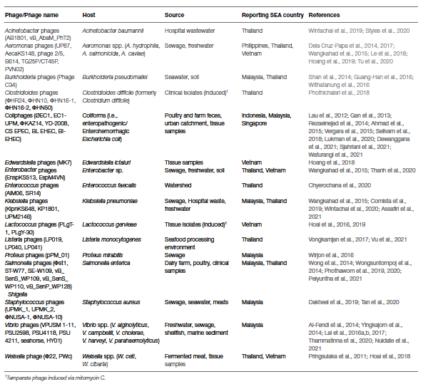

VI. EVOLUTION OF PHAGE THERAPY
Phage therapy was first used in the 20th century to reduce the number of disease-causing bacterial pathogens. In 1919, D'Herelle gave anti-shigella phages to four patients who were suffering from Shigella-caused dysentery. Within a day, the patients showed signs of recovery [13].In 1945, a new era known as the "golden age of antibiotics" began, and phage products were removed from the market. Shortly thereafter, penicillin resistance emerged as a clinical issue, prompting the development of new antibiotic classes and modifications to existing ones [14].Multiple drug resistance (MDR) bacteria are making it more difficult for currently available antibiotics to remain on the market [15].Phage therapy is once again being regarded as a crucial treatment option for bacterial infections that do not respond to antibiotics. A 30-year-old woman was severely injured in a suicide bombing at Brussels airport in March 2016.Due to the presence of a resistant Klebsiella pneumoniae strain, her wounds did not heal despite the administration of antibiotics. Treatment with antibiotics had its own set of side effects, but they didn't get rid of the infection. In 2018, the phage and antibiotics were finally administered to her for treatment. Her condition improved within a few weeks, and the severely damaged femur began to heal. AMR , after ischaemic heart attacks and strokes, was the third leading cause of death worldwide in 2019. According to the more conservative estimate, AMR was responsible for more deaths than AIDS in that year. Ten million people are expected to die from AMR by 2050.

In the Body, a book by Bill Bryson , Antimicrobial resistance is anticipated to cause ten million preventable deaths annually at the current rate of spread. The following is reported in a Chemistry World article: 700,000 people die annually from drug-resistant bacterial infections, and this number could rise to 10 million by 2050. According to a UN interagency group's report from April 2019, drug-resistant diseases already kill at least 700,000 people a year worldwide, including 230,000 people who die from multidrug-resistant tuberculosis. This number could reach 10 million people a year by 2050 under the most alarming scenario if nothing is done, so it's important to take action now. Referring back to the 10 million figure, an analysis published in PLoS Medicine makes the following observation: The scenario that appears to be underlying the most frequently cited line predicts a 40 percent initial rise in current resistance rates, which will then stabilize until 2050 and double infection rates.16] We ought to take the threat's warning very seriously when we learn that antimicrobial resistance could result in the deaths of 10 million people by 2050.We must achieve at least a minimum level of reduction within that timeframe when scientists tell us that we must take far-reaching and unprecedented changes in society to avoid particularly disastrous levels of climate change. This despite the fact that 2030 is becoming increasingly significant in human history. In order for the audience to comprehend exactly what the claim is, journalists ought to provide the complete context anticipated possibilities of future events. The situation is critical for the majority of difficult-to-treat, community-acquired, healthcare-associated, and nosocomial infections caused by ESKAPEE pathogens [40], as the AMR Review points out—there will be 10 million deaths annually by 2050.

Table 2: The global priority pathogen’s list of antibiotic-resistant bacteria by the World Health Organization in 2017 [4]

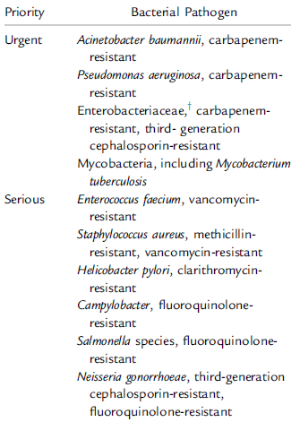

VII. PHAGE SELECTION
Therapeutic phages should be obligately lytic in order to eradicate the target pathogen [9,18,19]. Additionally, the phage should have species-specific activity, a short generation time, and a high rate of adsorption to the target pathogen [20]. Additionally, the phages should be profiled in a phagogram, just like typical antimicrobials [21].By continuously testing the phage particle's effectiveness against a defined collection of pathogens known as a pathogen library, Phagogram will ensure that the therapeutic phages are specific to their target pathogen [22,23].

VIII. PHAGE FORMULA
Phages are typically administered to patients in the clinic as a mixture of various viral strains [24,25, 26,27 ,28,29]. A single phage strain has the ability to precisely target a specific bacterial strain. Prior to treatment, the method must meticulously define the etiologic bacterium, which is a drawback. It is only useful for testing efficacy, tolerability, and proof of concept in vitro. The benefits of the cocktail approach, on the other hand, include increasing the spectrums of the target bacterial strains, simultaneously targeting multiple species, increasing the dose potency as a result of multiple phage strains attacking the same bacterial cell, and limiting resistance as a result of forcing the target bacterium to develop resistance to multiple phages simultaneously in order to survive [30-34]. All of these advantages come with the cocktail approach. The only drawback is that, in order to drive cross-resistance [35], individual phages must compete with one another for the same bacterial cell surface receptor when combined into a single dose.

IX. PHAGE RESISTANCE
Various antiviral mechanisms, including spontaneous chromosomal mutations (a major problem), the ability to prevent the phage particle's genetic material from entering, the presence of DNA restriction-modification enzymes, an unsuccessful infection, and CRISPR-Cas adaptive immunity, all help bacteria resist phage attacks. Phage therapy's efficacy can be improved by switching to new phages with different binding sites or order of exposure [36]. However, maintaining bacterial antiviral defense mechanisms comes at a cost [37,38].However, phages also possess a defense mechanism to combat bacterial immunity [39,40] and to counter-adapt to reinfect resistant bacteria [41,42], both of which are delightful advantages.

X. PHAGE ADJUVANT
Phage adjuvants—active compounds that do not affect bacterial growth on their own—help to prevent phage resistance or boost phage activity when given with the phages. An adjuvant is a combination of synergistic antimicrobials that boost phage production. Phage-infected Burkholderia cenocepacia cells, for instance, produce higher phage particles in the presence of sub-inhibitory concentrations of ciprofloxacin, tetracycline, and meropenem [43]. Tetracycline reduces lateral travel between adjacent cells, which increases contact with phage receptors on the cell surface of uninfected cells, resulting in cell clustering, which may increase phage infections. Phage production does not slow down when bacteria are resistant to antibiotics. Combining phages with sub-inhibitory concentrations of ciprofloxacin or meropenem in a murine endocarditis model may prevent the resistant phage mutants from regrowing, enhancing the efficacy of phage therapy. Combining antibiotics and phage therapy might put more pressure on its development and give researchers a chance to discover more recent antibiotics. Although synergy studies in vitro support the use of phage antibiotic therapy together, animal models are not used [44].Aside from this, the fact that bacterial biofilms are inherently resistant to various antibiotics makes them a major obstacle in the fight against bacterial infections. Phage antibiotic therapy has many drawbacks, one of which is this. DNAs, a potent adjuvant, can degrade extracellular DNA, which plays a variety of roles in bacterial aggregations and the interaction of the biofilm with polymorphonuclear leukocytes during the inflammatory response [45]. Sugar alcohols like sorbitol and xylitol, which diffuse through the biofilm and accumulate as a toxic substance known as non-metabolizable sugar alcohol phosphate, can also be used as phage adjuvants. These findings suggest that phage adjuvants may improve the efficiency with which bacteria are killed during treatment.

XI. THREE-PHASE PHAGE STRATEGY
Using phage therapy to combat multidrug-resistant infections requires a well-organized research and implementation strategy.The following are the three phases:[49]

Phase One (First phase) : Based on knowledge of phage biology, it entails the isolation, characterization, and, ultimately,
matching of phages to their target pathogen.

Second Phase :In this phase, appropriate laboratory and clinical-based models are used to implement relevant phage therapy
rules .

Third Phase : Phage therapy necessitates the establishment of specific regulations and standards.
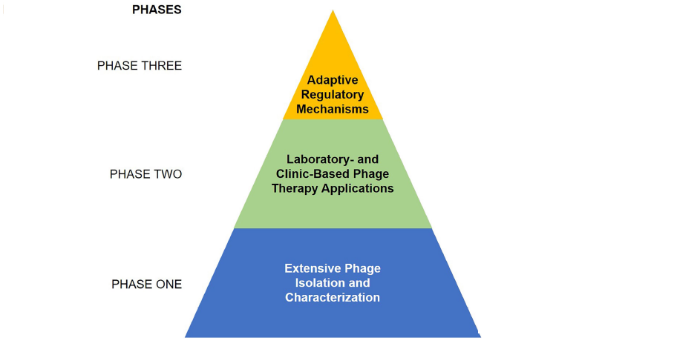

Figure 3: Three-phase phage strategy to combat multiple drug resistance (adopted from Carascal, B., M., et al., 2022.)

XII. TYPES OF PHAGES GENERALLY FOUND
Over the last ﬁfty years, more than 5100 bacteriophages have been identiﬁed and studied, with more than 90% of them belonging to the Siphoviridae , Myoviridae and Podoviridae families . In relation to the type of genetic material they have within the capsid's core, bacteriophages can be divided into four major groups (see): single stranded DNA phages (ssDNA), single stranded RNA phages (ssRNA), double stranded DNA phages (dsDNA), and double stranded RNA phages (dsRNA). [50]
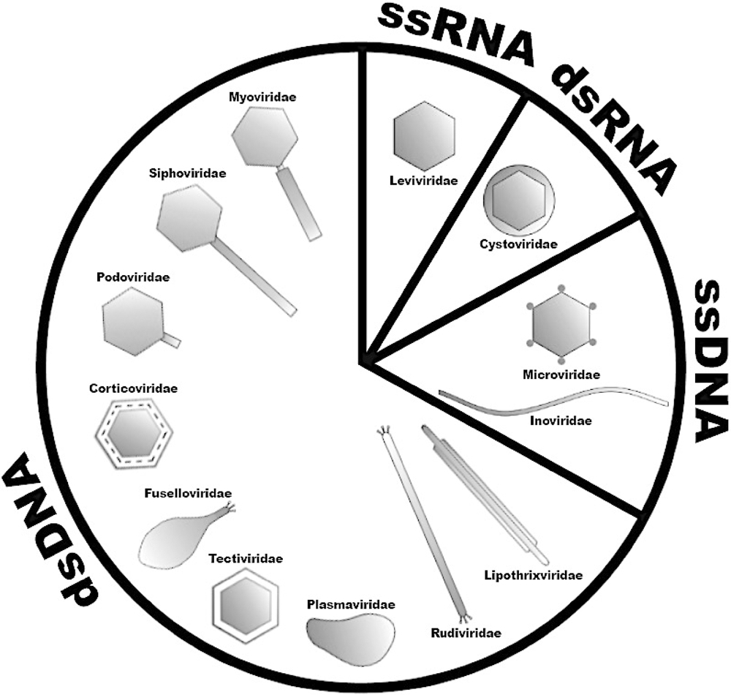

Figure 4: Classiﬁcation of bacteriophages according to their morphology, genetic material and major characteristics.

XIII. STRATEGIES OF REPLICATION AND POSSIBLE FUTURE COMMERCIALIZATION
In general terms, Bacteriophages or phage cultures require host cells in which they multiply. Cultures are grown by infecting bacterial cells with bacteriophages. The phages can be isolated then from the resulting plaques in a lawn of bacteria on a microbial plate.[48]

XIV. THEORETICAL MODELS FOR BACTERIOPHAGE PRODUCTION
The three fundamental parameters for phage production are the populations of phage-infected bacteria, susceptible uninfected bacteria, and free phages.Following this, additional variables, such as resistant uninfected bacteria, have been incorporated into various models.They are influenced by a number of kinetic parameters connected to phage infection and bacterial growth. We generally use Greek characters to name the various kinetic parameters in phage reproduction, following the nomenclature used by other authors.Similarly, burst size, eclipse time, phage decay rate, and adsorption rate can all be represented by Phage concentration, which is typically denoted by the letter "P," and latency time, which is denoted by the letter "L," are the only exceptions. The uniformity of this mathematical language is the only thing that facilitates understanding and data mining in this realm for subsequent reviewers.
Phage production models with descriptions of the population's behavior under various conditions were the subject of numerous efforts. Table 1 provides a differential and integral equation-based summary of various models of phage production.
Phage population shifts over time are typically described by phage production models. A kinetic change in plaque forming units (PFU) per unit of time could be used to illustrate this. The balancing of phage particles is consistent in several models proposed by Campbell (1961) and Beretta and Kuang (1998). These models are useful due to their extensive simplicity. One interesting model proposed by Santos et al.2014) takes into account how the bacterial growth rate affects the phage adsorption constant. The occurrence of bacterial resistance has been the subject of numerous other models. Krysiak-Baltyn et al.'s interesting analytical study (2018), which used a two-stage process to estimate operational cost and productivity and also described variable infection parameters.
Because the phages might become more effective at infecting bacteria over time, the evolution of phages must be considered in terms of a commercial process. In host-range enhancement experiments, where methods for host-range expansion can be achieved for phage therapy applications, this concept could be represented in the form of infection rates. [47]

Table 3. Models of bacteriophage production
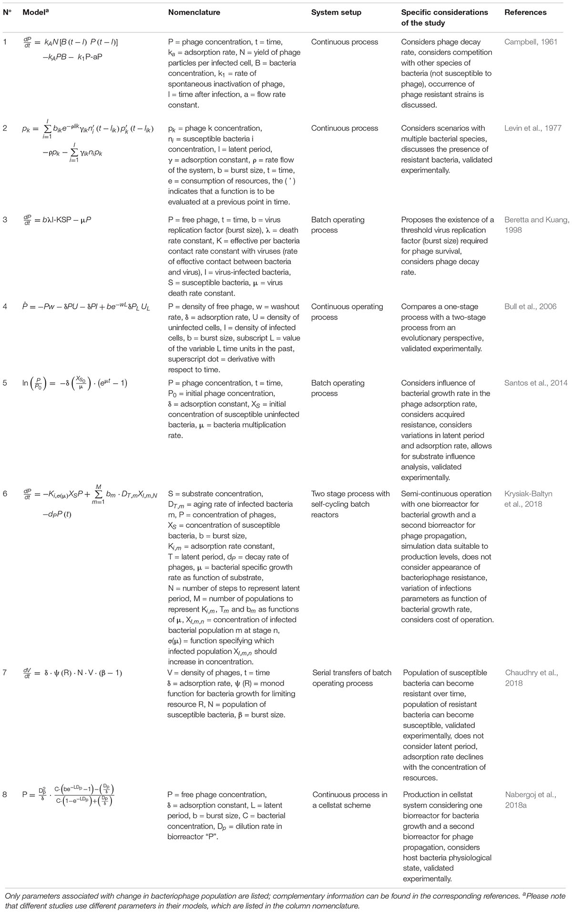

Table 4. Data available on bacteriophage production and various cases of evaluated experiments
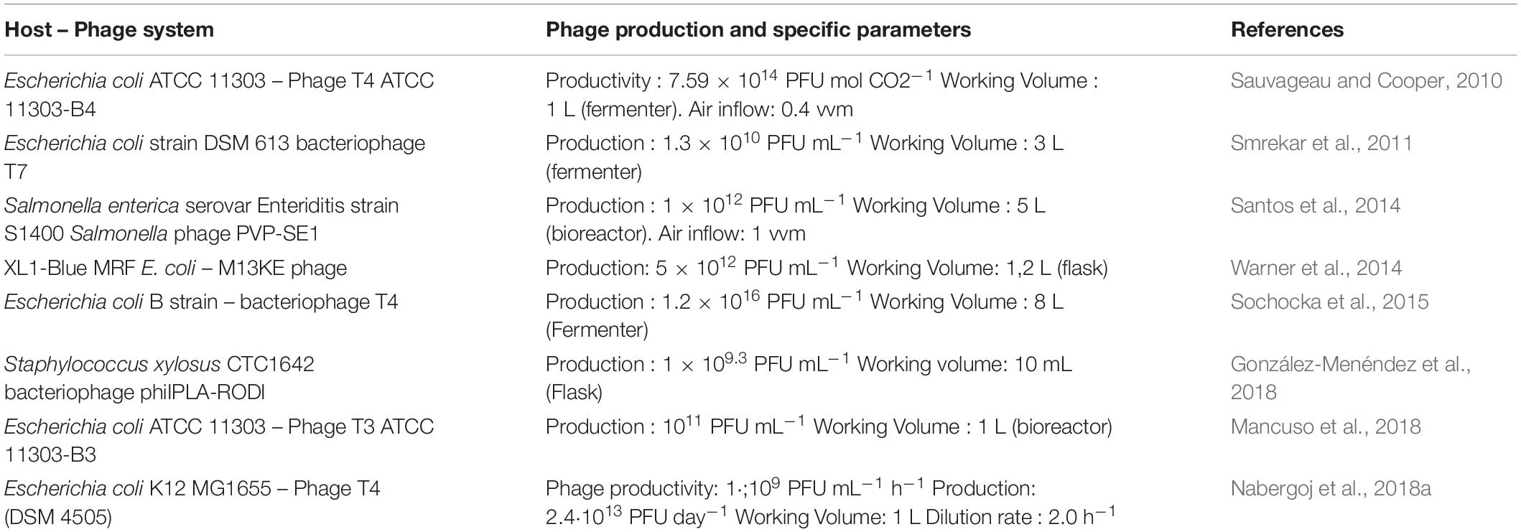

XV. PHAGE ABUNDANCE AND DIVERSITY
Considering the possible phage life cycles, it is quite logical to review where phages are found, and how they are characterized. Specific phages and their characterization are being in the case studies. The first approaches which led to the realization of phage abundance were based on epifluorescent microscopy followed by DNA staining which suggested that, in sea water there are approximately around 10 phages in existence for each bacterial or archaeal cell. Hence, to make sense of phage abundance, one must establish where the majority of their hosts exist. Most of the Earth’s Bacteria and Archaea are found in the open ocean, in ocean sediments and in terrestrial sub-surfaces, where, an estimation of 1.2 x 10²⁹, cells can be found respectively. Bacteria and Archaea are often associated with humans and animals, who provide many niche environments within them, where these micro-organisms become an essential symbiont. Although not significant, bacteria are of essential importance when associated with humans, particularly either in a disease, or as a food producing context, which can fall prey to the bacteriophage attack. Therefore, in terms of human impact, a study of the roles of bacteriophages which infect these bacteria is of immense importance. [46,47]

XVI. SOME METHODS TO GENETICALLY ENHANCE PHAGE & THEIR CAPABILITY
Even though there are a lot of phages that are found in nature, genetic engineering techniques can still improve them.Phage killing efficacy can be increased and additional desirable properties introduced through these methods. Homologous recombination is one of the most widely used methods for phage engineering. To keep phage replication from having a potentially harmful effect, yeast-based and in vitro methods for assembling phage genomes have been developed.Lastly, the DNA-based phage virus-like particles can be produced by cell-free transcription-translation systems. In order to successfully synthesize, replicate, and assemble MS2, T7, phiX174, and T4 phages, the Noireaux laboratory has developed cell-free systems[48,49].

XVII. ADMINISTRATIVE ROUTES AND REAL LIFE EXAMPLES OF PHAGE COCKTAILS IN PATIENTS
Since phage therapy is a very new scientific approach in health care , every patients , who are being treated with phage therapy, are treated empirically . This means adequate routes of administration, duration, dosing, and antibiotic compatibility of phages is just in a trail and error scenario. Fig. 5, briefly summarize the selected phage therapy clinical trials and the single-patient reports in between 2005 and 2020 in terms of routes of administration. [49,50,51] With limited clinical trial data available , the experience , gathered from various case studies , we have showed the potential data of routes and their pathway of threat possession , in the following figure .

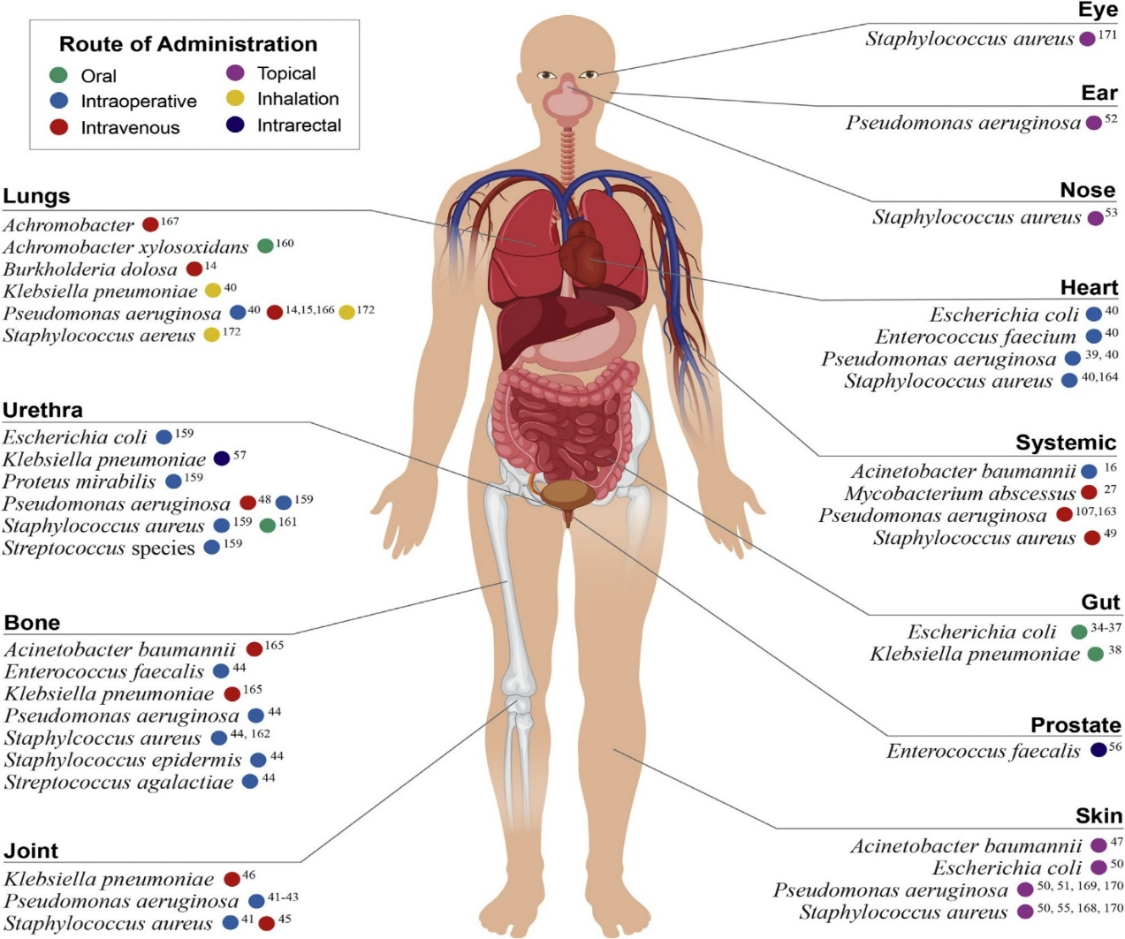

Figure 5. A summary of the clinical trials of phage therapy (case reports ranging between 2005 - 2020). Reports are grouped by the target pathogen and site of infection . The coded color, represents the primary routes of phage administration.

XVIII. APPLICATIONS OF BACTERIOPHAGES IN REAL LIFE:

A. Therapeutic potential Enhancement
Phage therapy's therapeutic potential can be increased through the use of genetically modified synthetic phages. Similar to one study, Zhang and colleagues made the phages insensitive to repression by removing genes related to lysogeny. This allowed them to kill Enterococcus faecalis (vancomycin-resistant) in a biofilm and increase lytic growth and host range [52,53,54].In addition, the treatment of a cystic fibrosis patient with a Mycobacterium abscessus infection was the first clinical application of engineered bacteriophages in recent times. The patient was able to leave the hospital nine days after the phage therapy was started [55].

B. Host Range enhancement for broad spectrum attacks
Phages have so far have been only able to infect a small number of bacterial species [56]. Phages are unable to disrupt the host's commensal bacteria because of this narrow specificity property, which is kind of an advantage in a way. However, the high cost of this therapy is a drawback. Therefore, multiple phage populations can be combined into a cocktail to overcome this restriction and guarantee a wider therapeutic range. In addition, the host range of phages can be expanded through genetic modification [57,58,59].Using targeted mutagenesis of specific regions of the tail fiber, which plays an active role in host recognition, Yehl and colleagues developed a strategy to expand the host range. A lot of diversity was ensured by this strategy. The number of phage-resistant bacteria has decreased as a result of the mutant phage library's expanded host range [60].

C. Removal of Antibiotic Resistance
Individually, the phage components can be altered to carry payloads to enhance antibiotics' bactericidal activity. Lu along with Collins altered a lysogenic phage called M13mp18 in one of these studies, which suppressed the SOS DNA repair system [61].In an extremely lucrative in-vivo mouse model, they demonstrated the efficacy of this method by demonstrating that mice treated with an antibiotic and modified phage had a survival rate of 80% [62].Another illustration is the phage that was engineered by Edgar and colleagues to carry wild-type versions of the rpsL and gyrA genes [63].
Phages have also been engineered by a number of different scientific groups to carry CRISPR-Cas systems to break the resistance to antibiotics [64].Citorik and his colleagues targeted -lactamase genes, which confer resistance to -lactam antibiotics, in the design of several phage-based products [65]

D. Animal Gut Modification
In a variety of animal models, the use of bacteriophages to alter the gut microbial community has already been attempted.Hsu and colleagues examined the effect of phages on germ-free mice in one study.The mice were pre-populated with bacterial species that are known to thrive in human intestines.Phages were used to make individual attacks on each member.28% of the Enterococcus faecalis population was found to be phage resistant within two days [66].This research demonstrates how crucial the development of resistance is to the possibility of using phages to alter the gut microbiome.

E. Delivering of new Antimicrobial agents
The use of bacteriophages to alter the gut microbial community has already been attempted in a variety of animal models.In one study, Hsu and his colleagues looked at how phages affected germ-free mice.Bacterial species that are known to thrive in human intestines were pre-populated in the mice.Phishing was used to target each member individually.28% of the Enterococcus faecalis population was found to be phage resistant within two days [66].Concerns about the potential use of phages to alter the gut microbiome are raised by this study, which demonstrates how crucial it is for resistance to develop.

F. Targeted CRISPR Editing by Phages
Any gene in a bacterial population can be disabled using CRISPR editing.In one study, Selle and his colleagues used the genetically modified phage CD24-2, which contains a self-targeting CRISPR, to direct the Clostridioides difficile type I-B CRISPR-Cas3 system toward the bacterial chromosome [71]. The phage-delivered CRISPR activated the endogenous Cas3 protein in order to digest the chromosomal DNA of the bacterial host.It was found that the modified phage was better at getting rid of Clostridioides difficile [72].

G. Disrupting of Biofilms for better antibacterial environments
By creating a physical barrier, biofilms actually provide resistance to antimicrobial agents [73]. Depolymerases are enzymes that break down polysaccharides and are produced by phages that infect bacterial strains. In one study, Lu and Collins created a T7 phage that, during infection, produced dispersin B, a biofilm-degrading enzyme. The bacterial biofilm cell counts were reduced by 99 percent using the modified phage [74].Bioengineering phages can also deactivate quorum-sensing molecules. The application of T7aiiA reduced Pseudomonas aeruginosa's quorum sensing in a mixed biofilm, resulting in a 75% decrease in biomass [75].

H. Killing of bacteria with Endolysins – the phage enzymes
Instead of utilizing the entire phage, a number of researchers concentrated on the cell wall degrading endolysins encoded by phages.Phage endolysins degrade the host peptidoglycan toward the end of the replication cycle, resulting in cell lysis.The phage particles are then released as part of the process [76].In one study, 13/15 patient samples showed that an endolysin could kill Gardnerella bacteria without affecting the vaginal microbiome [77].
Lysocin PyS2-GN4 was also found to sterilize high Pseudomonas concentrations in a number of other studies.

I. Delivering of Drugs in association with phages (In terms of Eukaryotic Applications)
The ability of bio-engineered phages to deliver drugs to specific cancer cells is like a boon of wish to minimize the toxicity and side effects of cancer therapies [77,78,79]. Drugs with low solubility can have phages attached to them, allowing for lower dosages.In one study, Bar and colleagues found that hygromycin, which is carried by phages, was more effective than free drugs for treating human breast carcinoma [80]. In another study, Du and colleagues used phage coupling to target the human hepato-carcinoma cell line with doxorubicin and saw a decrease in the growth of the tumor [81].Additionally, it has been proposed that modified phages can cause the targeted killing of cancer cells [82].Phage applications are also being used to treat brain disorders like tinnitus, Parkinson's, and Alzheimer's.
J. Phages acting as Sensors
Sensors generally have at least two functional components. First , is the recognition element for a target and the Second is transducing for reporting , after the recognition element detects the target. After the target, such as a bacterium, is found by the receptor binding proteins, the phage's genome acts as the reporter, resulting in the formation of additional phages as a plaque upon entering the target cell.As a result, bacteriophages have a remarkable capacity to recognize their target and function as biosensors.82, 83, and 84]. Bacterial-specific bacteriophage proteins are used in another method for detecting bacteria [84, 85].Each of them binds to particular molecules on a bacterium's surface.After that, the reporter binds to the surface of the bacteria[86,87].Poshtiban and colleagues [88] functionalized paramagnetic beads using the alleged RBP of a Campylobacter jejuni phage in one study.The beads were used as a detector and to concentrate C. jejuni from food samples.

K. Tissue Construction by Genetically Bio-Engineered Phages
Additionally, phages containing cell-binding peptides can be produced through phage display, which in turn can construct tissue.Phages are capable of self-assembling into two-dimensional and three-dimensional structures [89,90] and can be utilized in 3-D printing to construct scaffolds on which cells can grow [91,92].The best option for this are filamentous phages that can be used for display and contain more than one protein [93].Lastly, phages can be cultured at various scales if necessary, and they are chemically and genetically modified [89].

L. Eukaryotic cell gene delivery
Due to the numerous advantages of phages in terms of targeting, safety, and cargo capacity, interest in using phage vectors is growing steadily [95,97].Bacteriophages can carry a lot of cargo. In addition, it is simple to modify them so that they express targeting of eukaryotic cells. Due to their lack of natural tropism for eukaryotic cells, bacteriophages may also be safer than mammalian viral vectors. Phages can also be used to deliver siRNAs [96-98].A viral vector known as AAVP was created by Hajitou and colleagues in one study. In it, a chimeric genome containing an adeno-associated virus (AAV) cassette was introduced into the phage genome and packaged in a M13 phage particle. In addition, when using bacteriophages to target cancer cells in the brains of mice, the international team at Imperial College London demonstrated promising results. They were able to directly treat cancer with targeted therapy by employing that particular strategy. In addition, a study demonstrated antitumor activity of bacteriophage T4 in a mouse B16 model of melanoma.
Lastly, Qazi and colleagues used P22 VLPs to create a programmable delivery vehicle for Cas9 in one study, as CRISPR Cas systems are emerging to edit genetic information[99].
M. Phages in making Vaccines
Some phages are useful as excellent vaccine delivery vehicles due to their inherent immunogenicity [99,100].Phage gene therapy can be applied to DNA-based vaccines [101,102], and the phage's nucleic acid cargo deliverer is another lucrative product [99,103,104].Various antigens for HIV, the foot and mouth disease virus (FMDV), and the anthrax toxin have been displayed using T4 bacteriophages.105] These preliminary studies demonstrate that phage-based vaccines can elicit responses from both cells and antibodies.

XIX. CONSTRAINTS OF PHAGE THERAPY

Phage therapy can also show some cons.

1. Since , every creature evolves and adapts . Bacterial evolution in respect to phage attacks may hinder the therapy . New implementations are done by the bacterial hosts to digest external bacteriophage DNA (via restriction modification) provides one such example of the evolution .

2. Adsorption blocking and production of extracellular barrier matrix by some bacteria present another problematic side to this therapy .

3. With the mechanism of super injection exclusion (Sie) bacteria can impair genome injection done by phages.
Phage genome replication can also be inhibited by (B-R-E-X) systems , present in bacteria .

4.Pharmacokinetics of phages is much more complex than we thought . Like , phage therapy in animals can elicit immune system to produce antibodies of bacteriophages .

6. Not all bacteriophages have the capability to be quality therapeutic agents. The main challenge lies in their application , stability and their adaptability to get to and lyse the bacterial host.

XX. CONCLUSION – AN END AND A BEGINNING
While combating bacterial infections , the available data on the use of bacteriophages , specifically those of multidrug-resistant bacteria, shows promise for the new revolution of phage therapy , as either a supplement to antibiotics or as an excellent alternative to it . However, inconsistencies in recent findings on the potential for horizontal gene transfer and the host range , makes it very clear that we need a far better understanding of the interaction between phage, the human host and the microbiome, before doing a large scale implementation of phage therapy . Here , comes the Phage endolysins , which may thus be a much more practical therapeutic tool for their immunological potential and other ease of access benefits . Finally , these antibacterial bioagents when used in cocktails , like in association with antibiotics or modified mutant phage forms , showed that, this will be an absolute necessity for countering the rising problem of antibiotic-resistant infections as , till now it’s the only effective way to enhance its efficacy .

XXI. FINAL THOUGHTS
If there is a disease, the nature will always create a therapy for it. We just need to find it, like we did with the bacteriophages. In the biome it’s always a inter – relationships between a prey and a predator. So, what seems like a predator must be a prey to some other organism or microorganism.
Finally, if the findings of ours, in this review, can help even 1% of the population we would think this work of ours has reached its zenith of success.

REFERENCES

1. How 'good' viruses may influence health. https://www.medicalnewstoday.com/articles/327167#What-is-the-virome?

2. News Track .Know the deep secret about Ganga water, Scientists proved. Jul 13 2020
https://english.newstracklive.com/news/why-ganga-water-is-so-pure-scientifically-secret-is-so-deep-sc108-nu910-ta294-1106121-1.html

3. Hankin EH. L’action bactéricide des eaux de la Jumna et du Gange sur le vibrion du choléra. Ann Inst Pasteur. 1896;10:511–23.

4. Dwivedi, S., Chauhan, P.S., Mishra, S. et al. Self-cleansing properties of Ganga during mass ritualistic bathing on Maha-Kumbh. Environ Monit Assess 192, 221 (2020). https://doi.org/10.1007/s10661-020-8152-2

5. Phage therapy .https://www.whatisbiotechnology.org/ index.php/science/ summary/phage-therapy/#:~: text=Definition, to%20treat% 20 pathogenic%20bacterial%20infections.

6. Harper, D.R. (2020). Introduction to Bacteriophages. In: Harper, D.R., Abedon, S.T., Burrowes, B.H., McConville, M.L. (eds) Bacteriophages. Springer, Cham. https://doi.org/10.1007/978-3-319-40598-8_48-2

7. Science First Hand , 15 Mar 2017 , Bacteriophages the enemies of our enemies , volume 46, N1

6-8. Liu, Y., Demina, T. A., Roux, S., Aiewsakun, P., Kazlauskas, D., Simmonds, P., et al. (2021). Diversity, taxonomy, and evolution of archaeal viruses of the class Caudoviricetes. PLoS Biol. 19:e3001442. doi: 10.1371/journal. pbio.3001442

9. Harper, D. R., and Enright, M. C. (2011). Bacteriophages for the treatment of Pseudomonas aeruginosa infections. J. Appl. Microbiol. 111, 1–7. doi: 10.1111/j.1365-2672.2011.05003.x

10. Lin, D. M., Koskella, B., and Lin, H. C. (2017). Phage therapy: an alternative to antibiotics in the age of multi-drug resistance. World J. Gastrointest. Pharmacol. Ther. 8:162. doi: 10.4292/wjgpt.v8.i3.162

11. Khawaja, K. A., Rauf, M., Abbas, Z., and Rehman, S. U. (2016). A virulent phage JHP against Pseudomonas aeruginosa showed infectivity against multiple genera. J. Basic Microbiol. 56, 1090–1097. doi: 10.1002/ jobm.201500764

12. Bhetwal, A., Maharjan, A., Shakya, S., Satyal, D., Ghimire, S., Khanal, P. R., et al. (2017). Isolation of potential phages against multidrug-resistant bacterial isolates: promising agents in the rivers of Kathmandu, Nepal. Biomed. Res. Int. 2017:3723254. doi: 10.1155/2017/3723254

13. Summers WC. The strange history of phage therapy. Bacteriophage. 2012;2:130e133.

14. Aminov RI. A brief history of the antibiotic era: lessons learned and challenges for the future. Front Microbiol. 2010;1:134.

15. CDC. Antibiotic resistance threats in the United States. http://www.cdc.gov/drugresistance/threat-report- 20132013.

16. New report calls for urgent action to avert antimicrobial resistance crisis . 29 April 2019 https://www.who.int/news/item/29-04-2019-new-report-calls-for-urgent-action-to-avert-antimicrobial-resistance-crisis

17. Eric A. Friedman . Behind the Headlines: 10 Million Deaths From Antimicrobial Resistance by 2050 (or Not?) .February 12, 2020
https://oneill.law.georgetown.edu/behind-the-headlines-10-million-antimicrobial-deaths-by-2050-or-not/

18. Wirjon, I. A., Lau, N. S., and Arip, Y. M. (2016). Complete genome sequence of Proteus mirabilis phage pPM_01 isolated from raw sewage. Intervirology 59, 243–253. doi: 10.1159/000468987

19. Lehman, S. M., Mearns, G., Rankin, D., Cole, R. A., Smrekar, F., Branston, S. D., et al. (2019). Design and preclinical development of a phage product for the treatment of antibiotic-resistant Staphylococcus aureus infections. Viruses 11:88. doi: 10.3390/v11010088

20. Drulis-Kawa, Z., Majkowska-Skrobek, G., and Maciejewska, B. (2015). Bacteriophages and phage-derived proteins–application approaches. Curr. Med. Chem. 22, 1757–1773. doi:10.2174/0929867322666150209152851

21. Barbu, E. M., Cady, K. C., and Hubby, B. (2016). Phage therapy in the era of synthetic biology. Cold Spring Harb. Perspect. Biol. 8:a023879. doi: 10.1101/ cshperspect.a023879

22. Deresinski, S. (2009). Bacteriophage therapy: exploiting smaller fleas. Clin. Infect. Dis. 48, 1096–1101. doi: 10.1086/597405

23. Casey, E., Van Sinderen, D., and Mahony, J. (2018). In vitro characteristics of phages to guide ‘real life’ phage therapy suitability. Viruses 10:163. doi: 10.3390/v10040163

24. Law N, Logan C, Yung G, et al. Successful adjunctive use of bacteriophage therapy for treatment of multidrug-resistant Pseudomonas aeruginosa infection in a cystic fibrosis patient. Infection. 2019;47:665e668.

25.Schooley RT, Biswas B, Gill JJ, et al. Development and use of personalized bacteriophage-based therapeutic cocktails to treat a patient with a disseminated resistant Acinetobacter baumannii infection. Antimicrob Agent Chemother. 2017;61. e00954-17.

26.Dedrick RM, Guerrero-Bustamante CA, Garlena RA, et al. Engineered bacteriophages for treatment of a patient with a disseminated drug-resistant Mycobacterium abscessus. Nat Med. 2019;25:730e733.

27. Jault P, Leclerc T, Jennes S, et al. Efficacy and tolerability of a cocktail of bacteriophages to treat burn wounds infected by Pseudomonas aeruginosa (PhagoBurn): a randomised, controlled, doubleblind phase 1/2 trial. Lancet Infect Dis. 2019;19:35e45.

28. Chan BK, Turner PE, Kim S, Mojibian HR, Elefteriades JA, Narayan D. Phage treatment of an aortic graft infected with Pseudomonas aeruginosa. Evol Med Public Health. 2018;2018:60e66.

29.Doub JB, Ng VY, Johnson AJ, et al. Salvage bacteriophage therapy for a chronic MRSA prosthetic joint infection. Antibiotics. 2020;9:241.

30.Ross A, Ward S, Hyman P. More is better: selecting for broad host range bacteriophages. Front Microbiol. 2016;7:1352.

31.Schmerer M, Molineux IJ, Bull JJ. Synergy as a rationale for phage therapy using phage cocktails. PeerJ. 2014;2, e590.

32.Levin BR, Bull JJ. Population and evolutionary dynamics of phage therapy. Nat Rev Microbiol. 2004;2:166e173.

33.Oechslin F. Resistance development to bacteriophages occurring during bacteriophage therapy. Viruses. 2018;10:351.

34.Costa P, Pereira C, Gomes A, Almeida A. Efficiency of single phage suspensions and phage cocktail in the inactivation of Escherichia coli and Salmonella typhimurium: an in vitro preliminary study. Microorganisms. 2019;7:94.

35. Abedon ST, Thomas-Abedon C. Phage therapy pharmacology. Curr Pharm Biotechnol. 2010;11:28e47.

36. Wright RCT, Friman VP, Smith MCM, Brockhurst MA. Resistance evolution against phage combinations depends on the timing and order of exposure. mBio. 2019;10. e01652-01619
37. Vasu K, Nagaraja V. Diverse functions of restriction modification systems in addition to cellular defense. Microbiol Mol Biol Rev. 2013;77:53e72.

38.Vale PF, Lafforgue G, Gatchitch F, Gardan R, Moineau S, Gandon S. Costs of CRISPR-cas-mediated resistance in Streptococcus thermophilus. Proc Biol Sci. 2015;282:20151270.

39.Piya D, Vara L, Russell WK, Young R, Gill JJ. The multicomponent antirestriction system of phage P1 is linked to capsid morphogenesis. Mol Microbiol. 2017;105:399e412.

40.Pawluk A, Davidson AR, Maxwell KL. Anti-CRISPR: discovery, mechanism and function. Nat Rev Microbiol. 2018;16:12e17.

41. Cortez MH, Weitz JS. Coevolution can reverse predator-prey cycles. Proc Natl Acad Sci U S A. 2014;111:7486e7491.

42. Hampton HG, Watson BNJ, Fineran PC. The arms race between bacteria and their phage foes.Nature. 2020;577:327e336.

43. Kamal F, Dennis JJ. Burkholderia cepacia complex phage-antibiotic synergy (PAS): antibiotics stimulate lytic phage activity. Appl Environ Microbiol. 2015;81:1132e1138.

44. Luong, T., Salabarria, C., A., Roach, R., D., 2020. Phage Therapy in the Resistance Era: Where Do We Stand and Where Are We Going? https://doi.org/10.1016/j.clinthera.2020.07.014

45. Harper D, Parracho H, Walker J, et al. Bacteriophages and biofilms. Antibiotics. 2014;3:270e284.

46. 9.4A: Batch Culture of Bacteriophages https://bio.libretexts.org/Bookshelves/Microbiology/Book%3A_Microbiology_ (Boundless)/9%3A_Viruses/9.4%3A_Culturing_Viruses/9.4A%3A_Batch_Culture_of_Bacteriophages#:~:text=which%20to%20multiply.-,For%20bacteriophages%2C%20cultures%20are%20grown%20by%20infecting%20bacterial%20cells.,of%20viruses%20that%20 infect %20bacteria

47. García, R., Latz, S., Romero, J., Higuera, G., García, K., & Bastías, R. (2019). Bacteriophage Production Models: An Overview. Frontiers in microbiology, 10, 1187. https://doi.org/10.3389/fmicb.2019.01187

48. Clokie, M. R., Millard, A. D., Letarov, A. V., & Heaphy, S. (2011). Phages in nature. Bacteriophage, 1(1), 31–45. https://doi.org/10.4161/bact.1.1.14942

49. Hyman, P. (2019). Phages for phage therapy: isolation, characterization, and host range breadth. Pharmaceuticals (Basel) 12:35. doi: 10.3390/ph12010035

50. Harada, L.K., Silva, E.C., Campos, W.F., Del Fiol, F.S., Vila, M., Dąbrowska, K., Krylov, V.N., & Balcão, V.M. (2018). Biotechnological applications of bacteriophages: State of the art. Microbiological research, 212-213, 38-58 .

51. Qadir, M. I., Mobeen, T., & Masood, A. (2018). Phage therapy: progress in pharmacokinetics. Brazilian Journal of Pharmaceutical Sciences, 54(1). doi:10.1590/s2175-97902018000117093

52. Stevens, R.H.; Porras, O.D.; Delisle, A.L. Bacteriophages induced from lysogenic root canal isolates ofEnterococcus faecalis. Oral Microbiol. Immunol. 2009, 24, 278–284. [CrossRef]

53. .Zhang, H.; Fouts, D.E.; DePew, J.; Stevens, R.H. Genetic modifications to temperate Enterococcus faecalis phage Ef11 that abolish the establishment of lysogeny and sensitivity to repressor, and increase host range and productivity of lytic infection. Microbiology 2013, 159, 1023–1035. [CrossRef]

54.Tinoco, J.M.; Buttaro, B.; Zhang, H.; Liss, N.; Sassone, L.M.; Stevens, R. Effect of a genetically engineered bacteriophage on Enterococcus faecalis biofilms. Arch. Oral Biol. 2016, 71, 80–86. [CrossRef] [PubMed]

55. Bioscience,E.Eligobiotics®(Re)Programmingthe Microbiome. Available online: https://eligo.bio/technology/ (accessed on 1 April 2021).

56. Yehl, K.; Lemire, S.; Yang, A.C.; Ando, H.; Mimee, M.; Torres, M.D.T.; de la Fuente-Nunez, C.; Lu, T.K. Engineering Phage Host-Range and Suppressing Bacterial Resistance through Phage Tail Fiber Mutagenesis. Cell 2019, 179, 459–469.e9. [CrossRef] [PubMed]

57.Mahichi, F.; Synnott, A.J.; Yamamichi, K.; Osada, T.; Tanji, Y. Site-specific recombination of T2 phage using IP008 long tail fiber genes provides a targeted method for expanding host range while retaining lytic activity. FEMS Microbiol. Lett. 2009, 295, 211–217. [CrossRef]

58.Sarkis, G.J.; Jacobs, W.R., Jr.; Hatfulll, G.F. L5 luciferase reporter mycobacteriophages: A sensitive tool for the detection and assay of live mycobacteria. Mol. Microbiol. 1995, 15, 1055–1067. [CrossRef] [PubMed]

59.Edgar, R.; Friedman, N.; Molshanski-Mor, S.; Qimron, U. Reversing Bacterial Resistance to Antibiotics by Phage-Mediated Delivery of Dominant Sensitive Genes. Appl. Environ. Microbiol. 2012, 78, 744–751. [CrossRef] [PubMed]

60.Vaks, L.; Benhar, I. In vivo characteristics of targeted drug-carrying filamentous bacteriophage nanomedicines. J. Nanobiotechnol. 2011, 9, 58. [CrossRef] [PubMed]

61. Sarker SA, Sultana S, Reuteler G, et al. Oral phage therapy of acute bacterial diarrhea with two coliphage preparations: a randomized trial in children from Bangladesh. EBioMedicine. 2016;4: 124e137.

62. Gibb B, Hyman P, Schneider CL. The Many Applications of Engineered Bacteriophages-An Overview. Pharmaceuticals (Basel). 2021 Jun 30;14(7):634. doi: 10.3390/ph14070634. PMID: 34208847; PMCID: PMC8308837.

63. Selle, K.; Fletcher, J.R.; Tuson, H.; Schmitt, D.S.; McMillan, L.; Vridhambal, G.S.; Rivera, A.J.; Montgomery, S.A.; Fortier, L.-C.; Barrangou, R.; et al. In Vivo Targeting of Clostridioides difficile Using Phage-Delivered CRISPR-Cas3 Antimicrobials. mBio 2020,11. [CrossRef]

64. Lu, T.K.; Collins, J.J. Dispersing biofilms with engineered enzymatic bacteriophage. Proc. Natl. Acad. Sci. USA 2007,104, 11197–11202. [CrossRef] [PubMed]

65.Pei, R.; Lamas-Samanamud, G.R. Inhibition of biofilm formation by t7 bacteriophages producing quorum-quenching enzymes. Appl. Environ. Microbiol. 2014, 80, 5340–5348. [CrossRef]

66. Ross, A.; Ward, S.; Hyman, P. More Is Better: Selecting for Broad Host Range Bacteriophages. Front. Microbiol. 2016, 7, 1352. [CrossRef] [PubMed]

67. .Díez-Martínez, R.; De Paz, H.D.; Garcia-Fernandez, E.; Bustamante, N.; Euler, C.W.; Fischetti, V.A.; Menéndez, M.; García, P. A novel chimeric phage lysin with high in vitro and in vivo bactericidal activity against Streptococcus pneumoniae. J. Antimicrob. Chemother. 2015, 70, 1763–1773. [CrossRef]

68.Landlinger, C.; Tisakova, L.; Oberbauer, V.; Schwebs, T.; Muhammad, A.; Latka, A.; Van Simaey, L.; Vaneechoutte, M.; Guschin, A.; Resch, G.; et al. Engineered Phage Endolysin Eliminates Gardnerella Biofilm without Damaging Beneficial Bacteria in Bacterial Vaginosis Ex Vivo. Pathogens 2021, 10, 54. [CrossRef]

69.Briers, Y.; Walmagh, M.; Van Puyenbroeck, V.; Cornelissen, A.; Cenens, W.; Aertsen, A.; Oliveira, H.; Azeredo, J.; Verween, G.; Pirnay, J.-P.; et al. Engineered endolysin-based “artilysins” to combat multidrug-resistant gram-negative pathogens. mBio 2014, 5, e01379-14. [CrossRef]

70. Heselpoth, R.D.; Euler, C.W.; Schuch, R.; Fischetti, V.A. Lysocins: Bioengineered Antimicrobials That Deliver Lysins across the Outer Membrane of Gram-Negative Bacteria. Antimicrob. Agents Chemother. 2019, 63. [CrossRef]

71. Kim, D.; Kwon, S.-J.; Wu, X.; Sauve, J.; Lee, I.; Nam, J.; Kim, J.; Dordick, J.S. Selective Killing of Pathogenic Bacteria by Antimicrobial Silver Nanoparticle—Cell Wall Binding Domain Conjugates. ACS Appl. Mater. Interfaces 2018, 10, 13317–13324. [CrossRef]
72. Grigonyte, A.M.; Hapeshi, A.; Constantinidou, C.; Millard, A. Modification of Bacteriophages to Increase Their Association with Lung Epithelium Cells In Vitro. Pharmaceuticals 2021, 14, 308. [CrossRef] [PubMed]

73.Karimi, M.; Mirshekari, H.; Basri, S.M.M.; Bahrami, S.; Moghoofei, M.; Hamblin, M.R. Bacteriophages and phage-inspired nanocarriers for targeted delivery of therapeutic cargos. Adv. Drug Deliv. Rev. 2016, 106, 45–62. [CrossRef] [PubMed]

74.Hyman, P.; Denyes, J. Bacteriophages in Nanotechnology: History and Future; Springer International Publishing: Cham, Switzerland, 2021.

75. Schmelcher, M.; Tchang, V.S.; Loessner, M.J. Domain shuffling and module engineering of Listeria phage endolysins for enhanced lytic activity and binding affinity. Microb. Biotechnol. 2011, 4, 651–662. [CrossRef] [PubMed]

76. Yayon, A.; Aviezer, D.; Safran, M.; Gross, J.L.; Heldman, Y.; Cabilly, S.; Givol, D.; Katchalski-Katzir, E. Isolation of peptides that inhibit binding of basic fibroblast growth factor to its receptor from a random phage-epitope library. Proc. Natl. Acad. Sci. USA 1993, 90, 10643–10647. [CrossRef]

77. Hosseinidoust, Z. Phage-Mediated Gene Therapy. Curr. Gene Ther. 2017, 17, 120–126. [CrossRef]

78.Bedi, D.; Musacchio, T.; Fagbohun, O.A.; Gillespie, J.W.; Deinnocentes, P.; Bird, R.C.; Bookbinder, L.; Torchilin, V.P.; Petrenko, V.A. Delivery of siRNA into breast cancer cells via phage fusion protein-targeted liposomes. Nanomed. Nanotechnol. Biol. Med. 2011, 7, 315–323. [CrossRef] [PubMed]

79. Bedi, D.; Gillespie, J.W.; Petrenko, V.A., Jr.; Ebner, A.; Leitner, M.; Hinterdorfer, P.; Petrenko, V.A. Targeted Delivery of siRNA into Breast Cancer Cells via Phage Fusion Proteins. Mol. Pharm. 2013, 10, 551–559. [CrossRef]

80. Ashley, C.E.; Carnes, E.C.; Phillips, G.K.; Durfee, P.N.; Buley, M.D.; Lino, C.A.; Padilla, D.P.; Phillips, B.; Carter, M.B.; Willman, C.L.; et al. Cell-Specific Delivery of Diverse Cargos by Bacteriophage MS2 Virus-like Particles. ACS Nano 2011, 5, 5729–5745. [CrossRef] [PubMed]

81.Hajitou, A.; Trepel, M.; Lilley, C.E.; Soghomonyan, S.; Alauddin, M.M.; Marini, F.C., 3rd; Restel, B.H.; Ozawa, M.G.; Moya, C.A.; Rangel, R.; et al. A hybrid vector for ligand-directed tumor targeting and molecular imaging. Cell 2006, 125, 385–398. [CrossRef]

82. Staquicini, F.I.; Sidman, R.L.; Arap, W.; Pasqualini, R. Phage display technology for stem cell delivery and systemic therapy. Adv. Drug Deliv. Rev. 2010, 62, 1213–1216. [CrossRef]

83.Hyman, P. Bacteriophages and Nanostructured Materials. Adv. Appl. Microbiol. 2012, 78, 55–73. [CrossRef] [PubMed]

84. Wang, J.; Yang, M.; Zhu, Y.; Wang, L.; Tomsia, A.P.; Mao, C. Phage nanofibers induce vascularized osteogenesis in 3d printed bone scaffolds. Adv. Mater. 2014, 26, 4961–4966. [CrossRef] [PubMed]

85. Cao, B.; Yang, M.; Mao, C. Phage as a Genetically Modifiable Supramacromolecule in Chemistry, Materials and Medicine. Acc. Chem. Res. 2016, 49, 1111–1120. [CrossRef] [PubMed]

86.Lee, D.-Y.; Lee, H.; Kim, Y.; Yoo, S.Y.; Chung, W.-J.; Kim, G. Phage as versatile nanoink for printing 3-D cell-laden scaffolds. Acta Biomater. 2016, 29, 112–124. [CrossRef] [PubMed]

87.Yoo, S.Y.; Merzlyak, A.; Lee, S.-W. Facile growth factor immobilization platform based on engineered phage matrices. Soft Matter 2011, 7, 1660–1666. [CrossRef]
88.Chung, W.-J.; Merzlyak, A.; Lee, S.-W. Fabrication of engineered M13 bacteriophages into liquid crystalline films and fibers for directional growth and encapsulation of fibroblasts. Soft Matter 2010, 6, 4454–4459. [CrossRef]

89.Shao, Z.; Zhang, X.; Pi, Y.; Wang, X.; Jia, Z.; Zhu, J.; Dai, L.; Chen, W.; Yin, L.; Chen, H.; et al. Polycaprolactone electrospun mesh conjugated with an MSC affinity peptide for MSC homing in vivo. Biomaterials 2012, 33, 3375–3387. [CrossRef] [PubMed]

90.Yoo, S.Y.; Kobayashi, M.; Lee, P.P.; Lee, S.-W. Early osteogenic differentiation of mouse preosteoblasts induced by collagen-derived dgea-peptide on nanofibrous phage tissue matrices. Biomacromolecules 2011, 12, 987–996. [CrossRef] [PubMed]

91.Raja, I.S.; Kim, C.; Song, S.-J.; Shin, Y.C.; Kang, M.S.; Hyon, S.-H.; Oh, J.-W.; Han, D.-W. Virus-Incorporated Biomimetic Nanocomposites for Tissue Regeneration. Nanomaterials 2019, 9, 1014. [CrossRef] [PubMed]

92.Paczesny, J.; Bielec, K. Application of Bacteriophages in Nanotechnology. Nanomaterials 2020, 10, 1944. [CrossRef]
93.García, R.; Latz, S.; Romero, J.; Higuera, G.; García, K.; Bastías, R. Bacteriophage Production Models: An Overview. Front.Microbiol. 2019, 10, 1187. [CrossRef]

94. Ryan O'Hare. Tumour-targeting viruses hold hope for incurable brain cancers. 01 April 2019 https://www.imperial.ac.uk/news/190727/tumour-targeting-viruses-hold-hope-incurable-brain/#:~:text=Now%2C%20an% 20international%20team%20led,in%20the%20brains%20of%20mice.&text=Using%20the%20approach%2C%20they%20were,amplify%20the%20effect%20with%20TMZ.

95.Abbaszadeh, F., Leylabadlo, H.E., Alinezhad, F. et al. Bacteriophages: cancer diagnosis, treatment, and future prospects. J. Pharm. Investig. 51, 23–34 (2021). https://doi.org/10.1007/s40005-020-00503-x

96.Gibb B, Hyman P, Schneider CL. The Many Applications of Engineered Bacteriophages-An Overview. Pharmaceuticals (Basel). 2021 Jun 30;14(7):634. doi: 10.3390/ph14070634. PMID: 34208847; PMCID: PMC8308837.

97. Bahadir, A.O.; Balcioglu, B.K.; Uzyol, K.S.; Hatipoglu, I.; Sogut, I.; Bas¸alp, A.; Erdag, B. Phage displayed hbv core antigen with immunogenic activity. Appl. Biochem. Biotechnol. 2011, 165, 1437–1447. [CrossRef]

98. Caldeira, J.; Bustos, J.; Peabody, J.; Chackerian, B.; Peabody, D.S. Epitope-Specific Anti-hCG Vaccines on a Virus Like Particle Platform. PLoS ONE 2015, 10, e0141407. [CrossRef] [PubMed]

99.Mogus, A.T.; Liu, L.; Jia, M.; Ajayi, D.T.; Xu, K.; Kong, R.; Huang, J.; Yu, J.; Kwong, P.D.; Mascola, J.R.; et al. Virus-Like Particle Based Vaccines Elicit Neutralizing Antibodies against the HIV-1 Fusion Peptide. Vaccines 2020, 8, 765. [CrossRef]

100.Sartorius, R.; D’Apice, L.; Trovato, M.; Cuccaro, F.; Costa, V.; De Leo, M.G.; Marzullo, V.M.; Biondo, C.; D’Auria, S.; De Matteis, M.A.; et al. Antigen delivery by filamentous bacteriophage fd displaying an anti- DEC -205 single-chain variable fragment confers adjuvanticity by triggering a TLR 9-mediated immune response. EMBO Mol. Med. 2015, 7, 973–988. [CrossRef]

101. Thrane, S.; Janitzek, C.M.; Matondo, S.; Resende, M.; Gustavsson, T.; de Jongh, W.A.; Clemmensen, S.; Roeffen, W.; van de Vegte-Bolmer, M.; van Gemert, G.J.; et al. Bacterial superglue enables easy development of efficient virus-like particle based vaccines. J. Nanobiotechnol. 2016, 14, 30. [CrossRef]

102. Whaley, S.R.; English, D.S.; Hu, E.L.; Barbara, P.F.; Belcher, A.M. Selection of peptides with semiconductor binding specificity for directed nanocrystal assembly. Nature 2000, 405, 665–668. [CrossRef]

103. Tkhilaishvili, T., Winkler, T., Müller, M., Perka, C., & Trampuz, A. (2019). Bacteriophages as adjuvant to antibiotics for the treatment of periprosthetic joint infection caused by multidrug-resistant Pseudomonas aeruginosa. Antimicrobial Agents and Chemotherapy. doi:10.1128/aac.00924-19

104. Ferry, T., Kolenda, C., Batailler, C., Gustave, C.-A., Lustig, S., Malatray, M., … Laurent, F. (2020). Phage Therapy as Adjuvant to Conservative Surgery and Antibiotics to Salvage Patients With Relapsing S. aureus Prosthetic Knee Infection. Frontiers in Medicine, 7. doi:10.3389/fmed.2020.570572

105. Van Belleghem, J., Dąbrowska, K., Vaneechoutte, M., Barr, J., & Bollyky, P. (2018). Interactions between Bacteriophage, Bacteria, and the Mammalian Immune System. Viruses, 11(1), 10. doi:10.3390/v11010010

