Covid - 19: Digital Transactions and its Acceptance among Underprivileged Sections of the Society

Namrata Ganguly*, Dr. Pooja Chaturvedi**
*Research Scholar, Rabindranath Tagore University, Bhopal**
Assistant Professor, Department of Commerce & Management
Career College, Bhopal
** Associate Professor, Faculty of Management, Rabindranath Tagore University, Bhopal*
6261504538/ 8120029888
Email: namrataganguly26@gmail.com*
Email:pooja23jan@gmail.com**

Abstract:
This chapter is an attempt to bring forward the relevance of digital transactions in the modern era. This era is better known as the digital era. Digitalisation is everywhere and people from almost all walks of life have accepted it. Covid-19 has definitely increased the frequency of digital mode payments. The chapter primarily discusses digital transactions and its acceptance among underprivileged sections of the society. It focuses on the various modes of digital payments which have been preferred and also highlights the prime reasons for people of this section choose digital mode over traditional mode of payments.
Keywords: Digitalisation, Covid-19, Economy, Underprivileged

Covid - 19: Digital Transactions and its Acceptance among Underprivileged Sections of the Society

Namrata Ganguly*, Dr. Pooja Chaturvedi**
*Research Scholar, Rabindranath Tagore University, Bhopal**
Assistant Professor, Department of Commerce & Management
Career College, Bhopal
** Associate Professor, Faculty of Management, Rabindranath Tagore University, Bhopal*
6261504538/ 8120029888
Email: namrataganguly26@gmail.com*
Email:pooja23jan@gmail.com**

(I) Introduction:
The “Novel Corona Virus” commonly known as Covid – 19 has brought the entire world to a standstill. Until now we have experienced three waves of the Novel Corona Virus. The deadliest among them waves was the second wave. The lives and livelihood of every individual was shattered as every moment we saw or heard our near and dear ones leaving us. This pandemic made the economy freeze and not only the Indian economy but the economy of the world came to a standstill by the implementation of levels of lockdown as and when required. Covid-19 has changed the lifestyle of people. Even people with low income and limited educational background have started thinking thoughtfully.
The pandemic has taught us many lessons. One of the prominent among them is the use of digital transactions. Although we have been using digital mode of transactions since long but post covid its usage frequency has increased. Earlier people were reluctant of using plastic money and preferred only the traditional form money. Kaur, S., & Walia, N. (2021) in their study observed that challenges such as low rate of financial inclusion, issues with network congestion and internet connectivity, and cultural preference for cash are preventing people from moving over to digital payment platform. Despite of these hindrances now, a larger mass has learnt about the convenience of using digital transactions over traditional methods. This change in the habit of people is a positive result which resulted due the pandemic Covid -19. The Indian Government has been since long trying to inculcate the habit of using plastic money, unified payments interface (UPI), etc. and other sources of digital transactions but a larger mass was restrictive in using these modes of payment systems. It was at this point that when the novel corona virus hit the nation and the country which said to be the largest democracy in the world went for indefinite period lockdown. But to keep the day to day life moving almost all the sectors including those sections of the society with low income, less education and limited means of the society opted for online mode of transactions.
This chapter will bring out the insights on how people of the said specific group have imbibed the digital mode of transaction in their day to day life.
(II) Modes of Digital Transactions:
- Banking Cards

Banking cards have become house hold names not in affluent group of people but also among the people with low and medium income group of the society. The reason of this popularity is the ease and simplicity with which it carries out all the transactions.
Source: 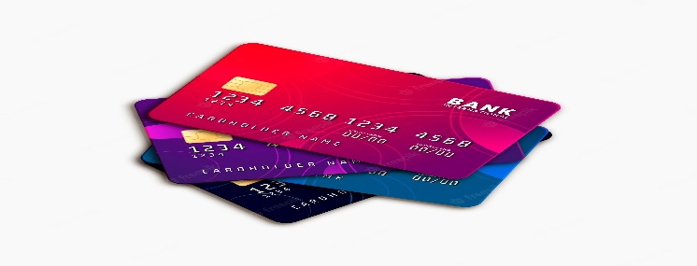https://www.google.com/search?q=pixabay+free+images+of+banking+cards&tbm=isch&ved=2ahUKEwj09pa_s9X5AhUwjtgFHYRpC2gQ2-cCegQIABAA&oq=pixabay+free+images+of+banking+cards&gs_lcp=CgNpbWcQA1CSCFjggwFg6I0BaABwAHgAgAHeAYgBohqSAQYwLjExLjaYAQCgAQGqAQtnd3Mtd2l6LWltZ8ABAQ&sclient=img&ei=L9EAY7SjCbCc4t4PhNOtwAY&bih=754&biw=1519&rlz=1C1SQJL_enIN994IN994&hl=en

- UPI

The Unified Payment Interface was introduced in 2016 after the demonetisation took place. UPI is a system which has made account handling very easy. People of multiple age group and even of different income groups have adopted it with ease. It operates seamlessly and effortlessly.

Source: 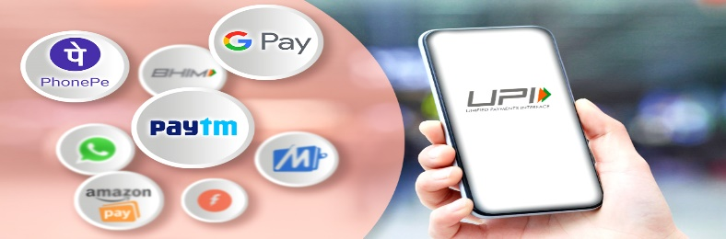https://www.google.com/search?q=pixabay%20free%20images%20upi&tbm=isch&tbs=rimg:CRZ_1okfnIkzdYRLts7eTEHLd8AEAsgIMCgIIABAAOgQIARAA&rlz=1C1SQJL_enIN994IN994&hl=en&sa=X&ved=0CBwQuIIBahcKEwj4nsqsutX5AhUAAAAAHQAAAAAQBg&biw=1519&bih=754

- Mobile Banking

Mobile devices are in the reach of almost every individual in the current scenario. Mobile banking is a way of transacting financial matters with ease. This facility has also been helpful to people with limited income and resources. It has been assumed that the increased account handling due to automatic deposit and withdrawal leads to tendency to save more. This will help the financial role players i.e. the banking industry to show more savings behaviour. This will further help the low income group to get more credit with ease which results to positive financial inclusion.

Source: 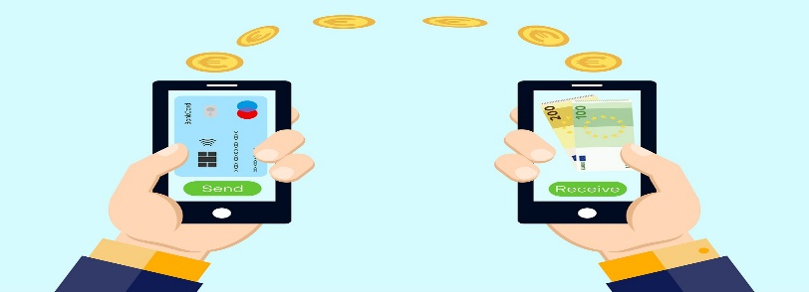
https://www.google.com/search?q=pixabay%20free%20images%20mobile%20banking&tbm=isch&hl=en&tbs=rimg:CVOFj-UgfK4GYSMWYat8WsmO8AEAsgIMCgIIABAAOgQIARAA&rlz=1C1SQJL_enIN994IN994&sa=X&ved=0CBsQuIIBahcKEwi4k-mrtdX5AhUAAAAAHQAAAAAQBg&biw=1519&bih=754

- USSD

At times internet connectivity becomes a matter of concern. This USSD facility is a type of function which can be done through mobile phone without internet. It does not even need any application to be downloaded. It has been mainly designed for the underprivileged section of the society. So that they develop a habit of banking.

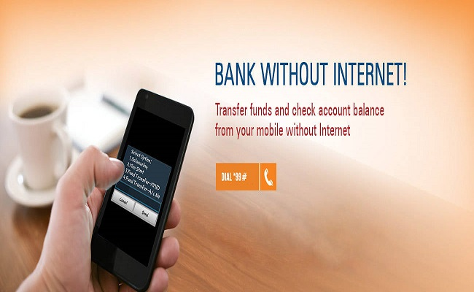
Source:
https://www.google.com/search?q=pixabay+free+images+ussd&tbm=isch&ved=2ahUKEwiAmYKytdX5AhUsiNgFHc9GD2kQ2-cCegQIABAA&oq=pixabay+free+images+ussd&gs_lcp=CgNpbWcQAzoGCAAQHhAIOgUIABCABDoECAAQHjoGCAAQHhAFOgQIABAYUNQHWKYvYOw3aABwAHgAgAHKAogB2yCSAQcwLjkuNy4zmAEAoAEBqgELZ3dzLXdpei1pbWfAAQE&sclient=img&ei=LNMAY4DTGayQ4t4Pz429yAY&bih=754&biw=1519&rlz=1C1SQJenIN994IN994&hl=ennIN994IN994&hl=en

- PoS Terminals
Point of Sale terminals or the PoS as it is commonly referred to as is another widely accepted tool of performing digital transaction with ease and simplicity. It is generally a small hand device which works with the insertion of the debit or credit cards. It instantly reads the inserted card and within fraction of a time the processing is done. PoS helps the small businessmen as this system does not need any sophisticated investment for its installation.

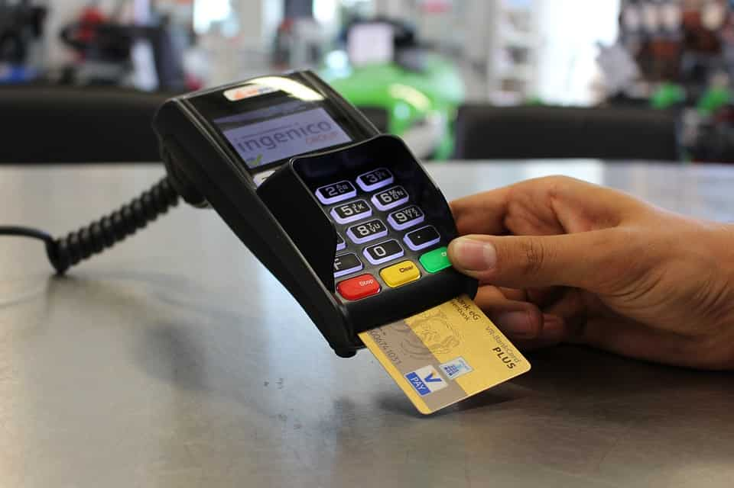
source: https://www.google.com/search?q=pixabay+free+images+PoS+terminals&tbm=isch&hl=en&rlz=1C1SQJL_enIN994IN994&sa=X&ved=2ahUKEwjy2pL7t9X5AhXSk9gFHe8wBcMQgowBKAB6BAgBEB4&biw=1519&bih=754
(III) Reasons for Shift from Traditional Mode to Digital Mode:
Being digital is the new India. Prior to COVID-19, some countries had made sustained investments over many years in extending the basic digital infrastructure—creating nation-wide ID systems, facilitating the spread of mobile networks, and encouraging financial inclusion and digital payments systems. In a number of developing countries, especially in Africa, mobile money had driven the adoption of digital payments, primarily through facilitating P2P remittances and payments. In some others such as India, with “bank-based” financial systems, mobile wallets and other facilities linked to bank accounts offered similar digital payment services Gelb, A., & Mukherjee, A. (2020). The term digital or digitalisation is not new to us. What is new is the wide range of acceptance towards digitalisation which has increased over a period of time. Two factors responsible for this change is the demonetisation and the spread of Novel Corona Virus i.e. Covid-19. Despite the ill effects that the pandemic Covid -19 has given to the entire mankind there are also few rays of hope because of this epidemic. One of which is the increased use of digital mode of payments specifically among the low and medium income group of the society. Some of the prime reasons responsible for this are discussed below----
- Observing Social Distance
During the pandemic and even post pandemic one of the major matter of concern was to maintain the protocol of social distancing. At the same time, we were required to perform the day to day activities which also included various financial transactions. It has been observed and experienced that digital mode of payment was seen everywhere. Starting from a daily earner like vegetable or fruit vendors to small grocery stores who otherwise were reluctant to use the digital mode and now it has become part of their life. Mansour, H. (2021) in his study observed and mentioned that low- and lower-middle-income countries had significantly responded to the surged need for digital means of payment during the pandemic compared to the upper-middle-income and high-income countries.
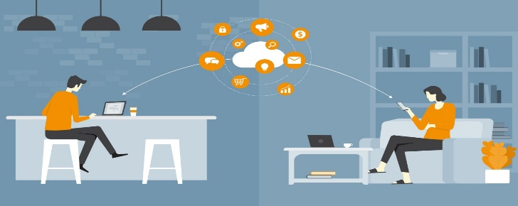
Social Distancing: A Catalyst for Digital Transformation
Source: https://www.google.com/search?q=images+on+social+distancing+and+digitalisation&tbm=isch&hl=en&rlz=1C1SQJL_enIN994IN994&sa=X&ved=2ahUKEwjE-qWk8tX5AhWnjNgFHR5LDCUQgowBKAB6BAgBEB4&biw=1519&bih=737

- Increased Digital Literacy

The government programmes and reforms have always been for the betterment of the underprivileged sections of the society. So is the case with digital literacy awareness. The government identified that the digital acceptance is low in some sections of the society as the digital world is too fast and trying to match with the pace would difficult for some specific group of people. So government went for collaborative working and worked in partnership with many business and NGOs organisations to spread awareness for digital literacy. Some payments industry players have also introduced new products or features to help businesses adapt to COVID-19 restrictions and respond to consumers’ increasing preference for digital or contactless payment methods Toh, Y. L., & Tran, T. (2020). The result came out to be overwhelming and people with low income or medium income also started accepting digital mode of payments with open hands once they were aware about its benefits and also how to use the mode safely and securely.

Source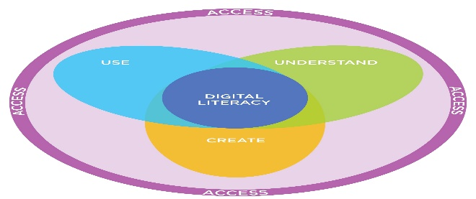 https://www.google.com/search?q=images+on+increased+digital+literacy&tbm=isch&ved=2ahUKEwiXlajA8tX5AhXyxnMBHYQhCmkQ2-cCegQIABAA&oq=images+on+increased+digital+literacy&gs_lcp=CgNpbWcQDDoFCAAQgAQ6BggAEB4QBToGCAAQHhAIOgQIABAYULoKWL7PA2D64ANoCHAAeACAAecCiAGOW5IBCDAuNzAuMC4xmAEAoAEBqgELZ3dzLXdpei1pbWfAAQE&sclient=img&ei=QBMBY5f1OvKNz7sPhMOoyAY&bih=737&biw=1519&rlz=1C1SQJL_enIN994IN994&hl=en

- Simplified Product Offering

Reaching the rural mass was a tough job for both the government and banking institutions. Options like hyper localisation were used to connect with rural audience. Multilingual alternatives were developed which made the rural chunk more inclusive in adopting the digital mode of payments. Some of the local innovators were a boon for this, as they are more aware and are more connected with local needs and requirements.

Source: https://www.google.com/search?q=simplified+digitalproduct+offering+&tbm=isch&ved=2ahUKEwi_lvHs99X5AhXgyXMBHfgvC0cQ2-cCegQIABAA&oq=simplified+digitalproduct+offering+&gs_lcp=CgNpbWcQA1CJB1jBV2C1XWgAcAB4AIABugGIAeUfkgEEMC4yNpgBAKABAaoBC2d3cy13aXotaW1nwAEB&sclient=img&ei=3BgBY7-4JeCTz7sP-N-suAQ&bih=737&biw=1519&rlz=1C1SQJL_enIN994IN994&hl=en
(IV) Conclusion
The chapter discusses aspects related to Covid-19 and the various modes of digital payment that are popularly accepted by the larger mass. It also highlights the major factors which has made digital transactions a success specially for those sections of the society for whom digital acceptance was a challenge. The simplified online payment options have made life much easier. The only need and matter of concern is that it has to done with safety and security. The government has taken numerous steps and many are still being taken for using digital mode in a secured manner. Digital transaction and its increased acceptance among the underprivileged and middle income group is the new normal.
(V) References
Kaur, S., & Walia, N. (2021). COVID-19 and adoption of digital payments in India. World Economics, 22(1), 149-160.
Argüelles, A. J., Cortés, H. D., Ramirez, O. E. P., & Bustamante, O. A. (2021). Technological Spotlights of Digital Transformation: Uses and Implications Under COVID-19 Conditions. In Information Technology Trends for a Global and Interdisciplinary Research Community (pp. 19-49). IGI Global.
Mansour, H. (2021). How successful countries are in promoting digital transactions during COVID-19. Journal of Economic Studies.
Toh, Y. L., & Tran, T. (2020). How the COVID-19 Pandemic May Reshape the Digital Payments Landscape. Payments System Research Briefing, 1-10.
Gelb, A., & Mukherjee, A. (2020). Digital technology in social assistance transfers for COVID-19 relief: Lessons from selected cases. CGD Policy Paper, 181.

