Biochar: A Green Technology for Water Treatment
Shamika Shantaram Sawant¹, Arun Konduri¹, Tao Kara¹, Swaraj Adakney², Vidya Shree Bharti^{3*}, Sagar Kisan Shinde⁴
¹Ph.D. student, Aquatic Environment and Health Management Division, ICAR-CIFE, Panch Marg, Off Yari Road, Versova, Andheri (W), Mumbai, Maharashtra, India- 400061
²M.F.Sc. student, Aquatic Environment and Health Management Division, ICAR-CIFE, Panch Marg, Off Yari Road, Versova, Andheri (W), Mumbai, Maharashtra, India- 400061
³Senior Scientist, Aquatic Environment and Health Management Division, ICAR-CIFE, Panch Marg, Off Yari Road, Versova, Andheri (W), Mumbai, Maharashtra, India- 400061
⁴M.F.Sc., Department of Fisheries Resource Management, College of Fisheries, Ratnagiri, Maharashtra, India- 415629
Corresponding email- vidya.bharti.icar@gmail.com

Abstract
With ever-increasing population and depleting water resources, water pollution has become a grave concern. Also, the nature of contaminants and wastewater being generated is changing day by day. Emerging Contaminants are a rising cause of worry as they are detrimental to aquatic life and can disrupt the ecological balance. Conventional wastewater treatment methods remain inadequate for their treatment and complete removal. Hence, there is a need for sustainable contaminant remediation technology. Biochar is a recalcitrant and porous carbonaceous substance obtained thermochemically from agro-waste in oxygen-deficient conditions. Its porous nature and surface functional groups aid in the remediation of these contaminants by various adsorption mechanisms. Hence, it is increasingly being used for water treatment. Engineering of biochar by physical or chemical means provides additional advantages and higher remediation can be achieved. It is gaining popularity because of the readily and abundantly available feedstock, ease of preparation, cost-effectiveness, recyclability and eco-friendliness. Hence, it can be considered a green solution for water treatment.
Keywords
Wastewater, Biochar, Emerging Contaminants, Eco-friendly, Remediation

Introduction
The fundamental concern of drinking and wastewater treatment before the rampant use of pharmaceutical drugs and industrial chemicals was the elimination of viral or bacterial pathogens and the prevention of nutrient pollution. However, in recent times, a new class of chemicals, essentially known as ‘Emerging Contaminants’ is being found in all environmental matrices- water bodies and food sources. Emerging Contaminants are artificially synthesized or naturally existing substances, as well as microorganisms, that are not usually monitored in the environment but are capable of entering the environment and producing deleterious damage to humans and the ecological balance (Rosenfeld & Feng, 2011). Emerging Contaminants include Pharmaceutical and Personal Care products (PPCPs), Endocrine-Disrupting Chemicals (EDCs), Brominated Flame Retardants, Pesticide Transformation Products, and industrial additives which are widely used, and their use is unavoidable in the modern world (Li et al., 2019; Richardson & Ternes, 2011). About 700 substances in 20 classes have been recognised as Emerging Contaminants by the European aquatic network. Solids, suspended particles, nutrients, and dissolved biodegradable organic matter are removed from sewage in Waste Water Treatment Plants (WWTPs) by use of the existing conventional physicochemical methods of wastewater treatment, but emerging pollutants are not removed. As a result, an increasing fraction of ECs has been found to remain unmetabolized or degraded in WWTPs. However, due to water scarcity in many areas throughout the world, there is a growing trend of using treated wastewater for agriculture or groundwater recharge. Reclaimed wastewater can be used for aquaculture as well and sewage-fed aquaculture is viewed as a potential area of work. As a consequence, ECs have been detected frequently in all environmental matrices and aquatic organisms. However, these ECs have extremely negative impacts on the environment.
They have the capability to negatively affect all aquatic lifeforms in all of their life-stages. They include a class of endocrine disruptors which severely hamper the reproductive processes. They can cause behavioural changes, hampered feeding, reduced growth and even death. A category of UV filters is capable of causing coral bleaching. Widely used pharmaceuticals are of great concern because of their ability to stimulate Antimicrobial Resistance in the host. Also, the end-products are potentially detrimental than the parent components. In addition, most of them are seen to be potentially bioaccumulating, bioconcentrating and biomagnifying and environmentally persistent thereby posing a threat to the food web and causing ecological imbalance.
The major underlying threat of ECs is the inadequacy of experimental studies on environmental and human toxicology of most of these ECs, wherein new potential ECs are being discovered daily, and the lack of attention paid to the management of such contaminants. Hence, there is a dire need of an eco-friendly solution to replace or modify the age-old water treatment methods and achieve a holistic treatment.
Need for an eco-friendly water treatment solution
Physicochemical properties of the contaminants and the treatment process are the factors influencing the removal of ECs in treatment plants. Some of the methods applied for the removal of ECs are oxygen-dependent and independent degradation, ultrasound technology, Advanced Oxidation Processes (AOPs), etc. Certain ECs are highly stable under UV and artificial solar light, hence light-mediated degradation has limited relevance for their remediation. Chlorination can form halogenated end-products which are highly carcinogenic. Though ozonation could remediate ECs from oxygenated grey water, ozonation can also form potent carcinogenic bromate ion. Reverse osmosis achieves an effective removal, but it is still not generally utilised because it is a very expensive treatment process. As a result, although sophisticated treatment techniques lead to high contaminant removal, the resultant end-products and their deployment and operational cost should be given due consideration before their execution. Since the age-old water treatment methods and sophisticated physicochemical remediation methods are insufficient for the disruption of ECs from the system, it is essential to replace them with other novel approaches and safeguard the lives of aquatic organisms.
Biochar: A Green Technology
Globally, abundant agricultural wastes are generated in the process of meeting the nutritional demands of the growing population. India produces about 350-990Mt of agricultural waste yearly and is the second largest producer after China (Koul et al., 2022), of which only 25-30% is reused. The limited and improper management causing pollution, has created an urgent need to devise strategies for their timely and planned disposal.
Biochar is a porous, solid material made by thermochemically converting agro-waste biomass in an oxygen-depleted or anaerobic atmosphere (Modified from (Definition, 2015) and (Inyang & Dickenson, 2015)). It is highly biodegradable with very high carbon content and adequate elemental composition such as K, Na, Mg, Ca, Cu, Zn, Fe, etc. It is characterised by high surface area, high functionality, high porosity and high pH. The pores in biochar's pore network range in size from macropores (>/= 50 nm), and mesopores (2- 50 nm) to micropores (</= 2 nm) (Rouquerol et al., 2013). Functional groups such as –OH, –COOH, –NH₂, –CONH₂, –SH₂, and –OCH₃, etc. are present on the surface of biochar (Rezende et al., 2011) (Tomczyk et al., 2020).
Biochar is prepared by the elevated temperature decomposition in oxygen-limited conditions i.e. by the pyrolysis (which is an age-old method of burning down of biomass) of agro-waste biomass. The type of agro-waste used and the temperature it is subjected to for burning, determine the biochar characteristics. The feedstock sources can be paddy straw, sugarcane bagasse, corn straw or organic waste procured from industries and forestry. Wood chips and pellets, tree cuttings, bagasse, distiller grains, press cakes from the oil and juice industry, rice husks and crop residues being the very common feedstocks for biochar production, it can also be produced from sewage sludge, poultry litter, excrement, bones, livestock manure, etc. (Tomczyk et al., 2020). The pyrolysis process produces 3 products- oil, syngas and biochar (Tomczyk et al., 2020). Depending upon the pyrolysis temperature, residence time and subjected process pressure, these products are produced in varying proportions as shown in Table 1 and Figure 1.
Table 1. Products of pyrolysis in varying process conditions (Tomczyk et al., 2020)
Process | Pyrolysis temperature (°C) | Pressure | Residence Time | Proportion of pyrolysis products (%)
 |  |  |  | Bio-oil | Syngas | Biochar
Fast Pyrolysis | 400 – 600 | Vacuum-Atmospheric | Sec | 75 | 13 | 12
Slow Pyrolysis or Biocarbonisation | 350 – 800 | Atmospheric | Sec -Hrs | 30 | 35 | 35
Gasification | 700 - 1500 | Atmospheric - elevated | Sec - Mins | 5 | 85 | 10

Figure 1. Commonly used raw materials, products obtained, application and their uses (Filiberto & Gaunt, 2013)
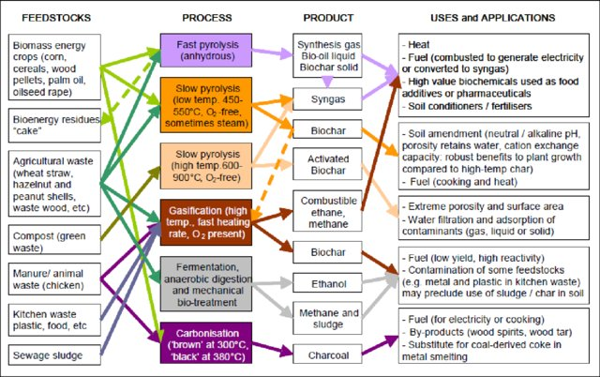
The pyrolysis conditions influence the aromaticity and the adsorption capabilities of biochar. At low pyrolysis temperatures, the amount of surface functional groups is abundant. However, as the temperature and the retention time increases and there is oxygen during pyrolysis, the aromaticity of biochar also rises. As the temperature increases, the porosity, surface area, pH and volatility of biochar increases with a simultaneous reduction in the abundance of hydrogen- and oxygen- containing functional groups and its CEC.
Biochar as a solution for water treatment
Recently, biochar is increasingly being used in water treatment technologies due to its amazing capability to eliminate contaminants from water. Also, its cost-effective and eco-friendly nature makes it an economically feasible and environmentally acceptable solution. However, it is imperative to have knowledge of the possible adsorption mechanisms in order to acknowledge the effectivity of biochar-based removal methods.
- Adsorption mechanisms of Biochar
Adsorption mechanisms vary depending on the biochar's available surface area, functional groups, porous nature, ionic composition, acidity/basicity, preparation method and temperature. Because of its high available surface area and development of micropores, biochar produced at temperatures more than 400°C is highly beneficial for the adsorption of organic contaminants (Ahmad et al., 2014; Uchimiya et al., 2011; Yang et al., 2010). Aqueous organic pollutant sorption is impacted by the polarity and aromaticity of biochar surface (Chen et al., 2008). The loss of oxygen- and hydrogen-containing functional groups causes biochar surfaces to generally become less polar and more aromatic at temperatures above 500°C, which may further impact the adsorption of organic contaminants (Jung et al., 2015).
The adsorption of organic ECs onto biochar may also be affected by solution chemistry factors including pH and ionic strength. Biochar made from agricultural residue has a substantial increase in sorption capacity for methyl violet dye from pH 7.7 to 8.7 when heated to 350°C (Xu et al., 2011). The separation of biochar's phenolic hydroxyl group enhanced the net negative charge on their surfaces, enhancing the electrostatic attraction between methyl violet and biochar (Xu et al., 2011). Similar to this, the solution's ionic strength had a favourable effect on the adsorption of organic ECs on biochar (Qiu et al., 2009; Xu et al., 2011). On the pH-dependent surfaces, a rise in pH causes the charge on biochar to be increasingly negative (Xu et al., 2011). The net charge on biochar varies as per the biochar's point of zero charge or its relative acidity/basicity (Bolan et al., 1999).
The adsorption of ECs is due to the synergistic effect of various kinds of interactions as shown in Figure 2 (Li et al., 2019). It includes chemisorption and physisorption, such as π-π electron-donor-acceptor (EDA) (F. Wang et al., 2016), electrostatic (Jung et al., 2015), pore-filling (G. Zhang et al., 2011), hydrophobic (Ghaffar et al., 2015), hydrogen bonding (Lian et al., 2014), functional groups (Sun et al., 2012), cation exchange and bridging interactions.
Figure 2. Mechanisms of adsorption for biochar EC uptake (Li et al., 2019)
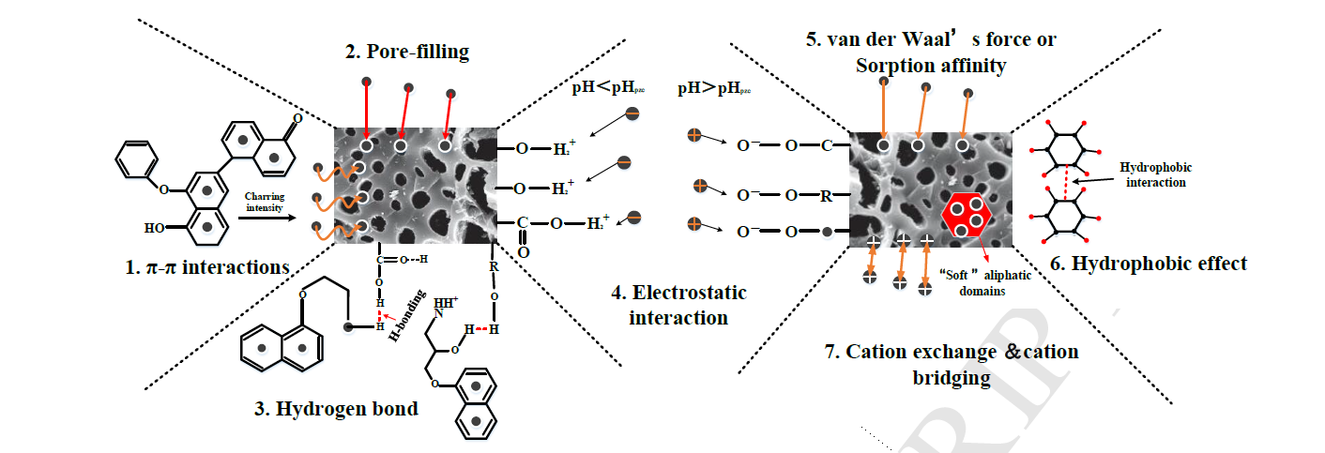
- π-π interactions (F. Wang et al., 2016)
As some ECs are thought to be acceptors of electron whereas biochar is thought to be a donor, the process of electron acceptor/donor interaction (EDA) may act in the increased adsorption of ECs (Zheng et al., 2013). Khan et al. and Waqas et al. anticipated in their work that the biochar surfaces would have higher -electron densities, as it had graphitized surfaces (2015) (2014). In contrast, polycondensed aromatic rings or electron-rich graphene sheets in high-temperature biochars might act as -donors that attach -separating molecules. The surface of the biochar became rich in C=C, -OH, and -COOH after functionalisation. Hence, it can act as a strong π-electron-donor (C. Zhang et al., 2016).
- Hydrogen bonds and functional groups (Lian et al., 2014) (Sun et al., 2012)
Strong hydrogen bonds and (-) EDA interactions are expected to be the most common adsorption processes for the adsorption of ECs onto biochar (Ahmed et al., 2017). A number of functional groups are present on the surface of biochar. These groups easily establish hydrogen bonds with the electrons in benzene rings in ECs, increasing the EC adsorption capability of biochar (Sun et al., 2012).
- Electrostatic interactions (Jung et al., 2015)
The primary mechanism for the adsorption of ionic and ionizable ECs is electrostatic contact (Zheng et al., 2013). Negatively charged biochar surfaces might make positively charged cationic organic molecules more electrostatically attracted to them. (Xu et al., 2011) and (Qiu et al., 2009) reported on this electrostatic attraction in relation to investigations on the sorption of dyes such as rhodamine from aqueous systems. The degree of ionisation and configuration of a adsorbate and the surface charge of the adsorbent, may all be affected by the pH of the solution (Ma et al., 2012).
- Hydrophobic interactions (Ghaffar et al., 2015)
An efficient medium for the separation of hydrophobic organic molecules is provided by biochar, since it has an amorphous structure and contains significant quantities of "soft" aliphatic groups. Both partitioning and hydrophobic adsorption are generally included in the hydrophobic interaction process (X. Wang et al., 2006).
- Pore filling (G. Zhang et al., 2011)
This can be inferred to be the most significant mechanisms for adsorption of ECs, in addition to the others listed (Chun et al., 2004). According to Williams et al. adsorption is correlated with the characteristics of biochar and is directly dependent on the available micropores and mechanisms of pore-filling (2015). Biochar with a higher proportion of aromatic carbon and a bigger available surface area is anticipated to be better for ECs adsorption (Ran et al., 2007).
- Water treatment with biochar
Biochar is highly effective for the removal of Emerging Contaminants whose concentration and occurrence in the environmental matrices is increasing rapidly. Along with the application of pristine biochar, innovative intervention by modification of biochar by physical or chemical methods leads to superior treatment of wastewater and removal of ECs as shown in Figure 3 and Table 2. Either the feedstock can be modified or pristine biochar can be produced first and modified. Physical modification processes are steam activation and gas purging, while chemical modification processes involve treatment with acids, bases, mineral oxides, oxidants, etc. Modification of biochar yields higher surface functionality, surface area, pore volume and distribution.
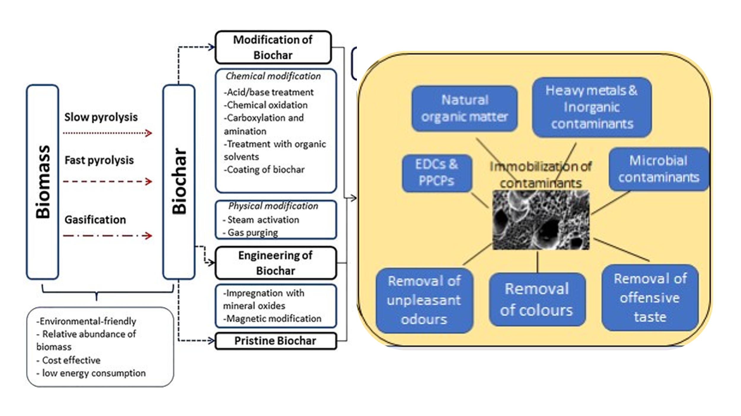
Figure 3. Schematic diagram of biochar preparation, modification and its use for water treatment (Produced from (Palansooriya et al., 2020))

Table 2. Remediation of Emerging Contaminants from water using biochar (Produced from (Cheng et al., 2021))
Biochar feedstock, Pyrolysis temp. (°C), Duration | BC Treatment | Emerging Contaminant | Removal efficiency (%)
Pinewood, 425 | Original BC | Ibuprofen | 74
Coffee grounds, 250 | Magnetite | Tetracycline | 96
Shredded cotton stalks, 350 | H₂O₂ | Sulfadimethoxine | 71
Reed straw, 500 | Zn-TiO₂ | Sulfamethoxazole | 81.21
Cassava, 500 | KOH | Norfloxacin | 86.8-96.5
Peanut shells, 450 | CuNO₃ | Doxycycline | 93.22
Sawdust, 500 | Co/Fe | Cefotaxime | 99.23
Reed straw, 500 | Fe₃O₄ | Carbamazepine | 95.51
Kenaf bar, 600 | nZVI | Bisphenol A | 98
Rice, 400 | nZVI | Nonylphenol | 96.2
Cotton straw, 350 | NH₂Cl | Estradiol | 87
Cotton straw, 350 | NH₂Cl | Ethinyl Estradiol | 75
Rice husk, 700/2h | Steam activated | Glyphosate | 82
Water hyacinth, 250/1h | Fe loaded BC  (Fe:BC 54.56 w/w%) | Arsenic (V) | 98.46
Forestry wood waste,  700/15h | H₃PO₄-  modified BC | E. coli | 96
Conclusion-
Emerging contaminants are commonly present in water and pose a threat to the native biota as they remain untreated in water treatment plants. Biochar is an ecologically beneficial and cheap solution for the treatment of ECs and can be easily incorporated into water treatment technologies. Biochar has come into limelight recently because of its multi-usability, which includes carbon sequestration and improvement in soil fertility, bio-energy production, and environmental remediation. It is seen as a potential green replacement for conventional treatment methods in water treatment because of its less cost, ease of preparation and availability, superior adsorption capacity and eco-friendliness.
References
Ahmad, M., Rajapaksha, A. U., Lim, J. E., Zhang, M., Bolan, N., Mohan, D., Vithanage, M., Lee, S. S., & Ok, Y. S. (2014). Biochar as a sorbent for contaminant management in soil and water: A review. Chemosphere, 99, 19–33.
Ahmed, M. B., Zhou, J. L., Ngo, H. H., Guo, W., Johir, M. A. H., & Belhaj, D. (2017). Competitive sorption affinity of sulfonamides and chloramphenicol antibiotics toward functionalized biochar for water and wastewater treatment. Bioresource Technology, 238, 306–312.
Bolan, N. S., Naidu, R., Syers, J. K., & Tillman, R. W. (1999). Surface charge and solute interactions in soils. Advances in Agronomy, 67, 87–140.
Chen, B., Zhou, D., & Zhu, L. (2008). Transitional adsorption and partition of nonpolar and polar aromatic contaminants by biochars of pine needles with different pyrolytic temperatures. Environmental Science & Technology, 42(14), 5137–5143.
Cheng, N., Wang, B., Wu, P., Lee, X., Xing, Y., Chen, M., & Gao, B. (2021). Adsorption of emerging contaminants from water and wastewater by modified biochar: A review. Environmental Pollution, 273, 116448.
Chun, Y., Sheng, G., Chiou, C. T., & Xing, B. (2004). Compositions and sorptive properties of crop residue-derived chars. Environmental Science & Technology, 38(17), 4649–4655.
Definition, P. (2015). Specification Standards: Standardized Product Defini-tion and Product Testing Guidelines for Biochar That Is Used in Soil (aka IBI Biochar Standards). Version.
Filiberto, D. M., & Gaunt, J. L. (2013). Practicality of biochar additions to enhance soil and crop productivity. Agriculture, 3(4), 715–725.
Ghaffar, A., Ghosh, S., Li, F., Dong, X., Zhang, D., Wu, M., Li, H., & Pan, B. (2015). Effect of biochar aging on surface characteristics and adsorption behavior of dialkyl phthalates. Environmental Pollution, 206, 502–509.
Inyang, M., & Dickenson, E. (2015). The potential role of biochar in the removal of organic and microbial contaminants from potable and reuse water: A review. Chemosphere, 134, 232–240.
Jung, C., Boateng, L. K., Flora, J. R., Oh, J., Braswell, M. C., Son, A., & Yoon, Y. (2015). Competitive adsorption of selected non-steroidal anti-inflammatory drugs on activated biochars: Experimental and molecular modeling study. Chemical Engineering Journal, 264, 1–9.
Khan, S., Waqas, M., Ding, F., Shamshad, I., Arp, H. P. H., & Li, G. (2015). The influence of various biochars on the bioaccessibility and bioaccumulation of PAHs and potentially toxic elements to turnips (Brassica rapa L.). Journal of Hazardous Materials, 300, 243–253.
Koul, B., Yakoob, M., & Shah, M. P. (2022). Agricultural waste management strategies for environmental sustainability. Environmental Research, 206, 112285.
Li, L., Zou, D., Xiao, Z., Zeng, X., Zhang, L., Jiang, L., Wang, A., Ge, D., Zhang, G., & Liu, F. (2019). Biochar as a sorbent for emerging contaminants enables improvements in waste management and sustainable resource use. Journal of Cleaner Production, 210, 1324–1342.
Lian, F., Sun, B., Song, Z., Zhu, L., Qi, X., & Xing, B. (2014). Physicochemical properties of herb-residue biochar and its sorption to ionizable antibiotic sulfamethoxazole. Chemical Engineering Journal, 248, 128–134.
Ma, J., Yu, F., Zhou, L., Jin, L., Yang, M., Luan, J., Tang, Y., Fan, H., Yuan, Z., & Chen, J. (2012). Enhanced adsorptive removal of methyl orange and methylene blue from aqueous solution by alkali-activated multiwalled carbon nanotubes. ACS Applied Materials & Interfaces, 4(11), 5749–5760.
Palansooriya, K. N., Yang, Y., Tsang, Y. F., Sarkar, B., Hou, D., Cao, X., Meers, E., Rinklebe, J., Kim, K.-H., & Ok, Y. S. (2020). Occurrence of contaminants in drinking water sources and the potential of biochar for water quality improvement: A review. Critical Reviews in Environmental Science and Technology, 50(6), 549–611.
Qiu, Y., Zheng, Z., Zhou, Z., & Sheng, G. D. (2009). Effectiveness and mechanisms of dye adsorption on a straw-based biochar. Bioresource Technology, 100(21), 5348–5351.
Ran, Y., Sun, K., Yang, Y., Xing, B., & Zeng, E. (2007). Strong sorption of phenanthrene by condensed organic matter in soils and sediments. Environmental Science & Technology, 41(11), 3952–3958.
Rezende, C. A., De Lima, M. A., Maziero, P., deAzevedo, E. R., Garcia, W., & Polikarpov, I. (2011). Chemical and morphological characterization of sugarcane bagasse submitted to a delignification process for enhanced enzymatic digestibility. Biotechnology for Biofuels, 4(1), 1–19.
Richardson, S. D., & Ternes, T. A. (2011). Water Analysis: Emerging Contaminants and Current Issues. Analytical Chemistry, 83(12), 4614–4648. https://doi.org/10.1021/ac200915r
Rosenfeld, P. E., & Feng, L. (2011). Risks of hazardous wastes. William Andrew.
Rouquerol, J., Rouquerol, F., Llewellyn, P., Maurin, G., & Sing, K. (2013). Adsorption by powders and porous solids: Principles, methodology and applications. Academic press.
Sun, K., Jin, J., Keiluweit, M., Kleber, M., Wang, Z., Pan, Z., & Xing, B. (2012). Polar and aliphatic domains regulate sorption of phthalic acid esters (PAEs) to biochars. Bioresource Technology, 118, 120–127.
Tomczyk, A., Soko\lowska, Z., & Boguta, P. (2020). Biochar physicochemical properties: Pyrolysis temperature and feedstock kind effects. Reviews in Environmental Science and Bio/Technology, 19, 191–215.
Uchimiya, M., Klasson, K. T., Wartelle, L. H., & Lima, I. M. (2011). Influence of soil properties on heavy metal sequestration by biochar amendment: 1. Copper sorption isotherms and the release of cations. Chemosphere, 82(10), 1431–1437.
Wang, F., Ren, X., Sun, H., Ma, L., Zhu, H., & Xu, J. (2016). Sorption of polychlorinated biphenyls onto biochars derived from corn straw and the effect of propranolol. Bioresource Technology, 219, 458–465.
Wang, X., Sato, T., & Xing, B. (2006). Competitive sorption of pyrene on wood chars. Environmental Science & Technology, 40(10), 3267–3272.
Waqas, M., Khan, S., Qing, H., Reid, B. J., & Chao, C. (2014). The effects of sewage sludge and sewage sludge biochar on PAHs and potentially toxic element bioaccumulation in Cucumis sativa L. Chemosphere, 105, 53–61.
Williams, M., Martin, S., & Kookana, R. S. (2015). Sorption and plant uptake of pharmaceuticals from an artificially contaminated soil amended with biochars. Plant and Soil, 395, 75–86.
Xu, R., Xiao, S., Yuan, J., & Zhao, A. (2011). Adsorption of methyl violet from aqueous solutions by the biochars derived from crop residues. Bioresource Technology, 102(22), 10293–10298.
Yang, X.-B., Ying, G.-G., Peng, P.-A., Wang, L., Zhao, J.-L., Zhang, L.-J., Yuan, P., & He, H.-P. (2010). Influence of biochars on plant uptake and dissipation of two pesticides in an agricultural soil. Journal of Agricultural and Food Chemistry, 58(13), 7915–7921.
Zhang, C., Lai, C., Zeng, G., Huang, D., Yang, C., Wang, Y., Zhou, Y., & Cheng, M. (2016). Efficacy of carbonaceous nanocomposites for sorbing ionizable antibiotic sulfamethazine from aqueous solution. Water Research, 95, 103–112.
Zhang, G., Zhang, Q., Sun, K., Liu, X., Zheng, W., & Zhao, Y. (2011). Sorption of simazine to corn straw biochars prepared at different pyrolytic temperatures. Environmental Pollution, 159(10), 2594–2601.
Zheng, H., Wang, Z., Zhao, J., Herbert, S., & Xing, B. (2013). Sorption of antibiotic sulfamethoxazole varies with biochars produced at different temperatures. Environmental Pollution, 181, 60–67.

