Groundwater quality in the coastal areas of Mahabalipuram, Chennai, India: a hydrogeochemical analysis

*Ramachandran .A¹., Krishnamurthy. R.R¹., Nandhakumar. S¹., Gopal .V²

¹Department of Applied Geology, School of Earth and Atmospheric Sciences, University of Madras, Guindy Campus, Chennai - 600 025, Tamil Nadu, India

²Centre for Earth and Atmospheric Sciences, Sathyabama Institute of Science and Technology
(Deemed to be University) Jeppiaar Nagar, Rajiv Gandhi Salai, Chennai - 600 119, Tamil Nadu, India

Abstract

The present study examines coastal groundwater quality in Kanchipuram District, East Coast, Tamil Nadu. 72 pre and post monsoon groundwater samples were examined for pH, EC, TDS, HCO₃, Cl, SO₄, NO₃, Ca, Mg, Na, K, and total hardness. GIS created spatial distribution maps for all physicochemical parameters. The results were compared to WHO and BIS water quality criteria. Piper plot and correlation methods are commonly used to assess water quality and pollutants. Coastal areas with shallow groundwater tube wells have worse groundwater quality issues. Groundwater is fresh to brackish, according to results. Cations and Anions are dominated by Na and Cl. Few samples have Cl, Ca, and Mg ions within the acceptable limit. Gibbs figure shows that most samples are rock–water interactions. The Piper diagram displays Na–Cl and mixed Ca-Mg-Cl groundwater samples. The majority of water quality samples are excellent to good and appropriate for drinking. The USSL graph demonstrates that most groundwater samples have high and medium salinity and low alkali risks. Factor analyses were used to classify groundwater samples and identify contaminants, and leaching of secondary salts dominates groundwater hydro geochemistry in the research area. The investigation found all groundwater samples appropriate for irrigation.

Key words: Groundwater, Coastal, Spatial diagram, Piper diagram, SPSS

Introduction
Groundwater plays a pivotal function in the fundamental sustenance of organisms. Several variables, such as industrial activities and sewage disposal, have a significant impact on the quality of groundwater, leading to its degradation and reduced suitability for consumption. Groundwater is widely utilized as the primary drinking water source in both rural and urban areas, with a significant majority of the population relying on it. The study conducted by Ramachandran and Sivakumar et al. (2020) examined the assessment of groundwater zone identification using the Water Quality Index and GIS technology in the Adyar river basin. The findings revealed that the groundwater quality in this area falls into the very bad to inappropriate category. The deployment of artificial groundwater recharge in the Adyar river basin is proposed as a means to enhance the quality of groundwater and render it appropriate for potable use. A study conducted by Aishwarya (2021) examined the spatial distribution of physicochemical parameters of groundwater in the vicinity of the Kodungaiyur dump yard. The research emphasized the utilization of GIS for testing and spatial representation purposes. Annapoorani et al. (2013) conducted a study on groundwater analysis in the coastal area of Chennai city, Tamil Nadu. The researchers focused on the impact of saltwater intrusion on groundwater basins in the coastal region, specifically examining changes in geochemical properties such as total dissolved solids (TDS), pH, electrical conductivity (EC), as well as the presence of cations and anions in the groundwater surrounding the study area. In their study, Elango and Gnanasundar (1999) conducted an evaluation of the groundwater quality within a coastal aquifer located south of Chennai. They employed geo-electrical techniques as a means of analysis. The coastal environment exerts a substantial influence on the availability of resources, the development of productive behaviors, and the maintenance of diverse ecosystems. The study conducted by Elango et al. (1992) focused on the assessment of groundwater quality in the coastal areas of South Madras. The findings indicated that sodium (Na+) and chloride (Cl-) ions were the prevailing constituents in the groundwater. In their study, Lakshmanan et al. (2003) examined the ion chemistry of hydro-geochemical processes in groundwater within certain areas of the Kancheepuram district. They found that the chemical composition of groundwater is significantly impacted by interactions between rocks and water, as well as the dissolution and deposition of carbonate and silicate minerals, ion exchange, and interactions with surface water. Similarly, Sridhar et al. (2013) investigated the chemical composition of groundwater in the Kanchipuram District of Tamil Nadu, India, and concluded that it is strongly influenced by the aforementioned factors. Panigrah et al. (1996), Atwia et al. (1997), Ballukraya and Ravi (1999), and Ramappa and Suresh (2000) have conducted studies on this topic. Numerous investigations have been conducted to examine the issue of contamination resulting from the presence of high levels of heavy metals in both surface water and groundwater (Asubiojo et al., 1997; Klavins et al., 2000; Leung and Jiao, 2006; Kaushik et al., 2009; Mansouri et al., 2012). Several investigations have been conducted to investigate the presence of metal pollution. The impact of human activities and population growth on groundwater quality and its variability was investigated by hydrochemical tests (Ramesh and Purvaja, 1995; Kumaresan and Riyazuddin, 2008; Jayaprakash et al., 2012). In their study, Majumdar and Gupta (2005) examined the influence of many factors on the chemical composition of groundwater. These factors encompass the composition of precipitation, anthropogenic activities, as well as the geological composition and mineralogy of both the watershed and aquifer inside the aquifer medium. The District possesses a cumulative coastal extent of 87.2 kilometers and is situated at an elevation of 36 meters above the Mean Sea Level (MSL). The southeastern coast of India holds significant importance due to its geographical features, including the convergence of numerous major rivers that flow into the Bay of Bengal. This region is also characterized by its abundant marine biodiversity, encompassing a diverse range of flora and animals (Rajkumar et al., 2011). The current investigation focuses on the assessment of groundwater quality in the Kanchipuram district, namely in the coastal region spanning from Kovalam to Mahabalipuram in Tamil Nadu, India.
Study Area
The study region encompasses the Chennai coast, spanning a linear distance of 10 kilometers from Kovalam to Mamallapuram in the Kanchipuram district. The study region is situated within the geographical coordinates of 12°35' to 12°50' East Latitude and 80°12' to 80°16' North Longitude. The location map depicted in Figure 1.The primary aquifer consists of the coastal sands, which reach to a depth of 30-40 feet. The thickness of sand is observed to exhibit an increasing trend in proximity to the coast, which can be attributed to the presence of the Buckingham canal that runs parallel to the coastline. The primary area of groundwater presence is located at the mouth of the Palar River, where the riverbed serves as a promising geological structure. Silica sands, a crucial mineral, are present along the coast of Mahabalipuram.

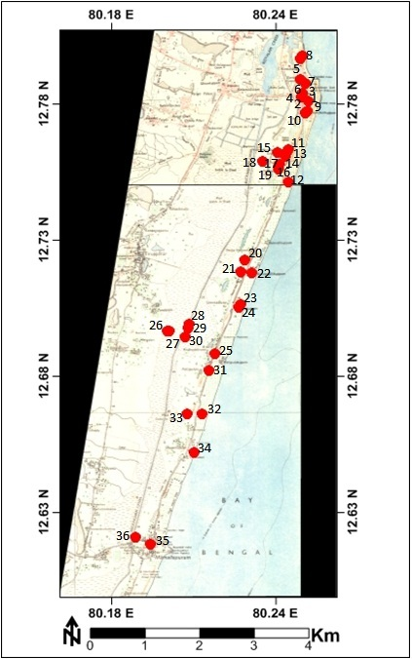
Fig 1: Location Map of the study area
Methodology
A total of seventy-two groundwater samples were gathered from the Kovalam – Mahabalipuram region, located in the Kanchipuram District of Tamil Nadu. The collection of ground water samples took place both before and after the monsoon season, from both bore wells and dug wells. The samples were obtained using polyethylene (PVC) bottles with a volume of 1.5 liters. The pH, electrical conductivity (EC), and total dissolved solids (TDS) were measured in situ using a portable bore well logger known as the Multi probe system, specifically the YSI 556 MPS model. The laboratory conducted an analysis of the samples in order to ascertain the concentration of significant ions. The technique employed in this study is ion chromatography.

Results and Discussion
Groundwater samples were collected systematically in both spatial and temporal dimensions, and subsequently subjected to analysis for the presence of main and minor dissolved ions, employing established and widely accepted protocols. Table 1 presents the findings of the physico-chemical study conducted on the groundwater samples collected from the coastal regions of Kovalam - Mahabalipuram during two distinct seasons.

Table 1. Shows the estimated values of collected samples.
Major ions | Pre monsoon |  | Post monsoon |  | WHO | BIS
EC µs/cm | 148 | 1689 | 217 | 1136 | 500-1000 | 500-1000
pH | 6.8 | 7.1 | 7 | 8.6 | 6.5-8.5 | 6.5-8.5
TDS mg/l | 147 | 1336 | 112 | 1324 | 500-1000 | 500-2000
Ca mg/l | 6 | 256 | 0 | 96 | 75 | 75-200
Mg mg/l | 4.8 | 79 | 0 | 42 | 50 | 30-100
Na mg/l | 2.4 | 432 | 2.5 | 244 | 200 | X
K mg/l | 2.3 | 178 | 0.1 | 166 | 20 | X
HCO₃ mg/l | 24.4 | 464 | 24.4 | 695 | 250 | 250-1000
SO₄ mg/l | 11.7 | 519 | 0 | 326 | X | X
Cl mg/l | 10 | 1892 | 15 | 860 | 50 | 45
NO₃ mg/l | 0 | 377 | 0 | 165 | 200 | 200-400

The pH of hydrogen ions in the research area exhibits a range of 6.8 to 8.6, with an average of 7.4 during the post-monsoon period. In the pre-monsoon period, the pH ranges from 6.8 to 7.1, with an average of 7.17. The electrical conductivity (EC) ranges from 148 to 1689 μS/cm, with an average of 827 μS/cm, during the post-monsoon period. In the pre-monsoon period, the EC ranges from 217 to 1136 μS/cm, with an average of 827.32 μS/cm. The concentration of total dissolved solids (TDS) in the post-monsoon period varies between 72 and 884 mg/l, with an average value of 579.41 mg/l. In the pre-monsoon period, the TDS concentration ranges from 112 to 870 mg/l, with an average value of 581.82 mg/l. The water samples collected from the study area exhibit a classification ranging from fresh to brackish water type. In both the post-monsoon and pre-monsoon seasons, the major anion is HCO₃, followed by Cl, SO₄, NO₃, and PO₄. The prevailing cations during the post-monsoon period are primarily calcium (Ca), followed by sodium (Na), potassium (K), and magnesium (Mg). Conversely, during the pre-monsoon period, the dominating cations are calcium (Ca), followed by magnesium (Mg), sodium (Na), and potassium (K).

The spatial distribution analysis of electrical conductivity (EC) in groundwater samples was conducted for both seasons, as depicted in Figure 2. Typically, elevated levels of EC are observed in proximity to coastal regions. To gain insights into the chemical properties of groundwater in the designated study area, the researchers employed a Triplot diagram (Piper, 1944) and AquaChem Software to visualize and classify the collected groundwater samples (Figure 3). The prevailing groundwater water types are arranged in the following order: NaCl > CaMgCl > mixed CaNaHCO₃ > CaHCO₃. However, the majority of the samples exhibit clustering within the Na Cl and Ca-Mg-Cl segments. The presence of water types characterized by high salinity, specifically CaMgCl and NaCl, indicates the occurrence of water mixing resulting from surface pollution sources, such as the introduction of irrigation return flow, residential wastewater, and effluents. This mixing process is subsequently followed by ion exchange processes. In conjunction with the Piper diagram, the Gibbs plot (1970) elucidated that plotting total dissolved solids (TDS) against the ratio of sodium (Na) to the sum of sodium and calcium (Na + Ca) yields insights into the underlying mechanisms governing the chemical composition of water bodies. Figure 2 illustrates that the majority of the groundwater samples were situated within the rock-water interaction zone, while only a limited number of samples were found within the evaporation zone. Both the Piper and Gibbs plots indicate that the regulation of water chemistry is influenced by the mixing of saline water resulting from surface contamination sources with pre-existing water, as well as ion exchange reactions, mineral dissolution, and potentially evaporation.

Spatial Analysis of groundwater quality of Pre & Post-monsoon respectively
The graphical representation of different ion concentrations serves as a straightforward method for illustrating the groundwater quality within the designated research region. The current study involved the utilization of GIS to analyze the spatial-temporal fluctuations of physicochemical parameters.

Figs 2.Spatial Diagrams of major elements (Pre and Post monsoon)

Major Cations
The prevalence of main cations is observed to be in the following order: Na > Mg > Ca > K throughout the periods of particulate matter (PRM) and primary organic matter (POM) emissions. The concentration of sodium ions during the pre-monsoon season exhibits a range of 2.4 to 432 mg/l, whereas in the post-monsoon season, it ranges from 2.5 to 244 mg/l. The evaluation of groundwater quality for irrigation is significantly influenced by the content of sodium, as it has been observed that sodium contributes to the increased soil hardness and reduced permeability (Tijani, 1994). The concentration of calcium ions during the pre-monsoon season exhibits a range of 6 to 256 mg/l, whereas in the post-monsoon period, it falls within the range of 0 to 96 mg/l. The concentration of Mg ions during the pre-monsoon season exhibits a range of 4.8 to 79 mg/l, but in post-monsoon samples, the concentration ranges from 0 to 42 mg/l. The content of potassium (K) during the pre-monsoon season exhibits a range of 2.3 to 178 mg/l, whereas in the post-monsoon period, it varies between 0.1 and 166 mg/l.
Major Anions
The relative prevalence of anions is observed to be in the order of chloride (Cl) > bicarbonate (HCO₃) > nitrate (NO₃) > sulfate (SO₄) in both the post-monsoon and pre-monsoon periods. The concentration of chloride ions during the pre-monsoon period varies from 10 to 1892 mg/l, whereas during the post-monsoon period, it ranges between 15 and 860 mg/l. The concentration of Cl- is elevated as a result of the influence of saline water and the occurrence of ion exchange reactions (Freeze and Cherry, 1979). The concentration of HCO₃ ions during the pre-monsoon season exhibits a range of 24.4 to 464 mg/l, but in post-monsoon samples, it spans from 24.4 to 695 mg/l. A greater concentration of bicarbonate signifies the presence of country rock, also known as Charnockite. The concentration of SO₄ ions during the pre-monsoon season exhibits a range of 11.7 to 519 mg/l, but in the post-monsoon samples, it varies from 0 to 326 mg/l. The concentration of ion NO₃ in the pre-monsoon season exhibits a range of 0 to 377 mg/l, while in the post-monsoon samples, it ranges from 0 to 165 mg/l.

Figs 3.Spatial Diagrams of Major Cations (Pre and Post monsoon)

Figs 4.Spatial Diagrams of Major Anions (Pre and Post monsoon)

Gibbs Plot
The investigation of the chemical associations in groundwater, with respect to the lithology of the aquifer, has been examined utilizing Gibb's Plot methodology (Gibb, 1970). The water that is mostly influenced by weathering processes exhibits elevated levels of calcium (Ca) and bicarbonate ions (HCO₃₋), while the water that is primarily influenced by evaporation and crystallization processes is characterized by elevated levels of sodium ions (Na⁺) and chloride ions (Cl⁻). Figure 5 illustrates that the chemical composition of groundwater in the study area is mostly influenced by rock-water interaction, with a few water samples falling within the evaporation range. This holds true for both seasons examined.
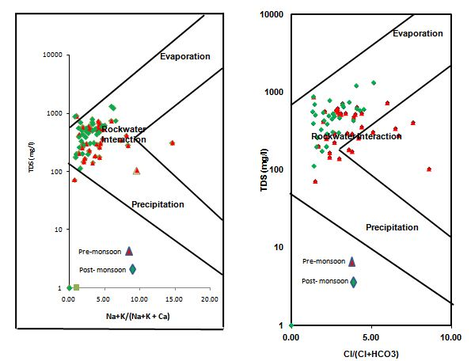

Fig. 5. Shows Gibbs plot

USSL Diagram
The diagram serves as a tool for assessing the level of appropriateness of groundwater for the purpose of irrigation. Figure 6 illustrates a graphic wherein the vertical axis represents the Sodium Absorption Ratio, while the horizontal axis represents conductance. An elevated concentration of dissolved salts in groundwater has the potential to impede soil permeability, which in turn can lead to a reduction in agricultural output. The classification of groundwater suitability for irrigation is conducted by the United States Salinity Laboratory (USSL) diagram, which categorizes it into two distinct types: salinity hazard and sodium hazard. The assessment of salinity hazard is conducted by considering the electrical conductivity (EC) parameter, whereas the determination of sodium hazard is accomplished through the utilization of the sodium adsorption ratio (SAR) equation. The SAR (Sodium Adsorption Ratio) is a measure used to estimate the proportion of sodium in relation to calcium and magnesium. The USSL diagram categorizes dangers associated with sodium and salinity using the S1, S2, S3, S4 types for sodium hazards and the C1, C2, C3, C4 types for salinity hazards. Based on the classification provided, a significant proportion of the samples may be categorized as belonging to C3S1 (medium salinity, low sodium) and C3S1 (high salinity, low sodium) during the pre and post monsoon seasons, respectively.
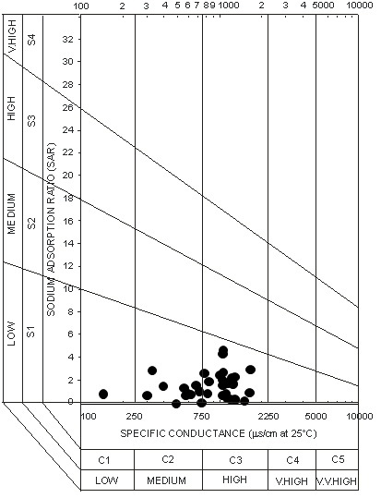
Fig 6. Shows the USSL Diagram

Wilcox diagram
The significance of sodium in the categorization of groundwater for agricultural purposes was underscored because to its reactivity with soil, leading to particle blockage and subsequent reduction in permeability (Todd, 1980; Domenico et al., 1990). Srinivasamoorthy (2004) highlights the significance of the Na cation, emphasizing its detrimental effects on soil structure and agricultural output when present in excessive quantities. The Wilcox diagram (Wilcox, 1955) utilizes milli equivalents per liter as the unit of measurement for expressing the concentrations of ions. Water classification is determined by the relative concentration of sodium (Na%) in relation to other cations present in the water. The values of pre- and post-monsoon groundwater samples from the area were graphically represented in the Wilcox diagram, as depicted in Figure 7. In the designated study region, it was seen that 54% and 57% of the collected samples were classified as falling within the range of good to permitted during the Pre and Post-monsoon seasons, respectively. Additionally, 37% of the samples were categorized as very good during both seasons. A small proportion of the samples were found to fall into the categories of permissible to doubtful and doubtful to unsuitable during both seasons. The majority of the samples within the study area are classified as being within the good to very good category.
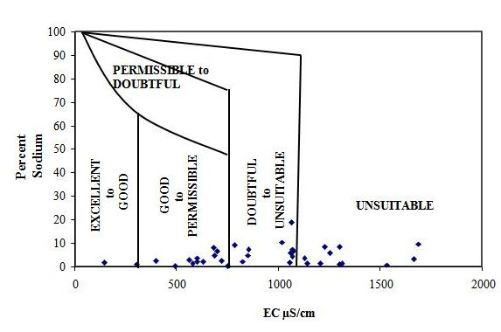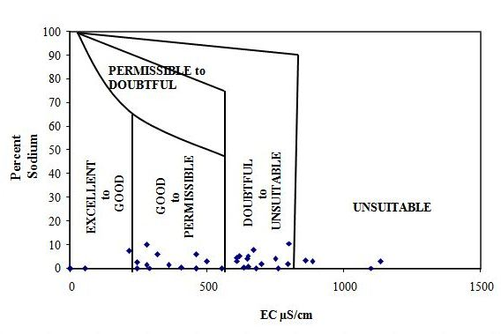
Fig 7. Shows the Wilcox pre and Post-monsoon
Box whisker diagram
In the present study in groundwater were graphically represents by Box plots can be used to compare ground water quality between wells. The plots are constructed using the median value and the interquartile range 25 and 75 cumulative frequencies, groundwater samples is shown in Fig. 8 diagram reveals that the major cations is in the order of Na>Ca>Mg for both seasons. The abundance of major anions is in the order of Cl>HCO₃>SO₄ during both seasons.

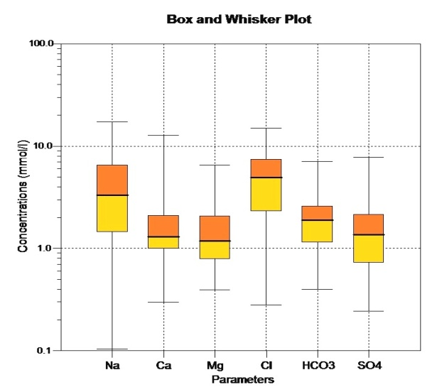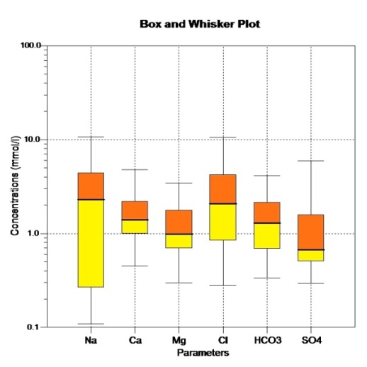
Fig 8. Shows the Pre and Post Monsoon Box plot diagram

Chemical Relationship
The evaluation of the nature and composition of water can be conducted by analyzing the concentration of key ions dissolved in water samples. These concentrations are then plotted on a Trilinear Piper diagram, as first proposed by Piper in 1953. The resulting diagram, depicted in Figure 9, provides a visual representation of the water's characteristics and composition. During the pre-monsoon period, it was observed that 90.9% of strong acids (chloride) surpassed weak acids (bicarbonate and sulfate), while 78.8% of alkaline earth elements (calcium and magnesium) exceeded alkalies (sodium and potassium). Additionally, a majority of 63.6% exhibited a mixed composition (calcium-sodium-bicarbonate). Similarly, during the post-monsoon period, all strong acids (chloride) were found to surpass weak acids (bicarbonate and sulfate), while 66.6% of alkaline earth elements (calcium and magnesium) exceeded alkalies (sodium and potassium). Furthermore, 63.6% of the samples displayed a mixed composition (calcium-sodium-bicarbonate). The rationale behind this phenomenon is that groundwater flowing through igneous rocks has limited capacity to dissolve mineral substances due to the relatively low solubility of the rock composition.
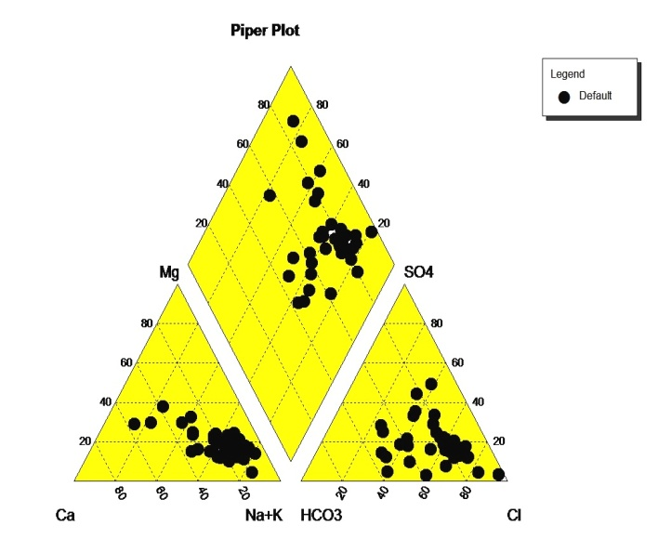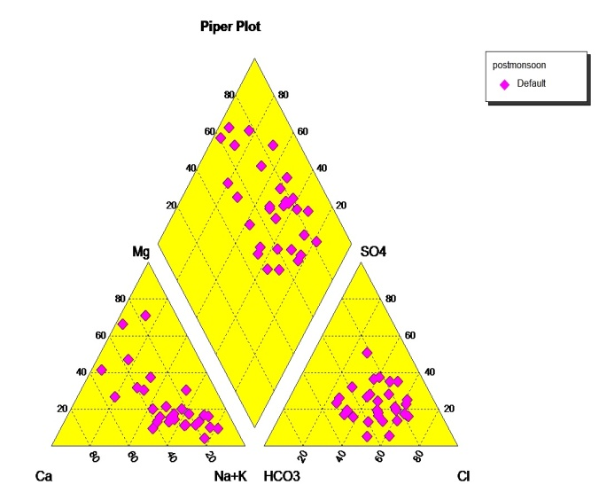
Fig 9. Shows the Pre and Post Monsoon samples Piper plot diagram

Correlation Analysis of Groundwater Quality
The use of the correlation coefficient is a prevalent approach in the current investigation for assessing the association between two variables. This metric serves to demonstrate the extent to which one variable may accurately anticipate the behavior of another variable. The findings indicate a substantial association between the electrical conductivity (EC) and calcium (Ca) levels in pre-monsoon groundwater samples, as observed in Table 2, with chloride (Cl) and sulfate (SO₄) levels. The analysis of Table 3, which comprises groundwater samples collected during the post-monsoon period, reveals a noteworthy link between the presence of calcium (Ca) and magnesium (Mg). Similarly, the presence of Na is positively correlated with Cl, indicating a salinization process that is influenced by both evaporation and anthropogenic activity. The hydro-geochemical nature of alkalis elucidates the association between sodium (Na) and chloride (Cl) ions, with the prevalence of the latter as the dominant anion. Furthermore, a notable increase in sodium content is found in the coastal groundwater, potentially attributed to the infiltration of sewage or discharge of domestic effluents.

Table 2. Shows the correlation matrix for pre-monsoon groundwater sample

Parameters | EC | PH | TDS | Ca | Mg | HCO₃ | Cl | Na | K | SO₄ | NO₃ | Fl
EC | 1.0
PH | -0.23 | 1.00
TDS | 0.57 | -0.17 | 1.00
Ca | -0.06 | -0.40 | -0.04 | 1.00
Mg | 0.21 | -0.34 | 0.08 | 0.81 | 1.00
HCO₃ | 0.31 | -0.24 | -0.08 | 0.34 | 0.49 | 1.00
Cl | 0.12 | -0.38 | 0.09 | 0.90 | 0.92 | 0.38 | 1.00
Na | 0.25 | 0.06 | -0.01 | -0.08 | 0.27 | 0.30 | 0.21 | 1.00
K | 0.29 | -0.38 | 0.28 | 0.36 | 0.50 | 0.59 | 0.45 | -0.09 | 1.00
SO₄ | 0.08 | -0.42 | 0.09 | 0.84 | 0.80 | 0.43 | 0.85 | 0.03 | 0.62 | 1.00
NO₃ | 0.57 | -0.07 | 0.49 | -0.05 | 0.19 | 0.25 | 0.04 | -0.09 | 0.57 | 0.23 | 1.00
Fl | -0.06 | -0.07 | -0.11 | -0.09 | -0.14 | 0.09 | -0.02 | 0.03 | 0.18 | 0.07 | -0.18 | 1.00

Table 3. Shows the correlation matrix for post monsoon groundwater sample

Parameters | EC | pH | TDS | Ca | Mg | Na | K | Cl | HCO3 | Fl | SO4 | NO3
EC | 1.0
PH | 0.52 | 1.00
TDS | 0.27 | 0.41 | 1.00
Ca | 0.34 | 0.40 | 0.69 | 1.00
Mg | 0.28 | 0.31 | 0.71 | 0.55 | 1.00
Na | 0.17 | 0.24 | 0.67 | 0.38 | 0.51 | 1.00
K | 0.04 | 0.21 | 0.77 | 0.59 | 0.56 | 0.49 | 1.00
Cl | 0.19 | 0.24 | 0.78 | 0.53 | 0.66 | 0.94 | 0.65 | 1.00
HCO₃ | 0.27 | 0.37 | 0.76 | 0.57 | 0.52 | 0.79 | 0.70 | 0.81 | 1.00
Fl | 0.22 | 0.73 | 0.27 | 0.34 | 0.16 | 0.17 | 0.05 | 0.09 | 0.30 | 1.00
SO₄ | -0.02 | 0.21 | 0.79 | 0.62 | 0.69 | 0.58 | 0.69 | 0.67 | 0.56 | 0.23 | 1.00
NO₃ | 0.17 | 0.27 | 0.55 | 0.54 | 0.51 | 0.61 | 0.53 | 0.60 | 0.42 | 0.22 | 0.49 | 1.00

V. Conclusion
The current study monitored groundwater quality in the coastal region of Kanchipuram, Tamil Nadu, from Kovalam to Mahabalipuram. The study found cation dominance in the research region: Na>Ca>Mg>K. Anions are arranged HCO₃>Cl>SO₄>NO₃.EC concentration was higher in the southern part of the research region than in other areas. Calcium distribution in the studied area is mostly southern and western. The magnesium distribution map shows high amounts in the southern and northeastern research area. The regional distribution map of sulphate shows that the south has more of it than other places. Like sulphate ions, sodium ions have a high potassium (K) concentration in most sample locations. This distribution is acceptable. The high concentration may be due to fertilizer leaching. Bicarbonate is mostly found in the south, east, and northeast. Box plot shows main cations' relative abundance in the order Na> Ca>Mg pre-monsoon and Ca>Na>Mg post-monsoon. A large percentage of groundwater samples are classified as C2S1, C2S2, C3S1, and C3S2 by USSL. This grade implies that groundwater is suitable for irrigation in both seasons. Calcium bicarbonate (Ca-HCO₃) dominated groundwater.The Total Dissolved Solids (TDS) examination showed that 75% of the groundwater was fresh enough for consumption. Gibb's figure classifies most samples as rock-water interaction. This shows that rock chemical composition and underlying water infiltration occur frequently. Sodium percentage, electrical conductivity, and sodium adsorption ratio were used to evaluate groundwater's irrigation potential. The groundwater in this area was suitable for drinking and household usage. In some places, groundwater was unfit for irrigation. The correlation matrix analysis shows that EC, TDS, Ca, and Mg are positively correlated for both seasons. Additionally, most ions have a positive connection with EC. The Kovalam-Mahabalipuram groundwater quality is generally usable.

Acknowledgement
All the authors are thankful to Department of Applied Geology, University of Madras, for the support and infrastructures provided for the study.

Reference
APHA., (1998). Standard methods for the examination of water and wastewater (19thed.).Washington, DC: American public Health Association.
Annapoorani.A, Murugesan.A, Ramu. A, Renganathan.N.G (2013). Hydrochemistry of groundwater in and around Chennai, India - A case study, Res. J. Chem. Sci. 4 (4) pp.99– 106.
Balakrishnan T. District groundwater brochure Chennai district Tamil Nadu. Government of India Ministry of Water Resources Central Ground Water Board South Eastern Coastal RegionChennaiNovember2008.
Ballukraya, P.N. (1997). Groundwater over-exploitation, A case study from Moje-Anepura, Kolar district, Karnataka. Jr. Geol. Soc. India. v.50, pp.277-282.
Ballukraya, PN and Ravi, R (1999). Characterization of groundwater in the unconfined aquifer of chennai city, India: Part 1- Hydro geochemistry, India v.54, pp.1-11.
Chidambaram, S., Ramanathan, A.L., Anandhan, P., Srinivasamoorthy, K., Prasanna, M.V., 2005. A comparative study on the coastal surface and ground water in and around Puduchattiram region, Tamilnadu. Special issue in International Journal of Ecology and Environment Sciences 31 (3), 299–306.

Chidambaram, S., Ramanathan, A.L., Srinivasamoorthy, K., Anandhan, P., 2003. WATCLAST-A Computer Program for Hydrogeochemical Studies. Recent Trends in Hydrogeochemistry (case studies from surface and subsurface waters of selected countries). Capital Publishing Company, New Delhi (pp. 203–207).

Elango.L and Manickam (1987). Hydrogeochemistry of the Madras aquifer, India:spatial and temporal variation in chemical quality of groundwater. The Role of Geology in urban development., Geological Society of Hong Kong Bulletin .No.3., pp-525-534.

Hussain, M., Ahmad, S.M. and Abderrahman, W. (2008) Cluster analysis and qualityassessment of logged water at an irrigation project, eastern Saudi Arabia. J. Environmental Management, 86: 297-307.
Jayakumar, R. and Siraz, L. (1997) Factor analysis. in Hydrogeochemistry of Coastal aquifer-a preliminary study. Environmental Geology, 31(3/4): 174-177.
Piper, A. M.: A graphic procedure I the geo-chemical interpretation of water analysis, USGS GroundwaterNote no, 1953, 12.

Ramachandran.A, Sivakumar.K, Shanmugasundharam.A, Sangunathan.U, Krishnamurthy.R.R (2021).Evaluation of potable groundwater zones identiﬁcation based on WQI and GIS techniques in Adyar River basin, Chennai, Tamilnadu, India Acta Ecol Sin (2021) Volume 41, Issue 4, pp. 285-295.

Sivakumar.K, Shanmugasundaram.A, Jayaprakash.M, Prabakaran.K Muthusamy.S, Ramachandran.A, Venkatramanan.S and Selvam.S (2021). Causes of heavy metal contamination in groundwater of Tuticorin industrial block, Tamil Nadu, India Environmental Science and Pollution Research (2021) 28:18651–18666 https://doi.org/10.1007/s11356-020-11704-0

Schoeller. H (1967) Qualitative evaluation of ground water resources.In: Methods and techniques of groundwater investigation anddevelopment. Water Research Series-33, UNESCO, pp 44–52.

Subramanian. Hydro geological studies of the coastal aquifers of Tiruchendur, Tamil nadu. PhD thesis, Manonmanian sundaranar University, Thiruneveli,1994, p-75.

Suk, H, Lee K. (1999) Characterization of a ground water hydrochemical system through multivariate analysis: Clustering into ground water zones. Ground Water, 37: 358-366.

Venkateswaran S, Vijay Prabhu M, Mohammed Rafi M, Vallel LK (2011) Assessment of groundwater quality for irrigational use inCumbum Valley, Madurai District, Tamil Nadu, India. Nat Environ Poll Tech 10:207–212.

Wicox, L. V.: Classification and use of irrigation waters, US Department of Agriculture, WashingtonDc, 1995, p-19

