Revolutionizing Food Packaging: Unveiling the Potential of Artificial Intelligence

Armaanjot Singh, Gurleen Kaur
Punjab Agricultural University, Ludhiana – 141004
Email: armaanjot-2002054@pau.edu
Abstract
In the modern era, the marriage of technology and traditional industries has led to remarkable advancements, and the world of food packaging is no exception. With the advent of “Artificial Intelligence (AI), the food packaging” landscape is undergoing a transformation that promises enhanced efficiency, sustainability, and consumer experience. This article delves into the various ways AI is reshaping food packaging, from design and material selection to quality control and beyond.
Globally, the world has been failing to meet the overall “nutritional and environmental” needs that are related to quality of food being available in certain varieties. One of the main advancements in the modern food industry comes with the Smart Packaging initiatives. Just like the traditional packaging involves four basic principles leading to the Preservation, Protection, Containment, Convenience. Smart packaging Approaches have led to the improvements in the efficacy and therefore, to safeguard the nutritive value of the food products in a more structured manner.
Keywords- Food Packaging; Artificial Intelligence; Nutrition; Smart Packaging

Introduction
Food Packaging is performed to protect the biochemical nature of the food, to protect the starch structures in food products from the subsequent gelatinisation, to prevent the essential nutrients from further oxidation, and thus, for safe handling of both, non-processed and processed food products. Food composition influences the satiety and the nutrient bioavailability. Food Packages have been developed with the aim of improving operational efficiency, with the variety of sizes and shapes to hold nutritional composition, with the adequate labelling information (ingredients, manufacture’s name and address, nutritional facts).
Packaging in the earlier times was not much of a difficult piece of work. Starting with the leaves, the sellers used newspaper and cloth pouches, superlatively used for packing flour or sugar. Cardboard and paperboard boxes, later gained much importance for their transport and marketing convenience.
For about decades, plastic packaging (Cellophane and polyethylene) has been accustomed in the food industry due to their economical predominance. Back then, plastic packages were adaptable, functional and light which took over the food industry from using steel, glass and paper containers for the use of air tight packaging to preserve the food components from external contamination.
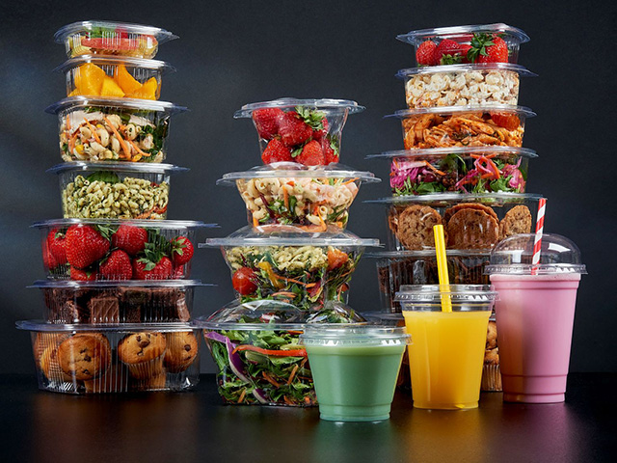
Img-Plastic food packaging
Consumer preference has always played a key role to develop food packages including Freshness, High quality food and the palatability determine the quality of the food being served. Different packaging methods have been unfolded with time with subordinate functions like accountability, tamper signalling and portion size checks. New packaging technologies have led to the development of advancements with the aim of extending shelf life while maintaining the nutritive value of food products along with ensuring the safety.

Design and Material Selection
AI-driven predictive modeling is changing the way packaging designs are conceptualized and materials are selected. By analyzing consumer preferences, market trends, and regulatory requirements, AI algorithms assist packaging designers in creating appealing designs that resonate with target audiences. Furthermore, these algorithms can evaluate the environmental impact of different packaging materials, aiding companies in making sustainable choices that align with the growing demand for eco-friendly packaging solutions.

Supply Chain Optimization and Personalized Packaging
The integration of AI in supply chain management offers unparalleled benefits. Demand forecasting based on historical sales data and external factors enables optimized inventory management and efficient packaging processes. AI-powered route optimization reduces transportation costs and environmental impact. Moreover, AI introduces the concept of personalized packaging. Consumers can design packaging according to their preferences, fostering a sense of connection with the brand and product. This customization not only enhances consumer engagement but also sets the stage for unique marketing strategies.
Active Packaging
Active Packaging is a broader term for advanced packaging systems. Active packaging is one of the effective methods that focuses on the internal functional properties of the biopolymers used for packaging systems. Biopolymers having antibacterial and antifungal properties have been used for protection purposes like, chitosan which have been allocated in cellular permeability of micro-organisms , these active agents are added into the packaging solutions .
Technologies for the Production of Active Packaging-
A number of basic technologies have the prospective of being coupled with packaging films to stabilize the shelf life and enhance the quality of high moisture content foods.
- Oxygen Scavenging from the surrounding atmosphere – by glucose oxidase and alcohol oxidase.
- Reducing the oxygen partial pressure in the package materials results in the altered rate of metabolism of fresh produce. The bacteria which grow under the presence of oxygen i.e. aerobic bacteria and molds cannot grow under such conditions, therefore, Certain fresh produce like meat will remain purple under reduced oxygen conditions and red if the oxygen pressure will be high.
- In Climacteric fruits like tomato, banana, apple and peach, the ripening movement is controlled by ethylene , a growth hormone released during late ripening stages. Controlling the hormone will positively affect the shelf-life of fruits.
- Time – Temperature markers can be used on the package surface to regulate achievement of optimum temperature for the adequate storage of highly perishable foods and to prevent the growth of bacteria that grow on different temperature ranges. Another advantage would be the indication of unused and the contaminated food so that they could not used again, this helps to maintain the nutritional quality of food.
- Controlled and careful release of ethanol (acts as a microbial inhibitor), Antioxidants like BHA and BHT which will reduce the progressive loss of shelf life, already used with some cereals.

Thus, Active packaging involves some parameters to substitute gas permeability, light absorbing surfaces, surface films that impart a prominent colour sue to any mineral, metal (zinc, magnesium) , or the surface films that may leach a particular odour from the packaged foods.

Antimicrobial Packaging
As discussed above, microbes grow under specific conditions, temperature, pH range, pressure which leads to spoilage of the food and hence, many health hazards (Salmonelliosis, Listeriosis) . Therefore, Antimicrobial packaging has been developed with the potential of reducing, inhibiting the microbial contamination of food. Antimicrobial packaging can be of two types – a)those that have agents with antimicrobial properties that release to food surface. B) those that does not require antimicrobial agents on the surface but, that are protective against the microbes present on the surface.
Substances that are used for antimicrobial packaging-
- Organic Acids- Propionic acids, Ascorbic acids have specific membrane permeability with the required antimicrobial properties. Sodium benzoate with GRAS (Generally Regarded As Safe) properties ,antifungal specificity . Sodium citrate inhibits the growth of Listeria monocytogenes and E.Coli.
- Plant Extracts and Biopolymers- Essential oils from spices and certain vegetables like mustard, basil, oregano, lemon were added into the CMC solution (carboxymethyl-cellulose solution), starch, gelatin for the production of efficient protective packaging for perishable foods like meat, mik etc.
Antioxidants
Lipid Oxidation has one of the major concerns leading to spoilage of the food. Foods with high degree of trans fats and lipid content are more prone to oxidation and thus, spoilage. The spoilage thus results in a rancid smell and odour, reducing the nutritive value and palatability of foods. Antioxidants cannot be directly added to food surface as they are consumed once, the protection limits and the food gets spoils at a higher rate. Synthetic Antioxidants like BHA (Butylated Hydroxyanisole) and BHT ( Butylated Hydroxytoluene) are added to carragean and gelatin. Natural Antioxidants like rosmarinic adic, caffiec acid, tocopherols , plant extracts like rosemary, mint have the advantages of limiting the microbial growth and thus, enhancing the shelf-life. Antioxidants, are itself necessary for improving the nutritional status as they reduce the oxidative stress, helps disease prevention.
Moister Absorbers
Foods with high water content and activity are more susceptible to rapid degradation and microbial growth, leading to spoilage. Moisture absorbers are the substances which tend to control the total water activity, to remove the de – iced water from the frozen foods (meat) , prevent excessive condensation . Application of biopolymers coupled with carragean, agar etc. have been found to have potential moisture reducing capacities for maintain the shelf life of food products because of their large water vapour capacity.
Biosensors
Biosensors are the substances used in the food packaging surface films to detect biological reactions, which may monitor the freshness of the food, reducing the chances of food-borne illnesses.
Nanotechnology has emerged as a revolutionised mode of packaging of fresh produce which include the usage of nanobiosensors to detect chemical pathogenic activities in food, presence of chemical pollutants in specific ranges of food produce. For Example, Food Senital System which is a freshly developed biosensor to detect pathogen with a specific antibody.
Freshness of the food ,bioactive compounds of the foods resulting in different colour ranges are detected, monitored by different biosensors. Hypoxanthine and trimethylamine oxide (freshness) and colorimetric methods to measure the colour changes and detection of volatile compounds in food products.
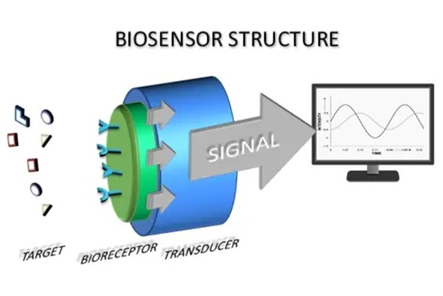
Img-Biosensors
Safety Concerns
As a new product is launched in the market with certain guidelines, Smart Food Packaging must be added to the packaging systems with detailed norms with accurate intrinsic testing, labelling, safety norms, handling by qualified professionals to avoid any misuse and risk to the consumers. Packaging must be provided with specific regulations . Environmental regulations are next in line to be ensured, to circulate the motive of reuse, recycle and reduce . Finally, the packages must be protected against the risks of antimicrobial agents that may possess any serious effects on human health.
Regulatory Compliance and Market Analysis
AI's analytical prowess extends to ensuring regulatory compliance in food packaging. By automatically assessing packaging designs and materials against industry standards, companies can avoid costly violations and ensure consumer safety. Additionally, AI's ability to monitor social media and online platforms allows companies to gauge consumer sentiment regarding packaging designs. This real-time feedback loop enables agile adjustments to packaging strategies, keeping brands attuned to customer preferences.

Ethical Considerations and Future Implications
While AI-driven food packaging brings substantial benefits, ethical considerations such as data privacy and security cannot be overlooked. Striking a balance between technology and consumer rights is imperative to building trust in these innovations. Looking ahead, the evolution of AI in food packaging holds untapped potential. As AI algorithms become more sophisticated, they will continue to optimize packaging processes, reduce waste, and enhance consumer experiences. However, collaboration between stakeholders, including industry leaders, regulators, and technology experts, is essential to navigate challenges and fully unlock the transformative power of AI in food packaging.

Conclusion
Artificial Intelligence is ushering in a new era of innovation in food packaging. From designing sustainable materials to predicting shelf life and enhancing supply chain efficiency, AI is redefining every aspect of packaging. As this technology continues to evolve, the industry must tread carefully, embracing the benefits while addressing ethical concerns. The future of food packaging is here, and AI is leading the way toward a more sustainable, efficient, and consumer-centric packaging landscape.Smart Packaging has evolved to be an emerging trend with potential benefits of providing stability, protection, preservation of food components along with maintaining and enhancing the nutritive value of food, safeguarding the presence of essential nutrients, colour , structure and flavour of the fresh food products. Different approaches to build advancements in bioplastics at industrial scale results in the postitive impact on sustainability and environmental care.

REFERENCES-
- Recent Developments in Smart Food Packaging Focused on Biobased and Biodegradable Polymers.Pablo R. Salgado* Luciana Di Giorgio Yanina S. Musso Adriana N. Mauri
- Application of ‘Active Packaging’ Technologies for the Improvement of Shelf-Life and Nutritional Quality of Fresh and Extended Shelf-Life Foods .Theodore P Labuza
- Advances in food packaging – a review. Harpreet Kour Dr. Naseer Ahmed
- How Packaging Affects The Food We Eat: Bioplastics And Other New Environment-Friendly Options By Slurrp Editorial
- Foodomics: A Data-Driven Approach to Revolutionize Nutrition and Sustainable Diets
Selena Ahmed1,2* John de la Parra3,4 Ismahane Elouafi5 Bruce German6 Andy Jarvis7 Vincent Lal8 Anna Lartey9 T. Longvah10 Carlos Malpica11 Natalia Vázquez-Manjarrez12 Jessica Prenni13 Carlos A. Aguilar-Salinas12 Warangkana Srichamnong14 Maya Rajasekharan7 Tracy Shafizadeh15 Justin Bloomfield Siegel6 Roy Steiner3 Joe Tohme7 Steve Watkins15
- Active Packaging In Food Industry – Priyanka Prasad Anita kocchar
- Biosensor Image- https://www.pyroistech.com/wp-content/uploads/2020/02/12.-Optical-Biosensors-1.jpg
- Packaging image-https://celebration.co.uk/wp-content/uploads/recycled-plastic-cups-and-food-containers.jpg

