Determination and Analysis of Water Cut from Crude Oil Samples of the Upper Assam Basin

Supriya Deori, Bhaskarjyoti Khanikar, Sharahnan Puzari and Dhrubajyoti Neog
Department of Petroleum Technology
Dibrugarh University
Dibrugarh-786004, Assam, India

ABSTRACT
Crude oil is an intermediate fraction of hydrocarbons produced from reservoirs beneath the Earth’s surface. The composition includes paraffins, naphthenes, aromatics, and some inert gases. In the recent scenario, there is a need to address the high water cut from a part of brown oilfields of upper Assam basin, which is a major area of concern in the upstream industry. The separated produced water from oil and gas wells is either re-injected into the reservoir for pressure maintenance or discharged to the environment. The produced water contains certain contaminants like hard ions, etc., which cannot be disposed of without treatment. In this study, at the initial phase, the focus has been concentrated on the quantitative determination of water cut and the qualitative analysis of crude oil samples collected from Upper Assam Basin oilfields. The novelty of the experimental work will be to analyse the chemical properties of the oil samples to figure out the chemical composition and behaviour of the crude oil.

Keywords—water cut; produced water; crude oil; brown oil fields; visocity

INTRODUCTION
Petroleum, also referred to as crude oil, is a liquid that may be found on Earth and is mostly made up of metal ions, organic molecules, and hydrocarbons. While hydrocarbons are often the main component of crude oil, their content can vary from 50% to 97% based on the kind of crude oil and the extraction method. Between 6% and 10% of crude oil is normally made up of organic molecules like nitrogen, oxygen, and sulphur, whereas less than 1% of the composition is made up of metals like iron, copper, arsenic, nickel, and vanadium. Because of water from the formation or chemicals introduced during drilling and production, inorganic salts of magnesium chloride, sodium chloride, and other mineral salts are also released with crude oil from the well [1].
Pentane to pentadecane (C₅–C₁₅) are among the liquid paraffin hydrocarbon molecules that make up crude oils. The many groups of hydrocarbons that make up these compounds include regular paraffins, iso-paraffins (branched chain paraffins), alkyl paraffins, naphthenes (or cycloparaffins), alkylbenzene, and nuclear aromatics. Normal paraffins are low-molecular-weight, saturated hydrocarbons. These phases belong to a group of related gaseous phases. The naphthenes (or cycloparaffins) are hydrocarbons with high molecular weights and strongly bound structures. All crude oils contain 10% or more naphthene molecules, which is a significant proportion.
Additionally, crude oils contain a wide range of heteroatomic chemical constituents, including nitrogen, oxygen, carbon dioxide, and trace metals. Nitrogen is diverse as a dissolved gas in crude oil, ranging from 0.01 to 2% (Levinson, 1974). Oxygen-containing resinous compounds include oxygen in a variety of forms. In geologic formations known as traps," crude oils assemble. A trap can be stratigraphic, paleogeomorphic, or both of these things at once. Structure folds are a type of paleomorphic trap, and lateral changes in the characteristics of reservoir rock within a stratum are referred to as stratigraphic traps [2].

HYDROCARBONS IN CRUDE OIL

Three main types of hydrocarbons in crude oil are: Paraffins (15–60%), Naphthenes (30–60%), and aromatics (3–30%).

Paraffin
These hydrocarbons are saturated ones. When a carbon atom's four bonds are connected to four other atoms, the resultant chemical is a saturated hydrocarbon. Methane, ethane, propane, butane, pentane, and hexane are among the examples. C_{n}H_{2n+2}, where n represents the quantity of carbon atoms in the compound, is the general molecular formula. Alkanes are the name for the homologous series of these hydrocarbons. Compared to aromatics and olefins, alkanes are comparatively inert. Concentrated fuming sulfuric acid, concentrated alkalies, or potent oxidising agents like chromic acid have little effect on alkanes at normal temperatures. With chlorine in the presence of sunlight and bromine in the presence of a catalyst, they slowly carry out substitution reactions. There are two types of paraffin: normal and isoparaffin. Isoparaffins have branched compounds, whereas normal paraffins are straight-chain compounds. Isoparaffins are preferred in the motor spirit because they are more reactive than regular paraffins. Thermal or catalytic procedures can turn regular paraffins into isoparaffins. This is known as the isomerization reaction [1].

Olefins
Since they are unsaturated hydrocarbons, the double bond between the two carbon atoms in their chemical formula is present. The general formula is C_{n}H_{2n}, and ethylene, symbol C₂H₄, is the lowest constituent of this homologous series. Alkenes are in this group of compounds. These are extremely reactive and can react with monoolefins. Crude oil does not contain olefins; nevertheless, typical paraffins can be thermally and catalytically decomposed or hydrogenated to form olefins. Olefins can be eliminated by absorption in sulfuric acid but are typically undesirable in finished products due to the double bonds' reactivity and the compounds' propensity to rapidly oxidise and polymerize into gums and varnishes.

Naphthenes
They are cyclic saturated hydrocarbons, commonly referred to as cyclo-alkanes, and have the general formula C_{n}H_{2n}, just like olefins. Like paraffins, they are generally inactive since they are saturated. For the manufacture of aromatics and high-quality lubricating oil base stocks, naphthenes are attractive chemicals.

Aromatics
Often known as benzenes, they are among the most chemically active subcategories of hydrocarbons. Their fundamental equation is C_{n}H_{2n-6}. Particularly, oxygen attacks these hydrocarbons to produce organic acids. Dehydrogenation of naphthenes in the presence of a platinum catalyst is another method for producing aromatics. For many petrochemicals, lower aromatics like benzene, toluene, and xylenes work well as solvents and initiators. Aromatics from petroleum products can be extracted using solvents like phenol, furfural, and diethylene glycol to separate them.

NON-HYDROCARBONS OR HETERO-ATOMIC COMPOUNDS IN OIL

Sulphur compounds
As mercaptans, mono-, and disulfides with the general formulas R-SH, R-S-R1, and R-S-S-R1, where R and R1 are the alkyl radicals, they are found in crude oil. not as corrosive as mercaptans are. Thiophenes and benzothiophene are two examples of cyclic sulphur compounds. When heated, hydrogen sulphide (H₂S) gas, which is linked to crude oil in dissolved form, is emitted. High temperatures and the presence of moisture make H₂S corrosive. Sour crude is a type of oil that has a high H₂S content. The sulphur included in petroleum fuels also contributes to the formation of several sulphur oxides (SOx), potent environmental pollutants, during combustion. Gases can be cleaned of H₂S by absorbing it in an amine solution.

Nitrogen compounds
The heavier portions of crude oil are often where you'll find the hydrocarbons. These oversee colour, colour instability, and the toxicity of some catalysts. The nitrogen concentration of an oil increases with how asphaltic it is. Because of the nitrogen in petroleum fuels, nitrogen oxides (NO_{x}), which are also significant air pollutants, are produced. Through catalytic hydrogenation, nitrogen from petroleum products can be eliminated. Because nitrogen compounds are more stable than sulphur compounds, they are more difficult to get rid of. even though they exist in very small quantities.

Oxygen compounds
Oxygen-containing substances such as naphthenic acids, phenols, and cresols, which have corrosive properties, can be found in crude oil. For many catalysts, oxygen also has a poisonous effect. Catalytic hydrogenation is a method that can get rid of this.

Metallic compounds
Crude oil also contains metallic compounds like vanadium, nickel, lead, arsenic, etc. The heavier portions of crude oil are where vanadium and nickel are primarily found in the form of organometallic compounds, where the metal atoms are distributed in a complex form known as porphyrins. The burners, lines, and walls of the combustion chambers may become harmed by petroleum fuels that include these metallic compounds.

CHEMICAL PROPERTIES

The chemical properties of crude oil deal with the chemical nature and the changes in composition in relation to temperature and pressure variations that always occur within the oil pool. Some of the chemical properties are related to the origin, migration, and accumulation of the crude oil [2]. Hydrogenation of crude oil: Anaerobic bacterial activities and the thermal cracking of organic molecules combine to produce crude oil. The catalytic effects of trace metals like vanadium and nickel cause the complex organic matter to change into alkene-rich paraffinic oil. Additionally, according to Zobel (1947), the dissociation of available sulphides into free sulphur and hydrogen occurs because of chemical reactions catalysed by reservoirs. In close proximity to the kerogen (or organic source rock), the elemental hydrogen would transform the alkene-rich paraffinic crude oil into an accumulation of gaseous paraffinic oils.

Paraffin wax content
Paraffin waxes in crude oils are semi-solid to solid forms of hydrocarbons, consisting mainly of normal paraffins. These n-paraffins range from about C5 to C30. Admixtures of branched-chain paraffins are also contained. Paraffin waxes in crude oils have melting points above 30 to 35 °C. The amount of wax in crude oils varies greatly.

Porphyrins in Crude Oil

Porphyrins are complex hydrocarbon compounds that originate from living organic matter such as chlorophyll and hermins. The basic structure of porphyrins consists of four interconnected rings, each ring containing four carbon atoms and four nitrogen atoms. Porphyrins have a high affinity for trace metals such as vanadium, nickel, and iron. This property enhances the hybridization of unstable porphyrin substances with nickel or vanadium to produce metal-porphyrin complexes. The latter is produced by the simplification of the ring structures of the chlorophyll matter coupled with the replacement of the magnesium metal atom in the centre by such trace metals as V, Ni, or Fe, thus producing a metallic porphyrin complex. The latter exists more stably in crude oil, as it offers more resistance to degradation and alteration. Porphyrin substances are of moderately low temperature origin and are usually destroyed at temperatures of about 200°C. Thus, their presence in crude oils is an indication that the crude was formed at temperatures below 200°C [2].

Trace Metals in Crude Oils
The number of trace elements in crude oils varies, but some of them are iron, aluminium, calcium, magnesium, copper, lead, tin, antimony, astrium, zinc, silver, nickel, chromium, molybdenum, and vanadium. Vanadium, nickel, and iron are the three trace elements that are most significant. Any of these trace metals have concentrations so low that their value is stated in parts per million. Any crude oil's trace metal concentration has been found to be inversely correlated with its API gravity.

Effect of Carbon Dioxide and Saline Water
Carbon dioxide is produced in large quantities by anaerobic microbes in some reservoir rocks, which, along with the dissolved gases that mobilise the liquid hydrocarbon, are known as hydrocarbon gases. Crude oil is propelled out of dead-end pockets and across interstitial spaces by internal gas pressure created by carbon dioxide, which also helps the oil's viscosity decrease. When these gases are dissolved in salt water, there is enough reservoir drive to allow for the flow of light paraffin-base oils. Since the water is salty, there is less surface tension, which leads to molecular interaction between the water and the crudes and, ultimately, to the efficient mobilisation of the crude oil [2].
The highest volume of formation water (FW), a complex mixture of organic and inorganic substances, is produced during oil and gas recovery activities. In light of environmental concerns, it contains a sizable number of pollutants and other suspended particles and cannot be disposed of directly or injected into the subsurface for secondary recovery purposes. Therefore, FW characteristic evaluation is crucial for reservoir management as well as environmental management. In this study, we characterise eight FW samples obtained from Upper Assam Basin oilfields. Organics, inorganics, biochemical oxygen demand (BOD) and dissolved oxygen (DO), hardness, oil and grease (O&G), pH, turbidity, conductivity (EC), total dissolved solids (TDS), and salinity (Sal) are all analysed. In any case, if effluent is released into the environment without being treated, this will result in pollution, which will have an impact on the salinity, BOD, COD, and many other water sources into which it may be released on contaminated land. Gravity separation is the most widely used method for oil and water separation. The principle for the separation of both fluids is the density difference. The density differences allow water to separate by gravity. With enough time in a non-turbulent state, the differing specific gravities will naturally separate into distinct layers.
The effluents cause environmental disturbances that could harm aquatic biota by reducing DO content and causing sludge formations. Additionally, if suspended particles and oil are not removed before injection, injecting effluent into a formation may cause its injectivity to diminish due to the plugging and choking of pores. Additionally, more and more advanced EOR procedures are being employed, combining polymers, surfactants, and other gases, which will negatively alter the interfacial properties of the produced waste fluids and make it more challenging to resolve emulsions in the future. When it comes to beneficial uses like irrigation, agricultural restoration, animal consumption, and drinking water for personal or public usage, produced water may occasionally need to undergo extensive treatment. It is crucial to remove all bacteria, viruses, germs, algae, and other contaminants to avoid scaling and water contamination from PW [3]. To remove microorganisms from PW that are present naturally or that may have been added during de-oiling processes, sophisticated filtration techniques are one of the most efficient technologies. Other available procedures to disinfect generated water include UV light therapy, chorine or iodine reactions, ozone treatment, and pH reduction [4].

APPARATUS USED

Separating Funnel
Two immiscible liquids are separated by using a separating funnel. The mixture of oil and water forms two separate layers because they are completely insoluble in each other. Oil forms the upper layer, while water forms the lower. In the separating funnel, they are kept for resting, and when two layers become stable by using the separating funnel, they are filtered one by one.

Measuring Cylinder
A graduated cylinder, also known as a measuring cylinder or mixing cylinder, is a common piece of laboratory equipment used to measure the volume of a liquid. It has a narrow, cylindrical shape. Each marked line on the graduated cylinder represents the amount of liquid that has been measured.

Sample collecting tube
It is used for collecting the required sample for further testing and analysis.

CHEMICAL USED

Crude Oil
Crude oil was collected from some oil fields of the Upper Assam Basin

Deoiler
To separate oil from water, the oil and gas sector uses deoiler chemicals, a type of specialty chemical. They are primarily used to remove oil from water so that it can be safely discharged or reused during production processes, wastewater treatment, and spill response activities.

Calcium Chloride
A drying agent or desiccant with exceptional effectiveness is calcium chloride. It has a great affinity for water and is able to take in moisture from its environment very quickly. When water is removed from an oil and water mixture using calcium chloride, it is easier to separate the oil from the water. Because calcium chloride is hygroscopic, it can draw and absorb water molecules from its surroundings. This characteristic enables it to suck water out of the mixture of oil and water, speeding up the separation procedure. Calcium Chloride is simple to handle in the lab, readily available, and reasonably priced. It is usually offered in a solid form, like flakes or pellets, making it simple to include it in the mixture.

METHODOLOGY
The method that is applied in the detection of the water content or cut of the crude oil samples is a simple gravity settling process under the standard method of ASTM D1401-21. It includes mixing the accelerator, i.e., liquified deoiler polyelectrolytes (C₃H₅NO_{n}) and powdered form of calcium chloride (CaCl2), as a chemical catalyst that enhances the process of separation of the phases, along with heating treatment generally for low API gravity oil. Gravity separation relies on the difference in density between oil and water to separate them. In a separating funnel, the mixture is allowed to settle for a period of time, allowing the oil to rise to the top while the water settles at the bottom.
A deoiler enhances bulk oil and water separation for the purpose of facilitating downstream oil removal. These deoilers are uniform liquids free from visible impurities and are soluble in water in all proportions. They separate two liquids with different specific gravities. They also separate and remove a range of oils from water, including hydrocarbon oil and fuel, mineral oils, vegetable oils, animal fats and oils, and fish oil. Deoilers can be flocculants or coagulants. Wax provides innovative and suitable deoilers along with relevant technical assistance to help produce water with the lowest oil content in accordance with the highest HSE standards.
It is highly intriguing to examine the viability of using mineral powders that are both oleophilic and superhydrophobic to selectively absorb oil from water [5]. The process of heating heavy crude oil samples from their ambient temperature to almost 40–60 °C, depending on their tendency to flow, is conducted by detecting their pour point. In the middle portion of the mixture, the presence of some emulsified contaminants (mainly sand, debris, or chemicals) can be detected in some separation. The separated oil, emulsion, and water can then be collected and characterised for further analysis.

PROCESS DESCRIPTION
In the current work, crude oil samples were collected from the wellheads of Wells A, B, C, D, and E of the oilfields of the Upper Assam Basin, which are expected to have high water cuts. The collected crude oil samples were brought in sealed containers for analysis, and the water cut was determined for each sample. The crude oil sample(s) were shaken, and 20 ml was taken out in a measuring cylinder for investigation. The sample(s) were then taken in a separating funnel and placed in a stand. As per the literature review, we have measured 0.1 g of fused CaCO₃ (powdered form) in a weighing balance and 2-3 drops of deoiler in a measuring cylinder.
Thereafter, in the present work, fused CaCO₃ (powdered form) and deoiler, respectively, were added to the crude oil sample in the separating funnel and kept in the idle position for 24 hours under observation in the laboratory for effective water separation by gravity segregation with proper label markings of the sample(s).
After 24 hours, the volume of separated water was collected in a beaker and measured to determine the water cut. The collected water was kept in tubes for further analysis.

DISCUSSION AND RESULTS
The water cut of crude oil samples obtained from oil wells in the Upper Assam Basin was calculated using the conventional water separation method. After 48 hours of no turbulent state in the separating funnel, the water was separated from the crude oil. This can be seen clearly due to the density difference. A total of five well-fluid samples were collected for the analysis. 20-ml crude oil samples from five different wells, wells A to E, were used for the water cut calculations. At first, 20 ml of crude oil samples from five different wells were put on the separating funnel and kept for 24 hours. After the 24 hours of ageing allotted to the five samples in five different separating funnels, each funnel was opened to separate the water volume. Following this, the percentages of crude oil samples and water cuts have been determined. Figures 1–5 depict the before and after of separating crude oil from formation water.
In Well A, it has been observed that the water cut is negligible, as evident from Figure. 1, which indicates that there is a negligible amount of produced water in the crude oil sample, which indicates the producing horizon has highly viscous crude oil and the flow is dominated by oil content. It also infers that the well is in the development phase with a very low water cut in the initial stage, which can also be ascertained by reservoir simulation studies.
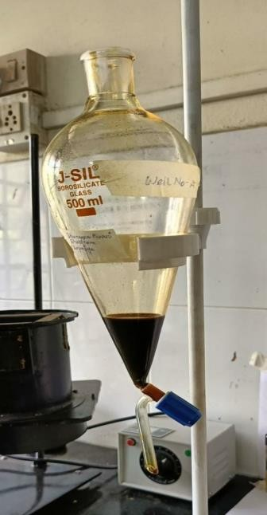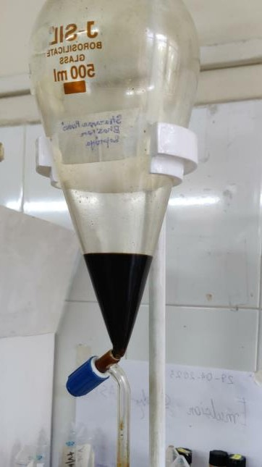
(a) Wellhead sample before separation (b) Wellhead sample after separation
Figure 1: Welllhead fluid sample (a) before and (b) after separation

In Well B, it has been observed that the water cut is very high, as evident from Figure. 2, which indicates that there is a high amount of produced water in the crude oil sample, which indicates the producing horizon has low viscous crude oil and the flow is dominated by water content. It also infers that the well may be in the decline phase with a high water cut in the later stage, which can also be ascertained by reservoir simulation studies. It needs well intervention to reduce the water and increase the production rate per day.

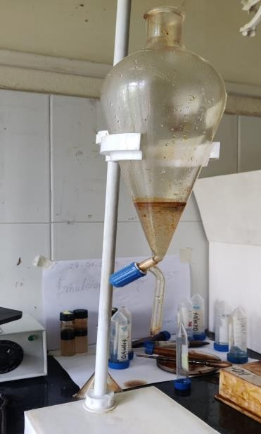
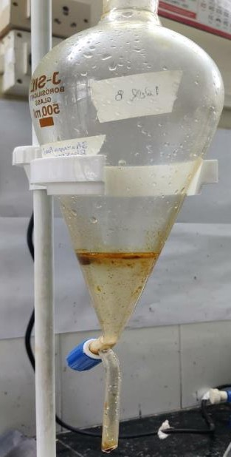

(a) Wellhead sample before separation (b) Wellhead sample after separation

Figure 2: Welllhead fluid sample (a) before and (b) after separation

In Well C, it has been observed that the water cut is low, as evident from Figure. 3, which indicates that there is a low amount of produced water in the crude oil sample, which indicates the producing horizon has highly viscous crude oil and the flow is dominated by oil content. It also infers that the well is in the development phase with a very low water cut in the initial stage, which can also be ascertained by reservoir simulation studies.
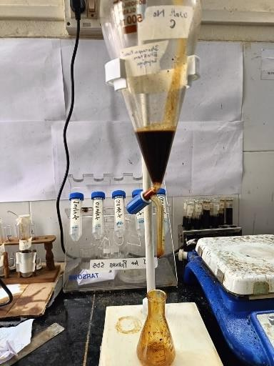
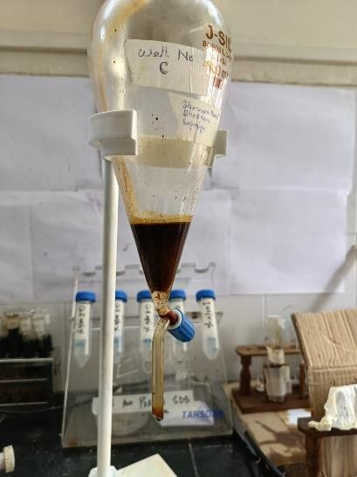
(a) Wellhead sample before separation (b) Wellhead sample after separation

Figure 3: Welllhead fluid sample (a) before and (b) after separation

In Well D, it has been observed that the water cut is low, as evident from Figure. 4, which indicates that there is a negligible amount of produced water in the crude oil sample, which indicates the producing horizon has highly viscous crude oil and the flow is dominated by oil content. It also infers that the well may be in the development phase with a low water cut in the intermediate stage, which can also be ascertained by reservoir simulation studies.
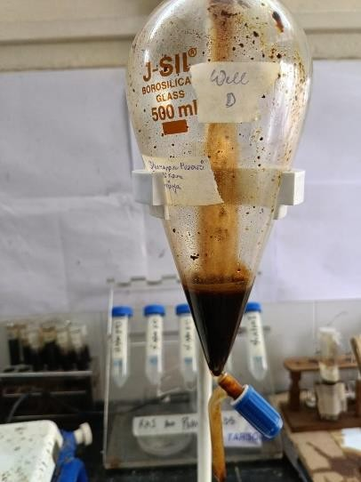
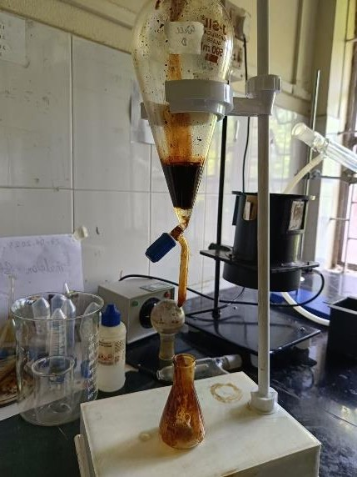

(a) Wellhead sample before separation (b) Wellhead sample after separation

Figure 4: Welllhead fluid sample (a) before and (b) after separation

In Well E, it has been observed that the water cut is negligible, as evident from Figure. 5, which indicates that there is a negligible amount of produced water in the crude oil sample, which indicates the producing horizon has highly viscous crude oil and the flow is dominated by oil content. It also infers that the well is in the development phase with a very low water cut in the initial stage, which can also be ascertained by reservoir simulation studies.

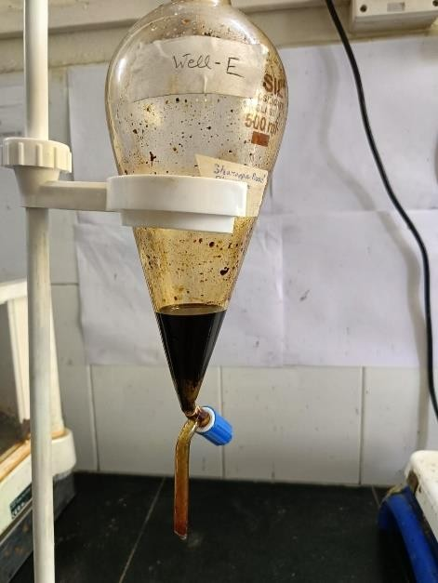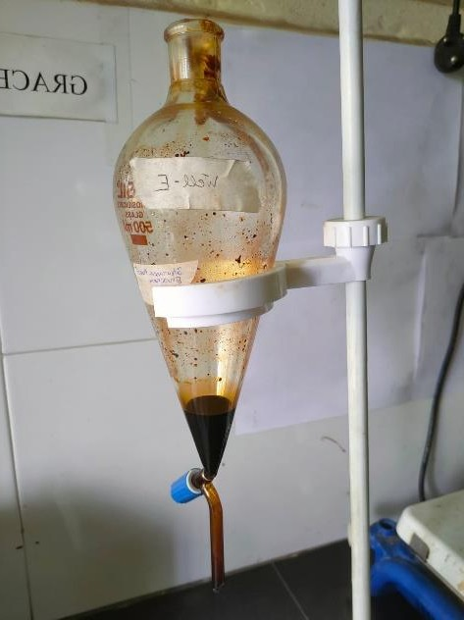

(a) Wellhead sample before separation (b) Wellhead sample after separation

Figure 5: Welllhead fluid sample (a) before and (b) after separation

Table 1: Data of crude oil and water cut for different wells

Sl. No. | Well | Water volume after separation (ml) | Crude oil (%) | Water cut (%)
1. | A | 0 | 100 | 0
2. | B | 17 | 15 | 85
3. | C | 2.5 | 87.5 | 12.5
4. | D | 4 | 80 | 20
5. | E | 0 | 100 | 0

18
16
14
12
10
8
6
4
2
0
A
B
C
Well
D
E
Produced Water Volume (ml)

Figure. 6: Graphical Representation of the produced water volume for different wells

25

20

15

10

5

0
A
B
C
Well
D
E
Collected Crude oil volume after separation (ml)

Figure. 7: Graphical Representation of the Collected Crude oil volume after separation

90
80
70
60
50
40
30
20
10
0
A
B
C
Well
D
E
Water Cut (%)

Figure. 8: Graphical Representation of the Water Cut for different wells

120

100

80

60
Crude oil (%)
40

20

0
A
B
C
Well
D
E

Figure. 9: Graphical Representation of the crude oil cut for different wells

CONCLUSION

The experimental work attempts to determine and analyse the water cut from crude oil samples of the Upper Assam Basin by using a simple gravity segregation process, including the mixing of liquified deoiler and fused CaCl₂ as a chemical catalyst that enhances the process of separation by phases. From the results obtained, the following conclusion can be drawn:
The water cuts from almost all wells are 0–20%, except for Well B, which contains 85% of the water content. It shows that the producing horizon has low viscosity and that water content dominates the flow. Additionally, it implies that the well might be in the decline phase with a high water cut in the later stages. Reservoir simulation studies can confirm this. To increase the daily production rate, well intervention is required to decrease water usage. Such a well must initiate a low production interval to eliminate early water production along with oil production. It is not necessary to completely shut off the co-produced water. but the rate at which water is produced should be below the water or oil economic limit.
For those wells containing a negligible amount of water (less than 0%)), it means the flow is dominated by oil content and the producing horizon contains highly viscous crude oil. It also implies that the well is in the development stage with a very low initial water cut, and this can be confirmed by reservoir simulation studies. Overall, a lower water cut in an oil well offers numerous benefits, including increased oil production, cost efficiency, improved well performance, an extended well lifespan, and enhanced oil quality.

REFERENCES

[1] García, M. D. C., & Carbognani, L. (2001). Asphaltene− paraffin structural interactions. Effect on crude oil stability. Energy & fuels,
15(5), 1021-1027.
[2] Altgelt, K. H. (1993). Composition and analysis of heavy petroleum fractions. CRC press.
[3] Neog D. Sensitivity analysis for enhancing crude oil recovery with continuous flow gas lift: A study in reference to the porous media of
the upper Assam basin, India. Heliyon. 2023 Jun 27;9(7): e17466. doi: 10.1016/j.heliyon. 2023.e17466. PMID: 37424596; PMCID:
PMC10328846.
[4] Basha, M., Shaahid, S. M., & Al-Hems, L. M. (2018, March). Effect of water cut on pressure drop of oil (D130)-water flow in 4 ″Horizontal
Pipe. In IOP Conference Series: Materials Science and Engineering (Vol. 326, No. 1, p. 012002). IOP Publishing.
[5] Arbatan T, Fang X, Shen W. Superhydrophobic and oleophilic calcium carbonate powder as a selective oil sorbent with potential use in
oil spill clean- ups. Chemical Engineering Journal. 2011 Jan 15;166(2):787-91

