DEVELOPMENT OF A SMALL SIZE PACKET SEALING MACHINE

Rashmi Arora
Department of Mechanical Engineering
Punjab Agricultural University
Ludhiana (Punjab) India
rashmiarora@pau.edu

Simranjeet Kaur
Department of Processing and Food Engineering
Punjab Agricultural University
Ludhiana (Punjab) India

Saurabh Ratra
Department of Electrical Engg. and IT
Punjab Agricultural University
Ludhiana (Punjab) India

ABSTRACT
A small-sized packet sealing machine is a device used in the packaging industry to seal packets. Packaging is essential, particularly for food products, as it helps prolong their shelf life. Regrettably, small business owners often encounter challenges when it comes to acquiring these packaging machines, primarily because of their comparatively high price. There are many local products produced by small entrepreneurs especially food products such as chips, pastes and some other open plastic packs in houses which we need to seal. This generally results in damage of the food after some time because they do not use the correct packaging method. Hence, the goal of this study is to assist small business owners in acquiring affordable and high-quality packaging machines. These machines facilitate fast and efficient food packaging, saving valuable time. The primary objective of this research is to design a compact packet sealing machine. During the designing, the main consideration is to avoid accidental chances as well as to hold the machine easily for any person. In this, wooden pieces of bamboo are used for making holders and wires are used for electricity flow and a switch is attached within wires to control the working of machine. Battery of 12V is attached as a source for supply of current. The machine is tested on some plastic waste wrappers and on small household items and the result obtained is satisfactory.

Keywords— Sealing machine, food products, bamboo, low cost, packet sealing

INTRODUCTION

Packaging plays a vital role in marketing a product, ensuring both its safety and marketability. Particularly for essential items like food, the method of product packaging is a crucial aspect of production planning. It not only guarantees the safety of the product but also signifies the product's quality and the company's identity. Product packaging involves how the item is packed, the materials used, as well as the packaging features and specifications. Choosing the right packaging method is essential for the product to find its place in the market and attract consumers. An ideal packaging method meets customer needs and entices them to purchase the product. Consequently, various sealer machines are available in the market, each with its own advantages and disadvantages based on its application. Before the advent of these machines, finishing plastic was attached using less practical wax methods, resulting in less tidy outcomes. While there are many types of sealer machines in the market, most of them are large-sized and expensive, making it a significant investment.
As the flexible packaging sector undergoes growth, the range and diversity of heat-sealing equipment have expanded to cater to escalating needs. Amid the plethora of distinct sealing devices available, three primary techniques for heat sealing have emerged: Impulse sealing, direct or continuous heat sealing, and ultrasonic sealing. Gaining insight into the advantages and possible limitations of each approach significantly aids prospective buyers in selecting the optimal fit for their specific requirements.
Impulse heat sealing is a commonly utilized technique for bonding thermoplastic materials such as Polyethylene and Polyurethane. It operates at a moderate temperature to ensure effective sealing. This method is frequently employed for sealing bags and pouches that have multiple layers, are metalized, or feature oxygen barriers. Impulse heat sealers come equipped with replaceable heating elements, which can be round or flat and are typically constructed from a specialized material, often a Nichrome alloy. These heating elements are strategically positioned in the top and/or bottom sections of the sealing bars. When the materials to be sealed are placed between the sealer jaws, the jaws are closed and secured using either pneumatic or mechanical pressure. Subsequently, an electric current is briefly applied to heat the Nichrome element for a predetermined duration, achieving the necessary sealing temperature.
Impulse sealing offers inherent safety as high heat is generated solely when the sealing jaws are under pressure and the heating element is activated. This design ensures minimal risk of burns upon contact with the sealing jaws. Moreover, operating costs are reduced with impulse sealing. The energy consumption is minimized because the heating elements are activated for a very brief period during each sealing cycle.
This small size sealer machine is a packaging sealer machine used to simplify and speed up the adhesion of plastic finishes. Small business owners can benefit from utilizing this machine, as it effectively and neatly seals food packaging. Furthermore, it aids in preserving food quality by preventing exposure to bacteria and air, which can otherwise degrade the food. This machine ensures a meticulous finish and extends the shelf life of food products. It's not limited to dry food industries; even producers of wet foods like pastes find it useful.
A research study was carried out on wrap-around-machine (WAM) [1] To enhance productivity at Famifarm Oy, Finland, an analysis was conducted to assess the operational efficiency of the packaging machine. The study aimed to pinpoint potential obstacles and inefficiencies associated with the packaging machine's functioning, which were subsequently utilized as the focal points for the research. The outcome of this investigation offered systematic suggestions aimed at enhancing the overall performance and efficiency of the Wrap-Around-Packaging Machine. The strains packaging was mainly completed by hand in mushroom planting industry. In order to regulate the low efficiency, an automated packaging machine of the strains was designed [2]. The machine involved the auger delivery, heat-sealing and cutting mechanism. Theoretical calculation and numerical simulation was applied for the auger delivery unit. This packaging machine met the demand of the relative technical requirements, and suitable for promotion in the medium and small farmers. A design of an Automatic Wrapping Machine was offered [3] using a PIC18F45X Micro-controller where the machine enhanced the efficiency of the packaging process which resulted in minimizing the labour cost. That machine had 2 sections. One section was the wrapping mechanism, and the second section was the control system to control this mechanism. A Light Dependent Resistor (LDR) was used to detect the intensity of light on the feeder and give signals to the controller. A similar kind of system was developed [4] that supplied polythene bags through vacuum grippers and sealed these bags automatically and hence it was called an automated sealer. A homemade sealer machine [5] resulted in higher tidier in packaging and also was better. The sealer product successfully tested as more neat packaging, sealer was stronger, and conveyor could accommodate the weight of food products and could facilitate work during the sealer process is carried out. A simple and small packaging system was designed [6] to seal the plastic bags. The major components used were air compressor, double acting cylinder, air storage tank, 5/2 direction control valve, SMPS (Switch Mode Power Supply), a foot operated push button switch, a heat sealer, and tubes for air supply. The production rate was increased due to the use of pneumatic systems. An automated stamping machine [7] driven by pneumatic systems that consists of air compressor, directional control valves, air service unit was designed, fabricated, tested, and operated.
This invention must consider the characteristics and theory of origin while creating this small size sealer machine. The final design should be simple, lightweight, and portable. Component selection is based on studies and experiments to ensure that this sealer machine works flawlessly. In reality, safety and comfort are also prioritised.
The small size sealing machine was assembled with different materials collected from the market and assembled according to the requirement for holding the machine and to avoid electric shocks. Two bamboo wooden pieces having 3 inches length with round shape are used as a holder. Along with them the wires were connected for flow of current. A tactile switch having diagonal legs is also attached along with wires for controlling the machine. Battery of 1200 mAh is attached for providing electricity. A base made up of wooden sheet is also attached, where the whole machine is placed. It is a useful portable device called mini plastic sealer or mini heat sealer. It can be used to seal daily used small packaging for e.g., shampoo pouches, masala packets, chips packets, etc. Basically, this is used for small plastic packaging which we use in a small quantity and after that we have to preserve in another container or vessel. To avoid this, this mini sealer is used to seal once opened pouches or packaging to preserve and prevent them from deteriorating.

CONSTRUCTION

Firstly, a bamboo stick of 1 inch diameter was taken and cut into half vertically with the help of wood cutter saw. Then two halves of 3 inch length were taken. The length of bamboo depends on the length of nichrome wire used. The length of bamboo was taken half of the length of nichrome wire. Accordingly, the battery size is also selected. For joining bamboos, simple rubber was used. Then 30 Awg nichrome wire was used along with 1200 mAh lithium-ion battery. After that nichrome wire is adjusted on the outer sides of bamboo of specific length. The wire is fixed with the help of small screws and rubber bands. The components used for making this small size sealing machine are:
- The holder – The two pieces of bamboo having length and diameter of 3 inches and 1 inch respectively are used for making holder which seal the plastic bags.
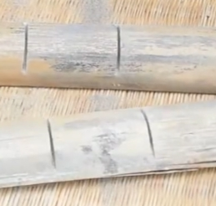
Fig 1: Pictorial representation of Holder

- NichromeWire - Nichrome refers to an alloy which is made from nickel and chromium. Nichrome wire is very useful as it resists heat as well as oxidation. The average wire diameter is 0.01 inches having resistance 6.68.
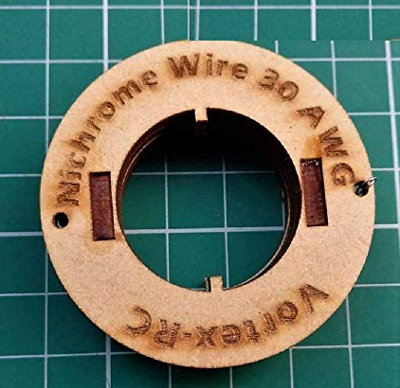
Fig 2: Pictorial representation Nichrome wire

- Switch – The tactile switch is an electromechanical device used to start or stop current flow along a circuit. The current rating of the switch is 50mA and having voltage 12v DC supply.
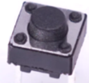
Fig 3: Pictorial representation of switch

- Screws – The screws should fit the nichrome wire so that the screws used do not damage the wood plate. Besides that, the finish can also be produced.

e) Rubbers – Simple Rubbers are used for joining the holder.

WORKING

A heat-sealing machine is a type of sealer that encloses things using heat as the sealing agent. It functions by sending a high current impulse to the heater ribbon located on the device's surface. The heat wave created by this is powerful enough to melt and seal the bag or sheet that is sandwiched between the sealing bars. Most manufacturers will provide temperatures for sealing each film, and this provides a good starting point for the heat or time. It is generally recommended to start with a heat time of two seconds at 200° F and a cool time of two to three times the heat time. Heat sealers are used in many food packaging industries to seal the materials having thermoplastic layer. Firstly, sealing bar is heated to the required degrees of temperature, material melts and gets joined just like a zip liner bag.

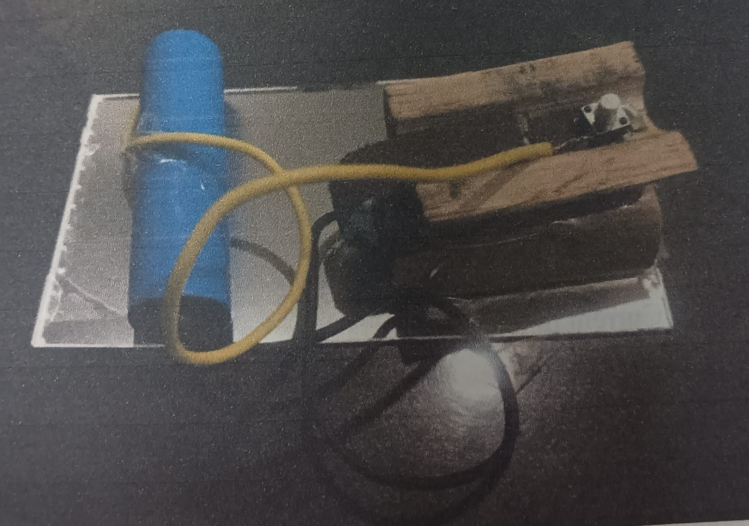
Fig. 4 Pictorial Representation of Small Size Packet Sealing Machine
Figure 4 shows pictorial representation of the developed small size packet sealing machine using bamboo sticks and lithium ion battery connected with nichrome wire and tactile switch. Firstly, when the tactile switch is pressed then the current starts flowing from the positive terminal of the lithium ion battery, then the current is passed through screw 1 and after that the current reaches nichrome wire. The negative terminal of the lithium ion battery is connected to screw 2 to complete the circuit. When the current reaches the nichrome wire, it starts heating up and the bamboo sticks are being pressed by hand. The plastic bag which is to be sealed is placed inside the bamboo sticks. This results in sealing of that bag. The circuit diagram for the machine is shown in Figure 5.

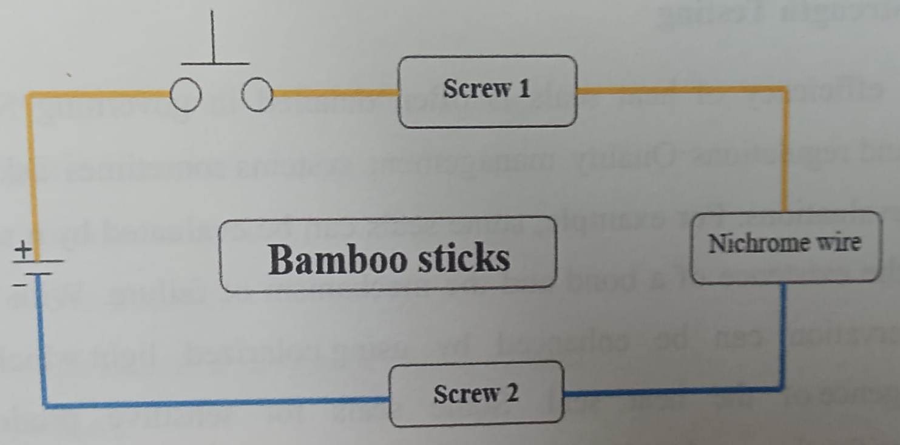
Fig. 5 Circuit Diagram of Small Size Packet Sealing Machine

Symbols | Name
 | Tactile Switch
 | Battery

Calculations for Heat Generated
The heat equation used to calculate the heat generated during sealing of a shampoo pouch of 6 ml is
Q = I²RT
Where Q is Amount of Heat Generated in Joules
I is Electric Current in Ampere
R is Resistance in ohm
T is Time in Seconds
Time taken to seal a shampoo pouch of 6 ml is 16 seconds.
Current (I) = 1200 mAh
As 1 mAh = 0.001 Ah
Therefore I = 1200*0.001
= 1.2 Ah
= 1.2*3600 Amp Sec
= 4.32*10² Amp Sec
Resistance of Nichrome Wire (R) = 6.68 ohm
Hence Q = (4.32)²*(10)⁴*6.68*16
= 19.94*10⁶ Joules
= 19.94 MJ

CONCLUSIONS AND FUTURE SCOPE

The small size sealing machine provided good results during operating and there was no difficulty found. This advancement in sealing technology led to improved packaging hygiene and effectiveness. When utilizing the appropriate technique, such as employing a tightly sealed machine that eliminates any possibility of air gaps entering or leaving the package. It can easily be handled by a person even by small children above the age of 6 years. The material is available at cheaper cost and is easily available. This machine is environment friendly as bamboo sticks are used and no plastic is used as per Indian government norms. Moreover, if plastic sticks are used instead of bamboo sticks, then it may burn due to the quick heating of nichrome wire. We can easily seal open packets with this mini sealer machine. This is more time saving than any other machine. The biggest advantage is that there are no accidental chances. The only disadvantage of this machine is that the battery life is short, and we need to recharge it after using twice. It takes ten seconds to seal a plastic packet. This cannot be used to seal large or heavy packets.
By scaling up the size of parts of machine and increasing the power supply, heavy plastic products can be used for sealing purpose. If we increase the length of bamboo pieces, we can use it on large scale. We can also use the battery having more voltage and use it on industrial level or big scale.

REFERENCES

Famifarm Oy, Joroinen Finland (2011) Improving The Performance And Efficiency Of Wrap Around Machine:Bachelor. Packaging and Food Machinery, 15:230-33

Qiuxiao Yang, Kaibao Wang, Mingzhu Zhang, Li Zhao, Su Hang, Ming Meng (2015) The Design and Research on Automatic Packaging Machine of the Strains Proceedings of the 2015 International Conference on Management Science and Innovative Education.
Suraj S. Nair, Suraj D. Mankar, Anuradha D. Jadhav (2016) Automatic Wrapping Machine International Journal of Engineering Trends and Technology, 31(5): 228-231
Avik Das, Abu Sayeed , Md. Rafiquzzaman (2019) Development of an Automated Sealing System for Polythene Bag Journal of Automation and Automobile Engineering, 4(1): 25-32
Khairulnizam Bin Kasim, Mujahid Bin Amran, Nurul Nadzirah Binti Mohd Hanafi and Nur Diyana Binti Zulkifli (2020) Sealer Machine
http://repository.psa.edu.my/handle/123456789/3176
Renis D Thumar, Rinkesh M Soni, Kalpak I Patel, Hardik A Mistry, Ravi Dabla (2007) Electro-Pneumatic Portable Packaging Machine International Journal Of Creative Research Thoughts 70:1200-10
S. Jagadeesan, M. Ganesh, S. Karthik (2019) Design and Fabrication of Automated Sealing Machine Packaging and Food Machinery 7: 2321-9939

