Protective Shielding in Radiology
Author: Mr. JEEVA.M, Assistant Professor
Department of Radiology,
School of Allied Health Sciences,
Vinayaka mission research foundation
Deemed to be university
Paiyanoor Chennai, India.
Email ID: jeeva.sahs@avit.ac.in

Abstract
Protective Shielding and basic radiation protection tools, Shielding is used to protect radiosensitive areas of the body by adequately attenuation the radiation with a 0.5 mm lead protection. Here were used a several types of shielding in radiology department. In Controlled area are radiation worker exposed upto1 mSv (100 mrem) per week and Uncontrolled area dose limit upto0.1 mSv (10 mrem). Then they were described a Protective barrier and types, In Radiation shielding factors effecting the barrier thickness. They were partially differentiating daily patient load and weekly patient workload and factors(U). In diagnostic radiology they were used materials for shielding and determining the barrier thickness are two methods like half value layer and tenth value layer. And AERB guidelines for protective shielding of X ray examination room and patients waiting room and described the shielding of the X-ray control room.
  - Introduction
Shielding is the main means of radiation protection. It helps reduce the radiation dose and also protects against radiation syndrome. Several types of protection are used in the radiology department.
Source shielding: t is defined as the shielding of the radiation source, i.e. the tube body, which is called radiation source shielding. It protects against leakage radiation.
Structural shielding: It is defined as protecting the walls of the X-ray room. It should be covered with adequate thickness of lead as per AERB guidelines. Structural shielding protects against all types of radiation, such as primary, stray and leakage radiation. The following parameters affect the structural protection:
Controlled area: Used by a radiation worker to be exposed to up to 1 mSv (100 mrem) per week.
Uncontrolled area: Used by a radiation worker, as a relative of a patient, etc. The dose limit has a difference of 0.1 mSv (10 mrem).
1.2. Protective barrier
It is defined as a device used to protect against radiation called a shielding barrier. The lead-lined wall of a radiology department is generally said to be a protective barrier. The height of the fence must be 2.1 m (7 ft) from the floor. The primary beam is always perpendicular to the main resistance. There are two types of protective barriers.

- Primary Protective barrier: The main protective barrier. It is defined as the wall of the radiological room where the primary radiation enters, called the primary shield. It should be lead coated with a 1.6 mm thick barrier.
Basics of Radiation, Hazards & Prevention in Diagnostic Radiology
ii. Secondary barrier: It is defined as the wall of the radiology department that hit
secondary radiation called the secondary protective barrier. It should be lead coated with a 0.8mm thick barrier.

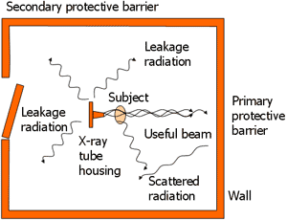
Figure. 1
NOTE. Where the primary and secondary barriers meet, it should be lined with a 1.3 mm thick barrier.
Control cabin:
It is an important part of the x-ray room where there are various control panels like Kv, mAs meter, ON/OFF switch etc. Therefore, it is very important to consider the protection of the structure. It protects against secondary radiation, so the wall of the control room must be considered as a secondary protective barrier. A very important part of the cockpit is the viewing window. This should be a 1.5 mm thick lead and allow the technician to monitor the patient during the exposure.
Factors affecting barrier thickness: Many factors affect the thickness of the radiation shield, such as dose limitation, workload, utilization rate, utilization factor, etc.
Dose limit: To produce a radiation shielding device, the dose limit of the controlled and non-controlled area must be known. 1 mSv and 0.1 mSv dose limit for surveillance and monitoring area.
Work load: It is defined as the utilization volume of a unit of radiation exposure, i.e., the operating time of the X-ray tube per week is called the workload. It is calculated in the form

W = mAs per patient No of pt per Hr No of hour per week
60 min

Typically, weekly workload for general radiography and other examination: -
Daily patient load

Daily patient load

General radiography - 24
Fluoroscopy - 24

Typically, Weekly Workload

<100kVp | 125kVp | 150kVp
1000 | 400 | 200
750 | 300 | 150

- Use factor: It is defined so that the time required for the main beam to hit any wall is called the utilization factor. It is also known as beam directivity. Primary wall exposed to primary beam duty factor 1. Walls periodically exposed to radiation with duty factor. The utilization factor of the roof is very low or zero. Since all walls of the X-ray room are exposed to scattered radiation, its utilization factor is also 1.
- Occupancy factor: It is very important to consider when designing a protective barrier. It is defined as the time when a person is outside the exhibition space. There are the following categories of residential areas.
BARRIER | PRIMARY BARRIER USE FACTOR (U) | SECONDARY BARRIER USE FACTOR(U)
Floor | 1 | 1
Wall | 1/4 | 1
Ceiling | Very Small | 1

(a) Full Occupancy: An area occupied during normal working hours, such as an office, laboratory, medical centre, etc., with 1 person.
b) Partial use: Partially used during working hours. Example - washrooms, corridors, etc. with a usage of 1/4.
c) Informal use: Informal use during working hours, for example in the waiting room, toilet, etc.

Basics, hazards and prevention of radiation in diagnostic radiology usage rate 1/16. They are all intended for the general public, which does not work. Working people are considered a controlled area with a utilization rate of 1.
v. Distance: Confirm the minimum distance of the worker from the source, because increasing the distance reduces the radiation dose.
vi. Energy of the radiation and attenuation factor: The attenuation factor A depends on the barrier material and the energy of the radiation effect on the barrier.
1.3. Materials for Shielding
Lead is the most commonly used shielding material in the radiology department. Lead is the most popular material because it effectively absorbs radiation due to its high atomic number and molecular density. An atomic number is 82 and the lead is a chemical element in the symbol pb with the carbon group. The higher molecular density of lead (11.34 grams per cm³) makes it a useful shield against X-rays and gamma rays. Lead in its pure form is sensitive and cannot be used as clothing. To turn pure lead into a radiation shielding material, it is mixed with binders and additives to form a flexible lead vinyl sheet. Lead sheets are then layered to the desired thickness to achieve the required lead equivalence and added to the radiation shield. Traditional lead shielding typically has three standard levels of lead equivalent shielding, including 0.25 mm, 0.35 mm, and 0.5 mm. Lead shielding commonly used in a variety of applications including diagnostic imaging, radiation therapy, nuclear and industrial shielding.
Lead (Pb) synthetic shielding: This is a mixture of lead and other lighter metals, which may include a mixture of lead, tin, rubber, PVC vinyl and other damping metals. Lead-based composite radiation shields are lighter (up to 25%) than standard lead and are available with the same protection levels as lead.

Lead free shielding:

Lead and lead-free shielding materials offer the same level of protection as lead-based composite shielding materials. Lead-free shielding materials are made with additives and binders mixed with quenching heavy metals of the same material class as lead, which also absorb or block radiation. These metals may contain tin (Sn), antimony (Sb), tungsten (W), bismuth (Bi), or other elements. Lead and lead-free aprons are reusable and safe.

Determining the barrier thickness:

Technicians are not directly involved in determining the thickness of the protective shield or barrier. Several methods are used to determine the barrier thickness, such as half value layer, tenth value layer, etc.

HVL- It is defined as the thickness of material that reduces the radiation intensity to half of its original value. The HVL value of the wire used for protection is 0.06, 0.17, 0.27 and 0.28 at voltages of 50, 70, 100 and 125kVp.

TVL- It is defined as the thickness of material that reduces the intensity to one tenth of its original value.

1.4. AERB guidelines for shielding of X-ray

examination room and patient's waiting room which are as follows:

      - X-ray examination room shielding:
The rooms for diagnostic X-ray units and related equipment are located as far as possible from tall buildings and areas with public traffic, such as maternity and children's wards and other hospital wards that are not directly related to radiation and its use. The room containing the X-ray equipment is at least 18 m2 for general radiography and standard fluoroscopy equipment. If the facility is located in a residential complex, it must be ensured that (i) the wall of the x-ray rooms, on which the primary x-ray beam falls, is at least 35 cm thick brick etc., (ii)the walls of the x-ray room, where the scattered x-rays fall, must not be less than 23 cm thick brick, etc. (iii) Protection is the same as at

Basics of Diagnostic Radiology, Hazards and Radiation Avoidance At least 23 cm thick brick or 1.7 mm lead in front of x-ray doors and windows to protect adjacent areas.
Patient waiting area:
Patient waiting areas are outside the X-ray room. An appropriate warning signal, such as a red light and a warning sign, must be placed outside the X-ray room and must be kept "ON" when the equipment is in operation.
Shielding of the X-ray control room:
The control room of the X-ray machine is a secondary protective barrier with two important aspects: (a) Control room walls and viewing window, which should have a lead equivalent of 1.5 mm. (b) the location of the cockpit, which should not be where the primary arm falls straight.

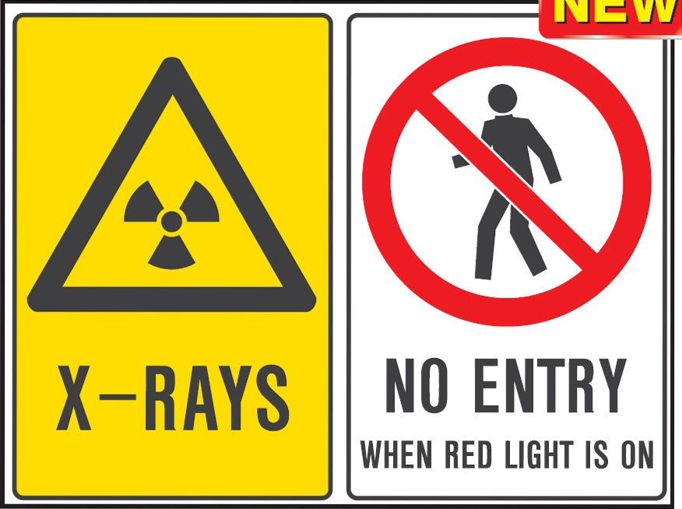

Figure No. 2
The AERB recommends the following shielding for the X-ray control room:
The control panel of diagnostic X-ray equipment operating at 125 kVp or higher must be installed in a separate room located outside the X-ray room and equipped with adequate shielding. The control panel of X-ray equipment operating up to 125 kVp can be placed in the X-ray room. The AERB recommends that the distance between the control panel and the base of the X-ray unit/box should not be less than 3m for general purpose stationary X-ray equipment.

References: -

- The 2007 Recommendations of the International Commission on Radiological Protection. ICRP publication 103. Ann ICRP. 2007;37(2-4):1-332.
- Zielinski JM, Shilnikova NS, Krewski D. Canadian National Dose Registry of radiation workers: overview of research from 1951 through 2007. Int J Occup Med Environ Health. 2008;21(4):269-75.
- López PO, Dauer LT, Loose R, Martin CJ, Miller DL, Vañó E, Doruff M, Padovani R, Massera G, Yoder C., Authors on Behalf of ICRP. ICRP Publication 139: Occupational Radiological Protection in Interventional Procedures. Ann ICRP. 2018 Mar;47(2):1-118.
- Leonard RB, Ricks RC. Emergency department radiation accident protocol. Ann Emerg Med. 1980 Sep;9(9):462-70.
- Frane N, Megas A, Stapleton E, Ganz M, Bitterman AD. Radiation Exposure in Orthopaedics. JBJS Rev. 2020 Jan;8(1):e0060.
- Lin Y. Internal radiation therapy: a neglected aspect of nuclear medicine in the molecular era. J Biomed Res. 2015 Sep;29(5):345-55.
- Matityahu A, Duffy RK, Goldhahn S, Joeris A, Richter PH, Gebhard F. The Great Unknown-A systematic literature review about risk associated with intraoperative imaging during orthopaedic surgeries. Injury. 2017 Aug;48(8):1727-1734.
- Naini FB, Gill DS. Smile Aesthetics. In: FB Naini. Facial Aesthetics: Concepts and Clinical Diagnosis. Oxford: Wiley-Blackwell, 2011.
- Desai S, Upadhyay M and Nanda R. Dynamic smile analysis: Changes with age. Am J Orthod Dentofacial Orthop. 2009; 136: 310.e1–10.
- Roden-Johnson D, Gallerano R, English J. The effects of buccal corridor spaces and arch form on smile esthetics. Am J Orthod Dentofacial Orthop. 2005; 127: 343–50.

