INTERNAL AUDITOR’S PIVOTAL ROLE IN ESG REPORTING:
FROM CONFUSION TO CONVERGENCE
Dr. Amit Kumar Nag
Professor, BSSS Institute of Advanced Studies (BSSS IAS),
Email: amitnag148@gmail.com
Dr. Atul Dubey
Associate Professor, BSSS Institute of Advanced Studies (BSSS IAS),
Email: dubey.atul@bsssias.ac.in

Dr. Rahul Joshi
Assistant Professor, Department of Commerce, The Bhopal School of Social Sciences
Email: joshirs@rediffmail.com
Abstract
We are in a pivotal period of profound transformations and unparalleled possibilities. The survival and prosperity of the human race hinge on the conservation of planet Earth in its pristine form. To realize this, ESG principles must be deeply ingrained in the core ethos of organizations worldwide. ESG, therefore, must evolve beyond mere letters in the alphabet, restricted to discussions in conferences, academic articles, and polished annual reports. To ensure ESG doesn't remain just ornamental jargon, periodic reviews of its practices are paramount. To facilitate these reviews, a comprehensive evaluation system with criteria for environmental, social, and governance aspects is crucial. This is where the role of an internal auditor becomes indispensable.
Keywords: ESG, regulatory environment, internal auditors, investors, investing trend
Introduction To ESG: -Sounding The Alarm
Over the years, discussions surrounding ESG have been ongoing. Nevertheless, it was a significant turning point in 2021 when a Swiss report garnered widespread attention. Swiss Re, renowned as the world's largest reinsurance company, released a projection that projected a 3.2-degree Celsius increase in global temperatures by 2050 could result in an alarming 18 percent depletion of the global GDP. This revelation sent shockwaves among investors, as such drastic climatic shifts could render numerous investment opportunities, including operational businesses, unviable within a mere three decades. Faced with the prospect of enduring substantial long-term losses, investors swiftly initiated the practice of scrutinizing companies through the lens of ESG criteria.
ESG transcends a mere checklist of items. It embodies a commitment to enact meaningful change, both within the company and on a global scale. ESG entails generating enduring outcomes that not only enhance value and propel expansion but also contribute positively to our surroundings and communities, fostering a harmonious synergy between progress and the well-being of the environment and societies at large.
ESG represents more than a collection of admirable ideals. It involves crafting a tangible, practical strategy that delivers substantial results. Merely acknowledging climate change, diversity, and transparency falls short of guaranteeing triumph. The true essence lies in seamlessly integrating these principles across the entirety of the organization, spanning from investment decisions to the ongoing cultivation of innovative solutions over the long term.
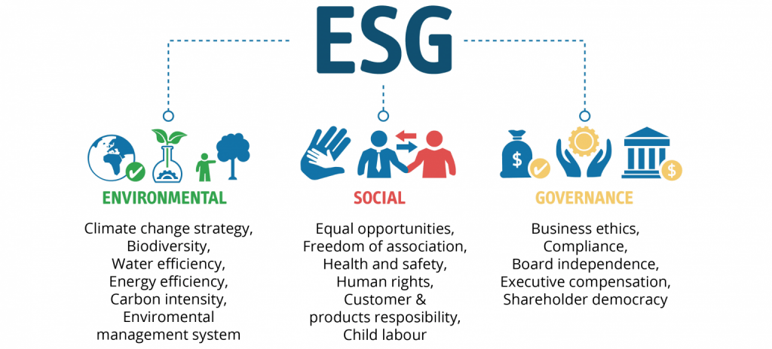
ESG Analysis- Factors Analysed
- Environment: Environment: This section focuses on a company's environmental disclosure, its impact on the environment, and any measures it may be making to decrease pollution or carbon emissions.
- Social: Social: Refers to workplace ethics (diversity, management, human rights) as well as their relationships with people in the community (philanthropy or corporate citizenship)
- Governance: Accounts for compensation, shareholder rights, and the relationship between shareholders and management
ESG Reporting:- The Investor Way
Throughout history, financial considerations have overwhelmingly influenced investment choices. However, with the global prominence of climate change, the imperative to mitigate its impact by transitioning to sustainable developmental paradigms (and consequently, investment strategies) has taken center stage. Shifting away from strictly finance-driven investment models, investors are increasingly directing their attention toward socially and ecologically conscious, forward-looking investment trends.
Consequently, there has been a substantial surge in the demand for Environmental, Social, and Governance (ESG) investing. This approach shifts the focal point of investment decisions from being solely geared toward financial gains, to using non-financial factors as benchmarks. This shift is gaining remarkable traction on a global scale. In India, investors are displaying a growing inclination toward companies and investment vehicles that adhere to ESG standards. Simultaneously, corporations are taking proactive measures to integrate ESG principles into their corporate governance strategies. For instance, Tata Consultancy Services has publicly stated its commitment to achieving net-zero absolute greenhouse gas emissions by the year 2030.
Similarly, Hindustan Unilever established a centre in Mumbai to address the lack of personal hygiene, lack of access to clean water, and poor sanitation in slums.
Setting a remarkable precedent, the Ghaziabad Municipal Corporation has taken a pioneering step by becoming India's inaugural civic entity to release green bonds on the BSE. These bonds have been issued for a unique project aimed at repurposing wastewater in an environmentally sustainable manner. The successful issuance garnered 150 crores in rupees, earmarked for the construction of a tertiary water treatment facility that will notably benefit industries situated in Ghaziabad.
From an investment perspective, an increasing number of individuals are inclined to allocate their resources to enterprises that exhibit a genuine concern for both societal welfare and the environment. Failing to integrate ESG considerations into business strategies and policies could render existing business processes obsolete in the future. This is because evolving laws and regulations might render certain conventional business practices unlawful, rendering the enterprise less appealing to potential investors. Traditionally, investment decisions were grounded in practical variables like resource availability, debt ratios, and operational efficiencies, determining a company's investability. However, the emergence of ESG as a new stratum of intangibles is now reshaping this landscape. Investors seek assurance that companies can sustain their profitability while upholding these intangible aspects. Despite India boasting ten ESG-focused mutual fund plans, most of them are currently underperforming compared to the BSE 100 Total Return Index. Given the scarcity of vital resources, particularly human capital, the fervor around ESG might indeed be indicative of a broader trend.

Hence, investors are not solely focused on maximizing profits; they also prioritize aligning their portfolios with sustainable development objectives. Consequently, the integration of ESG disclosures with a company's corporate governance practices is gaining paramount significance within the realm of investment. This integration plays a pivotal role in accurately discerning a company's true value.

Relevance of ESG Reporting:-
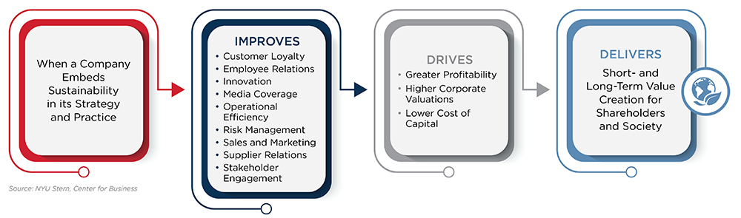
Internal Auditors’ ESG Role: Adding value through assurance and advice
With a mission to "enhance and safeguard organizational value through the provision of risk-based and unbiased assurance, guidance, and insights," the engagement of internal audit in ESG reporting is not only crucial but also inherently fitting.
The impending legislative changes are propelling a shift towards heightened emphasis on ESG reporting, alongside the expectations of stakeholders.
Internal auditors amalgamate knowledge, empathy, and technology to convert ambiguity into curiosity, intricacy into lucidity, and challenges into prospects. Hence, internal auditing must surpass the mere identification of risks, encompassing root cause analysis, potential risk mitigation strategies, and preemptive controls. Furthermore, it must ensure the seamless operation of the organization's governance, risk management, and internal controls.

By verifying the efficiency of ESG-related protocols and endeavors, internal auditors are aiding organizations in managing these risks and cultivating resilience.
Predominantly, internal audit is engaged in assurance services that bolster processes, controls, and validation of reported substantial ESG data. Among the usual advisory services is the evaluation of climate risk and the integration of ESG factors into the organization's enterprise risk management.
At a minimum, the internal audit department should deliver the following assurances pertaining to ESG reporting.
ASSURANCE
• Scrutinizing the tracking and monitoring of ESG objectives and Key Performance Indicators (KPIs).
• Analyzing the implementation of the ESG program and pertinent policy documents.
• Ensuring the accuracy of ESG reports disseminated to stakeholders.
• Verifying the correctness, timeliness, and consistency of reporting metrics: The integrity of public ESG reports is paramount to adequately represent an organization's ESG endeavors, given the increasing regulatory oversight and public scrutiny.
• Ensuring that reporting aligns with official financial disclosure submissions: While ESG reporting predominantly includes non-financial data, any disparities with formal financial disclosures would undoubtedly raise concerns among investors and regulatory bodies.
• Appraising the materiality or risk assessment pertinent to ESG reporting: Organizations need to grasp how ongoing ESG activities or the public's fervor for achieving ESG objectives could attain a level of significance warranting attention.
• Integrating ESG considerations into routine audit plans.
ADVISORY
• Providing counsel on the formulation of ESG program objectives and metrics.
• Creating an ESG control framework: Internal audit's expertise can aid in crafting dedicated internal controls tailored for ESG reporting.
• Suggesting suitable reporting metrics: Internal audit's perspective can illuminate the kind of data that accurately mirrors the organization's pertinent ESG undertakings.
• Offering direction on ESG Governance: Given its comprehensive understanding of risks spanning the organization, internal audit is well-equipped to provide guidance on ESG governance.
Apart from these Assurance and Advisory services -
• Internal audit departments execute governance assessments to ascertain the presence of appropriate roles, responsibilities, and procedures essential for implementing the ESG strategy and mitigating risk.
• Internal audit can additionally conduct ESG audits covering topics such as climate-related matters, environmental adherence and performance, employee safety, data protection, and the sustainability of supply chain operations.
More broadly, internal audit can support management in answering relevant questions such as:
• Do we possess a thorough comprehension of all ESG risks, encompassing compliance risks tied to prevailing and imminent national and global regulations, and do we consistently undergo re-evaluation?
• Is our ESG culture effectively aligned with our ESG undertakings?
• Are we diligently monitoring and reporting our ESG endeavors through pertinent Key Performance Indicators (KPIs) connected to the ESG strategy?
Amidst the expanding ESG market and evolving regulatory scenario, the internal audit function assumes a pivotal role in fortifying risk management and enhancing performance through the assurance of controls.
Following figure depicts internal audit involvement in an organisation’s ESG program
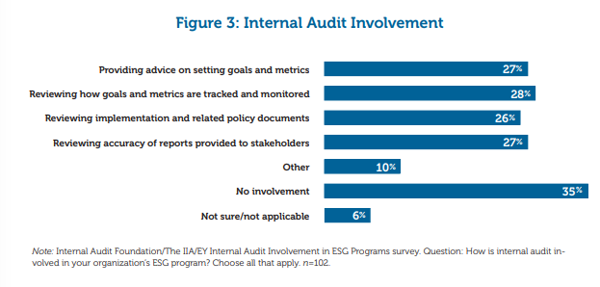
MACRO CHALLENGES TO AUDITING ESG-LADDER TO CLIMB
Part of the complexity arises from the proliferation of ESG ratings and risk assessment metrics that were predominantly developed in isolation. Ratings lack transparency and comparability due to their foundation on a multitude of criteria drawn from frameworks established by various standard-setting entities. Even within organizations that give precedence to ESG concerns, the advancement of ESG is impeded by conflicting business objectives, disparate reporting regulations, and diverse leadership responsibilities.
Following chart depicts the biggest barriers which are preventing companies from progressing on ESG
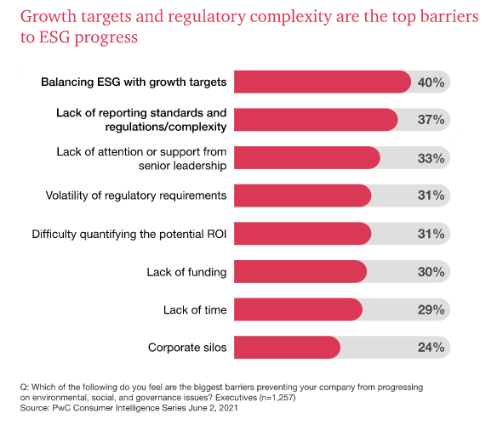
Steps to Take-Navigate through Challenges
Numerous internal auditors will require the acquisition of fresh proficiencies to effectively navigate these challenges and offer robust assurance. Auditors must acquaint themselves with domains such as Greenhouse Gas (GHG) Calculation Frameworks.
In the short to medium term, several internal audit teams might need to lean on in-house or external technical sustainability experts, particularly for the intricacies of ESG information, such as injury reporting.
Moreover, internal auditors will need to develop the capability to assess IT systems and essential data components integral to ESG reporting, even if they have not been integral to financial reporting before.
ESG ASSESSMENT – Steps An Internal Auditor Should Follow To Decode And Define The Gap Between Intent And Action.
1. Perform a Materiality Evaluation:
The cornerstone of the ESG strategy should be a meticulous materiality analysis. In the absence of a thorough evaluation, enterprises often resort to impromptu approaches or lack consistent dedication to established priorities. The aim is to concentrate on ESG issues and prospects that hold the greatest potential to influence both the business performance of the company and the well-being of its stakeholders.
2. Analyse Current Situation :
After determining the ESG variables to be addressed, the auditor should proceed to evaluate the company's existing initiatives, policies, metrics, and undertakings. This can be achieved by engaging directly with cross-functional stakeholders within the organization who hold proficiency in each focal ESG aspect.
This evaluation empowers the auditor to assess the current state of the company and gauge the varying stages of ESG integration throughout the entire organization.
3. Establish goals and objectives for ESG strategy:
Equipped with the foundational ESG data, the auditor should now formulate a course for steering their endeavors in the forthcoming stages. To refine strategic goals, the auditor ought to organize topic-specific collaborative sessions with crucial stakeholders, commencing with:
• Sustain: What existing practices are already commendable and solely require effective communication or maintenance?
• Enhance: Which domains could benefit from gradual enhancements to achieve closer alignment with peers, meet stakeholder expectations, or showcase our resolute ESG dedication?
• Maximize: Where can we fortify our ongoing initiatives to secure a position of ESG leadership within our industry?
4. Analyse: Hurdles to Future State Achievement
Steps 1, 2, and 3 are the initial round of health tests to prepare for a successful ESG sprint, but he also needs to be aware of all the potential obstacles organization may face as it attempts to reach its new objectives. Auditor should complete a brief gap analysis between current state and aims or goals to determine what may be missing so that he may build strategy and plan for the future accordingly.
5. Develop a roadmap and framework for ESG:
A robust ESG program is contingent on the establishment of a framework that precisely delineates the intersection of the company's vision and mission with ESG priorities. The internal auditor should play an integral role in formulating a roadmap that ensures accountability for pivotal initiatives and in crafting a compelling ESG framework that offers stakeholders a lucid insight into the organization's capacities and aspirations.
6. Develop and evaluate action plans and key performance indicators:
For the seamless execution of an ESG program, the auditor must seamlessly infuse ESG considerations into company protocols and procedures. To chart a course in line with this objective, the auditor should adeptly discern relevant concerns, oversee ESG performance, and take actions in harmony with ESG principles.
7. Provide an Update on ESG Strategy:
During the finalization of the report, the auditor's foremost task is to establish the desired deliverables. Ideally, these should encompass:
• Conveying the ESG strategy to stakeholders and demonstrating its congruence with business objectives.
• Spotlighting pre-existing ESG policies and initiatives.
• Sharing specific ESG goals and performance metrics.
• Appraising advancements and endeavors within critical ESG domains.
Apart from selecting the content to divulge, the auditor must also deliberate on the manner of presentation. It is imperative that information is conveyed in a clear and uncomplicated fashion, encompassing topics that hold utmost relevance for the organization.
Lastly, the internal auditor should engage in a recurring assessment and enhancement of the ESG strategy to ensure its ongoing alignment with both stakeholder expectations and business imperatives. It's important to recognize that this isn't a one-off evaluation plan, but rather a dynamic and evolving approach that must continuously progress and evolve.
SUSTAINABILITY REPORTING FRAMEWORKS: - MEASURES OF TRANSPARENCY
The bedrock of reliable, comparable, and relevant ESG information resides in the quality of reporting undertaken by company management. In a landscape characterized by a multitude of frameworks and standards, businesses often grapple with the challenge of effectively conveying meaningful insights to stakeholders and deciding which ESG data to present. A variety of frameworks and standards exist that management can utilize to navigate the selection of ESG data for disclosure.
Reporting frameworks offer principled guidance to assist organizations in delineating the ESG topics that warrant coverage and in shaping the structure and presentation of ESG information for public dissemination. Reporting standards furnish explicit and comprehensive directives that aid companies in determining the precise information, both qualitative and quantitative, to furnish for each individual issue. 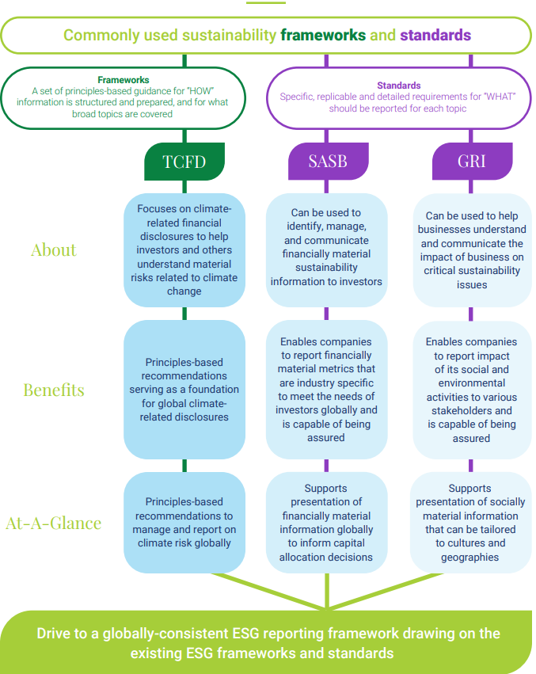

What support and resources does internal auditor require to take ESG forward ?
According to internal auditors, propelling organizational progress requires a heightened recognition of ESG-related risks within the enterprise-wide risk assessment. Both the board and the C-suite are essential in ensuring the actualization of this perspective. Approximately 44% assert the necessity for regulatory frameworks and compliance mandates, while an additional 43% advocate for guidance and official stances from the IIA regarding the role of internal audit in ESG endeavors.
Following chart depicts the factors needed to support internal auditor’s involvement in ESG related initiatives
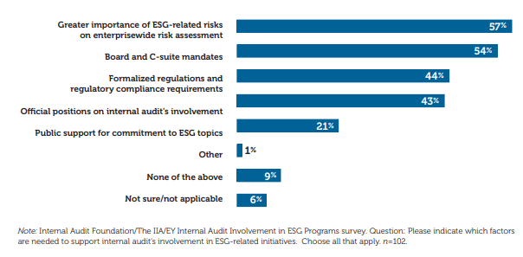
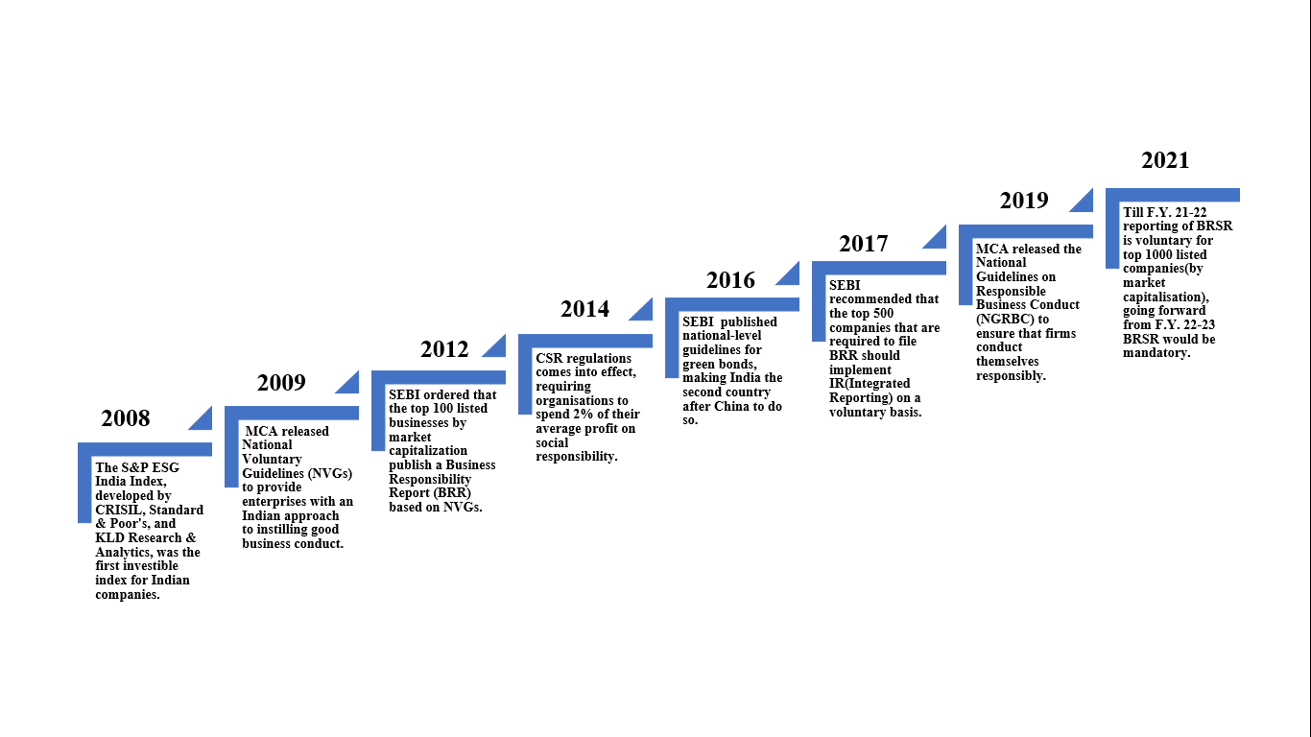
Relevant Guidelines & Reporting Standards, In India –Catching Up With Global Trend

BRR To BRSR-Towards A More Comprehensive Integrated Mechanism
Traits | Business Responsibility Reporting (BRR) | Business Responsibility & Sustainability Reporting (BRSR)
Release Year | 2012 | 2021
Applicable to | In the year of release, it was applicable to top 100 listed companies (by market capitalization). This number rose to 1000 companies in the year 2019. | Till F.Y. 21-22 reporting of BRSR is voluntary for top 1000 listed companies(by market capitalisation), going forward from F.Y. 22-23 BRSR would be mandatory.
Core guideline | National Voluntary Guidelines(NVGs) framed in 2011 | 9 principles of National Guidelines on Responsible Business Conduct (NGRBC) which underwent revision in 2019.
Basic Reporting Values | Integrity & ethics | Accountability, increased clarity, cross-reporting and interlinkage with other reporting standards, well defined performance indicators, industry standardisation and comparability.
Reporting method | Published in annual reports | Published in Annual Reports and simultaneously filed with Ministry of Corporate Affairs (MCA)
Fundamental Values | Ethics and openness, Safety, Employee welfare, Management of stakeholder, Human rights, Environmental protection, Public and regulatory policy, Inclusive growth, Customer-oriented service. | The NGRBC's 9 principles have been expanded upon and matched to performance metrics that may be mandatory or voluntary (Leadership). The details required in the BRSR requires leadership accountability, consistency in reporting, and ownership of the business impact.
SEBI has proposed two BRSR reporting options:
- BRSR Lite- For organisation just starting out.
- BRSR Comprehensive- For Mature Organisations.
CONCLUSION
In India, the ESG regulatory environment is fast growing, and there has been a noticeable increase in the frequency and quality of company reporting. The goal is to gradually develop a more comprehensive and extensive ESG reporting regime, with the goal of encompassing all listed and unlisted entities and bringing them under the ESG reporting framework's purview, in order to achieve a more sustainable, transparent, and long-term viable investing trend. However, this is not without difficulties. The lack of cross-border standardisation of reporting standards may make it challenging to harmonise ESG principles, frameworks, and considerations. Furthermore, problems related to the transparency, consistency, materiality, and comparability of ESG standards may impede the smooth deployment of an ESG reporting system in the future. These challenges must be addressed in order to develop an effective and efficient ESG reporting process in the future.
This article is an attempt by the authors to assist readers in comprehending the current ESG landscape, including the implications of the current reporting environment and how internal auditors may support boards and investors in advocating the use of high-quality, comparable, trustworthy, and relevant ESG disclosure.
REFERENCES: -
- Bhatia, A. (2021, October 29). Environmental, Social, and Governance Compliance in India: New Reporting Requirements. India Briefing, pp. 1-7. Retrieved May 31, 2022, from https://www.india-briefing.com/news/esg-reporting-india-new-disclosure-requirements-sustainability-23471.html/
- Business Responsibility and Sustainability Reporting (BRSR). (2022, January 2). Sattva Delivering High Impact, pp. 1-3. Retrieved June 4, 2022, from https://www.sattva.co.in/insight/business-responsibility-and-sustainability-reporting-brsr/
- CAQ (October, 2020). The Role of Auditors in Company- Prepared Cybersecurity Information : Present and Future About the Center for Audit Quality. https://www.thecaq.org/rota-esg/
- Chu, P. (2021, November 13). 7 Steps to Develop and Implement an ESG Strategy. Antea Group, pp. 1-9. Retrieved June 1, 2022, from https://us.anteagroup.com/news-events/blog/develop-and-implement-an-esg-strategy
- Dayal, G., & Sawhney, S. (2022, May 25). Taking ESG Reporting to the next level. BusinessLine, p. 4. Retrieved June 4, 2022.
- Gassmann, P., & Scott, L. (2017, June 4). Environmental, Social and Governance (ESG). PwC Global, pp. 1-5. Retrieved June 2, 2022, from https://www.pwc.com/gx/en/issues/esg.html
- Gassmann, P., Herman, C., & Kelly, C. (2021). Are you ready for the ESG revolution? www.strategy-business.com, pp. 1-15. Retrieved June 2, 2022, from https://www.pwc.com/gx/en/issues/reinventing-the-future/take-on-tomorrow/download/pwcSB_2021-06-15-Are-you-ready-ESG-revolution.pdf
- Kroll, K. (2022, April 12). As New Rules Loom, Internal Audit’s Role in ESG Reporting Under Review. Internal Audit 360", pp. 1-8. Retrieved June 3, 2022, from https://internalaudit360.com/as-new-rules-loom-internal-audits-role-in-esg-reporting-under-review/
- Roberts, S., Ogunnaike, O., Uwasomba, M., Wong, S., & Munaretto, A. (2021). Prioritizing Environmental , Social , and Governance., 1-16. Retrieved May 30, 2022, from https://www.theiia.org/globalassets/site/foundation/latest-research-and-products/2021-3910-fnd-prioritizingesg-report_final_v6.pdf
- Woo, P., & Lee, A. (2012). Internal Audit ’ S Role in ESG. KPMG August, 37–41.

