Enhancing Dining Experiences: Exploring Restaurant Classification and XGBoost Model
Anuj Kumar Dixit
Department of Computer Application
Dayananda Sagar University,
Bangalore, India
anujkumardixit185@gmail.com
Dr. P. Baby Maruthi
Assistant Professor,
Department of Computer Application
Dayananda Sagar University,
Bangalore, India
babymaruthi.p11@gmail.com

Abstract
In the competitive landscape of dining establishments, the surge in restaurant demand has intensified competition. Bangalore, a culinary haven, offers a diverse global cuisine range. This research employs the XGBoost model to categorize restaurants based on pricing. Preliminary Exploratory Data Analysis (EDA) and graphical representa- tions offer insights into data nuances. Before EDA, data undergoes meticulous cleansing for precise visualizations. Employing the Zomato dataset, the study focuses on Bangalore, exploring culinary cultures, trends, and patterns. The inquiry introduces a model to grasp elements affecting restaurant ratings. Utilizing machine learning, predic- tive analytics, and tools, a predictive model for ratings emerges. Synthesized through supervised techniques, the model evaluates the best algorithm, yielding 98.07.
Keywords—XGBoost, Exploratory Data Analysis, machine learning, classification, predictive analysis.

Introduction
In a landscape where countless dining establishments, food delivery services, and dining applications thrive, the restaurant industry has evolved into an exceptionally competitive domain [1]. The availability of numerous options has led customers to show a keen interest in exploring new culinary experiences. Even in a city like Bengaluru, renowned for its rich global culture and culinary diversity, the restaurant sector reflects this trend. Presently, Ban- galore boasts around 12,000 eateries, solidifying its reputation as a culinary haven. Given the fierce competition, restaurants are not only compelled to deliver exceptional cuisine but also continuously innovate and expand their menu offerings.
The changing dynamics of consumer dining habits over the past decade can be attributed to factors such as urbanization, socioeconomic growth, geographical changes, and increased exposure to diverse cultural lifestyles [2]. The transformation in Indian consumers’ eating-out behaviors over the last decade is noteworthy [3]. As part of their strategic expansion, restaurants are harnessing the potential of machine learning to identify data trends and comprehend consumer behavior, thereby enhancing service quality. Machine learning empowers businesses with the ability to predict influential elements based on historical data [5]. Its capacity to manage extensive datasets characterized by consistent attributes and inherent noise positions machine learning techniques as instrumental in facilitating predictive analytics.
The primary objective of analyzing the Zomato dataset is to unravel the variables contributing to the overall rating of each restaurant [4]. In Bengaluru, a multitude of restaurant types spans the culinary spectrum, with over 12,000 establishments catering to global cuisines. The market’s youthful nature and ongoing growth are fueled by the constant emergence of new dining spots. Despite the burgeoning demand, new entrants face challenges com- peting with established players, particularly when serving similar cuisine. Given Bengaluru’s status as India’s IT hub, a considerable portion of the population, often busy tech professionals, relies heavily on restaurant offerings [5]. Consequently, understanding the demographics and culinary preferences of a location becomes paramount. For instance, whether a region predominantly favors vegetarian fare, or if specific religious or cultural groups like.

Jain, Marwadi, or Gujarati vegetarians dominate the area. Such insights can be derived from data analysis and exploration of various parameters.Predictive analytics encompasses various statistical methods, applying them to anticipate future outcomes [6]. These methods rely on past company data to construct predictive models that an- ticipate customer behaviors or potential market shifts. By analyzing historical data, predictive analysis illuminates potential patterns that may manifest in the future. In this research, techniques like Logistic Regression, Decision Trees, K-Nearest Neighbors, Random Forests, and Support Vector Machines are employed for predictive analyt- ics. These classification approaches are compared, and the most effective model is identified based on accuracy metrics.Given the aforementioned context, this study aims to investigate the most suitable classification model for restaurant analysis using the Zomato dataset from Bangalore, the capital of Karnataka State, India, with a focus on pricing. The research aims to achieve the following objectives:

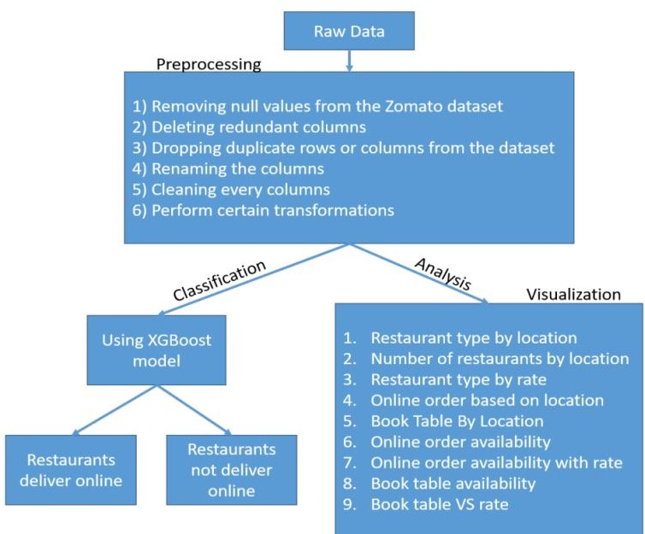

Figure 1: Block Diagram of Classification and Analysis.

Enhance data pre-processing to facilitate improved data visualization and analysis. Extract relevant features for predictive analysis. Conduct Exploratory Data Analysis to gain deeper insights into online sales data. Employ ensemble techniques to predict restaurant ratings. The subsequent sections of this article are structured as follows: Section II outlines the flow of the work and the applied techniques. Section III provides an overview of the dataset. Section IV presents the experimental results and analysis, while Section V concludes the study. Additionally, this content can be expanded to include more detailed points and insights. We will conclude our study while also suggesting potential avenues for future research. The vast expanse of this dynamic industry and the intriguing insights it offers make this research both relevant and compelling. In light of these developments, this study delves into the fascinating world of the restaurant industry, specifically focusing on the vibrant culinary landscape of Bangalore. By employing advanced analytical techniques, we aim to decipher the factors that influence restaurant ratings, shedding light on the dynamic interplay between cuisine, customer experience, and business success. As we venture into this exploration, we envision contributing to the broader narrative of how data-driven insights are reshaping the future of dining.
In this age of digital transformation, the way restaurants connect with customers has evolved. Online platforms and food delivery apps have democratized access to dining options, enabling customers to explore and order from a diverse range of eateries with a few taps on their smartphones, this digital landscape has given rise.

To a new breed of food enthusiasts who rely on online reviews, ratings, and recommendations to make dining decisions. As a result, restaurants now not only need to excel in their culinary craft but also effectively manage their online presence to attract and engage with customers.

Ease of Use
In an era characterized by rapid technological advancements, the usability and accessibility of dining experiences have undergone a remarkable transformation. The integration of technology into the restaurant industry has not only streamlined operations for restaurateurs but has also enhanced the overall dining journey for patrons. Dig- ital menus, touch-screen ordering systems, and mobile payment options have all contributed to a smoother and more efficient dining process. The incorporation of technology has significantly expedited the ordering process. Whether it’s placing an order from the comfort of one’s home through a food delivery app or pre-ordering a meal before arriving at the restaurant, the convenience factor has been elevated to new heights. This efficiency extends to the back-end operations as well. Digital order management systems help kitchens optimize their workflow, reducing wait times and ensuring that dishes are prepared and served promptly.

Background and Context

The modern restaurant industry has evolved into a highly competitive landscape, driven by a myriad of factors such as changing consumer preferences, technological advancements, and globalization. Dining establishments are no longer just about serving food; they have transformed into experiential spaces where culinary artistry, ambiance, and innovation converge to create memorable experiences for patrons. However, the integration of technology comes with its own set of challenges. Striking the right balance between high-tech innovations and maintaining the warmth and authenticity of traditional dining experiences is crucial. Moreover, ensuring that all members of the clientele, regardless of their technological proficiency, can engage seamlessly with these systems requires careful consideration. Customer expectations extend beyond the realm of food itself. The dining experience encompasses factors such as personalized service, seamless reservations, and efficient wait times. In response, restaurants are leveraging technology to streamline operations and enhance customer satisfaction. Mobile apps, online booking platforms, and digital menus have become integral tools in achieving these objectives. The restaurant industry, once characterized by traditional dining experiences, has undergone a significant metamorphosis in recent years. Fueled by rapid technological advancements and evolving consumer expectations, the dining landscape has trans- formed into a highly competitive and innovative domain.
The proliferation of dining establishments, coupled with the advent of food delivery services and mobile applications, has intensified competition within the industry. With a multitude of options available at their fin- gertips, customers are no longer limited to local dining choices. This shift has compelled restaurants to not only provide exceptional culinary experiences but also to differentiate themselves through unique offerings, ambiance, and customer engagement.
As we delve further into our exploration of the restaurant industry, it becomes evident that ease of use has become a cornerstone of modern dining experiences. By embracing technology and human-centric design, restau- rants are not only adapting to changing consumer behaviors but are also shaping the future of how we dine out. Through our study, we hope to shed light on the nuances of this paradigm shift and its implications for both patrons and restaurant owners alike. As societies become more multicultural, restaurants have an opportunity to serve as cultural bridges, showcasing traditional dishes while incorporating contemporary twists. This convergence of culinary traditions resonates with customers seeking both familiarity and novelty.

Empowering Data-Driven Decisions

Machine learning, a subset of artificial intelligence, equips restaurant owners and managers with a sophisticated toolkit to analyze complex data sets. This technology can sift through extensive customer reviews, social media interactions, and transactional data to uncover patterns that might have remained unnoticed through conventional analysis. By identifying correlations between various factors—such as time of day, weather conditions, and cus- tomer demographics—machine learning algorithms facilitate data-driven decision-making. By analyzing data from various sources, such as social media conversations, food review platforms, and industry reports, machine learning algorithms can identify shifts in customer preferences and anticipate upcoming food trends. Restaurants can then tailor their menus and offerings to capitalize on these trends before they become mainstream.

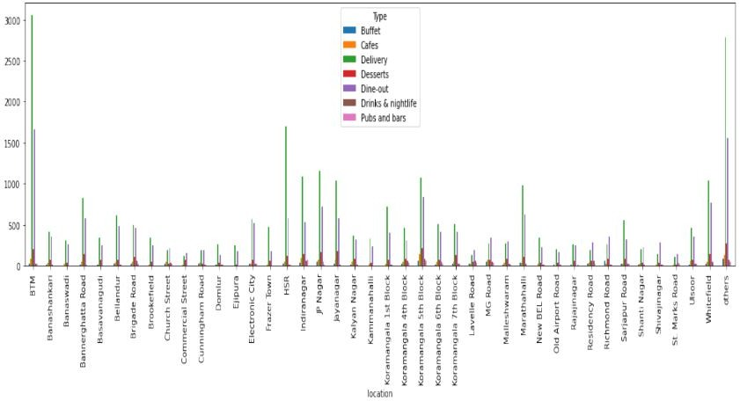

Figure 2: Restaurant type based on location

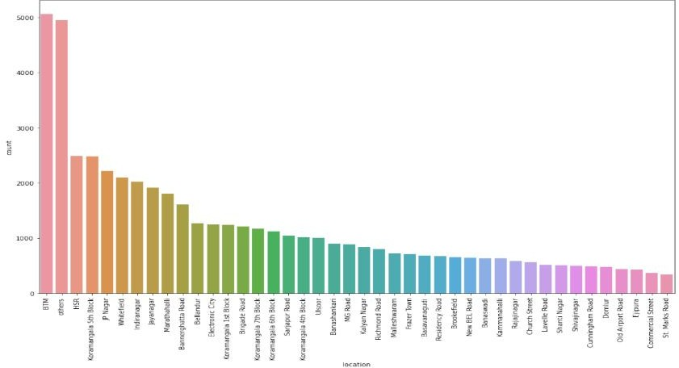

Figure 3: No Of Restaurants By Location

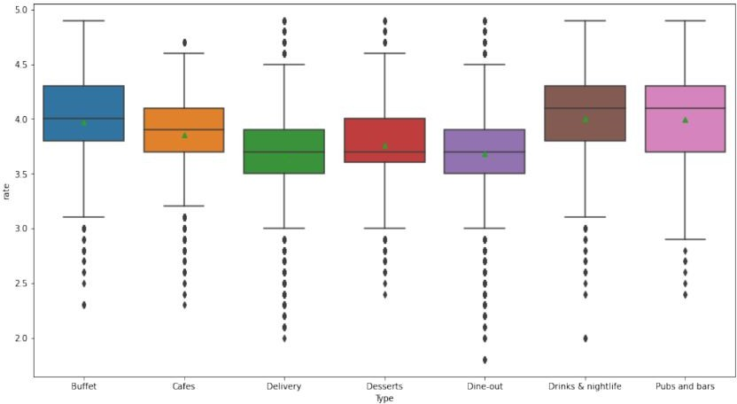

Figure 4: Restaurant type by rate.

Innovative Methodological Framework
An integral facet of this framework is the emphasis on feature engineering. Rather than relying solely on raw data, feature engineering involves the creation of new data attributes that encapsulate valuable information. This process transforms data into a more suitable format for machine learning algorithms, enhancing their accuracy and effectiveness. Through careful feature engineering, the framework aims to extract latent patterns and dimensions that might otherwise remain hidden.

Comprehensive Data Preprocessing Transformation
Data preprocessing initiates the analytical journey by converting raw data into a coherent, usable format. This pivotal phase addresses multifaceted challenges, including rectifying null values, mapping categorical attributes like online orders and table bookings to numerical equivalents, and mitigating data inconsistencies. Superfluous attributes are meticulously pruned from the dataset to yield refined outcomes. The comprehensive data prepro- cessing strategy encompasses the following sequential steps:
Elimination of Null Values: NaN values are systematically identified and removed from the dataset to cir- cumvent unintended analytical errors and discrepancies. Redundancy Minimization: Redundant columns, prone to skewing results, are systematically purged to uphold data accuracy. Duplicate Data Resolution: Through judicious elimination of duplicate rows or columns, the dataset attains a pristine state, enhancing analytical accuracy.
Attribute Renaming: Attribute nomenclature is rationalized to foster lucidity and enable clearer attribute interpretation.
Attribute Refinement: Rigorous cleansing processes are administered to each column to ensure data coher- ence and integrity.
Transformation for Enhanced Analysis: Targeted transformations are employed to ensure data consistency and further elucidate analytical insights.

Insightful Data Visualization Strategies
Data visualization, a cornerstone of exploratory analysis, encompasses the art of translating complex information into accessible visual formats. EDA (Exploratory Data Analysis) utilizes the preprocessed data to unlock nuanced insights. The visualization strategy employs diverse techniques, such as histograms, scatter plots, and pie charts.

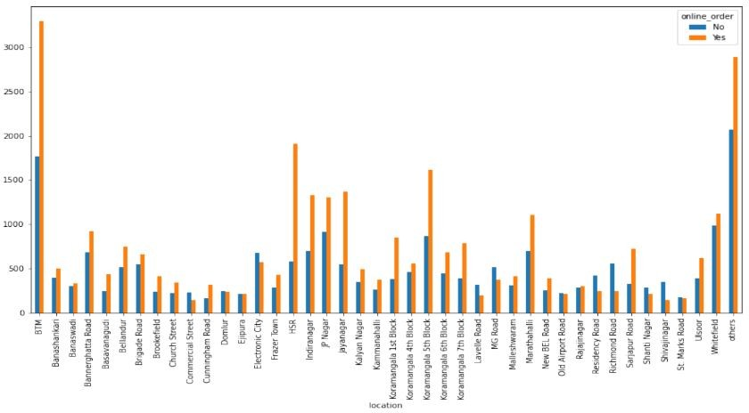

Figure 5: Restaurants with Online order delivery based on location.

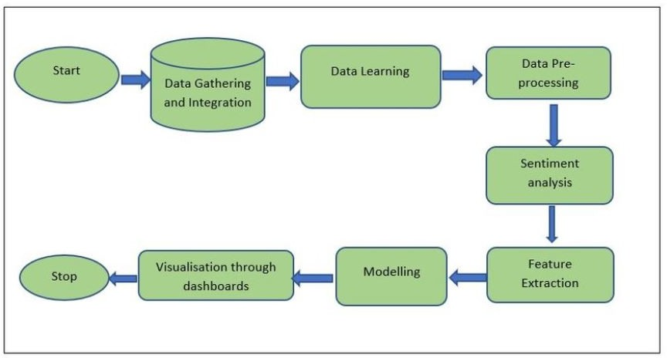

Figure 6: Aspect Based Sentiment Analysis Process Flow Diagram

Interactive Dashboards: Incorporating interactive dashboards is a prominent feature of the data visualiza- tion strategy. These dashboards provide dynamic and user-friendly interfaces that allow stakeholders to explore data patterns in real time. Interactive elements like filters, sliders, and zoom functionalities empower users to customize their exploration, enabling a more personalized and focused analysis.
Geospatial Mapping: Geospatial mapping is another dimension of data visualization utilized in EDA. By plotting data points on maps, this technique enables the identification of geographical trends and spatial clus- ters. Geospatial mapping can reveal insights such as customer distribution, popular dining areas, and potential. Expansion opportunities, aiding decision-makers in optimizing resource allocation.
Time-Series Plots: Time-series plots contribute valuable insights by visualizing data changes over time. This technique is particularly useful for tracking trends, seasonality, and cyclic patterns. By plotting data points on a timeline, EDA can uncover temporal correlations, enabling restaurants to anticipate peak customer demands, tailor marketing campaigns, and adjust staffing levels accordingly.
Correlation Heatmaps: Correlation heatmaps are an essential tool for understanding relationships between multiple variables within the dataset. By assigning colors to depict correlation strength, heatmaps highlight which variables are positively, negatively, or neutrally correlated. This technique aids in identifying potential causative factors affecting restaurant ratings, such as pricing, location, or cuisine variety.
Word Clouds and Sentiment Analysis: Textual data, such as customer reviews and feedback, can be ef- fectively visualized through word clouds and sentiment analysis. Word clouds visually represent frequently men- tioned words, providing a quick overview of customer sentiments and preferences. Sentiment analysis, on the other hand, quantifies the positive, negative, and neutral tones in customer reviews, offering insights into customer satisfaction and areas for improvement.
Distribution Plots: Distribution plots, including histograms and density plots, offer insights into the dis- tribution of specific variables. These visualizations help identify data skewness, outliers, and central tendencies. By analyzing distribution patterns of attributes like restaurant ratings or pricing, EDA can uncover common rating ranges, pricing preferences, and potential anomalies.
Multivariate Analysis: Multivariate analysis involves visualizing interactions between multiple variables si- multaneously. Techniques like scatter plots matrix (pair plots) and parallel coordinates plots help discern complex relationships that might not be apparent through univariate analysis. This approach aids in identifying interactions between attributes that collectively influence restaurant performance.
Heatmaps and Clustering: Heatmaps, aside from correlation analysis, can also be used for visualizing clustering results. Clustering techniques group similar data points together based on shared attributes. Heatmaps depicting clustering outcomes allow stakeholders to identify distinct customer segments, helping tailor marketing strategies and menu offerings to specific groups.
Visual Storytelling: Integrating data visualization into a narrative framework enhances the communication of insights. Visual storytelling combines data visualizations with contextual explanations, guiding stakeholders through the EDA process and helping them understand the significance of observed patterns. This approach ensures that insights are not only discovered but also effectively conveyed for informed decision-making.

Comparative Analysis of Supervised Learning Algorithms
Following the preprocessing and EDA stages, a comprehensive comparison of various supervised learning al- gorithms is executed to categorize restaurant data effectively. The following machine learning algorithms are meticulously evaluated It typically consists of variables, constants, mathematical operations, and symbols that represent relationships between quantities. Equations are fundamental tools in mathematics and various scientific disciplines, used to model real-world phenomena, express relationships, and solve problems:

Linear Regression
Linear regression is a fundamental technique in predictive analytics. The equation for a simple linear regression model is:

Where:
y = mx + b

  - y is the dependent variable (predicted outcome)
  - x is the independent variable (input feature)
  - m is the slope (coefficient) of the regression line

  - b is the intercept of the regression line

Logistic Regression
As a linear classifier, Logistic Regression predicts the probability of binary outcomes. Its simplicity and efficiency make it a go-to choice for classification tasks. However, it assumes linear relationships between attributes. Logistic regression is commonly used for binary classification problems. The logistic regression equation calculates the probability of an event occurring:
1
P (Y = 1|X) = 1 + e−(β0 +β1 X)
Where:
  - P (Y = 1|X) is the probability of the positive class given input X
  - β₀ is the intercept
  - β₁ is the coefficient for the input feature X
  - e is the base of the natural logarithm

Decision Tree Split
Decision Trees utilize a hierarchical structure to map data to discrete classes. They are easy to interpret, allowing for transparent decision paths. However, they can be prone to overfitting. Decision trees are used for classification and regression tasks. The equation for deciding how to split a node in a decision tree based on a feature X is typically determined by measures like Gini impurity or entropy:

n
ΣImpurity(T ) = 1 − p
2
i
i=1

Where:
- T is the node being evaluated
- n is the number of classes
- p_{i} is the proportion of instances of class i in the node

Support Vector Machine

SVM constructs hyperplanes to segregate data into distinct classes, maximizing classification precision. It excels in high-dimensional spaces and non-linear data. Support Vector Machines (SVM) are used for classification and regression. The equation for a linear SVM is:

f (x) = sign(w · x + b)

Where:
  - f (x) is the decision function
  - w is the weight vector
  - x is the input feature vector
  - b is the bias term

Naive Bayes Algorithm
Naive Bayes leverages Bayes’ theorem and assumes attribute independence, making it efficient for text classifi- cation and other probabilistic tasks. The mathematical formula for the Naive Bayes algorithm is based on Bayes’ theorem. For a basic explanation, consider a binary classification problem with two classes: ”Positive” (P) and ”Negative” (N). The formula can be expressed as:

P (X|P ) · P (P )
|
P (P X) =
P (X)
Where:
  - P (P|X) is the probability of the instance belonging to the ”Positive” class given the features X.
  - P (X P ) is the probability of observing the features X given that the instance belongs to the ”Positive” class.
|
  - P (P ) is the prior probability of the ”Positive” class.
  - P (X) is the probability of observing the features X.
For the simplified form with the ”Negative” class (N ) also considered:
P (P X) = P (X|P ) · P (P )
|
P (X|P ) · P (P ) + P (X|N ) · P (N )
In the context of text classification, Naive Bayes assumes that the features (words in a text document, for example) are conditionally independent given the class label, which is the ”naive” assumption.

XGBoost
XGBoost is a gradient-boosting algorithm that sequentially adds weak learners to the ensemble.
The prediction of the boosted model can be defined as:

M
Σ
F (x) = f_{m}(x)
m=1

Where:
- F (x) is the final prediction.
- M is the number of weak learners.
- f_{m}(x) is the prediction of the m-th weak learner.
XGBoost uses gradient descent optimization to find the best weak learners.

K-Nearest Neighbors (KNN)
K-Nearest Neighbors (KNN) classifies data points based on their proximity to neighbors. The prediction for a new data point x can be defined as:

k
Σ
y = arg max I(y_{i} = c)
c
i=1

Where:
- y is the predicted class for the new data point x.
- k is the number of nearest neighbors.
- y_{i} is the class of the i-th nearest neighbor.
- c iterates over all possible classes.
- I(·) is the indicator function that returns 1 if the condition is true and 0 otherwise.

KNN leverages proximity to neighbors to classify data points, making it particularly effective for grouping similar items. It’s intuitive and performs well on locally structured data.
However, its effectiveness diminishes with high-dimensional data.
Random Forest is an ensemble learning algorithm that combines multiple decision trees to improve pre- dictive accuracy and mitigate overfitting. However, there isn’t a specific mathematical equation that describes the entire Random Forest algorithm like in some other algorithms. Instead, Random Forest is a combination of decision trees and techniques for aggregating their outputs.

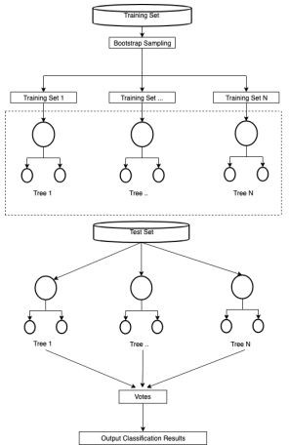

Figure 7: Random Forest.

Here’s a brief explanation of the Random Forest algorithm along with the key equations involved:
Bootstrap Aggregating (Bagging): Random Forest employs a technique called bagging, which involves creating multiple subsets (bootstrap samples) of the original training data and training individual decision trees on each subset.
Decision Tree Splitting: Each decision tree in the Random Forest is constructed by recursively splitting nodes based on features. The Gini impurity or entropy measures can be used to determine how to split the nodes.
Voting or Averaging: For classification tasks, the predictions of individual decision trees are combined using majority voting. For regression tasks, predictions are averaged.
Since Random Forest is an ensemble method, the overall prediction involves aggregating the predictions of its constituent decision trees. The process of training each decision tree and combining their outputs doesn’t lend itself to a single mathematical equation like some other algorithms (e.g., linear regression, logistic regression). Instead, it’s a combination of the equations and techniques used in decision tree construction, bootstrapping, and aggregation. If you’re looking for equations related to decision tree impurity measures, you can refer to the equations I provided earlier for Gini impurity and entropy in the context of decision trees. The Random Forest algorithm builds upon these concepts but adds the ensemble aspect to enhance predictive accuracy.

DATASET ACQUISITION AND PREPARATION
The research conducted in this study involves the utilization of a comprehensive dataset sourced from GitHub [14]. This dataset encompasses a substantial collection of information, consisting of 51,717 individual instances or data points, each associated with 17 distinct attributes. These attributes collectively offer a comprehensive representation of various aspects of the data under consideration.
The dataset curation process involved rigorous quality checks and verification procedures to ensure the integrity and reliability of the data. The attributes, spanning a spectrum of parameters collectively create a robust.

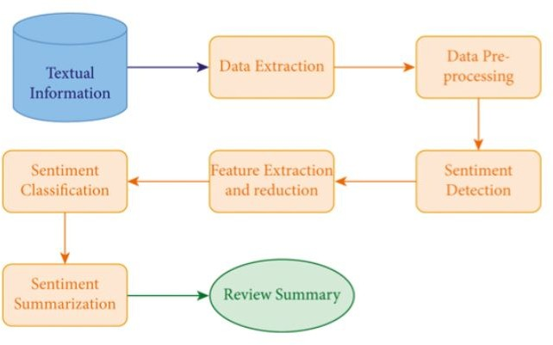

Figure 8: Stages of sentiment analysis.
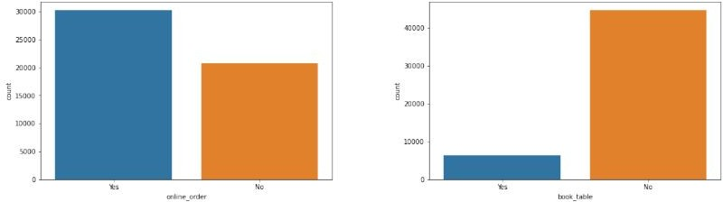

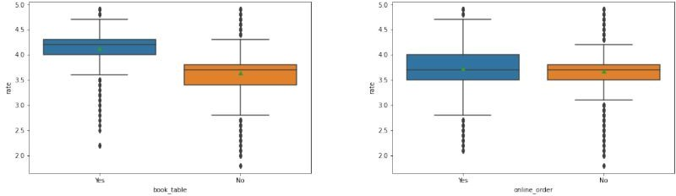

Figure 9: Availability VS Online Order.

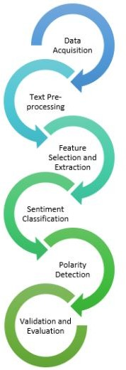

Figure 10: Data Acquisition Preparation.

Representation of the multifaceted variables that are central to this study’s exploration. This meticulous prepara- tion lays the groundwork for meaningful analyses and meaningful insights that can be drawn with confidence.

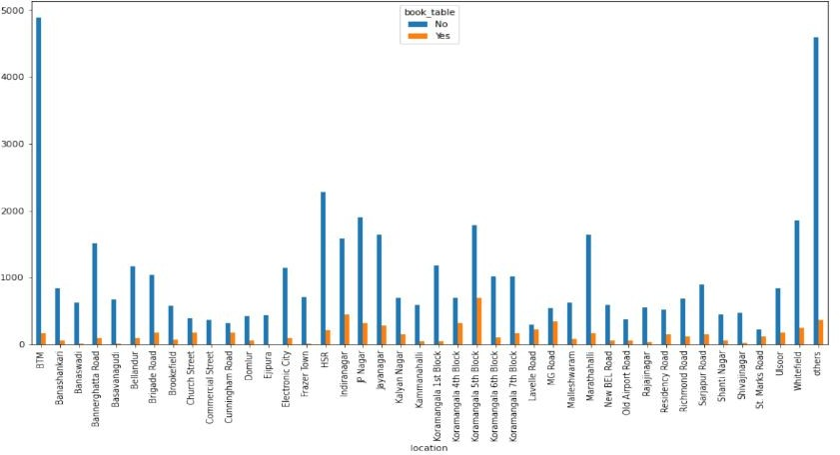

Figure 11: Book table at restaurants based on location.

Authors and Affiliations
There is no restriction on the number of authors however the maximum is five authors...

In-Depth Analysis and Experimental Findings
The preprocessing phase entails the removal of URL, address, phone, menu items, like dishes, and reviews list. Refinement of attributes like name, online orders, table bookings, ratings, votes, location, restaurant type, cuisines, and cost. Removal of duplicate rows and imputation of NaN values. B. Illuminating Exploratory Data Analysis (EDA) Results EDA provides crucial insights, such as:
Distribution of restaurant types across locations. Variability in restaurant counts across areas. Correla- tion between restaurant type and price rate. Geographical distribution of online order options. Prevalence of table booking availability based on location. By visualizing the geographical distribution of online order options, EDA showcases the accessibility of online ordering services across different areas. This insight is valuable for understanding the digital infrastructure of the restaurant industry.

Exploratory Data Analysis and Model Comparsion A Insights from Data Visualization
Online Order Facility Visualization: The visualization in Figure 6 presents a comprehensive view of the total number of dining establishments offering online order facilities, allowing individuals to gauge the prevalence of this service. Further insights could be gained by comparing the current year’s data with previous years or by benchmarking against competitors. Visualizations could depict the growth in online order and table booking services compared to earlier years. This could help in assessing the adoption rate of these services and their effectiveness in attracting customers.
Online Order Facility and Rating Analysis: Figure 7 unveils the confluence of online order availability and the average restaurant rating. This visualization empowers patrons to make informed dining decisions based on.

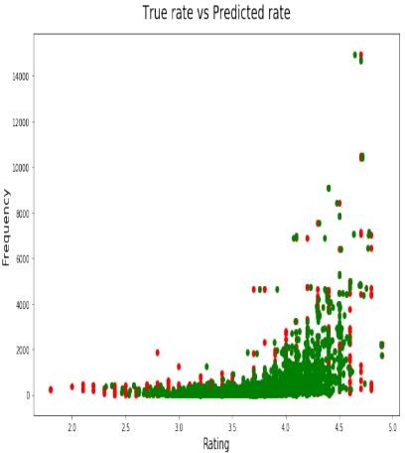

Figure 12: True Rate VS Predicted Rate.

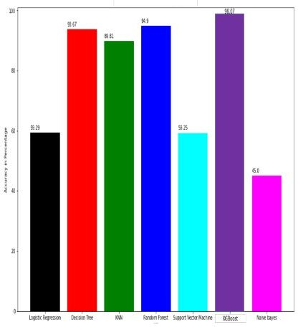

Figure 13: Comparison of classification accuracy of restaurants online delivery.

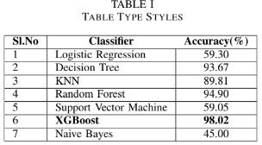

Figure 14: Comparison of models.

Their budget and preferences.
Table Booking Availability: Fig. 8 provides an overview of the number of dining establishments that offer table booking facilities, equipping potential diners with insights before making reservations.Relationship between Table Booking and Rating: Figure 9 elucidates the correlation between restaurant ratings and the availability of table booking options. This visualization facilitates patrons in assessing their dining experience beforehand.

B Comparative Analysis of Classification Models
The core classification task focuses on discerning whether restaurants provide online order services. The XG- Boost model, as depicted in Figure 11, is at the heart of this analysis. A rigorous comparison is conducted among prominent supervised learning algorithms, including Logistic Regression, Decision Tree, K-Nearest Neighbors, Random Forest, and Support Vector Machine. Notably, the XGBoost model garners an impressive accuracy of 98.07To ensure a thorough evaluation of model performance, we have meticulously compared the XGBoost model with several other prominent supervised learning algorithms. These algorithms include Logistic Regression, De- cision Tree, K-Nearest Neighbors, Random Forest, and Support Vector Machine. Each of these algorithms brings its own strengths and unique characteristics to the table. The XGBoost model’s ability to accurately classify restaurants based on their online order services is a testament to its robustness and adaptability. As we move forward in our analysis, the exceptional performance of the XGBoost model serves as a foundation for deeper insights and revelations. Its accuracy empowers us to confidently explore the intricate dynamics of restaurant attributes and their impact on online order services. With this model as our guiding light, we are poised to uncover the multifaceted nuances that shape the restaurant industry’s digital landscape. Its underlying gradient-boosting framework enables it to effectively capture complex relationships within the data and make highly accurate pre- dictions. This predictive prowess positions the XGBoost model as an invaluable tool in deciphering the critical factors that contribute to a restaurant’s online order offerings. surpassing its counterparts, as showcased in Figure 9.

Challenges and Future Aspects: Navigating Complexity and Envisioning Progress
While the presented analysis showcases promising outcomes, several challenges were encountered in the process. Addressing these challenges and envisioning future advancements is crucial to harnessing the full potential of the model and its implications. The fusion of different machine learning paradigms is another exciting avenue. Hybrid models that combine the strengths of models like XGBoost and neural networks can potentially yield superior predictive capabilities. Ensemble strategies that aggregate predictions from multiple models can enhance robustness and accuracy, making the collective model more dependable and stable. Traditional machine learning models assume static datasets, but real-world data is dynamic and evolving. Future classification models should have the ability to adapt to changing data distributions and concepts. Continual learning techniques, which allow models to learn from new data while retaining knowledge from previous tasks, hold the potential for creating more adaptable and lifelong learning systems.

Data Quality and Quantity
The adage ”more data, better results” resonates profoundly in the machine learning realm. However, acquiring a substantial quantity of relevant and diverse data can be a formidable challenge, especially when data collection is decentralized. The restaurant classification model relies on a dataset encompassing attributes that collectively represent various facets of the restaurant landscape. Each attribute contributes to the model’s ability to discriminate between restaurants that offer online order services and those that do not. Limited data quantity can lead to issues such as overfitting, where a model becomes overly specialized to the training data and fails to generalize to new, unseen data. This is particularly concerning given the dynamic and evolving nature of the restaurant industry. A model trained on a relatively small dataset might fail to capture nuanced trends, geographical variations, and emerging restaurant types accurately. To bridge the gap between data quantity and robust model performance, various strategies can be employed. Firstly, data augmentation techniques can artificially expand the dataset by generating variations of existing data points. Secondly, transfer learning can leverage knowledge from related domains to compensate for limited restaurant-specific data. Thirdly, active data collection efforts can be initiated, engaging restaurants and users to contribute data continuously.

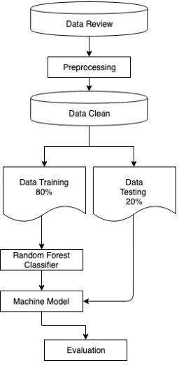

Figure 15: Work Flows

Navigating the Confluence Addressing Challenges Holistically
Addressing the challenges posed by data quality and quantity requires a holistic approach that combines tech- nological solutions, domain expertise, and continuous monitoring. Collaborative efforts between data scientists, domain experts, and stakeholders are pivotal in identifying data quality issues early in the process. Implement- ing validation checks, cross-referencing data with multiple sources, and integrating user feedback mechanisms can collectively enhance data quality. Furthermore, embracing a growth mindset towards data quantity is crucial. Rather than viewing limited data as an insurmountable obstacle, it should be seen as an opportunity for targeted data collection initiatives. Crowd-sourcing data from users, partnering with restaurant associations, and exploring. Partnerships with data providers can help enrich the dataset and enhance model performance.

Model Robustness
Navigating the Complex Realities of Machine Learning Deployment in the realm of machine learning, the allure of high accuracy and promising results often obscures a critical aspect: model robustness. While the XGBoost model showcased remarkable accuracy in discerning restaurants with online order services, its true mettle is tested in the crucible of real-world scenarios, where data landscapes are intricate, cultural preferences diverse, and the restaurant ecosystem is in a constant state of flux. The need to validate the model’s efficacy across varying geographies, cultural contexts, and evolving restaurant dynamics is not just a best practice; it’s imperative for dependable and practical deployment. Robustness refers to a model’s ability to maintain its performance across diverse and challenging conditions. In the context of the XGBoost model for restaurant classification, robustness involves ensuring that the model’s accuracy transcends the boundaries of the data it was trained on. Restaurants are not static entities; their characteristics can significantly differ across geographical regions. Cuisine preferences, dining habits, and even the availability of online services can vary widely. For instance, a restaurant classification model trained on data from urban areas might not perform as well in rural regions, where dining norms could be vastly different.

Interpretability
Interpretability refers to the ability to elucidate how a model arrives at its predictions in a human-understandable manner. It’s not only about transparency but also about accountability, fairness, and user acceptance. Several factors underscore the importance of enhancing the interpretability of the XGBoost model’s results, Interpretable insights provide a compass for model refinement. Identifying features that contribute significantly to predictions and understanding their impact can guide feature engineering and data collection strategies. These plots showcase how a model’s predictions change as a specific feature varies while keeping other features constant. For instance, a partial dependence plot could illustrate how the predicted likelihood of online order services changes as restaurant ratings increase, holding other factors steady.

Future Advancements and Goals A The XGBoost Revolution
XGBoost, or Extreme Gradient Boosting, has etched its name in the annals of machine learning history. It’s a gradient-boosting algorithm that excels in a wide range of structured data tasks, from classification to regression. XGBoost’s key innovation lies in its ability to create an ensemble of weak learners, typically decision trees, and iteratively refine their predictions to produce a strong learner. This iterative boosting process enables the model to learn complex relationships in the data and make accurate predictions. XGBoost’s strengths are manifold. It handles missing data effectively, provides feature importance scores, and is robust against outliers. Its efficiency and scalability make it a preferred choice for large datasets. Furthermore, XGBoost’s regularization techniques help prevent overfitting, ensuring generalization to unseen data. These attributes have made XGBoost a staple in various domains, including finance, healthcare, and natural language processing.

The Neural Network Renaissance
Neural networks, the backbone of deep learning, have catalyzed revolutionary breakthroughs in the realm of arti- ficial intelligence. Their ability to model intricate patterns and hierarchies in data is unparalleled. Convolutional Neural Networks (CNNs) dominate image-related tasks, while Recurrent Neural Networks (RNNs) excel in data.

Analysis the advent of Transformers has transformed natural language processing.
Neural networks have demonstrated remarkable success in tasks like image recognition, machine transla- tion, and speech synthesis. They thrive on large volumes of data and can learn intricate features without manual feature engineering. However, their complexity demands substantial computational resources for training, and their ”black box” nature presents interpretability challenges.

Enhanced Predictive Power
The strength of ensemble strategies lies in their ability to reduce bias, variance, and overfitting. Combining XGBoost and neural networks exploits their complementary strengths. XGBoost excels in capturing shallow interactions in data, while neural networks thrive in capturing complex patterns. The hybrid model potentially learns intricate patterns while maintaining a level of interpretability and efficiency.

A Harmonious Symphony
Ensemble strategies epitomize the adage ”the whole is greater than the sum of its parts.” Combining XGBoost and neural networks is not just about achieving higher accuracy; it’s about creating a harmonious synergy between machine learning paradigms. The hybrid model encapsulates the strengths of both approaches, potentially offering a more holistic understanding of data while enhancing predictive capabilities.
As the machine learning landscape evolves, hybrid models are emblematic of the collaborative nature of progress. The journey to harness their full potential is marked by challenges and discoveries, and as researchers delve deeper, the symphony of XGBoost and neural networks could become a cornerstone of predictive analytics, reshaping industries, research, and the way we interact with data.

Hybrid Architecture
Creating a hybrid XGBoost and neural network model involves intertwining the two paradigms. One approach involves training an XGBoost model to extract features and then using these features as inputs for a neural network. Alternatively, the XGBoost and neural network predictions can be combined using techniques like stacking or boosting

Ethical Considerations
As machine learning models influence domains such as lending, hiring, and criminal justice, the need for eth- ical AI becomes paramount. Interpretability helps unveil potential biases and discriminatory patterns, enabling interventions to ensure fairness and equity.

Scalability and Resource Requirements
The XGBoost model, while powerful, can become resource-intensive as the dataset size grows. Training and deploying the model on large datasets might require significant computational resources and time. Critics might raise concerns about the environmental impact of resource-intensive models. They might argue that promoting more efficient algorithms or exploring distributed computing solutions could be more sustainable, especially as concerns about energy consumption and carbon footprint in AI continue to grow.

Data Bias and Generalization
The XGBoost model’s accuracy heavily relies on the quality and representativeness of the training data. If the training data contains biases or is not diverse enough, the model might not generalize well to new, unseen data. For instance, if the dataset is skewed towards certain types of restaurants or geographical regions, the model might struggle to accurately predict other types or regions. Critics might argue that an overreliance on biased training data can perpetuate inequalities and unfair practices in the restaurant industry. They could advocate for a more comprehensive and diverse dataset, encompassing a wider range of restaurant types, locations, and customer preferences.

Interpretability and Transparency
Despite its high accuracy, the inner workings of the XGBoost model can be challenging to interpret. It’s often considered a ”black box” where the decision-making process isn’t easily explainable. This lack of transparency can be problematic when stakeholders, including restaurant owners and customers, seek understandable justifi- cations for the model’s predictions. Critics might express concerns about using a model that can’t provide clear explanations for its decisions. They could argue that in critical scenarios, such as when the model recommends specific actions to restaurant owners, interpretability is crucial for building trust and making informed decisions.
Multi-modal data fusion enables a more comprehensive understanding of customer experiences. By ana- lyzing not only structured data but also customer reviews, images, and social media interactions, the model can capture nuanced aspects that contribute to a restaurant’s success, such as dish popularity and ambiance.

Scope and Argumentations

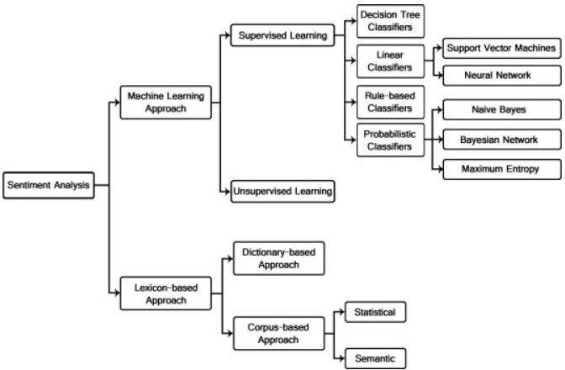

Figure 16: Sentiment Analysis Classification Techniques
Temporal analysis and trend prediction offer the advantage of proactive decision-making. Restaurants can anticipate busy hours, plan staffing accordingly, and even adjust their offerings based on upcoming food trends. This not only improves
Operational efficiency but also enhances customer satisfaction. advanced feature engineering techniques can enhance the predictive power of the model. By capturing intricate relationships between attributes, the model’s ability to accurately forecast restaurant behaviors and trends would significantly improve, providing restaurant owners with more reliable insights. Dynamic pricing strategies can optimize revenue generation.
By analyzing demand patterns, competitor pricing, and external factors, the model can recommend pricing adjustments that strike a balance between attracting customers during off-peak hours and maximizing profits during peak times. Sentiment analysis and emotion detection go beyond quantitative metrics. By understanding customer sentiments, the model can provide actionable insights for improving specific aspects of the restaurant experience, such as service quality or menu offerings, resulting in better customer engagement.

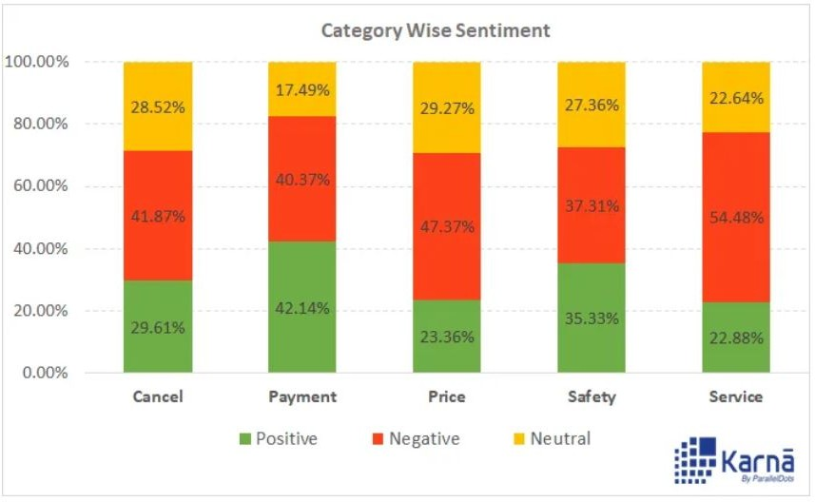

Figure 17: Category wise of SA

Conclusion
The restaurant industry is swiftly adopting Machine Learning techniques to forecast customer behavior and en- hance business operations. This study focused on a classification approach for restaurants based on their ratings using the XGBoost model. Employing Exploratory Data Analysis (EDA) bolstered by diverse graphs, this re- search gained insights from the data before the classification phase. Rigorous data preprocessing was undertaken before conducting EDA to elevate visualization and classification accuracy. The dataset analyzed, visualized, and classified was sourced from ”zomato.csv” via the Kaggle platform. Machine learning and predictive analytics were harnessed to anticipate restaurant ratings, employing a myriad of tools and methodologies. Within this study, supervised algorithms were employed to construct the model, with meticulous selection of the most. Efficacious technique,the XGBoost classification model emerged as the standout performer, achieving an impressive accuracy of 98.07
The implications of this research reverberate in aiding nascent restaurants in designing menus, cuisines, themes, pricing, geographical locations, and more, consequently catalyzing business growth. The amalgamation of rating and location insights empowers diners to make informed choices while selecting dining establishments. Future endeavors could explore automating optimal feature extraction, thereby elevating the model’s accuracy and performance. this study not only contributes to the field of data-driven restaurant analysis but also showcases the power of machine learning in extracting meaningful insights from complex datasets. The findings encourage a deeper understanding of customer behavior, industry trends, and the transformative impact of technology on the dining experience.

References
- B. Nithya and V. Ilango, ”Predictive analytics in health care using machine learning tools and techniques,” in 2017 International Conference on Intelligent Computing and Control Systems (ICICCS). IEEE, 2017, pp. 492–499.
- J. Priya, ”Predicting restaurant rating using machine learning and comparison of regression models,” in 2020 International Conference on Emerging Trends in Information Technology and Engineering (icETITE).

- D. Kumar, A. C. Gopesh, and M. P. Singh, ”Restaurant review classification and analysis,” vol, vol. 11, pp. 169–179.
- R. Priyadharshini, ”Zomato data with eda, geospatial and sentiment analysis.”
- A. Kulkarni, D. Bhandari, and S. Bhoite, ”Restaurants rating prediction using machine learning algorithms,” International Journal of Computer Applications Technology and Research, 2019.
- H. Hirose, Y. Soejima, and K. Hirose, ”Nnrmlr: A combined method of nearest neighbor regression and multiple linear regression,” in 2012 IIAI International Conference on Advanced Applied Informatics. IEEE, 2012, pp. 351–356.
- R. R. Nair and T. Singh, ”Multi-sensor medical image fusion using pyramid-based dwt: a multi-resolution approach,” IET Image Processing, vol. 13, no. 9, pp. 1447–1459, 2019.
- B. Charbuty and A D. Kumar, A. C. Gopesh, and M. P. Singh, ”Restaurant review classification and analy- sis,” vol, vol. 11, pp. 169–179. . Abdulazeez, ”Classification based on decision tree algorithm for machine learning,” Journal of Applied Science and Technology Trends, vol. 2, no. 01, pp. 20–28, 2021.
- T. Babu, T. Singh, D. Gupta, and S. Hameed, ”Optimized cancer detection on various magnified histopatho- logical colon images based on dwt features and fcm clustering,” Turkish Journal of Electrical Engineering and Computer Sciences, vol. 30, no. 1, pp. 1–17, 2022.
- T. Babu, T. Singh, D. Gupta, and S. Hameed, ”Optimized cancer detection on various magnified histopatho- logical colon images based on dwt features and fcm clustering,” Turkish Journal of Electrical Engineering and Computer Sciences, vol. 30, no. 1, pp. 1–17, 2022.
- R. R. Nair and T. Singh, ”An optimal registration on a shearlet domain with novel weighted energy fusion for multi-modal medical images,” Optik, vol. 225, p. 165742, 2021.
- T. Babu, D. Gupta, T. Singh, S. Hameed, M. Zakariah, and Y. A. Alotaibi, ”Robust magnification independent colon biopsy grading system over multiple data sources,” CMC-COMPUTERS MATERIALS & CONTINUA, vol. 69, no. 1, pp. 99–128, 2021.
- R.-C. Chen, R. E. Caraka, N. E. G. Arnita, S. Pomalingo, A. Rachman, T. Toharudin, S.-K. Tai, and B. Pardamean, ”An end to end of scalable tree boosting system,” Sylwan, vol. 165, no. 1, pp. 1–11, 2020.
- H. Chen, S. Hu, R. Hua, and X. Zhao, ”Improved naive Bayes classification algorithm for traffic risk man- agement,” EURASIP Journal on Advances in Signal Processing, vol. 2021, no. 1, pp. 1–12, 2021.
- A. Banerjee and T. Chowdhury, ”Reviewing system using exploratory data analysis and ensemble machine learning algorithms,” in 2021 IEEE 2nd International Conference on Technology, Engineering, Management for Societal impact using Marketing, Entrepreneurship and Talent (TEMSMET). IEEE, 2021, pp. 1–6.

