SELF DRIVING CARS- AN AI POWERED AUTOMATION
Surya.V¹, Valarmathi.V²,Sathya.T³, Buvana.C⁴
¹Assistant Professor, CSE, Sathyabama Institute of Science and Technology, Chennai.119
² Assistant Professor, IT, Sri Sairam Engineering College, Chennai.109
³ Associate Professor, CSBS, Sri Sairam Engineering College, Chennai.109
⁴UG Scholar, IT, Sri Sairam Engineering College, Chennai.109

ABSTRACT
Self-driving cars operate on a principle that mimics the human body's sensory and decision-making processes. Just as our sense organs like the eyes, ears, and nose gather information about the environment, self-driving cars are equipped with an array of advanced sensors to perceive their surroundings accurately. These sensors include RADAR sensors, which use radio waves to detect the distance and speed of objects; LiDAR sensors, which utilize lasers to create detailed 3D maps of the surroundings; GPS sensors for location data, and ultrasonic sensors to detect nearby objects. By utilizing these sensors, automated cars continuously gather real-time information about road conditions, obstacles, pedestrians, and other vehicles. This constant stream of data is crucial for making split-second decisions to ensure safe and efficient navigation. To process and interpret this vast amount of data, self-driving cars rely on Artificial Intelligence (AI). AI algorithms analyze the information received from the sensors and enable the car to make intelligent decisions on how to respond in various situations. The power of AI lies in its ability to quickly analyze massive datasets, assess potential risks, and determine the most appropriate course of action, much like how the human brain processes sensory inputs and reacts accordingly. One of the primary reasons for adopting AI in autonomous vehicles is its multitasking capability. Unlike human drivers, who can get overwhelmed by processing information from multiple sources simultaneously, supercomputers running AI algorithms can handle this parallel processing efficiently. AI allows the car to process data from various sensors simultaneously, making it better equipped to understand complex driving scenarios and respond promptly with the safest actions. Moreover, self-driving cars can communicate with one another through Vehicle-to-Vehicle (V2V) and Vehicle-to-Infrastructure (V2I) technologies. This vehicle-to-vehicle communication enables the cars to share essential information about their positions, speed, and intended actions, creating a network of real-time data exchange among nearby vehicles. This collective intelligence enhances the overall safety and efficiency of autonomous driving, as each car learns from the experiences and decisions of others, leading to continuous improvements in the system. Self-driving cars incorporate a sophisticated combination of sensory input from various sensors and advanced AI algorithms to replicate the decision-making processes of a human driver. By harnessing the multitasking capabilities of AI, these vehicles can analyze and respond to complex driving situations swiftly and safely. The ability of autonomous cars to share information with each other enables them to learn collectively and work collaboratively, paving the way for a future where transportation is not only efficient but also significantly safer for all road users.

Keywords: Artificial Intelligence, IoT Sensors, RADOR, LiDAR, GPS, Automation, Camera, Self-driving cars.

INTRODUCTION

In recent years, there has been intense competition among vehicle manufacturers and tech agencies to develop and deploy self-driving cars. While the primary focus has been on being the first to have autonomous vehicles on the road, this paper aims to shed light on other crucial factors in this race. Two essential parameters to consider are standardization of safety guarantees and the development of self-driving technologies. The first parameter revolves around establishing minimum safety requirements that every self-driving car must meet, along with methods to verify and ensure compliance with these requirements. As self-driving cars become increasingly prevalent on our roads, it becomes imperative to have standardized safety guidelines to protect both passengers and pedestrians. Creating a comprehensive set of safety standards and mechanisms for testing and validation is essential to build public trust in autonomous vehicles. Advancements in technology have transformed self-driving cars over the years. Just as manual cars used to struggle with identifying objects in adverse weather conditions, current self-driving cars have become much more adept at navigating through such challenges. For instance, self-driving cars today can detect obstacles even in rain and snow, showcasing significant progress in their sensor capabilities and overall intelligence.

When a self-driving car encounters an obstacle in its path or on a busy road, the internal system quickly analyzes the situation. If it predicts that the obstacle is likely to stop on the road, the car's supercomputer triggers an emergency alert to warn pedestrians and other road users. In cases where the obstacle may not be crossing the road but waiting for someone, some self-driving cars are equipped with a "voice" feature to alert and prompt the person to move from the way, ensuring smoother traffic flow. Notably, Tesla, a prominent company in the field of autonomous vehicles, is currently working on self-driving cars that have the ability to fly in traffic using propellants. However, the implementation of such technology will require the development of numerous rules and regulations to ensure safe and controlled aerial mobility within traffic environments.

One of the key technologies driving self-driving cars is the Convolutional Neural Network (CNN). This AI system is trained to process raw pixels from a single front-facing camera and directly map them into steering instructions. The end-to-end approach used in CNN has proved highly effective, allowing the system to learn to drive in various traffic conditions, including local roads with or without lane markings and highways. Moreover, CNN can handle challenging environments, such as parking lots and unpaved roads, thanks to its ability to learn internal representations of essential processing steps, like detecting road features, based on human steering perspectives as the training signal. This end-to-end system optimization enables the use of smaller networks while still achieving efficient problem-solving capabilities. Beyond the race to be the first to deploy self-driving cars, it is essential to focus on standardizing safety guarantees and creating comprehensive regulations for the safe integration of autonomous vehicles on our roads. The development and advancement of technologies, such as the Convolutional Neural Network, play a significant role in making self-driving cars more capable, efficient, and safer for widespread adoption. By addressing these additional parameters, the future of self-driving cars can be one of enhanced safety and seamless mobility.

RELATED WORKS
- This paper discusses the three essential components of our sensing system, with cameras playing a pivotal role in achieving long-range, 360-degree coverage of the environment. Cameras offer high resolution, texture perception, and cost-effectiveness, making them indispensable for a scalable system. Their detailed imaging enables superior long-distance detection, while texture perception aids in understanding scene semantics like lane markings, traffic lights, and pedestrian intentions. Nevertheless, cameras have limitations, including difficulties in estimating longitudinal distance in 2D and sensitivity to lighting conditions. To address these challenges, our system employs sensor fusion, integrating LiDAR and RADAR data, along with advanced image processing algorithms to enhance visibility under diverse lighting conditions. By leveraging the strengths of cameras and implementing these solutions, our sensing system achieves a comprehensive and reliable perception of the environment, essential for the advancement of safe and efficient self-driving cars.

- This paper introduces a novel approach to high-definition mapping technology called Road Experience Management (REM). Unlike the common geometric mapping methods that rely on storing a cloud of 3D points obtained from LIDAR sensors and matching them for localization, REM follows a semantic-based strategy. This innovative technique leverages the prevalence of vehicles equipped with cameras and software capable of detecting semantically significant objects in the environment, such as lane marks, curbs, poles, and traffic lights. The traditional LIDAR-based mapping approach suffers from several drawbacks. It requires substantial memory to store kilometers of mapping data, leading to expensive communication infrastructure. Additionally, only a few vehicles are equipped with LIDAR sensors, resulting in infrequent map updates. This time lag poses a problem as road conditions can change, including construction zones and hazards. In contrast, REM optimizes the use of vehicles with cameras and advanced driver assistance systems (ADAS). These ADAS systems can be leveraged for crowd-sourced mapping based on the semantic analysis of the scene. By processing the data on the vehicle side, only a small amount of semantic information needs to be communicated to the cloud. This efficient approach enables widespread deployment, as autonomous vehicles can easily obtain the small-sized mapping data over existing communication platforms, such as the mobile network. An additional advantage of REM is highly accurate localization on the map, achieved purely based on camera data without the need for expensive LIDAR sensors. This significantly reduces the cost of implementing self-driving technology and opens up new possibilities for more vehicles to contribute to and benefit from the mapping ecosystem. REM's semantic-based approach to high-definition mapping represents a significant advancement in self-driving technology. By capitalizing on the abundance of cameras and ADAS-equipped vehicles, it provides an efficient, cost-effective, and frequently updated mapping solution. The potential widespread adoption of REM can lead to enhanced safety, navigation, and overall autonomous driving capabilities on our roads.

- This paper proposes the adoption of Road Experience Management (REM) for three distinct purposes. Firstly, REM offers valuable insights into the static structure of the road. By leveraging the large number of vehicles equipped with cameras and ADAS systems, it enables the creation of a comprehensive and up-to-date map of the environment, including lane marks, curbs, poles, and traffic lights. Secondly, REM serves as an additional source of accurate static information, complementing other digital diagram detections. By combining the data from REM with other sources, the system gains a robust and reliable view of the static elements present in the environment. This holistic understanding is crucial for the proper functioning of self-driving cars, as it allows them to navigate effectively and safely through various road scenarios. Thirdly, REM addresses the challenge of converting 2D data from the image plane into a 3D representation of the world. The map generated by REM describes all the lanes as curves within the 3D world. Consequently, when the ego vehicle localizes itself on the map, it can easily and accurately lift each object observed in the image plane to its corresponding 3D position in the real world. This means that the REM-generated map not only provides information about the static elements of the environment but also serves as a key tool for accurately translating 2D image data into the 3D world. This critical capability enables self-driving cars to perceive and understand their surroundings in three dimensions, facilitating precise navigation and interaction with the dynamic elements of the road. REM serves three essential purposes in the context of self-driving cars. It offers a comprehensive and updated overview of the static road structure, enhances the overall static information of the environment, and provides a reliable means to convert 2D image data into a 3D representation. With these capabilities, REM significantly contributes to the advancement and reliability of autonomous driving technology, paving the way for safer and more efficient transportation systems.

III. CHALLENGES INVOLVED WITH AUTONOMOUS CARS
There are certainly many benefits to having a driverless car, such as providing transportation for people who cannot drive and relieving driver stress. However, there are also many obstacles that must be overcome in order to put this technology into practice. The following are some of the main problems with driverless cars:
a. Cost
These driverless vehicles required significant financial investment from numerous automakers. One can use Google as an example, which pays roughly $80,000 for one of its AV models, making it completely out of reach for the average person or business. Future forecasts anticipate that this price will decrease by half, which is still more affordable. According to a recent JD Power survey, 37% of individuals will select an autonomous automobile as their next vehicle in the future.

b. Infrastructure
Although many major corporations, including BMW, Audi, Nissan, and others, have made commitments to deploy autonomous cars, the road system is not sufficiently modern to allow for the launch of these vehicles without risk. A certain form of infrastructure won't be developed for another 10 to 15 years, claims one report. Companies are concentrating heavily on investing such a large sum with a return.
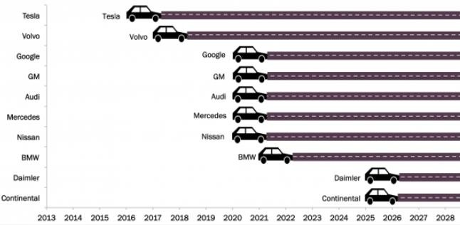
Figure 1: Expected release of Autonomous cars

Replacing Conventional Cars
The need to replace obsolete conventional cars in order to improve the efficiency of autonomous vehicles is one of the main issues that specialists are now facing. The security of the autonomous vehicle is jeopardized during interactions with other vehicles if the older vehicles are still operating on the same platform.

Security Concerns

The largest problem with electronic systems is almost usually one of security and privacy. Because autonomous vehicles are based on an AI system, which needs the Internet for management and information transmission, they are vulnerable to hacker attacks. The involvement of terrorists in such activity raises the second significant issue since it could provide a convenient location for them to carry out their suicide mission. And because the GPS system in these automobiles is so dependent upon it, anyone may enter them and utilize them for evil.

IV.ETHICAL ISSUES WITH DRIVERLESS CARS
As a result of the use of these autos, several ethical questions may arise. The high rate of unemployment among drivers is one of the primary problems. Millions of people around the world depend on this industry for their primary source of income. However, as autonomous vehicles eventually take over all aspects of driving, there will be no need for human drivers. This will result in the replacement of all manual driving procedures, specifically those for taxis, trucking, and other businesses.
Stereo cameras are one type of sensor that this technology uses, among others. These cameras continuously record the video and store it in a database for later viewing and learning, but they can also be used for bad purposes by the owner or anyone else because the recorded videos are not secure and contain images of the surroundings that are quite unethical, including details of other vehicles and images of people.
The effectiveness of the autonomous vehicle may positively alter how people see purchasing such a powerful vehicle. The conventional car will swiftly change into an autonomous car as a result of this. For the makers of traditional cars, this will result in a significant loss. The overall industry for conventional cars will decline by 37%, according to one report, and this trend may continue as more people become aware of the benefits of utilizing this AI-based technology. So, for the other industries focused on traditional autos, the surge in autonomous vehicles is a rather unethical strategy.
V. ENVIRONMENTAL IMPACT
The practical application of the driverless vehicle on a commercial basis will have a significant environmental impact. These vehicles are made to be ecologically beneficial in a variety of ways. Artificial intelligence (AI)-based vehicles planned their routes by taking into account all factors, such as the fastest route to the destination and staying in one lane. This will lead to lower fuel usage and, ultimately, lower atmospheric carbon emissions.
The accuracy feature used by these cars is based on the same idea. Avoid traffic congestion with precision and accuracy based on AI. For instance, while this car is stopped at a traffic signal, it will maintain a very close distance from the other vehicles in the lane. As a result, by using this method, it becomes more accurate in terms of where it is physically located, and this feature has a favorable effect on the environment.

When one of the autonomous vehicles made by VisLab, known as BRAiVE, was tested to drive in the heart of Parma in July 2013, the environmental impact of these vehicles was demonstrated. The outcomes were absolutely amazing; the vehicle successfully navigated all obstacles, including rural areas, traffic signs, and small roads, and was shown to be more accurate in terms of timing and fuel usage than the typical human-driven autos.

Short-term and Long-Term Impacts
Autonomous vehicles have the potential to significantly alter society in ways that benefit not only people but also other aspects of life, making them a more advantageous mode of transportation. There will be a lot of advancements in this technology in the future, which is still in its infancy. Therefore, the predictions support a number of consequences that may have both short-term and long-term effects. These automobiles' technology is incredibly expensive, so when they first go on sale, not many people will be able to afford to buy them. As of now, Google's AI-based AV module costs $80,000, but experts expect that price will steadily decline over time.

The roads and the price may initially terrify people away from riding on it or simply coming into contact with it. However, if the norms and guidelines for autonomous vehicles are carefully followed, this anxiety can be eliminated. The conventional and autonomous cars will be in stark contrast to one another, and the autonomous vehicle concept will slowly take hold in society. The largest problem will always be other terrorism and security concerns, which have terrible short-term effects.
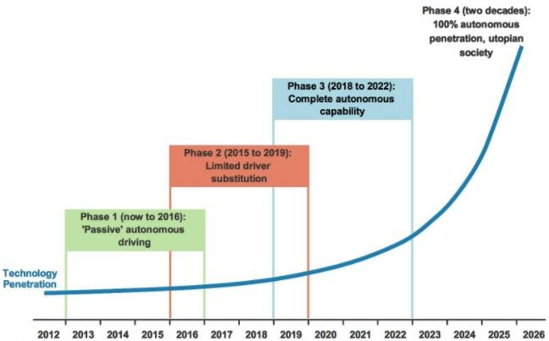

Fig 2: Stages of Autonomous Car

PROPOSED SYSTEM
How do self-driving cars see?
Self-driving cars rely on advanced sensor technologies to "see" and perceive their surroundings accurately. When an obstacle appears in the car's path, it needs to detect and gather essential information about the obstacle's size, shape, and position so that its controlled algorithms can determine the safest course of action in a split-second, without human intervention. To achieve this, self-driving cars utilize a combination of sensor technologies, including LiDAR (Light Detection and Ranging) and integrated photonics. LiDAR is a laser-based probe that emits laser pulses and measures the time it takes for the reflected light to return to the sensor, creating a detailed 3D map of the environment. This technology allows the car to precisely detect objects and obstacles in various weather and lighting conditions, ensuring a high level of accuracy and safety. Additionally, integrated photonics, a miniature version of communication technology used in the internet, plays a crucial role in processing the vast amount of data gathered by LiDAR and other sensors. These sensors work together, allowing the self-driving car's system to interpret the environment, identify potential hazards, and make informed decisions on the most optimal route to navigate through the road safely. Self-driving cars rely on LiDAR and integrated photonics technology, among other

advanced sensor systems, to effectively "see" and understand the surroundings, ensuring a safe and efficient autonomous driving experience regardless of the environmental conditions.
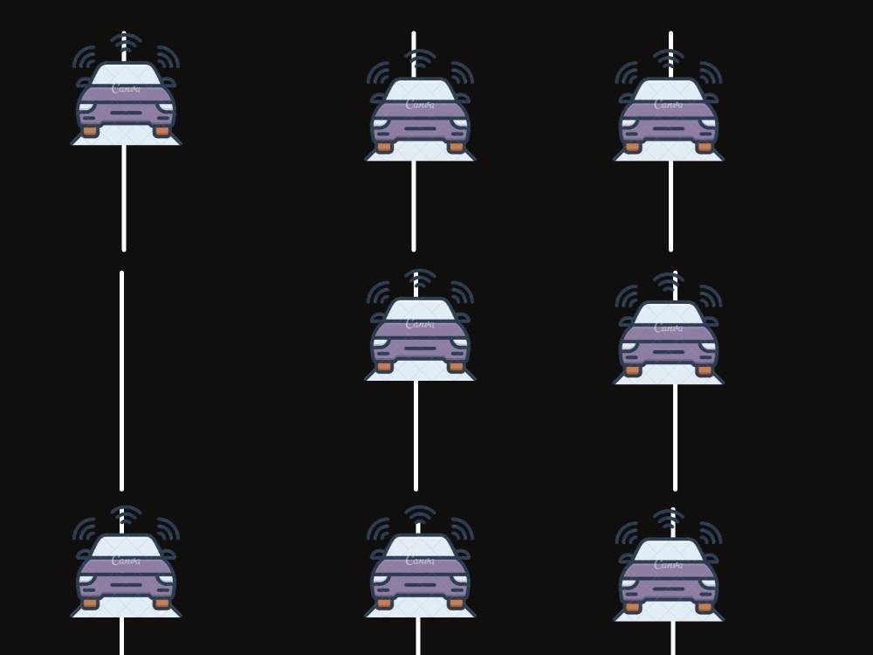
Fig 3: Self-driving cars riding in a straight line
In addition to RADAR antennas, which use radio or microwaves to determine object locations, self-driving cars utilize LiDAR systems, which offer a more advanced way of perceiving the environment. LiDAR, standing for Light Detection and Ranging, employs a narrow, invisible infrared laser that can image small details, even as tiny as the button on a pedestrian's shirt across the street. The LiDAR sensor fires super-short laser pulses in a train, providing accurate depth resolution. For instance, imagine a moose on a country road as the self-driving car passes by. One LiDAR pulse scatters off the base of its antlers, while the next might reach the tip before bouncing back. Measuring the time difference between these pulses allows data about the antler's shape to be obtained. With numerous short pulses, the LiDAR system quickly generates a detailed profile of the surroundings. Traditional laser pulsing, involving switching the laser on and off, can make it unstable and impact timing, limiting depth resolution. A better approach is to keep the laser continuously on and periodically block the light using integrated photonics technology. Integrated photonics, used in the digital data transmission of the internet, employs precision-timed pulses of light as short as 100 picoseconds.

The Mach-Zehnder Modulator is a key component in integrated photonics, capitalizing on the wave property called interference. It splits light waves along two parallel arms and then recombines them. By delaying the light in one arm, the waves recombine out of sync and cancel, effectively blocking the light. By toggling this delay, the modulator acts as an on-off switch, emitting pulses of light. While a 100 picosecond light pulse results in depth resolution in centimeters, future self-driving cars demand even better performance. By pairing the modulator with a super-sensitive, fast-acting light detector, the resolution can be refined to a millimeter, exceeding human 20/20 vision capability by more than a hundred times, even from across a street. The LiDAR system, enabled by integrated photonics and the Mach-Zehnder Modulator, empowers self-driving cars with an advanced and precise way of "seeing" the environment, enabling safe and efficient navigation on the roads. This sophisticated technology is a critical component of the autonomous driving revolution, bringing us closer to a future of fully autonomous and reliable transportation systems.
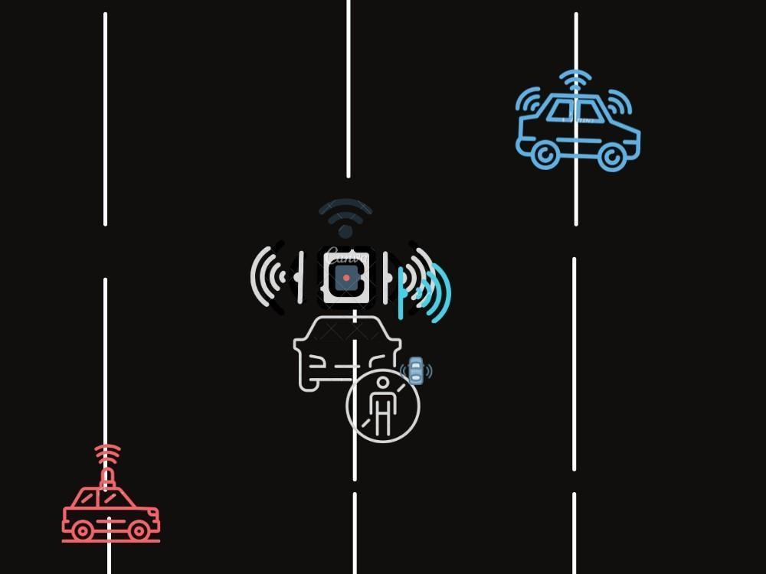
Fig 4: Audio alert by supercomputer to the obstacles standing near the line
The evolution of LiDAR technology has seen significant advancements, moving from complex spinning assemblies mounted on rooftops or hoods to integrated photonics. With integrated photonics, modulators and detectors are miniaturized to less than 0.1mm, allowing them to be packed into tiny chips that will eventually fit inside a car's lights. These compact LiDAR chips will also feature a modified modulator to eliminate moving parts, enabling rapid scanning at high speeds. The novel design of the LiDAR chips incorporates an array of modulator arms, each with a precise and tiny controlled delay. By slightly slowing down the light in these arms, the additional device functions more like a dimmer, offering continuous modulation rather than just an on/off switch. When stacked in parallel, this array creates a steerable laser beam, enhancing the versatility and capabilities of the LiDAR system.

These advanced LiDAR chips act as smart eyes for self-driving cars, providing unparalleled clarity and precision in perceiving the environment. Nature could not have imagined such advanced vision capabilities, allowing the cars to navigate through any number of obstacles with ease and accuracy. In the near future, as LiDAR technology continues to advance, the integration of these compact chips into car lights will enable self-driving cars to "see" the world in a way that surpasses human vision. These smart and precise eyes will be instrumental in making autonomous driving safer, more efficient, and reliable, bringing us closer to a future where self-driving cars seamlessly navigate complex road scenarios, ultimately transforming transportation as we know it.

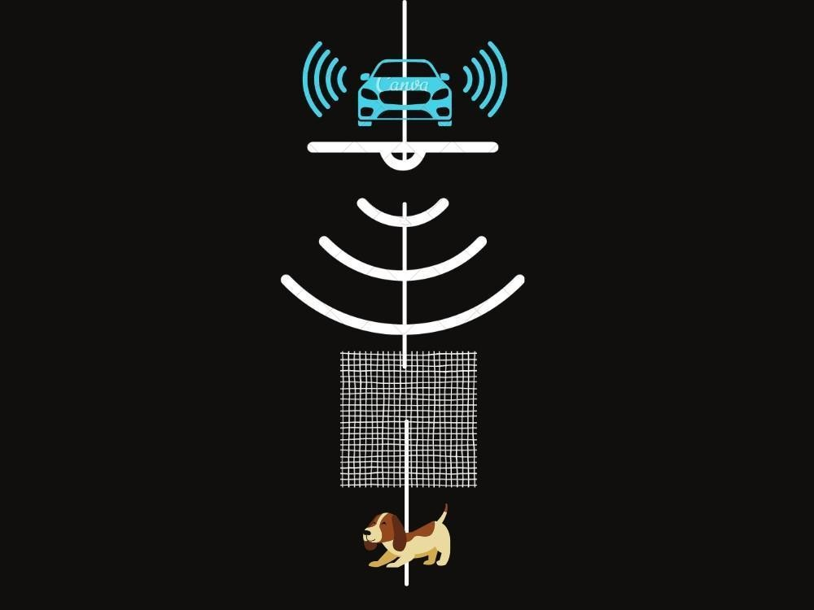
Fig 5: Internal alert to stop the car when obstacles interfere in the line.
Deep convolutional neural networks (CNNs) have demonstrated remarkable performance in various tasks but require significant compute time on GPUs when trained on large datasets. However, certain applications, such as pedestrian detection for self-driving cars or image recognition on mobile phones, demand very low latency due to real-time constraints and limited processing resources, respectively. The success of CNNs in such scenarios depends on the speed of their computations. While conventional FFT-based convolution is fast for large filters, the state-of-the-art CNNs primarily use small 3x3 filters, which present a challenge for efficient computation. To address this, a new class of rapid algorithms leveraging Winograd's minimum filtering algorithms has emerged. These algorithms perform minimum complexity convolution over small tiles, enabling fast computation with small filters and small batch sizes.

This breakthrough in convolutional neural networks' GPU implementation has been demonstrated through benchmarks using the VGG network. The results showcased impressive throughput at various batch sizes, ranging from 1 to 64. The use of Winograd's minimum filtering algorithms significantly enhances the speed and efficiency of CNNs, making them more suitable for real-time applications and resource-constrained devices. By leveraging these advancements, self-driving cars can achieve swift pedestrian detection, ensuring enhanced safety and responsiveness on the road. Similarly, image recognition on mobile phones can become more seamless and efficient, providing users with faster and more accurate results. Overall, the adoption of Winograd's minimum filtering algorithms in CNNs marks a significant step towards accelerating computation and improving the practicality and performance of deep learning models in various real-world applications.

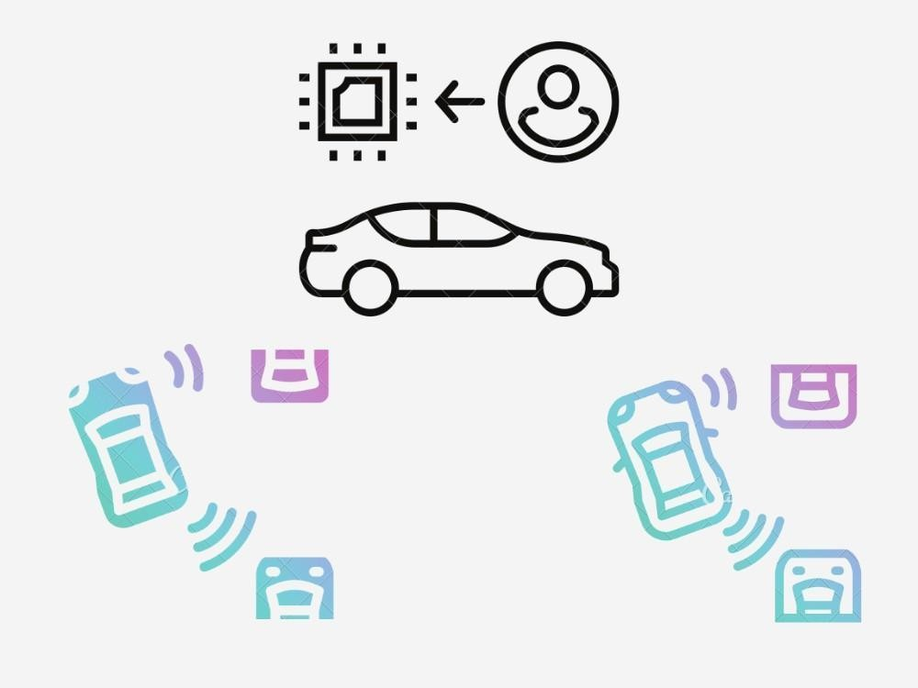
Fig 6: CNN in self-driving cars
Deep neural networks have demonstrated impressive results in image classification tasks. However, they can be highly vulnerable to adversarial perturbations, where small changes in the input image can lead the network to misclassify it. This raises concerns about the safety of using such networks in critical applications like self-driving cars, where reliability is crucial. To address these concerns, researchers have developed a novel automatic verification framework based on Satisfiability Modulo Theory (SMT) for feed-forward multi-layer neural networks. The focus is on ensuring the safety of image classification decisions against image manipulations, such as scratches or changes in the digital diagram's angle or lighting conditions. The goal is to ensure that even with these manipulations, the network continues to assign the same class as a human would within a small neighborhood of the original image.

The framework enables an exhaustive search of the image's vicinity using discretization and propagates the analysis layer by layer within the network. Unlike existing methods, this approach directly works with the network code and can guarantee the detection of adversarial examples, if they exist, for the specified neighborhood and family of manipulations. Detected adversarial examples can then be shown to human testers or used to fine-tune the network for improved robustness. The methods are implemented using Z3 and tested on various standard networks, including regularized and deep learning networks. They are compared against existing techniques for finding adversarial examples and estimating network robustness. The ultimate goal is to ensure that self-driving cars, equipped with these improved and robust neural networks, can navigate the roads smarter and safer, benefiting people from all walks of life. The development of this verification framework is a significant step towards enhancing the reliability and safety of deep learning networks used in critical applications like self-driving cars.

By ensuring that these networks are less susceptible to adversarial perturbations, we can create future where autonomous vehicles play a crucial role in making the roads safer and more efficient, benefiting society as a whole.

MERITS
The major merits and advantages of self-driving cars. One of the key benefits of adopting self-driving cars is the potential to eliminate traffic jams. With the entire world transitioning towards autonomous vehicles, traffic congestion can be significantly reduced, saving people about 40 hours per year. This time-saving aspect is crucial, as time is precious, and self-driving cars can effectively value and optimize each individual's time. Moreover, self-driving cars can greatly contribute to improving road safety. By eliminating human errors and reckless driving, accidents can be reduced by up to 90 percent, making roads much safer for everyone. Additionally, the use of self-driving cars can also aid law enforcement in reducing crime rates. Criminals will have limited means to escape from police as these autonomous vehicles can be tracked and stopped remotely.

Furthermore, self-driving cars revolutionize transportation services. They offer efficient and fast taxi services, reducing waiting times to as little as 28 seconds in a city without traffic jams. Additionally, self-driving cars enable fast delivery services, making them ideal for various logistics and transportation needs. An exciting aspect of self-driving cars is their potential to transform urban landscapes. With no need for parking spaces, real estate areas can be better utilized and repurposed for other purposes, contributing to more efficient land usage. Beyond the immediate benefits to transportation and convenience, self-driving cars also address significant environmental concerns. Traditional fueled vehicles contribute to air pollution, emitting harmful gases like carbon monoxide, leading to air-borne diseases and environmental damage. However, the evolution of autonomous vehicles promises a sustainable environment and ecology, ensuring cleaner air and a healthier ecosystem. Lastly, the adoption of self-driving cars can revolutionize long-distance delivery services, making them faster and more efficient, benefiting various industries and businesses. The self-driving cars have the potential to significantly improve transportation, safety, efficiency, and environmental sustainability, creating a more convenient and environmentally friendly future for everyone.

DEMERITS
The major problem with self-driving cars is that they are not economically friendly. The price of self-driving cars is too expensive and high due to its design with a lot

of sensors and cameras. A common man from a middle-class family is not capable of affording automated cars. The development of automated cars is very difficult. If a self-driven car is repaired or broken, that makes a much bigger problem which cannot be solved by the common man. Only the technicians and developers can solve this major issue, for which it requires a lot of money. Once again it is not affordable for a common middle-class man. Even a minor malfunction may lead to a serious accident. Mass production of the self-driving cars might lead to the delay in the quality. There is a high possibility of cybercrime threats. The cyber criminals might mess up with the computer and lead to some ill activities. Environmental issues and constant surveillance might raise up. The drivers and other workers might lose their job which leads to an unsustainable economy in many middle class families. People who love to drive might lose their driving pleasure due to the automated cars powered by Artificial intelligence.

The major problems and challenges associated with self-driving cars in detail:
  - High Cost and Affordability: Self-driving cars are currently expensive due to the incorporation of advanced sensors, cameras, and complex computing systems. This high cost makes them unaffordable for many individuals, especially those from middle-class families. The price barrier restricts accessibility to a wider population, limiting the adoption of autonomous vehicles.

  - Complex Repairs and Maintenance: The development and maintenance of self-driving cars require specialized knowledge and skills. If a self-driving car encounters issues or requires repair, it can pose significant challenges for common users. Only trained technicians and developers can address these problems, which can be costly and time-consuming for the car owners.

  - Safety Concerns: Despite their advanced technology, self-driving cars are not immune to malfunctions or technical errors. Even minor glitches in their systems can lead to serious accidents, raising safety concerns for both passengers and pedestrians. Ensuring the safety and reliability of self-driving cars is critical before they become mainstream.

  - Delay in Mass Production: As self-driving car technology is still in its developmental stage, mass production could face delays. Maintaining consistent quality and safety standards across a large-scale production can be challenging and may hinder widespread adoption.

  - Cybersecurity Threats: Self-driving cars heavily rely on Artificial Intelligence (AI) and complex software systems. This reliance opens the possibility of cybercrime threats, where malicious actors could hack into the car's system, leading to potentially dangerous situations or unauthorized control of the vehicle.

  - Environmental Impact: While self-driving cars may offer environmental benefits through reduced congestion and optimized driving patterns, their production and maintenance can still have an environmental impact. Manufacturing the advanced components and disposing of old parts could generate electronic waste and raise concerns about sustainable practices.

  - Job Displacement: The widespread adoption of self-driving cars could lead to job displacement in certain industries, such as driving and transportation. Many workers, including professional drivers and related professions, may face job insecurity as automation replaces certain tasks.

  - Loss of Driving Pleasure: Some individuals genuinely enjoy driving and find it to be a pleasurable experience. The rise of self-driving cars, controlled by AI, might take away this pleasure for driving enthusiasts, impacting their overall driving experience.

IX. CHALLENGES
After years of study and development, AVs are now a reality, but designing and implementing autonomous systems is still incredibly difficult. The difficulties also get worse as AV autonomy levels rise. It is necessary to solve problems with data perception, localisation, planning, control, and prediction. According to Parekh et al. (2022), the key difficulty lies in implementing technology in the intricate real-world setting. The future success of AV is also heavily influenced by non-technological variables like customer behavior and trust.
Road and traffic conditions are erratic and vary from location to location. Potholes, mountainous and tunnel routes, unclear external cues for direction, and unclear lanes are all problems on the road. Additionally variable and ever-changing from place to place, weather conditions. No of the weather, whether it is sunny, cloudy, wet, or clear, AVs must be able to perform well. Since failure or downtime are not options, its impact on the car's functionality must be addressed.
a. The traffic situation is ever-changing. Once they are on the road, AVs would

be susceptible to a range of traffic conditions. Around them, there would be other vehicles, AVs, and people. When people are breaching the law and driving recklessly, traffic can either be tightly controlled and self-regulated or unpredictable and unregulated. Unexpected circumstances or events are possible. In crowded areas, even a small amount of movement every minute counts.
b. Self-driving cars will have difficulty navigating due to radar interference from other AVs on the road. To distinguish between its own signal and the signal reflected from another vehicle when there are numerous such AVs on the road at once will be a challenging and complex task. Although there are several radio frequencies that can be used for radar, it's unlikely that this frequency range will be adequate for all cars produced.

c. Big Data Analytics is difficult since inefficient data handling can severely hamper innovation. For significant volumes of AV data, it is required to construct training and decision-making algorithms (Khayyam et al., 2019).

d. Making 3D maps is a difficult task. Typically, self-driving car manufacturers use a sophisticated machine learning algorithm to conduct a road test before feeding map data to the vehicle's system. However, the self-driving car could be unable to offer the necessary guidance if the passenger decides to visit a website that is not listed in the navigation system. Additionally, even after the laborious 3D maps are produced, building projects or adjustments to traffic signals may cause self-driving cars problems. (2022; Tata Elxsi)

e. Complex social interactions, which are necessary for driving, are still challenging for autonomous vehicles. Humans rely on their general intelligence when they are driving because it is a highly social activity that involves complicated interactions with other drivers, cyclists, and pedestrians. This sensation is absent in robots. Drivers must contend with a variety of driving situations, such as poor visibility, poor communication, navigating four-way intersections, or a police officer guiding traffic around an accident scene.

f. Data security and privacy are also issues because such autos are susceptible to hacking and disruption. For instance, if the auto industry attempts to create systems that permit various vehicles to communicate with one another on the road, such as if one receives a message to slam on the brakes, he should be able to trust that message in a safe manner as that is the very foundation of Vehicle-to-Vehicle communication (V2V). But maintaining the system's security could be quite difficult (Plumer, 2016).

g. There are no laws governing fully autonomous systems, for one. According to existing automotive laws, the human driver is responsible for any accidents or takes over in an emergency. Because the software in AVs makes all the decisions, the people within may not be fully awake and may generally be in a relaxed state. Sometimes paying attention is necessary; otherwise, it can be too late to escape the predicament.

h. The social acceptability of self-driving automobiles is a hot topic right now. The current generation of automatic vehicles, including Tesla models, have been involved in a number of tragic incidents. The acceptance of such vehicles affects both persons considering purchasing the vehicle and other road users. Self-driving car deployment and use decisions must involve the general public, or the technology may not be adopted.

FUTURE SCOPE
CNNs are capable of looking into the complete project of lane and avenue following without manual decomposition into avenue or lane marking detection, semantic abstraction, course making plans, and control. A small amount of schooling data from much less than a hundred hours of driving became enough to educate the automobile to carry out in many situations, on highways, community and residential roads in sunny, cloudy, and wet conditions. The CNN is capable of testing significant avenue features from a completely sparse schooling sign (steerage via way of means of myself). The tool learns as an example to come across the outline without the want of specific labels at some point of schooling. greater artwork is wanted to decorate the robustness of the community, to discover strategies to verify the robustness, and to decorate visualization of the network-inner processing steps.

To further enhance CNNs' performance, several future enhancements can be considered:

- Robustness Improvement: CNNs can be made more robust to various environmental and driving conditions, such as adverse weather, low visibility, and challenging road scenarios. This can be achieved by training the network with diverse and extensive datasets that cover a wide range of driving scenarios.

- Adversarial Testing: Verifying the robustness of the network against adversarial attacks is crucial. Adversarial testing involves intentionally introducing small perturbations to the input data to test the network's ability to maintain accuracy and reliability under challenging conditions.

- Visualization of Inner Processing Steps: Understanding how CNNs process information internally can provide insights into their decision-making processes. Visualization techniques can be employed to gain a better understanding of the network's inner workings, helping researchers and developers identify areas for improvement.

- Transfer Learning: Leveraging transfer learning can be beneficial for fine-tuning CNNs for specific driving environments or tasks. Pre-trained CNN models can be used as a starting point and then fine-tuned with additional data from the target domain to improve performance and efficiency.

- Data Augmentation: Increasing the diversity and quantity of training data through data augmentation techniques can enhance the network's ability to generalize to different scenarios and variations in the real-world.

- Continuous Learning: Implementing continuous learning strategies can enable CNNs to adapt and improve their performance over time with new data and experiences. This is especially useful in dynamic and evolving driving environments.

- Safety Validation: Validating the safety and reliability of CNN-based autonomous driving systems through rigorous testing and real-world evaluations is crucial. Safety validation processes should be comprehensive and ensure that the system operates safely in a wide range of scenarios.

By incorporating these future enhancements, CNN-based lane and avenue following systems can become more robust, accurate, and safe, paving the way for the widespread adoption of self-driving technologies and significantly advancing the field of autonomous vehicles.

REFERENCES

- Autonomous car / self-driving car - How it works → https://youtu.be/gEy91PGGLR0
- How do Self Driving Cars Work? | Artificial Intelligence → https://youtu.be/taMP_n3wL7M
- How Do Self-Driving Cars Actually Work? (Tesla, Volvo, Google)
→ https://youtu.be/xMH8dk9b3yA
- Autonomous Vehicle Technical Stack → https://youtu.be/V8LA0_bb9LI

- Lowrie, James W., Mark Thomas, Keith Gremban, and Matthew Turk. "The autonomous land vehicle (ALV) preliminary road-following demonstration."
- Leighty, Robert D. DARPA ALV (Autonomous Land Vehicle) Summary. No.ETL-R-085. Army Engineer Topographic Labs fort Belvoir VA, 1986.
- Davis, Larry S., Daniel Dementhon, Ramesh Gajulapalli, Todd R. Kushner,
- M. S. BRANDON SCHOETTLE, July 2014. [Online]. Available: http://cdn.theatlantic.com/newsroom/img/posts/ UMTRI-2014-21.pdf. [Accessed 06 12 2017].
- Los Angeles Times. (2014, May 28). Look, Ma, no hands: Google to test 200 selfdriving cars. Available at: http://www.latimes.com/business/autos/la-fi- googlecar-20140529-story.html

