THERMAL ANALYSIS OF MONOCRYSTALLINE PHOTOVOLTAIC

CELL USING ANSYS WORKBENCH

Venktesh Kumar

Assistant Professor,

Faculty of Information Technology,

Gopal Narayan Singh University, Jamuhar, Sasaram
Corresponding Email :- venkteshkumar2@gmail.com

Abstract

The purpose of this thesis is to develop monocrystalline silicon photovoltaic cells through the use of current technology and a screen printing method, and then to incorporate them into a photovoltaic device that makes use of these photovoltaic cells, design/methodology/approach this study will look at the characteristics of modern voltage that will determine fundamental electric properties. The characteristics of monocrystalline silicon photovoltaic cells have been investigated in the context of conventional examination situations. Photovoltaic, the module was built with the best short-circuit current photovoltaic cells available, which were then connected together in a sequence configuration to form the final product. Concluding remarks: This examination provides an illustration of a conventional technical technique that makes use of a display printed method of manufacturing. Manufacturing of monocrystalline silicon photovoltaic cells is a process. The electricity generated by the sun can be used to power a device that generates electric energy. The sun module was created by connecting cells together in a circular pattern. After that, Schottky and Zener diodes are used to protect the circuit from damage. Usefulness: The module was used to construct a model solar power system, complete with traffic signals and a pedestrian overpass. This bridge demonstrates the practical application of a readily available, renewable source of energy, in this case, the sun, in a real-world setting.

INTRODUCTION

General Introduction

The electricity requirement of the world is increasing at alarming rate and the power demand is running much ahead of the supply. Fossil fuels like oil, coal and natural gas provide about 80% of the word energy, but generation of electrical power by fossil fuel is causing adverse environmental,social and economic problems [1]. It isi also widely recognized that thei fossil fuels (i.e., coal, petroleum and natural gas) are depleting at fast rate [2] therefore, attention has been moved towardsi other energy resources like: Nuclear energy source which isi plentiful and cleani alternative to fossil fuels buti has increased concern about the safety, cost, and nuclear waste disposal Other traditional supplies may not be appropriate or permitted for catering to the world's ever-increasing need for electrical energy. Toi overcomei problems associated with conventional and nuclear energy resources iti mandatory for countriesi throughout the worldi to developi different renewable energy source; because nature replenishes, renewable energy source faster than it consume; thesei sources are inexhaustible, self-generating , produce clean green energy,i help in controlling climate changes and global warning [3]. The development of renewable technologies are becoming increasingly cost competitivei in number of countries. Renewable based power generation capacity isi estimated toi have increasedi by 128 GW ini 2014, of which 37%i is wind power, almost one third solar power . Earthi receive solar energy from the sun at the rate of 1000 KW h/m2 the total energy received by earthi in onei hour is morei than the energy consumedi in the whole world for onei year. The availability of global averagei power insolation is about 140000 Tera watt (TW) as compared to their consumption of 17 TW.

Solar Cell Technologies

Monocrystalline silicon solar cells

The oldest solar cell technology and still the mosti popular and efficient are solar cells madei from thin wafersi of silicon. These are called monocrystalline solar cells. Monocrystalline silicon solar PV cells were made up from single continuous crystal lattice of silicon having virtually no defects or impurities Silicon is mainly occurs as SiO2 in the form of quartz, sand and silicates,i it is normally produced fromi a naturally occurringi ore, quartzite gravel (a form ofi sand stone). In natural occurring quartzitei there arei several impurities including Al, B, P, Cu, C, Ca, Mg, Fe, Ti, Mn, Mg, etc. The acceptable level ofi impurities isi generally parts per million (ppm) for solar cell applicationsi meansi 5×1016 atoms/cm3 in Si. Various steps are involved in converting an impure quartzitei to high purity crystal wafer. The first stepi isi thei productioni of 99 percent pure metallurgical grade silicon (MGS)i from its ore, SiO2 by reduction reaction with carbon in an arc furnace. The energy cost of this step isi 50 kWh/kgi of silicon. Also in this processi CO2 isi produced asi a byproduct, which is a greenhouse gas. Electronic gradei pure polycrystalline silicon is then obtained by refining iti further thoughi variousi complex operations ati an energy costi of 200i kWh/kg of silicon. These two steps arei highly energy intensive. Worldwide, about 1 million tons of MGS is produced and less than 5 percent of it isi used in makingi electronic grade silicon[5]. The typical monocrystalline photovoltaic cell is a dark black in colour, and the corners of cells are usually missing as a result of the production process and the physical nature of monocrystalline silicon [6]. Typically, the cells are a few inches across, and a number of cells are laid out in a grid to create a panel. Relativei to the other types of cells, they have a higher efficiency (upi toi 24.2%). These cells are preferred for low available area of panel mounting. Thei production costs for thisi type of panel have highesti of all thei solar panel types sincei large amount of energy is required for growing large crystals of pure silicon. Although production methods havei improved and pricesi for raw silicon as well as panel development cost of monocrystalline solar cells have fallen. Their efficiency decreases as the temperature increases above 25˚C, so they need to be installedi ini such a way as to permit thei air toi circulatei over and under the panels to improve their efficiency [7].

Polycrystallinei silicon solar cells
Polycrystalline silicon essentially consists of small grains of monocrystalline silicon. Solar cell wafersi can bei made from polycrystalline silicon directly in various ways, one approach is the controlled casting of molten polycrystallinei silicon into cube shapei ingots (Sii block) with grain size from mm to cm range which are then cut, using fine wire saws, into thin squarei wafers and fabricatedi into completei cells in the same way as monocrystalline silicon. Polycrystalline silicon solar cells are easier and cheaper to manufacture than monocrystalline cells, but their efficiency is lesser becausei lighti generated electroni hole pairs may recombine ati the boundariesi between the grains withi in polycrystalline silicon. However, if the material isi processed ini such ai way that grains are relatively largei in size and oriented in top-bottom direction toi allow light to penetrate deeply ini to each grain the efficiency may bei increased. For commercially available polycrystalline solar cell module efficiency has reached 19.3%. Figurei 1.1. Monocrystalline and polycrystalline solar cells.
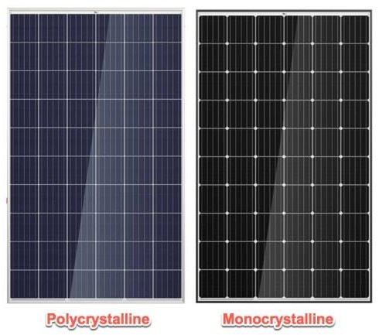

Figure 1.1. Monocrystalline and polycrystalline solar cell i

Structure of Dye-Sensitized Solar cell (DSSC)

A great deal of theoretical and practical effort has been done to explain the effective operation of these solar cells since the development of the nanostructured DSSC. Due to the basic operational differences between the DSSCs and their conventional semi conducting pn-junction solar cells, they are in need of specific theoretical considerations of the photovoltaic effect in DSSCs. The DSSC separates both tasks; photons are absorbed by the dye molecules and charge transport is carried out in the TiO2 electrode and electrolyte. This is in contrast to semiconductor pn-junction solar cells, in which light absorption and charge transport occur in the same material. The charge separation in DSSCs is based on a hole transport mechanism from the oxidised dye to the electrolyte and an electron transfer process from the dye molecule to TiO2. The electronic structure of the adsorbed dye molecule and the energy level matching between the excited state of the dye and the conduction band of the TiO2 are both important factors in the electron transfer mechanism.

LITRATURE REVIEW

The first generation of photovoltaic cells were researched during 1950’s to 1960’s for improved performance and reduction in cost. In 1954, the modern use of photovoltaic technology began. The p-n junction diodes under room light created a voltage, as was found by Bell Labs researchers in the United States. They created a silicon p-n junction solar cell with 6% efficiency that year, which is a significant development in photovoltaic technology but was also quite costly.

In 1958,i first solar poweredi satellite was developedi in which solar cells were used to power ai small radio transmitter. In 1963, Sharpi Corporation (Japan) produced the first commercial Si modules. Ini 1970, Zhores Alferov, Russian physicist and his co-workers, created highly effective first Gallium Arsenide (GaAs)i heteroi structurei solar cells. Year 1973 was also important for photovoltaics becausei worldwide oil crisis encouraged many countries to seek for renewable energy sources. In 1976i Davidi Carlson and Christopher Wronski, of RCA Laboratoriesi developed first amorphous silicon photovoltaic cells which was lessi expensive than crystalline silicon devices. The photovoltaic technology developedi very fast ini the 1980s. University of Delaware developed firsti thin-filmi solar cell made of copper sulphide (Cu2S) and cadmium sulphide (CdS) which exceeded 10% efficiency.

Ini 1981, Paul Mac Cready developedi first solar-powered aircraft and thei Solar Challenger. The aircraft flied fromi Francei toi England acrossi the English Channel, iti comprised of over 16,000 solar cellsi mountedi oni itsi wings, whichi produced a power ofi 3kW. Ini 1985, researchers of the University of New South Walesi (Australia) broke the efficiency barrier for silicon solar cells under standard sunlight (one sun condition). In 1986, ARCO Solar, developed first commercial thin film photovoltaici module. British Petroleumi got a patenti for thei production of thin-film solar cell and Reflective solar concentrators in 1989 . In 1991, efficient Photoi electrochemical cells (PEC) later known as Dyei sensitizedi solar cells were developedi. In year 1992, A 15.9% efficient thin-film photovoltaici cell made ofi cadmium telluride was developed, which brokei 15% barrier for the first time for thisi technology . Number of technologies from photovoltaici devicei using selenium wafers in 1883 toi thin-film solar modules in 2000i has beeni developedi to utilize solar energy. Ini 2000, two new thin-film solar modules, broke previousi performance recordsi and achieved 10.8 % conversion efficiency, the highest in the world for thin-filmi modules of their kind. The efficiency of commercially available crystalline silicon solar cell modules is about 20% ini standard test conditions [8]. Now Australian engineers have taken us closer than ever before to the theoretical limits of sunlight-to-electricity conversion, by buildingi photovoltaic cells thati cani harvesti 34.5% of the Sun's energy without concentrators, setting a new world record, these new photovoltaic cells aren't only morei efficient, they also cover far less surface area [9]. The long-term goal is to produce 34%i of thei total world electricity production by 2050i and toi achieve thisi goal improvementi in performance (efficiency) and reductioni of direct manufacturing costs is required. Nanotechnology isi emerging as ai kindi of new technology [10].

METHOD AND METHODOLOGY

Structure of Dye Sensitized Photovoltaic cell (DSSC)

A substantial amount of theoretical and experimental diligence has been done to explain the effective operation of these solar cells since the development of the nanostructure DSSC. Due to the basic fundamental distinctions between the DSSCs and standard semiconductor pn-junction solar cells, special theoretical considerations of the photovoltaic effect in DSSCs have to be taken into account. The DSSC isolates either functionalities; photons are absorbed by the dye molecules, whilst charge transport is carried out in the TiO2 electrode and electrolyte, in contrast to semiconductor pn-junction solar cells, whereby light absorption and charge transport occur in the same material. In DSSCs, the separation of charge is based on a hole-mediated transport mechanism from the oxygenated dye to the electrolyte and an electron transfer process through the dye molecule to TiO2. The electronic structure of the adsorbed dye molecular structure and the energy level match between the excited state of the dye and the conduction band of TiO2 are both significant variables in the electron transfer mechanism. While charge separation occurred at semiconductor pn-junctions as a consequence of an electric field in the space-charge layer near the junction, this is not the case at the electrode-electrolyte interface for nanoparticles. The nanostructured electrode's individual particle size, which is generally a few tens of nanometers, is too minuscule for a space charge layer to establish itself inside the particles. In semiconductor pn-junction cells, created opposing charges circulate through the same material, nevertheless in DSSCs, electrons move across a network of nanoporous TiO2 while holes move throughout the electrolyte. In the case of a semiconductor pn-junction solar cell, where recombination can only take effect at the semiconductor electrolyte interface, this implies that the requirement for a clean and defect-free semiconductor material is reduced. Sunlight may partially reflect onto the outermost layer of glass of a solar cell, photons of light could be absorbed by dye sensitizers, photons of light can be dispersed inside the solar cell, and photons of light may be partially transmitted when it engages with the solar cell. The main technique of light absorption depends on the light harvester that occupies the photoanode and factors such the photoanode's optical density, extinction coefficient, and the quantity of time that the light utilises inside the photoanode. A large number of the aforementioned factors have been affected by the incident radiation's wavelength. Enhancing the utilisation of light by light harvesting equipment throughout the broadest wavelength range is necessary, as is minimising charge recombination, which results in the loss of photogenerated charges [12].

3.2. Transparent Substrate for Electrodesi (TCO)

Since they combine the physical characteristics of electrical conductivity for current collection with visible light transmittance for light harvesting, transparent conductive oxides (TCOs) are crucial for solar cell applications. Clear glass substrates are often utilised due to their availability, affordability, and great optical transparency in the visible and near infrared spectrums. On one side of the substrate, a thin layer of transparent conductive oxide (TCO), a conductive coating, is applied. Low electric resistance/cm2 is made possible by the conductive film. At room temperature, a typical value for this resistance is 10–20 I/cm2. TCO is a key material not just for solar cells but also for many other applications, particularly in the optoelectronic industry, such as flat panel displays, LEDs, and waveguide devices. This is because of its unique properties of high transparency and low sheet resistance. TCO is a semiconductor with a broad bandgap and a large concentration of free electrons [13].

3.1.ai Tin doped Indium Oxidei (ITO)

Due to its high transmittance (in the range of 80% and 90%) as well as excellent conductivity all throughout the decades that followed, ITO has been one of the most widely implemented TCO materials in both industries and labs. Nevertheless, the material's conductivity significantly decreases when heated over 300 °C. This is caused by a reduction in oxygen vacancies at high temperatures, which additionally induces a reduction in the quantity of electric carriers. Additionally, high price tags on materials are a result of the expensivei Indium material's scarcity. In addition, the researchers are searching for a better replacement due to the material's toxicity and simplicity in interacting with hydrogen plasma

3.2.b Fluorine doped Tin Oxide (FTO)

Another TCO that has been utilised extensively, particularly in solar cells, is FTO. This is because of its excellent stability at high temperatures and its affordable price compared to ITO. Due to the change in resistivity caused by the degree of doping, FTO is more frequently utilised. It is ideal for DSSC preparation, which necessitates sintering up to 450°C, as it is thermally stable up to 650°C. The optimised FTOi had a thin film with a resistivity of 6.71 103 cmi, an optical bandgap of 3.80 eV, and an average visual transmittance of 83%i

3.3.c Aluminum doped Zinc Oxidei (AZO)

Aluminium oxide compounds (AZO), which are extremely insoluble, thermally stable, and electrically non-conductive. But certain electrically conductive perovskite-structured oxides are finding use as the cathode of solid oxide fuel cells and oxygen production devices.

Nanostructured Photo Electrodei (Anode)

Initially, the photo electrodes for photo electrochemical solar cells (PSC) were manufactured from clumsy semiconducting substances like Si, GaAs, or CdS. The photo electrochemical cell's low stability is caused by photoi corrosion, which occurs when these types of photo electrodes are exposed to light. Due to their resistance to photocorrosion, sensitised wide-bandgap semiconductors like TiO2 or ZnO resulted in a high level of chemical stability of the cell. The issue with large single or polycrystalline wide bandgapi is the low light to current conversion efficiency, which is mostly caused by the insufficient adsorption of sensitizer due to the electrode's constrained surface area. Increasing the surface area (the roughness factor) of the sensitised photo electrode is one way to improve light-harvesting efficiency (LHE) and subsequently the light-to-current conversion efficiency [14].

Dyei Sensitizer

The purpose of the dye molecules is to absorb solar energy and introduce electrons into the semiconductor. Therefore, an effective sensitizer must strongly bind to the semiconductor oxide's surface, exhibit intense absorption in the visible spectrum, and have the correct energy level alignment between the dye's excited state and the semiconductor's conduction band edge [15]. The photosensitization material's molecular structure has a significant impact on the performance of DSSCs.

i Operating principle of the dye-sensitized solar cell

Anode and cathode constructed of tin oxide coated with fluorine glass (FTO), semiconductor layer of titanium dioxide (TiO2), dye sensitizer (natural or synthetic), and electrolyte (iodide, tri-iodide) are the key components of a dye-sensitized solar cell. The fundamental concept behind DSSC is that dye sensitizers, whether artificial or organic, absorb photons at a length of wavelength that is equal to the quantity of energy difference between the dye's highest occupied molecular orbital (HOMO) and minimum unfilled molecular orbital (LUMO). Through this process, the dye is excited to its excited state, at which point the electrons travel to the photo-anode and get hooked up with the semiconductor TiO2's conduction band. The photo-anode's captured electrons go through the outer circuit through a load before returning through the cathode [16].

RESULT AND DISCUSSION

1. Monocrystalline Photovoltaic cell (3D Model)

Given: Drawing of Monocrystalline Photovoltaic cell
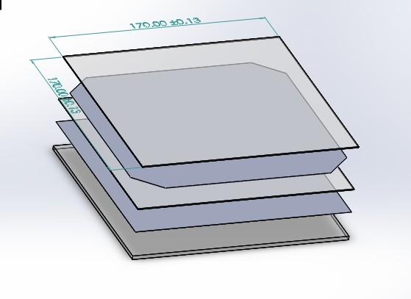

Step 1- Geometry

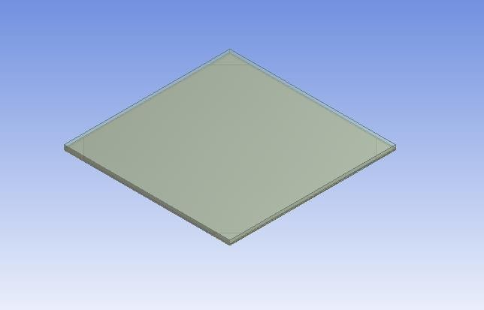

Step 2- Meshing

1) Element size: 4mm

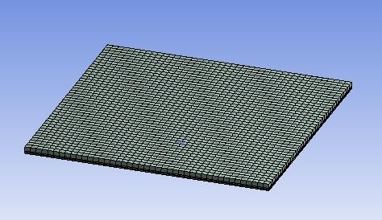

Step 3 – Setup

Boundary condition

Glass Convection 28 C, 36.087W/m^2 C
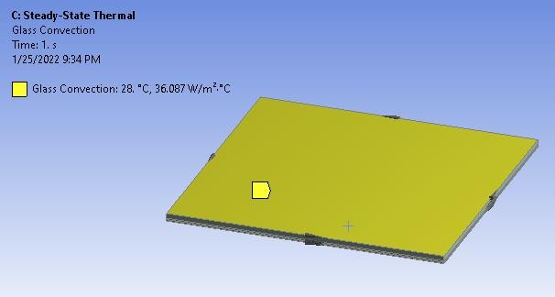

Glass Heat Flux: 80 W/m^2

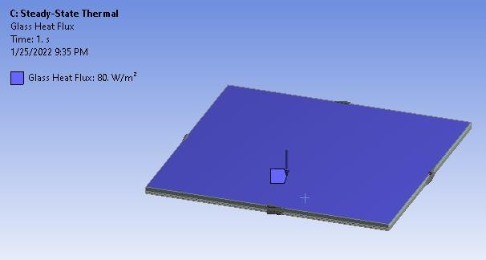

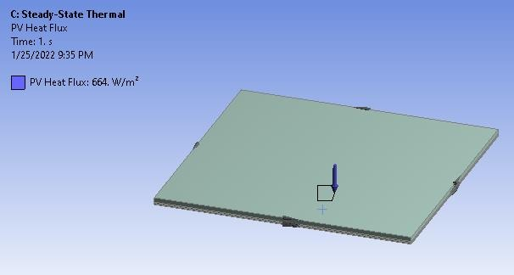
PV Heat Flux : 664 W/m^2

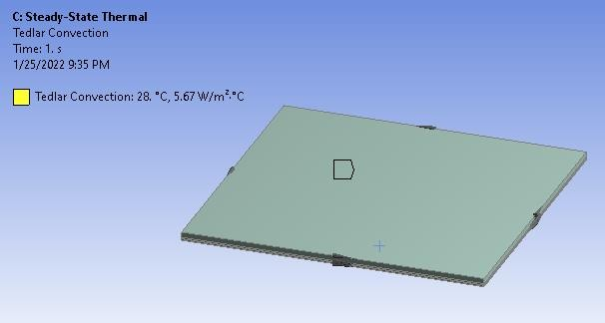
Tedlar Convection: 28 C, 5.67 W/m^2 C

Material Properties

Thermal conductivity of EVA: 0.311 W/mK Thermal conductivity of Glass: 0.7 W/mK

Thermal conductivity of Monocryastaline Si: 148 W/mK
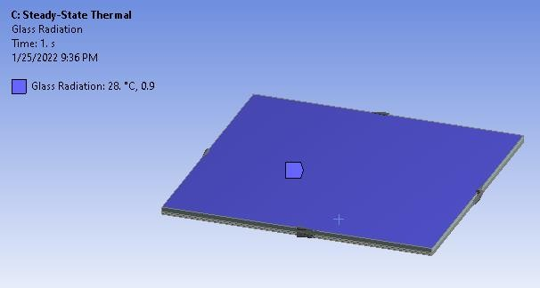

Glass Radiation: 28 C, 0.9 Step 4- Solution and result Temperature Distribution:

Max Temp: 46.97 C Min Temp: 44.7 C

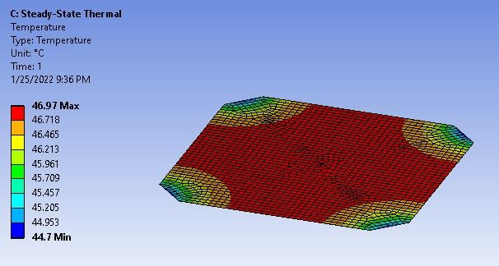

Conclusion

As all the values of Temp. are below the value which is given for material so our design is safe.

CONLUSION AND FUTURE SCOPE

Systematic investigations were carried out to fabricate and evaluate different types of photovoltaic cells, since the nanocrystalline cell is feasible under laboratory conditions various nanocrystalline solar PV cells were developed and tested for their performance under ambient conditions. The working of nanocrystalline DSSC is based on the conduction by electron injection from the dye to the semiconductor and redox reaction to reduce the dye. The main technological challenges are the volatility of the iodide electrolyte, the inflexibility of glass substrates and the cell degradation, with the consequent reduction in useful life compared to silicon cells. The parameters of DSSC can be varied by changing its anode material, cathode material, type of dye, type of electrolyte, and the procedure adopted to fabricate the cell. In this thesis different types of cells were developed and tested under standard conditions, for each type of cell at least ten samples were prepared and tested on the basis of various characterization carried out under the present study, following conclusions can be drawn:

Future Scope

Monocrystalline and polycrystalline photovoltaic cells have achieved presentable conversion efficiencies and are available in market. The nanocrystalline photovoltaic cells such as DSSC, and perovskite photovoltaic cells are emerging technology. Further future work need to be done for the efficiency enhancement of DSSC using different cathode materials and electrolytes. The costly ruthenium dye may be replaced by natural sensitizers. More work is required on the stability study of these nanocrystalline photovoltaic cells. DSSCs are estimated to significantly provide renewable energy by the year 2020. Although progress is there in perovskite photovoltaic cells but work is required to be done to reduce the effect of moisture on perovskite photovoltaic cell parameters. Other nano composites such as TiO2V2O5 may also be used for DSSC anode fabrication. Hence, future research may be focused on producing more stable, flexible, environmental resistant, lower cost and higher efficient DSSCs. The flexible substrates may be used in place of FTO. Their flexibility and variety of colors and shapes can be employed and can be used as decoration in colored windows that not only allow light through, but can use this light to generate electricity. Although less efficient than the silicon based photovoltaic cell, DSSC is more cost efficient due to the low cost of the materials and processing, than the silicon photovoltaic cells. I do hope that the work presented in this thesis will encourage further research in the direction of realization of more efficient and cost effective photovoltaic cells in future.

References

B.G. Boyle, B. Everett, G. Alexander, Introducing renewable energy, 2012.

M. Hosenuzzaman, N.A. Rahim, J. Selvaraj, M. Hasanuzzaman, A.B.M.A. Malek, A. Nahar, Global prospects, progress, policies, and environmental impact of solar photovoltaic power generation, Renew. Sustain. Energy Rev. 41 (2015) 284–297. doi:10.1016/j.rser.2014.08.046.

M. Thirugnanasambandam, S. Iniyan, R. Goic, A review of solar thermal technologies, Renew. Sustain. Energy Rev. 14 (2010) 312–322. doi:10.1016 /j.rser.2009.07.014.

K.. M. Rajiv Kohli, Developments in Surface Contamination and Cleaning, First, Elsevier, 2011.

M. Gaetzel, A.J. Mcevoy, Principles and Applications of Dye Sensitized Nanocrystalline Photovoltaic cells ( DSC ), Asian J. Energy Environ. 5 (2004) 197– 210.

M. Hoeven, Energy and Climate Change, World Energy Outlook Spec. Rep. (2015) 1–200. www.worldenergyoutlook.org.

C.S. Solanki, Solar Photovoltaics: Fundamental Technologies and Applications, Second Edi, PHI, 2013.

W. Siemens, Van Nostrands Engineering Magazine, (1885).

M.A. Green, Silicon photovoltaic cells: evolution, high-efficiency design and efficiency enhancements, Semicond. Sci. Technol. 8 (1993) 1–12. doi:10.1088/0268- 1242/8/1/001.

B.I. Kamiya, Engineering of Energy Conversion , Summer Semester 2012 Physics of photovoltaic cells The principles of operation and fundamental physics How to understand photovoltaic cells and other photovoltaics Semiconductor physics & electronics : Topics to be dealt : carrier gen, (2012) 1–11.

M.A. Green, The path to 25% silicon photovoltaic cell efficiency: History of silicon cell evolution, Prog. Photovoltaics Res. Appl. 17 (2009) 183–189. doi:10.1002/pip.892.

B. O’Regan, M. Grätzel, A low-cost, high-efficiency photovoltaic cell based on dyesensitized colloidal TiO2 films, Nature. 353 (1991) 737–740. doi:10.1038/353737a0.

D.J. Friedman, S.R. Kurtz, K.A. Bertness, A.E. Kibbler, C. Kramer, J.M. Olson, D.L. King, B.R. Hansen, J.K. Snyder, Accelerated publication 30.2% efficient GaInP/GaAs monolithic two-terminal tandem concentrator cell, Prog. Photovoltaics Res. Appl. 3 (1995) 47–50. doi:10.1002/pip.4670030105.

M. Gratzel, Photo electro chemical cells, Nat. (London, U. K.). 414 (2001) 338– 344. doi:10.1038/35104607.

M.A. Green, K. Emery, Y. Hishikawa, W. Warta, Photovoltaic cell efficiency tables (version 37), Prog. Photovoltaics Res. Appl. 19 (2011) 84–92. doi:10.1002/pip.1088.

M. Keevers, Engineers just created the most efficient photovoltaic cells ever, (2016) 1– 3. http://www.sciencealert.com (accessed July 7, 2016).

