Magnetically Recoverable Palladium Nanocatalyst for C-C bond Homocoupling

Mayuri V. Patil, Pradeep M. Mhaldar, Dattaprasad M. Pore
Department of Chemistry, Shivaji University,Kolhapur 416 004, India
Email: p_dattaprasad@rediffmail.com

Abstract
Nanonatalysts considered as imperious nanomaterial scaffold in synthetic chemistry. Design and synthesis of such material are of great interest in scientific community. In light of this, a highly efficient and sustainable ferrite supported palladium nanocatalyst (Pd(II)-Benz-Am-Fe₃O₄@SiO₂) has been prepared and characterized by diverse microscopic and spectroscopic techniques. The Pd(II)-Benz-Am-Fe₃O₄@SiO₂ was employed as magnetically recoverable nanocatalyst in the synthesis of symmetrical biaryls by reductive homocoupling of haloarenes (I, Br and Cl) using hydrazine hydrate (N₂H₄) as reducing agent. The Pd-Benz-Am-Fe₃O₄@SiO₂ nanocatalyst exhibited high surface area and efficient magnetization as 45.25 m² g⁻¹ and 34 emu/g, respectively. The Electron Dispersive X-ray (EDX) analysis confirmed 3.9 mol % loading of Pd in Pd-Benz-Am-Fe₃O₄@SiO₂. Moverever, high turnover number (TON) and turnover frequency (TOF), operational simplicity and facial recyclability and reusability (up to eight runs) are the remarkable advantages of the nanocatalyst. The catalytic activity and stability of recycled Pd(II)-Benz-Am-Fe₃O₄@SiO₂ catalyst was comprehensively studied from X- ray diffraction (XRD), Scanning Electron Microscopy (SEM), Transmission Electron Microscopic (TEM) and EDX analysis.

Keywords Magnetic nanoparticles, Symmetrical biaryls, Homocoupling, Hydrazine hydrate, Ullmann

INTRODUCTION

In last few decades, development of newer economical and greener processes for synthesis of drug and intermediate chemicals has taken a high momentum due to the stringent legislations imposed by pollution control bodies concerning ecosystem and environmental protection. In recent years coupling chemistry became one of the highly focused areas of research as it is an important tool for the preparation of industrially and pharmaceutically significant compounds via formation of C-C and C-X (X=Heteroatom) bond.[1-2] Transition metals are recognized as the heart of coupling chemistry due to their remarkable properties viz. easy oxidation-reduction tendency, variable valencies and an ability to form labile bonds with carbon during the course of coupling reactions. A number of transition metals such as Pd,[3-6] Cu,[7-8] Ni,[9] Zn,[10] Au,[11] Ru[12] and Fe[13] has been used in the catalytic systems of coupling reactions. Interestingly, palladium-catalyzed C-C formation couplings like Suzuki, [14-15] Heck, [16] Sonogashira,[17] Ullmann, [18] Negishi [19-20] and Stille [21] are more relaying in the advanced synthesis. Initially, these reactions were used to perform under homogeneous condition employing solvent soluble inorganic / organic palladium salts / complexes. [22] However, on account of the high cost, toxic nature, tedious workup and contamination in the product, the use of homogeneous Pd catalytic systems failed to comply with the economic and environmental obligations. Accordingly, to overcome these limitations, heterogenization of homogeneous catalysts became appealing task in the coupling chemistry in the ecological and economical perspective. [23-24]
The heterogenization can be achieved by immobilizing different homogeneous palladium salts, nanoparticles and complexes on suitable solid support. The properties like thermal stability, recyclability, catalytic efficiency are mainly considered in the selection of appropriate support material during preparation of heterogeneous catalyst. [25-26] In recent years, various supports such as metal oxides, [27] polymers, [28] zeolites, [29] silica, [30] carbon [31] and metal–organic frameworks [32] have been successfully used for generation of active heterogeneous catalysts for coupling reactions. Though these supports have their own merits and demerits, ferrite (Fe₃O₄) magnetic nanoparticles (MNPs) are found to be much superior and advantageous over other catalysts due to their remarkable properties such as large surface area, easy magnetic separation, non-toxicity, low cost, stability and easy availability. [33-36]
Interestingly, surface modified functionalized organic/inorganic palladium magnetic nanoparticles are being extensively utilized as a catalyst in coupling reactions. Remarkably, silica coating around MNPs is the popular modification as it prevents agglomeration of ferrite nanoparticles into large clusters. The functionalization of silica coated MNPs using alkyl amino spacers provides co-ordination sites for easy immobilization of metal. In short, such tailored catalysts exhibits superiority over other heterogeneous catalysts.
In medicinal chemistry, biaryls are considered as a privileged medicinal scaffold owing to their presence in most of the natural products and biologically active compounds. [37-38] Biaryls are key building blocks of many organic compounds belonging to pharmaceuticals, [39] agrochemicals,40 polymers, [41] sensor, [42] conducting materials [43] and supramolecules. These compounds are also used as a ligand in the synthesis of asymmetric catalysts [44-45]. Biaryls are generally synthesized by several classical coupling reactions viz Ullmann, [46] Suzuki, [47] Stille [48] and by direct arylation of simple arenes. [49] However, most of the reported methods suffers from major drawbacks such as requirement of stoichiometric amounts of expensive and moisture sensitive organometallic compounds viz. arylmetals, arylboronic acids, [50] arylstannanes, [51] arylzinc [52] and aryl Grignard reagents. [53] Thus, to overcome these drawbacks, researchers have focused their efforts towards development of simple and expedient method for synthesis of biaryl. Although general Ullmann coupling is convenient and direct method for the synthesis of biaryls, regrettably it requires harsh reaction conditions. [54-55]

Ullmann homocoupling by heterogeneous Palladium catalyzed

A palladium nanoparticles supported on mesoporous carbon (Pd@IFMC) was prepared by Karimi and co-workers. [56] Initially, an ionic liquid derived nano-fibrillated mesoporous carbon (IFMC) was synthesized by carbonation of 1-methyl-3-phenethyl-1H-imidazolium hydrogen sulphate (MPIHS) in the presence of SBA-15 as support followed by Pd metalation. The catalyst was screened for Ullmann homocoupling of aryl halides (Br, I) in absence of co-reducing agent [Scheme 1].

Scheme 1
Karimi [57] and co-workers performed N-heterocyclic carbene (NHC) immobilized N-dodecyl substituted palladium catalyst for Ullmann homocoupling in PEG-200 at 90 ºC. The catalyst was also employed for synthesis of symmetrical heteroaryls [Scheme 2].

Scheme 2

Puthiaraj [58] et al. investigated a Ullmann homocoupling of aryl chlorides in water catalyzed by ethylenediamine functionalized palladium nanoparticles incorporated aromatic polymer nanocatalyst [Pd@CBAP-1(EDA)]. The nanocatalyst possessed particle size 2–4 nm. Efficiency and stability of catalyst was examined by hot filtration and ICP analysis [Scheme 3].

Scheme 3
Feiz et al. achieved a continuous flow room temperature aqueous reductive homo-coupling of aryl halides using supported palladium catalyst. [59] The reaction performed in an H-Cube mini at mild reaction conditions. The symmetrical biaryls were synthesized with significant yield [Scheme 4].

Scheme 4
An organic-inorganic hybrid material immobilized bidentate nitrogen ligand tethered palladium was synthesized and screened for homo-coupling of aryl iodide and bromide by Chen and coworkers. [60] The reaction was performed in N,N-dimethylacetamide as a solvent, and n-tributylamine as a base at high temperature. Recyclability of the catalyst was examined up to five reaction cycles [Scheme 5].
Scheme 5
An aqueous mediated Ullmann homocoupling of aryl halides were achieved by Dubey and Kumar using synthesized polydopamine-coated iron oxide supported palladium nanoparticles (Pd/Fe₃O₄@PDA). [61] The reaction performed in β-cyclodextrin with caesium carbonate as a base at 100 ºC. The synthesized nanoparticles were characterized by techniques such as TEM, SEM, EDX, XPS, ICP-AES and XRD [Scheme 6

Scheme 6
Nowadays, palladium catalyzed reductive Ullmann coupling is considered as a more reliable and convenient alternative for the synthesis of biaryls. Such reductive couplings are usually performed in the presence of active reducing agents such as molecular hydrogen, [69] amines, [70] Zn dust, [71] alcohols, [72] hydroquinones, [73] ascorbic acid, [74] sugars, [75] etc. However, the selection of appropriate reducing agent is most important as improper reducing agent can lead to parallel side reaction such as reduction of other functional groups and hydrodehalogenation of aryl halides. In continuation with our previous work on the designing and synthesis of ferrite MNPs supported catalysts and their applications in coupling reactions, [76-79] we explored herein, new magnetically separable Pd(II)-Benz-Am-Fe₃O₄@SiO₂ catalyst for the reductive Ullmann type homocoupling of diverse aryl halides employing hydrazine hydrate as a reducing agent.

Result and Discussion
Synthesis of Pd(II)-Benz-Am-Fe₃O₄@SiO₂
The magnetic nanoparticles (Fe₃O₄) were prepared by co-precipitation method [80] [Scheme 14]. The coating of silica on MNPs was achieved by sol-gel approach treating with tetraethoxysilane (TEOS) in ammonia solution.⁸¹ The silica coating of MNPs facilitates heterogenization by providing binding sites (Si–OH units). The functionalization of Fe₃O₄@SiO₂ was carried out by using a functionalizing agent, 3-aminopropyl triethoxysilane (APTES) resulted Am-Si-Fe₃O₄ which was then treated with benzil (Benz) to furnish Benz-Am-Fe₃O₄@SiO₂. Finally, the benzil immobilized amine functionalized silica coated palladium magnetite nanoparticles acronyms Pd-Benz-Am-Fe₃O₄@SiO₂ were achieved by metalation with palladium acetate. The prepared catalyst was subjected to various characterization techniques viz. IR, XRD, SEM, EDX, HR-TEM, XPS, BET, TGA, VSM and BET analysis.
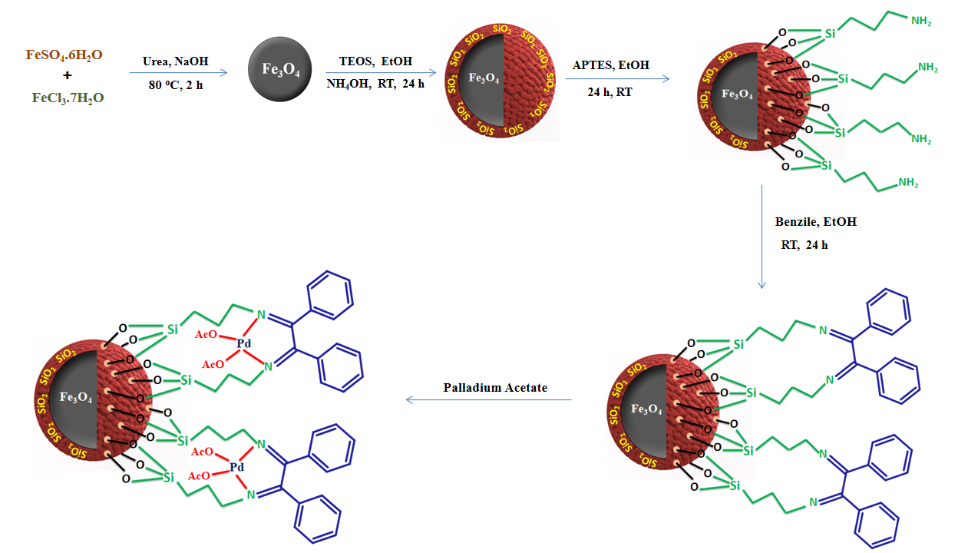

Scheme 14: Preparation of Pd-Benz-Am- Fe₃O₄@SiO₂ catalyst

- Characterization of Pd-Benz-Am-Fe₃O₄@SiO₂ catalyst
X-Ray Diffraction (XRD)
The crystalline structure and phase purity of MNPs (Fe₃O₄) and Pd-Benz-Am-Fe₃O₄@SiO₂ nanocatalyst were examined by powder XRD as shown in fig. 1. The XRD pattern of MNPs exhibit a cubic spinel structure with peaks attributed at 2θ = 30.102, 35.781, 43.021, 53.511, 57.465 and 62.989 which correspond to the reflection planes (220), (311), (400), (422), (511) and (440), respectively (JCPDS card no.00-019-0629). The XRD pattern of Pd-Benz-Am-Fe₃O₄@SiO₂ exhibited unaltered phases even after the functionalization of MNPs. The intensities and diffraction peak position confirms that the modification and metallation did not affected the crystalline nature of MNPs which is also in good agreement with the TEM micrographs. Further, absence of characteristic peaks for palladium in the XRD pattern of the catalyst indicates that the palladium sites are well dispersed on the ferrite support.
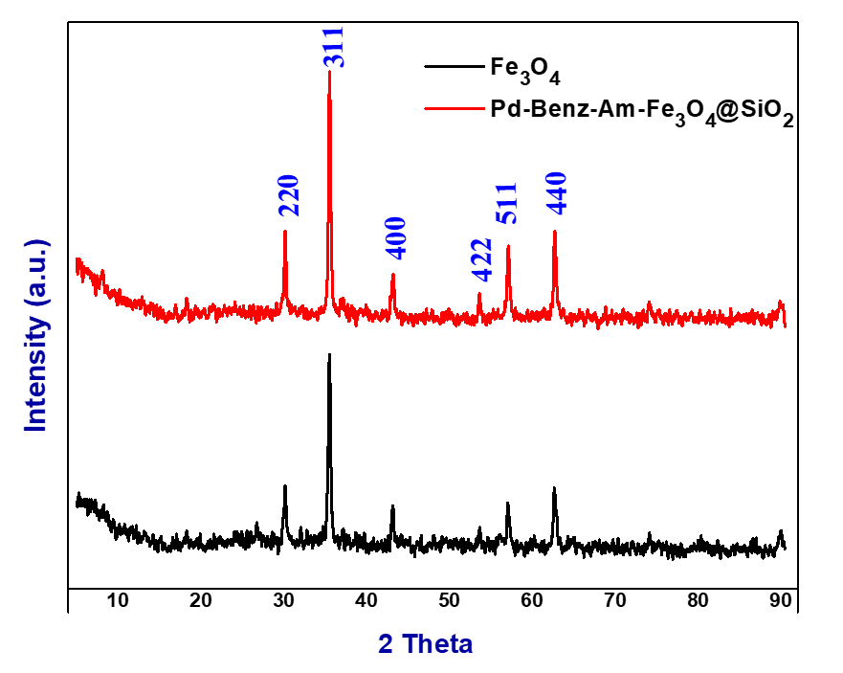

Fig. 1: XRD patterns of MNPs and Pd(II)-Benz-Am-Fe₃O₄@SiO₂ catalyst

Scanning Electron Microscopy (SEM)
The surface morphology of synthesized nanocatalyst was investigated by SEM analysis. SEM micrographs of the fresh Pd-Benz-Am-Fe₃O₄@SiO₂ and recycled Pd-Benz-Am-Fe₃O₄@SiO₂ catalyst are depicted in Fig. 2. The SEM image of freshly prepared Pd-Benz-Am-Fe₃O₄@SiO₂ [Fig. 2a & 2b] displayed uniform distribution of nanoparticles with spherical morphology having nanometres size. The surface morphology of eight time recycled Pd-Benz-Am-Fe₃O₄@SiO₂ catalyst was remain unaffected [Fig. 2c], indicate unaltered morphology which is in good favor with TEM analysis.
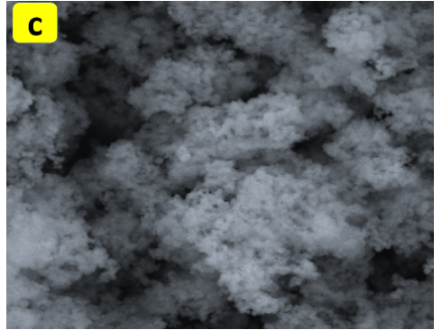
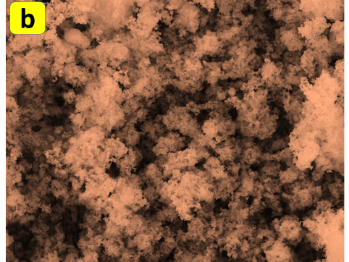
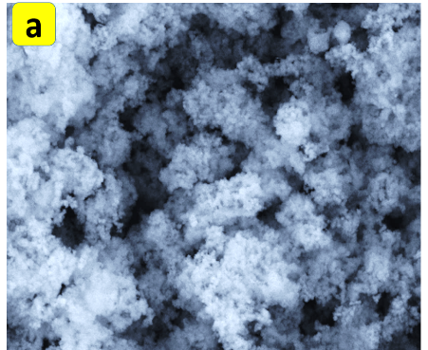
Fig. 2: SEM micrograph of fresh Pd-Benz-Am-Fe₃O₄@SiO₂ catalyst (a-b) and eight time recycled Pd-Benz-Am-Fe₃O₄@SiO₂ catalyst (c)

Energy Dispersive X-Ray (EDX)
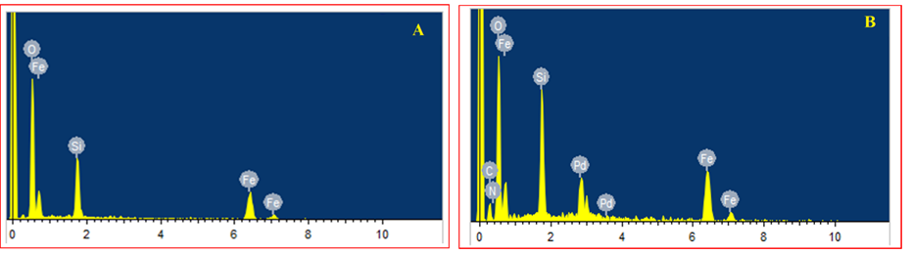
The elemental composition of Fe₃O₄@SiO₂ and Pd-Benz-Am-Fe₃O₄@SiO₂ was confirmed by EDS analysis. The EDS spectrum of Fe₃O₄@SiO₂ exhibit characteristic signal of O, Fe and Si ensuring the pure synthesis of silica coated ferrite [Fig. 3A]. The successful synthesis of Pd-Benz-Am-Fe₃O₄@SiO₂ was evidenced by presence of Pd signal at respective energy position at 2.83 KeV and 3.38 KeV [Fig. 3B]. It also confirms the functionalization and benzyl immobilization on Fe₃O₄@SiO₂. EDS analysis was revealed 8.27 wt % of palladium in catalyst. The exact quantity of Pd in the catalyst, Pd-Benz-Am-Fe₃O₄@SiO₂ was determined by ICP-AES analysis which is found to be 8.04 % w/w.
Fig. 3: EDS pattern of (A) Fe₃O₄@SiO₂ and (B) Pd-Benz-Am-Fe₃O₄@SiO₂
Transmission Electron Microscopy (TEM)
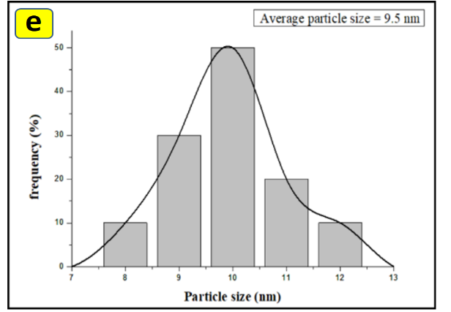
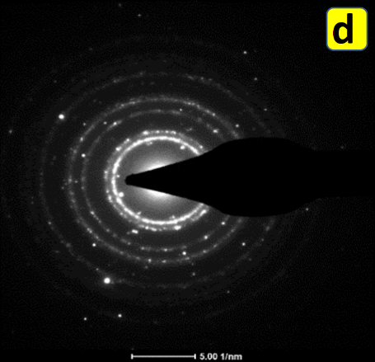
The morphology and structure of Pd-Benz-Am-Fe₃O₄@SiO₂ was obtained by HR-TEM analysis. The resulted data and micrographs were depicted in Fig. 4. The TEM images revealed the quasi-spherical morphology with an average size ranging from 9 to 11 nm. Further, dark magnetic core present inside the Pd(II)-Benz-Am-Fe₃O₄@SiO₂ nanomagnetic particles can be clearly seen in the TEM image [Fig. 4a-b]. The TEM image of the recovered nanocatalyst ensued no rema rkable change in morphology of the nanocatalyst even after eight consecutive reaction cycles which verify the high catalytic efficiency of Pd(II)-Benz-Am-Fe3O4@SiO2 [Fig. 4c]. In selected area electron diffraction (SAED) pattern of Pd-Benz-Am-Fe3O4@SiO2, the white spots as well as bright diffraction rings confirms that the material is highly crystalline [Fig. 4d]. The size distribution histogram [Fig. 4e] also confirm the average particle size is about 9.5 nm.
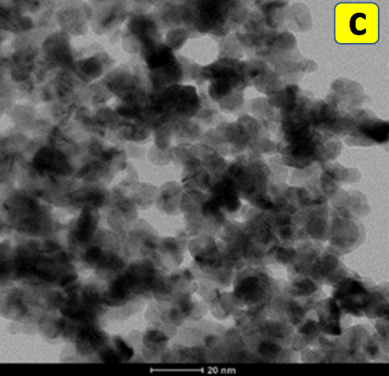
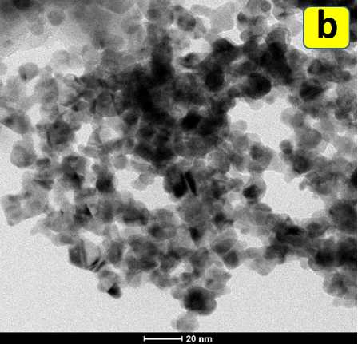
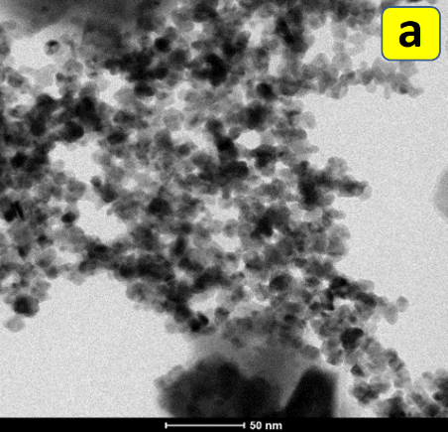
Fig. 4:HR-TEM image of freshPd-Benz-Am-Fe₃O₄@SiO₂ nanomagnetic catalyst (a, b); recycles Pd-Benz-Am-Fe₃O₄@SiO₂ catalyst (c); SAED pattern (d) & particle size distribution histograms (e) of Pd-Benz-Am-Fe₃O₄@SiO₂ catalyst

X-ray Photoelectron Spectroscopy (XPS)
The electron environment, oxidation state and binding energy of species on the surface were analyzed by X-ray photoelectron spectroscopy (XPS). Fig. 5(a) elucidate the XPS elemental survey scans for Pd(II)-Benz-Am-Fe₃O₄@SiO₂ with peaks corresponding to oxygen, silicon, carbon, nitrogen, palladium and iron. The oxidation state of palladium is ascertained as Pd (II) as the Pd binding energy exhibits two strong peaks centered at 342.38 and 336.88 eV corresponding to Pd 3d_{3/2} and Pd 3d_{5/2}, respectively [Fig. 5b]. These binding energy values are in good agreement with Pd (II) binding energy of palladium acetate. Additionally, high resolution XPS spectra confirms the presence of silicon (peak at 103.68 eV) [Fig. 5c] and iron (peak at 724.72 eV and 711.06 eV) [Fig. 5d].
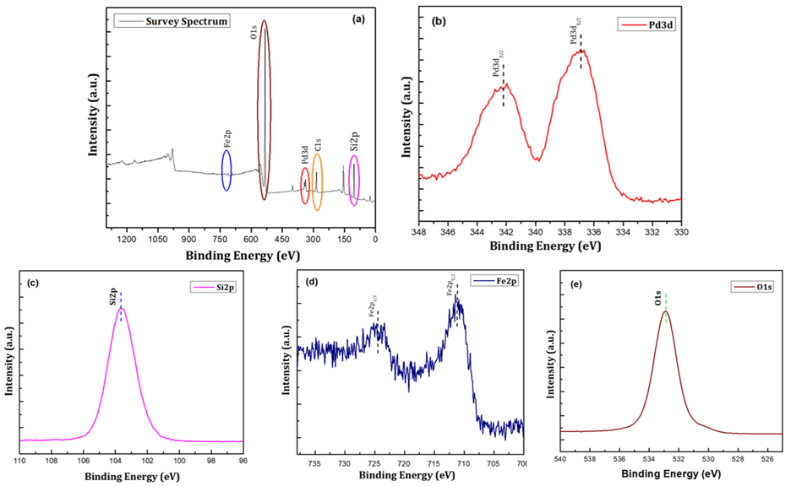
Fig. 5: XPS analysis of Pd(II)-Benz-Am-Fe₃O₄@SiO₂ (a) elemental survey scan of Pd(II)-Benz-Am-Fe₃O₄@SiO₂ (b) high resolution XPS Pd 3d spectrum (c) high-resolution XPS Si 2p spectrum (d) high-resolution XPS Fe 2p spectrum of and (e) high-resolution XPS O1s spectrum of Pd(II)-Benz-Am-Fe₃O₄@SiO₂

Brunauer–Emmett–Teller (BET)
The surface functionalization of Pd-Benz-Am-Fe₃O₄@SiO₂ was investigated from BET surface area analysis. The nitrogen adsorption-desorption isotherm for Pd-Benz-Am-Fe₃O₄@SiO₂ is depicted in fig. 6 which exhibited a type-II isotherm. The MNPs adsorbed high amount of nitrogen as compared to that on the catalyst, Pd-Benz-Am-Fe₃O₄@SiO₂. The surface area of Pd-Benz-Am-Fe₃O₄@SiO₂ nanocatalyst decreased to 45.25 m² g⁻¹ compared to surface area of bare MNPs (77.47 m² g⁻¹). The decrease in surface area of final catalyst attributed to successful functionalization of MNPs with inorganic-organic hybrid palladium (II) complex. Furthermore, the porous structure of Pd-Benz-Am-Fe₃O₄@SiO₂ was confirmed by a pore volume distribution curves (inset) obtained using BJH method.
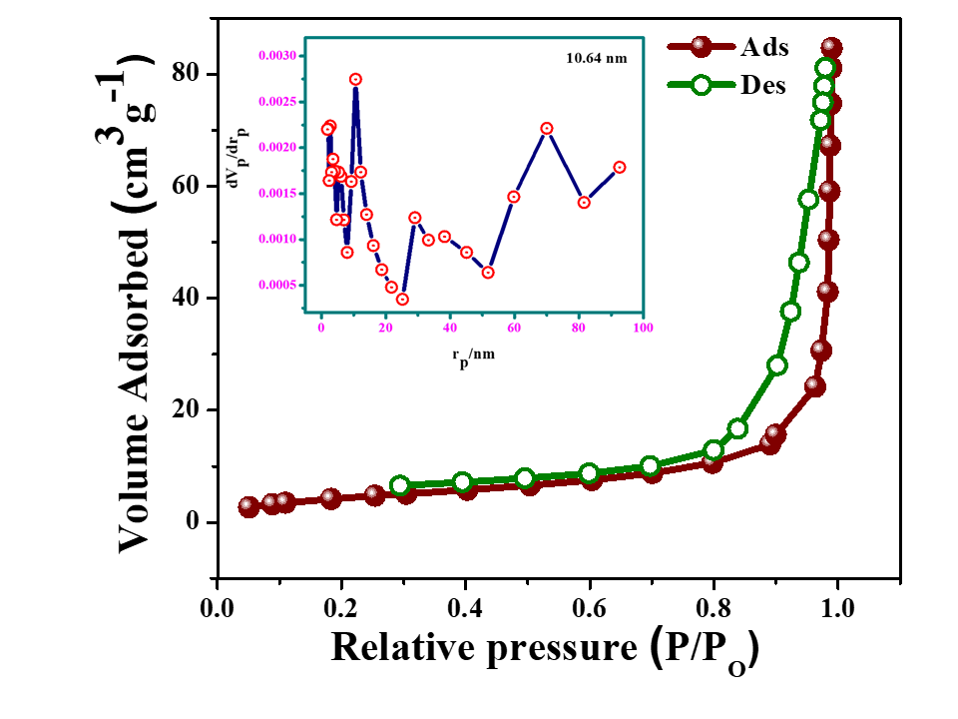
Fig. 6: Nitrogen adsorption–desorption curves and BJH pore size distribution (inset) for Pd-Benz-Am-Fe₃O₄@SiO₂catalyst
Vibrating Sample Magnetometer (VSM)
The magnetic properties of the synthesized Fe₃O₄ magnetic nanoparticles (MNPs), Am-Fe₃O₄@SiO₂ and Pd-Benz-Am-Fe₃O₄@SiO₂ catalyst were examined by vibrating sample magnetometry (VSM). The field-dependent magnetization curves obtained from magnetization (emu/g) as a function of applied magnetic field (Oe) which measured at room temperature (293 K) with the field sweeping from −15,000 to 15,000 Oe were depicted in Fig. 7. VSM analysis revealed super paramagnetic property of the synthesized catalyst. The saturation magnetization (M_{s}) for synthesized Fe₃O₄ MNPs was found reduced to 78 emu/g from the saturation magnetization value of bulk magnetite (92 emu/g). The reduction in the magnetization of MNPs in an external field was due to its size value which is proportional to the magnetization. The silica coating and functionalization of the MNPs led to decrease in the magnetization of Am-Fe₃O₄@SiO₂ and Pd-Benz-Am-Fe₃O₄@SiO₂ to 58 emu/g and 34 emu/g, respectively. In spite of decrease in magnetization values of Pd-Benz-Am-Fe₃O₄@SiO₂ with respect to magnetization of MNPs, it could be easily separated by a conventional magnet from reaction mixture.
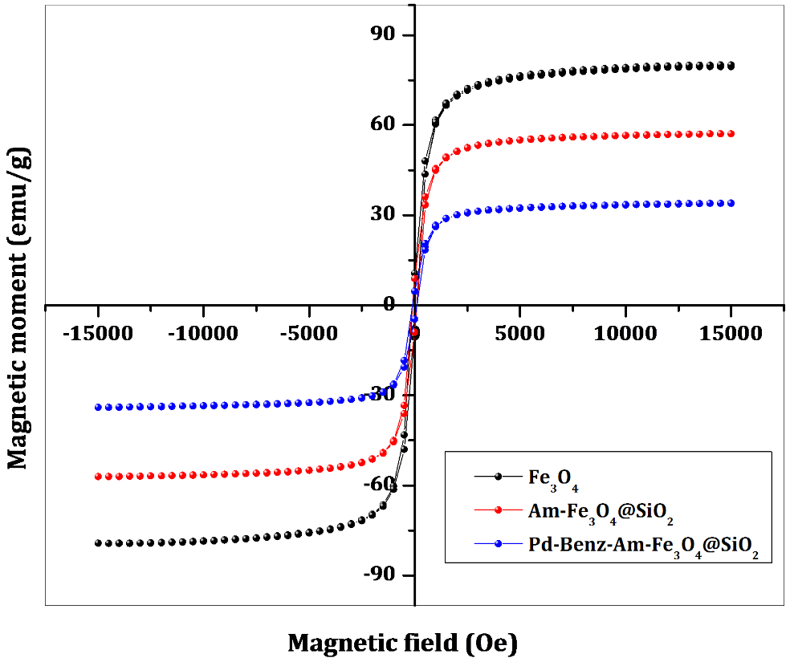
Fig. 7: Magnetization curves obtained by VSM at room temperature for (a) Fe₃O₄ (b) Am-Fe₃O₄@SiO₂ (c) Pd-Benz-Am-Fe₃O₄@SiO₂

Thermo-Gravimetric Analysis (TGA)
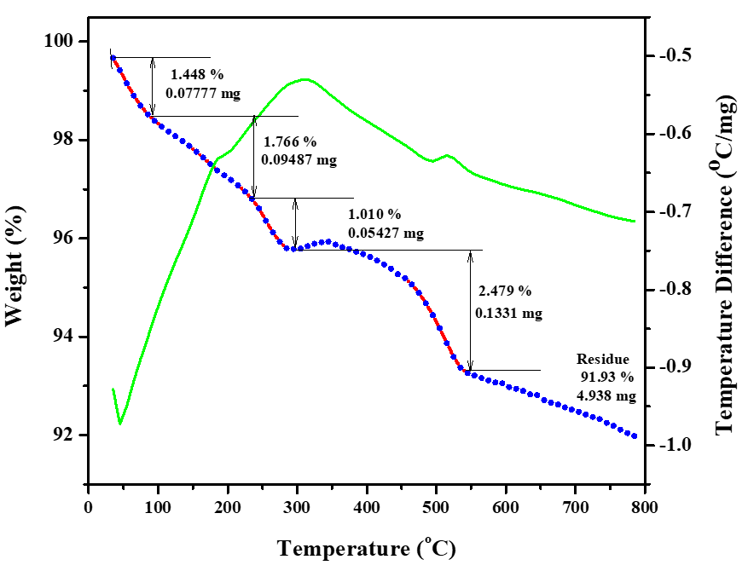
The TG-DTA thermo-gram for Pd-Benz-Am-Fe₃O₄@SiO₂ depicted in fig. 8 indicate multistage deposition curve. The sample was analyzed from temperature range of 35 to 800 ºC at a rate of 10 ºC/min under air atmosphere. The initial weight loss of 1.44 % was observed due to evaporation of physically adsorbed water on the surface of catalyst. The second weight loss at temperature 100 -240 ºC associated with the decomposition of Pd species along with organic ligand. The dissociation of aminopropylsilane spacer resulted 1.01 % weight loss of the catalyst. An abrupt loss in weight (2.48 %) at temperature 300-550 ºC related to decomposition silica coating on ferrite support. The final weight loss of 91.93 % is in accordance with the non-volatile oxides of ferrite.
Fig. 8: TG-DTA curve for Pd-Benz-Am-Fe₃O₄@SiO₂

- Reductive Ullmann type homocoupling
The properties and stability of Pd-Benz-Am-Fe₃O₄@SiO₂ were confirmed by aforementioned characterization study. The optimization of reaction conditions for Ullmann type reductive homocoupling was carried out by performing homocoupling of 4-bromoanisole. The bromoanisole was selected as test substrate for better assessment due to electronic effect (+R effect) of methoxy group and less reactive bromo substituent.
Selection of superior reducing agent is important for successful reductive homocoupling of aryl halide. The screening of reducing agents have been carried out for model reaction using Pd-Benz-Am-Fe₃O₄@SiO₂. In absence of reducing agent, reaction resulted low conversion even after long reaction time (Entry 1, Table 1). Ascorbic acid and glucose furnished moderate yield of desired product with 50 mg of catalyst (Entries 2-3, Table 1). Interestingly, hydrazine hydrate resulted 92 % yield within 2 h (Entry 4, Table 1). Theoretically, the high yield is due to the relative reducing ability (E^{θ} = −1.16 V) as well as the alkalinity of hydrazine hydrate (pKb = 5.89). However the other reducing agents viz. glycerol, ethylene glycol, hydroquinone and propionaldehyde resulted low to moderate yield in lavish reaction time (Entries 5-8, Table 1). The reducing property of hydrazine hydrate was then tested at low (30 mg) and high (70 mg) amount of catalyst, Pd-Benz-Am-Fe₃O₄@SiO₂ however, no noticeable change in yield was observed (Entries 9-10, Table 1). Further yield of homocopling product wasn’t efficiently changed on varying the moles of hydrazine hydrate (Entries 11-12, Table 1). Thus hydrazine hydrate was found to be much efficient reducing agent with respect to time and yield of the product.
Table 1: Screening of reducing agents and amount of catalystsª
Entry |  | Reducing agent | Equivalent of Reducing agent | Amount of catalyst (mg) | Time  (h) | Yield^{b} (%)
1 |  | -- | -- | 50 | 10 | 10
2 |  | Ascorbic acid | 2 | 50 | 5 | 56
3 |  | Glucose | 2 | 50 | 5 | 68
4 |  | Hydrazine hydrate | 2 | 50 | 1.5 | 92
5 |  | Glycerol | 2 | 50 | 7 | 44
6 |  | Ethylene glycol | 2 | 50 | 6 | 66
7 |  | Hydroquinone | 2 | 50 | 6 | 32
8 |  | Propionaldehyde | 2 | 50 | 5 | 64
9 |  | Hydrazine hydrate | 2 | 30 | 2 | 80
10 |  | Hydrazine hydrate | 2 | 70 | 1.5 | 89
11 |  | Hydrazine hydrate | 1 | 50 | 2 | 82
12 |  | Hydrazine hydrate | 3 | 50 | 2 | 90
 | ªReaction conditions: 2 mmol 1-Bromo-4-methoxybenzene, 1.5 mmol K₂CO₃, 3 mL DMF:H₂O, 3 h. ^{b}Isolated yield

The reaction conditions for model homocoupling reaction in the presence of hydrazine hydrate (2 mmol) and 50 mg of catalyst were optimized. Initially, various bases were screened in DMF solvent at 100 ºC as the most of the report employed at higher temperature. The amine bases viz. Et₃N and (i-Pr)₂ NEt gave moderate yield (Entries 1-2, Table 2). K₃PO₄ in DMF resulted 72 % yield in 3 h (Entry 3, Table 2). The strong bases like KOH and NaOH provided moderate yield of the desired product (Entries 4-5, Table 2). A range of carbonate bases were tested for model reaction (Entries 6-9, Table 2). Among these, K₂CO₃ efficiently gave high yield (88 %) of product (Entry 9, Table 2). Electing K₂CO₃ as effective base, the model reaction was performed in different solvents including EtOH, THF, toluene, DCM and acetonitrile (Entries 10-14, Table 2). The undesirable yields are obtained for aforementioned solvents. DMF:H₂O (1:1) system was also employed resulting remarkable increase in the yield (91 %) (Entry 15, Table 2). The effect of temperature was examined by subjecting model reaction at 80 ºC, 60 ºC and room temperature in DMF:H₂O (1:1) (Entries 16-18, Table 2). Auspiciously, high yield of desired product was obtained at 80 ºC. In presence of Benz-Am-Fe₃O₄@SiO₂ (preloading of Pd), homocoupling product was not obtained indicate the necessity of Pd in the catalyst. Overall, the optimization study revealed that hydrazine hydrate as efficient reducing agent, K₂CO₃ as base and DMF:H₂O (1:1) as solvent with 50 mg of Pd-Benz-Am-Fe₃O₄@SiO₂ are suitable reaction conditions.

Table 2: Optimization of reaction conditionsª
Entry | Base | Solvent | Time  (h) | Temperature (ºC) | Yield^{b}  (%)
1 | Et₃N | DMF | 4 | 100 | 78
2 | (i-Pr)₂NEt | DMF | 5 | 100 | 64
3 | K₃PO₄ | DMF | 3 | 100 | 72
4 | KOH | DMF | 4 | 100 | 65
5 | NaOH | DMF | 4 | 100 | 66
6 | Na₂CO₃ | DMF | 3 | 100 | 80
7 | NaHCO₃ | DMF | 4 | 100 | 76
8 | Cs₂CO₃ | DMF | 4 | 100 | 76
9 | K₂CO₃ | DMF | 2 | 100 | 88
10 | K₂CO₃ | EtOH | 4 | 100 | 74
11 | K₂CO₃ | THF | 4 | 100 | 58
12 | K₂CO₃ | Toluene | 3 | 100 | 46
13 | K₂CO₃ | CH₂Cl₂ | 2 | 100 | 70
14 | K₂CO₃ | Acetonitrile | 2 | 100 | 76
15 | K₂CO₃ | DMF:H₂O | 1.5 | 100 | 91
16 | K₂CO₃ | DMF:H₂O | 1.5 | 80 | 92
17 | K₂CO₃ | DMF:H₂O | 3 | 60 | 64
18 | K₂CO₃ | DMF:H₂O | 18 | RT | 34
19^{C} | K₂CO₃ | DMF:H₂O | 12 | 80 | 00
ª2 mmol of 1-bromo-4-methoxybenzene, 50 mg of Pd(II)-Benz-Am-Fe₃O₄@SiO₂ and 1.5mmol of a base, 2 mmol hydrazine hydrate, 3 mL solvent. ^{b}Isolated yields. ^{c}The reactions were conducted using Benz-Am-Fe₃O₄@SiO₂.
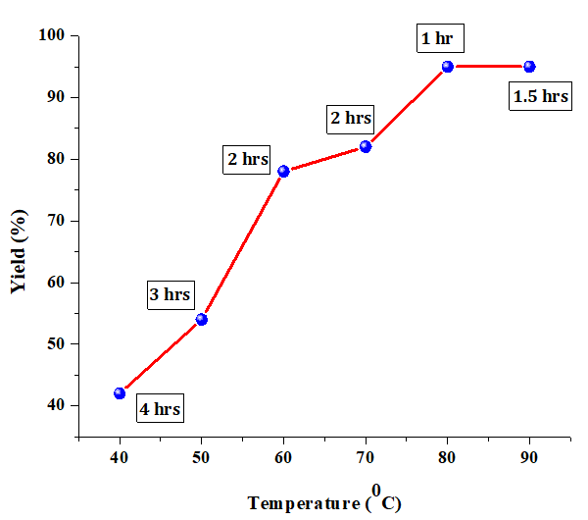
Effect of temperature on homocoupling of 4-iodobenzonitrile in the presence of K₂CO₃ and DMF:H₂O (1:1) was investigated [Fig. 9]. Initially, the reaction was performed at room temperature resulted 42 % yield in 4 h. As the collision of reactant molecules accelerated by increasing temperature, the model reaction was performed at different temperature (50 to 90 ºC) with 10 ºC interval. Moderate yields are obtained for the reaction at 50 ºC to 70 ºC. Interestingly, 95 % yield was observed at 80 ºC within 1 h only. Further increase in temperature not altered the yield which confirmed 80 ºC is suitable temperature of the reaction.
Fig. 9: Effect of temperature on Suzuki cross coupling

Knowing desirable optimal reaction conditions, we focused on the scope of homocoupling of aryl halides using NH₂-NH₂ as reductant [Scheme 15]. It is noteworthy that the reaction conditions were also suitable for homocoupling of less reactive bromo- and chloro arenes. Generally, both electron donating (-Me, -OMe) and electron withdrawing groups (-CHO, -CN, -F) were perfectly compatible for furnishing desired symmetrical biaryls in high yieds (85−94 %) (Entries 1-17, Table 3). Alternatively, heterocyclic aryl halides such as 2-bromo/iodopyridine and 5-iodothiophene-2-carbaldehyde furnished corresponding symmetrical heterocyclic derivatives within one hour only (Entries 18-20, Table 3). Polynuclear hydrocarbons like 1-halonaphthalenes (I & Br) were homocoupled smoothly and resulted the desired product in high yield (Entry 22, Table 3). Subsequently, the generality was examined by considering highly substituted aryl halide, 5-iodovanillin. 5-iodovanillin furnished high yield (92 %) of desired product in short reaction time (Entry 21, Table 3). Overall, a admissible avenue for homocoupling of a variety of aryl halides in K₂CO₃ and DMF:Water 1:1) using Pd(II)-Benz-Am-Fe₃O₄@SiO₂ as catalyst (50 mg) efficiently employed for synthesis of highly substituted symmetrical biaryls.
The reductive homocoupling of 4-bromo anisol under optimized reaction conditions was performed. The structure of synthesized 4,4'-dimethoxy-1,1'-biphenyl was confirmed by ¹H and ¹³C NMR analysis. The ¹H spectrum indicate a singlet at δ 3.88 ppm for six methoxy protons. Two doublets for aromatic protons were observed at δ 6.98-7.02 and δ 7.50-7.53 ppm with coupling constant (J) = 8 Hz. In ¹³C NMR spectrum the signals observed at δ 55.56 (-OMe), 114.41, 127.95, 133.73, 158.95 ppm. The spectral data is in good agreement with the structure of synthesized compound.
Scheme 15: Homocoupling of aryl halides

Table 3: Scope of Pd(II)-Benz-Am-Fe₃O₄@SiO₂ catalytic activity for reductive Ullmann type homocoupling of various halidesª
Entry | Biphenyl/biaryl | X | Time (h) | Yield^{b} (%) | TON | TOF  (h⁻¹)
15 |  | I | 1.5 | 90 | 2307 | 1538
16 |  | Br | 2.5 | 85 | 2179 | 871
17 |  | Br | 1.5 | 94 | 2410 | 1606
18 |  | I | 1 | 92 | 2358 | 2358
19 |  | Br | 1 | 88 | 2256 | 2256
20 |  | I | 1 | 96 | 2461 | 2461
21 |  | I | 1 | 92 | 2358 | 2358
22 |  | I | 1.5 | 91 | 2333 | 1555
23 |  | Br | 2 | 86 | 2205 | 2205
ª2 mmol of 1-bromo-4-methoxybenzene, 50 mg of Pd(II)-Benz-Am-Fe₃O₄@SiO₂ (Pd loading was calculated to be 3.6 mol.% based on ICP-AES analysis) and 1.5 mmol of a base, 2 mmol hydrazine hydrate, 3 mL solvent. ^{b}Isolated yields.

Kinetic Study of Ullmann homocoupling
The kinetic study for Ullmann homocoupling of 4-iodoanisol was investigated and the results are summarized as kinetic plot [Fig. 10]. A conversion of desired product has been screened at successive reaction times which revealed the catalytic activity of Pd-Benz-Am-Fe₃O₄@SiO₂ with respect to time for desired symmetrical biaryl synthesis.

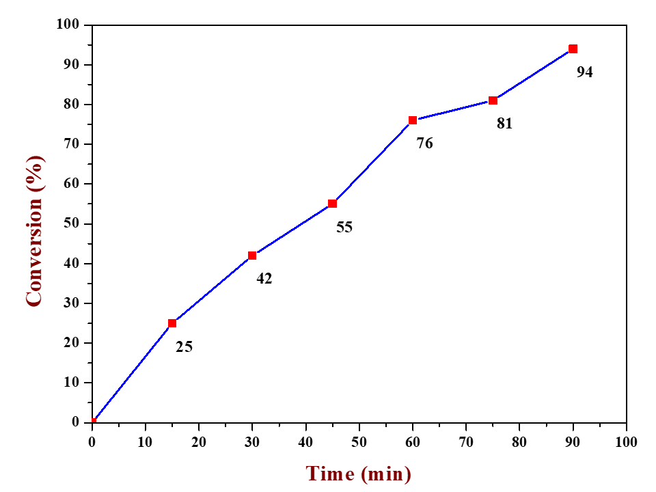
Fig 10: Kinetic study of Ullmann Homocoupling

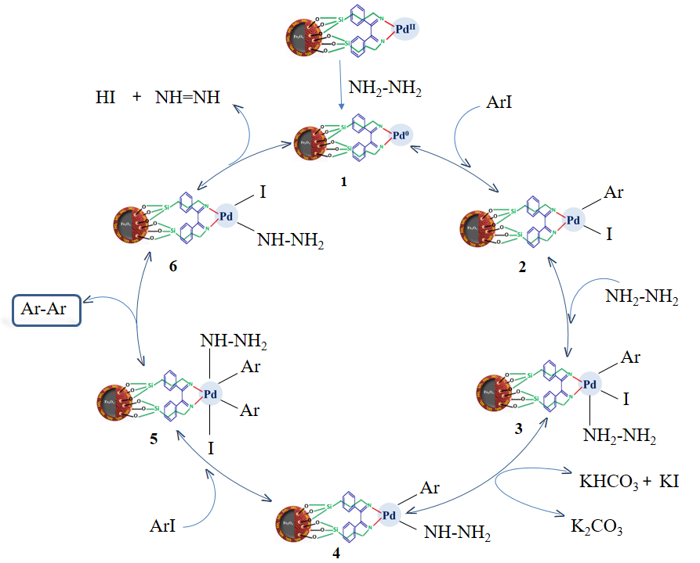
Fig 11: Plausible mechanism for reductive Ullmann homocoupling

A plausible mechanism for the hydrazine hydrate mediated Ullmann homo-coupling is shown in fig. 11.⁸² Initially, NH₂NH₂ reduces Pd(II) complex to generate active Pd (0) complex. The oxidative addition of aryl halide to Pd (0) lead to formation of Ar(Pd)I which on nucleophilic substitution with NH₂NH₂ produces complex 3. The base-assisted displacement of the halogen atom by NH₂NH₂ in complex 3 followed by oxidative addition of another molecule of aryl halide results diaryl palladium complex 5. The reductive elimination of complex 5 lead to formation of biaryl and regenerate Pd(0) species along with diazene and HI.
The heterogenization of homogeneous complexes enhance life of the catalyst and become more economical and efficient for industrial application. The competency of Pd-benz-Am-Fe₃O₄@SiO₂ was confirmed from its reusability study by performing a model reaction of bromobenzene at optimized reaction conditions. On completion of reaction, the catalyst was magnetically separated, washed with ethanol, dried under vacuum and employed for next reaction cycle. The catalyst was reused up to eight reaction cycles and obtained results are depicted in fig. 12. From the result, it is revealed that even after eight run, the catalytic efficiency and durability of the catalyst remained same.
Fig. 12: Reusability study of Pd-Benz-Am-Fe₃O₄@SiO₂

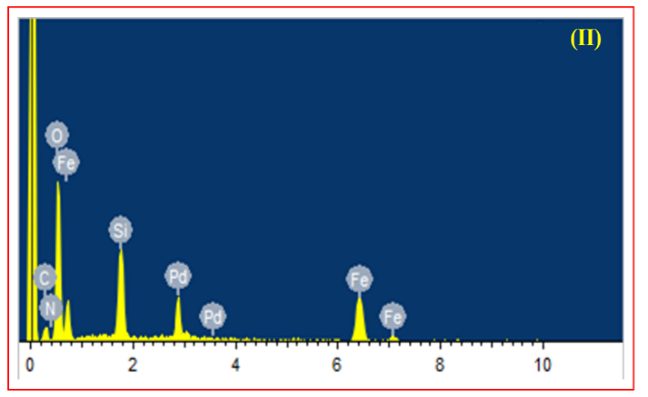
The morphology, crystallinity and composition of Pd-Benz-Am-Fe₃O₄@SiO₂ after eight reaction cycles was scrutinized to check its catalytic efficiency. As mentioned earlier, SEM and TEM analysis were revealed no change in morphology of the catalyst [Fig. 2c & 4c]. The XRD and EDS analysis of reused catalyst is depicted in fig. 13 (I & II). The characteristic peaks observed in XRD pattern confirms unaltered crystallinity of the catalyst. The EDS analysis indicated slight change in elemental composition (6.87 %) even after long range reusability.
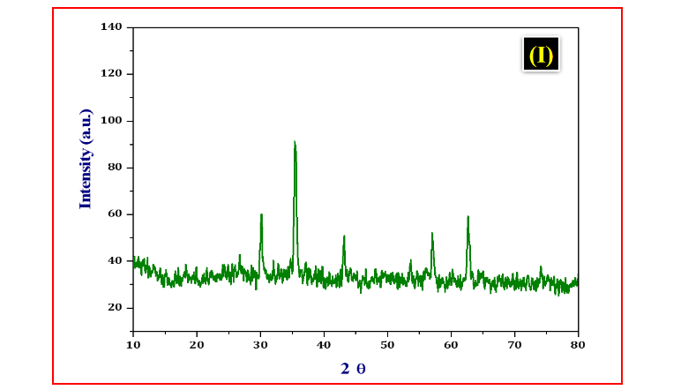
Fig. 13: XRD and EDS analysis of recycled Pd-Benz-Am-Fe₃O₄@SiO₂
The heterogeneity of the synthesized catalyst was checked by performing hot filtration test. The selected reaction for the test was allowed to half complete and the catalyst was magnetically separated from the reaction mixture. The resultant mixture was subjected to GC-MS analysis resulted 79 % conversion. Further, the supernatant mixture was continuously heated at same reaction conditions for reported time and reanalyzed. However, no further conversion of reactant was observed which confirm the heterogeneity of catalyst and no leaching of the palladium species. AAS analysis of reaction filtrate also confirmed no leaching of the catalyst. Overall the above study demonstrated that the catalyst involved strong bonding between organic moiety and palladium and it is heterogeneous in nature.
Catalyst Comparison Study
The efficiency of Pd-Benz-Am-Fe₃O₄@SiO₂ was examined by comparison with reported catalysts along with reducing agents used for synthesis of bipheyl [Table 4]. From the study, it revealed that the catalyst in presence of hydrazine hydrate is superior to all reported catalysts with respect to yield and reaction time.
Table 4: Comparison study of Pd-Benz-Am-Fe₃O₄@SiO₂ with reported catalysts
Sr. No. | Reaction condition | Reducing agent | Time (h) | Yield (%) | Ref.
1 | Pd_{colloids} (3%), TBAOH, H₂O, 40 ºC | Glucose | 6 | 85 | 62
2 | Pd_{colloids}/TBAA, 90 ºC, N₂ | Propionaldehyde | 2 | 90 | 71
3 | Pd(OAc), P(o-tol)₃, Cs₂CO₃, DMA, 75 ºC | Hydroquinone, | 8 | 96 | 84
4 | Pd/C, CsF, DMSO, 120 ºC | Ethanol | 3 | 86 | 85
5 | Pd(0)/Cellulose, water:ethanol, rt | Zn | 6 | 94 | 86
6 | Ni(cod)₂, 1,4-dioxane, K₃PO₄, | N₂H₄ | 12 | 81 | 87
7 | Pd@poly-CN-PF₆, NaOH, Water,RT | Ascorbic acid | 9 | 93 | 88
8 | Pd(II)-Benz-Am-Fe₃O₄@SiO₂ , K₂CO₃, DMF:H₂O, 80 ºC | NH₂-NH₂ | 1 | 96 | This work

Experimental
Materials and Methods
Ferric chloride hexahydrate (FeCl₃.6H₂O), Ferrous sulphate heptahydrate (FeSO₄.7H₂O) (Loba Chemie), Sodium hydroxide (Sigma-Aldrich), Tetraethyl orthosilicate (TEOS), 3-aminopropyltriethoxysilane (APTES) (Alfa Aesar), Palladium acetate (S. D. Fine), Sodium hydroxide (NaOH) (Sigma-Aldrich), Urea (Thomas Baker) and all other reagents and solvents were commercially obtained and used without any further purification. Melting points were recorded by open capillary method and are not corrected. ¹H (400 MHz) and ¹³C (100 MHz) NMR spectra were recorded using Bruker AV 400 spectrometer. All δ values were expressed in ppm with reference to TMS. XRD analysis was performed on Ultima IV, Rigaku Corporation. Scanning electron micrographs were obtained using Scanning Electron Microscope (SEM) with Energy Dispersive Spectrometer (EDS) using JEOL JSM-7600F. Transmission Electron Microscopy (TEM) analysis of the sample was carried out using Philips CM 200 operated at 200 kV. X-ray photo electron spectroscopy (XPS) analysis was done on Nexsa base Thermo fisher Scientific. Magnetic property of the sample was analyzed using Vibrating Sample Magnetometer (VSM) lakeshore 7410. Thermo gravimetric analysis (TG-DTA-DSC) was performed on SDT Q600 V20.9 Build 20. BET surface analysis was performed on Quanta chrome NOVA 1000e, USA.

Preparation of Pd(II)-Benz-Am-Fe₃O₄@SiO₂ catalyst
Preparation of magnetic nanoparticles (MNPs):
Magnetite nanoparticles (MNPs) were synthesized by simple co-precipitation method. In synthesis of MNPs, FeCl₃.6H₂O (5.41 g) and urea (3.6 g) were dissolved in 200 mL water and refluxed at 85 to 90 °C for 2 h. The resultant brown colored solution was cooled to room temperature. To this solution FeSO₄.7H₂O (2.78 g) and 0.1M NaOH was added until pH reached to 10. The black precipitate formed was subjected to ultrasonication at 35 °C for 45 min. The obtained MNPs was washed thoroughly with ethanol and dried under vacuum.

Preparation of silica coated magnetic nanoparticles (Fe₃O₄@SiO₄):
The MNPs (1.0 g) were dispersed in ethanol (200 mL) by means of ultrasonication for 30 min. at room temperature. Then 1:1 NH₃ (12 mL) and tetraethoxysilane (TEOS) (2 mL) was added successively and mixture was stirred for 24 h. Fe₃O₄@SiO₂ was then separated using magnet and washed with ethanol (3 x 15 mL) and dried under vacuum.

Functionalization of Fe₃O₄@SiO₂ with 3-aminopropyltriethoxysilane (APTES):
The functionalization of Fe₃O₄@SiO₂ was achieved by addition of 3-aminopropyltriethoxysilane (5 mL) to a well dispersed solution of Fe₃O₄@SiO₂ (1.0 g) in ethanol (200 mL) and stirred at room temperature for 24 h. The formed Am-Fe₃O₄@SiO₂ was filtered and washed well with ethanol to remove unreacted APTES and finally dried in oven.

Preparation of benzil immobilized amine functionalized silica coated palladium magnetite nanoparticles (Pd-Benz-Am-Fe₃O₄@SiO₂):-
The final catalyst, Pd-Benz-Am-Fe₃O₄@SiO₂ was prepared in two steps. Initially, a mixture of Am-Fe₃O₄@SiO₂ (1.0 g) and benzil (2 mmol) was mixed and stirred in ethanol (200 mL) at room temperature for 24 h to obtain Benz-Am-Fe₃O₄@SiO₂. In final step Benz-Am-Fe₃O₄@SiO₂ (1.0 g) was added to solution containing Palladium acetate (1 mmol) and mixture was stirred for 6 h at room temperature. The resulting Pd-Benz-Am-Fe₃O₄@SiO₂ nanocatalyst was separated magnetically, washed thoroughly with acetone and dried in oven.

General procedure of the reductive Ullmann type homocoupling
Aryl halide (2 mmol) was refluxed at 85 °C in the presence of the nanocatalyst, Pd(II)-Benz-Am-Fe₃O₄@SiO₂ (50 mg), K₂CO₃ (1.5 mmol) and hydrazine hydrate (2 mmol). The completion of the reaction was confirmed by TLC (ethyl acetate : hexane, 10: 90). The reaction mixture was then allowed to cool at room temperature, quenched with water and extracted with ethyl acetate. The catalyst was recovered by magnetic separation and washed with ethyl acetate. The combined organic layers were dried over Na₂SO₄ and concentrated under vacuum to afford the products. The crude products were purified by silica gel column chromatography (Ether /EtOAc = 9:1 v/v).\

Conclusion
In summary, a magnetically separable palladium catalyzed [Pd(II)-Benz-Am-Fe₃O₄@SiO₂] Ullmann type reductive homocoupling of aryl halides have been performed for the synthesis of functionalized symmetrical biaryls. The synthesized catalyst exhibited significant catalytic activity with high crystallinity, sufficient palladium loading, magnetically separable, high surface area and nanoscale size. The NH₂-NH_{2 was} first time used as reductant for homocoupling of aryl halides. Its high reducing ability and alkalinity furnished desired products in very short reaction time with proficient yield. The procedure is relatively mild with broad applicability over homocoupling of both electron deficient and electron-rich aryl bromides and chlorides. The catalyst found highly effectual as compared to the reported reductive homocouplings. The heterogeneous nature and non-leaching ability of catalyst is confirmed by hot filtration test and ICP-AES analysis, respectively. The catalyst was reused up to eight runs and efficiency checked by SEM, XRD and EDX spectroscopy.

Spectral data
Entry 1-3, Table 3: Biphenyl
White solid, mp 70–72 ºC (lit. 69-70 °C)⁸⁶; ¹H NMR (400 MHz, CDCl₃) δ (ppm): 7.31-7.36 (m, 2H), 7.41- 7.45 (m, 4H), 7.58-7.60 (m, 4H); ¹³C NMR (100 MHz, CDCl₃) δ (ppm): 127.38, 128.96, 141.47.
Entry 4-5, Table 3: 4,4'-dimethyl-1,1'-biphenyl
White solid, mp 120 °C (lit. 120-121 °C)⁸⁶; ¹H NMR (400 MHz, CDCl₃) δ (ppm): 7.45-7.48 (d, J = 8 Hz, 2H), 7.21-7.23 (d, J = 8 Hz, 2H), 2.38 (s, 6H); ¹³C NMR (75 MHz, CDCl₃) δ (ppm): 21.30, 127.04, 129.07, 136.92, 138.54.
Entry 6-8, Table 3: 4,4'-dimethoxy-1,1'-biphenyl
White solid, mp 178 ºC (lit. 177-178 °C)⁸⁶; ¹H NMR (400 MHz, CDCl₃) δ (ppm): 3.88 (s, 6H), 7.50-7.53 (d, J = 8 Hz, 4H), 6.98-7.02 (d, J = 8 Hz, 4H); ¹³C NMR (100 MHz, CDCl₃) δ (ppm): 55.56, 114.41, 127.95, 133.73, 158.95.
Entry 10-11, Table 3: 3,3'-dimethoxy-1,1'-biphenyl
Yellow solid, mp 42 ºC (lit. 40-41 °C)⁸⁶; ¹H NMR (400 MHz, CDCl₃) δ (ppm): 3.82 (s, 6H), 6.86-6.89 (s, 2H), 7.10-7.11 (d, J = 8 Hz, 2H), 7.15 (d, J = 8 Hz, 2H), 7.30-7.34 (t, J = 8 Hz, 2H); ¹³C NMR (100 MHz, CDCl₃) δ (ppm): 55.47, 113.02, 113.17, 119.90, 129.92, 142.84, 160.14.
Entry 12-14, Table 3: biphenyl-4,4'-dicarbonitrile
White solid, mp 238 ⁰C (lit. 236-240 °C)⁸⁶; ¹H NMR (400 MHz, CDCl₃) δ (ppm) 7.68-7.69 (d, J = 6.5, 4H), 7.77–7.79 (d, J = 8.8, 4H); ¹³C NMR (75 MHz, CDCl₃) δ (ppm): 112.74, 118.62, 128.18, 133.13 and 143.78.
Entry 18, Table 3: 2,2'-bipyridine
White solid, mp 71 °C (lit. 70-71 °C)⁸⁸; ¹H NMR (400 MHz, CDCl₃) δ (ppm): 7.29-732 (t, J = 8Hz, 2H), 7.80-7.84 (t, J = 8Hz, 2H), 7.38-7.41 (d, J = 8Hz, 2H), 7.67-7.69 (d, J = 8Hz, 2H); ¹³C NMR (100 MHz, CDCl₃) δ (ppm): 121.32, 123.92, 137.13, 149.41, 156.40.

References
- Szostak M., Fazakerley N. J., Parmar D., Procter D. J. Chem. Rev. 2014, 114, 5959.
- Balanta A., Godard C., Claver C. Chem. Soc. Rev. 2011, 40, 4973.
- Yuan B., Pan Y., Li Y., Yin B., Jiang H. Angew. Chem. Int. Ed. 2010, 49, 4054.
- Karimi B., Behzadnia H., Vali H. ChemCatChem 2014, 6, 745.
- (a) Puthiaraj P., Ahn W. S. Mol. Catal. 2017, 437, 73; (b) Movahed S. K., Dabiri M., Bazgir A. Appl. Catal. Gen. 2014, 488, 265.
- Sambiagio C., Marsden S. P., Blacker A. J., McGowan P. C. Chem. Soc. Rev. 2014, 43, 3525.
- Guo L., Huang C., Liu L., Shao Z., Tong Y., Hou H., Fan Y. Cryst. Growth des. 2016, 16, 4926.
- Chen W. -W., Zhao Q., Xu M. -H., Lin G. -Q. Org. Lett. 2010, 12, 1072.
- Tran H., McCallum T., Morin M., Barriault L. Org. Lett. 2016, 18, 4308.
- Crabbe B. W., Kuehm O. P., Bennett J. C., Hallett-Tapley G. L. Catal. Sci. Technol. 2018, 8, 4907.
- Tyagi D., Binnani C., Rai R. K., Dwivedi A. D., Gupta K., Li P.- Z., Zhao Y., Singh S. K. Inorg. Chem. 2016, 55, 6332.
- Wu Q., Han Y., Shao Z., Li J., Hou H. Dalton Trans. 2018, 47, 8063.
- Niakan M., Asadi Z., Emami M. Catal. Lett. 2020, 150, 404.
- Prajapati P. K., Saini S., Jain S. L. J. Mater. Chem. A 2020, 8, 5246.
- Kamal A., Srinivasulu V., Seshadri B. N., Markandeya N., Alarifi A., Shankaraiah N. Green Chem. 2012, 14, 2513.
- Wang K., Yang L., Zhao W., Cao L., Sun Z., Zhang F. Green Chem. 2017, 19, 1949.
- Gong X., Wu J., Meng Y., Zhang Y., Ye L.-W., Zhu C. Green Chem. 2019, 21, 995.
- Busch M., Wodrich M. D., Corminboeuf C. ACS Catal. 2017, 7, 5643.
- Diner C., Organ M. G. Organometallics 2018, 38, 66.
- Jin M. J., Lee D. H. Angew. Chem. Int. Ed. 2010, 49, 1119.
- Zhang Y., Gao X., Li J., Tu G. J. Mater. Chem. C 2015, 3, 7463.
- Song S., Wang X., Li S., Wang Z., Zhu Q., Zhang H., Chem. Sci. 2015, 6, 6420.
- Li X., Zhou L., Wei Y., El-Toni A. M., Zhang F., Zhao D. J. Am. Chem. Soc., 2015, 137, 5903.
- He L., Natte K., Rabeah J., Taeschler C., Neumann H., Bruckner A., Beller M. Angew. Chem., Int. Ed. 2015, 54, 4320.
- Baran T., J. Colloid Interface Sci. 2017, 496, 446.
- Zhang S., Chang C. R., Huang Z. Q., Li J., Wu Z., Ma Y., Zhang Z., Wang Y., Qu Y. J. Am. Chem. Soc. 2016, 138, 2629.
- Kaur H., Shah D., Pal U. Catal. Commun. 2011, 12, 1384.
- González-Rivera J., Galindo-Esquivel I. R., Onor M., Bramanti E., Longo I., Ferrari C. Green Chem. 2014, 16, 1417.
- Kawasaki T., Araki Y., Hatase K., Suzuki K., Matsumoto A., Yokoi T., Kubota Y., Tatsumi T., Soai K. Chem.Commun. 2015, 51, 8742.
- Cai M., Xu Q., Huang Y. J. Mol. Catal. A: Chem. 2007, 271, 93.
- Yuan B., Pan Y., Li Y., Yin B., Jiang H. Angew. Chem., Int. Ed. 2010, 49, 4054.
- Mazur M., Barras A., Kuncser V., Galatanu A., Zaitzev V., Turcheniuk K.V., Woisel P., Lyskawa J., Laure W., Siriwardena A., Boukherrouba R., Szunerits S. Nanoscale 2013, 5, 2692.
- Singamaneni S., Bliznyuk V. N., Binek C., Tsymbal E. Y. J. Mater. Chem. 2011, 21, 16819.
- Gawande M. B., Rathi A. K., Nogueira I. D., Varma R. S., Branco P. S. Green Chem. 2013, 15, 1895.
- Gawande M. B., Branco P. S., Varma R. S. Chem. Soc. Rev. 2013, 42, 3371.
- Baudoin O., Gueritte F. Stud. Nat. Prod. Chem. 2003, 29, 355.
- Bringmann G., Gunther C., Ochse M., Schupp O., Tasler S. Springer, New York, 2001, 82, 1.
- Bellina F., Carpita A., Rossi R. Synthesis 2004, 15, 2419.
- Horton D. A., Bourne G. T., Smythe L. M. Chem. Rev. 2003, 103, 893.
- Kertesz M., Choi C. H., Yang S. Chem. Rev. 2005, 105, 3448.
- Mei X., Wolf C. J. Am. Chem. Soc. 2006, 128, 13326.
- Lightowler S., Hird M. Chem. Mater. 2005, 22, 5538.
- Brunel J. M. Chem. Rev. 2005, 105, 857.
- Berthod M., Mignani G., Woodward G., Lemaire M. Chem. Rev. 2005, 105, 1801.
- Beletskaya I. P., Cheprakov A. V. Coord. Chem. Rev. 2004, 248, 2337.
- Alonso F., Beletskaya I. P., Yus M. Tetrahedron 2008, 64, 3047.
- Phan N. T. S., Van Der Sluys M., Jones C. W. Adv. Synth. Catal. 2006, 348, 609.
- Alberico D., Scott M. E., Lautens M. Chem. Rev. 2007, 107, 174.
- (a) Miao W., Chan T. H. Org. Lett. 2003, 5, 5003. b) Revell J. D., Ganesan A. Org. Lett. 2002, 4, 3071.
- Baxter P. N. W. J. Org. Chem. 2000, 65, 1257.
- Hossain K. M., Shibata T., Takagi K. Synlett 2000, 8, 1137.
- (a) Huang J., Nolan S. P. J. Am. Chem. Soc. 1999, 121, 9889. (b) Spivey A. C., Fekner T., Spey S. E. J. Org. Chem. 2000, 65, 3154.
- Ullman F. Chem. Ber. 1903, 36, 2389.
- Fanta P. E. Chem. Rev. 1964, 64, 613.
- Fanta P. E. Chem. Rev. 1946, 38, 139.
- Karimi B., Behzadnia H., Vali H. ChemCatChem 2014, 6, 745.
- Karimi B., Vafaeezadeh M., Akhavan P. F. ChemCatChem 2015, 7, 2248.
- Puthiaraj P., Ahn W.-S. Mol. Catal. 2017, 437, 73.
- A. Feiz, A. Bazgir, A. M. Balu, R. Luque Sci. Rep., 2016, 6, 32719
- Chen X., Wang L. Chin. J. Chem. 2009, 27, 2037.
- A. V. Dubey, A. V. Kumar, Appl Organometal Chem. 2020; e5570.
- Deepa Dumbre, Vasant R. Choudhary, P.R. Selvakannan, Polyhedron 2016, 120, 180.
- Wu Q., Wang L. Synthesis 2008, 13, 2007.
- Hongyan Zhao, Guijie Mao, Huatao Han, Jinyi Song, Yang Liu, Wenyi Chu, Zhizhong Sun, RSC Adv. 2016, 6, 41108
- Shahnaz Rostamizadeh, Hamid Estiri, Mohammad Azad, J Iran Chem Soc, 2017, 14, 1005.
- Wang Yao, Wei-Jie Gong, Hong-Xi Li, Fei-Long Li, Jun Gao, Jian-Ping Lang, Dalton Trans. 2014, 43, 15752
- Tianyou Chen, Ba-Tian Chen, Konstantin V. Bukhryakov, Valentin O. Rodionov, Chem. Commun. 2017, 53, 11638
- Minoo Dabiri, Monire Shariatipour, Siyavash Kazemi Movahed, Sahareh Bashiribod, RSC Adv. 2014, 4, 39428
- Mukhopadhyay S., Rothenberg G., Wiener H., Sasson Y. Tetrahedron 1999, 55, 14763.
- Kuroboshi M., Waki Y., Tanaka H. J. Org. Chem. 2003, 68, 3938.
- Abiraj K., Srinivasa G. R., Gowda C. D. Tetrahedron Lett. 2004, 45, 2081.
- Moon J., Nam H., Ju J., Jeong M., Lee S. Chem. Lett. 2007, 36, 1432.
- Ma N., Duan Z., Wu Y. J. Organomet. Chem. 2006, 691, 5697.
- Ram R. N., Singh V. Tetrahedron Lett. 2006, 47, 7625.
- Monopoli A., Calo V., Ciminale F., Cotugno P., Angelici C., Cioffi N., Nacci A. J. Org. Chem. 2010, 75, 3908.
- Vibhute S. P., Mhaldar P. M., Korade S. N., Gaikwad D. S., Shejawal R. V., Pore D. M. Tetrahedron Lett. 2018, 41, 3643.
- Vibhute S. P., Mhaldar P. M., Shejawal R. V., Pore D. M. Tetrahedron Lett. 2020, 11, 151594.
- Mhaldar P. M., Vibhute S. P., Rashinkar G. S., Pore D. M. React. Funct. Polym. 2020, 152, 104586.
- Vibhute S. P., Mhaldar P. M., Gaikwad D. S., Shejwal R. V., Pore D. M. Monatsh. Chem. 2020, 151, 87.
- Polshettiwar V., Varma R. S. Org. Biomol. Chem. 2009, 7, 37.
- Zhang Z., Zhang F., Zhu Q., Zhao W., Ma B., Ding Y. J. Colloid Interf. Sci. 2011, 360, 189.
- Liu Y., Tang D., Cao K., Yu L., Han J., Xu Q. J. Catal. 2018, 360, 250.
- Cal V., Nacci A., Monopoli A., Cotugno P. Chem. Eur. J. 2009, 15, 1272.
- Hennings D. D., Iwama T., Rawal V. H. Org. Lett. 1999, 8, 1205.
- Shaoa L., Dub Y., Zenga M., Lia X., Shena W., Zuoa S., Lua Y., Zhanga, C. Qia X. –M., Appl. Organometal. Chem. 2010, 24, 421.
- Rasouli M. A., Ranjbar P. R. Z. Naturforsch B 2013, 68, 946.
- Lv L., Qiu Z., Li J., Liu M., Li C.-J. Nat. Commun. 2018, 9, 4739.
- Wang J., Li Y., Li P., Song G. Monatsh. Chem. 2013, 144, 1159.

