Autobiographical Note
First Author (Corresponding Author)
Kajal Kiran, Research Scholar, IKG Punjab Technical
University, Kapurthala & Head, Department of
Commerce, JC DAV College, Dasuya
Mobile No :- 9463059967
E-Mail id :- kajalkirankakkar@yahoo.in

Second Author

Dr. Mandeep Kaur, Assistant Professor in Management, IKG Punjab Technical University, Kapurthala
Mobile No:- 9478098056
E-Mail id :- mandeeparora.ptu@gmail.com
Third Author
Dr. Gunjan, Assistant Professor in Commerce, Mehr Chand Mahajan DAV College for Women, Chandigarh
Mobile No :- 9915703134
E-Mail id :- drgunjancsr@gmail.com
An explorative analysis of Competency mapping in banking sector
Introduction
The key factor on which the success of any organisation depends is the human resources working therein. Infact, human capital is the source of innovation and competitive improvement. Thus, it is utmost important to identify and develop the required competencies of its human resources in order to achieve its ultimate goal and objectives. The process of competency mapping helps to identify key competencies for an organisation, the jobs and functions within it. A competency is a set of skills, related knowledge and attributes that allow an individual to successful perform a task or an activity within a specific function or a job (UNIDO, 2002). Identification of key competencies required by a business is of utmost importance to compete in a specific environment. In present scenario, the concept of competency mapping has gained a lot of attention among HR professionals as a tool to improve human resource management activities like recruitment, selection, training and development, succession planning, wage/remunration fixation etc. Competency management involves identifying the gap between the required level of competencies and existing level of competencies and then bridging the gap. Thus, the focus has shifted from traditional (task based) HRM to Competency based HRM.

Difference between Traditional (task based) HRM and Competency based HRM
Under traditional human resource management, work analysis and job descriptions form the basis of HR activities.It makes forecasts on the assumption that the future will be like the past and the same number and quality of persons will be needed to achieve predictable and measureable work results. The selection process involves finding a candidate to match the qualification outlined in job specification. The process of training and development is also vague and ambiguous under traditional human resource management system.
Under competency based human resource management, competencies (traits that individual use for successful and exemplary performance) are the basis of human resource activities. Competency based human resource management concentrates on the talent and value that an individual brings to the organisation. Moreover, it does not assume that the future will like the past. It also includes periodical assessment of individuals against competency framework for the work performed by them and provides feedback to help them in exemplary performance.
There are three major roles of HRM i.e. administrative role (keeping employees records and applying rules and regulations), operational role (training, recruitment, performance evaluation etc.) and strategic role (enhancing the ability of the organisation to compete through determining organisations needs of human resources to adapt with the challenges and to achieve sustainable progress) (Robet and John, 2007) . However, competency based HRM has made the role of HRM to be more strategic than administrative and operational to help organisation to achieve its goals and meet different challenges.
Fig1: Changing role of HRM
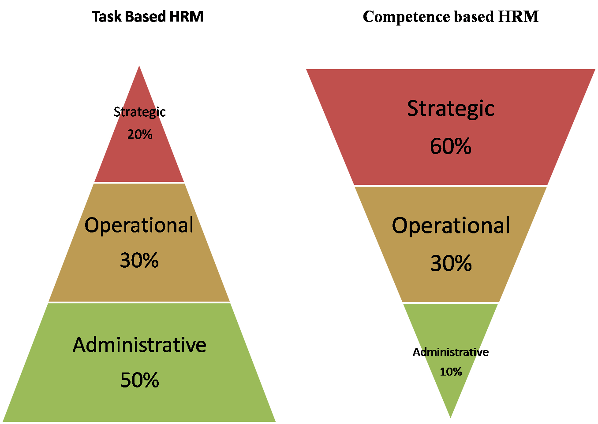
Source: Robet and John, 2007

Importance of Competency based HRM
In the wake of globalisation, organisations are facing a number of challenges like rapid development in information and communication technology (Nagiub, 2001). The next challenge is the trade liberalisation and open markets because of World Trade Organisation rules resulting in more competition between nations and organisations (El. Selmie, 2007). The third challenge especially for developing countries is the economic alliance between countries resulting in creation of huge multinational corporations that have huge abilties to compete and weaken other organisations. Thus, it is very important for the organisations to enhance their capabilities through adopting new practices to manage human resources who are able to compete. One of such practices by which highly skilled employees are recruited and retained is competence based human resource management. Hence, Globalisation, privatisation, increasing competition, diversity among consumers and constant upgradation of technology are some of the prominent driving forces of competency based human resource management. For competency based HRM, human resource development efforts must respond to job changes and integrate long term plans and strategies of the organisation for efficient and effective use of resources. Competency based HRM considers competencies in terms of Iceberg.
Fig2: Competency Iceberg Model
Skill and Knowledge
Self Image
Traits
Motives
As in Iceberg, the portion above the waterline is clearly visible, in the same way the technical competencies of the human resources can be easily assessed.However, behavioural competencies, which demonstrate the self-image, traits and motives possessed by human resources, are difficult to be assessed just like the portion of iceberg under waterline. However, these behavioural competencies also influence the performance of human resource.
Performance (dependent variable) = Skill + Knowledege+ Traits (Independent variables)
Only those organisations which are able to engage skilled and committed workforce can compete in today’ fast changing global market place. Comptency mapping brings out an individual’s strengths and weaknesses in order to help him better understand himself and gives direction to his career development efforts.

Competency based HRM in banking sector
The era of globalisation, privatisation, mergers and technology driven applications in banking sector has made competancy management an important part in rendering superior services to customers. Competency based HRM in banks will encourage creativity, innovation , attract excellent human resources, improve competitiveness of banks, more customer satisfaction and constant development of skills and abilities of bank employees.
The present study reviews the competency management literature to understand different perspectives of competency management and applies it for banking sector.
Table 1: Different perspectives of competencies
S.No. | Competency | Description
1 | Generic Competencies | Common competencies across various organisations and levels of job positions (Rodriguez et al., 2002; Bartram, 2005)
2. | Organisation Specific Competencies | Competencies required to support translation of organisation strategy into operational terms (Lucia and Lepsinger,1999; Kaplan and Norton ,2005)
3. | Managerial Competencies | Competencies required to cover the broard range of managerial responsibilities like planning ,organising, controlling, motivating and coordinating (Quin and Hilmar ,1994 ; Parry,1996)
4. | Operational Competencies | Competencies related to specific job with either no or very limited managerial responsibilities (Catano,1998)
5. | Competencies as Skills | Sufficiency of skills in executing a specific job operational or managerial (Lawler, 1994; Rowe,1995)
6. | Competencies as behaviour | Individual behaviour such as initiative, creativity, persistence, empathy, assertiveness ,discipline while performing the job (Rowe 1995; Nordhaug, 1998)

To understand competency based human resource management in banks the competencies stated in Table 1 have been used as basis to understand competencies required by customer relationship manager and human resource manager in a bank for examplery performance.
Table 2: Key competencies required by Customer Relationship manager of a bank
S.No. | Job Description | Key competencies required
1 | For montioring and evaluating customer’s information, financial ability, relationship with bank and updating customer’s file | - Organisation Specific Competencies  - Operational Competencies  - Competencies as Skills
2. | For montioring customer’s portfolio and ensuring its quality and competeness , identification of problem and taking corrective action | - Organisation Specific Competencies  - Operational Competencies  - Competencies as Skills
3 | Evaluating customer’s portfolio according to market conditions | - Organisation Specific Competencies  - Operational Competencies  - Competencies as Skills
4 | Approving loans/lending according within the scope of authority | - Organisation Specific Competencies  - Operational Competencies  - Competencies as Skills
5 | Actively handling customer querries aiming at developing potential sales supported by central marketing programs | - Generic Competencies  - Operational Competencies  - Competencies as behaviour
6 | Maintaing and improving cordial relationship between customer and bank | - Generic Competencies  - Operational Competencies  - Competencies as behaviour
7 | Participating actively in training related to responsibilty range | - Generic Competencies  - Operational Competencies  - Competencies as behaviour

Table 3: Key Competencies required by human resource manager of a bank
S.No. | Job Description | Key competencies required
1 | To conduct interviews, lead conflict resolution, create job description, write bank’hand book, hiring and training new employees | - Organisation Specific Competencies  - Managerial Competencies  - Competencies as skills
2 | Managing employee contracts and other complex paper work relating to benefits and salaries that employees receive | - Organisation Specific Competencies  - Operational Competencies  - Competencies as Skills
3 | Managing employees and their concerns regarding employees conflict, salary complaints and workloads | - Generic Competencies  - Managerial Competencies  - Competencies as behaviour
4 | Demonstrate trustorthiness and professionalism in handling personal information of employees and sensitive business information | - Organisation Specific  Competencies  - Managerial Competencies  - Competencies as skills
5 | Selecting a suitable candidate while screening or interviewing | - Organisation Specific  Competencies  - Managerial Competencies  - Competencies as skills
6 | Proficiency in different software programs like talent management system and pay role management software | - Organisation Specific  Competencies  - Operational Competencies  - Competencies as skills
7 | Ability to keep and maintain records about employees and sorting large amount of data strategically | - Organisation Specific  Competencies  - Operational Competencies  - Competencies as skills
8 | Ability to rethink HR policies and procedures and implementing change as per the need of time | - Organisation Specific  Competencies  - Managerial Competencies  - Competencies as skills
9 | Ability to remain calm while handling multiple tasks at the same time like screening resume, managing interview schedule, deciding employee remunration, creating robust training program | - Organisation Specific  Competencies  - Managerial Competencies  - Competencies as behaviour
10 | Ensuring that business remains compliant with various labour laws as well as government rules and regulations | - Organisation Specific  Competencies  - Operational Competencies  - Competencies as skills

Need of Holistic Model for technology based competency management in Banks
It is utmost important to systematically determine the competencies required to achieve enhanced job performance and exploit the potential of human capital and boost their value to the bank. In this digital world, the comprehensive solution to technologically support the bank is establishing a holistic model for HRM strategy. Innovative ways of doing banking transactions and increasing competition necessitate determinimg key competencies that concern organisation and individual to exploit the potential of human resources and increasing its value to the organisation. The management of talent and learning can be achieved only through alignment of strategy, learning and technology. In this technology driven world, the recent HRM program require responsibility of individual towards developing their skill and of banks to recoganise the challenges of the knowledge society and responding to changes in the environment.
Competency management involves the measurement of and judgement on the competencies of all the employees to determine proper career development plans according to bank’s business objective. It refers to all the methods applied in the bank to systematically consider current competencies, identifying gaps between job description and competencies, analysing learning gaps, determine important aspects of development plans, detect redundancy and achieve awareness of available competencies for the preparation of new assignments, tasks and projects.
Implementation of technology based competency management system requires the successful strategic management scheme that addresses the organisational goals and assuring that these goals also fulfill individual goals.It also requires systematic analysis of competencies of employees of bank.
The process of competency management also focuses on recruitment and hiring procedures, project management procedures, skill gap analysis, personal development plans and self- organized learning etc.
Fig 3: Process of competency management

Requirements for effective implementation of competency based HRM in banks
To implement competency based human resource management in banks, all the functions of human resource management have to be competency based.
Table 4: Implementation of competency based HRM in banks
Implementation of Competency based HRM in banks
1 | Competency based recruitment and selection | Recruitment and selection process to be strictly according to skills, ability (assessed through written test) and personality traits (assessed through interview)
2 | Competency based training and development | To be designed to bridge the gap between actual skills and required skills and capablities of employees to excel and improve their performance at work.
3 | Competency based pay | Incentives, rewards and promotions of employees to be linked with acquisition of new skills and capabilities that enables them to give examplery performance.
4 | Competency based performance evaluation | Performance evaluation reports to be the reflection of skills and abilities and training requirements to fill the gap in performance.

Conclusion
The competency approach in managing human resources in the banks is the need of the time to be more flexible, adaptable to changes in the environment, face competition and fulfill the expectations of the customers. Competency based recruitment, selection, training, development, pay fixation and performance evaluation will not only encourage creativity, innovation and exemplary performance among bank employees but will also enable banks to retain talented employees as well as increase customer satisfaction.

References
Retrieved from https://in.indeed.com/career-advice/finding-a-job/competencies-in-hr.
Klett, F. The Design of a Sustainable Competency-Based Human Resources Management : A Holistic Approach. Knowledge Management & E-Learning: An International Journal , 2 (3), 278-291.
Motaleb, A. M. (2021, December 10). Competency based Human Resource Management (Case Study). MEJSP , pp. 42-72.
N. G. Vovchenko, L. Y. (2018). Information and Financial Technologies in a System of Russian Banks’. Contemporary Issues in Business and Financial Management in Eastern Europe , 19-29.
Prastacos, K. E. (2010). From task- based to competency-based. Personnel Review , 325-346.
R. Jeevarekha, R. H. (2018). Competency Mapping in banking sector. IJEMR , 8 (4), 1-10.

