Role of Digital Leadership in Transforming B-Schools
Dr. Kankana Mukhopadhyay
Professor, Praxis Business School, Kolkata
Dr. Prathima V.G.
Associate Professor, BNM Institute of Technology, Bangalore

Abstract:
Business schools in India operate in a highly competitive and turbulent market. The one of the most critical challenges for a B-School offering PGDM program is technological innovation. E-learning is creating a massive challenge as well as a huge opportunity for B-Schools across the world. Massive Open Online Courses (MOOCs) is opening a new platform for fresh graduates to explore the digital learning platform at a nominal price. It also helps the professionals who have the learning appetite but are unable to manage time. Furthermore, there are several companies who are customizing the training needs for executive education at a much cheaper price than the B-School offers. Due to technological advancements, the digital world is imposing challenges which are difficult to react and manage by the B-Schools. The B-Schools are also not able to capitalize the opportunities created by the digital world unless they are digitally prepared for this change. This change management requires digital mindset of the business leaders. This chapter aims to identify the personality attributes of the digital leader(s) a B-School needs to possess in order to be in a digitally strategic advantageous position in comparison to its competitors.
Keywords: e-Learning, digital transformation, digital leadership
Introduction
Due to COVID 19 pandemic major part of the world went into online mode. Even the kinder garden children started attending school in online mode. Most of the companies during lock down situations encouraged employees to work from home and some of the major IT giants continued to do so post pandemic. Even, the school education and higher education is largely depending on digital platform in some of the countries. The classes are being held online which was initially a big challenge for the faculty and staff members of the schools to adopt. Digital literacy became the need of the hour. The faculty members were forced to become conversant with the digital platforms for taking classes. The leaders of B-Schools had to play pivotal role in encouraging and motivating the faculty and staff members in adapting the digital acumen. Leaders also needed to facilitate the digital learning of the faculty members by creating and ensuring the right infrastructure. Digital technology through the Internet and cloud impacted the structure in all industries.
Digital leadership is the effectiveness with which organization’s digital resources can be utilized to achieve the business goals.
Digital leaders are looking to explore better usage of Information Technology (IT) to become more responsive to customer needs with agility and the other changing requirements of business. The digital leaders place high value on their communication, creativity and willingness to explore the ways that new emerging technology and digital information can be used to help business projects. Organizations need top-tier talent leading their digital functions and B-Schools are no exceptions. The need of the hour is the head of the B-School needs to be well versed with the challenges of the digital world. Due to digitalization the number of internet users has exceeded half of the global population in 2018. Digitalization has reduced transaction cost to a great extent. COVID 19 has impacted the customer to shift to digital platform. The B-School admission is getting impacted a lot due to COVID 19 as with a much lesser price the B-School aspirants are getting similar learning and degree while sitting at home. This is shaking the existing business model of B-Schools. Not only is the revenue getting impacted but also way of running the school. Digital technology generates a certain paradox between the opportunity and efficiency. The opportunity is to generate revenue through innovation in business models and efficiency through the digitized processes. It is a bit difficult for the existing B-Schools to implement the digital changes in the business process without a digital drive as they have to mostly rely on their existing assets. It is comparatively easy for the new entrants in the field of professional management education to start the business from digital perspective in order to cater to the specific requirements of the prospective learners.
With strategic leadership the B-School can implement breakthrough initiatives by turning the school into a research-oriented institution with the existing faculty members with different backgrounds and also to come up with killer game changer digital program curriculum with innovative pedagogy while maintain effective liaison with the industry captains.
Challenges and Opportunities of 4th Industrial Revolution
In the era of Artificial Intelligence, the computers are able to replicate all our activities including some functions of management. The new generations like Generation Y and Generation Z, they do not consider this change as digital revolution as they have seen smart phones since their birth. The digital and physical world are getting merged in this 4th industrial revolution like there are some devices at home which can perform our activities like alexa, robot etc. We are now in the 4th industrial revolution. The 1st industrial revolution started with the advent of steam engines which completely changed the way people used to travel from one place to another. That introduced a new industry ‘locomotive’ to the world. The 2nd industrial revolution started with the production of electricity. That revolutionary invention changed the activities of mankind altogether a new way. The 3rd industrial revolution started with the advent of computers, which changed our way of functioning. We are now at the 4th industrial revolution; here we have the highest density of robots in the factories in the entire world. The 4th industrial revolution actually combines the physical and the digital world with ‘intelligence’. This transforms our learning and our practice to computers to do the task on our behalf and it causes significant changes in the field of management.
Is management even necessary in this 4th industrial revolution?
Accounting and Finance – this is one of the basics of management field. Accounting and finance deals with calculations which require verifying by people. Now we have the ability to use these numbers not just after the fact but we can use those numbers as they fly around across the world. We can now have a transaction be trusted when it initiates with the use of block chain technology. Accounting has become extremely digital. We now no longer need human power to verify things with the invention of Artificial Intelligence but the human power can be better utilized to make critical, vital business decisions at a much faster pace. With reduced manual intervention by making the management processes and functions computerized, empowered with intelligence, the organization can move faster with better human power driven decision in this information age.
Operations is one of the major parts of management currently being performed mostly by robots and AI tools. Therefore, the question is: What is the role of management in Operations? Management is responsible to supervise the functioning of these robot driven operations in the manufacturing units. Hence, the managers in the 4th industrial revolution don’t become organizers, they become orchestrarian.
Another fundamental function of management is marketing. It is inherent to every business in order to sell the products or services they produce. The 4th industrial revolution is changing the scenario dramatically. It is not about where you are to the product but where the product is to you. Due to the transformation of the physical world to the digital world, the businesses are enabled to implement AI tools to sell their products on screen and also can evaluate the facial expression, gesture and body language to check to what extent the customers are happy with the products.
Next we come to the most important function of management i.e. managing human resources. The same orchestrarian principal is applicable here as well. The ‘human’ part of it makes the difference. Human beings are naturally biased in terms of their way of thinking, impact of culture, influence by others to name a few. With the advent of AI tools in the 4th industrial revolution the organisations are able to effectively evaluate both verbal and non-verbal skills of the candidates to ensure better quality of hire.
Strategy, the game changer for every business is also getting influenced by AI in the 4th industrial revolution. Formulation of strategy requires critical and complex thinking which is dominated by human brain power. Though in certain cases AI driven strategic solution are yielding better results.
Leadership is probably the most fundamental function of management which is not only about influencing others but also to instil trust among people to achieve the business. With AI interventions, the scope of leadership has enhanced to influencing and managing both humans and things that help us. Even we can think of an AI driven robot which is enabled to lead the business, but, the question is: Can we trust this AI leader?
Therefore the conclusion is AI tools cannot completely replace management but has changed the role of management to a great extent. Management in its new role has to have the ability to make use of the digital facilities to make better, faster and effective business decisions.
The B-School Curriculum
In India, autonomous business schools have been growing at a high pace. The growth has opened up opportunities for students to undergo learning in management courses, but the question is if the contribution of B-Schools enough to develop the students and make them ready for the industry. There has to have a clear match between the expectations of the industry and the quality of the students they can hire. This depends on admission and placement of students of a B-School. The most important KPI for the admission process is to check the quality of students offered admission. Quality of students can be assessed in terms of the following factors:
- academic performance
- analytical ability
- data literacy
- communication skills
- social skills etc.
These inputs are to be converted into industry ready skill sets in terms of T-shaped approach. T stands for vertical depth as well as horizontal broadness. Vertical depth can be ensured with the effective execution of core and super specialization courses. Horizontal broadness can be ensured with the amalgamated implementation of the following:
- Corporate Mentorship
- Personality Enhancement
- Summer Internship Projects
- Others
The industry is not only looking for a specialist nor a generalist, but a combination of both which justifies the T-shaped approach. The need of the industry has gone through a drastic change. For example, the car manufacturing companies like Maruti Suzuki and Hyundai are not competing with each other; they are competing with Ola and Uber in industry 4.0. Hence, the B-Schools need to come up with a unique and innovative curriculum with a digital touch. The digital facets that are curriculum difference creators are:
- Fintech
- Marktech
- Big Data
- Block Chain
- AI interventions
- Business Analytics etc.
Since, the roles of the professionals have changed a lot in the 4th industrial revolution; the B-Schools are compelled to change their curriculum. For example the digital era has come up with the requirements of combination of marketing and technology professionals. Specializing in marketing is no longer enough as the organizations are in need of Chief Marketing Technology Officer (CMTO). Courses like Marktech, Fintech are the enablers for B-Schools to get prepared for the digital transformation.
Digital Business Management courses at B-Schools
B-Schools play pivotal role in creating effective business leaders. With the commencement of digital era, the role of B-Schools has been shifted to create digital business leaders who are instrumental in leading the digital transformation of the business. Hence the need of the hour is to include a few robust digital leadership courses in the curriculum of the PG management programs. Several B-Schools across the globe have introduced “Digital Business Leadership” programs with an objective to enable the future business leaders to innovate new strategies and business models and lead their organizations to thrive in the digital age. Mostly the courses on digital business leadership are catering to the following three areas:
- Digital Strategy
- Fast Innovation and
- Organizational Transformation
These areas are to be addressed with the following interventions:
- Curriculum developed by industry-academia partnership
- Learning from experienced and expert faculty members in terms of business cases and industry practices
- Work on capstone project
- Connect with alumni network
Employee Categories in 4th Industrial Revolution
The organizations in the 4th industrial revolution are categorizing their employees into letter shaped groups. They are as follows:
I-shaped
Figure 1: I-shaped employees (Specialists)
The I-shaped employees have in-depth knowledge and expertise in a single field. Employees, who belong to the age group of baby boomer or Generation X, are specialists. They do not possess basic competence across disciplines. Generalists are the T’s without legs.
T-shaped
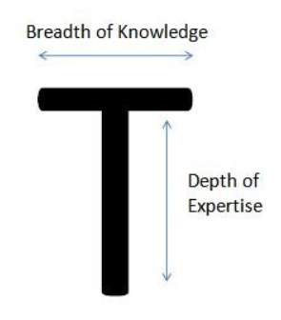
Figure 2: T-shaped employees (Generalists Specialists)
The T-shaped employees have thorough knowledge and competences in one area but can work beyond it and can collaborate and contribute in other fields. According to Tim Brown, who popularized the concept of T-shaped employees, empathy and enthusiasm are the two most important characteristics of the T-shaped employees. Empathy allows them to look into the problem from another angle and enthusiasm makes them interested in others disciplines.
M-shaped
Figure 3: M-shaped employees (High Performers in Cross-Functional Teams)
When compared to T-shaped employees, M-shaped employees are more knowledgeable than the skills and competencies of T-shaped as the two bars are the representations of two T-shapes. M-shaped employees are high performers in cross-functional teams. They have multiple specialties. The generation Y employees are optimistic and confident charmers. They belong to this M-shaped category.
Pi-shaped
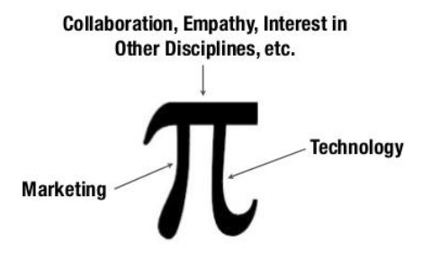
Figure 4: Pi-shaped employees (High Performers in Cross-Functional Teams)
Pi-shaped employees are both analytical and data driven. But, what differentiates them from others is that they also understand brands, story telling and experiential marketing. Research suggests Pi-shaped employees are superior to I-shaped, T-shaped and M-shaped employees, but still something is missing.
Comb-shaped
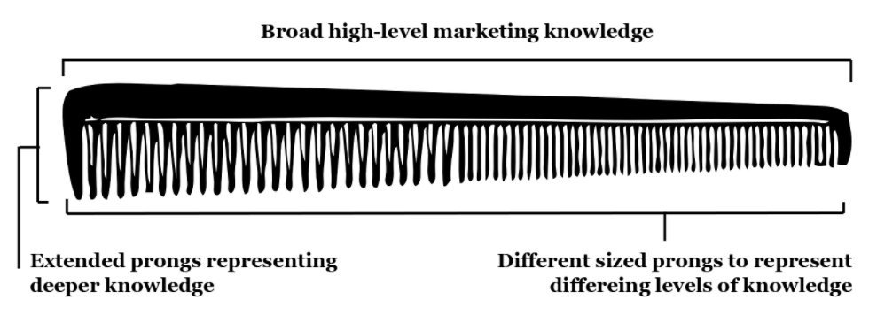
Figure 5: Comb-shaped employees (Agile Life-Long Learners)
Comb-shaped employees possess expertise in several domains with some breath. They have the ability to change continuously and develop. They are the agile life-long learners. Comb-shaped employees are the leaders who are in high demand in this digital era.
E-shaped

Figure 6: E-shaped employees (Agile Life-Long Learners)
E-shaped employees have a combination of 4Es, viz, Expertise, Experience, Execution and Exploration. They are the next generation specialists. They have limitless potential in terms of the following:
- Expertise – they are the specialists in multiple areas;
- Experience – they have the requisite experience;
- Execution – they are specialists with proven execution skills;
- Exploration – they have the ability to craft and learn new skills;
Let us try to understand what makes the E-shaped employees better leaders in comparison to the I-shaped and T-shaped employees. According to Sarah Davanzo, a person’s CQ matters more than his/her IQ and EQ. The E-shaped employees have better Curiosity Quotient (CQ) influencing them to Explore and Execute to be proactive to changes in an agile way. This makes them better digital business leaders.
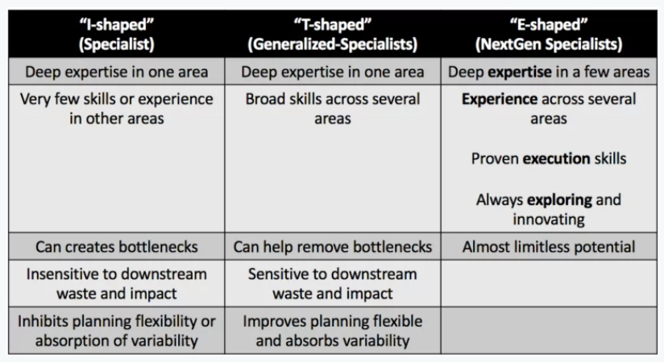
Figure 7: Comparative Analysis (I-shaped, T-shaped and E-shaped)
Hence, through B-School interventions the students are to be converted to T-shaped employees so as to make them industry ready to hit the job market. But, another opportunity of B-Schools is to cater to the industry specific needs in transforming their T-shaped employees to E-shaped employees who are the future C-suite digital leaders though Management Development Programs and Executive Development Programs. These programs come under the umbrella of Leadership Development Programs.
The B-School Deliverables
Leadership is the process by which the leader influences the followers to pursue the common goal. The primary goal of a B-School is to make the students industry ready by implementing need of the hour course curriculum to inculcate business acumen to the students. The strategic role of a B-School leader includes four major dimensions:
- school visibility
- fund raising
- intellectual guidance and
- operations management
Strategic leadership skills of the B-School leader are of key importance today as B-Schools strive to realign their internal functioning and reformulate their value propositions to match the real-world needs. Some leading B-Schools have reacted to this critical challenge by recruiting management professionals both from industry and academia. This blend not only helps them to identify the skill gap areas that are needed to be addressed, but also to formulate effective learning and developmental plans for the students.
The leaders of B-Schools must be able to figure out different perspectives internally and externally before they can formulate a strategic direction for the school. The external context needs to properly analyzed to identify the opportunities and threats shaped by a variety of factors like disruptive technology, digital transformation, regional and global business trends, domestic and international economic conditions to name a few. On the other hand the B-School leader must scan through the internal environment to check the level of preparedness in terms of curriculum, pedagogy, faculty, infrastructure, library, admission and placement facility etc. and also the needs of the stakeholders to come up with an effective business model.
The contribution of B-Schools in shaping the management students also need to be quantified in terms of two key outputs:
  - Learning outcomes of the B-School education
  - Student employability after the management course
Both these aspects are of immense interest of several stakeholders' e.g. prospective students, their parents, industry recruiters, B-School administrators, teachers, society at large who benefit from capable & industrious B-School graduates.
Every year thousands of students graduate from B-Schools with an aspiration to achieve higher managerial positions five years down the line. A student’s selection of B-School generally depends on the following factors:
- placement records
- infrastructure
- faculty
- geographical location
- Interaction with alumni etc.
A B-School’s selection of students solely depends on student quality. Quality is often judged on the basis of previous performance, qualifying exam score, previous job experience etc to name a few and along with that on the basis of certain managerial acumen like out of the box thinking, analytical ability and communication skills etc.
The B-Schools are differentiated in terms of the following factors:
- Skill attainment
- Corporate Academia partnership
- Campus placements
- Alumni relations
- Curriculum and pedagogy
- Accreditation
The B-School business model depends on the parity between the deliveries promised by B-Schools with those expected by the students.

Figure 8: B-School Business Model (Authors’ perception)
The B-School Business Lines
Digital transformation of business models is presently one of the most critical areas to explore. But, the fact well accepted among the digital leaders is that the digital technologies open up new opportunities for organizations to explore a more varied spectrum of business models. Higher Education Institutions or B-Schools are not exceptions. The business lines of a B-School are as below:

Figure 9: B-School Business Lines (Source: Leadership in B-Schools by Mukul P Gupta)
Most of the B-Schools completely rely on Post Graduate Diploma in Management (PGDM) program as their flagship program. Business through PGDM program quite predictable as the number of admissions and placements can be predicted keeping in mind the past trends. This business line is linear and coherent as a result this business line easy to understand and execute.
B-Schools with good brand values explore the second business line i.e., Executive PGDM and Fellow program. The market for this business line is volatile and it changes rapidly. Due to COVID 19, the work from home employees are exploring such programs as good value for money with respect to time. The execution of the program is complex in terms of finding the learning and practicing gap areas of industry through proper research and then designing the program curriculum. The expected outcome for the B-School as well as for the companies is not clear or is not easy to formulate.
B-School is a space wherein there is a mix of both academics and corporate exposure. Premier B-Schools go for the third business line with an objective to offer customized Management Development Programs (MDP) to companies and customized Faculty Development Programs (FDP) either to specific academic institutions or they offer open FDPs. They offer MDPs in prominent areas like digital transformation, strategic leadership, business analytics to name a few. The fundamental objective of these programs is to prepare the participants to develop leadership abilities to effectively manage high performing teams. But, the industry requirements of such program are not clearly predictable and they are chaotic. Participants sometimes are unable to strike a balance between such professional programs and their job roles and hence leave the program in between. This makes the B-Schools to attract candidates for the next pipelined programs.
Leadership in B-Schools
The different types of employees and their competencies have already been discussed in one of the earlier sections along with the employee age generations. Similarly customers are also changing in terms of their generations. These are forcing the organizations to react and increase customer centricity. This driving force of accelerated change is the foundation for a new paradigm of leadership i.e., “Leadership in the Digital Future”. It describes the ability to anticipate waves of accelerated changes based on new technologies that disrupt the business. B-Schools also need to be more customer-centric in terms of the value the customers (the prospective students) can generate out of the B-School programs through the enriched program curriculum.
Technologies like artificial intelligence, blockchain or big data are creating disruption in markets and the digital transformation of businesses. These phenomena need to have places in the B-School curriculum in terms of case studies, industry projects, industry interaction etc. The leader of the B-School has to have the ability to think differently and accommodate all the avenues of digital transformation not only in the courses or in pedagogy of the courses but also into its business model. An effective digital leader must act outside his/her comfort zone. He/she is the person who is instrumental in digital thinking and digital transformation of his/her business. Research suggests that digital priorities do not rely more on technology but on human factor. Digitalization leads to the growing importance of customer requirements so that companies have to align their offering to fit better with the specific demands of their customers.” (Schwarzmüller et al, 2017:2).
The customers of a B-School are two folds: one, the aspiring management students and two, the companies. The B-School needs to satisfy the students by developing them, making them industry ready and thereby placing them in suitable positions. The B-School also has the responsibility to cater to the specific requirements of the companies by creating a good recruitment pipeline with students for the companies. In order to satisfy both, the impacts for the role of the B-School leaders on themselves are the following:
- Decrease of power, democratization (less influence of leader)
- Increase of relationship-building measures (coaching, enabling, networking)
- Increase of required skills and competencies (agility, change management, digital leadership)
Decrease of power – The B-School structure should clearly depict the demarcations in responsibilities in terms of the following:
- Head – Admissions
- Chair – PGP programs
- Head – Placement
- Head – Compliance
- Head – Administration
- Head – Accounts
- Dean/Principal
The Dean/Principal is the governing authority for smooth execution of the B-School programs. The faculty members report to the Dean/Principal for conduct of day to day tasks. The faculty members of a B-School play a pivotal role in coaching and enabling the students with the requisite skills sets.
The PGP-Chair along with his/her team is responsible for preparing the curriculum, course designs and conduct of examination.
The Head of Compliance is responsible to comply with the norms and regulations framed by the governing body like All India Council for Technical Education, Ministry of higher education department etc.
The Head of Administration plays a supervisory role in ensuring that the students are governing the rules and regulations framed by the institution and in case of discrepancies, strict disciplines are enforced. He/she is also responsible for facilitating the extra-curricular activities for the students.
The Head of Admissions and Placements are the persons responsible for maintaining liaison and building relationship with the external stakeholders.
If all the above mentioned roles are parts of B-School leadership then the obvious question is who is leading from the front? But, who so ever is the person he/she needs to run the show along with his/her team and the person who leads the team must be very well conversant with the changes in the environment. The strategist requires to have a very agile and technology mindset with equipped and prepared with change management initiatives.
How is a B-School like, and not like, a business?
Corporates while searching for a young mind with go-getter attitude are actually looking for the perfect things required for a Chief Executive Officer. Time will come for the good candidates for sure but before that they need to be prepared for rolling their sleeves up to work for thinnest margin possible, understand the value for money, develop the ability to convert fixed cost into variable cost and have the ability to smell revenue in every possible aspect of business. The B-Schools should deliver to these expectations.
Therefore, the B-Schools should not be ready with the competencies required to be present in students to become the future C-suite employees but the hard workers who are not afraid of hard work. The ever changing business environment is continuously imposing restrictions and challenges to the businesses. Hence, the skills sets which appear to be necessary right now may not work in future. Corporates are looking for candidates who have the ability to learn from their yesterday’s mistakes and converting them to tomorrow’s benefits. In this regard, the overseas attitude towards management education is better than India. In developed countries, students after completing their under graduation program go for gaining work experience which is quite scientific in a sense that it helps them to relate managerial concepts better by virtue of their work experience. Therefore, one of the pre-requisites for getting into a B-School program is to have prior work experience.
Another issue is by the time the students can apply their B-School learnt concepts into practices it is almost a decade they have already traversed. This makes their successfully learnt B-School concepts outdated. This is another big challenge for the B-Schools to design their curriculum in such a way that their students can contribute from the very beginning. This happens through strong industry academic amalgamation. But, there has to have a strategic alliance that creates a win-win situation for both the parties. This strategic alliance will in turn bring revenue for the B-School.
Digital Transformation for Business Model Innovation of B-Schools
Due to rapid changes in the learning environment, the B-Schools are facing challenges to continue to run with their existing business model. Certain new initiatives are threatening them further, like MOOCs and NPTEL courses offered by leading academic institutions are actually taking a shape of “No-Pay MBA product”. COVID 19 pandemic has opened new avenues for the aspiring management students to get through a combination of such free open source online courses instead of going investing in full-time regular PGDM/MBA programs.
The constantly emerging new digital technologies are creating challenges and opportunities to the B-Schools both internally (e.g. virtual campus) and externally (e.g. social networks). Hence, an unintentional difference is being created between resources and capabilities to react to the digital transformation and thereby making the right decision to survive and strive for excellence.
Challenges of Digital Leadership
Digital technology allows us to keep things or to make things virtual. Digital transformation talks about how things are taken from the real world and are transformed into virtual world. Therefore the question is how management changes in the digital age or whether management is even necessary in this digital age. Rapidly we are reaching at a point where human performance is being outrun by computer performance.
Covid 19, though has devastating impacts on mankind, but has a remarkable contribution to individuals and to the organizations, i.e., we have acquired the capability to adapt to changes on a much faster time scale than we previously expected. There is always resistance to change given human psychology. This inertial force resisting change was instrumental in dragging down the digital initiatives for the organizations. As per Martec’s Law, technology changes exponentially (fast) but organizations change logarithmically (slow). Hence, business leaders must strategically choose which technological changes to embrace given the highly constrained bandwidth for absorbing organizational changes.
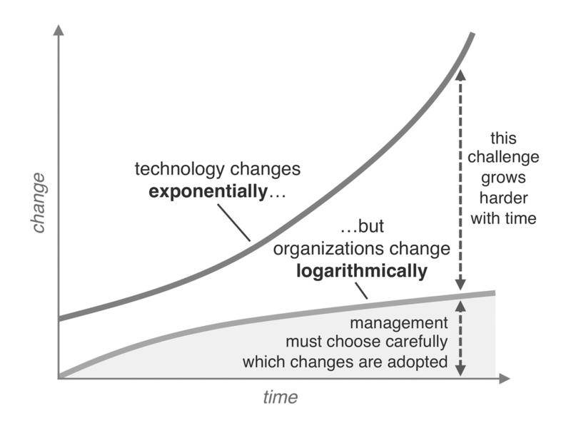
Figure 10: Martec’s Law for Digital Transformation
The Digital Adoption Curve
Hence, the question is how to reach the goal when the goal post keeps moving?
Once a commitment is made for digital transformation and the initial investment is made a platform is created that allows further expansion and makes adoption of technological advancements easier to achieve else the "Digital Adoption Gap" will expand exponentially, and the financial investment to effectively start over could be insurmountable.
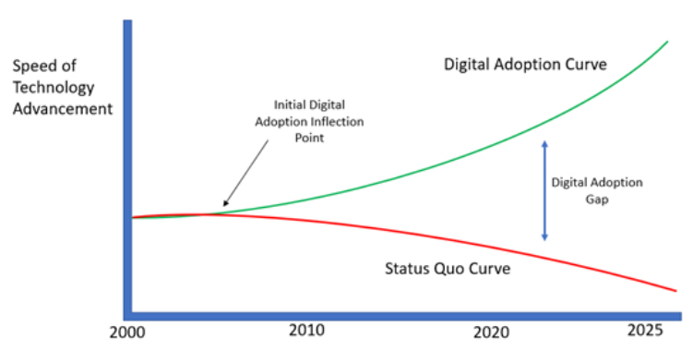
Figure 11: The Digital Adoption Curve
Once the digital transformation is funded, the Return on Investment must be ensured. Business leaders must keep three following factors in mind to align the digital transformation with business goals:
- the leaders must articulate the value of digital transformation to business clearly;
- the need for digital transformation must be realistic and pragmatic, but there also have to have a sense of urgency to act;
- leaders must be supportive of digital thinking;
Digital thinking and execution are of key importance in terms of the following dimensions:
- Digital strategy – evaluating what is essential to succeed
- Managing Assets – arranging the capital and acquiring the resources that support the digital strategy
- Digital business execution – building and managing the capability to effectively leverage the digital asset to deliver strategic objectives
Business Success
=
Digital Business Capability
Digital Asset
Digital Strategy

Figure 12: Successful Digital Transformation
Digital Maturity Level of B-Schools
It is of key importance to assess the digital maturity level of the B-School. In this regard, execution of Digital Maturity Assessment Tool (DMAT) based on a questionnaire can be of help for the school leadership to understand the digital preparedness for this change. The tool assesses digital maturity across six dimensions:
- Strategy - Focuses on how the business transforms or operates to increase its competitive advantage through digital initiatives; it is embedded within the overall business strategy
- Organization and Culture - Defining and developing an organizational culture with governance and talent processes to support progress along the digital maturity curve, and the flexibly to achieve growth and innovation objectives
- Operations - Executing and evolving processes and tasks by utilizing digital technologies to drive strategic management and enhance business efficiency and effectiveness
- Technology - Underpins the success of digital strategy by helping to create, process, store, secure and exchange data to meet the needs of customers at low cost and low overheads
- Customers and partners - Providing an experience where customers view the organization as their digital partner using their preferred channels of interaction to control their connected future on and offline
These five core dimensions are divided into 28 sub-dimensions which are further broken into 179 individual criteria based on which digital mindset is assessed:
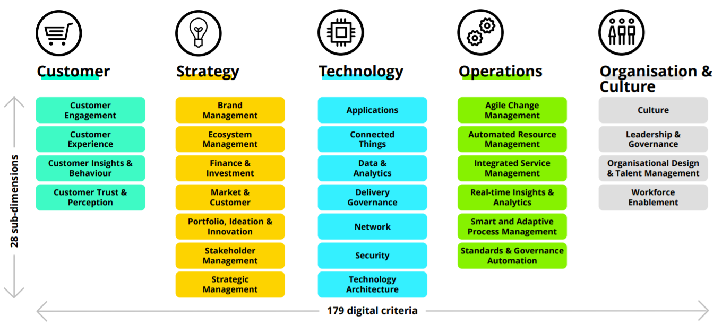
Figure 13: Dimensions of Digital Maturity Model (Adopted from Digital Maturity Model: Achieving Digital Maturity to Drive Growth, February 2018 published by Deloitte)
On the basis of these above mentioned parameters the digital preparedness of an organization can be assessed. A B-School’s business model fits well into this frame. The digital maturity assessment enlightens the B-School with its current state in terms of their digital strengths and the areas they need improvement.

Digital Transformation Journey of B-Schools
The Geena Davis Inclusion Quotient to assess the five levels of digital transformation maturity is a good indicator of the phases of the digital transformation journey. The five phases are as follows:
- Minimal – the B-School has limited or no experience in digital technologies
- Reactive – the digital ability of the B-School is not marketed and taken only in silos
- Moderate – the digital assets or the capabilities of the B-School sill lack customer focus
- Customer Centric – customer centric digital engagement is happening in B-School and more plans are in place
- Transformed – continuous action of customer centred digitization in B-School
Before starting its digital journey, the B-School leadership must be thorough with the assessment of the digital maturity level of the B-School.
Roadmap for the Digital Leaders of B-Schools
Once, the digital maturity level is evaluated, the roadmap for the digital transformation of the B-School is formulated with the following steps:
- Define Strategy – develop and align the B-School digital direction including brand, growth, experiences of the B-School alumni program curriculum
- Ignite Innovation – designing the program curriculum in an innovative way which others are unable to execute simultaneously
- Derive Insights – the B-School leaders must analyse the market, the trends of the students and perspectives of the alumni to support the direction of the digital strategy
- Create Experiences – the B-School leaders must architect and deliver the innovative digital curriculum through Internet of Things (IoT) experience and solution design
- Reinvent the Core – the B-School leaders must redefine the core capabilities of the B-School in terms of teaching learning process with complete digital touch
- Lead the Change – the B-School leaders should drive the change by redesigning the organization functions and job roles
- Sustain and Optimize – the B-School leader must support deployment of organization change and platforms to drive value realization and sustained business agility
Digital Leadership Traits for B-School Leaders
Literature suggests the biggest challenges for digital disruption are as follows:
  - The increased pace of doing business
  - Shift in organizational culture
  - Conflict of interest between “change makers” and the “change dislikers”
Digital transformation is all about change and leaders are instrumental in implementing the required changes in their organizations. Digital transformation is a critical change which changes the context and the conditions for the business leaders. Therefore, the leaders must possess certain differentiating traits to drive digital transformation successfully in their organizations. Digital leaders must possess a clear vision about the opportunities that the digital technologies are bringing in and will be a source of competitive advantage in future. The digital leaders should be well versed with digital tools and techniques and should develop capabilities to experiment new things and figure out fast whether the new initiatives are working for the organization. They need to believe in empowerment and need to delegate their power to get the best out of digital initiatives. As digital transformation brings different functions and stakeholders to the same platform, the digital leaders need to have the ability to build teams with high Adversity Quotients (AQ). Hence we can conclude that the effective digital leaders must possess the following critical traits:
- Digital transformative vision
- Forward looking perspective
- Digital literacy
- Change oriented
- Build teams with high AQs
- Open minded
- Adaptable
- Innovative and appreciate innovation
- Agile approach to collaboration
- Empowerment

Figure 14: The Digital Leadership Traits of B-School Leaders
References
Faisal Imran et. al., Leadership Competencies for Digital Transformation: Evidence from Multiple Cases, Book Chapter, July 2020;
Gilchrist, A.: Industry 4.0: The Industrial Internet of Things. Apress, Bangkok (2016);
Riitta-Liisa Larjovuori et. al., Leadership in the digital business transformation, Conference 2018. 212-221. New York: MindTrek Conference;
Julie Okada et. al., Learning While Leading: The Digital Leadership Challenge, Harvard Business Review, May 2021;
Esin Akay, Which Letter-shaped will Future Employees and Leaders be?, (https://www.linkedin.com/pulse/which-letter-shaped-future-employees-leaders-esin-akay/)

