Braking Framework Investigate Utilizing All-Electric Braking Framework

Dr. Hredeya Mishra¹
Lecturer in MED
MVPS’s RSM Polytechnic Nashik
1002mishrahk@gmail.com

Dr. Pradnya Prakash More²
Lecturer in MED
MVPS’s RSM Polytechnic Nashik
pradnya.more@rsmpoly.org

ABSTRACT
Brake system is a combination of pneumatic brake and electric brake. The system is the main cause of disc brake shoe noise when the train stops, causing noise and air pollution. Therefore, the scientific literature suggests a method that uses the entire brake system as a static force to remove dust and other pollutants from the air.
Keywords— brake shoe, static braking, method, total braking

INTRODUCTION

In recent years, electric trains have become an important means of public transportation. As passenger comfort increases and electronic equipment increases, vehicle performance, handling and handling should improve. The braking system manages a combination of pneumatic and electric brakes. This is the main cause of noise and disc brake shoes when the train stops. It causes environmental pollution.
So this article presents a method of using the entire brake system as a braking system to remove dust and other contaminants.

ELECTRIC BRAKE FRAMEWORK

The start and stop of the electric train is driven by an inverter. Electric brakes can operate at 5 km/h. The air brake operates at a vehicle speed of approximately 5 km/h. This system uses an encoder that acts as vector control to identify the motor. Precise vector control cannot be achieved due to the power characteristics of the encoder system around 60-100 pulses per revolution. For this reason, hybrid electric and pneumatic braking systems are used. This is the main cause of noise and disc brake shoes when the train stops. It causes environmental pollution. When the train speed drops below 5 km/h, the compressor makes noise, it is not easy to control and the air brake is at risk of aging.
All electric cars often use electric brakes to reduce the risk of the air brakes failing. The benefits of using all-electric brake racks are as follows:
1. Reduce the use of shoes by reducing the air brake
2. Reduce brake noise caused by mechanical wear
3. Save on parking fees
4. Increase power consumption and improve collision braking.

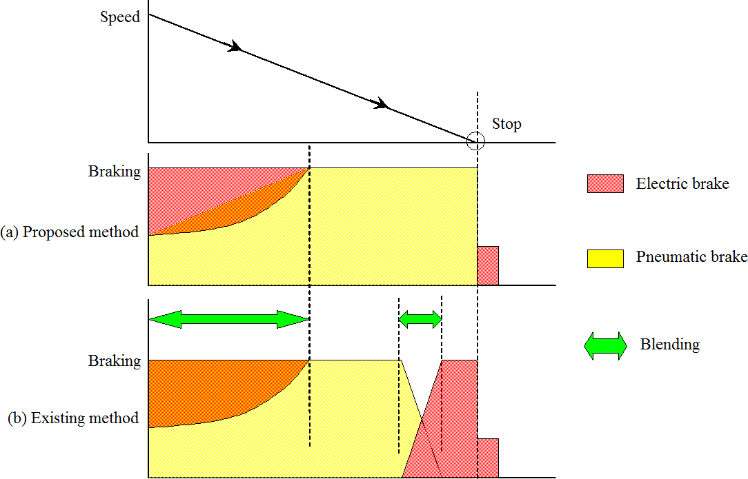
Figure 1. Electric brake framework

COMBINATION OF THE ENTIRE ELECTRICAL FRAMEWORK

The brake system consists of inverter, PWM control unit, vector control unit, drive control unit and speed control unit. The inverter controls the speed of the motor by converting the DC voltage into DC voltage from the collector.
PWM control unit to control the rotation of the inverter. The PWM controller changes the voltage and frequency of the stepper motor input circuit. The vector control unit receives speed and current signals from the motor.
The vector controller determines the voltage and frequency of the inverter. The driver's control unit carries out the driver's acceleration, braking and deceleration commands.
Brake control. The speed control unit determines the rotor speed for motor control. For engine control, the driver starts holding the brake after stopping in standby mode.
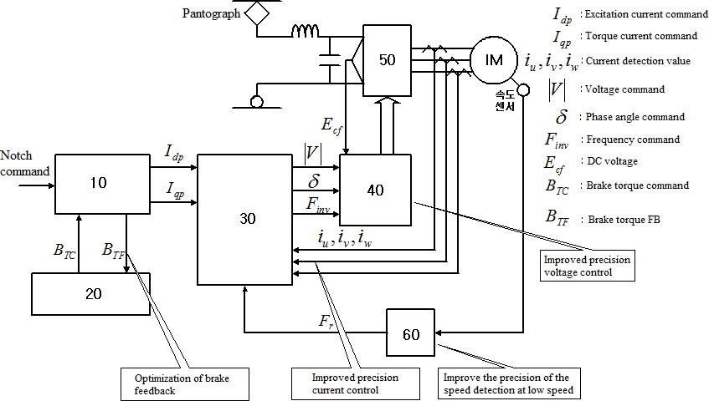
Figure 2. Control configuration for Brake Framework
Vector control unit provides pedal control and speed control by taking motor current and speed values. pedal engine. The balance of stroke width changes to form a control unit.
The main functions of the vector control unit, such as current control and frequency vectoring, respond to the values ​​used by the drive control unit.
In this case the solver is used to determine and precisely control the speed in the low-speed range.
Figure 3 shows the braking control during deceleration. When the brake signal is detected, the power current command (Iqp) is executed to apply the brake power.
When the shift speed enters a low gear (5 km/h or less), the electric brake reduces the set current torque point. Use the brake when the vehicle stops

Figure 3. Control of brake graph at moo velocity

TEST

The following conditions stop the engine.
4.1 Do not roll away after parking.
1. The air brake works when the braking torque is 0
2. Braking torque is developed in degrees. Stopping with pneumatic braking force in preparation for
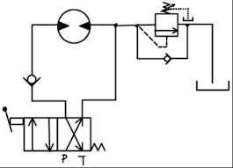
stopping
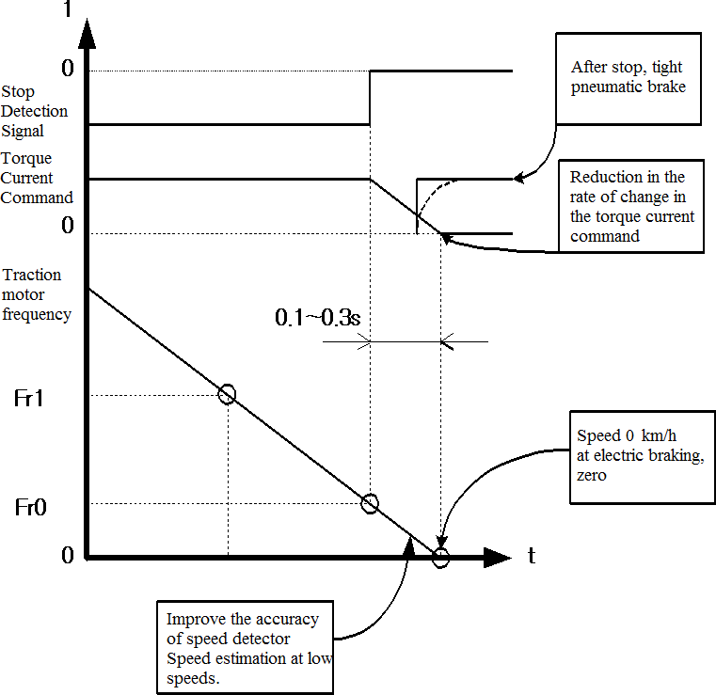
Figure 4: Braking Sequence

Electric motors for propulsion and regenerative braking. Figure 5 shows engine speed starting at 360 [rpm] and power at 0 at 800 [rpm]. Braking torque is proportional to braking speed.
Figure 5 and Figure 6 show the step change in torque setting. It can work at slow speed when braking
The braking system is a combination of pneumatic and electric brake
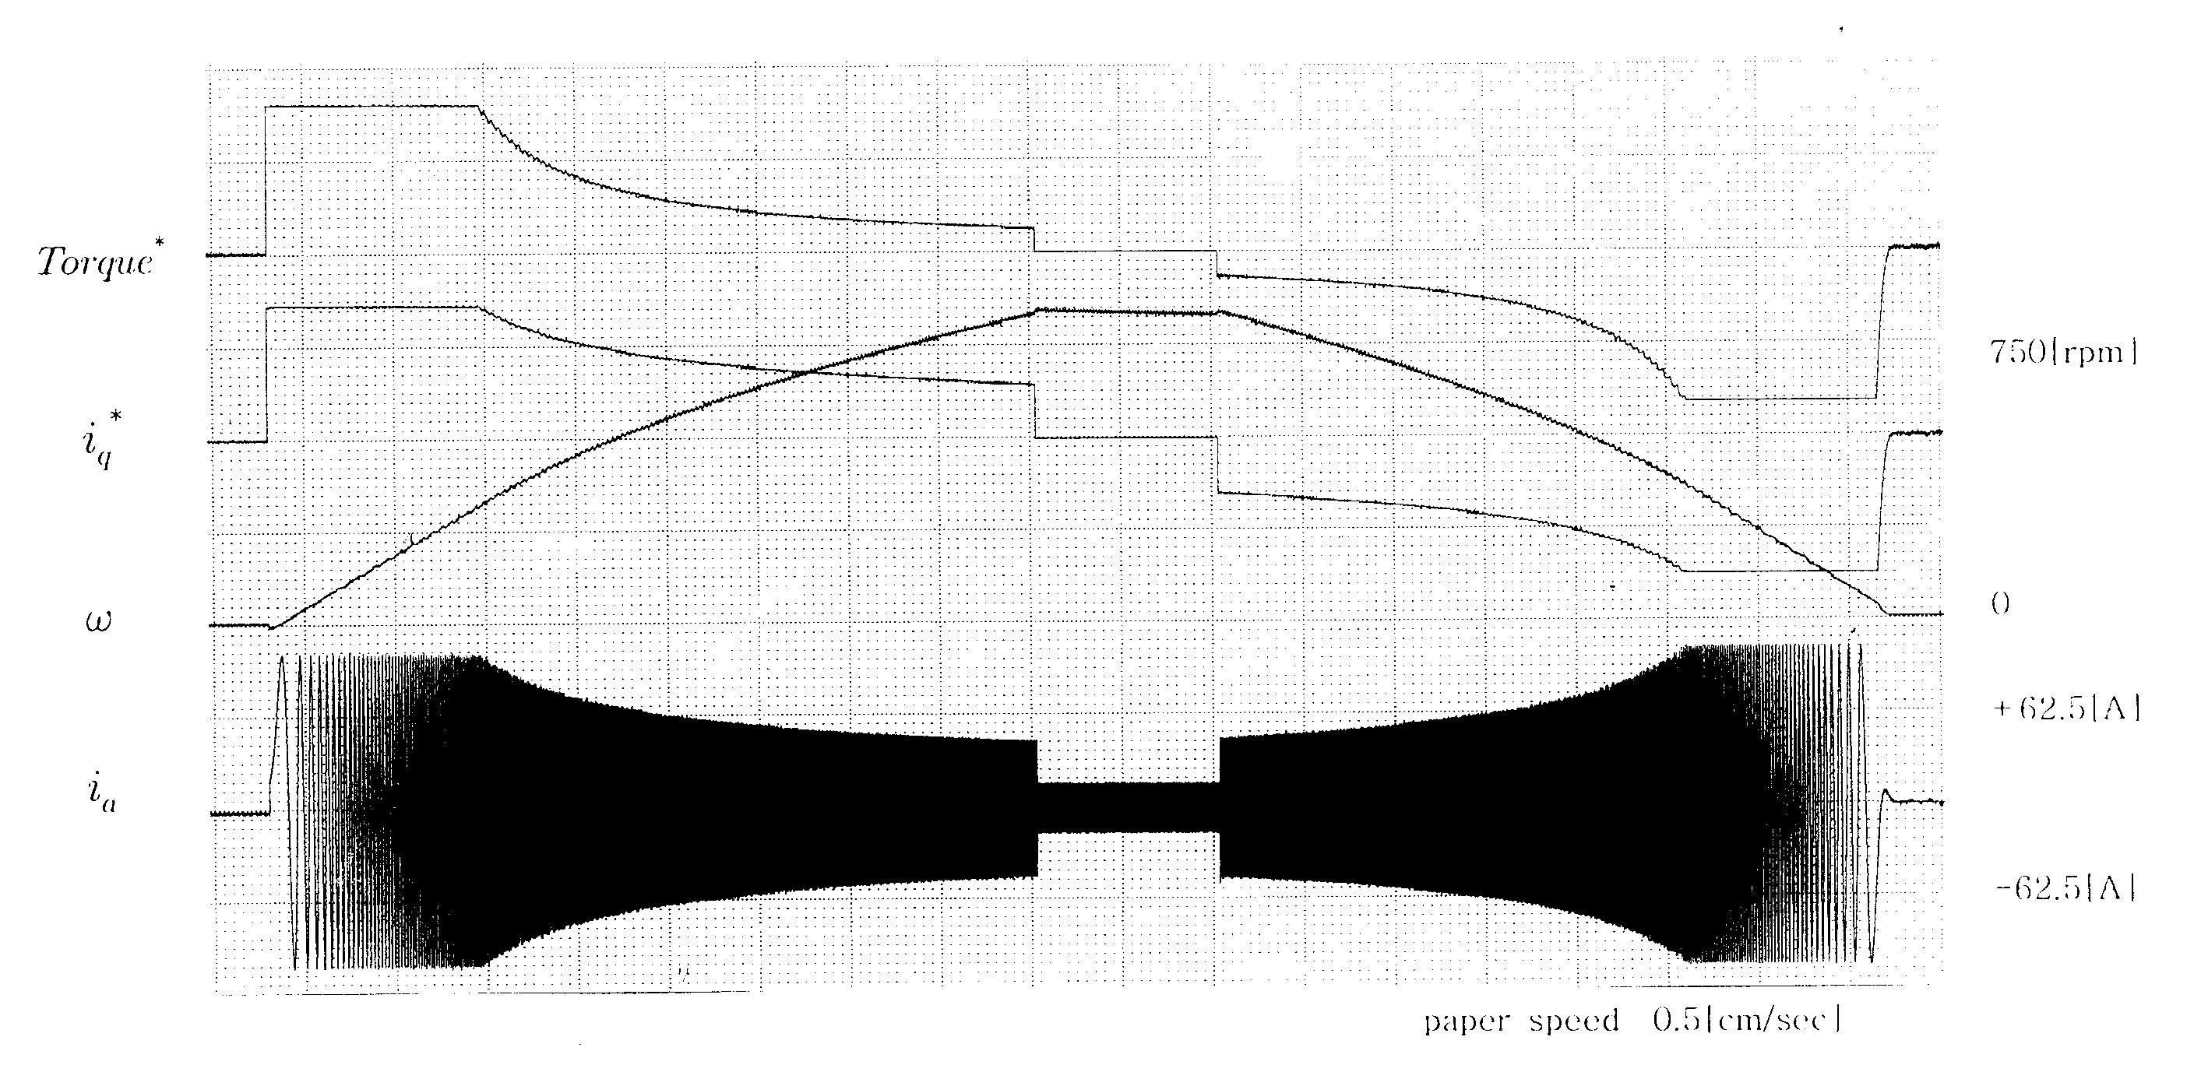
Figure 5. Driving test on given load

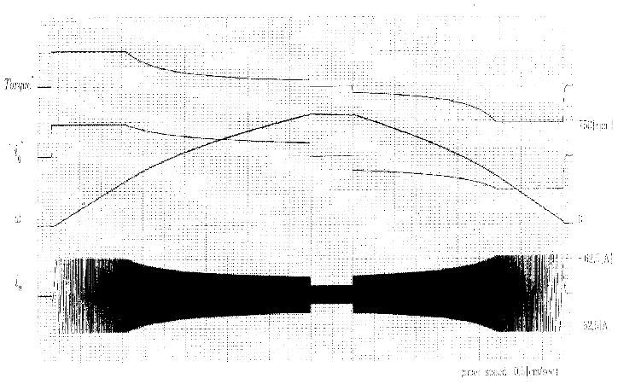
Figure 6. Testing of the rod in different load

CONCLUSION
The brake frame controls a combination of air brakes and electric brakes. The frame is the main reason for preparing the shock and brake shoe contact plate when the brake part is applied. causing natural pollution. Therefore, this paper presents a strategy to use the all-electric brake frame as a zero-speed brake frame to evacuate particulates and other pollutants. Advantages of using an all-electric car:
1. Reduce the use of air brakes and reduce shoes.
2. Can reduce the mess and clean from using the machine
3. Reserve for brake cost
4. Use the most prominent features to connect additional customization

REFERENCES

- Hanmin lee, Gildong Kim, Changmu Lee, Euijin Joung, “A study on Braking Control for Pure electric Brake of Electric Train”, The Korean Institute of Electrical Engineers conference, 2012
- Hanmin lee, Gildong Kim, “A Study on Electric Braking System to 0km/h”, The Korean Society for Railway conference,pp.178, 2007
- Sone, Ashiya, "Pure electrical brake of the railway electric vehicles",Railway cybernetics, vol.34,No.513, pp.194~197, 1997
- Ogasa, Nagai, Watanabe, "Plant-test Result of All Electrical Braking (Report 1)", National convention Record I.E.E.Japan, 1260,pp.5- 389~390, 1998
- Ogasa, Nagai, Watanabe, Toda, "Plant-test of Electrical Breaking to Zero Speed for Railway Vehicle", National Convention Record I.E.E.Japan-Industry Application Society-, No.77,pp.257~262, 1998
- Sato, Iida, Hisatomi, "Pure electric braking system test using stsrt", National Convention Record I.E.E.Japan-Industry Application Society-, No.78,pp.253~2666, 1998

