Youth Employability in Retail Sector of Delhi/NCR: Implications on Building a Resilient Workforce
Meghna Joshi, Founder, SWAN Livelihood, New Delhi, India
Phone No. : +91-9953115182
swanlivelihood@gmail.com

Youth Employability in Retail Sector of Delhi/NCR: Implications on Building a Resilient Workforce
Abstract: Indian retail market is fourth largest in the world and supports a workforce of over 40 million individuals. Retail sector also involves over 15 million conventional and contemporary traders. Post- Covid revival of the Indian economy is witnessing a surge in the consumption levels leading to enhanced commercial activity. This trend has given rise to a higher requirement of the frontline personnel in the retail sector.
Frontline employees constitute nearly two-third of the retail workforce and play a vital role in shaping customer experience. These workers play a major role in implementing a company's objectives at the shop floor and are valued as brand ambassadors. Many frontline workers come from weak socio-economic backgrounds and possess limited skills. During their professional journey these workers face challenges in terms of achieving high targets, limited career growth, and long working hours.
COVID-19 impacted retail operations and resources prompted a comprehensive reassessment. Digital transformation accelerated evolving new approaches for empowering the workforce and ensuring sustainability. The present study emphasizes on innovative learning models in retail sector that were derived through extensive surveys of the employees and the employers keeping in view the changed conditions from pre- to post- Covid scenario. The main aims were to know about the intricacies of the system, identification of gap areas and strategize ways to develop a skilled retail workforce to thrive in the new normal.
The present work delves into policy implications for fostering industry partnerships besides the welfare of retail employees and their skill development.
Keywords: Retail Industry, Frontline Workforce, On the Job Training, Business Sustainability, Skill Development

Introduction
The retail sector in India has over 15 million traditional and modern traders, and it employs nearly 40 to 50 million people (Parul, 2020). According to the Retailers Association of India (RAI), modern trade contributes to about 12% of the total retail consumption of the country and employs over 6 million people (Business World, 2020).
Lockdown imposed in the country to prevent the spread of COVID-19 had badly affected the retail business. Most stores, except those selling essential items of food and grocery were shut down. Retailers of essential items had to face losses as they were not allowed to sell non-essential items that could bring higher profits (OECD, 2020). The cash inflow of the industry had come to a standstill while the fixed operating costs remained intact. The non-food retail outlets remained closed during the lockdown and could not generate any revenue. Most of the retailers were in ‘stocked in, locked in’ situation. Many others faced inventory struggles with excess of few particular items to not enough products of other essential things. Many retailers lost business as their customers moved to other home delivery options or e-commerce channels. Few others, like grocery retailers, faced unprecedented high demand and faced prolonged out-of-stock situations. Stock piling of certain essential supplies by consumers was the key reason besides the disruption in the supply chain (Vader et al., 2022).
Sustaining the employees and rationalising the manpower became the main issue for the retailers during the lockdown. Managing migrant workers and payment of the wages of the engaged workers with no or very low revenue inflow were other areas of concern for them. Severe liquidity challenges experienced by the retail business lead to large-scale unemployment (Vader et al., 2022).
In order to ensure a future where businesses would not only survive but thrive, it became critical for the retailers to foresee the nature of the post-pandemic world. Adaptation to the new realities of the immediate future could be accomplished only when the workable models and frameworks were available for the post lockdown period
SWAN (Skilled Workforce Advancing Nation) Livelihood, a start-up based at Delhi, had been empowering the youthful workforce through specially designed training and learning programs that were being conducted offline. During the pandemic and lockdown most of the retail outlets were closed and many young participants who had earlier attended the skill enhancement trainings conducted by the SWAN lost their jobs. Discussions with them and subsequent surveys highlighted a dire need for further upgradation of the skill sets of the workforce employed in the Retail sector in the post pandemic world. The present work in an outcome of the author’s involvement with the SWAN Livelihood and the Retail Department of the DSEU (Dellhi Skill and Entrepreneurship University), Vivek Vihar campus.

Objective
Pandemic induced lockdown and the later opening up of the industry was a short but horrific period for the present generation. It starkly manifested the dynamic nature of the job market and the economic landscape. An urgent anxiety was created amongst people, especially youth, to equip themselves with skills that could allow them to sail through unprecedented difficult times. Current study examines the retail sector in Delhi/NCR region, in the pre- and post- Covid scenarios. It discusses the skill development models adopted by SWAN Livelihood for the youthful aspirants of the retail sector. This study enumerates impact of Coronavirus pandemic on the retail industry in terms of employment opportunities and closure of learning institutions. This work showcases the significance and shortcomings of the learning models evolved by the SWAN Livelihood for making youth job-ready in the pre-Covid period. It also highlights the need for new learning models in the post Covid world. While discussing new innovative learning models for the retail sector, an attempt is made here to provide insights and practical guidance to stakeholders, educators, and policymakers to enable them towards fostering a more resilient and adaptable workforce.

Skill Development Model prior to Covid Pandemic
Deep involvement with the retail sector in Delhi / NCR and earlier professional engagement with corporate and social sector institutions had shown that a great disparity exists between the knowledge acquired through educational institutions and the practical skills demanded by the industry. An understanding of this gap brings the challenges faced by educated youth on completing their education and the specific requirements of employers to the forefront. As a consequence of this knowledge-skill mismatch, these young individuals are compelled to pursue employment in the unorganized sectors, which often offer poor working conditions, meagre compensation, and job instability. Simultaneously, the corporate sector, as an employer, faces a shortage of readily available skilled and well-groomed personnel. The high attrition rate for the unskilled youth in the corporate sector has been observed to be due to difficulty in adapting to the corporate work environment, poor communications skills leading to strained relationships with colleagues and employers besides behavioural and geographical barriers.
SWAN Livelihood had been empowering youthful aspirants and the workforce through specially designed training programmes and counselling sessions. The comprehensive model adopted by it included sustained field activity, class room teaching and practice, counselling sessions besides on the job training (Joshi and Duhan, 2022). The advantages and shortcomings of this model of pre-pandemic era are discussed below,

Advantages
- Classroom learning and practical experience followed in this model provides a well-rounded approach towards career counselling. Practical exposure visits to retail outlets equips individuals with a strong foundation of real-world skills, enhancing their preparedness for future careers.
Figure 1 Shows various aspects of skill development program followed by SWAN Livelihood for facilitating youth employment in the retail industry during the pre-covid period.
- Conducting a psychometric analysis for the batch in the beginning proved invaluable in gaining insights into the aspirations of the youth and aligning them with the training and placement plan. This assessment led to accurately map the strengths, interests, and career goals for stitching a suitable training and placement approach as per individualistic need thus maximizing the potential for success.
- Psychological counselling provided under this model to students and their parents played a crucial role in addressing early challenges and preventing student dropouts from the program. Support and guidance were offered to effectively resolve the issues that came up in the initial stages of the program. These interventions ensured that students and their parents felt equipped to overcome obstacles and stay committed to the learning process.

- Incorporation of exposure visits during the training program proved beneficial for the students. These visits provided first hand insights into the operations of retail outlets and the nature of various jobs. As a result, students gained valuable knowledge and practical experience, which significantly enhanced their preparedness for upcoming interview sessions. This hands-on approach not only deepened their understanding of the industry but also boosted their confidence and ability to showcase their skills effectively during interviews.

- The inclusion of employee engagement programs featuring expert talks from HR professionals had a profound impact on the students. These programs offered valuable guidelines for understanding the structure and requirements the interview process. These sessions made the participants more confident and adept in navigating interviews and establishing meaningful connections within the industry. Such sessions often fostered a cordial relationship between the students and industry professionals, creating a positive scope for mutual collaboration.

- Alumni gatherings led to interactions between the current students and the participants of the earlier batches, These sessions were terrific moral boosters, inspiring and motivating the current students and nurturing a successful network of alumni.

- In the model the provision of post-placement assistance, after successful completion of the program, played a vital role in mitigating attrition rates within the industry. This support helped the recruited individuals to settle smoothly into their roles and fostered congenial relationships with the industry partners. Through ongoing guidance and support, skilled and motivated employees were retained by the industry thereby strengthening the workforce. It also led to the successful branding of the program and enhanced its demand for collaboration with the industry partners.
Shortcomings
- Ensuring the sustainability of the model during the pandemic proved to be a great challenge. The communities were severely impacted by the complete shutdown, and the collapse of prominent retail sector industries, such as the Future Group, further exacerbated the situation. The adverse circumstances disrupted the regular operations and hindered the model's ability to function optimally during these challenging times.

- Students employed in frontline positions as cashiers or sales associates were on contractual terms and faced sudden job losses when the retail industries initiated mass layoffs during the initial phase..

Impact of Pandemic on Retail Industry
Retail industry had always been useful to the society for the services it provides and the employment it generates. It had responded well during the lockdown and had provided service to the people so that they can stay at home. During the pandemic, the retail sector got together, found collaborators and responded to the need of the hour.
During pandemic, the closure of shopping malls badly impacted the business of the multiplexes and food courts. Non- functioning of both these businesses is directly linked to the entertainment and the consumer industries. On a gross estimate, if the retail industry loses a million jobs it will have a livelihood impact on 5 to 6 million people (Chand, 2021).
It would be pertinent to mention here that during the pandemic, the retail sector had to struggle to keep its workforce together on account of low or no earning and mounting payments. Even when the business is coming back to the normal conditions now, the disruption that occurred in the retail industry during the lockdown and the peak pandemic is yet to be completely managed. The recent past had a massive economic impact in terms of the financial losses and changed patterns of the consumer behaviour.

Lessons Learnt by the Retail Industry
The Corona virus outbreak has created a new class of ‘essential workers’ who have been ensuring the well being and continuity of the food supply chain. These people including the store associates, truck drivers, and the food workforce became the front-liners in the fight against the pandemic. As a result, supply chain security, vendor relationships, and workforce management have now become critical issues for the retailers, the government and the entire society. In the current scenario, the food retailers have become an essential component of the crisis communications (OECD, 2020).

During pandemic, consumers were observing the Covid protocol and avoiding public places. Staying indoors gave a boost to the online business. The online retail sites catering to essential goods were in demand and showed excellent growth. It was observed that the non-essential items were barely in demand giving rise to the apprehensions amongst the retail chains that the pandemic suitable consumer behaviour might become permanent (Kuijpers, et al., 2018). In this context, it may be mentioned that during this period only7 to 8 percent of the retail industry engaged in the sale of essential items was operational. Even the shopping malls had to lure their customers by adapting to online mode and offering home delivery options. This type of complete makeover took almost a year of planning and implementation to avoid crowding and maintaining the Covid protocol (Briedis et al., 2020).

In terms of fiscal conditioning, retailers also thought about their high dependency on continuous revenue inflow for making payments for the staff, stock and the rental. The enhanced vulnerability as observed during the lockdowns made them consider other viable options to tide over the situation in similar circumstances in future.

Evolving New Innovative Models
In the post-Covid era, RASCI (Retailers Assocition’s Skill Council of India) has taken a proactive approach to address the demand and supply gap of the workforce by introducing the 3-Year Apprenticeship Embedded Degree Program (AEDP) in Retail Operations. This program is the result of a strong collaboration between RASCI, industry experts, and academic institutions, aiming to achieve a hybrid outcome that benefits individuals, industries, and institutes alike. It involves a combination of 3 days of classroom learning and 3 days of on-the-job training with retail industry partners, ensuring a mutually beneficial model for all involved stakeholders

Advantages
- The continuation for three years during graduation would enhance familiarity with a particular industry that would ease a transition from student to employee. It may also act as a catalyst in lowering the attrition rate.
- Students would recover the entire tuition fees of the undergraduate program from the stipend of their on-the-job training.
- The course structure aligns seamlessly with the class syllabus and on-the-job learning, enabling yearly promotions for the students. During the three year graduation, the student experience career progression from apprentice to retail trainee associate and supervisor respectively. It boosts their confidence and makes them more attentive towards studies and work.
- The introduction of continuous assessment for the on-the-job training of the graduation program, would make the students more concerned while ensuring the cooperation of the employer.
Shortcomings
- The graduation course had specialized industry requirements that requires full time faculty not available with the universities.
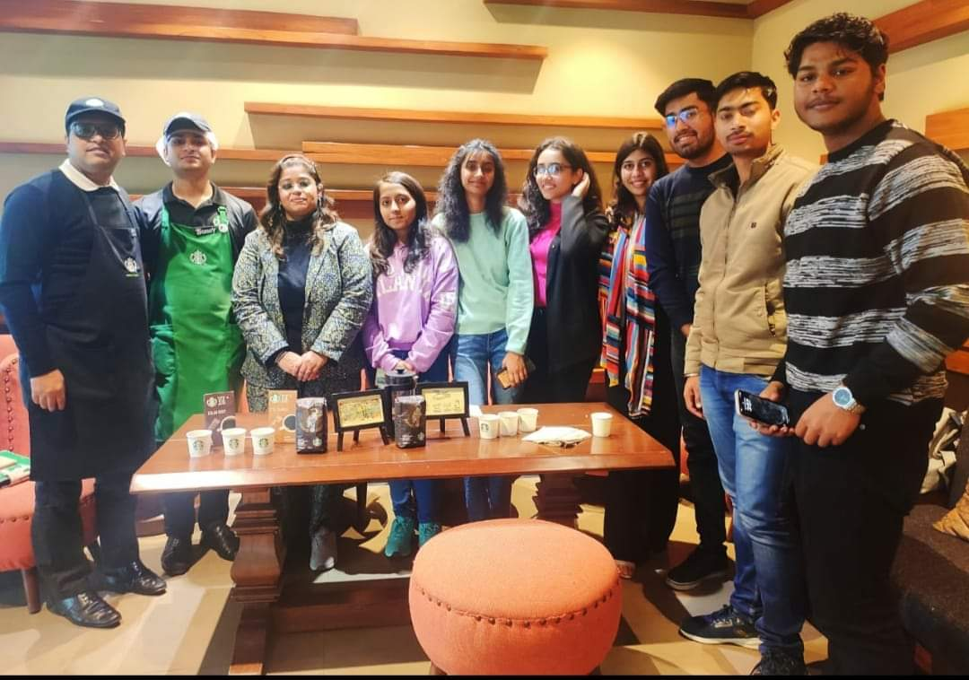
Figure 2 (A) Industry interaction of students at TATA Starbucks outlet and coffee tasting session. | (B) Student receiving the Black Belt Barista Certification at the TATA Starbucks Outlet in Delhi University, North Campus.
 | 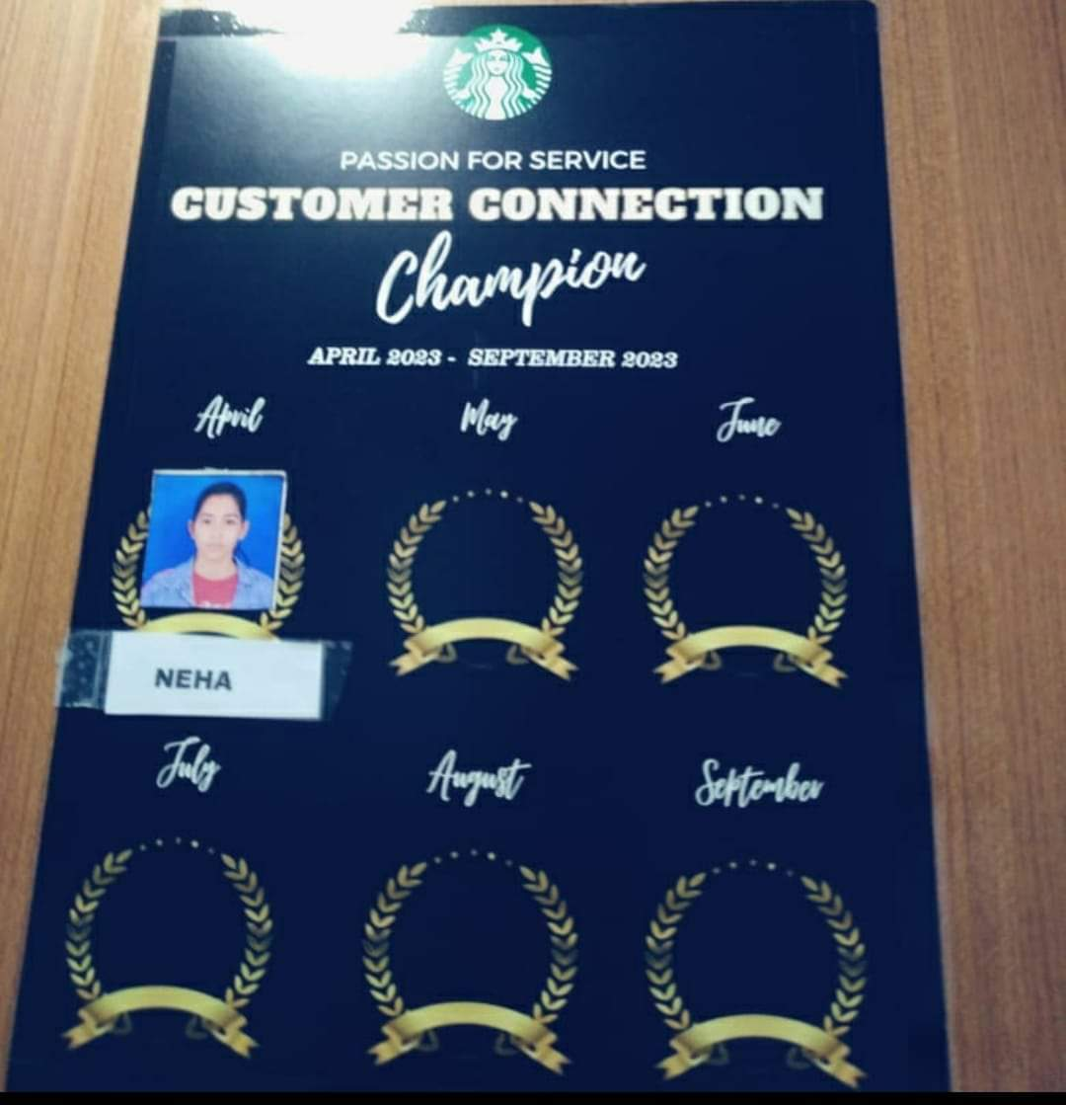
(C) Student receiving the Achiever's Award at the TATA Chroma outlet in Connaught Place, New Delhi | (D) Student receiving the "Passion for Service, Customer Connection Champion Award" at the TATA Starbucks outlet in Connaught Place for the period of April to September 2023.

2. It was difficult for the supervisors of the outlets to comprehend the situation where the students spent three days on the shop floor but were absent during rest of the days attending classes.

3. The supervisors did not well receive the fact that the students under them would soon
be replacing them in their positions
.
4. Delay in making payments to the industry partners and part time faculty by the university results in further delays in organizing placement drives for the students and loosing interest in teaching leading to improper implementation of the programme

Implications of the Present Study
Lives and livelihoods were severely disrupted during the pandemic. Urban India has been worst affected by the Covid-induced unemployment that had surged to over 10 percent by April 2021 (CMIE), with numbers expanding rapidly during the second wave of the pandemic (Adeeb, 2021). On the brighter side, the pandemic has accelerated digital adoption that would reach to over 500 million people belonging to lower rungs of the society in India by 2022 (ONI). In other words, the post pandemic world would have half a billion new opportunities for digital skilling and entry into the skill-based economy (Seiler, 2020).
A sizable chunk of India’s population is in the 18 to 34 age bracket comprising young, emerging workforce that will be pivotal in improving the country’s social and economic conditions (Adeeb, 2021). Opportunities would open up for them in Customer service, Retail, BPO, Food & Beverages, and Sales far more easily. As more and more services become online, all job aspiring students and employed workers from various sectors of businesses are learning new skills to cope up with the pandemic like situations in future (Adeeb, 2021).
Technology is being effectively used now to bridge the gap between the physical and digital worlds to provide a unique ‘Phygital’ experience to the customers (Kumar, 2021). The Phygital retail experience has brought forth certain trends in the retail industry, one of these being the Convergence. This concept blurs the boundaries between the unorganised sectors like the handloom workers, craftsmen and the organised marketplace. In addition, there is the emergence of a concept of collaboration beyond competition. Retailers are now beginning to see the drawbacks of an isolated approach in comparison to strategic partnerships (Kumar, 2021).
The AEDP in Retail Operations is a welcome step in promoting this sector. This program is in alignment with UGC guidelines, actively involves academia and industry and is designed to create a workforce that is well-prepared for the industry. This employment-oriented program focuses on nurturing undergraduate students from the very beginning of their educational journey.

Conclusions
The pandemic experience, spread and cost effectiveness of information technology and easy availability of digital gadgets attracted the retailers to acquire and engage customers in all new possible ways.
The rapid rise in digital adoption would enable the disadvantaged youth of the society located in Tier 2 and 3 locations to acquire skills that would facilitate their entry to the service sector.
This comfort of digital medium coupled with availability of smart phones and cheap data rates have provided an excellent opportunity to youth to access online training programs. A detailed analysis of the data collected by SWAN Livelihood during the Covid period showed that digital learning, communication skills, financial literacy creative and critical thinking skills and counselling support were the main aspirations of the youth in order to become job ready
The pre Covid learning and skill development models are still relevant but need more technological inputs. The post Covid introduction of the AEDP by the RASCI in Skill Development Universities caters to the urgent need of fulfilling the gaps in demand and supply of the workforce in the retail industry. However, it requires induction of full time experienced professionals for close monitoring and better financial management.
In context of retail chains, there has to be a reorientation of the roles of the workers and acquiring employment would be easier for those in possession of digital skills such as web chat, social and direct messaging. Keeping in view the reinvented customer journey, retailers would look out for sufficiently skilled staff to deal with their demands. There is also a need to increase the apprentice payroll in line with the wage rate set by the government to ensure that the long working hours of the retail associates matches with the salary or remuneration of the employees and motivates them to perform well.
Furthermore, it is essential to ensure the effective execution of the retail program by deploying specialists with a robust background in monitoring skill development initiatives at the grassroots level. These experts should be appointed in institutions instead of relying on professionals with an academic background but lacking familiarity with the industry setup.

References
Adeeb, Saurabh. (May 15, 2021). Unemployment surges to 10.72% amid COVID-19 pandemic; digital upskilling may help revive job market. Financial Express.Retrieved from https://www.financialexpress.com/industry/unemployment-surges-to-10-72-amid-covid-19-pandemic-digital-upskilling-may-help-revive-job-market/2252018/ on date March 10, 2022.

Briedis, Holly.,Kronschnabl, Anne., Rodriguez, Alex., and Ungerman, Kelly. (May 14, 2020). Adapting to the next normal in retail: The customer experience imperative. McKinsey & Company. Retrieved from https://www.mckinsey.com/business-functions/strategy-and-corporate-finance/our-insights/how-covid-19-has-pushed-companies-over-the-technology-tipping-point-and-transformed-business-forever on date March 11, 2022.

Business World Online Bureau. (April 07, 2020). RAI Survey Results – Impact of Covid-19 on Indian Retailers.Business World. Retrieved from
https://www.businessworld.in/article/RAI-Survey-Results-Impact-of-Covid-19-on-Indian-Retailers/07-04-2020-188501/on date March 09, 2022.

Chand, Nandika. (April 01, 2021). COVID-19 driven lockdowns and curfews affecting business: RAI. Plunge Daily. Retrieved from https://mybigplunge.com/business/covid-19-driven-lockdowns-curfews-affecting-business-rai/ on date March 11, 2022.

Joshi, M., &Duhan, P. (2022). Skill Development in Retail Sector: An Innovative Approach Using Smart Technology for the Underprivileged Youth in Delhi. In Futuristic Trends in Management, Volume 2, Book 6, Part 2, Chapter 3 (pp. 187-200). IIP Proceedings. Retrieved from https://www.rsquarel.org/assets/docupload/rsl2023C950730B0473F4A.pdf

Kuijpers, Dymfke., Simmons, Virginia., and Wamele, Jasper van. (December 03, 2018). Reviving grocery retail: Six imperatives. Retrieved from
https://www.mckinsey.com/industries/retail/our-insights/reviving-grocery-retail-six-imperatives on date March 11, 2022.

Kumar. (February 23, 2021). Is your talent ready for the new ‘phygital’ era in retail? Disprz blog article.Retrieved from https://disprz.com/blog/is-your-talent-ready-for-the-new-physical-era-in-retail/ on date March 11, 2022.

LaBerge, Laura., O’Toole, Clayton., Schneider, Jeremy., and Smaje, Kate. (October 5, 2020).
How Covid-19 has pushed companies over the technology tipping point- and transformed businesses forever. Retrieved from COVID-19 digital transformation & technology | McKinsey on date March 12, 2022.

OECD Policy Responses. (June 16, 2020). COVID-19 and the retail sector: impact and policy responses. Retrieved from https://www.oecd.org/coronavirus/policy-responses/covid-19-and-the-retail-sector-impact-and-policy-responses-371d7599/ on date March 13, 2022.
Parul.(April 07, 2020).COVID-19 Impact on Indian retail: Recovery dependent on the government’s support. Retrieved from https://smefutures.com/covid-19-impact-on-indian-retail-recovery-dependent-on-the-governments-support/ on date March 14, 2022.

Seiler, Daniella. (October 05, 2020). How COVID-19 has pushed companies over the technology tipping point—and transformed business forever, McKinsey & Company. Retrieved from https://www.mckinsey.com/business-functions/strategy-and-corporate-finance/our-insights/how-covid-19-has-pushed-companies-over-the-technology-tipping-point-and-transformed-business-forever on date March 14, 2022

Vader, Rene., Martin, Paul., and Qian, Jessie. (KPMG, 2022).The realities of retailing in a COVID-19 world.Retrieved from https://home.kpmg/xx/en/home/insights/2020/03/realities-of-retailing-in-covid-19-world.html on date March 14, 2022.

