“USE OF PLASTIC IN BITUMEN FOR CONSTRUCTION OF ROAD”

Prof.Mrs.A.P.Chougule.
Faculty of Civil Engineering Department Dr J.J.Magdum College of Engineering, Jaysingpur.
Kolhapur , Tal - Shirol
Email- arati.chougule@jjmcoe.ac.in

Prof. Mahendra Umare
Faculty of Civil Engineering Department
KDK College of engineering, Nagpur.
Dist – Nagpur.
Email- mnu72@rediffmail.com

Abstract: The use of plastic in bitumen will allow for the utilization of waste plastic materials it increases the quality of the road in this case plastic bitumen can reduce the overall cost of the project since plastic bitumen can increase the life of the road & reduce the long term maintenance requirement it should provide long term cost saving to the agency when the proper use of plastic bitumen in construction of a road.
In this project, we have to increase the concentration of plastic & decrease the concentration of bitumen by taking different concentration ratios of plastic & bitumen. We have to design the module of plastic bitumen blend which have all the standard properties of the regular bitumen by taking a different test like flash fire point, penetration etc, on plastic bitumen blend.
Keywords: - plastic, bitumen, plastic bitumen blend
1. INTRODUCTION
Plastic is everywhere in the world. In every industry plastic is used as a main component like packing material in building construction, in making toys etc. Also in the automobile industry plastic materials are widely used all over the world. Nowadays plastic is widely used in plastic bottles, used for mineral water packing, cold rinks storage, detergent storage etc. After use of that bottle for a one-time purpose they are thrown here and there. And that creates pollution. By using these plastic bottles in bitumen we can increase the strength of the road. If the plastic is added in proper proportion to the bitumen the life span of the road would be increased. It can save money and also protects the environment. In various countries, the plastic is used in road construction.
The proper use of these materials can help to build an economical road. The maximum proportion of plastic in plastic bitumen blend can help strong and durable roads.
II. OBJECTIVES
1. To reduce the quantity of bituminous and to increase the quantity of plastic in the construction of flexible pavement.
2. To increase the life span of the road.
3. To reduce the overall cost of the road.
4. To test the bitumen and modified bind.

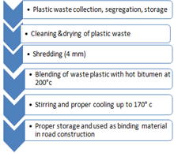
III. LITERATURE REVIEW
1. Dr R. Vasudevan (2007) concluded in his research article that a polymer bitumen blend outperforms ordinary bitumen in terms of binding. Blend lowers the penetration value while increasing the softening point of bitumen. When used in road construction, it raises the temperature of the road. Plastic coating reduces porosity and moisture absorption while also improving soundness. The use of waste plastic on the road aids in various ways, including garbage disposal, improved road conditions, and pollution presentation, among others.
2: Anzar Hamid Mir (2015) “Plastic Waste in Pavement Construction He introduces that the viscous elastic nature of binder has complex modulus phases of angles of binders, which need to be measured at different temperatures, loading rates which are resembling weather and climatic condition.
3: Amit P. Gowanda (2013) “Economics and Viability of Plastic Road” In that research paper polymer modified bitumen is used due to its better performance but in the case of a higher percentage of polymer bitumen blend, the blend is more polymer dispersion in bitumen, which get separated on cooling this may affect the properties and quality of the road.
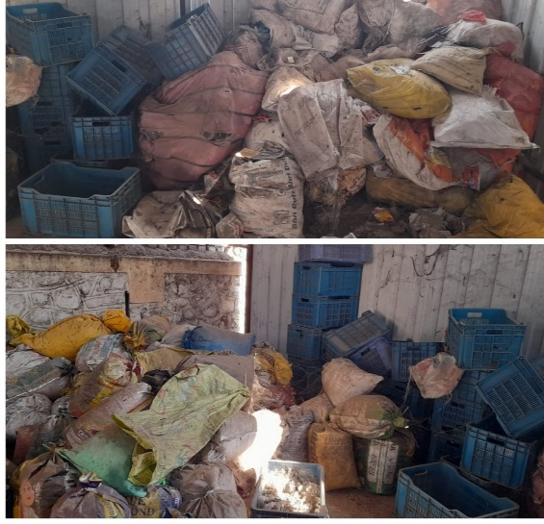
4: Verma S.S (2008) Studied that plastic will increase the melting point of bitumen. This technology not only strengthens the road but also increases the life of the road.
5:Dr. S. Vasudevan and S. Rajasekaran (2006) Examine the polymer bituminous blend as a better binder as compared to plain bitumen. The blend has increased the softening point of bitumen but decreased the penetration value with a suitable ductility.
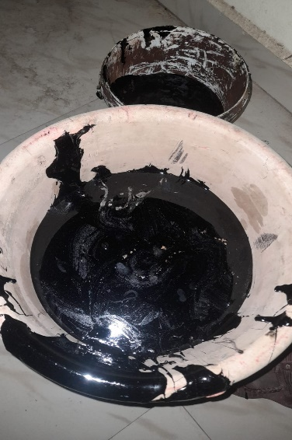
IV. MATERIAL USED AND COLLECTION OF MATERIAL
The following materials are used in the manufacturing of plastic bitumen blends. Waste poly bags, waste plastic bottles, and bitumen are the main materials used for making plastic bitumen blend.
A: POLY BAGS &WASTE PLASTIC BOTTLES: Low-density polyethene bags or plastic bags &waste plastic bottles are waste which is highly found in the environment. These types of bags are regularly used by people for carrying goods and daily needs. Being lightweight they can carry enough number of items which we can predict good strength. A lot of research had been done by the researchers to involve plastic in the construction material. This waste of low-density polyethene is polybasic and is found in the dumping area and the place where huge plastic bags are gathered. Due to environmental problems by these waste LDPE poly bags, they have to be properly disposed of by using plastic management techniques or used for recycling.
B: BITUMEN: Bitumen is a low-grade crude oil which is composed of complex, heavy hydrocarbons. In an oil reservoir, bitumen is a thick, viscous fluid and must be extracted from the ground. When extracting it, a lot of heat and effort must be used to upgrade it to a better product. Although bitumen is hard to extract from the ground, it can bubble naturally to the surface of the Earth in petroleum seeps. These seeps are places where fossil fuels and petroleum products leak out of the Earth instead of being trapped deep below the ground. In these seeps, bitumen, asphalt, and tar bubble up into pools. Additionally, bitumen is the main fossil fuel component of oil sands. When bitumen combines with asphalt, a solid is formed that is useful for paving roads.
V. TESTS ON MATERIALS

1. Penetration
2. Flash & Fire point test
3. Viscosity

RESULTS
- For 15% plastic in the blend
TEST | RESULT | RANGE
PENETRATION | 23 | 60-70
FLASH & FIRE POINT. | 305  320 | 250-300
VISCOSITY | 601 | 550-600

2. For 20% plastic in the blend
TEST | RESULT | RANGE
PENETRATION | 23 | 60-70
FLASH & FIRE POINT. | 305  320 | 250-300
VISCOSITY | 640 | 550-600

3. For 30 % plastic in the blend
TEST | RESULT | RANGE
PENETRATION | 23 | 60-70
FLASH & FIRE POINT. | 305  320 | 250-300
VISCOSITY | 701 | 550-600

VI. CONCLUSION
- When the plastic is replaced by bitumen using 30%, the standard range exceeds. Hence, we conclude that plastic bitumen blend with 30% plastic is not suitable for road construction purposes.
- Now the plastic is replaced by bitumen using 20%, and the results of the test exceed the permissible range by a small percentage.
- Lastly, the plastic is replaced by bitumen using 15%, and the results of the test are found in between the permissible range

Hence our conclusion is the replacement of plastic with bitumen using 15% is suitable for road construction purposes.
REFERENCES
- Amit Gawande, G.S Zaire, V.C Range G.R Bharsakalea and Saurabh Tayde, utilization of waste plastic in the asphalt of roads, scientific reviews and chemical communication
- Dr S.S. Verma, “Road from Plastic State. Science Tech Entrepreneur, March 2008 Gianni A.K. Mode, A.J., “Bio Enzymatic Soil Stabilizers for Construction of Rural Roads”, International Seminar on Sustainable Development in Road Transport, New Delhi-India 8-10November 2001
- Dr Salish Chandra, Shiv Kumar & Rajesh Kumar An ad, “Soil Stabilization with Rice Husk Ash and line Sludge”, India Highways, Indian Roads Congress, vol. 33 No. 5, May 2005, pp.87-98
- Dr. Vasudevan and S. Rajasekaran, (2007). ‘Utilization of Waste Plastics in Construction of Flexible Pavements (Reuse of waste plastics – a path-breaking initiative)’
- Use of waste Plastic in Construction of bituminous road.”( Vol. 4 No.05 May 2012) (International Journal of Engineering Science and Technology (IJEST)
- Vasudevan, Rajasekaran, S.Saravanavel, “Reuse of Waste Plastics for Road Laying” Indian Highways, (Journal of Indian Roads Congress) Vol. 34. Issue 7, Page No: 5 – 20 July 2006.
- Vera S.S. (I.C.J.), (2008). ‘Roads from plastic waste

