Bioethanol production from Horticultural waste
Gouthami Y. ¹ and Praveen Gidagiri ²
Ph.D. Research Scholar, Department of Post Harvest Management, College of Horticulture, Bagalkot, Karnataka
Ph.D. Research Scholar, Department of Post Harvest Management, College of Agriculture, Vellyani, Thiruvanthapuram, Kerala

- INTRODUCTION
India generates about 350 million tonnes of agricultural waste every year. As per the estimates given by the ministry of new and renewable energy, this waste can generate more than 18,000 MW of power every year apart from generating green fertilizer for use in agriculture. Globally about 1.3 billion tonnes of food products for human consumption gets wasted or lost every year. Taking a single crop of potato for example, total world potato waste is estimated to be 12 million tonnes per annum out of which 2 million tonnes of potato waste is generated in India alone (Anon., 2020). This in turn generates obnoxious gases and greenhouse gases besides foul odour, around the landfill sites.
Several technologies are used to convert agricultural waste into wealth by development of biocommodities with potential market demand such as fermented beverages, single-cell proteins (SCP), single-cell oils (SCO), biocolours, flavours, polysaccharides, biopesticides, plant growth regulators, bioethanol, biogas and biohydrogen through microbial processing (Panda et al., 2017).
The world’s present economy is highly dependent on various fossil energy sources such as oil, coal, natural gas, etc. These are being used to produce fuel, electricity, and other goods (Uihlein and Schbek, 2009). Excessive consumption of fossil fuels has resulted in environmental pollution and the level of greenhouse gasses in the earth’s atmosphere has drastically increased (Ballesteros et al., 2006). In this scenario, renewable sources might serve as an alternative, and petroleum-based fuels can be replaced by renewable biomass fuels such as bioethanol, biodiesel, bio-hydrogen, etc., derived from sugarcane, corn, algae, other agricultural wastes, fruits and vegetable wastes etc.
2. BIO ETHANOL AND ITS IMPORTANCE
Bioethanol is a liquid biofuel that is produced by microbial fermentation of several different types of feedstocks such as corn, soybeans, wheat straw, woodchips, fruits and vegetable wastes and more recently microalgae. Bioethanol is non-toxic, biodegradable and does not cause environmental pollution as compared to the fossil fuel. The conversion of waste to bioethanol can reduce emission of greenhouse gases (Stichnothe and Azapagic, 2009). Waste materials containing cellulose, lignin, and lignocellulosic can be used to produce bioethanol. In addition, the biomass containing high carbon content including waste can be used to produce bioethanol by converting polysaccharides into simple fermentable sugars. The yeast fermentation of these sugars can result in the production of bioethanol. North America and Brazil produce large quantities of bioethanol as transportation fuel. It is necessary to increase the production and use of bioethanol as an alternative to petroleum fuel.
There are many advantages of biofuel as bioenergy source. Biofuel is considered as carbon neutral, due to the release of carbon dioxide while burning which is equal to the amount that the plants absorb, and they don’t contribute to the increasing of the global warming. For the same reason biofuel is less polluting the environment than fossil fuel. Biofuel encourages farm income, reduce energy costs and promote further rural development while pleasing the environmental community. Production of biofuel replaces the usage of high price petroleum.
Bioethanol production process is classified into three generations.
  - First-generation bioethanol
  - Second-generation bioethanol
  - Third-generation bioethanol
2.1 First-generation bioethanol
First-generation ethanol was produced mainly from plant sugars or starches, directly from food crops. Corn, wheat and sugarcane were the major feedstocks used . Sugar-based ethanol plants are predominantly produced in Brazil from sugarcane and starch-based ethanol was produced generally from corn and from grains significantly in USA, followed by other ethanol-producing countries such as China, Canada, France, Germany, and Sweden (Arifin et al., 2014).
The United States alone accounted for 58% of ethanol production, followed by Brazil (28%), China (3%), Canada (2%) and Thailand (1%); the European Union, led by France and Germany, accounted for 6 % of global production (Niphadkar et al., 2017).
The main disadvantage of first-generation biofuel is the food versus-fuel crisis which is the main reason for rising food prices due to an increase in production of these fuels. Therefore, there is a search for more efficient and productive alternatives. Plant waste biomass, which mainly contains lignocellulosic materials, has the potential to produce novel biofuels known as second generation biofuels.
Drawbacks and current status
Corn is the foremost source for ethanol production, especially in the US where 40% or more of the corn crop was used for such production. Corn is the staple food in many developing as well as developed countries, and this led to a global increase in food prices and even hunger. The same problem also results when sugarcane is used as feedstock. Both corn and sugarcane cultivation require the use of pesticides and fertilizers, which is costly and, moreover, results in soil and water contamination. So environmental hazards posed another constraint in the production. In addition, the production rate of ethanol with corn as feedstock is slow (350 gallons of fuel per acre) and energy yield is also quite low (20 % net yield).
2.2 Second-generation bioethanol
Second-generation bioethanol production used ‘plant biomass’ that was considerably cheaper, abundant and did not present food-related conflicts (Gomez et al., 2008). Second generation ethanol production processes were designed in such a way to avoid food-versus-fuel conflicts and focused on agricultural residues and forest wastes mainly comprising of different types of lignocellulosics (Lennartsson et al., 2014). The second-generation bioethanol production processes were a little immature initially, but with advancement in bioprocess strategies, cost reduction and availability of sustainable resources, they developed into a profitable venture for a few producers. Eg:- Borregaard Company (Norway), often considered the largest second-generation ethanol-producing unit (Rodsrud et al., 2012).
Drawbacks or production constraints of second-generation bioethanol
The major concern with second-generation bioethanol production was the sugar degradation and energy consumption in pre-treatment operations, which make the overall process a costly affair (Palacios-Bereche et al., 2013; Dias et al., 2014). Another major constraint was the lack of efficient microorganisms for simultaneous C₅ and C₆ fermentation into bioethanol. Again, the enzymes used for saccharification process were costly, adding to the overall production cost.
2.3Third-generation bioethanol
Third-generation bioethanol used high-carbon embedded biomass for production purposes. Nahak et al. (2011) reported that seaweed and marine algae such as Enteromorpha species contain 70% carbohydrate (dry weight basis), which can be explored for bioethanol production. Borines et al. (2013) carried out the degradation of polysaccharides from Sargassum spp. by optimizing pretreatment conditions in terms of glucose and reducing sugar and produced ethanol (10–15%). Due to high biomass conversion potential (46,760–140,290 L/ha), more research is done now a days on the production of third-generation biofuels, especially biofuels from macro or micro algae (Chaudhary et al., 2014).
Drawbacks, new approaches and current status
The chemical analysis of different macroalgae in the late 1990s revealed carbohydrate contents of 25–50 % in green algae, 30–60 % in red algae and 30–50 % in brown algae (Sarkar et al., 2012; Karimi et al., 2013). In macroalgae species such as Ascophyllum, Porphyra and Palmaria, the polysaccharide contents can be as high as 70–76 %. The major drawback associated with algal biorefining was that it did not directly yield fermentable sugars and a further optimized pre-treatment was a prerequisite.

Table 1. Approximate ethanol yields from different feedstocks.
Bioethanol Generation | Biomass Source | Ethanol Yield (L/t) | Reference
First generation | Sugar beet  Sugar cane  Cassava  Maize  Rice  Wheat | 110 (L/t)  70–75 (L/t)  137–180 (L/t)  400 (L/t)  430 (L/t)  340 (L/t) | FAO, 2008
Second generation | Corn stover  Wheat straw  Sugarcane bagasse  Juice from Agave americana leaves  Rice straw | 362–456 (L/t)  406 (L/t)  318–500 (L/t)  34 (L/t)  416 (L/t) | Corbin et al., 2015
Third generation | Microalgae  Brown seaweeds (macroalgae)  Seagrass (macroalgae)  Green seaweeds (macroalgae)  Red seaweeds (macroalgae) | 167–501 (L/t)  12–1128 (L/t)  747 (L/t)  72–608 (L/t)  12–595 (L/t) | Ramachandra and Hebbale, 2020

Among the threegeneration process of bioethanol production, second generation process comprises a wide range of novel biofuels based on new feedstocks from lignocellulosic materials which includes agricultural wastes (eg. straw), energy crops (eg. Miscanthus, poplar), forestry products and wastes and parts of municipal solid waste. Hence second generation (2G) bioethanol production process is an attractive alternative for bio waste utilization (Niphadkar et al., 2017)
3. RAW MATERIALS USED FOR BIOETHANOL PRODUCTION
Different types of biomass have a potential as raw materials for bioethanol production and based on the chemical composition, i.e., carbohydrate sources, they mostly form three groups:
- Sugar-containing raw materials: sugar beet, sugarcane, molasses, whey, sweet sorghum
- Starch-containing feedstocks: grains such as corn, wheat, root crops such as cassava
- Lignocellulosic biomass: straw, agricultural waste, crop and wood residues (Mussatto et al., 2010).
However, these sugar-and starch-containing feedstocks (first generation) compete with their use as food or feed, thus influencing their supply. Therefore, lignocellulosic biomass (second generation) represents an alternative feedstock for bioethanol production due to its low cost, availability, wide distribution and it is not competitive with food and feed crops (Tomas-Pejo et al., 2011).
4. PRETREATMENT OF BIOMASS FOR BIOETHANOL PRODUCTION
The most important processing challenge in the production of biofuel is pretreatment of the biomass. Lignocellulosic biomass is composed of three main constituents namely hemicellulose, lignin and cellulose. Pretreatment methods refer to the solubilization and separation of one or more of these components of biomass. It makes the remaining solid biomass more accessible to further chemical or biological treatment (Demirbas, 2005). The pretreatment is done to break the matrix in order to reduce the degree of crystallinity of the cellulose and increase the fraction of amorphous cellulose, the most suitable form for enzymatic attack (Sanchez and Cardona, 2008).
Goals of an effective pretreatment process are
- Formation of sugars directly or subsequently by hydrolysis
- To avoid loss and/or degradation of sugars formed
- To limit formation of inhibitory products
- To reduce energy demands
- To minimize costs
Physical, chemical, physicochemical and biological treatments are the four fundamental types of pretreatment techniques employed. In general, a combination of these processes is used in the pretreatment step.
4.1 PHYSICAL PRETREATMENT
4.1.1 Mechanical size reduction
The first step for ethanol production from agricultural solid wastes is comminution through milling, grinding or chipping. This reduces cellulose crystallinity (Sun and Cheng, 2002) and improves the efficiency of downstream processing. Wet milling, dry milling, vibratory ball milling and compression milling are usually done. Size reduction may provide better results, but very fine particle size may impose negative effects on the subsequent processing such as pretreatment and enzymatic hydrolysis.
4.1.2 Pyrolysis
Pyrolysis is an endothermic process where less input of energy is required. In this process the materials are treated at a temperature greater than 300 ºC, whereby cellulose rapidly decomposes to produce gaseous products such as H₂ and CO and residual char. The residual char is further treated by leaching with water or with mild acid. The water leachate contains enough carbon source to support microbial growth for bioethanol production. Glucose is the main component of water leachate. An average of 55% of total weight of biomass is lost during water leaching (Das et al., 2004).
4.2 PHYSICOCHEMICAL PRETREATMENT
4.2.1 Steam explosion or autohydrolysis
Steam explosion is a promising method of pretreatment which makes biomass more accessible to cellulase attack (Neves et al., 2007). This method of pretreatment without the use of any catalyst is promising and the biomass fractionates to yield levulinic acid, xylitol and alcohols. In this method the biomass is heated using high pressure steam (20-50 bar, 160-290 ºC) for a few minutes; the reaction is then stopped by sudden decompression to atmospheric pressure (Sanchez and Cardona, 2008). When steam is allowed to expand within the lignocellulosic matrix it separates the individual fibers (Balat et al., 2008).
4.2.2 Liquid hot water method
The liquid hot water method uses compressed hot liquid water (at pressure above saturation point) to hydrolyze the hemicellulose (Neves et al., 2007). It is a hydrothermal pretreatment method which releases high fraction of hemicellulosic sugars in the form of oligomers. The treatment generally occurs at temperatures of 170-230 ºC and pressures above 5 MPa for 20 min.
4.2.3 Ammonia fiber explosion
Ammonia fiber explosion (AFEX) pretreatment involves liquid ammonia and steam explosion (Balat et al., 2008). AFEX is an alkaline thermal pretreatment which exposes the lignocellulosic materials by high temperature and pressure treatment followed by rapid pressure release.
4.2.4 CO₂ explosion
CO₂ explosion acts in a manner like that of the steam and ammonia explosion techniques. Conversion yields are higher compared to the steam explosion method (Hamelinck et al., 2005). However, CO₂ explosion is more cost effective than ammonia explosion and does not cause the formation of inhibitors as in steam explosion (Prasad et al., 2007).
4.3 CHEMICAL PRETREATMENT
Chemical pretreatment methods involve the usage of dilute acid, alkali, ammonia, organic solvent, SO₂, CO₂ or other chemicals. These methods are easy in operation and have good conversion yields in short span of time.
4.3.1 Acid pretreatment
Acid pretreatment is considered as one of the most important techniques and aims for high yields of sugars from lignocellulosics. It is usually carried out by concentrated or diluted acids (usually between 0.2 % and 2.5 % w/w) at temperatures between 130 ºC and 210 ºC. Moiser et al. (2005) reported higher hydrolysis yield from lignocellulose pretreated with diluted H₂SO₄ compared to other acids. A saccharification yield of 74 % was obtained from wheat straw when subjected to 0.75 % v/v of H₂SO₄ at 121 ºC for 1 h (Saha et al., 2005). Sulfuric acid is widely used for acid pretreatment among various types of acid such as hydrochloric acid, nitric acid and phosphoric acid (Cardona et al., 2009).
4.3.2 Alkaline pretreatment
Alkali treatment of lignocellulose disrupts the cell wall by dissolving hemicelluloses, lignin, and silica, by hydrolyzing uronic and acetic esters, and by swelling cellulose. Crystallinity of cellulose is decreased due to swelling. Sun et al. (1995) studied the effectiveness of different alkaline solutions by analyzing the delignification and dissolution of hemicellulose in wheat straw. They found that the optimal process condition was that using 1.5% NaOH for 144 h at 20 ºC, releasing 60 % and 80 % lignin and hemicellulose, respectively. Alkaline pretreatment of lignocellulosics digests the lignin matrix and makes cellulose and hemicellulose available for enzymatic degradation (Pandey et al., 2000a). NaOH has been reported to increase hardwood digestibility from 14 % to 55 % by reducing lignin content from 24-55 % to 20 % (Kumar and Wyman, 2009).
4.3.3 Wet oxidation
In wet oxidation, the feedstock material is treated with water and either by air or oxygen at temperatures above 120 ºC (Martin et al., 2007). The water is added to the biomass at a ratio of 1 L per 6 g of biomass. There have been several studies on wet oxidation as a pretreatment strategy using different substrates (Banerjee et al., 2009). Pedarson and Meyer (2009) obtained yields of 400 and 200 g/kg of wet oxidation treated wheat straw for glucose and xylose respectively after 24 h at 50 ºC using an enzyme mixture of 36 FPU/g celluclaste 1.5 L and 37 CBU/g of Novozyme-188.
4.3.4 Organosolv pretreatment
Organic solvent or organosolv pulping processes are alternative methods for the delignification of lignocellulosic materials. The utilization of organic solvent/water mixtures eliminates the need to burn the liquor and allows the isolation of the lignins (by distillation of the organic solvent). Examples of such pretreatments include the use of 90 % formic acid and that of pressurized carbon dioxide in combination (50 % alcohol/water mixture and 50 % carbon dioxide). Other various organic solvents which can be used for delignification are methanol, ethanol, acetic acid, performic acid and peracetic acid, acetone, etc. (Zhao et al., 2009). A combination of ammonia and ionic liquid pretreatments of rice straw resulted in 97 % conversion of cellulose to glucose (Nguyen et al., 2010).
4.4 BIOLOGICAL PRETREATMENT
In comparison to most of other pretreatments used, biological pretreatments are considered as environmentally friendly processes, since they do not employ chemicals, energy input is relatively low, there are no corrosion-related problems, no waste stream, and production of inhibitors is on the lowest level. In these pretreatments, microorganisms like brown, white and soft rot fungi degrade lignin and hemicellulose, but they are not effective in cellulose disruption (Sanchez, 2009).
4.4.1 Enzymes hydrolysis
Biological pretreatment also includes the use of enzymes for hydrolysis of raw lignocellulosic materials. Cellulases perform enzymatic hydrolysis of cellulose, so that yeasts or bacteria can ferment the obtained reducing sugars into ethanol (Sun and Cheng, 2002). In the hydrolysis of cellulose at least three major groups of cellulases take part: endoglucanases (attack regions of low crystallinity in the cellulose fibre creating free chain ends), exoglucanases (cellobiohydrolases; degrade the molecule further by removing cellobiose units from the free chain ends) and β-glucosidases (hydrolyze cellobiose to produce glucose) (Prasad et al., 2007).
Enzymatic hydrolysis can be divided into two stages: primary and secondary.
- Primary hydrolysis: Stage involves the action of endoglucanases and exoglucanases on the surface of solid substrate, resulting in the release of oligosacharides (up to 6 glucose units in chain) into liquid phase.
- Secondary hydrolysis: Stage includes further hydrolysis of oligosacharides to cellobiose (by cellobiohydrolase) and glucose (by β-glucosidases).
Lignin is closely bound to cellulose and therefore it is not accessible for cellulases. The main characteristic of lignin degradation is the action of peroxidases where lignin peroxidase (also called ligninase) and manganese peroxidase (also called Mn-dependent peroxidase) are the two major enzymes. Laccase (benzenediol oxygen oxidoreductase) also takes part in the lignin degradation which is synthesized by the broad variety of white rot fungi (Binod et al., 2010).
Enzymatic hydrolysis is highly specific, and it occurs in milder reaction conditions (e.g. pH=5 and temperature below 50 ºC) with lower energy consumption and environmental impact than the acid hydrolysis of lignocellulose. It also gives high glucose yield with low byproduct formation, which is favourable for further use of hydrolysate in fermentation.
5. BIOETHANOL PRODUCTION PROCESS
Bioethanol can be produced from a large variety of carbohydrates (mono, di, and polysaccharides). Polysaccharides are often organised in chains of bonded monosaccharides, which result from dehydration syntheses. Polysaccharides and disaccharides are usually broken down to monosaccharides and later monosaccharides are converted to bioethanol and CO₂.
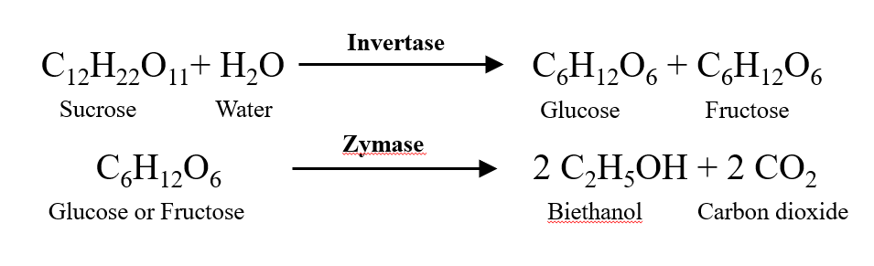
Yeast fermentation is a well-established natural metabolic process where industrial yeast strains turn complex carbohydrates into single sugars and sugar into an alcohol or an acid. Usually, two reactions perform as basic ingredients in converting cellulose into bioethanol by enzymatic hydrolysis and fermentation process.

Bioethanol production largely depends on fermentation processes which are,
- Simultaneous saccharification and fermentation (SSF)
- Simultaneous saccharification and co-fermentation (SSCF)
- Separate hydrolysis and fermentation (SHF)
- Solid state fermentation (SSF)
5.1 Simultaneous saccharification and fermentation (SSF)
Simultaneous saccharification and fermentation (SSF) is a process that combines enzymatic hydrolysis with fermentation to obtain value-added products in a single step. This process is based on the use of an enzymatic complex to hydrolyze cellulose and obtain sugars. These sugars are later used by the microorganisms and are converted into value-added products. SSF has several advantages with respect to other fermentative processes. Some of the advantages compared to separate enzymatic hydrolysis and fermentation (SHF) are the use of a single vessel for the fermentation and saccharification, reducing both residence times and the capital costs of the process. Another prominent advantage is the reduction of inhibitory compounds from enzymatic hydrolysis, which improves the overall performance of the process. Due to these advantages, SSF has been widely investigated to produce biofuels such as ethanol and butanol from lignocellulosic and starchy raw materials (Das-Neves et al., 2007).
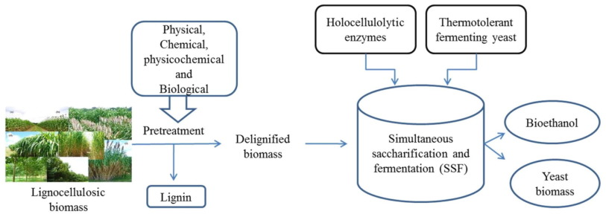
Among the disadvantages are the pH and temperature of the process, since the optimum temperature of enzymatic hydrolysis is typically greater than the fermentation temperature. Therefore, it is necessary to find an equilibrium point where the process works properly (Niphadkar et al., 2017)

5.2 Simultaneous saccharification and co-fermentation (SSCF)
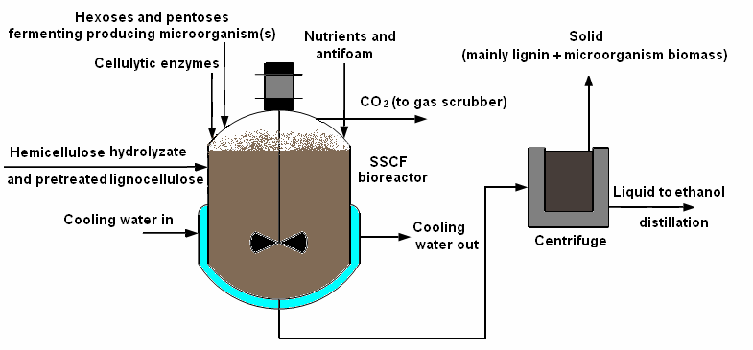
Simultaneous saccharification and co-fermentation (SSCF) is another alternate process to SSF which allows hexose and pentose fermentation simultaneously. In SSCF configuration, microorganisms used for fermentation should have similar operating pH and temperature. SSCF offers the potential of streamlined processing while reducing capital costs (Cardona and Sanchez, 2007).

5.3 Separate hydrolysis and fermentation (SHF)
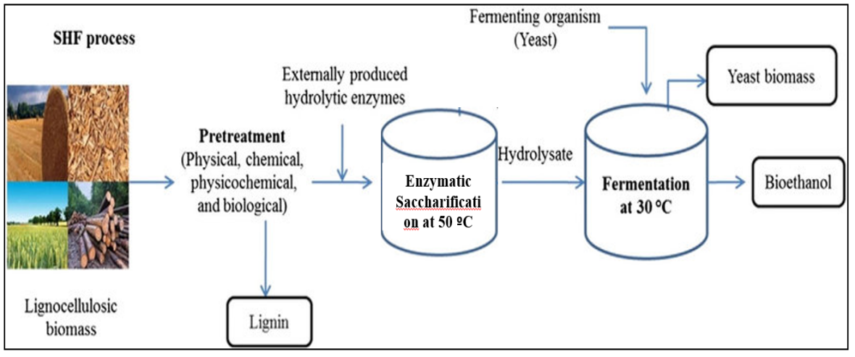
Separate hydrolysis and fermentation (SHF) process has been fairly implemented for ethanol production and is basically starch based ethanol production process. In this process, starch is initially catalysed by the action of amylolytic enzymes viz. α-amylase (for liquefaction) and glucoamylase (for saccharification). The process can be accomplished by fermentation in separate vessels. Major disadvantage with this process is inhibition of enzyme activity due to accumulation of hydrolysed sugar. It is also an expensive and time-consuming process (Das-Neves et al., 2007).

5.4 Solid state fermentation (SSF)
Solid state fermentation is an efficient, cost effective and promising technology in which microorganisms grow on the surface of solid materials in the absence of free water resulting in elimination of sugar extraction process and less water production, which in turn yields lower distillation and purification costs. Furthermore, SSF is well established technology for production different enzymes. This potential of SSF makes it an appropriate process for enzymatic pretreatment and hydrolysis of substrates and subsequent bioethanol production. (Pandey et al., 2000b).
Solid state fermentation stimulates the growth of micro-organisms in nature on moist solids and has been credited to be responsible for the beginning of fermentation technique in ancient time (Mitchell and Lonsane, 1990). Almost all the fermentation processes used in ancient time were based on the principles of SSF. SSF offers numerous opportunities in processing of agro-industrial residues as the solid-state processes have lower energy requirements, produce lesser wastewater and are environmental-friendly as they resolve the problem of solid wastes disposal.
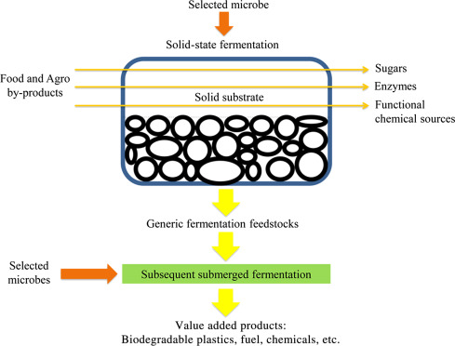

- FERMENTATION MODES
6.1 Batch fermentation: Microorganisms are provided with a fixed volume of medium (nutrients and other ingredients). Culture environment is consistently changing as nutrients are consumed (Yang and Sha, 2019).
Advantages | Disadvantages
- Low cost  - Low risk of contamination  - Less control required  - Easier sterilization | - Lower cell densities, ethanol production  - Longer downtime between batches due to cleaning, vessel setup, and sterilization

6.2 Fed-Batch fermentation: Media is inoculated with microorganisms which then grow under a batch regime for a certain amount of time, then nutrients are added incrementally throughout the fermentation (Yang and Sha, 2019).
Advantages | Disadvantages
- Maintenance of maximum viable cell concentration  - Extended lifespan of cells  - Higher ethanol accumulation  - By-product accumulation is limited  - Control of factors (e.g., pH, temperature, dissolved oxygen) | - Increased costs for process control  - Longer downtime between batches due to cleaning, vessel setup, and sterilization

6.3 Continuous fermentation: Fresh media is continuously added to the fermenter, replacing the consumed nutrients. Ethanol, used media, and toxic metabolites are continuously removed (Yang and Sha, 2019).
Advantages | Disadvantages
- Less downtime for vessel cleaning  - Increased productivity  - Lower cost  - Higher degree of control  - Ability to automate, more cost-efficient and less sensitive to human error. | - Less control for non-growth-related products  - Cell aggregation can prevent optimum steady-state growth  - Long growth periods can increase risk of contamination  - Can be difficult to maintain filamentous organisms due to viscosity and heterogeneity of the medium
[[[

Table 2. Difference between batch, fed batch and continuous fermentation
Characteristics | Batch | Fed batch | Continuous
Cultivation system | Closed type | Semi-closed type | Open type
Addition of fresh nutrition | No | Yes | Yes
Volume of culture | Constant | Increases | Constant
Removal of wastes | No | No | Yes
Chance of contamination | Minimum | Intermediate | Maximum
Growth phase | Lag, Log, Stationary and Decline phase | Lag, Log, Stationary and Decline phase | Lag and Log phase
Log phase | Shorter | Longer | Longest and continuous
Product yield | Low | Medium | High

7. BIOETHANOL SEPARATION AND PURIFICATION
Two energy-demanding separation steps are necessary to obtain purified ethanol (95.63 % by mass) from binary azeotrope ethanol-water (Huang et al., 2008). The first step is a standard distillation that concentrates ethanol up to the level of 92.4–94 % by mass. The cyclic distillation for ethanol purification is an energy-efficient alternative that is characterised by relatively low investments. The second step involves ethanol dehydration to obtain an anhydrous ethanol (ethanol concentrations above the azeotropic composition). Several well-known methods serve that purpose, such as pressure-swing distillation (Mulia-Soto and Flores-Tlacuahuac, 2011), extractive distillation (with liquid solvent, dissolved salt, their mixture, ionic liquids, hyperbranched polymers), azeotropic distillation and combination of these methods.
In order to reduce energy consumption of conventional distillation, membrane techniques have gained attention as an alternative because of a number of advantages that make them attractive for the separation of liquid mixtures. They have high separation efficiency, energy and operating costs are relatively low, they produce no waste streams, and they can be used in the separation of temperature-sensitive materials (Radocaj and Diosady, 2014).
Pervaporation can be carried out in parallel to the fermentation. This is promising system for in situ extraction of ethanol, which is harmless to the working microorganism (Kaewkannetra et al., 2011). Gas stripping is another alternative to distillation for the extraction of volatile components, such as ethanol, from fermentation broth (de Vrije et al., 2013). The nanocomposite membrane made of polyamides with integrated carbon nanotubes was also used for ethanol separation (Marjani et al., 2014). The silicalite-1/polydimethylsiloxane /polyvinylidene fluoride hybrid composite membrane was used for the in situ extraction of ethanol during the fermentation of sorghum juice in a fed-batch and a continuous bioprocess (Cai et al., 2016).
4. Fourth generation bioethanol (4G)
Genetically modified algae can offer higher product yields and a variety of other improvements compared to wild-type algae. With respect to genetic engineering, CRIPSR/Cas9 is a frequently used tool, as it offers a simple design with efficient transfection and targeted gene disruption.
In fourth-generation biofuel processes that focus on genetically optimized Cyanobacteria, the production of ethanol, as well as other fuel products such as butanol, isobutanol, and modified fatty acids have been realized successfully.
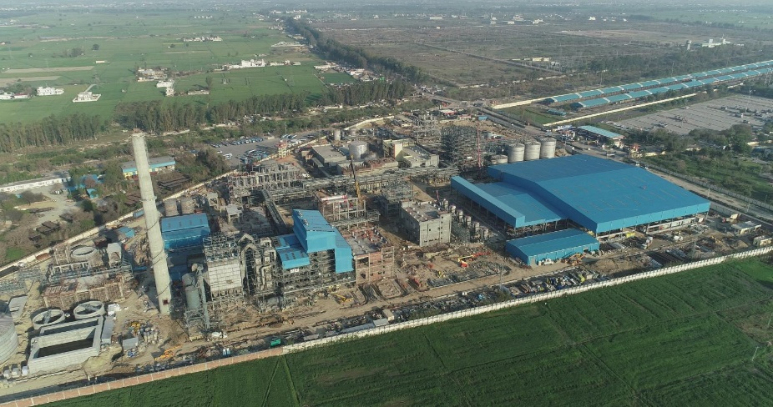

Asia's First 2G Ethanol Bio-Refinery of Indian Oil Corporation Limited (IOCL) at
Panipat, Haryana (10th Aug 2022).

Advantages of Bioethanol
- Carbon neutral
- Encourages farm income
- Reduce energy costs
- Replaces the usage of high price petroleum
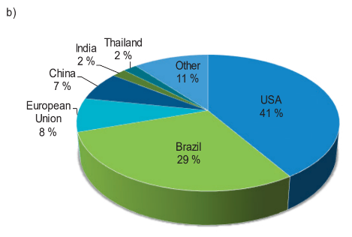
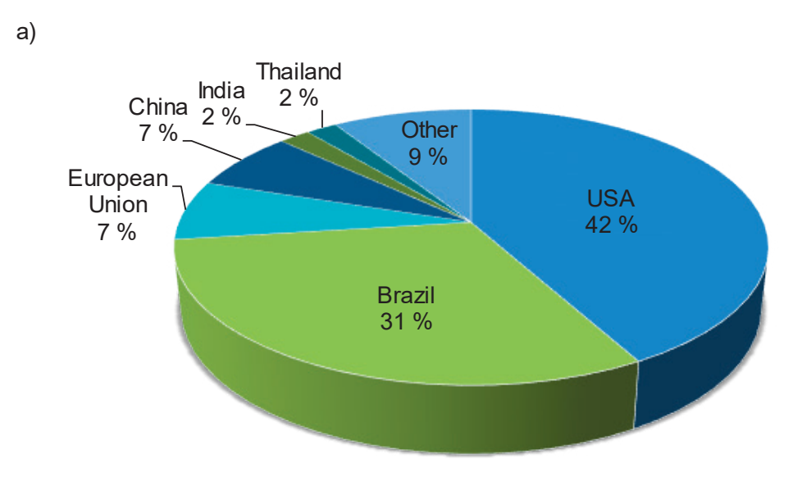
Fig. 12: Predictions of the world bioethanol (a) production and (b) consumption by 2024

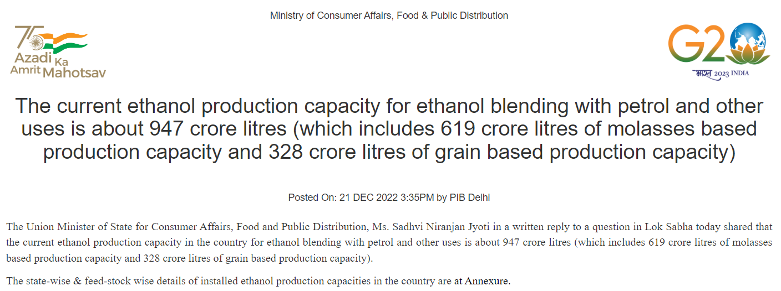

https://pib.gov.in/PressReleasePage.aspx?PRID=1885392
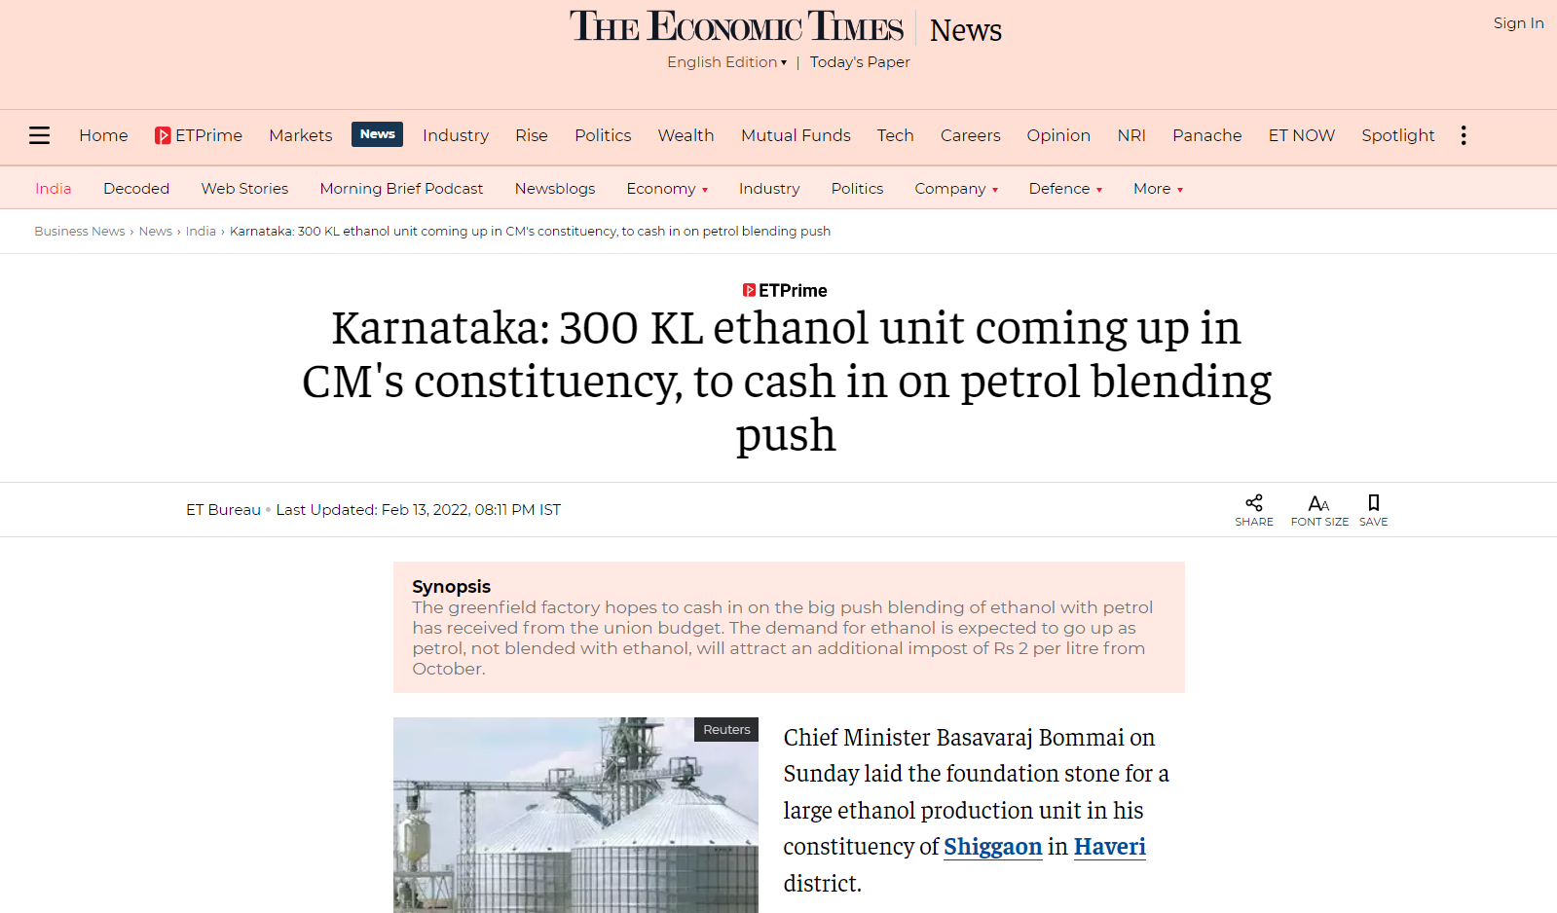
Ministry of Petroleum & Natural Gas
India has achieved the target of 10 percent ethanol blending, 5 months ahead of schedule Posted On: 05 JUN 2022 2:11PM by PIB Delhi
A “Roadmap for Ethanol Blending in India 2020-25” was released by the Hon’ble Prime Minister in June 2021 which lays out a detailed pathway for achieving 20 per cent ethanol blending. This roadmap also mentioned an intermediate milestone of 10 per cent blending to be achieved by November 2022.
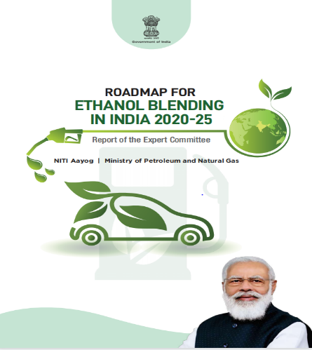
Twelve commercial plants ave already been proposed to be built under the Pradhan Mantri JI-VAN (Jaiv Indhan-Vatavaran Anukool Fasal Awashesh Nivaran) Yojana in regions with adequate biomass supply.
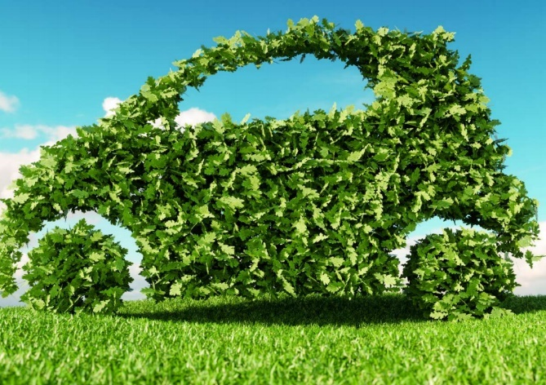

Companies
- Balrampur Chini Mills Ltd.
- Triveni Engineering Ind.
- Shree Renuka Sugars Ltd.
- EID Parry (India) Ltd
- Bajaj Hindusthan Sugar Company
- Godavari Biorefineries Limited
- Dalmia Bharat Sugar and Industries Limited
- Simbhaoli Sugars Limited
Uses of Bioethanol has several applications, including:
Uses of Fuel: It is blended with gasoline to create ethanol fuel (commonly known as E10 or E85, depending on the ethanol-to-gasoline ratio). Ethanol is used as a renewable and cleaner-burning alternative to fossil fuels, reducing greenhouse gas emissions and dependence on finite resources.
1. Industrial Applications: Ethanol is used as a solvent in the manufacturing of various products, including pharmaceuticals, personal care items, and cleaning agents.
2. Alcoholic Beverages: Ethanol is the primary alcohol found in alcoholic beverages.
Benefits and Challenges: Bioethanol offers several environmental benefits, as it is produced from renewable resources and reduces net carbon dioxide emissions compared to fossil fuels. However, there are also challenges associated with its production, including competition with food crops, land-use changes, and potential impacts on water resources.
Researchers and scientists continue to work on improving bioethanol production methods and exploring alternative feedstocks that are less resource-intensive and do not directly compete with food production. Additionally, advancements in second-generation biofuels, such as cellulosic ethanol, aim to use non-food-based feedstocks like agricultural residues and municipal solid waste, further reducing environmental impacts.
Overall, bioethanol remains an essential component of the global effort to transition to more sustainable and environmentally friendly energy sources.
9. CONCLUSION
Total agricultural wastes of India are about 350 million tonnes for every year. Indiscriminate dumping and burning of agricultural solid waste have resulted in pollution, a threat to human lives as well as other environmental problems. These wastes can be managed properly through the number of applications such as fuel, fertilizers, animal feed production etc. The principle of using agricultural wastes to produce bioethanol will aid in keeping the environment clean and process will help in overcoming the challenges of depletion of fossil fuel with the creation of bioresearch energy. Bioethanol produced from the agricultural waste is valuable, eco-friendly alternative to non-renewable fuels. Adding a proportion of bioethanol to conventional gasoline reduces greenhouse gas emissions during combustion. Additionally, modern motor vehicles run perfectly on bioethanol blends without any engine modification that has led to a cleaner environment and energy-savings. Hence bioethanol is a potential alternative energy source in future as there is a strong need for sustainable energy sources to decrease reliance on foreign petroleum oil.
- Eco-friendly alternative to non-renewable fuels
- Environment clean
- Reduces greenhouse gas emissions during combustion
- Modern motor vehicles run perfectly on bioethanol blends without any engine modification.
“Waste is not a waste until it is waste”.

10. REFERENCES
[Anonymous]. 2020. Creating Wealth From Agricultural Waste. Ministry of Agriculture and Farmers Welfare, Government of India, 148p.
Anoop, P. 2014. Utilization of pineapple (Ananas comosus (L.) Merr.) Biomass for biofuel production. M.Sc.(Ag) thesis, Kerala Agricultural University, Thrissur, 103p.
Arifin, Y., Tanudjaja, E., Dimyati, A., and Pinontoan, R. 2014. A second generation biofuel from cellulosic agricultural by-product fermentation using clostridium species for electricity generation. Energy Procedia 47: 310–315.
Balat, M., Balat, H., and Oz, C. 2008. Progress in bioethanol processing. Prog. Energy Combust. Sci. 34: 551-573.
Ballesteros, I., Negro, M. J., Oliva, J. M., Cabanas, A., Manzanares, P., and Ballesteros, M. 2006. Ethanol production from steam-explosion pretreated wheat straw. App. Biochem. Biotechnol.130: 496-508.
Banerjee, S., Sen, R., Pandey, R. A., Chakrabarti, T., Satpute, D., and Giri, B. S. 2009. Evaluation of wet air oxidation as a pretreatment strategy for bioethanol production from rice husk and process optimization. Biomass Bioenerg. 33: 1680-1686.
Binod, P., Sindhu, R., Singhania, R. R., Vikram, S., Devi, L., and Nagalakshmi, S. 2010. Bioethanol production from rice straw: An overview. Bioresour. Technol. 101(13): 4767–4774.
Borines, M. G., de Leon, R. L., and Cuello, J. L. 2013. Bioethanol production from the macroalgae Sargassum spp. Bioresour. Technol. 138: 22–29.
Cai, D., Hu, S., Chen, C., Wang, Y., Zhang, C., and Miao, Q. 2016. Immobilized ethanol fermentation coupled to pervaporation with silicalite-1/polydimethylsiloxane/polyvinylidene fluoride composite membrane. Bioresour. Technol. 220: 124–131.
Cardona, C. A. and Sanchez, O. J. 2007. Fuel ethanol production: Process design:trends and integration opportunities. Bioresour. Technol. 98(12): 2415-2457.
Cardona, C. A., Quintero, J. A., and Paz, I. C. 2009. Production of bioethanol from sugarcane bagasse: status and perspectives. Bioresour. Technol. 101(13): 4754-4766.
Casabar, J. T., Unpaprom, Y., and Ramaraj, R. 2019. Fermentation of pineapple fruit peel wastes for bioethanol production. Biomass Conv. Bioref. 15: 56-65.
Chaudhary, L., Pradhan, P., and Soni, N. 2014. Algae as a feedstock for bioethanol production: new entrance in biofuel world. Int. J. Chem. Tech. Res. 6(2): 1381–1389.
Corbin, K. R., Byrt, C. S., Bauer, S., DeBolt, S., Chambers, D., Holtum, J. A. M., Karem, G., Henderson, M., Lahnstein, J., and Beahan, C. T. 2015. Prospecting for energy-rich renewable raw materials: Agave leaf case study. PLoS ONE 10: 135382.
Danmaliki, G. I., Muhammad, A. M., Shamsuddeen, A. A., and Usman, B. J. 2016. Bioethanol production from banana peels. IOSR J. Environ. Sci., Toxicol. Food Technol. 10 (6): 56-62.
Das, P., Ganesha, A., and Wangikar, P. 2004. Influence of pretreatment for deashing of sugarcane bagasse on pyrolysis products. Biomass Bioenerg. 27: 445-457.
Das-Neves, M. A., Toshinori, K., Naoto, S., and Nakajima. 2007. State of the art and future trends of bioethanol production. Dyn. Biochem. Process Biotechnol. Mol. Boil. 1(1): 1-14.
de Vrije, T., Budde, M., Vander, W. H., Claassen, P. A. M., and Lopez-Contreras, A. M. 2013. ‘In situ’ removal of isopropanol, butanol and ethanol from fermentation broth by gas stripping. Bioresour. Technol. 137: 153–159.
Demirbas, A. 2005. Bioethanol from cellulosic materials: a renewable motor fuel from biomass. Energy Sources 27: 327-333.
Dias, M. O. S., Cavalett, O., and Filhob, R. M. 2014. Integrated first and second generation ethanol production from sugarcane. Chem. Engg. Transac. 37: 445–450.
Doda, S. and Sahu, O. 2021. Production of bioethanol from biomass (Marigold flower). Materials Today: Proceedings. www.elsevier.com/locate/matpr. 1-6.
FAO (Food and Agriculture Organization) 2008. The State of Food and Agriculture 2008. Biofuels: Prospects, Risks and Opportunities. Available online: http://www.fao.org/3/i0100e/i0100e.pdf (accessed on 5 August 2021).
Gomez, L. D., Clare, G. S., and McQueen-Mason, J. 2008. Sustainable liquid biofuels from biomass: the writing’s on the walls. New Phytol. 178: 473–485.
Gunam, I. B. W., Dewi, I. A. P. K., Antara, N. S., Anggreni, A. A. M. D., and Setiyo, Y. 2021. Bioethanol production from sugarcane bagasse by Saccharomyces cerevisiae ATCC 9763 immobilized in Na-alginate. IOP Conf. Series: Earth Environ. Sci. 824: 012054.
Hamelinck, C. N., Hooijdonk, G. V., and Faaij, A. P. C. 2005. Ethanol from lignocellulosic biomass: techno-economic performance in short-, middle- and long-term. Biomass Bioenerg. 28: 384-410.
Huang, H. J., Ramaswamy, S., Tschirner, U. W., and Ramarao, B. V. 2008. A review of separation technologies in current and future biorefineries. Sep. Purif. Technol. 62(1): 1–21.
Kaewkannetra, P., Chutinate, N., Moonamart, S., Kamsan, T., and Chiu, T. Y. 2011. Separation of ethanol from ethanol–water mixture and fermented sweet sorghum juice using pervaporation membrane reactor. Desalination. 271(1–3): 88–91.
Karimi, K., Shafiei, M., and Kumar, R. 2013. Progress in physical and chemical pretreatment of lignocellulosic biomass. In: Biofuel Technologies Recent Developments. Berlin Heidelberg: Springer-Verlag; p. 53–96.
Khoshkho, S. M., Mahdavian, M., Karimi, F., Karimi-Maleh, H., and Razaghi, P. 2022. Production of bioethanol from carrot pulp in the presence of Saccharomyces cerevisiae and beet molasses inoculum; A biomass based investigation. Chemosphere 286: 131688.
Kumar, R. and Wyman, C. E. 2009. Effects of cellulase and xylanase enzymes on the deconstruction of solids from pretreatment of poplar by leading technologies. Biotechnol. Prog. 25: 302-314.
Lennartsson, P. R., Erlandsson, P., and Taherzadeh, M. J. 2014. Integration of the first- and second-generation bioethanol processes and the importance of by-products. Bioresour. Technol. 165: 3–8.
Marjani, A., Mohammadi, M., Pelalak, R., and Moradi, S. 2014. Ethanol purification using polyamide-carbon nanotube composite membranes. Polym. Eng. Sci. 54(4): 961–968.
Martin, C., Klinke, H. B., and Thomsen, A. B. 2007. Wet oxidation as a pretreatment method for enhancing the enzymatic convertibility of sugarcane bagasse. Enzyme Microb. Technol. 40: 426-432.
Mitchell, D.A. and Lonsane, B. K. 1990. Definition, characterization and economic evaluation. In: Doelle, H. W. and Rolz, C. (Eds.). General Principles of Solid Substrate Fermentation. Rapid Publications of Oxford Ltd, UK.
Mosier, N., Hendrickson, R., Ho, N., Sedlak, M., and Ladisch, M. R. 2005. Optimization of pH controlled liquid hot water pretreatment of corn stover. Bioresour. Technol. 96: 1986-1993.
Mulia-Soto, J. F. and Flores-Tlacuahuac, A. 2011. Modeling, simulation and control of an internally heat integrated pressure-swing distillation process for bioethanol separation. Comput. Chem. Eng. 35(8): 1532–1546.
Mussatto, S. I., Dragone, G., Guimaraes, P. M. R., Silva, J. P. A., Carneiro, L. M., and Roberto, I. C. 2010. Technological trends, global market, and challenges of bio-ethanol production. Biotechnol. Adv. 28(6): 817–830.
Nahak, S., Nahak, G., and Pradhan, I. 2011. Bioethanol from marine algae: a solution to global warming problem. J. Appl. Environ. Biol. Sci. 1(4): 74–80.
Neves, M. A., Kimura, T., Shimizu, N., and Nakajima, M. 2007. State of the art and future trends of bioethanol production, dynamic biochemistry, process biotechnology and molecular biology. Global Science Books; 1-13.
Nguyen, T. A. D., Kim, K. R., Han, S. J., Cho, H. Y., Kim, J. W., and Park, S. M. 2010. Pretreatment of rice straw with ammonia and ionic liquid for lignocellulose conversion to fermentable sugars. Bioresour. Technol. 101(19): 7432-7438.
Niphadkar, S., Bagade, P., and Ahmed, S. 2017. Bioethanol production: insight into past, present and future perspectives. Biofuels. https://doi.org/10.1080/17597269.2017. 1334338.
Nugrahini, A. D., Kurniawan, M. P., and Kinasih, D. A. 2021. Development of lignocellulose-based bioethanol from chrysanthemum flower waste (Chrysanthemum sp.). IOP conf. series: Earth and Environ. sci. 963: 012017.
Palacios-Bereche, R., Mosqueira-Salazar, K. J., and Modesto, M. 2013. Exergetic analysis of the integrated first- and second-generation ethanol production from sugarcane. Energy 62: 46–61.
Panda, S. K., Ray, R. C., Mishra, S. S., and Kayitesi, E. 2017. Microbial processing of fruit and vegetable wastes into potential biocommodities: a review. Crit. Rev. Biotechnol. 1549-7801.
Pandey, A., Soccol, C. R., Nigam, P., and Soccol, V. T. 2000a. Biotechnological potential of agroindustrial residues. I: sugarcane baggase. Bioresour. Technol. 74: 69-80.
Pandey, A., Soccol, C. R., and Mitchell, D. A. 2000b. New developments in solid-state fermentation. I. Bioprocesses and products. Process Biochem. 35 (10): 1153-1169.
Pedersen, M. and Meyer, A. S. 2009. Influence of substrate particle size and wet oxidation on physical surface structures and enzymatic hydrolysis of wheat straw. Biotechnol. Prog. 25(2): 399-408.
Phuong, D. V., Quoc, L. P. T., Tan, P. V., and Duy, L. N. D. 2019. Production of bioethanol from Robusta coffee pulp (Coffea robusta L.) in Vietnam. Foods Raw Mater. 7(1): 10-17.
Phwan, C. K., Chew, K. W., Sebayang, A. H., Ong, H. C., Ling, T. C., Malek, M. A., Yeek‑Chia, H., and Show, P. K. 2019. Effects of acids pre‑treatment on the microbial fermentation process for bioethanol production from microalgae. Biotechnol. Biofuels 12:191.
Prasad, S., Singh, A., and Joshi, H. C. 2007. Ethanol as an alternative fuel from agricultural, industrial and urban residues. Resour. Conser. Recycl. 50: 1-39.
Radocaj, O. and Diosady, L. L. 2014. Continuous ethanol fermentation in immersed, cross-flow microfiltration membrane bioreactor with cell retention. J. Basic Appl. Sci. 10: 543–553.
Ramachandra, T. V. and Hebbale, D. 2020. Bioethanol from macroalgae: Prospects and challenges. Renew. Sustain. Energy Rev. 117: 109147.
Rodriguez, L. A., Toro, M. E., Vazquez, F., Correa-Daneri, M. L., Gouiric, S. C., and Vallejo, M. D. 2010. Bioethanol production from grape and sugar beet pomaces by solid-state fermentation. Int. J. Hydrogen Energy 35: 5914-5917.
Rodsrud, G., Lersch, M., and Sjode, A. 2012. History and future of world’s most advanced biorefinery in operation. Biomass Bioenrg. 46: 46–59.
Saha, B. C., Iten, L. B., Cotta, M. A., and Wu, Y. V. 2005. Dilute acid pretreatment, enzymatic saccharification and fermentation of wheat straw to ethanol. Process Biochem. 40: 3693-3700.
Sanchez, C. 2009. Lignocellulosic residues: Biodegradation and bioconversion by fungi. Biotechnol. Adv. 27(2): 185–194.
Sanchez, O. J. and Cardona, C. A. 2008. Trends in biotechnological production of fuel ethanol from different feedstocks. Bioresour. Technol. 99: 5270-5295.
Sarkar, N., Ghosh, S. K., and Bannerjee, S. 2012. Bioethanol production from agricultural wastes: An overview. Renew. Energ. 37(1): 19–27.
Seong, Choi., Jae-Hoon, Kim., Seung, G. W., Kyoung, H. K., and Hyeun-Jong, B. 2013. Bioethanol production from mandarin (Citrus unshiu) peel waste using popping pretreatment. Appl. Energy 102: 204–210.
Stichnothe, H. and Azapagic, A. 2009. Bioethanol from Waste: Life Cycle Estimation of the Greenhouse Gas Saving Potential. Resour. Conserv. Recy. 53: 624–630.
Sun, R. C., Lawther, J. M., and Banks, W. B. 1995. Influence of alkaline pretreatments on the cell-wall components of wheat-straw. Ind. Crops Prod. 4(2): 127-145.
Sun, Y. and Cheng, J. 2002. Hydrolysis of lignocellulosic material for ethanol production: a review. Bioresour. Technol. 96: 673-686.
Taha, M. G., Khattab, A. E., Ali, H. E., and Dawood, M. A. M. 2019. Production of bio-ethanol from potato starch wastes by Saccharomyces cerevisiae. Egypt. J. Appl. Sci. 34 (12): 256-267.
Tomas-Pejo, E., Alvira, P., Ballesteros, M., and Negro, M. J. 2011. Pretreatment technologies for lignocellulose-to-bioethanol conversion. In: Pandey A, Larroche C, Ricke SC, Dussap CG, Gnansounou E, editors. Biofuels – Alternative feedstocks and conversion processes. Oxford, UK: Academic Press; 2011. pp. 149–176.
Uihlein, A. and Schbek, L. 2009. Environmental impacts of a lignocellulosic feedstock biorefinery system: an assessment. Biomass and Bioenergy 33: 793-802.
Yang, Y. and Sha, M. A. 2019. Beginner’s Guide to Bioprocess Modes—Batch, Fed-Batch, and Continuous Fermentation; Eppendorf Application Note 408; Eppendorf: Hamburg, Germany.
Zhao, X., Cheng, K., and Liu, D. 2009. Organosolv pretreatment of lignocellulosic biomass for enzymatic hydrolysis. Appl. Microbiol. Biotechnol. 82: 815-827.

