BIOFUELS AS A RENEWABLE SOURCE OF ENERGY FOR PRESENT AND FUTURE

Dr.Deepti Suhalka

Assistant Professor, Department of Botany, B.N. University, Udaipur(Raj.)

Abstract: In the current context, biofuels are gaining growing popularity as a fuel source due to their environmental advantages and renewable characteristics. Biofuel is the method by which the energy derived from organic materials replaces the role of fossil fuels.
Biofuels encompass fuels sourced from organic materials, including plants and animals. These organic-based fuels encompass gaseous options like hydrogen (H2) and methane (CH4), as well as liquid alternatives such as methanol (CH3OH), ethanol (C2H5OH), biodiesel, and acetone (C3H6O).
Biofuels are regarded as some of the most straightforward and readily accessible fuels on Earth, primarily sourced from biomass such as wood and straw. These materials can be transformed into gaseous and liquid fuels through direct combustion of dry matter. Additionally, other sources like organic matter such as sludge, sewage, and vegetable oils can be converted into biofuels through wet processes like digestion and fermentation.
A biofuel encompasses any liquid fuel originating from biological materials like trees, agricultural residues, crops, or grass. These fuels can be generated from carbon sources that renew quickly, such as plants. Biofuels find global utility, with substantial growth in the biofuel sectors observed in Europe, Asia, North America, and South America. Notably, biofuels are characterized by their absence of sulfur and their capacity to yield low levels of carbon monoxide and toxic emissions.
Numerous tree species are known to produce oil-rich seeds, making them valuable sources of feedstock for biofuel production. Biodiesel can be manufactured using a range of raw materials, including soybean oil, rapeseed oil, Jatropha oil, palm oil, waste vegetable oil, and animal fat, among others.
The Bioenergy Technologies division is working in partnership with the industry to advance the development of next-generation biofuels produced from waste materials, cellulosic biomass, and resources derived from algae. These hydrocarbon biofuels, commonly referred to as "drop-in fuels," have the capacity to function as substitutes for petroleum in existing refineries, storage tanks, pipelines, vehicles, and smaller engines.
Biofuels function as alternatives to traditional fossil fuels like petroleum, propane, coal, and natural gas. Certain U.S. agricultural crops, such as switchgrass and soybeans, are deliberately cultivated for the specific purpose of biofuel production. The use of biofuels has the potential to decrease greenhouse gas emissions and enhance energy security by offering an alternative to fossil fuels. Projections indicate that by 2050, biofuels could lead to a reduction of approximately 1.7 billion tons of greenhouse gas emissions per year, equivalent to over 80% of the current emissions from transportation-related sources.
Economics is a pivotal factor in facilitating a seamless transition toward a future reliant on biofuels. Biomass and biofuels stand out as the sole renewable energy source capable of substituting fossil fuels, addressing both current and anticipated energy challenges.
Keywords: Gaseous Fuels, methanol, ethanol, rapeseed, switch grass

1.0 Introduction
Biofuel is an inexhaustible, biodegradable fuel manufactured from Biomass.”
Biofuels are gaining global attention as viable alternatives to petroleum-based transportation fuels, addressing concerns related to energy costs, energy security, and global warming associated with liquid fossil fuels. In this context, the term "biofuel" refers to any liquid fuel derived from plant materials that can serve as a substitute for petroleum-derived fuel. These biofuels encompass well-known options like ethanol from sugarcane or diesel-like fuels from soybean oil, as well as less familiar choices like dimethyl ether (DME) or Fischer-Tropsch liquids (FTL) produced from lignocellulosic biomass.
A relatively recent classification for liquid biofuels distinguishes between "first-generation" and "second-generation" fuels, with no strict technical definitions for these terms. The primary differentiation lies in the feedstock employed. First-generation fuels are typically derived from sugars, grains, or seeds, often utilizing the edible portions of plant biomass, and their production involves relatively simple processes. First-generation fuels are already being commercially produced in several countries.
In contrast, second-generation fuels are primarily crafted from non-edible lignocellulosic biomass, including inedible residues from food crop production (e.g., corn stalks or rice husks) or non-edible whole-plant biomass (e.g., grasses or trees specifically cultivated for energy purposes). As of now, second-generation fuels are not yet in commercial production in any country.
Biofuels have been in production since the early 1800s, with a common fuel blend of camphene and alcohol used for lamps during that period. While there were sporadic instances of biofuel development and utilization in the ensuing decades, it wasn't until the 1990s that biofuels gained more widespread prominence. The increasing cost of oil and concerns regarding greenhouse gas emissions have played pivotal roles in sustaining the development and production of biofuels over the past two decades.
In all cases, when biofuels are combusted for cooking, the resulting emissions of pollutants are notably lower, or even significantly lower, compared to emissions from cooking with solid fuels. Approximately 3 billion people in developing countries currently rely on solid fuels for cooking, and this practice has severe health implications due to indoor air pollution [1, 2]. One estimate [3] suggests that about 4 to 5 exajoules2 of clean cooking fuel annually would be sufficient to meet the basic cooking requirements of these 3 billion people. This quantity is roughly equivalent to around 1 percent of the world's current commercial energy consumption.
The most widely recognized first-generation biofuel is ethanol, which is produced through the fermentation of sugar extracted from sources like sugar cane, sugar beets, or starch found in maize kernels and other starch-rich crops. A similar processing method, employing different fermentation organisms, can also produce another alcohol known as butanol. Ongoing efforts are focused on the commercialization of butanol [4], whereas ethanol has already established itself as a well-established industry. In 2006, the global production of first-generation bio-ethanol reached approximately 51 billion liters [5], with significant contributions from Brazil (sugar cane) and the United States (maize).
In 2011, biofuels contributed to 3% of the energy utilized for road transportation on a global scale. The United States, being the largest biofuel producer worldwide, was a notable participant in this context. Meanwhile, Brazil, the second-largest biofuel producer globally, made an even more substantial impact in 2009, with biofuels accounting for 23% of the energy used for road transportation [6].
The substantial demand for various oils and their elevated prices pose a significant concern for humanity. As environmental awareness continues to grow, there is an imminent requirement to investigate alternative energy sources. Biofuels are widely recognized in this regard as a viable option for substituting fossil fuels [7].
Biofuel is characterized as any fuel obtained from biomass, which is synonymous with organic matter. This category encompasses plant and algae materials (including wood) as well as animal waste. Given that these fuel sources are naturally replenished through the life cycle, they are classified as renewable energy sources.
Biofuels are gaining growing appeal due to their environmental advantages. The ongoing reliance on petroleum-derived fuels is now widely acknowledged as unsustainable due to diminishing reserves and the significant contribution of these fuels to global warming, primarily through the substantial accumulation of carbon dioxide in the environment. Rising oil prices have incentivized major consumers worldwide to significantly boost their utilization of biofuels [8].
This renders them a compelling substitute for fossil fuels such as coal, oil, and natural gas. The latter resources necessitate development spanning millennia and extraction from deep underground through costly and environmentally detrimental procedures. Moreover, their consumption surpasses their natural production rate, leading to the eventual depletion of the planet's fossil fuel reserves, particularly if we persist in depleting them at the present rate.

1.1Need for biofuels
Fossil fuels, such as coal and petroleum, represent the most commonly used energy sources. These fossil fuels are considered non-renewable, implying that their depletion is inevitable. Consequently, the cost of petroleum continues to rise steadily. Fossil fuels undergo a formation process spanning millions of years through diverse geological mechanisms, making their extraction a costly endeavor. The release of greenhouse gases (GHGs) by fossil fuels contributes to global warming, intensifying the need for a renewable energy source that is both cost-effective and environmentally friendly. In this context, biofuels emerge as a promising alternative to fossil fuels.
2.0Classification of Biofuels

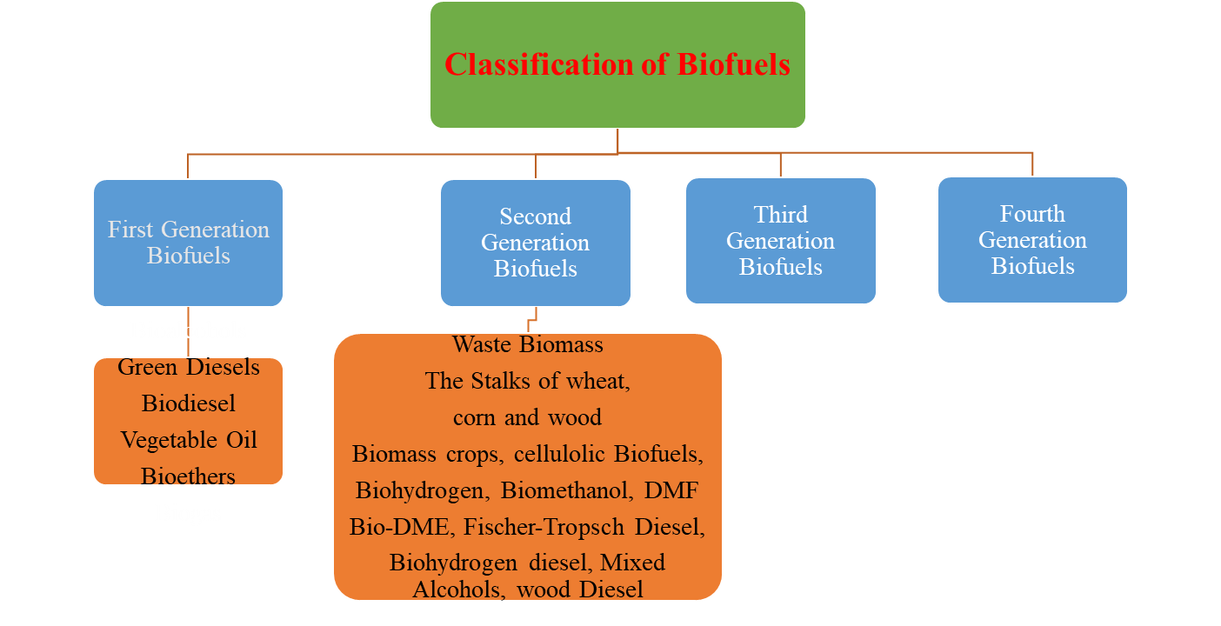
Green Gasoline, Green Diesel, Green Aviation Fuel
Algal Fuel

2.1First generation biofuels:
These fuels are manufactured from food-derived sources like sugar, starch, vegetable oil, or animal fats using conventional methods. Typical first-generation biofuels encompass Bioalcohols, Biodiesel, Vegetable oil, Bioethers, and Biogas. While the conversion process is straightforward, the utilization of food sources in biofuel production disrupts the food economy, resulting in elevated food costs and heightened instances of hunger.

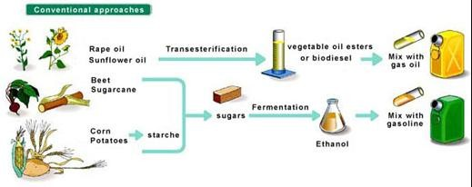

2.2 Second generation biofuels:
These fuels are derived from non-food crops or inedible parts of food crops, typically regarded as waste materials, such as stems, husks, wood chips, fruit skins, and peels. The production of these fuels involves thermochemical reactions or biochemical conversion processes. Examples include cellulose ethanol and biodiesel. While the production of these fuels doesn't impact the food economy, it is worth noting that their production is relatively complex. Additionally, it has been reported that these second-generation biofuels emit fewer greenhouse gases when compared to first-generation biofuels.
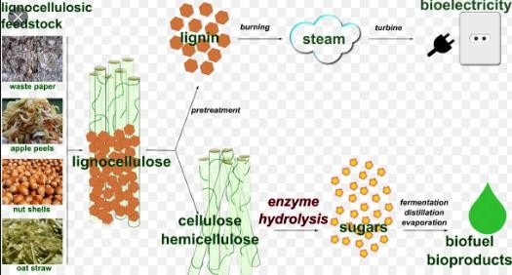
2.3 Third generation biofuels: These These fuels are generated from microorganisms such as algae, with butanol being an example. Microorganisms like algae can be cultivated in areas of land and water that are not suitable for food production, thus alleviating the burden on already scarce water resources. However, a drawback is that the use of fertilizers in the cultivation of these crops results in environmental pollution.
Top of Form

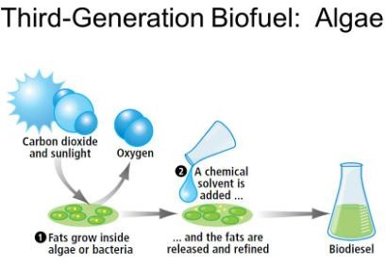
2.4 Fourth Generation Biofuels: In the manufacturing process of these fuels, genetically modified crops designed to absorb substantial amounts of carbon are cultivated and harvested as biomass. Subsequently, these crops undergo conversion into fuel utilizing second-generation methods. The fuel is pre-combusted, and the carbon is captured. This captured carbon is then geosequestered, signifying that it is stored in depleted oil or gas reservoirs or in unmineable coal seams. Certain biofuels are classified as carbon-negative since their production effectively removes carbon from the environment. These represent some of the primary types of biofuels.
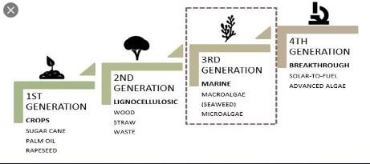
The overwhelming majority of biofuel consumption occurs within domestic settings, primarily in economically disadvantaged regions where alternative energy sources are scarce. These biofuels are predominantly employed for tasks such as heating water for cooking, washing, cleaning, and home heating. Presently, approximately 80% of all biofuels are dedicated to these domestic purposes. About 18% of known biofuels find application in industrial settings, while a mere 2% are utilized as a feedstock for vehicles in the transportation sector. Nonetheless, this latter usage is on the rise as individual drivers, automotive manufacturers, and national governments increasingly recognize the imperative to enhance the emissions performance of vehicles..

3.0Major Types of Biofuels
Bioethanol: Ethanol is produced through the fermentation of corn and sugarcane. One liter of ethanol contains roughly two-thirds of the energy content found in a liter of gasoline. When blended with gasoline, it enhances combustion efficiency and reduces emissions of carbon monoxide and sulfur oxide.
Biodiesel, on the other hand, is obtained from sources such as vegetable oils (e.g., soybean oil or palm oil), vegetable waste oils, and animal fats through a biochemical process known as "Transesterification." Biodiesel emits minimal or no harmful gases when compared to conventional diesel fuel, making it a viable alternative to traditional diesel.
Biogas: Biogas is generated through the anaerobic decomposition of organic materials, including animal and human sewage. The primary components of biogas comprise methane and carbon dioxide, with smaller fractions of hydrogen sulfide, hydrogen, carbon monoxide, and siloxanes. This versatile energy source finds widespread application in heating, electricity generation, and as a fuel for automobiles.
Top of Form
Biobutanol: Butanol is manufactured using a similar process to that of bioethanol, involving the fermentation of starch. Notably, butanol boasts the highest energy content among various gasoline alternatives. It can be blended with diesel to mitigate emissions, and it finds utility as a solvent in the textile industry, as well as serving as a foundational component in the production of perfumes.
Biohydrogen: Biohydrogen, similar to biogas, can be generated through various processes like pyrolysis, gasification, or biological fermentation. It represents a viable substitute for fossil fuels. One key advantage of biofuels is their availability since they are derived from biomass, making them a renewable energy source.
3.1 Plants for Biofuel extraction
Non-edible Plants: Jatropha, Castor, Mahua, Canola, Neem, Karanjia, Jojoba, Mint, Linseed.
Edible Plants: Sugarcane, Rapeseed, Sunflower, Palm oil, Soyabean, Molasses, Sugarbeat, Maize, Wheat, Barley, Potato, Peanut, Hemp, Coconut, Groundnut.

3.2 Process Of Biofuels
Step-1
The chosen plant crops are allowed to freely capture solar heat.
Step-2
Subsequently, these crops undergo processing in factories to manufacture food products.
Step-3
After the food products are manufactured, these crops undergo processing to produce biofuel.
Step-4
After the production of biofuels, they are collected in tanks and used for a different process.
Biomass or feedstock used for the production of biofuels are:
- Grain starch to produce bioethanol: Corn and wheat.
- Sugar crops to produce bioethanol: Sugarcane and sugar beets.
- The crops of oilseed used to produce biodiesel: Soybeans, rapeseeds, palm oil, cooking oil and other tropical oilseeds.
Cellulosic biomass to produce bioethanol are:
- Forest wastes.
- Municipal solid waste.
- Managed biomass such as trees and grass.
- Crop residues, such as corn Stover, wheat straw, rice straw, sugarcane bagasse.

4.0 Advantages of Biofuels
- Promotes a healthier population.
- It contributes to a more environmentally friendly ecosystem.
- No harmful gases like Carbon monoxide (CO) and sulfur oxide (SO) are emitted.
- Opting for biofuels instead of fossil fuels results in the emission of only non-toxic substances, mitigating the risk of cancer and respiratory issues in humans.
- Biofuels promote environmental friendliness by reducing the risk of global warming.
- Renewable. As previously stated, fossil fuels are a finite energy source that will eventually become depleted. In contrast, biofuels are theoretically renewable because they can be replenished by generating more organic matter.
- Carbon. Because biofuels are derived from organic matter, such as plants, and these plants absorb carbon from the atmosphere, biofuels are fundamentally more environmentally friendly than fossil fuels. Nevertheless, this argument loses some of its persuasiveness when the emissions savings are counterbalanced by the expenses and emissions associated with fertilization, transportation, and processing.
- Cost-effectiveness. The production of bioethanol is more cost-effective than that of petrol, thus merging the two can offer substantial cost savings in the transportation sector. Similarly, the pairing of biodiesel with diesel can yield similar advantages. Furthermore, as fossil fuel reserves diminish, their prices are bound to increase. Biofuels, being sustainable, contribute to greater pricing stability.
- Fuel efficiency. Compared to fossil fuels, bioethanol and biodiesel have lower levels of chemical contaminants such as chlorine and sulfur. Consequently, when blended with petrol or diesel, they have the capacity to reduce the concentration of these pollutants in the fuel, leading to cleaner emissions. For further details on the mechanics of this process, you can refer to the article titled "Ensure Accurate Results for Sulphur and Chlorine Analysis in Biodiesels," which provides valuable insights.
- Locality. Ultimately, biofuels have the potential for local production, generating employment opportunities in the very region where they will be utilized, thereby curbing transportation expenses and emissions linked to their distribution to the point of sale.
Top of Form
- Rise in farm land value – Increased demand for corn results in an escalation of agricultural land values. Health advantages stemming from decreased global warming.
- More efficient use than gasoline and protect vehicles – Ethanol can help prevent engine knocking, and it increases gasoline's lubricity.
- Low adoption cost – In the United States, ethanol is suitable for use in all gasoline-powered vehicles, with concentrations of up to approximately 10%. Ethanol offers the benefit of reducing vehicle emissions, eliminating the necessity to invest in a hybrid vehicle.
- Social‐Economics Benefits-Lowering the cost of oil - Economical ethanol leads to decreased oil demand and subsequently, lower oil prices. Diminish fossil fuel imports - Ethanol usage can cut down on gasoline consumption, reducing reliance on volatile foreign oil sources. Alleviate poverty rates - Since the majority of ethanol plants are located in rural areas, ethanol production fosters job creation through plant construction, ongoing operations, and maintenance.

4.1 Relevance of Biofuel Technology
Both developing and industrialized countries consider biofuels to be pertinent technologies for various reasons.
These reasons encompass energy security, environmental considerations, preservation of foreign exchange, and socioeconomic factors pertaining to rural areas..
Because biomass resources are abundant, technology centered on biomass-based fuel has the potential to create employment opportunities for a larger workforce compared to technology based on fossil fuels.
The escalating demand for energy is a consequence of the swift expansion of the population and urbanization.
As the primary conventional energy sources like coal, petroleum, and natural gas continue to diminish, biomass is emerging as a promising environmentally friendly and renewable energy alternative.
Because of its environmental advantages, the biofuel portion of the automotive fuel market is expected to experience rapid growth in the near future.
.
4.2 How Biofuels differ from Petroleum Feed stocks?
The primary distinction between biofuels and petroleum feedstocks lies in their oxygen content. Biofuels typically contain oxygen levels ranging from 10 to 45%, whereas petroleum essentially lacks oxygen, resulting in distinct chemical properties for biofuels in comparison to petroleum. Both biofuels and petroleum exhibit very low sulfur levels, with many biofuels also having low nitrogen levels. Biomass can be transformed into liquid and gaseous fuels through thermochemical and biological processes. Biofuel represents a non-polluting, locally available, accessible, sustainable, and reliable fuel derived from renewable sources.
Biomass serves as an appealing feedstock for three key reasons. Firstly, it is a renewable resource with the potential for sustainable development. Secondly, it demonstrates notably positive environmental characteristics, leading to negligible net carbon dioxide emissions and minimal sulfur content. Thirdly, biomass holds significant economic promise, particularly if fossil fuel prices rise in the future. The low emissions associated with lignocellulosic biomethanol stem from the fact that the carbon content in the alcohol primarily originates from carbon sequestered during the growth of the biofeedstock, thus being released back into the atmosphere. Carbohydrates found in plant materials, including hemicelluloses and cellulose, can undergo hydrolysis to transform into sugars. Fermentation, an anaerobic biological process, involves the conversion of these sugars into alcohol through the activity of microorganisms, typically yeast. This resultant alcohol is known as bioethanol. The suitability of a specific biomass type as a feedstock for fermentation is determined by the ease with which it can be converted into sugars.
4.3 Challengesofbiofuels
- Biofuels offer the promise of numerous benefits related to energy security, economics,andtheenvironment.
- Atthesametime,severalchallengesmustbeovercometorealizethesebenefits.
- ThemainadvantagesandchallengesintheproductionandconsumptionofbiofuelsarehighlightedintheTable given below
- Thekeyadvantageoftheutilisationofrenewablesourcesfortheproductionofbiofuelsistheutilizationofnaturalbioresources(thataregeographicallymoreevenlydistributed

thanfossilfuels)andproducedbioenergyprovidesindependenceandsecurityofenergysupply.

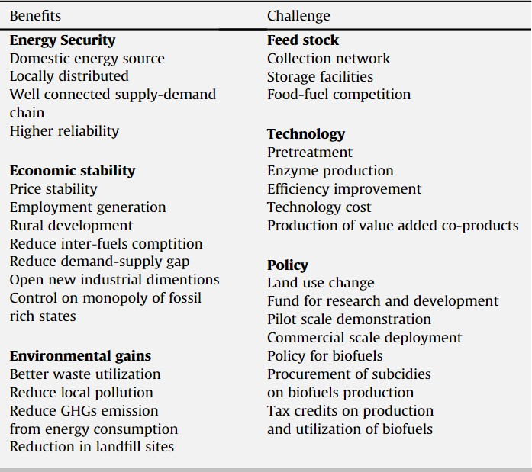Table-:BenefitsandChallengesofBiofuels

The utilization of agricultural residuals and waste substrates as raw materials serves to mitigate the potential conflict between food and fuel production while also generating biofertilizers and biopesticides.

5.0 Disadvantages Of Biofuel:
- It disrupts the life cycle.
- Labor costs are high, and extensive storage space is necessary.
- There is increased water consumption, particularly in arid regions.
- The cultivation of biomass for biofuel production raises the demand for agricultural land.

- Resource use. The energy output from biofuels is significantly lower compared to that derived from fossil fuel combustion, necessitating a substantially larger amount of land, water, and fertilizer to fulfill the energy requirements of an equivalent population. This holds especially true for primary biofuels.
- Delicate ecosystems. The oils required for biodiesel production frequently originate from endangered habitats like rainforests or other biodiverse regions. This method of land utilization results in the displacement of animal populations, ecosystem destruction, and the discouragement of biodiversity.
- Suitability. Not all vehicles are compatible with every type of biofuel. This issue is especially prominent in the UK, as many car models are not designed to operate with 100% biofuel blends. Additionally, biodiesel is unsuitable for aviation use due to its inadequate oxidative stability and elevated freezing point.
- Emissions. When primary biofuels are burned to generate heat, which is a prevalent practice in developing nations, they yield higher levels of local emissions compared to alternative heating methods.
- Increasing in water price – Increased water usage for crops reduces the available water for human consumption, leading to water shortages.
- Create new health problem – The use of ethanol in the presence of formaldehyde can result in decreased air quality when using biofuel.
- Demand of agriculture land- As the demand for alternative energy sources continues to rise, there could be an increase in the demand for agricultural land.
- Increase demand for biofuel- The utilization of cash crops like sugarcane, sugar beet, maize, and sorghum for biofuel production would lead to significant alterations in existing land utilization patterns.
- Deforestation (Socio economical problem)- When considering CO2 emissions, ethanol is more efficient than the preservation of native forests. Deforestation can lead to species extinction, alterations in weather patterns, soil degradation, and erosion. It also impacts local climates, future land utilization, and precipitation levels due to extensive agricultural activities.
6.0 Conclusion
Biofuel is a type of fuel derived from biomass, encompassing gases and liquid fuels. Biomass sources can include plant or algae materials as well as animal waste. Biofuel is regarded as a renewable energy source because its feedstock material can be readily replenished, distinguishing it from non-renewable fossil fuels like petroleum, coal, and natural gas. It is often promoted as a cost-effective and environmentally friendly alternative to petroleum and other fossil fuels, especially amid concerns about rising petroleum prices and the environmental impact of fossil fuels on global warming.
However, there are concerns among critics regarding the potential expansion of certain biofuels. This expansion is associated with economic and environmental costs in the refining process and the potential conversion of large areas of arable land away from food production. Biofuels are typically produced from crops that are rich in sugar (such as sugarcane, sugar beet, and sweet sorghum), starch (such as maize and tapioca), or oils. The term "biofuel" primarily refers to liquid or gaseous fuels used in the transportation sector, primarily derived from biomass. The consensus is that biofuels offer numerous advantages, including sustainability, reduced greenhouse gas emissions, and enhanced supply security. Biomass resources can yield a variety of fuels, encompassing liquid fuels like ethanol, methanol, biodiesel, and Fischer-Tropsch diesel, as well as gaseous fuels such as hydrogen and methane. Although biofuels are primarily employed in vehicles, they can also be utilized in engines or fuel cells for electricity generation. A more appealing progression would involve countries becoming producers, consumers, and exporters of finished biofuels, thus retaining a significant portion of the added value generated during the conversion of feedstocks into final fuels. Various scenarios support the conclusion that biofuels will see widespread utilization in the future energy landscape. The primary objective of this chapter is to examine a range of environmentally friendly techniques documented for the production of alcohols and esters using renewable energy sources. Additionally, it offers a comprehensive review of the environmental and economic consequences associated with biofuels.

References:
1. World Health Organization (2006). Fuel for Life: Household Energy and Health. Geneva.
2. International Energy Agency (2006). Energy for cooking in developing countries. World Energy Outlook, Chapter 15. Paris.
3. Goldemberg J, Johansson TB, Reddy AKN, and Williams RH (2004). A global clean cooking fuel initiative. Energy for Sustainable Development, VIII(3): 5–12.
4. Dupont (2007) DuPont invests $58 million to construct two biofuels facilities. Press release, 26 June (accessed via http://www2.dupont.com/Biofuels/en_US/news/index.html).
5. Website of the Renewable Fuels Association (http://www.ethanolrfa.org/).
6. Carlos H. Brito Cruz, Glaucia Mendes Souza and Luiz A. Biofuels for Transport(2014).Science direct Second Edition . 215-244
7.Z.A. Kapasia, A.R Nair, S.Sonawane and S.K. Satpute(2010).Biofuel- An alternative source of energy for present and future. J.of Advances in Science and Technology.Vol 13(3):105-108
8.Zafar I. Buhroo, MA Bhat, NA Ganai and JA Lone(2016) Biofuels and their future Perspectives. J. of Medicinal Plant Studies.4(6):256-264
9.OECD-FAQ Agricultural Outlook 2018-2027. Chapters on Biofuels
10.Daniela Thran, K.Naumann, E.Billing. Data on Biofuel Production, Trade and Demand.
11. Source:http://bioenergycenter.org/. what are biofuels.
12.Petro industry online 24 july 2023.What is biofuel, Advntages and Uses.
13.Biofuel Support policies and Economic Assesment.Biofuels, Introduction, objective and Scope.ISBN-97-89-26404922-2. OECD 2008
14. World Health Organization (2006). Fuel for Life: Household Energy and Health. Geneva.
15. International Energy Agency (2006). Energy for cooking in developing countries. World Energy Outlook, Chapter 15. Paris.
16. Goldemberg J, Johansson TB, Reddy AKN, and Williams RH (2004). A global clean cooking fuel initiative. Energy for Sustainable Development, VIII(3): 5–12.
17. Dupont (2007) DuPont invests $58 million to construct two biofuels facilities. Press release, 26 June (accessed via http://www2.dupont.com/Biofuels/en_US/news/index.html).
18. Website of the Renewable Fuels Association (http://www.ethanolrfa.org/).
19.Macedo IC (2007). Etanol de Cana de Acucar no Brasil. Presentation at the Seminar on Technologies for Future Ethanol Production in Brazil. Instituto Tecnologia Promon, Sao Paulo, Brazil, 17 April.
20. Collins K (Chief Economist, United States Department of Agriculture) (2007). The new world of biofuels: implications for agriculture and energy. Energy Information Administration (United States Department of Energy) Energy Outlook, Modeling, and Data Conference. 28 March.
21. Coelho S (2006). Brazilian sugar cane ethanol: lessons learned. Energy for Sustainable Development, X(2): 26–39.
22. Website of the European Biodiesel Board (http://www.ebb-eu.org/).
23. Bioproducts Alberta (2006). http://www.bioproductsalberta.com/news/sep/sep06_22.php.

