X RAY PRODUCTION IN DIAGNOSTIC RADIOLOGY
AUTHORS
1* VIGNESH. K, DEPARTMENT OF RADIOLOGY AND IMAGING TECHNOLOGY
SCHOOL OF ALLIED HEALTH SCIENCES, VINAYAKA MISSIONS RESEARCH FOUNDATION -DU, CHENNAI, TAMILNADU, INDIA
Vigneshmphy9@gmail.com

2*PREETHI.B, DEPARTMENT OF RADIO DIAGNOSIS
SRM MEDICAL COLLEGE HOSPITAL AND RESEARCH CENTRE
MAHATMA GANDHI RD, POTHERI, SRM NAGAR, KATTANKULATHUR, TAMIL NADU 603211, INDIA.
preethibaskar2406@gmail.com
Abstract
X-rays are a form of electromagnetic radiation with wavelengths ranging from 0.01 to 10 nanometers. In the setting of diagnostic radiology, X-rays have long enjoyed use in the imaging of body tissues and aid in the diagnosis of disease. Simply understood, the generation of X-rays occurs when electrons are accelerated under a potential difference and turned into electromagnetic radiation. An X-ray tube, with its respective components placed in a vacuum, and a generator, make up the basic components of X-ray production
I. INTRODUCTION
Medical imaging of the human body requires some form of energy. In the medical imaging techniques used in radiology, the energy used to produce the image must be capable of penetrating tissues. Visible light, which has a limited ability to penetrate tissues at depth, is used mostly outside of the radiology department for medical imaging. Visible light images are used in dermatology (skin photography), gastroenterology and obstetrics (endoscopy), and pathology (light microscopy). Of course, all disciplines in medicine use direct visual observation, which also utilizes visible light. In diagnostic radiology, the electromagnetic spectrum outside the visible light region is used for X-ray imaging, including mammography and computed tomography, magnetic resonance imaging, and nuclear medicine. Mechanical energy, in the form of high-frequency sound waves, is used in ultrasound imaging
II. PRODUCTION OF X RAY
The Conventional X-Ray Tube Consists of a Glass envelope to High Vacuum. One end is a cathode (negative electrode) at the other end is a Positive electrode both hermetically sealed in the Tube. The Cathode is a Tungsten lament when the heat emits an electron is known as thermionic emission. X-Ray is Produced when highly energetic electron interacts with matter and convert their kinetic energy into electromagnetic radiation.
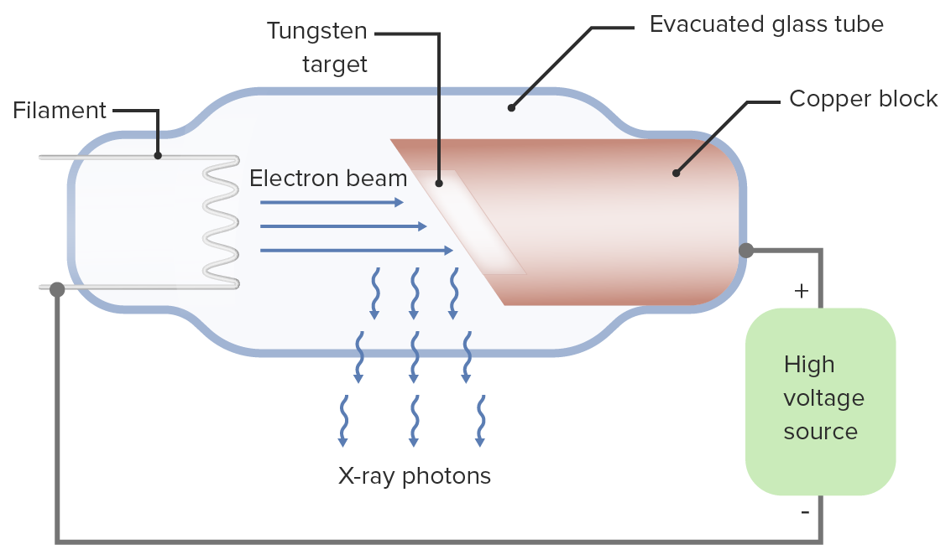

Figure:1 X Ray Production

A device that accomplishes this task consists of
1. Electron Source
2. An evacuated path Vacuum for electron acceleration
3. An External energy source to accelerate that electron
X-Ray Tube
X-Ray Tube
1. Cathode
2. Anode
3. Rotor/Stator
4. Glass or Metal envelope
5. Tube Housing

Cathode:
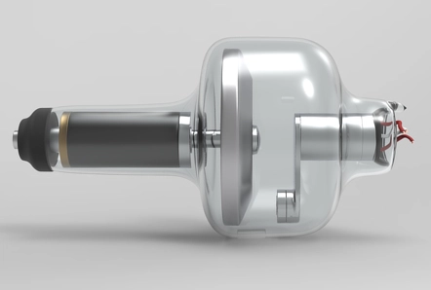
1. The cathode consists of a helical lament of Tungsten wire surrounded by a
focusing cup
2.The filament circuits provides a voltage cup to about 10 V to the filament, Producing a current of up to about 7A
3.Electron resistance heats the filaments and releases electrons
4.Electron Liberated from the filament flow through the vacuum of the tube to the anode when a positive voltage is applied to the anode relative to the cathode

Focusing cup Figure:2 Cathode
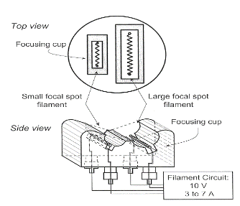
Surrounds the filaments and shapes the electron beam width
An insulated focusing cup may be biased with a more negative voltage (about 100V less) than the filament
Create a tighter electric field around the filament
1.Reduces the spread of the beam
2.Results in small focal spot width

Filament Current
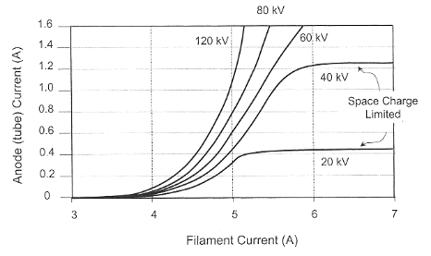
Filament current determines filament temperature and thus the rate of thermionic electron emission When no voltage is applied between the cathode and the anode an electron cloud space charge cloud builds around the filament
Application of high positive Voltage to the anode with respect to the cathode accelerates the electron towards the anode and produces a tube current. Small changes in the filament current can produce relatively large changes in the tube current.
Anode Figure: 3 Filament Current
The anode is a metal target electrode that is maintained at a positive potential difference relative to the cathode
Tungsten is the most widely used anode material because of its high melting point (3,370°C) and high atomic number (Z=74)
Tungsten anode can handle substantial heat deposition without cracking or pitting of its surface

Anode configurations:
1. Simplest type of X-ray tube has a stationary (fixed) anode
2. Consists of a tungsten insert embedded in a copper block
3. Copper supports the tungsten target, and it removes heat efficiently from the target
4. Small target area limits heat dissipation rate, limiting the maximum tube
current and thus the x-ray flux
5. Used in dental X-ray units, portable X-ray machines, portable fluoroscopy
systems
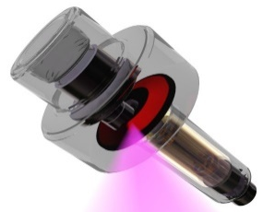
Rotating anode:
1.Rotating anodes used for most diagnostic x-ray applications
2.Greater heat loading and consequent higher x-ray output capabilities
3.Electrons impart energy to a continuously rotating target, spreading thermal energy over a large area and mass
Rotor:
Rotor consists of copper bars arranged around a cylindrical iron core Electromagnets surrounding the rotor outside the x-ray tube make up the stator Alternating current passes through the stator windings, causing rotor to spin Rotation speeds are 3,000 to 3,600 (low speed) or 9,000 to 10,000 (high speed) revolutions per minute (rpm)
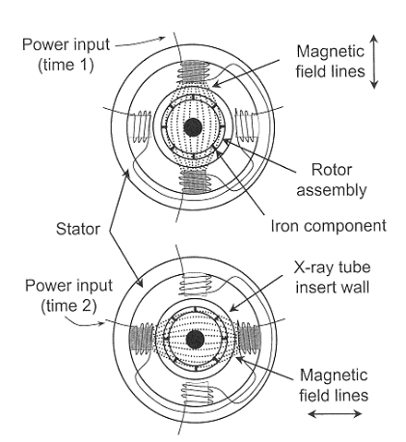
Focal spot size
Effective focal spot width is equal to the actual focal spot width
Effective focal length = actual focal length sin
Foreshortening of the focal spot length, as viewed down the central ray, is called the line focus principle
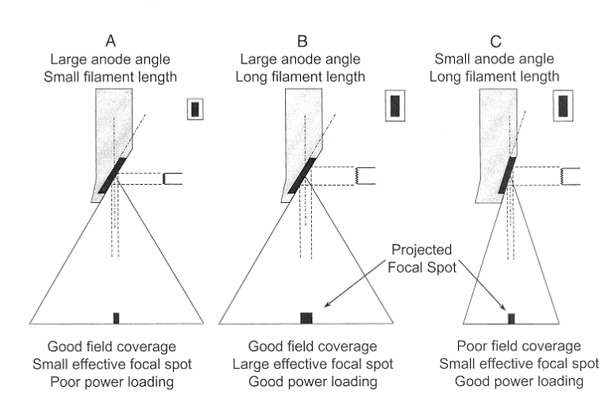
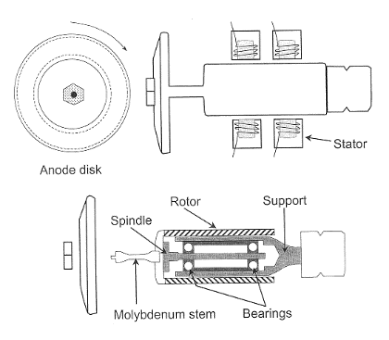

Figure:4 Focal Spot Size
Anode angle
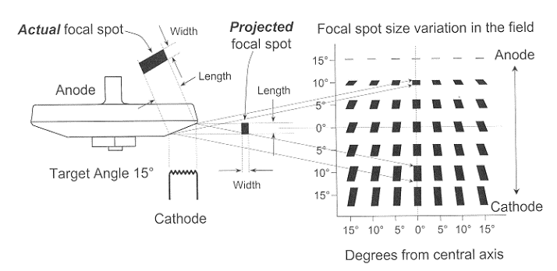
Optimal anode angle depends on the clinical imaging application small anode angle desirable for small field-of-view image receptors (cineangiographic and neuroangiographic equipment, where field coverage is limited by the image intensifier diameter)
Large anode angles necessary for general radiographic work to achieve large field area coverage at short focal spot-to-image distances
Figure:5 Anode angle
- Effective focal spot length varies with the position in the image plane, in the anode-cathode direction
- In the width dimension, the focal spot size does not change appreciably with position in the image plane
- Nominal size specified at the central ray of the beam
III. Transformers
Perform task of “transforming” alternating input voltage into alternating output voltage using principles of electromagnetic induction
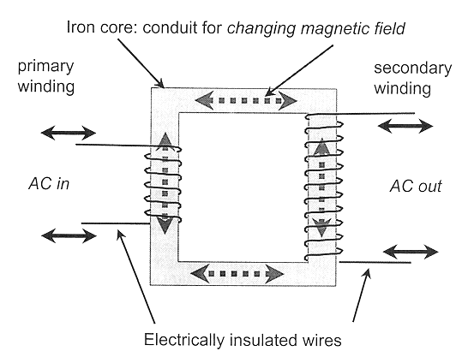
Generic transformer has two distinct, electrically insulated wires wrapped about a common iron core

Figure:6 Transformer

Law of Transformers

The ratio of the number of coils turns in the primary winding to the number of coils turns in the secondary winding is equal to the ratio of the primary voltage to the secondary voltage
$$\frac{V_{P}}{V_{S}}=\frac{N_{P}}{N_{S}}$$
1.Transformer can increase, decrease, or isolate voltage
Depends on ratio of the number of turns in the two coils
2.N_{S} > N_{P}: “step-up” transformer, increases secondary voltage
3.N_{S} < N_{P}: “step-down” transformer, decreases secondary voltage
4.N_{S} = N_{P}: “isolation” transformer, secondary voltage equal to primary voltage

Autotransformer
Consists of a single coil of wire wrapped around an iron core Law of Transformers still applies Operates on principle of self-induction rather than mutual induction. Smaller increases or decreases in secondary voltage than normal transformers Does not electrically isolate primary from secondary circuit.

Diodes
Electrical devices with two terminals that allow current flow in one direction only Example of a diode is the x-ray tube itself Solid-state diode contains a crystal of a semiconductor material Crystal “doped” with trace amounts of impurity elements Conductivity increased when voltage applied in one direction but reduced to very low level when voltage applied in opposite polarity

DIODES
ONE-WAY FLOW OF ELECTRON

ANODE CATHODE

Vacuum tube diode
(e.g.-Ray Tube)

Solid-State Diode

Figure:7 One Way Flow of Electron
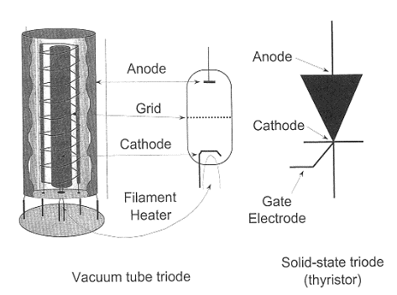
Triodes
A vacuum tube diode with a third electrode placed close to the cathode (a grid)
Electrons en route from cathode to anode must pass through the grid Small negative voltage applied to grid exerts large force on electrons from cathode, enabling on/off switching or current control

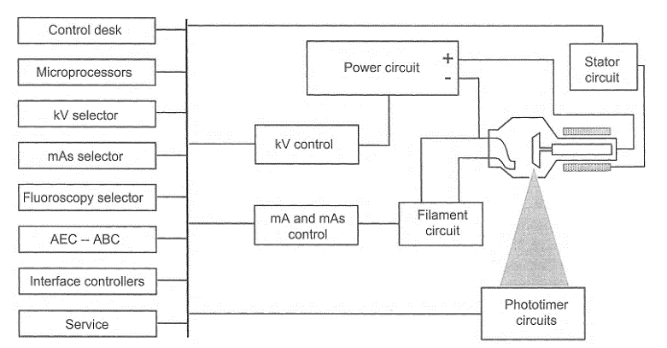

Operator Console
Operator selects the kVp, the mA (proportional to the number of x-rays in the beam at a given kVp), the exposure time, and the focal spot size Peak kilovoltage (kVp) determines x-ray beam quality (penetrability), which plays a role in subject contrast Tube current (mA) determines the x-ray flux Selection of focal spot size usually determined by mA setting Some generators support preprogrammed techniques
Figure:8 X Ray Control Console Circuits
Timing the x-ray exposure
Digital timers have largely replaced electronic timers (high reproducibility and microsecond accuracy) Mechanical switches only used in single-phase, low-power generators High-voltage triode switches used in 3-phase and constant potential circuits High-frequency inverter uses electronic switching on the primary side of the high-voltage transformer

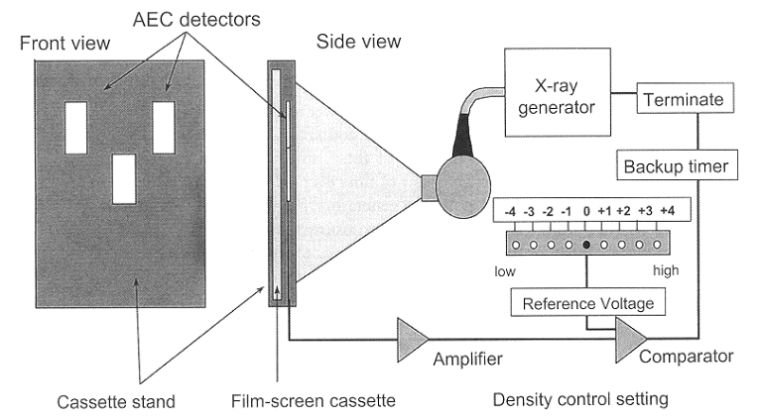
Photo timers
Measure the actual amount of radiation incident on the image receptor Terminate the x-ray production when the proper amount is obtained Provides a consistent exposure to the image receptor by compensating for thickness and other variations in attenuation in a particular patient.

Figure:9 Photo Trimers
Falling-Load Generator
Works in concert with the photo timing (AEC) subsystem Delivers the maximum possible mA for the selected kVp by considering the instantaneous heat load characteristics of the x-ray tube. Continuously reduces the power as the exposure continues Delivers the desired amount of radiation to the image receptor (IR) in the shortest possible exposure time
Factors affecting x-ray emission
Output of an x-ray tube described by the term’s quality, quantity and exposure
Quality describes penetrability of an x-ray beam
Quantity refers to the number of photons comprising the beam
Exposure is nearly proportional to the energy fluence of the x-ray beam and therefore has quality and quantity associated characteristics

X-ray production efficiency, exposure, quality and quantity are determined by:
- X-ray tube target material
- Voltage
- Current
- Exposure time
- Beam filtration
- Generator waveform
Target (anode) material
Affects efficiency of bremsstrahlung radiation production Output exposure roughly proportional to atomic number Energies of characteristic x-rays depend on target material Target material affects quantity of bremsstrahlung radiation and the quality of characteristic radiation

Tube voltage (kVp)

Determines the maximum energy in the bremsstrahlung spectrum and affects the quality of the output spectrum
Efficiency of x-ray production is directly related to tube voltage
Exposure approximately proportional to the square of the kVp in the diagnostic range:
$$\text{Exposure}∝\text{kV}{\text{p}}^{2}$$

Changes in kVp must be compensated by corresponding changes in mAs to maintain the same exposure
Additional consideration of technique adjustment concerns the x-ray attenuation characteristics of the patient
To achieve equal transmitted exposure through a typical patient, the mAs varies with the fifth power of the kVp ratio:

Tube current is equal to the number of electrons flowing from the cathode to the anode per unit time Exposure of the beam for a given kVp and filtration is proportional to the tube current

Exposure time
Exposure time is the duration of x-ray production Quantity of x-rays is directly proportional to the product of the tube current and exposure time (mAs)

Beam filtration
Beam filtration modifies the quantity and quality of the x-ray beam by selectively removing low-energy photons in the spectrum This reduces the photon number (quantity) and shifts the average energy to higher values, increasing the quality

Generator waveform
Generator waveform affects the quality of the emitted x-ray spectrum for the same kVp, a single-phase generator provides a lower average potential difference than a three-phase or high-frequency generator Both the quantity of x-rays produced and the quality of the x-ray spectrum are affected

References
[1] Diagnostic Radiology Physics: A Handbook for Teachers and Students
[2] J.T. Bushberg, J.A. Seibert, E.M. Leidtholdt, J.M. Boone, 3rd edn. (Lippincott Williams &
Wilkins, 2011)
[3] W.R. Hendee, E.R. Ritenour, Medical Imaging Physics, 4 edn. (Wiley, New York, NY, USA,
2002)
[4] IAEA. (2010). Clinical Training of Medical Physicists Specializing in Diagnostic Radiology.
Training Course Series, 47, International Atomic Energy Agency
[5] Core Curriculum for medical physicists in Radiology, Recommendations from am EFOMP/ESR working group, 2011
[6] International Commission on Radiological Protection,
the 2007 Recommendations of the international commission on Radiological
Protection, ICRP Publication 103, Elsevier (2008)
[7] United nations, sources and effects of ionizing Radiation, Report 2000, Vol.
1: Sources, Scientific Committee on the Effects of Atomic Radiation (UNSCEAR),un, new York (2000)
[8] H. Jones, J. Cunningham, The Physics of Radiology, Fourth Edition (C. Thomas, 1983)

