CASE STUDY ON FUTURISTIC APPROACH OF PROMOTING SUSTAINABLE TOURISM IN MANAS NATIONAL PARK, ASSAM

Daivik Mishra
Hospitality, IHM Guwahati
Guwahati, Assam, India – 781036
daivikmishra@gmail.com

I. ABSTRACT

The research abstract aims to provide an overview of a case study conducted on the futuristic approach of promoting sustainable tourism in Manas National Park.
The primary objective of this case study is to analyze the futuristic approach based on current scenario which could be implemented in Manas National Park to promote or improvise sustainable tourism practices. The park, located in the northeastern region of India, is renowned for its unique biodiversity and ecological significance. The study aims to explore the strategies and initiatives adopted by park management to ensure the long-term sustainability of tourism activities while preserving the park's fragile ecosystem.
The case study employs a qualitative and quantitative research design, utilizing in-depth interviews with local communities of Assam and tourists. Additionally, observations and document analysis are conducted to gather relevant data. The qualitative data provides insights into the perceptions, experiences, and attitudes of stakeholders towards sustainable tourism practices in Manas National Park.
This study will highlight the successful implementation of futuristic approaches to promoting sustainable tourism in Manas National Park. The park management has focused on implementing eco-friendly practices, such as waste management, energy conservation, and water resource management, to minimize the environmental impact of tourism activities. Furthermore park management and especially local bodies should be aware of importance of sustainable tourism in order to preserve the park.
The implications of this case study are significant for other protected areas and destinations striving to promote sustainable tourism practices. The innovative approaches implemented in Manas National Park can serve as a valuable model for other parks and destinations seeking to balance conservation objectives with tourism development. The findings emphasize the importance of incorporating sustainable practices, community involvement, and stakeholder cooperation in achieving long-term sustainability in tourism.

Keywords – Sustainable Tourism, Local communities, MNP(Manas National Park), Eco-lodge

II. INTRODUCTION

A. About Manas National Park and its brief history
Assam is lying in the North- Eastern region of India and is home for its various national parks and wildlife sanctuaries out of which it has 2 UNESCO world heritage Sites. One is Kaziranga National Park and the other one is Manas National Park which was declared as UNESCO World Heritage Site in the year 1985.
The Brahmaputra River, which flows through the center of the national park, has a significant tributary called the Manas River and is whence the park gets its name.
A hotspot for biodiversity, the State of Assam in North-East India, is home to the Manas Wildlife Sanctuary. It bridges the Manas River and is bordered to the north by Bhutanese woods, taking up an area of almost 40,000 hectares. As one of the most significant surviving natural spaces in the area and one of the protected regions on the Indian subcontinent with the largest populations of numerous threatened species still thriving, Manas is of special value.
Manas National Park is located 176 Km away from Guwahati, Assam. The location offers vital and sustainable habitats for rare and threatened species which includes Tiger, One – horned rhino, roofed turtle, hipid hare, pygmy hog etc. The site’s scenic beauty includes a range of forested hills, alluvial grasslands and tropical evergreen forests. It plays a significant role in attracting local and inbound tourists and is one of the main tourists’ spots in Assam.
The Manas National Park was designated a sanctuary on 1st October 1928 by the Britishers. Earlier it covered approx 360 km sq. In 1973, the Manas Bio Reserve was established. Manas R.F. and North Kamrup R.F. were the names of the reserved forests there before the sanctuaries designated.
It was declared a World Heritage Site in December 1985 by UNESCO and as a ‘World Heritage Site in danger’ due to heavy poaching and terrorist activities. On 25 February 2008, the area was increased to 500 km² (190 sq mi). It was honored for its preservation efforts on June 21, 2011, when it was taken from the "List of World Heritage in Danger."

B. Sustainable Tourism
Talking about tourism, it is one of the world's fastest growing industries and an important source of foreign exchange and employment, while being closely linked to the social, economic, and environmental well-being of many countries, especially developing countries. People travel to various places includes mountains, coastal areas, monuments, worship places. The Wildlife tourism is also important for a state or a country as in a large way, the tourists and travelers visiting the wildlife destinations contribute to the conservation and improvement of the conditions for the animals. The flow of the people keeps the poachers at bay from killing the valuable animals. More will be the tourists at any place, industries like hotels, roadways, restaurants, shops etc also develop but at the same time the likelihood of the environment being ruined by humans may also increase. Looking at the above factors sustainable tourism is very important.
The World Tourism Organization defines sustainable tourism as “tourism that takes full account of its current and future economic, social and environmental impacts, addressing the needs of visitors, the industry, and the environment and host communities".

C. Sustainable tourism in context with Manas national park
Due to security concerns, the park was cut off for a considerable amount of time. Only in the 21st century did the park start to recover and put more of an emphasis on conservation. Two requests were approved for ‘International Assistance’ worth 165,000 USD by UNESCO in order to preserve and maintain the park in 1997. The property benefited in 2008 from the UNF-funded initiative for boosting total numbers of staffs, improving management effectiveness, and raising local people involvement.
Even now, a lot of work is being done to safeguard the park's wildlife. 13 species of mammals are classified as completely protected. According to the most recent IUCN Red List, Parks is home to one severely endangered mammal species, six endangered species, eleven vulnerable species, and two near threatened species. Twelve kinds of birds are listed by the International Union for Conservation of Nature (IUCN), including two that are critically endangered, five that are vulnerable, five that are near-threatened, and six that have restricted ranges. The park is home to two bird species that are completely protected and are classified in Schedule I of the Forest and Nature Conservation Act, 1995.With the aim to enhance and build sustainable tourism opportunities in the park, the first ever eco-tourism project was initiated in October 2010 with financial and technical assistance from WWF UK. Since this project was the first of its kind, basic infrastructure was required.
The implications of this case study have important implications for other protected areas seeking to enhance ecotourism. The futuristic approach adopted by Manas National Park provides valuable insights into effective strategies to promote sustainable tourism, maximize revenue generation, and conserve biodiversity. The findings can guide policymakers, park managers, and local communities in developing and implementing similar initiatives in other ecologically sensitive areas.

III. REVIEW OF LITERATURE

(Shapna Medhi) – The Author states that unanticipated growth in tourism can also have the greatest negative impact on a destination's natural, social and cultural environment. The risks posed by the tourism industry can only be contained through the sustainable development of tourism which requires proper planning and implementation. On a positive note, the situation the World Heritage Site – Manas National Park is better than the past, still there are milestones to be achieved. The interests and welfare of the local community should also be kept in mind without affecting their lives in a negative way.
(Premangshu Chakrabarty – 2019) – The Authors concludes that to achieve a sustainable tourism, proper planning and organizing is necessary. Community participation is also crucial in order to protect their area. It's worth mentioning that World Heritage Site designation was threatened by untoward events in Manas between the late 1980s and the late 1990s since then The adoption of sustainable tourism promotion involves convincing people about its economic and environmental benefits.
(Pranjit Kr. Sarma 2008) – According to the author Manas National Park is an important conservation area in the Bhabhar ecosystem and the floodplains of northeastern India. As proved by the satellite images, there had been a substantial change in grasslands and many of them also were enroached. Water sources in the Park have declined and there has been a significant shift towards a drier and woodland type of vegetation. These land-use changes were a result of non-implementation of habitat management/manipulation activities that are a prerequisite for supporting viable populations of specific endangered animal species in a given Protected Area.
(Moromita Roy 2021). The author expresses that Manas National Park has a great deal of potential for ecotourism as it can act as a major source of income for the state as well can generate employment for the local communities. In order to promote the park, Government officials along with NGOs are working together with the local people to promote eco-tourism by promoting various awareness camps are organized to control environmental degradation and conservation of the biodiversity of the national park. .
(Michael Islary, 2021) Author concludes through their research on ‘Biodiversity and Ecosystem Governance in Indian Protected Areas’ that to successfully protect the bio-rich landscape controlled by humans, a tight balance between conservation and resource use is required for the long-term viability of socio-ecological systems. In other words, conservation programmes should be able to incorporate the livelihood needs of the local people; only then would the conservation programmes be successful.

IV. OBJECTIVES

- To study the perception and awareness of tourists towards sustainable tourism practices in Manas National Park
- To comprehend from the opinions received, what could be done to enhance sustainable tourism in Manas National Park in future
- To analyze the economic benefits of sustainable tourism practices for the local communities and the overall regional development
- To learn about the current state of the Park's sustainable tourism policies.

V. METHODOLOGY

A qualitative and quantitative approach to data analysis was adopted from the enormous group of people from Assam. The purpose of the research was to solicit opinions on sustainable tourism and its futuristic approach to Manas National Park. The various people were asked to give the responses towards it.
Primary data was collected from various people in and across state of Assam and the questionnaire circulated. The questionnaire was circulated various especially among young people. In total 170 responses were received and used for data collection.

VI. DATA ANALYSIS

The survey was done by circulating questionnaire among random various people in Assam. The total number of participants was 170. Secondary data was collected through websites, published research papers etc.
Fig. 1
Out of total respondents, 56.5% were male and 43.5% were female

Fig. 2
Out of total responses, 83.5% were aged below 30 years of age, 11.8% were aged between 30 – 45 years of age and rest above 45 years of age

A. What type of experiences and interests you look for when you visit a national park like Manas?
Fig. 3
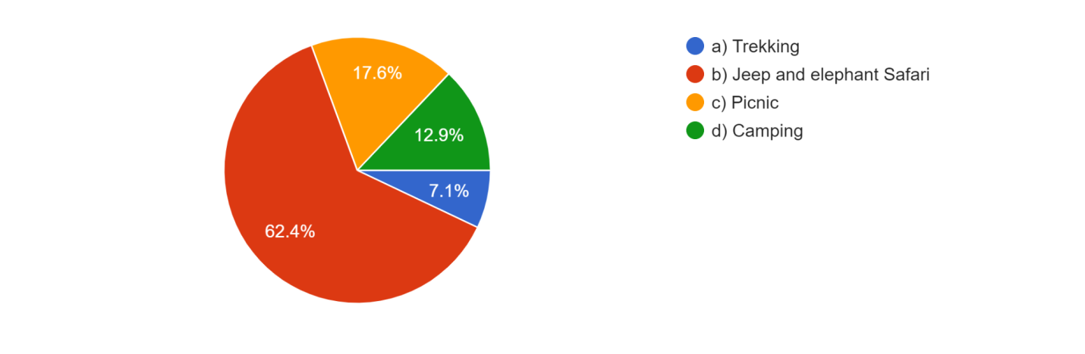
It has been found that people are mostly interested in Jeep and elephant Safari

B. Are you familiar with the concept of sustainable tourism?
Fig. 4
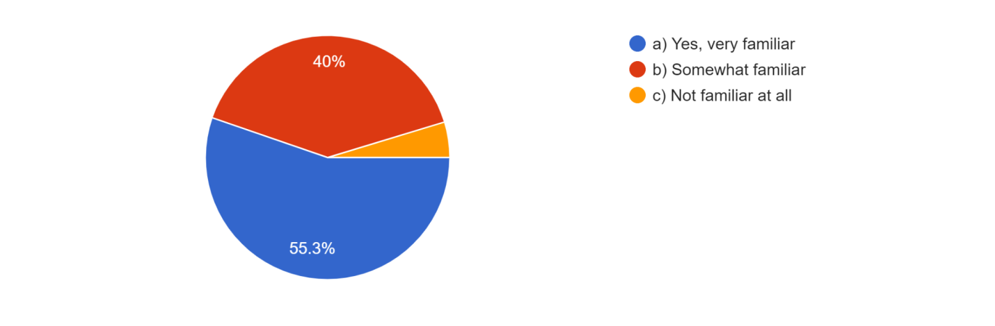
Exceptionally all the people are familiar with the concept of SUSTAINABLE TOURISM out of which majority of them are more familiar with it

C. How did you first come to know about Manas National Park?
Fig. 5
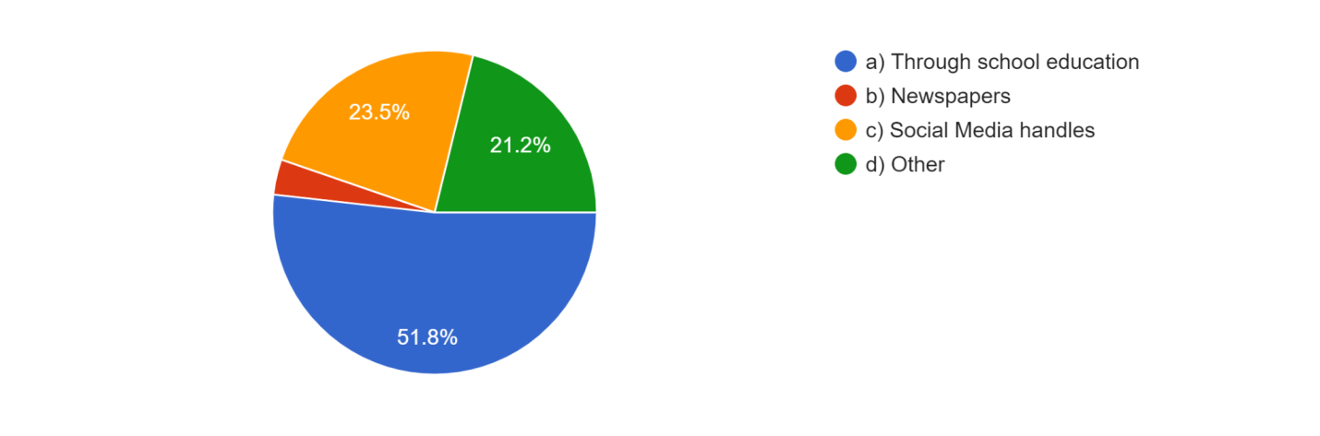
As per the survey, majority of the people first came to know about Manas National Park was through the education provided in schools followed by Social media handles

D. How important do you consider sustainable tourism practices in preserving the natural and cultural heritage of Manas National Park?
Fig. 6
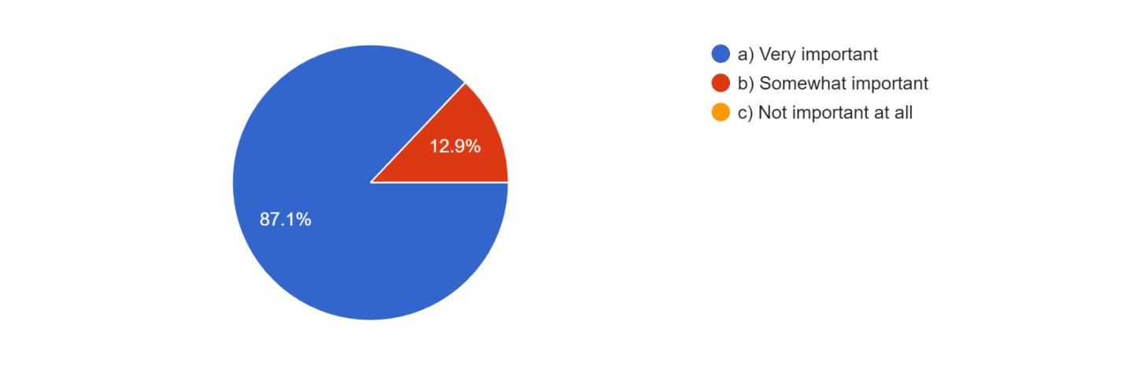
It had been found that few claims sustainable tourism to be ‘somewhat important’ but majority accepts it as ‘very important’.

E. In your opinion, what more can be done to promote sustainable tourism in Manas National Park? If any other please mention.
Fig. 7
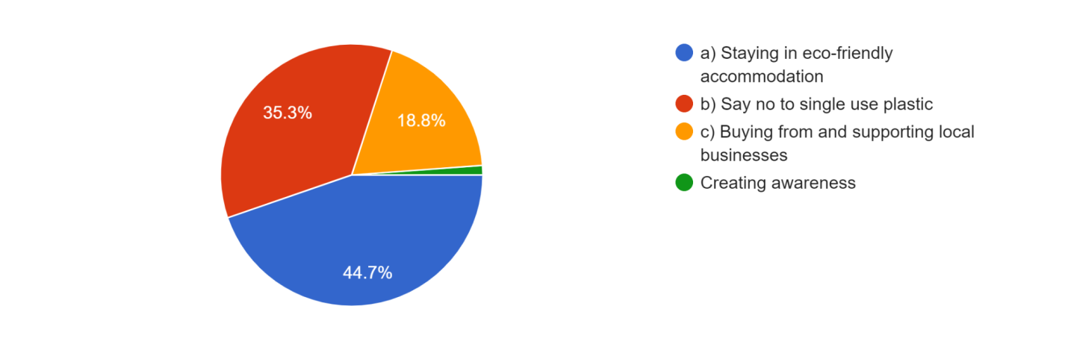Staying in eco-friendly accommodation can promote more of sustainable tourism followed by saying no to single use plastic. Surprisingly, creating awareness is given as least importance in here.

F. How might the local populations in and surrounding Manas National Park benefit from sustainable tourism, in your opinion? (More than 1 answer could also be selected)
Fig. 8
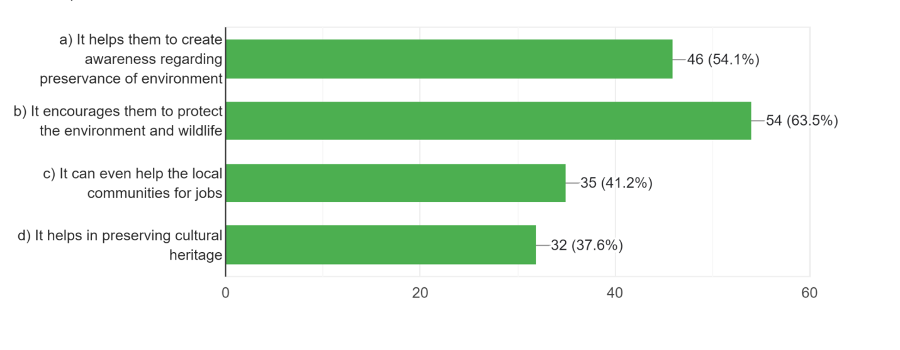
All the above answers are important but many strongly believe that sustainable tourism mostly benefits park by local people getting encouraged to protect the environment and wildlife.

G. How would you rate the efforts made by the Govt. and local authorities in promoting sustainable tourism in Manas National Park?
Fig. 9
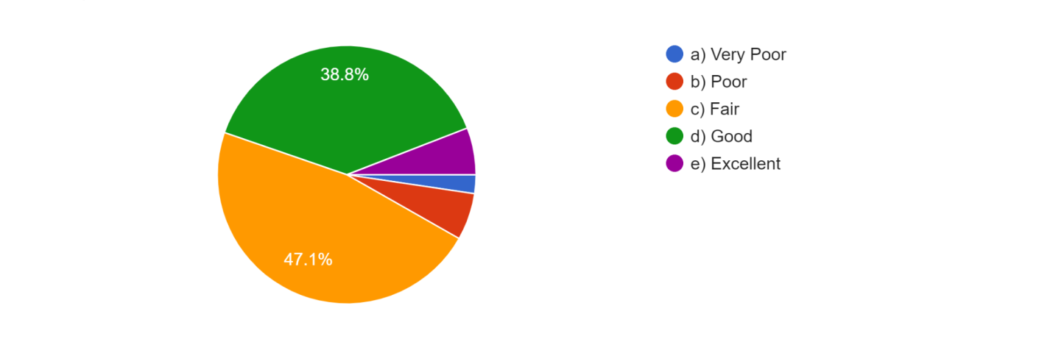
According to almost half of the people’s opinion, they feel that efforts that are being made to promote sustainable tourism in MNP are fair. 38.8% feel the efforts are good and very few claim it to be excellent.

H. Would you be interested in learning about eco-tourism packages and initiatives at Manas National Park?
Fig. 10
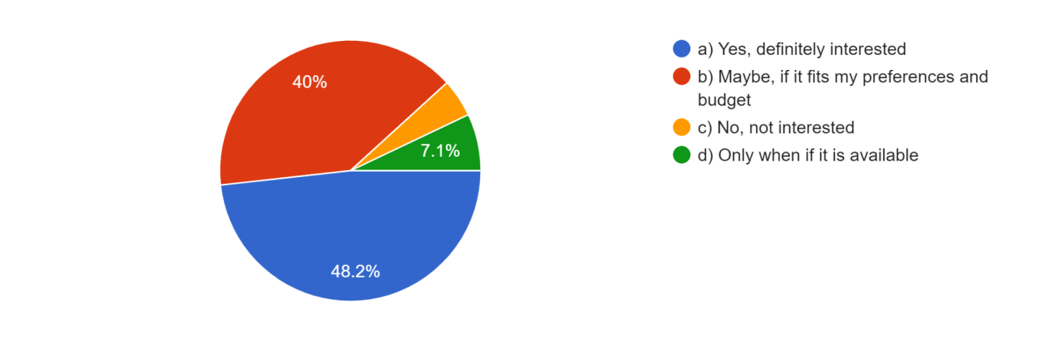
According to the above observation, many are interested to know about eco-tourism packages and initiatives at Manas National Park followed by some people’s opinion of their preference and budget getting adjusted.
I. Do you believe that sustainable tourism can contribute to the overall development of the region surrounding Manas National Park?
Fig. 11
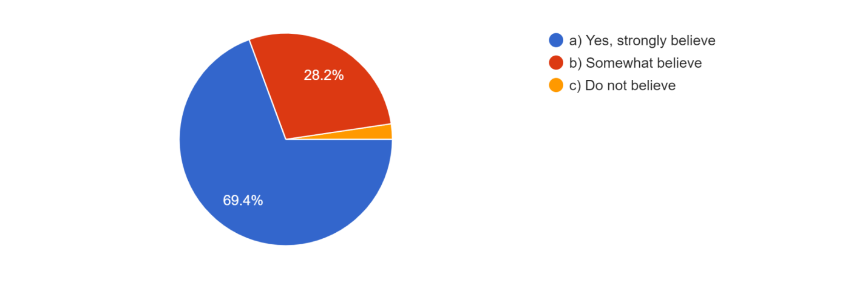
Almost everyone believes that sustainable tourism can contribute to the overall development of the region surrounding Manas National Park.

J. Which one among the following you think should be majorly considered minimizing the environmental impact of tourism in the Manas National Park? If any other pleases mention.
Fig. 12
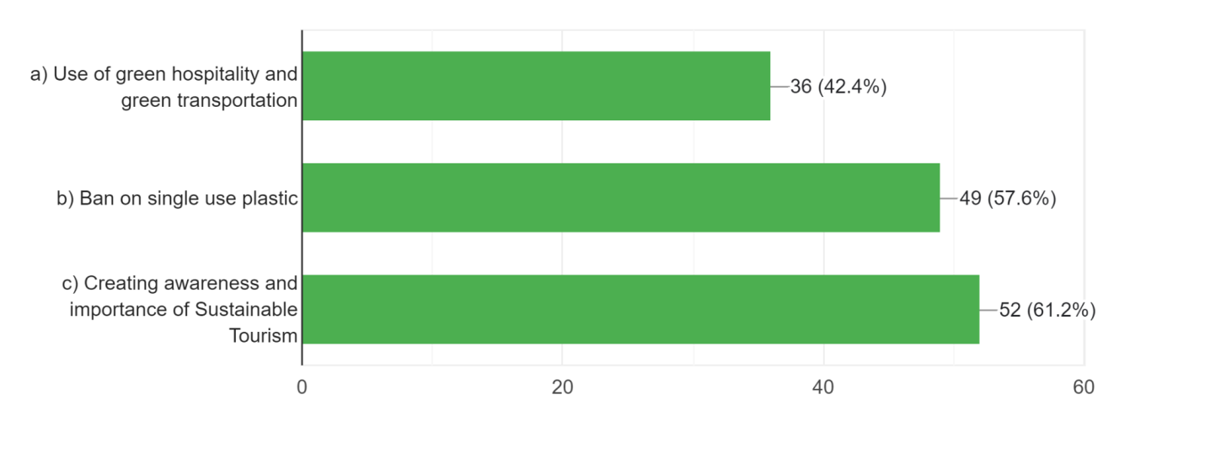According to the survey, many people believe that only by creating awareness of sustainable tourism should be majorly considered minimizing the environmental impact of tourism in the Manas National Park

K. Which among the following could be the biggest challenge in futuristic approach of promoting sustainable tourism in Manas National Park? (More than one answer could also be selected).
Fig. 13
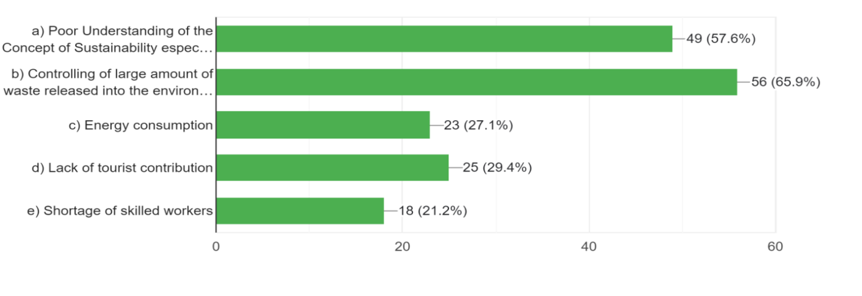According to the survey conducted, controlling of large amount of waste released into the environment is the biggest challenge in future for promoting sustainable tourism in MNP. Poor understanding of the concept of sustainability especially by local community is also a challenge

L. Apart from above questions, a question was asked that whether citizens are aware of any sustainable tourism practices being implemented currently in Manas National Park! Many of them told that they are not aware of any such practices. Some claims that yes they are aware of practices like by involving of local government and people as a tourist guide and handling of nearby things like shops, Eco friendly products shops etc, by also minimizing use of plastics, by responsible regular waste management etc.

M. A question was also asked whether anyone of them have ever taken part in any conservation or volunteering activities in Manas National Park. Many people’s response was given as ‘No’ while some mentioned it as ‘yes’. 1 candidate replied that he took part as a volunteer in maintaining the park with ‘National Service Scheme’

VII. CONCLUSION

The conservation of the park's biodiversity and the socioeconomic advancement of the local inhabitants are significantly impacted by a futuristic strategy for encouraging sustainable tourism in Assam's Manas National Park. This research has demonstrated that a comprehensive strategy encompassing various aspects, including infrastructure development, community involvement, strict policies made by park community - Govt and local bodies, control over plastics etc. can foster sustainable tourism practices in the park. The findings suggest that developing eco-friendly accommodations, such as eco-lodges and well-planned visitor centers, can attract responsible tourists while minimizing the ecological footprint. Creating regular awareness program related to sustainable tourism among tourists especially local community of the park can be really effective.
Furthermore, actively involving local communities in decision-making processes, providing opportunities for skill development and capacity building, and promoting community-based tourism initiatives have proven to enhance the socio-economic conditions of the local population. To work together on sustainable development and the preservation of the park's natural resources, conservation organizations, local communities, tourists etc. must forge partnerships.
Waste management is also very important for the same. Moreover, effective policy implementation and enforcement are essential for the long-term success of sustainable tourism in Manas National Park. It is essential to work together with government and non-governmental organizations to guarantee that laws are upheld, to monitor compliance, and to give financial support for initiatives too.
Overall, a futuristic approach to promoting sustainable tourism in Manas National Park, Assam, offers a promising solution to balance conservation goals with socio-economic development and reduction of environmental hazardous substances. By empowering local communities, waste management and implementing comprehensive policies, the park can become a model for sustainable tourism practices in the region, ensuring the preservation of its unique biodiversity for future generations.

VIII. LIMITATIONS

Selected people from Assam were randomly selected to participate in the survey by being given questionnaires. More people from outside the state may have provided their opinions, however this was not possible due to a lack of time due to work obligations. Lack of proper corporation by the correspondents also affected the research.

REFERENCES

[1] Medhi Shapna. “Planning For The Development Of Sustainable Tourism For Upliftment Of Socio Economic Condition Of The People” – A Case Study Of Manas National Park

[2] Chakrabarty Premangshu, “Promoting Wildlife Tourism On Geotourism Landscape: A Study In Manas And Kaziranga National Parks Of Assam, India” (2019).

[3] Sarma P. K., “Land-Use and Land-Cover Change And Future Implication Analysis In Manas National Park, India Using Multi-Temporal Satellite Data”, (2008).

[4] Roy Moromita, “A Study On The Status Of Biodiversity Conservation And Sustainable Ecotourism In Manas National Park, Assam”, (2021).

[5] WWF, “Royal Manas National Park open it’s door to Eco Tourism’’, (7th July 2011). https://wwf.panda.org/wwf_news/?200891/Royal- Manas-National-Park-opens-its-doors-to-eco-tourism,

[6] UNESCO, “World Heritage Convention’, (2021), https://whc.unesco.org/en/soc/4215”

[7] Travel Triangle, “Manas National Park – A wild utopia in the North East One Must Explore in 2023”. https://traveltriangle.com/blog/manas-national-park/, (3rd November 2021).

[8] Michael Islary, “Biodiversity and Ecosystem Governance in Indian Protected Areas: A Case Study from Manas in Assam’, (July 2021).

[9] UNESCO, Manas Wildlife Sanctuary, https://whc.unesco.org/en/list/338/

