ETHOSOME: A NOVEL VESICULAR CARRIER FOR TRANSDERMAL DRUG DELIVERY
Pratiksha Pawar……………………..
Dr. D. Y. Patil College of Pharmacy Akurdi, Pune-44
INTRODUCTION
The body's largest and most accessible organ, the skin, can be used as a potential medication delivery route for systemic impact on body. The skin is a multilayered, exterior sensory organ that serves as both a permeability barrier and a protective tissue, keeping outside molecules from entering the body.[4] Bioavailability increases when permeability enhancers are used against stratum corneum which acts as a reliable barrier against drug penetration.[1] Consequently, unique carriers are needed to get beyond the natural barrier of skin and get medication molecules with different physicochemical qualities into the bloodstream.[4] The less invasive transdermal drug delivery system (TDDS) method of pharmaceutical administration that offers controlled medication delivery, less frequent dosing, patient compliance, and first-pass metabolism prevention, was consequently established.[1] These systems use liposomes, other vesicles, prodrugs, supersaturated systems, penetration enhancers, and other vesicles.[2]
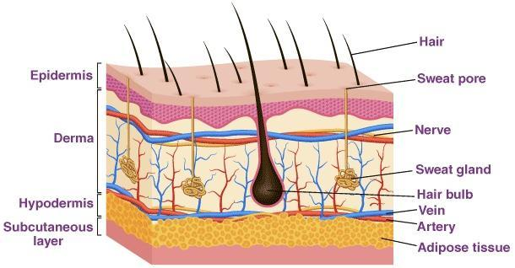
Fig No. 1 Structure of Skin[10]

VESICULAR SYSTEMS
1. Liposomes
They are tiny vesicles which contain water that are structurally similar to the phospholipid bilayer of skin, and in rare situations, the phospholipid chain from egg yolk or soy and cholesterol. Mezei took the initiative to use liposomes as delivery vehicles. No direct absorption is accomplished, addressing the need for advanced characteristics, and it merely assists in administering the medication to the top layer of the skin. Studies using liposomes revealed enhanced miconazole nitrate deposition with minimal penetrability in the upper layers of the skin.[7]

2. Nisosomes
Except for the non-ionic surfactants used, they are composed similarly to conventional liposomes but are more stable and less expensive. The mechanisms rely on the drug's physico-chemical characteristics, the type of vesicle, and the lipids utilized. Thin-film hydrated fluconazole nisosomes with spans of 60, 40, and 72 showed prolonged drug release and excellent cutaneous retention. Another medicine that was found to be more effectively administered in a different trial is ciclopirox.[7]

3. Transfersomes
Due to their higher flexibility and deformability, they are often referred to as ultra-deformable vesicles or liposomes. Phospholipids and various types of surfactants give a flexible and effective delivery mechanism for transdermal and topical delivery of medications, genetic material, and vaccinations. Ethosomes are more effective as a vesicular delivery method was subsequently demonstrated by research on clotrimazole-loaded ethosomes, which revealed that compared to normal transfersomes, the drug fluctuation was more considerable in the system.[7]

4. Ethosome
Another innovative lipid carrier, the ethosome, was recently created and exhibited improved skin delivery. Water, ethanol, and phospholipid make up the ethosomal system. Depending on the manner of formulation and the use of procedures like sonication, the size of ethosomes ranges from nanometers to micrometres.[7]
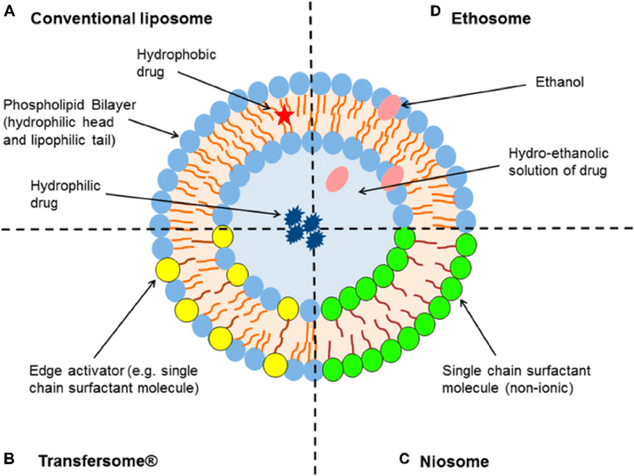
Fig No. 2 Illustration of Different Types of Vesicular Systems[12]

5. Pharmacosomes
Potential replacements for traditional vesicular systems include pharmacosomes. Pharmacon is short for "drug and carrier. They are Covalently bound pharmaceuticals in colloidal dispersions. Depending on the nature of the drug-lipid matrix, they may take the shape of hexagonal, micellar, or ultrafine vesicular aggregates. Certain medications that contain an active hydrogen or carboxyl group is esterifiable to create a system with an amphiphilic prodrug. It is s a self-assembling system of nanoparticles. that allows for the loading of greater amounts of medication and has a lower interfacial tension and a higher contact area, both of which increase bioavailability.[7]
6. Virosomes
Virosomes are globular, consisting of single lamella, bilayered phospholipid vesicles that contain virus-derived proteins that allow them to merge with target cells. For the resistance of influenza virus, Membrane proteins are intercalated with lipids, including neuraminidase and, haemagglutinin which enables them to transmit the medication to the cytoplasm of a target cell. It involves the integration of the genetic material and nucleocapsid of the cradle virus into the covering. The vesicles hold the viral surface glycoprotein, which has a size range of 120–180 nanometers.[7]
7. Colloidosomes
They are emulsion droplet interface-based coagulated or fused particles in hollow-shelled microcapsules. Since the membrane of colloidosomes offers higher potential in manipulating the species that are trapped in permeability, assuring precise and timely drug release, they have highly flexible applications. As broader utility is rare, the system is still in its early stages of development.[7]
8. Aquasomes
It is a self-assembling system of nanoparticles consisting of three layers with a glassy cellobiose coating over a ceramic carbon nanocrystalline particulate core that aids in molecular shielding and precise targeting.[7]
9. Cubosomes
These are devices that have been employed in an experimental setting to distribute herbal medications for the drug KIOM-MA 128, used to treat allergic dermatitis. Compared to suspension form, M-A 128's permeability feature was improved using cubosomes. [7]
10. Sphingosomes
They are concentric bilayer vesicles with a size range of 0.05 to 0.45 micrometres, and there is an aqueous compartment. fully surrounded by a two layered membranes made of natural or synthesized sphingolipids. As they are only formed of amide and ether connections and have fewer double bonds than lecithin, they are more stable and have longer circulation times than typical vesicular systems. They are perfect for investigations on immunology, gene delivery, and targeting tumours. According to Saraf et al., in 2001, it was utilized in the treatment of cancer. Sphingosomes are created utilizing cholesterol derived from sphingomyelin, which gives them properties including resistance to acid hydrolysis and oxidation, providing them better stability in plasma and longer circulation times, improving bioavailability.[7]
Table No. 1 Difference between Liposomes, Transferosomes and Ethosomes [9]

Characteristics | Liposome | Transferosome | Ethosome
Characteristics | Vesicles in the microcosm | Vesicles of Ultra-flexible | Vesicles of Elastic
Composition | Phospholipids and Cholesterol | Phospholipids and edge activators | Phospholipid with Ethanol
Mechanism of Permeation | Diffusion mechanism | Deformation of Vesicle Penetration | Lipid Perturbation
Degree of Skin Penetration | Less Penetration | Easy Penetration | Easy Penetration
Flexibility | Rigid | Highly deformable | Elasticity due to ethanol
Route of Administration | Transdermal, Oral, Parenteral, Topical | Transdermal and Topical | Transdermal and Topical
Marketed Formulation | Ambidone | Transferosomes  (Idea AG) | Nanominox, Decorin Cream

ETHOSOMES
Touitou et al., 1997 created ethanolosomes which is composed of a special lipid carrier consisting of phospholipids, water, and ethanol. Ethosomes are phospholipids, water, and ethanol (at a relatively high concentration)-based soft, flexible vesicles. New vesicular carriers for enhanced skin delivery, these soft vesicles.[5] The intercellular region of the stratum corneum is impacted by ethanol's role as a permeation enhancer. They disrupt the lipid bilayer of the skin by including 20–50% ethanol in its ethosomal composition. The physical and chemical properties of therapeutic drugs included in the transdermal and dermal distribution are enhanced by the transethosomal system. Higher ethanol concentration causes the medicine to be released to the targeted area by opening up the outer layer's pores and causing hydration.[6]

Composition of Ethosomes
Ethosomes are composed of three components:
- Concentric layers of flexible Phospholipids
- High Concentration Ethanol (20-45%)
- Water

Phospholipids (phosphatidylserine, phosphatidylcholine, and phosphatidic acid) The majority of the components of ethosomes are water and ethanol in high quantities. There is a range of 22% to 70% in the nonaqueous phase. Either isopropyl or ethanol alcohol can be used. Since It is well known that ethanol can alter the structure of lipid bilayers in the skin. its high concentration in the ethosomes makes them special because, when It allows a vesicle to pass through the stratum corneum when integrated into the membrane of the vesicle. Additionally, the stratum corneum lipids' high ethanol content causes the lipid membrane to pack less closely vesicles while retaining a similar level of stability. This makes it possible for a more flexible structure and improves the ability to disperse medications.[7]

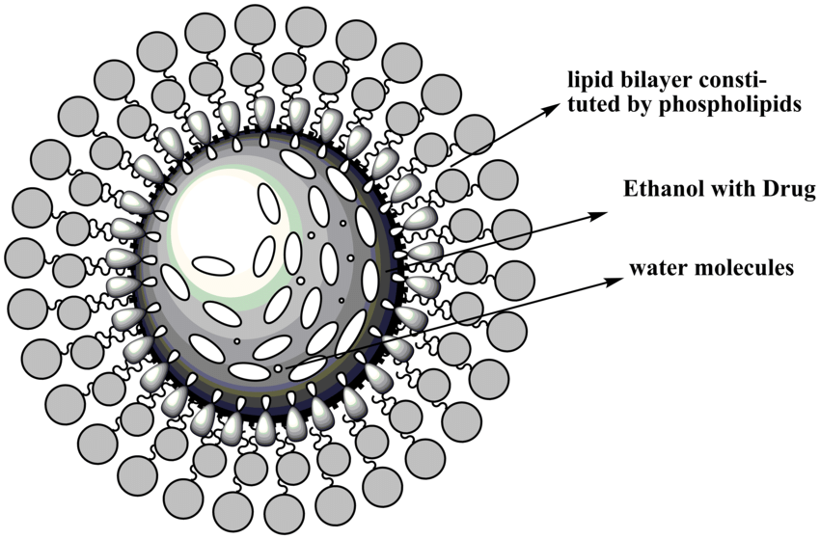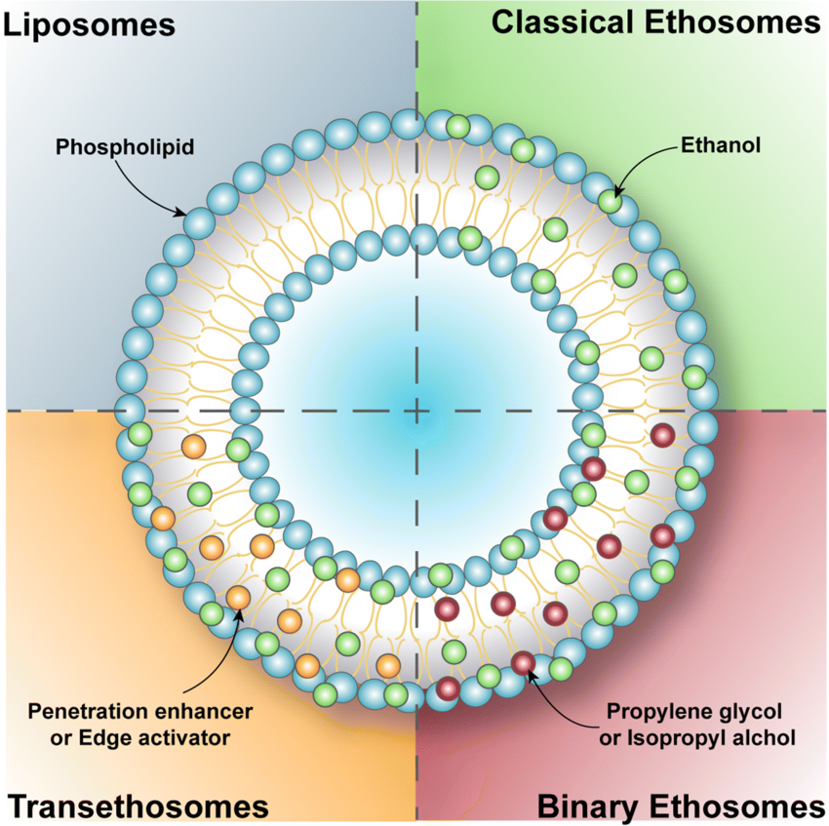
Fig No. 4 Structure of Ethosome[13] Fig No. 5 Types of Ethosome [6]

Mechanism of action
The main aim of ethosomes is to improve drug penetration over liposomes.Absorption of the drug probably occurs in the following two phases:
1. Ethanol effect
Through the skin, ethanol enhances permeation. Its impact of increasing penetration has a familiar mechanism. Additionally, ethanol increases the fluidity of cell membrane lipids and lowers the density of the lipid multilayer of the cell membrane. It also penetrates into intercellular lipids.[3]
2. Ethosomes effect
The ethanol of ethosomes increases the fluidity of cell membrane lipids, which in turn enhances the permeability of skin. Thus, the ethosomes can easily penetrate the under layers of skin, where they combine with skin lipids and release the medication..[3]
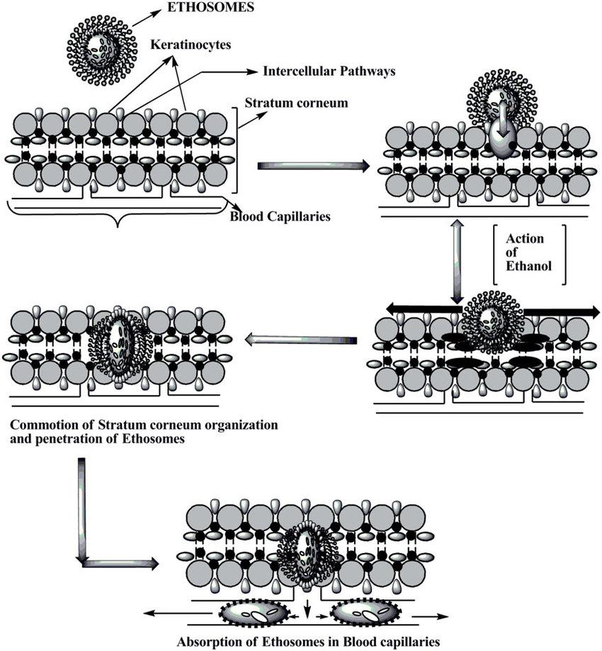
Fig No. 6 Mechanism of Action [11]

Types of Ethosomes
1. Classical Ethosomes
They are essentially modified versions of traditional liposomes that include a lot of Alcohol (45%w/w). Compared to traditional ethosomes, they exhibit improved entrapment efficiency and a greater negative zeta potential. The molecular weights range from 130.007 Da to 24k Da², so they have increased permeability and improved stability.[1]
In addition, traditional ethosomes outperformed traditional liposomes in terms of skin penetration and stability characteristics.

2. Binary ethosomes
They are binary because another alcohol is added to the formulation to give them more of the perfect qualities. Isopropyl alcohol (IPA) and propylene glycol (PG) are two alcohols that are frequently added. [1]

3. Transethosomes
Transethosomes are vesicles of lipid composed of transfersomes and ethosomes. They are comparable to traditional preparations but add an additional component, such as an enhancement of penetration or an edge activator. (usually a surfactant). In a formulation known as transethosomes, the unique delivery mechanism pools the optimal characteristics of traditional ethosomes with the flexibility and deformability of transfersomes. They were said to possess traits that were better and more advantageous than those of traditional ethosomes. They can capture drugs with molecular weights between 200 and 235 kDa and 130.077Da. Transethosomes contain up to 30% of ethanol, which improves penetration well. They have a wavy form. They combine the benefits of ethosomes and transfersomes. Studies on vesicle elasticity and skin penetration show higher values when ethanol and an edge activator are combined with lipid bilayer rearrangement. They frequently pass through undamaged skin using the transcutaneous hydration gradient. [1]
Table 2: Differential properties of different Ethosomes [1]

Sr. No | Parameters | Classical ethosome | Binary ethosome | Transethosome
 | Morphology | Spherical Shape | Spherical Shape | Regular or irregular spherical shapes
 | Composition | 1. Phospholipids  2. Ethanol  3. Stabilizer  4. Charge inducer  5. Water  6. Drug/agent | 1. Phospholipids  2. Ethanol  3. Propylene glycol  4. Charge inducer  5. Water  6. Drug/agent | 1. Phospholipids  2. Ethanol  3. Surfactant  4. Charge inducer  5. Water  6. Drug/agent
 | Entrapment efficiency | Superior to traditional liposomes | frequently more than conventional ethosomes | higher than the majority of ethosomes that are usual
 | Skin permeation | Usually greater than traditional liposomes | Usually equal to or better than conventional ethosomes | frequently more than conventional ethosomes
 | Size | Smaller than the classical liposomes | smaller or equivalent to typical ethosomes | Depending on the type and dosage of the edge activator or penetration enhancer utilised

Preparation Methods of Ethosomes
There are two extremely easy and practical ways to produce ethosomes
1. Cold Method. and
2. Hot Method

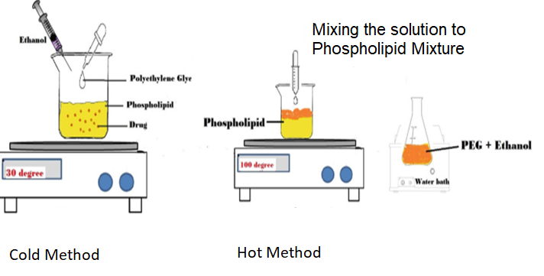
Fig No. 7 Methods of Preparation of Ethosomes [8]

1. Cold Method
In this method, phospholipid, medicine, and other lipid components are dissolved in ethanol in a covered jar at room temperature by aggressively whirling with the help of a mixer. The addition of propylene glycol or another polyol is done while stirring. These ingredients are cooked to 300C in a water bath. After that, the mixture is stirred for 5 minutes in a closed saucepan while water boiled to 300C is poured to it from another pot. The needed degree of ethosomal formulation vesicle size can be achieved by sonication or extrusion procedures. The mixture is then maintained in a fridge..[1]

2. Hot method
This technique involves heating the phospholipid in a water bath at 400 C until a colloidal solution is produced. In a separate tank, propylene glycol and ethanol are mixed and heated to 400 C. Once both solutions have reached 400 C, the aqueous phase is separated from the organic phase. The drug dissolves in either water or ethanol depending on whether it is hydrophilic or hydrophobic. The vesicle size of the ethosomal formulation can be decreased to the necessary level using the probe sonication or extrusion technique..[1]

Advantages
1. Proteins and peptides can be conveniently supplied with the help of technology.[1]
2. The delivery method can be applied in a variety of ways, including veterinary and aesthetic care, in addition to the pharmaceutical industry[1]
3. It contains an ethosomal system, which is passive, non-intrusive, and immediately commercializable.[2]
4. The semisolid form (gel or cream) in which the ethosomal medication is delivered results in great patient compliance..[3]
5. It is the simplest among other methods of drug delivery like iontophoresis, sonophoresis and other complicated methods.[4]
6. No preservatives need to be added since ethosomes contain Alcohol, which acts as a natural preservative.[4]
7. Ethosomes can be produced at a very low cost. [4]
8. Drugs go through the skin without regard to concentration..[4]
9. High market attractiveness for products with proprietary technology. Relatively simple to manufacture with no complicate technical investment required for the production of ethosomes.[5]
10. Low-risk profile - Because the toxicological profiles of the ethosome components are well-documented in the scientific literature, there is no danger associated with the technology's large-scale development.5]
11. Ethosomes increase the permeation of the drug through skin.[5]

Disadvantages
- The molecular size of the medication must be suitable for absorption by percutaneous 1]
- Excipients in ethosomes can cause skin irritation or disadvantages.[1]]
- It is not meant to achieve rapid bolus-type drug input; rather, it is usually designed to offer slow, sustained drug delivery.[2]
- It requires sufficient drug solubility in aqueous and lipophilic media to penetrate cutaneous microcirculation and enter the systemic circulation.[3]
- They show poor adhesive properties and hence, do not adhere properly to all skin types.[3]
- Allergic reactions can be identified if the patients are allergic to ethanol or any of the ethosomal components.[4]
- Ethosomal carriers are relevant solely for transdermal application, in contrast to other carriers (solid lipid nanoparticles, polymeric nanoparticles, etc.), which can be employed for numerous routes.[4]
- Ethosomes are not very economical as they give poor yields.[4]

Therapeutic Applications of Ethosome
1. Treatment of bacterial and viral skin infection
Different skin infections have been treated with ethosomal systems that contain antibiotics. The development of the bacitracin and erythromycin ethosomal systems, as well as their effectiveness, were studied using deep skin infection animal models..[2]

2. Anti-inflammatory Activity
the results of ammonium glycyrrhizinate (AG) ethosome on healthy human volunteers who had erythema brought on by methyl-nicotinate. After either pre-treatment or treating cutaneous erythema, the anti-inflammatory effects of the ethosomal AG system were compared to those of aqueous or hydroethanolic pharmaceutical solutions using a spectrum visible spectrophotometer. Results showed that AG ethosomes significantly reduced the degree of erythema intensity and duration when compared to other formulations..[2]

3. Menopausal Syndrome
Ethosomal compositions have been put through tests to examine how effectively they can cure the menopausal syndrome in women and the androgen deficiency associated with menopause in men. Male androgen deficiency is treated with the Testosome testosterone ethosomal patch technology. In vivo testing was done to compare the testosterone serum levels in rabbits after a single application of the Testosome patch or after many administrations of the Testoderm patch (Alza). Results from a single patch test showed no observable differences between the groups that were examined..[2]

4. Erectile Dysfunction
In a "in-office" pilot clinical trial, ethosomal prostaglandin E1 (PGE1_ systems were used to treat 16 males with a total of 17 episodes of erectile dysfunction. The patients' capacity for sexual activity was also rated by them, in addition to the doctor's evaluation of their erections. Using a duplex examination of the cavernous arteries to assess the peak systolic velocity (PSV) and pulsatile index (PI) of the left and right cavernous arteries, the effect was further examined after 15 minutes of application. The duration of the erection was documented. The results of the study showed that 12 men who had a single topical injection of the PGE1 ethosomal system had improved peak systolic velocity and increased penile rigidity..[2]

5. Antipyretic and Analgesic Ethosomal Systems
In a recent study, the in vivo analgesic and antipyretic therapeutic effects of transdermal ethosomal ibuprofen were investigated using the tail flick nociception mouse and Brewer's yeast-induced fever rat as animal models. Rats with fevers had their body temperatures gradually lowered after administering ibuprofen gel to their skin. The tail-flick test was performed to compare the analgesic effects of oral treatment against topically administered ibuprofen gel in mice. At 120 and 360 minutes following treatment, the ethosomal ibuprofen technique showed a statistically significant larger benefit. It had an impact for at least six hours..[2]

6. Topical Delivery of DNA
Numerous environmental diseases attempt to enter the body through the skin. As a result, skin has established into a superb protective barrier that can express the gene and is immunologically active. Based on the previously mentioned information, topical transfer of DNA molecules to activate genes in skin cells is another significant usage of ethosomes.
Table No. 3 Marketed Products [3]

Sr. No. | Name of Product | Uses | Manufacturer
1. | Cellutight EF | Helps in breaking down fats and increases metabolism. | USA Hampden Health,
2. | Decorin cream | Used in Skincare Cosmetics as it shows certain properties like anti-ageing, anti-wrinkle, skin tightening, etc. | Pennsylvania, Genome Cosmetics, US
3. | Nanominox | Growth of Hair | Sincere, Germany
4. | Supravir Cream | Herpes Virus can be treated. | K Trima, Israel

Conclusion
It is evident that ethosomes have more skin penetration than liposomes. Ethosomes are preferable to transdermal and dermal administration methods. They are the non-invasive drug delivery systems that enable drugs to penetrate the skin's deep layers and finally enter systemic circulation.. It transports big molecules like protein and peptide molecules. Ethosomes can be customized for improved skin penetration of active medicines and are distinguished by ease of manufacture, safety, and efficacy. Ethosomes can significantly reduce the epidermal barrier, which serves as the primary barrier to transdermal medication delivery systems. Carriers of Ethosomes create new complications and possibilities for the establishment of advanced, upgraded treatments. Additionally, this research will enable more precise drug release control.

References:
[1] Chauhan N, Vasava P, Khan S, Siddiqui F, Islam S, Chopra H, Emran T, Ethosomes: A novel drug carrier, AMS 2022;82;1-3.

[2] Mohanty D, Sahoo C, Haque M, Ethosomes: A Novel Approach for Transdermal Drug Delivery, IJCTR, 2018;11(8);220-224

[3] Aggarwal D, Nautiyal U, Ethosomes: A review, Int. J. Pharm. Med. Res, 2016;4(4);354-363.

[4] Jadhav P, Kapadnis K, Shinkar D, Pathan V, Jadhav A, Ethosomes as Novel Drug Delivery System: A review, Int. J. Pharm.
Sci. Rev. Res, 2020;62(1);173-182. (5)

[5] Verma P, Pathak K, Therapeutic and Cosmeceutical Potential of Ethosomes: An Overview, J Adv Pharm technol Res,
2010;1(3);274-282. (7)

[6] Saieswari K, Gopinath E, Ganesh N.S, Chandy V, Transethosomes: A Novel Drug Delivery Through Skin, IJARIIE
2022;8(2);1736-1739. (8)

[7] Devaki J, Pavuluri S, Suma N, Ethosomes: A Vesicular Carrier as a Novel Tool for Transdermal Drug Delivery System, Journal
of Drug Delivery and Therapeutics. 2023; 13(4):159-164.

[8] Nayal D, Mohanda Y, Rauta P, Chakrabartty R, Saravanan M, Pharmaceutical Nanobiotechnology for Targeted Therapy,
Ethosomes for Dermal and Transdermal Drug Delivery Systems, 19 october 2022, [cited 2023 Aug 23].

[9] Maxwell A, Priya S, Nanosized Ethosomes-A Promising Vesicular Drug Carrier for Transdermal Drug Delivery, Research
Journal of Pharmacy and Technology:2019:12(2)876.

[10] https://byjus.com/biology/skin-diagram (Cited 14 August 2023)

[11] https://www.researchgate.net/figure/Projected-model-presenting-mechanism-of-action-of-ethosomes-for-skin-
delivery_fig1_260442456 (Cited 16 August 2023)

[12] Rahman H, Othman H, Hammadi N, Yeap S, Novel Drug Delivery Systems for Loading of Natural Plant Extracts and Their
Biomedical Applications, Int. Journal of Nanomedicine, 2020; 15:2439-2483

[13] Pandey V, Golhani D, Shukla R, Ethosomes: Versatile vesicular carriers for efficient transdermal delivery of therapeutic
agents, 2014:22(8):2

