CONTENT

Joints
Structural classification, functional classification joints movements types and their articulation

Introduction
A place where 2 or more articular structure are joined.two parts of the skeleton are joined together in the human or animal body.

- Structural Classification based on 2 criteria
- Presence or absence of space between bones called synovial cavity
- Type of connective tissue that binds bones
- Functional Classification based on degree of movement
1. The structural classification of joints
A) Fibrous :-Synovial cavity absent,fibrous tissue rich in collagen fibers are present between the bones to hold together.
B) Cartilaginous :-Synovial cavity absent , cartilage is present between the bones.
C) Synovial :- synovial cavity is presnt,dense irregular connective tissue is present between the bones.
2.The functional classification of joints
A)Synarthrosis an immovable joint
B)Amphiarthrosis a slightly movable joint
C) Diarthrosis a freely movable joint

1.A.Fibrous Joints:
-Tough fibrous material joints will does not permit movements.
-Lack a synovial cavity
-The articulating bones are held very closely together by dense fibrous connective tissue.Eg-coronal suture,Fibrous joints are immovable.
Three types
a)Sutures
b)Syndesmoses
c)Gomphoses
JOINTS (FIBROUS JOINTS)
a)Sutures:-
-A joint where two bony structures are united by thin layer of dense fibrous tissue
-Occur only between bones of the skull
b) Syndesmoses
-A joint where two bones are joined by a fibrous connective tissue arranged as bundle (ligament) or sheet (interosseous membrane) .Permits slight movement Greater distance between articulating bones,Distal tibiofibular joint- anterior tibiofibular ligament.
c) Gomphoses:
One bony structure implanted by another called Gomphoses.Example: jaw bone,it is an immovable joint,where cone-shaped peg fits into a socket
TYPES OF FIBROUS JOINTS:-
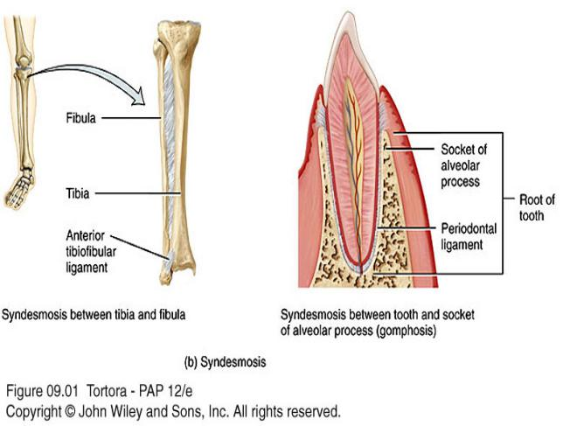

1.B.JOINTS (CARTILAGINOUS JOINTS):-
-Cartillaginous joints are madeup of a tough material called firocartillage which have property to absor shock.
-Lacks a synovial cavity,allows little or no movement,Connected by either cartilage- -Hyaline or fibrocartilage
-Two types of cartilaginous joints
a)Synchondroses
b)Symphyses
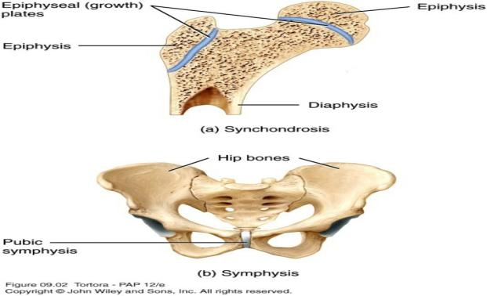
a)Synchondroses:
-Connecting tissue is hyaline cartilage,
-Epiphyseal (growth) plate,
b)Symphyses:-
-Slightly movable joint,Joints where bones are connected by a fibrocartilage
-Example:Pubic symphysis pubisand intervertebral joints between the vertebrae

1.C.JOINTS (SYNOVIAL JOINTS):-
These are made up of capsule or space in-between articulating ony structures.
Synovial cavity allows a joint to be freely movable,bones are covered with layer of hyaline cartilage-Articular cartilage,articular Capsule,a sleeve-like capsule encloses the synovial cavity.
The articular capsule is composed of two layers,an outer fibrous capsule- dense irregular connective tissue,an inner synovial membrane-Areolar connective tissue and Synovial Fluid
The synovial membrane secretes synovial fluid.

Functions to reduce friction by:
- Lubricating the joint
- Absorbing shocks
- Supplying oxygen and nutrients to the cartilage.
- Removing carbon dioxide and metabolic wastes from the cartilage.
- Contains phagocytic cells to removes microbes.
1.C.JOINTS (SYNOVIAL JOINTS)
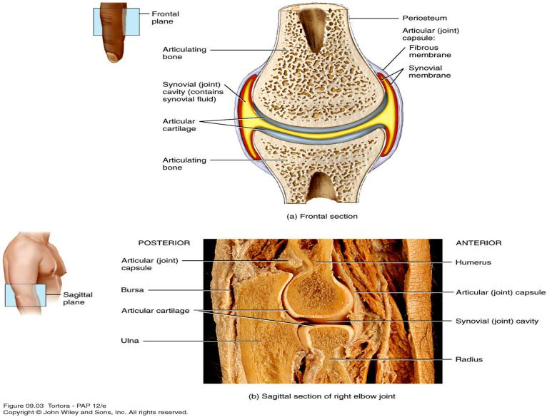
NERVES AND SUPPLY IN JOINTS (SYNOVIAL JOINTS)
-The spinal cord and brain receive information aout pain from the joints.
-Degree of movement and stretch at a joint affects Nerve endings response.
-Around a joint arterial branches merge before entering the articular capsule.
Bursae and Tendon Sheaths:-
- Bursae:-
Fluid similar to synovial fluid filled in Sac-like structure present in between tendons, ligaments and bones which provide cusion like movements.
- Tendon sheaths:-
Wrap around tendons,Reduce friction at joints

1.C.a.TYPES OF MOVEMENTS AT SYNOVIAL JOINTS:-
- According to the range of movement possible or to the shape of the articulating bones synovial joints are classified.
-Specific terminology is used to designate the movements that occur at joints
Movements are grouped into four main categories:
1) Gliding
2) Angular movements
3) Rotation
4) Special movements
TYPES OF MOVEMENTS AT SYNOVIAL JOINTS:-
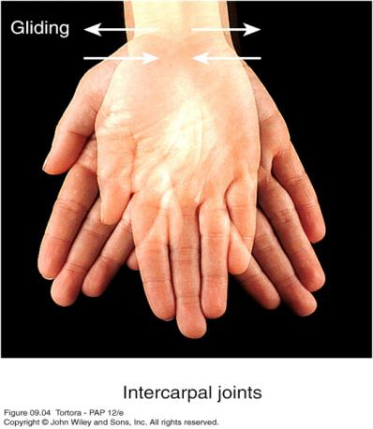
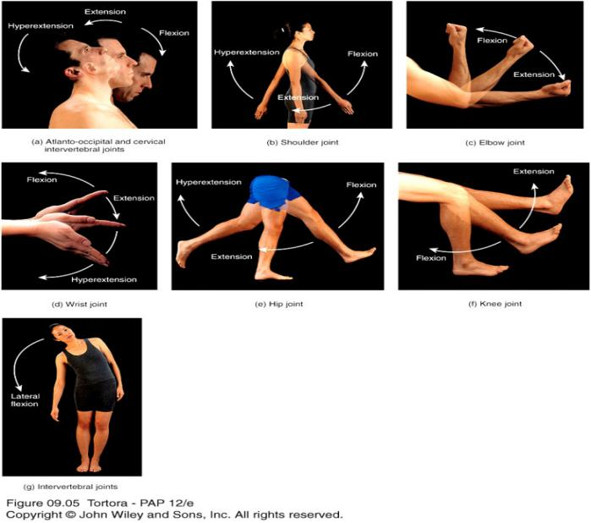
1)Gliding:-
-Simple movement back-and-forth and from side-to-side.
- Alteration of the bones angle between the bones.
-Limited in range.
-Intercarpal joints.
2)Angular Movements:-
Either decrease or increased angle between articulating bones, movements include:
- Flexion
- Extension
- Lateral flexion
- Hyperextension
- Abduction
- Adduction
- Circumduction
a)Flexion:-
Decrease in the angle between articulating bones.
Bending the trunk forward but occasionally backward.
Eg-Knee Joint.
b)Extension:-
Straightening or bending backward.
Increase in the angle between articulating bones.
Flexion and extension are opposite movements.
c)Lateral flexion:-
sideway movement of the trunks at the waist to the right or left.
d)Hyperextension:-
Continuation of extension beyond the normal extension.
Bending the trunk backward.
e)Abduction:-
Movement of a bone away from the midline.
Moving the humerus laterally at the shoulder joint
f)Adduction:-
Movement of a bone toward the midlineof the body.
From abduction.returning the body parts to normal position.

JOINTS (TYPES OF MOVEMENTS AT SYNOVIAL JOINTS)

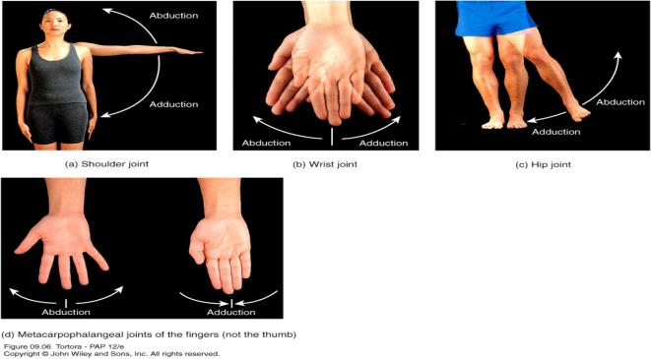
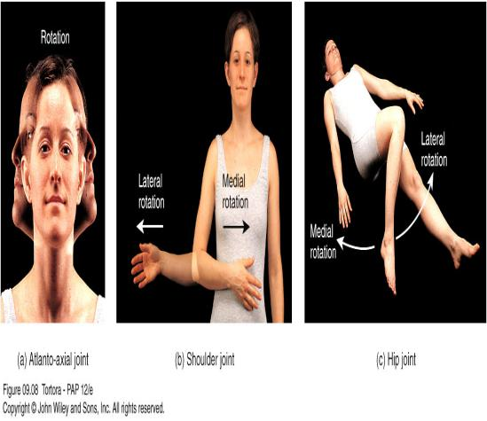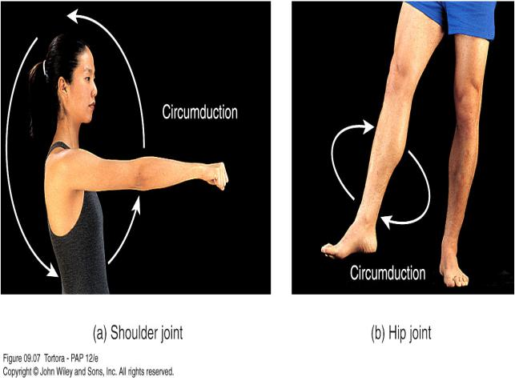
g)Circumduction:-
Movement of a limb or digit so that it describes the shape of a cone.
Body movement part in a circle.
Moving the humerus in a circle at the shoulder joints.

CIRCUMDUCTION:-
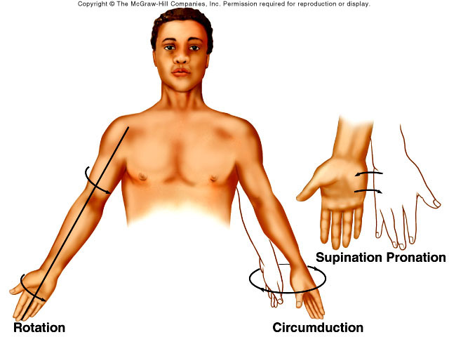
3)Rotation:-
Long axis movement of a bone.
Own longitudinal axis one movement.
Side to side turning after shaking head.
4)Special Movements:-
a)Elevation
b)Depression
c)Protraction
d)Retraction
c)Inversion
d)Eversion
e)Dorsiflexion
f)Plantar flexion
g)Supination
h)Pronation
i)Opposition

SPECIAL MOVEMENTS:-
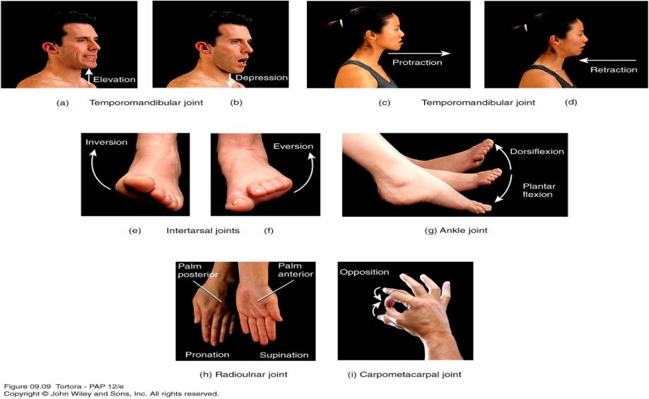
a)Elevation:-
Body part upper movement.
Closing the mouth
Its opposing movement is depression
b)Depression:-
Downward body part movement
Opening the mouth.
c)Protraction:-
Movement of a part of the body anteriorly
Thrusting the mandible outward
Its opposing movement is retraction
d)Retraction:-
Body back to normal from protraction
e)Inversion:-
Movement of the foot medially
Its opposing movement is eversion
f)Eversion:-
Movement of the sole laterally
g)Dorsiflexion:-
Bending of the foot at the ankle in an upward direction
Its opposing movement is plantar flexion
h)Plantar flexion:-
Bending of the foot at the ankle in a downward direction
i)Supination:-
upward movement of palm
Its opposing movement is pronation
j)Pronation:-
Forearm/ palm is turned downward
k)Opposition:-
Movement of the thumb in which the thumb moves across the palm to touch the tips of the fingers on the same hand.
1.C.b.TYPES OF SYNOVIAL JOINTS BASED ON TYPE OF MOVEMENT:-
Synovial joints are classified based on type of movement
1)Planar
2)Hinge
3)Pivot
4)Condyloid
5)Saddle
6)Ball-and-socket
1)Planar Joints:-
- Primarily permit back-and-forth and side-to-side movements.
- flat or slightly curved bones.
- Non axial movements.
- Intercarpal, Intertarsal, sternoclavicular, acromioclavicular, sternocostal, vertebrocostal joints.
2)Hinge joints:-
- Hinged door opening and closing motio .
- concave surface fits into convex surface of bone.
- Monoaxial:Permit only flexion and extension,Knee, elbow, ankle
PLANAR JOINT AND HINGE JOINT:-
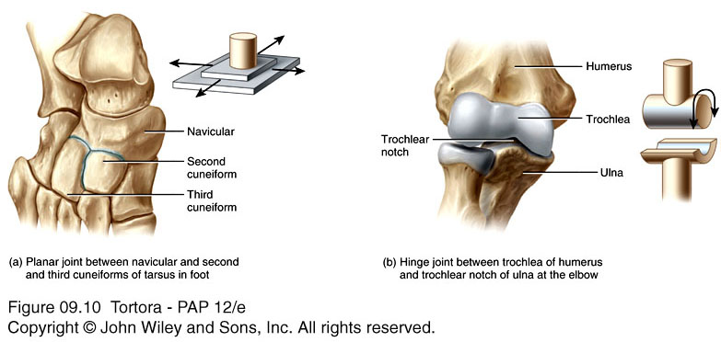

3)Pivot Joints
- Surface of one bone articulates with a ring formed partly by another bone and partly by ligament.
- Monoaxial.
- anteriorly turn of palm by radioulnar joint and posteriorly turn by atlantoaxial joints
4)Condyloid Joints
- The convex oval shaped projection of one bone fits into the oval-shaped depression of another bone.
- Biaxial.
- Wrist and metacarpophalangeal joints.

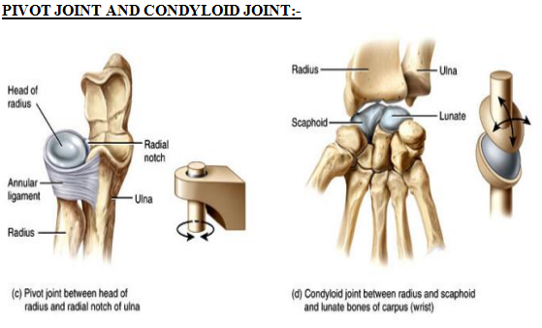

5)Saddle Joints:
- saddle-shaped bone fits into the “saddle”
- Biaxial:Carpometacarpal joint between trapezium of carpus and matacarpal of thumb
6)Ball-and-Socket Joints
- Ball-like surface of one bone fitting into a cuplike depression of another bone
- Multiaxial:Shoulder (Head of humerus fits into glenoid cavity of scapula), hip(head of femur fits into acetabulum of hip bone)

SADDLE JOINT AND BALL-and-SOCKET JOINT

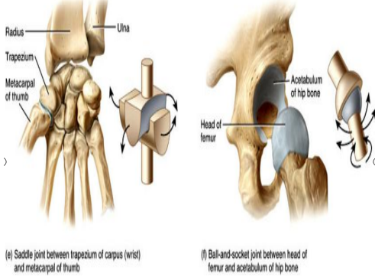

Disorders of Joints
a)Osteoporosis:
Reduced bone density with resorption.
b)Rickets &osteomalacia:
It is inadequate mineralisation of bone usually because of vitamin D deficiency
c)Arthritis:
Inflammatory joint diseases(RA,Rheumatoid disease):This is chronic progressive inflammatory autoimmune disease mainly affcting peripheral symovial joints.
d)Osteoarthritis(Osteoarthosis,OA):
This is a degenerative non-inflammatory disease result in pain and restricted movement of affected joints.
e)Gout:
This condition is more prevalent in males,it is caused by deposition of sodium urate crystals in joints,tendons provoking an acute inflammatory response.

QUESTION:-
5 MARKS:-
1.Write the functions of bones.
2.What are joints? Classify joints with examples.
2 MARKS:-
1.Difference between cartilage and bone.
2.Functions of bones.
3.Define rickets and gout.

