Drowsiness Detection and Auto Alerting System Using Image Processing

A.Sri Divya¹, B.Thanuja², B.Karuna Sree³,Dr.M.Paul Daniel⁴

Asst. Professor, Dept of ECE, CMR Technical Campus, Hyderabad

divyaatla@gmail.com¹

Asst. Professor, Dept of ECE, CMR Technical Campus, Hyderabad

thanujabandari@gmail.com²

Asso. Professor, Dept of ECE, CMR Technical Campus, Hyderabad

karunasree.ece@cmrtc.ac.in³

Professor, Dept of Mechanical Engineering, Narayana Engineering College, Gudur

daniel.matcha7@gmail.com ⁴

ABSTRACT

Developingintelligentsystemstopreventcaraccidentscanbeveryeffectiveinminimizingaccident death toll. One of the factors which play an important role in accidents is the humanerrors including driving fatigue relying on new smart techniques; this application detects thesigns of fatigue and sleepiness in the face of the person at the time of driving. The proposedsystem is based on three separate algorithms. In this model, the person's face is filmed by acamerainthefirststepbyreceiving14-16fpsvideosequence.Then,theimagesaretransformedfrom RGB space into YCbCr and HSV spaces. The face area is separated from other parts andhighly accurate HDP is achieved. That the eyes are open or closed in a specific time interval isdetermined by focusing on thresholding and equations concerning the symmetry of humanfaces.
The proposed system has been implemented on more than thirty different video sequenceswithaverageaccuracyof93.18%anddetectionrate(DR)of92.71%outofapproximately2500imageframes.Highaccuracyinsegmentation,lowerrorrateandquickprocessingofinputdatadistinguishesthissystemfromsimilarones.Thissystemcanminimizethenumberofaccidentscaused bydrivers'fatigue.

CONTENTS

LISTOFCONTENTS PAGENO

Acknowledgement I
Abstract II
ListofFigures V

CHAPTER1:INTRODUCTION TOIMAGEPROCESSING | 1-10
1.1Image | 1-2
1.2 ImageFileSizes | 2-3
1.3ImageFileFormats | 3-5
1.4 ImageProcessing | 6
1.5FundamentalstepsinImageProcessing | 6-11
1.6Componentsof ImageProcessingsystem | 12-15
CHAPTER2:INTRODUCTIONABOUTPROJECT | 10-18
2.1Backgroundof Study | 17
2.2Objectives | 17
2.3Scopeof Study | 18
2.4Implementationoftheproject | 18-20
2.5ModulesoftheApplication | 20-21
2.6Classification | 21-22
2.7 LiteratureSurvey | 22-24

CHAPTER3:TECHNOLOGY 19-27
  - AlgorithmUsed 26-27
  - CasscadeOfClassifiers 27-28
  - Matlab 28-29
  - HistoryOf Matlab 29-31
  - MatlabSystem 31
  - Applicationsof Matlab 31-32
CHAPTER4:APPLICATIONS OFDROWSINESS DETECTION 33
CHAPTER5:RESULTS 34-35
CHAPTER6:CONCLUSIONS ANDFUTURE SCOPE 36
  - Conclusion 36
  - FutureScope 36
BIBLIOGRAPHY 37-38

LISTOFFIGURES

LIST OFFIGURES PageNo
Fig.1.1General Image 1
Fig.1.2ImagePixel 2
Fig.1.3TransparencyImage 2
Fig.1.4ResolutionImage 3
Fig.1.5ImageFundamentals 6
Fig.1.6 Enhancement 7
Fig.1.7Restoration 8
Fig.1.8Colour andGrayScale Image 8
Fig.1.9RGBHistogram 9
Fig.1.10 BlurtoDeblurImage 10
Fig.1.11Segmentation 10
Fig.2.1 ExamplesofFatigue andDrowsiness 16
Fig.2.2 FlowDiagram 19
Fig.2.3 FlowchartofAlgorithm 20
Fig.3.1 FlowchartofProjectProgress 25
Fig.3.2CascadeofClassifiers 27
Fig.3.3Matlabvarious Disciples 28
Fig.3.4MatlabMultiparadigm 29
Fig.3.5SchematicofMatlabmainfeatures 30
Fig.3.6 ElementsofMatlabSystem 31
Fig.5.1Drowsy 34
Fig.5.2Drowsy 34
Fig.5.3Active 35

V

CHAPTER 1INTRODUCTIONTOIMAGEPROCESSING

IMAGE:
An image is a two-dimensional picture, which has a similar appearance to some subjectusuallyaphysical objector aperson.
Image is a two-dimensional, such as a photograph, screen display, and as well as a three-dimensional, such as a statue. They may be captured by optical devices—such as cameras,mirrors, lenses, telescopes, microscopes, etc. and natural objects and phenomena, such as thehumaneyeorwatersurfaces.
Thewordimageisalsousedinthebroadersenseofanytwo-dimensionalfiguresuchasamap,agraph, a pie chart, or an abstract painting. In this wider sense, images can also be renderedmanually,suchasbydrawing,painting,carving,renderedautomaticallybyprintingorcomputergraphics technology, or developed by a combination of methods, especially in a pseudo-photograph.

Figure.1.1General Image

Animageisarectangulargridofpixels.Ithasadefiniteheightandadefinitewidthcountedinpixels.Eachpixelissquareandhasafixedsizeonagivendisplay.Howeverdifferentcomputermonitors may use different sized pixels. The pixels that constitute an image are ordered as agrid(columnsandrows);eachpixelconsistsofnumbersrepresentingmagnitudesofbrightnessandcolour.

Each pixel has a color. The color is a 32-bit integer. The first eight bits determine the rednessofthepixel,thenexteightbitsthegreenness,thenexteightbitsthebluenessandtheremainingeightbits thetransparencyof thepixel.
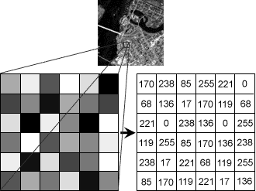

Figure.1.2. ImagePixel

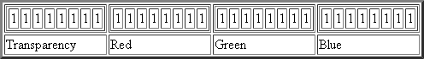

Figure.1.3.TransparencyImage

IMAGEFILESIZES:
Imagefilesizeisexpressedasthenumberofbytesthatincreaseswiththenumberofpixelscomposing an image, and the colour depth of the pixels. The greater the number of rows andcolumns, the greater the image resolution, and the larger the file. Also, each pixel of an imageincreases in size when its colour depth increases, an 8-bit pixel (1 byte) stores 256 colours, a24-bitpixel (3 bytes)stores 16 millioncolours, the latter knownas truecolour.
Image compression uses algorithms to decrease the size of a file. High resolution camerasproducelargeimagefiles,rangingfromhundredsofkilobytestomegabytes,perthecamera'sresolution and the image-storage format capacity. High resolution digital camerasrecord12megapixel(1MP=1,000,000pixels/1million)images,ormore,intruecolor.For

example, an image recorded by a 12 MP camera; since each pixel uses 3 bytes to record truecolor, the uncompressed image would occupy 36,000,000 bytes of memory, a great amount ofdigital storage for one image, given that cameras must record and store many images to bepractical.Faced with large file sizes, both within the camera and a storage disc, image fileformatsweredeveloped to storesuch large images.

IMAGEFILEFORMATS:
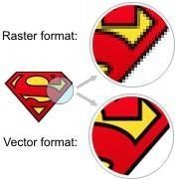
Image file formats are standardized means of organizing and storing images. This entry isabout digital image formats used to store photographic and other images. Image files arecomposedofeitherpixelorvector(geometric)datathatarerasterizedtopixelswhendisplayed(withfewexceptions)inavectorgraphicdisplay.Includingproprietary types,therearehundreds of image file types. The PNG, JPEG, and GIF formats are most often used to displayimageson theInternet.
Figure.1.4Resolution Image
In addition to straight image formats, Metafile formats are portable formats which canincludebothrasterandvectorinformation.Themetafileformatisanintermediateformat.MostWindowsapplications open metafilesand then savethemin their own nativeformat.

RASTERFORMATS:
Theseformatsstoreimagesasbitmaps

JPEG/JFIF:
JPEG(JointPhotographicExpertsGroup)isacompressionmethod.JPEGcompressedimagesareusually storedintheJFIF(JPEGFileInterchangeFormat)fileformat.JPEGcompressionislossycompression.NearlyeverydigitalcameracansaveimagesintheJPEG/JFIFformat,whichsupports8bitspercolor(red,green,blue)fora24-bittotal,producing

relativelysmallfiles. Photographic images may be better stored in a lossless non-JPEG formatif they will be re-edited, or if small "artifacts" are unacceptable. The JPEG/JFIF format also isusedas the imagecompression algorithm in manyAdobePDFfiles.

EXIF:
The EXIF (Exchangeable image file format) format is a file standard similar to the JFIFformatwith TIFF extensions. It is incorporated in the JPEG writing software used in mostcameras.Itspurposeistorecordandtostandardizetheexchangeofimageswithimagemetadatabetween digital cameras and editing and viewing software. The metadata are recorded forindividual images and include such things as camera settings, time and date, shutter speed,exposure, image size, compression, name of camera, color information, etc. When imagesareviewedor editedbyimageeditingsoftware, allofthisimageinformationcanbedisplayed.

TIFF:
The TIFF (Tagged Image File Format) format is a flexible format that normally saves 8 bitsor16 bits per colour (red, green, blue) for 24-bit and 48-bit totals, respectively, usually usingeithertheTIFForTIFfilenameextension.TIFFsarelossyandlossless.Someofferrelativelygood lossless compression for bi-level (black & white) images. Some digital camerascansaveinTIFFformat,usingtheLZWcompressionalgorithmforlosslessstorage.TIFFimageformatisnotwidelysupportedbywebbrowsers.TIFFremainswidelyacceptedasaphotographfilestandardintheprintingbusiness.TIFFcanhandledevice-specificcolorspaces,suchastheCMYKdefined byaparticular set of printingpress inks.

PNG:
The PNG (Portable Network Graphics) file format wascreated as the free, open- sourcesuccessortotheGIF.ThePNGfileformatsupportstruecolor(16millioncolors)whiletheGIFsupports only 256 colors. The PNG file excels when the image has large, uniformly coloredareas. The lossless PNG format is best suited for editing pictures, and the lossy formats, likeJPG, are best for the final distribution of photographic images, because JPG files are smallerthan PNG files. PNG, an extensible file format for the lossless, portable, well- compressedstorage of raster images. PNG provides a patent-free replacement for GIF and canalso replacemany common uses of TIFF. Indexed-color, grayscale, and true color images are supported,plusan optional alphachannel.PNGis designedto work well inonline viewingapplications,

such as the World Wide Web. PNG is robust, providing both full file integrity checking andsimpledetection ofcommon transmission errors.

GIF:
GIF (Graphics Interchange Format) is limited to an 8-bit palette, or 256 colors. This makestheGIF format suitable for storing graphics with relatively few colors such as simple diagrams,shapes,logosandcartoonstyleimages.TheGIFformatsupportsanimationandisstillwidelyusedto provideimageanimation effects.

BMP :
TheBMPfileformat(Windowsbitmap)handlesgraphicsfileswithintheMicrosoftWindowsOS. Typically, BMP files are uncompressed, hence they are large. The advantage istheirsimplicityand wideacceptancein Windows programs.

VECTORFORMATS:
As opposed to the raster image formats above (where the data describes the characteristicsof each individual pixel), vector image formats contain a geometric description which can berendered smoothly at any desired display size. At some point, all vector graphics must berasterizedin order to bedisplayed ondigital monitors.

CGM :
CGM(ComputerGraphicsMetafile)isafileformatfor2Dvectorgraphics,rastergraphics,andtext. All graphical elements can be specified in a textual source file that can be compiled into abinaryfileoroneoftwotextrepresentations.CGMprovidesameansofgraphicsdatainterchange for computer representation of 2D graphical information independent from anyparticularapplication, system, platform, or device.

SVG:
SVG (Scalable Vector Graphics) is an open standard created and developed by the WorldWideWebConsortium to address the need for a versatile, scriptable and all purpose vectorformat for the web and otherwise. The SVG format does not have a compression scheme of itsown,butduetothetextualnatureofXML,anSVGgraphiccanbecompressedusingaprogramsuchasgzip.

IMAGEPROCESSING:
Digital image processing, the manipulation of images by computer, is relatively recentdevelopment in terms of man’s ancient fascination with visual stimuli. In its short history, ithas been applied to practically every type of images with varying degree of success. Theinherent subjective appeal of pictorial displays attracts perhaps a disproportionate amount ofattention from the scientists and also from the layman. Digital image processing like otherglamour fields, suffers from myths, misconnect ions, misunderstandings and misinformation.Itisvastumbrellaunderwhichfalldiverseaspectofoptics,electronics,mathematics,photographygraphicsandcomputertechnology.Itistrulymultidisciplinaryendeavourploughed with imprecise jargon. Several factor combine to indicate a lively future for digitalimage processing. A major factor is the declining cost of computer equipment. Several newtechnologicaltrends promisetofurtherpromote digitalimageprocessing.

FUNDAMENTALSTEPSINIMAGEPROCESSING:
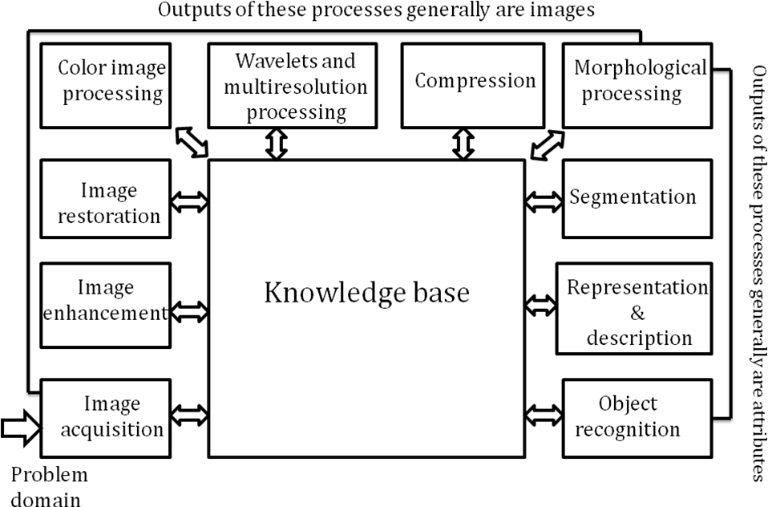

Figure.1.5.ImageFundamentals

ImageAcquisition:

Image Acquisition is to acquire a digital image. To do so requires an image sensor and thecapability to digitize the signal produced by the sensor. The sensor could be monochrome orcolour TV camera that produces an entire image of the problem domain every 1/30 sec. theimage sensor could also be line scan camera that produces a single image line at a time. Inthiscase,the objects motion past theline.
Scanner produces a two-dimensional image. If the output of the camera or other imagingsensorisnot in digitalform, an analogueto digital converter digitizesit.

1.5.2ImageEnhancement:
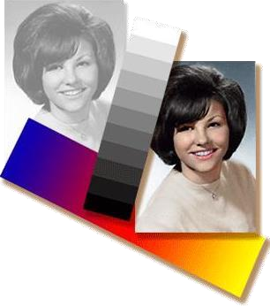
Imageenhancementisamongthesimplestandmostappealingareasofdigitalimageprocessing.Basically, the idea behind enhancement techniques is to bring out detail that is obscured, orsimplytohighlightcertainfeaturesofinterestinganimage.Afamiliarexampleofenhancementis when we increase the contrast of an image because “it looks better.” It is important to keepinmind that enhancement is averysubjectiveareaof imageprocessing.

ImageRestoration:
Fig.1.6.Enhancement

Image restoration is an area that also deals with improving the appearance of animage.However, unlike enhancement, which is subjective, image restoration is objective, in the sensethat restoration techniques tend to be based on mathematical or probabilistic models of imagedegradation.Enhancement,ontheotherhand,isbasedonhumansubjectivepreferencesregarding what constitutes a “good” enhancement result. For example, contrast stretching isconsideredanenhancementtechnique becauseitisbased primarilyonthepleasingaspectsit

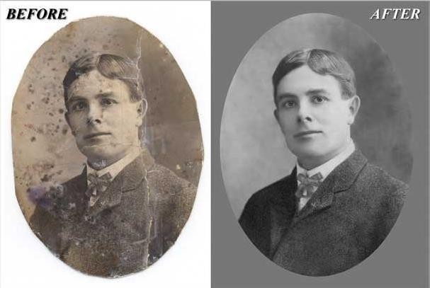
mightpresenttotheviewer,whereas removalofimageblurbyapplyingadeblurringfunctionisconsideredarestorationtechnique.
Fig.1.7.Restoration

ColourImageProcessing:
The use of colour in image processing is motivated by two principal factors. First, colour is apowerful descriptor that often simplifies object identification and extraction from a scene.Second,humanscandiscernthousandsofcolourshadesandintensities,comparedtoaboutonlytwodozenshadesofgray.Thissecondfactorisparticularlyimportantinmanualimageanalysis.
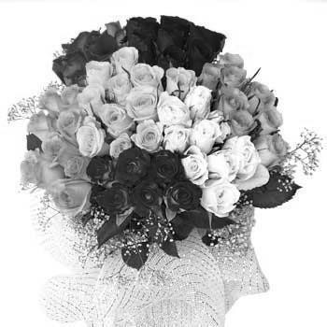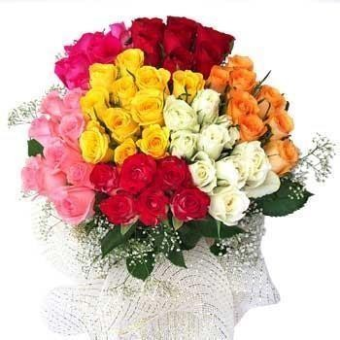

Fig.1.8.Colour&grayscaleimage

WaveletsandMultiresolutionProcessing:
Waveletsaretheformationforrepresentingimagesinvariousdegreesofresolution.AlthoughtheFouriertransformhasbeenthemainstayoftransformbasedimageprocessingsincethe late1950’s, a more recent transformation, called the wavelet transform, and is now makingiteveneasiertocompress,transmit,andanalyzemanyimages.UnliketheFouriertransform,

whose basis functions are sinusoids, wavelet transforms are based on small values, calledWavelets,of varyingfrequencyand limited duration.

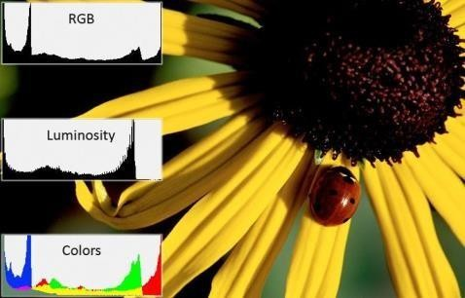
Fig.1.9.RGBHistogram Image

Waveletswerefirstshowntobethefoundationofapowerfulnewapproachtosignalprocessingand analysis called Multiresolution theory. Multiresolution theory incorporates and unifiestechniques from a variety of disciplines, including sub band coding from signal processing,quadraturemirrorfilteringfromdigitalspeechrecognition,and pyramidalimageprocessing.

Compression:
Compression, as the name implies, deals with techniques for reducing the storage requiredsavinganimage,orthebandwidthrequiredfortransmittingit.Althoughstoragetechnologyhasimprovedsignificantlyoverthepastdecade,thesamecannotbesaid fortransmissioncapacity.This is true particularly in uses of the Internet, which are characterized by significant pictorialcontent. Image compression is familiar to most users of computers in the form of image fileextensions,suchasthejpgfileextensionused intheJPEG(JointPhotographicExpertsGroup)image compression.

1.5.7Morphologicalprocessing:
Morphological processing deals with tools for extracting image components that are useful inthe representation and description of shape. The language of mathematical morphology is settheory. As such, morphology offers a unified and powerful approach to numerous imageprocessingproblems.Setsinmathematicalmorphologyrepresentobjectsinanimage.For

example, the set of all black pixels in a binary image is a complete morphological descriptionoftheimage.
Fig.1.10.BlurtoDeblurimage
In binary images, the sets in question are members of the 2-D integer space Z2, where eachelement of a set is a 2-D vector whose coordinates are the (x,y) coordinates of a black(orwhite)pixelintheimage.Gray-scaledigitalimagescanberepresentedassetswhosecomponents arein Z3. In this case, two components of each element of the set refer to thecoordinatesofapixel,andthethird correspondstoits discretegray-level value.

Segmentation:
Segmentationprocedures partitionanimageintoitsconstituentpartsortheobjects. Ingeneral,
autonomous segmentation is one of the most difficult tasks in digital image processing. Arugged segmentation procedure brings the process a long way toward successful solution ofimagingproblems that requireobjects to beidentified individually.

Fig.1.11.Segmentation

Representationanddescription:
Representation and description almost always follow the output of a segmentation stage,whichusually is raw pixel data, constituting either the boundary of a region (i.e., the set ofpixels separating one image region from another) or all the points in the region itself. In eithercase, converting the data to a form suitable for computer processing is necessary. The firstdecisionthat must be made is whether the data should be represented as a boundary or as acomplete region. Boundary representation is appropriate when the focus is on external shapecharacteristics.
Regional representation is appropriate when the focus is on internal properties, such astextureor skeletal shape. In some applications, these representations complement each other.Choosing a representation is only part of the solution for transforming raw data into a formsuitable for subsequent computer processing. A method must also be specified for describingthe data so that features of interest are highlighted. Description, also called feature selection,deals with extracting attributes that result in some quantitative information of interest or arebasicfor differentiatingoneclass ofobjects from another.

ObjectRecognition:
The last stage involves recognition and interpretation. Recognition is the process that assigns alabeltoanobjectbasedontheinformationprovidedbyitsdescriptors.Interpretationinvolvesassigningmeaningto anensembleofrecognized objects.

1.5.11Knowledgebase:
Knowledge about a problem domain is coded into image processing system in the formof aknowledge database. This knowledge may be as simple as detailing regions of an image whenthe information of interests is known to be located, thus limiting the search that has to beconducted in seeking that information. The knowledge base also can be quite complex, such asaninterrelatedtolistofallmajorpossibledefectsinamaterialsinspectionproblemoranimagedata base containing high resolution satellite images of a region in connection with changedeletion application. In addition to guiding the operation of each processing module, theknowledge base also controls the interaction between modules. The system must be endowedwith the knowledge to recognize the significance of the location of the string with respect toothercomponentsofanaddressfield.Thisknowledgeglidesnotonlytheoperationofeach

module,butitalsoaidsinfeedbackoperationsbetweenmodulesthroughtheknowledgebase.Weimplemented pre-processingtechniques usingMATLAB.

COMPONENTSOFANIMAGEPROCESSINGSYSTEM:
As recently as the mid-1980s, numerous models of image processing systems being soldthroughouttheworldwererathersubstantialperipheraldevicesthatattachedtoequallysubstantialhostcomputers.Lateinthe1980sandearlyinthe1990s,themarketshiftedtoimageprocessing hardware in the form of single boards designed to be compatible with industrystandard buses and to fit into engineering workstation cabinets and personal computers. Inadditiontoloweringcosts,thismarketshiftalsoservedasacatalystforasignificantnumberofnew companies whose specialty is the development of software written specifically for imageprocessing. Although large-scale image processing systems still are being sold for massiveimagingapplications,suchasprocessingofsatelliteimages,thetrendcontinuestowardminiaturizingandblendingofgeneral-purposesmallcomputerswithspecializedimageprocessinghardware.

ImageSensors:
Withreferencetosensing,twoelementsarerequiredtoacquiredigitalimages.Thefirstisa physical device that is sensitive to the energy radiated by the object we wish to image. Thesecond, called a digitizer, is a device for converting the output of the physical sensing deviceintodigitalform.Forinstance,inadigitalvideocamera,thesensorsproduceanelectricaloutputproportionalto lightintensity.Thedigitizer convertstheseoutputsto digitaldata.

SpecializedImageProcessingHardware:
Specialized image processing hardware usually consists of the digitizer just mentioned,plushardwarethatperformsotherprimitiveoperations,suchasanarithmeticlogicunit(ALU),which performs arithmetic and logical operations in parallel on entire images. One example ofhow an ALU is used is in averaging images as quickly as they are digitized, for the purpose ofnoise reduction. This type of hardware sometimes is called a front-end subsystem, and its mostdistinguishing characteristic is speed. In other words, this unit performs functions that requirefast data throughputs (e.g., digitizing and averaging video images at 30 frames) that the typicalmaincomputer cannot handle.

Computer:
The computer in an image processing system is a general-purpose computer and can rangefromaPCtoasupercomputer.Indedicatedapplications,sometimesspeciallydesignedcomputers are used to achieve a required level of performance, but our interest here is ongeneral-purpose image processing systems. In these systems, almost any well-equipped PC-typemachine is suitablefor offlineimageprocessingtasks.

ImageProcessingSoftware:
Softwareforimageprocessingconsistsofspecializedmodulesthatperformspecifictasks.Awell-designedpackagealsoincludesthecapabilityfortheusertowritecodethat,asaminimum,utilizesthespecializedmodules.Moresophisticatedsoftwarepackagesallowtheintegrationofthosemodulesandgeneral-purposesoftwarecommandsfromatleastone computerlanguage.

Mass storage:
Mass storage capability is a must in image processing applications. An imageof size1024*1024 pixels, in which the intensity of each pixel is an 8-bit quantity, requires onemegabyte of storage space if the image is not compressed. When dealing with thousands, oreven millions, of images, providing adequate storage in an image processing system can be achallenge.Digitalstorageforimageprocessingapplicationsfallintothreeprincipalcategories:
(1) short-term storage for use during processing, (2) on-line storage for relatively fast recall,and(3)archivalstorage,characterizedbyinfrequentaccess.Storageismeasuredinbytes(eightbits), Kbytes (one thousand bytes), Mbytes (one million bytes), Gbytes (meaning giga, or onebillion,bytes), and Tbytes (meaningtera,or onetrillion, bytes)
Onemethodofprovidingshort-termstorageiscomputermemory.Anotherisbyspecializedboards,called framebuffersthatstoreoneormoreimages andcanbeaccessedrapidly,usuallyat video rates. The latter method allows virtually instantaneous image zoom, as well as scroll(verticalshifts)andpan(horizontalshifts).Framebuffersusuallyarehousedinthespecializedimage processing hardware unit shown in Fig. 1.24. Online storage generally takesthe form ofmagnetic disks or optical-media storage. The key factor characterizing on-linestorageisfrequentaccesstothestoreddata.Finally,archivalstorageischaracterizedbymassivestoragerequirementsbutinfrequentneedforaccess.Magnetictapesandopticaldiskshousedin“jukeboxes”aretheusual media for archival applications.

Imagedisplays:
Imagedisplaysinusetodayaremainlycolor(preferablyflatscreen)TVmonitors.Monitorsare driven by the outputs of image and graphics display cards that are an integral part of thecomputer system. Seldom are there requirements for image display applications that cannot bemetbydisplaycardsavailablecommerciallyaspartofthecomputersystem.Insome cases,itisnecessarytohavestereodisplays,andtheseareimplementedintheformofheadgearcontainingtwosmall displaysembedded in goggleswornbythe user.

Hardcopy :
Hardcopy devices for recording images include laser printers, film cameras, heat- sensitivedevices, inkjet units, and digital units, such as optical and CD-ROM disks. Film provides thehighestpossibleresolution,butpaperistheobviousmediumofchoiceforwrittenmaterial.Forpresentations,imagesaredisplayedonfilmtransparenciesorinadigitalmediumifimageprojection equipment is used. The latter approach is gaining acceptance as the standardforimagepresentations.

Network :
Networking is almost a default function in any computer system in use today. Because ofthe large amount of data inherent in image processing applications, the key consideration inimage transmission is bandwidth. In dedicated networks, this typically is not a problem, butcommunications with remote sites via the Internet are not always as efficient. Fortunately, thissituation is improvingquicklyasaresult of optical fiber and otherbroadband technologies.
Colourandtexturearetwolow-levelfeatureswidelyusedforimageclassification,indexingand retrieval. Colour is usually represented as a histogram, which is a first order statisticalmeasure that captures global distribution of colour in an image One of the main drawbacks ofthehistogram-basedapproachesisthatthespatialdistributionandlocalvariationsincolourareignored.Localspatialvariationofpixelintensityiscommonlyusedtocapturetextureinformation in an image. Grayscale Co- occurrence Matrix (GCM) is a well-known methodfortexture extraction in the spatial domain. A GCM stores the number of pixel neighbourhoodsinan image that have a particular grayscale combination. Let I be an image and let p and Nprespectivelydenoteanyarbitrarypixelanditsneighbourinagivendirection.If GLdenotesthetotalnumberofquantizedgraylevels and gldenotestheindividual graylevels,where, gl{0,..
.,GL_ 1}, then each component of GCMcan bewritten as follows:

gcm(i, j)is thenumberoftimesthegraylevelof apixelpdenotedbyglp equalsi,andthe graylevel of its neighbour Np denoted by gl Np equals j, as a fraction of the total number of pixelsin the image. Thus, it estimates the probability that the gray level of an arbitrary pixel in animage is i, and that of its neighbour is j. One GCM matrix is generated for each possibleneighbourhood direction, namely, 0, 45, 90 and 135.Average and range of 14 features likeAngular Second Moment, Contrast, Correlation, etc., are generated by combining all the fourmatrices to get a total of 28 features. In the GCM approach for texture extraction, colorinformation is completelylost sinceonlypixel graylevels areconsidered.
To incorporate spatial information along with the colour of image pixels, a feature calledcolourcorrelogram has recently been proposed. It is a three dimensional matrix that representstheprobabilityoffindingpixelsofanytwogivencoloursatadistance‘d’apartAutocorrelogramisavariationofcorrelogram,whichrepresentstheprobabilityoffindingtwopixelswith the same colour at a distance ‘d’ apart. This approach can effectively represent colourdistributioninanimage.However,correlogramfeaturesdonotcaptureintensityvariationManyimagedatabasesoftencontainbothcolouraswellasgrayscaleimages.Thecolourcorrelogrammethod does not constitute a good descriptor in such databases. Another method called ColourCo-occurrenceMatrix(CCM)hasbeenproposedtocapturecolourvariationinanimage.CCMis represented as a three-dimensional matrix, where colour pair of the pixels p and Np arecapturedinthefirsttwodimensionsofthematrixandthespatialdistance‘d’betweenthesetwopixelsis captured inthe third dimension.

CHAPTER 2INTRODUCTIONABOUTPROJECT
Drowsiness is a state of near sleep, where the person has a strong desire for sleep. It hastwodistinct meanings, referring both to the usual state precedingfallingasleepandthechroniccondition referring to being in that state independent ofa dailyrhythm.Sleepiness canbedangerouswhenperformingtasksthatrequireconstantconcentration,suchasdrivingavehicle.When a person is sufficiently fatigue while driving, they will experience drowsiness and thisleadsto increasethe factor ofroadaccident.
Figure.2.1:ExamplesofFatigue&DrowsinessCondition

The development of technologies for detecting or preventing drowsiness while drivingis a major challenge in the field of accident avoidance system. Because of the hazard thatdrowsinesspresents ontheroad,methods needtobedevelopedforcounteractingitsaffects.

Theaimofthisprojectistodevelopasimulationofdrowsinessdetectionsystem.Thefocuswillbeplaced on designing a system that will accurately monitor the open or closed state of the driver’seyesandmouth.Bymonitoringtheeyes,itisbelievedthatthesymptomsofdriver'sdrowsinesscanbe detected in sufficiently early stage, to avoid a car accident. Yawning detection is a method toassess the driver’s fatigue. When a person is fatigue, they keep yawning to ensure that there isenoughoxygenforthebrainconsumptionbeforegoingtodrowsinessstate[17].Detectionoffatigueand drowsiness involves a sequence of images of a face, and the observation of eyes and mouthopenorclosedduration.AnothermethodtodetecteyeclosureisPERCLOS.Thisdetectionmethodisbased onthe timeofeyesclosed whichrefersto percentageofaspecifictime.

The analysis of face images is a popular research area with applications such as facerecognition,andhumanidentificationandtrackingforsecuritysystems.Thisprojectisfocused

onthelocalizationoftheeyesandmouth,whichinvolveslookingattheentireimageoftheface,anddeterminingthepositionoftheeyesandmouth,byapplyingtheexistingmethodsinimage-processing algorithm. Once the position of the eyes is located, the system is designed todetermine whether the eyes and mouth are opened or closed, and detect fatigue &drowsiness.2.1Backgroundof Study
Each year, there is an increase in road accidents cases involving cars and heavy vehicleslike buses, lorries and trucks. Drowsiness and fatigue condition is one of the prime factorscontributingtoroadaccidents.Drivinginthisconditionmayresultterriblecausessinceitaffectsthedriver’sjudgmentandconcentration.Fallingasleeponthewheelcanbeavoidifthedriverstake efforts such as getting enough sleep before driving, taking caffeine or stop for a while torestwhen the signs of fatigueand drowsiness appears.
However,inmanycases,driversrefusetotakeoneofthesestepsevenwhentheyknowthatthey are suffering from fatigue, and will continue driving. Therefore, detecting drowsiness isimportant as one of the steps to prevent the road accidents. This project proposed that yawningandeyes detection is the obvious signs of fatigue and drowsiness.
A drowsiness detection system which use a camera placed in front of the driver is moresuitable to be use but the physical signs that will indicate drowsiness need to be located first inorder to come up with a drowsiness detection algorithm that is reliable and accurate. Lightingintensityandwhilethedrivertilttheirfaceleftorrightaretheproblemsoccurduringdetectionof eyes and mouth region. Therefore, this project aims to analyse all the previous research andmethod, hence propose a method to detect drowsiness by using video or webcam. It analysesthe video images that have been recorded and come up with a system that can analyse eachframe ofthevideo.

Objectives
Theproject focuseson theseobjectives,which are:
    - Tosuggestwaystodetectfatigueanddrowsiness whiledriving.
    - Tostudyon eyesand mouth fromthevideo imagesof participants inthe experiment.
    - Toinvestigatethephysicalchangesoffatigueanddrowsiness.
    - To develop a system that use eyes closure and yawning as a way to detect fatigueanddrowsiness.

ScopeofStudy
Inthisproject, thewewill focusonthesefollowingprocedures:

    - Basic conceptofdrowsinessdetectionsystem.

    - Familiarizewiththesignsofdrowsiness.

    - Determinethedrowsinessfromtheseparameters.

    - Eyeblink.

    - Areaofthepupilsdetectedat eyes.

    - Yawning.

    - Datacollectionandmeasurement.

    - Integrationofthemethodschosen.

    - Codingdevelopment andtesting.

    - Completetestingandimprovement.

Thisprojectisrelevanttotheimplementationsincefatigueanddrowsinessdriverscontributeto the percentage of road accidents. Many researches have been conducted to implement safedrivingsystemsinordertoreduceroadaccidents.Detectingthedriver’salertnessanddrowsiness is an efficient way to prevent road accidents. With this system, drivers who aredrowsywillbealertedbyanalarmtoregulateconsciousness,attentionandconcentrationofthedrivers.This will help to reducethenumberof road accidents.
This project is an active topic that is still being enhanced and improved by researches andcanbeappliedinmanyareassuchasdetectingtheattention-levelofstudentsinclassroomsandlectures. This is also relevant to the three author’s field of study since it requires the author toapplyand combinethe knowledgeof electronics,programmingand algorithms.

IMPLEMENTATIONOFTHEPROJECT:
Once the face area is found, the eyes are found by computing the horizontal averages in thearea. Taking into account the knowledge that eye regions in the face present great intensitychanges,theeyes arelocated byfindingthesignificant intensitychanges inthe face.

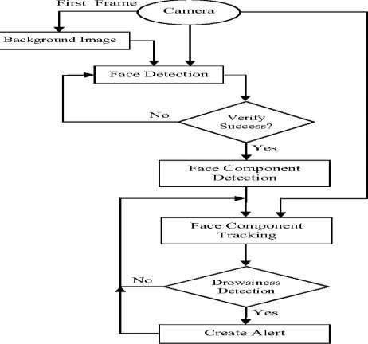

Figure.2.2FlowDiagram

Once the eyes are located, measuring the distances between the intensity changes in e areadeterminewhether the eyes areopen or closed.
A large distance corresponds to eye closure.If the eyes are found closed for 5 consecutiveframes, the system draws the conclusion that the driver is falling asleep and issues a warningsignal. The system is also able to detect when the eyes cannot be found, and works underreasonablelightingconditions.
Inthisprojectweuse Viola-JonesAlgorithm.

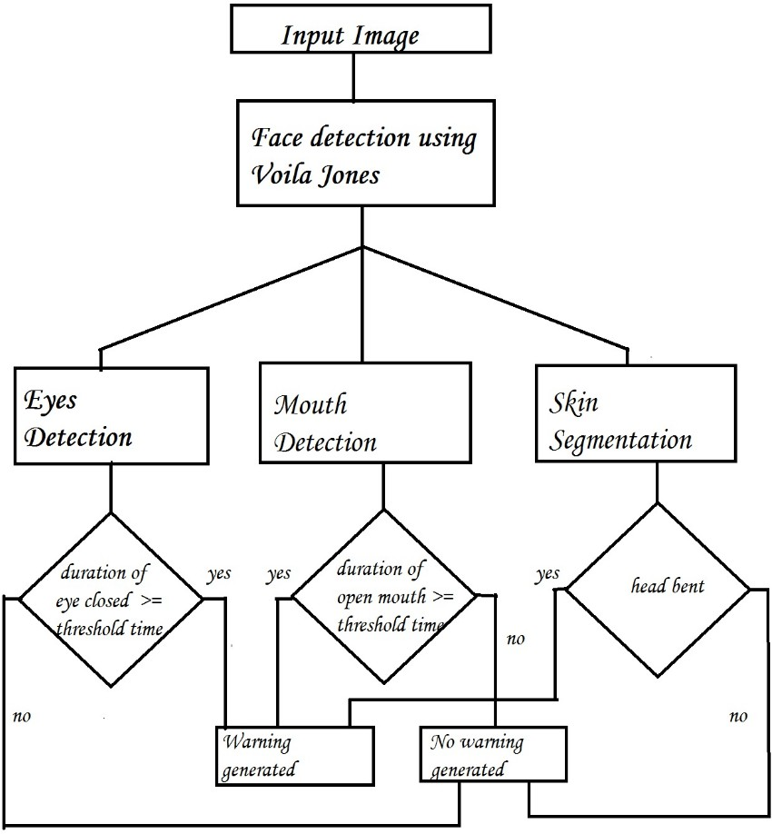
Figure2.3FlowchartoftheAlgorithm

MODULESOFTHEAPPLICATION:

DataAcquisition:
The video is recorded using webcam (Sony CMU-BR300) and the frames are extracted andprocessed in a laptop. After extracting the frames, image processing techniques are applied onthese 2D images. Presently, synthetic driver data has been generated. The volunteers are askedto look at the webcam with intermittent eye blinking, eye closing, yawning and head bending.Thevideo is captured for 30 minutes duration.

FaceDetection:
After extracting the frames, first the human faces are detected. Numerous online facedetection algorithms are there. In this study, histogram of oriented gradients (HOG).In thismethod,positivesamplesofdescriptorsarecomputedonthem.Subsequently,negativesamples(samples that do not contain the required object to be detected i.e., human face here) of samesize are taken and HOG descriptors are calculated. Usually the number of negative samples isvery greater than number of positive samples. After obtaining the features for both the classes.ToimprovetheaccuracyofVJM,hardnegativeminingisused.Inthismethod,aftertraining,

the classifier is tested on the labelled data and the false positive sample feature values are usedagainfortrainingpurpose.
For the test image, the fixed size window is translated over the image and the classifiercomputestheoutputforeachwindowlocation.Finally,themaximumvalueoutputisconsideredasthedetectedfaceandaboundingboxis drawnaroundtheface.Thisnon-maximumsuppressionstep removesthe redundant and overlappingboundingboxes.

FacialLandmarkmarking:
Afterdetectingtheface,thenexttaskistofindthelocationsofdifferentfacialfeatureslikethe corners of the eyes and mouth, the tip of the nose and so on. Prior to that, the face imagesshould be normalized in order to reduce the effect of distance from the camera, non-uniformillumination and varying image resolution. Therefore, the face image is resized to a width of500pixelsandconvertedtograyscaleimage.Afterimagenormalization,ensembleofregressiontreesisusedtoestimatethelandmarkpositionsonfacefromasparsesubsetofpixelintensities.In this method, the sum of square error loss is optimized using gradient boosting learning.Different priors are used to find different structures. Using this method, the boundary points ofeyes,mouthandthecentrallineofthenosearemarkedandthenumberofpointsforeye,mouthandnose. The redpoints arethe detectedlandmarks forfurtherprocessing.

FeatureExtraction:
After detecting the facial landmarks, the features are computed. From the eye corner pointsthe,eyeaspect ratiois calculated as theratio of height andwidth of the eye.

CLASSIFICATION:
Aftercomputingallthethreefeatures,thenexttaskistodetectdrowsinessintheextractedframes.Inthebeginning,adaptivethresholdingisconsideredforclassification.Laterusingviolajone algorithm is utilized to classify the data. For computing the threshold values for eachfeature, it is assumed that initially the driver is in complete awake state. This is called setupphase. In the setup phase, the EAR values for first three hundred (for 10s at 30 fps) frames arerecorded. Out 4of these three hundred initial frames containing face, average of 150 maximumvaluesisconsideredasthehardthresholdforEAR.Thehighervaluesareconsideredsothatnoeyeclosinginstanceswillbepresent.Ifthetestvalueislessthanthisthreshold,theneyeclosing(i.e.,drowsiness)isdetected.Asthesizeofeyecanvaryfrompersontoperson,thisinitialsetupforeachpersonwillreducethiseffect.Similarly,forcalculatingthresholdofMOR,sincethe

mouthmaynotbeopentoitsmaximumininitialframes (setupphase)sothethresholdis takenexperimentally from the observations. If the test value is greater than this threshold then yawn(i.e.,drowsiness)isdetected.Headbendingfeatureisusedto findtheanglemadebyhead withrespect to vertical axis in terms of ratio of projected nose lengths. Normally, NLR has valuesrom0.9to1.1fornormaluprightpositionofheadanditincreasesordecreaseswhenheadbendsdown or up in the state of drowsiness. The average nose length is computed as the average ofthenoselengthsinthesetupphaseassumingthatnoheadbendingisthere.Aftercomputingthethreshold values, the system is used for testing. The system detects the drowsiness if in a testframe drowsiness is detected for at least one feature. To make this thresholding more realistic,thedecisionforeachframedependsonthelast75frames.Ifatleast70frames(outofthose75)satisfydrowsinessconditionsforatleastonefeature,thenthesystemgivesdrowsinessdetectionindicationand the alarm.

DecisionMaking:
The first frame is used for learning. All the results are calculated taking first frame as idealframe.
EyesClosed
Wheneyesareclosed,thenumberofblackpixels inbinaryimagedecreasesconsiderably.
If eyes are found closed for atleast 2 consecutive seconds (i.e. 2 * 16 = 32 frames, considering16frames per second),then the warningwill begenerated.
HeadLowering
If the head is lowered, or turned around the number of skin pixels considerably decrease ascomparedto theideal frame.
If head is found lowered or found turned in other directions for atleast 2 consecutive seconds(i.e.2*16=32frames,considering16framespersecond),itmeansthatthepersonisvulnerableforaccident and in responsethe warningwill begenerated.

2.7.LITERATURESURVEY:
There are many previous researches regarding driver drowsiness detection system that canbe used as a reference to develop a real-time system on detecting drowsiness for drivers. Thereisalsoseveralmethodwhichusedifferentapproachestodetectthedrowsinesssigns.AccordingtoMIROS(MalaysiaInstituteofRoadSafety),fromtheyearof2007until2010,theywere439casesofroad accidents havebeen investigated bythe MIROS crashteam.

Antoine Picot et al, stated that drowsiness is where a person is in the middle of awake andsleepystate.Thissituationleadsthedrivertonotgivingfullattentiontotheirdriving.Therefore,the vehicle can no longer be controlled due to the driver being in a semi-conscious state.AccordingtoGianlucaBorghini etal,mentalfatigueisafactorofdrowsinessanditcausedthepersonwhoexperiencestonotbeabletoperformbecauseitdecreasestheefficiencyofthebraintorespondtowardssuddenevents.Electroencephalography(EEG)isamethodthatmeasuresthebrain electrical activity. It can be used to measure the heartbeat, eye blink and even majorphysical movement such as head movement. It can be used on human or animal as subjects toget the brain activity. It uses a special hardware that place sensors around the top of the headareato senseanyelectrical brain activity.
B.T.Jap,S.Lal,P.Fischer,andE.Bekiarismentionedthatfromthemethodthathasbeenimplemented by the previous researcher to detect drowsiness signs, the EEG method is best tobe applied for drowsiness and fatigue detection. In the method, EEG have four types offrequencycomponentsthatcanbeanalyzed,i.e.alpha(α),beta(β),theta(θ)anddelta(δ).Whenthe power is increased in alpha (α) and delta (δ) frequency bands, it shows that the driver isfacingfatigueanddrowsiness.Thedisadvantagesofthismethodare,itisverysensitivetonoisearoundthesensors.Forexample,whenthepersonisdoingtheEEGexperiment,thesurroundingarea must be completely silent. The noise will interfere with the sensors that detect the brainactivity. Another disadvantage of this method is that even if the result might be accurate, it isnot suitable to use for real driving application. Imagine when a person is driving and he iswearing something on his head with full of wires and when the driver moves their head, thewire may strip off from their place. Even though it is not convenient to be used for real-timedrivingbut for experiment purposesand data collection, itis oneofthebest methodsso far.
D. Liu,P. Sun,Y.Xiao, andY.Yinstatedthatthedrowsinesscan bedetectedbyusingfacearea detection.The methods to detect drowsiness within face area are vary due to drowsinesssignaremorevisibleandcleartobedetectedatfacearea.Fromthefacearea,wecandetecttheeyes location. From eyes detection, authors stated that there are four types of eyelid movementthat can be used for drowsiness detection. They are complete open, complete close, and in themiddlewheretheeyes arefrom open to close andviceversa.
The algorithm processes the images captured in grey-scale method; where the color fromthe images is then transformed into black and white. Working with black and white imagesiseasierbecauseonlytwoparametershavetobemeasured.Theauthorthenperformstheedge

detection to detect the edges of eyes so that the value of eyelid area can be calculated. Theproblem occurring with this method is that the size area of eye might vary from one person toanother.Someonemayhavesmall eyesand looks likeit issleepybut somearenot.
Other than that, if the person is wearing glasses, there is obstacle to detect eye region. Timagesthat being captured must be in certain range from the camera because when the distance is farfromthecamera, the imagesareblurred.
D.F.DingesandR.Grace,statedthatdrowsinesscanbecapturedbydetectingtheeyeblinksand percentage of eye closure (PERCLOS). For eye blink detection, propose a method whichlearned the pattern of duration of eyelid closed. According to T. Danisman, I. M. Bilasco, C.Djeraba,andN.Ihaddadene,‘thisproposedmethodmeasuresthetimefor apersonclosedtheireyes and if they are closed longer than the normal eye blink time, it is possible that the personis falling asleep’. The author mentioned that ‘nearly 310.3ms are the average of normal personeye blink’.
PERCLOS method proposes that drowsiness is measured by calculating the percentage ofthe eyelid ‘droops’. Sets of eye open and eye closed have been stored in the software library tobeusedasaparametertodifferentiate eithertheeyesisfullyopenorfullyclosed.Foreyelidtodroops, it happened in much slower time as the person is slowly falling asleep. Hence, thetransition of the driver’s drowsy can be recorded. Thus, PERCLOS method put a proportionalvalue where when the eyes is 80% closed, which it is nearly to fully close, it assumed that thedriveris drowsy.
This method is not convenient to be used in real-time driving as it needs fix threshold valueof eye opening for the PERCLOS method to perform accurately. Both methods to detectdrowsiness using eye blink pattern and PERCLOS have the same problem where the cameraneed to be placed at a specific angle in order to get a good image of video with no disturbanceofeyebrow and shadow that covers theeyes.

CHAPTER 3TECHNOLOGY
This chapter will explain about the method that has been taken in order to reach the objectivesof the project and a closer look on how the project is implemented. It is the analysis of eachstagethatwillbefacedinordertocompletethisproject.Eachselectionandachievementofthemethod taken that has been implement in this project will be explained for each stage until theprojectissuccess.ThisprojectinvolvessoftwareusagewhichisMATLAB®ComputerVisionSystem. The methods used are existing method in MATLAB® command to detect face, eyes,andmouth area.

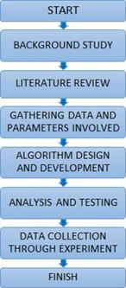
Figure.3.1 Flowchartofprojectprogress

Before starting any research or project, basic information of the related topic is required toensurethattheauthorunderstandswhattheprojectisallabout.Inthisstage,thebackgroundofstudyhelpstheauthorunderstandstherelationbetweendrowsinessandfatigue.Italsohelpstheauthor in understanding the seriousness of driving a motored vehicle in drowsiness condition.It is proven that driving the vehicle in fatigue and drowsiness condition is a factor to roadaccidents. A few algorithms and technique has been used in the process of detecting face, eyesandmouth.ThealgorithmandtechniqueusedisCascadeObjectDetector.TheCascadeObject

Detector uses the Viola-Jones algorithm to detect people’s face, nose, eyes, mouth or upperbody.

ALGORITHMUSED:
Viola-JonesFaceDetectionAlgorithm:
The Viola–Jones object detection framework is the first object detection framework toprovide competitive object detection rates in real-time proposed in 2001 by Paul Viola andMichaelJones.Althoughitcanbetrainedtodetectavarietyofobjectclasses,itwasmotivatedprimarily by the problem of face detection. In the detection phase of the Viola–Jones objectdetection framework, a window of the target size is moved over the input image, and for eachsubsectionofthe imagetheHaar-likefeatureis calculated.
This difference is then compared to a learned threshold that separates non-objects fromobjects. Because such a Haar-like feature is only a weak learner or classifier (its detectionquality is slightly better than random guessing) a large number of Haar-like features arenecessary to describe an object with sufficient accuracy. In the Viola–Jones object detectionframework, the Haar-like features are therefore organized in something called a classifiercascadeto form a stronglearner orclassifier.
AfterthefaceisdetectedusingVoila-Jones,theregioncontainingthe eyesandmouthhastobeseparated.Todetectthecoordinatefromwheretheregionofeyeisstartingcertaincalculations are done. After the rectangular window is extracted, we have considered that theeyes are located at a distance of (0.25 * height of window) from the top and (0.15 * width ofwindow) from the left.The size of window is (0.25 * height of window) in height and (0.68 *width of window)in width.
After the eyes are cropped the image is coverted to YCbCr. The reason for conversion andway to convert is mentioned in “Skin Segmentation” column. Then image is converted tograyscaleandultimatelytobinaryimagebysettingathresholdof(minimumpixelvalue+10).To detect the coordinate from where the region of mouth is starting certain calculations aredone.Aftertherectangularwindowisextracted,wehaveconsideredthatthemoutharelocatedat a distance of (0.67 * height of window) from the top and (0.27 * width of window) from theleft.The size of window is (0.20* height of window) in height and (0.45 * width of window) inwidth.
An image which taken inside a vehicle includes the driver’s face. Typically a camera takesimageswithintheRGBmodel(Red,GreenandBlue).However,theRGBmodelincludes

brightness in addition to the colours. When it comes to human’s eyes, different brightness forthesame color means differentcolour.
Whenanalyzingahumanface,RGBmodelisverysensitiveinimagebrightness.Therefore,to remove the brightness from the images is second step. We use the YCbCr space since it iswidely used in video compression standards .Since the skin-tone color depends on luminance,we nonlinearly transform the YCbCrcolour space to make the skin cluster luma-independent.This also enables robust detection of dark and light skin tone colours. The main advantage ofconverting the image to the YCbCr domain is that influence of luminosity can be removedduringour imageprocessing.
In the RGB domain, each component of the picture (red, green and blue) has a differentbrightness.However,intheYCbCrdomainallinformationaboutthebrightnessisgivenbytheYcomponent,sincetheCb(blue)andCr(red)componentsareindependentfromtheluminosity.Conversion fromRGBto YCbCr:
Cb =(0.148* Red)- (0.291* Green)+ (0.439 * Blue)+ 128;Cr=(0.439 * Red)-(0.368* Green)– (0.071 *Blue) +128;

Conversion fromRGBto HSV:
MATLAB has predefined function for conversion of RGB color space to HSV color space.I’ =rgb2hsv(I);

CascadeofClassifiers:
In a standard 24x24 pixel sub-window, there are a total of 45,396 possible features that aredetected.Thisisanumberthatistoolargeandprohibitivelyexpensivetobeevaluated.Inordertoimprovedetectionperformance,features needto be addedto the classifiers.

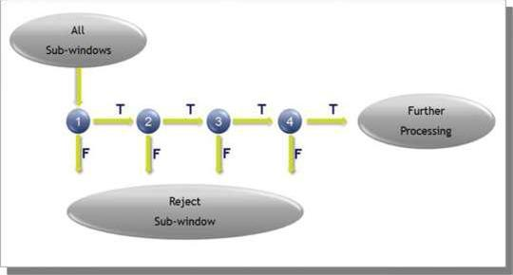
Figure.3.2Cascadeofclassifiers

However,thisstepdirectlyincreasesthecomputationtimeandmakingthedetectionprocessmuchslower.Therefore,acascadeofclassifiersisconstructedtoincreasedetectionperformancewhileradicallyreducing computation time.
Theevaluationofthestrongclassifiersgeneratedbythelearningprocesscanbedonequicklybut it is not fast enough to run in real-time. Therefore, the strong classifiers are arranged in acascade in order of complexity. Each successive classifier is trained only on selected sampleswhich pass through the preceding classifiers. If at any stage in the cascade a classifier rejectsthesub-windowunderinspection,nofurtherprocessingisperformedanditcontinuestosearchthe nextsub-window.
In order to detect eye and mouth area, the face area need to be detected first. However, thisstep will reduce the performance and the speed of the system due to a large area of detection.The project objective is the detection of the drowsiness signs which is eyes and mouth area.Therefore, this project limited the area of detection to eye and mouth. This will enhance theperformanceofthesystem.CascadeObjectDetectoralgorithmisbeingtestedbyusingMATLAB®softwaretogetthedetectionareaforthesystemthatwillbedevelop.Testingneedtobe doneto ensureit fulfils therequired parameters needed.

MATLAB:
Itisasoftwarepackageforhigh-performance mathematicalcomputation,visualization,andprogramming environment. It provides an interactive environment with hundreds of built-infunctions for technical computing, graphics, and animations. MATLAB stands for “MatrixLaboratory”.Itwaswritteninitially toimplementasimpleapproachtomatrixsoftwaredevelopedby the“LINPACK”(Linearsystempackage)and“EISPACK”(Eigensystempackage)projects.

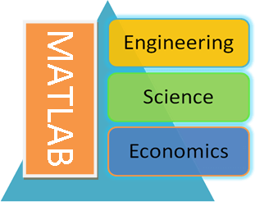
Figure.3.3MATLABVariousDisciples

It is a modern programming language environment, Multi-paradigm and has refined datastructures,includesbuilt-ineditinganddebuggingtools,andsupportsobject-orientedprogramming.Itcanworkwithmultipletypesofprogrammingapproaches,suchasFunctional,Object-Oriented,andVisual. Besidesan environment,it isalsoa programminglanguage.

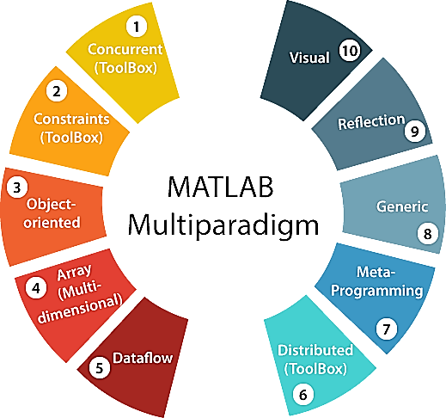
Figure3.4MATLABMultiparadigm

AsitsnamecontainsthewordMatrix,MATLABdoesits'allcomputingbasedonmathematical matrices and arrays. MATLAB's all types of variables hold data in the form ofthearrayonly,letitbeanintegertype,charactertypeorStringtypevariable.Itisusedinvariousdisciplinesofengineering, science,and economics.

Historyof MATLAB:
The development of the MATLAB started in the late 1970s by Cleve Moler, the chairmanof the Computer Science department at the University of New Mexico. Cleve wanted to makehis students able to use LINPACK & EISPACK (software libraries for numerical computing,writteninFORTRAN),andwithoutlearningFORTRAN.In1984,CleveMolerwithJackLittle&SteveBangertrewroteMATLABinCandfoundedMath-Works.Theselibrarieswereknownas JACKPAC at that time, later these were revised in 2000 for matrix manipulation and namedasLAPACK.

MainFeaturesandCapabilitiesof MATLAB:
MATLAB's built-in functions provide excellent tools for linear algebra computations, dataanalysis, signal processing, optimization, numerical solution of ordinary differential equations(ODEs),quadrate,andmanyothertypesofscientificcalculations.Mostofthesefunctionsuse

state-of-the-artalgorithms.Thesearenumerousfunctionsfor2-D and3-Dgraphics,aswellasforanimations.
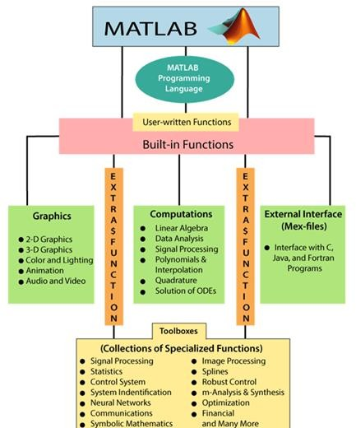
Figure3.5SchematicDiagramofMatlabMainFeatures

MATLABsupportsanexternalinterfacetorunthoseprogramsfromwithinMATLAB.Theuserisnotlimitedtothebuilt-infunctions;hecanwritehisfunctionsintheMATLABlanguage.Therearealsovariousoptional"Toolboxes"availablefromthedevelopersofMATLAB.Thesetoolboxes are a collection of functions written for primary applications such as symboliccomputations,imageprocessing,statistics, controlsystem design,and neuralnetworks.
ThenecessarybuildingcomponentsofMATLABarethematrix.Thefundamentaldatatypeisthearray.Vectors,scalars,realmatrices,andcomplexmatricesareallautomaticallyhandledasspecialcasesoftheprimarydatatype.MATLABlovesmatricesandmatrixfunctions.The

built-infunctionsareoptimizedforvectorfunctions.Therefore,Vectorisedcommandsorcodesrunmuch faster in MATLAB.

MATLABSystem:
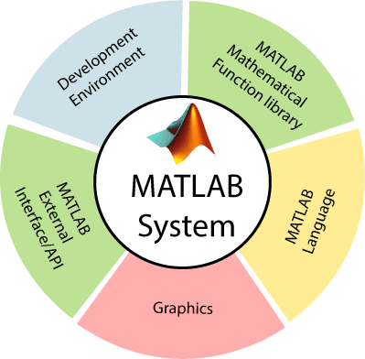
Figure3.6Elements ofMATLABsystem

ApplicationsOf MATLAB:
MATLAB can be used as a tool for simulating various electrical networks but the recentdevelopmentsinMATLABmakeitaverycompetitivetoolforArtificialIntelligence,Robotics,Image processing, Wireless communication, Machine learning, Data analytics and whatnot. Itisa tool that enables computation,programming and graphicallyvisualizingthe results.
ThebasicdataelementofMATLABasthename suggestsistheMatrixor anarray.MATLABtoolboxesareprofessionally builtandenableyoutoturnyourimaginationsintoreality.MATLABprogrammingisquitesimilartoCprogrammingandjustrequiresalittlebrushupofyourbasic programming skills to start workingwith.
Belowareafew applicationsofMATLAB:

StatisticsandMachineLearning(ML):
This toolbox in MATLAB can be very handy for the programmers. Statistical methods such asdescriptive or inferential can be easily implemented. So is the case with machine learning?Various models can be employed to solve modern-day problems. The algorithms used can alsobeused forbigdata applications.
- Curve fitting: The curve fitting toolbox helps to analyse the pattern of occurrence of data.After a particular trend which can be a curve or surface is obtained, its future trends can bepredicted. Furtherplotting,calculatingintegrals,derivatives,interpolation, etc.canbedone.

Controlsystems:
Systems nature can be obtained. Factors such as closed-loop, open-loop, its controllabilityandobservability,Bodeplot,Nyquistplot,etc.canbeobtained.VariouscontrollingtechniquessuchasPD,PIandPIDcanbevisualized.Analysiscanbedoneinthetimedomainorfrequencydomain.

SignalProcessing:
Signals and systems and digital signal processing are taught in various engineering streams.But MATLAB provides the opportunity for proper visualization of this. Various transformssuch as Laplace, Z, etc. can be done on any given signal. Theorems can be validated. Analysiscan be done in the time domain or frequency domain. There are multiple built-in functions thatcanbeused.

Mapping:
Mappinghasmultipleapplicationsinvariousdomains.Forexample,inbigdata,theMapReduce tool is quite important which has multiple applications in the real world. Theftanalysisorfinancialfrauddetection,regressionmodels,contingencyanalysis,predictingtechniquesin social media, data monitoring,etc. canbedonebydata mapping.

Deeplearning:
It’s a subclass of machine learning which can be used for speech recognition, financial frauddetection, and medical image analysis. Tools such as time-series, Artificial neural network(ANN), Fuzzylogicor combination ofsuchtools can beemployed.

Financialanalysis:
An entrepreneur before starting any endeavour needs to do a proper survey and the financialanalysis in order to plan the course of action. The tools needed for this are all available inMATLAB. Elements such as profitability, solvency, liquidity, and stability can be identified.Businessvaluation, capital budgeting,costof capital, etc. can beevaluated.

Imageprocessing:
The most common application that we observe almost every day are bar code scanners, selfie(face beauty, blurring the background, face detection), image enhancement, etc. The digitalimage processing also plays quite an important role in transmitting data from far off satellitesand receiving and decoding it in the same way. Algorithms to support all such applications areavailable.

CHAPTER4

APPLICATIONSOFDROWSINESSDETECTION

The applications of a drowsiness detection and auto alerting system using image processing isto detect when a driver is becoming drowsy and alert them to prevent an accident.Thedrowsiness detection and auto alerting system using image processing can be useful in anysituation where the safety of people is a concern. This technology can be used in varioussettings,such as:

Transportation:
This technology can be implemented in cars, buses, and trucks to ensure that the driver is alertwhiledriving.Ifthesystemdetectsdrowsiness,itcanalertthedrivertotakeabreakorpullovertorest.

WorkplaceSafety:
Workers who operate machinery or perform safety critical tasks can benefit from a drowsinessdetection system. This system can detect when the worker is getting drowsy and alert them ortheirsupervisorto takeabreak or switch to alesssafetycriticaltask.

MesdicalApplications:
Drowsiness can be a symptom of many medical conditions, including sleep apnea, narcolepsyandothersleepdisorders.Adrowsinessdetectionsystemcanhelpdoctorsmonitorpatientswiththeseconditions and adjust their treatment accordingly.

GamingIndustry:
Adrowsinessdetectionsystemcanalsobeusedinthe gamingindustryto alertplayerswhoaregetting too tired and may need to take a break to avoid eye strain or other health problemsassociatedwith excessivescreen time.

EducationalInstitutions:
Studentswhoarestudyingorattendingonlineclassesforextendedperiodscanbenefitfromthissystem. It can detect when they are getting drowsy and suggest them to take a break or switchtoa different task.

RESULTS

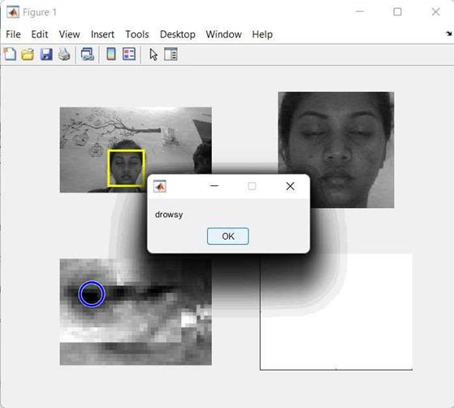
Figure5.1 Drowsy

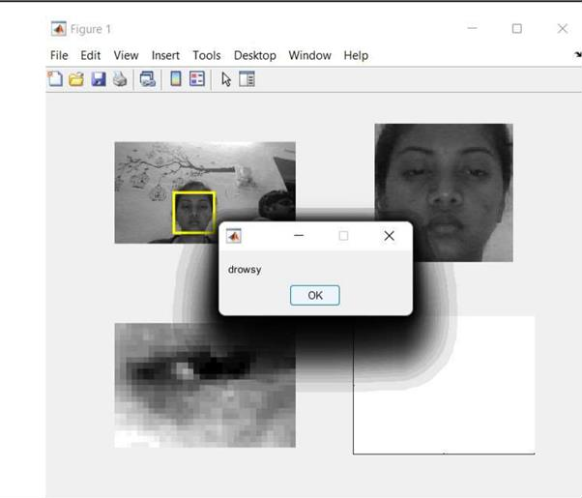
Figure5.2 Drowsy

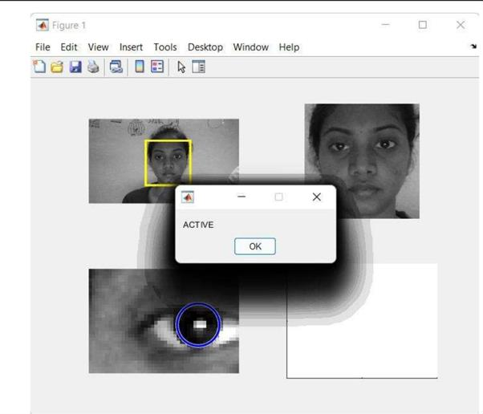
Figure5.3Active

CHAPTER6

CONCLUSIONANDFUTURESCOPE

CONCLUSION:

Inthisway,wehavesuccessfullyimplementeddrowsinessdetectionusingMATLABandViola Jones Algorithm. The developed system has been successfully tested and its limitationsareidentified.

FUTURESCOPE:

It is required to make the speed of vehicle slow or slow down the speed of vehicle in realtime drowsiness detection. In order to create continuous monitoring, threshold drowsinessdetection should be kept aside. While monitoring the drowsiness continuously, when the levelexceedscertain valueasignalisgenerated whichdirectlycontrolsthebrakingofvehicle.

BIBLIOGRAPHY

1.Z.AhmadNoorSyukri,M.SitiAtiqah,L.Fauziana,andA. AbdulRahmat,"MIROScrashinvestigationand reconstruction: annualstatistical2007-2010,"2012.

2.A. Picot, S. Charbonnier, and A. Caplier, "On-line automatic detection of driver drowsinessusing a single electroencephalographic channel," in Engineering in Medicine and BiologySociety,2008.EMBS2008.30thAnnualInternationalConferenceoftheIEEE,2008,pp.3864-3867.

3.G.Borghini,L.Astolfi,G.Vecchiato,D.Mattia,andF.Babiloni,"Measuringneurophysiological signals in aircraft pilots and car drivers for the assessment of mentalworkload,fatigueand drowsiness,"Neuroscience&BiobehavioralReviews, 2012.

4.B. T. Jap, S. Lal, P. Fischer, and E. Bekiaris, "Using EEG spectral components to assessalgorithms for detecting fatigue," Expert Systems with Applications, vol. 36, pp. 2352-2359,2009.

5.D. Liu, P. Sun, Y. Xiao, and Y. Yin, "Drowsiness Detection Based on Eyelid Movement," inEducation[1]TechnologyandComputerScience(ETCS),2010SecondInternationalWorkshopon,2010, pp. 49-52.

6.H.Seifoory,D.Taherkhani,B.Arzhang,Z.Eftekhari,andH.Memari,"AnAccurateMorphologicalDrowsyDetection,"ed:IEEE,2011.

7.D.J.McKnight,"Methodandapparatusfordisplayinggrey-scaleorcolorimagesfrombinaryimages,"ed:Google Patents, 1998.

8.T. Welsh, M. Ashikhmin, and K. Mueller, "Transferring color to greyscale images," ACMTransactionson Graphics, vol. 21, pp. 277-280, 2002.

9.I.Garcia,S.Bronte,L.Bergasa,N.Hernandez,B.Delgado,andM.Sevillano,"Vision-baseddrowsiness detector for a realistic driving simulator," in Intelligent Transportation Systems(ITSC),2010 13thInternationalIEEEConferenceon, 2010,pp. 887-894.

- T. Danisman, I. M. Bilasco, C. Djeraba, and N. Ihaddadene, "Drowsy driver detectionsystemusingeyeblinkpatterns,"inMachineandWebIntelligence(ICMWI),2010InternationalConferenceon, 2010, pp. 230-233.

- S. T. Lin, Y. Y. Tan, P. Y. Chua, L. K. Tey, and C. H. Ang, "PERCLOS Threshold forDrowsinessDetection duringReal Driving,"Journal of Vision,vol. 12, pp. 546-546, 2012.

- R. Grace, V. E. Byrne, D. M. Bierman, J.-M. Legrand, D. Gricourt, B. Davis, et al., "Adrowsy driver detection system for heavy vehicles," in Digital Avionics Systems Conference,1998.Proceedings., 17thDASC. TheAIAA/IEEE/SAE, 1998,pp.I36/1-I36/8vol. 2.

- Q.Wang,J.Yang,M.Ren,andY.Zheng,"Driverfatiguedetection:asurvey,"inIntelligentControl and Automation, 2006. WCICA 2006. The Sixth World Congress on, 2006, pp. 8587-8591.

14.M. Saradadevi and P. Bajaj, "Driver fatigue detection using mouth and yawning analysis,"IJCSNS International Journal of Computer Science and Network Security, vol. 8, pp. 183-188,2008.

15. Bereshpolova Y, Stoelzel CR, Zhuang J, Amitai Y, Alonso JM, Swadlow HA. (2011)"Getting drowsy? Alert/nonalert transitions and visual thalamocortical network dynamics". JNeurosci.2011, 48: 17480-17487.

