Profitability of oregano farming (Origanum vulgare L.) in hilly regions of India: A comprehensive review

VERMA PPS^{1*}, KUMAR D, TIWARI AK², SINGH S², ², PADALIA RC²
¹Division of Crop Production and Protection, CSIR- Central Institute of Medicinal and Aromatic Plants, Research Centre Purara, PO Gagrigole, Bageshwar (Uttarakhand) India
² CSIR- Central Institute of Medicinal and Aromatic Plants, Research Centre, Pantnagar, Near Dairy Farm Nagla, Post Nagla, Udham Singh Nagar (Uttarakhand) India
*Corresponding Author, E-mail: prawalpratapsv@gmail.com

Abstract:
Oregano (Origanum vulgare L.) is a highly significant herb with versatile applications in medicine, aromatics, and cuisine. The primary chemical compounds found in the plant's essential oil include carvacrol, thymol, terpinene, cymene, and pinene. Traditionally, oregano has been harnessed for various medicinal purposes, such as its antimicrobial, antioxidant, anti-cancerous, antibacterial, blood glucose-regulating, and digestive-enhancing properties, among others. In addition to its medicinal virtues, oregano is renowned as the "Pizza herb." Oregano leaves, whether used in fresh or dried form, are prized for their ability to enhance the flavor of dishes. These leaves exude a delightful fragrance that imparts a savory taste when incorporated into various culinary creations. Oregano is particularly favored for elevating the taste of Italian, Greek, Mexican, and Spanish cuisines. It serves as a popular seasoning agent, enhancing the flavors of pizza, pasta, chicken, mutton, sauces, and more. This article delves into the multifaceted uses of oregano, provides product descriptions, and explores advanced agricultural management techniques in comprehensive detail. The present review represents a concerted effort to offer an exhaustive survey of the literature concerning the plant's medicinal properties, applications, and cultivation practices.

Key words: Oregano, Origanum vulgare L., carvacrol, thymol, antimicrobial, antioxidant, antibacterial, antifungal.

- Introduction:
Oregano, a remarkable herb renowned for both its culinary and medicinal virtues, bears the botanical name Origanum vulgare L. and belongs to the illustrious Lamiaceae family (Kosakowska et al., 2021). The very name "Oregano" is rooted in Greek, stemming from the amalgamation of "Oros" and "Ganos," where "Oros" signifies "mountain" and "Ganos" denotes "beauty." In essence, Oregano translates to "the joy of the mountain." This resilient herb thrives in temperate climates, particularly gracing the landscapes of the Mediterranean and tropical regions of Asia(Gutiérrez-Grijalva et al., 2018). Cultivated across various regions spanning Europe, Asia, North Africa, and the Americas, Oregano is a versatile and globally cherished botanical treasure. In the vibrant tapestry of India's flora and culinary traditions, Oregano is affectionately referred to as "Suthra" in Hindi (Cui et al., 2019). India, with its ever-expanding horizons and evolving lifestyles, is experiencing a burgeoning interest in diverse culinary herbs and medicinal plants. While culinary enthusiasts continually seek novel flavors and seasonings, health-conscious individuals are exploring the healing potential of medicinal plants through herbal teas (Sripoo et al., 2022). Oregano emerges as a unique and sought-after herb in this botanical realm, steadily gaining global recognition for its tantalizing flavor and profound therapeutic properties. Whether in the aromatic forms of fresh or dried leaves, Oregano lends its essence to Thai, Italian, and Greek cuisines, enhancing dishes with its distinctive spice, flavor, and seasoning (Kant & Kumar, 2022). Furthermore, Oregano's medicinal incarnation finds expression in the realm of herbal teas, celebrated for its health-enhancing attributes. In contemporary times, the demand for Oregano in India is on a steadfast ascent, driven by its multifaceted utility. However, production lags behind consumption, bestowing elevated market value upon products derived from this versatile herb. It is in this context that the imperative to promote Oregano cultivation arises—bridging the gap between surging demand and supply, while simultaneously optimizing production to mitigate costs (Gutiérrez-Grijalva et al., 2019). Oregano, a perennial gem, graces the landscape with its stature ranging from 30 to 90 cm, bearing leaves measuring 1 to 4 cm in length. This tenacious herb thrives in soils with a pH range between 6.0 to 4.0, flourishing in conditions conducive to its vibrant growth. Adorned with purple-hued flowers, each measuring 3 to 4 mm, elegantly arranged in upright spikes, Oregano exhibits a modest demeanor in terms of size. Its elliptical leaves, broad and bountiful, contribute to its distinct visual allure (Gutiérrez-Grijalva et al., 2019). The blossoms, resplendent in shades of blue or pink, evoke a sense of natural grace. Its fruits, petite and smooth, boast a warm, brown hue. The herb's woody branches lend it durability and stability. Notably, the leaves of Oregano bear small, dot-like glands, which house volatile oils, the very essence that imparts both aroma and hue to this remarkable herb. Throughout the annals of history, humanity has honed several subspecies and strains of Oregano, each meticulously crafted to evoke unique flavors and harness other commendable attributes. Oregano's taste spectrum ranges from piquant and astringent to intricately sweet and multifaceted. In India, Origanum vulgare L. has found a hospitable home, with some varieties even offering a tantalizing fusion of Oregano's zest and Marjoram's charm. As we delve deeper into the world of Oregano, we unearth a treasure trove of culinary delights and medicinal wonders, poised to enrich both the palate and the well-being of those who partake in its essence (Mechergui et al., 2010).
Origanum vulgare L. subsp. glandulosum, renowned for its green leaves and pink flowers, finds its niche in ornamental cultivation, boasting a distinctive spicy and pungent flavor. This subspecies thrives in regions across Central Asia, Iran, India, Turkey, Afghanistan, and Pakistan (De Falco et al., 2013). In contrast, Origanum vulgare L. subsp. hirtum, colloquially known as Italian or Greek oregano, stands out for its robust growth, resilience, and the presence of dark green, slightly hairy foliage, making it a favored choice in general culinary applications (Kofidis & Bosabalidis, 2012). The geographical range of Origanum vulgare L. subsp. virens extends from Morocco to China, encompassing areas like Spain, Portugal, the Balearic Islands, Canary Islands, Azores, and Madeira. Notably, many oregano cultivars marketed as Italian and Sicilian are, in fact, products of the hardy sweet marjoram hybrid, characterized by a harmonious blend of sweet and spicy flavors with minimal bitterness (Kofidis & Bosabalidis, 2012). This unique flavor profile has elevated their status in gastronomy, making them prized ingredients for a wide array of dishes, including pizza, pasta, chicken, mutton, and various sauces within the culinary world. Oregano, a versatile herb, thrives in natural habitats situated at altitudes ranging from 1500 to 3000 meters above sea level. This herb is cultivated worldwide, with prominent cultivation regions including America, Australia, England, and Turkey (Leyva-López et al., 2017).
In India, oregano can be predominantly found in various states, including Jammu and Kashmir, Assam, Karnataka, Tamil Nadu, Meghalaya, Uttar Pradesh, Uttarakhand, and hilly areas of Madhya Pradesh. However, oregano cultivation can also be successfully undertaken in the plains (Giménez-Martínez et al., 2022). The commercial use of the oregano plant primarily centers around its leaves, which are commonly employed in culinary applications. Additionally, the entire plant is utilized for distillation purposes to extract its valuable oil. In terms of its chemical composition, oregano contains approximately 0.15 to 0.40 percent oil. This oil is rich in phenolic compounds, with up to 63 percent comprised of phenols such as Carvacrol, thymol, and borneol (Nagamaniammai et al., 2019). Furthermore, oregano oil contains around 7 to 10 percent monoterpenes. It's worth noting that the oil composition of Origanum vulgare, a common oregano variety, can vary significantly depending on seasonal factors, as evidenced by a study conducted by R.S. Verma (Verma et al., 2010) at the CIMAP Research Centre in Purara.
- Diverse uses of oregano
Oregano, a versatile herb, offers a wide array of applications beyond its culinary uses. Its remarkable medicinal properties make it a valuable asset in traditional and alternative medicine (Vallverdú-Queralt et al., 2014). Oregano has been harnessed to treat an array of ailments, ranging from sore throats, coughs, and colds to muscle aches, acne, dandruff, and even toothaches (Farghaly & Abdullah, 2021). Its efficacy extends to addressing conditions like bronchitis, headaches, heart disease, allergies, earaches, and physical fatigue. This herb's antimicrobial prowess is noteworthy, with both its essential oils and extracts demonstrating the ability to suppress various harmful microbes responsible for food spoilage and disease in humans and animals (Sun et al., 2023). Furthermore, oregano is a potent antioxidant, although the strength of this property can vary among different Origanum species. In some studies, oregano has exhibited high total antioxidant capacity and phenolic content, outperforming other herbs from the Labiatae family. Its extracts have displayed radical scavenging abilities, protection against DNA damage caused by oxidants, and the inhibition of nitric oxide activity. Oregano's impact extends to the nervous system, as chemical compounds like carvacrol, thymol, and terpinene influence neural chemistry and functions, including responses to olfactory stimuli. Some intriguing animal studies suggest that rosmarinic acid, found in oregano, may have antidepressant effects and counteract emotional abnormalities induced by stress. Additionally, oregano exhibits potential as a blood glucose regulator, offering promise in managing diabetes and cardiovascular diseases. Extracts of oregano containing rosmarinic acid have demonstrated glucosidase inhibitory activity and inhibited porcine pancreatic amylase activity (Muñoz Centeno, 2002). In diabetic rats, oral administration of water extracts of Origanum vulgare L. displayed hyperglycemic activity. Oregano leaves also showcase anti-cancer properties, with documented anti-proliferative, anti-genotoxic, and anti-mutagenic effects (Narimani-Rad et al., 2011). In cell culture studies, oregano has protected against oxidative stress, DNA damage induced by various agents, and the growth of cancer cells. Moreover, oregano's antibacterial properties are attributed to a compound called carvacrol found in its essential oil, making it effective against numerous pathogenic bacteria. Its anti-fungal qualities are particularly useful in combatting skin infections, such as ringworm and itching caused by excess moisture (Narimani-Rad et al., 2011). Oregano oil, when mixed with a carrier oil and applied to affected areas, has proven effective in curing these fungal infections, making it a valuable addition to skincare routines.
- Remarkable health benefits of oregano
Oregano, often celebrated for its culinary prowess, offers an array of health benefits that extend far beyond its use in the kitchen. First and foremost, oregano is a rich source of dietary fiber, which plays a pivotal role in enhancing digestive health (Narimani-Rad et al., 2011). The fiber content helps prevent constipation and ensures the gradual and efficient movement of waste through the intestines. By keeping the digestive system in check, oregano contributes to overall gut health and ensures optimal nutrient absorption from the foods we consume. Beyond digestive health, oregano contains Omega-3 fatty acids, which are known for their heart-protective properties (Cinbilgel & Kurt, 2019). These fatty acids help manage cholesterol levels and reduce the risk of heart-related ailments. Moreover, oregano boasts an impressive lineup of essential minerals, including manganese, calcium, iron, and vitamin K. This nutrient profile positions it as a valuable herb for detoxifying the body and promoting the smooth functioning of the liver, a crucial organ for detoxification. Oregano's medicinal potential extends to its immune-boosting properties. This can be attributed to key chemical compounds found in oregano, such as rosmarinic and thymol, which not only bolster the body's immune defenses but also mitigate stress. Additionally, these compounds serve as potent antioxidants, combating harmful free radicals that can lead to various diseases, including cancer. By incorporating oregano into one's diet, individuals can fortify their immune systems and reduce the risk of falling prey to dangerous illnesses. Another noteworthy benefit of oregano is its role in maintaining bone health. As people age, the risk of bone disorders, like osteoporosis, becomes a concern. Oregano provides a rich source of essential minerals, including calcium, iron, and manganese, which are crucial for maintaining strong and healthy bones. Regular consumption of oregano can help prevent bone-related issues and ensure optimal skeletal health. Oregano's positive influence on overall vitality cannot be overlooked. Thanks to its unique blend of organic compounds and vitamin B, oregano enhances metabolic processes in the body, leading to increased energy levels and a rejuvenated feeling. For those aiming to manage their weight effectively, oregano, containing the active ingredient carvacrol, helps reduce body fat and supports weight control. Furthermore, oregano's versatility extends to skin and hair care. It can be used to combat common issues like dandruff by mixing oregano oil with carrier oils like coconut oil. This combination effectively eliminates dandruff and promotes a healthier scalp. Oregano oil also offers a solution for hair loss when blended with olive or coconut oil, stimulating hair growth, and improving overall hair health. Its antiseptic and antibacterial properties make it an excellent natural remedy for acne relief, offering benefits for skin health. Oregano transcends its culinary appeal and emerges as a powerhouse of health benefits (Singletary, 2010). From digestive support to immunity enhancement, bone health, vitality, weight management, and skin care, oregano stands as a versatile and holistic herb that promotes overall well-being and vitality.
- Culinary uses
Oregano, revered for its distinctive flavor and aroma, finds its place in both culinary traditions and as an herbal tea. Health-conscious individuals worldwide harness its potential to promote mental and physical well-being through two primary avenues—herbal tea and seasoning. Oregano's fresh leaves serve as the foundation for a revitalizing herbal tea that has gained popularity among health enthusiasts (Vallverdú-Queralt et al., 2014). These leaves can be steeped to create a fragrant and health-boosting beverage. When oregano leaves are abundant, they are often dried in the shade and carefully stored in airtight containers for future use. This practice ensures a convenient and readily accessible source of oregano tea, allowing individuals to enjoy its numerous health benefits. Oregano leaves, whether in their fresh or dried form, are valued as a culinary seasoning. Their remarkable fragrance, even in the dried state, imparts a delightful flavor to dishes. Oregano is a key player in enhancing the taste of various world cuisines, including Italian, Greek, Mexican, and Spanish dishes (Ivanović et al., 2021). It plays a pivotal role in elevating the flavor profile of beloved dishes such as pizza, pasta, chicken, mutton, and a wide array of sauces. Its versatile nature makes it an indispensable seasoning, adding a burst of savory goodness to countless culinary creations. Whether enjoyed as a comforting cup of herbal tea or used as a flavorful seasoning, oregano stands as a testament to its role in both culinary and holistic wellness practices.
- Pre-harvesting management of oregano

  - Soil and climate
Successful oregano cultivation is contingent upon several crucial factors. Firstly, it is imperative to utilize loam soil that is rich in essential nutrients, as this type of soil provides an ideal foundation for oregano growth. It is of paramount importance to ensure the absence of stones or any hard layers in the soil, as these can obstruct the proper development of the plants. Nutrient-rich soil significantly contributes to higher oil content in the oregano, enhancing its overall quality and yield. Oregano is classified as a temperate plant and thrives best in regions characterized by a temperate climate. Adequate sunlight is also a critical prerequisite for optimal growth. Planting oregano during the month of November is considered optimal for achieving robust plant growth and maximizing yield. This strategic timing aligns with favorable environmental conditions for oregano cultivation, thereby providing the ideal circumstances for a successful harvest.

  - Preparation before planting
To prepare for oregano cultivation, the field should undergo thorough plowing, ideally two to three times, to ensure the soil is adequately crumbly. During plowing, mix in 10-15 tons of FYM to enrich the soil. Create well-structured drainage and irrigation channels within the field to manage water effectively. For a more environmentally friendly approach, avoid chemical fertilizers and instead incorporate 250 kg of bone dust or rock phosphate, along with neem cake, per hectare of the field. These organic alternatives provide essential nutrients while promoting sustainable agricultural practices. Following these steps meticulously sets the stage for successful oregano cultivation.

  - Propagation
Commercial propagation of oregano is commonly achieved through the use of cuttings. This method not only ensures the preservation of genetic purity but also accelerates the plant's readiness for cultivation. For this process, it is recommended to select branches that are approximately 15 cm long from one-year-old oregano plants. These chosen branches are then used to create cuttings, which should be planted in polybags. To provide the ideal conditions for the cuttings' growth, it is advisable to place the polybags within net houses or shaded areas. To ensure the necessary moisture levels for the cuttings' development, a controlled irrigation system can be implemented, such as utilizing fountains. This careful management of moisture contributes to the successful establishment of oregano plants from cuttings, ultimately streamlining the commercial propagation process.

  - Transplanting
When planting oregano, it is customary to arrange the plants in rows with a spacing of 50 cm between the rows as well as between individual plants. This systematic spacing helps ensure proper plant development and efficient space utilization. Following the planting process, it is essential to compact the soil around the base of the oregano plants. This compaction aids in securing the plants in the soil swiftly, facilitating quicker establishment and promoting robust growth. Immediate irrigation is imperative after transplanting to provide the newly planted oregano with the moisture it needs to take root and begin its growth journey. However, it is crucial to exercise caution to avoid waterlogging. If excessive water accumulates in the field due to irrigation, it should be promptly removed to prevent any adverse effects on the plants. Balancing proper irrigation with adequate drainage is essential for the healthy development of oregano crops.

  - Intercropping
To enhance the utilization of land and potentially increase profitability during the initial growth phase of oregano plants, intercropping with other crops is a viable strategy. This approach not only maximizes land productivity but can also contribute to overall farm income. In particular, crops like garlic, onions, and peas can be effectively intercropped with oregano. These vegetables typically have a harvesting window in February-March, which coincides with the early growth stages of oregano. This timing minimizes adverse effects on oregano growth caused by intercropping, as the oregano plants are still establishing themselves. Intercropping not only optimizes land use but also diversifies income sources, making it a valuable technique for oregano cultivation in the initial stages. Careful planning and management of intercropping can lead to a more sustainable and profitable farming venture.

  - Manures and fertilizers
Accurate estimation of the required amount of manure and fertilizers for oregano cultivation is contingent upon a thorough soil analysis, encompassing parameters such as basic productivity, organic matter content, moisture levels, and pH. These factors collectively determine the specific nutrient needs of the soil and the oregano plants. Before transplanting oregano, a standard practice involves applying 10-15 tonnes of cow dung manure per hectare. Additionally, nitrogen (N), phosphorus (P), and potash (K) fertilizers should be incorporated into the soil at a balanced ratio of 100:40:80 per hectare. This initial application provides the necessary nutrients to support early plant growth. Approximately two months after transplanting, when the oregano plants have fully developed and new branches are emerging, it is advisable to provide an additional 50 kg of nitrogen. This supplemental nitrogen application fosters robust plant growth and development. Moreover, it is crucial to maintain a consistent nutrient supply to the oregano plants to sustain their productivity. Therefore, after each harvesting cycle, it is recommended to apply the same amount of nitrogen (50 kg per hectare) to ensure continuous healthy growth and yield. Research conducted by Janki Pal et al. in 2016 at Pithoragarh indicated that the highest herb yield in oregano was achieved with the application of 150 kg of urea (a nitrogen source) per hectare, along with 125 kg of phosphorus and 150 kg of potash per hectare. This study underscores the importance of appropriate nutrient management to maximize oregano productivity.
  - Irrigation and drainage
It is imperative to maintain optimal soil moisture levels throughout the oregano cultivation cycle, starting from plant growth stages and extending through crop development. Both excessive moisture and soil dryness can adversely affect crop production. During dry months, irrigation should be employed to ensure that the soil retains adequate moisture. Typically, 1-2 irrigations are necessary from the planting stage until bud emergence. Subsequently, for the following three months, it is essential to sustain sufficient moisture in the field. After this initial period, irrigation should be conducted at monthly intervals. Throughout the entire cropping period, irrigating at intervals of 25-30 days will necessitate approximately 8-10 irrigations. Proper drainage is critical during the rainy season. To effectively manage drainage, it is advisable to level the field before planting, as part of the field preparation process. The field's slope should be oriented in such a way that excess water, especially during heavy rainfall, can be efficiently drained away through the designated drainage channels. By adhering to these practices, growers can ensure an optimal balance of moisture and drainage in the soil, promoting healthy oregano crop development and mitigating potential water-related issues.
  - Weed management
Effective weed control is paramount for successful oregano cultivation. In the initial stages of the crop, typically within the first 60-70 days, it is recommended to perform 2-3 rounds of hoeing. Proper weed control during this phase is crucial, as inadequate management can lead to a decline in crop production. Additionally, after each harvesting cycle, it is advisable to conduct hoeing using khurpi or a shovel. During this process, earthing-up should also be carried out to ensure that the plant's roots have a secure grip on the soil. This practice helps maintain the stability and health of the oregano plants. As the oregano plants reach full maturity, they become more capable of competing with weeds. However, to achieve a good crop yield, it is still necessary to carry out weeding approximately 4-5 times a year. Consistent weeding throughout the cultivation period is essential to prevent weed interference and ensure the successful growth of oregano.
  - Harvesting
The initial harvest of oregano crops should be conducted approximately 90 days after transplanting. This timing aligns with the onset of flowering on the plants, marking a suitable stage for the first cutting. Typically, oregano can be harvested multiple times throughout the year, and around four cuttings are performed annually. After each harvesting cycle, it is advisable to replenish the soil's nutrient content by providing additional nitrogen through fertilizers. This practice helps maintain the plant's vigor and productivity, ensuring a consistent and healthy oregano crop throughout its growth cycle.
  - Yield
Oil extraction from oregano, as conducted in the testing laboratory of the Central Institute of Medicinal and Aromatic Plants, Research Centre, Purara, Uttarakhand, yielded an oil content ranging from 0.70 to 0.72 percent. With regards to the cultivation of oregano in the recently developed cultivar CIM-Sudeeksha by CSIR-CIMAP Lucknow, it was reported that approximately 600-700 quintal kilograms of fresh herb can be obtained through two to three harvesting cycles.

- Post harvest management of oregano

  - Harvesting or harvesting
Oregano plants can typically be harvested two months after transplanting. When conducting the harvest, it is advisable to cut the plants approximately 6 inches above the ground using a sharp cutting tool. This practice allows for the collection of the desired plant material while preserving the plant's lower portions for regrowth. Oregano can be harvested three times a year, provided that the conditions are conducive for its growth. However, if cultivation occurs in plains or areas with different climatic conditions, it may be feasible to carry out only two cuttings per year. It's crucial to note that harvesting should be scheduled before sunrise or during the cooler parts of the day to optimize the quality and shelf life of the harvested oregano branches. After harvesting, it is customary to collect the branches in baskets for further processing and utilization.

  - Washing and grading
In order to ensure the highest quality of plant leaves for market value, it is essential to conduct thorough washing to remove dust particles and harmful elements present on the upper surfaces of branches and leaves. Clean leaves are crucial for achieving a good market value. Additionally, after washing, a meticulous grading process should be implemented to eliminate leaves with diseases or stains. This sorting process should be repeated during the drying phase, ultimately yielding leaves that are free from diseases and of superior quality, thereby enhancing their market desirability.

  - Drying
The research conducted at the CSIR-CIMAP Research Centre Purara aimed to determine the most economically efficient method for drying oregano while maximizing dry herb and oil yield, all without compromising the color, aroma, and flavor of the leaves. Four drying treatments, including oven drying, shade drying with air, shade drying without air, and sun drying, were investigated. The results indicated that the drying method significantly influenced several key parameters, including the time required for drying (in hours), oil content (%), oil yield per hectare (in kilograms), dry herb yield per hectare (in kilograms), and the cost of drying (in Rupees). The shortest drying time was observed with oven drying (4.40 hours), followed by sun drying (6.4 hours), while shade drying with air (49.40 hours) and shade drying without air (51.45 hours) required the longest drying times. Sun drying yielded the highest oil content (2.0%), followed by shade drying without air (1.8%), with shade drying with air (1.3%) and oven drying (0.6%) having the lowest oil percentages. Oil yield was directly influenced by oil content, with sun drying producing the highest oil yield (200 kilograms), followed by shade drying without air (180 kilograms). Dry herb yield per hectare was significantly greater in shade drying without air (400 kilograms) followed by sun drying. The lowest drying cost was associated with sun drying (6,000 Rupees), followed by oven drying (10,000 Rupees). In summary, this research provides valuable insights into the various drying methods for oregano, with sun drying appearing as the most cost-effective and efficient approach. In general, the oregano crop is dried by the following methods.

    - Drying in the sunlight
To proficiently dry oregano leaves, it is crucial to choose a clean and dust-free location with proper airflow. Arrange the oregano branches to facilitate ventilation, ensuring uniform drying. If you're drying oregano on a smaller scale, group the branches and suspend them in the air using either wire or string. Drying oregano under direct sunlight typically takes around 4 to 5 days and is an excellent method when you plan to use the herb for seasoning or flavoring. This approach preserves the herb's quality, safeguarding its aromatic and flavorful qualities for culinary purposes.

    - Drying in shade
The safest method for drying oregano is in a shaded environment, and you can enhance airflow using fans. Drying in shaded areas minimizes the loss of essential oils and preserves the nutritional value of the dried herb. Additionally, this approach shields the leaves from airborne particles. Typically, it takes approximately 3 to 4 days to completely dry the leaves using this method. Many herbal tea producers prefer drying plants in shaded areas to maintain the quality of the herbs for crafting herbal teas.

    - Drying in dryer
Oregano drying can be achieved through the utilization of either electric dryers or solar energy-powered dryers, both of which greatly expedite the drying process, reducing it to a mere 4 to 5 hours. This approach proves highly efficient not only in terms of time but also in preserving the herb's quality safely. Whether opting for electric or solar-powered drying methods, this contemporary technique provides a fast and dependable means of preparing oregano for a diverse range of culinary applications.
- Quality material production
All agriculture practices should be done in a scientific manner so that quality In order to obtain high-quality dried oregano, it is imperative to adopt a scientific approach to agricultural practices. Quality dried herb is characterized by its vibrant color, rich aroma, and delightful flavor. To determine the most suitable drying method, a research study was conducted at the CIMAP Research Center in Purara, focusing on the aroma, color, and flavor of the dried herb (Table 5). Four different drying treatments were employed: oven drying, shade drying with air circulation, shade drying without air circulation, and sun drying. The research findings revealed that the most superior aroma in the dried herb was achieved through shade drying with adequate air circulation, closely followed by shade drying without air. The optimal color appearance of the dried herb was observed in the shade drying without air, with sun drying as the second-best choice. Regarding flavor, the richest flavor was attained in the shade drying without air treatment, closely trailed by shade drying with air circulation, while oven drying resulted in the least desirable flavor. Based on this comprehensive research, it is recommended to use the shade drying method with adequate air circulation to achieve the best aroma, flavor, and color in dried oregano. In cases where fans are unavailable for air circulation, drying in a well-ventilated shade is a viable alternative. If quick drying is required, using an oven is advisable, and sun drying can be a suitable option when ovens are not available. Moreover, if the aim is to maximize oil yield from the dried herb, sun drying green oregano should be considered. For cultivation purposes aimed at producing dried herbs or branches, shade drying without air circulation is recommended. Lastly, it's worth noting that sun drying stands out as a cost-effective drying method compared to other alternatives.

- Storage
Once the oregano leaves have been properly dried, it is crucial to store them in a location that is both free from air and moisture to preserve their quality. This will help maintain the aroma and flavor of the dried herb. If oregano has been cultivated with the intention of extracting oil, the next step following crop harvesting is to place the oregano branches into a distillation unit to obtain oregano oil. The oil extraction process typically spans a duration of 4 to 5 hours. Once the distillation process is successfully completed, it is essential to collect the freshly extracted oil and store it in a suitable container. Aluminum or glass containers are ideal choices for storing oregano oil, as they help maintain its quality and prevent unwanted interactions with other materials. Proper storage is essential to ensure the longevity and effectiveness of the extracted oregano oil for various applications.

- Cost of cultivation and expenditure
Cultivating oregano following the outlined guidelines can prove to be economically advantageous for farmers. Despite initial investments in seeds, infrastructure, and labor, the practice offers a range of benefits. These include the potential for high market value due to oregano's quality attributes, diversification of crops to mitigate risks, soil health improvement, value-added product opportunities, alignment with sustainable farming practices, and steady market demand. Additionally, oregano cultivation can provide a sustainable income source over multiple growing seasons, making it a valuable addition to farming operations.
- Business applications of oregano

  - Oregano herbal tea
Oregano tea is made from fresh or dried leaves. By putting the leaves of the oregano in the boiling water, the pan of the fugitive should be stopped for some time. After filtering the water, tea, sugar, honey, lemon juice or according to your taste can be taken for health benefits.
  - Oregano tea bag
After drying the leaves of the oregano, small pieces are kept in a tea bag. Tea bags should be stored in airtight pouches or containers to avoid exposure of air to protect the aroma and nutrients of oregano. To consume tea, a tea bag should be put in a cup of hot water and taken with sugar or honey.
  - Oregano herbal blend
The dried leaves of the oregano are mixed with the leaves or flowers of other beneficial plants and taken as herbal tea. Tea made mainly of chamomile, lemongrass, mint, basil leaves or a mixture of flowers has a very good taste.
  - Seasoning
Oregano leaves are used in fresh or dried form to enhance the taste of dishes. The leaves have a very good fragrance even in dry state, which gives it a good taste when used in dishes. It is used to enhance the taste of Italian, Greek, Mexican and Spanish cuisines. Oregano leaves are used as seasonings in our country mainly to enhance the taste of pizza, pasta, chicken, mutton and sauces etc. A mixture of oregano, basil, thyme and rosemary leaves is mixed with sea salt and garlic to make seasoning.
  - Oregano oil
Oregano oil is used in soap, hair oil, shampoo, lotion, incense sticks, dhoop cone and medicine. The oil is extracted after the distillation process of the oregano plant.
Conclusion
Currently, Oregano cultivation in India is decreasing compared to its demand. There is a growing demand for Oregano in the culinary and health sectors. Industries making oregano tea bags, oregano herbal mixtures, spices and oregano oil are dependent on other countries to meet their demand. This herb became popular among those who found the taste. It has already made its space among health-conscious people. In such a situation, it has become necessary to expand the cultivation of oregano in India, so that the demand of oregano dried herb can be fulfilled in our country. Research institutes need to develop improved varieties of oregano so that good quality raw material can be available to the related industries. Farmers in hilly areas of India can improve their economic condition by cultivating oregano.

Acknowledgment
The authors extend their gratitude to the Director of CIMAP Lucknow for their support. Additionally, the authors would like to express their appreciation to the authors and editors of the various articles, journals, and books that have been referenced and discussed in the preparation of this article.

Reference

Chahla, B., Salih, B. M., Adriana, B., Viviana, M., Guido, F., Sergio, S., Federica, C., Rosaria, N., Marina, P., Abdelmounaim, K., Asma, Z., & Sara, M. (2021). Chemical composition and biological activities of oregano and lavender essential oils. Applied Sciences (Switzerland), 11(12). https://doi.org/10.3390/app11125688
Cinbilgel, I., & Kurt, Y. (2019). Oregano and/or marjoram: Traditional oil production and ethnomedical utilization of Origanum species in southern Turkey. Journal of Herbal Medicine, 16. https://doi.org/10.1016/j.hermed.2019.100257
Cui, H., Zhang, C., Li, C., & Lin, L. (2019). Antibacterial mechanism of oregano essential oil. Industrial Crops and Products, 139. https://doi.org/10.1016/j.indcrop.2019.111498
De Falco, E., Mancini, E., Roscigno, G., Mignola, E., Taglialatela-Scafati, O., & Senatore, F. (2013). Chemical composition and biological activity of essential oils of origanum vulgare L. subsp. vulgare L. under different growth conditions. Molecules, 18(12). https://doi.org/10.3390/molecules181214948
Farghaly, M., & Abdullah, M. (2021). EFFECT OF DIETARY OREGANO, ROSEMARY AND PEPPERMINT AS FEED ADDITIVES ON NUTRIENTS DIGESTIBILITY, RUMEN FERMENTATION AND PERFORMANCE OF FATTENING SHEEP. Egyptian Journal of Nutrition and Feeds, 24(3). https://doi.org/10.21608/ejnf.2021.210838
Giménez-Martínez, P., Ramirez, C., Mitton, G., Meroi Arcerito, F., Ramos, F., Cooley, H., Fuselli, S., & Maggi, M. (2022). Lethal concentrations of Cymbopogon nardus essential oils and their main component citronellal on Varroa destructor and Apis mellifera. Experimental Parasitology, 238. https://doi.org/10.1016/j.exppara.2022.108279
Guerra A., C. M., , Galán O., Jorge A. , Méndez A., J. J., & y Murillo A., E. (2008). Evaluación del efecto del extracto de orégano (Oreganum vulgare) sobre algunos parámetros productivos de cerdos destetos. Revista Tumbaga, 3(2008).
Gutiérrez-Grijalva, E. P., Antunes-Ricardo, M., Acosta-Estrada, B. A., Gutiérrez-Uribe, J. A., & Basilio Heredia, J. (2019). Cellular antioxidant activity and in vitro inhibition of α-glucosidase, α-amylase and pancreatic lipase of oregano polyphenols under simulated gastrointestinal digestion. Food Research International, 116. https://doi.org/10.1016/j.foodres.2018.08.096
Gutiérrez-Grijalva, E. P., Picos-Salas, M. A., Leyva-López, N., Criollo-Mendoza, M. S., Vazquez-Olivo, G., & Heredia, J. B. (2018). Flavonoids and phenolic acids from Oregano: Occurrence, biological activity and health benefits. In Plants (Vol. 7, Issue 1). https://doi.org/10.3390/plants7010002
Ilić, Z., Stanojević, L., Milenković, L., Šunić, L., Milenković, A., Stanojević, J., & Cvetković, D. (2022). The Yield, Chemical Composition, and Antioxidant Activities of Essential Oils from Different Plant Parts of the Wild and Cultivated Oregano (Origanum vulgare L.). Horticulturae, 8(11). https://doi.org/10.3390/horticulturae8111042
Ivanović, S., Mandrone, M., Simić, K., Ristić, M., Todosijević, M., Mandić, B., & Gođevac, D. (2021). GC-MS-based metabolomics for the detection of adulteration in oregano samples. Journal of the Serbian Chemical Society, 86(12). https://doi.org/10.2298/JSC210809089I
Kant, R., & Kumar, A. (2022). Review on essential oil extraction from aromatic and medicinal plants: Techniques, performance and economic analysis. In Sustainable Chemistry and Pharmacy (Vol. 30). https://doi.org/10.1016/j.scp.2022.100829
Kofidis, G., & Bosabalidis, A. M. (2012). Seasonal distribution of phenolics in leaves of aromatic plants (Origanum vulgare L., Mentha spicata L., Clinopodium vulgare L.) and their ecophysiological implications. Biological Letters, 49(1). https://doi.org/10.2478/v10120-012-0012-5
Kosakowska, O., Wȩglarz, Z., Pióro-Jabrucka, E., Przybył, J. L., Kraśniewska, K., Gniewosz, M., & Bączek, K. (2021). Antioxidant and antibacterial activity of essential oils and hydroethanolic extracts of Greek oregano (O. vulgare L. subsp. hirtum (link) ietswaart) and common oregano (o. vulgare L. subsp. vulgare). Molecules, 26(4). https://doi.org/10.3390/molecules26040988
Leyva-López, N., Gutiérrez-Grijalva, E. P., Vazquez-Olivo, G., & Heredia, J. B. (2017). Essential oils of oregano: Biological activity beyond their antimicrobial properties. In Molecules (Vol. 22, Issue 6). https://doi.org/10.3390/molecules22060989
Mechergui, K., Coelho, J. A., Serra, M. C., Lamine, S. B., Boukhchina, S., & Khouja, M. L. (2010). Essential oils of Origanum vulgare L. subsp. glandulosum (Desf.) Ietswaart from Tunisia: Chemical composition and antioxidant activity. Journal of the Science of Food and Agriculture, 90(10). https://doi.org/10.1002/jsfa.4011
Muñoz Centeno, L. M. (2002). Plantas medicinales españolas: Origanum vulgare L. (Lamiaceae) (Orégano). Acta Botanica Malacitana, 27. https://doi.org/10.24310/abm.v27i0.7343
Nagamaniammai, G., Chithra, M., & Ganga, M. U. (2019). Study on the effect of prawn (Machrobrachuim rosenbergii) chitosan coating on peeled shallot (Allium ascalonicum). Current Research in Nutrition and Food Science, 7(3). https://doi.org/10.12944/CRNFSJ.7.3.31
Narimani-Rad, M., Nobakht, A., Shahryar, H. A., Kamani, J., & Lotfi, A. (2011). Influence of dietary supplemented medicinal plants mixture (Ziziphora, oregano and Peppermint) on performance and carcass characterization of broiler chickens. Journal of Medicinal Plant Research, 5(23).
Singletary, K. (2010). Oregano: Overview of the literature on health benefits. In Nutrition Today (Vol. 45, Issue 3). https://doi.org/10.1097/NT.0b013e3181dec789
Sripoo, A. R., Maheswari, U. T. N., & Rajeshkumar, S. (2022). Preparation of oregano, coffee and black cumin aqueous formulation and its anti inflammatory activity. International Journal of Health Sciences. https://doi.org/10.53730/ijhs.v6ns3.5184
Sun, M., Liu, N., Miao, J., Zhang, Y., Hao, Y., Zhang, J., Li, H., Bai, H., & Shi, L. (2023). Creation of New Oregano Genotypes with Different Terpene Chemotypes via Inter- and Intraspecific Hybridization. International Journal of Molecular Sciences, 24(8). https://doi.org/10.3390/ijms24087320
Vallverdú-Queralt, A., Regueiro, J., Martínez-Huélamo, M., Rinaldi Alvarenga, J. F., Leal, L. N., & Lamuela-Raventos, R. M. (2014). A comprehensive study on the phenolic profile of widely used culinary herbs and spices: Rosemary, thyme, oregano, cinnamon, cumin and bay. Food Chemistry, 154. https://doi.org/10.1016/j.foodchem.2013.12.106
Verma, R. S., Padalia, R. C., Chauhan, A., Verma, R. K., Yadav, A. K., & Singh, H. P. (2010). Chemical diversity in Indian oregano (Origanum vulgare L.). Chemistry and Biodiversity, 7(8). https://doi.org/10.1002/cbdv.200900419

Table: 1. Essential oil composition of Origanum vulgare L. during annual growth.
Peak Area (%) in different season
Compound | Spring | Summer | Rainy | Autumn | Winter | Mean
ἁ-Pinene | 1.85(0.26) * | 2.14 (0.16) | 2.27 (0.37) | 1.62 (0.41) | 1.09 (0.02) | 1.79 (0.46)
Camphene | 0.28 (0.06) | 0.25 (0.03) | 0.27 (0.07) | 0.24 (0.06) | 0.38 (0.13) | 0.28 (0.05)
ß-Pinene | 0.08 (0.05) | 0.27 (0.06) | 0.15 (0.06) | 0.09 (0.02) | 0.20 (0.08) | 0.15 (0.07)
Sabinene | 0.07 (0.04) | - | 0.01 (0.02) | 0.07 (0.02) | 0.16 (0.22) | 0.06 (0.06)
ß-Myrcene | 1.62 (0.52) | 1.91 (0.02) | 1.74 (0.19) | 1.53 (0.43) | 0.50 (0.31) | 1.46 (0.55)
ἁ-Terpinene | 1.60 (0.63) | 1.80 (0.02) | 1.86 (0.31) | 1.26 (0.69) | 0.10 (0.01) | 1.32 (0.72)
Limonene | 0.17 (0.02) | 0.35 (0.26) | 0.30 (0.08) | 0.18 (0.05) | 0.30 (0.16) | 0.26 (0.08)
1,8 Cineole | 0.08 (0.02) | 0.08 (0.04) | 0.05 (0.07) | 0.09 (0.05) | 0.05 (0.01) | 0.07 (0.01)
ÿ-Terpinene | 16.44 (7.17) | 19.11 (1.02) | 17.15 (2.85) | 17.17 (5.40) | 2.49 (0.21) | 14.47 (6.77)
p-Cymene | 8.60 (7.77) | 13.08 (3.21) | 18.99 (4.07) | 8.65 (3.59) | 46.59 (3.51) | 19.18 (15.90)
I-Octem-3-ol | 0.08 (0.10) | 0.14 (0.01) | 0.24 (0.05) | 0.63 (0.59) | 0.58 (0.18) | 0.33 (0.25)
(E) Sabinene hydrate | 0.24 (0.11) | 0.39 (0.14) | 0.41 (0.09) | 0.20 (0.19) | 0.18 (0.04) | 0.28 (0.10)
Linalool | 0.22(0.21) | 0.26(0.06) | 0.32 (0.05) | 0.47 (0.09) | 0.57 (0.12) | 0.36 (0.14)
ß-Caryophyllene | 0.93 (0.40) | 1.05 (0.19) | 0.53 (0.32) | 0.46 (0.22) | 0.23 (0.24) | 0.64 (0.34)
Carvacrol methyl ether | 0.36 (0.10) | 0.78 (0.40) | 0.41 (0.26) | 0.63 (0.08) | 0.62 (0.33) | 0.56 (0.17)
ἁ-Caryophyllene | 0.08 (0.08) | 0.07 (0.03) | - | 0.09 (0.08) | 0.32 (0.27) | 0.11 (0.12)
Borneol | 0.68 (0.18) | 0.51 (0.03) | 0.69 (0.22) | 1.00 (0.19) | 1.14 (0.45) | 0.80 (0.25)
p-Cymen-8-ol | 0.39 (0.46) | 0.05 (0.04) | 0.03 (0.04) | 0.12 (0.12) | 1.00 (0.97) | 0.31 (0.40)
Carvacry acetate | 0.15 (0.16) | 0.04 (0.02) | - | 0.05 (0.08) | 0.09 (0.07) | 0.06 (0.05)
Caryophyllene oxide | 0.21 (0.35) | 0.28 (0.16) | 0.49 (0.26) | - | 0.93 (0.05) | 0.38 (0.35)
Thymol | 0.70 (0.06) | 0.67 (0.01) | 0.44 (0.04) | 0.64 (0.23) | 0.37 (0.00) | 0.56 (0.14)
Carvacrol | 62.81 (1.78) | 54.39 (3.04) | 51.52 (7.70) | 62.69 (8.70) | 35.02 (6.36) | 53.28 (11.37)
RIª, Retention indices on BP-20 column; RI^{b}, Retention indices on PE-5 column. *Values in parenthesis are standard deviation. , Source:(Chahla et al., 2021)

Table 2. Available nutrients in dried herb of Origanum vulgare L. (Guerra A. et al., 2008)
S. No. | Nutrient | Amount | Daily adult requirement
1 | Energy | 2.7 | 1,800–3,000
2 | Carbohydrate (g) | 0.7 | 130
3 | Fiber (g) | 0.4 | 25.2–33.6
4 | Calcium (mg) | 16.0 | 1,000–1,200
5 | Phosphorus (mg) | 1.5 | 700
6 | Potassium (mg) | 12.6 | 4,700
7 | Folate (mcg, DFE) | 2.4 | 400
8 | Vitamin E | 0.33 mg | 15
9 | Vitamins K | 11.2 micro gm | 120

Table 3. Oil content variation across phenological stages of Origanum vulgare L.
Month | Phenological stage | Oil content (%) *
February | Vegetative | 0.25 (0.01) **
March | Vegetative | 0.50 (0.02)
April | Vegetative | 0.70 (0.01)
May | Vegetative | 0.70 (0.02)
June | Flowering initiated | 0.71 (0.02)
July | Full flowering stage | 1.30 (0.04)
August | Green seed stage | 1.00 (0.02)
September | Brown seed stage | 0.80 (0.02)
October | Seed shattering | 0.60 (0.01)
November | Seed shattering | 0.52 (0.02)
December | Hibernation | 0.35 (0.02)
January | Hibernation | 0.20 (0.01)
*Calculated on fresh weight basis. **Values in parenthesis are standard deviation.
Source: ((Ilić et al., 2022))

Table 4. Effects of different drying treatments on oregano drying parameters.
Treatment | Time taking in drying (Hour) | Oil (%) | Oil yield/ha  (kg) | Dry herb yield/ha  (kg) | Cost of drying (Rs.)
Oven dry | 4.40 | 0.6 | 60 | 360 | 10,000
Shade dry with air | 49.40 | 1.3 | 130 | 380 | 13,000
Shade dry without air | 51.45 | 1.8 | 180 | 400 | 11,000
Sun drying | 6.4 | 2.0 | 200 | 380 | 6,000

Table 5. Comparative assessment of aroma, color appearance, and flavor of dry oregano herb
Treatment | *Aroma of dry herb | *Color appearance of dry herb | *Flavor of dry herb
Oven dry | 4 (Lowest aroma) | 4 (Blackish) | 4 (Lowest flavor)
Shade dry with air | 1 (Highest aroma) | 3 (Light green) | 1 (Highest flavor)
Shade dry without air | 2 (High aroma) | 1 (Dark Green) | 2 (High flavor)
Sun drying | 3 (Lower aroma) | 2(Brown) | 3 (Lower flavor)
*In the comparative study, the treatment was given 4 grades in the scale based on the number of treatments according to the level of aroma and color appearance and flavor of dry herb. After this, according to observations, the best was given the 1st grade and the lowest level was given the 4th grade.

Table 6. Cost of cultivation and expenditure of Origanum vulgare L. cultivation.
Cost of cultivation and expenditure
(A) Cost
Agricultural practices | Rs. / ha
- Preparation of field | 3500.00
- Plant material and nursery | 12000.00
- Manure and fertilizer | 5200.00
- Transplanting | 1700.00
- Weeding and hoeing | 5500.00
- Irrigation | 2300.00
- Crop Protection | 1000.00
- Harvesting | 2000.00
- Distillation | 5000.00
- Other | 850.00
Total expenditure | 39,050.00
(B) Total Income  Dry leaf yield  Total Income (Dry leaves Rs. / Kg) | 500/kg  300000 / -
(C) Net profit Rs. | 260950 / ha

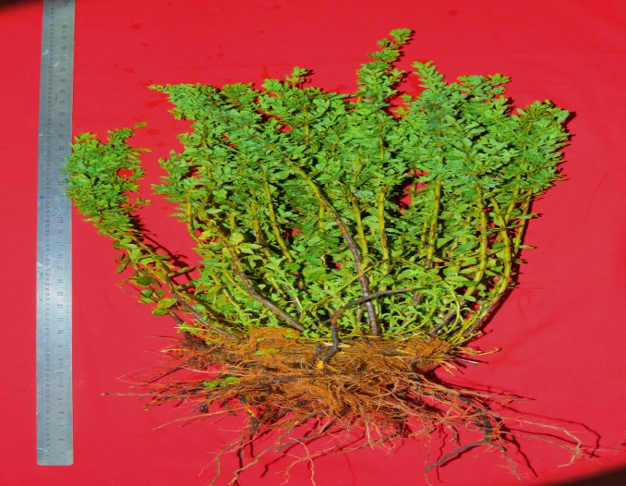  (a) | 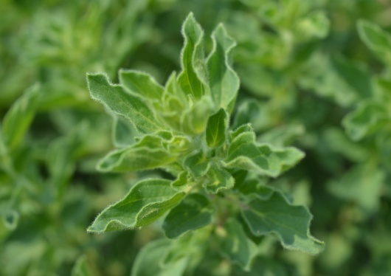  (b)
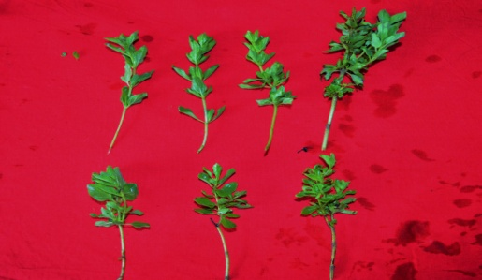
(c)
Fig. 1. Illustrates Origanum vulgare L. at different stages, including a (a) full plant view with the root zone, the (b) aerial part of the plant, and a (c) fresh cutting.
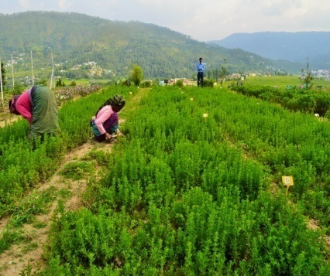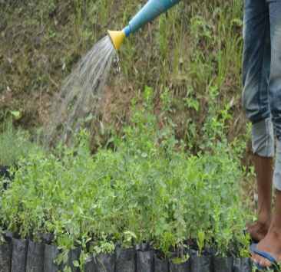
(a) (b)
Fig. 2. A visual representation of pre-harvest management practices for Origanum vulgare L. at CIMAP RC Purara in Bageshwar, Uttarakhand is presented, comprising (a) crop weeding and hoeing, as well as (b) the irrigation process for oregano cuttings in the nursery.

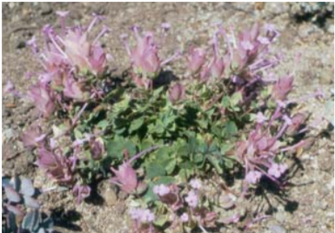  Origanum amanum | 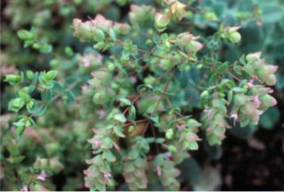  Origanum dictamnus
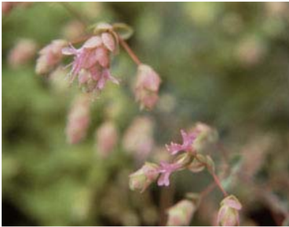  Origanum xhybridinum | 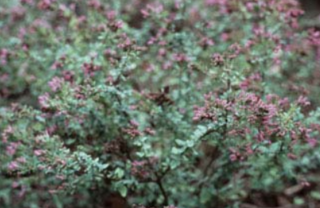  Origanum laevigatum
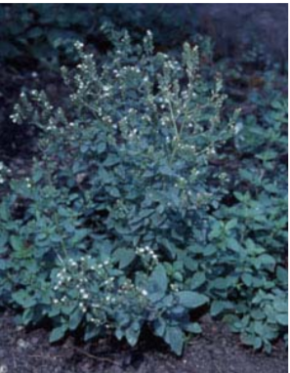  Origanum vulgare subsp. gracile | 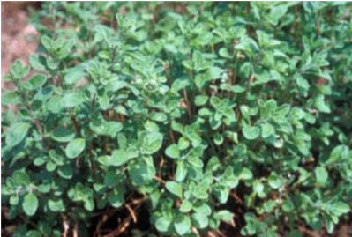  Origanum majorana
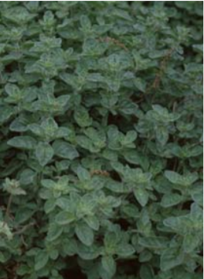  Origanum xmajoricum | 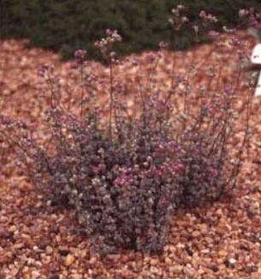  Origanum microphyllum
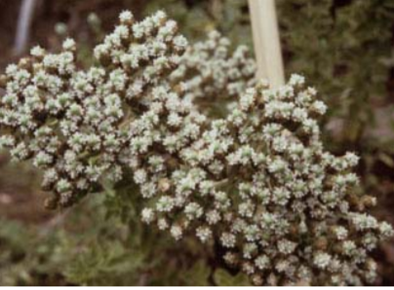  Origanum onites | 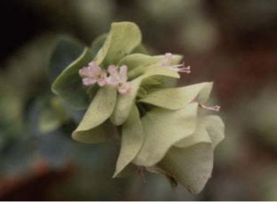  Origanum rotundifolium

Figure 3. Diverse varieties of oregano

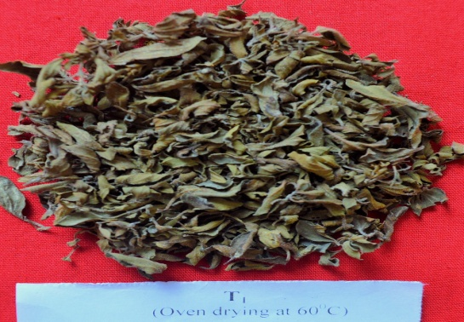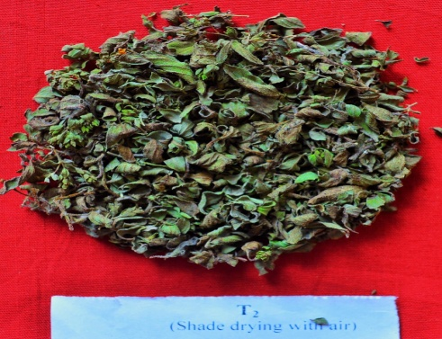
- (b)
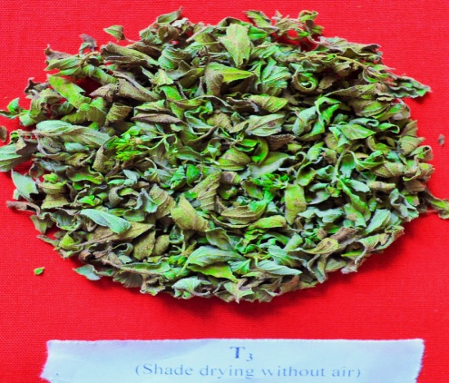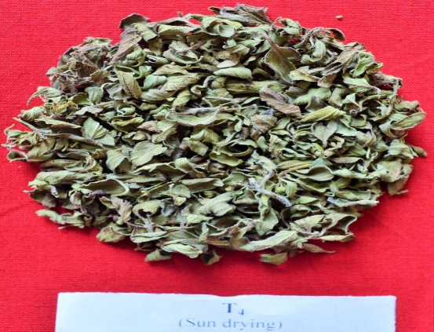
- (d)

Figure 4. The impact of various drying methods on the color appearance of dried Origanum vulgare L. herb is elucidated. (a) Represents oven drying, where the herb exhibits a blackish hue. (b) Depicts shade drying with air, resulting in a light green coloration. (c) Illustrates shade drying without air, which yields a dark green color. (d) Represents sun drying, characterized by a brownish coloration. This investigation was conducted at the CSIR-CIMAP Research Centre in Purara, shedding light on the diverse color outcomes associated with different drying techniques.

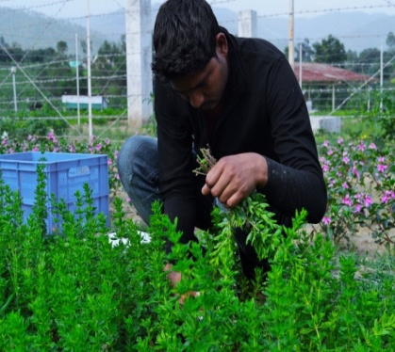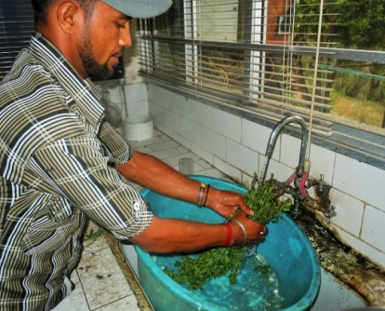
(a) (b)
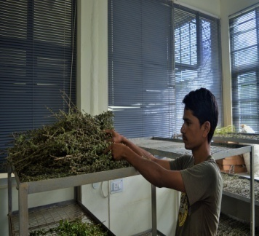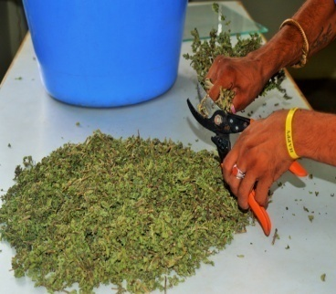
(c) (d)

Figure 5. Post-harvest management practices of Origanum vulgare L. at CIMAP RC Purara, Bageshwar, Uttarakhand. (a) Captures the harvesting process of the Origanum vulgare L. crop, showcasing the initial stage of post-harvest management. (b) Illustrates the meticulous washing of the fresh herb before it undergoes the drying process. (c) Highlights the collection of the dry herbs of Origanum vulgare L., marking a significant phase in post-harvest management. (d) Displays the step of cutting the dried herbs into small pieces, a crucial preparatory step before storage. These practices contribute to the effective post-harvest handling of Origanum vulgare L. at the research center.

