Dr. Sakshi Semwal, Assistant Professor

School of Liberal Arts and Management, DIT University

Dehradun, Uttarakhand

Email: drsakshi@dituniversity.edu.in

Rhythm Dhyani, Independent Scholar

Dehradun, Uttarakhand

Local to Global: Digitalization of Garhwali Folk Tales
ABSTRACT
Uttarakhand, a north Indian state is having a rich folk culture. It includes folk tales, folk music (Jaagars, Maangal geet) folkdance, etc. Being the oral society Garhwal and Kumaon region of Uttarakhand are known for their oral traditions. In the ancient time the traditions were passed on to the next generation orally. Now in the age of globalization people are shifting from the oral society to the digital media. In this progressive process of shifting towards the digital media people of Uttarakhand are leaving behind the rich oral traditions. The local folk traditions are required to reach on global level so that people may know the culture of Devbhomi, Uttarakhand and local tradition may be promoted and preserved for the next generations.This paper aims at widening the understanding on traditional culture of Uttarakhand through Garhwali folktales. Garhwali folk tales that are good source of education and entertainment provides the essence of unique culture and traditions of Garhwal. The paper focuses why there is a need to save and record these folk tales digitally and tries to explore the ways to integrate the traditional wisdom with latest technologies. For that a study is conducted to collect the data to know the connection of local people to the Garhwali folktales and responses were taken on various aspects to know their awareness about the status of Garhwali folktales in 21st century. The paper also offers some suggestions for preserving Garhwali folktales of Uttarakhand in the form of text, audio and video using the latest technologies so it can reach from local to global level.

Key words: Folk Tales, Digitalization, Uttarakhand, Garhwali

- Introduction.

Uttarakhand, a north Indian state of Himalayan region, popularly known as 'Devbhoomi' or 'Land of Gods' having large number of Hindu temples, rivers, pilgrimage centres is known for a rich history and cultural heritage. People here worship their natural surroundings and are proud of it. Uttarakhand is famous for its oral traditions and these rich oral traditions provide a deep understanding of the history and culture of Uttarakhand. From time immemorial oral traditions have passed on to the young generations to transmit custom, culture and philosophy of life. As Namita Gokhale states “Folktales and folklore are pervasive and enduring, the oral traditions travel across dialects and regional cultures, fashioning themselves to the lay of the land and the rhythms of local languages”(133).These beautiful folktales and folklore hold the traditional knowledge of a particular place and its culture. As Namita Gokhale says, “Folktales, folksongs, ballads, proverbs, and myths could be a potential source of study that comprises the vast ambit of folklore.” (134).
Garhwal and Kumaon are two demographical region of Uttarakhand. These areas are known for their rich oral traditions that persist exceptionally lively in rural and urban contexts. Oral narratives of Garhwal are deep rooted in the fabric of local culture that includes folklore, folktales, fairy tales, folk music, legends, proverbs and mythologies. These folktales show insights into local history, beliefs, and relationship between human and environment. The folktales of Garhwal are only famous in their region of origin but no one knows about these folktales outside the region. With the passage of time and in the era of globalization these folktales are not getting proper place in modern society and are towards extinction. It is important to connect the young generation with their roots and culture that can be easily done by creating awareness about the folktales of through the help of digital media. As in the age of globalization digitalization of folk tales will provide a platform to the local storied to reach on global level. The digitalization will not only help in preserving the local folk tales but also will make them available for global audience.

II. Research Gap

The study undertaken specifically focuses on the traditional folktales of Garhwal region of Uttarakhand. These folk tales are heading down towards the path to extinction and are steadily being blown away in the wind of change being fanned by increasing technology penetration. Today on the digital platforms we have very less information about Garhwali folktales of Uttarakhand region. Even the books containing the folk tales are in the native language. No translations have been made for global audience. It's the biggest hurdle in the promotion of these Folktales as the people who do not understand these native languages will have no clue about them. The efforts so far at preserving and promoting these folktales have been less than laudable.The kind of knowledge and belief system the traditional folktales provides to the society that deserve to be documented for posterity; as otherwise, they might disappear completely in coming time from the life of youngsters.

III. Research Questions:

To identify awareness of the people and the ways to save the folktales an online survey was conducted. The aim of the survey was to find out (i) Are the youth aware of the local folktales? (ii) What are the sources from where they got to know about the local folktales? (iii) What type of folktales are they familiar with? (iv)What are their suggestions to save the folk tales and to reach them from local to global level? (v) What are the ways to preserve the folk tales in digital era?

IV. Method

- Research Design
One time single group cross sectional research design was used in this study. A comparative study is also conducted to find the difference in use of social media by different gender. Calculation of the average of gender, occupation was also done to find out the actual average of the people having awareness of Garhwali folktales.

- Participants
Two hundred forty two responses of 18-40 age group people of different gender, classes, and different occupation were collected. All the responses were filled by people of Uttarakhand only. The responses from people of outside Uttarakhand and those who are residing in Uttarakhand but belong to some other states were not included in the study.

- Data collection`
A Google survey form was formed for the present study. The form was circulated on various social networking sites and groups of Garhwali community. While collecting the data the purpose of data collection was explained to all the participants. All the participants participated voluntarily to the survey. Socio-demographic information such as gender, age, occupation was asked in the form. In addition, other items were as follows:
- Which social media platform do you use the most and for which purpose?
- Are you familiar with the folktales of Uttarakhand?
- If you have ever been introduced to any folktale/s of Uttarakhand then kindly the select the source
- Which kinds of folktales have you read or heard?
- What are the benefits of Folktales of Uttarakhand?
- Folktales of Uttarakhand are heading towards the path of extinction. Would you like to contribute towards promoting and preserving them?
- According to you which can be the perfect medium to preserve and promote these folktales.
- Do you think interactive webinar sessions can be helpful in serving the purpose?
- How can we bring the Folktales of Uttarakhand from Local to Global level? Kindly suggest.
- Any other ideas which can be useful in preserving and promoting the Folktales of Uttarakhand?

- Data Analysis

Table No 1
Socio-Demographical Details
Table 1
Gender
Male | 113 | 46.69%
Female | 129 | 53.30%
Occupation
Student | 155 | 65.12%
Working Class | 91 | 34.87%
Do you belong to Uttarakhand?
Belong to UK | 197 | 81.40%
Don’t belong | 45 | 18.59%

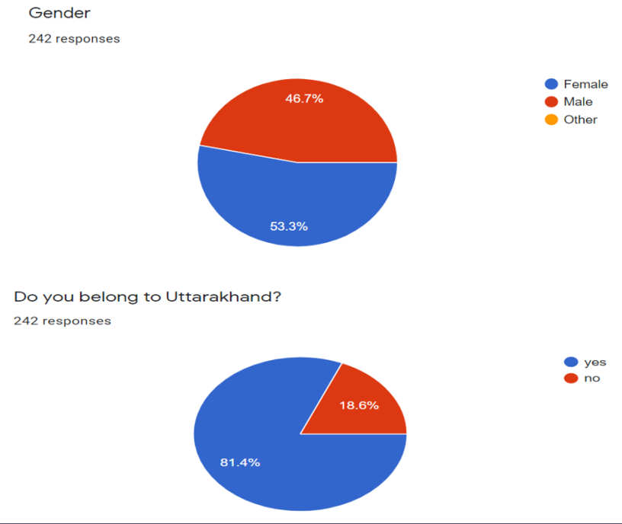
Figure No. 1
VII. Results

Percentage:
Percentage was calculated for Research questions (i) Are you familiar with the folktales of Uttarakhand? (ii) Folktales of Uttarakhand are heading towards the path of extinction. Would you like to contribute towards promoting and preserving them? (iii) Do you think interactive webinar sessions can be helpful in serving the purpose? (iv)Which social media platform do you use the most and for which purpose?

Table No. 2
Variable 2
Which social media platform do you use the most?
Facebook | 47 | 17.93%
Instagram | 186 | 70.99%
Twitter | 9 | 3.43%
Youtube | 20 | 7.63%
Are you familiar with the folktales of Uttarakhand?
Yes | 172 | 71.07%
No | 17 | 28.92%
 | 189
Folktales of Uttarakhand are heading towards the path of extinction.
Would you like to contribute towards promoting and preserving them?
Like contribute | 178 | 73.55%
don’t like | 4 | 1.65%
maybe | 60 | 24.79%
Do you think interactive webinar sessions can be helpful in serving the purpose
Yes | 144 | 59.50%
No | 23 | 9.50%
Maybe | 75 | 30.99%

Table No. 3
Variable 3
Which social media platform do females use the most? | number | total | %
Facebook | 30 | 129 | 23.25%
Instagram | 45 | 129 | 34.88%
Twitter | 10 | 129 | 7.75%
Youtube | 44 | 129 | 34.10%
Which social media platform do males use the most? | number | total | %
Facebook | 25 | 113 | 17.93%
Instagram | 53 | 113 | 70.99%
Twitter | 5 | 113 | 3.43%
Youtube | 30 | 113 | 7.63%

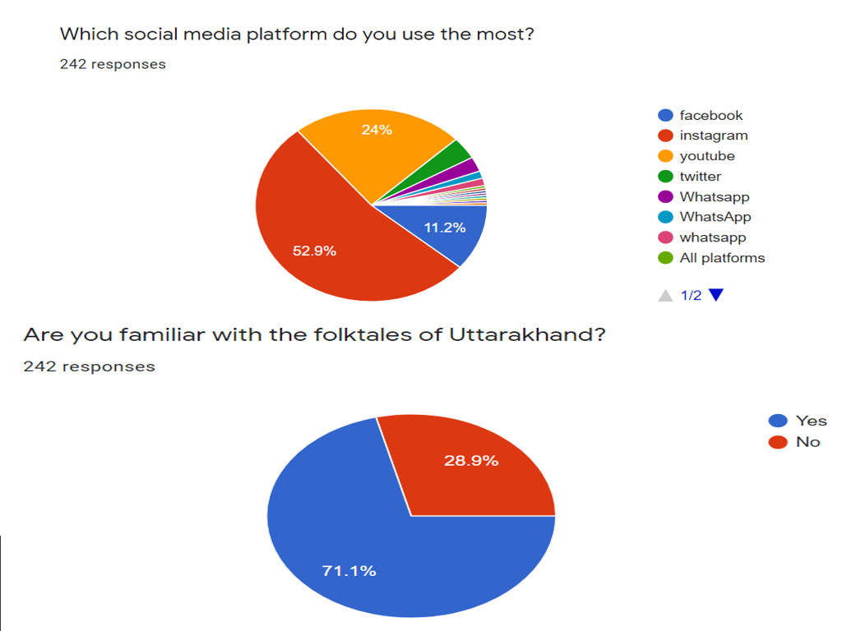
Figure No 2.
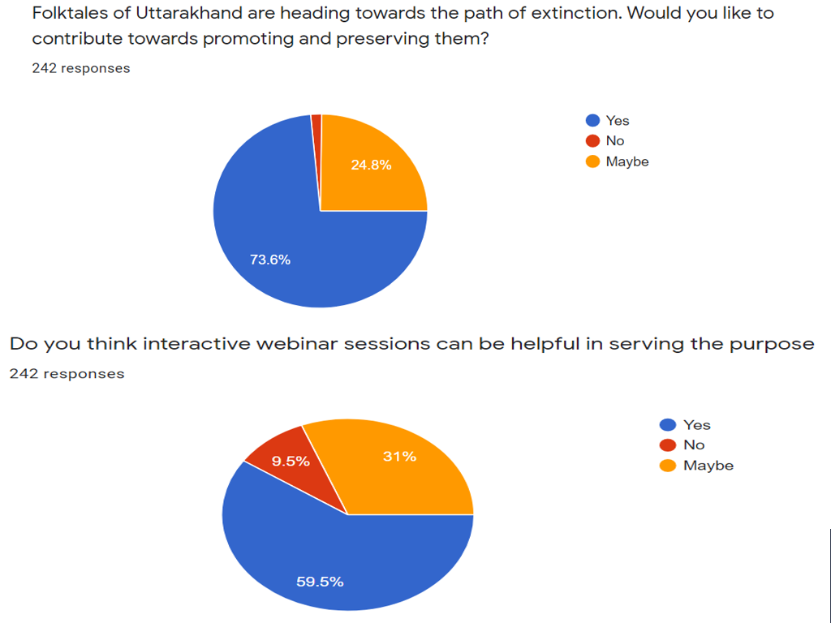
Figure No. 3

VIII. Discussion

- Importance of Folk Tales:

Folktales are very interesting and entertaining way of passing down history, culture and knowledge of a region. In Uttarakhand “Centuries of keen observations, cultural assimilation, learning by trials and errors, have been accentuated into various forms of traditional wisdom and practices, which have been reflected in unique socio-cultural, institutional and technological spheres of local societies” (Exploring Traditional Practices of Local Communities in Uttarkashi, Bageshwar and Pithoragarh Districts of Uttarakhand, 5). Through the practice of traditional culture and value the people of Uttarakhand are orally transmitting these folklore to the next generation. The result of the survey conducted clearly indicates that (60.8 %)of the people heard about the folktales from their ancestors and acquired the knowledge through oral mode. Only (27.9 %) of people read about folktales on internet through some blogs and among them all are students who are using new technologies. Only (2% )of people have read the stories from text books while (9.1%) people never heard or read about the folktales of Uttarakhand.

From the results of the study conducted it is visible that most of the people(49.1%) are aware of the stories of God, Goddess and local deities, (43.7 %) people have heard about folktales of Legendry Places and local heroes. (16.2 %) have heard the stories of fantasy and humor and rest (9.1 %)people have never heard or read about the folktales.(71.6 %) of the people who responded for the study feel that folk tales of local heroes and legendry tales are great source of getting understanding of local belief and history. The folk tales also help to inculcate moral values in the children and youth. (65%) of people accepted the importance of folk tales for teaching moral lessons to the children. After listening to the local folk tales people get a pleasure and they feel relaxed. (35%) people feel that the purpose of folk tales are to entertain the children. Children enjoy listening to stories from their grandparents and parents.
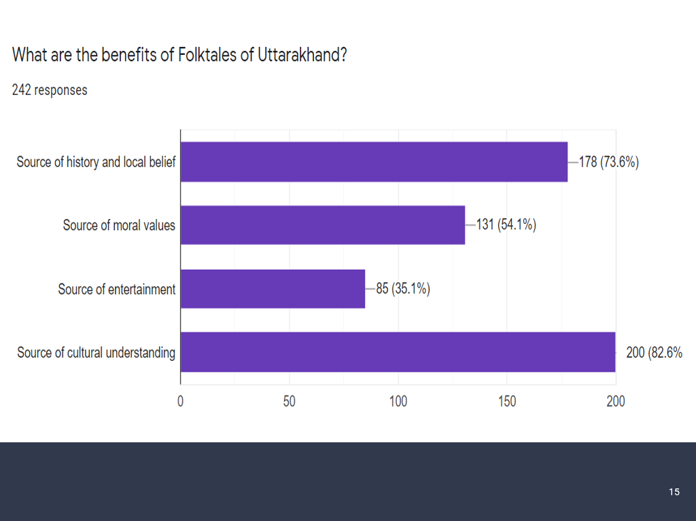

- Folktales towards Extinction
Uttarakhand Folktales are means of traditional knowledge and value but in the era of globalization culture and tradition are under threat. Presently very less books on Folktales of Uttarakhand are available, and most of them are written in Hindi or local language. Not much translation is done and that why in the era of globalization the young generation is not able to connect with the folk culture and tales. Oral traditions in Uttarakhand help in shaping the historical, regional and cultural consciousness in the native people and the question is that how it can be are recreated and preserved in the era of globalization today. Recently there is very less literature available related to the folktales of Uttarakhand. The famous book Uttarakhand ki lok Kathaye by govind Chatak is originally written in Hindi and then being translated by Dr. Arun Pant in English. Govind Chatak has also written books like Folk tales of Gharwal and Folktales of Kumao. There are few other books Uttarakhand ki lok kathaye by Deepa aggarwal, Uttarakhand ki lok kathaye by Harisuman Bisht, Where God Dwells central Himalayan folktales and legends by Kusum Budhiyal. Because of being written in native language and non-availability of these books on bookstores and Internet, these books are not popular.
In the era of globalization these folk tales need to be digitalized in the form of Audio, Video and translated texts. Few attempts have been done by the local people one such example is Uttarakhand Achieves- Kafal Tree that provides information on various things and also includes folktales in Hindi language. The other example of such site is Uttarakhand Meri Janambhoomi that contains one section of folklore having few folktales in Hindi. But this is not enough as these websites are not popular and there is no online repository initiated on government front for searching, accessing uploading text, audios and videos of local folktales. The oral history may be saved in the audio-visual documents that will increase its value and durability. It will help to provide the opportunity to the local traditions to the universal level and will be accessible to mass level of people. The role of digital media cannot be neglected in preserving the cultural memories as it help in spreading culture and tradition irrespective of space and time. Astrid Erll seems to express a similar view in her work Memory in Culture. “Cultural memory is unthinkable without media. It would be inconceivable without the role that media play on both levels — the individual and the collective.”(45)Re writing, Recreating and preserving the folktales are required. It can be done by using digital media. The following ways may be helpful in preserving and taking local folktales to the global level:

- 1. Creating Awareness among natives:
Only when local people will be aware of the existence of such folktales then it can be moved to global level. But initially attempts should be made to spread the folk tales on local level. We should advertise it more and more on social media platforms so that the people of Uttarakhand would be aware of their folktales and culture and others also take interest in it. A group named “Voices of Rural India aims to bring these storytellers on social media platforms and leverage online tools which will also help them in tourism and other side businesses”.( ) With that Government support is also one of the major requirements to save the folk tales. Government should initiate some projects and research grant may also be provided. A government repository, digital library, website should be created so that authentic content may be uploaded. Through the support of government and local people projects may be taken to record the folk tales and audio and visual documentation may be initiated

B. 2 Online Promotional Campaigns and reach out to local media:
Various campaigns and cultural programs, interactive events should be conducted in all the districts. Promoting local heroes and deities in various cultural activities will inculcate the traditional sense in our youth. An official culture social media group may be created and these events should be promoted through online platforms. In such cases rural storytellers, guides and folklorist will take pride in retelling their folk stories to the world. As righty said by Virdi “With the possibility of physical travel now on hold, learning to own our narratives in this new virtual medium is both exciting and challenging.”
Sharing it more on digital platforms in the form of short films, animated videos and
Promoting through Facebook, Youtube, Watsapp and other digital platforms will be one of the best way to reach to the local people. As per the results of the study 70.99%of the people are using Instagram and(17.93 %) of people are using facebook and (7.63 %) are using YouTube and remaining 3.43 % people are using Twitter. Social media may also be useful for spreading the awareness and evoking the interest. Broadcasting audio and video recordings on Local channels and Publishing articles and stories in local newspapers may also serve the purpose.

B.3 Creation of Web server and a database:
Creation of web server and database of Text, Audio and videos of folktales is an essential requirement of digitalization. As put forward by Kwartalnik “A digitised collection may be viewed from at least two perspectives: as a ‘store’ into which ‘someone has uploaded’ contents (the so-called ‘use-neutral’ or ‘uncommitted’ digitalisation’, which prioritises the technological dimension of the project) or in the context of breathing a ‘new life” (KwartalnikMłodychMuzykologów).
A dynamic official website, having various sections should be created for uploading, downloading and accessing the data. A repository may be formed by government to save the data. Building virtual achieves in universities and providing the content on digital library will also be helpful for researchers, teachers and students. As said by Agata Krajewska: “Such facilities make research more effective since the digitalized material is readily available and easy to locate, which allows scholars to save time and improve their efficacy on a previously unattainable scale” (Agata Krajewska). The database and repository will help to preserve the history, culture and traditional values. According to Paul Thompson, ‘all history depends ultimately upon its social purpose,’ which is in many cases ‘obscure”. For this reason, collecting data may sometimes appear to be an unreflective ‘pursuit of knowledge for its own sake.’(11)

B.4 Including Folktales in Curriculum and inculcating research tradition on folklore studies:
Traditional ways of writing and reading such tales can be used to spread these tales. Books regarding folktales of Uttarakhand, etc should be introduced in schools so that children become familiar with their tradition. Including these Folktales as a part of School Curriculum as well as Introducing them as interactive and fun activity for classroom can be useful. As put forward by Sonali “An interest in social interaction stems from the child’s need of companionship. Laptops, mobiles and/or tablets are now fulfilling this ‘need’”. So a combination of traditional folk tales with the latest technologies may provide a good companion to our young generation. Government should start some project and research grant may be given. As in absence of research grant it is difficult to do field work like audio and video recording of folk tales. Audio and video Recording- in the field work with precise documentation including, name, age, gender, place of residence and date of recording will help to maintain the data for creation of a repository.

IX Conclusion:

We should teach these folk tales to the next generation. For that we can involve the elder and younger generation to work on same platform. The elders can share the stories and the youth can carry the stories on digital platform by using the modern day technology. The stories recited by grandparents and elder may be recorded as audio and video clips. The inhabitants may tell the story in their native tongue that can be recorded and then translated by young generation. The digitalization is the best way to procure, save and share the folktales which will help the young generation to connect with their cultural roots.

REFERENCES
[1] Agata Krajewska Digitisation of Folklore Archives: A Crisis of Tradition or Its ‘New Life’ on the Internet? The Example of Adolf Dygacz’s Collection. 2018.
[2] Eden Pema., “Folklore: A Glimpse Into The Gaine Tradition Of Nepal And The Folktales Of Bhutan” International Journal Of English Language, Literature And Translation Studies. 2015
[3] Erll, A., Memory in Culture, Palgrave Macmillan Memory Studies (Palgrave Macmillan UK: London, 2011).
[4] Francis Lee Utley, 1961, “Folk Literature: An Operational Definition”, The Journal of American Folklore, Vol 7, No 293 (Jul- Sep., 1961), p 194, (American Folklore Society), http://www.jstor.org/stable/537632 Gurung, M M., (1997),
[5] Gokhale Namita., Travelling Tales: Some Stories from the Middle Himalayas, Cracow Indological Studies vol. XVII (2015)
[6]Kwartalnik Młodych Muzykologów UJ no. 46 (3/2020), 67–86 DOI 10.4467/23537094KMMUJ.20.038.13911 www.ejournals.eu/kmmuj file:///C:/Users/user/Downloads/5-Krajewska_KMMUJ_44_3-2020_EN.pdf- accessed on 20-June 2023
[7] Kusum Budhwar., Where Gods Dwell- Central Himalayan Folktales and Legends.
[8] P. Thompson., The Voice of the Past: Oral History (1988), 21.
[9] Sonali Dhasmana.,“Uttaranchal folktales for increasing social interaction in Children” https://pdfroom.com/books/uttaranchal-folktales-for-increasing-social-interaction-in-childrenpdf/on5bbz3L56V, accessed on 21-July 2023
[10] Tshering Cigay Dorji., “Preserving our Folktales, Myths and Legends in the Digital Era”
[11] Taylor, Archer. 1948, “Folklore and the Student of Literature”, (The Pacific Spectator; Vol. 2. Pp. 216 – 223)
[12] Vishambar Prasad Sati., “ Cultural Geography of Uttarakhand Where Folk Dances with the Nature’s Rhythm” Today’s and Tommorow’s printer and publishers. New Delhi
[15] Exploring Traditional Practices of Local Communities in Uttarkashi, Bageshwar and Pithoragarh Districts of Uttarakhand file:///D:/Gharwali%20folk/Exploring_Traditional_Practices.pdf accessed on 10-July 2023
[16] Mohan Singh Panwar and Renu “ Impact of geographical factors on culture and cultural landscapes: An analytical study of Garhwal region” International Journal of Multidisciplinary Research and Development Online ISSN: 2349-4182, Print ISSN: 2349-5979, Volume 4; Issue 7; July 2017; Page No. 176-182
[17] Panwar Shikha “Folk Religion In The Central Himalayas (Kumaon And Garhwal)”Impact: International Journal of Research in Humanities, Arts and Literature ISSN(P): 2347-4564; ISSN(E): 2321-8878 Vol. 5, Issue 6, Jun 2017, 169-182 https://www.jagran.com/uttarakhand/dehradun-city-folktales-of-uttarakhand-will-come-on-digital-platform-21570363.html accessed on 21-July 2023

