**PROSPECTS OF PROCESSING AND VALUE ADDITION IN SUPERFOODS**

**Archana Y. Kalal1, Udaykumar Nidoni2, Sharanagouda Hiregoudar2 and Pramod Katti3**

1Ph. D. (Agril. Engg.), Dept. of Processing and Food Engineering, College of Agricultural Engineering, University of Agricultural Sciences, Raichur-584102

2Professor, Dept. of Processing and Food Engineering, College of Agricultural Engineering, University of Agricultural Sciences, Raichur-584102

3Professor and Administrative Officer, University of Agricultural Sciences,   
Raichur-584102, Karnataka

**Abstract**

In a global arena in which the identification of healthier and cleaner nutrient sources is practically mandatory, superfoods, known as foods of high nutritional and biological value with satisfactory bioavailability and bioactivity within the body due to extraordinary concentrations of nutrients and bioactive ingredients, can play a key role. These products are closely related to sustainability, which includes economic, environmental and social balance, interpreted mainly in terms of meeting nutritional needs (Fernandez-Rios *et al.,* 2022).

The term "superfood" does not have an official definition *i.e.,* there is no scientific, legal or legal explanation is suggested by the food safety regulations. It is informally used to refer to foods that can provide large amounts of nutrients, play an important role in the diet, and contribute to the proper functioning of the body (AESAN, 2019). These foods were registered in a classified list based on the FoodEx classification system proposed by EFSA (EFSA, 2011).

Quinoa (*Chenopodium quinoa* Willd.) is an annual herbaceous plant, also called pseudocereal, originally cultivated in the Andes region of South America. Quinoa processing involves several steps such as seed separation, washing, drying to produce processed seeds, milling, crushing and sieving to obtain quinoa flour and semolina (Hirich *et al.,* 2021). Many traditional foods and beverages, such as Phiri, Chiwa, Qusa, as well as new industrial foods, such as quinoa pasta, flakes, and noodles, have been produced from quinoa (Angeli *et al.,* 2020).

Teff (*Eragrostis tef*) is a tropical cereal native to Africa. Before being used in the production of various food products, such as bread, unleavened bread, cookies, cakes and extruded products, teff seeds are converted into fine flour particles. The widely produced teff-based product in Ethiopia is injera– a flatbread with pancake-like texture and softness (Bultosa, 2007). Teff seed undergoes a fermentation process to produce traditional Ethiopian alcoholic beverages, Arake, Shamit and Tella (Gebremariam *et al.,* 2014).

Chia seeds (*Salvia hispanica* L.), also known as chia, are annual plants native to southern Mexico and Northern Guatemala. Mexico is known as the largest producer of chia in the world. The positive benefits of chia seeds as a dietary supplement include supporting the digestive system, healthy skin, promoting stronger bones and muscles, and reducing the risk of heart disease and diabetes (Grancieri and Martino, 2019).

Queens Quinoa is a company specialized in the production of Quinoa and its value-added products started since 2013 by an entrepreneur Ms. Monika Goyal. Queens Quinoa – is the first Indian brand to launch 100% Organic, Non-GMO Project Verified, and Vegan-Friendly Quinoa products and to have a state-of-the-art processing facility that produces value-added products. It is involved in producing many quinoa-based products like pasta, noodles and flakes ([www.queensquinoa.com](http://www.queensquinoa.com)).

Superfoods are typically plant-based foods that are highly nutritious and provide maximum nutritional benefits with minimal calories. Superfoods have strong biological activity and nutritional potential and play an essential role in preventing chronic diseases. The extraction of bioactive components and their incorporation into various food applications may pave the way for the development of potential health-promoting foods in the food processing sector.

1. **Introduction**

The so-called "superfoods" have been more well-known in recent years as a potential solution to the pressing need to implement nutritional solutions to the worldwide dilemma of the intricately interwoven trilemma of diet, environment, and health. There is no official definition for the phrase "superfood," which means that there is no scientific, legal, or regulatory definition put forth by food safety rules. It is a colloquial term for foods that may supply nutrients in large quantities, are essential to diets, and support healthy bodily function (AESAN, 2019).

Superfoods, defined as foods of high nutritional and biological value with satisfactory bioavailability and bioactivity within the body due to extraordinary concentrations of nutrients and bioactive ingredients, can play a critical role in a global arena where the identification of healthier and cleaner nutrient sources is practically mandatory. These items are closely linked to sustainability, which is defined as an economic, environmental, and social balance that is primarily translated into providing nutritional demands. Superfoods are unique foods that have the ability to prevent various ailments, boost the immune system, and offer critical macro- and micronutrients in large numbers (Jagdale *et al.,* 2021). According to the Oxford English Dictionary, a superfood is a meal that is "considered particularly nutritious or in any case beneficial" (Meyerding *et al*., 2018).

Numerous studies suggest that superfoods are an excellent way to promote general health by strengthening the immune system, increasing the production of serotonin and other hormones, and encouraging the smooth operation of the human body's biological systems (Proestos, 2018). Some scientists compare these foods to other specific products that serve comparable tasks, classifying them as foods beyond diet but before medications (Fig. 1) (Santini and Novellino, 2014). For example, they are typically comparable to functional foods (Samec *et al.,* 2019), which resemble conventional foods, are consumed on a regular basis as part of a diet, and provide health benefits, such as lowering the risk of disease and positively affecting target functions beyond basic nutritional needs (Doyon and Labrecque, 2008).

They are also linked to nutraceuticals, which are defined as a food or component of a diet that delivers medicinal benefits such as illness prevention and/or therapy (Santini *et al.,* 2018). Other authors argue that superfoods differ from functional foods in their discursive construction by emphasizing their 'natural' nutrient density alongside 'traditional' and 'exotic' qualities, as functional foods are frequently enriched by bioactive compounds with immune-boosting and functional properties (Picone *et al.,* 2022), and thus require separate analysis (Loyer and Knight, 2018). Due to the dispute surrounding the idea of superfood, the most common informal definition was used in this review, which defined them as food products containing abnormally high quantities of any nutrient (AESAN, 2019). Under our perspective, a superfood must be a unique food, not a multi-compound product, and ‘natural’, *i.e.,* not submitted to human 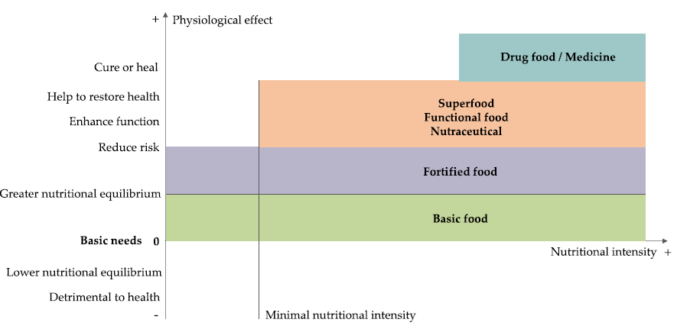intervention to add ingredients, supplements or additional nutrients.

**Fig. 1. Boundaries defining food categories (Doyon and Labrecque, 2008)**

1. **Classification of Superfoods**

They were entered in a list categorized according to the FoodEx classification system, proposed by EFSA (EFSA, 2011).

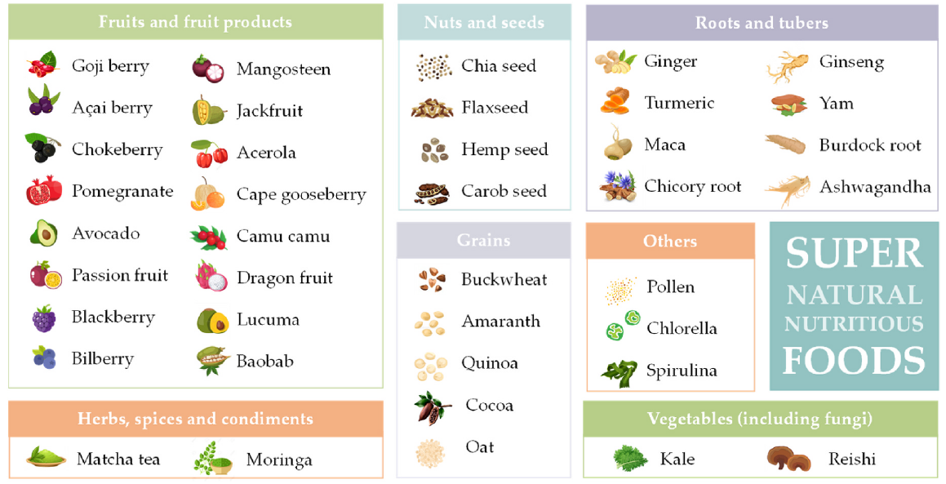

**Fig. 2. Classification of Superfoods in food categories (Fernandez-Rios *et al*., 2022)**

FoodEx is a hierarchical system based on 20 main food categories that are further divided into subgroups and that includes both natural and processed foods and beverages. However, the foods selected fit into only 6 out of the 20 defined categories: (i) Fruits and fruit products, (ii) vegetables and vegetable products (including *fungi* family), (iii) grains and grains-based products, (iv) starchy roots and tubers, (v) legumes, nuts and seeds, and (vi) herbs, spices and condiments. Furthermore, an extra category (defined as ‘others’) was added to arrange food products that are not included by this classification system, such as algae or bee products.

1. **MARKET OF SUPERFOODS**

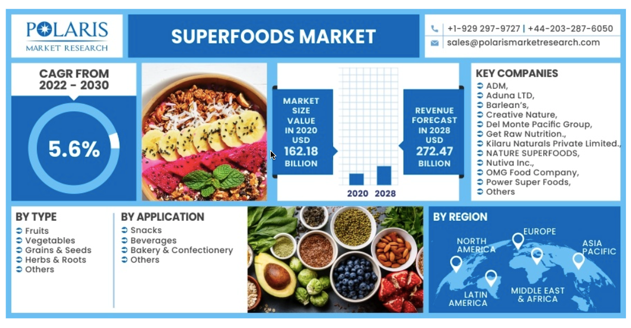

(www.polarismarketresearch.com)

**Fig. 3. Market of Superfoods (**[**www.polarismarketresearch.com**](http://www.polarismarketresearch.com)**)**

1. **DIFFERENT SUPERFOODS**

**QUINOA**

Quinoa is a grain with great nutritional value. It has been cultivated in the Andes of Bolivia and Peru for the past 5000 to 7000 years. The year 2013 was declared by the United Nations as the International Year of Quinoa due to its important potential (Tang *et al.,* 2015b). Quinoa contains a high concentration of protein, all essential amino acids, unsaturated fatty acids and a low glycemic index (GI). It also contains vitamins, minerals and other beneficial compounds and is essentially gluten-free. Quinoa is easy to prepare and offers cooking versatility (Vega-Galvez *et al.,* 2010).

**History**

Quinoa has been cultivated for thousands of years in the Andean regions of Bolivia and Peru (Jancurova *et al.,* 2009). It is known by various local names, or simply quinoa or quinoa (quinoa is the Quechua word) (Vega-Galvez *et al.,* 2010). This plant was called "mother grain" by the Incas, it was considered a gift from the gods and it was also used to treat medical problems. Traditionally, quinoa seeds were roasted and cooked, added to soups, used as a cereal, and even fermented in beer and chichi (a traditional Andean drink) (Vega-Galvez *et al.,* 2010). After the Spanish conquest of South America, settlers rejected quinoa as peasant or Indian food. Therefore, quinoa is considered a low social status food. In addition, the Catholic Church found that quinoa was used as a sacred drink (mudai) in indigenous religious ceremonies and actively suppressed its cultivation. Therefore, quinoa remained only where the Europeans could not reach it and replaced it with other cereals (Vega-Galvez *et al.,* 2010).

**Quinoa Production worldwide from 2010 to 2020 (MT)**

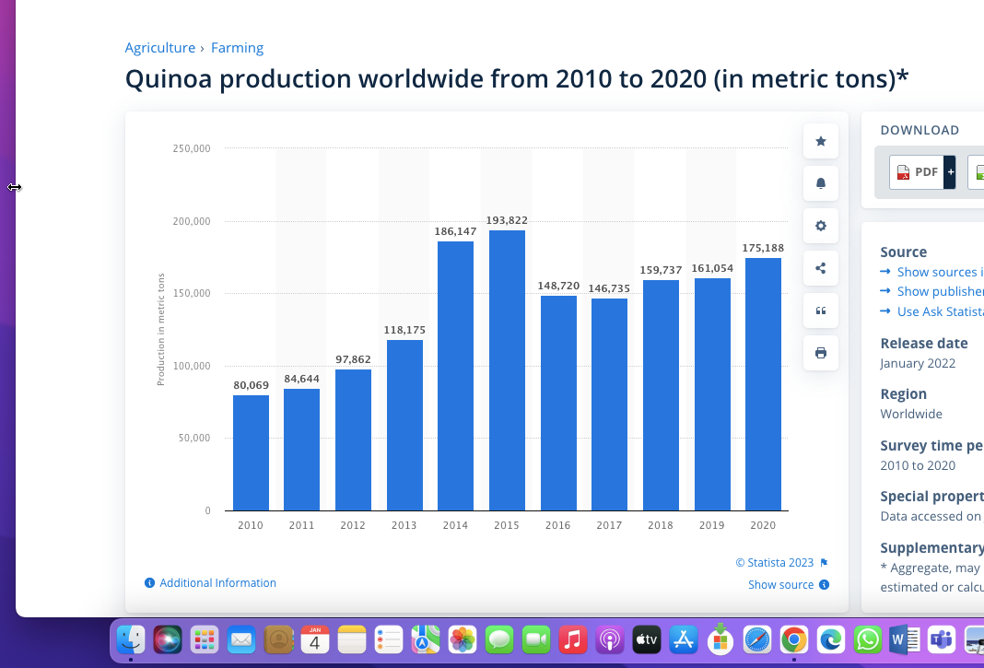

**Fig. 4. Quinoa worldwide production (www.statista.com)**

**Botanical description and cultivation**

The botanical name of quinoa is *Chenopodium quinoa* Willd, and it belongs to the "Chenopodium" family, which includes Swiss chard (Beta sp.), spinach (*Spinacia oleracea*), and lamb's quarter (*Chenopodium album*). Quinoa is a dicotyledonous plant whose height reaches from 1 to 3 meters. It is considered a pseudocereal, a fruit rather than a true seed. The seeds are round and flat, about 1.5 to 4.0 mm in diameter, and their colour varies from white to grey to black, with shades of yellow, pink, red, purple, and violet (Fig. 5) (Gordillo-Bastidas *et al.,* 2016).

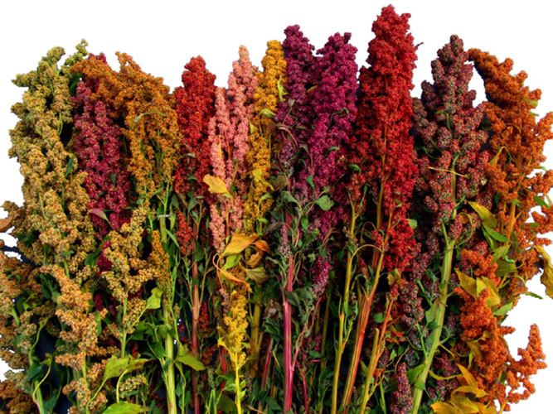

**Fig. 5. *Chenopodium quinoa* plants with varying fruit colors**

Quinoa is very resistant to salty, acidic, alkaline and cold weather (-5°C) or warm weather (up to 35°C) (Jancurova *et al.,* 2009). Quinoa is a hardy and drought-resistant plant with an irrigation and rain requirement of 25 to 38 cm per year, which is much less than the water requirements of other crops such as wheat and rice (Jacobsen *et al.,* 2003). Currently, there are more than 250 varieties of quinoa, the most cultivated varieties include Bear, Vanilla Cherry, Cochabamba, Dave 407, Gossi, Isluga, Kaslala, Kcoito, Linares, Puno, Titicaca, Rainbow, Red lighthouse, and Red head and Temuco (Sobota *et al.,* 2020). Classification is based on plant and fruit colour or plant morphology (Jancurova *et al.,* 2009). This seed is licensed for planting in Europe, North America, Asia and Africa.

**Botanical distinction from cereal grains**

Although quinoa is a dicot, it is often confused with grains such as rice, corn, and wheat (monocots from the Poaceae family), hence the term "pseudograin." However, quinoa is a member of the Amaranthaceae (formerly Chenopodiaceae) family (APG, 1998; Kadereit *et al.,* 2003) and is therefore systematically and morphologically distinct from cereals. This difference is particularly noticeable due to the unique structure of the quinoa fruit and seed. Quinoa fruit is an achene and consists of a single seed surrounded by an outer pericarp (FAO, 2011).

Quinoa seeds contain a central endosperm where carbohydrates are locally stored, surrounded by a circular oil- and protein-rich embryo, endosperm, and seed coat (Prego and Others 1998). The pericarp of quinoa fruit is rich in bitter saponins, which must be removed by mechanical grinding or washing before eating the seeds (Prego *et al.,* 1998; Vega-Galvez *et al.,* 2010). This process, called desaponification (removal of saponins), is also called dehusking (Miranda *et al*., 2012a), pearling (Gomez-Caravaca *et al*., 2014), or milling (Kumpun *et al*., 2011). From a nutritional standpoint, quinoa falls into the category of "whole grains" (McKune *et al.,* 2013). However, unlike traditional grains, which are typically processed to remove the nutrient-rich germ and bran, quinoa desaponification leaves the nutrient-rich embryo and endosperm intact. The embryos, which constitute up to 60% of the seed weight, provide a balanced nutritional profile of proteins, lipids, and carbohydrates (Valencia-Chamorro, 2003).

**Traditional use**

Quinoa has been traditionally used by several indigenous peoples of South America, including the Quechua, Aymara, Tiahuancota, Chibcha, and Mapuche (Vega-Galvez *et al.,* 2010; Bhargava and Srivastava, 2013). The seeds are eaten like rice, added to soups, puffed to make breakfast cereals, or ground to flour to produce toasted and baked goods (cookies, breads, biscuits, noodles, flakes, tortillas, pancakes) (Popenoe *et al.,* 1989; Bhargava *et al.,* 2006). Quinoa leaves are eaten like spinach (Oelke *et al.,* 1992) and sprouted quinoa seedlings (quinoa sprouts) are included in salads (Schlick and Bubenheim, 1996). Additionally, quinoa seeds can be fermented to make beer or a traditional South American ceremonial alcoholic beverage called chicha (Healy, 2001; FAO, 2011).

The whole plant is also used as a rich nutrient source for livestock such as cattle, pigs and poultry (Bhargava *et al.,* 2006). History shows a wide range of medicinal uses of quinoa, from treating wounds and bone fractures to promoting gastrointestinal health (Mujica, 1994; Bhargava *et al.,* 2006; Fau, 2011). Quinoa is widely regarded as an uplifting, health-promoting, and endurance-enhancing food (Popenoe *et al.,* 1989; Lafont, 1998; Gorelick-Feldman *et al.,* 2008; Kokoska and Janovska, 2009; FAO, 2011). A pungent ash made from quinoa stalks called "llipta" was mixed with coca leaves (*Erythroxylum coca* Lam) and chewed by Andean farmers to conserve energy (Martindale, 1894). A mixture of quinoa and fat called "war balls" was used to support Inca troops marching in the Andes Mountains (Small, 2013).

1. **Functional potential of quinoa for human health**

In addition to its high nutritional value and gluten-free properties, quinoa has beneficial effects on consumers in high-risk groups such as children, the elderly, lactose intolerance, anemia, diabetes, obesity, dyslipidemia. and celiac disease These benefits are related to the content of protein, fiber, vitamins, minerals and fatty acids, especially the presence of large amounts of phytochemicals, which give quinoa significant advantages over other grains in terms of nutrition and human health (Navruz-Varli *et al*., 2016).

The bioactive compounds identified in quinoa and their reported bioactivity are shown in Figure 6. The outer shell of the quinoa seed is rich in bitter saponins, whose bitterness disturbs the taste and digestibility and must be removed before eating the seeds. Despite their unpleasant properties, saponins have a wide range of biological activities, including antifungal, antiviral, anticancer, cholesterol-lowering, hypoglycemic, antithrombotic, diuretic, and anti-inflammatory effects (Graf *et al*., 2015). The total quinoa saponin fraction was reported to slightly inhibit the growth of *Candida albicans* (Woldemichael *et al.,* 2016). One of the main activities shown by quinoa seed is its antioxidant activity related to its high content of phenolic compounds (Abderrahim *et al.,* 2015). More than 20 phenolic compounds have been discovered in free or conjugated form (released by hydrolysis with alkali, acid and/or enzyme). The majority of phenolic acids consist of vanillic acid and ferulic acid and their derivatives, as well as the flavonoids quercetin, kaempferol and their glycosides (Tang *et al.,* 2015).

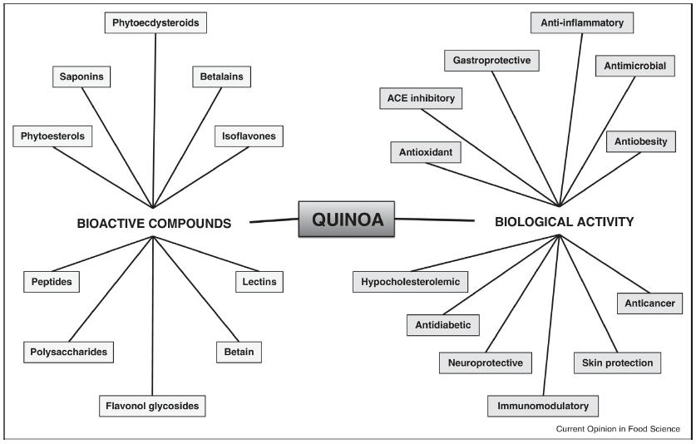

**Fig. 5 Bioactive compounds and biological activities of Quinoa (Vilcacundo and Hernandez-Ledesma, 2017)**

In addition to their antioxidant properties, these quinoa components have been reported to exert α-glucosidase and pancreatic lipase inhibitory activity (Tang *et al*., 2016). Phytoecdysteroids are polyhydroxylated steroids that are thought to play a role in plant defense due to their structural association with insect molting hormones. In addition, these substances have a wide range of health benefits, including anabolic, performance-enhancing, anti-osteoporosis, anti-diabetic, anti-obesity, and wound healing properties (Graf *et al.,* 2014). Quinoa is one of the richest food sources of phytoecdysteroids, the concentration of which varies from 138 to 570 mg/g and 13 different phytoecdysteroid types. The most common are: 20-Hydroxyecdysone (20HE) constitutes 62-90% of total quinoa phytoecdysteroids (Graf *et al.,* 2015). A 20HE-rich extract of quinoa was shown to reduce fasting blood glucose in hyperglycemic obese rats (Graff *et al.,* 2014).

**Table 1. Compositional and nutritional characteristics (per 100 g) (USDA, 2019)**

|  |  |  |  |  |  |  |  |  |  |  |
| --- | --- | --- | --- | --- | --- | --- | --- | --- | --- | --- |
| Nutrient |  | Black  cumin |  |  |  |  |  |  |  | |
| Unit | Chia | Flax | Hemp | Perilla | Pumpkin | Quinoa | Sesame | |
| **Proximate composition** | | | | | | | | | |
| Water | g | 7.06 | 5.80 | 6.96 | 4.96 | 4.60 | 5.23 | 13.28 | 4.69 | |
| Energy | kCal | 430.00 | 486.00 | 534.00 | 553.00 | 530.00 | 559.00 | 368.00 | 573.00 | |
| Protein | g | 21.50 | 16.54 | 18.29 | 31.56 | 22.68 | 30.23 | 14.12 | 17.73 | |
| Lipid (fat) | g | 27.11 | 30.74 | 42.16 | 48.75 | 39.74 | 49.05 | 6.07 | 49.67 | |
| SFA | g | 4.08 | 3.33 | 3.66 | 4.60 | 2.94 | 8.66 | 0.71 | 6.96 | |
| MUFA | g | 5.99 | 2.31 | 7.53 | 5.40 | 4.93 | 16.24 | 1.61 | 18.76 | |
| PUFA | g | 15.99 | 23.66 | 28.73 | 38.10 | 29.98 | 20.98 | 3.29 | 21.77 | |
| Ash | g | 3.93 | 4.80 | 3.72 | 6.06 | 3.72 | 4.78 | 2.38 | 4.45 | |
| Carbohydrate | g | 40.40 | 42.12 | 28.88 | 8.67 | 29.26 | 10.71 | 64.16 | 23.45 | |
| Dietary fiber | g | 30.67 | 34.40 | 27.30 | 4.00 | 22.00 | 6.00 | 7.00 | 11.80 | |
| Sugars | g | 3.27 | tr | 1.55 | 1.50 | 1.46 | 1.40 | tr | 0.30 | |
| Starch | g | 0.12 | – | – | – | – | 1.47 | 52.22 | – | |
| **Minerals** | | | | | | | | | |
| Calcium | mg | 477.00 | 631.00 | 255.00 | 70.00 | 391.00 | 46.00 | 47.00 | 975.00 | |
| Copper | mg | 1.07 | 0.92 | 1.22 | 1.60 | 1.21 | 1.34 | 0.59 | 4.08 | |
| Iron | mg | 14.03 | 7.72 | 5.73 | 7.95 | 7.74 | 8.82 | 4.57 | 14.55 | |
| Magnesium | mg | 285.00 | 335.00 | 392.00 | 700.00 | 254.00 | 592.00 | 197.00 | 351.00 | |
| Manganese | mg | 3.21 | 2.72 | 2.48 | 7.60 | 3.70 | 4.54 | 2.03 | 2.46 | |
| Phosphorus | mg | 697.00 | 860.00 | 642.00 | 1650.00 | 716.00 | 1233.00 | 457.00 | 629.00 | |
| Potassium | mg | 768.00 | 407.00 | 813.00 | 1200.00 | 583.00 | 809.00 | 563.00 | 468.00 | |
| Selenium | μg | 0.01 | 55.20 | 25.40 | – | 1.16 | 9.40 | 8.50 | 34.40 | |
| Sodium | mg | 10.69 | 16.00 | 30.00 | 5.00 | 1.00 | 7.00 | 5.00 | 11.00 | |
| Zinc | mg | 5.66 | 4.58 | 4.34 | 9.90 | 4.80 | 7.81 | 3.10 | 7.75 | |

1. **Quinoa Processing**

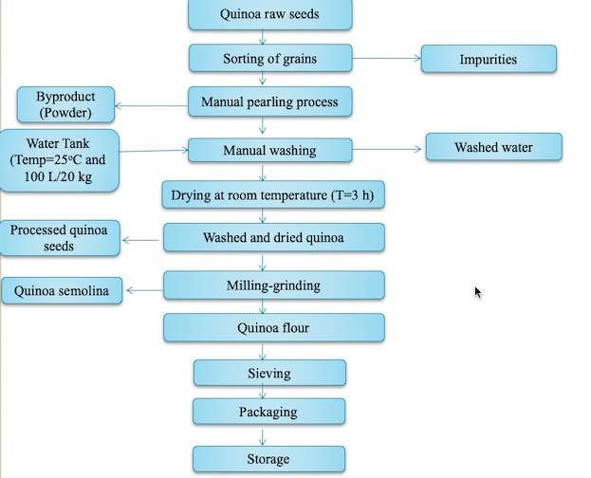

**Fig. 6 Flow chart of Quinoa Processing (Hirich *et al*., 2021)**

**Food Products and Beverages Developed from Quinoa**

**Table 2. Traditional Quinoa food products and Beverages (Bojanic, 2011)**

|  |  |
| --- | --- |
| **Product** | **Description** |
| Quinoa Soup | Cooked quinoa with meat, tubers and vegetables |
| Lawa | A porridge like dish with raw flour, water with lime and animal fat |
| Pesque | Quinoa grain cooked without salt, served with milk or grated cheese |
| Kispina | Steamed buns |
| Tacti o tactacho | Fried buns, like a doughnut, from flour and fat |
| Mucuna | Steamed cooked balls from quinoa flour, filled with seasoning |
| Phiri | Roasted and slightly dampened quinoa flour |
| Phisara | Lightly roasted and cooked quinoa grain |
| Qusa | Quinoa chicha, a macerated cold drink |
| El Ullphu, Ullphi | Cold drink prepared with roasted quinoa flour |
| Kaswira de quinua | Flattened bread fried in oil with lime and white quinoa |
| Kaswira de ajara | Flattened bread fried in oil with lime and black quinoa or ajara |
| Quichi quispina | Steamed and fried bread, made with katahui and quinoa flour |
| Juchcha | Andean soup based on ground quinoa and katahui |
| Chiwa | Young quinoa leaves are used as a vegetable in salads and soups |

**Table 3. Clinical trials on the effect of quinoa products in human health (Vilcacundo and Hernandez-Ledesma, 2017)**

|  |  |  |  |  |  |
| --- | --- | --- | --- | --- | --- |
| **Study participants** | **Treatment** | **Duration** | **Outcomes** | **Conclusions** | **Reference** |
| 50-65 month old boys | 100 g quinoa-added baby food | 15 days | Increase of IGF-1 | Have Potential role in reducing  childhood malnutrition | Foucault *et al*. (2011) |
| 22 students (18-45 years old) | Quinoa cereal bars | 30 days | Reduce the level of triglycerides, total cholesterol and LDL levels Reduce the (no significant) blood glucose and pressure, and body weight | Potential role in preventing  cardiovascular disease | Ruales *et al*. (2002) |
| 35 post-menopausal overweight women | 25 g quinoa flakes and cornflakes | 4 weeks | Reduction of triglycerides,TBARS and vitamin E Increase of urinary secretion of enterolignans  Decrease of total cholesterol and LDL  Increase in GSH | Beneficial effect on metabolic  parameters modulation | Farinazzi-Machado *et al*. (2012) |
| 19 celiac patients | 50 g quinoa | 6 weeks | Improve the histological and  Serological parameters, Mild hypocholesterolemic effect | Quinoa consumption is considered safe for celiac individuals | De Carvalho *et al*. (2014) |

**Quinoa protein concentrate**

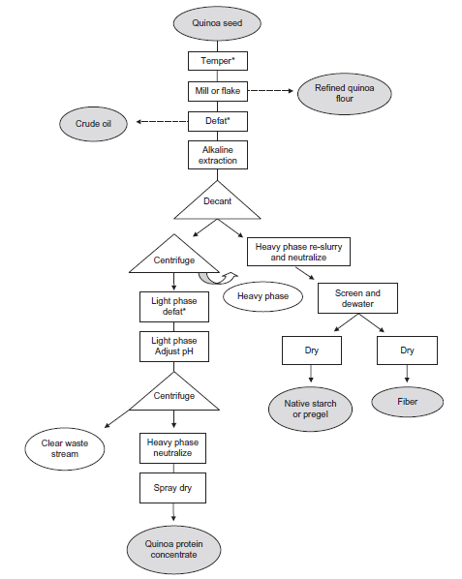

**Fig. 7 Pilot-scale process for quinoa protein concentrate and co-ingredients (crude oil, starch, fiber, refined white flour) (Scanlin *et al*., 2017)**

1. **TEFF**

Africa has a wide range and abundance of less explored cereal species such as teff and other types of millet. In Ethiopia, a major center of origin and diversity, teff occupies about   
3 out of 8 million hectares used for cereal production, with an annual production of about 3.8 million tons (Girma *et al.,* 2014). These grains are an important source of protein, carbohydrates, fiber, vitamins and minerals. They are fermented into numerous foods and beverages with improved texture, flavor, aroma, shelf-life, nutritional value, digestibility, microbial quality, and reduced anti-nutrient content (National Research Council, 1996; Yetneberk *et al.,* 2004). Teff (*Eragrostis tef* (Zuccagni) Trotter) is a tropical cereal grain belonging to the family Poaceae, subfamily Eragrostoidae, tribe Eragrostae, genus Eragrostis. About 350 species are known in the genus Eragrostis (Demissie, 2000), of which only teff is cultivated species. Chloridoideae is used synonymously with Eragrostoidae teff (Costanza *et al.,* 1980). The types of tef are identified and described based on the color of seeds and inflorescences, ramification of the inflorescences and the size of plants. For marketing purposes, teff is classified based on seed colour as netch (white), gey (red/brown), and sergegna (mixed) (Tefera *et al.*, 1995).



**Fig. 8 Teff grain: Longitudinal section with germ and endosperm (SEM image) (Helbing 2009)**

Teff seeds are hull-less (naked) and their color ranges from milky white to almost dark brown. The most common colors are white, cream white, light brown and dark brown. The word teff is believed to be derived from the Amharic word teffa, meaning "lost," because the seeds are small and easily lost if dropped. The seeds are oval, 0.9-1.7 mm long and 0.7-1.0 mm in diameter. The mass of single seeds is generally in the range of 0.2–0.4 mg, which is probably the smallest among carbohydrate-rich seeds (Belay *et al.,* 2009; Bultosa, 2007). Teff can adapt to a wide range of environments (National Research Council, 1996) and is considered to be highly resistant to pests. If direct contact with moisture and sunlight is avoided, teff seeds survive for several years (Gamboa and Ekris, 2008). Compared to other common grains, teff grains are less susceptible to attack by weevils and other storage pests (Tadesse, 1969). Therefore, it can be safely stored under normal storage conditions without chemical protection.

**Climatic and soil requirements**

In Tigray, Ethiopia, teff is planted by wet seedlings during the peak rainy season, third week of July to first week of August. This planting method allows farmers to achieve good seedling establishment and prevent stem fly infestation. The growing season is about 80-85 days, with the first 40-50 days of heavy rain. Important stages of teff growth, such as flowering and crop production, usually coincide with the dry season at the end of the season. During this period, teff is provided with sufficient irrigation to achieve optimal growth (Araya *et al.,* 2010). In the United States, teff is considered a warm-season annual because it cannot tolerate freezing temperatures during all stages of growth (Norberg, 2008). The optimal temperature for growth and development of teff is 15-21oC.

Yumbia (2014) reported that teff can grow in a temperature range of 13.2°C and 25.2°C per year, respectively. Their model predicted that these numbers would change to 14.9 and 26.7°C by 2050. A temperature lower than 10°C is not suitable for teff seed germination and seedling establishment. Teff is a short-day plant with a C4 photosynthetic pathway. Regarding rainfall, the minimum and maximum growth limits are 550 mm and 1770 mm, respectively. Their model predicts that the precipitation limit in favorable climate zones could be between 600 mm and 600 mm by 2050. The optimum altitude for teff growth is about 1300 m to 2800 m, but it can survive up to 3400 m above mean sea level (NRC, 1996). Teff is drought tolerant, but its productivity is relatively high under favorable rainfed conditions, so water is one of the main limiting factors. Tefera and Belay (2006) stated that the most suitable soil for teff are neutral or slightly acidic soils. This plant is mainly planted on sandy loam, but with proper drainage and sufficient nitrogen fertility, it can also survive in heavy black clay soils (Tefera and Belay, 2006).

**Table 4. The proximate (db1) and microelement compositions of teff grain compared with some gluten containing and gluten free cereals**

|  |  |  |  |  |  |  |  |  |
| --- | --- | --- | --- | --- | --- | --- | --- | --- |
| Component | Gluten rich cereals | | | Gluten-free cereals | | | | |
|  | Barley | Wheat | Rye | Teff | Maize | Brown rice | Sorghum | Pearl millet |
| Starch (%) | 60.6 | 71.0 | 69 | 73.0 | 72 | 64.3 | 62.9 | 67.0 |
| Crude protein (%) | 11.1 | 11.7 | 7.98 | 11.0 | 8–11 | 7.3 | 8.3 | 11.5 |
| Crude fat (%) | 3.2 | 2.0 | 1.98 | 2.5 | 4.9 | 2.2 | 3.9 | 4.8 |
| Moisture (%) | 10.6 | 12.6 | – | 10.5 | 14.0 | 14.0 | 14.0 | 9.5 |
| Ash (%) | 2.4 | 1.6 | 1.72 | 2.8 | 1.4 | 1.4 | 1.6 | 1.7 |
| Crude fiber (g/100 g) | 3.7 | 2.0 | 1.56 | 3.0 | – | 0.6–1.0 | 0.6 | 0.5 |
| Food energy (kJ/100 g) | – | 1105 | - | 1406 | ­- | - | - | - |
| Calcium (mg/100 g) | 3 | 39.45 | 31.5 | 165.2 | 48.3 | 6.85 | 50 | 46 |
| Copper (mg/100g) | 0.52 | 0.23 | - | 2.6 | 1.3 | 0.16 | 0.41 | 1.06 |
| Iron (mg/100 g) | 2.43 | 3.5 | 2.7 | 15.7 | 4.8 | 0.57 | 6 | - |
| Magnesium (mg/100 g) | 94.3 | 103.5 | 92 | - | 181.0 | 16.88 | 180.0 | 137 |
| Manganese (mg/100 g) | 8.97 | 0.95 | - | 3.8 | 1.0 | 0.36 | - | - |
| Phosphorus (mg/100 g) | 563 | – | 359 | 425.4 | 299.6 | 61.7 | 263.3 | 379 |
| Potassium (mg/100 g) | 507 | – | 412 | 380.0 | 324.8 | 181.71 | 225.23 | - |
| Sodium (mg/100 g) | 25.4 | – | - | 15.9 | 59.2 | 0.54 | 6.18 | - |
| Zinc (mg/100 g) | 2.2 | 1.94 | 3.0 | 4.8 | 4.6 | 2.0 | 2.0 | 3.1 |

**Food and feed utilization of Teff**

Teff seeds are converted into fine flour particles before being used in the production of various food products such as bread, unleavened bread, cookies, cakes, cookies, macaroni, baby food, pudding and extruded products, The grains themselves are cooked in the form of porridge or frying in most local families (Arnett and Zanini, 2013). A teff-based product widely produced in Ethiopia is injera, a flatbread with a pancake-like texture and softness (Bultosa, 2007). Injera is usually made by fermenting teff flour with water and bacteria and turning it into a mild yeast dough. Both white and red/brown tef seeds are ground into flour and used to make injera.

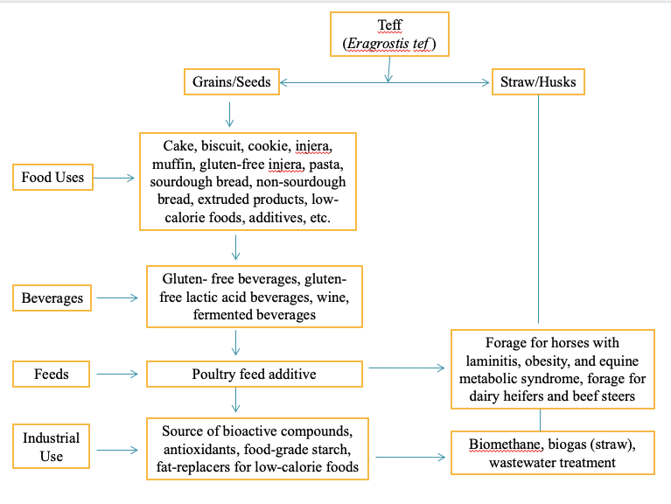

**Fig. 9 Uses of teff grain and straw (Barretto *et al*., 2021)**

However, white teff seeds are commonly consumed because it is more palatable, while red/brown teff seeds are chosen as a healthier alternative (Gebremariam *et al.,* 2014). Due to its high resistance to spoilage, teff confectionery products have palatability requirements for human consumption (Zegeye, 1997; Yetneberk *et al.,* 2004).

Teff seed undergoes a fermentation process to produce traditional Ethiopian alcoholic beverages, Arake, Shamit and Tella (Gebremariam *et al.,* 2014). Arake, also known as katikalla, is made by mixing unleavened bread made from teff (kita) and sprouted wheat or barley (bekel) in a mixture of 3 to 4 days old water and ground Gesho leaves. The resulting mixture is fermented for another 5-6 days and then distilled. However, Shamit is an Ethiopian beer with roots in the Gurage tribe. The ground fraction of Kita and Bekel is dissolved in water, fermented for 3-4 days and then filtered. Add chopped, toasted and dehusked barley (mitad) to enhance flavor and aroma. It is usually served with cardamom, cumin and bishop's weed. On the other hand, tella is noted for its smoky flavor (Selinus, 1971). The popularity of teff-based products stems from their gluten-free ingredients and nutritious whole grains. Compared to other cereals, teff is rich in calcium, zinc and iron (Stojceska *et al.,* 2010). Lactic acid fermentation in the further processing of teff food derivatives increases the synthesis and availability of nutrients, reduces anti-nutritional factors and further improves shelf life and palatability. Fermented products have the advantage of greater availability of nutrients due to the presence of beneficial bacteria and probiotics. Among its many health benefit, teff increases the level of hemoglobin in the blood, which can reduce the chance of developing anemia.

Teff by-products contribute significantly to the dairy and meat industries as animal feed (Amentae *et al.,* 2016). In Ethiopia, animal feed is made from alfalfa, vegetable straw, pasture grass, chopped straw and by-products. Among these sources, chopped straw (27.71%) is the second most consumed animal feed after grazing (61.48%). Teff accounts for about 6.93% of the cut straw supply in Ethiopia (Tesfaye, 2006). A study on the use of chopped teff straw reported that only 6.68 million tons of straw were used for animal feed nationwide, thus bringing the total straw waste to 860,000 tons (Zinash and Sayom, 1991). has experienced in recent years. Many losses occurred due to long transportation from farm to farm, lack of vehicles and transportation costs. In this case, the loss of quantity and quality becomes a big problem for the livestock industry, which is aggravated in the dry season (Tsefaye, 2016). In Utah, teff serves as an emergency forage crop during periods of winter blight, crop failure, and delayed planting schedules (Young *et al.,* 2014).

**What is injera?**

Injera is a flat bread with a unique taste. A soft and spongy round pancake with a thickness of 2 to 4 mm and a diameter of about 58 cm. The main ingredient for cooking injera is teff, although sometimes other grains such as sorghum and barley are also used. These days, some consumers add a few grams of rice flour to whiten the injera. The knowledge and techniques of cooking injera are well known to Ethiopians and have long been passed down from generation to generation. The general structure of well baked injera is shown in Fig. 13.

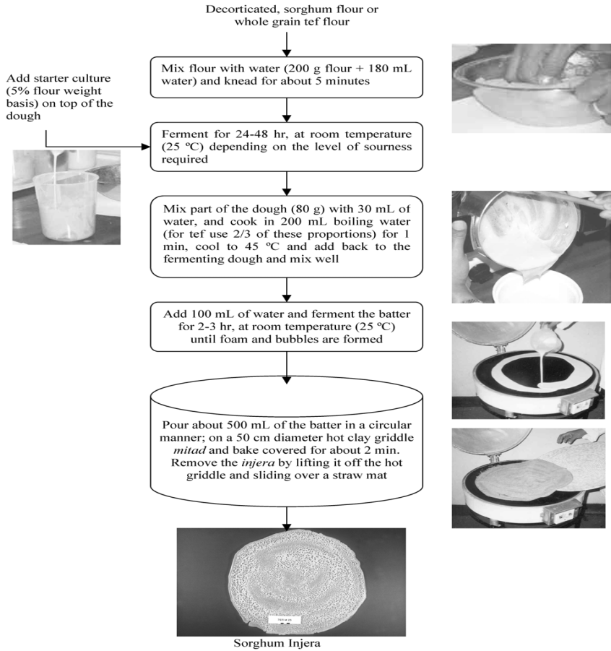

**Fig. 10 Flow diagram of standardized *injera* making procedure (Yetneberk *et al*., 2004)**

Injera is made from teff flour that is mixed with water and the remaining dough from a previous cooking session is added as a starter and left to rise. Once ready, a fire is lit from the bottom of a clay pot for biomass stoves or a resistor is lit for electric injera cooking stoves. When the temperature of the mold reaches about 200oC, pour the dough on the baking tray. Because of its viscosity, it can be poured onto the baking sheet instead of being stretched. Finally, remove the cooked injera from the baking sheet. The majority of Ethiopians still bake injera using three-stone fire. Since the 1980s, efforts have been made to improve biomass injera ovens and introduce electric injera ovens for urban dwellers.

**Preparation of Injera**

A flow chart of the standard injera manufacturing method is shown in Figure 13. This method involves grinding the whole decorticated sorghum or teff into flour, preparing the dough, adding a starter culture (batter from the previous batch) and then fermenting at room temperature for about 48 hours. Gram-negative bacilli, lactobacilli and yeasts have been reported to grow as microorganisms involved in the fermentation of teff dough (Gashe *et al.,* 1982). After fermentation, approximately 25% of the fermented dough was diluted with 30 mL of water and cooked in 200 mL of boiling water for 1 min. The purpose of gelatinization (cooking) was primarily to create dough cohesion and secondly to provide easily fermentable carbohydrates for injera fermentation. The gelatinized dough was cooled to about 45°C at room temperature and returned to the fermenting dough. After mixing well, add 100 ml of water and ferment the dough for 2-3 hours at room temperature. Additional water (20 mL) was added to the fermented teff dough to obtain a dough consistency. Returning the warm gelatinized starch to the fermented dough raises the fermentation temperature to about 30°C and promotes the growth of mesophilic microorganisms. Pour about 500 grams of the fermented dough on a heated clay griddle with a diameter of 50 cm in a circle, cover it and put it in the oven for about 2 minutes to cook the injera.

**TELLA**

Tella has a smoky flavor due to the addition of bread darkened by baking and use of a fermentation vessel which has been smoked by inversion over smoldering weyrawood. In addition to grains, the other most important element in the making of tella is the Gesho leaves (*Rhamnus prinoides*). It gives a special bitter taste to the drink. Research results have shown that Gesho regulates the microbiota involved in the fermentation process (Kleyn and Hough, 1971).

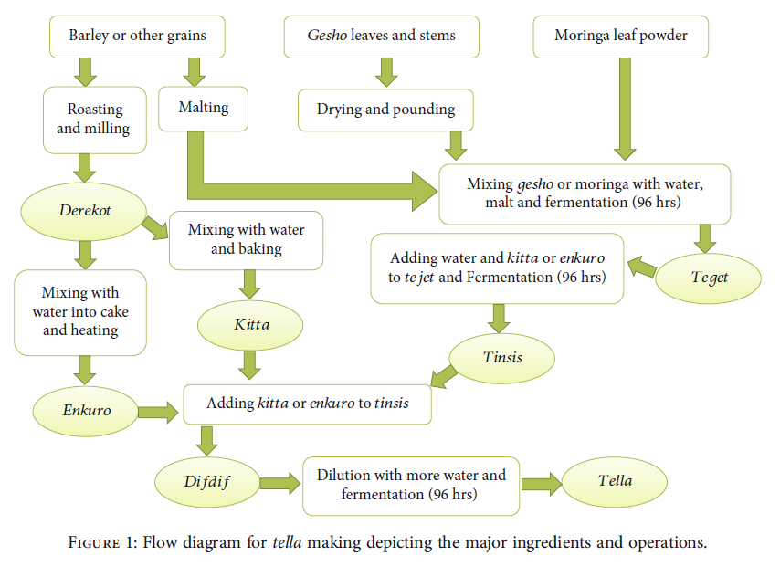

**Fig. 11 Flow diagram of for tellamaking depicting the major ingredients and operations (Birhanu *et al.,* 2021)**

It was also found that the bitterness of the beer has a direct relationship with the amount of Gesho added. Tella is unprocessed according to government regulations and the alcohol content varies between 2-4% by volume. Tella-filtered has a higher alcohol content in the range of 5-6% by volume (Selinus, 1971).

**Preparation of Ingredients**

Barley seeds are washed and dark roasted so that the endosperm changes along with the flavour and colour development. The roasted barley seeds were then ground into flour (locally known as derekot), packed in polyethylene bags, and stored at room temperature until required for the next processing step (Birhanu *et al.,* 2021). The malted barley was washed and ground and then stored in the same way as derekot. The leaves and thin branches of poppy seeds were ground using a traditional wooden mortar to the desired particle size (not too fine). The powder is also packed in a polythene bag and stored in a dry and dark place until it is needed for the next stage of tella production. Moringa leaf powder was also stored under the same conditions as gesho.

**Adjunct Preparation Methods for Tella**

Tella was made using two traditional methods: kitta-based preparation and emkuro-based preparation. Roasted oat flour was mixed with suitable water to form a sticky dough from the kitta preparation, which was baked into thick flatbreads on a hot metal griddle (Teferra *et al.,* 2015). Kitta was kept to cool and broken into pieces. Kitta pieces were dried and stored for use in the difdif step (final mixing of the tella for fermentation) of the tella fermentation stage. In enkuro-based preparations, roasted barley flour was mixed with a limited amount of water (compared to kitta) and mixed into bolus cakes and baked on a hot metal griddle. Then the Enkuro was cooled, dried, packed in polythene bags and transported to the laboratory for use in the difdif stage of tella fermentation.

**Tella Processing Phase**

Tella processing uses three basic fermentation steps: tejet, tinsis, and difedef (Fentie *et al.,* 2020). Three types of Tejet were prepared by mixing 100 g of malt with 125 g of (i) Gesho leaf powder, (ii) Moringa leaf powder and (iii) a 50:50 mixture of Gesho and Moringa, which was fermented for 96 hours, being covered with a piece of clean cloth (Figure 14). The Tejet formulation was divided into two parts and converted to tinsis by adding 225 g of kitta or enkuro adjuvant. The tinsis preparation was also fermented with lid for an additional 96 hours. Fermented thinsis was converted to the final stage of tella fermentation (difdif) by adding 900 grams of residual adjuvant (Kitta or Enkuro) and diluting to tella with 5 liters of water. The final tella mixture was also covered for another 96 hours for fermentation. The fermented solutions were filtered with a clean muslin cloth to remove larger suspended impurities and characterized biochemically and organoleptically.

**Table 5. Studies on application of teff in of gluten-free bakery products (Nascimento *et al.,* 2018)**

|  |  |  |  |
| --- | --- | --- | --- |
| **Developed products** | **Assay** | **Conclusion** | **Reference** |
| **Cookies** | Examined the effect of 25 and 50% replacement with teff flour on the physical, textural and sensory properties of gluten free sugar and peanut butter cookies | Panelists preferred the control and 25% teff cookie over the one prepared with 50% in case of sugar cookie, but no such preference was observed in case of peanut butter cookies. The results show that nutrient dense teff flour can be a good alternative and it can also improve the taste and flavour of gluten free cookies | Kenney *et al.,* (2011) |
| **Muffins** | This study examined the effects of substitution of rice flour (control) with teff flour at 25%, 50%, 75% and 100% on the physical, textural, and sensory characteristics of gluten free muffins | The study demonstrates that substituting 50% rice flour with teff not only produces acceptable gluten free muffins, but these are more nutritious because of their higher protein (27%), iron (20.95%), calcium (25%) and fiber (22.1%) contents | Assefa *et al.* (2011) |
| **Injera** | The effect of grain teff flour substitution with flaxseed on quality and functionality of injera was analyzed | The 9% flaxseed-substituted injera showed good proximate nutritional and energy contents of functional potential of high in dietary fibre, alpha linolenic acid, lignans, proteins and TP of antioxidant nature. | Girma *et al.* (2013) |

**Table 6. Phytochemical composition of teff grain (Baye *et al.,* 2014)**

|  |  |  |
| --- | --- | --- |
| **Parameters** |  |  |
| **Phytate** (mg/100 g dry matter) | 682-1374 | Phytates form complexes with secreted minerals such as zinc and calcium, making these minerals unavailable for reabsorption into the body (By soaking, fermentation and germination) |
| **Tannin** (mg CE/100 g dry matter) | 16 |  |
| **Total polyphenols** (mg gallic acid equivalent/100 g dry matter) | 140 | Polyphenols can hamper iron absorption from plant-based foods |
| **Iron-binding phenolics** |  |  |
| Galloyls (mg tannic acid equivalent/100 g dry matter) | 210 | These two functional groups hamper iron absorption |
| Catechols (mg catechin equivalent/100 g dry matter) | 200 |
| **Phenolic acids (μg/mg)** |  |  |
| Protocatechuic | 25.5 |  |
| Gentisic | 15.0 |  |
| Vanillic | 54.8 | No Galloyls and Catechols as functional groups  so doesn’t hamper iron absorption |
| Coumaric | 36.9 |
| Cinnamic | 46.0 |
| Caffeic | 3.9 |  |
| Syringic | 14.9 |  |
| Ferulic | 285.9 |  |

1. **Chia seeds**

*Salvia hispanica* L., also known as Chia, is an annual herbaceous plant native to Southern Mexico and Northern Guatemala. It belongs to the order Lamiales, mint family Labiate, subfamily Nepetoideae, and genus *Salvia.* The genus *Salvia* consists of about 900 species and has been widely distributed for thousands of years in several parts of the world, including South Africa, Central America, North and South America, and South-East Asia (Ciau-Solis *et al.,* 2014). As reported in the literature, today chia is cultivated not only in Mexico and Guatemala, but also in Australia, Bolivia, Colombia, Peru, Argentina, the United States, and Europe. Today, Mexico is known as the largest producer of chia in the world (Grancieri and Martino, 2019). In 2018 alone, Mexico produced 2,893.4 MT of chia seeds ([www.tradelinkinternational.com](http://www.tradelinkinternational.com))**.**

The word chia is derived from the Spanish word "chian" meaning oily. Chia is an oilseed, with a powerhouse composed of fats, carbohydrates, fiber, protein, vitamins (A, B, K, E, D), minerals and antioxidants. Chia seeds contain healthy omega-3 fatty acids, polyunsaturated fatty acids, dietary fiber, protein, vitamins and some minerals. Seeds are a very good source of polyphenols and antioxidants such as caffeic acid, rosmarinic acid, myricetin and quercetin. Chia seeds as a dietary supplement - positive benefits such as supporting the digestive system, healthy skin, promoting stronger bones and muscles, and reducing the risk of heart disease and diabetes (Grancieri and Martino, 2019).

Historical records show that *Salvia hispanica* L. was used in folk medicine and food preparation by ancient Mesoamerican cultures, the Aztecs, and the Mayans, along with corn, red beans, and calendula. In pre-Columbian societies, beans were the second major crop after beans (Ullah *et al.,* 2016). In Aztec society, chia was used in food, cosmetics, and religious ceremonies. *Salvia hispanica* L. is grown primarily for its seeds and produces small white and purple hermaphrodite flowers 3 to 4 mm thick. The plant itself is sensitive to sunlight, can grow up to 1 meter tall and has toothed leaves with inverted petioles 4-8 cm long and 3-5 cm wide. Chia seeds are generally very small, oval, less than 2 mm long, 1–1.5 mm wide, and less than 1 mm thick (Grancieri and Martino, 2019). The color of the seed varies from black, gray or black to white.

**Table 7. Nutritional properties, vitamins, fatty acids, and phenolic compounds content of chia seeds and other cereals per 100 g (Ho *et al*., 2013)**

|  |  |  |  |  |  |  |
| --- | --- | --- | --- | --- | --- | --- |
|  | Chia seeds | Rice | Corn | Wheat | Quinoa | Amaranth |
| Carbohydrates (g) | 42 | 80 | 74 | 71 | 64.2 | 71 |
| Protein (g) | 17 | 6.5 | 9.4 | 12.6 | 14.1 | 12.6 |
| Fat (g) | 31 | - | - | 1.5 | 1.92 | 1.5 |
| **Minerals (mg)** |  | | | | | | |
| Magnesium | 335 | 25 | 127 | 126 | 197 | 126 |
| Phosphorus | 860 | 115 | 210 | 288 | 457 | 288 |
| Calcium | 631 | 28 | 7 | 29 | - | 29 |
| Potassium | 407 | 115 | 287 | 363 | 563 | 363 |
| **Vitamins (mg)** |  | | | | | | |
| Vitamin A | 54 µg | 0 | 214 | 9 | 0 | n.d. |
| Vitamin E | 0.5 | 0.11 | 0.49 | 1.01 | 0.63 | 1.19 |
| Vitamin C | 1.6 | 0 | 0 | 0 | 0 | 4.2 |
| Thiamine (B1) | 0.62 | 0.07 | 0.39 | 0.30 | 0.11 | 0.12 |
| Riboflavin (B2) | 0.17 | 0.05 | 0.20 | 0.12 | 0.11 | 0.2 |
| Niacin (B3) | 8.83 | 1.6 | 3.63 | 5.46 | 0.412 | 0.92 |
| **Fatty acid content (%)** |  | | | | | | |
| Linolenic acid | 63.79 | 2.1 | 1 | 0.08 | 6.7 | 1.01 |
| Linoleic acid | 18.89 | 39.7 | 52 | 0.68 | 56.4 | 0.35 |
| Oleic acid | 7.3 | 35.1 | 31 | 0.24 | 20.4 | 22.69 |
| Palmitic acid | 7.04 | 20.8 | 13 | 3.02 | 9.7 | 18.59 |
| **Phenolic compounds (µg)** |  | | | | | | |
| Caffeic acid | 27 | n.d. | 26 | 40 | 37 | 0.90 |
| Quercetin | 0.17 | - | - | 30.1 | 43.3 | - |

**Table 8. Major constituents of chia oil (Hrncic *et al*., 2020)**

|  |  |  |  |
| --- | --- | --- | --- |
|  | **Composition** | | **References** |
| Chia seeds contain 39% oil (mass of dry seed) | 68% of ω-3 fatty acid | 19% of ω-6 fatty acid | Ciau-Solis *et al.* (2014) |
| Polyunsaturated fatty acids (PUFAs) | α-linolenic (ALA, ω-3 fatty acid) | Linoleic (LA, ω-6 fatty acid) acids) | Silva *et al.* (2016) |
|  | The ratio between ω-6 and ω-3 fatty acid is 0.3:0.35 | | Luz *et al.* (2012) |
| Benefits | lowering the cholesterol levels, anti-inflammatory activity, cardioprotective and hepatoprotective activities, antidiabetic action, and protection against cancer, arthritis, and autoimmune disease | ω-6 include anti-inflammatory activity, anti-  anti-thrombotic activities, and anticancer activities | Grancieri *et al.* (2019) |

**Table 9. Reviews on Chia seed oil extraction (Hrncic *et al*., 2020)**

|  |  |  |  |  |
| --- | --- | --- | --- | --- |
| **Sl. No.** | **Title** | **Parameters** | **Results** | **Reference** |
| 1) | Supercritical carbon dioxide extraction of oil from Mexican chia seed (*Salvia hispanica* L.): Characterization and process optimization | Temperature (40, 60and 80oC), Pressure (250, 350 and 450 bar) and Time (60, 150 and 240 min.) | Yield 92.8%, at 450 bar, 80oC, and 300 min. | Ixtaina *et al.* (2010) |
| 2) | Valorization of chia (*Salvia hispanica*) seed cake by means of supercritical fluid extraction | Supercritical fluid extraction (SFE) was performed at pressures from 150-300 bar (150, 200, 250, 300 bar) and temperatures of 40-50°C, when CO2 as solvent or CO2 added to ethanol (EtOH) or ethyl acetate (EtOAc) as cosolvents at 2.5-7.5% w/w of the total CO2 mass. | The highest extraction yield, 90.6%, with pure CO2 was obtained at 300 bar and 50oC | Guindani *et al.* (2016) |

**Table 10. Active compounds in Chia seeds (*Salvia hispanica* L.)**

|  |  |  |
| --- | --- | --- |
| **Active Compounds** | **Biological Activity** | **Reference** |
| Omega-3 fatty acid | -anti-inflammatory  - antidiabetic  -anticancer | Ali *et al.* (2012) |
| Omega-6 fatty acid | -anti-inflammatory  -anticancer | Ali *et al.* (2012) |
| Flavonoids |  | |
| Mycertin | - antioxidant | Falco *et al.* (2017) |
| Quercetin | * Antioxidant * anti-cancerogenic   -anti-hypertensive | Rahman *et al.*  (2017) |
| Kaempferol | -Antioxidant | Ali *et al.* (2012) |
| Caffeic acid | * Antioxidant * anti-cancerogenic   -anti-hypertensive | Rahman *et al.*  (2017) |
| Vitamins |  | |
| A | -healthy skin | Rahman *et al.*  (2017) |
| B1 | -for synthesizing ATP |
| B2 | -for normal RBC working |
| B3 | -for normal nervous and digestion system working |

1. **“Superfoods”-Labelling and Regulation (Fernandez-Rios *et al*., 2022)**

The list of superfoods has grown uncontrollably over the years, as health claims are often not supported by scientific evidence, particularly by controlled human intervention trials (Proestos, 2018). Furthermore, the lack of established criteria for classifying foods as "super" and the indiscriminate marketing that takes place have led some authors to consider them "food frauds" (Curll *et al.,* 2016). These claims highlight the need for stricter regulations and food fraud policies to regulate false health claims of superfoods (Smith, 2019). Since 2007, according to European Regulation (EC) No. 1924/2006 (European Commission, 2006) on nutrition and health claims made on foods, the term "superfood", which is considered a claim, cannot be used on product packaging. or cannot be used. be advertised in advertisements, because only healthy properties supported by solid scientific evidence are evaluated by EFSA (European Food Safety Authority). Therefore, superfoods should be defined and have their own rules regarding the requirements and labelling of products such as "eco" and "bio" products, governed by Regulation (EU) 2018/484 on environmentally friendly production. (European Union, 2018) which states that a product can only be advertised as organic or bio when at least 95% of its ingredients come from environmentally friendly production.

**Conclusion**

Superfoods are typically plant-based foods that are highly nutritious and provide maximum nutritional benefits with minimal calories. Superfoods are rich in vitamins, fiber, minerals and antioxidants. Because of their strong bioactivity and nutritional value, superfoods may play an essential role in the prevention of chronic diseases. The extraction of potential bioactive components and their incorporation into different food applications may pave the way for the development of potential health-promoting foods in the field of food processing.

**References**

Abderrahim, F., Huanatico, E., Segura, R., Arribas, S., Gonzalez, M. C. and Condezo Hoyos, L., Physical features, phenolic compounds, betalains and total antioxidant capacity of coloured quinoa seeds (*Chenopodium quinoa* Willd.) from Peruvian Altiplano. *Food Chemistry,* 2015, 183:83-90.

AESAN, 2019, Information Notes of Superfoods. https://www.aesan.gob. es/SIAC- WEB/pregunta.do;jsessionid=D9Tx8HIo6JEKEW3CbDo3aiweu6YNmS8GlLXaDV6DO gwSddNia7l!1306075272?reqCode=retrieve&bean.id=3465. (Accessed on 11 January 2022).

Angeli, V., Silva, P. M., Massuela, D. C., Khan, M. W., Hamar, A., Khajehei, F., Graeff- Honninger, S. and Piatti, C., 2020, Quinoa (*Chenopodium quinoa* Willd.): An Overview of the Potentials of the “Golden Grain” and Socio-Economic and Environmental Aspects of Its Cultivation and Marketization. *Food,* 9(1): 216. doi:10.3390/foods9020216.

Anonymous, 2011, Evaluation of Food Ex, the food classification system applied to the development of the EFSA comprehensive European food consumption database. EFSA J. https://doi.org/10.2903/j.efsa.2011.1970.

Antigo, J. L. D., Stafussa, A. P., Bergamasco, R. C. and Madrona, G. S., 2020, Chia seed mucilage as a potential encapsulating agent of a natural food dye. *Journal of Food Engineering*, 285 :110101. <https://doi.org/10.1016/j.jfoodeng.2020.110101>.

Assefa, K., Yu, J. K., Zeid, M., Belay, G., Tefera, H., Sorrells, M. E., 2011, Breeding tef [*Eragrostistef* (Zucc.) trotter]: conventional and molecular approaches. *Plant Breed*, 130(1): 1-9.

Berhanu, Microbial profile of tella and the role of gesho (*Rhamnus prinoides*) as bittering and antimicrobial agent in traditional tella (beer) production, 2014*, International* *Food Research Journal*, 21(1): 1-10.

Birhanu, A. M., Teferra, T. F. and Bekele, T., 2021, “Fermentation dynamics of Ethiopian traditional beer (tella) as influenced by substitution of gesho (*Rhamnus prinoides*) with Moringa stenopetala as innovation for nutrition,” in Preprint, 2021.

Bultosa, G., 2007, Physicochemical characteristics of grain and flour in 13 tef (*Eragrostistef* (Zucc.) Trotter) grain varieties. *Journal of Applied Science and Research*, 3: 2042–2051.

Ciau-Solis, N., Rosado-Rubio, G., Segura-Campos, M. R., Betancur-Ancona, D., Chel-Guerrero, L., 2014, Chemical and functional properties of chia Seed (*Salvia hispanica* L.) Gum. *International Journal of Food Science*, 2(4): 1–5.

Cooper, R., 2015, Re-discovering ancient wheat varieties as functional foods. *Journal of Traditional Complement Medicine*, 5(1): 138-143.

D'Amico, S., Jungkunz, S., Balasz, G., Foeste, M., Jekle, M., Tomoskoszi, S. and Schoenlechner, R., 2019, Abrasive milling of quinoa: Study on the distribution of selected nutrients and proteins within the quinoa seed kernel. *Journal of Cereal Science*, 86: 132–138.

Das, A., 2018, Advances in Chia Seed Research. *Advances in Biotechnology* *and Microbiology*,5(1): 5–7.

De Carvalho F. G., Ovidio, P. P., Padovan, G. J., Jordao, J. A. A., Marchini, J. S., Navarro, A. M., 2014, Metabolic parameters of post menopausal women after quinoa or corn flakes intake-aprospective and double-blind study. *International Journal of Food Science and Nutrition,* 65(1): 380-385.

Doyon, M., Labrecque, J., 2008, Functional foods: a conceptual definition. BFJ 110 (1): 1133– 1149. https://doi.org/10.1108/00070700810918036.

EFSA, 2011. Evaluation of FoodEx, the food classification system applied to the development of the EFSA comprehensive European food consumption database. *EFSA J.*, <https://doi.org/10.2903/j.efsa.2011.1970>.

Falco, B., Amato, M., Lanzotti, V., 2017, Chia seeds products: An overview. *Phytochemical Review*,16(1): 745–760.

Farinazzi-Machado, F. M. V., Barbalho, S. M., Oshiiwa, M., Goulart, R., Pessan, J. O., 2012, Use of cereal bars with quinoa (*Chenopodium quinoa* W.) to reduce risk factors related to cardiovascular diseases. *Cienc Technology Aliment* *Campinas*, 32(1): 239-244.

Fentie, E. G., Emire, S. A., Demsash, H. D., Dadi, D. W. and Shin, J. H., 2020, “Cereal- and fruit-based Ethiopian traditional fermented alcoholic beverages,” *Foods,* 9(12): 1781.

Fernandez-Rios, A., Laso, J., Hoehn, D., Amo-Setien, F. J., Abajas-Bustillo, R., Ortego, C., Fullana-i-Palmer, P., Bala, A., Batlle-Bayer, L., Balcells, M., Puig, R., Aldaco, R. and Margallo, M., 2022, A critical review of superfoods from a holistic nutritional and environmental approach. *Journal of Cleaner Production*, 379. <https://doi.org/10.1016/j.jclepro.2022.134491>.

Foucault, A. S., Mathe, V., Lafont, R., Even, P., Dioh, W., Veillet, S., Tome, D., Huneau, J. F., Hermier, D., Quignard-Boulange, 2011, A: Quinoa extract enriched in 20- hydroxyecdysone protects mice from diet induced obesity and modulates adipokines expression. *Obesity*, 20(1): 270-277.

Gebremariam, M. M., Zarnkow, M. and Becker, T., 2014, Teff (*Eragrostis tef*) as a raw material for malting, brewing and manufacturing of gluten-free foods and beverages: a review. *Journal of Food Science and Technology,* 51(11): 2881–2895.

Girma, T., Bultosa, G., Bussa, N., 2013, Effect of grain tef [*Eragrostis tef* (Zucc.) Trotter] flour substitution with flaxseed on quality and functionality of injera. *International Journal of Food Science and Technology*, 48(2): 350-356.

Gordillo-Bastidas, E., Diaz-Rizzolo, D. A., Roura, E., Massanes, T., Gomis, R., 2016, Quinoa (*Chenopodium quinoa* Willd*)* from nutritional value to potential health benefits: An integrative review. *Journal of Nutritional health and Food Science*, 6(1): 497-510.

Graf, B. L., Poulev, A., Kuhn, P., Grace, M. H., Lila, M. A. and Raskin, I., 2014, Quinoa seeds leach phytoecdysteroids and other compounds with anti-diabetic properties. *Food Chemistry,* 163:178-185.

Graf, B. L., Rojas-Silva, P., Rojo, L. E., Delatorre-Herrera, J., Baldeo, M. E., Raskin, I., 2015, Innovations in health value and functional food development of quinoa (*Chenopodium quinoa* Willd.). *Comprehensive Reviews Food Science and Food Safety,*14:431-445.

Grancieri, M., Martino, H. S. D., Gonzalez de Mejia, E., 2019, Chia Seed (*Salvia* *hispanica* L.) as a source of proteins and bioactive peptides with health benefits: A Review. *Comprehensive Review of Food Science and Food Safety,* 18(1): 480–499.

Guindani, C., Podesta, R., Block, J. M., Rossi, M. J., Mezzomo, N., Ferreira, S. R. S., 2016, Valorization of chia (*Salvia hispanica*) seed cake by means of supercritical fluid extraction. *Journal of Supercritical Fluids,* 112(1): 67–75.

Hirich, A.; Rafik, S.; Rahmani, M.; Fetouab, A.; Azaykou, F.; Filali, K.; Ahmadzai, H.; Jnaoui, Y.; Soulaimani, A.; Moussafir, M.; Gharous, E. L., Karboune, S., Sbai, A. and Choukr- Allah, R., 2021, Development of Quinoa Value Chain to Improve Food and Nutritional Security in Rural Communities in Rehamna, Morocco: Lessons Learned and Perspectives. *Plants,* 10: 301. [https://doi.org/10.3390/plants 10020301](https://doi.org/10.3390/plants%2010020301).

Ho, H., Lee, A. S., Jovanovski, E., Jenkins, A. L., DeSouza, R., Vuksan, V., 2013, Effect of whole and ground Salba seeds (*Salvia Hispanica* L.) on postprandial glycemia in healthy volunteers: A randomized controlled, dose-response trial. *European Journal of Clinical Nutrition,* 67(1): 786–788.

Hussain, M. I., Farooq, M., Syed, Q. A., Ishaq, A., Al-Ghamdi, A. A., Hatamleh, A. A., 2021, Botany, nutritional value, phytochemical composition and biological activities of Quinoa, *Plants,* 10(1): 2258-2269.

Ixtaina, V. Y., Martinez, M. L., Spotorno, V., Mateo, C. M., Maestri, D. M., Diehl, B. W. K., Nolasco, S.M., Tomas, M. C., 2011, Characterization of chia seed oils obtained by pressing and solvent extraction. *Journal of Food Composition and Anaysis*, 24(1): 166– 174.

Ixtaina, V. Y., Vega, A., Nolasco, S. M., Tomas, M. C., Gimeno, M., Barzana, E., Tecante, A., 2010, Supercritical carbon dioxide extraction of oil from Mexican chia seed (*Salvia hispanica* L.): characterization and process optimization. *Journal of Supercritical Fluids,* 55(1): 192–199.

Jacobsen, S. E., Mujica, A., Jensen, C. R., 2003, The resistance of quinoa (*Chenopodium quinoa* Willd.) to adverse abiotic factors. *Food Revolution International*, 19(1): 99–109.

Jagdale, Y. D., Mahale, S. V., Zohra, B., Nayik, G. A., Dar, A. H., Khan, K. A., Abdi, G., Karabagias, I. K., 2021, Nutritional profile and potential health benefits of super foods: A Review. *Sustainability*, https://doi.org/10.3390/su13169240.

Jancurova, M., Minarovicova, L., Dandar, A., 2009, Quinoa - A Review. *Czech Journal of Food Science,* 27(1): 71-79.

Kenney, E. S., Butler, C., Moore, C., Bhaduri, S., Ghatak, R., Navder, K. P., 2011, The effect of substituting teff flour in gluten-free sugar cookies and peanut butter cookies. *Journal of American Diet Association*, 111(9): 63-69.

Loyer, J., Knight, C., 2018, Selling the “Inca superfood”: nutritional primitivism in superfoods books and maca marketing. Food Culture and Society, 21 (4): 449–467. <https://doi>. org/10.1080/15528014.2018.1480645.

Luz, J. M. R., Nunes, M. D., Paes, S. A., Torres, D. P., Silva, M. D. C. S. D., Kasuya, M. C. M., 2012, Lignocellulolytic enzyme production of pleurotuso streatus growth in agroindustrial wastes. *Brazil Journal of Microbioogy,* 43(1): 1508–1515.

Magrach, A., Sanz, M. J., 2020, Environmental and social consequences of the increase in the demand of ‘superfoods’ world-wide. People. Nat. 2, 267–278.

<https://doi.org/> 10.1002/pan3.10085.

Maradini-Filho, A. M. Quinoa: Nutritional aspects. *Journal of Nutraceuticals and Food* *Science*, 2(1): 1–5.

Meyerding, S. G. H., Kurzdorfer, A., Gassler, B., Consumer Preferences for Super food Ingredients - the Case of Bread in Germany. *Sustainability* 10(1): 4661-4667.

Mohd Ali, N., Yeap, S. K., Ho, W. Y., Beh, B. K., Tan, S.W., Tan, S. G., 2012, The promising future of chia, *Salvia hispanica* L. *Journal of Biomedical and Biotechnology*, 20(1): 1–9.

Nascimento, K. O., Paes, S. N. D., Oliveira, I. R., Reis, I. P., Augusta, I. M., 2018, Teff: suitability for different food applications and as a raw material of gluten-free, a Literature review. *Journal of Food and Nutrition Research,* 6(2): 74-81.

Navruz-Varli, S., Sanlier, N., Nutritional and health benefits of quinoa (*Chenopodium quinoa* Willd.). *Journal of Cereal Science,* 2016, 69:371-376.

Picone, G., Mengucci, C., Capozzi, F., 2022, The NMR added value to the green foodomics perspective: advances by machine learning to the holistic view on food and nutrition. *Magn. Resoning. Chemistry,* 60: 590–596. https://doi.org/10.1002/ mrc.5257.

Prego, I., Maldonado, S., Otegui, M., 1998, Seed structure and localization of reserves in Chenopodium quinoa. *Annals of Botany,* 82(1): 481–488.

Proestos, C., 2018, Superfoods: recent data on their role in the prevention of diseases. *Current Research and Nutrition Food Science.* 6 (3): 576–593. https://doi.org/10.12944/CRNFSJ.6.3.02.

Rahman, M. J., Camargo, A. C., Shahidi, F., 2017, Phenolic and polyphenolic profiles of chia seeds and theirin vitro biological activities. *Journal of Functional Foods,* 35(1): 622–634.

Ruales, J., Grijalva, Y., Lopez-Jaramillo, P., Nair B. M., 2002, The nutritional quality of infant food from quinoa and its effect on the plasma level of insulin-like growth factor-1 (IGF-1) in undernourished children. *International Journal of Food Science* *and Nutrition*, 53(1):143-154.

Samec, D., Urlic, B., Salopek-Sondi, B., 2019, Kale (*Brassica oleracea* var. acephala) as a superfood: review of the scientific evidence behind the statement. *Critical Reviews in Food Science and Nutrition,* 59 (15): 2411–2422. <https://doi.org/10.1080/10408398.2018.1454400>.

Santini, A., Cammarata, S. M., Capone, G., Ianaro, A., Tenore, G. C., Pani, L., Novellino, E., 2018, Nutraceuticals: opening the debate for a regulatory framework. *Brazalian Journal Clinical Pharmacology*, 84 (4): 659–672. https://doi.org/10.1111/bcp.13496

Santini, A., Novellino, E., 2014, Nutraceuticals: beyond the diet before the drugs. *Current Bioactive Compounds.* 10 (1): 1–12. <https://doi.org/10.2174/> 157340721001140724145924.

Silva, C., Garcia, V. A. S., Zanette, C. M., 2016, Chia (*Salvia hispanica* L.) oil extraction using different organic solvents: Oil yield, fatty acids profile and technological analysis of defatted meal. *International Food Research Journal,* 23(1): 998–1004.

Sobota, A., Swieca, M., Gesinski, K., Wirkijowska, A., Bochnak, J., 2020, Yellow-coated quinoa (*Chenopodium quinoa* Willd)—Physicochemical, nutritional, and antioxidant properties. *Journal of Science, Food and Agriculture*, 100(1): 2035–2042.

Tang, Y., Li, X., Chen, P. X., Zhang, B., Hernandez, M., Zhang, H., Marcone, M. F., Liu, R. and Tsao, R., 2015, Characterisation of fatty acid, carotenoid, tocopherol/tocotrienol compositions and antioxidant activities in seeds of three *Chenopodium quinoa* Willd. genotypes. *Food Chemistry*, 174:502-508.

Tang, Y., Zhang, B., Li, X., Chen, P. X., Zhang, H., Liu, R. and Tsao, R., 2016, Bound phenolics of quinoa seeds released by acid, alkaline, and enzymatic treatments and their antioxidant and a-glucosidase and pancreatic lipase inhibitory effects. *Journal of Agriculture Food and Chemistry,* 64:1712-1719.

Teferra, T. F., H. Kurabachew, T. F. Tadesse, and G. Nigusse, 2015, “Nutritional, microbial and sensory properties of flat-bread (kitta) prepared from blends of maize (*Zea mays* L.) and orange-fleshed sweet potato (*Ipomoea batatas* L.) flours fabrication of iron and ascorbic acid nanocomposite view project nutritional, micro,” *International Journal of Food Science and Nutrition Engineering,* 5: 33–39.

Tekle, S., Jabasingh, A., Fantaw, D., 2019, An insight into the Ethiopian traditional alcoholic beverage:-tella, processing, fermentation kinetics, microbial profiling and nutrient analysis,” *LWT*, 107(1): 9–15.

Ullah, R., Nadeem, M., Khalique, A., Imran, M., Mehmood, S., Javid, A., Hussain, J., 2016, Nutritional and therapeutic perspectives of Chia (*Salvia hispanica* L.): A review. *Journal of Food Science and Technology*, 53(1): 1750–1758.

Vega-Galvez, A., Miranda, M., Vergara, J., Uribe, E. and Puente, L., 2010, Nutrition facts and functional potential of quinoa (*Chenopodium quinoa* Willd.), an ancient Andean grain: a review. *Journal of Science Food and Agriculture*, 90: 2541-2547.

Woldemichael, G. M. and Wink, M., 2001, Identification and biological activities of triterpenoid saponins from Chenopodium quinoa. *Journal of Agriculture and Food Chemistry*, 49:2327-2332.

[www.queensquinoa.com](http://www.queensquinoa.com) (Accessed on 27 December 2022)